CHARACTERIZATION OF EVENING TEMPERATURE INVERSIONS IN ALLEGHENY COUNTY, PENNSYLVANIA

By
Carlos Alberto Lopez
BS, Yale University, 2009
MD, University of Pittsburgh, 2015

Submitted to the Graduate Faculty of
Graduate School of Public Health in partial fulfillment
of the requirements for the degree of
Master of Public Health

University of Pittsburgh
2017

UNIVERSITY OF PITTSBURGH
GRADUATE SCHOOL OF PUBLIC HEALTH

This essay is submitted
by
Carlos Lopez

on

June 27th, 2017
and approved by

Essay Advisor:
David Finegold, MD _________________________________
Multidisciplinary MPH Program Director
Professor, Human Genetics
Graduate School of Public Health
University of Pittsburgh

Essay Reader:
Aaron Barchowsky, Ph.D. ________________________________
Professor
Environmental and Occupational Health
Graduate School of Public Health
University of Pittsburgh

Essay Reader:
Anthony Sadar, CCM, M.S., M.Ed. ________________________________
Air Pollution Meteorologist & Administrator
Allegheny County Health Department
Air Quality Program
Copyright © by Carlos Lopez
2017

ABSTRACT

Temperature inversions in the atmospheric boundary layer are associated with stagnant air masses that help trap air pollutants near the earth’s surface, which have been linked to adverse health events. The aim of this study was to use meteorological data from Allegheny County from 2009 to 2014 to identify days in which evening temperature inversion were present; the depth and strength of each inversion was also calculated and summarized with the goal of assisting future efforts to develop more accurate meteorological models for these phenomena. Future epidemiological goals using the results of this study will be used to determine whether temperature inversions are associated with increased pollutant concentrations and short-term adverse health events in the region, which is of public health importance. This is in keeping with the Allegheny County Health department’s ongoing efforts to minimize the effects on air pollutants on vulnerable populations in the region.
David Finegold, MD

EVENING TEMPERATURE INVERSIONS IN ALLEGHENY COUNTY, PENNSYLVANIA 2009-2014

Carlos Lopez, MPH
University of Pittsburgh, 2017

TABLE OF CONTENTS
preface viii
GLOSSARY ix
1.0 Introduction 1
2.0 Methods 6
2.1 Data Collection 6
2.2 Inversion Criteria and Characteristics 10
3.0 Results 13
4.0 Discussion 16
5.0 Conclusion: 19
APPENDIX: SUPPLEMENTAL TABLE 21
bibliography 29
List of tables
Table 1: Evening Inversion Statistics for 2009-2014 14
Table 2: Total Days of Evening Inversions from 2009 to 2014 14
Table 3: Evening Temperature Inversions in Pittsburgh from 2009-2014 21
List of figures
Figure 1: Typical Air Temperature Profile 3
Figure 2: Air Temperature Profile During Inversion 4
Figure 3: Sample Skew-T Plot for Non-inversion Day 8
Figure 4: Sample Skew-T Plot for Inversion Day 9
Figure 5: Diagram of Inversion Temperature Profile 11
Figure 6: Average Evening Inversion Frequency 15
Figure 7: Average Inversion Strength 15
preface
Firstly, I would like to express my immense gratitude to my program director, Dr. David N. Finegold, whose candid mentorship helped guide me through my studies and my research. He is a passionate advocate for the role of an interdisciplinary approach towards the study and practice of public health, and his wisdom and advice have truly left an indelible impression on me that I sincerely wish to emulate in the future.

Secondly, I would like to thank Mr. Anthony J. Sadar, who both oversaw my public health practicum and the data collection described in this essay. A gifted and patient teacher, he embodied the best qualities of a scientist and a public health advocate, and I am gratefully indebted to his contribution towards making this work possible.

I would also like to thank and acknowledge Dr. Aaron Barchowsky; I am gratefully indebted for his time, expertise, and valuable comments on this essay.
GLOSSARY
Air pollutant: substances that do not occur naturally in the atmosphere or those that occur in concentrations higher than their natural concentrations.
Atmospheric boundary layer: The bottom layer of the troposphere that is in contact with the surface of the earth. Abbreviated as ABL; also referred to as boundary layer or planetary boundary layer.
Criteria pollutants: pollutants that can injure health, harm the environment, and cause property damage. These include—but are not limited to—carbon monoxide (CO), lead (Pb), nitrogen dioxide (NO₂), Ozone (O₃), particulate matter with size less than or equal to 10 µm (PM-10) and sulfur dioxide (SO₂).
Dew-point temperature: the temperature at which water vapor in a given parcel of air will condense to form liquid dew. Generally, the higher the dew-point, the more moisture that is present in the air. On a Skew-T plot, the dew-point profile is depicted as the jagged line plotted on the left side of the diagram.
Dispersion: the spreading of atmospheric constituents, such as air pollutants. This can be the result of molecular diffusion, turbulent mixing, and/or wind shear.
Environmental sounding / temperature profile: the profile obtained by charting the measured temperature in the atmosphere collected via radiosonde against height (either altitude or distance from the ground surface). On a Skew-T plot, the temperature profile is depicted as the jagged line plotted on the right side of the diagram.
Inversion height: the distance from the surface to the top of an inversion. The top of an inversion is the point on the temperature profile where temperature begins decreasing with increasing height.
Inversion intensity / strength: the difference in temperature between the temperature at the top of an inversion and the surface temperature.
Isobar: lines of equal pressure. On a Skew-T plot, these are indicated by solid lines that run horizontally from left to right; values are labeled on the left side of the diagram.
Isotherm: lines of equal temperature. On a Skew-T plot, these are indicated by solid lines that run diagonally from the bottom left of the diagram to the top right. Points along this line have the same temperature; values are labeled on the bottom of the diagram.
Radiosonde: a small, expendable instrument package suspended below a weather balloon that measures and transmits weather data (e.g. pressure, temperature, relative humidity, wind direction and speed, position, etc.) each second as it ascends up to the troposphere. Data is transmitted via radio waves to receiving antenna in the ground. Worldwide, all observations are taken at the same time each day (up to an hour before 00:00 and/or 12:00 UTC), 365 days a year.
Relative humidity: the ratio of partial pressure of water vapor to the equilibrium vapor pressure of water at a given temperature.
Temperature inversion: a layer in which temperature increases with altitude. The principle characteristic of an inversion layer is its marked static stability so that very little turbulent exchange can occur within it.
Skew-T plot: a meteorological thermodynamic diagram on which temperature and dew point temperature data collected from radiosonde soundings is plotted with relation to altitude. Its primary use is in weather analysis and forecasting.
Definitions adapted from the Glossary of the American Meteorological Society [1].

Introduction
Multiple studies demonstrate the links between poor air quality and adverse health effects. These include the exacerbation of respiratory conditions such as asthma [2], increased cardiovascular disease risk [3-5], and increased risk of developing certain types of cancers [6]. Both short-term and long-term exposures to increased concentrations of air pollutants can result in detrimental health effects. In addition to the negative impact on the health of a community, air pollution can also negatively impact the surrounding environment. As such, multiple systematic efforts have been undertaken by public health agencies across the United States to improve air quality standards, typically by identifying pollutant sources and limiting their potential exposure to nearby communities.
An individual’s effective exposure to an air pollutant depends on three main factors: the concentration of the pollutant that the individual is exposed to, the length of time the exposure lasts, and the frequency of such exposure events [7]. Both meteorological conditions and an area’s topographical features can act in tandem to influence all three of these factors.
Temperature inversions are meteorological events that can result in the accumulation of air pollutants in the lower atmosphere, potentially raising them to exceed health-based air quality standards [8] and resulting in adverse health events. Low-lying areas such as valleys are especially vulnerable to such stagnant weather patterns. A notable example of this occurred in Donora, Pennsylvania in 1948 [9]. On October 26th, 1948, sparse air movement attributed to an air inversion trapped a fog laden with particulate matter and industrial contaminants in the small industrial town of Donora, located in the Monongahela River valley near Pittsburgh, Pennsylvania, resulting in 5,000 to 7,000 of the town’s 14,000 residents becoming ill. The incident lead to 400 hospitalizations and 20 deaths before rain dispersed the fog on the 31st of October. The incident led to the first major effort in the United States to document the health impacts of air pollution on public health; along with other environmental calamities, the tragedy led to public support for federal clean air legislation efforts, resulting in the passage of the 1955 Air Pollution Act. Though meteorological events like this are not directly preventable, predicting their frequency and severity may help guide efforts to minimize their impact on the public’s health. Indeed, the air temperature structure of the lower atmosphere can help predict whether conditions will favor pollution dispersion or stagnation.
In the microclimate (i.e. the climate near the ground), air temperature is primarily influenced by the exchange of electromagnetic radiation energy between the sun, the air, and the ground surface. The majority of solar radiation that makes it to the ground is either absorbed, reflected, or transmitted by the ground, depending on the surface’s material characteristics and the incident angle between the surface and the sun’s rays. Even as it absorbs solar radiation, the ground is also continuously emitting long wavelength radiation into the surrounding environment, though the net energy transfer during the day causes the temperature of the ground to rise. During the night, the ground will continue to emit long-wave electromagnetic radiation, causing the temperature of the ground to drop and the air near the surface to rise in temperature.
As predicted by the ideal gas law, a given parcel of air will increase in volume as its temperature increases, thus becoming less dense and rising. Inversely, cooler, relatively denser air will fall towards the ground surface. When air near the surface of the earth is warmer than the air above it, this results in dynamic, vertical mixing of the different air layers. A typical air temperature profile is shown in Figure 1, which shows the temperature of the air measured at different points above the ground; notably, the typical configuration shows decreasing air temperature with increasing altitude. Not shown is that in such a configuration, air density decreases with increasing altitude, favoring vertical mixing.
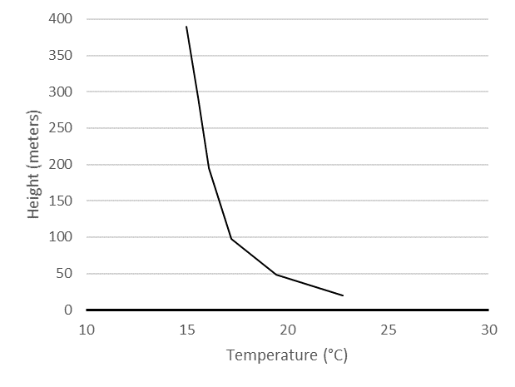
Figure 1: Typical Air Temperature Profile
Typical air temperature profile three to five hours after sunrise on a clear, calm day. Note the decrease in temperature with increasing height above the surface.

A temperature inversion is defined as a meteorological phenomenon where air temperature increases with increasing altitude; it is defined as such because it is the opposite of the typical air temperature profile depicted in Figure 1. This results in an air density gradient such that cooler, denser air will remain near the ground surface below warmer, less dense air. Such a configuration is remarkably stable and yields little to no vertical mixing of the air by subverting the typical pattern; even wind speeds up to 4 or 5 mph may not disrupt it [10]. This creates stagnant air conditions where air pollutants from ground sources that would typically be dispersed by rising convective air flow will remain close to the ground, dissipating only through diffusion and horizontal wind flow (if any is present); notably, a particularly buoyant plume of air or pollution can rise above a shallow surface inversion, but the pattern generally holds. The temperature profile of a typical inversion is shown in Figure 2; not pictured is the density profile of the air, which is highest near the surface of the ground but then becomes less dense as the altitude increases while in the inversion.
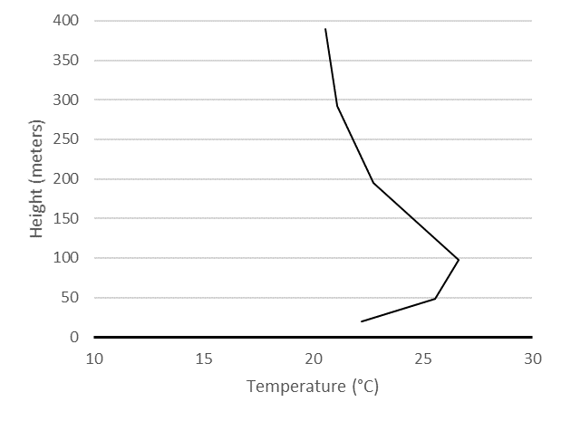
Figure 2: Air Temperature Profile During Inversion
Example of an air temperature profile when a shallow temperature inversion is present. In this example, note the increase in temperature as height increases up until it reaches approximately 100 meters, when temperature begins decreasing with ascending height.

Meteorological literature has long shown that surface air pollution levels worsen during times of inversions [11]. More recent retrospective epidemiological studies even suggest that short-term health effects (as measured by health complaints and emergency room department visits) are exacerbated on dates in which inversions were present [12, 13]. Though the mechanism for why this happens is not always entirely clear, data suggests it might be due to a combination of increasing pollutant concentrations as well as an increase in humidity. As such, it is of public health interest to be able to adequately characterize inversion properties, develop better models to predict their frequency and duration, and determine how other meteorological factors (such as wind speed, humidity, and precipitation) may influence pollutant dispersion during one of these events.
To that end, five years (2009-2014) of daily radiosonde data recorded at the Pittsburgh (PIT) National Weather Service in Moon Township, Pennsylvania were compiled and analyzed to determine which dates had inversion events. Previous work had been done to identify and analyze morning (12Z, or 7:00 a.m. EST) sounding data, but evening (00Z, or 7 p.m. EST) sounding data remains underutilized in forecasting predictions. This data was characterized for inversion strength, height and seasonal frequency. This study complements the ongoing efforts by the Allegheny County Health Department to better model air pollution dispersion in the area, to better identify actionable sources of pollution in the region, and to inform vulnerable members of the public when air pollution is expected to reach harmful levels.

Methods

Data Collection
Atmospheric data was obtained from the University of Wyoming Upper Air Sounding Database, which gathers data collected by the National Weather Service (NWS) sites across the country [14]. This data is collected via radiosonde, an expendable meteorological instrument package that is borne aloft using a free-flight weather balloon. As the instrument ascends from the ground, it measures the vertical profiles of atmospheric variables such as temperature, pressure, humidity, and wind speed and wind direction. This data is transmitted via radio to a ground receiving system. Radiosonde observations are conducted twice a day across the globe to help interpret weather conditions in the upper atmosphere, with approximately 70 radiosonde balloon launch sites present in the contiguous US; similarly scheduled launches are conducted in about 1000 sites outside of the US. Radiosonde data collected through these launches is used to both help interpret weather conditions in the upper atmosphere and characterize the weather conditions in the lower atmospheric boundary layer (ABL), where air dispersion effects are of particular interest to pollution meteorologists.
For each of the dates in the study period (January 1st, 2009 through December 31st, 2014), both morning and evening sounding data were collected from the database. For this study, only evening data were analyzed in detail, as morning data had already been examined and summarized prior to this study. Daily sounding data consisted of both of a skew-T plot and tabulated values of height, temperature, pressure, dew-point temperature, wind speed and wind direction for each day. The criteria for determining whether an inversion occurred in the region only depended on the altitude and the corresponding dry temperature data, so analysis primarily focused on height and temperature for this study (i.e. dew-point temperature did not factor into the analysis). For each inversion that was identified on the skew-T plot, the strength and the height of the inversion were calculated using the tabulated values, not the skew-T plot themselves.
Figures 3 and 4 show two typical skew-T plots representative of the data that was taken. Figure 3 depicts a typical temperature profile for a day in July. The skew-T plot’s name comes from the fact that the temperature axis is skewed so that isotherms run from the bottom left of the graph to the top right; points along the same isotherm have the same temperature. Similarly, points along the same horizontal level are isobars and have equal pressure. The smooth curves running from the bottom right of the plot to the top left are adiabatic lines. The wind-speed direction at each measured point is indicated on the right of the diagram with wind barbs.
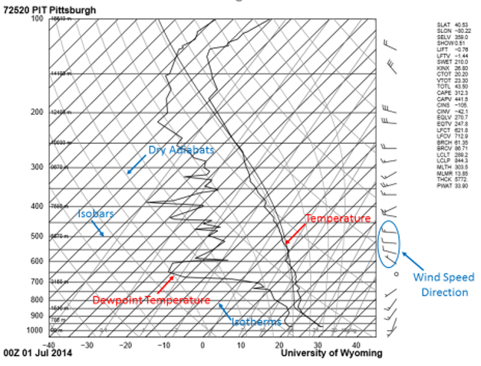
Figure 3: Sample Skew-T Plot for Non-inversion Day
Rightmost jagged curve is temperature profile, the leftmost jagged curve is the dewpoint temperature. Isotherms (solid diagonal lines) run from bottom left to top right; isobars (solid horizontal lines) run from left to right. Dry adiabats (light, solid curved lines) run from bottom right to top left. Wind barbs on right of diagram indicate wind speed and direction. Copyright by University of Wyoming, Department of Atmospheric Science (used with permission).

The rightmost jagged curve, the environmental sounding curve, shows the dry temperature profile of interest, as it is the actual measured temperature in the atmosphere, and is analogous to the temperature profile depicted in Figure 1. The leftmost plotted curve shows the dew-point temperature for each of the different heights; this curve is always at or to the left of the dry sounding curve, and points where they are superimposed can indicate the presence of precipitation (such as when the radiosonde passes through a cloud layer). The general temperature profile shown in Figure 3 shows that near the surface, the measured temperature decreases as the radiosonde ascends. By comparison, figure 4 shows a temperature profile for a day where a surface temperature inversion was present, where the temperature detected by the radiosonde increases as the weather balloon ascends (circled in red).
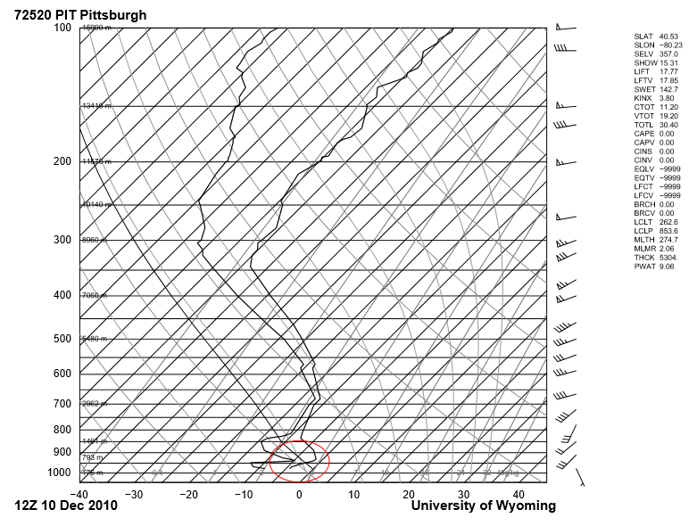
Figure 4: Sample Skew-T Plot for Inversion Day
Sample Skew-T plot for date surface temperature inversion was present (circled in red). Again, the rightmost curve represents the temperature profile of interest. Copyright by University of Wyoming, Department of Atmospheric Science (used with permission).

Though analysis of the data involved primarily tabulated raw data and was not obtained from the skew-T plots themselves, the plots offer valuable insight into that day’s weather conditions. At a glance, they provide information on the stability of the atmosphere and whether an inversion is present; situations when the dew-point and the temperature profile overlap significantly likely indicate the presence of rain, in which vertical air mixing between the different atmospheric layers is vigorous.
It should also be noted, however, that sounding data and skew-T plots offer only a snapshot of weather conditions at that time: weather patterns can change dramatically between the two daily soundings, and the data that is collected is not instantaneous, as it takes several minutes for the weather balloon to travel to the upper troposphere. Likewise, sounding data does not give a perfect vertical dimension of the weather conditions, as wind blows weather balloons downstream away from the launch site, and conditions can vary wildly depending on the topography of the terrain. Even so, radiosonde data remains a valuable, standardized source of weather information worldwide and can serve as an approximation for local weather conditions in the region.

Inversion Criteria and Characteristics
The strength of an inversion was defined as the difference in air temperature between the top of the inversion and the surface air temperature (ΔT = T_{top} – T_{surface}). The top of the inversion was defined as the height at which the temperature reached its maximum before beginning to decrease again with altitude. In deciding whether an inversion occurred on a particular day, only days that had an inversion strength of at least 0.4 °C were included. This is because any inversions that were weaker than this were judged to be less likely to have an impact on pollutant concentrations, or even represent a “true” inversion event. Figure 5 shows the characteristics of interest for a temperature inversion.
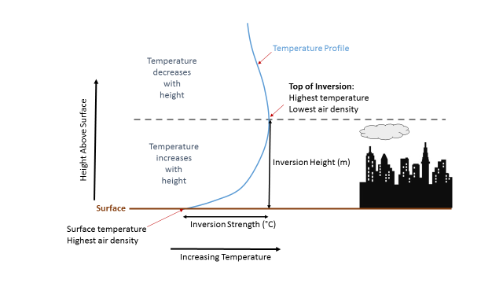
Figure 5: Diagram of Inversion Temperature Profile
Diagram showing an inversion's temperature profile (in blue), height, and strength. Because an inversion inhibits vertical mixing, pollution can be "capped" by the inversion layer and increase pollutant concentrations near populated areas.

Since pollution dispersion’s link to short-term health effects is primarily concerned with the mixing layer of the atmosphere (which is typically present below 1-2 km above ground level), analysis of radiosonde data focused on detecting and categorizing temperature inversions within this range; previous studies have similarly limited their analysis to this area when analyzing temperature inversions [15]. Temperature inversions certainly do occur in the upper atmosphere, but their effect on ground pollution is not as direct as inversions that occur in the planetary boundary layer and their effect on short-term dispersion dynamics is minimal. As such, an additional criteria was added that temperature increases had to occur within the first 135 m above the ground surface. Surface isothermal (ISO) layers and/or surface layers where temperatures decreased with height for no more than 0.9 ° C up to approximately 130 m were also included provided that the temperature inversion was of at least 0.4 ° C in strength (as measured from the surface temperature, not the minimum temperature). These were rarer cases where mixing dynamics are slightly different than the prototypical inversion where temperature rises gradually with no drops or isotherms, but the overall effect of creating stagnant air conditions is the same.
It should be noted that the meteorological literature, inversion depth is also occasionally calculated when characterizing inversions. It is generally defined as the difference between the top of an inversion and the base of the inversion (the altitude at which the temperature begins to rise). Because this study only looked at surface-based inversions, the base altitude was always defined as the National Weather Station elevation with respect to sea level (359 m); hence, the top of the inversion height was equivalent with the inversion depth.

Results
From January 1st, 2009 to December 31st, 2014, a total of 263 out of 2172 dates were identified where an inversion was present at the time of the evening sounding; summary statistics of the average strength, top, and count are listed in Table 1. The results of the frequency of inversions per month and per year is shown in Table 2. On average, approximately 12.11% of days in a year had evening inversions, with November being the month when evening inversions were most likely to occur (approximately a 33% chance); October and December were also notable for having high inversion likelihood probabilities. In contrast, spring and summer months were least likely to experience inversions (see Figure 6), with evening inversions being least frequent in August (2.69% chance of an evening inversion occurring), though the inversions that were present were more likely to be stronger (see Figure 7). The dates themselves where inversions were presented, along with their descriptive summary statistics, were submitted to the Allegheny County Health Department. They are also presented in the appendix.
The 5-year average evening inversion strength was approximately 1.10 °C. While evening inversions were much less likely to occur in the spring and summer than in the fall and winter, they were more likely to be stronger, with July having the strongest average inversion strength of 1.89 °C (compared to September’s lowest average strength at 0.78 °C). Similarly, stronger inversions were more likely to have a higher top height.

Table 1: Evening Inversion Statistics for 2009-2014
Year | Avg. Strength (°C) | Strength Std. Dev (°C) | Avg. Top (m) | Top Std. Dev (m) | Total Days of Inversion | Total % of Inversion
2009 | 1.10 | 1.18 | 106.90 | 96.06 | 49 | 13.92%
2010 | 1.20 | 1.15 | 140.26 | 157.43 | 50 | 13.74%
2011 | 0.96 | 0.61 | 118.25 | 76.83 | 43 | 11.78%
2012 | 0.90 | 0.62 | 93.40 | 78.76 | 41 | 11.29%
2013 | 1.16 | 1.02 | 126.69 | 120.23 | 39 | 10.71%
2014 | 1.27 | 1.06 | 121.60 | 95.92 | 40 | 10.99%
09-'14 Avg. | 1.10 | 0.99 | 118.21 | 109.08 | 43.67 | 12.06%

Evening Inversion Statistics for 2009-2014 derived from the Pittsburgh National Weather Service. Only evening (00Z) surface inversion measuring at least 0.4° C in strength were included.

Table 2: Total Days of Evening Inversions from 2009 to 2014
Total Days of Inversions: 2009-2014, DERIVED FROM PIT NWS SOUNDINGS
Month | 2009 | 2010 | 2011 | 2012 | 2013 | 2014 | 2009-2014
JAN | 3 (9.7%) | 3 (9.7%) | 3 (9.7%) | 4 (12.9%) | 6 (19.4%) | 6 (19.4%) | 25 (13.4%)
FEB | 8 (28.6%) | 5 (17.9%) | 4 (14.3%) | 2 (7.7%) | 1 (3.6%) | 3 (10.7%) | 23 (13.9%)
MAR | 2 (6.5%) | 1 (3.2%) | 1 (3.2%) | 3 (9.7%) | 0 (0%) | 1 (3.2%) | 8 (4.3%)
APR | 2 (6.7%) | 0 (0%) | 2 (6.7%) | 1 (3.3%) | 1 (3.3%) | 0 (0%) | 6 (3.4%)
MAY | 3 (10.7%) | 3 (9.7%) | 1 (3.2%) | 2 (6.5%) | 0 (0%) | 4 (12.9%) | 13 (7.1%)
JUN | 1 (4.8%) | 5 (16.7%) | 0 (0%) | 0 (0%) | 0 (0%) | 5 (16.7%) | 11 (6.4%)
JUL | 1 (3.2%) | 1 (3%) | 3 (9.7%) | 0 (0%) | 3 (9.7%) | 1 (3.3%) | 9 (4.9%)
AUG | 2 (6.5%) | 0 (0%) | 1 (3.2%) | 1 (3.2%) | 0 (0%) | 1 (3.2%) | 5 (2.7%)
SEP | 0 (0%) | 3 (10.0%) | 2 (6.7%) | 1 (3.3%) | 3 (10.0%) | 1 (3.3%) | 10 (5.6%)
OCT | 9 (30.0%) | 11 (35.5%) | 10 (32.3%) | 7 (22.6%) | 9 (29.0%) | 8 (25.8%) | 54 (29.2%)
NOV | 11 (36.7%) | 14 (46.7%) | 11 (36.7%) | 14 (46.7%) | 6 (20.0%) | 4 (13.3%) | 60 (33.3%)
DEC | 7 (22.6%) | 5 (16.1%) | 5 (16.1%) | 6 (19.4%) | 10 (33.3%) | 6 (19.4%) | 39 (21.1%)
Annual | 49 (13.9%) | 51 (14.%) | 43 (11.8%) | 41 (11.3%) | 39 (10.7%) | 40 (11.%) | 263 (12.1%)

Inversion events and frequency by month and by year. Rightmost column displays the total number of inversion recorded for each month; percentages in parentheses indicate frequency of inversions per month over the study period. Bottom row similarly shows number and frequency of inversions per year.
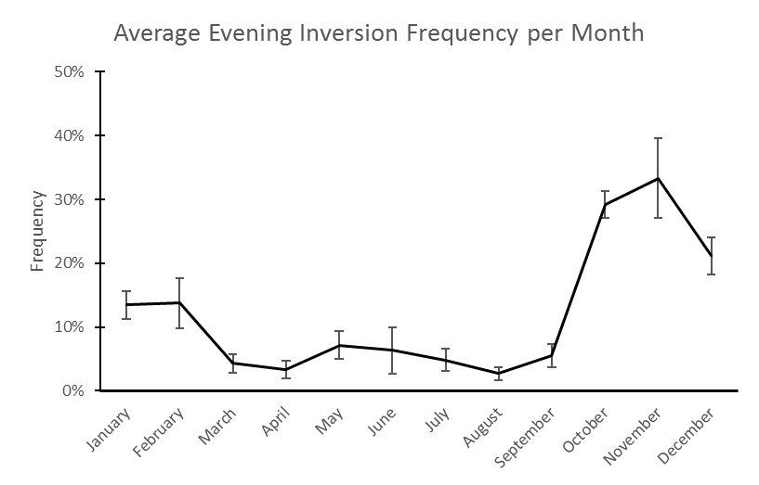
Figure 6: Average Evening Inversion Frequency
Average evening inversion frequency per month for the years 2009 through 2014. Error bars represent standard error of the monthly inversion frequency.
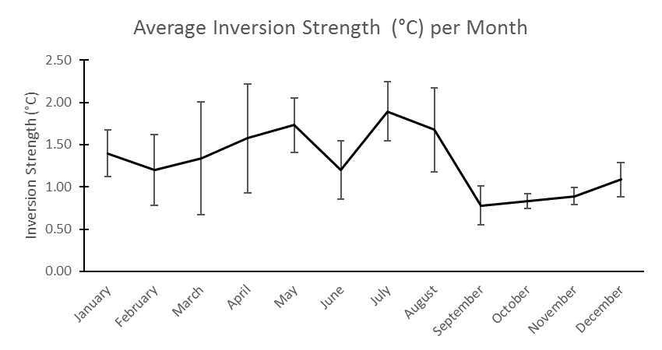
Figure 7: Average Inversion Strength
Average inversion strength per month for the years 2009 through 2014. Error bars for each month represent inversion strength standard error.

Discussion
In terms of frequency, evening inversion patterns in Allegheny County seem to be far more common in the winter months. The emergence, evolution, and eventual dissipation of an inversion depends on various thermodynamic and transport variables present in the environment, the most important of which is the transfer of heat energy in the form of electromagnetic radiation from the sun’s rays to the ground’s surface, which is diminished during winter. In a typical day, short-wave radiation from the sun gradually increases the temperature of the ground throughout the day, with rays that are more perpendicular to the ground being more easily absorbed and less likely to be reflected by the surface, resulting in more heat energy being transferred into the ground. At the same time, material properties of the surface can likewise affect this transfer of energy, as a layer of relatively more reflective snow can decrease the amount of solar energy absorbed by the ground as well as decrease the total amount of energy stored in the soil that is later released as long-wave radiation to heat up the air. Other meteorological effects that influence the presence and characteristics of inversions include the presence of cloud cover, water vapor in the atmosphere, wind speed, and precipitation; for a detailed discussion on their effects, please refer to Enz et al [16].
The ultimate public health aim of this study and an area of future research would be to determine whether or not a causative relationship exists between the presence of an inversion and adverse health effects. Though previous studies do seem to suggest that visits to emergency departments do increase on days when an inversion is present, the picture is confounded by the fact that inversions are more likely to occur during the winter months, when individuals are more likely to utilize emergency services for a variety of other reasons that may not be related to pollutants such as viral infections, which can similarly exacerbate existing respiratory conditions such as asthma and chronic obstructive pulmonary disease. Still, a promising body of data does exist to suggest that air quality as predicted by the presence of an inversion can have adverse short-term health effects and suggests that the inversion dates obtained in this study can be of great use for future epidemiological studies.
An ecological study in Oman in 2005 found that the monthly number of emergency room visits for respiratory diseases correlated with the number of inversion days in that month, as well as with the average increasing depth and strength of surface-based inversions [17]; while the mechanism proposed is promising, this and similar ecological studies are limited by the absence of direct measurement of pollutants or demonstration of this patient population having been exposed to higher concentrations of pollutants prior to going to the emergency room.
Previous studies have suggested a link between the concentration of pollutants and presence of temperature inversions. These studies have primarily focused on correlating the concentrations of NO₂, PM_{2.5}, and PM₁₀, since these are believed to be the most predictive of short-term adverse health effects such as exacerbations of existing respiratory conditions. Aiming to demonstrate a more direct physiological link between pollutant concentration and adverse health effects independent of weather conditions, a study by Wallace et al in 2010 demonstrated that patients in a respiratory health clinic in Ontario displayed significantly higher markers of airway inflammation (as demonstrated through increased sputum cell counts) on days in which there were inversions [18]. Interestingly, however, pollutant concentrations did not strongly correlate with either clinical or laboratory markers of worsening airway disease, potentially suggesting some other property of temperature inversions may also contribute to adverse health outcomes.
Recent research in the field has aimed to more clearly link the presence of temperature inversions to pollutant concentrations and adverse health events; a study in 2012 by Beard et al showed that in Salt Lake City during winter months, the odds of ratio for ED visits for asthma in association with inversions versus no inversions (and when adjusted for dew point and mean temperature) was approximately 1.14 (95% CI: 1.00, 1.30) [12]. The authors of the study note that epidemiological efforts to link a patient’s individual-level exposure to pollutants was also limited given that the average pollutant concentration across all available monitors in Salt Lake County was used instead of using concentrations from monitors closest to residents.

Conclusion:
Future work using the data collected for Allegheny County would focus not only in developing better models to predict the formation and duration of temperature inversions, but also look at the epidemiological link between the presence of inversions and adverse health effects. Epidemiological data for the area is available in the form of emergency room visits by diagnosis and by patient characteristics (e.g. age, gender, race, zip code, etc); with a case-cross over design, it would be feasible to estimate the odds of having to visit the emergency room for the exacerbation of a respiratory or a cardiovascular condition during an inversion event to the odds of visiting the emergency room on a similar day when no inversion event is present. In addition, daily pollutant concentration data is available from the U.S. EPA Airdata website as well as from the Allegheny County Health Department. Since zip code data is available for patients visiting the emergency room in Allegheny County, pollutant exposure data could be similarly analyzed to see whether it is an independent risk factor for emergency room visit or whether it is indeed directly influenced by the presence of an inversion. Furthermore, Allegheny County is distinct from other areas where inversion health effects have been studied, as previous studies have primarily focused on locations where the topography of the area favors the trapping of pollutants near the surface (e.g. regions surrounded by tall mountains such as or near coastal areas flanked by mountains). By comparison, Allegheny County is characterized by rolling hills and valleys, and though there are areas where pollutant concentrations are indeed higher, seeing whether previous studies’ conclusions on more homogeneous terrain holds in this type of geography would be of interest to public health officials in the region, as it might help future efforts to minimize pollutant exposure to vulnerable populations in the area.

APPENDIX: SUPPLEMENTAL TABLE

Table 3: Evening Temperature Inversions in Pittsburgh from 2009-2014
DATE (mm/dd/yyyy) | STRENGTH (°C) | TOP (m) | TEMP AT TOP (°C)
1/5/2009 | 6.2 | 215 | 9.2
1/23/2009 | 0.6 | 66 | 1.4
1/24/2009 | 0.4 | 66 | 7.4
2/7/2009 | 1.2 | 72 | 2.6
2/10/2009 | 0.8 | 57 | 7
2/12/2009 | 0.4 | 89 | 17.2
2/16/2009 | 0.6 | 64 | -3.1
2/19/2009 | 0.4 | 102 | 8.2
2/22/2009 | 0.6 | 48 | 5
2/25/2009 | 0.4 | 47 | -2.9
2/26/2009 | 0.4 | 92 | 9.4
3/9/2009 | 1.6 | 178 | 16.4
3/11/2009 | 6.2 | 402 | 17.2
4/21/2009 | 0.6 | 42 | 10.4
4/30/2009 | 0.4 | 50 | 14.2
5/25/2009 | 1.2 | 236 | 22.4
5/26/2009 | 0.4 | 61 | 25.2
5/28/2009 | 1 | 62 | 22.4
6/12/2009 | 0.4 | 25 | 20.2
7/21/2009 | 1.2 | 187 | 18.8
Table 3 Continued
8/11/2009 | 2.4 | 336 | 22.8
8/21/2009 | 1 | 146 | 25.4
10/6/2009 | 0.6 | 42 | 13.6
10/11/2009 | 1 | 50 | 11.8
10/21/2009 | 2.2 | 85 | 16.4
10/22/2009 | 1 | 51 | 18.4
10/23/2009 | 0.4 | 61 | 18.8
10/26/2009 | 1 | 33 | 13.8
10/27/2009 | 0.4 | 60 | 15.6
10/28/2009 | 0.4 | 122 | 13.8
10/30/2009 | 2.2 | 102 | 11.8
11/7/2009 | 0.8 | 65 | 7
11/8/2009 | 0.6 | 86 | 17.4
11/9/2009 | 1.4 | 113 | 19.6
11/10/2009 | 0.8 | 86 | 17.0
11/12/2009 | 0.6 | 49 | 9.8
11/13/2009 | 0.8 | 49 | 11
11/14/2009 | 1.2 | 112 | 16
11/15/2009 | 0.8 | 33 | 17.4
11/23/2009 | 0.8 | 84 | 10
11/26/2009 | 0.4 | 86 | 10.4
11/29/2009 | 0.4 | 126 | 5.6
12/3/2009 | 0.4 | 87 | 8.6
12/5/2009 | 0.8 | 65 | 1.2
12/6/2009 | 0.8 | 39 | -2.1
12/13/2009 | 1 | 72 | 1.8
12/15/2009 | 2.6 | 193 | 11
12/25/2009 | 0.4 | 65 | 2.2
12/27/2009 | 0.6 | 40 | 3.2
1/15/2010 | 1.2 | 141 | 3.6
1/17/2010 | 1 | 49 | 8
1/25/2010 | 1.2 | 388 | 9.8
2/1/2010 | 0.4 | 31 | -3.7
2/8/2010 | 0.8 | 30 | -6.1
2/10/2010 | 0.6 | 860 | -0.7
2/20/2010 | 0.4 | 65 | 1.2
2/23/2010 | 0.6 | 285 | 4.2
3/10/2010 | 0.4 | 77 | 11.6
5/12/2010 | 4.6 | 506 | 13.6
5/14/2010 | 0.6 | 251 | 23.2
Table 3 Continued
5/29/2010 | 2.4 | 370 | 21.8
6/3/2010 | 4.4 | 182 | 23.8
6/5/2010 | 1.4 | 81 | 22.8
6/6/2010 | 0.4 | 155 | 21
6/20/2010 | 0.6 | 441 | 22.6
6/24/2010 | 2.8 | 253 | 24.4
7/20/2010  8/22/2010 | 2  0.4 | 98  222 | 24  24.2
9/19/2010 | 1 | 43 | 22.8
9/23/2010 | 3.4 | 143 | 24
9/24/2010 | 0.4 | 80 | 28.6
10/3/2010 | 0.8 | 68 | 16.2
10/9/2010 | 0.4 | 132 | 20
10/11/2010 | 1 | 72 | 25.6
10/12/2010 | 0.6 | 136 | 23.4
10/14/2010 | 1.2 | 51 | 18.2
10/17/2010 | 1.2 | 59 | 14.2
10/18/2010 | 0.6 | 42 | 16
10/20/2010 | 1.4 | 50 | 11.2
10/24/2010 | 0.8 | 60 | 18.6
10/25/2010 | 1 | 88 | 21.8
10/28/2010  10/30/2010 | 0.4  0.4 | 43  65 | 17.8  5.4
11/8/2010 | 1 | 74 | 5.6
11/9/2010 | 0.8 | 41 | 11.4
11/10/2010 | 0.6 | 58 | 11.8
11/11/2010 | 0.8 | 32 | 13.4
11/12/2010 | 1.4 | 59 | 15.8
11/13/2010 | 1.4 | 59 | 17.8
11/14/2010 | 1.2 | 60 | 17.4
11/16/2010 | 0.4 | 91 | 7.2
11/18/2010 | 0.6 | 67 | 8.4
11/20/2010 | 0.8 | 40 | 5.4
11/23/2010 | 0.6 | 169 | 18.4
11/26/2010 | 4.4 | 167 | 13.2
11/29/2010 | 0.4 | 130 | 3
11/30/2010 | 0.8 | 32 | 8.4
12/10/2010 | 0.4 | 71 | -4.7
12/12/2010 | 0.4 | 24 | 5.8
12/19/2010 | 0.4 | 88 | -4.7
12/30/2010 | 1 | 90 | 1.2
Table 3 Continued
12/31/2010 | 4.8 | 429 | 8.4
1/1/2011 | 1.6 | 120 | 13.6
1/11/2011 | 1 | 38 | -5.1
1/25/2011 | 2.4 | 273 | -1.1
2/5/2011 | 0.4 | 88 | -0.5
2/14/2011 | 0.8 | 137 | 9
2/16/2011 | 0.4 | 47 | 1.8
2/28/2011 | 1.2 | 60 | 12.6
3/5/2011 | 1.4 | 203 | 7.4
4/26/2011 | 2.6 | 153 | 20.6
5/13/2011 | 2.4 | 154 | 23.8
7/19/2011 | 2.4 | 300 | 25.2
7/23/2011 | 0.6 | 81 | 25.4
7/29/2011 | 1.4 | 251 | 27.6
8/16/2011  8/20/2011 | 1.2  3.8 | 170  150 | 20.4  23.4
9/4/2011  9/5/2011 | 0.6  1.4 | 149  163 | 30.8  21.0
9/28/2011 | 0.4 | 70 | 19.2
10/5/2011 | 1.4 | 59 | 16.2
10/6/2011 | 1 | 77 | 19.4
10/7/2011 | 0.8 | 33 | 20
10/8/2011 | 0.4 | 105 | 21.2
10/9/2011 | 1.2 | 42 | 23.4
10/10/2011 | 2 | 60 | 23.8
10/11/2011 | 1.8 | 233 | 22
10/12/2011 | 0.4 | 79 | 20.6
10/17/2011 | 0.6 | 62 | 18.2
10/26/2011 | 0.6 | 158 | 14.6
11/3/2011 | 0.8 | 148 | 15
11/4/2011 | 0.4 | 157 | 14
11/6/2011 | 0.6 | 58 | 10.2
11/8/2011 | 0.8 | 77 | 16.4
11/9/2011 | 1.2 | 51 | 18.4
11/10/2011 | 0.6 | 61 | 16.8
11/13/2011 | 0.6 | 50 | 13.2
11/20/2011 | 0.4 | 111 | 11.6
11/26/2011 | 0.6 | 84 | 11.8
11/27/2011 | 0.4 | 189 | 13.6
11/29/2011  12/2/2011 | 0.8  0.4 | 105  251 | 15.8  1.6
Table 3 Continued
12/4/2011 | 0.8 | 192 | 8.2
12/5/2011 | 0.6 | 94 | 14.8
12/6/2011 | 0.6 | 50 | 13
12/12/2011 | 0.4 | 72 | 1.4
12/13/2011  12/15/2011 | 0.6  3.4 | 64  418 | 4.2  10.8
12/27/2011 | 0.6 | 74 | 3.8
1/7/2012 | 0.6 | 67 | 11.4
1/8/2012 | 0.4 | 100 | 5.2
1/11/2012 | 1.2 | 40 | 6.2
1/24/2012  1/27/2012 | 0.6  1.4 | 43  203 | 14.2  10.8
2/6/2012 | 0.8 | 56 | 3.8
2/7/2012 | 0.4 | 66 | 6
3/7/2012 | 0.4 | 134 | 8.4
3/8/2012 | 0.6 | 51 | 17.2
3/15/2012 | 0.8 | 43 | 22.2
4/10/2012 | 0.6 | 75 | 7.2
5/8/2012 | 0.6 | 272 | 22
5/30/2012 | 2.4 | 485 | 22
8/22/2012  9/2/2012 | 3.2  0.4 | 78  80 | 19.4  22.4
9/25/2012 | 0.4 | 60 | 13.6
10/14/2012 | 0.4 | 230 | 16.8
10/18/2012  10/19/2012 | 1  0.4 | 115  269 | 19.2  10.0
10/22/2012 | 0.4 | 111 | 12.6
10/23/2012 | 0.4 | 52 | 20.8
10/24/2012 | 0.8 | 43 | 21
10/25/2012 | 0.6 | 52 | 22.8
10/26/2012 | 1 | 53 | 25.4
11/7/2012 | 0.8 | 26 | 7.2
11/9/2012 | 1.4 | 33 | 5.4
11/10/2012 | 1 | 94 | 10.2
11/11/2012 | 1.4 | 87 | 18
11/12/2012 | 2.6 | 133 | 20.6
11/16/2012 | 0.6 | 100 | 6.4
11/18/2012 | 0.4 | 127 | 9.8
11/19/2012 | 1.2 | 34 | 11.2
11/20/2012 | 1.2 | 68 | 9.2
11/21/2012 | 0.4 | 60 | 10.2
Table 3 Continued
11/22/2012 | 1.2 | 43 | 12.6
11/23/2012 | 1 | 69 | 13.8
11/26/2012 | 0.6 | 76 | 2.2
11/29/2012 | 0.4 | 75 | 1.6
12/1/2012 | 0.4 | 161 | 10.2
12/2/2012 | 0.8 | 75 | 12.6
12/7/2012 | 1.2 | 108 | 7
12/14/2012 | 0.6 | 73 | 4.8
12/15/2012 | 1.8 | 82 | 7.4
12/20/2012 | 0.6 | 74 | 4.6
12/24/2012 | 0.4 | 99 | 1.6
1/9/2013 | 1.6 | 81 | 5.4
1/10/2013 | 0.4 | 40 | 6
1/12/2013 | 1.4 | 102 | 12.4
1/14/2013 | 0.4 | 52 | 17
1/20/2013 | 0.4 | 41 | 9
1/30/2013 | 1.2 | 88 | 17.4
2/13/2013 | 0.8 | 65 | 3.6
4/11/2013  6/26/2013 | 3.6  3.0 | 396  98 | 19.8  22.6
7/17/2013 | 1.8 | 127 | 25.6
7/20/2013 | 4.6 | 276 | 27
7/24/2013  9/10/2013 | 3.2  3.2 | 201  322 | 22  24.0
9/18/2013 | 0.4 | 53 | 17
9/25/2013 | 1 | 62 | 17.4
9/26/2013 | 1.6 | 107 | 20
10/4/2013  10/6/2013 | 0.8  1.8 | 142  226 | 20.2  21.4
10/9/2013 | 0.6 | 35 | 15.8
10/16/2013 | 0.4 | 45 | 19.4
10/19/2013 | 1 | 114 | 13.6
10/23/2013 | 0.6 | 94 | 7.8
10/28/2013 | 1.2 | 59 | 9.2
10/29/2013 | 1.2 | 35 | 12.6
10/30/2013 | 1.4 | 51 | 12.8
10/31/2013 | 0.8 | 53 | 15
11/9/2013 | 0.8 | 50 | 3.8
11/15/2013 | 0.8 | 197 | 6.8
11/17/2013 | 0.4 | 175 | 14.2
11/20/2013 | 0.6 | 25 | 1.2
Table 3 Continued
11/21/2013 | 0.4 | 83 | 6
11/22/2013 | 0.6 | 128 | 11.4
12/1/2013 | 1.4 | 158 | 3.2
12/2/2013 | 0.4 | 34 | 4.8
12/4/2013 | 1 | 78 | 10
12/5/2013 | 1.4 | 122 | 14.2
12/14/2013 | 0.6 | 65 | -0.1
12/19/2013 | 0.6 | 64 | -3.9
12/20/2013 | 1.2 | 311 | 9
12/22/2013 | 0.8 | 633 | 14.6
12/28/2013 | 1.2 | 91 | 4.2
12/29/2013 | 0.4 | 42 | 7.6
2/23/2013 | 4.6 | 295 | 5.8
10/5/2013 | 0.6 | 329 | 21.6
10/21/2013 | 0.4 | 122 | 11.8
1/5/2014 | 1.4 | 74 | 1.6
1/6/2014 | 4.8 | 294 | 11
1/13/2014 | 0.4 | 42 | 0.6
1/14/2014 | 0.4 | 34 | 7.6
1/15/2014 | 1.4 | 42 | 4.2
1/27/2014 | 1 | 66 | -2.9
2/2/2014 | 1.2 | 122 | 11.2
2/19/2014 | 1 | 85 | 5.8
2/21/2014 | 4 | 301 | 13.6
3/8/2014 | 0.4 | 43 | 10
5/1/2014 | 1.8 | 150 | 14.8
5/13/2014 | 0.6 | 181 | 21.8
5/28/2014 | 2.2 | 108 | 22.8
5/29/2014 | 0.8 | 118 | 20.4
6/4/2014 | 0.4 | 73 | 25.4
6/10/2014 | 0.4 | 45 | 19
6/12/2014 | 1 | 300 | 20.6
6/13/2014  6/25/2014 | 2  3.0 | 127  73 | 22.6  26.6
6/30/2014 | 2.6 | 83 | 26
7/15/2014 | 1.6 | 311 | 22.2
8/21/2014 | 0.6 | 246 | 22.8
9/29/2014 | 0.4 | 53 | 21.4
10/1/2014 | 0.8 | 45 | 18
10/2/2014 | 0.4 | 62 | 16.4
10/16/2014 | 0.4 | 44 | 15.2
Table 3 Continued
10/19/2014 | 0.4 | 17 | 7.8
10/20/2014 | 0.6 | 34 | 9.8
10/22/2014 | 0.4 | 34 | 8
10/25/2014 | 0.8 | 52 | 13.8
10/28/2014 | 0.8 | 117 | 21
11/4/2014 | 0.6 | 60 | 11.2
11/11/2014 | 1.6 | 98 | 17
11/12/2014 | 0.4 | 62 | 18
11/23/2014 | 2 | 310 | 9.2
12/5/2014 | 1.3 | 41 | 0.8
12/6/2014 | 3.6 | 299 | 9
12/8/2014 | 0.4 | 66 | 2.8
12/24/2014 | 3 | 238 | 14
12/25/2014 | 2 | 251 | 16.2
12/27/2014 | 0.8 | 136 | 6.8

bibliography
1. Glickman, T.S. and American Meteorological Society., Glossary of meteorology. 2nd ed. 2000, Boston, Mass.: American Meteorological Society. xii, 855 p.
2. Environmental Protection Agency. Integrated science assessment for particulate matter. US Environmental Protection Agency Washington, DC, 2009.
3. Devlin, R.B., et al., Controlled Exposure of Healthy Young Volunteers to Ozone Causes Cardiovascular Effects. Circulation, 2012.
4. Carder, M., et al., Interacting effects of particulate pollution and cold temperature on cardiorespiratory mortality in Scotland. Occup Environ Med, 2008. 65(3): p. 197-204.
5. Chen, T.M., et al., Outdoor air pollution: nitrogen dioxide, sulfur dioxide, and carbon monoxide health effects. Am J Med Sci, 2007. 333(4): p. 249-56.
6. Toxicological Profile for Benzene. 2007, Agency for Toxic Substances and Disease Registry (ATSDR): Atlanta, GA.
7. United States of America Environmental Protection Agency, Office of Air and Radiation (OAR). Risk Assessment for Toxic Air Pollutants: A Citizen's Guide. Retrieved January 25, 2017, from https://www3.epa.gov/airtoxics/3_90_024.html
8. National Ambient Air Quality Standards (NAAQS) | Air and Radiation | US EPA. Retrieved January 25, 2017, from https://www.epa.gov/criteria-air-pollutants/naaqs-table.
9. Helfand, W.H., J. Lazarus, and P. Theerman, Donora, Pennsylvania: an environmental disaster of the 20th century. Am J Public Health, 2001. 91(4): p. 553.
10. Fritz, B., et al., Low-level atmospheric temperature inversions and atmospheric stability: characteristics and impacts on agricultural applications. Agricultural Engineering International: CIGR Journal, 2008.
11. Turner, D.B., Workbook of atmospheric dispersion estimates: an introduction to dispersion modeling. 1994: CRC press.
12. Beard, J.D., et al., Winter temperature inversions and emergency department visits for asthma in Salt Lake County, Utah, 2003-2008. Environ Health Perspect, 2012. 120(10): p. 1385-90.
13. Abdul-Wahab, S.A., et al., Determination of the features of the low-level temperature inversions above a suburban site in Oman using radiosonde temperature measurements: Long-term analysis. Journal of Geophysical Research-Atmospheres, 2004. 109(D20): p. 9.
14. Oolman, L., University of Wyoming College of Engineering Department of Atmospheric Science Upper Air Sounding Database. Retrieved May 2015 from http://weather.uwyo.edu/upperair/sounding.html.
15. Abdul-Wahab, S.A., Analysis of thermal inversions in the Khareef Salalah region in the Sultanate of Oman. Journal of Geophysical Research-Atmospheres, 2003. 109(D9): p. 8.
16. Enz, J.W., V. Hofman, and A. Thostenson, Air Temperature Inversions Causes, Characteristics and Potential Effects on Pesticide Spray Drift. NDSU 2014.
17. Abdul-Wahab, S.A., C.S. Bakheit, and R.A. Siddiqui, Study the relationship between the health effects and characterization of thermal inversions in the Sultanate of Oman. Atmospheric Environment, 2005. 39(30): p. 5466-5471.
18. Wallace, J., P. Nair, and P. Kanaroglou, Atmospheric remote sensing to detect effects of temperature inversions on sputum cell counts in airway diseases. Environ Res, 2010. 110(6): p. 624-32.

Definitions adapted from the Glossary of the American Meteorological Society.
Table 3 lists all the evening temperature inversions in the Pittsburgh area identified from radiosonde data from the years 2009 to 2014. The inversion strength, height above the surface (top), and the temperature at the top calculated for each inversion date are listed.

