Mapping Pittsburgh’s Lead Problem
Using Geographic Information Systems in Community-Based Research to Evaluate the Local Response to a Complex Public Health Crisis

Raanan Gurewitsch
Dr. Hassan Karimi; Professor, School of Computing and Information, University of Pittsburgh
Michelle Naccarati-Chapkis; Executive Director, Women for a Healthy Environment - Pittsburgh
______________________________________________________________________________

Table of Contents:
- Introduction: A National Lead Crisis
- Background: Mapping Pittsburgh’s Lead Problem
- Methods
- Results and Discussion
  - Identifying High-Risk Housing
  - Assessing Public Engagement
  - Evaluating Environmental Justice
- Conclusions and Recommendations
- Acknowledgements
- Reflections
- References
- Tables and Figures

Abstract
After a shortage of clean drinking water spurred an environmental justice crisis in Flint, MI began in 2014, lead water contamination gained significant public attention in cities throughout the United States. In Pittsburgh, PA, elevated lead levels were found during regulatory compliance testing in 2016, spawning a multi-faceted response from the Pittsburgh Water and Sewer Authority (PWSA), the City government and local communities. The aims of this community-based, geospatial information system (GIS)-assisted cross-sectional study are threefold: 1) to identify high-risk housing areas, 2) to evaluate whether the distribution of information and resources is equitable and 3) to assess public engagement and education in response to public health concerns regarding lead-contaminated tap water in Pittsburgh. Through geostatistical analyses of housing age and the consideration of a range of stakeholder experiences, this mixed methods public health research study points to specific changes to public policy, pipe inspection protocols and engagement strategies that could improve efforts to prevent lead exposure through tap water.
- Introduction: A National Lead Crisis
Lead contaminated drinking water, is a widespread problem that has only recently gained significant public attention since a recent crisis in Flint, Michigan. The unprecedented contamination of Flint’s tap water began in 2014 when a state-appointed official switched the city’s water source from the Detroit River to the highly polluted and corrosive Flint River. Without appropriate corrosion control measures, the drinking water in a public water system will leach lead from lead pipes, fixtures and solder, endangering those who consume it. Lead, which is both invisible and tasteless, is a harmful heavy metal known to affect nearly every system in the body by mimicking other vital metals like calcium and iron. Blood lead levels (BLLs) under 10 µg/dL, which were previously considered safe, are now known to cause behavioral issues, poor academic performance and learning disabilities in children. The Centers for Disease Control and Prevention (CDC) justifies these links “based on the weight of evidence that includes studies with a large number and diverse group of children with low BLLs and associated IQ deficits.”²
After the Flint crisis, the problem of lead-contaminated water supply was determined to be far more widespread than was previously appreciated. The Natural Resources Defense Council (NRDC) determined in a 2016 report that 5,363 water systems in the United States, serving over 18 million people, were in violation of the U.S. Environmental Protection Agency’s Lead and Copper Rule (LCR)¹. The LCR, a federal regulation promulgated in 1991, mandates tap sampling for lead and copper by public water systems every three years to determine actions, if any, needed to reduce exposure to the two toxins. The prescribed responses for public water systems include corrosion control measures, lead service line replacements, public education efforts. Once notified, consumers must take certain steps as well to remediate their individual exposure to lead.³
However, as Olson and Fedinick (2016) indicate, LCR compliance among public utilities has been tragically lackluster and insufficient, potentially exposing over 18 million Americans to lead without their knowledge. Despite over 8,000 LCR violations were reported in 2015, only 11.2 percent of those water systems faced federal enforcement from the EPA¹. Furthermore, actual lead poisoning from tap water has been widely documented within water systems in and out of compliance with the LCR, suggesting that the law itself falls short of its intent.⁴
Del Toral et al. (2013), noted patterns in sampling practices for compliance that systematically underestimate high lead levels and potential human exposure. Additionally, the practice of partial service line replacements and poor public engagement exacerbate the problem and represent a much larger environmental and social injustice. Several studies have demonstrated that socioeconomically deprived communities are disproportionately affected by noncompliance, sampling bias and insufficient public education efforts. To wit, residents of Flint, Michigan are majority African American living in a city with a poverty rate of 40 percent.¹ The need for more effective responses to this widespread environmental health and justice crisis is obvious.^{5,3,4}
- Background: Mapping Pittsburgh’s Lead Problem
In the summer of 2016, as part of regulatory compliance testing, the Pittsburgh Water and Sewer Authority (PWSA) found water lead levels (WLLs) above the LCR action level of 15 parts per billion in over 10 percent of the homes sampled. These elevated WLLs are likely attributed to a 2014 changeover from soda ash, the Pennsylvania Department of Environmental Protection’s required anti-corrosion substance, to caustic soda, a cheaper, less effective corrosion control method.⁶ In an initial effort to notify the public, the authority published a brochure titled “Important Info About Lead in Your Drinking Water” on their website and sent the first of two similarly named public notices to their customers on July 25, 2016. However, local officials and the media have widely criticized the authority for their response to what has been deemed a public health and safety crisis on par with Flint.⁸
The aims of this are threefold: 1) to identify housing areas in Pittsburgh at high risk for lead contaminated water supply; 2) to assess whether distribution of information and resources by PWSA to the local population is equitable; and 3) to assess public engagement and education in response to the public health concern of lead-contaminated tap water. We use an epidemiological approach to community-based research to evaluate the relationship between the broader perception of power distribution and privilege in the City of Pittsburgh and potential human exposure to lead in water.⁹ Quantitative and qualitative data pertaining to lead corrosion and exposure are analyzed; and, potential improvements to public policy and community involvement are suggested for Pittsburgh and other cities similarly struggling to provide residents with safe water.
- Methods
To perform an unbiased examination of Pittsburgh’s lead problem, we chose a cross-sectional prevalence study design, using a geospatial information system and community-based research principles. A literature review provided a broader context within which the use of lead in plumbing systems could be understood and evaluated. Use of correlations between housing and plumbing materials to determine high-risk areas where local government and non-government organizations should prioritize their limited resources is supported by several studies.^{5, 10} We then performed a geospatial analysis leveraging publically available data from the City of Pittsburgh, the PWSA and Allegheny County property assessments to determine the age of each property in Pittsburgh.²⁶ Housing age was then mapped in multiple contexts and compared with existing inspection data using geospatial, ordinary least squares regression and frequency distribution analyses with ArcGIS™ (Redlands, CA), STATA™ (College Station, TX), and Microsoft Excel™ software.
Qualitatively, this study employed community-based research principles to better understand the impact on and involvement of Pittsburgh residents in the city’s ongoing lead problem and to explore existing and potential strategies for its solution. Israel et al. (1998) emphasizes the potential of community-based research to create and disseminate knowledge of health disparities and inequities that result from conditions of poverty such as inadequate housing.¹³ These principles were integrated into this study in an effort to analyze the social, economic and political dimensions of the ongoing lead problem and its solutions. This relied upon a community partnership with Michelle Naccarati-Chapkis, Executive Director of Women for a Healthy Environment, who facilitated focus groups with mothers and pregnant residents throughout the City of Pittsburgh, as well as interviews with local officials and utility representatives. Dominant themes from the focus groups and interviews were considered in the assessment of public engagement and identification of high risk housing.
- Results and Discussion
Identifying High-Risk Housing
Property boundary (parcel) data from the City of Pittsburgh was spatially joined to publically property assessment data, enabling a demographic and infrastructural analysis of the city. The primary risk factor mapped was the age of housing because the PWSA stated in its lead brochure that homes built prior to 1986 are more likely to have lead pipes, solder and flux. After 1986, an amendment to the Safe Drinking Water Act was passed that officially banned these plumbing materials.^{13,19} Figure 1 depicts all residential units with confirmed housing age that were built before 1986 in the City of Pittsburgh. Over 144,000 pre-1986 housing parcels are likely to have interior lead plumbing, as well as a lead service line. The abundance of pre-1986 housing in Pittsburgh has forced the PWSA to take on more targeted efforts to locate lead hazards.
Since December 2016, the PWSA has conducted almost two thousand curb box inspections, which are physical tests that allow them to identify the material of water lines within their service area (Figure 2). Figure 3 shows the map of all known service lines found in the PWSA service area, which the authority published in June 2017. ²⁷ Inspections performed through May 2017 were intended to determine whether the material of the public and or private side of the water line was lead. However, as illustrated in Figure 3 with transparent circles, half of these tests were inconclusive.
In Table 1, the frequency distribution of public and private side service line material is organized in five classes by age. Ninety percent of curb box inspections were performed at units built before 1930. Of these tests, approximately 21 percent were positive for lead on the public side and 18 percent were positive on the private side. An ordinary least squares regression model was used to analyze the relationship between age of housing in Pittsburgh and the prevalence of lead service lines in 499 conclusive private side inspection results. Table 2 indicates that houses built between 1860 and 1930 are twice as likely to have a private side lead service line than a house built in the past 30 years (p < 0.01). Additionally, houses built between 1930 and 1960, the period with the highest rate of urbanization, are nearly 62 percent more likely to have a private side lead line (p < 0.01).
We used this statistical model in a simulation of curb-box inspections at the remaining 143,000 households in Pittsburgh. Figure 5 displays in red over 4,300 houses where a private-side lead service line may exist. Although our simulation was intended to demonstrate the probability of lead contamination in a completely random selection of housing units, we recognized that the disproportionate number of curb box inspections performed at units built before 1930 likely skews the sample, and thus our simulation may not represent adequately the total population of parcels. Therefore, a more precise historical context was sought to evaluate the relationship between housing age and lead plumbing.
After 1930, the installation of lead service lines in public water systems declined significantly across the United States. However, the practice continued in several major US cities including Philadelphia, PA; Milwaukee, WI; Boston, MA; and Chicago, IL.¹⁴ The distribution of curb-box inspection results in Table 1 seem to indicates that Pittsburgh gradually began to gradually phase out the use of lead by the 1920’s. However, these inspections provide little evidence exists to refute a claim that the installation of lead service lines continued its legacy in Pittsburgh into the 1930’s and subsequent decades. In fact, the Lead Industries Association sought to reverse the downward trend of lead use through a series of publications and apprenticeship programs throughout the country, including in Pittsburgh.¹⁴
Such efforts to promote the lead industry, which spanned the years leading up to WWII until the late 1940s, were largely effective despite mounting public health concerns over lead poisoning in children at that time.²⁰ Lead plumbing manufacturers garnered much success from this campaign as the American Water Works Association, New York City and many other cities—including Pittsburgh—adopted the new industry standards for lead plumbing.^{14, 21} According to a 1938 secretary’s report for the Lead Industries Association, “all cities and towns [in the State of Pennsylvania] except Philadelphia” had implemented plumbing code amendments or regulations that required lead for plumbing and water distribution systems.²¹ The vocational training organized in Pittsburgh and other cities in the 1930s raised a generation of plumbers to install and repair lead piping during the period 1931 - 1960 when 153,000 housing units were built in the city of Pittsburgh (Figure 6).
Assessing Public Engagement
Logistical difficulty in locating lead service lines for replacement has forced the PWSA and the City to use alternative channels to address the concerns of a growing number of Pittsburgh residents. The LCR requires community water systems to take a number of public education measures to inform residents about lead’s health effects, its sources and the means by which to mitigate exposure.¹⁵ Public awareness and educational campaigns about lead exposure from tap water has taken many forms.
Every focus group participant in this study considered their own understanding of these topics to be “sufficient,” but emphasized that general awareness and education throughout their communities was not. Of note, one subject who was nursing her four-week-old son described a lack of information immediately available to her network of mothers and childcare professionals. Most frustrations primarily concerned what focus group subjects perceived as a lack of transparency from the PWSA, the City and the Allegheny County Health Department.
Our interview of PWSA officials noted that in response to exceeding the LCR action level last summer, the utility company made an effort not simply to comply with LCR requirements for public education but to exceed them. The authority’s community engagement efforts have included distribution of informational brochures and fliers, public service announcements on television and radio and in-person community meetings. At these meetings, which took place in all eight city districts within the PWSA service area, water quality experts, health professionals explained to community members the origins of lead contamination and the joint responsibility of the authority and homeowners to replace lead service lines, according to one official who attended the community meetings.
Nevertheless, the PWSA’s engagement efforts have thus far failed to reach particularly vulnerable populations. “The neighborhoods that have been historically been left behind by the local government tend not to have many people coming to these meetings,” the official noted, adding that the City’s voluntary testing program did not reach the “people who are most at risk.” The Safe Water Program, to which the official was referring, is a $1 million commitment from the Mayor of Pittsburgh to offer free tap tests and water filters to Pittsburgh residents. Table 3 shows a breakdown by neighborhood of Safe Water Program respondents. This analysis, along with the graph in Figure 7, assess the effectiveness of the PWSA and the City’s public engagement and education efforts by the number of participants in each neighborhood.
Of the 92 neighborhoods in the City of Pittsburgh, 19 have median income levels below $24,300, the federal poverty line for a family of four. These 19 neighborhoods represent 15 percent of the city’s population but only 10 percent of the respondents to the City’s Safe Water Program and nine are in the lower quartile for filter and test kit requests. In total, the Safe Water Program has received 10,591 requests since its May 2017 launch, far more than the program could feasibly fulfill in such a short period of time. Furthermore, the Safe Water Program has failed to reach a majority of residents in some of the poorest neighborhoods where these government-sponsored resources are needed the most.²⁸
Evaluating Environmental Justice
The process of removing lead hazards from consumers’ homes is vital for prevention of lead poisoning in children. As Pittsburgh’s curb box inspections and service line replacement program move forward, authorities must ensure that low-income and disadvantaged communities are neither neglected nor faced with prohibitive expenses when action is needed to address defects in public utilities that jeopardize health and safety. Despite a large number of inconclusive results, the curb box inspection program is a sign of progress in identifying high risk areas. However, the use of lead in public water systems is difficult to evaluate historically, complicating the process of discovering helpful correlations between characteristics of housing (e.g., year built) and the probable existence of lead service lines.
While many major cities discontinued the installation of lead pipes, the practice remained common in several municipalities until the passage of the Safe Drinking Water Act of 1986.^{14,12} In 1984, the EPA surveyed public water systems to examine the extent of lead usage throughout the United States, asking respondents to estimate the number or percentage of lead service lines remaining in their system. Pittsburgh was among the 70 percent of respondents able to offer an estimate (30 percent) of their remaining lead service lines in 1984.¹⁵ The challenge for Pittsburgh now, is locating and eventually replacing those remaining lead lines to effectively remove lead hazards.
In Figure 8, demonstrates the variability in curb box inspection results on single streets or neighborhoods. As a lead engineer and project manager at the PWSA noted in an interview, “on one street, you can have lead, lead, non-lead, lead, non-lead, and so on... ruling out any assumptions that an entire street or neighborhood will be entirely lead or not,” she explained. This presents a major challenge to the PWSA, who in light of their action level exceedance, are required by the LCR to replace 7 percent of lead service lines per year until the hazards are completely removed.¹⁵ The locations of lead service lines are difficult to determine because existing records of water lines are old and difficult to convert to discrete data. According to the engineer, the PWSA “have around 10,000 folders of pipe material records being scanned and filed” by employees and contractors of the authority to assist this effort.
The federal requirement to replace 7 percent of lead service lines annually has constrained the PWSA financially and practically. The PWSA faces intense public pressure to meet the 7 percent annual requirement; however, under current state law the authority is unable to replace the private side of lead service lines. The PWSA engineer confirms that the inability to replace private lines puts the City “between a rock and a hard place, where [the authority] have to meet the 7 percent requirement by doing partial line replacements.” Partial replacement of lead service lines does not effectively remove lead hazards from homes, and may increase the hazard owing to the disturbances of the lines created during replacement. In a study conducted in 2016, Trueman et al. analyzed tap water samples from several homes where lead service line replacements on the public side had taken place. The results showed that full lead service line replacements reduced WLLs by 50 percent within three days and significantly more within one month. Conversely, partial replacements failed to reduce lead release in the long term and more than doubled WLLs in the short term.¹⁶ Foreshadowing these striking results, Del Toral et al. determined that the highest lead results among sampling in Raleigh, NC occurred at sites with documented disturbances to lead service lines.⁵
The scientific evidence of the counter-productiveness of partial line replacements¹⁹ informed a public statement from Allegheny County Controller Chelsa Wagner in May 2016 that condemned the practice in Pittsburgh. Wagner demanded that Pittsburgh Mayor Bill Peduto stop the practice immediately and referred to ordinances enacted in cities throughout the country where full line replacement programs had been implemented.¹⁷ With the current jurisdictional restrictions hindering the replacement of private lead lines, the PWSA cannot comply with the LCR’s 7 percent requirement without engendering environmental injustice.
Since partial line replacement increases WLLs in most cases, the remaining financial burden is shifted onto the private resident, who may or may not be able to afford it. Replacing the private side of the line can cost thousands of dollars to homeowners and may not even be an option for renters. Therefore, without the ability to conduct full line replacements, the LCR requirement drives and perpetuates health disparities based on socioeconomic status.⁴ On June 2, 2017, the PWSA announced in a press release that it had officially suspended the practice and will continue replacing lead pipes only where the entire service line on both the public and privately owned sides can be replaced. Until the state regulation that prevents the authority from replacing the private side of lead service lines, the PWSA will not be able to remove these hazards from the houses of its customers. While laudable in ending a harmful practice, this does not address the need for full line replacement in socioeconomically depressed housing areas.
Environmental and social injustice are the reality of Pittsburgh’s lead problem and similar environmental health crises around the country. In 2016, Troesken et al. investigated the possibility that diminished cognitive ability resulting from environmental exposures could perpetuate low socioeconomic status. The study noted that childhood lead exposure via tap water “undermines the long term economic performance of poor socioeconomic groups more so than advantaged groups.”¹⁸ Troesken et al. explain that this is partially attributed to the cognitive deficits that result from lead poisoning. Such disparities, perpetuated by shortsighted, unscientific health standards, consign the poorest, most vulnerable people to continued poverty and hinders their economic mobility and advancement in education.¹⁸
- Conclusions and Recommendations
The city of Pittsburgh is comprised of 92 neighborhoods with housing predominantly built before lead was banned in 1986. Removing lead hazards from every one of these at-risk homes is infeasible for a number of reasons, namely the scarcity of public funds and the PWSA’s mounting debt. Lead service line replacements remain the primary focus of local authorities in the effort to remove lead hazards; however, the City shares the responsibility for line replacements with private property owners.
Pittsburgh housing data show that on average, about half of residents rent their homes, limiting not only their ability to mitigate their exposure to lead hazards but also their autonomy to conduct renovations on their home.²³ However, even at owner-occupied homes in wealthier areas, private residents lack the motivation to pay for private-side replacement. Daniel Gillman, representative of Pittsburgh’s 8th district, cited this problem as a major setback among his own constituents, who fall well above the city’s median income level. Without the help of private residents, Gillman emphasized, the PWSA faces prohibitive costs in replacing lead service lines that keep the program in stasis.
Councilman Corey O’Connor of Pittsburgh’s 5th district echoed this notion, explaining that there is no clear path forward that does not primarily impact ratepayers and neglect low income neighborhoods. The city could shift its focus to a more feasible immediate option like water filter distribution, but this solution is “putting a band-aid on a major wound without stopping the bleeding,” Mr. O’Connor noted. To move forward with the effort to prevent lead poisoning throughout the city, a multi-level strategy must be implemented that builds upon the strengths and resources within Pittsburgh communities. A comprehensive and equitable approach to this initiative must ensure that vital information and resources are made accessible in every neighborhood, regardless of socioeconomic status.
The PWSA and the local government share the responsibility to continue promoting public education throughout the city while providing consumers with free water testing and curb-box inspections. Public education efforts should be prioritized in neighborhoods where few residents have requested water filters and testing kits. As more residents in underserved areas are informed and included in this process, the City and the authority will be able to gather substantially more data and develop a broader understanding of lead’s prevalence in low income housing (Figure 9). Curb box inspections should be conducted on homes built when lead use was commonplace and urbanization was most prominent. If the curb box inspections on homes built between 1930 and 1960 find a high prevalence of lead service lines, it is more likely that the City and the PWSA will find willing partners to carry out full line replacements due to the income levels in these neighborhoods (Table 4). These same homes should be the target of the PWSA’s tap sampling program, which requires the cooperation of consumers.
Private residents must volunteer or otherwise be incentivized to participate by providing tap water samples, informing their neighbors and family of lead hazards, and ultimately replacing the private side of their service line if it is lead. The metric by which public education efforts must be evaluated is the number of people per neighborhood that have submitted tap samples, bought or requested water filters, or agreed to replace their lead service line.
The success of an awareness program does not rely solely on local authorities. Communities must engage to effectively prevent water-borne lead exposure. Landlords and management companies that own rental housing must also accept their responsibility to ensure the safety of their properties by inspecting for lead pipes and informing tenants of all hazards. Prior legislation in other cities such as Rochester, NY have effectively engaged landlords in the process of inspecting housing units for lead hazards and subsequently having them removed.²⁴
Lastly, networks of concerned residents and community organizations have the responsibility to foster activism, promote public education efforts and distribute free water filters. An interactive system through which community organizations, healthcare and childcare facilities can volunteer as distribution points for water filters should be created to maximize the accessibility of vital information and resources to at-risk families. This system could be integrated into a map that displays nearby distribution points and curb box inspection results to Pittsburgh residents.
Sufficient public and private funding is essential to the survival of a program of this magnitude and importance. City government and the PWSA must allocate enough money to continue its testing and inspection programs in an efficient manner. Interest-free loans and income-based subsidies will be necessary to guarantee that lead service line replacement is within the financial means of private residents. Meanwhile, local corporate entities and foundations have the moral responsibility to provide grant funding to organizations and universities that intend to distribute water filters and education materials to local residents. This kind of sustained investment in public health is crucial for the security of the city’s future and the physical and economic well-being of its most vulnerable residents.
- Reflections
The purpose of community-based research in the public health field is to involve community members holistically in the research process. This allows both the active engagement of key stakeholders and the integration of knowledge gained into the informed responses aimed at eliminating health disparities.¹³ To effectively contribute the knowledge gained from this study and disseminate its findings to all partners, a website titled LeadFreePGH.us will be developed for the public to access crucial water safety information. Using an interactive map, the website will make accessible to the public the information mapped throughout this study, which illustrates the scope of the lead problem and the community’s efforts to solve it. Pittsburgh residents can easily interact with this resource to find the location of lead service lines and replacement sites, lead test results, water filter distribution points and an age-based risk prediction. The intention of building this map is to adhere to the principles of community-based research outlined by Israel et al. (1998) and to aid the City of Pittsburgh in a large-scale effort reduce lead exposure and protect its most vulnerable residents.
Community-based research offers a perspective on the pursuit of knowledge that I believe, now more than ever, could meaningfully impact the way our communities, cities and the country as a whole solve problems. I began this fellowship with the idea of creating a new resource for the city of Pittsburgh to address a complex public health problem. At the time, I was not entirely familiar with the meaning or the implications of community-based research. But, as I read more about the purpose of such a practice it changed the way I approached my research project.
I began to recognize the barriers that existed between the parties that had a crucial role in reducing exposure to lead-contaminated water in Pittsburgh--namely public trust and education--and the blatant exigency of collaboration between these key stakeholders. So rather than independently analyze quantitative data and develop a risk assessment model, I decided to change the focus my project on highlighting not only the shortcomings in our city’s response, but also opportunities to make a meaningful difference in how the local authorities can engage communities and solve problems in an efficient, equitable way.
The experience of conducting research was one I personally aspired to have during my time as an undergraduate. After participating in the UHC Community-Based Research Fellowship--my very first exposure to research--I feel more fulfilled and passionate as ever. I firmly believe that where human beings are endowed with the right to life and liberty, clean water must not be treated as a commodity but as a right. That being said, devoting my summer to researching how the city I live in might be able to provide safe water to its residents despite the evident systemic failures, has been incredibly meaningful.
- Acknowledgements
Special thanks must be given to Michelle Naccarati-Chapkis of Women for a Healthy Environment, primarily for her tireless effort to protect the children of Pittsburgh from lead exposure and her work as a local activist but also for her support in facilitating access to communities of women in the City of Pittsburgh. Michelle’s role as a community partner and ability to organize focus groups was instrumental in the completion of this study and will continue to benefit the public in the future. Also incredibly helpful in planning and executing this study was the advice and counsel of Dr. Hassan Karimi of the University of Pittsburgh, Meirman Syzdykbayev, Dr. John Stolz, PhD of the Center of Environmental Research and Education at Duquesne University, Marnie Hampton and Aimee Sgourakis. Finally, I would like to thank Holly Hickling of the University of Pittsburgh Honors College for providing me with the unique opportunity to participate in the UHC Summer Community Based Research Fellowship.

- References
¹ Olson, Erik D., and Kristi Pullen Fedinick. "What’s in Your Water: Flint and Beyond." NRDC, June (2016).
² Advisory Committee on Childhood Lead Poisoning Prevention, Centers for Disease Control and Prevention, “Low Level Lead Exposure Harms Children: A Renewed Call for Primary Prevention,” 2012, www.cdc.gov/nceh/lead/acclpp/final_document_030712.pdf.
³ U.S. Environmental Protection Agency, Office of Water. “Lead and Copper Rule Revisions White Paper.” Environmental Protection Agency, October (2016).
⁴ Katner, Adrienne, Kelsey J. Pieper, Yanna Lambrinidou, Komal Brown, Chih-Yang Hu, Howard W. Mielke, and Marc A. Edwards. "Weaknesses in Federal Drinking Water Regulations and Public Health Policies That Impede Lead Poisoning Prevention and Environmental Justice." Environmental Justice 9.4 (2016): 109-17. Web. 28 May 2017.
⁵ Del Toral, Miguel A., Andrea Porter, and Michael R. Schock. "Detection and Evaluation of Elevated Lead Release from Service Lines: A Field Study." Environmental Science & Technology 47.16 (2013): 9300-307. Web. 23 May 2017.
⁶ Conway, Brian. "How Dangerous Is Pittsburgh's Lead Problem?" Public Source. Institute for Nonprofit News, 18 Apr. 2017. Web. 6 June 2017.
⁷ Lurie, Julia. "How One Company Contaminated Pittsburgh's Drinking Water." Wired. Conde Nast, 28 Oct. 2016. Web. 06 June 2017.
⁸ Wagner, Chelsa. "LeadPGH.com | Let's Eliminate Lead from Pittsburgh's Drinking Water!"LeadPGH. Allegheny County Controller, 30 Apr. 2017. Web. 21 July 2017.
⁹ Jason, Leonard A., and David S. Glenwick. "Epidemiologic Approaches to Community-Based Research." Methodological Approaches to Community-based Research. Washington, D.C.: American Psychological Association, 2012. 187-204. Print.
¹⁰ Wang, Z. Michael, Hugh A. Devine, Weidong Zhang, and Kenneth Waldroup. "Using a GIS and GIS-Assisted Water Quality Model to Analyze the Deterministic Factors for Lead and Copper Corrosion in Drinking Water Distribution Systems." Journal of Environmental Engineering 140.9 (2014): 1-12. Web. 26 May 2017.
¹¹ Korfmacher, Katrina Smith, Maria Ayoob, and Rebecca Morley. "Rochester's Lead Law: Evaluation of a Local Environmental Health Policy Innovation." Environmental Health Perspectives 120.2 (2011): 309-15. Web. 22 May 2017.
¹² U.S. Environmental Protection Agency, Office of Drinking Water (1986) (enacted). Print.
¹³ Israel, Barbara A., Amy J. Schulz, Edith A. Parker, and Adam B. Becker. "REVIEW OF COMMUNITY-BASED RESEARCH: Assessing Partnership Approaches to Improve Public Health." Annual Review of Public Health 19.1 (1998): 173-202. Web. 20 June 2017.
¹⁴ Rabin, Richard. "The Lead Industry and Lead Water Pipes ’A MODEST CAMPAIGN.’" American Journal of Public Health 98.9 (2008): 1584-592. Web. 3 July 2017.
¹⁵ Lead and Copper Rule: A Quick Reference Guide. EPA (2008).
¹⁶ Trueman, Benjamin F., Eliman Camara, and Graham A. Gagnon. "Evaluating the Effects of Full and Partial Lead Service Line Replacement on Lead Levels in Drinking Water."Environmental Science & Technology 50.14 (2016): 7389-396. Web. 23 May 2017.
¹⁷ Wagner, Chelsa. "Release: Wagner Sounds Alarm on City's Dangerous Partial Lead Line Replacement Program." Alleghenycontroller.com. Allegheny County Controller, 15 May 2017. Web. 21 July 2017.
¹⁸ Troesken, Werner, Karen Rolf, Joseph P. Ferrie. “Lead Exposure and the Perpetuation of Low Socioeconomic Status.” Retrieved on July 20 from: http://www.pitt.edu/~troesken/vita/ LeadAndThePerpetuationofLowSocioeconomicstatus7.pdf
¹⁹ Sandvig, A., Pierre Kwan, Gregory Kirmeyer, Barry Maynard, R. Rhodes Trussell, Shane Trussell, Abigail Cantor, Annette Prescott. “Contribution of Service Line and Plumbing Fixtures to Lead and Copper Rule Compliance Issues.” Research Report 91229; American Water Works Association Research Foundation: Denver, CO, 2008. Web. 23 May 2017.
²⁰ Markowitz G, Rosner D. ""Cater to the Children": The Role of the Lead Industry in a Public Health Tragedy, 1900-1955." American Journal of Public Health 90.1 (2000): 36-46. Web. 18 July 2017.
²¹ Secretary’s Report. Report presented at: Lead Industries Association; May 16, 1939; New York, NY.
²² Zhorov, Irina. "How We Ended up with Lead Piping and Why Removing It Will Be Hard."KeystoneCrossroads.org. Keystone Crossroads, 29 Feb. 2016. Web. 18 July 2017.
²³ Jacobs, DE, Clickner RP, Zhou JY, Viet SM, Marker DA, Rogers JW, et al. 2002. The prevalence of lead-based paint hazards in US housing. Environ Health Perspect 110:A599-A606.
²⁴ Korfmacher, Katrina Smith, Maria Ayoob, and Rebecca Morley. "Rochester’s Lead Law: Evaluation of a Local Environmental Health Policy Innovation." Environmental Health Perspectives 120.2 (2011): 309-15. Web. 24 July 2017.
²⁵ “National Primary Drinking Water Regulations.” 40 “CFR” §141.84. 1991
²⁶ Snyder, Mary Beth. “Allegheny County Property Assessments.” Western Pennsylvania Regional Data Center, 2 Aug. 2017.
²⁷ “Curb Box Inspection Results.” Pittsburgh Water and Sewer Authority, 20 June 2017. http://www.pgh2o.com/cbi.
²⁸ “Safe Water Program Raw Data.” Office of Mayor William Peduto, 20 June 2017.

- Tables and Figures

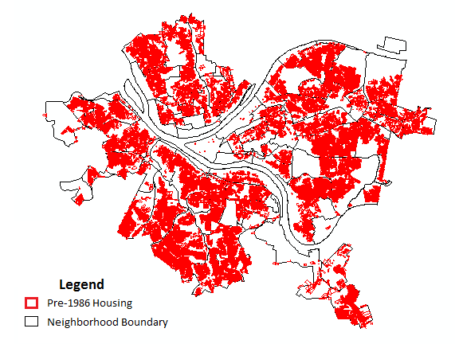
Figure 1. Pre-1986 Housing in Pittsburgh. Housing units built prior to 1986 are more likely to contain interior lead plumbing as well as a lead service line. Over 144,000 homes in Pittsburgh are currently at risk for lead contaminated tap water.

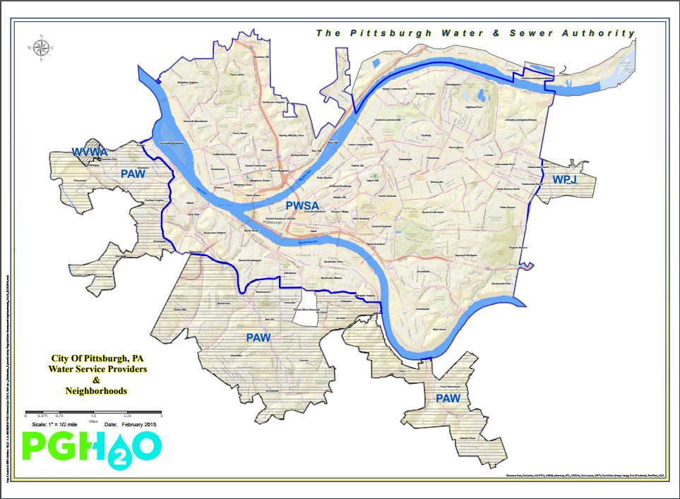
Figure 2. Pittsburgh Water and Sewer Authority (PWSA) Service Area

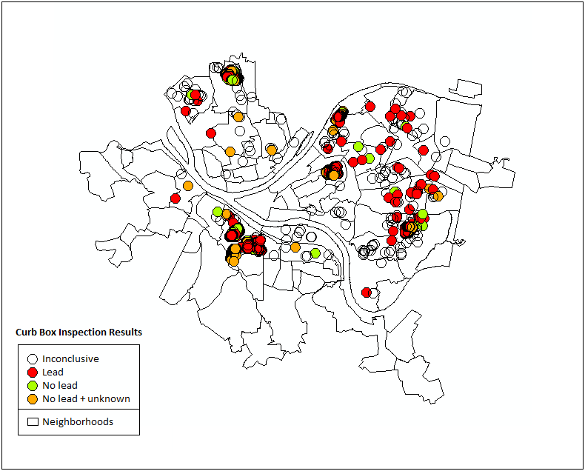
Figure 3. Curb Box Inspection Results (June 2017). Almost 2,000 curb box inspections—physical tests for water service line material—have been conducted by the Pittsburgh Water and Sewer Authority in an effort to locate public and private side lead service lines.²⁵

 | Public |  |  | Private
Year Built | Pb | NonPb | Unk | Pb | NonPb | Unk
Before 1900 | 66 | 115 | 181 | 50 | 84 | 216
1901 - 1930 | 211 | 191 | 442 | 175 | 145 | 521
1931 - 1960 | 12 | 28 | 66 | 10 | 28 | 68
1961 - 1990 | 0 | 2 | 9 | 0 | 3 | 8
1991 - 2014 | 2 | 3 | 5 | 0 | 4 | 5

Table 1. Frequency Distribution of Curb Box Inspection Results by Year Built. Although only one half of inspections were conclusive, a significant number found lead on the public and private sides of service lines.

Table 2 Figure 4
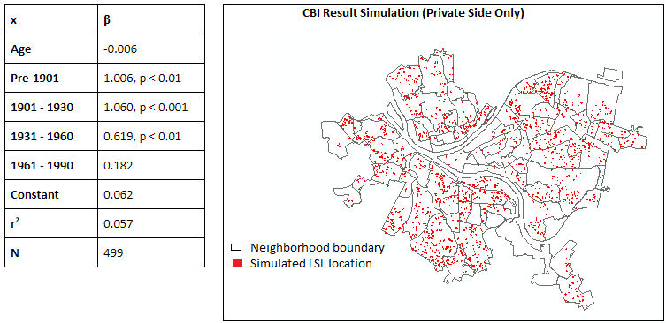
Table 2. STATA-assisted Ordinary Regression Model for Age of Housing. This statistical model was built to predict the relative probability of finding a private-side lead service line at any house given one more year of age.

Figure 4. Curb Box Inspection Result Simulation (Private Side Only). This map shows a randomly generated number of houses where a private-side lead service line might be found based off of the regression model from Table 2.

Table 3
Neighborhood | Population (2010) | 2009 Med. Income ('13 Dollars) | Respondents | With Children
Allegheny Center | 933 | $22,793 | 71 | 25
Allegheny West | 462 | $45,519 | 43 | 16
Allentown | 2,500 | $31,909 | 76 | 31
Arlington | 1,869 | $27,380 | 68 | 33
Arlington Heights | 244 | $10,265 | 11 | 4
Banksville | 4,144 | $55,181 | 97 | 28
Bedford Dwellings | 1,202 | $10,891 | 18 | 4
Beechview | 7,974 | $39,896 | 326 | 101
Beltzhoover | 1,925 | $36,917 | 52 | 17
Bloomfield | 8,442 | $33,604 | 335 | 44
Bluff | 6,600 | $13,947 | 20 | 1
Bon Air | 808 | $40,818 | 60 | 24
Brighton Heights | 7,247 | $43,267 | 474 | 155
Brookline | 13,214 | $49,803 | 529 | 161
California-Kirkbride | 761 | $28,723 | 9 | 5
Carrick | 10,113 | $40,943 | 372 | 122
Central Business District | 3,629 | $40,848 | 61 | 8
Central Lawrenceville | 4,482 | $34,679 | 170 | 26
Central Northside | 2,923 | $35,974 | 102 | 18
Central Oakland | 6,086 | $18,222 | 26 | 4
Chartiers City | 477 | $43,736 | 27 | 3
Crafton Heights | 3,814 | $42,824 | 110 | 9
Crawford-Roberts | 2,256 | $16,276 | 59 | 12
Duquesne Heights | 2,425 | $48,134 | 56 | 22
East Allegheny | 2,136 | $30,707 | 59 | 4
East Carnegie | 570 | $44,418 | 14 | 18
East Hills | 3,169 | $23,607 | 56 | 88
East Liberty | 5,869 | $25,024 | 331 | 33
Elliott | 2,381 | $28,386 | 100 | 0
Esplen | 301 | $14,844 | 5 | 2
Fairywood | 1,002 | $37,537 | 8 | 15
Fineview | 1,285 | $32,311 | 43 | 20
Friendship | 1,785 | $24,097 | 121 | 47
Garfield | 3,675 | $22,821 | 168 | 2
Glen Hazel | 716 | $13,988 | 8 | 105
Greenfield | 7,294 | $47,502 | 388 | 0
Hays | 362 | $32,518 | 8 | 58
Hazelwood | 4,317 | $33,863 | 174 | 55
Highland Park | 6,395 | $66,985 | 227 | 59
Hill District | (no census data) | (no census data) | 234 | 74
Homewood North | 3,280 | $23,062 | 196 | 29
Homewood South | 2,344 | $22,007 | 81 | 10
Homewood West | 818 | $15,721 | 30 | 29
Knoxville | 3,747 | $30,403 | 95 | 12
Larimer | 1,728 | $29,064 | 34 | 40
Lincoln Place | 3,227 | $44,895 | 142 | 44
Lincoln-Lemington-Belmar | 4,883 | $32,225 | 137 | 26
Lower Lawrenceville | 2,341 | $24,319 | 139 | 34
Manchester | 2,130 | $35,336 | 106 | 33
Marshall-Shadeland | 6,043 | $35,543 | 123 | 5
Middle Hill | 1,707 | $25,023 | 23 | 73
Millvale | (no census data) | (no census data) | 290 | 49
Morningside | 3,346 | $45,224 | 184 | 26
Mount Oliver | 509 | $41,970 | 59 | 73
Mount Washington | 8,799 | $47,219 | 307 | 3
New Homestead | 990 | $90,652 | 14 | 10
North Oakland | 10,551 | $54,504 | 69 | 13
North Shore | 303 | $90,089 | 36 | 12
Northview Heights | 1,214 | $14,097 | 25 | 14
Oakwood | 1,027 | $37,436 | 27 | 41
Overbrook | 3,644 | $46,046 | 109 | 66
Perry North | 4,050 | $50,412 | 185 | 24
Perry South | 4,145 | $32,478 | 82 | 50
Point Breeze | 5,315 | $95,704 | 179 | 15
Point Breeze North | 2,054 | $38,195 | 51 | 10
Polish Hill | 1,274 | $33,759 | 71 | 37
Regent Square | 928 | $84,635 | 108 | 2
Ridgemont | 483 | $61,313 | 18 | 51
Shadyside | 13,915 | $49,393 | 252 | 75
Sheraden | 5,299 | $33,860 | 213 | 15
South Oakland | 2,969 | $28,696 | 104
South Shore | 19 | $163,773 |  | 22
South Side Flats | 6,597 | $44,215 | 178 | 17
South Side Slopes | 4,423 | $41,359 | 111 | 22
Spring Garden | 884 | $41,876 | 68 | 44
Spring Hill-City View | 2,648 | $23,844 | 107 | 73
Squirrel Hill North | 11,363 | $91,409 | 210 | 117
Squirrel Hill South | 15,110 | $59,376 | 375 | 8
St. Clair | 209 | $30,851 | 15 | 61
Stanton Heights | 4,601 | $53,354 | 203 | 1
Strip District | 616 | $70,706 | 20 | 13
Summer Hill | 1,051 | $42,547 | 64 | 22
Swisshelm Park | 1,361 | $79,025 | 85 | 11
Terrace Village | 3,228 | $11,834 | 36 | 24
Troy Hill | 2,714 | $40,392 | 132 | 8
Upper Hill | 2,057 | $34,880 | 65 | 22
Upper Lawrenceville | 2,669 | $34,639 | 129 | 13
West End | 254 | $44,963 | 35 | 5
West Oakland | 2,604 | $22,849 | 22 | 41
Westwood | 3,066 | $54,366 | 103 | 6
Windgap | 1,369 | $44,670 | 33

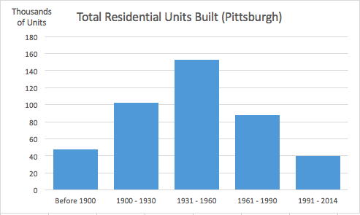
Figure 6. Total Residential Units Built in Pittsburgh. This frequency distribution clearly indicates that the highest rate of development in the City of Pittsburgh took place between 1931 and 1960.

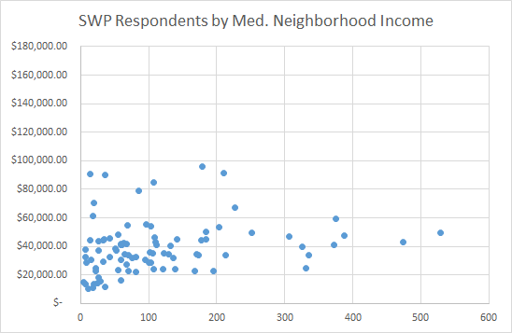
Figure 7. Safe Water Program Respondents by Median Neighborhood Income. This chart demonstrates a lack of awareness among lower-income communities that free water filters were made available to the public.

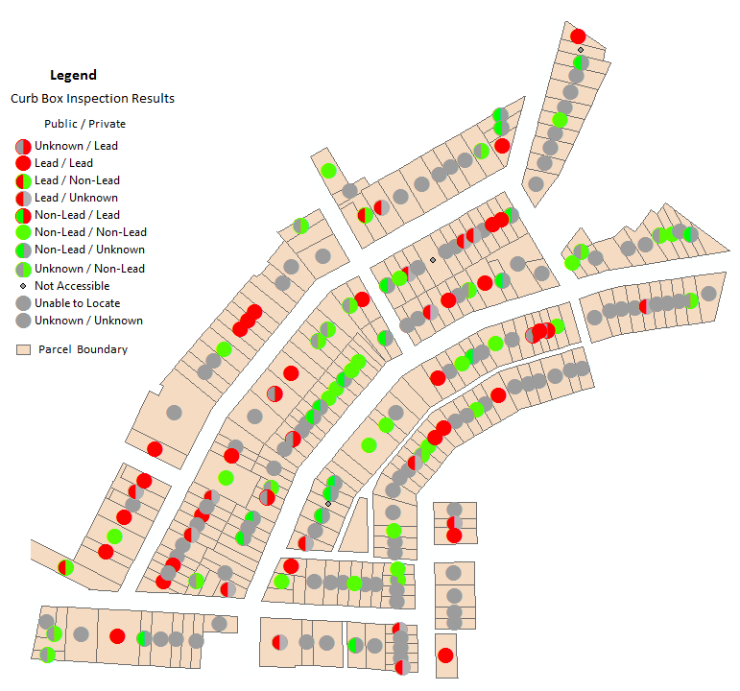

Figure 8. Inconsistency of Curb Box Results (Mount Washington neighborhood). A selection of 209 parcels with curb box inspection results from nine streets in the Mount Washington neighborhood of Pittsburgh are shown, color-coordinated to indicate the material of the public and private side of each service line. The results demonstrate a challenging lack of consistency in individual neighborhoods.

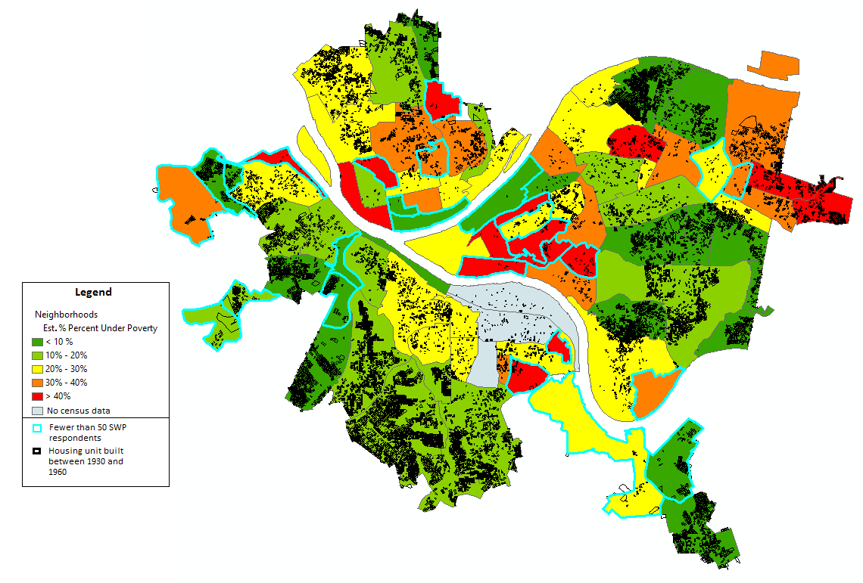
Figure 9. Lead Removal Strategy Map. Figure 9 depicts all housing units in Pittsburgh built between 1931 and 1960 superimposed on a map of median neighborhood income.

Neighborhood | Units | 2009 Med. Income ('13 Dollars) | SWP Respondents
Brookline | 3,237 | $49,803 | 529
Stanton Heights | 1,589 | $53,354 | 203
Beechview | 1,505 | $39,896 | 326
Carrick | 1,264 | $40,943 | 372
Squirrel Hill South | 1,131 | $59,376 | 375
Greenfield | 1,094 | $47,502 | 388
Overbrook | 964 | $46,046 | 109
Lincoln Place | 889 | $44,895 | 142
Brighton Heights | 856 | $43,267 | 474
Banksville | 837 | $55,181 | 97
Westwood | 679 | $54,366 | 103
Crafton Heights | 609 | $42,824 | 110
Point Breeze | 602 | $95,704 | 179
Squirrel Hill North | 568 | $91,409 | 210
Mount Washington | 557 | $41,970 | 59
Perry North | 532 | $50,412 | 185
Lincoln-Lemington Belmar | 528 | $32,225 | 137

Table 4. Highest Concentrations of Housing by Neighborhood (Built 1931 - 1960). All seventeen neighborhoods in Pittsburgh with over 500 units built between 1931 and 1960 have median income levels above $30,000 per year with ten having levels over $45,000.

