COST-EFFECTIVENESS ANALYSIS OF BIOPSY STRATEGIES FOR ENDOMETRIAL CANCER DIAGNOSIS IN WOMEN WITH POSTMENOPAUSAL BLEEDING: PIPELLE SAMPLING CURETTE VERSUS DILATATION & CURETTAGE

by
Yan Yi
MMed，Central South University, China, 2016

BMed, University of South China, China, 2013

Submitted to the Graduate Faculty of
Epidemiology
Graduate School of Public Health in partial fulfillment
of the requirements for the degree of
Master of Public Health

University of Pittsburgh
2017

UNIVERSITY OF PITTSBURGH
GRADUATE SCHOOL OF PUBLIC HEALTH

This essay is submitted
by
Yan Yi

on

December 1st, 2017
and approved by

Essay Advisor:
Lisa M. Bodnar, PhD, MPH, RD __________________________________________
Associate Professor (with tenure)
Department of Epidemiology
Graduate School of Public Health
Department of Obstetrics, Gynecology and Reproductive Sciences
School of Medicine
University of Pittsburgh

Essay Reader:
Faina Linkov, PhD, MPH __________________________________________
Associate Professor
Department of Obstetrics, Gynecology and Reproductive Sciences
School of Medicine
Department of Epidemiology
Graduate School of Public Health
University of Pittsburgh

Essay Reader:
Cindy L. Bryce, PhD __________________________________________
Associate Professor
Department of Health Policy and Management
Graduate School of Public Health
University of Pittsburgh

Copyright © by Yan Yi
2017
ABSTRACT
Lisa M. Bodnar, PhD

COST-EFFECTIVENESS ANALYSIS OF BIOPSY STRATEGIES FOR ENDOMETRIAL CANCER DIAGNOSIS IN WOMEN WITH POSTMENOPAUSAL BLEEDING: PIPELLE SAMPLING CURETTE VERSUS DILATATION & CURETTAGE
Yan Yi, MPH
University of Pittsburgh, 2017

Background:
Endometrial cancer (EC) is the most common gynecologic cancer affecting US women and usually requires a histological evaluation of an endometrial sample to be accurately diagnosed. The in-office usage of Pipelle endometrial biopsy has similar diagnostic accuracy for EC diagnosis and is cheaper than the traditional method-Dilatation & Curettage (D&C). However, the main drawback to Pipelle biopsy is its relatively higher sampling failure rate. The objective of this study was to explore the cost-effectiveness of two endometrial sampling procedures for diagnosing EC: 1) Pipelle endometrial biopsy and 2) D&C, accounting for both sampling procedure failure rates and diagnostic accuracy in women with postmenopausal bleeding (PMB).
Method:
The decision analytic model was built to compare the cost effectiveness of Pipelle biopsy and D&C strategy in a hypothetical cohort of PMB women. The analysis was performed from the perspective of a public healthcare payer (Medicare, US). We used 2017 Medicare reimbursement data to estimate costs for procedures in the model. The effectiveness of these two diagnostic strategies was measured by analyzing the remaining life expectancy. We compared the performance of the two procedures using the incremental cost and incremental effectiveness, and conducted one-way sensitivity analyses and Monte Carlo probabilistic sensitivity analysis to assess the effect of uncertainty on the result.
Results:
The base case analysis suggested that the Pipelle biopsy strategy was not only equally effective (32.11 vs. 32.11 years of life) but also less costly ($1897.80 vs. $2999.11) in comparison to D&C strategy. In one-way sensitivity analyses and Monte Carlo probabilistic sensitivity analysis, the Pipelle biopsy remained the more cost-effective strategy after accounting for uncertainties of variables.
Conclusion:
The Pipelle biopsy is the more cost-effective sampling strategy for EC diagnosis in women with PMB when compared to D&C. From a cost-effective perspective, the relatively higher sampling failure rate of Pipelle should not be regarded as a limitation in its clinical application. These findings have important public health significance as they have potentials to improve diagnostic efficiency of endometrial pathologies which affect millions of women in the US, and they can be broadly generalizable in Medicare providers in the US.

TABLE OF CONTENTS
preface x
1.0 Introduction 1
1.1 INCIDENCE OF ENDOMETRIAL CANCER 1
1.2 DILATATION & CURETTAGE (D&C) 1
1.3 Pipelle Biopsy 2
1.4 COST-EFFECTIVE ANALYSIS (CEA) 3
1.5 THE AIM 3
2.0 Methods 5
2.1 Model structure 5
2.2 Choosing D&C 5
2.3 Choosing Pipelle 6
2.4 Cost data 7
2.5 Effectiveness data 9
2.6 Statistical Analysis 9
3.0 Results 11
3.1 Base case analysis 11
3.2 Sensitivity analysis 11
4.0 Discussion 13
APPENDIX: TABLES AND FIGURES 17
bibliography 25
List of tables
Table 1: Estimated base-case values and ranges for model parameters 18
Table 2: One-way sensitivity analyses, Pipelle compared with D&C 19

List of figures
Figure 1: The decision analytic model 21
Figure 2: Tornado-diagram for multiple one-way sensitivity analyses 23
Figure 3: The cost effectiveness acceptability curve 24

preface
This is my first independent research project after I came to study Epidemiology in the US. During the studying related to this project, I have learned many interesting things and gathered valuable research experience at the Graduate School of Public Health. I would like to give my warm appreciation and gratitude to wonderful people who helped me throughout my graduate studies for their tremendous support and help. Without their support, comments, suggestions, and criticisms, I would not be able to accomplish my research project and complete my MPH program.
To Dr. Lisa M. Bodnar, my academic advisor, for her kind help and responsible guidance for my entire study (e.g. coursework, internship, essay etc.) during my MPH program;
To Dr. Faina Linkov, my internship preceptor, for giving me precious internship opportunity to work in her research group and helping me face all the challenges I encountered during this research project. Without her, this research project would not be possible. I would also like to thank her for motivating me to do my best and encouraging me to pursue my academic career and apply for PhD program.
To Dr. Cindy L. Bryce, my class (HPM 2217- Clinical Decision Analysis) and internship instructor, and essay reader, for giving me invaluable advice, comments, and ideas to my study in the class and research project, which always help me find solution to my dilemmas;
To Dr. Nancy W. Glynn and Lori S. Smith, who were always there helping me, for their kind suggestions and inspiration during this program;
To Shalkar Adambekov, for his brilliant ideas and invaluable comments which greatly improve my research project;
To my dear parents, for supporting my study in US and giving me such selfless and unconditional love;
And lastly, to those who are not mentioned above but give me help and support, especially my friends and classmates.

Introduction

INCIDENCE OF ENDOMETRIAL CANCER
Endometrial cancer (EC) is the most common gynecologic cancer in US women [1] with approximately 61,380 new cases diagnosed and 10,920 women expected to die from this malignancy in 2017[2, 3]. Projections indicate that the incidence of EC will increase in all racial groups in the US[4], and reach 42.13 per 100,000 women by 2030 [5]. EC is primarily a disease of the postmenopausal period (86% of cases are diagnosed in postmenopausal women), with abnormal uterine bleeding being the most common symptom of EC (90% of patients) [1]. Therefore, timely and efficient EC diagnostic procedures in women with postmenopausal bleeding (PMB) are a priority for research, clinical practice and policy, and have great public health significance in the US.

DILATATION & CURETTAGE (D&C)
Definitive diagnosis of EC requires collecting sufficient endometrial tissue to conduct a histological analysis. Dilatation & curettage (D&C) has traditionally been the method of choice for obtaining histological samples for diagnosis of EC[6] as it is a reliable and imposes little discomfort to the patient due to the use of anesthesia. However, D&C is performed in an OR setting and poses inherent risks, including the use of general anesthetics, infection, and perforation[7]. Also, because of the use of anesthetics, D&C results in loss of work time for the patients, as they need to take at least one day off of work to have the procedure done. In addition, its high cost can be another limitation[8] (range from $1,728 to $3,950 in the US[9]).

Pipelle Biopsy
Over the past two decades, Pipelle endometrial sampling has become an increasingly popular alternative to the endometrial tissue sampling that addresses many of the limitations of D&C[10]. The main advantage of Pipelle biopsy is its lower costs [11-13] (range from $318 to $644 in the US [14]) and availability for in-office usage. It is also a less invasive procedure, performed on an outpatient basis with fewer side effects[13, 15], and can inform diagnoses for a range of endometrial pathologies including EC, endometrial hyperplasia, and atrophy [16]. The overall accuracy between the two procedures is similar [8, 17, 18]. Demirkiran et al. performed Pipelle endometrial biopsy prior to D&C in a sample of 478 women and the outcomes showed that Pipelle and D&C were concordant with each other (84% concordance) [8]. Fothergill et al. showed that there was no statistical difference between the histological outcomes of Pipelle and D&C (concordance=84%, n=187) [17]. Other studies indicated that Pipelle biopsy only had a slightly lower true positive rate [6, 19, 20] compared with D&C (94% vs 96%)[13].
The main drawback to Pipelle biopsy is its higher sampling failure rate[21]. Sampling failure results from two primary reasons: (1) inability to access the uterine cavity, and (2) failure to obtain adequate samples for histological analyses [10, 22]. In a prior work that accounts for both sources of failure, we found 23% Pipelle biopsy sampling failure rate for the general population of gynecologic patients[10]; 38.3% for severely obese (BMI≥35) bariatric surgery candidates[23]; and 42% for the postmenopausal women in a large healthcare system[10]. These failure rates are substantially greater than failure rates with D&C, which result primarily from sample insufficiency and occur in only 0.4% of premenopausal women and 0.5% of postmenopausal women[24]. Hence, the need to repeat tests with Pipelle to confirm a diagnosis may offset some of the other advantages.

COST-EFFECTIVE ANALYSIS (CEA)
Considering that the above two strategies both have advantages and disadvantages, it is very meaningful and useful to quantify costs and outcomes of them to help clinical decision-making. We will utilize Cost-Effective Analysis (CEA) and decision analytic model as methods to evaluate above two strategies which are designed to inform decision making regarding both the economic and clinical consequences of these two strategies.

THE AIM
Prior study has estimated the cost-effectiveness of Pipelle biopsy, ultrasound and outpatient hysteroscopy in EC diagnosis based on UK healthcare payer system, but was limited in clinical perspective accounting for potential biopsy failure [13]. Moreover, the most commonly used endometrial sampling strategies in the US (Pipelle and D&C) were not compared. The aim of our study was to fill this important gap by estimating the cost-effectiveness of Pipelle biopsy and D&C for EC diagnosis in women with PMB while accounting for potential procedure failure, based on costs obtained from publicly available Medicare reimbursement data.

Methods

Model structure
We built a decision analytic model showing the management and treatment of a hypothetical cohort of 50-year old women with PMB using both Pipelle biopsy and D&C (Fig. 1). We compared the clinical diagnostic outcomes and economic outcomes using the public healthcare payer perspective (Medicare, US). Medicare reimbursement data for 2017 was used to estimate direct medical costs for these medical procedures[25, 26].
The decision for choosing between the two diagnostic procedures (Pipelle biopsy or D&C) was shown in Figure 1 where the “choice” is represented by a square node. The circles indicate the uncertain events, each of which has its own possibility (see Table 1) and will occur after the decision was made. The triangular nodes show the costs and life expectancy associated with the complete sequence of events on each pathway following the initial decision.

Choosing D&C
When D&C is used to diagnose EC in a cohort of women with PMB, sufficient samples are obtained most of the time (99.5% see table1). In these cases, the endometrial sample undergoes histological testing and diagnosed as positive or negative for EC. Women with a positive EC result (regardless of they actually have EC or not) will undergo standard treatment for apparent stage I EC, namely a laparoscopic hysterectomy and adnexectomy [1]. For those with a negative EC result, no further action will be taken in patient’s first visit. If abnormal bleeding persists we assume patients would revisit clinicians and undergo a second D&C for diagnosis. They would obtain a delayed diagnosis of EC and undergo a delayed treatment through a laparoscopic hysterectomy and adnexectomy for their EC. If their primary symptoms (mostly bleeding) resolves on its own, we assume patients do not have cancer and would not revisit clinicians.
For instances when the D&C sampling procedure initially fails to provide a sufficient sample for histological analysis, the clinician will discontinue further testing or procedures in the patient’s first visit. The clinicians will ask them to revisit if the abnormal bleeding persists. If bleeding persists, we assume patients would revisit clinicians and undergo a second D&C for diagnosis. They would obtain a delayed diagnosis of EC and undergo a delayed treatment through a laparoscopic hysterectomy and adnexectomy for their EC. If the bleeding ceases, we assume patients do not have EC and would not revisit clinicians.

Choosing Pipelle
Alternatively, when Pipelle is chosen for the same hypothetical cohort of patients, the first step is also collecting an endometrial sample. If the sampling procedure is successful, the sequence of uncertain events is similar to those described following sampling success by D&C (see “Choosing D&C”, section 2.2). However, the possibilities for uncertain events followed by Pipelle are different compared to D&C (see Table 1).
If the sampling procedure of Pipelle fails in the first step, there are a few additional steps. As noted with Pipelle, the sampling failure is relative high, in which case providers will make a second attempt to collect samples, either using D&C or repeating the Pipelle procedure. If the patient moves to a D&C route, the subsequent uncertain events in that route will be the same as the uncertain events of choosing D&C initially (see “Choosing D&C”, section 2.2). If the patient undergoes the repeated Pipelle, she may have sampling success in the second Pipelle attempt. The subsequent uncertain events after sampling success by second Pipelle attempt are the same as the uncertain events after sampling success by first Pipelle attempt, which we mentioned in the previous paragraph. If she still has sampling failure in the second Pipelle attempt, she will then move to the D&C route, and the subsequent uncertain events in that route will be the same as the uncertain events of choosing D&C initially (see “Choosing D&C”, section 2.2).

Cost data
We used 2017 Medicare reimbursement data from the Centers for Medicare & Medicaid Services (CMS)[25] to estimate costs (in 2017 U.S. dollars) for these two diagnostic procedures. The overall cost of a medical procedure includes physician service fee and outpatient hospital charge. We assumed that only physician service fee and outpatient hospital charge should be incorporated into cost calculations. This is due to the rarity of other potential adverse events related to these two procedures and inability to accurately assess them. Cost implications (intraoperative injuries etc.) were not included.
For the physician fee, we used the Healthcare Common Procedure Coding System (HCPCS)[27] for Pipelle biopsy (58100), D&C (58120), and laparoscopic hysterectomy and adnexectomy (58573). These codes were used to obtain the pricing information in the Medicare Physician Fee Schedule 2017 (MPFS)[28]. The MPFS provides the Medicare payment information for enrolled health care professionals in all Carrier/Medicare Administrative Contractor (MAC) for the entire nation. The MAC number indicates the health care providers in a specific geographic area, rather than representing a specific provider. After retrieving the complete list of the MPFS for Pipelle biopsy and D&C in CMS website[28], we used the average physician fee in all Carrier/ MAC as the base case and the range of the fee as the reference in sensitivity analysis.
For outpatient hospital charges, we used the Ambulatory Payment Classifications (APCs)[29] group to obtain the outpatient hospital charge for Pipelle biopsy and D&C. APCs are the main unit of payment under the Medicare Outpatient Prospective Payment System (OPPS)[30]. Each APC is a group of medical procedures which have similar clinical characteristics and similar costs. We obtained the Medicare hospital charge information on the CodeMap web site[26] which provides information on the 2017 Medicare OPPS Fee Schedule.
The overall Medicare reimbursement for Pipelle biopsy was $244.41 (range: $228.4 to 361.46), for D&C biopsy was $2310.47 (range: $2272.47 to 2600.47) and for laparoscopic hysterectomy and adnexectomy was $11,496 (range: $11045 to 11604) in 2017 (Table1)[26, 28].
For the patients who need to revisit the clinician and undergo a second D&C, we assume the cost of the second visit will be the same as the cost of the initial D&C sampling, and will be added to the total cost of the pathway.

Effectiveness data
The effectiveness of these two diagnostic strategies (Pipelle and D&C) was measured by remaining life expectancy. For the true negative patients (no EC and no treatment), remaining life expectancy was estimated from the U.S Actuarial Life Table 2013 based on approximated remaining life expectancy of 50 years old women [31]. For the true positive patients (EC with timely treatment), their remaining life expectancy were the estimated life expectancy of stage I EC from previous literature[11] since most EC cases (70%) are diagnosed at an early stage (International Federation of Gynecology and Obstetrics (FIGO) stages I)[1] . For the false negative patients (EC with delayed treatment), we assumed that their remaining life expectancy would be reduced by 5% [13] of the life expectancy of stage I EC[11] due to the delayed diagnosis and treatment. For the false positive patients (no EC with unnecessary treatment), their remaining life expectancy would be reduced by 5% of 50 years old women’s life expectancy in Actuarial Life Table 2013 [31], considering the low mortality rate of hysterectomy[32].

Statistical Analysis
We compared the performance of the two strategies (Pipelle vs. D&C) by the Incremental Cost-Effectiveness Ratio (ICER). The ICER is defined as the difference in costs (ΔC) of the two procedures divided by the difference in health benefits (ΔE, defined here as remaining life expectancy).
We then compared the ICER (ΔC/ΔE) to the threshold value of Willingness-To-Pay (WTP) which is the maximum money society is willing to pay for one unit health benefit gain. In the US, a threshold of WTP commonly used was $50,000 per quality adjusted life year (QALY) gained, and has been updated to US $100,000 per QALY gained in a recent decade[33]. In our study, the effectiveness is evaluated using life expectancy rather than QALY. Thus, the threshold of WTP in our study was assumed to be $50,000 per year of life gained.
We varied the values of the variables in their plausible ranges for both one-way and probabilistic sensitivity analyses to determine which variables have the greatest effect on the result and the robustness of result. The one-way sensitivity analysis is varying one variable within its plausible range and reports the outcome for various values of this variable. In our study, the one-way sensitivity analyses were conducted for all variables respectively to assess the effect of uncertainty on the result of ICER. Tornado diagram was used to rank multiple one-way sensitivity analyses by their impact on the outcome. Since each one-way sensitivity analysis only presents the variation of the result by varying a single variable, the variation of the result is unknown if all variables are varied simultaneously. Therefore, we conducted probabilistic sensitivity analyses by varying all variables simultaneously over uniform probability distributions to see if the optimal strategy changes. Values for each variable were randomly selected from their probability distributions by repeating the process 10,000 Monte Carlo iterations. The cost effectiveness acceptability at WTP was constructed to indicate the likelihood that the particular strategy is more cost effective at a WTP $50,000 per year of life gained. In addition, the cost effectiveness acceptability curve was built to indicate if the optimal strategy changes over the increasing of WTP to $200,000 per year of life gained.
This research was institutional review board exempt as the data used was from the published literatures and websites. The decision analytic model was constructed and analyzed by DATA Professional software (TreeAge, Williamstown, Massachusetts).

Results

Base case analysis
The cost represented the total cost in the model of using either Pipelle or D&C as the endometrial sampling strategy of choice in the hypothetical cohort women with PMB. The choice of using Pipelle strategy had a total cost of $1897.8 which was significantly less costly (incremental cost of -$ 1101.31), compared with the choice of using D&C strategy with a total cost of $2999.11. The choice of using Pipelle strategy would have remaining life expectancy of 32.11 years, which was equivalent to the remaining life expectancy of 32.11 years by using D&C. The base case estimation indicated that using Pipelle was both cost-saving and equally effective strategy, compared with using D&C. Therefore, in the base case analysis, the Pipelle biopsy was dominant over D&C biopsy for women with PMB in the diagnosis of EC based on 2017 Medicare reimbursement data. Since the value of incremental effectiveness was 0, we did not compute ICER for base case analysis.

Sensitivity analysis
We varied each variable of table 1 respectively in one-way sensitivity analyses to demonstrate if the optimal strategy changed at some cutoff point within their plausible ranges. In the plausible ranges of the following four variables, sensitivity and specificity of Pipelle, and sensitivity and specificity of D&C, the Piplle sampling strategy changed from being a more cost-effective strategy to a dominant strategy, or vice versa. We presented these transitions in table 2. In the plausible ranges of other variables of table 1, Pipelle sampling remained the more cost-effective strategy.
Tornado Diagram was used to rank the results of multiple one-way sensitivity analyses by their impact on the outcome (Fig 2). According to the Tornado Diagram, the ICER of Pipelle versus D&C was most sensitive to the following three variables: possibility of D&C sampling success, sensitivity of Pipelle and sensitivity of D&C.
If all variables varied simultaneously in Monte Carlo sensitivity analysis, the likelihood that Pipelle was the more cost-effective strategy compared to D&C was 100% at a WTP $50,000 per year of life gained over 10,000 iterations. Even if the WTP increased to $200,000 per year of life gained, the Pipelle was still the more cost-effective strategy compared to D&C in our hypothetical cohort (Fig 3).

Discussion
Our study presented a cost-effectiveness analysis of Pipelle endometrial biopsy in comparison D&C for diagnosis of EC in the women with PMB based on 2017 Medicare reimbursement data. The base case analysis suggested that the Pipelle biopsy strategy was not only equally effective but also less costly than the D&C strategy. The Pipelle biopsy remained the more cost-effective strategy compared to D&C in both one-way sensitivity analyses and Monte Carlo probabilistic sensitivity analysis after accounting for uncertainties of variables.
The biggest concern regarding the Pipelle application in clinical practice is the higher sampling failure rate compared to D&C[21]. However, according to the tornado diagram, the impact of sampling failure rate of Pipelle on our results ranked tenth among all 14 model variables, which means our ICER result was not sensitive to the variation of this variable. The variation of sampling failure rate of Pipelle will neither affect our ICER result too much nor alter the optimal strategy. Therefore, the higher sampling failure rate of Pipelle compared to D&C should not be regarded as a limitation for its application in clinical practice from the cost-effective perspective.
Through this study, we quantified the most cost-effective method for diagnosing EC in women with PMB, which has important public health significance considering the high incidence of abnormal vaginal bleeding in postmenopausal women (range from 4% to 11%[34]). There was estimated 2 million women[35] reaching menopause status every year in the US (over 6,000 every day[36]), which indicates approximately 200,000 menopausal women will occur PMB and need to receive endometrial sampling for diagnosis. Moreover, 10% PMB cases are caused by EC[34] and timely diagnosis of EC is imperative as cancer morbidity and mortality vary for local-stage disease and regional-stage disease[37, 38]. Furthermore, the costs of treatment can be reduced with timely diagnosis and treatment [1].
Our study also provides a cost-effective concept in clinical decision making and public health policies making considering the National Health Expenditure (NHE) is increasing dramatically in the US. In 2015, NHE accounted for 17.8% of Gross Domestic Product (GDP) (increasing 5.8% to $3.2 trillion)[39]. Medicare spending accounted for 20% of the total NHE (increasing 4.5% to $646.2 billion)[39]. Based on the Medical Expenditures Panel Survey, cancer ($52.7 billion expenditure in 2012) is one of the five most costly conditions among U.S. adults [40].Well-designed cost-effective analysis studies can provide solid scientific evidences for public health policies making process and public health programs assessment, which subsequently lead to better population health benefits through implementing more effective and efficient interventions.
The strength of our study is that we improve upon the data sources used in the model compared to previous studies [11, 13]. Feldman et al.[11] estimated the procedure costs from a single hospital only in 1993. Our study is based on standard Medicare reimbursement data for 2017 which can be broadly generalizable for the US. With Medicare covering 55 million people in the US, the conclusions of this study can help improve the cost-effectiveness of care for Medicare beneficiaries and has important implications for millions of women suffering from endometrial pathologies in the US. Clark et al.[13] used National Health Service (NHS) data, which reflects the experience and health care system of the UK. Our conclusion is consistent with Clark et al.’s study which signifies that Pipelle biopsy is cost-effective for EC diagnosis irrespective of healthcare system setting.
Another strength is that we considered potential procedure failure, and failure rates used in our analysis were obtained from a large healthcare system[10] and a validated prospective study[41], improving the reliability of our result. We know the benefits of a diagnostic test will not only depend on the diagnostic accuracy (e.g., sensitivity, specificity) but also the performance characteristics of the test itself (e.g., feasibility)[42]. We explicitly accounted for the performance of Pipelle and D&C themselves, defined here as sampling success (or failure) resulting from clinical sampling procedures. We adjusted our analysis for sampling failure as well as diagnostic accuracy so that our results more closely reflect real-life situations when procedures are not always successful. Even allowing for repeat procedures, we found the pipelle biopsy is more cost-effective than D&C for EC diagnosis. Thus, our study can be regarded as a reference for the physicians in deciding endometrial biopsy procedure in women with PMB and for the hospital administrators in healthcare resource allocation.
The major limitation of our study is that we used the life expectancy rather than the quality-adjusted life years (QALYs), and the reason is that no completed data regarding the quality of life can be used in EC patients. The quality of life in women with PMB can be impacted by the false positive and false negative diagnosis which can lead to unnecessary hysterectomy or delayed treatment for EC. The life expectancy also limits the comparisons of medical procedures across studies from the perspective of cost-effectiveness analysis because the QALYs is the most commonly used payoff parameter. In addition, we only analyzed the cost-effectiveness of Pipelle biopsy and D&C based on the costs information of Medicare reimbursement [43]. The primary reason is that the Medicaid is jointly funded by the states and federal government. The funding from the federal government vary by state based on income level in each state [44] which means the reimbursement for a given medical procedures differs in each state.
Future studies can be conducted to compare the cost-effectiveness of Pipelle biopsy and D&C in the diagnosis of endometrial disease for women of different age groups and risk status (e.g., obesity) as the incidence of endometrial disease and sampling success rate vary in different population. In addition, the ultrasound can also be considered in the model as alternative options for endometrial disease diagnosis. Because Pipelle biopsy and D&C are both reliable in the diagnosis of diffuse disease (adenomatous hyperplasia, carcinoma etc.), but are poor strategies in the diagnosis of focal disease (polyps and submucosal fibroids)[45-49]. However, transvaginal ultrasound has a high sensitivity in the diagnosis of focal endometrial disease[45, 49-51]. Future studies should also focus on investigating factors resulting in Pipelle biopsy sampling failures and false diagnosis, and then explore how to improve the Pipelle biopsy procedure in clinical practice to reduce Pipelle sampling failure and improve diagnostic accuracy. Breijer et al. demonstrated the potential to increase the cost-effectiveness by taking individual patient characteristics into account[52] which also provides a new perspective on the improvement of the cost-effectiveness of endometrial biopsy.

APPENDIX: TABLES AND FIGURES

Table 1: Estimated base-case values and ranges for model parameters
 | Baseline | Range/95% CI | Source | Notes
Prevalence of endometrial cancer in women with PMB | 0.05 | (95%CI 0.03-0.1) | [53, 54]
Possibilities
Pipelle *
P (successful sampling in 1st attempted Pipelle)* | 0.58 | 0.5-0.77 | [10] | Estimated
P (successful sampling in 2nd attempted Pipelle)* | 0.25 | 0.2-0.5 | [10] | Estimated range
P (moving to D&C if 1st attempted Pipelle failed )* | 0.95 | 0.94-1 | Estimated | Estimated range
Sensitivity | 0.94 | (95% CI 0.84-0.99) | [6, 13, 19, 20]
Specificity | 0.99 | (95%CI 0.98-1) | [6, 13, 19, 20]
D&C **
P (successful sampling) ** | 0.995 | 0.96-1.0 | [24] | Estimated range
Sensitivity | 0.96 | (95%CI 0.82-1) | [13]
Specificity | 0.99 | (95%CI 0.97-1) | [13]
Life expectancy (years of life)
EC with timely treatment | 12.6 | 7-19 | [11] | Life expectancy of stage I cancer
EC with delayed treatment | 11.97 | 6.65-18.05 | [11, 13] | Estimated by 5% discount of life expectancy of stage I cancer considering delayed treatment
No EC and no treatment | 33.16 | 28.74-37.73 | [31] | Estimated by life expectancy of 50 years old women based on U.S Actuarial Life Table
No EC with unnecessary treatment | 31.5 | 27.30-35.84 | WS[31, 32] | Estimated by 5% discount of life expectancy of 50 years old women based on U.S Actuarial Life Table
Costs ($)
Pipelle | $ 244.41 | 228.4-361.46 | WS[55]
D & C | $ 2310.47 | 2272.47-2600.47 | WS[55]
Hysterectomy | $ 11,496 | 11045-11604 | WS[56]

* For Pipelle biopsy, we derived probabilities of sampling success from our previous study, which assessed data from the UPMC (University of Pittsburgh Medicine Center) Health System. The success rate of Pipelle in age group equal or over 55 years old is 57.81% which was used to estimate base case of Pipelle success rate in our women with PMBcohort[10]. In addition, we estimated that only 5% (range: 0-6%) patients would undergo second attempted Pipelle if Pipelle sampling failed in the first time based on expert clinical estimation. The success rate of a second attempted Pipelle in our cohort would decline to 25% based on the success rate of Pipelle in women with a history of prior biopsy failure in our previous study [10].
**For D&C, we estimated the sampling success rate to be 99.5% from a retrospective study which investigated the surgical complication rate of nonobstetric D&Cs using a series of 5,359 consecutive patients[24].

Table 2: One-way sensitivity analyses, Pipelle compared with D&C
Variables | Incremental cost  ($) | Incremental Effectiveness  (year of life) | ICER  ($/ year of life ) | Optimal strategy  (at willingness to pay $50,000/year of life)
Sensitivity of Pipelle
0.84 | -1,094.55 | -0.0021 | 504,424.44 | Pipelle*
0.87 | -1,096.58 | -0.0016 | 678,223.80 | Pipelle*
0.90 | -1,098.61 | -0.0011 | 1032,740.45 | Pipelle*
0.93 | -1,100.64 | -0.0005 | 2155,075.23 | Pipelle *
0.96 | -1,102.66 | 0.0000 | - | Pipelle (Dominant)**
0.99 | -1,104.70 | 0.0006 | -1,855,367.18 | Pipelle (Dominant)**
Specificity of Pipelle
0.98 | -1,037.40 | -0.0096 | 108,562.45 | Pipelle*
0.984 | -1,062.96 | -0.0059 | 181,269.25 | Pipelle*
0.988 | -1,088.53 | -0.0022 | 501,108.47 | Pipelle*
0.992 | -1,114.10 | 0.0015 | -733,192.38 | Pipelle (Dominant)**
0.996 | -1,139.66 | 0.0052 | -218,691.86 | Pipelle (Dominant)**
1 | -1,165.23 | 0.0089 | -130,880.08 | Pipelle (Dominant)**
Sensitivity of D&C
0.82 | -1,110.73 | 0.0022 | -495,489.66 | Pipelle (Dominant)**
0.856 | -1,108.31 | 0.0016 | -700,872.33 | Pipelle (Dominant)**
0.892 | -1,105.89 | 0.00096 | -1,200,781.60 | Pipelle(Dominant)**
0.928 | -1,103.47 | 0.0003 | -4,234,038.99 | Pipelle(Dominant)**
0.964 | -1,101.04 | -0.0004 | 2,754,416.93 | Pipelle*
1 | -1,098.62 | -0.0011 | 1,036,345.16 | Pipelle*
Specificity of D&C
0.97 | -1,228.51 | 0.0180 | -68,098.54 | Pipelle (Dominant)**
0.976 | -1,190.35 | 0.0125 | -94,998.49 | Pipelle (Dominant)**
0.982 | -1,152.19 | 0.0070 | -164,124.22 | Pipelle (Dominant)**
0.988 | -1,114.03 | 0.0015 | -737,630.62 | Pipelle (Dominant)**
0.994 | -1,075.87 | -0.0040 | 268,991.17 | Pipelle*
1 | -1,037.72 | -0.0095 | 109,122.87 | Pipelle*
Note: Incremental cost = cost of Pipelle - cost of D&C
Incremental Effectiveness = life expectancy by choosing Pipelle - life expectancy by choosing D&C
Incremental cost effectiveness ratio (ICER) = Incremental cost/ Incremental Effectiveness
The ICERs were computed when possible values were selected in the plausible ranges of these four variables. The comparisons between ICERs and WTP were used to determine if Pipelle remains the optimal strategy (more cost-effective) over the plausible ranges of these four variables.
* If both the incremental cost and the incremental effect are negative, the new strategy (Pipelle) would be regarded as cost-effective when the ICER is higher than the threshold of WTP $50,000 per life year. (ICER > WTP).
**If the incremental cost is negative and the incremental effect is zero or positive, the Pipelle strategy is both cost saving and equal or more effective compared with D&C. The Pipelle strategy is dominant over D&C.

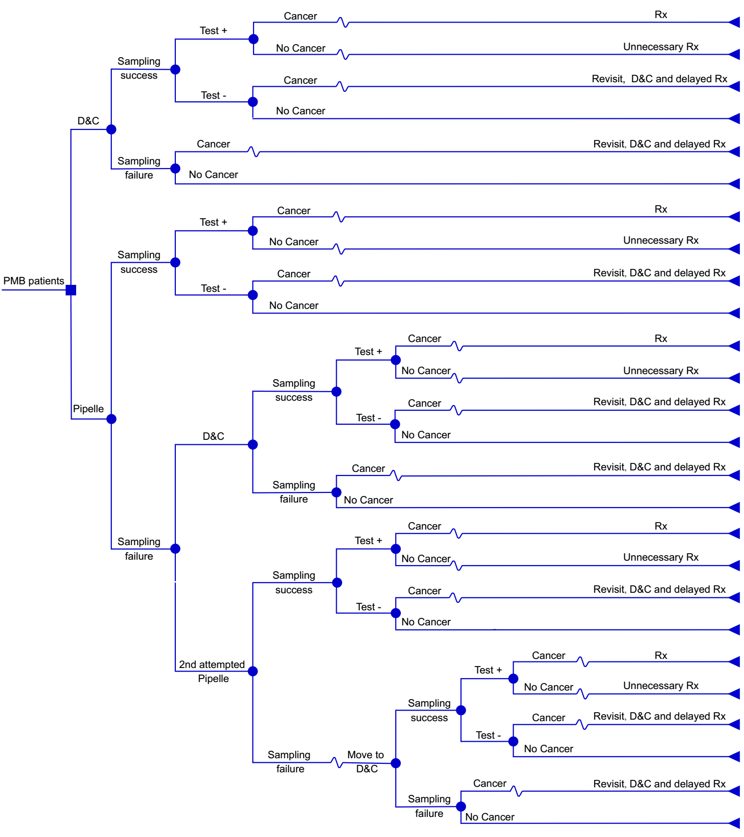
Figure 1: The decision analytic model
Note: Rx, an abbreviation for medical treatment (laparoscopic hysterectomy and adnexectomy in this study).
This is the decision tree structure for choosing between the two diagnostic procedures (Pipelle biopsy or D&C) for our hypothetical PMB cohort (The full tree in supplementary Fig.1). The “choice” making is represented by a square node. The circles indicate the uncertain events will occur after the decision was made. The triangular nodes show the costs and life expectancy associated with the full sequence of events on each pathway after the initial decision was made. Then we summarized the cost and effectiveness from pathways after each choice and compared these two “choices” by ICER.

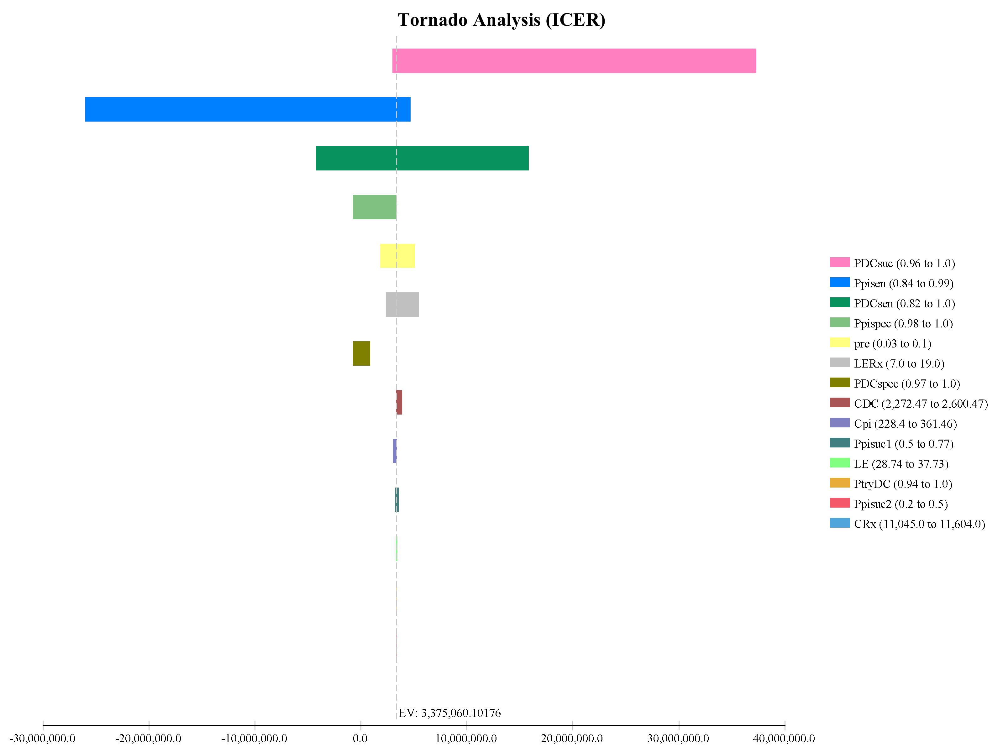

Figure 2: Tornado-diagram for multiple one-way sensitivity analyses

Note: PDCsuc, possibility of D&C sampling success; Ppisen, sensitivity of Pipelle; PDCsen, sensitivity of D&C; Ppispec, specificity of Pipelle; Pre, prevalence of EC; LERX, remaining life expectancy of EC with timely treatment; PDCspec, specificity of D&C; CDC, cost of D&C; Cpi, cost of Pipelle; Ppisuc1, possibility of sampling success by 1st attempted Pipelle; LE, remaining life expectancy of no EC; PtryCD, possibility of moving to D&C if failed in 1st attempted Pipelle; Ppisuc2, possibility of sampling success by 2nd attempted Pipelle; CRx, cost of EC treatment.
Tornado diagram shows the rank of variables whose variation have impact on the ICER (X-axis) in one-way sensitivity analyses. The numbers in the brackets indicate the plausible ranges for each variable (see table 1). Each bar represents a one-way sensitivity analysis for a single variable in the model. The width of bar shows the impact on model results. The variable at the top has the widest bar which has the greatest impact on model results.
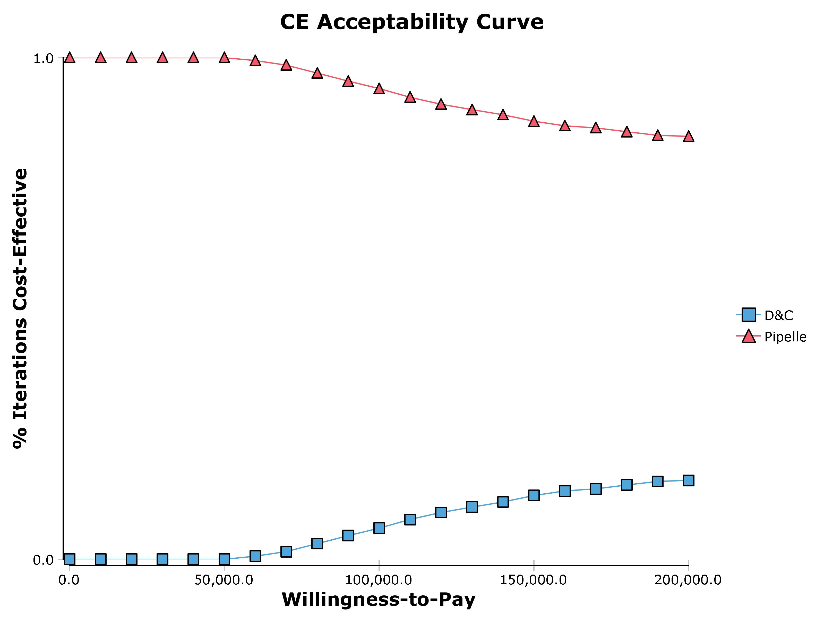
Figure 3: The cost effectiveness acceptability curve

Note: CE, cost-effective.
This CE acceptability curve shows the result of probabilistic sensitivity analysis which simultaneously varies multiple parameters to see if the Pipelle is still more preferred compared to D&C. Y axis represents the percentage of iterations that favor each strategy over a range of WTP (x axis). The Pipelle strategy is preferred constantly (the percentage of preferred iterations > 50% constantly) from WTP of $0 to 200,000 per year of life gained.

bibliography

