A COMPARISON OF 8-HOUR VERSUS 12-HOUR SHIFT DURATION ON FATIGUE AND FATIGUE-RELATED INDICATORS IN EMERGENCY MEDICAL SERVICES AND RELATED SHIFT WORKERS: A SYSTEMATIC REVIEW

by
Andrew J. Kroemer
BS, Allegheny College, 2016

Submitted to the Graduate Faculty of
the Department of Epidemiology
Graduate School of Public Health in partial fulfillment
of the requirements for the degree of
Master of Public Health

University of Pittsburgh
2017

ABSTRACT
UNIVERSITY OF PITTSBURGH
GRADUATE SCHOOL OF PUBLIC HEALTH

This essay is submitted
by
Andrew J. Kroemer

on

December 15, 2017
and approved by

Essay Advisor:
Kristine Ruppert, DrPH _____________________________________
Assistant Professor
Department of Epidemiology
Graduate School of Public Health
University of Pittsburgh

Essay Readers:

Paul D. Patterson, PhD _________________________
Assistant Professor
Department of Emergency Medicine
School of Medicine
University of Pittsburgh

Thomas Songer, PhD ______________________________________
Assistant Professor
Department of Epidemiology
Graduate School of Public Health
University of Pittsburgh
Copyright © by Andrew J. Kroemer
2017
Kristine Ruppert, PhD
A COMPARISON OF 8-HOUR VERSUS 12-HOUR SHIFT DURATION ON FATIGUE AND FATIGUE-RELATED INDICATORS IN EMERGENCY MEDICAL SERVICES AND RELATED SHIFT WORKERS: A SYSTEMATIC REVIEW
Andrew J. Kroemer, MPH
University of Pittsburgh, 2017
Background/Objectives:
Extensive literature over the past 30 years has examined the harmful effects of fatigue in a shiftwork setting. Long duration shifts have been linked to higher levels of fatigue and higher incidence of fatigue-related outcomes. We systematically reviewed the literature to determine if physical and psychological well-being differs by 8-hour and 12-hour shift durations.
Methods:
We used a systematic literature review study design and searched five databases and one website: PubMed/Medline, the Cumulative Index to Nursing and Allied Health Literature (CINAHL), Scopus, PsycINFO, the Published International Literature on Traumatic Stress (PILOTS), and the publications section of the National Institute of Justice (NIJ) website. We isolated our focus to studies that included EMS personnel and related shift workers, used the Standard Shiftwork Index (SSI), compared outcomes between 8-hour and 12-hour shifts, and reported the following outcomes job satisfaction, cognitive anxiety, somatic anxiety, psychological well-being, neuroticism, extraversion, digestive problems, cardiovascular problems, social disruption, domestic disruption, non-domestic disruption, sleep quality, and chronic fatigue. Details of the initial search are reported in a separate paper. Meta-analyses were performed when appropriate.
Results:
Initial screening was completed for 21,674 records. Of the 480 articles reviewed pertaining to shift duration, only 38 (7.9%) compared 8 and 12-hour shifts. Six studies reported findings germane to our outcome of interest. The meta-analysis revealed participants significantly favored the 12-hour shift for social disruption. When comparing 8-hour afternoon shift to 12-hour days shift and 8-hour night shift to 12-hour night shift, the 8-hour shifts were favored for sleep duration. No other outcomes reached a statistically significant difference.
Conclusion:
Twelve-hour shifts produce less social disruption based on having one less day of work. With 1/5 of the US workforce working shifts other than the standard 9-5 shift, shiftwork research like this study has a huge public health significance. Further shiftwork research surrounding social disruption is needed; Employers should tailor their shift schedules to their specific tasks and also prioritize outcomes in order of importance to their occupation.

TABLE OF CONTENTS
preface xvi
1.0 Background 1
2.0 Methods 4
2.1 Study Design 4
2.2 Inclusion/ Exclusion Criteria 4
2.3 Types of participants 7
2.4 Types of interventions 7
2.5 Types of outcome measures 8
2.6 Search methods for studies 11
2.7 Data collection 12
2.7.1 Screening 12
2.7.2 Full-text review 12
2.8 Analyses 13
3.0 Results 15
3.1.1 Studies Comparing 8-hour vs 12-hour shiftwork using the SSI assessing Job Satisfaction 15
3.1.2 Studies Comparing 8-hour vs 12-hour shiftwork using the SSI assessing Cognitive Anxiety 19
3.1.3 Studies Comparing 8-hour vs 12-hour shiftwork using the SSI assessing Somatic Anxiety 19
3.1.4 Studies Comparing 8-hour vs 12-hour shiftwork using the SSI assessing Psychological Well-being: 20
3.1.5 Studies Comparing 8-hour vs 12-hour shiftwork using the SSI assessing Neuroticism 21
3.1.6 Studies Comparing 8-hour vs 12-hour shiftwork using the SSI assessing Digestive problems 22
3.1.7 Studies Comparing 8-hour vs 12-hour shiftwork using the SSI assessing Cardiovascular Problems 23
3.1.8 Studies Comparing 8-hour vs 12-hour shiftwork using the SSI assessing Social Disruption 24
3.1.9 Studies Comparing 8-hour vs 12-hour shiftwork using the SSI assessing Domestic Disruption 25
3.1.10 Studies Comparing 8-hour vs 12-hour shiftwork using the SSI assessing Non-Domestic Disruption 26
3.1.11 Studies Comparing 8-hour vs 12-hour shiftwork using the SSI assessing Sleep Duration 27
3.1.12 Studies Comparing 8-hour vs 12-hour shiftwork using the SSI assessing Sleep Disruption/Quality 29
3.1.13 Studies Comparing 8-hour vs 12-hour shiftwork using the SSI assessing Chronic Fatigue 32
4.0 Discussion 36
5.0 Conclusion 42
Appendix A: INCLUSION TABLES 43
Appendix B: FOREST PLOTS 49
BIBLIOGRAPHY 65

List of tables
Table 1: Description of Included Studies 17
Table 2: Outcome Summary Table 34
Table 3: Outcome Summary Table Continued 35
Table 4: Summary of Pooled Effects 37
Table 5: Tucker et. al., 1996 43
Table 6: Mitchell & Williamson, 2000 44
Table 7: Tucker et. at., 1998 45
Table 8: Iskra-Golec et. al., 1996 46
Table 9: Poissonnet et. al., 2001 47
Table 10: Costa et. al., 2014 48

List of Figures
Figure 1: Consort Diagram 6
Figure 2: Fixed effects model with the pooled mean difference to assess job satisfaction. 49
Figure 3: Fixed effects model with the pooled standard mean difference to assess job satisfaction. 49
Figure 4: Random effects model with the pooled mean difference to assess job satisfaction. 49
Figure 5: Random effects model with the pooled standard mean difference to assess job satisfaction. 49
Figure 6: Fixed effects model with the pooled mean difference to assess psychological well-being (GHQ) 50
Figure 7: Fixed effects model with the pooled standard mean difference to assess psychological well-being (GHQ) 50
Figure 8: Random effects model with the pooled mean difference to assess psychological well-being (GHQ) 50
Figure 9:Random effects model with the pooled standard mean difference to assess psychological well-being (GHQ) 50
Figure 10: Fixed effects model with the pooled mean difference to assess neuroticism 51
Figure 11: Fixed effects model with the pooled standard mean difference to assess neuroticism 51
Figure 12: Random effects model with the pooled mean difference to assess neuroticism 51
Figure 13: Random effects model with the pooled standard mean difference to assess neuroticism 51
Figure 14: Fixed effects model with the pooled mean difference to assess digestive problems 51
Figure 15: Fixed effects model with the pooled standard mean difference to assess digestive problems 52
Figure 16: Random effects model with the pooled mean difference to assess digestive problems 52
Figure 17: Random effects model with the pooled standard mean difference to assess digestive problems 52
Figure 18: Fixed effects model with the pooled mean difference to assess cardiovascular problems 52
Figure 19: Fixed effects model with the pooled standard mean difference to assess cardiovascular problems 53
Figure 20: Random effects model with the pooled mean difference to assess cardiovascular problems 53
Figure 21: Random effects model with the pooled standard mean difference to assess cardiovascular problems 53
Figure 22: Fixed effects model with the pooled mean difference to assess social disruption 53
Figure 23: Fixed effects model with the pooled standard mean difference to assess social disruption 54
Figure 24: Random effects model with the pooled mean difference to assess social disruption 54
Figure 25: Random effects model with the pooled standard mean difference to assess social disruption 54
Figure 26: Fixed effects model with the pooled mean difference to assess domestic disruption 54
Figure 27: Fixed effects model with the pooled standard mean difference to assess domestic disruption 54
Figure 28: Random effects model with the pooled mean difference to assess domestic disruption 55
Figure 29: Random effects model with the pooled standard mean difference to assess domestic disruption 55
Figure 30: Fixed effects model with the pooled mean difference to assess sleep duration between the 8-hour morning shift and 12-hour day shift 55
Figure 31: Fixed effects model with the pooled standard mean difference to assess sleep duration between the 8-hour morning shift and 12-hour day shift 55
Figure 32: Random effects model with the pooled mean difference to assess sleep duration between the 8-hour morning shift and 12-hour day shift 55
Figure 33: Random effects model with the pooled standard mean difference to assess sleep duration between the 8-hour morning shift and 12-hour day shift 56
Figure 34: Fixed effects model with the pooled mean difference to assess sleep duration between the 8-hour afternoon shift and 12-hour day shift 56
Figure 35: Fixed effects model with the pooled standard mean difference to assess sleep duration between the 8-hour afternoon shift and 12-hour day shift 56
Figure 36: Random effects model with the pooled mean difference to assess sleep duration between the 8-hour afternoon shift and 12-hour day shift 56
Figure 37: Random effects model with the pooled standard mean difference to assess sleep duration between the 8-hour afternoon shift and 12-hour day shift 56
Figure 38: Fixed effects model with the pooled mean difference to assess sleep duration between the 8-hour night shift and 12-hour night shift 57
Figure 39: Fixed effects model with the pooled standard mean difference to assess sleep duration between the 8-hour night shift and 12-hour night shift 57
Figure 40: Random effects model with the pooled mean difference to assess sleep duration between the 8-hour night shift and 12-hour night shift 57
Figure 41: Random effects model with the pooled standard mean difference to assess sleep duration between the 8-hour night shift and 12-hour night shift 57
Figure 42: Fixed effects model with the pooled mean difference to assess sleep duration between the 8-hour rest day and 12-hour rest day 58
Figure 43: Fixed effects model with the pooled standard mean difference to assess sleep duration between the 8-hour rest day and 12-hour rest day 58
Figure 44: Random effects model with the pooled mean difference to assess sleep duration between the 8-hour rest day and 12-hour rest day 58
Figure 45: Random effects model with the pooled standard mean difference to assess sleep duration between the 8-hour rest day and 12-hour rest day 58
Figure 46: Fixed effects model with the pooled mean difference to assess sleep disruption between the 8-hour morning shift and 12-hour day shift 59
Figure 47: Fixed effects model with the pooled standard mean difference to assess sleep disruption between the 8-hour morning shift and 12-hour day shift 59
Figure 48: Random effects model with the pooled mean difference to assess sleep disruption between the 8-hour morning shift and 12-hour day shift 59
Figure 49: Random effects model with the pooled standard mean difference to assess sleep disruption between the 8-hour morning shift and 12-hour day shift 59
Figure 50: Fixed effects model with the pooled mean difference to assess sleep disruption between the 8-hour afternoon shift and 12-hour day shift 60
Figure 51: Fixed effects model with the pooled standard mean difference to assess sleep disruption between the 8-hour afternoon shift and 12-hour day shift 60
Figure 52: Random effects model with the pooled mean difference to assess sleep disruption between the 8-hour afternoon shift and 12-hour day shift 60
Figure 53: Random effects model with the pooled standard mean difference to assess sleep disruption between the 8-hour afternoon shift and 12-hour day shift 60
Figure 54: Fixed effects model with the pooled mean difference to assess sleep disruption between the 8-hour night shift and 12-hour night shift 61
Figure 55: Fixed effects model with the pooled standard mean difference to assess sleep disruption between the 8-hour night shift and 12-hour night shift 61
Figure 56: Random effects model with the pooled mean difference to assess sleep disruption between the 8-hour night shift and 12-hour night shift 61
Figure 57: Random effects model with the pooled standard mean difference to assess sleep disruption between the 8-hour night shift and 12-hour night shift 61
Figure 58: Fixed effects model with the pooled mean difference to assess sleep disruption between the 8-hour rest day and 12-hour rest day 62
Figure 59: Fixed effects model with the pooled standard mean difference to assess sleep disruption between the 8-hour rest day and 12-hour rest day 62
Figure 60: Random effects model with the pooled mean difference to assess sleep disruption between the 8-hour rest day and 12-hour rest day 62
Figure 61: Random effects model with the pooled standard mean difference to assess sleep disruption between the 8-hour rest day and 12-hour rest day 62
Figure 62: Fixed effects model with the pooled mean difference to assess chronic fatigue 63
Figure 63: Fixed effects model with the pooled standard mean difference to assess chronic fatigue 63
Figure 64: Random effects model with the pooled mean difference to assess chronic fatigue 63
Figure 65: Random effects model with the pooled standard mean difference to assess chronic fatigue 63

preface
I want to thank my friends and family who have supported me through thick and thin. I am especially thankful for the friendships I have made through this Master’s program. Lastly, I want to thank Dr. Ruppert, Dr. Patterson, and Dr. Songer for the guidance and support during the creation of this essay.

Background
Concern has existed for over 40 years on the potential detrimental health effects of shift scheduling on workers. Despite the extensive research over the past decades, optimal shift scheduling for worker health, safety, and performance is ongoing or unresolved. Findings from a recent systematic review show that long duration shifts are associated with higher levels of fatigue, poor sleep health, and a higher incidence of fatigue-related outcomes (1). This new evidence comes at a good time, because reports of vehicular accidents linked to fatigue and poor sleep involving emergency medical service personnel are on the rise (2).
Fatigue, defined as a subjective, unpleasant physical and cognitive state with feelings of tiredness and exhaustion, all contributing to an unrelenting overall condition that impacts the ability to function safely and efficiently, is reported as highly prevalent in emergency medical services (EMS) personnel (3, 4). Fatigue can result in a number of negative outcomes including, but not limited to, lapses in attention and inability to stay focused, reduced motivation, compromised problem solving, confusion, irritability, memory lapses, impaired communication, slowed or faulty information processing and judgment, diminished reaction time, and indifference and loss of empathy; all of which can be extremely detrimental in a workplace setting (5).The prevalence of fatigue, which may be defined differently across different studies, was 14.3% in all men and 20.4% in women who participated in the US Health and Nutritional Examination Survey (6). Globally, similar percentages of fatigue were recorded in populations from Norway, Australia, and the UK (7). Numerous studies have shown the potential harmful outcomes of being fatigued in a healthcare setting; including making medical errors when fatigued due to extended shift length (8-10). Rogers et. al., 2004 found the risks of nurses making a medical error, an outcome of fatigue, was significantly increased when work shifts were longer than 12 hours, worked overtime, and worker more than 40 hours per week (11). With there being 2,955,200 nursing jobs in the US in 2016, fatigue again can affect a large number of people (12).
EMS personnel, similar shift worker groups, are defined in this study as shift workers whose job activity requires multiple episodes of intense concentration and attention to detail per shift, with serious adverse consequences potentially resulting from lapses in concentration(13). According to the National Sleep Foundation, shift work is defined as “work that takes place on a schedule outside the traditional 9 am – 5 pm day.” (14). In a previous study, more than 50% of EMS personnel were classified as fatigued during shift as a part of a cross-sectional survey (15). In the same study, respondents report safety-compromising behavior amid shift (15) EMS personnel work using a shift schedule and are thus considered shift workers. As of 2004, nearly one-third of wage and salary workers utilize flexible schedules and about one-fifth, nearly 15 million Americans, work a shift other than regular daytime shift (16). It is most common for shift workers, including nurses, to work either a 2-shift 12-hour duty or a 3-shift 8-hour duty (17).
A considerable amount of research has been conducted comparing 8-hour versus 12-hour shift duration assessing different outcomes including, but not limited to, patient and personnel safety, personnel performance, retention and turnover, burnout, and costs to systems. A recent systematic review assessed these outcomes and reported on patterns that favored either shorter or longer shift durations (1). A low percentage of studies were favorable towards 8-hour shifts for each of the outcomes included. The majority were found to have no impact or mixed/inconclusive (1).
With the body of literature being large and spanning nearly four decades, the same outcome measurement tools were used in a number of studies involving different shift worker groups. This homogeneity across studies allowed for a unique opportunity to measure the pooled effects with the use of meta-analysis techniques. While most of meta-analytic techniques are limited to experimental studies, the public health implications drive the need for a meta-analysis of observational studies to help assess fatigue and fatigue related measures between 8-hour and 12-hour shifts.
We systematically reviewed the literature to determine if physical and psychological well-being differs by 8-hour and 12-hour shift durations. We sought to compare the following fatigue and fatigue related outcomes between 8-hour and 12-hour shift durations: job satisfaction, cognitive anxiety, somatic anxiety, psychological well-being, neuroticism, extraversion, digestive problems, cardiovascular problems, social disruption, domestic disruption, non-domestic disruption, sleep quality, and chronic fatigue.

Methods
We conducted a systematic review as a sub analysis to a larger systematic review (1). The following information is the process through which the systematic review and meta-analysis was conducted on studies comparing 8-hour versus 12-hour shift duration assessing fatigue and fatigue related measure.

Study Design
We included literature that contained quasi-experimental studies (e.g. before and after studies (18)) and observational study designs (e.g., prospective cohort studies and cross-sectional designs). Experimental studies were excluded for meta-analysis due to difference in study design and result collection.

Inclusion/ Exclusion Criteria
The screening and full text review process of potential studies pertaining to fatigue and shift duration are reported elsewhere (1). The primary investigator (AJK) included only studies comparing 8- hour and 12- hour shift duration (n=38). From this group, studies that involved the full, partial, or modified versions of the Standard Shiftwork Index (19) were retained (n=6). All other studies that were a part of the initial systematic review were excluded (1).
The Standard Shiftwork Index is a collection of short scales based on the theoretical framework outlined in Figure 1 from Barton et al., 1995 (19). The goal of the index was to “ Produce a reasonably comprehensive, but short, collection of standardized scales with good psychometric properties that could be used to compare groups of shift workers working on different types of shift systems” (19).

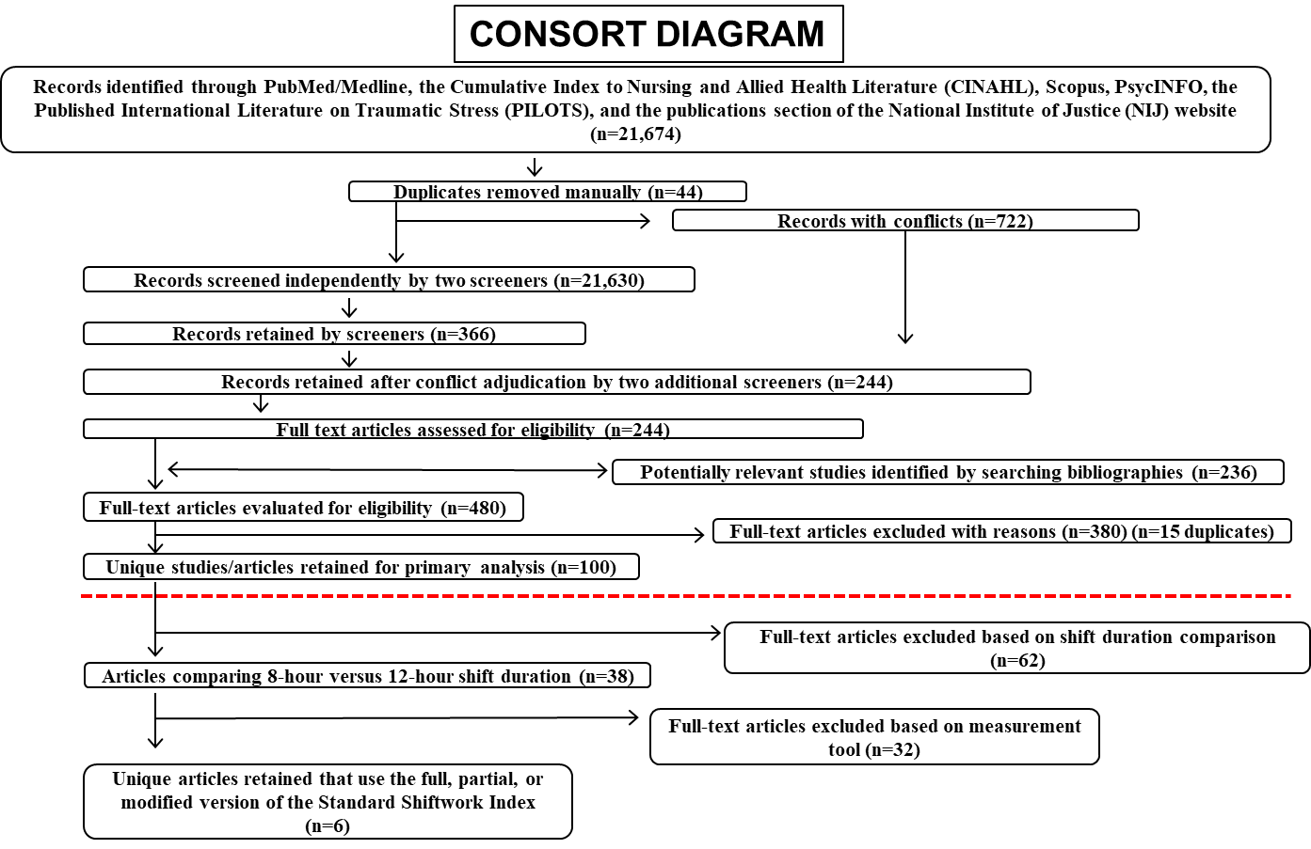

Figure 1: Consort Diagram

Types of participants
We included research that involved people 18 years of age or older who were employed at an institution that used shift work scheduling. Shift work refers to “any arrangement of work hours other than standard daylight hours” (20). Occupations potentially in the analysis included, but was not limited to, health professions such as EMS personnel and nurses, chemical workers, police officers, aviation personnel, and the military. The decision to include all types of shift workers was made because all shift workers are challenged by fatigue in the workplace and increasing generalizability. The primary analysis allowed for the inclusion of studies that had participants either remained on one shift system or where an intervention occurred: changing the shift duration during the study period. If a meta-analysis was performed, it excluded those studies that changed from one system to another (quasi-experimental) and retained those that had their participants remain on one shift system.

Types of interventions
The intervention in this analysis was the use of some iteration of the Standard Shiftwork Index (SSI). For the overall analysis (systematic review), timing of the implementation of the intervention was not specified. Implementation could have been a single administration at a single instance, or at the beginning or end of a certain time frame. During the secondary analysis (meta-analysis) of the retained research studies, the SSI needed to be employed once to shift groups that worked only one type of shift (8-hour or 12- hour; no changeover).

Types of outcome measures
There are 21 specific measures are included in the SSI; this includes 14 outcome measures and 7 moderator variables. The outcome measure can be broadly categorized in four categories: difficulties with sleep, impairment of physical and psychological health, social and domestic disruption, and job satisfaction (19).
Three measures were used under the broad category of “difficulties of sleep”. A new measure of sleep quality/disruption was created for the SSI. It consisted of 11 items and was loosely based on the Telecom Australia “Quality of Life” questionnaire. It consisted of two sections; the first assessed the timing and duration of sleep before and between morning, afternoon, nights and rest days (3 items). The second section measured sleep quality and difficulties associated with each of the shifts worked and rest days using 8 items (19).
Barton et al., 1995 created a new 10 item measure of chronic fatigue because no “pure” measure of chronic fatigue existed. They defined chronic fatigue as “a general tiredness and lack of energy irrespective of whether an individual has not had enough sleep or has been working hard, which persists even on rest days and holidays” (19). It was scored on a 5-point Likert scale and a single total score was computed. A higher score meant having greater feelings of chronic fatigue.
The second broad category of outcome measures formed by Barton et al., 1995 pertained to problems associated with physical and mental health. This group consisted of four questionnaires: Physical Health Questionnaire, General Health Questionnaire, Cognitive-Somatic Anxiety Questionnaire, and Eysenck Personality Inventory.
The Physical Health Questionnaire (PHQ) was created for the SSI because no standardized questionnaire specifically pertained to digestive and cardiovascular problems (19). The questionnaire consisted of two subscales, one each for digestive and cardiovascular symptoms. These two subscales were on a four-point Likert scale with a total score being calculated for each. Furthermore, it included a checklist for medical conditions suffered and medications taken before and since starting shiftwork, three questions regarding health behaviors, and two regarding menstrual cycle disruption. These were all treated as individual items and were not a part of an overall scale (19).
The General Health questionnaire (GHQ) was developed by Goldberg, 1972 to detect minor psychiatric disorders in the general population and gives a single mental health measure over the past few weeks. It is a standardized, self-administered screening test that covers recent levels of self-confidence, depression, sleep loss, and problem solving (19). The SSI used the 12-item, Likert scale version of the GHQ. The higher the computed score indicated poorer psychological health.
The Cognitive-Somatic Anxiety Questionnaire (CSAQ) was developed by Schwartz et al., 1978 to be a measure of trait anxiety (21). CSAQ consists of 14 descriptions of anxiety: seven with cognitive orientation and seven with somatic orientation. The degree of to which each item was experienced was scored on a five-point Likert scale, and total scores were computed for each subscale. The higher scores are being associated with higher levels of cognitive and somatic anxiety (19).
The Eysenck Personality Inventory (EPI) is a 12-item questionnaire that assesses neuroticism and extraversion. EPI originates from a 57-item version of EPI and Maudsley Personality Inventory (22). Six of the items pertained to neuroticism. The responses were scored on a 4-point Likert scale. The six items are summed to give an overall measure of neuroticism, and the higher the score, the higher associated level of neuroticism (19).
The third broad section of outcome measures involved disruption of social and domestic life. This section incorporated the Social and Domestic Survey.
According to Barton et al., 1995, the Social and Domestic Survey was developed for use in the SSI and measures the disruption to social and domestic life experienced as a result of working in a shift system (19). The survey contains 19 items and measure the degree to which individuals are satisfied with the amount of time their shift system for social and domestic activities. Examples of social activities would be sport and hobbies, and domestic activities would be childcare and shopping. The higher the scores on the first 19 items were associated with higher levels of satisfaction. The survey also has three questions relating to the amount of social, domestic, and non-domestic disruption experienced because of shift work. The higher scores from these three questions were associated with higher levels of disruption. All items were measured on a 5-point Likert scale.
The last outcome measure included in the SSI is job satisfaction. Extensive literature exists on the relationship between job satisfaction and mental health (23). The job satisfaction scale used in the SSI originates from the Job Diagnostic Survey created by Hackman and Oldham 1975 (24). Job satisfaction measures the degree to which the employee is satisfied and happy with the job. Job satisfaction was measured using a five-item survey on a 7-point Likert scale. Individual scores were summed to give an overall amount of job satisfaction. The higher the overall measure, the higher the associated job satisfaction. In some studies, some items are reverse coded so that a higher score indicates higher job dissatisfaction.

Search methods for studies
Searches for relevant literature for this sub-analysis originated from (1). A research librarian performed searches of six databases, including five bibliographic databases and one website: PubMed/Medline, the Cumulative Index to Nursing and Allied Health Literature (CINAHL), Scopus, PsycINFO, the Published International Literature on Traumatic Stress (PILOTS), and the publications section of the National Institute of Justice (NIJ) website. The search covered three overarching concepts: emergency medical services and other critical shift-based occupations; fatigue, sleep, and sleep disorders; and multiple variables of shift scheduling (i.e. duration, rotation, rotation speed, recovery time between shifts, number of consecutive shifts, and shift placement (night/day)). Literature from January 1980 to September 2016 were included in the systematic review. Bibliography searches of abstracted literature was also used to capture other literature that fit search criteria.

Data collection

Screening
The primary investigator independently screened titles and abstracts that potentially held relevant information. Retained literature during the screening process must have reported a population of interest, the 8-hour versus 12-hour comparison, and at least one outcome measure of interest.

Full-text review
The primary investigator full-text reviewed the retained cohort of n=38 titles regarding EMS workers or shift workers, 8 versus 12-hour shift duration, and specific outcome measure to assess for any mention of the Standard Shiftwork Index. If the SSI or any modified version of the original SSI was used in the study, all key information was abstracted and placed into Appendix B.
If a meta-analysis is an option for a specific outcome based on the study design and collection methods, the mean; standard deviation, F-value or t-value, and the group sample sizes were abstracted from the primary literature. Three studies did not report the standard deviation. The standard deviation was calculated by taking the square root of the F-statistic reported and inputting this statistic, the difference in means, and sample size of the group into a standard deviation calculator provided by Cochrane Reviews (25).

Analyses
The retained literature was classified by outcome measure. The investigators used a categorical system adopted by Bolster and Rourke to describe the impact of eight-hour shift duration, compared with 12-hour shift durations, on all possible outcome measures and moderator variables that were described in Barton et al., 1995 (26). The result for each outcome measure from each included study was deemed either favorable, unfavorable, mixed/inconclusive, or no impact when comparing of 8-hour shift duration to 12-hours shift duration.
When two or more studies collected their data in the same fashion for a specific outcome, a meta-analysis was performed. We used Review Manager (Revman) software (version 5.3, Copenhagen, Denmark) to calculate the mean difference and standard mean difference (SMD) and 95% confidence intervals (CIs) of a pooled effect (PE) (25). The SMD is the estimated intervention effect of each study relative to the variability in the study. A SMD less than zero indicates that the 12-hour shift duration is more efficacious than the 8-hour shift for a specific outcome. And visa versa. The SMD is non-significant if the corresponding 95% CI is wide and overlaps 0. The I² statistic was calculated as a standard measure of heterogeneity(25). The I² is the percentage of total variation across the included studies related to heterogeneity and not chance. Values range from 0% to 100% with higher values (e.g., >50%) signifying substantial heterogeneity (1). Both fixed and random effects models will be employed based on the level of heterogeneity (I²). All pooled effects models, fixed effects with mean difference, fixed effects with SMD, random effects with mean difference, and random effects model with SMD will be calculated. Because the included studies are observational, proper analyses is controversial. According to the Cochrane reviews handbook and a recent JAMA article on how to report meta-analyses of observational studies, the analyses will be like experimental study analysis protocol. If the heterogeneity between the studies (I²) is higher than 50%, then a random effects model will be used (27, 28). The mean difference or standard mean difference will be used depending on how similar the questionnaire scales were in measuring a specific outcome. If the scales are the same, the mean difference will be used, and if the scales are remotely different or not directly reported, the SMD will be used as the most meaningful model.

Results

Studies Comparing 8-hour vs 12-hour shiftwork using the SSI assessing Job Satisfaction
There are five studies that assess job satisfaction using the SSI. Mitchell et al. 2000 conducted a quasi-experimental study where 27 employees at an electrical power station were given the SSI while working an 8-hour shift schedule (29). The same employees were then changed over to a 1-hour shift system and were assessed again ten months later using the SSI. Mitchell et al., 2000 found no statistical difference in job satisfaction when comparing the scores from the two collection periods. Iskra-Golec et al., 1995 ran a cross-sectional survey study on a total of 126 ICU nurses under 35 years old, without children, that were either working 12-hour shifts or 8-hour shifts (30). They found no statistical significance in job satisfaction when comparing shift durations. Tucker et al. 1996 conducted a cross-sectional survey study on 162 chemical workers (31). There was no significant difference between shift groups when it comes to job dissatisfaction, but the 8-hour group was significantly more satisfied when it came to “Do advantages outweigh disadvantages?” compared to the 12-hour group. Poissonnet et al., 2001 performed a cross-sectional survey on 3,212 head nurse supervisors, head nurses, registered nurses, operating room nurses, anesthesiology nurses, pediatric nurses, nursing auxiliaries, hospital agents, midwives, and full-time physicians from 17 hospitals who worked in internal medicine, geriatrics, general pediatrics, orthopedic and general surgery, obstetrics, anesthesiology, ICU, emergency rooms, and operating rooms (32). Job satisfaction scores were higher among those working 12-hour shifts (various rotations) versus 8-hour shifts (various rotations; p<0.05). Costa et al., 2014 conducted a prospective cohort study on 294 nurses who worked in an ICU or poli-specialistic wards who worked one of three different rotations or durations: 3x8-hour rotation every 5 days with a backwards rotation, three by 8-hour rotation every 6 days with a backwards rotation, or a two by 12-hour rotation every 5 days with a forward rotation. There was no statistical difference between the 8-hour shift groups and the 12-hour shift group. We categorized Poissonnet et al., 2001 as unfavorable. We categorized Mitchell et al. 2000, Iskra-Golec et al., 1995, and Costa et al., 2014 as no impact. Finally, we categorized Tucker et al., 1996 as mixed/inconclusive (Table 2).
A meta-analysis was conducted on three observational studies that assessed job satisfaction. The fixed effects mean difference model yielded a significant pooled mean difference of 1.24 (95% CI 0.23, 2.25) (Figure 2). The chi-square test for heterogeneity yielded an I² of 11%. Thus, 8-hour shift durations were favored regarding jobs satisfaction. The fixed effects model yielded a statistically significant pooled standard mean difference of 0.22 favoring the 8-hour shift duration (95% CI 0.01, 0.42) (Figure 3). The chi square test for heterogeneity yielded an I² of 15%. Figure 3 was considered the most meaningful based on heterogeneity of the studies and the collection method of results. A random effects model yielded a statistically significant mean difference of 1.21 favoring the 8-hour shift duration (95% CI 0.13, 2.29) and had low heterogeneity between studies (I²=11) (Figure 4). Lastly, the random effects model using the standard mean difference had a non-significant pooled effect of 0.21 which again favored the 8-hour shift duration (I²=15%; 95% CI -0.01, 0.43) (Figure 5).

Table 1: Description of Included Studies
Author, Year | RefID#  PMID# | Study Design | Number of Subjects | Population | Setting | Measurement Tool | SSI Outcomes Measured | Scale | Scoring
Mitchell, 2000 | RefID-n/a  PMID-10709754 | Quasi-experimental | N=27 | Employees of the electrical power station that participated in shift work | Electrical power station | Modified version of SSI | Domestic disruption  Nondomestic disruption  Social disruption  Sleep disturbance  Sleep duration  Chronic fatigue  Cardiovascular problems  Digestive problems  Cognitive anxiety  Somatic anxiety  GHQ  Neuroticism | n/a  n/a  n/a  n/a  n/a  n/a  n/a  n/a  n/a  n/a  n/a  n/a | --  --  --  --  --  --  --  --  --  --  --  --
Iskra-Golec, 1996 | RefID-21429  PMID-n/a | Cross-sectional | N=126 | Full-time ICU nurses under 35 years old and without children | Cracovian hospitals, Intensive Care Units | SSI | Digestive Problems  Cardiovascular problems  Psychological ill health  Cognitive Anxiety  Somatic Anxiety  Chronic Fatigue  Job Satisfaction | n/a  n/a  n/a  n/a  n/a  n/a  n/a | 8-32  8-32  0-24  7-35  7-35  10-50  5-35
Tucker, 1998 | RefID-n/a  PMID-9916817 | Cross-sectional | N=862 | Industrial shift workers | 17 manufacturing and engineering companies in the UK | Revised version of the SSI. The Survey of Shiftwork (SOS) | Sleep Duration (4 comparisons)  Sleep Disruption (4 comparisons)  Chronic Fatigue  GHQ (mental health)  Neuroticism  Digestive problems  Cardiovascular problems  Leisure interference  Domestic interference  Nondomestic interference | Total hours  5 items  3 items  12 items  6 items  8 items  8 items  1 item  1 item  1 item | --  --  --  --  --  --  --  --  --  --
Tucker, 1996 | RefID-n/a  PMID-9038802 | Cross-sectional | N=162 | Male Chemical Workers | n/a | Modified Version of SSI: | Psychological Ill Health (GHQ)  Neuroticism  Gastrointestinal complaints  Cardiovascular Complaints  Social Disruption  Domestic Disruption  Non-domestic Disruption  Sleep Duration (4 comparisons)  Sleep Disturbance (4 comparisons) | 12 items†  6 items&  n/a&  n/a&  1 item  1 item  1 item  3 items#  8 items$ | --  --  --  --  --  --  --  --  --
Poissonnet,  2001 | RefID-11537  PMID-14564913 | Cross-sectional | N=3212 | A variety of nurses and physicians working in 17 hospitals. | Assistance Publique – Hopitaux de Paris (public hospital system of the city of Paris, France) | SSI | Gastrointestinal complaints  Cardiovascular complaints  GHQ  Job satisfaction | n/a&  n/a&  12 items†  5 items* | --  --  --  --
Costa,  2014 | RefID-5711  PMID-25216205 | Prospective cohort | N=294 | Nurses | Milano, Italy | SSI | Job Satisfaction  Home/work conflict  Digestive troubles  Cardiovascular troubles  Sleep troubles  Minor psychic disorders (GHQ)  Social Impairment  Neuroticism | n/a  n/a  n/a  n/a  n/a  n/a  n/a  n/a | 12-35  3-15  8-32  8-32  24-120  2-31  3-15  6-24
If items or scores were not reported in original text, a “—” was placed in the table. #= Scored by computing mean sleep duration; $=scored on a five-point Likert scale; &= four-point Likert Scale; *= 7 point Likert Scale; †= 4 response options
Table 1 Continued

Studies Comparing 8-hour vs 12-hour shiftwork using the SSI assessing Cognitive Anxiety
There are two studies that assess cognitive anxiety using the SSI. Mitchell et al. 2000 found no statistical difference between 8-hour and 12-hour shift groups. When Iskra-Golec et al., 1995 compared 12-hour shift nurses to 8-hour nurses, the 12-hour group experienced more cognitive anxiety (p<0.05). We categorized Iskra-Golec et al., 1996 as favorable. We categorized Mitchell et al., 2000 as no impact (Table 2).

Studies Comparing 8-hour vs 12-hour shiftwork using the SSI assessing Somatic Anxiety
There are two studies that assess somatic anxiety using the SSI. Mitchell et al. 2000 found there was no statistical difference between 8-hour and 1-hour shift groups regarding somatic anxiety. Iskra-Golec et al., 1995 also found no statistical difference in somatic anxiety between 8-hour and 12-hour shift groups. We categorized Iskra-Golec et al., 1996 and Mitchell et al., 2000 as no impact (Table 2).

Studies Comparing 8-hour vs 12-hour shiftwork using the SSI assessing Psychological Well-being:
There are six studies that assess psychological well-being using the General Health Questionnaire: a subset of the SSI. Mitchell et al., 2000; Iskra-Golec et al., 1996; Costa et al., 2014; and Tucker et al. 1996 found that there was no statistical difference between the two different shift systems. Tucker et al., 1998 conducted a cross sectional survey study on a total of 862 industrial shift workers from 17 manufacturing and engineering companies in the UK (33). There were three distinct groups apart of the study. One of the 12-hour groups worked two days or nights on, then two days off; The second 12-hour group worked 2 days, 2 nights, and then had four days off. Finally, an 8-hour group the worked a 2-2-3 combination of days, evenings, and nights. All participants were surveyed once. Tucker et al., 1998 found 12-hour workers reported better psychological well-being compared to 8-hour (p<0.001). Poissonnet et al., 2001 found high level of well-being in 12-hour fixed as well as rotating systems but low levels of well-being in 8-hour rotating (p<0.001).
We categorized Tucker et al., 1998 and Poissonnet et al., 2001 as unfavorable. We categorized Mitchell et al., 2000, Iskra-Golec et al., 1996, Tucker et al. 1996, Costa et al., 2014 as no impact (Table 2).
A meta-analysis was performed on the 5 observational studies that assessed psychological well-being with the GHQ. The fixed effects model using the mean difference measured a non-significant pooled effect of -0.11 (95% CI -0.22, -0.00) and an I² of 56% (Figure 6). The fixed effects model using the SMD yielded a non-significant pooled effect of -0.11 (I²=38%; 95% CI -0.22, -0.00) (Figure 7). This model had a heterogeneity chi-square of I²=38% (Figure 7). Figure 7 was considered the most meaningful based on heterogeneity of the studies and the collection method of results. When we employed the random effects model due to the moderate heterogeneity, the mean difference pooled effect was not significant; showing no difference between shift durations (I²=56%; PE -0.29; 95%CI -1.09, 0.52) (Figure 8). When the standard mean difference was used, the pooled effect remained not statistically significant (I²=38%; PE -0.09; 95% CI -0.25, 0.07) (Figure 9).

Studies Comparing 8-hour vs 12-hour shiftwork using the SSI assessing Neuroticism
Three studies assessed neuroticism using the SSI. Mitchell et al., 2000 found no statistical difference between the two separate collection periods. Tucker et al. 1996 found no statistical difference between the two shift systems. Costa et al., 2014 discovered no statistical difference in neuroticism between the 8-hour shift groups and the 12-hour shift group. All three studies were categorized as no impact (Table 1).
The heterogeneity between studies was high (I²=84%) (Figure 10). The fixed effects model using the mean difference resulted in a non-significant pooled effect of 0.29 which indicates no difference between shift durations (95%CI -0.53, 1.10) (Figure 10). The fixed effects model using the SMD also yielded a non-significant difference between shift durations for neuroticism (I²=84%; PE 0.01; 95% CI -0.24, 0.25) (Figure 11). A random effects model was employed and the mean difference resulted in a non-statistically significant pooled effect (I²=84%; PE 0.09; 95% CI -1.95, 2.14) (Figure 12). When the random effects model and the SMD are used, the pooled effect is not statistically significant (PE 0.07; 95% CI -0.55, 0.69) (Figure 13). Figure 13 was considered the most meaningful based on heterogeneity of the studies and the collection method of results.

Studies Comparing 8-hour vs 12-hour shiftwork using the SSI assessing Digestive problems
There are six studies that assess digestive problems using the standard shiftwork index. Mitchell et al., 2000 found no statistical difference in digestive problems between the two separate collection periods. Iskra-Golec et al., 1996 found no statistical difference in digestive problems when comparing the two shift systems. Tucker et al., 1998 found no statistical difference in digestive problems between the 12-hour groups and the 8-hour group. Tucker et al. 1996 also found no statistical difference between the 12-hour system group and the 8-hour system group. Poissonnet et al., 2001 found fewer reports of gastrointestinal complaints among those working various 12-hour shift types compared to various 8-hour shift types (p<0.05). Costa et al., 2014 discovered there was no statistical difference in self-reported digestive problems between the 8-hour shift groups and the 12-hour shift group. We categorized all studies as no impact except Poissonnet et al., 2001 which was considered unfavorable (Table 2).
Low heterogeneity was found between the five observational studies that assessed digestive troubles (I²=0). A fixed effects model using the mean difference was employed and resulted in no statistical difference between shift durations (PE 0.04; 95% CI -0.49, 0.56) (Figure 14). The fixed model using the SMD had a similar non-significant result (PE 0.01; 95% CI -0.10, 0.12) (Figure 15). In this model the heterogeneity remained low (I²=0). Figure 15 was considered the most meaningful based on heterogeneity of the studies and the collection method of results. The random effects model using the mean difference for pooled effects found no statistical difference between shift durations (I²=0%; PE 0.04; 95% CI -0.49, 0.56) (Figure 16). Lastly, the random effects model using the SMD found no statistical difference between shift durations (I²=0%; PE 0.01; 95% CI -0.10, 0.12) (Figure 17).

Studies Comparing 8-hour vs 12-hour shiftwork using the SSI assessing Cardiovascular Problems
There are six studies that assess self-reported problems using the standard shiftwork index. Mitchell et al., 2000 found no statistical difference in self-reported cardiovascular problems between the two separate collection periods. Iskra-Golec et al., 1996 found no statistical difference in digestive problems when comparing the two shift systems. Tucker et al., 1998 found less self-reported cardiovascular problems among the 8-hour shift group compared to the 12-hour shift group (p<0.05). Tucker et al., 1996 reported that their 8-hour group reported more cardiovascular disease than the 12hr shift workers (P<0.05). Poissonnet et al., 2001 found fewer reports of cardiovascular complaints among those working various 12-hour shift types compared to various 8-hour shift types (p<0.05). Costa et al., 2014 found no statistical difference in self-reported cardiovascular problems between the 8-hour shift groups and the 12-hour shift group. We deemed Mitchell et al., 2000, Iskra-Golec et. al., 1996, and Costa et. al., 2014 as no impact. We deemed Tucker et. at. 1998 as favorable towards 8-hour shifts. Lastly, we considered Tucker et al., 1996 and Poissonnet et al., 2001 as unfavorable towards 8-hour shifts (Table 2).
The meta-analysis was performed on the five observational studies that had cardiovascular problems as an outcome. In the fixed effects model using the mean difference there was high heterogeneity (I²=83%) (Figure 18). The model found no statistical difference in cardiovascular problems between shift durations (PE -0.26; 95% CI -0.64, 0.11) (Figure 18). A fixed effects model using the SMD had high heterogeneity (I²=79%) and found no statistical difference between shift durations regarding cardiovascular problems (PE-0.01; 95% CI -0.13, 0.10) (Figure 19). The random effects mean difference model showed no significant difference between the shift durations with respect to cardiovascular problems (I²=%83; PE -0.55; 95% CI -1.59, 0.48) (Figure 20). Similarly, the random effects model using the standard mean difference showed no statistical difference between shift durations (PE -0.15; 95% CI -0.43, 0.13; I²=79%) (Figure 21). Figure 21 was considered the most meaningful based on heterogeneity of the studies and the collection method of results.

Studies Comparing 8-hour vs 12-hour shiftwork using the SSI assessing Social Disruption
There are 5 studies that assess social disruption using the SSI. Mitchell et al., 2000 found employees on the 12-hour roster were more satisfied with their social situation when compared to their time on the 8-hour shift system (t₍₂₅₎= -2.62, p<0.015). Iskra-Golec et al., 1996 stated that satisfaction with social activities were much higher in the 12-hour shift group compared to the 8-hour group, yet no p-value indicating significance was given. Tucker et al., 1998 found the 12-hour shift workers reported less interference with leisure time than the 8-hour workers (p<0.001, F=13.55). Tucker et al. 1996 found that the 8-hour group reported more disruption to their social life compared to 12hr workers (F=7.75, p<0.01). Costa and colleagues found no statistical difference in social impairment.
We concluded that Mitchell et al., 2000; Iskra-Golec et al., 1996; Tucker et al., 1996; and Tucker et al., 1998 as unfavorable for social disruption towards 8-hour shifts. Costa et al., 2014 was considered no impact (Table 2).
The meta-analysis was performed on the four observational studies that assessed social disruption. The fixed effects model using the mean difference had a high degree of heterogeneity (I²=79%), was found to be statistically significant favoring the 12-hour shift duration (PE -0.44; 95% CI -0.62, -0.25) (Figure 22). The fixed model with SMD was statistically significant favoring the 12-hour shift (I²=87%; PE -0.21; 95% CI -0.33, -0.09) (Figure 23). A random effects model was employed using the mean difference. There was high heterogeneity (I²=79%) and the pooled effect was statistically significant favoring the 12-hour shift (PE -0.44; -0.62, -0.25) (Figure 24). Lastly, the random effects model using the SMD favored the 12-hour shift duration regarding social disruption (I²=87%; PE -0.21; -0.33, -0.09) (Figure 25). Figure 25 was considered the most meaningful.

Studies Comparing 8-hour vs 12-hour shiftwork using the SSI assessing Domestic Disruption
There were four studies that assessed domestic disruption using the SSI. Mitchell et al., 2000 discovered there was no significant difference between assessment periods. Iskra-Golec et al., 1996 stated that satisfaction with domestic activities were much higher in the 12-hour shift group compared to the 8-hour group, yet no p-value indicating significance was given. Tucker et al., 1998 found no significant differences in self-reported domestic disruption between the three groups. Finally, Tucker et al., 1996 found no statistical difference in self-reported domestic disruption.
We categorized Mitchell et al., 2000 and Iskra-Golec et al., 1996 as unfavorable towards 8-hour shifts in regard to self-reported domestic disruption. We categorized Tucker et al., 1998 and Tucker et al., 1996 no impact of shift duration on self-reported domestic disruption (Table 2).
Three observational studies were included in the meta-analysis assessing the pooled effect of shift duration of domestic disruption. The fixed effects model using the mean difference yielded a nonsignificant difference between shift durations (I²=85%; PE -0.06; 95% CI -0.18, 0.06) (Figure 26). The fixed effects model using the SMD again resulted in a non-statistically significant result showing no difference between shift durations on domestic disruption (I²=85%; PE 0.03; 95% CI -0.10, 0.16) (Figure 27). A random effects model using the mean difference showed no significant difference between shift durations on domestic disruption (I²=85%; PE 0.11; 95% CI -0.84, 1.07) (Figure 28). Lastly, a random effects model using the SMD resulted in no statistical difference between shift durations (I²=85%; PE 0.15; 95% CI –0.33, 0.64) (Figure 29). Figure 29 was considered the most meaningful based on heterogeneity of the studies and the collection method of results.

Studies Comparing 8-hour vs 12-hour shiftwork using the SSI assessing Non-Domestic Disruption
There are three studies that assess non-domestic disruption using the SSI. Mitchell et al., 2000 found no statistical difference between the shift systems for self-reported non-domestic disruption. Tucker et al., 1998 found no significant differences in self-reported non-domestic disruption between the three groups. Tucker et al., 1996 found no statistical difference in self-reported non-domestic disruption. We categorized all three studies showing no impact of shift duration on non-domestic disruption (Table 2).
A meta-analysis was not performed on the two observational studies because one of the studies had the same mean for the two shift durations. Thus, the standard deviations could not be calculated for that study, and the whole pooled effects analysis could not be completed.

Studies Comparing 8-hour vs 12-hour shiftwork using the SSI assessing Sleep Duration
There are three studies that assess sleep duration using the SSI. According to Iskra-Golec et al., 1996, nurses working 12-hour shifts and nurses working 8-hour shift reported no significant difference in regard to duration of sleep. Tucker et al., 1998 found there are some significant differences in sleep duration between the two shift systems while others are not significant. The comparisons of 8-hour morning shift to 12-hour day shift, 8-hour afternoon shift to 12-hour day shift, “Before last night”, and “night” shifts were all statistically significant. The comparisons of “after last night” and “Rest days” were not statistically significant. Tucker et al. 1996 conducted a cross-sectional survey study on two groups of chemical workers: one on a 12-hour shift system, one on an 8-hour system. A total of 162 workers filled out the one-time questionnaire and returned it. Durations of sleep reported by the 12-day shift was significantly longer than the 8-hour morning shift, but shorter than those by the 8-hour afternoon shift (F=34.10, p<0.001; F=25.19, p<0.001). The was no significant difference between the two groups on their night shifts and when comparing their rest days. There was a significant difference in sleep duration when comparing 12-hour night shift and 8-hour afternoon shift (F=36.15, p<0.001).
We considered Iskra-Golec et al., 1996 as no impact. Both Tucker et al., 1998 and Tucker et al., 1996 were deemed mixed/inconclusive (Table 2).
The meta-analysis of sleep duration was stratified by specific shift comparisons: 8-hour morning shift versus 12-hour day shift, 8-hour afternoon shift versus 12-hour day shift, 8-hour night shift versus 12-hour night shift, and 8-hour rest day versus 12-hour rest day. Two observational studies were similar on design and outcome collection and were included in all analyses.
A fixed effects model using the mean difference found sleep duration to favor the 8-hour morning shift compared to the 12-hour day shift (I²=91%; PE 0.44; 95% 0.30, 0.59) (Figure 30). The fixed effects model using the SMD found similar statistically significant results (I²=92%; PE 0.37; 95% CI 0.24, 0.50) (Figure 31). The random effects model using the mean difference assessed the comparison between 8-hour morning shift and 12-hour day shift was found to be significant, favoring the 8-hour morning shift (I²=91%; PE 0.58; 95% CI 0.01, 1.14) (Figure 32). In contrast, the random effects model using the SMD found no statistical difference between shift duration regarding sleep duration (I²=92; PE 0.57; 95% CI -0.07, 1.22) (Figure 33). Figure 33 was considered the most meaningful based on heterogeneity of the studies and the collection method of results.
When assessing sleep duration between 8-hour afternoon shift and the 12-hour day shift, the fixed effects model using the mean difference found sleep duration to strongly favor the 12-hour shift (I²=60; PE -1.93; 95% CI -2.13, -1.74) (Figure 34). The fixed effects model using the SMD yielded a similar result (I²=85; PE -1.30; 95% CI -1.45, -1.16) (Figure 35). The comparison of the 8-hour afternoon shift and 12-hour day shift was assessed using the random effects mean difference model and the result showed a significant difference between shifts: favoring the 12-hour day shift (I²=60%; PE -2.13; 95% CI -2.80, -1.47) (Figure 36). The random effects model using the SMD found a similar significant result; sleep duration is higher in the 12-hour day shift (I²=85%; PE -1.18; 95% CI -1.64, -0.72) (Figure 37). Figure 37 was considered the most meaningful based on heterogeneity of the studies and the collection method of results.
A fixed effects model using the pooled mean difference compared sleep duration between 8-hour night shift and 12-hour night shift and found that the pooled effect significantly favored the 8-hour night shift (I²=0; PE 0.46; 95% CI 0.26, 0.66) (Figure 38). In other words, sleep duration was higher in the 8-hour shift duration. A fixed effects model using the SMD showed a similar result; self-reported sleep duration was higher (favored) in the 8-hour shift (I²=0%; PE 0.31; 95% 0.18, 0.44) (Figure 39). Additionally, the 8-hour night shift was favored over the 12-hour night shift using a random effects model with the mean difference (I²=0%; PE 0.46; 95% CI 0.26, 0.66) (Figure 40). The random effects model using the SMD resulted in a similar finding (I²=0%; PE 0.31; 95% CI 0.18, 0.44) (Figure 41). Figure 41 was considered the most meaningful based on heterogeneity of the studies and the collection method of results.
The rest days were compared between the two shift durations to assess sleep duration. The fixed effects model using the mean difference found no significant difference between shift durations on sleep duration (I²=0%; PE 0.03; 95% CI -0.18, 0.24) (Figure 42). It remained non-significant for the other three models (Figures 43-45). Figure 45 was considered most meaningful.

Studies Comparing 8-hour vs 12-hour shiftwork using the SSI assessing Sleep Disruption/Quality
There are five studies that assess sleep disturbance or sleep quality using the SSI. Mitchell et al., 2000 found no statistical difference between the shift systems for self-reported sleep disturbances in dayshift, nightshift, or rest periods. Iskra-Golec et al., 1996 discovered nurses working 12-hour shifts reported significantly worse general sleep quality and felt more tired compared to nurses working 8-hour shifts (p<0.01, F=10.35; p<0.05, F=3.68). Tucker et al., 1998 found 12-hour workers experienced less sleep disruptions compared to 8hr shifts for the 8-hour afternoon vs 12-hour day shift and 8-hour night shift vs 12-hour night shift comparisons (p<0.001, p<0.01; F=98.8, 7.53 respectively). Tucker et al., 1998 found no statistical difference in sleep disruptions in the 8-hour morning shift vs 12-hour day shift and rest day comparisons. Tucker et al., 1996 found when working on the day shift, the 12-hour group reported better quality and less disturbed sleep than the 8-hour group working the morning shift, although after controlling for the average number of hours worked a week, the analysis did not reach significance. The 12-hour days group, reported significantly poorer quality and more disturbed sleep than the 8-hour afternoon shift after controlling for average number of hours worked a week (F=11.05, p<0.01). The 12-hour night group reported significantly poorer quality and disturbed sleep when compared to the 8hr afternoon shift after controlling for average number of hours worked a week (F=22.45, p<0.001). There was no significant difference when comparing the two-night shift groups and between the groups on rest days. Costa et al., 2014 found no statistical difference between shift groups and self-reported sleep disturbance.
We categorized Iskra-Golec et al., 1996 as favorable for 8-hour shifts in regard to sleep disruption. We decided both Tucker et al., 1998 and Tucker et al., 1996 were mixed/inconclusive results on the association between shift duration and sleep disruption. We categorized Mitchell et al., 2000 and Costa et al., 2014 as no impact on the association between shift duration and sleep disruption (Table 2).
The meta-analysis of sleep disruption was stratified by specific shift comparisons: 8-hour morning shift versus 12-hour day shift, 8-hour afternoon shift versus 12-hour day shift, 8-hour night shift versus 12-hour night shift, and 8-hour rest day versus 12-hour rest day. Two observational studies were similar in design and outcome collection and were included in all analyses. A fixed effects model using the mean difference found no significant difference in sleep disruption between 8-hour morning shift and 12-hour day shift (I²=62%; PE -0.11; 95% CI -0.27, 0.05) (Figure 46). Additionally, a fixed effects model using the SMD found no significant difference (I²=5%; PE -0.12; 95% CI -0.25, 0.01) (Figure 47). A random effects model using the mean difference was used for the comparison between the morning 8-hour shift and the 12-hour day shift duration assessing sleep disruption. The pooled effect was not statistically significant (I²=62%; PE -0.60; -2.05, 0.85) (Figure 48). Lastly, the random effects model with the SMD was not significant (I²=5%; PE -0.13; 95% CI -0.27, 0.01) (Figure 49). Figure 49 was considered the most meaningful based on heterogeneity of the studies and the collection method of results.
For the 8-hour afternoon versus 12-hour day shift comparison, the fixed effects model using the mean difference was found to statistically higher sleep disruption in the 8-hour afternoon shift over the 12-hour day shift (I²=85%; PE 0.61; 95% CI 0.49, 0.73) (Figure 50). The fixed effects model using the SMD showed those responding to the questionnaire to report higher sleep disruption in 8-hour afternoon shift compared to the 12-hour day shift (I²=31%; PE 0.70; 95% CI 0.57, 0.84) (Figure 51). The random effects model with the mean difference showed no statistical difference in sleep disruption between shift durations (I²=85%; PE 1.54; 95% CI -0.59, 3.67) (Figure 52). Lastly, the random effects model with the SMD found sleep disruption significantly favored the 8-hour afternoon shift compared to the 12-hour day (I²=31%; PE 0.68; 95% CI 0.49, 0.87) (Figure 53). Figure 53 was considered the most meaningful based on heterogeneity of the studies and the collection method of results.
A fixed effects model using the mean difference was used to assess self-reported sleep disruption between 8-hour night shift and 12-hour night shift. The model found that sleep disruption was significantly higher in the 12-hour duration up compared to the 8-hour shift disruption (I²=96%; PE -0.17; 95% CI -0.31, -0.03) (Figure 54). A fixed effects model using the standard mean difference assessed the same comparison and found no statistical differences between groups (I²=96%; PE -0.04; 95% -0.17, 0.09) (Figure 55). When using the random effects model using the mean difference, there was no statistical difference between shift disruption (I²=96%; PE 2.05; 95% CI -2.54, 6.63) (Figure 56). The random effects model with the SMD also did not reach significance (I²=96%; PE 0.26; 05% CI -0.67, 1.19) (Figure 57). Figure 57 was considered the most meaningful based on heterogeneity of the studies and the collection method of results.
Four statistical models were employed to compare sleep disruption between the 8-hour rest day measure and the 12-hour rest day measure. Because the SDs were not reported for one of the two studies in the analysis and in conjunction with that same study having the same mean point estimates for both shift durations, the pooled analysis was not calculated.

Studies Comparing 8-hour vs 12-hour shiftwork using the SSI assessing Chronic Fatigue
There are four studies assessing chronic fatigue using the SSI. Mitchell et al., 2000 found no statistical difference between shift periods when assessing self-reported chronic fatigue. Iskra-Golec et al., 1996 found 12-hour shift nurses, when compared to 8-hour nurses, experienced more chronic fatigue (p<0.01, F=6.75). Tucker at al., 1998 found that 12-hour shift workers reported lower levels of chronic fatigue compared to 8-hour shift workers (p<0.05 F=5.62). Tucker et al., 1996 found no statistical difference between shift durations regarding self-reported chronic fatigue.
We categorized Iskra-Golec as favorable for 8-hour shifts when assessing self-reported chronic fatigue. We categorized Tucker et al., 1998 as unfavorable for 8-hour shifts when looking at self-reported chronic fatigue. Lastly, we deemed Mitchell et al., 2000 and Tucker et al., 1996 having no impact on chronic fatigue when comparing the two shift durations (Table 2).
Three observational studies were included in the meta-analysis. The fixed effects mean difference model yielded a significant difference between 8-hour and 12-hour shifts where the 12-hour shift is favored (I²=76%; PE -0.20; 95% CI -0.36, -0.03) (Figure 62). When the SMD is used in a fixed effects model, there is no significant difference between shift durations (I²=81%; PE -0.11; 95% CI -0.24, 0.01) (Figure 63). A random effects model with mean difference was used to assess the pooled effects of 8-hour versus 12-hour shift duration on chronic fatigue. This model yielded no difference between shift durations and continued to have high heterogeneity (I²=76%; PE 0.22; 95% CI -1.07, 1.5) (Figure 64). Figure 64 was considered the most meaningful based on heterogeneity of the studies and the collection method of results. Lastly, the random effects mode with the SMD yielded no statistical difference between durations (I²=81%; PE 0.01; -0.36, 0.39) (Figure 65).

Table 2: Outcome Summary Table
Comparing 8-hour versus 12-hour shifts
 |  |  | Outcome Variables for the SSI
 |  |  | Job Satisfaction Scale | Cognitive-Somatic Anxiety Questionnaire |  | General Health Questionnaire | Eysenck Personality Inventory | Physical Health Questionnaire
Author, Year | RefID#  PMID# | Study Design | Job Satisfaction | Cognitive Anxiety | Somatic Anxiety | Psychological Well-being | Neuroticism | Digestive Problems | Cardiovascular Problems
Mitchell, 2000 | RefID-n/a  PMID-10709754 | Quasi-experimental  N=27 | No Impact | No Impact | No Impact | No Impact | No Impact | No Impact | No Impact
Iskra-Golec, 1996 | RefID-21429  PMID-n/a | Cross-sectional  N=126 | No Impact | Favorable | No Impact | No Impact | -- | No Impact | No Impact
Tucker, 1998 | RefID-n/a  PMID-9916817 | Cross-sectional  N=862 | -- | -- | -- | Unfavorable | -- | No Impact | Favorable
Tucker, 1996 | RefID-n/a  PMID-9038802 | Cross-sectional  N=162 | Mixed/Inconclusive | -- | -- | No Impact | No Impact | No Impact | Unfavorable
Poissonnet,  2001 | RefID- 11537  PMID-14564913 | Cross-sectional  N=3212 | Unfavorable | -- | -- | Unfavorable | -- | Unfavorable | Unfavorable
Costa,  2014 | RefID-5711  PMID-25216205 | Prospective cohort  N=294 | No Impact | -- | -- | No Impact | No Impact | No Impact | No Impact

Table 3: Outcome Summary Table Continued
 |  |  | Outcome Variables for the SSI
 |  |  | Social and Domestic Survey |  |  | Sleep Quality and Disturbance Questionnaire
Author, Year | RefID#  PMID# | Study Design | Social Disruption | Domestic Disruption | Non-Domestic Disruption | Sleep Duration | Sleep Disturbance/Quality | Chronic Fatigue
Mitchell, 2000 | RefID-n/a  PMID-10709754 | Quasi-experimental  N=27 | Unfavorable | Unfavorable | No Impact | -- | No Impact | No Impact
Iskra-Golec, 1996 | RefID-21429  PMID-n/a | Cross-sectional  N=126 | Unfavorable/Inconclusive | Unfavorable/inconclusive | -- | No Impact | Favorable | Favorable
Tucker, 1998 | RefID-n/a  PMID-9916817 | Cross-sectional  N=862 | Unfavorable | No Impact | No Impact | Mixed/Inconclusive | Mixed/ Inconclusive | Unfavorable
Tucker, 1996 | RefID-n/a  PMID-9038802 | Cross-sectional  N=162 | Unfavorable | No Impact | No Impact | Mixed/Inconclusive | Mixed/Inconclusive | No impact
Poissonnet,  2001 | RefID-11537  PMID-14564913 | Cross-sectional  N=3212 | -- | -- | -- | -- | -- | --
Costa,  2014 | RefID-5711  PMID-25216205 | Prospective cohort  N=294 | No Impact | -- | -- | -- | No Impact | --

Discussion
All models were consistent showing that the 12-hour shift duration is favored when it comes to social disruption (Figure 25). The high heterogeneity and variation in collection made the random effects with SMD the most meaningful model. This result is consistent in nearly all studies that assessed social disruption regardless of study design (29, 34). Intuitively this makes sense because the longer shifts would allow for an extra day of leisure away from work.
The random effects model using the SMD found a similar significant result; sleep duration is higher in the 12-hour day shift compared to the 8-hour afternoon shift (I²=85%; -1.18; 95% CI -1.64, -0.72) (Figure 37). This result if intuitive because the shift worker must sleep more prior to going and working the 12-hour shift. Similarly, the random effects model using the SMD resulted in a similar finding; favoring the 8-hour night shift duration (I²=0%; 0.31; 95% CI 0.18, 0.44) (Figure 41). This result makes sense because it allows workers to sleep or nap for four more hours into the evening.

Table 4: Summary of Pooled Effects
Outcome | Figure # | Number of Studies | Pooled Effect | 95% Confidence Intervals | Heterogeneity (I²) (%) | Standard Mean Difference Used? | Random Effects Used?
Job Satisfaction | 3 | 3 | 0.22 | 0.01, 0.42 | 15 | Yes | No
Psychological Well-being (GHQ) | 7 | 5 | -0.11 | -0.22, -0.00 | 38 | Yes | No
Neuroticism | 13 | 2 | 0.07 | -0.55, 0.69 | 84 | Yes | Yes
Digestive Problems | 15 | 5 | 0.01 | -0.10, 0.12 | 0 | Yes | No
Cardiovascular Problems | 21 | 5 | 0.19 | -0.43, 0.13 | 79 | Yes | Yes
Social Disruption | 25 | 4 | -0.21 | -0.33, -0.09 | 87 | Yes | No
Domestic Disruption | 29 | 3 | 0.15 | -0.33, 0.64 | 85 | Yes | Yes
Sleep Duration (M vs D) | 33 | 2 | 0.57 | -0.07, 1.22 | 92 | Yes | Yes
Sleep Duration (A vs D) | 37 | 2 | -1.18 | -1.64, -0.72 | 85 | Yes | Yes
Sleep Duration (N vs N) | 41 | 2 | 0.31 | 0.18, 0.44 | 0 | Yes | Yes
Sleep Duration (R vs R) | 45 | 2 | 0.03 | -0.10, 0.16 | 0 | Yes | Yes
Sleep Disruption (M vs D) | 49 | 2 | -0.13 | -0.27, 0.01 | 5 | Yes | Yes
Sleep Disruption (A vs D) | 53 | 2 | 0.68 | 0.49, 0.87 | 31 | Yes | Yes
Sleep Disruption (N vs N) | 57 | 2 | 0.26 | -0.67, 1.19 | 96 | Yes | Yes
Chronic Fatigue | 64 | 3 | 0.22 | -1.07, 1.50 | 76 | No | Yes
Table 4. Overview of most meaningful pooled effects analyses from meta-analyses based on heterogeneity and similarity level of outcome collection between studies. If standard mean difference was not used, then a mean difference statistic was employed. If a random effects model was not used, the fixed effect analysis was reported in this table.

However, we cannot disregard the few significant findings from this study: especially how study participants favored the 12-hour shift due to less social disruption. Shift workers overwhelmingly preferred extending the shift 4 hours for the reduction in how many days they had to come into work. Not only did it cut down work itself, but it cut down on the frequency of traveling and subsequently reducing travel times. It takes the average worker 25.1 minutes to get to work (35). Thus, commuting to and from work takes up nearly 1 hour of the day.
The outcomes that were nonsignificant were psychological well-being, neuroticism, digestive complaints, cardiovascular problems, domestic description, sleep disruption comparing 8-hour morning shift and 12-hour day shift, comparing sleep disruption between 8-hour afternoon shift and 12-hour day shift, sleep disruption between the 8-hour night shift and 12-hour night shift, sleep disruption between 8-hour rest day and 12-hours today, sleep duration between eight hour morning shift and 12-hour day shift, sleep duration between 8-hour rest day and 12-hour rest day, and chronic fatigue. The sleep duration and disruption comparisons used a random effect model with a standard mean difference due to the high heterogeneity and difference in scoring. The other outcomes varied based on the heterogeneity, but all used the standard mean difference because the differences in measurement.
It is difficult to pinpoint one exact reason why these outcomes were or were not significant, but it sheds light upon the fact that, even with pooled quantitative measurements, the controversy as to which shift duration is more favorable is still debated. The comparison between the two shifts has been ongoing for over 30 years (36). Fortunately, the question has been addressed in different ways, including large systematic reviews encompassing the extent of literature base (1, 37). In the past, authors have pointed out that 8-hour and 12-hour shifts could be present different problems based on the populations studied which could have lead to the current meta-analysis showing no significant differences in these outcomes. (38). The preferences of shift duration could be based on merely demographic differences: age, sex, dependents, and or household duties as examples (38). Costa et al., 2014 recommends to consider the contextuality of the situation and try to balance the ergonomics of shift durations with the social preferences of the shift workers themselves (39). Mitchell et al., 2000 recommends weighing the pros and cons based on comparing other more critical outcomes like work-related errors to measures of fatigue and well-being (29).
The path forward needs to address three areas of consideration when attempting to optimize shift scheduling. First, the shift system should be optimized to the work at hand. For each specific job or profession (i.e. nursing, plant workers, police officers, etc.) there needs to be observational and experimental research continued in their specific field. Specifically, there needs to be further cost-benefit analyses comparing the two shift durations. Through the systematic review process, Patterson et al., 2017 retained only one study that assessed cost to the system, a broad metric that could be considered as a part of a cost-benefit analysis. The study, Smith et al., 1998, compared 8-hour and 12-hour shift durations at three sewage plants in Sydney, Australia. The plants started on 8-hour shift schedule and then changed over to a 12-hour system. When this occurred, plant 2 reduced overtime by 47% when the 12-hour shift was introduced and plant 3 showed a 60% reduction with 12-hour shifts (40).
Secondly, with shift workers preferring the 12-hour shift due to less social disruptions, it is important to further explore. Stronger study designs such as quasi-experimental studies and randomized control trials should assess the specific association between social disruption and outcomes such as job performance and error rates while comparing shift durations. Using metrics beyond self-reported questionnaires would reduce the potential bias from self-reports and reduce heterogeneity in results. A global definition of social disruption would make it pooled analyses much stronger.
Lastly, when it comes to employers optimizing their company by using a specific shift system, it is imperative to prioritize their outcomes. If not all outcomes resolutely preference one shift duration, the outcomes need to be prioritized. In other words, if their main goal is to keep their personnel and patients safe, they must hold metrics recording said outcomes above others. If safety is not a concern and they want their employees to be satisfied with both their job and their time off, measures like job satisfaction and social disruption should be more favored. From the findings in this study, only fatigue and fatigue related measures were recorded, and these findings should be incorporated into the conversation as evidence as to aiding employers and administrators to make decisions. In the case of Patterson et al., 2017, a committee was created in the prioritization of the outcomes that were sought. Patient and personnel safety were held to be more important than the others (1).
There are strengths to the study. The findings from this meta-analysis are important due to the high level of generalizability that can come from observational studies. With the collation of the sample sizes from these studies, and a wide variety of shiftwork jobs included, the external validity is high. To the best of our knowledge, this is the first attempt to systematically review observational studies comparing eight and 12-hour shift durations on outcomes pertaining to fatigue and fatigue related measures using pooled effects analysis. With the ability to quantitatively summarize the findings of findings over the past two decades has given us insight that we have not had before. With 1/5 of the US population on a shift schedule other than the traditional 9 to 5 work day, it is imperative to understand and organize the information that is already been collected.
The strength of this study go beyond the potential for public health impact; the systematic process of searching databases and systematically screening and reviewing the full text articles resulted in a comprehensive and thorough review of the bulk of literature.
There were limitations to our study as well. Because all the studies that were included in the meta-analysis were observational studies, primarily cross sectional, the groups working the two different shift durations were different individuals. Participants were not followed throughout time. Even with the baseline characteristics being similar, which was reported in the “Tables 1’s” in each study, potential unknown confounders could be affecting the association between the exposure and outcomes. Additionally, the use of separate within-study populations introduced a selection bias that all the people working a specific shift would have favored that shift partially compared to the other. In the cases of these subjects be there was no comparison group. Similarly, one could surmise that there was too much variability in the populations between studies, and too long of time from which these studies were conducted.
Another issue in the data collection pertained to the outcomes themselves. Outcomes like cardiovascular problems and digestive problems are all self-reported with no hard measure or surrogate measure. The use of hard outcomes would better elucidate the association between shift durations. Additionally, a limitation exists on how to properly analyze a meta-analysis of observational studies. According to a review in JAMA and the Cochrane handbook, meta-analysis such as this should be handled in a similar fashion to be more standard experimental studies (25, 41). Based on substantial amounts of inherent bias and heterogeneity, observational meta-analyses must put a lot of weight into risk of bias forms. The risk of bias forms for the included studies can be found in Patterson et al., 2017.

Conclusion
In conclusion, we systematically reviewed the literature to determine if physical and psychological well-being differs by 8-hour and 12-hour shift durations. We found that 12-hour shifts were significantly favored over 8-hour shifts regarding social disruption, sleep duration prior to a day shift compared to an 8-hour afternoon shift, and when night shifts were compared. All other outcomes were found to be non-significant when comparing shift durations. Three takeaways from the study are that research is needed within specific shift group populations to better understand their specific context, further research is needed surrounding social disruption and shift duration, and prioritization of measurable outcomes should be a driver in how shift scheduling decisions should be made.

        - : INCLUSION TABLES
Table 5: Tucker et. al., 1996
(31)
Study Setting
Eligible Participants | Male Chemical Workers
Study Aims | To assess advantages and disadvantages of 12 hour shifts and the possible health consequences which might result
Study Design & Participants | Cross-sectional Questionnaire Design  N=162  Two groups (12hr and 8hr) of chemical workers from 3 organizations were given questionnaires one time and were asked to fill out and return them. The two groups were similar in regard to a demographic and work factors.
Intervention | No intervention
Comparison(s) | Outcome measures were compared between the 8hr and 12hr shift groups.
Outcome Measure(s) | A modified version of the SSI. Specific measures were: Biographical information, work related information, Psychological well-being, Neuroticism, physical ill health, Social and domestic disruption, attitudes towards shiftwork, general job dissatisfaction, sleep duration, amount of sleep needed each day (irrespective of shift), sleep quality and disturbances, chronic fatigue, retrospective alertness rating scale.
Key Finding(s) | Present shift system was significantly correlated with cardiovascular disease (r=0.16, p<0.05). ANCOVA analysis controlling for neuroticism, sleep disturbances between morning shifts and, sleep disturbances between night shifts, found a significant association between cardiovascular complaints and shift duration (F=4.37, p<0.05). Eight-hour group reported more cardiovascular disease than the 12hr shift workers. ANOVA analysis found a significant association between social disruption and shift duration (F=7.75, p<0.01). Eight-hour group reported more disruption to their social life compared to 12hr workers. The 8hr group was significantly more satisfied in the “Do advantages outweigh disadvantages?” compared to 12hr shift (F=133.35, p<0.001). However, 12-hour shifts reported less desire to “give up working shifts all together and take up a job without shifts” compared to 8hr shifts ((F=6.18, p<0.05). All measures excluding sleep measures were NS.(Table 3)

Table 6: Mitchell & Williamson, 2000
(29)
Study Setting | Electrical Power Station
Eligible Participants | Employees of the electrical power station who participated in shift work.
Study Aims | to investigate the changeover from an 8 to a 12 h shift roster in a particular workplace through examining on-shift performance, general health and well-being, sleep and mood behavior, as well as absence and accident data at the workplace.
Study Design & Participants | N=27 male employees; 15 participants for 8-hour shift data collection and 12 for the 12-hour shift data collection
Intervention | Changeover from an 8 h roster to a 12 h roster.
Comparison(s) | Comparing 8-hour shifts to 12-hour shifts based on performance, general health and well-being, sleep and mood behavior, absences, and accidents.
Outcome Measure(s) | The Standard Shiftwork Index was modified by deleting the section relating to shift details and shortening the section on coping abilities.
Key Finding(s) | There was no significant difference in difference in sleep disturbance scores, General Health Questionnaire scores, chronic fatigue score, Cognitive-Somatic Anxiety Questionnaire scores, Physical Health Questionnaire scores (including GI and cardio), or General Health Questionnaire. Employees during the 8-hour roster experienced more overall health complaints (t=2.07, p<0.05). Significant differences were found to exist between the two rosters for coping with social life(p<0.045) and coping with home life(p<0.01). Employees felt they coped better under the 12 h roster.

Table 7: Tucker et. at., 1998
(33)
Study Setting | 17 manufacturing and engineering companies in the UK
Eligible Participants | industrial shift workers
Study Aims | To assess the separate and combined effects of shift changeover time and shift length on the sleep of the individuals working them and the chronic effects of physical health and psychological well-being.
Study Design & Participants | Cross-sectional Questionnaire  N=506  12hr group had two systems: Group1 (1/3 of 12s) worked 2 days or nights on, 2 days off. Group2 (2/3) 2 days, 2nights, then 4 days off. 8hr group worked 2-2-3 combinations of days, nights, evenings forwards and backwards. All were surveyed once.
Intervention | No intervention
Comparison(s) | Compared outcome measures between changeover times and 8hr and 12 hr shift durations.
Outcome Measure(s) | A revised version of the Standard Shiftwork Index (SSI) called the Survey of Shiftwork. Assessed workers on Sleep duration, sleep disruption, chronic fatigue, GHQ*, Neuroticism*, Digestive problems, Cardiovascular Problems, Infectious diseases, Pain, Leisure interference, domestic interference, nondomestic interference, “advantages outweigh disadvantages”.
Key Finding(s) | Look at Table 4. ANCOVA  12hr workers reported longer sleeps than 8hr workers (p<0.001 for 4 distinct comparisons F=12.31, 353.56, 13.78,19.06).12hr workers experienced less sleep disruptions compared to 8hr shifts (p<0.01 or less for two comparisons F=98.8, 7.53). 12hr shifts reported lower levels of chronic fatigue compared to 8hrs (p<0.05 F=5.62) 12hr workers reported better psychological well-being compared to 8hr (p<0.001; F=16.41). However, regarding musculoskeletal pain (pain), 8hr shift was preferred compared to 12hr (p<0.001, F=12.41). Regarding cardiovascular problems, 8hr shifts were preferred over 12hr shifts (p<0.05, F=6.31) The 12hr shift workers reported less interference with leisure time than the 8hr workers (p<0.001, F=13.55). Regarding “the advantages of their shift system outweighed the disadvantages” the 12hr workers rated their system more positively than the 8hr workers rated theirs (P<0.001, F=45.02).

Table 8: Iskra-Golec et. al., 1996
(30)
Study Setting | Cracovian hospitals, Intensive Care Units
Eligible Participants | Full-time ICU nurses under 35 years old and without children
Study Aims | To compare measures of health, sleep, psychological and social well-being, job satisfaction and burnout of ICU nurses on 12- and 8-hour shifts.
Study Design & Participants | Cross-sectional, observational, survey study  12-hour nurses (n=96) and 8-hour nurses (n=30) were matched for age, shiftwork, experience, and marital status.  All subjects individually completed a questionnaire during a specially allotted time in their working hours.
Intervention | No intervention
Comparison(s) | Comparing 8-hour shift vs. 12-hour shift in regards to health, sleep, psychological and social well-being, job satisfaction, and burnout.
Outcome Measure(s) | Standard Shiftwork Index (SSI): health, fatigue, sleep disturbances, job satisfaction  (digestive and cardiovascular symptoms, chronic fatigue, cognitive and somatic anxiety, psychological health, sleep disturbances, job satisfaction and social and domestic disruption.  Maslach Burnout Inventory: burnout
Key Finding(s) | The 12-hour shift nurses when compared to 8-hour nurses, experienced more chronic fatigue (p<0.01, F=6.75), cognitive anxiety(p<0.05, F=5.05), sleep disturbance (p<0.01, F=10.35), tiredness after sleep (p<0.05, F=3.68), and emotional exhaustion(P<.05, F=4.02).  Job satisfaction seems to be independent of the shift duration. (f=0.09). Satisfaction with free time was higher in 12hr shift systems. (p<0.001, F=12.89)

Table 9: Poissonnet et. al., 2001
(32)
Study Setting | Assistance Publique – Hopitaux de Paris (public hospital system of the city of Paris, France)
Eligible Participants | Head nurse supervisors, head nurses, registered nurses, operating room nurses, anesthesiology nurses, pediatric nurses, nursing auxiliaries, hospital agents, midwives, and full-time physicians from 17 hospitals who worked in internal medicine, geriatrics, general pediatrics, orthopedic and general surgery, obstetrics, anesthesiology, ICU, emergency rooms, operating rooms
Study Aims | To investigate the effects of work schedules on the psychological well-being, general job satisfaction, physical ill health, and sleep in a population of hospital workers.
Study Design & Participants | Cross-sectional survey study design  Data was collected between March and April 1999  Members of the Committee on Health ad Safety of Working Conditions and occupational physicians distributed questionnaires  N=3,250 out of n=10,000 surveys returned. Analyses performed on n=3,212 surveys.
Intervention | No intervention
Comparison(s) | Comparing select outcomes by 8-hr shifts to 12-hr shifts (by various patterns of shift rotation).
Outcome Measure(s) | Standard Shiftwork Index (SSI)  General Health Questionnaire (GHQ): measures psychological well-being  Sleep debt was calculated from the estimated sleep need and the time spent sleeping between the various shifts.  Self-reported job satisfaction, GI and cardiovascular complaints, sleep quality and duration, and medication use.
Key Finding(s) | GHQ Scores: high level of well-being in 12-hr fixed and rotating (mean = 8.1, 9.0 respectively), low level of well-being in 8-hr rotating (mean = 10.7), p<0.001.  Job satisfaction scores were higher among those working 12-hour shifts (various rotations) versus 8-hour shifts (various rotations) p<0.05.  Fewer reports of gastro-intestinal and cardiovascular complaints among those working 12-hour shifts (various rotations) versus 8-hour shifts (various rotations) p<0.05.  Greater sleep debt among those working longer hours.

Table 10: Costa et. al., 2014
(39)
Study Setting | Milano, Italy
Eligible Participants | N=294 nurses examined in a survey focused on work-related stress. 69.5% worked in the ICU, 30.5% in Poli-Specialistic Wards
Study Aims | Assessing the impact of 3 types of fast rotating shift schedules on nurses’ health & wellbeing, sleep and alertness at work
Study Design & Participants | Prospective cohort study N=294 participants with questionnaire surveys and semi-structured interviews. A sub-sample of N=30 (matched by age and work seniority) enrolled and provided measurements of actigraphy, sleep diaries and saliva samples during their rotation for 5 or 6 days.
Intervention | No intervention
Comparison(s) | Comparison of outcomes by three different shift rotations and durations: 3x8-hour rotation every 5 days with a backwards rotation (labeled the 3x8x5). 3x8-hour rotation every 6 days with a backwards rotation (labeled the 3x8x6). 2x12-hour rotation every 5 days with a forward rotation.
Outcome Measure(s) | Questionnaire included: Standard Shiftwork Index (SSI) [Job Satisfaction, emotional load, emotional dissonance, home/work conflict, digestive troubles (GI), Cardiovascular troubles, sleep troubles, minor psychic disorders (GHQ), over commitment, engagement, disengagement, neuroticism, extraversion] Effort Reward Imbalance, ESS, emotional load and dissonance scales, job satisfaction, multiple health measures. Sleep duration.
Key Finding(s) | In Table 1, panel B, when comparing “3x8” to “2x12” there was no statistical difference in, Job Satisfaction, emotional load, emotional dissonance, home/work conflict, digestive troubles (GI), Cardiovascular troubles, sleep troubles, minor psychic disorders (GHQ), over commitment, engagement, disengagement, neuroticism and extraversion.

        - : FOREST PLOTS
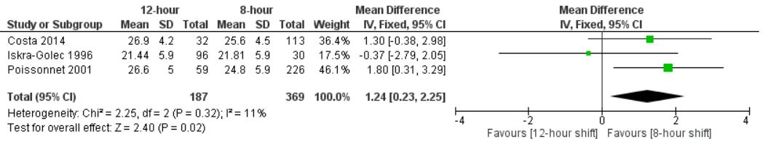
Figure 2: Fixed effects model with the pooled mean difference to assess job satisfaction.

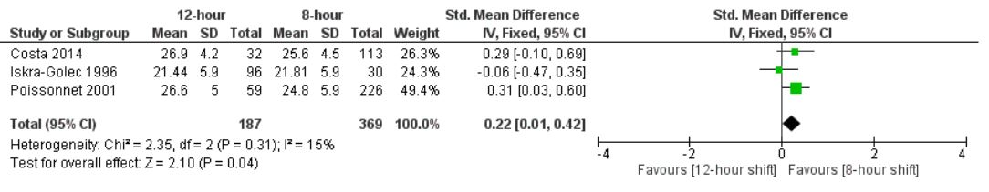
Figure 3: Fixed effects model with the pooled standard mean difference to assess job satisfaction.

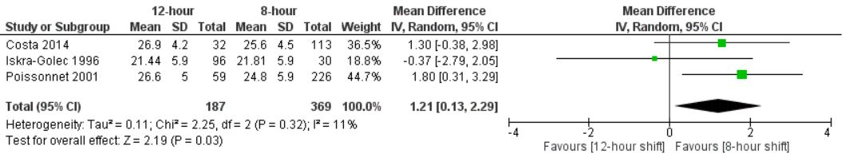
Figure 4: Random effects model with the pooled mean difference to assess job satisfaction.

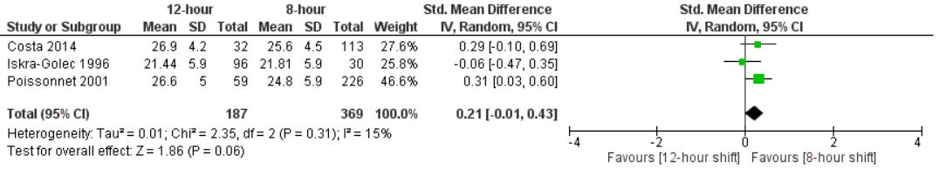Figure 5: Random effects model with the pooled standard mean difference to assess job satisfaction.

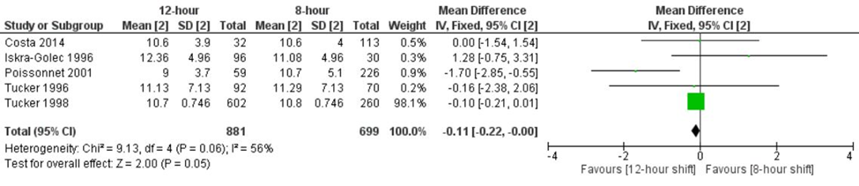
Figure 6: Fixed effects model with the pooled mean difference to assess psychological well-being (GHQ)
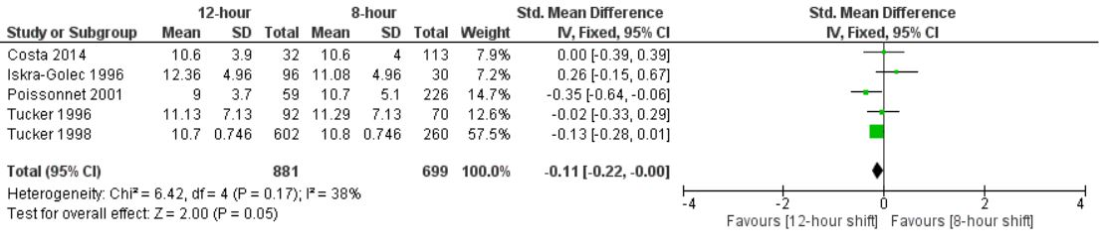
Figure 7: Fixed effects model with the pooled standard mean difference to assess psychological well-being (GHQ)

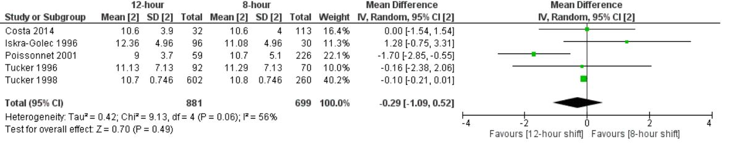
Figure 8: Random effects model with the pooled mean difference to assess psychological well-being (GHQ)
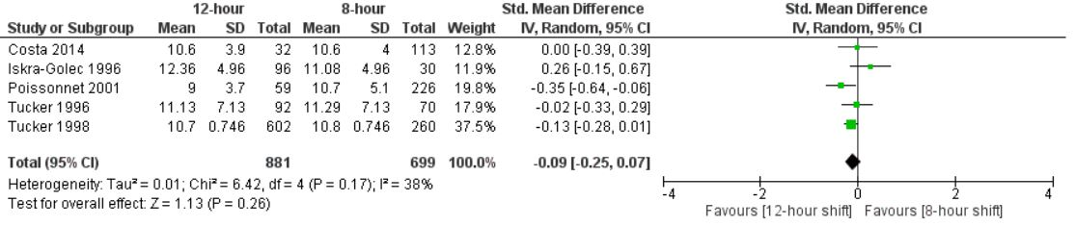
Figure 9:Random effects model with the pooled standard mean difference to assess psychological well-being (GHQ)

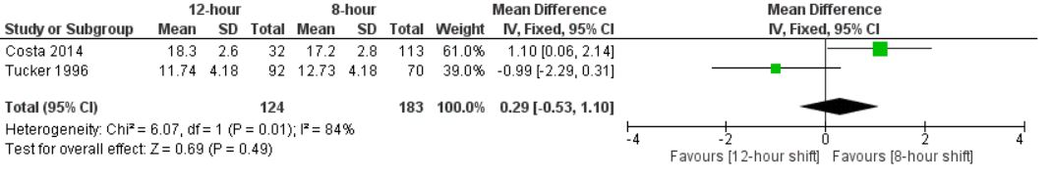
Figure 10: Fixed effects model with the pooled mean difference to assess neuroticism
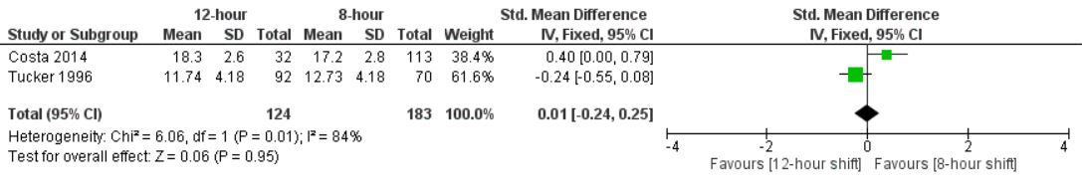
Figure 11: Fixed effects model with the pooled standard mean difference to assess neuroticism
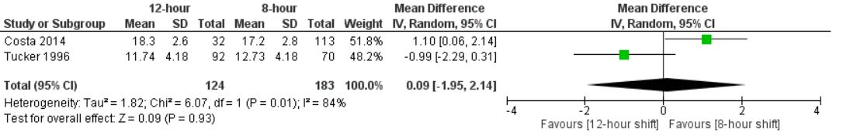
Figure 12: Random effects model with the pooled mean difference to assess neuroticism
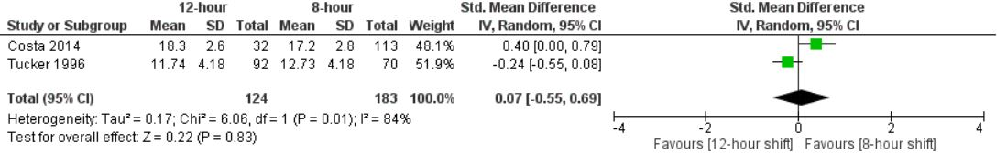
Figure 13: Random effects model with the pooled standard mean difference to assess neuroticism
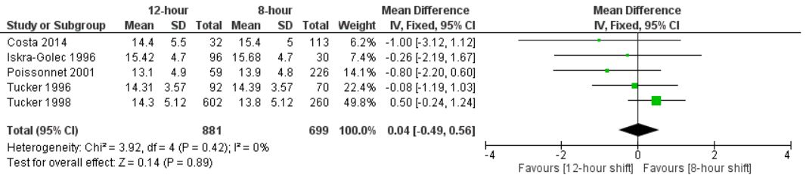 Figure 14: Fixed effects model with the pooled mean difference to assess digestive problems

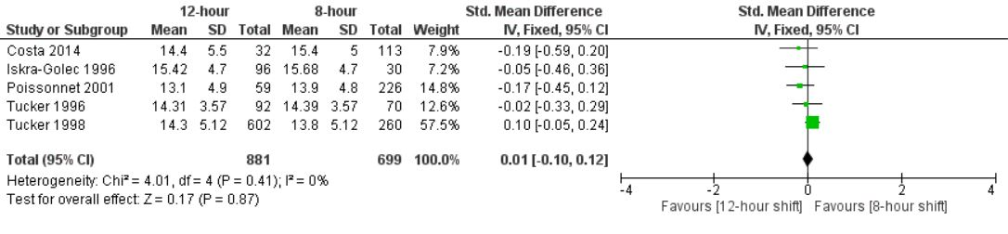
Figure 15: Fixed effects model with the pooled standard mean difference to assess digestive problems
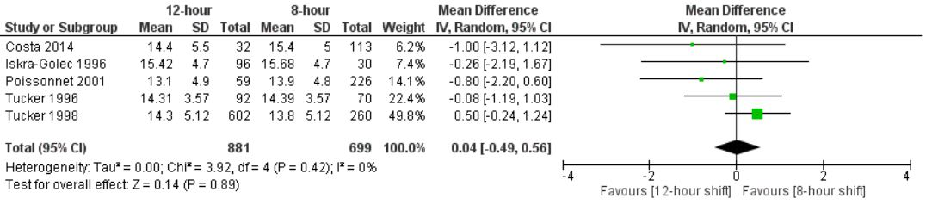
Figure 16: Random effects model with the pooled mean difference to assess digestive problems
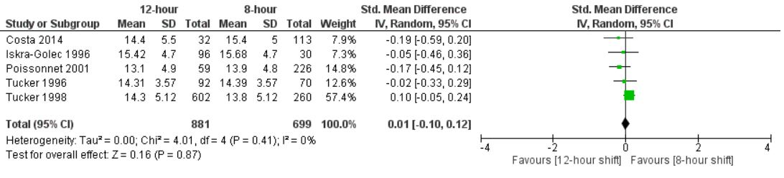
Figure 17: Random effects model with the pooled standard mean difference to assess digestive problems
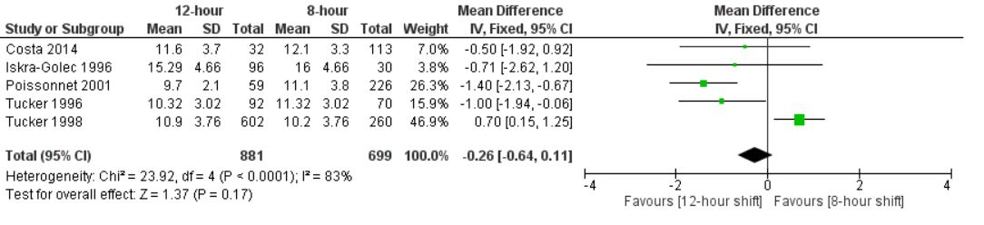 Figure 18: Fixed effects model with the pooled mean difference to assess cardiovascular problems

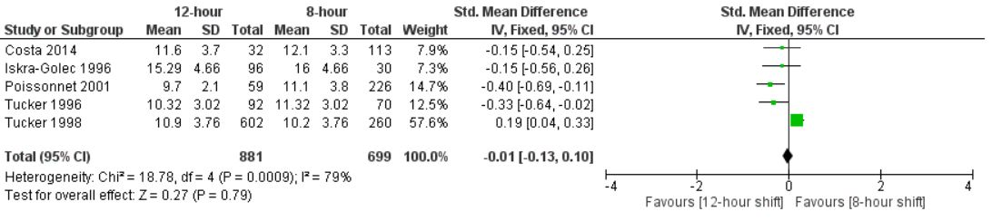
Figure 19: Fixed effects model with the pooled standard mean difference to assess cardiovascular problems
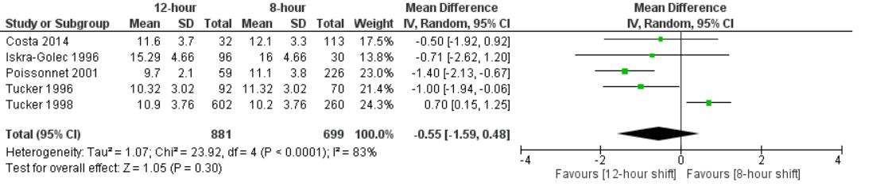
Figure 20: Random effects model with the pooled mean difference to assess cardiovascular problems
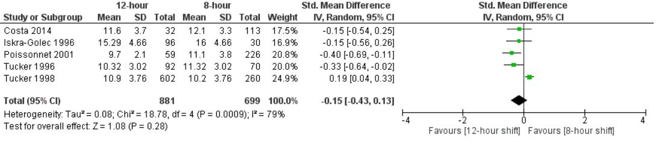
Figure 21: Random effects model with the pooled standard mean difference to assess cardiovascular problems
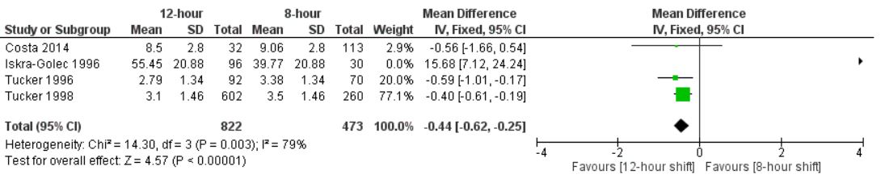
Figure 22: Fixed effects model with the pooled mean difference to assess social disruption

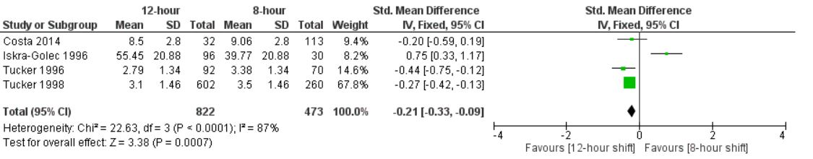
Figure 23: Fixed effects model with the pooled standard mean difference to assess social disruption
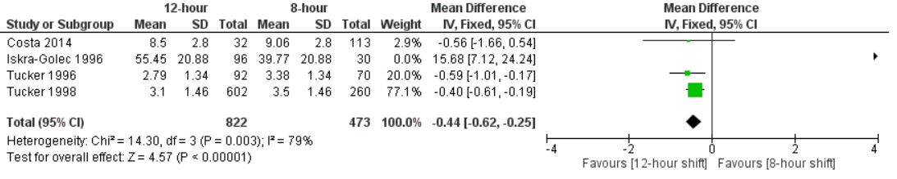
Figure 24: Random effects model with the pooled mean difference to assess social disruption
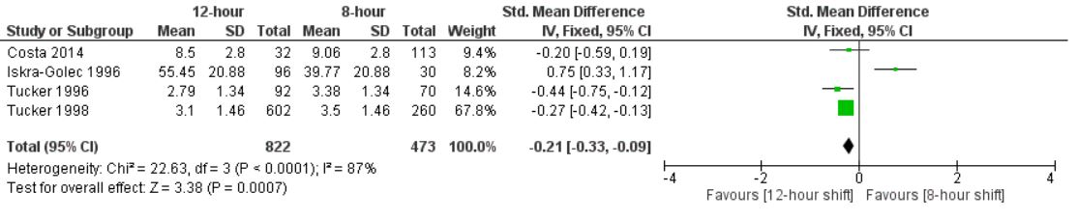
Figure 25: Random effects model with the pooled standard mean difference to assess social disruption
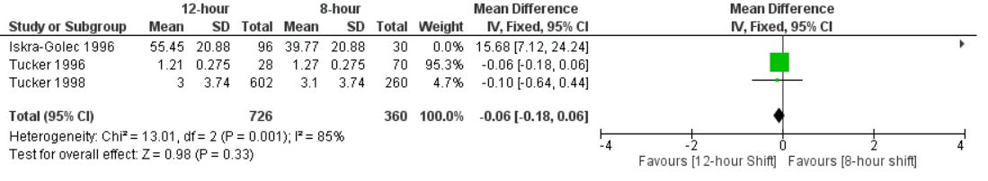
Figure 26: Fixed effects model with the pooled mean difference to assess domestic disruption
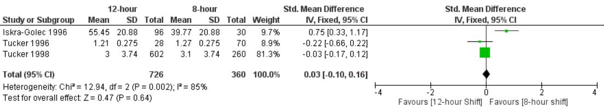
Figure 27: Fixed effects model with the pooled standard mean difference to assess domestic disruption

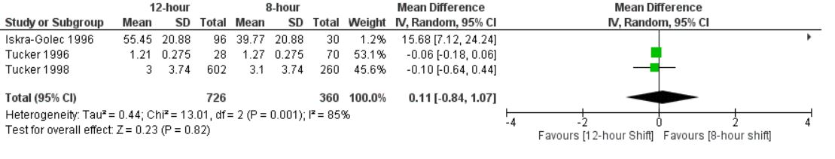
Figure 28: Random effects model with the pooled mean difference to assess domestic disruption
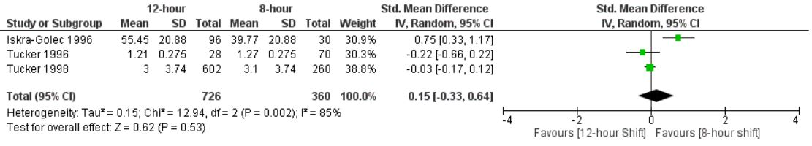
Figure 29: Random effects model with the pooled standard mean difference to assess domestic disruption
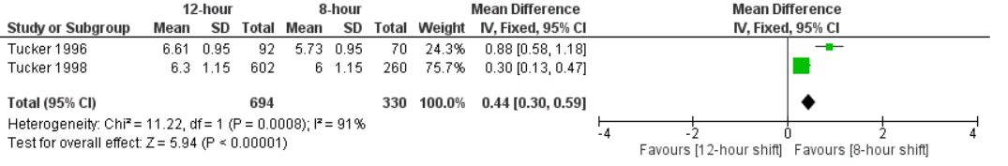
Figure 30: Fixed effects model with the pooled mean difference to assess sleep duration between the 8-hour morning shift and 12-hour day shift

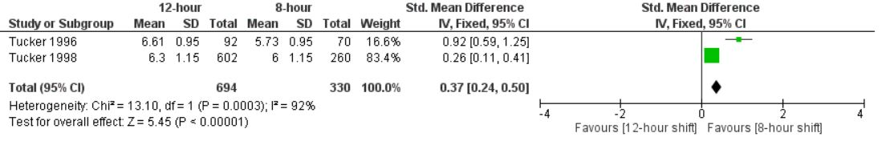 Figure 31: Fixed effects model with the pooled standard mean difference to assess sleep duration between the 8-hour morning shift and 12-hour day shift

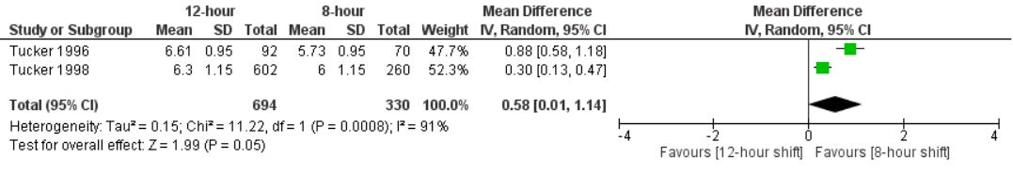
Figure 32: Random effects model with the pooled mean difference to assess sleep duration between the 8-hour morning shift and 12-hour day shift

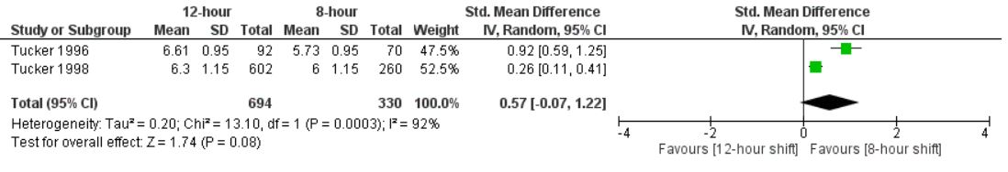
Figure 33: Random effects model with the pooled standard mean difference to assess sleep duration between the 8-hour morning shift and 12-hour day shift

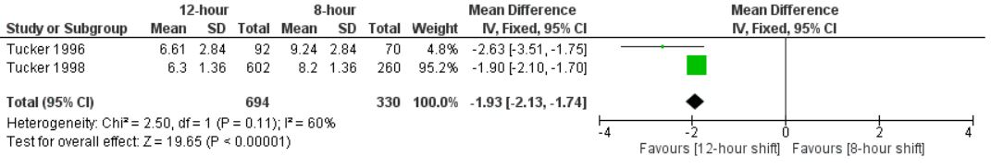
Figure 34: Fixed effects model with the pooled mean difference to assess sleep duration between the 8-hour afternoon shift and 12-hour day shift

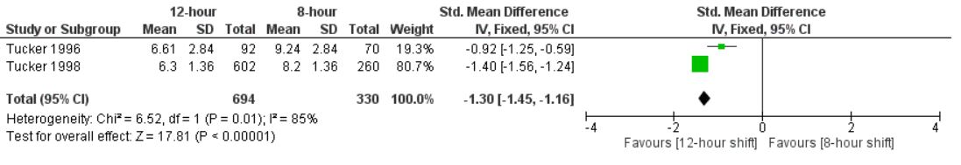
Figure 35: Fixed effects model with the pooled standard mean difference to assess sleep duration between the 8-hour afternoon shift and 12-hour day shift

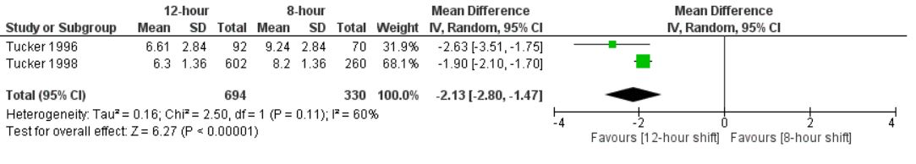
Figure 36: Random effects model with the pooled mean difference to assess sleep duration between the 8-hour afternoon shift and 12-hour day shift

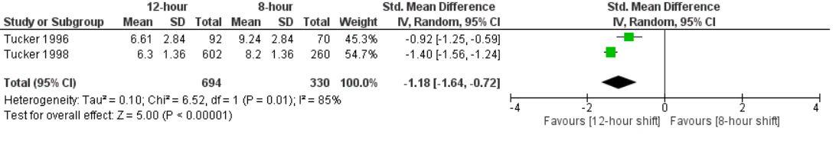
Figure 37: Random effects model with the pooled standard mean difference to assess sleep duration between the 8-hour afternoon shift and 12-hour day shift

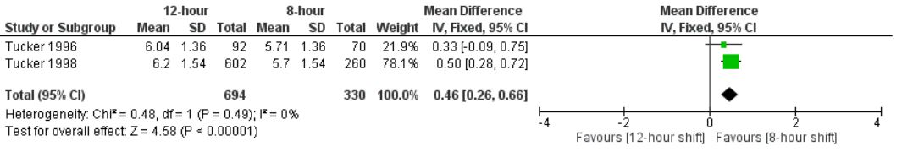
Figure 38: Fixed effects model with the pooled mean difference to assess sleep duration between the 8-hour night shift and 12-hour night shift

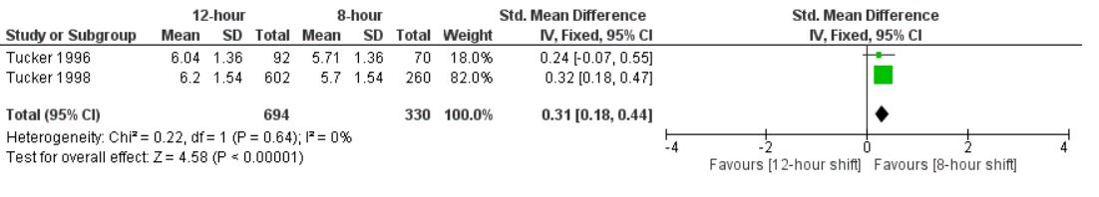
Figure 39: Fixed effects model with the pooled standard mean difference to assess sleep duration between the 8-hour night shift and 12-hour night shift

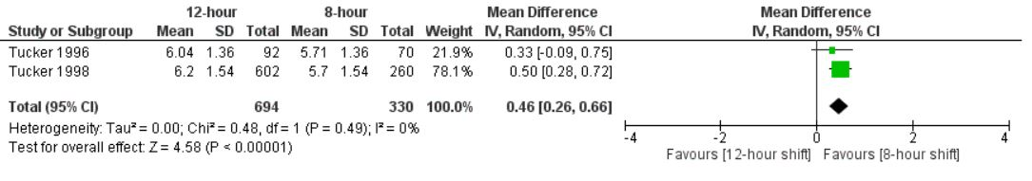
Figure 40: Random effects model with the pooled mean difference to assess sleep duration between the 8-hour night shift and 12-hour night shift

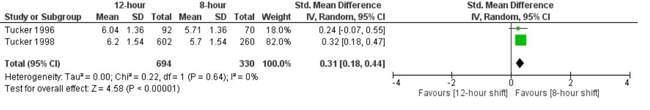
Figure 41: Random effects model with the pooled standard mean difference to assess sleep duration between the 8-hour night shift and 12-hour night shift

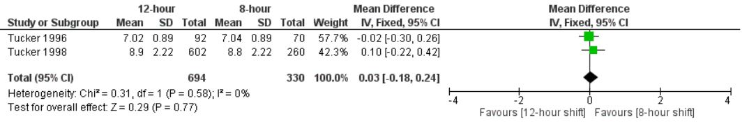
Figure 42: Fixed effects model with the pooled mean difference to assess sleep duration between the 8-hour rest day and 12-hour rest day

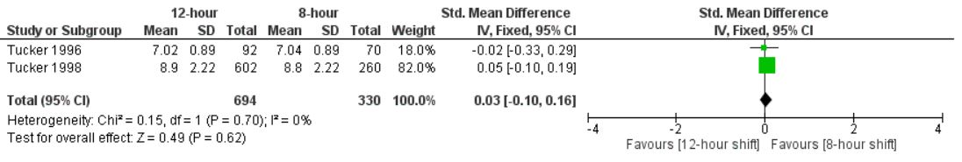
Figure 43: Fixed effects model with the pooled standard mean difference to assess sleep duration between the 8-hour rest day and 12-hour rest day

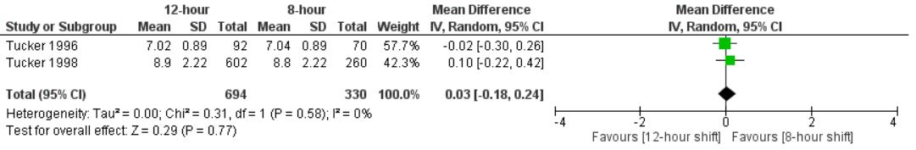
Figure 44: Random effects model with the pooled mean difference to assess sleep duration between the 8-hour rest day and 12-hour rest day

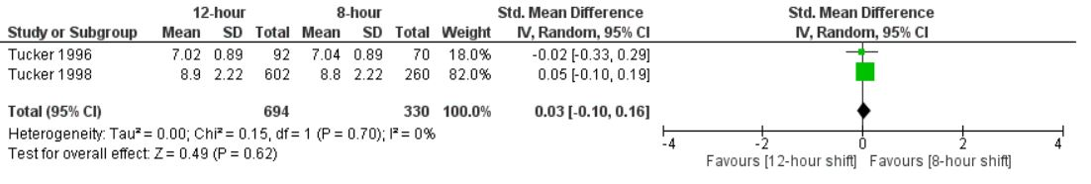
Figure 45: Random effects model with the pooled standard mean difference to assess sleep duration between the 8-hour rest day and 12-hour rest day

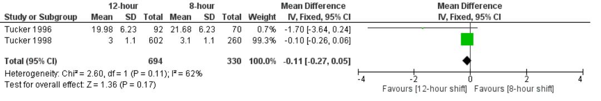
Figure 46: Fixed effects model with the pooled mean difference to assess sleep disruption between the 8-hour morning shift and 12-hour day shift

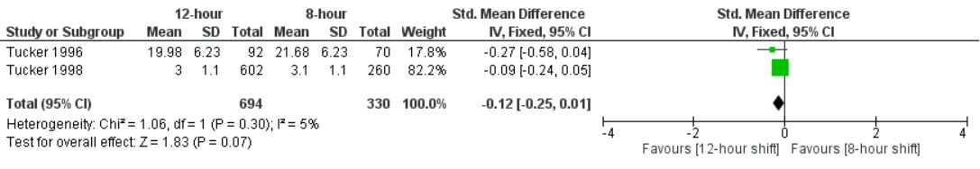
Figure 47: Fixed effects model with the pooled standard mean difference to assess sleep disruption between the 8-hour morning shift and 12-hour day shift

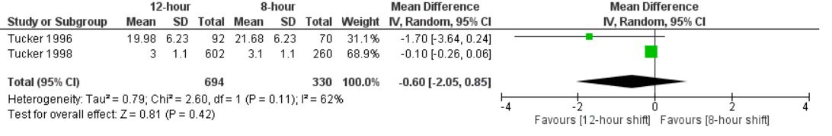
Figure 48: Random effects model with the pooled mean difference to assess sleep disruption between the 8-hour morning shift and 12-hour day shift

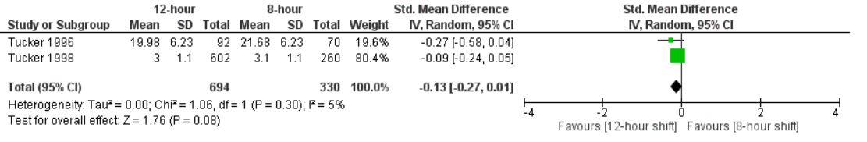
Figure 49: Random effects model with the pooled standard mean difference to assess sleep disruption between the 8-hour morning shift and 12-hour day shift

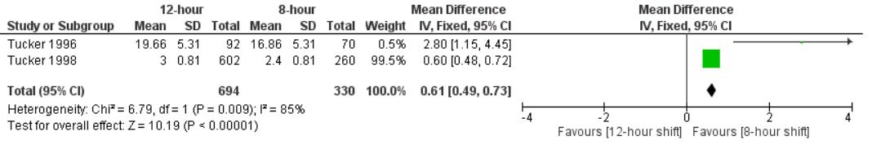
Figure 50: Fixed effects model with the pooled mean difference to assess sleep disruption between the 8-hour afternoon shift and 12-hour day shift

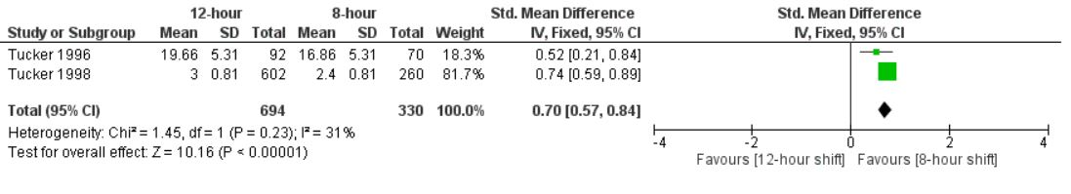
Figure 51: Fixed effects model with the pooled standard mean difference to assess sleep disruption between the 8-hour afternoon shift and 12-hour day shift

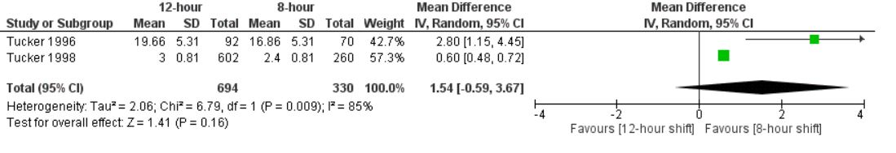
Figure 52: Random effects model with the pooled mean difference to assess sleep disruption between the 8-hour afternoon shift and 12-hour day shift

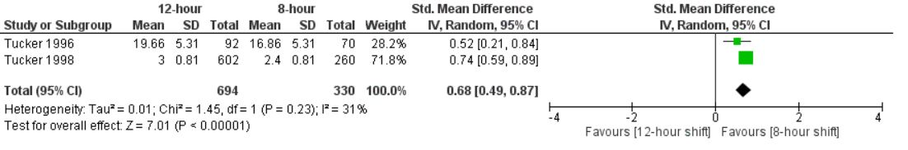
Figure 53: Random effects model with the pooled standard mean difference to assess sleep disruption between the 8-hour afternoon shift and 12-hour day shift

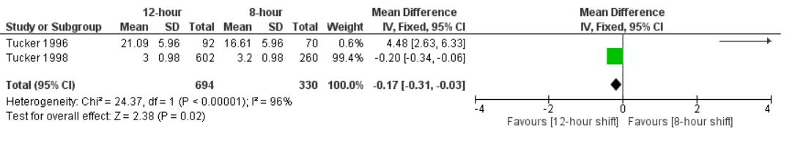
Figure 54: Fixed effects model with the pooled mean difference to assess sleep disruption between the 8-hour night shift and 12-hour night shift

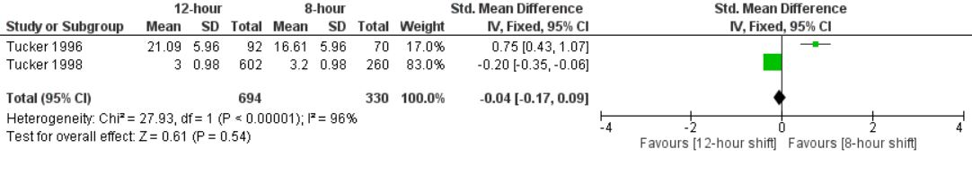
Figure 55: Fixed effects model with the pooled standard mean difference to assess sleep disruption between the 8-hour night shift and 12-hour night shift

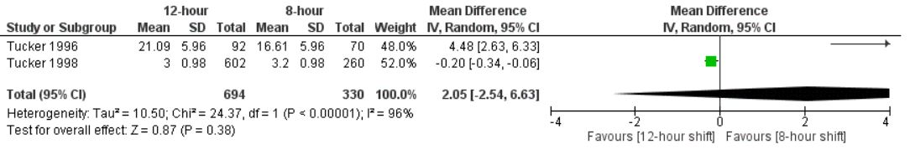
Figure 56: Random effects model with the pooled mean difference to assess sleep disruption between the 8-hour night shift and 12-hour night shift

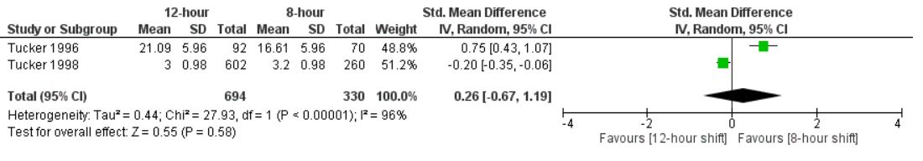
Figure 57: Random effects model with the pooled standard mean difference to assess sleep disruption between the 8-hour night shift and 12-hour night shift

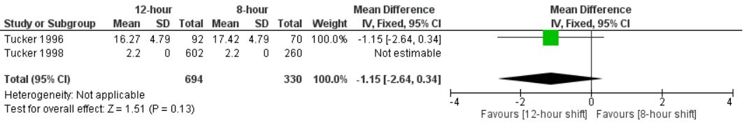
Figure 58: Fixed effects model with the pooled mean difference to assess sleep disruption between the 8-hour rest day and 12-hour rest day

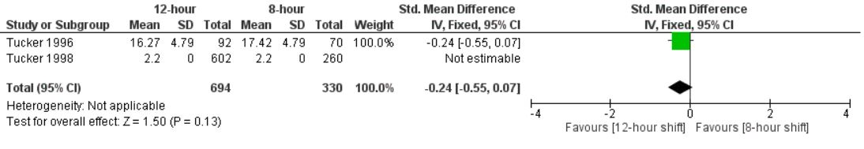
Figure 59: Fixed effects model with the pooled standard mean difference to assess sleep disruption between the 8-hour rest day and 12-hour rest day

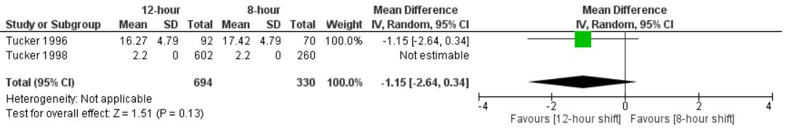
Figure 60: Random effects model with the pooled mean difference to assess sleep disruption between the 8-hour rest day and 12-hour rest day

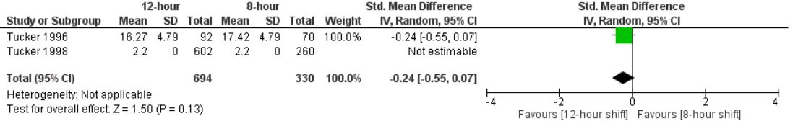
Figure 61: Random effects model with the pooled standard mean difference to assess sleep disruption between the 8-hour rest day and 12-hour rest day

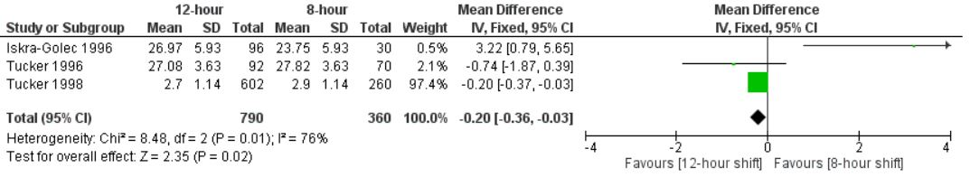
Figure 62: Fixed effects model with the pooled mean difference to assess chronic fatigue

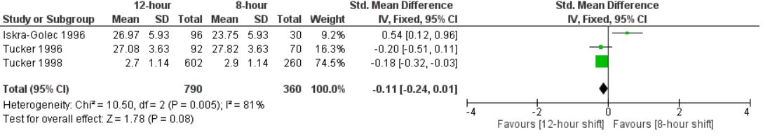
Figure 63: Fixed effects model with the pooled standard mean difference to assess chronic fatigue

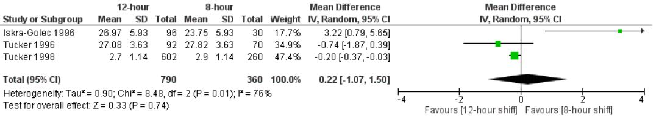
Figure 64: Random effects model with the pooled mean difference to assess chronic fatigue

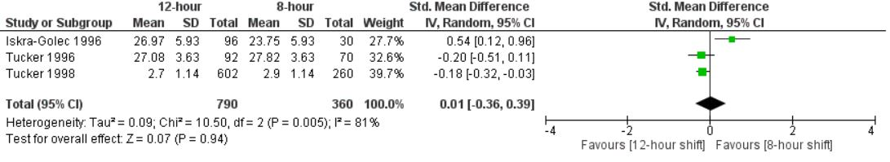
Figure 65: Random effects model with the pooled standard mean difference to assess chronic fatigue

BIBLIOGRAPHY
1. Patterson PD, Runyon M, Higgins JS, Weaver M, Teasley E, Kroemer A, et al. Shorter versus longer shift durations to mitigate fatigue and fatigue related risks in Emergency Medical Services personnel and related shift workers: A systematic review Prehospital Emergency Ccare 2017.
2. Llamas T, Wagschal G, Ferguson C, Broder B, Yoo HY, Messer S. Tired EMS Workers a Prescription for Danger on the Roads, Experts Say. In. ABC News; 2015.
3. Patterson PD, Suffoletto BP, Kupas DF, Weaver MD, Hostler D. Sleep quality and fatigue among prehospital providers. Prehospital Emergency Care 2010;14(2):187-193.
4. Ream E, Richardson A. Fatigue: a concept analysis. International journal of nursing studies 1996;33(5):519-529.
5. Hughes RG, Rogers AE. Are You Tired?: Sleep deprivation compromises nurses’ health—and jeopardizes patients. The American Journal of Nursing 2004;104(3):36-38.
6. Chen MK. The epidemiology of self-perceived fatigue among adults. Preventive Medicine 1986;1(0091-7435 (Print)):74-81.
7. Kant I, Bültmann U, Schröer KAP, Beurskens AJHM, van Amelsvoort LGPM, Swaen GMH. An epidemiological approach to study fatigue in the working population: the Maastricht Cohort Study. Occupational and Environmental Medicine 2003;60(suppl 1):i32-i39.
8. Landrigan CP, Rothschild JM, Cronin JW, Kaushal R, Burdick E, Katz JT, et al. Effect of Reducing Interns' Work Hours on Serious Medical Errors in Intensive Care Units. New England Journal of Medicine 2004;351(18):1838-1848.
9. Page A. Keeping patients safe: Transforming the work environment of nurses: National Academies Press; 2004.
10. Barger LK, Ayas NT, Cade BE, Cronin JW, Rosner B, Speizer FE, et al. Impact of extended-duration shifts on medical errors, adverse events, and attentional failures. PLoS medicine 2006;3(12):e487.
11. Rogers AE, Hwang W-T, Scott LD, Aiken LH, Dinges DF. The Working Hours Of Hospital Staff Nurses And Patient Safety. Health Affairs 2004;23(4):202-212.
12. Bureau Of Labor Statistics UDoL. Occupational Outlook Handbook, Registered Nurses. In. Bureau of Labor Statistics Website; 2017.
13. Patterson PD, Higgins JS, Lang ES, Runyon MS, Barger LK, Studnek JR, et al. Evidence-Based Guidelines for Fatigue Risk Management in EMS: Formulating Research Questions and Selecting Outcomes. Prehospital Emergency Care 2017;21(2):149-156.
14. National Sleep Foundation. What is Shift Work? In; 2017.
15. Patterson PD, Weaver MD, Frank RC, Warner CW, Martin-Gill C, Guyette FX, Fairbanks RJ, et al. Association between poor sleep, fatigue, and safety outcomes in emergency medical services providers. Prehospital Emergency Care 2012(1545-0066 (Electronic)).
16. McMenamin T. A time to work: recent trends in shift work and flexible schedules. Monthly Labor Review 2007;3.
17. Makowiec-Dąbrowska T, Krawczyk-Adamus P, Sprusińska E, Jóźwiak ZW. Can nurses be employed in 12-hour shift systems? International Journal of Occupational Safety and Ergonomics 2000;6(3):393-403.
18. Shadish WR, Cook TD, Campbell DT. Experimental and quasi-experimental designs for generalized causal inference: Wadsworth Cengage learning; 2002.
19. Barton J, Spelten E, Totterdell P, Smith L, Folkard S, Costa G. The Standard Shiftwork Index: a battery of questionnaires for assessing shiftwork-related problems. Work & Stress; 1995.
20. World Health Organization, International Agency for Research on Cancer (IARC). Shiftwork; 2010.
21. Goleman J. Patterning of cognitive and somatic processes in the self-regulation of anxiety: Effects of meditation versus exercise. Psychosomatic medicine 1978;40(4).
22. Eysenck HJ. Das" Maudsley Personality Inventory.". Acta Psychologica 1959.
23. Warr P. Job characteristics and mental health. Psychology at work 1987:247-268.
24. Hackman JR, Oldham GR. Development of the job diagnostic survey. Journal of Applied psychology 1975;60(2):159.
25. Higgins JP, Green S. Cochrane handbook for systematic reviews of interventions: John Wiley & Sons; 2011.
26. Bolster L, Rourke L. The Effect of Restricting Residents' Duty Hours on Patient Safety, Resident Well-Being, and Resident Education: An Updated Systematic Review. Journal of Graduate Medical Education 2015;7(3):349-363.
27. Higgins JP, Green S. Cochrane Handbook for Systematic Reviews of Interventions Version 5.1.0 In. The Cochrane Collaboration; 2011.
28. Stroup DF, Berlin JA, Morton SC, Olkin I, Williamson GD, Rennie D, et al. Meta-analysis of observational studies in epidemiology: a proposal for reporting. JAMA 2000;283(15):2008-2012.
29. Mitchell RJ, Williamson AM. Evaluation of an 8 hour versus a 12 hour shift roster on employees at a power station. Applied Ergonomics 2000;31(1):83-93.
30. Iskra-golec I, Folkard S, Marek T, Noworol C. Health, well-being and burnout of ICU nurses on 12-and 8-h shifts. Work & Stress 1996;10(3):251-256.
31. Tucker P, Barton J, Folkard S. Comparison of eight and 12 hour shifts: impacts on health, wellbeing, and alertness during the shift. Occupational and Environmental Medicine 1996;53(11):767-772.
32. Poissonnet CM, Iwatsubo Y, Cosquer M, Querasalva M-A, Caillard J-F, Veron M. A cross-sectional study of the health effects of work schedules on 3212 hospital workers in France: implications for the new French work schedule policy. Journal of Human Ergology 2001;30:387-391.
33. Tucker P, Macdonald I, Folkard S, Smith L. The impact of early and late shift changeovers on sleep, health, and well-being in 8-and 12-hour shift systems. Journal of occupational health psychology 1998;3(3):265.
34. Peacock B, Glube R, Miller M, Clune P. Police officers' responses to 8 and 12 hour shift schedules. Ergonomics 1983;26(5):479-493.
35. McKenzie B, Rapino M. Commuting in the United States: 2009. U.S Census Bureau: U.S. Department of Commerce; 2011.
36. Rosa RR, Bonnet MH. Performance and alertness on 8 h and 12 h rotating shifts at a natural gas utility. Ergonomics 1993;36(10):1177-1193.
37. Poissonnet CM, Véron M. Health effects of work schedules in healthcare professions. Journal of clinical nursing 2000;9(1):13-23.
38. Loudoun R. Balancing shiftwork and life outside work: Do 12-h shifts make a difference? Applied ergonomics 2008;39(5):572-579.
39. Costa G, Anelli MM, Castellini G, Fustinoni S, Neri L. Stress and sleep in nurses employed in “3× 8” and “2× 12” fast rotating shift schedules. Chronobiology international 2014;31(10):1169-1178.
40. Smith PA, Wright BM, Mackey RW, Milsop HW, Yates SC. Change from slowly rotating 8-hour shifts to rapidly rotating 8-hour and 12-hour shifts using participative shift roster design. Scandinavian journal of work, environment & health 1998:55-61.
41. Jadad AR, Cook DJ, Jones A, Klassen TP, Tugwell P, Moher M, et al. Methodology and reports of systematic reviews and meta-analyses. JAMA 1998;280.

