SPATIAL HETEROGENEITY OF MMR VACCINATION COVERAGE:
NEW YORK SCHOOL DISTRICTS, 2014-2015

by
Scott Chadwell
B.A in Exercise Science Education, The Ohio State University, 2013

Submitted to the Graduate Faculty of
the Department of Infectious Diseases and Microbiology
Graduate School of Public Health in partial fulfillment
of the requirements for the degree of
Master of Public Health

University of Pittsburgh
2017

UNIVERSITY OF PITTSBURGH
GRADUATE SCHOOL OF PUBLIC HEALTH

This essay is submitted

by

Scott Chadwell

on

December 14, 2017

and approved by

Essay Advisor/Reader:
Jeremy Martinson, DPhil _______________________________________
Assistant Professor
Department of Infectious Diseases and Microbiology
Graduate School of Public Health
University of Pittsburgh

Essay Reader:
Willem Van Panhuis, MD, PhD _______________________________________
Assistant Professor
Department of Epidemiology
Public Health Dynamics Lab
Graduate School of Public Health
University of Pittsburgh

Copyright © by Scott Chadwell
2017
Jeremy Martinson, DPhil

SPATIAL HETEROGENEITY OF MMR VACCINE COVERAGE:
NEW YORK SCHOOL DISTRICTS, 2014-2015

Scott Chadwell, MPH
University of Pittsburgh, 2017

ABSTRACT
Background: Despite having one of the highest vaccination rates in the entire country, New York State has had a number of vaccine preventable disease related outbreaks since 2003, including measles and mumps. There is now growing concern that there is spatial heterogeneity in vaccine coverage and geographic clustering of low vaccination areas. This paper examined spatial variation of measles, mumps, and rubella (MMR) vaccination rates among school districts in New York State and created a spatial model of sociodemographic variables. This has public health significance as identifying where there is spatial heterogeneity of vaccination coverage, is important for disease control, outbreak prevention, and potential eradication.
Methods: We examined the spatial heterogeneity of measles, mumps, and rubella vaccination among school districts in New York State. 2014-2015 data were collected from the New York State Department of Health (NYDH) and the Elementary and Secondary Information System (ElSi). Data processing, spatial analysis (global and local Moran’s I tests), and spatial regression was done in STATA 15.1. Maps were generated in QGIS 2.18.14.
Results: A global Moran’s I test revealed no different from random spatial variation among MMR vaccination rates (Moran’s I = 0.003; p = 0.341), however, some local autocorrelation presented among school districts. All but two (medical and religious exemptions) of the predictor variables were significant for spatial autocorrelation. The final spatial model included percent religious exemptions, percent medical exemptions, percent of students receiving free and reduced-priced lunch, and urban location. Percent religious and percent medical exemptions (p<0.001), along with percent of students receiving free and reduced priced lunch (p<0.001) were found to be significant predictors. Percent religious exemptions accounted for 41% of the variation in MMR vaccination rates. We found no clustering for school district-level MMR vaccination coverage in the overall New York State area. We found five districts with low vaccination coverage that had a significant Moran’s I value at the local level, indicating clustering.
Conclusions: Vaccination coverage in New York State is very high. There are no particular clusters of districts with low-MMR coverage in New York State, suggesting the absence of spatially driven determinants of vaccination coverage. Some school districts had coverage below the critical vaccination threshold, and should be a focus for New York State public health authorities.

TABLE OF CONTENTS
1.0 Introduction 1
1.1 Study aims 2
1.2 Public Health Significance 3
2.0 methods 4
2.1 DATA PROCESSING 4
2.2 Spatial ANAYLSIS 5
2.2.1 Spatial Models 6
3.0 Results 9
3.1 Spatial autocorrelation tests 12
3.2 Spatial regression 14
4.0 Discussion 16
4.1.1 Limitations 17
bibliography 19

List of tables
Table 1. Manual Model Selection 8
Table 2. Forward Stepwise Model Selection 8
Table 3. Descriptive Results of Model Covariates 9
Table 4. MMR Vaccination Coverage 9
Table 5. Results of Spatial Regression Model 14

List of figures
Figure 1. Covariate Plots 10
Figure 2. MMR Vaccination Coverage Over Model Covariates 11
Figure 3. MMR Vaccination Coverage by District 13

1.0 Introduction
Reduction in vaccine coverage is a growing problem in the US. It is currently blamed for a reemergence of vaccine preventable diseases, particularly measles, mumps, and pertussis [13]. The critical vaccination threshold is up to 95% for these diseases, so even small decreases can cause outbreaks [14]. At approximately 96%, New York State has one of the highest MMR vaccination rates in the United States in 2016 [1]. However, New York State has had a number of vaccine preventable disease (VPD) related outbreaks since 2003 including measles, mumps, and pertussis. At least two outbreaks of measles and pertussis have occurred in religious communities where vaccine refusal has been noted to be high [2][3]. An outbreak of measles hit New York State as a result of the Disney land outbreak in December 2014 [4]. Other outbreaks of mumps and pertussis have happened as recently as this year at universities and local schools [5][6][7]. The New York State Department of Health even warned earlier this year that there is a potential for an outbreak after a person tested positive for measles [8].
Since measles was declared eradicated from the US in 2000, there have been 1,789 cases from 2001-2015 [11] and 1,568 cases since 2010 reported nationwide [11][12]. While most outbreaks of measles in New York State since 2000 have started from imported cases from outside the United States, many of the cases afterward can be attributed to not receiving appropriate vaccinations [9]. Despite having high vaccination rates, New York State is third in the nation with 250 cases of measles since 2001 [9]. There is, however, growing concern that there is now increasing spatial heterogeneity of vaccine coverage and geographic “clustering” of under or non-immunized individuals whom are now the causes of VPD outbreaks [10][15][17].

Study aims
With this study we aim to accomplish two things. The first is to show if spatial heterogeneity exists across school districts in New York State. We hypothesize that there is spatial heterogeneity among New York State’s school districts. As mentioned above, there is evidence of spatial heterogeneity in vaccine coverage with geographical clustering of under or non-immunized individuals with similar socioeconomic and sociodemographic characteristics [17]. While some of these individuals may not explicitly refuse vaccination while others do (i.e. those claiming exemption to vaccination), this creates heterogeneity across areas where immunization levels fall below critical vaccination thresholds and are prime for outbreaks [14]. While these outbreaks can be contained within these areas, they still have the potential to jump outside these lower vaccinated communities, as those who cannot get vaccinated are at risk [18]. As the potential for a reduction in herd immunity protection on the boundaries of these geographic clusters loom [26], outbreaks among appropriately vaccinated communities could become a very adverse (and avoidable) consequence of failing to vaccinate [10].
The second goal is to determine if certain sociodemographic characteristics can explain vaccine coverage among New York State’s school districts. We hypothesize that vaccine exemptions (medical and religious exemptions), limited English proficiency, free and reduced-price lunch rates, pre-kindergarten enrollment, percent of student enrollment that is Hispanic, that is African-American, that is white, per pupil spending by district, and whether the district is urban or rural, can determine the vaccination coverage of a given district. Many studies have cited significant associations between these sociodemographic characteristics, socioeconomic characteristics, location variables, and subsequent vaccination coverage in the study area [15-25].

Public Health Significance
The major issue with spatial heterogeneity of vaccination coverage and measles, is that measles is a highly contagious disease. Its R₀ (the basic reproductive rate), which is a metric of how many others one infectious person can infect, is between 15-20 [36]. This makes it one of the most infectious diseases on the planet. In comparison, the R₀ for the 2009 H1N1 influenza in the United States was 1.7-1.8 [37]. Measles’ high R₀ leads to a much higher percentage of the population needing to be vaccinated to establish herd immunity. As mentioned above, the critical vaccination proportion for measles is 95% [14]. The issue with the way 95% was calculated, is that it assumes homogeneity of both vaccination coverage and population mixing [35]. Spatial Homogeneity of vaccination coverage and population mixing has been shown to be not always be an accurate assumption to make, as more people are choosing not to vaccinate while also living in similar areas [15, 17-19, 22, 25]. Spatial heterogeneity of vaccination coverage can effectively raise the critical vaccination proportion and propagate outbreaks in well vaccinated states such as New York [2-6, 35]. The ability to identify where heterogeneity exists (especially under vaccinated areas) has long-term implications for disease control and eradication. This study uses spatial regression to look at spatial vaccination heterogeneity among school districts in New York State; a highly vaccinated area that experiences outbreaks of VPDs regularly.

methods
The New York Department of Health (NYDH) records the following information on individual school districts used in this analysis: percentages of students vaccinated for Measles, Mumps, and Rubella, percent medical exemptions, percent religious exemptions, and latitude and longitude location data [28]. Other variables used in the analysis were recorded by the Elementary and Secondary Information System (ELSi). These variables are: Number of free and reduced-price lunch students (FRPL), PreK students, Hispanic students, Black students, White students, limited English students, and an urbanicity index. Total proposed spending for a district was taken from the New York State Property Tax Report Card [27].

DATA PROCESSING
Percent of students immunized for the MMR shot is the outcome variable used for analysis. It was derived by combining the average of the recorded vaccination percentages of measles, mumps, and rubella (i.e. (%measles + %mumps + %rubella) / 3) into one vaccination variable, MMR. Percentages for variables (i.e. percent of FRPL students) from NYDH for analysis were generated by dividing the number of each type of student by the total number of students enrolled in each district (provided by ELSI). Urbanicity index was recoded to simply “Rural” if listed as rural, or “Urban” if listed as city, town, or suburb in the ELSi data. Finally, per pupil spending was calculated from the New York State Property Tax Report Card by dividing total number of students in each district by total proposed spending in each district. All data is from 2014-2015.
NYDH collects immunization data on 693 school districts. Districts were included for analysis based on complete data availability for all variables included in the final spatial regression model. A total of 28 districts were excluded from analysis because of incomplete data on one or more variables. There was a total of 665 school districts included for analysis.
Descriptive maps of percent medical exemptions, percent religious exemptions, percent of free and reduced-priced lunch students, and urbanicity index were created to show where potential gaps in vaccination coverage may occur. School district locations were geocoded using latitude and longitude data provided by the NYDH. All maps were generated in QGIS.

Spatial ANAYLSIS
Spatial regression models were generated by the spatreg command in STATA 15.0., using percent immunized for measles, mumps, and rubella as outcome variables and the other previously listed NYDH and ELSi variables as predictors. Latitude and longitude data were transformed into web Mercator distances for use in spatial tests and models via the geo2xy package in STATA. Estimation of the spatial association of MMR vaccination rates among school districts was done by running Global and local Moran’s I tests. The Global Moran’s I ranges from -1 to 1 and is a single estimate of spatial association among all school districts (spatial autocorrelation). Values close to zero indicate no spatial association, i.e. coverage is randomly distributed, values close to negative one indicate strong spatial dispersion, and values close to positive one indicate strong clustering (autocorrelation) [30]. The local Moran’s I estimates the association of vaccination coverage rates (i.e. similarly high or low values) between a school district and its neighboring school district within a specified geographical area. Positive numbers indicate an area that has neighboring areas with similar high or low values (clustering), where negative numbers indicate and area has neighboring areas where values are not similar [31].
These spatial models allow us to adjust for any spatial autocorrelation among the variables. That is, the concept that two or more objects or areas (i.e. school districts) that are close in distance to one another, are more alike in each variable than they are to objects or areas that are further away [29]. There also tends to be areas where there are high values and areas where there are low values if there is autocorrelation. This is known as spatial clustering and tends to follow spatial autocorrelation [29]. There was no statistically significant global autocorrelation among MMR vaccination rates, however, all but two predictor variables (percent medical and religious exemptions) were significant for spatial autocorrelation. The local Moran I test revealed that some of the school districts did indeed have significant spatial clustering among MMR vaccination rates. For these reasons, we used a spatial regression model instead of normal regression.

Spatial Models
We used a spatial regression model to estimate MMR vaccination coverage based on the previous mentioned sociodemographic variables. We adjusted for spatial autocorrelation of MMR vaccination and predictor variables with continuous weighting matrix based on distance. An inverse distance weights matrix was selected because all school districts vaccination rates influence one another, but effects are largest in the districts that are closest together [34]. It was also chosen because longitude and latitude information were available.

Our model took the following form:

Y = β₀ + X₁β₁ + X₂β₂ + X₃β₃ + X₄β₄ + ρWY + ε

where Y represented the dependent variable (MMR vaccination rate), ρ represented the spatial autoregressive term, β₀ represented the constant term, β₁₋₄ represented the regression coefficients of the predictor covariates, ε represented the spatial error term, and W represented the inverse distance weights matrix.
The variable selection method for the final model included both a forward stepwise regression procedure (done in STATA 15.1), and a manual forward spatial regression model selection. The STATA procedure was done by specifying a p-value of 0.2 for a variable to be included in the model [32]. The manual selection method was based on the Akaike information criterion (AIC), the Bayesian information criterion (BIC), and the squared correlation coefficient (SQC) [33]. Lower values of AIC and BIC indicate better fits than higher values, and a higher SQC indicates a better fit model. This was done by first running each variable alone on MMR vaccination. The first variable to fix to the model was chosen by the lowest AIC, lowest BIC, and the highest SQC. This variable was fixed by itself to the model and regressed with each additional variable one by one on vaccination rates. A new variable was then selected to fix to the model if it lowered the AIC and BIC, and raised the SQC of the new model compared to the old. This process was repeated until no new variables could be added to the model. Table 1 shows the model statistics. Both selection methods yielded the same final model.

Table 1. Manual Model Selection
Model | AIC | BIC | Sq. Corr.
1ª | 2745.548 | 2763.547 | 0.412
2^{b} | 2694.553 | 2717.052 | 0.457
3^{c} | 2693.228 | 2720.226 | 0.460
4^{d} | 2691.531 | 2723.03 | 0.463
a Predictors: Religious Exemptions
b Predictors: Religious exemptions, medical exemptions
c Predictors: Religious exemptions, medical exemptions, % FRPL students
d Predictors: Religious exemptions, medical exemptions, % FRPL students, Urban district location

Table 2. Forward Stepwise Model Selection
Predictors | P-value at Inclusion
Religious Exemption | <0.0001
Medical Exemption | <0.0001
%FRPL | 0.0516
Urban Location | 0.0671
Model R² = 0.462, Predictor included if p<0.20

Results
Analysis indicated interesting findings about spatial autocorrelation, clustering of school districts, and predictor covariates in the model.

Table 3. Descriptive Results of Model Covariates
Covariate | Mean | Std. Dev. | Min | Max
Medical Exemptions (percent) | 0.191 | 2.473 | 0 | 8.33
Religious Exemptions (percent) | 0.675 | 1.631 | 0 | 37.42
FRPL Students (percent) | 36.728 | 18.858 | 0 | 86.594
 | District Count | Percent
Urban Location | 369 | 55.49
Total n=665

Table 4. MMR Vaccination Coverage
 | Mean | Std. Dev. | Min | Max
MMR Vaccination Rate (percent) | 98.829 | 2.473 | 62.5 | 100

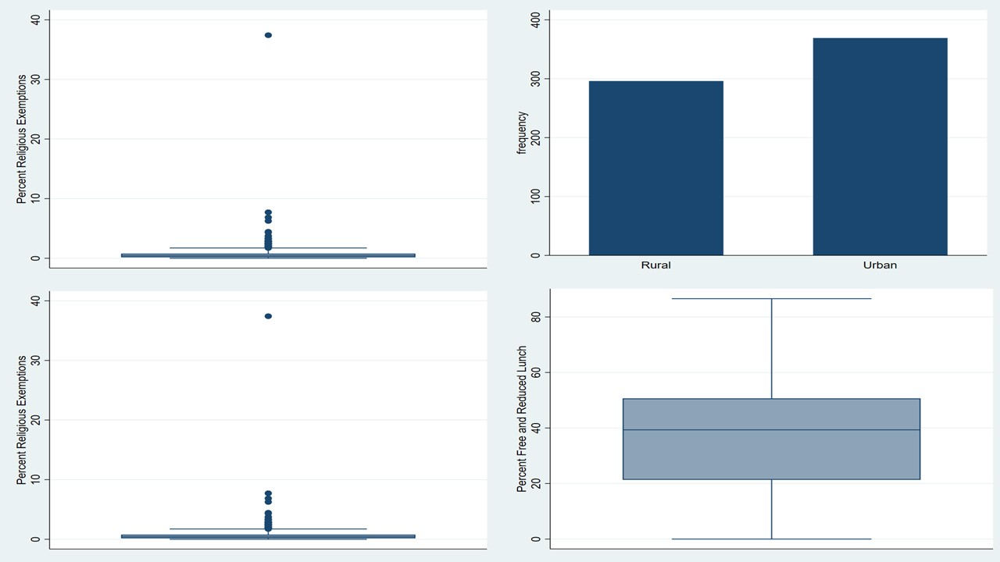
D
C
A
B
Panel A: Percent Religious Exemptions Box Plot
Panel B: Count of Rural and Urban Districts
Panel C: Percent Medical Exemptions Box Plot
Panel D: Percent FRPL Students Box Plot
Figure 1. Covariate Plots

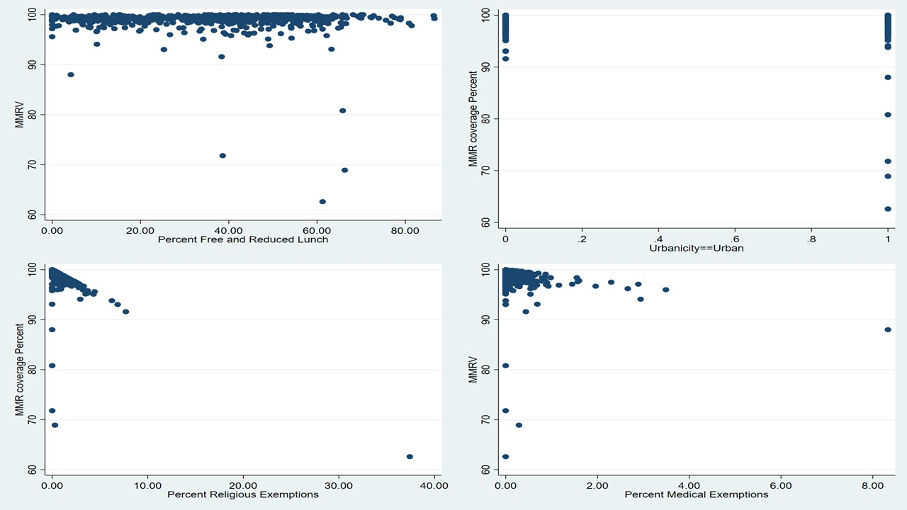
D
B
C
A
Panel A: Vaccination Coverage Over Percent FRPL Students
Panel B: Vaccination Coverage Over District Location Status (Urban or Rural)
Panel C: Vaccination Coverage Over Percent Religious Exemptions
Panel D: Vaccination Coverage Over Percent Medical Exemptions
Figure 2. MMR Vaccination Coverage Over Model Covariates

Spatial autocorrelation tests
A global Moran’s I test revealed that there was no clustering for school-district level MMR vaccination rates (n=665, Moran’s I=0.000, p=0.341), religious exemptions (Moran’s I =-0.001, p=0.40), or medical exemptions (Moran’s I=-0.001, p=0.437) in the New York State area. However, there was spatial autocorrelation among the percentage of free and reduced-price lunch students (Moran’s I=0.054, p<0.001) and urban location (Moran’s I=0.056, p<0.001). The local Moran’s I test for clustering of school districts of MMR vaccination coverage indicated that there were several districts that clustered together (n=5, p-values <0.05) and several districts where neighboring values were dissimilar (n=7, p-values <0.05). Figure 3 maps the centroid of each district and its corresponding MMR vaccination coverage. As one can see, there are several districts that have very low coverage (<80%) and several that are between 80% and 90%. Further analysis should look at any districts that are below or close to 95% coverage to see how individual schools lineup.

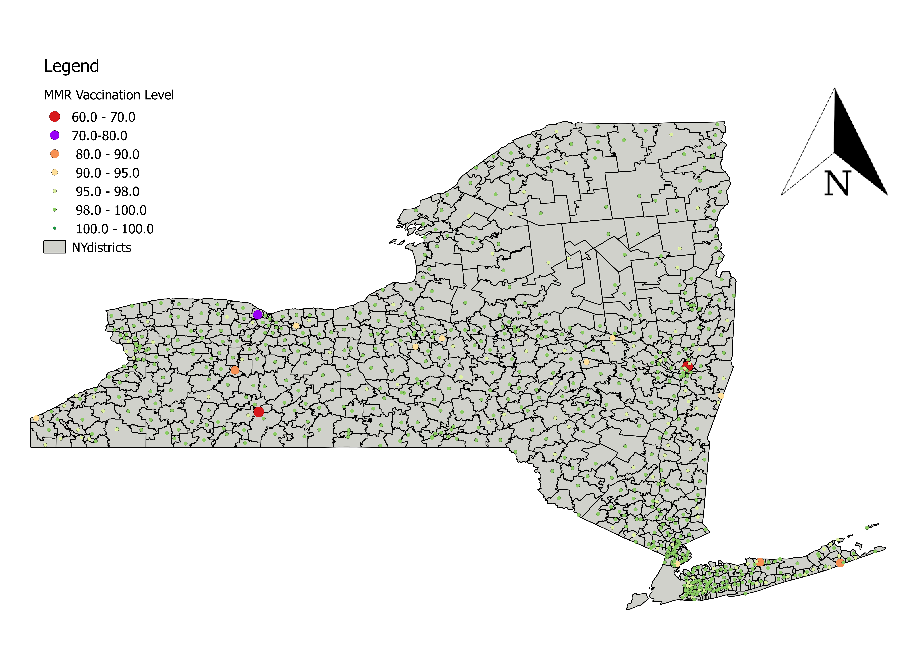
Figure 3. MMR Vaccination Coverage by District

Spatial regression
A spatial regression model was created with four variables from the initial 11 chosen to explore. These variables were: percent medical exemptions, percent religious exemptions, percent of students enrolled in a district that were using free and reduced-price lunch services (FRPL), and a district’s urban location status. These four variables explained 46.3% of the variation in MMR vaccination coverage rates among these districts.

Table 5. Results of Spatial Regression Model
Variable | Coefficient | Std. Err. | z-statistic | P-value | 95% CI
Constant | 99.99 | 0.319 | 313.19 | <0.0001 | [-0.0162, -0.0009]
Religious Exemptions (percent) | -0.963 | 0.043 | -22.30 | <0.0001 | [-1.047, -0.878]
Medical Exemptions (percent) | -1.190 | 0.157 | -7.58 | <0.0001 | [-1.50, -0.882]
Free and Reduced-Price Lunch (percent) | -0.009 | 0.004 | -2.19 | <0.0001 | [-0.0162, -0.0009]
Urban Locale | -0.282 | 0.147 | -1.93 | 0.054 | [-0.570, -0.005]
n=665, R²=0.463

Results of the spatial regression model show that MMR vaccination coverage was significantly associated with religious exemptions, medical exemptions, and percentage of free and reduced-price lunch students. Urban district location was negatively associated with, but not significantly, with MMR vaccination coverage. It was close to being significant, however (beta: -0.282, p-value=0.054, 95% CI: -0.570, -0.005). For every one percent increase in Medical Exemptions (p<0.001, 95% CI: -1.50, -0.882) and every one percent increase in Religious Exemptions (p<0.001, 95% CI: -1.047, -0.878), there was an associated 1.19% and 0.963% decrease in vaccination coverage in a district, respectively. Finally, for every one percent increase in FRPL students in a district, there was an associated 0.009% decrease in vaccination coverage (p<0.0001, 95% CI: -0.0162, -0.0009). These results are consistent with the graphical plots shown in Figure 2. While these are modest decreases in vaccination coverage for a given district, it is important to understand that even small decreases in coverage could bring a district below herd immunity levels.

Discussion
A global Moran’s I test revealed that there was no spatial variation in MMR vaccination coverage across the study area, however the decision was made to proceed with a spatial model as many predictor variables were significant for global autocorrelation. When comparing standard regression to it’s spatial counterpart, the spatial model was slightly more conservative in terms of p-values. Among the sociodemographic variables set to explore, four were included in our final model. We found percent medical exemptions, percent religious exemptions, and percent of students enrolled in free and reduced-price lunch to be significant negatively associated predictors (p<0.05) of MMR vaccination coverage, while a school district being an urban district was found not to be significant (p=0.054).
The result of no spatial autocorrelation among the study area came as a bit of a surprise since there has been evidence of outbreaks among religious communities, universities, and urban areas [2, 5, 6]. A possible reason for this result is that vaccination coverage data used in the analysis is from the 2014-2015 school year, and many of these outbreaks are from the last two years. More current vaccination data may give a different result.
While there was no indication of global spatial variation of MMR vaccination coverage among the districts in the final analysis, the local Moran’s I test showed that there were some districts that were significant for clustering (n=12). This potentially indicates “problem” districts where vaccination rates are lower than required for herd immunity, which could in turn lead to outbreaks. Identifying where these low-vaccination districts are will be important for future interventions and stopping outbreaks. Vaccination coverage in New York State is very high. We did not find evidence of clusters of districts with low-MMR coverage in New York State, suggesting the absence of spatially driven determinants of vaccination coverage. Some school districts had coverage below the critical vaccination threshold, and should be a focus for New York State public health authorities.
Future studies should look at these districts’ individual schools to assess if there is clustering of schools and what types of clustering is happening (i.e. high vaccination surrounded by high, low surrounded by low, etc.). The public health impact of finding clusters of low vaccination status areas is high. This will greatly inform public health intervention efforts in outbreak prevention and disease eradication, while informing policy decisions as the district level.

Limitations
There are a few limitations in our study. First, the immunization survey data collected by the New York Department of Health is from the 2014-2015 school year. More up-to-date survey data is available; however, we were limited by ELSi data as the most recent information is from 2014-2015. Newer vaccination coverage data could provide additional insights. A second potential limitation is the use of a spatial regression model when no spatial autocorrelation was detected from testing. As noted above, we chose to create a spatial model because there was spatial autocorrelation among predictor variables, as well as, wanting to take a more conservative approach in our estimates.
A third limitation in this study is not all school districts in New York were used in the analysis. The spatial regression package used for this analysis could not use districts that had missing values for any covariates used for model selection. The decision was made to drop districts from analysis that did not have complete data. Finally, for a more complete picture of spatial variation of MMR coverage in New York, individual schools will need to be assessed. This study has provided a look at school districts where low vaccination coverage occurs. A more high-resolution approach is needed to truly assess the spatial heterogeneity of MMR vaccination coverage in New York State.

bibliography
[1] U.S. Department of Health & Human Services, Centers for Disease Control and Prevention. (2016). ChildVaxView | 2016 Childhood MMR Vaccination Coverage Report | CDC. Retrieved November 18, 2017, from https://www.cdc.gov/vaccines/imz-managers/coverage/childvaxview/data-reports/mmr/reports/2016.html
[2] Ali, M., & Weichselbaum, S. (2013, May 16). Measles 'outbreak' hits two Jewish neighborhoods in Brooklyn. Retrieved November 18, 2017, from http://www.nydailynews.com/new-york/brooklyn/measles-outbreak-hits-jewish-neighborhoods-brooklyn-article-1.1346446
[3] Perez-Pena, R. (2003). Vaccine Refusal Is Cited in Whooping Cough Cases - The New York Times. Retrieved November 18, 2017, from http://www.nytimes.com/2003/10/07/nyregion/vaccine-refusal-is-cited-in-whooping-cough-cases.html
[4] Holley, P. (2015). Amid growing vaccination debate, measles continues to spread and is now in New York state - The Washington Post. Retrieved November 19, 2017, from https://www.washingtonpost.com/news/post-nation/wp/2015/01/31/amid-growing-vaccination-debate-measles-continues-to-spread-and-is-now-in-new-york-state/?utm_term=.5a7b7cbbb755
[5] Mulder, J. (2017). Syracuse University mumps case tally may exceed 40 | syracuse.com. Retrieved November 19, 2017, from http://www.syracuse.com/health/index.ssf/2017/10/syracuse_university_mumps_case_tally_may_exceed_40.html
[6] Hughes, C. (2017). Capital Region deals with first mumps outbreak in years - Times Union. Retrieved November 19, 2017, from http://www.timesunion.com/allwcm/article/Capital-Region-has-first-mumps-outbreak-in-years-11206309.php
[7] Hughes, C. (2017). Bethlehem schools have 7 cases of whooping cough - Times Union. Retrieved November 18, 2017, from http://www.timesunion.com/allwcm/article/Bethlehem-schools-have-7-cases-of-whooping-cough-11136242.php
[8] New York State Department of Health. (2017). New York State Department of Health Warns of Potential Measles Exposures in Saratoga and Warren Counties. Retrieved November 18, 2017, from https://www.health.ny.gov/press/releases/2017/2017-06-18_measles.htm
[9] Clemmons, N. S., Wallace, G. S., Patel, M., & Gastañaduy, P. A. (2017). Incidence of Measles in the United States, 2001-2015. JAMA, 318(13), 1279. https://doi.org/10.1001/jama.2017.9984
[10] Sun, L. H. (2017, October 03). Failure to vaccinate is likely driver of U.S. measles outbreaks, report says. Retrieved November 18, 2017, from https://www.washingtonpost.com/news/to-your-health/wp/2017/10/03/failure-to-vaccinate-is-likely-driver-of-u-s-measles-outbreaks-report-says/?utm_term=.b304a29f9bd9
[11] Facts About the Measles Outbreak. (2015, February 02). Retrieved October 29, 2017, from https://www.nytimes.com/interactive/2015/02/02/us/measles-facts.html?mcubz=1
[12] U. Department of Health and Human Services & the Centers for Disease Control and Prevention. Measles (Rubeola). (2017, August 23). Retrieved November 17, 2017, from https://www.cdc.gov/measles/cases-outbreaks.html
[13] U. S. Department of Health and Human Services & the Centers for Disease Control and Prevention. The Reemergence of Vaccine-Preventable Diseases: Exploring the Public Health Successes and Challenges. (2015, April 09). Retrieved September 12, 2017, from https://www.cdc.gov/washington/testimony/2015/t20150210.htm
[14] Scherer, A., & McLean, A. (2002). Mathematical models of vaccination. British Medical Bulletin, 62(1), 187–199. https://doi.org/10.1093/bmb/62.1.187
[15] Omer, S. B., Salmon, D. A., Orenstein, W. A., Patricia, M., & Halsey, N. (2009). Vaccine Refusal, Mandatory Immunization, and the Risks of Vaccine-Preventable Diseases. Rollins School of Public Health At-Lanta; the Department of International Health (S.B.O. N Engl J Med, 360, 1981–8. Retrieved from https://search-proquest-com.pitt.idm.oclc.org/docview/223910735/fulltextPDF/572EB65467E64F2FPQ/1?accountid=14709
[16] Herrera, G. A., Zhao, Z., & Klevens, R. M. (2001). Variation in vaccination coverage among children of Hispanic ancestry22Address reprint requests to: Centers for Disease Control and Prevention, National Immunization Program Resource Center, 1600 Clifton Road NE, Mailstop E-34, Atlanta, Georgia 30333. Fax: (404) 639-8828. American Journal of Preventive Medicine, 20(4), 69–74. https://doi.org/10.1016/S0749-3797(01)00277-X
[17] Smith, P. J., Chu, S. Y., & Barker, L. E. (2004). Children who have received no vaccines: who are they and where do they live? Pediatrics, 114(1), 187–196. Retrieved from http://go.galegroup.com.pitt.idm.oclc.org/ps/i.do?p=AONE&u=upitt_main&id=GALE%7CA119368350&v=2.1&it=r&sid=summon
[18] U. S. Department of Health and Human Services & the Centers for Disease Control and Prevention. (2013). Notes from the Field: Measles Outbreak Among Members of a Religious Community — Brooklyn, New York, March–June 2013. Retrieved November 1, 2017, from https://www.cdc.gov/mmwr/preview/mmwrhtml/mm6236a5.htm
[19] Berezin, M., & Eads, A. (2016). Risk is for the rich? Childhood vaccination resistance and a Culture of Health. Social Science and Medicine, 165, 233–245. https://doi.org/10.1016/j.socscimed.2016.07.009
[20] Markland, R. E., & Durand, D. E. (1976). An investigation of socio-psychological factors affecting infant immunization. American Journal of Public Health, 66(2), 168–70. https://doi.org/10.2105/AJPH.66.2.168
[21] Cutts, F. T., Orenstein, W. A., & Bernier, R. H. (1992). Causes of Low Preschool Immunization Coverage in the United States. Annual Review of Public Health, 13(1), 385–398. https://doi.org/10.1146/annurev.pu.13.050192.002125
[22] Marks, J. S., Halpin, T. J., Irvin, J. J., Johnson, D. A., & Keller, J. R. (1979). Risk factors associated with failure to receive vaccinations. Pediatrics, 64(3), 304–9. Retrieved from http://www.ncbi.nlm.nih.gov/pubmed/481972
[23] Martin, D. A., Fleming, S. J., Fleming, T. G., & Scott, D. C. (1969). An Evaluation of Immunization Status of White Children in a Kentucky County. Public Health Reports (1896-1970), 84(7), 605. https://doi.org/10.2307/4593628
[24] Daniels, D., Jiles, R. B., Klevens, R. M., & Herrera, G. A. (2001). Undervaccinated African-American preschoolers. American Journal of Preventive Medicine, 20(4), 61–68. https://doi.org/10.1016/S0749-3797(01)00278-1
[25] Carrel, M., & Bitterman, P. (2015). Personal Belief Exemptions to Vaccination in California: A Spatial Analysis. Pediatrics, 136(1), 80–8. https://doi.org/10.1542/peds.2015-0831
[26] Fine, P., Eames, K., & Heymann, D. L. (n.d.). “Herd Immunity”: A Rough Guide. Clinical Infectious Diseases. Oxford University Press. https://doi.org/10.2307/23053478
[27] New York State Education Department. (n.d.). 2015-2016 New York State Property Tax Report Card: Educational Management : P-12 : NYSED. Retrieved November 18, 2017, from http://www.p12.nysed.gov/mgtserv/propertytax/
[28] New York Dept. of Health. School Immunization Survey: Beginning 2012-13 School Year. Retrieved November 26, 2017, from https://health.data.ny.gov/Health/School-Immunization-Survey-Beginning-2012-13-Schoo/5pme-xbs5
[29] Pisati, M. (2012). Introduction Spatial data Visualizing spatial data Exploring spatial point patterns Detecting spatial autocorrelation References Exploratory spatial data analysis using Stata. Retrieved from https://www.stata.com/meeting/germany12/abstracts/desug12_pisati.pdf
[30] ArcGIS Pro. How Spatial Autocorrelation (Global Moran's I) works. Retrieved November 26, 2017, from http://pro.arcgis.com/en/pro-app/tool-reference/spatial-statistics/h-how-spatial-autocorrelation-moran-s-i-spatial-st.htm
[31] How Cluster and Outlier Analysis (Anselin Local Moran's I) works. (n.d.). Retrieved November 26, 2017, from http://pro.arcgis.com/en/pro-app/tool-reference/spatial-statistics/h-how-cluster-and-outlier-analysis-anselin-local-m.htm
[32] University of British Columbia Statistics Dept. , & Brant, R. (2004, March 3). Forward selection. Retrieved November 26, 2017, from https://www.stat.ubc.ca/~rollin/teach/643w04/lec/node41.html
[33] Lee, H., & Ghosh, S. K. (2009). Performance of Information Criteria for Spatial Models. Journal of Statistical Computation and Simulation, 79(1), 93–106. https://doi.org/10.1080/00949650701611143
[34] Fotheringham, A. S., Brunsdon, C., & Charlton, M. (2002). Geographically weighted regression : the analysis of spatially varying relationships. Wiley. Retrieved from https://books.google.com/books?hl=en&lr=&id=9DZgV1vXOuMC&oi=fnd&pg=PR7&dq=aic+and+bic+spatial+regression&ots=65ABPeveGK&sig=FI3g2-B4w-CbXDCxXcdchLiasmc#v=snippet&q=inverse matrix&f=false
[35] Feng, Z., Hill N, A., Smith J, P., & Glasser W, J. (2015). An elaboration of theory about preventing outbreaks in homogeneous populations to include heterogeneity or preferential mixing. Journal of Theoretical Biology, 386, 177–187. https://doi.org/10.1016/J.JTBI.2015.09.006
[36] Griffin, D. E., Pan, C.-H., & Moss, W. J. (2008). Measles vaccines. Frontiers in Bioscience : A Journal and Virtual Library, 13, 1352–70. Retrieved from http://www.ncbi.nlm.nih.gov/pubmed/17981635
[37] Ridenhour, B., Kowalik, J. M., & Shay, D. K. (2014). Unraveling R0: considerations for public health applications. American Journal of Public Health, 104(2), e32-41. https://doi.org/10.2105/AJPH.2013.301704

