**ENVIRONMENTAL AND PERSONAL RISK FACTORS FOR SARCOIDOSIS:**

**A PILOT CASE-CONTROL STUDY**

by

**Noel Britton**

BA, The Ohio State University, 2008

Submitted to the Graduate Faculty of

the Department of Epidemiology

Graduate School of Public Health in partial fulfillment

of the requirements for the degree of

Master of Public Health.

University of Pittsburgh

2017

UNIVERSITY OF PITTSBURGH

Graduate School of Public Health

This essay is submitted

by

**Noel Britton**

on

December 15, 2017

and approved by

**Essay Advisor:**

Evelyn Talbott, DrPH _______________________________________

Professor

Department of Epidemiology

Graduate School of Public Health

University of Pittsburgh

**Committee Members:**

Alison Morris, MD, MS _______________________________________

Professor of Medicine, Immunology and Clinical and Translational Research

Director, Center for Medicine and the Microbiome

Vice Chair for Clinical Research, Department of Medicine

UPMC Chair in Translational Pulmonary and Critical Care Medicine

School of Medicine

University of Pittsburgh

Jennifer Adibi, MPH, ScD _______________________________________

Assistant Professor

Department of Epidemiology

Graduate School of Public Health

Department of Obstetrics/Gynecology and Reproductive Sciences

School of Medicine

University of Pittsburgh

Copyright © by Noel Britton

2017

Evelyn Talbott, DrPH

**Environmental and Personal Risk Factors for Sarcoidosis:**

**A PILOT Case-Control Study**

Noel Britton, MPH

University of Pittsburgh, 2017

**ABSTRACT**

**Rationale**

Sarcoidosis is a life threatening systemic disease characterized by granulomatous inflammation in affected organs. There is significant clinical heterogeneity in both manifestation and disease course. Sarcoidosis is seen worldwide, however, there is tremendous difference in the prevalence of sarcoidosis between different racial groups and the sexes. In the U.S., sarcoidosis affects 8.8 people out of 100,000 yearly; however, incidence rates vary widely between the races with 8.1 per 100,000 white individuals affected by sarcoidosis compared to 17.8 per 100,000. Females have a higher age-adjusted incidence rate (6.3 per 100,000) than males (5.9 per 100,000). Populations with exposure to specific environmental exposures have higher incidence rates of sarcoidosis as well. Although recent research has provided increased understanding of immunological pathways involved in sarcoidosis, determinants of the clinical course and manifestations as well as the etiologic processes remain uncertain. The human microbiome is increasingly recognized as a critical determinant of health and disease. The role of the microbiome in the pathobiology of immunologic diseases is as of yet unexplored. The microbiome may be responsible for the differences in clinical outcomes in sarcoidosis.

**Objective**

The analysis presented here aims to describe the epidemiology of sarcoidosis and risk factors using

a subset of cases with sarcoidosis and a comparison group of individuals with a diagnosis of Alpha-1 Antitrypsin Deficiency (AATD). The objective of this analysis is to examine differences in residential, occupational, chemical and personal exposures and to characterize the gut fungal microbiome, the mycobiome, of participants with both disease types. In studying the mycobiome of sarcoidosis cases, the objective is to determine if distinct patterns in the microbiome are characteristic of sarcoidosis phenotypes.

**Methods**

A subpopulation of 96 participants from the Genomic Research in Alpha-1 Antitrypsin Deficiency and Sarcoidosis (GRADS) study were included in an analysis that compared environmental exposures and personal risk factors between those with sarcoidosis (cases) and those with AATD (controls). Mycobiome analysis was performed on stool samples from participants with sarcoidosis. Comparisons between abundance of fungi were made between clinical phenotype groups.

**Results**

A significant negative association was found between some environmental exposures including exposure to animal droppings (OR: 0.41, CI:0.17-0.96, p=0.04) and use of an air conditioner (OR:0.19, CI: 0.05-0.71, p=0.014). A significant association was made between exposure to parakeets and sarcoidosis (OR: 0.23, CI:0.08-0.66, p=0.006). No significant association was found between sarcoidosis and industrial exposures including metallurgic, organic and inorganic exposures. Differences were found in the abundance of fungi in the stool of phenotypically different participants with sarcoidosis, with differences in both the *Saccharomyceales* and *Nectriaceae* families.

**Conclusion**

Sarcoidosis is a life-threatening disease that can cause significant disability in affected individuals. The etiology and heterogeneity in clinical outcomes remains unclear. However, understanding role of microbial and environmental exposure in activation of inflammatory pathways in sarcoidosis may elucidate the etiological mystery. Discerning biological signatures specific to clinical phenotypes would provide for predictive biomarkers for disease outcomes. The potential therapeutic advances such a biomarker would allow for represent a significant advance in precision medicine and the potential for significant public health efforts toward prevention and awareness. The understanding the clinical determinants and risk factors would allow for the development of public health programs targeting those in at-risk occupations or populations for possible prevention activities and additional screening.

TABLE OF CONTENTS

preface xiii

1.0 Introduction 1

1.1 Sarcoidosis 3

1.1.1 Diagnosis 5

1.1.2 Staging of Disease Progression in Sarcoidosis 7

1.1.3 Clinical Heterogeneity 8

1.1.4 Treatment of Sarcoidosis 9

1.2 EPIDEMIOLOGY OF SARCOIDOSIS 10

1.2.1 Incidence and Prevalence 10

1.2.2 Morbidity and Mortality 11

1.2.2.1 Comorbid Conditions 13

1.2.2.2 Geographic Region 14

(a) Sarcoidosis in the United States 14

(b) Sarcoidosis Worldwide 17

1.2.3 Risk Factors 18

1.2.3.1 Age 18

1.2.3.2 Sex 19

1.2.3.3 Race 24

1.2.3.4 Socioeconomic Status 26

1.2.3.5 Occupational Exposure 30

1.2.3.6 Animal Exposures 33

1.2.3.7 Smoking 34

1.2.3.8 Exposure to Sarcoidosis 35

1.2.4 Public Health Significance 36

1.3 Pathobiology OF Sarcoidosis 38

1.3.1 Etiological Hypotheses of Sarcoidosis 39

1.3.1.1 Infectious Agents in Sarcoidosis 39

1.4 The Microbiome 47

1.4.1 Defining the Microbiome 47

1.4.2 Defining the Mycobiome 48

1.4.3 Role of the Microbiome in Sarcoidosis 49

1.4.3.1 Gaps in Current Knowledge Regarding the Microbiome and Sarcoidosis 51

2.0 objectives 53

2.1 OBjectives of the Overall GRADS STUDy 53

2.2 Objectives of the current analysis 54

3.0 Methods 55

3.1 Case Control study of environmental and Personal risk factors in sarcoidosis: A PILOT case control Study 55

3.1.1 Data Sources 55

3.1.2 Data Collection 56

3.1.3 Statistical Methods 56

3.1.4 Microbiome Analysis 57

3.1.5 Inclusion/Exclusion Criteria of GRADS study 58

3.1.5.1 Sarcoidosis Patient Cohort 58

3.1.5.2 Alpha 1 Antitrypsin Deficiency Cohort 59

3.1.6 Phenotypic Designations 60

3.1.7 Patient Recruitment 65

3.2 GRADS Study Design 66

3.2.1.1 Data Collection 67

3.2.1.2 Data Handling 69

3.2.1.3 Sample Collection and Processing 70

4.0 Results 72

4.1 Characteristics of Cases and Controls 72

4.1.1 Participants with Sarcoidosis 73

4.2 Characterization of exposures in sarcoidosis 75

4.2.1 Occupational Exposures 75

4.2.2 Animal Exposures 76

4.2.3 Residential Exposures 78

4.2.4 Personal Exposures 80

4.2.3.1 Medical History 80

4.3 Characterization of the GUt mycobiome in sarcoidosis 82

4.3.1 Abundance 82

4.3.2 Differences in Clinical Phenotypes 87

5.0 Discussion 93

5.1.1 Strengths 94

5.1.2 Limitations 95

5.2 Future Directions 97

APPENDIX: ENVIRONMENTAL QUESTIONNAIRE 98

Bibliography 113

List of tables

Table 1. GRADS Phenotypic Designations 62

Table 2. GRADS Schedule of Study Procedures 67

Table 3. Sociodemographic Characteristics of Sarcoidosis Cases and Controls 73

Table 4. Scadding Stage Distribution Among Sarcoidosis Cases 74

Table 5. Clinical Phenotype Group Distribution Among Sarcoidosis Cases 74

Table 6. Occupational Exposures Among Sarcoidosis Cases and Controls 76

Table 7. Animal Exposures Among Sarcoidosis Cases and Controls 78

Table 8. Residential Exposures Among Cases and Controls 79

Table 9. Environmental Exposures Among Sarcoidosis Cases and Controls using a Multivariate Model 79

Table 10. Vitals Signs Among Sarcoidosis Cases and Controls 81

Table 11. Family Medical History Among Sarcoidosis Case and Controls 81

List of figures

Figure 1. Gross pathology of pulmonary sarcoidosis with obvious granulomatous inflammation. 3

Figure 2. Axial CT image of Pulmonary Sarcoidosis 5

Figure 3. Histopathology of Lymph Node with Multiple Sarcoid Granulomas 6

Figure 4. Chest radiograph of Scadding stage IV Pulmonary Sarcoidosis 8

Figure 5. Rank Abundance of Fungi at the Level of Phylum 82

Figure 6. Rank Abundance of Fungi at the Level of Order 84

Figure 7. Rank Abundance of the 15 Most Abundant Fungi at the Level of Order 85

Figure 8. Rank Abundance of Fungi at the Level of Genus 86

Figure 9. Rank Abundance of the 15 most Abundant Fungi at the Level of Genus 87

Figure 10. Ubiquity-Ubiquity Plot Comparing Abundance of *Nectriaceae* in Participants with Multi-Organ Involvement to All Participants who have been treated 88

Figure 11. Ubiquity-Ubiquity Plot Comparing Abundance of *Hypocreales* in Participants with Remitting Disease and those with treated stage II-III disease 89

Figure 12. Ubiquity-Ubiquity Plot of Abundance of *Saccharomycetales* in Participants with Multi-Organ Involvement and Participants with untreated stage II-III disease 90

Figure 13. Ubiquity-Ubiquity Plot of Abundance of *Saccharomycetales* in Participants with untreated stage I disease and Participants with untreated stage II-III disease 91

Figure 14. Ubiquity-Ubiquity Plot of Abundance of *Saccharomycetes* in Participants with untreated stage I disease and Participants with treated stage IV disease 92

# preface

All images used were obtained from open-use sources and have been cited below. A debt of gratitude is owed to Dr. Alison Morris, Dr. Barbara Methé, Adam Fitch, Kelvin Li, Dr. Jennifer Adibi and Dr. Evelyn Talbott for their mentorship, guidance and support in the writing of this essay.

# Introduction

Sarcoidosis is an inflammatory granulomatous disease characterized by multi-organ system involvement, diverse clinical manifestation and disease course and a predilection for affecting middle aged people worldwide.1 The chronic disease burden in the population due to sarcoidosis is very low (<1%); however it is important to study in the public health framework as it can provide insights into the microbiome as an important mediator of disease risk. This is highly relevant to public health in terms of how we monitor and prevent the distribution of inflammatory disease. Public health science is only beginning to incorporate knowledge of the microbiome and specific methods to assess and model it. The aim of this Master’s Essay was to create a framework for studying the microbiome and mycobiome as a critical and emerging source of measurement and knowledge related to inflammatory disease overall, and the somewhat extreme pathophysiology associated with sarcoidosis.

Individuals of all races, ages and of either sex are diagnosed with sarcoidosis, however there is significant heterogeneity in clinical presentation and disparity of incidence between people of different ethnic/racial groups and sex. In the U.S., incidence of sarcoidosis is reported at 8.8 cases per 100,000 people. Incidence rates vary widely among racial groups in the U.S. with black individuals experiencing the highest rates (17.8 per 100,000) compared to white individuals (8.1 per 100,000).2 While a majority of patients with sarcoidosis experience a spontaneous remission of disease at some point, nearly 30% of patients experience a chronic and progressive disease course. Sarcoidosis nearly always affects the lungs and can cause cough, dyspnea and pulmonary fibrosis. Involvement of other organ systems can result in swollen, painful joints, hair loss, uveitis, blindness, headaches, small fiber neuropathy, liver disease, kidney failure and cardiac problems. Sarcoidosis-related health care costs have been estimated to be as high as $8.7 billion.2,3 Without a known cause or pharmacotherapy that is universally successful in treating sarcoidosis, public health efforts to curb this life-threatening disease should focus on the design and implementation of clinical research as well as the identification of high risk groups to be targeted with potential prevention efforts based on identified risk factors and awareness to facilitate access to medical care early in the disease course.

While previous research has found weak associations with different environmental and occupational exposures, an etiological trigger has not been identified in sarcoidosis.4,5 In this analysis, we hypothesize that the inflammatory cascade associated with formation of granulomatous tissue pathognomonic of sarcoidosis is elicited by environmental exposure(s) in concert with a perturbation of the microbiome. With both environmental and microbial agents known to have an immune modulating effect, the potential for immune disruption and inflammatory pathway activation in the presence of multiple synergistic pro-inflammatory agents is plausible. Identifying the molecular and biologic signatures unique to different clinical manifestations and phenotypes seen in sarcoidosis would allow for a better understanding of the relationship between environmental exposures and microbial communities as it is associated with sarcoidosis. Such an understanding would not only provide insights into the etiology of sarcoidosis, but could point toward prevention strategies, pharmacotherapies and pave the way for future research into potentially pathologic synergy of environmental exposures and the microbiome in other known immune mediated and inflammatory disorders.

## Sarcoidosis

Sarcoidosis is a chronic systemic inflammatory disease that causes the development of non-caseating epithelioid granulomatous inflammation (Figure 1).5–8 Granulomas are formed as way of protecting the body from further insult from a foreign agent by walling off the foreign body. Granulomas are a marker of inflammation rather than infection. This inflammation can be restricted to one organ system or can be caused by widespread inflammation throughout the body with many concurrent areas of inflammation.

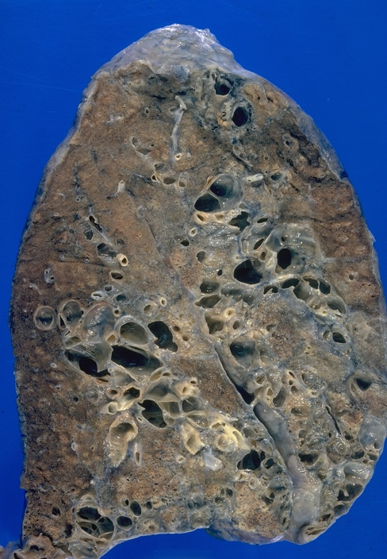

Figure . Gross pathology of pulmonary sarcoidosis with obvious granulomatous inflammation.

In over 90% of cases, the lungs or intrathoracic lymph nodes are involved with other organs and tissues variably involved.9 It is common for the liver, spleen, salivary glands, nervous system, musculoskeletal system and heart to be affected by sarcoidosis.1 Patients with sarcoidosis may be asymptomatic or may experience a wide range of symptoms including respiratory problems, skin rashes musculoskeletal pain and ocular pain or vision change.10 There is significant heterogeneity in the clinical manifestations, severity and clinical course of sarcoidosis across different ethnic and racial groups.9

Formed through the recruitment of T and B lymphocytes, fibroblasts, tissue macrophages and activated monocytes and orchestrated by cytokines and chemokines, the epithelioid granuloma is the hallmark of sarcoidosis. 11 The granulomas can occur in any organ system, but have a predilection for the lung and lymphatic system (Figure 2).12 There are no validated biomarkers that allow clinicians to overall organ involvement or to predict the disease course or response to pharmaceutical agents.9,13 Although recent research has contributed to the understanding of the immunologic basis of sarcoidosis, the determinants of the manifestation and course of the disease are still unclear and the etiology of sarcoidosis has yet to be elucidated.14 The likelihood that sarcoidosis is caused by a single common environmental exposure (e.g. infection, antigen, chemical agent) is low. Assuming a polygenic pathogenesis for sarcoidosis, the understanding of direct genetic mechanisms, related biological biomarkers and metagenomic signatures, the unique genetic content of a host and microbial communities, will provide further definition to sarcoidosis sub-phenotypes, mechanisms responsible for differences in clinical outcomes and possibly etiology.15,16

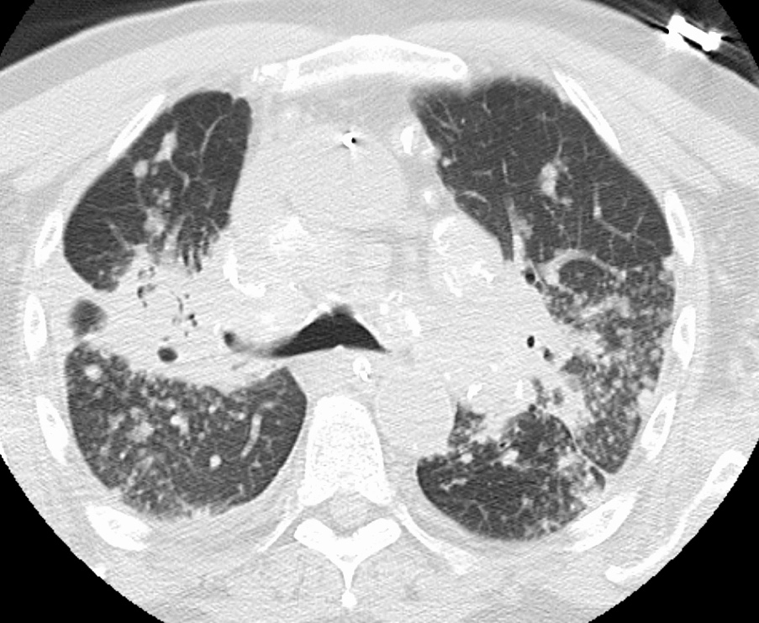

Figure . Axial CT image of Pulmonary Sarcoidosis

### Diagnosis

The diagnosis of sarcoidosis requires clinical correlation of symptoms with biochemical, radiological and pathological findings supporting a diagnosis. The diagnostic work up for sarcoidosis frequently includes a thorough medical and exposure history, physical exam including an eye investigation, imaging including chest radiography and CT imaging, pulmonary function tests, blood tests including blood counts and serum chemistries, urine analysis, electrocardiography and bronchoscopy with biopsy and histopathological examination of biopsied tissue (Figure 3).17–19 A diagnostic yield of 53% has been demonstrated using trans bronchial biopsy (CI:45%-61%, p<0.001).20 Recent studies by von Bartheld et al in 2013 have shown that ultrasonography-guided trans bronchial needle aspiration may be an alternative to the invasive biopsy performed during bronchoscopy and has been shown to have significantly better detection of granulomas (74% vs 48%, p<0.001) and diagnostic yield (yield= 80%, CI=73%-86%, p<0.001).20 Ratio of CD4/CD8 cells in bronchoalveolar lavage has also been proposed as a less invasive diagnostic biomarker of sarcoidosis and has a sensitivity similar to that of trans bronchial biopsy (sensitivity=54%, CI=46%-62%, p<0.001).20,21

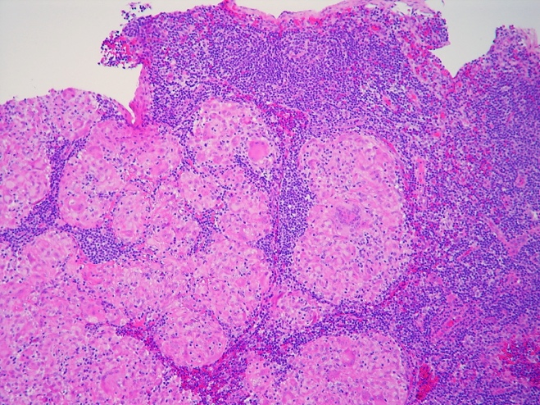

Figure . Histopathology of Lymph Node with Multiple Sarcoid Granulomas

Sarcoidosis is often referred to as the great masquerader and symptoms of sarcoidosis can mimic other illnesses and is often included in the differential diagnosis of many pulmonary and systemic processes. 17 For example, chronic beryllium disease may have pulmonary and extra-pulmonary manifestations that are indistinguishable from sarcoidosis with pathology that also demonstrates non-caseating granulomas. However, the presence of noncaseating granulomas in a single organ does not establish a diagnosis of sarcoidosis.1 Mycobacterial infections, too, are common etiologies for granulomatous disease. As such, a diagnosis of sarcoidosis is reliant on clinical picture combined with radiographic and pathologic findings in the absence of an alternative diagnosis. Given the potential for multi-organ system involvement, patients with sarcoidosis may present with organ specific symptoms or be asymptomatic at the time of diagnosis. Many patients with pulmonary sarcoidosis, for example, are diagnosed incidentally by screening chest radiograph.

Development of prognostic biomarkers may offer clinicians and public health researchers tools to guide research and diagnostic efforts. Refinement of predictive biological signatures, such as microbiome composition, may allow for screening programs to be implemented in high risk groups in the future.

### Staging of Disease Progression in Sarcoidosis

The traditional method of characterizing pulmonary sarcoidosis had been via the chest radiograph (Figure 4) using the Scadding stage staging system.9,22 The Scadding stage system assigns scores from 0 to IV, with higher scores representing more severe disease. There is some evidence that the Scadding stage has predictive value in estimating the likelihood of achieving a remission from disease. For example, those with a Scadding stage below II are likely to experience a remission from sarcoidosis where those with a Scadding stage of III or greater are much less likely to experience a complete spontaneous disease remission. 23 The predictive value of the Scadding stage model has not been well validated in large clinical trials, however, it has been used clinically for decades. The development of additional predictive biomarkers and increased understanding of the interaction of environmental exposures in concert with specific predictive biomarkers may add significantly to the usefulness of the chest radiograph and Scadding stage system for prognostication. Future research to validate the use of Scadding stages across time and with potential biological signatures of disease course are needed to optimize the identification of high risk patient groups.

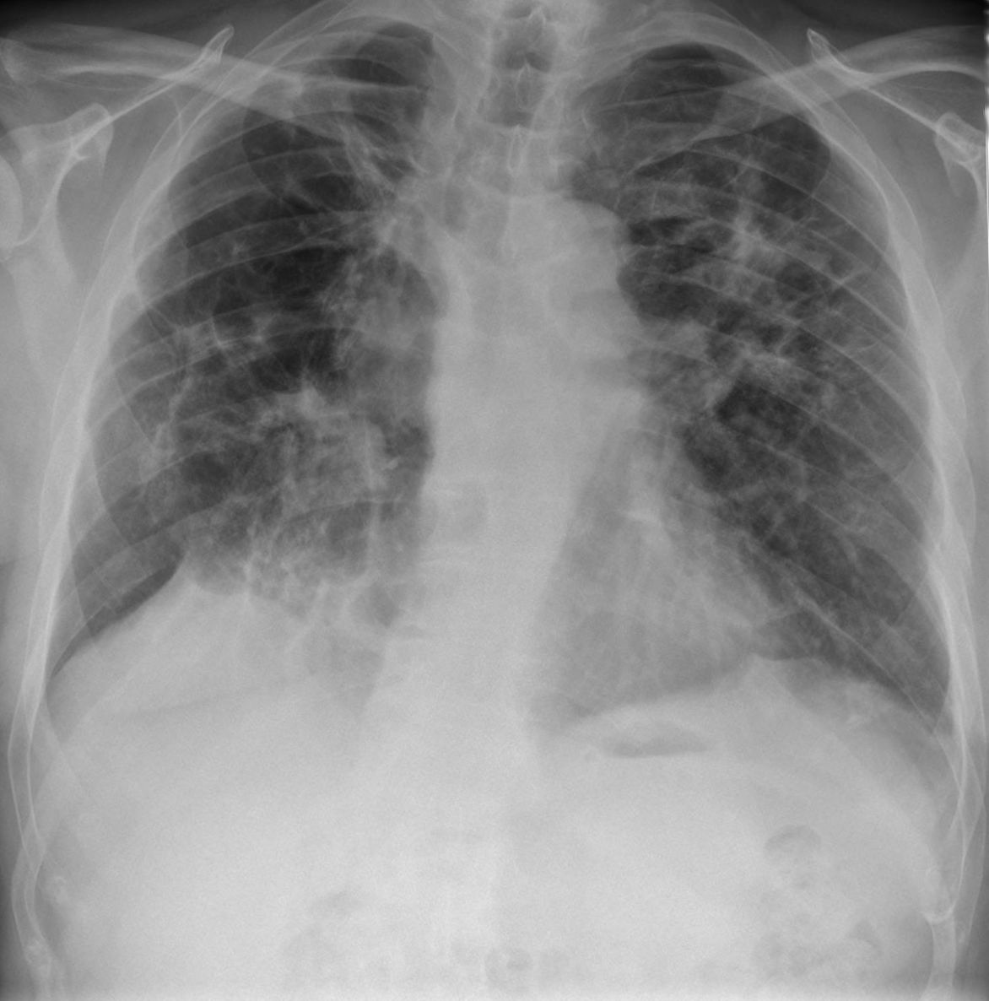

Figure . Chest radiograph of Scadding stage IV Pulmonary Sarcoidosis

### Clinical Heterogeneity

In patients with sarcoidosis there is significant clinical heterogeneity.9 Both the clinical manifestations and course of disease are variable and highly unpredictable.9 Clinical presentation can range from acute sarcoidosis, known as Löfgren Syndrome, to chronic and severe disease including cardiomyopathy, pulmonary hypertension and advanced lung disease.24 Some individuals with sarcoidosis may achieve a disease remission within the first 2-3 years following diagnosis, 30-50% of patients with sarcoidosis experience chronic active disease that necessitates treatment to prevent progression of disease causing organ dysfunction and fibrosis.5 The clinical course of the disease can vary significantly, from an acute but limited occurrence of granulomatous inflammation to progressive organ dysfunction leading to morbidity and mortality. Mortality has been reported as high as 12% in patients with advanced or severe disease.25

The mechanisms underlying the maintenance, progression or resolution of the inflammatory processes driving sarcoidosis are still unknown.5 Some patients experience chronic disease while others experience a relapse and remittance of their disease. The reported rate of sarcoidosis patients in the U.S. who have required pharmacological therapy in the treatment of their sarcoidosis has ranged widely across studies from 10 to 80%. Sarcoidosis is categorized into two diagnostic subgroups, intra-thoracic and extra-thoracic, determined by the organ systems involved. There is some correlation between the clinical presentation of the disease and the prognosis.1 For example, disease which presents as asymptomatic bilateral hilar lymphadenopathy usually indicates a self-limiting course where disease with symptomatic lung involvement or many extra-thoracic lesions is more apt to progress to chronic fibrotic disease. The significant clinical heterogeneity of the disease may be attributed to environmental exposures and host factors.5,17

### Treatment of Sarcoidosis

While lung involvement occurs in over 90% of patients with sarcoidosis, only about half will require systemic therapy.26 Treatment of sarcoidosis is offered with the goals of improving quality of life, palliating symptoms and to prevent end-organ disease.27 Symptoms targeted for improvement frequently include pulmonary manifestations as well as extra-pulmonary involvement such as cardiac and skin manifestations. Clinical trials have supported the use of glucocorticoids, such as prednisone, as first line therapy. However, dosing, length of treatment and tapering schedule have not been well established.28 Glucocorticoid steroids are often not well tolerated and second line therapy including immunosuppressants such as methotrexate, azathioprine, leflunomide and mycophenolate have been considered. Biological agents, specifically monoclonal anti-tumor necrosis factor (anti-TNF) antibodies have been used when other pharmaceutical treatments have proved ineffective. More research into dose and duration of therapy are needed to minimize risks to the patient while maximizing therapeutic benefit.27

## EPIDEMIOLOGY OF SARCOIDOSIS

Sarcoidosis is a disorder that occurs worldwide and impacts both males and females of all races and ages.29 However, there is significant disparity in the prevalence, incidence and course of the disease between people of different racial/ethnic groups and sex.30 Prevalence rates of sarcoidosis have remained consistently higher in both women and African American individuals.2

Understanding the epidemiology of sarcoidosis has presented several challenges: diagnosis remains challenging due to the lack of noninvasive diagnostic tests, resulting in misdiagnosis and under diagnosis, the lack of a precise consistent case definition and variability in case reporting and ascertainment.1 A large and systematic epidemiological study of sarcoidosis in the United States has not been undertaken since the mid-1990s.31

### Incidence and Prevalence

Once considered to be a rare disease, sarcoidosis is now recognized as a fairly common disease that is seen worldwide. Recent epidemiological studies of sarcoidosis have utilized health care and health insurance databases to identify and characterize patients with sarcoidosis. 2 Such databases often do not provide a wholly accurate depiction of the epidemiology of a disease owing to the differences in private and public insurance providers, inaccuracy of medical coding systems and incomplete data. Incidence has remained relatively stable over the last decade (8.4 per 100,000 in 2010, 8.3 in 2011, 8.8 in 2012).2 In a study using health insurance data, incidence of sarcoidosis in the U.S. was found to be 8.8 per 100,000 individuals with insurance (2012).2 Recent epidemiological studies using national health care databases in the United States found that in adults incidence in African American individuals (incidence rate (IR): 17.8 per 100,000) is higher than in white individuals (IR: 8.1 per 100,000), Hispanic individuals (IR: 4.3 per 100,000) and Asian individuals (IR: 3.2 per 100,000).2

Prevalence rates of sarcoidosis have remained consistently higher in both women and African American individuals.2 Recent epidemiological studies using national health care databases in the United States found that in adults prevalence in African American individuals (prevalence rate (PR): 141.4 per 100,000) is higher than in white individuals (PR:49.8 per 100,000), Hispanic individuals (PR: 21.7 per 100,000) and Asian individuals (PR: 18.9 per 100,000).2

### Morbidity and Mortality

The burden of disease as experienced by a patient with sarcoidosis is highly dependent on the pattern of disease progression. In some patients, a remitting-relapsing pattern of disease activity characterizes their experience with sarcoidosis and a small subset of patients experience a spontaneous remission.24,25,32 For those patients with chronic sarcoidosis, the disease is debilitating and life threatening.5,33,34 The case fatality rate of sarcoidosis is estimated to be as high as 5%.34

Estimates of mortality vary from 0.5% in population based data sources to as high as 12% from referral source based data.35,36 Recent research utilizing both referral and population based data sources as well as meta-analyses of existing studies of mortality have narrowed the range of mortality estimates to 1-8%.

Using death certificates from the National Center for Health Statistics from 1988-2007 encompassing 46,450,489 deaths in the United States, sarcoidosis was mentioned on 23,679 death certificates.25 Adjusting for age and sex, the sarcoidosis-related mortality rate was 4.32 per 1,000,000 population. Over the course of the two-decade period, mortality rates increased by 3% yearly. Adjusting for age, the mortality rate rose over 30% in males from 1988 to 2007 (2.89 per 1,000,000 in 1988 to 3.76 per 1,000,000 in 2007) and over 50% in females (4.06 per 1,000,00 in 1988 to 6.11 per 1,000,000 in 2007).25 Age-adjusted mortality rates increased more for white individuals than black individuals. Considering sex and race, black males had the lowest relative increase (21%) while white males had a relative increase of 65% in mortality.25 White females experienced the largest relative increase in mortality over time (74%) compared to a 46% increase in mortality for black females; however black females experienced the largest absolute difference with a rate increase of 10 deaths per 1,000,000 (18.85 per 1,000,000 in 1988 to 27.58 per 1,000,000 in 2007). In the same 2 decade period between 1988 and 2007, black males experienced a rate of increase of 3 deaths per 1,000,000 while both white males and white females experienced a rate increase of 1 per 1,000,000.25 Sarcoidosis was listed as the underlying cause of death on 59% of death certificates of patients with a sarcoidosis diagnosis. Among patients with a sarcoidosis diagnosis, 25% of death certificates listed “Other causes” as the underlying cause. Additional causes mentioned included pulmonary hypertension (7.5%), ischemic heart disease (7.2%), COPD (2.3%), cardiomyopathy (1.7%), lung cancer (1.4%), stroke (1.4%), pneumonia (1.1%) and liver disease (1.0%).34

#### Comorbid Conditions

Chronic sarcoidosis is a disease accompanied by many comorbid conditions. In a retrospective analysis of a large cohort of white patients with sarcoidosis 54% of patients had at least one comorbid condition with arterial hypertension (22.4%), thyroid disorders (7%), diabetes mellitus (5%), chronic obstructive pulmonary disease (COPD) (4.3%) and obesity (3.3%) being the most common.37 In patients with sarcoidosis affecting more than one organ system, the likelihood of having a comorbid condition (OR=1.52) was increased compared to those with pulmonary involvement only (OR=0.90).37 A smaller cohort of black patients with sarcoidosis reported much higher rates of comorbid conditions (96%) with similar common causes: arterial hypertension (39%), diabetes mellitus (19%), anemia (19%), asthma(15%) and depression(13%).33,37

A cross-sectional study of patients who had been diagnosed with sarcoidosis for more than a year found clinical depression in 60% of patients.38 When adjusting for race, income and use of steroid therapy, the odds ratio of depression in female patients with sarcoidosis is 3.33 when compared to males.38 A lack of access to medical care (11.64) and increased dyspnea on exertion (2.78) also increased the likelihood of depression in patients with sarcoidosis when adjusting for race, income and steroid therapy use.38 While sex alone has an on impact the odds of depression in patients with sarcoidosis, there is an interaction between sex and race. When all races are considered, females were significantly more likely to experience depression (66%) than males (38%). A larger, but not statistically significant, proportion of black and Hispanic patients with sarcoidosis experience depression when considering both sexes. When race and sex were both considered in the analysis, higher rates of depression in black females compared to black males (OR:3.71, p=0.0006) were found. In order to account for the increased socioeconomic risk factors for depression experienced by black patients, a multivariate model including income and education was used to analyze the role of race in depression in patients with sarcoidosis. This model failed to find a statistically significant relationship between depression in sarcoidosis patients and race alone.38,39 The highest risk factors for depression in sarcoidosis patients are access to medical care and female sex. The constellation of symptoms experienced by those with sarcoidosis likely impacts depression.

The contribution of comorbid conditions, including mental illness, and resulting therapies to perturbations of the immune system and immune modulating factors such as the microbiome cannot be discounted. To provide for a greater understanding of the potential impact of comorbid conditions on the pathogenesis, clinical manifestations and disease course of sarcoidosis, future clinical study design may employ the use of electronic medical records as well as pharmacy records to collect information in an accurate and detailed fashion regarding comorbid diagnoses and pharmaceutical therapy use. Additionally, routine blood chemistries and anthropomorphic characteristics could be examined over time with the intention of understanding the role of overall health and physical condition in the development of inflammatory disorders such as sarcoidosis.

#### Geographic Region

#### Sarcoidosis in the United States

While the BWHS analyses demonstrates no statistically significant difference in incidence or prevalence by geographic region (p=0.6589), analyses from the Nurse’s Health Study II (NHSII) looking at the influence of geographic location on sarcoidosis prevalence have found a significant difference in those living in the four U.S. census defined regions.40 Adjusting for age, women living in the Northeast experienced both higher prevalence (134 per 100,000) and incidence (13 per 100,000) of sarcoidosis compared to other regions. However, women living in the Midwest at the time of diagnosis experienced the highest incidence rates (14 per 100,000) of the four regions, with an incidence rate ratio of 2 compared to women living in the West (CI:1.31-3.07).40 However, adjusting for racial distribution across geographic regions, incidence rate ratios remained similar.

Additionally, sarcoidosis incidence is impacted by seasonality with some variation in diagnosis rates between the seasons.41–44 In the Rochester Epidemiology Project, a community based study of clinically diagnosed sarcoidosis, a small seasonal peak of 31% in diagnosis was found during the spring (March-May).41 In a study of patients with sarcoidosis with skin involvement, incidence was clustered in the winter and spring (p<0.001).45

Prevalence of sarcoidosis is higher in rural areas than suburban or urban areas.46–48 In previous research seeking to better understand the risk factors responsible for the rural clusters, exposures such as use of coal stoves, use of wood stoves, exposure to firewood, exposure to livestock and farm animals and use of nonpublic water supplies such as cisterns and private wells have been found to be inconclusive or conflicting.47,48 These exposures were often measured in a binary fashion (ever versus never) and exposure level was not considered. In a matched case-control study of rural patients with sarcoidosis in South Carolina, researchers sought to assess both exposure and level of exposure to common rurally associated exposures. All patients lived in South Carolina and had a biopsy confirmed diagnosis of sarcoidosis. Controls were identified using random digit dialing and were matched on a two to one ratio with cases on the area code and three-digit prefix in the phone number to ensure geographic similarity as well as age (±10 years), race and sex. Interviews were conducted by telephone using a computer assisted interview system and utilized a 15-minute questionnaire designed to collect data about demographics, health care access and use, treatment history related to sarcoidosis, smoking history, environmental exposure history as well as residential and employment histories. Additional information was collected about education, health care facility use, ability to access care or obtain prescribed medications, health insurance and employment status. Self-reported exposures to coal stoves, wood stoves, fireplaces, insecticides, herbicides, nonpublic water sources and farming were included as suspected exposures and exposure was assessed as ever, never or differing levels of frequency.

Using a binary (ever versus never) exposure level assessment and conditional logistic regression adjusting for primary care location and prescription drug utilization, statistically significant associations were found between sarcoidosis cases and use of a coal stove (OR=6.2, CI=1.7-22.7, p<0.05), use of a wood stove (OR=3.7, CI=1.5-8.8, p<0.05), use of a fire place (OR=6.8, CI=2.1-21.8, p<0.05), use of well or spring water (OR=2.2, CI=1.1-4.7, p<0.05) and living or working on a farm (OR=3.4, CI=1.2-9.1, p<0.05). When analyzing differing levels of exposure, a logistic regression model adjusting for primary care location and prescription drug utilization found statistically significant associations between sarcoidosis cases and more frequent use of a coal stove (OR=1.7, CI=1.1-2.4, p<0.05) compared to less frequent coal stove use, more frequent use of a wood stove (OR=1.5, CI=1.2=1.8, p<0.05) compared to less frequent wood stove use, more frequent use of a fireplace (OR=1.8, CI=1.3-2.6, p<0.05) compared to less frequent fireplace use. Associations were also found between sarcoidosis cases and consistent herbicide or insecticide exposure of more than one year (OR=1.9, CI=1.1-3.3, p<0.5) compared to inconsistent exposure for less than one year and between sarcoidosis cases and longer time spent living or working on a farm (OR=1.9, CI=1.1-3.1, p<0.05) compared to those who spent less time living or working on a farm.47 A Case Controlled Etiologic Study of Sarcoidosis (ACCESS) study conducted by Baughman, et al in 2000 found that living in a suburban area is negatively associated with sarcoidosis incidence (OR=0.75, CI=0.57-0.99, p=0.040).49 This analysis of rurally based exposures supports the previous research associating living in a rural area with sarcoidosis risk.47,48

Geographic differences may account for some of the differences we see in both environmental and microbial profile composition. Future research utilizing zip code date for several years before and after sarcoidosis diagnosis could prove a valuable research. In many states, data has been collected detailing the use of pesticides and herbicides by zip code, and analyzing the chemical exposure in such detail may provide insights previously unavailable. Additionally, the availability of different types of foods should be considered as a potential confounder when assessing the relationship between the microbiome, sarcoidosis and geographic exposures as diet plays a significant role in the gut microbiome.

The effect of a disparity in access to medical care between urban and rural communities may play a role in the heterogeneity of disease course seen in sarcoidosis. Urban versus rural community as well as access to health insurance, the existence of public transportation, public and university hospitals, and socioeconomic status should be considered as confounders to an association with geography.

#### Sarcoidosis Worldwide

Sarcoidosis is a disease that is found worldwide, but incidence varies widely. The global prevalence and incidence of sarcoidosis are challenging to determine due to the disparity in health care services available in parts of the world. Sarcoidosis can be incredibly challenging to diagnosis without extensive medical imaging and testing which is not available in underdeveloped countries. The incidence and prevalence rates are likely artificially low in areas where patients with symptoms are not able to be diagnosed. Additionally, in areas of the world where *Mycobacterium tuberculosis* has a significant prevalence, patients with sarcoidosis may be misdiagnosed as have tuberculosis—a disease which causes caveating granulomas that can be indistinguishable from sarcoidosis except by pathological analysis. Accordingly, in northern European countries, where health care is more readily available and rates of tuberculosis are lower, the highest incidence of sarcoidosis are reported, with estimates of incidence as high as 40 cases per 100,000 people.

In addition to varying rates of sarcoidosis in across the world, clinical presentation of disease also varies widely by region. While certain clinical phenotypes seem to arise more often in different areas of the world, pulmonary involvement is present in over 90% of cases worldwide. In Japan, ocular and cardiac sarcoid involvement is seen in 50% of cases compared to a worldwide rate of 10% ocular and cardiac disease. In an analysis of national autopsy records from Japan and autopsy records from two large medical institutions in the U.S. (109 white patients, 74 black patients and 320 Japanese), Japanese patients with sarcoidosis were found to have granulomas in the myocardium in 69.1% of cases compared to 18% in white patients and 14.3% of black patients. Compared to white patients, Japanese patients had higher rates of death from cardiac sarcoidosis and lower rates of death from pulmonary sarcoidosis.50,51 Although higher rates of sarcoidosis are seen in U.S. black patients, black patients in Africa and South America have lower rates of sarcoidosis compared to black in the U.S. Incidence of sarcoidosis is extremely low in Spain, Portugal, India, Saudi Arabia or South America likely due to the absence of screening programs and because of the higher prevalence of other granulomatous diseases such as tuberculosis and leprosy obscuring sarcoidosis diagnosis.1,52

### Risk Factors

#### Age

Although often thought of as a disease primarily affecting adults over 40 years of age, recent studies have demonstrated a bimodal trend in age of diagnosis.29,2,53 Incidence peaks first between ages 25-29 years and then again at ages 65-69 years.54 In a community-based study of sarcoidosis, a peak incidence in males (IR:18.7) was found at ages 30-39 years and in females (IR: 15.6) at ages 40 to 49 years.41 The Black Women’s Health Study (BWHS), an ongoing cohort study of black women in the U.S., has found that incidence was highest among black women in their 40s with a median age of diagnosis of 32 for prevalent cases and 44 years for incident cases, with an incidence rate of 92 per 100,000.29 The NHSII included an epidemiologic analysis of sarcoidosis in their cohort of primarily white nurses found the highest incident rates at ages 50-55 years. This discrepancy in age of diagnosis may be related to the previously mentioned challenges in diagnosing sarcoidosis, especially in patients over the age of 50 years, compounded by the lower prevalence of sarcoidosis in white people and the difference in clinical presentation by race. However, in case-control study of sarcoidosis, no significant difference was found between races in time-to-diagnosis.55 Sarcoidosis is very rare in children as compared to adults.56–58

#### Sex

Sarcoidosis is more common in women than men. This sex related difference in incidence has been seen worldwide, as supported by population based studies from three different countries. In a study of prevalence and incidence in Japan, nationwide surveys were conducted and vital statistics were examined over a decade. Researchers found that females had a higher incidence rate (1.4 per 100,000) compared to males (1.2 per 100,000).59 The difference in incidence by sex was much more pronounced in Sweden where a population based study over the course of nearly 30 years found a rate of 21.7 per 100,000 person years in females compared to 16.5 per 100,000 person years.44 In the U.S., researchers developed an incidence cohort of 75 individuals with sarcoidosis diagnosed over 30 years in Rochester, Minnesota who were followed retrospectively through their comprehensive medical records.41 Age-adjusted incidence rates were higher in females (6.3 per 100,000) than in males (5.9 per 100,000).

More recently, a study of patients evaluated at a tertiary referral care center in South Carolina found that 65.5% of the patients diagnosed there were female. The retrospective analysis used a clinical database and electronic medical records from the Medical University of South Carolina (MUSC) to develop a large cohort of patients with a sarcoidosis diagnosis diverse by age, race and sex. The cohort of 1236 patients was followed for over ten years and over 90% of patients had a diagnosis confirmed by biopsy increasing the validity of the findings considerably. Males had symptoms of sarcoidosis earlier than females (p=0.03) and had a diagnostic biopsy two years earlier than females on average (p=0.02).26 Previous research supports this trend of a later onset of sarcoidosis for women compared to men.60 In a study by Varron et al. that compared patients with sarcoidosis by age of onset, the proportion of females diagnosed with sarcoidosis after age 65 was five times larger than that of males.61

Organ involvement differed by sex as well. In males, sarcoidosis involvement of the lungs (OR=1.99, CI=1.31-3.04, p<0.05) and heart (OR=2.18, CI=1.27-3.74, p<0.05) was more prevalent than in females while males less had involvement of the liver (OR=0.68, CI=0.50-0.93, p<0.05), peripheral lymph nodes (OR=0.62, CI=0.42-0.91, p<0.05), skin (OR=0.59, CI=0.45-0.76, p<0.05) and eye (OR=0.67, CI= 0.50-0.93, p<0.05). Males required treatment for neurologic involvement (OR=3.03, CI=1.32-6.7, p<0.05), lung involvement (OR=1.31, CI=1.01-1.69, p<0.05) more frequently than females and required treatment of skin involvement (OR=0.58, CI=0.37-0.92, p<0.05) less frequently than females.26 Treatment with corticosteroids during the disease course was more likely to be prescribed for males (65.3%) than females (59.5%) (p=0.01).26 On radiographic images of the chest, males were classified into more advanced Scadding radiographic stages than females (p<0.0001) indicating that while more females were diagnosed with sarcoidosis in the cohort, males had more advanced pulmonary disease on diagnosis than females.26

A report from 2007 compared rates of mortality from sarcoidosis to those in 1988 and found a difference in increase in the mortality rate that was significantly different by sex. Over the 20 years analyzed, there was a 30% increase in mortality for males compared to a 50% increase in mortality from sarcoidosis in women. 62,63

##### Sex Hormones and Sarcoidosis Risk

Due to the increased incidence of sarcoidosis in females, some researchers have hypothesized that sex hormones may play a role in developing sarcoidosis. An inflammatory cascade has been observed in sarcoidosis with a polarized T helper Type 1 (Th1) response from lymphocytes.64,65 There is also significant evidence that sex hormones can act as immunomodulators.65–68 Immune cells, including T cells, B cells, monocytes and macrophages have been demonstrated to possess functional sex hormone receptors.69–72 This hypothesis was tested and proved in a 2011 study by Tajima et al using an animal model. In Tajima et al’s study, ovariectomized rats and intact rats were induced to develop chronic pulmonary granulomatous inflammation by an injection of Freund’s adjuvant. On histologic examination, the ovariectimized group had an increased number granulomas associated with enhanced Th1-based cytokine production in BAL fluid.65 While it is clear that sex hormones play a critical role in pulmonary granuloma formation by modulation of Th1 responses, more research is needed to elucidate this pathway. Hormone disruption is a well-known sequelae of

The BWHS collected data concerning reproductive history and sarcoidosis. The analysis suggests that experiencing a full term pregnancy and later age at menopause may be associated with a reduced risk of developing sarcoidosis.63,73 Researchers studied the relationship between exogenous estrogen exposure (oral contraceptive and supplemental female hormone use) and markers of endogenous estrogen exposure (age at menarche, age at menopause, pregnancy related data) to sarcoidosis incidence in black women and found a negative association between prolonged endogenous estrogen exposure, by way of births later in life and later in life onset of menopause, and sarcoidosis risk. Adjusting for age, education, geographic region, smoking status, BMI and follow up questionnaire cycle, no significant association between age at menarche and sarcoidosis risk was found. Among postmenopausal women, later age at menopause was associated with a decreased risk of developing sarcoidosis (p=0.03). Compared to those who experienced menopause before 40 years, those who experienced menopause between 40 and 44 years of age had an incidence rate ratio (IRR) of 0.92 (CI=0.51-1.67), between ages 45-49 had an IRR of 0.65 (CI=0.34-1.22) and 0.60 (CI=0.31-1.15) (p-trend=0.03). No association was found between parity and sarcoidosis incidence. Among childbearing women, the IRR for mothers with a first birth at age 30 years or older compared to those who had their first birth before the age of 20 years (IRR=0.52, CI=0.34-0.82, p=0.02). Decreased time since last birth was associated with decreased risk. Comparing those with less than five years since their last birth to those who experienced their last birth 15 or more years ago, the IRR was 0.56 (CI=0.35-0.91, p=0.01). The IRR for those who had ever lactated to those who had never lactated was 0.87 (CI=0.69-1.09); however there was no statistically significant association between duration of lactation and sarcoidosis (p=0.25). In examining exogenous exposure, no statistically significant association between oral contraceptive use and sarcoidosis was found (IRR=0.98, CI=0.78-1.23). In those using female hormone therapy compared to those who have not used female hormone therapy the IRR was 1.20 (CI=0.87-1.64) representing a possible increased risk of sarcoidosis in those using female hormone therapy.73 These findings suggest that endogenous estrogen exposure is a mediating factor for decreased sarcoidosis risk.

Animal studies have shown that endogenous estrogen exposure may play a role in the development and disease course of sarcoidosis.73 Shirai et al have developed a model of sarcoidosis in rats by using heat-killed bacilli Calmette-Guerin (BCG) to elicit a granulomatous reaction in the lung. Researchers compared the granulomatous inflammatory changes between ovariectomized rats and intact rats with the pulmonary granulomas provoked with BCG and found increased diffuse, mature granulomas throughout the lung in the ovariectomized rats compare to the intact rats. When given supplemental estradiol, rates of granulomas were similar to the intact rats. This supports the idea that endogenous estrogen exposure as a protective factor against sarcoidosis and points to ovarian dysfunction as a risk factor for the development of sarcoidosis.74

In a case report of a postmenopausal woman with a 12-year history of chronic sarcoidosis with pulmonary, ocular, hepatic and submandibular lymph node involvement treated with conjugated estrogen and medroxyprogesterone, liver function and pulmonary function tests improved with hormone replacement therapy. The patient had been diagnosed by trans bronchial and lymph node biopsy at age 41 years and had a favorable disease course for 12 years and did not require any pharmaceutical therapy during that time. The patient experienced onset of menopause at age 50 (9 years after diagnosis). 3 years following the onset of menopause (12 years after diagnosis), the patient was hospitalized with elevated liver function tests and hepatic abnormalities including multiple areas consistent with granulomas on CT imaging that were confirmed with needle biopsy. Due to potential for serious adverse risks, the patient was prescribed hormone replacement therapy rather than the standard glucocorticoid therapy. Following initiation of the hormone replacement therapy the patient experienced rapid normalization of liver function and liver biopsy performed after 7 months showed remarkable improvement. Pulmonary function tests and chest radiographs immediately and 3 years after the initiation of hormone replacement therapy have shown improvement as well. 75

The rate of relapse for those with systemic sarcoidosis may also be impacted by sex. White males have the highest rates of relapse compared to white females and black patients of both sexes.76,77 In a study of nearly 350 patients diagnosed with sarcoidosis enrolled in a registry over a four-year period, black patients of both sexes received pharmacologic therapy with twice the frequency of white patients of both sexes due to the severity of their disease presentation but had a similar relapse rate.26

Sarcoidosis occurs predominantly in women of reproductive age (under age 40) with a peak in incidence observed again among women age 50 to 60 years.13,78 Notably, patients diagnosed after age 50 years are more often women.54,59,78 The higher prevalence of sarcoidosis in women of reproductive age, the peak in incidence in the postmenopausal years and the fact that those diagnosed with sarcoidosis after age 50 years makes the continued study of hormones as a potential mediator of sarcoidosis pathogenesis. Research into the use of hormone replacement therapy for postmenopausal women with sarcoidosis should be undertaken. Recent research has shown that there is significant interaction between gut microbiota and hormones. Controlling production and inhibition of hormones, the gut microbiota have been considered an independent endocrine organ. Gut microbiota have been shown to promote levels of estrogens, including estriol.79 Perturbations of the microbiome may interact with hormone levels to increase risk of sarcoidosis.

#### Race

In the U.S., sarcoidosis has been reported as being 10-17 times more prevalent in black patients than in white patients.31 The highest incidence rates of sarcoidosis in the U.S. are experienced by black women.31,80 In a recent case-control study, approximately one-third of the sarcoidosis cases (736) were black women, with a total of 44% of the cases identifying as black.81 In the MUSC cohort, black women made up 44% of the affected cohort and were the most common combination of race and sex (p=0.01).26 Of the nearly 1300 sarcoidosis patients in the MUSC cohort, 65.2% were black. Compared to white patients, black patients had more advanced disease as seen on radiographic images of the chest described using Scadding stages (p<0.0001), increased extra-pulmonary organ involvement (p<0.0001) and required pharmacologic treatment more frequently (<0.0001). Black patients received treatment for pulmonary sarcoidosis more often than white patients (OR=2.68, CI=2.06-3.48, p<0.0001).

Organ involvement differed between black and white patients. Overall, the severity of disease in black patients was higher than in white patients. Black patients had more pulmonary (OR=2.05, CI=1.43-2.94, p<0.001), neurologic (OR=1.67, CI=1.07-2.61, p<0.05), skin (OR=1.97, CI=1.51-2.58, p<0.001), eye (OR= 2.19, CI=1.61-2.99, p<0.001), and liver (OR=1.48, CI=1.09-2.01, p<0.001) involvement than white patients. Black patients experienced less sarcoid involvement of the spleen (OR=0.63, CI=0.41-0.97, p<0.05) as well as lower rates of hypercalcemia attributed to sarcoidosis (OR=0.58, CI=0.37-0.89, p<0.05). Additionally, certain combinations of organ involvement were more likely in black patients than white patients. Black patients were more likely to have both eye and neurologic involvement (OR=5.31, CI=1.60-17.5) as well as ear, nose, throat and skin involvement (OR=2.65, CI=1.37-5.12) more often than white patients but had lower rates of both spleen and liver involvement (OR=0.53, CI=0.31-0.91, p<0.05). On average, black patients had a higher number of organs involved (2.48) in the disease process than white patients (2.06) (difference=0.42, p<0.0001). The number of organs involved increased during the follow up period at a higher rate for black patients (mean increase=0.31±0.86) than white patients (mean increase=0.19 ± 0.77) (p<0.0001). This difference by race in the increase in the number of organs involved was also found in a case-control study of 706 sarcoidosis patients and matched controls where new organ involvement was more likely in black patients (mean increase=0.48) compared to white patients (mean increase=0.17) over two years.49

Black patients developed their first symptoms related to sarcoidosis on average 10 years earlier than white patients (p<0.0001) and had a diagnostic biopsy on average 10 years earlier than white patients (p<0.0001).26 More black patients received pharmacologic treatment (74.5%) than white patients (55.1%) (p<0.0001) with a higher percentage of black patients receiving corticosteroid therapy (69.9%) at any time during the study follow up period than white patients (59.5%) (p<0.01). The racial difference in sarcoidosis incidence necessitates future study into the psychosocial and environmental differences between black and white patients with sarcoidosis.

#### Socioeconomic Status

Severity of disease in sarcoidosis is associated with socioeconomic status (SES). Patients with low SES are at risk of having poor or no health insurance, which contributes to lack of access to care. In sarcoidosis patients with low SES and no health insurance, poor health status and severe dyspnea are more common.82,83

In 2001, Rabin et al recruited patients with sarcoidosis from a private university hospital sarcoidosis clinic and from a public municipal hospital to develop a cohort of sarcoidosis patients diverse by health insurance, SES, race, sex and age to characterize the role of insurance status and SES in sarcoidosis incidence, prevalence and outcome. By representing patients from both a private university hospital who may be more likely to have a higher SES and private insurance as well as patients from a public municipal hospital who may be more likely to have a lower SES and public insurance or no insurance, a much broader demographic was represented increasing the validity and generalizability of this analysis. A validated questionnaire, the Sarcoidosis Telephone Survey Form, was used to assess current health status, SES, insurance status and demographic characteristics. The Health Status Questionnaire Short Form 36 was used to assess general health status and quality of life was assess using the Medical Outcomes Study Short-Form General Health Survey. Dyspnea was specifically assessed using the Modified Medical Research Dyspnea Scale and data pertaining to use of medical services, health insurance, education and income was collected using selected questions from the National Health Interview Survey. Data was collected using telephone survey. 82

Patients who self-reported their health status as only fair to poor more often had a high school education or less (p=0.001), an income less than $20,000 per year (p <0.0001) and either no health insurance or public health insurance (p<0.0001) but were not statistically different by age, sex or race. Patients who self-reported moderate or severe dyspnea more often had less than a high school education (p=0.007), an income less than $20,000 per year (p=0.002) and no health insurance or public health insurance (p=0.006). Patients who had a more advanced radiographic Scadding Scale score more often had an income of less than $20,000 per year (p=0.034). Patients who had less than a high school education more often had pulmonary function tests indicating severe pulmonary impairment (p-0.041). Patients with an income less than $20,000 per year reported limitations in activities due to physical disability (0.022) and emotional disability (p=0.001). Patients with no insurance or public health insurance report limitations in activities due to physical disability (p=0.003), emotional disability (p=0.009) and social limitations due to disability (p=0.039). 82 This analysis did not account for racial differences. The racial differences noted above should be considered in light of the socioeconomic confounders presented here.

However, similar results were seen in the ACCESS study with analysis including adjustment for race, sex and age. Patients with an income less than $20,000 per year were more likely to have no or public insurance (<0.0001), to report difficulty getting their medications (<0.0001), transportation barriers to accessing medical care (<0.0001) and reported missing more medical appointments (<0.0001). Additionally, patients with an income less than $20,000 had a greater number of organ systems involved in the disease process (p=0.006), pulmonary function tests indicating severe pulmonary impairment (p=0.003) and reported more dyspnea (p<0.0001). Low income patients reported decreased physical functioning (p<0.0001), increased limitation on their physical activities (p<0.0001), decreased quality of health (p <0.0001) and decreased social functioning (p<0.0001). 83

Adjustment for race, sex and age logistic regression was used to understand the association between the number of organs involved and socioeconomic factors. While barriers to care, comorbities, symptoms and income were assessed, only reported difficulty obtaining medications was statistically associated with increased number of organs involved in the disease process (OR=2.23, CI=1.27-3.92, p<0.01) compared to those who did not report barriers to accessing prescribed medicines. A logistic regression model adjusting for race, sex and age examining the association between socioeconomic factors and pulmonary function test (a surrogate for pulmonary disease severity) found several statistically significant associations. Patients with an income less than $20,000 were more likely to have a lower forced expiratory volume in one second predicted (FEV1) (OR=1.6, CI=1.06-2.42, p<0.05) compared to those with an income over $50,000. Patients who self-reported generally poor health have both a lower FEV1 (OR=1.27, CI=1.08-1.49, p<0.01) and lower forced vital capacity percent predicted (FVC) (OR=1.27, CI=1.07-1.51, p<0.01).

In a logistic regression model adjusting for age, race and sex examining the association between self-reported dyspnea and socioeconomic factors found associations between increased dyspnea and income less than $20,000 (OR=2.13, CI=1.41-3.23, p<0.001), reported difficulty getting prescribed medications (OR=3.25, CI=1.79-5.89, p <0.001), and reported poor health (OR=2.17, CI=1.81-2.59, p<0.001). Reported poor physical function was associated with income less than $20,000 (OR=2.58, CI= 1.71-3.89, p<0.001), difficulty getting prescribed medications (OR=4.24, CI=2.10-8.56, p<0.001) and reported poor physical health (OR=2.37, CI=2.00-2.80, p<0.001). Increased physical limitations were associated with more missed medical appointments (OR=1.74, CI=1.04-2.93, p<0.05) and trouble getting prescribed medications (OR=1.95, CI=1.04-3.67, p<0.05) and self-reported poor health (OR=2.05, CI=1.73-2.42, p<0.001) and income less than $20,000 (OR=1.58, CI=1.05-2.37, p<0.05). Restricted social functioning was associated with income less than $20,000 (OR=1.98, CI=1.32-2.97, p<0.001) and income between $20,000 and $49,999 (OR=1.70, CI=1.24-2.32, p<0.001), difficulty getting prescribed medications (OR=1.84, CI=1.06-3.20, p<0.05), more missed medical appointments (OR=1.97, CI=1.24-3.14, p<0.01), and poor mood (OR=1.03, CI=1.01-1.05, p<0.01). Self-reported poor general health was associated with income less than $20,000 (OR=1.86, CI=1.28-2.72, p<0.01), difficulty getting prescribed medications (OR=3.35, CI=1.82-6.16, p<0.001), and decreased mood (OR=1.10, CI=1.097-1.12, p<0.001). 83 Low SES patients have access to different food options than higher SES patients and the gut microbiome may be impacted by this disparity in food consumption. Additionally, the microbiome of patients with differing levels of physical functioning may be impacted due to restricted activity or a change in exposure due to inactivity.

#### Occupational Exposure

Although the etiology of the sarcoidosis is still unclear, previous research has suggested that environmental factors and occupational exposures have been associated with incidence of sarcoidosis and may play a putative role by directly triggering granulomatous inflammation or indirectly inducing immunologic changes that alter the risk of sarcoidosis. 4,84 It is unclear if environmental exposures reflect a direct trigger to induce granulomatous inflammation or an indirect influence, impacting the immune system and host response readiness.84 The lungs and the skin, both common organs involved in sarcoidosis, have regular exposure to a wide variety of environmental agents.85

There are several known occupational and environmental exposures that can cause sensitization which can result in a cell-mediated immune response responsible for the development of granulomas.11,21 Acute or chronic inhalation of both organic and inorganic antigens can cause hypersensitivity pneumonitis.86 Hypersensitivity pneumonitis has similar clinical, laboratory and pathological features to pulmonary sarcoidosis including the development of pulmonary granulomas and is often misdiagnosed as pulmonary sarcoidosis. Beryllium inhalation is one such occupational exposure which can cause sensitization and chronic beryllium exposure can result in the development of pulmonary granulomas indistinguishable to those seen in sarcoidosis.87 Granulomatous lung disease that imitates sarcoidosis can also be induced by inhalation of other metals including aluminum, titanium and zirconium.88–90. Inhalation of other inorganic materials such as silica has also been associated with a sarcoid-like response as well.91 A sarcoidosis-like disorder was experienced by many first-response rescue workers from the World Trade Center (inhalational exposure to a complex mix of organic and inorganic chemicals) disaster in 2001.92 Whether these diseases should be considered sarcoidosis or remain independent pulmonary disorders is contentious due to the absence of systemic granulomatous inflammation or extra-pulmonary involvement.93

With a clear predilection for those in early to middle adulthood, incidence is not frequently seen in children, pointing toward an exposure occurring in working-age individuals.57,94 There are several known occupational and environmental exposures that can cause sensitization which can result in a cell-mediated immune response responsible for the development of granulomas.11,21 Beryllium inhalation can cause sensitization and chronic beryllium disease which presents with pulmonary granulomas similar to those seen in sarcoidosis.87 Granulomatous lung disease that imitates can be induced by inhalation of other metals including aluminum, titanium and zirconium.88–90 Inhalation of both organic and inorganic antigens can cause hypersensitivity pneumonitis.86 Hypersensitivity pneumonitis has similar clinical, laboratory and pathological features to pulmonary sarcoidosis and is often misdiagnosed as pulmonary sarcoidosis.86 In animal studies, a wide variety of antigens have been found to cause hypersensitivity and induce a granulomatous formation. Experimental antigens have included mycobacterial extracts, avian protein, fungal spores, schistosome eggs, carrageenan and other bacterial and viral agents.

In 2001, the ACCESS trial examined both occupational and non-occupational exposures in a sample of 706 cases and age, race and sex matched controls. Patients were recruited from 10 clinical centers across the U.S. Cases were newly diagnosed with sarcoidosis (less than six months from diagnosis) by biopsy. Cases were recruited from a variety of clinical settings including inpatient and outpatient hospital settings and nonhospital outpatient settings at each of the 10 centers. Controls were recruited by random digit dialing and matched on age (within five years), sex and race. Both cases and controls completed questionnaires collecting data on demographic information, medical history, environmental and occupational exposure history, family history, quality of life variables and medical care usage. Cases had a physical examination and extent of disease and organ involvement was assessed using standard of care diagnostic testing. Radiographic images of the chest, pulmonary function tests, complete blood count and chemistries were completed for all cases.

The ACCESS study found that several occupations were associated with sarcoidosis. Cases with sarcoidosis were more likely to work in the agricultural industry (OR=1.46, CI=1.13-1.89, p=0.004), as a physician (OR=11.00, CI=1.6-473.47, p=0.006), raising birds (OR=3.5, CI=1.1-14.60, p=0.031), in automotive manufacturing (OR=8.00, CI=1.07-354.98, p=0.039), as a teacher (OR=1.55, CI=1.02-2.40, p=0.042) or in a job with radiation exposure (OR=1.83, CI=1.01-3.46, p=0.049) compared to healthy controls. Sarcoidosis patients were more likely to work in an industry that uses pesticides (OR=1.41, CI=1.09-1.83, p=0.008) as well as to have exposure to insecticide (OR=1.52, CI=1.14-2.04, p=0.003), mold or mildew (OR=1.61, CI=1.13-2.31, p=0.007) or musty odors (OR=1.42, CI=1.09-1.84, p=0.008) in the workplace compared to healthy controls. 4

Patients with sarcoidosis were less likely to work as a wait-staff in a restaurant (OR=0.68, CI=0.51-0.90, p=0.006) or in a job that required isolation (OR=0.77, CI=0.61-0.97, p=0.023) or work that was done primarily on the computer (OR=0.77, CI=0.60-0.97, p=0.029) compared to healthy controls. Although previous research findings had suggested that a positive association between animal exposures including animal dust, feathers and animal droppings, the ACCESS found that sarcoidosis cases were less likely to have been exposed to cats (OR=0.70, CI=0.52-0.95, p=0.022), animal dust (OR=0.77, CI=0.61-0.98, p=0.032), animal feathers in down pillows (OR=0.71, CI=0.57-0.89) and fish tanks (OR=0.71, CI=0.57-0.89, p=0.002). Use of indoor pools (OR=0.73, CI=0.56-0.94, p=0.013) and hot tubs (OR=0.76, CI=0.60-0.96, p=0.021) was also negatively associated with sarcoidosis incidence.49

Research has shown high prevalence rates in areas where timbering occurs and lumber is processed and in rural areas where wood and coal are burned for heat. Cummings et al found clustering of sarcoidosis incidence in areas in which lumber mills or carpentry mills were the primary local industry.95 Soil, foliage and other organic antigens have been considered as potential etiologic agents.

Previous studies have shown that exposures in the workplace have been associated with sarcoidosis risk.49,85,88–90,96 Workers in industries that utilize metals, specifically aluminum, zirconium, titanium and beryllium, are known to have increased risk of sarcoidosis, hypersensitivity pneumonitis and granulomatous lung disease.4,21,49,81,85,88–90 Other sarcoidosis clusters have been identified in mechanics, postal workers and firefighters. 47,85,97

#### Animal Exposures

Previous literature has found a positive association between cats and sarcoidosis. A case control study by Revsbech in 1992 reported that in an analysis of pet exposures and sarcoidosis risk, no difference in sarcoidosis was found between those who lived with cats.98 In 2012, Drent et al presented a case of severe sarcoidosis in a woman with 8 cats. Her physicians advised she avoid contact with her cats and within 6 months of following this advice, her sarcoidosis had relented such that she no longer required pharmaceutical therapy. Drent et al postulate that the silica-containing cat litter was responsible for triggering the induction of sarcoidosis in this patient as the patient was able to live with her cats again after changing their litter to a newspaper based product rather than the silica-based litter used previously.99 More research into types of cat litter used, if cats lived in doors or not and how long individuals were exposed to cats may help to explain this association.

Research has shown an association between exposure to birds and hypersensitivity pneumonitis.100 In 2004, Newman et al conducted a case-control study and found that both occupational (OR:3.73, CI: 1.10-12.59, p=0.034) and avocational exposure (OR:1.49, CI: 1-2.21, p=0.049) to birds was associated with sarcoidosis.4 The hyperinflammatory state caused by exposure to birds in some people may play a role in triggering the inflammatory pathways associated with sarcoidosis. Research into the types of birds and dose dependent relationship of the exposure will elucidate this connection in the future.

#### Smoking

Although smoking tobacco products has been strongly associated with pulmonary disease, most notably COPD and lung cancer, smoking appears to be negatively correlated with development of sarcoidosis. In the ACCESS case-control study, a history of ever smoking cigarettes was less frequently observed in cases than in controls (OR=0.62, CI=0.50-0.77, p<0.05). Tobacco smoke exposure, including cigars and pipes, was less frequently observed in sarcoidosis cases (OR=0.20, CI=0.14-0.29, p<0.001) as was second hand exposure to tobacco smoke of any type (OR=0.70, CI=0.55-0.88, p=0.002).4 This is consistent with other studies presenting low prevalence of cigarette smoking among sarcoidosis patients.101 Negative associations between smoking and sarcoidosis have been found in the literature since the 1970s.4,102–105 A study of 200 patients with sarcoidosis found that only 21.9% of patients in the study had ever smoked, which was significantly less than was expected in the population (p<0.0001). An estimation of relative risk of smoking in sarcoidosis patients was statistically significant in heavy smokers (RR=0.44, CI=0.24-0.81, p<0.05) compared to nonsmokers with sarcoidosis.104

Tobacco smoke has been shown to have immunosuppressive properties and effects on both innate and adaptive immunity which have been implicated in the known major health hazards associated with tobacco use including cardiovascular disease, cancer and increased infection risk.102,106 However, the immunosuppression may offer a beneficial impact on some inflammatory diseases including hypersensitivity pneumonitis and sarcoidosis.107 In smokers, lower serum antibody response to agents that have been known to cause hypersensitivity pneumonitis has been demonstrated in the literature as well .102 These findings indicate that smoking may actually be protective and inhibit the development of granulomatous inflammation.

#### Exposure to Sarcoidosis

An association between the development of sarcoidosis and contact with a patient with sarcoidosis has been demonstrated. In a study of an isolated community on an island with a high prevalence rate of sarcoidosis, those who had had contact with patients with sarcoidosis were more likely to develop sarcoidosis than those who had not had contact with someone with sarcoidosis indicating that an infectious or microbial agent spread through person to person transmission is responsible for the etiology of sarcoidosis. 108 Individuals who worked with someone with sarcoidosis were more likely to develop sarcoidosis than those who did not work with someone with sarcoidosis (p=0.0003). Individuals who lived within 100m of an individual with sarcoidosis with in the last two years were more likely to develop sarcoidosis than those who did not live near someone with a new sarcoidosis diagnosis (p=0.0005). Those living in proximity to an individual with sarcoidosis were more likely to develop sarcoidosis compare to those who did not (100m, p=0.0034, 50m, p=0.0020, 10m, p=0.0026). 46,108–110 There are also reports of clusters in Sweden and Japan that suggest an infectious cause for sarcoidosis.111 A series of cases were also reported that were clustered together, including a pair of siblings, an employer of one of the siblings and the employer’s friend, who was unacquainted with the siblings.112 This evidence suggests that sarcoidosis could be a communicable disease or caused by an infectious agent requiring transmission from person to person through prolonged close contact. 46,108–110 Research has demonstrated that those who share environments or are in prolonged close contact can develop microbial communities that are more similar to each other. It is possible that through physical interaction and the sharing of space that changes in the microbiota occur that increase the susceptibility to sarcoidosis.

### Public Health Significance

The public health significance of sarcoidosis is reflected in the monetary as well as in the quality of life of individuals with sarcoidosis. A case-control study of sarcoidosis patients diagnosed between 1988 and 2015 undertaken by Rice et al in 2017, who had continuous private health insurance during that time, and matched controls was undertaken to understand the financial costs incurred in the treatment of sarcoidosis.3 Rice et al estimated that the total direct medical cost burden of sarcoidosis is between $1.3 to $8.7 billion to commercial health insurance companies. Compared to costs incurred treating matched controls, health insurance companies paid between $0.3 to $2.3 billion more on health care for patients with sarcoidosis. Overall private health insurance companies incurred a mean total of $19,714 in annual healthcare costs per sarcoidosis patient. The costs were driven primarily by outpatient visits (46%), costing $9,050 per year per patient in 2015 and inpatient hospital admissions (32%), costing $6,398 per year per patient. Compared to controls, patients with sarcoidosis had 36% higher health care costs ($5,190 difference, $19,714 for cases, $14,524 for controls, p<0.0001).3 Due in large part to the heterogeneity of clinical presentation, disease course and treatment requirements, medical costs related to sarcoidosis vary widely. For sarcoidosis patients, the median cost of care is $18,663 and the mean cost of care was over $32,000. The 20% of patients with the highest medical costs made up over 72% of the total health care costs for all patients with sarcoidosis. However, the sickest 5% of patients had total health care costs of over $240 million per year with a cost per patient value of $93,000 per year.3 High medical cost sarcoidosis patients are complicated patients with higher rates of multi-organ involvement and higher rates of comorbidities. These high-cost patients have increased use of health care resources, primarily through inpatient admissions and specialty clinic visits and are more likely to be treated with biological therapies rather than glucocorticoid steroidal therapies. When comparing the annual total health care cost for this high cost group of patients to patients considered low cost, the mean annual total cost was over 10 times higher ($73, 345 for the high cost group compared to $7,073 for the low-cost group).

Additionally, compared to controls, patients with sarcoidosis have more work loss days (15.9 v 11.3, p<0.001) and increased costs involved in work loss ($3,288 vs $2,527, p<0.001). An overall total direct medical cost of $1.3-$8.7 billion dollars per year was spent on health care for patients with sarcoidosis by health insurance companies. Indirect costs related to work loss days because of sarcoidosis totaled $0.2-$1.5 billion per year.

Elucidating the factors underlying the pathobiology responsible for the heterogeneous clinical manifestations and disease course will provide opportunities for prevention and intervention efforts directed at those with identified risk factors. While hormonal involvement may account for a significant proportion of the sex differences seen in sarcoidosis incidence, understanding other sex related differences impacting the etiological processes that drive sarcoidosis will allow for targeted public health programs designed to promote awareness and mediate risk factors. Identifying ‘omic signatures for different clinical phenotypes will create an opportunity to design research that is more precise and informative.

## Pathobiology OF Sarcoidosis

The pathobiology of sarcoidosis is uncertain due to an incomplete understanding of the etiology in addition to a lack of understanding as to how clinical manifestations, clinical outcomes and responses to therapeutic interventions are associated with genetic, environmental and immunologic factors.9,84 Although not unique to sarcoidosis, the epithelioid granuloma is pathognomonic of the disease. 11 In sarcoidosis, granulomas are the result of both a local and systemic inflammatory response with an activation of the adaptive and innate immune systems.5 Granulomas are an immunologic response involving tissue macrophages, activated monocytes, fibroblasts and T and B lymphocytes.5 The granuloma consists primarily of monocytes, macrophages, epithelioid cells and multinucleated giant cells well as T lymphocytes.

In the lung, an inflammatory cascade associated with sarcoidosis displays a polarized T helper Type 1 (Th1) response from lymphocytes and subsequent increase in production of IFN-y, IL-2, IL-12 and IL-18.14 Recruitment of additional lymphocytes and monocytes to the lung and differentiation of macrophages into epithelioid and multinucleated giant cells is caused by chemotactic and pro-inflammatory effector and regulatory cytokine signals. This in turn leads to granuloma formation.9,11 Additionally, oligoclonal T-cell expansion in the lungs consistent with T-cell antigen-driven inflammation is seen in sarcoidosis along with regulatory T-cell deficiency. This innate immune pathway dysregulation has been associated with a genetic susceptibility involving human leukocyte antigens (HLA) and variants in the major histocompatibility (MHC) locus.113–115 Variants in the MHC have been implicated in the varying susceptibility individuals have to infectious disease and supports the infectious etiology hypothesis.113,116

### Etiological Hypotheses of Sarcoidosis

The etiology of sarcoidosis is not yet elucidated, despite years of research.49 While recent research has shed light on the immunologic basis of sarcoidosis, much remains uncertain.5,9,14 An association with Th17 effector T-cell responses has been shown in recent research, but the role of these responses in disease pathogenesis or prognosis remains unclear.64,117–119 Hypotheses involving occupational and environmental factors as well as infection and genetic risk factors have been explored, but a definitive cause has not been identified.17 While both genetic susceptibility involving HLA and MHC variants and environmental triggers are thought to play a role in the pathogenesis of sarcoidosis, significant evidence for the role of a microbial agent exists.116,120–122 In patients with chronic systemic sarcoidosis, multiple studies support a microbial cause, however, no consensus has been reached regarding the specific microbial agents or pathogenesis of the disease following exposure.5,116,122–128 The role of specific organisms in etiology and pathogenesis has yet to be elucidated and remains an area requiring additional research.9,14,116

#### Infectious Agents in Sarcoidosis

While no consensus on the role of microbial agents in sarcoidosis has been reached, mounting evidence points toward microbial involvement in the pathogenesis and phenotypic development of sarcoidosis with the most convincing data implicating mycobacteria or propionibacteria.129 Mycobacterium is a genus of both gram-positive and gram-negative bacteria known to cause serious disease in mammals.130 Propionibacteriumis a genus of gram-positive anaerobic bacteria named for their unique ability to synthesize propionic acid.131

Clusters of sarcoidosis have been noted in neighbors, unrelated cohabitants, coworkers and other unrelated social contacts.46,108–110 In a study of a relatively isolated island population, patients with sarcoidosis were more likely to have had contact with an individual who had sarcoidosis prior to their own sarcoidosis diagnosis compared to controls.46,108–110 These findings lend support to the hypothesis that sarcoidosis is caused by an infectious agent.5,46,85,108–110,128 Seasonal clustering of incidence in winter and early spring may indicate that exposure to an offending antigen occurs when people are spending more time indoors in confined spaces and less time outdoors during these colder months.41–45

Researchers have demonstrated that granuloma formation can be induced in mice by injecting them with human sarcoidosis tissue. Healthy mice were given an injection of either control tissue homogenate or human sarcoid tissue homogenate. After 15 months, granulomas were present in the mice inoculated with the sarcoid tissue in many organs and tissues throughout their bodies but the mice inoculated with the control tissue did not develop any detectable granulomatous inflammation.132 Furthermore, the evidence for a microbial agent responsible for transmission of sarcoidosis is strengthened by the fact that when human sarcoidosis tissue homogenate was autoclaved, stored at -20°C for one week or was exposed to 60Co irradiation, the effect of transmission was absent.132 However, the evidence for a microbial agent responsible for transmission of sarcoidosis is strengthened by the fact that when human sarcoidosis tissue homogenate was autoclaved, stored at -20°C for 1 week or were exposed to 60Co irradiation, the effect of transmission was absent. 132 The response to the Kveim-Siltzbach test, in which homogenates from sarcoid spleen or lymph nodes is injected subcutaneously, in those with sarcoidosis involves a granulomatous reaction that is indistinguishable from the development of sarcoid granulomas, providing evidence for an antigen-induced disease etiology.128

There are several case reports of possible transmission of sarcoidosis via organ or bone transplantation. In a clinical report implicating allogenic bone marrow transplantation as a possible route of transmission for sarcoidosis, a 34-year-old male received an allogenic bone marrow transplant (BMT) for non-Hodgkins lymphoma. Two years before donation, pulmonary sarcoidosis had been diagnosed in the donor. The donor had achieved a clinical remission from sarcoidosis after steroid therapy and had only minor radiographic evidence of disease at the time of the bone marrow donation. Ninety days after the BMT, the recipient was diagnosed with sarcoidosis confirmed by both lung and liver biopsy. The recipient achieved a remission from sarcoidosis in 10 weeks following a change in immunosuppressive therapy.133 Several case reports document patients diagnosed with sarcoidosis shortly after receiving an allogenic lung or heart transplant or the recurrence of sarcoidosis in the period following their transplant.134–137 Despite these associations, no studies have shown live replicating microorganisms by direct culture or through histological staining. Potential explanations include the possibility that the transmissible agent in the transplant cases are actually donor immune cells that contain pathogenic microbial antigens, autoantigens or misfolded proteins that cause granuloma formation and that a microbial agent will become apparent with increased use of culture independent techniques.116,136

In further support of an infectious etiology of sarcoidosis, there are known microbial infectious agents that can induce granulomatous inflammation that resembles that of sarcoidosis.138 It is feasible that more than one microbial agent or a combination of microbial agents working in concert are responsible for the induction of sarcoidosis. 5,33,116,128,139 The involvement of infectious agents in sarcoidosis is supported by the detection of the genomes of microbes within granulomas, including the genomes of *Propionibacterium acnes* (P. acnes) and *Mycobacterium tuberculosis* (MT).122

Due to their clinical and histological similarities, mycobacterial infection has long been hypothesized to be associated with sarcoidosis.5,120 Indirect evidence linking mycobacterium to sarcoidosis has included serum antibody titers to specific mycobacterial antigens as well as T-cell responses to mycobacterial antigens in patients with sarcoidosis. More direct evidence includes the presence of tuberculosteraic acid in granulomas on gas chromatography and mass spectrometry, the identification of mycobacterial proteins in granulomas on immunohistochemistry assays, mass spectrometry and protein immunoblots. Using PCR and in situ hybridization, mycobacterial nucleic acids have been found in granulomas of patients with sarcoidosis. 5,120,127,128 A research group in Greece was able to amplify mycobacterial DNA in 72% of the sarcoidosis tissue biopsies studied.123 In a Japanese study, the genome of mycobacteria were found in 100% of the tissue biopsies examined.122 The presence of DNA in the granulomatous tissue is independent of any culture data suggesting infection with mycobacteria, but rather suggests that mycobacteria were present and were retained in the granuloma during the inflammatory cascade causing the formation of the granuloma. In at least a subset of patients with sarcoidosis, it is likely that mycobacteria play an etiologic role.120,122

In order to test the etiologic hypothesis that mycobacterial infection is associated with sarcoidosis, researchers undertook a randomized placebo controlled clinical trial in patients with pulmonary and skin sarcoidosis testing anti-mycobacterial medications. Patients randomized to treatment were prescribed a standard mycobacterial regimen of levofloxacin, ethambutol, azithromycin and rifampin for eight weeks. Beneficial effects of granulomas of the skin were reported. While it has been suggested that these positive effects may be due in part to the anti-inflammatory properties of the antibiotics, there was still an appreciable improvement and any evidence of mycobacterial infection in granulomas that had been previously superinfected was gone. These findings may indicate that there is indeed mycobacterial involvement in sarcoidosis and that antimicrobial therapy may be an important area of discovery. 5,140

Propionibacterium acnes has also been associated with sarcoidosis. In direct evidence for the involvement of P. acnes includes increased serum antibody titers specific to propionibacterial antigens as well as an enhanced cellular immune response to specific propionibacterial antigens. More direct evidence includes the isolation of Propionibacterium from sarcoidosis tissues using culture based methods. Additionally, propionibacterial lipoteichoic acid and propionibacterial proteins are present on protein immunoblot. Using PCR and in situ hybridization propionibacterial nucleic acids have been identified in tissues from sarcoidosis patients.5 In a study from Japan, Propionibacterium was found in 100% of sarcoidosis tissue samples.141 Extra-pulmonary sensitization to P. acnes has demonstrated an induction of pulmonary Th1 granulomas in the lung in a murine model used by Nishiwaki et al.125 DNA from P. acnes has been found in both granuloma as well as non-granulomatous tissue from lung and lymph node biopsies of patients with sarcoidosis.122–124 The presence of propionibacterial DNA in the granuloma tissue is not indicative of an active, replicating infection but rather suggests that the Propionibacterium was retained inside the granuloma formed as a result of the induction of the inflammatory cascade as a reaction to the propionibacterium’s presence. Using a mouse model, researchers have shown that introducing P. acnes into the lungs causes granulomatous lung inflammation.125 Additional animal studies have shown changes in murine Th1 immune response, pulmonary inflammation and the formation of granulomas after introduction of heat killed P. acnes directly into the lung.118,126

Additionally, while granuloma formation may occur in response to an intact organism capable of infection, there is also the possibility that granulomas are induced by a microbial agent product, such as the cell wall. In instances of cutaneous granulomas caused by the herpes zoster virus, polymerase chain reaction (PCR) failed to detect the varicella-zoster virus in the biopsy specimen indicating that viral nucleic acid is not present in the granuloma. Research has suggested that the viral envelope glycoproteins rather than complete viral particles trigger the inflammatory process that produces granulomas.142,143 Again, this postulates that the existence of granulomas, the pathology pathognomonic of sarcoidosis, is evidence of prior exposure to an infectious agent rather than active, ongoing infection.

The clinical patterns seen in sarcoidosis of granulomas spread throughout the body strongly implies that an etiologic agent is circulated through the blood stream at some point during the disease process. It is important to consider that an infectious agent that has previously been invisible to researchers may now come to light with the use of culture independent molecular methods (methods used to identify microbes without utilizing culture techniques, such as high-throughput sequencing).

Drake et al in 2002, Song et al in 2005 and Oswald-Richeter et al in 2012 have all contributed molecular evidence of mycobacterial RNA, DNA and proteins in sarcoidosis tissues that are not present in non-sarcoidosis tissues taken from control patients.9,144–146 A research group in Greece reported that they were able to amplify mycobacterial DNA in 72% of the sarcoidosis tissue biopsies studied.123 In a Japanese study, the genome of mycobacteria were found in 100% of the tissue biopsies examined.122 Oswald-Richter et al have reported a marked enhancement in Th1 immune responses to mycobacterial proteins in patients with sarcoidosis compared to control patients without sarcoidosis.

The mounting evidence of mycobacterial nucleic acids in sarcoid granulomas points to mycobacterium as a trigger for the immune cascade that causes granuloma formation. Oswald-Richter et al have reported a marked enhancement in Th1 immune responses to mycobacterial proteins in patients with sarcoidosis compared to control patients without sarcoidosis.147–149 Chen et al found a similar increase in Th1 immune response to specific mycobacterial proteins in patients with sarcoidosis.150 In at least a subset of patients with sarcoidosis, it is likely that mycobacteria play an etiologic role.120,122

In order to test the etiologic hypothesis that mycobacterial infection is associated with sarcoidosis, researchers undertook a randomized placebo controlled clinical trial in patients with pulmonary and skin sarcoidosis testing anti-mycobacterial medications. Patients randomized to treatment were prescribed a regimen of levofloxacin, ethambutol, azithromycin and rifampin for 8 weeks. Beneficial effects of granulomas of the skin were reported. While it has been suggested that these positive effects may be due in part to the anti-inflammatory properties of the antibiotics, there was still an appreciable improvement and any evidence of mycobacterial infection in granulomas that had been previously superinfected was gone. These findings may indicate that there is indeed mycobacterial involvement in sarcoidosis and that antimicrobial therapy may be an important area of discovery. 5,140

Propionibacterium acnes has also been associated with sarcoidosis. A 2013 meta-analysis of 9 clinical studies including a total of 458 sarcoidosis cases and 438 controls investigating the role of P. acnes in sarcoidosis by Zhou et al showed an elevated risk of sarcoidosis associated with the presences of P.acnes (OR=19.58, CI=13.06-29.36, p<0.01).151 Direct evidence for the involvement of P. acnes includes serum antibody titers specific to propionibacterial antigens as well as specific cellular immune responses to specific propionibacterial antigens as well as includes the isolation of Propionibacterium from sarcoidosis tissues using culture based methods. P. acnes has been the only bacterium to be isolated in culture from biopsy of sarcoidosis tissue.152 P. acnes has been found in both lung and lymph node biopsies of patients with sarcoidosis that included tissue from granuloma as well as non-granulomatous tissue.122–124 Abe et al were able to grow P. acnes in culture from lymph node biopsies confirmed as sarcoidosis in 77.5% (31 out of 40, p<0.001) biopsy samples. They found P. acnes in non-sarcoidosis biopsies in only 21.1% of control samples (38 out 180).152 In a study from Japan, Propionibacterium was found in 100% of sarcoidosis tissue samples.141 Using PCR and in situ hybridization propionibacterial nucleic acids have been identified in tissues from sarcoidosis patients.5 Additionally, propionibacterial lipoteichoic acid and propionibacterial proteins present on protein immunoblot. Using PCR and in situ hybridization propionibacterial nucleic acids have been identified in tissues from sarcoidosis patients.5

Using a mouse model, researchers have shown that introducing P. acnes into the lungs causes granulomatous lung inflammation.125 Additional animal studies have shown changes in murine Th1 immune response, pulmonary inflammation and the formation of granulomas after introduction of heat killed P. acnes directly into the lung.118,126 A preferential cellular immune response to P.acnes trigger factor proteins in sarcoidosis has also been described.125

The clinical patterns seen in sarcoidosis of granulomas spread throughout the body strongly implies that an etiologic agent is circulated through the blood stream at some point during the disease process. While some researchers have postulated that an active, replicating mycobacterial or propionibacterial infection could be the cause of sarcoidosis, the evidence for the immunologic cascade seen in sarcoidosis as well as the lack of an identifiable active infection leads other scientists to hypothesize that a hyperimmune response to tissue antigens, specifically remnant microbial antigens, involving Th1 is responsible for the inflammatory response seen in sarcoidosis.5,116,129,153 The latter is supported by the association of an aberrant innate response involving possible misfolding aggregation of serum amyloid A inside granulomas with sarcoidosis and the expression of tumor necrosis factor (TNF). The role of anti-TNF pharmaceutical agents in sarcoidosis could presents an area of research that could provide a significant improvement in the treatment of sarcoidosis.129

## The Microbiome

### Defining the Microbiome

Humans are host to an enormous variety of microbes. Every body surface, including the skin, mouth, gut and lung, contains a diverse community of microbial agents.154–156 The microbiome refers to the community of microbial agents, including bacteria, viruses, fungi and archaea, and their genes contained in an environment.157 The human microbiome contains nearly 10 times as many cells as are in the rest of our bodies, contributes several pounds of body weight and contains orders of magnitude more microbial genetic material than human genetic material.158,159 The microbiome varies from one person to the next and from one body site to the next depending on environmental and genetic variables.15,155,159,160 The microbiome has been demonstrated to be responsible for modifications in fundamental human physiology, energy acquisition, vitamin-cofactor availability, xenobiotic metabolism and neurological development. 161 The evidence indicating that the microbiome influences the development and function of the immune system is mounting.162,163

Standard culture based microbiologic and virologic methods are only able to detect a very small proportion of the bacteria, fungi and viruses that are present in different body sites because a significant majority of these microorganisms are uncultivatable or uncharacterized.9,164 The analysis of the genetic material recovered from an environment is referred to as metagenomics. Metagenomic approaches utilize sequence-based methods rather than culture-based methods to investigate the microbial communities of interest.

The use of metagenomics has provided new insight into the incredibly complex composition of the human microbiome and the microbiome of several specific body sites.154,160,165–168 Recent advances in technology have provided powerful high-throughput sequencing and bioinformatics tools that contribute to the ability to understand the contribution of the human microbiome to health and the huge potential available for therapeutic interventions targeting the microbiome.154 This information has allowed for the formation of a tentative understanding regarding the relationships between specific microbiomes and health. The understanding of relationship between microbiomes of different body sites with each other as well as the relationship between different microbial agents with each other and the host immune system is rudimentary at best. Significant research into this area needed to elucidate these relationships and therapeutic interventions that may be possible.

### Defining the Mycobiome

Mycobiome refers specifically to the fungi and their genes contained in an environment.161 Despite the low relative abundance (<0.1%) of fungi to bacteria, the mycobiome is a fundamental part of the human microbiome.158 There have been extensive studies into the composition and dynamics of the bacterial communities with in the human microbiome and the association with health and disease. However, the fungal communities with in the human microbiome have been largely ignored.161,169,170 Although there is a remarkable association between fungi and infectious diseases and allergies, the diversity and dynamics of the mycobiome are not well understood.171 The role of the mycobiome in maintaining microbial community structure, metabolic function and immune priming and modulation are unexplored. The relationship and interaction between fungi and the bacteria and viruses at a body site is a source of significant questions.

### Role of the Microbiome in Sarcoidosis

Previously thought to be sterile, the lung is host to a diverse microbiome.172–174 Due in part to the difficulty in sampling the microbiome of the lung compared to the gut, there is much less research into the microbiome of the lung.172–174 Additionally, there is significant difficulty in determining the true lung microbiome versus organisms that carried over from the mouth by the bronchoscope. BAL samples are very low biomass and easily susceptible to environmental contamination as well.9 Recent research has supported the concept that the lung microbiome is altered in lung diseases including COPD, asthma and cystic fibrosis, however there is very little research into the role of the microbiome and sarcoidosis.175–180

To date, little is known about the role of the microbiome in the pathogenesis of sarcoidosis.15 Understanding that changes in the microbiome impact host immunity, it is likely that such perturbations of the microbiome will contribute to the formation of granulomas by presenting offending antigens or by modifying the function of the immune cells and/or triggering an inflammatory cascade.11,15 While the relationship is as of yet unclear in sarcoidosis, recent animal studies have found an association between the gut microbiome and aberrant systemic inflammatory responses. Scher and Abramson describe the use of a germ free, or gnotobiotic, mouse model to study inflammatory arthritis. IL-1 receptor antagonist knockout (Il1rn-/-) mice spontaneously develop arthritis. When raised in a germfree environment, the gnotobiotic Il1rn-/- mice did not develop the expected autoimmune T-cell-mediated arthritis.181 Dysbiosis, or the perturbation of the microbiome from its healthy state, has been associated with autoimmune diseases, inflammatory and irritable bowel diseases, allergies, neurodevelopmental disorders, cancer and cardiovascular disease.181–184

The nature of the inflammatory response in sarcoidosis suggests that infectious agents play a significant role in sarcoidosis, however, no culture-based studies have directly proven an infectious pathogenesis. The metagenomics approach is not subject to the limitations of traditional culture-based methods and provides the capacity to improve understanding of the complexity of the microbiome in sarcoidosis patients, in the lung and at other body sites.

This analysis examines the mycobiome of the gut in patients with sarcoidosis. The gut mycobiome has been linked to many inflammatory conditions and has been shown to play a role in the maturation of the systemic immune system.185 Previous research by Geamanu et al in 2016 describes differences in gut microbiota in patients with sarcoidosis and used metabolomics profiling to identify changes in energy production and metabolism of immune modulators such as homocysteine that impact many pathways directly responsible for systemic inflammatory responses.186 Gut microbiota may influence immune responses in other parts of the body as well. Wheeler et al used a murine model with induced colitis to demonstrate that oral anti-fungal drugs lead to an altered gut mycobiota and resulted in allergic airway disease.187 McAleer et al used a murine model to demonstrate the influence of gut microbiota on pulmonary immune responses. Mice were give vancomycin in their drinking water for 30 days and gut dysbiosis was noted. McAleer et al found that the mice then had significant decreases in IL-17 and IL-22 levels along with elevated IL-4 levels in their lungs after exposure to *Aspergillus fumigatus.*188 Analyzing the gut mycobiome will allow us to identify patterns in fungal communities that may play a significant role in the inflammatory pathways fueling sarcoidosis. The gut microbiome is much less invasive to study and therefore presents its self as a potential low risk prognostic biomarker for the clinical manifestations and disease course in sarcoidosis.

#### Gaps in Current Knowledge Regarding the Microbiome and Sarcoidosis

In 2013, Garzoni et al examined the bacterial community in the lung of a very small sample (n=7) of sarcoidosis patients.189 They sought to compare the bacterial community in the lung of patients with sarcoidosis to patients with idiopathic interstitial pneumonia (IIP) (n=5), non-idiopathic interstitial pneumonia (non-IIP) (n=6), patients with Pneumocystis pneumonia (PCP) (n=6) and normal controls (n=9). Garzoni et al reported no significant differences in abundance and diversity of bacteria between the 5 different groups, however, the very small number of participants likely does not provide the sample size needed to make a comparison of this nature.189 Larger studies of the microbiome of patients with sarcoidosis, such as the GRADS study, will provide a more accurate description of the microbial communities of those with sarcoidosis. Additional insight into the relationship between bacteria and fungi and the impact on immune function will be available from studies of larger sarcoidosis patient populations.9

As described previously, research suggests that the microbiome and genomic network interactions, such as those between bacteria and fungi, likely play critical roles in disease pathogenesis, disease course and clinical phenotype. However, the current state of knowledge in these areas is paltry and determinants of disease heterogeneity in sarcoidosis remain poorly understood. A more complete understanding of the biologic pathways responsible for the pathogenesis and clinical heterogeneity of sarcoidosis is needed in order to improve health and outcomes for patients with sarcoidosis, in particular, those that suffer the most severe manifestations.84

Significant questions remain unanswered: How does the microbiome contribute to the diverse phenotypes seen in sarcoidosis? Does the microbiome of the different body sites, including the gut, lung and skin, contribute to the pathogenesis and phenotypical differences of sarcoidosis? What are the interactions between the microbiome and the host immune response networks that contribute to pathogenesis and clinical outcome? Are there different microbiome signatures associated with phenotype or outcome? What role does the genomic network interactions between bacteria, viruses and fungi play in pathogenesis and differing clinical phenotypes and outcomes? What is the role of the mycobiome in the pathogenesis, phenotypical differences and clinical outcomes? Are there specific mycobiome signatures associated with differing phenotypes of sarcoidosis?

# objectives

## OBjectives of the Overall GRADS STUDy

The analysis presented here includes a subset of participants from the Genomic Research in Alpha-1 Antitrypsin Deficiency and Sarcoidosis (GRADS) study (NCT01831739).190 The GRADS study included cohort studies of two distinct populations, patients with sarcoidosis and patients with a genetic condition the predisposes them to early onset pulmonary emphysema and airway obstruction similar to that of chronic obstructive pulmonary disease (COPD) caused by a genetic deficiency in the protein Alpha-1 Antitrypsin Deficiency (AATD, Alpha1).9,191 Both sarcoidosis and AATD are diseases of chronic pulmonary dysfunction and act as a comparison group for each other in this case-control study in which each disease group acts as both case and control.  In studying the sarcoidosis cohort in the GRADS study, the objective is to determine if distinct patterns in the microbiome are characteristic of sarcoidosis phenotypes and reflect changes in systemic inflammatory responses.9,190 The GRADS study aimed to identify peripheral blood mononuclear cell (PBMC) gene expression patterns that characterize distinct sarcoidosis phenotypes, to correlated mRNA and microRNA expression patterns in organs with sarcoidosis involvement with changes in the microbiome clinical parameters and PBMC gene expression patterns.9 Markers for disease phenotypes, severity and outcome will be identified by focusing on PBMCs. Mechanistic insight will be provided through analysis of transcriptomes (mRNA, microRNA).9,190 Additionally, the GRADS study sought to integrate clinical, transcriptomic and microbiome data to identify novel molecular phenotypes in sarcoidosis as well as to determine if patterns in the lung microbiome are associated with sarcoidosis severity and clinical phenotypes. Utilizing high throughput screening to analyze the microbiome of lung, mouth and gut will potentially identify patterns in microbial communities that determine disease activity and clinical response to therapeutic intervention. The GRADS study was supported with funding by the National Institutes of Health Grants U01 HL112707, U01 HL112694, U01 HL112695, U01 HL112696, U01 HL112702, U01 HL112708, U01 HL112711, U01 HL112712, UL1 RR029882, UL1 RR025780, R01 HL110883, and R01 HL114587; Clinical and Translational Science Institute Grant U54 9 UL1 TR000005; and Centers for Disease Control and Prevention National Mesothelioma Virtual Bank for Translational Research Grant 5 U24 OH009077.

## Objectives of the current analysis

The analysis presented here aims to describe a subset of patients with both sarcoidosis and AATD and to examine differences in residential, occupational, chemical and personal exposures and to characterize the gut fungal microbiome, the mycobiome, of participants with both disease types. In studying the mycobiome of sarcoidosis cases, the objective is to determine if distinct patterns in the microbiome are characteristic of sarcoidosis phenotypes.9,190 Comparisons of the abundance and diversity of the gut mycobiome will be made between the phenotypic groups to identify differences or mycobiome signatures specific to groups.

# Methods

## Case Control study of environmental and Personal risk factors in sarcoidosis: A PILOT case control Study

### Data Sources

I had the opportunity through the recently completed study of Sarcoidosis and AATD, the GRADS study, to analyze data on personal, occupational and environmental factors for sarcoidosis in a subset of 96 patients previously randomly selected for microbiome analysis. The University of Pittsburgh functioned as both a clinical site under the direction of Dr. Kevin Gibson and as one of the Genomic and Informatics centers under the leadership of Dr. Naftali Kaminski. Design of GRADS sarcoidosis study is presented in Moller et al’s “Rationale and Design of Genomic Research in Alpha-1 Antitrypsin Deficiency and Sarcoidosis (GRADS) Study. Sarcoidosis Protocol” published in the Annals of the American Thoracic Society in October of 2015.

This was a pilot analysis of data from the GRADS study, described at greater length below. Here we report on cases with sarcoidosis and controls with AATD at a single baseline time point. 58 cases of documented sarcoidosis and 38 controls with AATD were included. Clinical diagnosis was based on the medical record, radiographic images, and in the case of AATD, genotype. The focus of this analysis was sociodemographic, health related and environmental risk factors for sarcoidosis. The sample of cases and controls were randomly selected. We compared the sample of participants included in this analysis to the overall GRADS study sample.

### Data Collection

Sociodemographic data including age, sex, race, income level, education and occupation were collected. We also collected information on smoking status, occupation, occupational exposure and environmental exposures including residential exposures such as pet ownership. Medical history including history of infectious disease, medication use and sarcoidosis organ involvement were included.

Age was examined as a continuous variable. Race was categorized as White, Back, Asian/Pacific Islander/Native Hawaiian, American Indian/Native Alaskan, more than one race and unknown. Case and control participants completed the same exposure questionnaire (Appendix A). The questionnaire asked participants if they were a) currently exposed to; started before diagnosis b) currently exposed to; started after diagnosis c) not exposed currently; ended before diagnosis d) not exposed currently; ended after diagnosis e) never exposed. In this sample size, there were small numbers of reported exposures. In order to provide some statistical relevance, these responses were examined in an ever versus never fashion. Additionally, exposure variables were examined by considering an exposure before diagnosis versus no exposure or exposure after diagnosis.

### Statistical Methods

Descriptive statistical analysis was performed and comparisons between case and controls were made using a Chi Square Test or Fisher’s Exact Test where appropriate. An odds ratio was computed for all environmental, occupational, animal and personal exposure variables included.192 Exposures were also examined using a logistic regression model with case/control (1/0) as the dependent variable and adjusting for age, educational level and smoking status (ever versus never). We utilized a stepwise method of model building. Covariates were chosen based on previous research indicating their role as possible confounders. We used the Hosmer-Lemeshow goodness of fit test for logistic regression and obtained a p-value of 0.1430 which may indicate an adequate fit of the model to the data.193 Statistical analysis was performed using SAS Studio®.194

### Microbiome Analysis

Mycobiome analyses were carried out as a part of the GRADS project and the samples utilized in the present represent a random subset of the larger GRADS study population. Stool samples were collected from both cases and controls at the initial visit. Stool samples were stored at -80ºC. DNA was extracted from raw stool samples and reagent controls using the PowerSoil DNA Isolation kit (Qiagen) according to the manufacturer’s protocol. DNA was amplified using polymerase chain reaction (PCR) and primers designed to target the internal transcribed spacer. Sequencing was completed using Illumina’s MiSeq platform.195

Comparisons between the 9 clinical phenotype groups described below were made as well as comparisons that included 4 groups: treated, untreated, multi-organ involvement and cardiac involvement using pairwise comparison tests. Non-parametric statistical tests, including the permutational multivariate analysis of variance (PERMANOVA), were performed using the R platform.196,197 Taxonomic characterizations were performed using Qiime.198 The Shannon diversity index, a description of the entropy and uncertainty of the sampling out come and the Simpson’s diversity index, a description of the probability that randomly drawing two reads from the sample will produce the same taxon were calculated at multiple taxonomic levels.155,156,199

### Inclusion/Exclusion Criteria of GRADS study

#### Sarcoidosis Patient Cohort

Participants were prescreened to ensure they met the characteristics of one of the specified clinical phenotypes of sarcoidosis. Participants of both sexes were eligible to be included in the study population if they were age 18 to 85.9,190 Eligible participants had a diagnosis of sarcoidosis consistent with the consensus criteria established by either the American Thoracic Society (ATS) or the European Respiratory Society (ERS) and either biopsy confirmation or manifestations consistent with acute sarcoidosis in the absence of another diagnosis. Participants were consented and included if they had a presumed diagnosis of sarcoidosis using the ATS/ERS criteria and were scheduled for a biopsy procedure to confirm the diagnosis.9

Participants were excluded if they had a history of a comorbid condition severe enough to increase risks significantly, were an active smoker or on active anticoagulation therapy. Patients who had comorbid disease the precluded bronchoscopy, hypersensitivity to medications used for sedation used during bronchoscopy or severe pulmonary impairment (<50% predicted FVC, <1 L FEV1; DLco <40% predicted, resting hypoxemia <92% with or without supplemental oxygen) causing increased risk during bronchoscopy. Patients with known systemic autoimmune disease, including rheumatoid arthritis, lupus, scleroderma and Sjögrens were excluded. Patients with any non-sarcoidosis pulmonary disease limiting analysis were excluded. If found to have interstitial lung disease not attributed to sarcoidosis during evaluation, patients were excluded from further study follow up. Unstable cardiovascular disease including recent myocardial infarction, uncontrolled congestive heart failure or arrhythmia were not included. Patients with a medical history of primary biliary cirrhosis or autoimmune hepatitis, Crohn’s disease, chronic beryllium disease, demyelinating diseases, lymphoproliferative disease or malignancies or evidence of a likely malignancy on chest radiograph were excluded. Patients with active bacterial or viral infection, including HIV, HBV, HCV and tuberculosis were not included in the study population. Patients who had used antibiotics within 28 days of screening for enrollment were not included, but were rescreened for enrollment after 28 days had passed from antibiotic use. Patients with a history of surgical intervention that limited their lung volume or who had a history of any organ transplant were not included in the study population. Patients who were actively pregnant, institutionalized or unable to comprehend the consent documentation or questionnaires were excluded from participation. 9,190

#### Alpha 1 Antitrypsin Deficiency Cohort

Participants with AATD were recruited through the Alpha-1 Foundation Research Registry. Contact was made with participants by email, telephone, mailings, and through the Registry’s website. Participants were also recruited for participation at the clinical centers through flyers, websites, mailings and physician referrals. 191

Participants with AATD were included if they were between ages 40 to 80 at enrollment and the Alpha-1 Antitrypsin genotypes PiZZ or PiMZ. Patients with a genotype of PiMZ who had received intravenous or inhaled Alpha-1 augmentation therapy were not included. Exclusion criteria included severe comorbid conditions that could cause study procedures to have significantly increased risk, unstable cardiovascular disease, uncontrolled congestive heart failure or uncontrolled arrhythmia. Participants with a saturation level of oxygen in hemoglobin (SaO2) on room air at rest of less than 85% were not included. Patients receiving anticoagulation therapy or who had a pulmonary embolism in the last 2 years were excluded from the study population. Patients with other pulmonary disease that would limit the interpretability of pulmonary function testing as well as patients with hypersensitivity to albuterol sulfate or medications required for sedation during bronchoscopy were not included in the study population. Active infection with tuberculosis or HIV/AIDS, history of surgical interventions that could reduce lung volume, history of organ transplant, history of thoracic metal implants and BMI > 40 kg/m2 at baseline were all exclusion criteria. A patient’s current use of illicit substances, immunosuppressive agents, chemotherapy and radiation excluded them from participation as well. Patients who were pregnant or planned to become pregnant as well as those patients who were institutionalized were excluded from the study as well. 191

### Phenotypic Designations

The objective of the GRADS study is to understand how genomic and microbiomic relationships are associated with clinical phenotypes, necessitating the definition of clear phenotypic groups for analysis. However, due to the rich heterogeneity in the clinical presentation of sarcoidosis and limited sample size, phenotypic groups were limited to nine presentations.9 Pulmonary sarcoidosis is represented as a hallmark feature in over two-thirds of the phenotypic groupings. This is owing to more than 90% of patients with sarcoidosis who have involvement of the lung.1 Another critical clinical distinction is between remitting and chronic sarcoidosis and the disproportionate impact the chronic course of the disease has on patients. Given that this study was extremely limited in the length of follow up, there was not adequate follow up time to determine which patients would experience a remission of disease and which would maintain chronic sarcoidosis. Phenotypic groups which represented expected outcomes were chosen. Theorizing that the prognostic information provided by radiographic images reflects underlying changes in pathobiology, the Scadding Staging system was used in defining phenotypic groups. There are expected clinical outcomes associated with the different radiographic Scadding stages, allowing for assumptions to be made about the clinical course of the phenotypic groups.9,23 Finally, advanced pulmonary disease and cardiac sarcoidosis are responsible for the highest rates of mortality and disability associated with sarcoidosis and any knowledge gained about these severe manifestations of sarcoidosis presents an opportunity for making profound advances in improvement of mortality and quality of life.9,25,34 The phenotypic groups (Table 1) selected have been used in the ACCESS study and their use here allows for comparisons to be made between findings in the ACCESS study and those in the GRADS study.

Table . GRADS Phenotypic Designations

|  |  |  |  |  |  |  |  |
| --- | --- | --- | --- | --- | --- | --- | --- |
| **Group** | **Clinical Phenotype** | **Presentation** | **Scadding Stage** | **Multi-Organ Involvement** | **Clinical Course** | **Treatment > 3 months** | **Significant Cardiac Manifestations** |
| 1 | *Multi-Organ* | Non-Acute | Any | > 5 organs involved | Chronic, Uncertain | Any | No |
| 2 | *Non-Acute, Stage I, untreated* | Non-Acute | Stage I | < 5 organs involved | Chronic, Uncertain | No | No |
| 3 | *Stage II-III, treated* | Non-Acute | Stage II, III | < 5 organs involved | Chronic, Uncertain | Yes | No |
| 4 | *Stage II-III, untreated* | Non-Acute | Stage II, III | < 5 organs involved | Chronic, Uncertain | No | No |
| 5 | *Stage IV, treated* | Non-Acute | Stage IV | < 5 organs involved | Chronic, Uncertain | Yes | No |
| 6 | *Stage IV, untreated* | Non-Acute | Stage IV | < 5 organs involved | Chronic, Uncertain | No | No |
| 7 | *Acute Sarcoidosis, untreated* | Acute | Stage I, II, III | Any | Chronic, Uncertain | No | No |
| 8 | *Remitting, untreated* | Any | Any | Any | Remitting | No | Any |
| 9 | *Cardiac Defining Therapy* | Any | Any | < 5 organs involved | Chronic, Uncertain | Any | Yes |

Phenotypic group 1 includes patients with multi-organ sarcoidosis involvement. Those with more than 5 organs with sarcoidosis involvement are most likely to have a disease course that in chronic and unremitting. Widespread inflammatory changes are present in participants with in this clinical designation and patients often have abdominal sarcoidosis involvement including the liver, spleen or bone and bone marrow involvement in addition to pulmonary involvement.

The second phenotypic group includes patients with Scadding stage I sarcoidosis that has not been treated. Patients in this group have active sarcoidosis with intrathoracic granulomatous inflammation in one or more lymph nodes but no radiologic evidence of lung inflammation. There is heterogeneity in the disease course in this phenotypic group creating uncertainty as to the prognosis of these patients, however, 70-80% of patients with this clinical presentation will experience a remission.

Patients in phenotypic groups 3 and 4 have the same clinical presentation but are divided by treated (group 4) and untreated (group 3). These patients have Scadding stage II and III lung inflammation. Prognosis for these patients is notably uncertain, with 50% of patients with stage II experiencing a remission and 20% of patients with stage III sarcoidosis experiencing a remission.

Phenotypic groups 5 and 6 include patients with Scadding stage IV pulmonary sarcoidosis with pulmonary fibrosis. These groups are delineated by treatment status: untreated participants were categorized as group 5 and treated participants were categorized as group 6. In these groups, the clinical course is reliably chronic and unremitting, with only approximately 5% of patients with advanced disease of this level achieving remission. These groups are important for scientific study as the inflammatory pathways that lead to fibrosis are not well understood.

Patients in phenotypic group 7 have acute sarcoidosis. Knowns as Löfgren syndrome, acute sarcoidosis is characterized by arthritis, bilateral hilar lymphadenopathy, erythema nodosum and uveitis. This phenotype is found much more in white populations in the U.S. and Europe and in Scandinavian patients, a distinct genetic and immunological signature is present along with a defined onset marked by either arthritis or erythema nodosum. While still uncertain, the prognosis is good for patients presenting with this clinical phenotype as 70% of patients with this phenotype achieve a remission from sarcoidosis. Acute sarcoidosis is much less common in black population and represents an area of research that could provide information that points toward an etiological source.

Patients classified in the eighth phenotypic group, remitting sarcoidosis, have had no evidence of active sarcoidosis for over 1 year. The ability to identify the specific pathways and relevant mechanisms involved in the transition from active disease to remitting disease may come from careful examination of this group. It is not clear if patients in this group will resemble the healthy population or will exhibit biologic signatures more similar to those of patients with active disease that is persisting but at lower levels.

Phenotypic group 9 is composed of patients with cardiac sarcoidosis. The major cause of sarcoidosis mortality and morbidity is from cardiac involvement. By requiring the patients in this group to have severe enough cardiac involvement to necessitate anti-inflammatory intervention, we maximize the likelihood of detecting biological signatures that are unique to this phenotype.

At enrollment participants were assigned a clinical phenotype designation. Any participant who did not match the characteristics of any of the specified clinical phenotypes were excluded from participation in the study. Clinical phenotypes were reviewed and confirmed using medical records and physical exam. Throughout the study clinical phenotype was monitored and reassessed to ensure proper classification. 9,190

### Patient Recruitment

As sarcoidosis is an uncommon disease, many patients with sarcoidosis are referred to specialty clinics at academic centers. Potential participants with sarcoidosis were recruited through the ten different clinical centers included as study sites. Additionally, major sarcoidosis foundations and patient organizations provide an avenue to contact patients with sarcoidosis about research opportunities. Recruitment efforts focused on both the clinical centers as well as the resources found in the sarcoidosis foundations and patient organizations. Coordinators utilized flyers, websites, mailings and physician referrals. Participants were included if they had biopsy confirmed sarcoidosis or a suspected diagnosis of sarcoidosis as well as a scheduled diagnostic biopsy. Patients in which biopsy did not indicate sarcoidosis did not undergo any subsequent study procedures. Patients were pre-screened using a standardized screening form in person, by phone or via a medical records review. The investigator then confirmed the diagnosis of sarcoidosis, ensure that inclusion and exclusion criteria are met and assigned a preliminary phenotype grouping to each participant. Recruitment was monitored to ensure even distribution of participants in each of the phenotypic group. All methods used for recruitment were compliant with HIPAA regulations and approved by a local institutional review board (IRB) at each clinical site as well as the IRB of the Genomic and Informatics Centers.

In order to recruit participants with AATD, the Alpha-1 Foundation Research Registry was utilized. Participants were contacted by email, telephone, mailings, and through the Registry’s website. Clinical centers were also used as sources for recruitment of potential participants and contact was made through flyers, websites, mailings and physician referrals. 191

## GRADS Study Design

The study enrolled about 400 participants with sarcoidosis and about 200 participants with sarcoidosis. Participants participated in the informed consent process during a screening visit and returned for an initial visit within 3 weeks of their screening visit. At the initial visit, participants completed self-administered questionnaires to assess dyspnea, fatigue and quality of life. Physical examinations, research chest CT examinations, pulmonary function tests as well as blood and urine tests. A majority of participants underwent bronchoscopy with brushings and bronchoalveolar lavage (BAL) either for research-only purposes or as part of a clinically indicated bronchoscopy for diagnostic biopsy. Patients in clinical phenotype groups 5, 6 or 7 with Scadding stage IV or cardiac sarcoidosis involvement did not undergo research-only bronchoscopy owing to the higher theoretical risk of complications arising during bronchoscopy. If appropriate, participants had a biopsy of sarcoidosis skin lesions. Patients having a skin biopsy underwent the Skin Physician’s Global Assessment and the Sarcoidosis Activity and Severity Index. Photographs were taken of the skin lesions before the biopsy was performed. Patients returned for a 6 month follow up visit and had a repeat physical examination and blood, urine and stool sample collections as well as completed the self-administered questionnaires.

Table . GRADS Schedule of Study Procedures

|  |  |  |
| --- | --- | --- |
| **Study Procedure** | **Initial Visit** | **Follow Up Visit** |
| Physical Examination | X | X |
| Medical History | X | X |
| Blood Collection | X | X |
| Urine Collection | X | X |
| Stool Collection | X | X |
| Bronchoscopy | X |  |
| Skin Biopsy, if appropriate | X |  |
| Chest Radiograph | X |  |
| Chest Computed Tomography | X |  |
| Spirometry | X | X |
| Assessment of Organ Involvement | X |  |
| Questionnaires | X | X |

#### Data Collection

##### Physical Examination

All participants underwent a thorough physical examination at both the initial visit and the follow up visit. The physical examination included the recording of a detailed medical history and spirometry.

##### Radiology

A more precise clinical phenotyping than the traditional Scadding Stage system may be possible.9,200–202 The Scadding Stage system utilizes chest radiographs to identify thoracic abnormalities associated with sarcoidosis. Using CT imaging, lung abnormalities associated with sarcoidosis such as bronchovascular bundle thickening or irregularity, traction bronchiectasis, bronchial distortion, intra-parenchymal nodules, septal and non-septal lines, parenchymal opacity and distortion, focal pleural thickening, lymphadenopathy, lymph node enlargement and fissure displacement or distortion.200 The ability to appreciate specific sarcoidosis related lung abnormalities allows for more careful phenotyping. As such, the Scadding Stage system was supplemented with CT images obtained during the study.

Study participants underwent chest radiograph and CT imaging at the initial visit. The radiograph included both anterior-posterior and lateral chest X-rays. The CT images were obtained without contrast using a helical technique with participants in the supine position. Images were reviewed and interpreted by a radiologist within three days of the examination. If abnormalities requiring follow-up or treatment were observed the Principal Investigator at the clinical center was informed.

##### Organ Assessment

Organ involvement with sarcoidosis was determined using the World Association of Sarcoidosis and Other Granulomatous Diseases’ (WASOG) Sarcoidosis Organ Assessment Instrument.9,203 This instrument was originally designed for use as a part of the ACCESS study and has since then been modified to include new technologies that have developed as well as to include possible organ involvement that was not considered in the ACCESS study. The WASOG instrument has been used in several published studies and is an established way of confirming organ involvement. Using the WASOG instrument, clinical manifestations are assessed as either highly probable, at least a 90% likelihood of sarcoidosis causing the manifestation, probable, 90-50% likelihood of sarcoidosis causing the manifestation and possible, 50% or less likelihood of sarcoidosis causing the manifestation.

##### Questionnaires

Standardized instruments were used to assess demographic characteristics, medical, environmental and occupational histories as well as symptoms of dyspnea and fatigue and measures of cognitive function and quality of life. Instruments that have been previously utilized in published clinical studies were used and included the Gastroesophageal Reflux Disease Questionnaire (GERDq),the University of California San Diego Shortness of Breath Questionnaire (UCSD SOBQ), the Fatigue Assessment Scale (FAS), the Patient-Reported Outcomes Measurement Information System fatigue profile (PROMIS), the Cognitive Failure Questionnaire (CFQ), the Medical Outcomes Study 12-item Short Form Health Survey (SF-12).9,204

The SF-12 was used to evaluate patient’s quality of life. The UCSD SOBQ is a validated twenty-four item tool that assesses shortness of breath and has been used in studies of interstitial lung disease.205 Both the PROMIS and FAS evaluate fatigue and have been validated in previous studies of sarcoidosis.206–209 The CFQ assesses cognitive function and was been used in studies of sarcoidosis previously.191,210,211

Instruments to collect data regarding demographics, including race, age, sex and SES as well as current medical history including infections, comorbid conditions and drug use were based off the instruments used in the ACCESS study and from the Lung Microbiome Questionnaire.9,49,85 A detailed occupational, residential and environmental exposure history was collected using modifications of the ACCESS occupational and environmental questionnaires (Appendix A).4,9,49,85

#### Data Handling

Data were entered at clinical sites using an encrypted and password protected web-based system. Clinical data was initially collected on paper forms while self-administered participant instruments are entered directly into the web-based system using a tablet computer. Radiographic data were de-identified and transferred electronically using secure format. Participant data were labeled with a study ID code. The link between patient information and the study ID code was held only at the clinical center at which the participant was enrolled. The study maintained a biorepository for all samples collected. The biorepository tracked shipments of samples from clinical sites, stored samples and distributed samples to study-associated researchers for analyses.

#### Sample Collection and Processing

In order to collect samples for microbiome analysis of the mouth and upper airway, participants were asked to complete an oral rinse and tongue scraping. Sterile water in a sample cup was used as an oral wash contamination control. Participants underwent a bronchoscopy at the initial visit. Bronchoscopy was used to collect samples for microbiome analysis of the lung with minimal contamination. Before anesthesia was induced participants were asked to gargle with an antiseptic mouth wash for oral decontamination. To act as a control representing possible microbial contamination of the bronchoscope, a sample of the working channel of the bronchoscope was collected prior to bronchoscopy. Using images from chest radiograph or CT scan, BAL was performed at sites of sarcoidosis involvement. Participants were asked for permission to perform bronchial brushings and those who agreed underwent the procedure during bronchoscopy. Bronchial brushing samples were stored in Qiazol (Qiagen) for RNA integrity. Samples collected during bronchoscopy were processed to allow for maximum sample integrity for RNA, microRNA, DNA and proteins. The BAL sample was aliquoted and centrifuged to separate into a cell-free BAL supernatant fluid for cytokine, proteomic and biochemical analyses and a cell pellet for biochemical, transcriptomic and microbiome analyses.

Blood was collected by phlebotomy and was sent to a clinical laboratory for analysis. Plasma and serum were separated and analyzed along with whole blood and PBMCs. A complete blood count was performed and levels of calcium, c-reactive protein and vitamin D were established. Whole blood RNA and DNA were sequenced using the PAXgene blood system (Qiagen). Stool was collected for microbiome analysis. Urine was also collected and cotinine was measured.

# Results

## Characteristics of Cases and Controls

Sarcoidosis cases had a mean age of 54.84 years (SD=9.22) and AATD controls had a mean age of 56.91 (SD=11.38). There was no statistical difference between the age of cases and controls in this analysis (p=0.33). 41.38% of sarcoidosis cases and 65.79% of AATD controls were female (p=0.20). Sarcoidosis cases had a higher BMI on average (30.56, SD=7.21) compared to AATD controls (27.86, SD=5.26) (p=0.05). The cases and controls were similar in education level, employment status and income distribution. Vital signs including systolic and diastolic blood pressure as well as pulse and respiration rate at the initial visit were not statistically different between the two groups. 77.59% of sarcoidosis patients had used pharmaceutical treatment to manage their sarcoidosis at any time while only 2.63% of the AATD controls had used pharmaceutical treatment to manage their disease process despite the availability of treatments (p<0.0001).191

Table . Sociodemographic Characteristics of Sarcoidosis Cases and Controls

|  |  |  |
| --- | --- | --- |
|  | **Sarcoidosis Cases (N-58)** | **AATD Controls (N=38)** |
| Age, Mean (SD) | 54.84 (9.22) | 56.91 (11.38) |
| Sex (Females), N (%) | 24 (41.38) | 25 (65.79) |
| **Race** | **N (%)** | **N (%)** |
| White, N (%) | 42 (72.41) | 38 (100) |
| Black, N (%) | 13 (22.41) | 0 |
| Hispanic, N (%) | 3 (5.17) | 0 |
| More than 1 race, N (%) | 1 (1.75) | 0 |
| **Income** | **N (%)** | **N (%)** |
| $0-$49,999, N (%) | 13 (22.41) | 9 (24.3) |
| $50,000-$99,999, N (%) | 12 (21.05) | 13 (35.13) |
| $100,000+, N (%) | 25 (43.85) | 15 (40.54) |
| **Education Level** | **N (%)** | **N (%)** |
| Less than High School, N (%) | 4 (7.01) | 0 |
| High School Graduate or GED, N (%) | 5 (8.77) | 4 (10.81) |
| Some College/ Technical School/ Associates Degree, N (%) | 13 (22.41) | 13 (35.13) |
| College Graduate, N (%) | 19 (32.76) | 10 (27.03) |
| Graduate or Professional Degree, N (%) | 16 (28.07) | 10 (27.03) |
| **Employment Status** | **N (%)** | **N (%)** |
| Full Time Employment, N (%) | 43 (73.68) | 26 (70.27) |
| Part Time Employment, N (%) | 4 (7.02) | 4 (10.81) |
| Homemaker, N (%) | 3 (5.17) | 2 (5.40) |
| Retired, N (%) | 4 (7.02) | 4 (10.81) |
| Unemployed, N (%) | 4 (7.02) | 1 (2.70) |

### Participants with Sarcoidosis

Two percent of sarcoidosis patients were experiencing acute sarcoidosis, 56.9% of sarcoidosis patients had chronic, unremitting disease and 18.97% of the sarcoidosis patients in this population had sarcoidosis with a remitting disease course. Disease course was uncertain in 24.14% of participants with sarcoidosis. 5.17% of participants were considered Scadding stage 0, with no radiologic evidence of pulmonary involvement. Participants staged as Scadding stage I accounted for 17.24% of population included in this analysis. The majority (44.83%) of included sarcoidosis patients were considered Scadding stage II. Those with Scadding stage III composed 15.52% of the population. Those with the most severe disease, Scadding stage IV, accounted for 17.24% of the study patients considered in this analysis. 8 of the 9 phenotypic groups were represented in our analysis, however, no participants with cardiac defining therapy were included in our random sample from the larger study population. There was not equal distribution of participants among the phenotypic groups.

Table . Scadding Stage Distribution Among Sarcoidosis Cases

|  |  |
| --- | --- |
| **Scadding Stage** | **N=58 (%)** |
| 0 | 3 (5.17) |
| I | 10 (17.24) |
| II | 26 (44.83) |
| III | 9 (15.52) |
| IV | 10 (17.24) |

Table . Clinical Phenotype Group Distribution Among Sarcoidosis Cases

|  |  |
| --- | --- |
| **Phenotype Group** | **N= 58 (%)** |
| 1: Multi-Organ Involvement | 8 (13.79) |
| 2: Non-Acute, Stage I, untreated | 6 (10.34) |
| 3: Stage II-III, treated | 13 (22.41) |
| 4: Stage II-III, untreated | 13 (22.41) |
| 5: Stage IV, treated | 6 (10.34) |
| 6: Stage IV, untreated | 3 (5.17) |
| 7: Acute Sarcoidosis, untreated | 1 (1.72) |
| 8: Remitting, untreated | 8 (13.79) |
| 9: Cardiac Defining Therapy | 0 |

## Characterization of exposures in sarcoidosis

### Occupational Exposures

Participants were asked if they had ever been exposed to several organic and inorganic exposures in their work place. In our univariate analysis using Chi Square tests and Fisher Exact test to calculate odd’s ratios, we found no significant association between any of the occupational exposures of interest and sarcoidosis (Table 6). When adjusting for age, education level and smoking status, we failed to find an association between exposures to metals, such as beryllium, chromium, cobalt, gold, nickel, platinum, titanium and zirconium and sarcoidosis. Workplace exposure to other organic exposures such as animals, animal feces or dust from vegetables was not associated with sarcoidosis in this analysis. No association was found between workplace exposure to inorganic substances including pesticides and silica and sarcoidosis in this population when adjusting for age, education level and smoking status. While not statistically significant using an alpha of 0.05, our model identified aluminum as an exposure of interest that should be further investigated (OR: 2.94, CI:0.76-11.35, p=0.119). A dose response relationship may be at play or additional confounders not included in our model may impact these results. Our failure to find a statistically significant association may be due to the small number of participants endorsing a workplace exposure. Participants were asked if they had ever been exposed to any of the identified metallurgic, organic or inorganic exposures of interest outside of their workplace and no statistically significant association was found when assessing exposure before diagnosis to the compounds indicated above.

Table . Occupational Exposures Among Sarcoidosis Cases and Controls

|  |  |  |  |  |  |
| --- | --- | --- | --- | --- | --- |
|  | **Sarcoidosis**  **Cases,**  **N=58 (%)** | **AATD Controls, N=38 (%)** | **Odds Ratio** | **Confidence Interval** | **P-Value** |
| Aluminum Exposure: Ever | 10 (17.24) | 4 (10.53) | 1.77 | 0.51-6.11 | 0.362 |
| Beryllium Exposure: Ever | 1 (1.72) | 1 (2.63) | 0.65 | 0.03-10.70 | 0.761 |
| Chromium Exposure: Ever | 3 (5.17) | 2 (5.26) | 0.98 | 0.15-6.16 | 0.984 |
| Cobalt Exposure: Ever | 2 (3.45) | 1 (2.63) | 1.32 | 0.11-15.10 | 0.822 |
| Gold Exposure: Ever | 6 (10.34) | 3 (7.89) | 1.35 | 0.31-5.74 | 0.687 |
| Nickel Exposure: Ever | 6 (10.34) | 1 (2.63) | 4.27 | 0.49-36.96 | 0.155 |
| Pesticides Exposure: Ever | 31 (53.45) | 20 (52.63) | 1.03 | 0.45-2.34 | 0.937 |
| Platinum Exposure: Ever | 4 (6.90) | 2 (5.26) | 1.33 | 0.23-7.66 | 0.746 |
| Silica Exposure: Ever | 7 (12.07) | 5 (13.16) | 0.91 | 0.26-3.09 | 0.874 |
| Titanium Exposure: Ever | 3 (5.17) | 0 | 1.06 | 0.991.11 | 0.154 |
| Vegetable Dust Exposure: Ever | 9 (15.52) | 9 (23.68) | 0.59 | 0.21-1.66 | 0.316 |
| Zirconium Exposure: Ever | 1 | 0 | 1.02 | 0.98-1.05 | 0.415 |

### Animal Exposures

Data were collected regarding participant exposure to different animals. Animal exposures are possible in an occupational or residential setting and were examined using exposure to these agents before diagnosis versus no exposure before diagnosis. A negative association between exposure to cats and sarcoidosis (OR=0.3802, CI=0.1593-0.907, p=0.0274) indicating that those with sarcoidosis were 62% less likely to be exposed to cats than those with AATD in a univariate analysis. We found no association between exposure to amphibians, chickens, pigeons, turkeys, birds in general, animal feces, rat feces or fish tanks. This could be due to the small sample size included in this analysis and could be further elucidated by examining lengths of exposure in more detail than ever versus never. Using a Chi Square test, we did find a negative association between exposure to parakeets and sarcoidosis (OR=0.273, CI=0.1013-0.7424, p=0.0086) indicating that those with sarcoidosis are nearly 75% less likely to have been exposed to a parakeet. A similar association with bird feathers and decreased risk of sarcoidosis was also found. A negative association between pillows stuffed with down feathers and incidence of sarcoidosis was found in this analysis (OR=0.311, CI=0.1639-0.9842, p=0.0301). Univariate analyses are detailed in Table 7.

When adjusting for age, education level and smoking status, we found no association between exposure to lizards, salamanders, frogs, turtles, snakes, chickens, pigeons, turkeys, birds in general or fish tanks. This could be due to the small sample size included in this analysis and could be further elucidated by examining lengths of exposure in a dose response model. However, we did identify an association between parakeets and sarcoidosis (OR: 0.23, CI: 0.08-0.66, P=0.006). This result is contrary to others seen in previous research that implicated exposure to birds as a risk factor for sarcoidosis. There may be socioeconomic and racial confounders or other unidentified cofounders in our sample that provide this opposite conclusion. There is not a strong biological explanation for why parakeets would be protective and is not a plausible finding. When adjusting for age, education level and smoking status, we did find a negative association between sarcoidosis and exposure to animal droppings (OR:0.41, CI:0.17-0.96, p=0.04). Exposure to animal feces may be associated with a more diverse microbiome that provides a protective factor. Further research into the dose response relationship of animal droppings and investigation into potential cofounders not included in this model.

Table . Animal Exposures Among Sarcoidosis Cases and Controls

|  |  |  |  |  |  |
| --- | --- | --- | --- | --- | --- |
|  | **Sarcoidosis**  **Cases,**  **N=58 (%)** | **AATD Controls,**  **N=38 (%)** | **Odds Ratio** | **Confidence Interval** | **P-Value** |
| Amphibian Exposure: Ever | 6 (10.34) | 6 (15.79) | 0.61 | 0.18-2.07 | 0.531 |
| Cat Exposure: Ever | 28 (48.28) | 27 (71.05) | 0.38 | 0.15-0.90 | 0.027 |
| Chicken Exposure: Ever | 12 (20.69) | 9 (23.66) | 0.84 | 0.31-2.24 | 0.728 |
| Pigeon Exposure: Ever | 1 (1.72) | 3 (7.89) | 0.20 | 0.02-2.04 | 0.139 |
| Turkey Exposure: Ever | 3 (5.17) | 3 (7.89) | 0.63 | 0.12-3.33 | 0.590 |
| Bird Exposure: Ever | 12 (20.69) | 5 (13.16) | 1.72 | 0.55-5.35 | 0.344 |
| Parakeet Exposure: Ever | 8 (13.79) | 14 (36.84) | 0.27 | 0.10-0.74 | 0.008 |
| Animal Dropping Exposure: Ever | 28 (48.28) | 23 (60.53) | 0.60 | 0.26-1.39 | 0.239 |
| Rat Dropping Exposure: Ever | 28 (48.28) | 18 (47.37) | 1.03 | 0.45-2.35 | 0.930 |
| Fish Tank Exposure: Ever | 27 (46.55) | 17 (44.74) | 1.07 | 0.47-2.44 | 0.861 |

### Residential Exposures

Participants were asked about exposures that could arise from features of their living environment including water leaks in basements, the presence of wet carpets, mold and different heating and cooling systems, fire places, wood or coal burning stoves or vaporizers. No statistically significant association was found between these potential residential exposures and sarcoidosis using univariate analysis (Table 8). When adjusting for age, education level and smoking status, a negative association was found between air conditioning and sarcoidosis was found (OR:0.19, CI: 0.051-0.71, p=0.014). While this finding may be impacted by confounders not included in our model, a plausible reason that air conditioner use may be protective in sarcoidosis may have to do with having windows open allowing air carrying environmental exposures, allowing an increased exposure to various airborne environmental agents. While previous studies have found an association between living in a rural area and sarcoidosis, we did not see a statistically significant association in our population.4,47 This may be due to an attainment bias, as the majority of our participants were recruited from academic clinical centers, but additional analysis by zip code for years and after diagnosis may provide increased insight into the impact of geographic location on sarcoidosis.

Table . Residential Exposures Among Cases and Controls

|  |  |  |  |  |  |
| --- | --- | --- | --- | --- | --- |
|  | **Sarcoidosis**  **Cases,**  **N=58 (%)** | **AATD Controls, N=38 (%)** | **Odds Ratio** | **Confidence Interval** | **P-Value** |
| Down Pillow Exposure: Ever | 39 (67.24) | 33 (86.84) | 0.311 | 0.16-0.98 | 0.03 |
| Foam Pillow Exposure: Ever | 1 (1.75) | 2 (5.41) | 0.312 | 0.03-43.57 | 0.33 |
| Basement Leak Exposure: Ever | 19 (32.76) | 14 (36.84) | 0.84 | 0.35-1.97 | 0.68 |
| Wet Carpet Exposure: Ever | 10 (17.24) | 4 (10.53) | 1.77 | 0.51-6.12 | 0.36 |
| Household Mold Exposure: Ever | 18 (31.03) | 11 (28.95) | 1.10 | 0.45-2.70 | 0.83 |
| Bathroom Mold Exposure: Ever | 20 (34.48) | 16 (42.11) | 0.72 | 0.31-1.68 | 0.45 |
| Vaporizer Exposure: Ever | 17 (29.31) | 13 (34.21) | 0.80 | 0.33-1.92 | 0.61 |
| Fireplace Exposure: Ever | 29 (50) | 17 (44.74) | 1.24 | 0.54-2.81 | 0.68 |
| Wood/Coal Burning Stove Exposure: Ever | 19 (32.76) | 16 (42.11) | 0.67 | 0.29-1.56 | 0.35 |
| Air Conditioner Exposure: Ever | 48 (82.76) | 35 (92.11) | 0.41 | 0.11-1.61 | 0.19 |

Table . Environmental Exposures Among Sarcoidosis Cases and Controls using a Multivariate Model

|  |  |  |  |
| --- | --- | --- | --- |
| **Exposure** | **Odds Ratio** | **Confidence Interval** | **P-Value** |
| Aluminum | 2.94 | 0.76-11.35 | 0.119 |
| Animal Droppings | 0.41 | 0.17-0.96 | 0.04 |
| Air Conditioning Use | 0.19 | 0.05-0.71 | 0.014 |
| Foam Pillow Use | 2.13 | 0.86-5.26 | 0.102 |
| Parakeet | 0.23 | 0.08-0.66 | 0.006 |

### 4.2.4 Personal Exposures

No association was found between smoking or secondhand smoke exposure and risk of sarcoidosis. As described above, a negative association with smoking and sarcoidosis incidence has been reported widely in the literature4,107. Our inability to find an association may be due in part to sample size and the ever versus never assessment of the exposure. No association between recreational drug use including marijuana, heroin, methamphetamine, crack cocaine, and cocaine and sarcoidosis incidence was not found. No statistically significant relationship between alcohol use and sarcoidosis was identified in this population.

We examined some selected avocational exposures based on literature suggesting possible associations with sarcoidosis incidence. We did not find a statistically significant difference in sarcoidosis incidence and gardening, volunteering at a hospital, making pottery, using a sauna or indoor pool, using spray paint or wood working.

#### Medical History

A negative association with history of both pneumococcal infection (OR=0.4020, CI=0.1707-0.9469, p=0.0351) and bacterial pneumonia (OR=0.3535, CI=0.1472-0.8488, p=0.0182) and incidence of sarcoidosis was found. No association between history of other infections including tuberculosis, influenza and influenza H1N1, pneumocystis, pneumococcal infection, histoplasmosis, herpes infection, coccidioidomyosis infection and candidiasis.

An expected negative association with emphysema (OR=0.0175, CI=0.0022-0.1400, p<0.0001) and chronic bronchitis (OR=0.1587, CI=0.0548-0.4591, p=0.0003), both characteristic of AATD, was found in this population.191,212 Other non-sarcoidosis related medical conditions were not associated with an increased risk of sarcoidosis. Pulmonary symptoms including wheeze and cough were not significantly associated to sarcoidosis incidence.

Table . Vitals Signs Among Sarcoidosis Cases and Controls

|  |  |  |  |
| --- | --- | --- | --- |
|  | **Sarcoidosis Cases,**  **N=58** | **AATD Controls,**  **N=58** | **P-Value** |
| Diastolic Blood Pressure, Mean (SD) | 81.05 (9.31) | 77.13 (12.86) | 0.09 |
| Systolic Blood Pressure, Mean (SD) | 130.22 (13.27) | 129.78 (18.23) | 0.89 |
| Pulse Rate, Mean (SD) | 73.65 (12.75) | 72.55 (13.25) | 0.68 |
| Respiration Rate, Mean (SD) | 17.22 (2.85) | 16.97 (3.02) | 0.68 |

Table . Family Medical History Among Sarcoidosis Case and Controls

|  |  |  |  |
| --- | --- | --- | --- |
|  | **Sarcoidosis Cases,**  **N=58 (%)** | **AATD Controls,**  **N=38 (%)** | **P-Value** |
| **History of Pulmonary Fibrosis** |  |  |  |
| Family History of Pulmonary Fibrosis | 8 (14.04) | 3 (8.11) | 0.46 |
| Aunt or Uncle with History of Pulmonary Fibrosis | 0 | 1 (2.70) | 0.20 |
| Grandparent with History of Pulmonary Fibrosis | 2 (3.51) | 1 (2.70) | 0.64 |
| Parent with History of Pulmonary Fibrosis | 6 (10.53) | 2 (5.41) | 0.34 |
| Sibling with History of Pulmonary Fibrosis | 0 | 3 (8.11) | 0.017 |
| **History of Sarcoidosis** |  |  |  |
| Family History of Sarcoidosis | 6 (10.53) | ➖ | ➖ |
| Aunt or Uncle with History of Sarcoidosis | 3 (5.26) | ➖ | ➖ |
| Grandparent with History of Sarcoidosis | 1 (1.79) | ➖ | ➖ |
| Parent with History of Sarcoidosis | 4 (7.14) | ➖ | ➖ |
| Sibling with History of Sarcoidosis | 1 (1.79) | ➖ | ➖ |
| **History of AATDD** |  |  |  |
| Family History of AATD | ➖ | 10 (27.03) | ➖ |
| Aunt or Uncle with History of AATD | ➖ | 1 (2.7) | ➖ |
| Child with History of AATD | ➖ | 4 (12.5) | ➖ |
| Grandparent with History of AATD | ➖ | 2 (6.67) | ➖ |
| Parent with History of AATD | ➖ | 8 (21.62) | ➖ |
| Sibling with History of AATD | ➖ | 6 (18.18) | ➖ |

## Characterization of the GUt mycobiome in sarcoidosis

### Abundance

At a phylum level, we found that the sample was dominated by *Ascomycota* and *Basidiomycota* as well as large amount (11%) of unclassified fungi. *Ascomycota* comprised 80% of the fungi and 7% of fungi were classified as *Basidiomycota*. Fungi from the phyla *Anthopyta*, *Chytridiomycota*, and *Zygomycota* were present in lower abundance (Figure 5). At the level of phylum, the Shannon diversity index was 0.6210 and the Simpson’s diversity index was 0.3265 with an evenness of 0.3191.

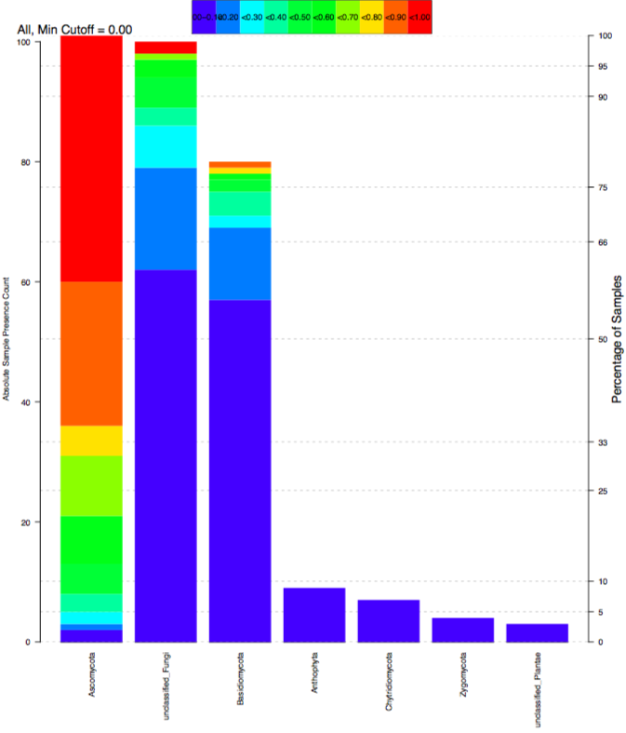

Figure . Rank Abundance of Fungi at the Level of Phylum

At the level of order, *Saccharomycetales* made up 63% of the fungi in the sample with *Hypocreales* (6.1%), *Eurotiales* (4.7%), *Pleosporales* (2.6%), *Cystofilobasidaiales* (2.6%), *Sporidiobolales* (1.9%), *Agaricales* (1.5%) and *Tremellales* (1.4%), *Capnodiales* (0.8%), *Helotiales* (0.7%) comprising the ten most abundant fungi. *Eurotiomcyetes*, *Conciochaetales* (Figure 6). *Dothideales* and *Botrysophaeriales* were also identified at a lower level of abundance (Figure 7). We calculated the Shannon diversity index to be 1.4980 and the Simpson’s diversity index to be 0.5788 with evenness of 0.3689 at the taxonomic level of order.

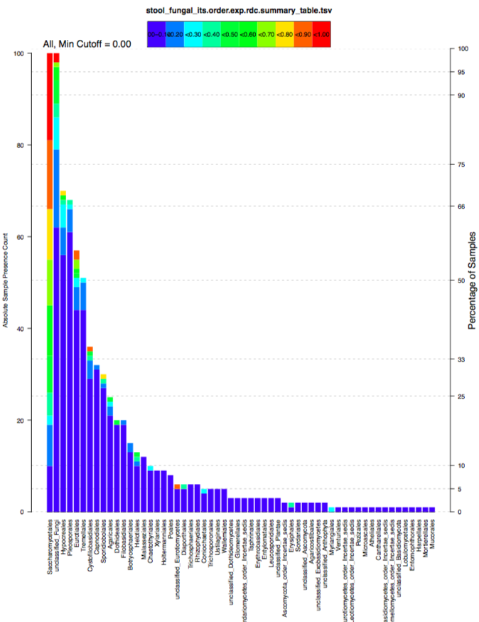

Figure . Rank Abundance of Fungi at the Level of Order

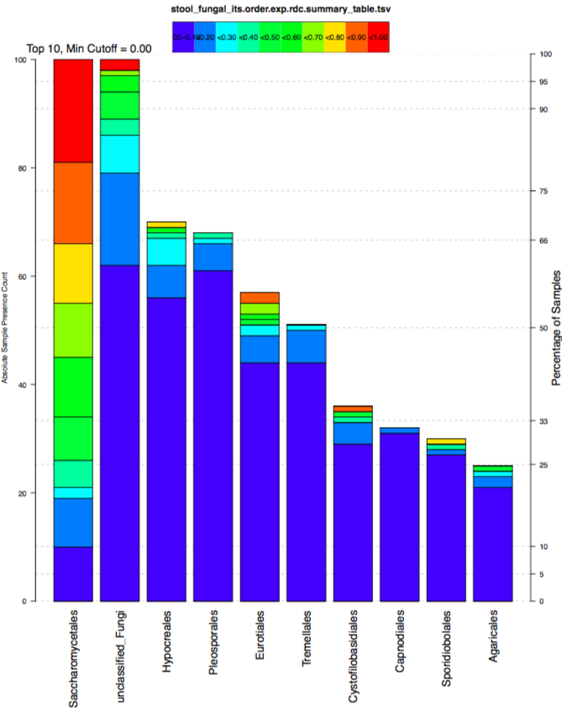

Figure . Rank Abundance of the 15 Most Abundant Fungi at the Level of Order

The genera with the highest abundance in this analysis were *Saccharomyces* (29.9%), *Candida* (18.9%), *Cyberlindnera* (10.9%), *Cosmospora* (3.7%), *Penicillium* (3.5%), *Rhodotorula* (1.7%), *Alternaria* (1.6%), *Agaricus* (1.4%), *Debaryomyces* (1.4%), *Cryptococcus* (1.4%), *Mrakia* (1.3%), *Gibberealla* (1.2%), *Aspergillus* (1.1%) and *Cystofilobasidium* (1.1%) (Figure 8, Figure 9). At the level of genus, the Shannon diversity index was 2.4929 and the Simpson’s diversity index was 0.8454 with an evenness of 0.4790.

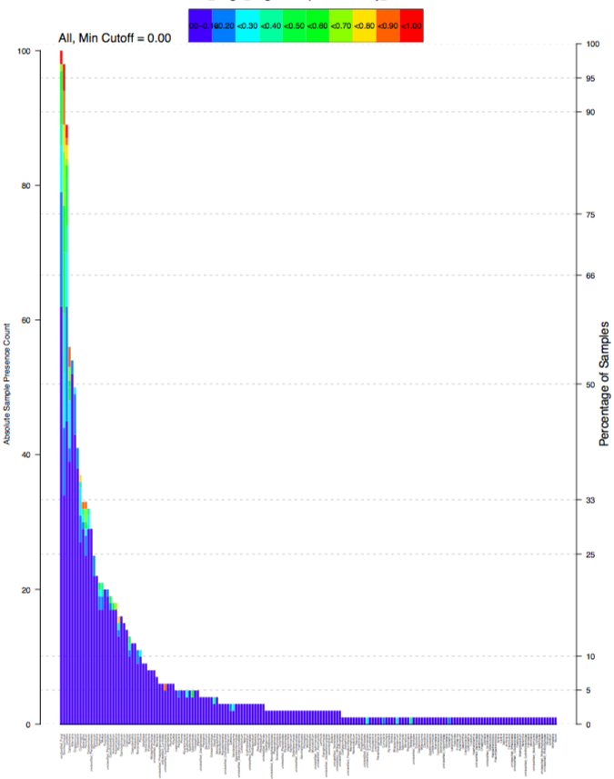

Figure . Rank Abundance of Fungi at the Level of Genus

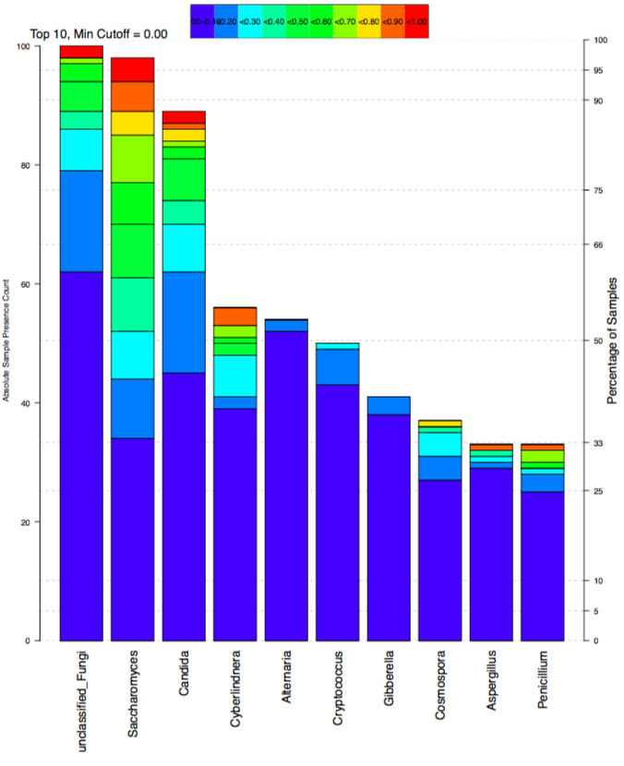

Figure . Rank Abundance of the 15 most Abundant Fungi at the Level of Genus

### Differences in Clinical Phenotypes

A major objective of the GRADS study and of this analysis was to identify biological signatures that differ between clinical phenotype groups. To accomplish this goal, we compared the stool mycobiome of sarcoidosis patients in the different phenotypical groups at a several different taxonomic levels. We used a multiple comparison test to examine the differences in distribution of the abundance of at multiple taxonomic levels between the phenotype groups as well as the combined groups (untreated, treated and multi-organ). All comparisons showed some differences between groups, but not all were statistically significant.

At a Family level, we found a difference between the combined groups of multi-organ involvement and all treated participants. The multi-organ group had a significantly higher abundance of *Nectriaceae* (Figure 10). The ascomycete family *Nectriaceae* includes a number of important plant and human pathogens known to be primarily soil-borne including the *Fusarium genera*, which are responsible for serious infections in humans.213 At the order level, participants with untreated disease with a remitting course had a higher abundance of *Hypocreales* than patients with treated stage II-III disease (Figure 11). *Hypocreales* includes the *Nectriaceae* family.

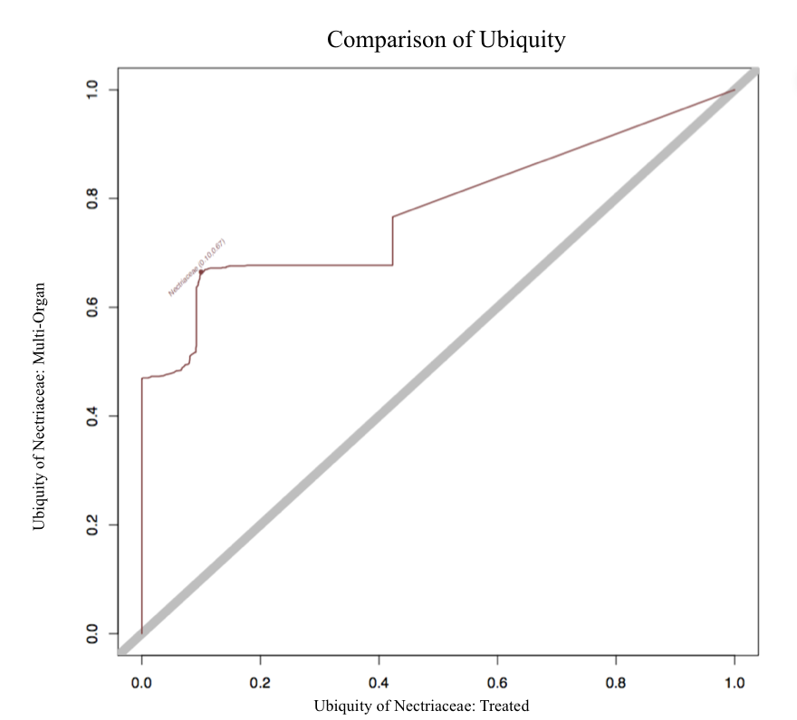

Figure . Ubiquity-Ubiquity Plot Comparing Abundance of *Nectriaceae* in Participants with Multi-Organ Involvement to All Participants who have been treated

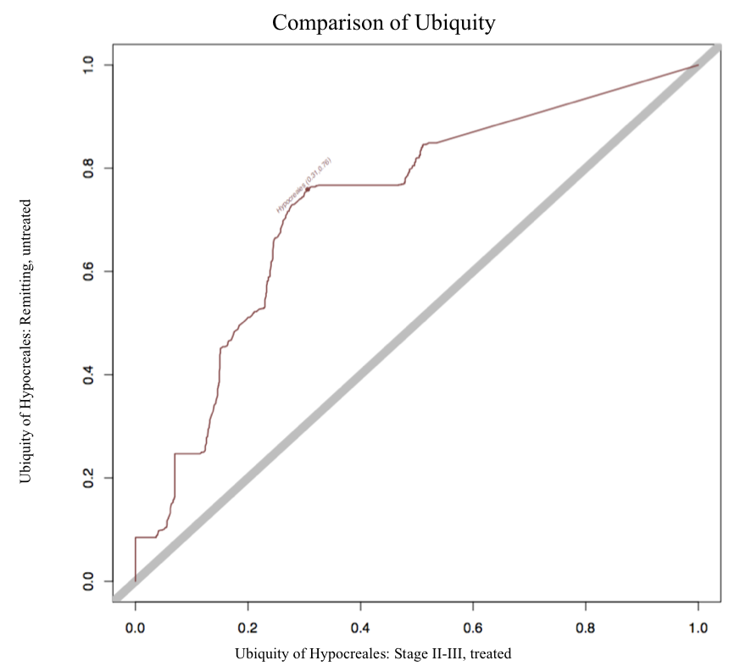

Figure . Ubiquity-Ubiquity Plot Comparing Abundance of *Hypocreales* in Participants with Remitting Disease and those with treated stage II-III disease

When comparing the phenotype groups, we found a significant difference at the family level between participants with multi-organ involvement and participants with untreated Scadding stage II-III disease. Patients with multi-organ disease had higher abundance of *Saccharomycetales* than patients with untreated stage II-III disease (Figure 12). Participants with untreated stage I disease had a higher abundance of *Saccharomycetales* compared to participants with untreated stage II-III disease at a family level (Figure 13). At a class and order level, participants with stage I disease had higher abundance of *Saccharomycetes* and *Saccharomycetales* respectively than participants with treated stage IV disease (Figure 14).

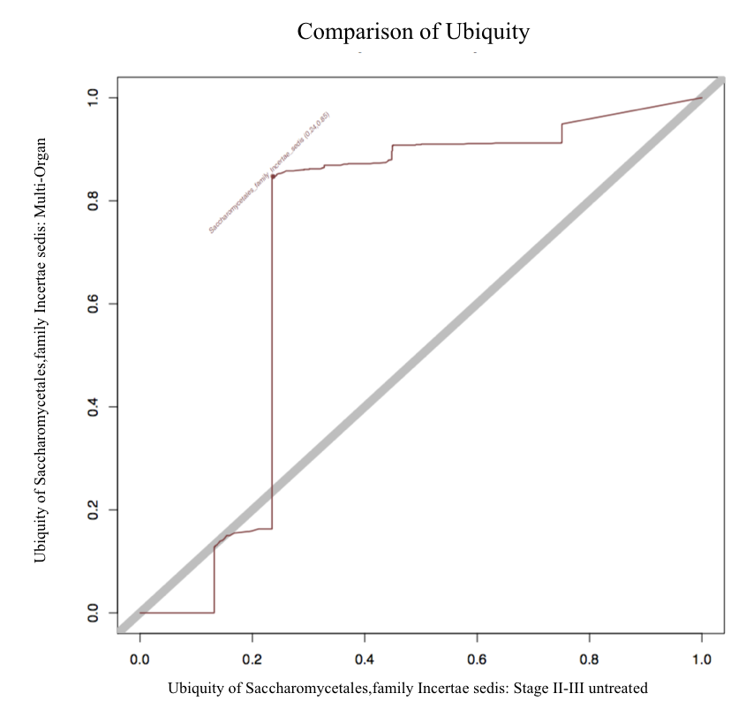

Figure . Ubiquity-Ubiquity Plot of Abundance of *Saccharomycetales* in Participants with Multi-Organ Involvement and Participants with untreated stage II-III disease

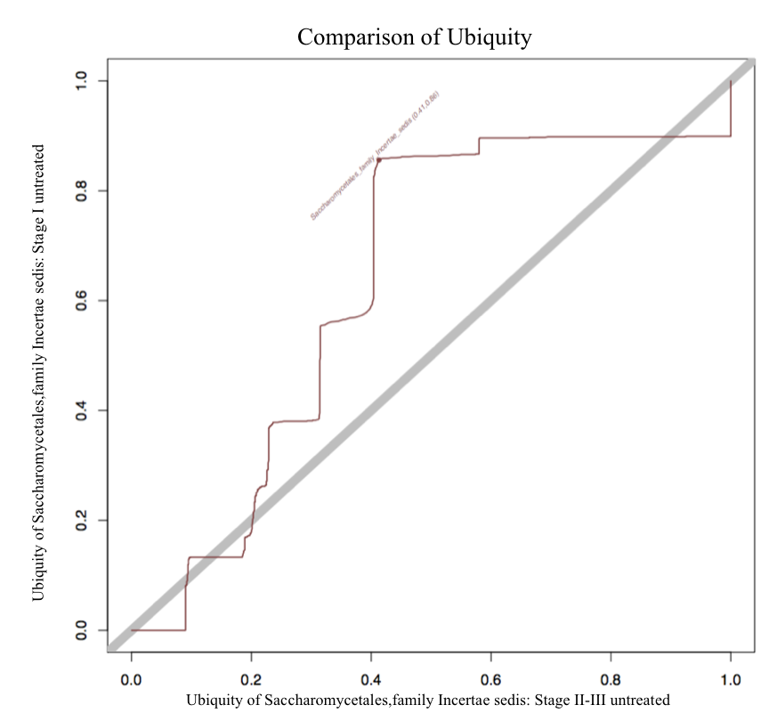

Figure . Ubiquity-Ubiquity Plot of Abundance of *Saccharomycetales* in Participants with untreated stage I disease and Participants with untreated stage II-III disease

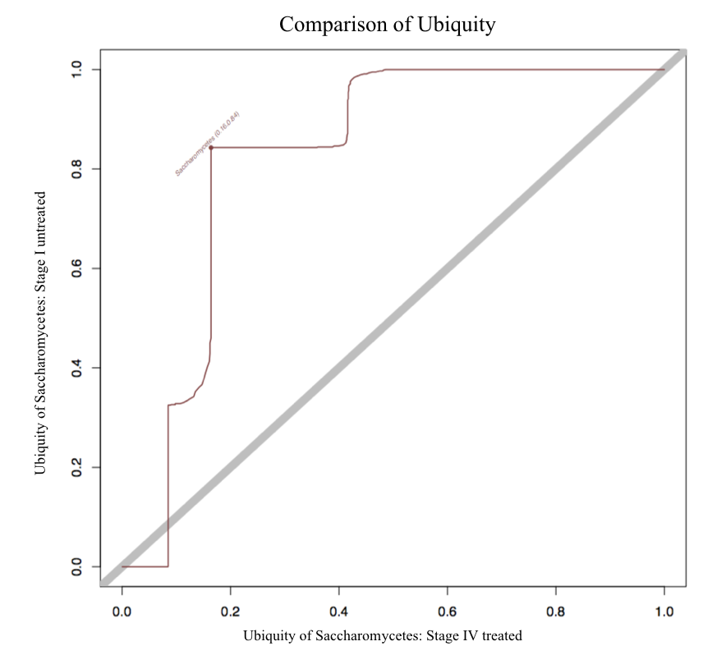

Figure . Ubiquity-Ubiquity Plot of Abundance of *Saccharomycetes* in Participants with untreated stage I disease and Participants with treated stage IV disease

# Discussion

Since the recognition of sarcoidosis as a distinct disease in the 1860s, sarcoidosis has confounded those who have sought to understand the etiologic basis and factors affecting the heterogeneity in the disease course and presentation.214 While resent research has elucidated immune pathways that are implicated in the systemic development of granulomatous inflammation, researchers do not know what causes sarcoidosis or predicts the disease course. It is accepted that the inflammatory cascade implicated in the formation of sarcoidosis is triggered by exposure to one or more microbial agents in addition to susceptibility caused by environmental exposure or genetic predilection. New and developing technologies, including high-throughput screening and ‘omic methodologies, provide the capability to examine this hypothesis with increased rigor. Large clinical trials, such as the GRADS study, combining environmental and clinical data with ‘omics data will potentially provide significant advances in our understanding of mechanistic pathways and interactions that play a critical role in sarcoidosis etiology, clinical manifestation and outcomes. Continued research is needed to understand differences in environmental exposures, genetic, metagenomics and transcriptomic signatures between clinical phenotypes and disease course outcomes.

Sarcoidosis can result in chronic disease that limits functioning, causes dyspnea and can be fatal. Based on estimated incidence levels of sarcoidosis in the U.S. (8.1 per 100,000), we can estimate that about 27,000 people per year are diagnosed with sarcoidosis in the U.S. each year. 2 The distribution of sarcoidosis is not even across racial groups, black people, specifically black women, are much more likely to be diagnosed with sarcoidosis. Because we do not yet have biomarkers to predict increased sarcoidosis risk or a clear understanding of risk factors, there is not a feasible public health intervention that could be employed to prevent or screen for sarcoidosis. Given that the disease burden is higher in females and black individuals, it is important to undertake research efforts to understand the risk factors and biological processes that underlie the risk discrepancy to provide for effective preventions efforts. Efforts should be made to provide for increased awareness in these high-risk populations. Primary care providers and other health care providers should be given education about the heterogeneity of sarcoidosis presentations, population groups at risk, research being undertaken and new pharmaceutical therapies, such as anti-TNF-alpha agents. People in the high-risk groups should be educated about their increased risk, how to obtain medical care and how to connect with researchers interested in these groups. Additionally, research has shown that lack of access to medical care contributes to an increase in symptoms related to sarcoidosis such as dyspnea and decreased functional ability.82,83 As such, connecting low SES patients, patients without access to health insurance and those with other barriers to quality medical care should be an important goal of public health programs addressing sarcoidosis. Efforts to provide access to medical care for patients with sarcoidosis will likely lead to overall decreased health care costs and costs associated with lost work days and disability.

### Strengths

While studies of sarcoidosis have examined environmental factors previously, none have included examination of the critical role of the microbiome and molecular phenotypes in etiology and disease course. The hypothesis implicating one or many microbial agents as an etiologic trigger inducing the inflammatory cascade responsible for the pathobiology of sarcoidosis has become increasingly accepted. Utilizing high-throughput sequencing will allow for identification of bacteria and fungi that were previously unable to be characterized using culture dependent techniques. The integration of clinical, environmental and microbiome data provides the ability to identify correlations between exposures, microbial communities and clinical phenotypes and outcomes in a way that may allow for the discovery of etiologic predictors and potential therapeutic interventions.

This analysis took into account a wide variety of organic, inorganic and metallurgic exposures that had been previously mentioned in the literature which may contribute to the identification of a constellation of exposures that contribute to the etiology and phenotypic heterogeneity of sarcoidosis.

Although patients were all enrolled at academic clinical centers, potentially introducing a bias of ascertainment, recruitment efforts were focused on national sarcoidosis patient organizations and sarcoidosis foundations allowing for the recruitment of patients that were not patients of the academic clinical center. Clinical centers were distributed across the U.S, contributing the diversity of the patient population included.

### Limitations

Many of the limitations of this analysis have already been addressed by the overall GRADS study. In the larger GRADS analysis, nearly 400 cases and 200 controls were included, eliminating the difficulties in related to the smaller sample size of this analysis. Additionally, environmental and occupational exposures that were assessed to detect dose dependent associations to sarcoidosis will be informative when examined in a larger sample size. In this analysis, ever versus never exposures were analyzed, owing to the small number of participants endorsing rare exposures such as the metallurgic occupational exposures of interest here.

While the use of clinical phenotypes allows for comparison between groups, it does have limitations. The definitions and diagnostic instruments used to define organ involvement and disease staging are based on previous use in published research but have not been validated in a large clinical trial. With advances in technology and imaging techniques, more sensitive ways to detect inflammatory areas of sarcoidosis involvement continue to evolve. As an example, the Scadding Staging system was developed before the advent of computed tomography (CT) imaging was available. There is currently no prognostic staging system that employs CT images, despite the higher quality image provided by CT. Given the limitations of the relatively short follow up time of the GRADS study, the true nature of patients’ disease course was not able to be determined and assumptions about the chronic or remitting nature of their disease course were based on the known outcome expectations provided by the Scadding Staging system. Additionally, due to the significant clinical heterogeneity of sarcoidosis and the limited sample size of the study, not all manifestations of sarcoidosis were able to be included.

In our analysis of environmental exposures, we failed to find an association between several occupational and environmental exposures that have been identified as positively associated with sarcoidosis in previous literature. It is possible that this discrepancy is due to the choice of the control population. Replicating results from studies that utilized healthy controls may not be possible when using a control population with a known illness. Utilizing a population with a chronic pulmonary disease that has a known genetic cause likely does not provide the best-case population and a population of controls should be selected in future research that do not suffer from a chronic pulmonary disorder. Additionally, a selection bias could have impacted our results as our primary source of recruitment was from academic clinical centers and there may be differences between patients who receive treatment at academic clinical centers and those who do not. Unmeasured confounders could be impacting our results and may include information about diet and food availability.

## Future Directions

The analysis of the data collected during the GRADS study is currently ongoing. The data collected during this trial creates a substantial foundation for future study into the mechanistic pathways and interactions between the environment and human host.

With the previously collected GRADS data, investigations into the associations between microbiomic and genomic signatures with clinical phenotypes will provide direction for more focused mechanistic studies into the immunologic pathways underlying different clinical manifestations. The potential molecular phenotypes identified could lead to the development of precision therapies that address specific inflammatory pathways identified. The potential identification of molecular signatures differing between remitting and chronic disease course may represent an opportunity for the identification of therapies to manipulate the pathways involved.

I am performing mycobiome analysis on the mouth and lung. In addition to identifying distinct microbial communities between sarcoidosis cases and controls as well as between phenotypic groups, I plan to correlate this information with both clinical data and data about the bacterial communities of the mouth, lung and gut. The role of the genomic network interactions between bacteria and fungi may represent a significant factor in the inflammatory pathways contributing to sarcoidosis. The identification of interactions between microflora may lead to therapeutic interventions to mediate these interactions or restore dysbiosis.

**APPENDIX: ENVIRONMENTAL QUESTIONNAIRE**

../../../../Desktop/ACCESS-Environmental%20questionnaire.pdf

env%20questionnaire/page1.pdf

env%20questionnaire/page2.pdf

env%20questionnaire/page3.pdf

env%20questionnaire/page4.pdf

env%20questionnaire/page5.pdf

env%20questionnaire/page7.pdfenv%20questionnaire/page8.pdfenv%20questionnaire/page9.pdfenv%20questionnaire/page10.pdf12.pdfenv%20questionnaire/page12.pdf14.pdf../../../../Desktop/15.pdf

# Bibliography

1. Statement on sarcoidosis. Joint Statement of the American Thoracic Society (ATS), the European Respiratory Society (ERS) and the World Association of Sarcoidosis and Other Granulomatous Disorders (WASOG) adopted by the ATS Board of Directors and by the ERS Executive Committee, February 1999. Am J Respir Crit Care Med 1999;160(2):736–55.

2. Baughman RP, Field S, Costabel U, et al. Sarcoidosis in america. analysis based on health care use. Annals of the American Thoracic Society 2016;13(8):1244–52.

3. Rice JB, White A, Lopez A, et al. Economic burden of sarcoidosis in a commercially-insured population in the United States. J Med Econ 2017;20(10):1048–55.

4. Newman LS, Rose CS, Bresnitz EA, et al. A case control etiologic study of sarcoidosis: environmental and occupational risk factors. Am J Respir Crit Care Med 2004;170(12):1324–30.

5. Chen ES, Moller DR. Etiologies of Sarcoidosis. Clin Rev Allergy Immunol 2015;49(1):6–18.

6. Thomas KW, Hunninghake GW. Sarcoidosis. JAMA 2003;289(24):3300–3.

7. Ungprasert P, Carmona EM, Utz JP, Ryu JH, Crowson CS, Matteson EL. Epidemiology of Sarcoidosis 1946-2013: A Population-Based Study. Mayo Clin Proc 2016;91(2):183–8.

8. Rosen Y. Sarcoidosis- Emphysema & fibrosis (6076578226) [Internet]. Wikipedia Commons. 2011 [cited 2017 Nov 30];Available from: https://commons.wikimedia.org/wiki/File:Sarcoidosis-_Emphysema_%26_fibrosis_(6076578226).jpg

9. Moller DR, Koth LL, Maier LA, et al. Rationale and Design of the Genomic Research in Alpha-1 Antitrypsin Deficiency and Sarcoidosis (GRADS) Study. Sarcoidosis Protocol. Annals of the American Thoracic Society 2015;12(10):1561–71.

10. Sand M, Sand D, Thrandorf C, Paech V, Altmeyer P, Bechara FG. Cutaneous lesions of the nose. Head Face Med 2010;6:7.

11. Broos CE, van Nimwegen M, Hoogsteden HC, Hendriks RW, Kool M, van den Blink B. Granuloma formation in pulmonary sarcoidosis. Front Immunol 2013;4:437.

12. Heilman J. PulSarcoid [Internet]. Wikipedia Commons. 2016 [cited 2017 Nov 30];Available from: https://commons.wikimedia.org/wiki/File:PulSarcoid.png

13. Judson MA, Baughman RP, Teirstein AS, Terrin ML, Yeager H. Defining organ involvement in sarcoidosis: the ACCESS proposed instrument. ACCESS Research Group. A Case Control Etiologic Study of Sarcoidosis. Sarcoidosis Vasc Diffuse Lung Dis 1999;16(1):75–86.

14. Müller-Quernheim J, Prasse A, Zissel G. Pathogenesis of sarcoidosis. Presse Med 2012;41(6 Pt 2):e275-87.

15. Crouser ED, Fingerlin TE, Yang IV, et al. Application of “omics” and systems biology to sarcoidosis research. Annals of the American Thoracic Society 2017.

16. Thomas T, Gilbert J, Meyer F. Metagenomics - a guide from sampling to data analysis. Microb Inform Exp 2012;2(1):3.

17. Carmona EM, Kalra S, Ryu JH. Pulmonary sarcoidosis: diagnosis and treatment. Mayo Clin Proc 2016;91(7):946–54.

18. Costabel U, Ohshimo S, Guzman J. Diagnosis of sarcoidosis. Curr Opin Pulm Med 2008;14(5):455–61.

19. Rosen Y. Sarcoidosis - Lymph node - non-necrotizing granulomas (6201134703) [Internet]. Wikipedia Commons. 2005 [cited 2017 Nov 30];Available from: https://commons.wikimedia.org/wiki/File:Sarcoidosis_-_Lymph_node_-_non-necrotizing_granulomas_(6201134703).jpg

20. von Bartheld MB, Dekkers OM, Szlubowski A, et al. Endosonography vs conventional bronchoscopy for the diagnosis of sarcoidosis: the GRANULOMA randomized clinical trial. JAMA 2013;309(23):2457–64.

21. Semenzato G, Chilosi M, Ossi E, et al. Bronchoalveolar lavage and lung histology. Comparative analysis of inflammatory and immunocompetent cells in patients with sarcoidosis and hypersensitivity pneumonitis. Am Rev Respir Dis 1985;132(2):400–4.

22. Hellerhoff. Sarkoidose der Lunge Stadium 4 nach Scadding [Internet]. Wikipedia Commons. 2014 [cited 2017 Nov 30];Available from: https://commons.wikimedia.org/wiki/File:Sarkoidose_der_Lunge_Stadium_4_nach_Scadding.jpg

23. Scadding JG. Prognosis of intrathoracic sarcoidosis in England. A review of 136 cases after five years’ observation. Br Med J 1961;2(5261):1165–72.

24. Iannuzzi MC, Rybicki BA, Teirstein AS. Sarcoidosis. N Engl J Med 2007;357(21):2153–65.

25. Swigris JJ, Olson AL, Huie TJ, et al. Sarcoidosis-related mortality in the United States from 1988 to 2007. Am J Respir Crit Care Med 2011;183(11):1524–30.

26. Judson MA, Boan AD, Lackland DT. The clinical course of sarcoidosis: presentation, diagnosis, and treatment in a large white and black cohort in the United States. Sarcoidosis Vasc Diffuse Lung Dis 2012;29(2):119–27.

27. Baughman RP, Lower EE. Treatment of Sarcoidosis. Clin Rev Allergy Immunol 2015;49(1):79–92.

28. Broos CE, Poell LHC, Looman CWN, et al. No evidence found for an association between prednisone dose and FVC change in newly-treated pulmonary sarcoidosis. Respir Med 2017.

29. Cozier YC, Berman JS, Palmer JR, Boggs DA, Serlin DM, Rosenberg L. Sarcoidosis in black women in the United States: data from the Black Women’s Health Study. Chest 2011;139(1):144–50.

30. Cozier YC. Assessing the worldwide epidemiology of sarcoidosis: challenges and future directions. Eur Respir J 2016;48(6):1545–8.

31. Rybicki BA, Major M, Popovich J, Maliarik MJ, Iannuzzi MC. Racial differences in sarcoidosis incidence: a 5-year study in a health maintenance organization. Am J Epidemiol 1997;145(3):234–41.

32. Newman LS, Rose CS, Maier LA. Sarcoidosis. N Engl J Med 1997;336(17):1224–34.

33. Reynolds HY. Sarcoidosis: impact of other illnesses on the presentation and management of multi-organ disease. Lung 2002;180(5):281–99.

34. Gerke AK. Morbidity and mortality in sarcoidosis. Curr Opin Pulm Med 2014;20(5):472–8.

35. Reich JM. Mortality of Intrathoracic Sarcoidosis in Referral vs Population-Based Settings. Chest 2002;121(1):32–9.

36. Rømer FK. Presentation of sarcoidosis and outcome of pulmonary changes. Dan Med Bull 1982;29(1):27–32.

37. Martusewicz-Boros MM, Boros PW, Wiatr E, Roszkowski-Śliż K. What comorbidities accompany sarcoidosis? A large cohort (n=1779) patients analysis. Sarcoidosis Vasc Diffuse Lung Dis 2015;32(2):115–20.

38. Chang B, Steimel J, Moller DR, et al. Depression in sarcoidosis. Am J Respir Crit Care Med 2001;163(2):329–34.

39. Cockerham WC. A test of the relationship between race, socioeconomic status, and psychological distress. Soc Sci Med 1990;31(12):1321–6.

40. Dumas O, Abramovitz L, Wiley AS, Cozier YC, Camargo CA. Epidemiology of sarcoidosis in a prospective cohort study of U.S. women. Annals of the American Thoracic Society 2016;13(1):67–71.

41. Henke CE, Henke G, Elveback LR, Beard CM, Ballard DJ, Kurland LT. The epidemiology of sarcoidosis in Rochester, Minnesota: a population-based study of incidence and survival. Am J Epidemiol 1986;123(5):840–5.

42. Pietinalho A, Hiraga Y, Hosoda Y, Löfroos AB, Yamaguchi M, Selroos O. The frequency of sarcoidosis in Finland and Hokkaido, Japan. A comparative epidemiological study. Sarcoidosis 1995;12(1):61–7.

43. The frequency of pulmonary sarcoidosis in finland. Acta Med Scand 2009;186(S503):13–21.

44. Milman N, Selroos O. Pulmonary sarcoidosis in the Nordic countries 1950-1982. Epidemiology and clinical picture. Sarcoidosis 1990;7(1):50–7.

45. Wilsher ML. Seasonal clustering of sarcoidosis presenting with erythema nodosum. Eur Respir J 1998;12(5):1197–9.

46. Parkes SA, Baker SB, Bourdillon RE, Murray CR, Rakshit M. Epidemiology of sarcoidosis in the Isle of Man--1: A case controlled study. Thorax 1987;42(6):420–6.

47. Kajdasz DK, Lackland DT, Mohr LC, Judson MA. A current assessment of rurally linked exposures as potential risk factors for sarcoidosis. Ann Epidemiol 2001;11(2):111–7.

48. Gentry JT, Nitowsky HM, Michael M. Studies on the epidemiology of sarcoidosis in the United States: the relationship to soil areas and to urban-rural residence. J Clin Invest 1955;34(12):1839–56.

49. Semenzato G. ACCESS: A case control etiologic study of sarcoidosis. Sarcoidosis Vasc Diffuse Lung Dis 2005;22(2):83–6.

50. Iwai K, Sekiguti M, Hosoda Y, et al. Racial difference in cardiac sarcoidosis incidence observed at autopsy. Sarcoidosis 1994;11(1):26–31.

51. Sharma OP. Sarcoidosis around the world. Clin Chest Med 2008;29(3):357–63, vii.

52. Mañá J, Badrinas F, Morera J, Fité E, Manresa F, Fernández-Nogués F. Sarcoidosis in Spain. Sarcoidosis 1992;9(2):118–22.

53. Lenner R, Schilero GJ, Padilla ML, Teirstein AS. Sarcoidosis presenting in patients older than 50 years. Sarcoidosis Vasc Diffuse Lung Dis 2002;19(2):143–7.

54. Hillerdal G, Nöu E, Osterman K, Schmekel B. Sarcoidosis: epidemiology and prognosis. A 15-year European study. Am Rev Respir Dis 1984;130(1):29–32.

55. Judson MA, Thompson BW, Rabin DL, et al. The diagnostic pathway to sarcoidosis*. Chest 2003;123(2):406–12.

56. Schabel SI, Stanley JH, Shelley BE. Pediatric sarcoidosis. J S C Med Assoc 1980;76(9):419–22.

57. Milman N, Hoffmann AL. Childhood sarcoidosis: long-term follow-up. Eur Respir J 2008;31(3):592–8.

58. Lazarus A. Sarcoidosis: epidemiology, etiology, pathogenesis, and genetics. Dis Mon 2009;55(11):649–60.

59. Yamaguchi M, Hosoda Y, Sasaki R, Aoki K. Epidemiological study on sarcoidosis in Japan. Recent trends in incidence and prevalence rates and changes in epidemiological features. Sarcoidosis 1989;6(2):138–46.

60. Chevalet P, Clément R, Rodat O, Moreau A, Brisseau J-M, Clarke J-P. Sarcoidosis diagnosed in elderly subjects: retrospective study of 30 cases. Chest 2004;126(5):1423–30.

61. Varron L, Cottin V, Schott A-M, Broussolle C, Sève P. Late-onset sarcoidosis: a comparative study. Medicine 2012;91(3):137–43.

62. Bourbonnais JM, Samavati L. Effect of gender on health related quality of life in sarcoidosis. Sarcoidosis Vasc Diffuse Lung Dis 2010;27(2):96–102.

63. Birnbaum AD, Rifkin LM. Sarcoidosis: sex-dependent variations in presentation and management. J Ophthalmol 2014;2014:236905.

64. Facco M, Cabrelle A, Teramo A, et al. Sarcoidosis is a Th1/Th17 multisystem disorder. Thorax 2011;66(2):144–50.

65. Tajima K, Miura K, Ishiwata T, et al. Sex hormones alter Th1 responses and enhance granuloma formation in the lung. Respiration 2011;81(6):491–8.

66. Ansar Ahmed S, Penhale WJ, Talal N. Sex hormones, immune responses, and autoimmune diseases. Mechanisms of sex hormone action. Am J Pathol 1985;121(3):531–51.

67. Whitacre CC, Reingold SC, O’Looney PA. A gender gap in autoimmunity. Science 1999;283(5406):1277–8.

68. Ito A, Bebo BF, Matejuk A, et al. Estrogen treatment down-regulates TNF-alpha production and reduces the severity of experimental autoimmune encephalomyelitis in cytokine knockout mice. J Immunol 2001;167(1):542–52.

69. Bouman A, Heineman MJ, Faas MM. Sex hormones and the immune response in humans. Hum Reprod Update 2005;11(4):411–23.

70. Shames RS. Gender differences in the development and function of the immune system. J Adolesc Health 2002;30(4 Suppl):59–70.

71. Olsen NJ, Kovacs WJ. Gonadal steroids and immunity. Endocr Rev 1996;17(4):369–84.

72. Cutolo M, Sulli A, Seriolo B, Accardo S, Masi AT. Estrogens, the immune response and autoimmunity. Clin Exp Rheumatol 1995;13(2):217–26.

73. Cozier YC, Berman JS, Palmer JR, Boggs DA, Wise LA, Rosenberg L. Reproductive and hormonal factors in relation to incidence of sarcoidosis in US Black women: The Black Women’s Health Study. Am J Epidemiol 2012;176(7):635–41.

74. Shirai M, Sato A, Chida K. The influence of ovarian hormones on the granulomatous inflammatory process in the rat lung. Eur Respir J 1995;8(2):272–7.

75. Chida K, Shirai M, Sato M, Sato J, Nakamura H. Successful treatment of hepatic sarcoidosis with hormone replacement in a postmenopausal woman. Respirology 1999;4(3):259–61.

76. Gottlieb JE, Israel HL, Steiner RM, Triolo J, Patrick H. Outcome in Sarcoidosis. Chest 1997;111(3):623–31.

77. Hunninghake GW, Gilbert S, Pueringer R, et al. Outcome of the treatment for sarcoidosis. Am J Respir Crit Care Med 1994;149(4 Pt 1):893–8.

78. Zurkova M, Turkova M, Tichy T, Pilka R, Kolek V, Kriegova E. Sarcoidosis of female reproductive organs in a postmenopausal woman: a case report and review of the literature: is there a potential for hormone therapy? Menopause 2015;22(5):549–53.

79. Sudo N. Microbiome, HPA axis and production of endocrine hormones in the gut. Adv Exp Med Biol 2014;817:177–94.

80. Rybicki BA, Maliarik MJ, Major M, Popovich J, Iannuzzi MC. Epidemiology, demographics, and genetics of sarcoidosis. Semin Respir Infect 1998;13(3):166–73.

81. Baughman RP, Teirstein AS, Judson MA, et al. Clinical characteristics of patients in a case control study of sarcoidosis. Am J Respir Crit Care Med 2001;164(10 Pt 1):1885–9.

82. Rabin DL, Richardson MS, Stein SR, Yeager H. Sarcoidosis severity and socioeconomic status. Eur Respir J 2001;18(3):499–506.

83. Rabin DL, Thompson B, Brown KM, et al. Sarcoidosis: social predictors of severity at presentation. Eur Respir J 2004;24(4):601–8.

84. Moller DR, Rybicki BA, Hamzeh NY, et al. Genetic, immunological and environmental basis of sarcoidosis. Annals of the American Thoracic Society 2017;

85. Design of a case control etiologic study of sarcoidosis (ACCESS). ACCESS Research Group. J Clin Epidemiol 1999;52(12):1173–86.

86. Forst LS, Abraham J. Hypersensitivity pneumonitis presenting as sarcoidosis. Br J Ind Med 1993;50(6):497–500.

87. Newman LS. Beryllium disease and sarcoidosis: clinical and laboratory links. Sarcoidosis 1995;12(1):7–19.

88. Redline S, Barna BP, Tomashefski JF, Abraham JL. Granulomatous disease associated with pulmonary deposition of titanium. Br J Ind Med 1986;43(10):652–6.

89. De Vuyst P, Dumortier P, Schandené L, Estenne M, Verhest A, Yernault JC. Sarcoidlike lung granulomatosis induced by aluminum dusts. Am Rev Respir Dis 1987;135(2):493–7.

90. Skelton HG, Smith KJ, Johnson FB, Cooper CR, Tyler WF, Lupton GP. Zirconium granuloma resulting from an aluminum zirconium complex: a previously unrecognized agent in the development of hypersensitivity granulomas. J Am Acad Dermatol 1993;28(5 Pt 2):874–6.

91. Rafnsson V, Ingimarsson O, Hjalmarsson I, Gunnarsdottir H. Association between exposure to crystalline silica and risk of sarcoidosis. Occup Environ Med 1998;55(10):657–60.

92. Izbicki G, Chavko R, Banauch GI, et al. World Trade Center “sarcoid-like” granulomatous pulmonary disease in New York City Fire Department rescue workers. Chest 2007;131(5):1414–23.

93. Judson MA, Baughman RP. How many organs need to be involved to diagnose sarcoidosis?: An unanswered question that, hopefully, will become irrelevant. Sarcoidosis Vasc Diffuse Lung Dis 2014;31(1):6–7.

94. Pattishall EN, Strope GL, Spinola SM, Denny FW. Childhood sarcoidosis. J Pediatr 1986;108(2):169–77.

95. Epidemiologic and clinical observations in sarcoidosis. Ann Intern Med 1959;50(4):879.

96. Keller AZ. Hospital, age, racial, occupational, geographical, clinical and survivorship characteristics in the epidemiology of sarcoidosis. Am J Epidemiol 1971;94(3):222–30.

97. Kern DG, Neill MA, Wrenn DS, Varone JC. Investigation of a unique time-space cluster of sarcoidosis in firefighters. Am Rev Respir Dis 1993;148(4 Pt 1):974–80.

98. Revsbech P. Is sarcoidosis related to exposure to pets or the housing conditions? A case-referent study. Sarcoidosis 1992;9(2):101–3.

99. Drent M, Wijnen PA, Boots AW, Bast A. Cat litter is a possible trigger for sarcoidosis. Eur Respir J 2012;39(1):221–2.

100. Apostolakos MJ, Rossmoore H, Beckett WS. Hypersensitivity pneumonitis from ordinary residential exposures. Environ Health Perspect 2001;109(9):979–81.

101. Bresnitz EA, Stolley PD, Israel HL, Soper K. Possible risk factors for sarcoidosis. A case-control study. Ann N Y Acad Sci 1986;465:632–42.

102. Sopori M. Effects of cigarette smoke on the immune system. Nat Rev Immunol 2002;2(5):372–7.

103. Maier LA. Is smoking beneficial for granulomatous lung diseases? Am J Respir Crit Care Med 2004;169(8):893–5.

104. Douglas JG, Middleton WG, Gaddie J, et al. Sarcoidosis: a disorder commoner in non-smokers? Thorax 1986;41(10):787–91.

105. Warren CP. Extrinsic allergic alveolitis: a disease commoner in non-smokers. Thorax 1977;32(5):567–9.

106. Blanchet M-R, Israël-Assayag E, Cormier Y. Inhibitory effect of nicotine on experimental hypersensitivity pneumonitis in vivo and in vitro. Am J Respir Crit Care Med 2004;169(8):903–9.

107. Valeyre D, Soler P, Clerici C, et al. Smoking and pulmonary sarcoidosis: effect of cigarette smoking on prevalence, clinical manifestations, alveolitis, and evolution of the disease. Thorax 1988;43(7):516–24.

108. Hills SE, Parkes SA, Baker SB. Epidemiology of sarcoidosis in the Isle of Man--2: Evidence for space-time clustering. Thorax 1987;42(6):427–30.

109. Parkes SA, Baker SB, Bourdillon RE, et al. Incidence of sarcoidosis in the Isle of Man. Thorax 1985;40(4):284–7.

110. Ayres JG. Epidemiology of sarcoidosis in the Isle of Man. Thorax 1987;42(11):911.

111. Hosoda Y, Hiraga Y, Odaka M, et al. A cooperative study of sarcoidosis in Asia and Africa: analytic epidemiology. Ann N Y Acad Sci 1976;278:355–67.

112. Stewart IC, Davidson NM. Clustering of sarcoidosis. Thorax 1982;37(5):398–9.

113. Matzaraki V, Kumar V, Wijmenga C, Zhernakova A. The MHC locus and genetic susceptibility to autoimmune and infectious diseases. Genome Biol 2017;18(1):76.

114. Iannuzzi MC, Rybicki BA. Genetics of sarcoidosis: candidate genes and genome scans. Proc Am Thorac Soc 2007;4(1):108–16.

115. Darlington P, Gabrielsen A, Sörensson P, et al. HLA-alleles associated with increased risk for extra-pulmonary involvement in sarcoidosis. Tissue Antigens 2014;83(4):267–72.

116. Chen ES, Moller DR. Etiologic role of infectious agents. Semin Respir Crit Care Med 2014;35(3):285–95.

117. Richmond BW, Ploetze K, Isom J, et al. Sarcoidosis Th17 cells are ESAT-6 antigen specific but demonstrate reduced IFN-γ expression. J Clin Immunol 2013;33(2):446–55.

118. Simonian PL, Roark CL, Wehrmann F, et al. Th17-polarized immune response in a murine model of hypersensitivity pneumonitis and lung fibrosis. J Immunol 2009;182(1):657–65.

119. Ten Berge B, Paats MS, Bergen IM, et al. Increased IL-17A expression in granulomas and in circulating memory T cells in sarcoidosis. Rheumatology (Oxford) 2012;51(1):37–46.

120. Brownell I, Ramírez-Valle F, Sanchez M, Prystowsky S. Evidence for mycobacteria in sarcoidosis. Am J Respir Cell Mol Biol 2011;45(5):899–905.

121. Kon OM, du Bois RM. Mycobacteria and sarcoidosis. Thorax 1997;52 Suppl 3:S47-51.

122. Eishi Y, Suga M, Ishige I, et al. Quantitative analysis of mycobacterial and propionibacterial DNA in lymph nodes of Japanese and European patients with sarcoidosis. J Clin Microbiol 2002;40(1):198–204.

123. Gazouli M, Ikonomopoulos J, Trigidou R, Foteinou M, Kittas C, Gorgoulis V. Assessment of mycobacterial, propionibacterial, and human herpesvirus 8 DNA in tissues of greek patients with sarcoidosis. J Clin Microbiol 2002;40(8):3060–3.

124. Ishige I, Eishi Y, Takemura T, et al. Propionibacterium acnes is the most common bacterium commensal in peripheral lung tissue and mediastinal lymph nodes from subjects without sarcoidosis. Sarcoidosis Vasc Diffuse Lung Dis 2005;22(1):33–42.

125. Nishiwaki T, Yoneyama H, Eishi Y, et al. Indigenous pulmonary Propionibacterium acnes primes the host in the development of sarcoid-like pulmonary granulomatosis in mice. Am J Pathol 2004;165(2):631–9.

126. McCaskill JG, Chason KD, Hua X, et al. Pulmonary immune responses to Propionibacterium acnes in C57BL/6 and BALB/c mice. Am J Respir Cell Mol Biol 2006;35(3):347–56.

127. Popper HH, Winter E, Höfler G. DNA of Mycobacterium tuberculosis in formalin-fixed, paraffin-embedded tissue in tuberculosis and sarcoidosis detected by polymerase chain reaction. Am J Clin Pathol 1994;101(6):738–41.

128. Moller DR. Potential etiologic agents in sarcoidosis. Proc Am Thorac Soc 2007;4(5):465–8.

129. Chen ES, Moller DR. Sarcoidosis--scientific progress and clinical challenges. Nat Rev Rheumatol 2011;7(8):457–67.

130. Fu LM, Fu-Liu CS. Is Mycobacterium tuberculosis a closer relative to Gram-positive or Gram-negative bacterial pathogens? Tuberculosis (Edinb) 2002;82(2–3):85–90.

131. Bhatia A, Maisonneuve J-F, Persing DH. PROPIONIBACTERIUM ACNES AND CHRONIC DISEASES - The Infectious Etiology of Chronic Diseases - NCBI Bookshelf. 2004;

132. Mitchell DN, Rees RJ, Goswami KK. Transmissible agents from human sarcoid and Crohn’s disease tissues. The Lancet 1976;2(7989):761–5.

133. Heyll A, Meckenstock G, Aul C, et al. Possible transmission of sarcoidosis via allogeneic bone marrow transplantation. Bone Marrow Transplant 1994;14(1):161–4.

134. Martinez FJ, Orens JB, Deeb M, Brunsting LA, Flint A, Lynch JP. Recurrence of sarcoidosis following bilateral allogeneic lung transplantation. Chest 1994;106(5):1597–9.

135. Kazerooni EA, Cascade PN. Recurrent miliary sarcoidosis after lung transplantation. Radiology 1995;194(3):913–913.

136. Milman N, Andersen CB, Burton CM, Iversen M. Recurrent sarcoid granulomas in a transplanted lung derive from recipient immune cells. Eur Respir J 2005;26(3):549–52.

137. Burke WMJ, Keogh A, Maloney PJ, Delprado W, Bryant DH, Spratt P. Transmission of sarcoidosis via cardiac transplantation. The Lancet 1990;336(8730–8731):1579.

138. Design of A Case Control Etiologic Study of Sarcoidosis (ACCESS). J Clin Epidemiol 1999;52(12):1173–86.

139. Clarke EL, Lauder AP, Hofstaedter CE, et al. Microbial lineages in sarcoidosis: A metagenomic analysis tailored for low microbial content samples. Am J Respir Crit Care Med 2017;

140. Drake WP, Oswald-Richter K, Richmond BW, et al. Oral antimycobacterial therapy in chronic cutaneous sarcoidosis: a randomized, single-masked, placebo-controlled study. JAMA Dermatol 2013;149(9):1040–9.

141. Ebe Y, Ikushima S, Yamaguchi T, et al. Proliferative response of peripheral blood mononuclear cells and levels of antibody to recombinant protein from Propionibacterium acnes DNA expression library in Japanese patients with sarcoidosis. Sarcoidosis Vasc Diffuse Lung Dis 2000;17(3):256–65.

142. Nikkels AF, Debrus S, Delvenne P, et al. Viral glycoproteins in herpesviridae granulomas. Am J Dermatopathol 1994;16(6):588–92.

143. Langenberg A, Yen TS, LeBoit PE. Granulomatous vasculitis occurring after cutaneous herpes zoster despite absence of viral genome. J Am Acad Dermatol 1991;24(3):429–33.

144. Oswald-Richter KA, Beachboard DC, Seeley EH, et al. Dual analysis for mycobacteria and propionibacteria in sarcoidosis BAL. J Clin Immunol 2012;32(5):1129–40.

145. Song Z, Marzilli L, Greenlee BM, et al. Mycobacterial catalase-peroxidase is a tissue antigen and target of the adaptive immune response in systemic sarcoidosis. J Exp Med 2005;201(5):755–67.

146. Drake WP, Pei Z, Pride DT, Collins RD, Cover TL, Blaser MJ. Molecular analysis of sarcoidosis tissues for mycobacterium species DNA. Emerging Infect Dis 2002;8(11):1334–41.

147. Oswald-Richter KA, Culver DA, Hawkins C, et al. Cellular responses to mycobacterial antigens are present in bronchoalveolar lavage fluid used in the diagnosis of sarcoidosis. Infect Immun 2009;77(9):3740–8.

148. Oswald-Richter KA, Beachboard DC, Zhan X, et al. Multiple mycobacterial antigens are targets of the adaptive immune response in pulmonary sarcoidosis. Respir Res 2010;11:161.

149. Oswald-Richter K, Sato H, Hajizadeh R, et al. Mycobacterial ESAT-6 and katG are recognized by sarcoidosis CD4+ T cells when presented by the American sarcoidosis susceptibility allele, DRB1*1101. J Clin Immunol 2010;30(1):157–66.

150. Chen ES, Wahlström J, Song Z, et al. T cell responses to mycobacterial catalase-peroxidase profile a pathogenic antigen in systemic sarcoidosis. J Immunol 2008;181(12):8784–96.

151. Zhou Y, Hu Y, Li H. Role of Propionibacterium Acnes in Sarcoidosis: A Meta-analysis. Sarcoidosis Vasc Diffuse Lung Dis 2013;30(4):262–7.

152. Abe C, Iwai K, Mikami R, Hosoda Y. Frequent isolation of Propionibacterium acnes from sarcoidosis lymph nodes. Zentralbl Bakteriol Mikrobiol Hyg A 1984;256(4):541–7.

153. Oswald-Richter KA, Drake WP. The etiologic role of infectious antigens in sarcoidosis pathogenesis. Semin Respir Crit Care Med 2010;31(4):375–9.

154. Morgan XC, Huttenhower C. Chapter 12: Human microbiome analysis. PLoS Comput Biol 2012;8(12):e1002808.

155. Li K, Bihan M, Yooseph S, Methé BA. Analyses of the microbial diversity across the human microbiome. PLoS ONE 2012;7(6):e32118.

156. Li K, Bihan M, Methé BA. Analyses of the stability and core taxonomic memberships of the human microbiome. PLoS ONE 2013;8(5):e63139.

157. Ley RE, Lozupone CA, Hamady M, Knight R, Gordon JI. Worlds within worlds: evolution of the vertebrate gut microbiota. Nat Rev Microbiol 2008;6(10):776–88.

158. Qin J, Li R, Raes J, et al. A human gut microbial gene catalogue established by metagenomic sequencing. Nature 2010;464(7285):59–65.

159. Human Microbiome Project Consortium. Structure, function and diversity of the healthy human microbiome. Nature 2012;486(7402):207–14.

160. NIH HMP Working Group, Peterson J, Garges S, et al. The NIH human microbiome project. Genome Res 2009;19(12):2317–23.

161. Seed PC. The human mycobiome. Cold Spring Harb Perspect Med 2014;5(5):a019810.

162. Eloe-Fadrosh EA, Rasko DA. The human microbiome: from symbiosis to pathogenesis. Annu Rev Med 2013;64:145–63.

163. Underhill DM, Iliev ID. The mycobiota: interactions between commensal fungi and the host immune system. Nat Rev Immunol 2014;14(6):405–16.

164. Suhr MJ, Banjara N, Hallen-Adams HE. Sequence-based methods for detecting and evaluating the human gut mycobiome. Lett Appl Microbiol 2016;62(3):209–15.

165. Bik EM, Eckburg PB, Gill SR, et al. Molecular analysis of the bacterial microbiota in the human stomach. Proc Natl Acad Sci U S A 2006;103(3):732–7.

166. Gao Z, Tseng C, Pei Z, Blaser MJ. Molecular analysis of human forearm superficial skin bacterial biota. Proc Natl Acad Sci U S A 2007;104(8):2927–32.

167. Paster BJ, Boches SK, Galvin JL, et al. Bacterial diversity in human subgingival plaque. J Bacteriol 2001;183(12):3770–83.

168. Kroes I, Lepp PW, Relman DA. Bacterial diversity within the human subgingival crevice. Proc Natl Acad Sci U S A 1999;96(25):14547–52.

169. Huseyin CE, Rubio RC, O’Sullivan O, Cotter PD, Scanlan PD. The fungal frontier: A comparative analysis of methods used in the study of the human gut mycobiome. Front Microbiol 2017;8:1432.

170. Huseyin CE, O’Toole PW, Cotter PD, Scanlan PD. Forgotten fungi-the gut mycobiome in human health and disease. FEMS Microbiol Rev 2017;41(4):479–511.

171. Walsh TJ, Dixon DM. Spectrum of Mycoses. In: Baron S, editor. Medical Microbiology. Galveston (TX): University of Texas Medical Branch at Galveston; 1996.

172. Cui L, Morris A, Huang L, et al. The microbiome and the lung. Annals of the American Thoracic Society 2014;11 Suppl 4:S227-32.

173. Huang YJ, Charlson ES, Collman RG, Colombini-Hatch S, Martinez FD, Senior RM. The role of the lung microbiome in health and disease. A National Heart, Lung, and Blood Institute workshop report. Am J Respir Crit Care Med 2013;187(12):1382–7.

174. Nguyen LDN, Viscogliosi E, Delhaes L. The lung mycobiome: an emerging field of the human respiratory microbiome. Front Microbiol 2015;6:89.

175. Flanagan JL, Brodie EL, Weng L, et al. Loss of bacterial diversity during antibiotic treatment of intubated patients colonized with Pseudomonas aeruginosa. J Clin Microbiol 2007;45(6):1954–62.

176. Bahrani-Mougeot FK, Paster BJ, Coleman S, et al. Molecular analysis of oral and respiratory bacterial species associated with ventilator-associated pneumonia. J Clin Microbiol 2007;45(5):1588–93.

177. Bittar F, Richet H, Dubus J-C, et al. Molecular detection of multiple emerging pathogens in sputa from cystic fibrosis patients. PLoS ONE 2008;3(8):e2908.

178. Kistler A, Avila PC, Rouskin S, et al. Pan-viral screening of respiratory tract infections in adults with and without asthma reveals unexpected human coronavirus and human rhinovirus diversity. J Infect Dis 2007;196(6):817–25.

179. Hilty M, Burke C, Pedro H, et al. Disordered microbial communities in asthmatic airways. PLoS ONE 2010;5(1):e8578.

180. Erb-Downward JR, Thompson DL, Han MK, et al. Analysis of the lung microbiome in the “healthy” smoker and in COPD. PLoS ONE 2011;6(2):e16384.

181. Scher JU, Abramson SB. The microbiome and rheumatoid arthritis. Nat Rev Rheumatol 2011;7(10):569–78.

182. Wang W-L, Xu S-Y, Ren Z-G, Tao L, Jiang J-W, Zheng S-S. Application of metagenomics in the human gut microbiome. World J Gastroenterol 2015;21(3):803–14.

183. Yurkovetskiy L, Burrows M, Khan AA, et al. Gender bias in autoimmunity is influenced by microbiota. Immunity 2013;39(2):400–12.

184. Martín R, Miquel S, Langella P, Bermúdez-Humarán LG. The role of metagenomics in understanding the human microbiome in health and disease. Virulence 2014;5(3):413–23.

185. Sam QH, Chang MW, Chai LYA. The Fungal Mycobiome and Its Interaction with Gut Bacteria in the Host. Int J Mol Sci 2017;18(2).

186. Geamanu A, Gupta SV, Bauerfeld C, Samavati L. Metabolomics connects aberrant bioenergetic, transmethylation, and gut microbiota in sarcoidosis. Metabolomics 2016;12.

187. Sokol H, Leducq V, Aschard H, et al. Fungal microbiota dysbiosis in IBD. Gut 2017;66(6):1039–48.

188. McAleer JP, Nguyen NLH, Chen K, et al. Pulmonary th17 antifungal immunity is regulated by the gut microbiome. J Immunol 2016;197(1):97–107.

189. Garzoni C, Brugger SD, Qi W, et al. Microbial communities in the respiratory tract of patients with interstitial lung disease. Thorax 2013;68(12):1150–6.

190. Genomic Research in Sarcoidosis - Full Text View - ClinicalTrials.gov [Internet]. [cited 2017 Nov 21];Available from: https://clinicaltrials.gov/ct2/show/NCT01831739?term=GRADS&draw=1&rank=1

191. Strange C, Senior RM, Sciurba F, et al. Rationale and Design of the Genomic Research in Alpha-1 Antitrypsin Deficiency and Sarcoidosis Study. Alpha-1 Protocol. Annals of the American Thoracic Society 2015;12(10):1551–60.

192. Fisher’s exact test of independence - Handbook of Biological Statistics [Internet]. [cited 2017 Nov 27];Available from: http://www.biostathandbook.com/fishers.html

193. Lemeshow S, Hosmer DW. A review of goodness of fit statistics for use in the development of logistic regression models1. Am J Epidemiol 1982;115(1):92–106.

194. SAS Studio [Internet]. [cited 2017 Nov 27];Available from: https://odamid.oda.sas.com/SASStudio/main?locale=en_US&zone=GMT-05%253A00&https%3A%2F%2Fodamid.oda.sas.com%2FSASStudio%2Findex=

195. Caporaso JG, Lauber CL, Walters WA, et al. Ultra-high-throughput microbial community analysis on the Illumina HiSeq and MiSeq platforms. ISME J 2012;6(8):1621–4.

196. Anderson MJ, Walsh DCI. PERMANOVA, ANOSIM, and the Mantel test in the face of heterogeneous dispersions: What null hypothesis are you testing? Ecological Monographs 2013;83(4):557–74.

197. R: a language and environment for statistical computing [Internet]. [cited 2017 Nov 27];Available from: https://www.gbif.org/tool/81287/r-a-language-and-environment-for-statistical-computing

198. Caporaso JG, Kuczynski J, Stombaugh J, et al. QIIME allows analysis of high-throughput community sequencing data. Nat Methods 2010;7(5):335–6.

199. Magurran AE. Diversity indices and species abundance models. In: Ecological diversity and its measurement. Dordrecht: Springer Netherlands; 1988. p. 7–45.

200. Drent M, De Vries J, Lenters M, et al. Sarcoidosis: assessment of disease severity using HRCT. Eur Radiol 2003;13(11):2462–71.

201. Leader JK, Zheng B, Rogers RM, et al. Automated lung segmentation in X-ray computed tomography: development and evaluation of a heuristic threshold-based scheme. Acad Radiol 2003;10(11):1224–36.

202. Miller BH, Rosado-de-Christenson ML, McAdams HP, Fishback NF. Thoracic sarcoidosis: radiologic-pathologic correlation. Radiographics 1995;15(2):421–37.

203. Judson MA, Costabel U, Drent M, et al. The WASOG Sarcoidosis Organ Assessment Instrument: An update of a previous clinical tool. Sarcoidosis Vasc Diffuse Lung Dis 2014;31(1):19–27.

204. Jones R, Junghard O, Dent J, et al. Development of the GerdQ, a tool for the diagnosis and management of gastro-oesophageal reflux disease in primary care. Aliment Pharmacol Ther 2009;30(10):1030–8.

205. Eakin EG, Resnikoff PM, Prewitt LM, Ries AL, Kaplan RM. Validation of a new dyspnea measure: the UCSD Shortness of Breath Questionnaire. University of California, San Diego. Chest 1998;113(3):619–24.

206. De Vries J, Michielsen H, Van Heck GL, Drent M. Measuring fatigue in sarcoidosis: the Fatigue Assessment Scale (FAS). Br J Health Psychol 2004;9(Pt 3):279–91.

207. Michielsen HJ, Drent M, Peros-Golubicic T, De Vries J. Fatigue is associated with quality of life in sarcoidosis patients. Chest 2006;130(4):989–94.

208. Broderick JE, Schneider S, Junghaenel DU, Schwartz JE, Stone AA. Validity and reliability of patient-reported outcomes measurement information system instruments in osteoarthritis. Arthritis Care Res (Hoboken) 2013;65(10):1625–33.

209. Cella D, Riley W, Stone A, et al. The Patient-Reported Outcomes Measurement Information System (PROMIS) developed and tested its first wave of adult self-reported health outcome item banks: 2005-2008. J Clin Epidemiol 2010;63(11):1179–94.

210. Broadbent DE, Cooper PF, FitzGerald P, Parkes KR. The Cognitive Failures Questionnaire (CFQ) and its correlates. Br J Clin Psychol 1982;21 (Pt 1):1–16.

211. Elfferich MD, Nelemans PJ, Ponds RW, De Vries J, Wijnen PA, Drent M. Everyday cognitive failure in sarcoidosis: the prevalence and the effect of anti-TNF-alpha treatment. Respiration 2010;80(3):212–9.

212. Barker AF. Alpha 1-antitrypsin-deficiency-related emphysema. J Am Board Fam Pract 1992;5(5):489–93.

213. Lombard L, van der Merwe NA, Groenewald JZ, Crous PW. Generic concepts in Nectriaceae. Stud Mycol 2015;80:189–245.

214. Valeyre D, Prasse A, Nunes H, Uzunhan Y, Brillet P-Y, Müller-Quernheim J. Sarcoidosis. The Lancet 2014;383(9923):1155–67.