EMPLOYEES' PERCEPTION OF ORGANIZATIONAL STRUCTURE AND CULTURE AT ANGKOR HOSPITAL FOR CHILDREN IN SIEM REAP, CAMBODIA

by
Hiroko Henker
MD, University of Tsukuba, Japan, 2001

Submitted to the Graduate Faculty of
the Department of Health Policy and Management
Graduate School of Public Health in partial fulfillment
of the requirements for the degree of
Master of Public Health

University of Pittsburgh
2018

UNIVERSITY OF PITTSBURGH
GRADUATE SCHOOL OF PUBLIC HEALTH

This essay is submitted
by
Hiroko Henker

on

March 26, 2018
and approved by

Essay Advisor:
Gerald M. Barron, MPH _________________________________
Associate Professor and Director MPH Program
Department of Health Policy and Management
Graduate School of Public Health
University of Pittsburgh

Essay Readers:

Joanne Russell, MPPM ________________________________
Assistant Professor
Department of Behavioral and Community Health Sciences
Graduate School of Public Health
University of Pittsburgh

Claudia Turner, MB BS, PhD, FRCPCH ________________________________
Chief Executive Officer
Angkor Hospital for Children
Siem Reap, Cambodia

Copyright © by Hiroko Henker
2018
ABSTRACT
Gerald M. Barron, MPH
EMPLOYEES' PERCEPTION OF ORGANIZATIONAL STRUCTURE AND CULTURE AT ANGKOR HOSPITAL FOR CHILDREN IN SIEM REAP, CAMBODIA
Hiroko Henker, MPH
University of Pittsburgh, 2018

Background: The dynamic environment that surrounds healthcare compels restructuring within healthcare organizations. However, such structural changes are not always successful due partly to employees’ responses. Changes in organizational structure impact employees’ behaviors, attitudes, job satisfaction, and job commitment. Furthermore, the impacts of structural changes can be influenced by organizational culture embedded in an organization. Angkor Hospital for Children (AHC) is a non-governmental hospital in Siem Reap, Cambodia, providing inpatient and outpatient services, healthcare education, and community outreach to surrounding communities. Recently, AHC experienced major structural changes along with the expansion of its capacity. The purpose of this study is to explore organizational culture embedded in AHC and employees' perception of AHC’s organizational structure and organizational culture.
Methods: This study employed mixed methods. Organizational culture was identified using the Organizational Culture Assessment Instrument (OCAI), a questionnaire based upon the Competing Values Framework. Semi-structured interviews (SSIs) were conducted to explore hospital staff members’ perceptions of organizational structure and organizational culture.
Results: In total, 504 questionnaires were distributed, and 267 were included in the analysis (53% response rate). The dominant culture at AHC was “clan” culture. The result of thirteen SSIs showed that participants recognized the changes in organizational structure at AHC as evident in organizational size, configuration, leadership structure, and formalization. The SSIs also revealed that participants put great values on close relationships, good communication, transparency, and fairness. SSIs participants considered that the changes in organizational size and configuration negatively impacted their professional relationships and communication channels. And they perceived the changes in leadership structure and formalization positively because of the influence on transparency and fairness.
Conclusion: Employee’s attitudes toward the changes in formal organizational structure depend on how those changes influenced employees’ values and beliefs, which are not always explicit but are incorporated in organizational culture.
Public Health Significance: This study suggests that understanding employees’ attitudes, values, and beliefs helps hospital administrations to make proposed structural changes successful in order to improve quality of care and services to patients and the communities.

TABLE OF CONTENTS
ACKNOWLEDGMENTs x
1.0 Introduction 1
2.0 Organizational context 3
3.0 Public Health Significance 7
4.0 Literature review 9
4.1 Organizational structure 9
4.1.1 Typology of organizational structure 9
4.1.2 Dimensions of organizational structures 10
4.1.3 The impact of organizational structure 11
4.2 Organizational Culture 14
4.2.1 Frameworks of organizational culture 15
4.2.2 The impact of organizational culture 18
5.0 Research team 21
6.0 Study design and methods 22
6.1 Quantitative approach 22
6.2 Qualitative approach 24
7.0 Ethical consideration 26
8.0 Results 27
8.1 OCAI questionnaire 27
8.2 Semi-structured interviews 28
9.0 Discussions 35
10.0 Limitations 40
11.0 Conclusions 42
12.0 Recommendations 43
APPENDIX: TABLES AND FIGURES 44
BIBLIOGRAPHY 58
List of tables
Table 1. The number of patients, healthcare workers, and people in communities served by Angkor Hospital for Children from 2013 to 2016 46
Table 2. Demographics of Questionnaire Respondents 50
Table 3. Demographics of interview participants 56
List of figures
Figure 1. Map of Cambodia 44
Figure 2. Organizational Chart at Angkor Hospital for Children 45
Figure 3. The trend of the number of patients treated by Angkor Hospital for Children from 1999 to 2016 47
Figure 4. The diagram of the professional bureaucracy type in Mintzberg's structure in fives 48
Figure 5. The Competing Values Framework 49
Figure 6. Distributions of age and years of service 51
Figure 7. The graph of organizational culture (Total) at AHC 52
Figure 8. The graphs of organizational culture by items 55
Figure 9. The relationship between dimensions of organizational structure and factors of organizational culture 57
List OF ACROnyms
AHC: Angkor Hospital for Children
CBO: Chief Business Officer
CEO: Chief Executive Officer
CIA: Central Intelligence Agency
COO: Chief Operating Officer
CVF: Competing Values Framework
FWAB: Friends Without A Border
HD: Hospital Director
NGO: Non-governmental organization
OCAI: Organizational Culture Assessment Instrument
PHC: Primary healthcare
SSIs: Semi-structured Interviews
WHO: World Health Organization

ACKNOWLEDGMENTs
Conducting this project would not have been possible without the kind support and help of many individuals at Angkor Hospital for Children. I would like to extend my sincere thanks to all of them.
I would like to thank Prof. Barron for his guidance and mentoring for this project and throughout my MPH program.
Dr. Joanne Russell provided a considerable expertise related to global health on this project. It has been a pleasure to work with her on this project.
I am highly indebted to Dr. Claudia Turner, Executive Director of Angkor Hospital for Children for the opportunity to conduct the project and her guidance and supervision as well as support in completing the project.
I would like to express my gratitude towards Ms. Shemom Pol, a researcher at Cambodia Oxford Medical Research Unit, for helping prepare and conduct the survey and semi-structured interviews, transcribe and analyze data, and provide feedback.
I would like to thank Mr. Navy Tep, Chief Operating Officer of Angkor Hospital for Children, for helping conduct this project.
I also would like to express my special gratitude towards Mr. Dary Vanna, a secretary of CEO, for helping communicate with employees.
I would like to express my gratitude towards Dr. Shivani Fox-Lewis, a doctor at Mahidol Oxford Tropical Medicine Research Unit, for helping write the draft and provide feedback.
Lastly, this project could not be done without the tutors at the Writing Center at the University of Pittsburgh. They have contributed a great deal to my development as a scholar.

Introduction
The structure of an organization is defined as “the nature of the distribution of the units and positions within it, and […] the nature of the relationships among those units and positions” (Ghiselli & Siegel, 1972). It determines how people are allocated and grouped, what roles and responsibilities are given to them, and how they connect and communicate with each other in an organization. Usually, organizational structure is formulated by management to support their strategies and accomplish their goals (Longest & Darr, 2008).
The structure of an organization is often not fixed. In particular, that structure in healthcare may frequently change due to the necessity of shifting strategic approach to goals or the goals itself, in response to a dynamic environment where new policies and regulations are issued, new technology and science are developed, and new competitors appear. Current pressures of quality of care and increasing healthcare expenditures compel management to consider re-designing the structure in an organization to improve its productivity, effectiveness, and efficiency (Dubois, Bentein, Mansour, Gilbert, & Bédard, 2014).
However, re-designing the structure of an organization does not automatically bring such success. Some studies suggest that structural changes in an organization were associated with lower job satisfaction (Hughes, 2008). Optimal outcomes are dependent upon employees’ cooperation and enthusiasm toward their jobs and organizations (Piderit, 2000). If the structural changes in an organization were not favorable for its employees, they would feel stress, which could induce resistance to the changes (Dubois et al., 2014; Piderit, 2000).
Employees’ attitudes and emotions – favor or disfavor, receptive or resistant – toward structural changes in an organization are related to their values, beliefs, and norms, that is, their culture. Furthermore, the existence of longstanding informal networks and common values among employees can be obstructive to managers’ expectation (Karlöf & Lövingsson, 2007; Longest & Darr, 2008). Therefore, it is important for management to understand their employees’ perceptions of organizational structure and the culture embedded in an organization to order to strike a balance between the new formal structure and the culture (Longest & Darr, 2008).
Angkor Hospital for Children (AHC) is a non-governmental, charitable pediatric hospital in Siem Reap, Cambodia, founded in 1999 by Friends Without A Border (FWAB) (New York, USA). The hospital provides inpatient and outpatient services, medical education, and community outreach programs, aimed at providing compassionate care for Cambodian children with a fully Cambodian staff. The hospital successfully grew and eventually became a local non-governmental organization hospital in 2013, independent from FWAB. Although AHC’s mission – “Improve health care for all Cambodian children” (AHC, n.d.) – remained constant, the strategies to achieve the mission were updated in 2015, with changes in the leadership and other organizational structures.
The purpose of this study is to identify the type of organizational culture embedded in the hospital and to explore hospital employees’ perceptions of the hospital’s current organizational structure with relation to organizational culture. An understanding of these factors would provide insights into how the hospital can best relate to and support its employees to achieve its goals.

Organizational context
Cambodia is located in the southern part of the Indochina peninsula in Southeast Asia, surrounded by Thailand, Laos, and Vietnam (Figure 1). After experiencing a series of invasions by Thailand, Vietnam, France, and Japan for several centuries, Cambodia finally gained full independence from France in 1953 (CIA, 2017). However, soon after, spurred by the Vietnam War, the Cambodian civil wars began. During the period of the so-called Khmer Rouge regime, about a quarter of the population was massacred, including most of educated professionals such as lawyers, teachers, and doctors (Reed & Keely, 2001). Infrastructure was devastated; the healthcare system was not an exception (McGrew, 1990). In 1993, the democratic election was carried out under the United Nation Transitional Authority in Cambodia, which became a start to restoring the country with a coalition government. However, the government administration was unstable and filled with corruption; its recovery was full of difficulty (CIA, 2017). As a result, Cambodia remained one of the poorest countries in Southeast Asia. Its health parameters indicated a poor health standard, especially for children. The under-five mortality rate in Cambodia in 1999 was 114 per 1,000 live births and about 50% of children under-five years old were suffering from malnutrition (World Bank, 2017).
In such circumstances, AHC opened to its door in 1999 to communities in Siem Reap (Figure 1), a tourist city famous for Angkor Watt, with 35 Cambodian staff and foreign volunteers and $1 million annual revenue. Its sustained aim is to "provide essential, effective medical treatment for all children by Cambodian providers" (AHC, n.d.). AHC has focused on not only providing primary healthcare services but also developing human resources and educating communities. International staff and volunteers have taught Cambodian doctors and nurses administrative and teaching skills as well as clinical skills. Along with the development of human resources, AHC has gradually expanded its capacity, opening inpatient wards, an intensive care unit, an operation theater, physical and occupational therapy, and social services. In 2010, AHC opened a satellite clinic in partnership with the government-run Sotnikum Referral hospital 30 miles away from AHC. In 2013, the hospital transitioned to a locally-managed NGO hospital, independent from FWAB. Dental services, eye surgeries, and neonatal intensive care were also added to the list of services. AHC treated about 160,000 children in 2014. More than 500 employees were working at the hospital, 98% of whom are Cambodians. The annual revenue reached $6 million in 2015.
Along with the expansion, the organizational structure of AHC was redesigned. The current organizational structure of AHC is shown in Figure 2. One of the main changes was its management style. The hospital used to be led by one Chief Executive Officer (CEO), but now it is led by an executive committee consisting of the CEO, the Chief Operation Officer (COO), the Chief Business Officer (CBO), and the Hospital Director (HD). Another significant change was the subdivision of the departments. Previously, there were only three departments: Administration, Medicine, and Nursing, but now the number of departments reached nine. Financial and Human Resource sections were separated from the Administration Department and were moved under the CBO. Educational sections in the Medical and the Nursing Departments were detached and integrated into the Education Department in order to enhance the quality of education. The departments for community activities were reorganized, and the Communication Department and the Development Department were created. Their tasks were specialized for external relationships. Further, reorganization of lower level positions continues to occur, which are not shown on the organizational chart.
The situation surrounding AHC has also been changing. Two decades of strong economic growth pushed Cambodia from being designated a low-income country to a lower middle-income country (CIA, 2017). Gross national income per capita reached $3,510 in 2016, and the poverty rate significantly dropped to 17.57% in 2012 from 40.2 % in 2003 (World Bank, 2017). Increasing “middle class” consumers have driven Cambodian economic growth further (Sokunthea, 2017). However, about a third of the population remains just a little above the poverty line and are vulnerable to marginal external changes (World Bank, 2017). Some people spend much money to seek better healthcare services abroad ("Building Trust in Local Doctors and Healthcare," 2016); some cannot afford to pay for even transportation to the nearest hospital.
Appropriate responses to economic circumstance are critical to AHC. A current hospital budget exceeds 6 million dollars, most of which is paid by donors all over the world. Its independence from FWAB in 2013 meant that AHC had to do fundraising on their own. Specified departments play central roles in understanding donors’ behaviors, establishing and sustaining relationships with donors, and carrying out strategic fundraising activities. Besides, All staff – not only the Development Department staff – help to raise money by, for example, joining fundraising events. Additionally, through continuous needs assessments, AHC is optimizing its services provided. Under the new management, a new strategic plan was developed in order to achieve the hospital mission. The strategic plan includes: providing high standards, high quality, and compassionate care; becoming a center of excellence for medical education and research; developing strong and sustainable teamwork at the hospital, community, and national levels; and becoming a sustainable and replicable model of healthcare in Cambodia.

Public Health Significance
Along with the economic growth, significant improvement has been seen in health status among Cambodians. Life expectancy at birth was 68.5 years in 2016, 11 years longer than in 1999 (World Bank, 2017). The under-five mortality rate improved dramatically from 114 per 1,000 live births in 1999 to 30.6 per 1,000 live births in 2016 (World Bank, 2017). Yet, these indicators do not reach the World Health Organization regional averages, and a huge health disparity exists between regions and socioeconomic statuses within Cambodia.
There are three sections in the Cambodian health system: governmental sectors, private practices, and NGO facilities. The Ministry of Health is responsible for delivering health infrastructure and public health care (Annear P.L. et al., 2015). Governmental health services are provided through 8 national hospitals, 24 provincial hospitals, 61 referral hospitals and 1085 health centers (Annear P.L. et al., 2015). In addition, two-thirds of healthcare professionals in the governmental sector practice privately, mainly offering outpatient services under the government’s regulation (Annear P.L. et al., 2015). Local and international non-governmental health facilities and charitable hospitals also provide inpatient and outpatient services outside of the governmental system (Annear P.L. et al., 2015). AHC is one of the local NGO hospitals.
Siem Reap province has a population of 896,309, 80% of whom live in rural areas (General Population Census of Cambodia 2008. Provisional Population Totals, 2008). AHC is located in the city of Siem Reap, and patients come from all over the province (Figure 1). AHC has provided a wide variety of health services for children (Table 1). The number of patients treated at AHC has constantly increased and exceeded 180,000 in 2015 (Figure 3). AHC’s community outreach involved about 200,000 people in education programs.
AHC’s contribution to medical education is noteworthy. Because lack of human resources is a major obstruction to improving health in Cambodia, AHC set a goal to increase the number of professionals in the medical field. AHC provides continuous nursing and medical education sessions for government staff as well as AHC staff. In 2005, AHC was officially recognized as a pediatric teaching hospital by the Royal Government of Cambodia. Nowadays, medical and nursing students from government schools rotate at AHC to learn pediatric care. AHC staff also attend national and international conferences and share their knowledge with other healthcare providers in the country.
Through its actions, AHC is dedicated to the continuous improvement of child health as well as the development of healthcare professionals in Cambodia. It is, therefore, crucial to maintain and enhance AHC’s ability in order to continue to play its role as a primary source of sustainability in children's health in Cambodia. To do so, it is important for the hospital managers to know how their employees think about the hospital because they are an essential component of the hospital and their attitudes and performances have a great impact on the hospital performances, particularly in the current period of change. Therefore, this study, exploring hospital employees’ perceptions toward AHC’s structural changes and its organizational culture, will provide beneficial information to the hospital leadership in order for them to make right decisions to maximize the hospital’s performance and to ensure its long-term sustainability.

Literature review

Organizational structure

Typology of organizational structure
The characteristics of organizational structure have been discussed in terms of efficiency and effectiveness in performance to achieve aims in an organization. In the early twentieth century, organizational theorists tried to find the one best way to organize an entity. Max Weber proposed bureaucratic administration, consisting of a rigid division of labor, clear hierarchy of authority, and formulation of rules and regulations, as an ideal model of organization in both public and private sectors (Weber, Gerth, & Mills, 1958). Three concepts of his idealized model became a basis of modernist organizational theorists (Hatch & Cunliffe, 2013).
Weber’s theory was empirically examined by modern organizational theorists, and they found that there were more dimensions in organizational structure besides Weber’s three concepts. Moreover, through those studies, they realized that there was no one best way to organize; rather, it was dependent on the environment surrounding an organization, which is called contingency theory (Hatch & Cunliffe, 2013). Contingency theorists Burns and Stalker (1961) propounded that there were two types of management systems and each system was preferred in a certain situation. A mechanistic system is rigid, similar to bureaucracy, and suitable to stable conditions. An organic system is flexible so that it is appropriate to changing conditions (Burns & Stalker, 1961). However, Burns and Stalker ‘s work placed an mechanical and organic systems at two ends of one continuum, suggesting that intermediate stages existed between the two systems (Burns & Stalker, 1961).
Inspired by the predecessors, modern organizational theorists developed their own typologies of organizational structure; Mintzberg’s structure in fives is one of the best-known typologies (Hatch & Cunliffe, 2013). He categorized organizational structure into five configurations: simple structure, machine bureaucracy, professional bureaucracy, divisionalized form and adhocracy (Mintzberg, 1980). Each configuration is mainly characterized by the balance of five basic parts of organization (the operating core, strategic apex, middle line, technostructure, and support staff) and one of five basic mechanisms of coordination (mutual adjustment, direct supervision, and the standardization of work processes, outputs, and skills).(Mintzberg, 1980). Healthcare organizations tend to have the professional bureaucracy type (Hatch & Cunliffe, 2013), which is less centralized bureaucracy and employs the standardization of skills as a coordination mechanism (Mintzberg, 1980) (Figure 4). Because, in hospitals, trained physicians and nurses take central operational roles with autonomy, separating from administrative hierarchy.

Dimensions of organizational structures
As mentioned above, many dimensions and characteristics of organizational structure were found through empirical examinations. Among those dimensions, Pugh et al. (1968) extracted six dimensions of organizational structure from works of organization theory and created a feasible scale to analyze characteristics of the structure in an organization (Pugh, Hickson, Hinings, & Turner, 1968). Their study which tested this scale with 52 organizations verified that analysis with five of the six dimensions made it possible to describe characteristics of structure (Pugh et al., 1968). Pugh's five primary dimensions of organizational structure are:
- Specialization: the extent to which organizational tasks are divided and distributed among positions and what specialist roles exist
- Standardization: the extent to which procedures are standardized
- Formalization: the extent to which roles are defined and structured and the extent to which rules, procedures, instructions and communications are written
- Centralization: the extent to which authority of decision-making is concentrated in top management, who participates in decision making, and how hierarchy of authority is structured
- Configuration: the shape of the role structure, and the extend of the number of hierarchical levels and subdivisions
These dimensions have been used to measure the relationships between organizational structure and various indicators for organizational and individual performances.

The impact of organizational structure
Organizational theory produced in the manufacturing field has also been applied in the healthcare field, and the study examining the effects of organizational structure and the performance of hospitals and employees has flourished.
Benefits of specialization in health care professionals on hospital performance and patient outcomes can be seen in various areas of medical care. Implementation of clinical nurse specialists, who are expert clinicians in specialized areas of nursing practice, decreased the length of stay in congestive heart failure patients, readmission rate in elder patients, and mortality and hospitalization in prenatal and maternal care (O’Grady, 2008). Specialization in cancer care (e.g. a colorectal surgical specialist, and a gynecologic oncologist) was associated with better outcomes such as optimal process of cancer treatment and mortality (Archampong, Borowski, Wille-Jorgensen, & Iversen, 2012; du Bois, Rochon, Pfisterer, & Hoskins, 2009; Grilli et al., 1998; Hillner, Smith, & Desch, 2000). Specialization also influences health care professionals themselves. Willem et al. (2006) found that nurses who had specialized roles were satisfied with their tasks and status, payment, and interactions with other health professionals (Willem, Buelens, & De Jonghe, 2007). They concluded that because specialization increased nurses’ autonomy, nurses were more satisfied as their jobs were more specialized.
Standardization is a common measure in quality improvement interventions. Medical societies have created and updated clinical guidelines and recommendations, and those have been implemented all over the world. For example, the World Heath Organization (WHO) developed the Surgical Safety Checklist (SSC) in order to reduce errors and adverse events during anesthesia and surgery (WHO, n.d.). Bergs et al. (2014) systematically reviewed articles investigating the SSC’s impacts on patient outcomes and found the implementation of the SSC reduced surgical site infections and postoperative complications and mortality (Bergs et al., 2014). Some researchers recognized that culture and relationships among employees could become an obstacle to effective implementation of the SSC (Fourcade, Blache, Grenier, Bourgain, & Minvielle, 2011; Papaconstantinou, Jo, Reznik, Smythe, & Wehbe-Janek, 2013); on the other hand, other studies showed that the SSC implementation changed employees’ attitude toward safety (Haynes et al., 2011; Kawano, Taniwaki, Ogata, Sakamoto, & Yokoyama, 2014). Thus, this example indicates that although there are positive influences of standardization on hospital performance and employee’s attitudes, the degree of effectiveness more depends on how standardized procedures are implemented than what is implemented.
The impacts of formalization, centralization, and configuration in organizational structure have been examined mainly on employees’ attitudes and behaviors such as job satisfaction and job commitment. Acorn and Crawford (1997) tested relationships between decentralization, perceived autonomy, job satisfaction, and organizational commitment among nurse managers in acute care hospitals in Canada. They found that decentralization had indirect influences through its positive impact on perceived autonomy and job satisfaction as well as indirect impacts on organizational commitment (Acorn, Ratner, & Crawford, 1997). Carney's (2004) qualitative study targeting middle-level nursing directors in not-for-profit hospitals in Ireland revealed that when the hierarchical distance between nursing directors and the locus of decision-making is close, the nursing directors tended to be more involved in the development of strategic plans and to be more cooperative in facilitating implementation of strategic plans (Carney, 2004). Along with specialization, Willem et al. (2007) also looked at the effect of centralization and formalization on nurses’ job satisfaction and found that high centralization was related negatively to nurses’ satisfaction due to limited autonomy, while formalization positively impacted nurses’ satisfaction by increasing clarity of roles (Willem et al., 2007). Campbell's study (2004) targeting public health nurses found that while job satisfaction was positively correlated to participation in decision-making with supervisors and peers, there was no relationship between job satisfaction and formalization (Campbell, Fowles, & Weber, 2004).
Bilal and Ahmed (2016) explored the relationship of organizational structure to job burnout among Pakistanian pediatric nurses and showed that participation in decision-making had preventable effects on burnout while formalization negatively impacted burnout (Bilal & Ahmed, 2016). Strodeur et al. (2007) found that hospitals with higher nurse recruitment and retention had flatter hierarchical structure and better communication between nurses and nursing managers (Stordeur et al., 2007). The effects of each dimension of organizational structure on nurses’ attitudes differ across the studies. As Dalton et al. notes (Dalton, Todor, Spendolini, Fielding, & Porter, 1980), these differences are likely related to contextual differences.
Although those researchers focused on nurses’ attitudes and behaviors, there are some studies that examined the influence of on physicians and health systems. For physicians, the extend of formalization and bureaucracy affect their job satisfaction in relation with autonomy and clarity of roles and procedures (Stevens, Diederiks, & Philipsen, 1992). At a health network and system level, more centralized networks showed higher quality care compared to more decentralized networks and systems (Mitchell, 2001).

Organizational Culture
In the middle of the twentieth century, organizational theorists treated culture mainly as an inherent feature in an organization, but they also dealt with it as a contingency factor, much like different societies have different cultures (Allaire & Firsirotu, 1984). Since then, researchers have made substantial efforts to understand culture in an organization and its influence on the structures and processes of the organization and managers’ attitudes and behaviors (Allaire & Firsirotu, 1984) from social psychological and anthropological view points (Scott, Mannion, Davies, & Marshall, 2003b). Allaire and Firsirotu (1984) examined the management and organization literature from an anthropologic perspective and concluded: “organizational culture […] is a powerful tool for interpreting organizational life and behaviour and for understanding the process of decay, adaptation and radical change in organizations”(Allaire & Firsirotu, 1984; Scott et al., 2003b).
To use organizational culture as a tool to understand an organization, it is essential to define organizational culture. Since culture encompasses a wide range of phenomena, there are many definitions of organizational culture (Scott et al., 2003b). Edger Schein’s definition is the one that is most referred to by scholars. His definition of organizational culture is the following:
A pattern of shared basic assumptions that was learned by a group as it solved its problems of external adaptation and internal integration, that has worked well enough to be considered valid and, therefore, to be taught to new members as the correct way to perceive, think, and feel in relation to those problems. (Schein, 1985)
This definition reflects Allaire and Firsirotus’s idea and tells us the challenges to understanding why employees in an organization behave in particular ways to get things done and why and how they react to changes.

Frameworks of organizational culture
The concept and framework for organizational culture are necessary to identify culture in an organization and understand its effect on the performance of the organization and its employees. As the definitions of organizational culture vary, so do the frameworks of organizational culture.
One of the most popular frameworks is the Competing Values Framework (CVF). This typological framework was developed by Quinn and Rohrbaugh through empirical analysis of individual’s values toward desirable organizational performance (Quinn & Rohrbaugh, 1981). The CVF uses two dimensions through which to measure efficacy: organizational focus (internal or external) and organizational structure (flexible or stable). These two dimensions intersect, resulting in four core types of organizational culture (clan, adhocracy, market, and hierarchy) (Figure 5). Clan culture, which is internal and flexible, refers to an organization that is like an extended family. Leaders seem like its parents and encourage employees to participate in decision-making and develop themselves. Employees value tradition, loyalty, commitment, teamwork, and consensus. Adhocracy culture, which is external and flexible, is described as a dynamic and innovative workplace. Leaders are visionaries, entrepreneurs, and risk-takers. Employees are allowed to work flexibly to pursue cutting-edge innovation. Market culture, which is external and stable, is characterized by competitiveness and productivity. The major focus of an organization with this culture is to conduct transactions with stakeholders in order to develop competitive advantages. To do so, the organization emphasizes external positioning and control. Hierarchy culture, which is internal and stable, is depicted as well formalized and structured. Leaders in an organization with this culture coordinate and organize activities to maintain smooth management of the organization, and its employees follow procedures. Clear authority, standardized rules and procedures, control, and accountability are characteristics of this culture.
Another framework that has also frequently been applied is Harrison’s Organizational Ideology (Scott et al., 2003b). Harrison used organizational ideology as a principal determinant of the character of an organization to categorize organizational culture into four types: power orientation, role orientation, task orientation, and person orientation (Harrison, 1972). A power- oriented organization strives to be superior to competitors, and its leaders are powerful, dominant, and autocratic, and put their subordinates under control. A role-oriented organization values rationality and order. Rights, rules, and procedures are strictly defined and staff in the organization must adhere to them. Although it has a strong hierarchy, that hierarchy would be mitigated by legitimacy and legality, which is different from a power-oriented organization. For a task-oriented organization, achieving an ultimate goal is most valuable. Any factors in the organization such as structures, functions, rules and regulations, activities, and individual tasks are set for goal accomplishment. If changes in the factors are required to obtain better results, these occur relatively quickly. Individuals cooperate each other to achieve the goal. Lastly, a person-oriented organization aims at serving the needs of its members. People in this organization are caring and helpful, and they favor consensus-based decision-making.
Many other typologies exist, but what is common in those typologies is that developers did not work from the perspectives of “right” or “wrong” (Maximini, 2015). They also understood that there was no “pure” organization with only one cultural type, but instead, an organization has a “primary” culture (Harrison, 1972; Quinn & Rohrbaugh, 1981).
Based on theories and frameworks like those above, various instruments to measure organizational culture were developed. In the healthcare setting, Scott et al. (2003) identified thirteen instruments, including the CVF and Harrison’s Organizational Ideology Questionnaire (Scott et al., 2003b). They found considerable differences in those instruments in terms of theory on which they rely, scope, format, and the number of questions, and concluded that it is necessary for researchers to consider what the research questions are, what concept is applied, how the results are used, and what resources are available in order to decide which instrument should be used (Scott et al., 2003b).

The impact of organizational culture
Whether by using an existing instrument or by developing a new instrument, the study exploring the impact of organizational culture on healthcare performance has become commonplace. However, Scott et al. (2003) concluded in their qualitative literature review with that while some studies suggested relevance of organizational culture to healthcare performance, they could not provide conclusive evidence (Scott, Mannion, Davies, & Marshall, 2003a). In the study with hospitals in the UK NHS, Mannion et al. (2005) found that organizational culture was associated with performance; however, they cautioned readers about the interpretation of their findings due to methodological considerations (Mannion, Davies, & Marshall, 2005).
Nonetheless, the attention to the management of organizational culture has increased as a critical part of quality improvement (Parmelli et al., 2011), further evidenced by increasing publications from countries other than North America and European countries. For example, Ukawa et al. (2015) quantitatively examined the relationships between organizational culture and clinical performance in perioperative prophylaxis in 83 acute care hospitals in Japan and found that hospitals with high scores in some dimensions (i.e., collaboration and professional growth) of organizational culture were more likely to follow the prophylaxis guideline (Ukawa, Tanaka, Morishima, & Imanaka, 2015). Pilav and Jatic (2017) explored the organizational culture in two municipal primary health centers in the Federation of Bosnia and Herzegovina using the CVF and investigated its impact on patient satisfaction (Pilav & Jatić, 2017). They found that hierarchal culture was associated with higher patient satisfaction, compared to market culture. A study conducted in an academic medical center in Iran showed the significant relationships between organizational culture and organizational commitment, using standardized instruments for each aspect (Azizollah, Abolghasem, & Mohammad Amin, 2015). Zachariadou et al. (2013) investigated organizational culture embedded in the primary healthcare setting of Cyprus, facing health system reconstruction (Zachariadou, Zannetos, & Pavlakis, 2013). Using the Organizational Culture Profile questionnaire, which includes seven cultural dimensions (Sarros, Gray, Densten, & Cooper, 2005), they investigated the perception of health professionals in the primary healthcare (PHC) level toward prevailing and desired cultures in their PHC centers. This study revealed that participants saw “supportiveness” and “social responsibility” as prevailing cultures but their desired culture was “performance orientation” (Zachariadou et al., 2013). They also found there were significant differences in the perceptions of culture among different demographic groups. In the setting of a public health hospital in Pakistan, Jafree et al. (2016) found the association between organizational culture and the culture of error reporting from nurses’ perspectives by using two standardized instruments, “Practice Environment Scale-Nurse Work Index Revised“ and “Survey to Solicit Information about the Culture of Reporting” (Jafree, Zakar, Zakar, & Fischer, 2016). From China, Xue et al. (2013) inquired into the association between organizational culture and different strategic groups in Chinese public general hospitals but did not find a strong connection (Xue, Zhou, Bundorf, Huang, & Chang, 2013). In Cambodia, no study about organizational culture has been conducted in a healthcare setting.
Again, many different measurement tools for organizational culture were used for its impact on different aspects of organizations. Furthermore, many studies addressed the importance of understanding organizational culture and the necessity to change it; however, there is no clear evidence of an effective strategy to change organizational culture yet (Parmelli et al., 2011). In their review article, Parmelli et al. only found two articles that were relevant to review in terms of the effective strategy to change culture, and neither of them could provide sufficient evidence due to bias (Parmelli et al., 2011). They pointed out differences in the way to seek evidence of organizational culture in healthcare from that of biomedical science and suggested that researchers should work to build a clear definition of organizational culture and to achieve consensus on how to measure it in order to generate relevant evidence.

Research team
This study was conducted by Hiroko Henker, a principal investigator and a Master of Public Heath student at the University of Pittsburgh, Dr. Claudia Turner, Executive Director of Angkor Hospital for Children, Ms. Shemom Pol, a researcher at Cambodia Oxford Medical Research Unit, and Mr. Navy Tap, Executive Operation Officer of AHC, with a kind help from Dary Vanna, a secretary of CEO, as a key informant.

Study design and methods
This study relied on both quantitative and qualitative approaches. Data from questionnaires were analyzed quantitatively, and data from interviews were analyzed in a qualitative manner. The quantitative approach was used to analyze a large sample size of data in order to capture a holistic view of the organizational culture at AHC. The qualitative approach allowed us to collect and analyze subjective data based on employees' personal views regarding their experiences at AHC. By analyzing sets of data together, we expected to obtain the better understanding of the impact of the organizational structure and the organizational culture on employees' attitude and behaviors.

Quantitative approach
The research question driving the quantitative part of the study is: what type of culture is perceived and preferred by employees at AHC?
Study population. An anonymous survey was conducted at AHC from July to August 2016. At the time of the study, a total of 516 employees, 365 healthcare practitioners and 151 administrators, were working at AHC. All those who had been employed for one month or more were eligible for this study.
Questionnaires were distributed to all eligible employees through directors, with the aim of receiving responses from at least the 50% of employees. Explanatory information sheets were given to potential participants. Participants were invited to sessions to explain the questionnaire and how to answer it. Participants completed questionnaires independently and individually. Questionnaires included demographic details of participants (age, gender, years of employment, and department).
OCAI questionnaire. The Organizational Culture Assessment Instrument (OCAI), based on the CVF (Cameron & Quinn, 2011), was used to determine the dominant orientation of the organizational culture at AHC. It is a questionnaire consisting of six domains, each of which contains four statements. Each statement (A, B, C, and D) corresponds to one of the core types of organizational culture, clan, adhocracy, market, and hierarchy. The OCAI has been applied to numerous organizations including healthcare industries and international settings (Choi, Seo, Scott, & Martin, 2010; Igo & Skitmore, 2006; Nazarian, Irani, & Ali, 2013; Wagner et al., 2014) and its validity was assessed to be adequate for determining organizational culture (Helfrich, Li, Mohr, Meterko, & Sales, 2007; Heritage, Pollock, & Roberts, 2014; Kalliath, Bluedorn, & Gillespie, 1999).
Participants were asked to rank the four statements within each domain according to which they felt most accurately described AHC. Given a total of 100 points per domain, participants were asked to distribute them across the four statements, giving more points to the statements they most agreed with. For example, participants may assign values as 55-20-10-15 to the four statements, to demonstrate the degree to which they think each statement applies to AHC. The six domains were: dominant characteristics, organizational leadership, management of employees, organizational glue, strategic emphases, and criteria for success. Participants were asked to respond to each statement as it applies to AHC now, and what they would want it to be like in the future.
The OCAI questionnaire was translated into Khmer (national language of Cambodia) by a bilingual member of the study team, and validated by another bilingual member.
Data Analysis. The OCAI applies an arithmetic calculation to analyze data. Each participant gave numerical values to statements (A, B, C, and D) for each of the six domains. The average scores for each A, B, C, and D were calculated for each participant. Then, the average scores for A, B, C, and D across all participants were calculated. Thus, the overall extent to which participants perceived the four organizational culture types as they apply to AHC was visualized. This was done for responses to AHC as it is now, and how participants wish it to be in the future.

Qualitative approach
The research question driving the qualitative approach to the study is: how do employees perceive the organizational structure and the organizational culture at AHC?
Study population. All employees who have worked for AHC for at least one month and who gave written consent to partake were eligible to participate in the qualitative part of this study. Participants were recruited through convenience sampling. The study was explained at general department meetings, and those who were willing to participate in the study were approached by the principal investigator to further explain the study procedures.
Data collection. Individual face-to-face SSIs were conducted by the principal investigator in English; if participants preferred to respond in Khmer, interpretation support was offered by a study team member. SSIs were audio recorded, and field notes were taken. The iterative topic guide included perceptions of job roles and responsibilities, of organizational structure and its change, of the working environment, relationships, and expectations of employees and the organization. After each SSI, the study team discussed the findings and revised the topic guide as needed.
Data analysis and saturation. The audio recordings were transcribed in English verbatim and anonymized (participants were referred to by a study identification number only). Where needed, translation from Khmer to English was done by author SP. Data collection and analysis occurred concurrently until data saturation was reached. Transcripts and field notes were imported into the NVivo software package version 11 (QSR International, Victoria, Australia) to aid in thematic content analysis. Emerging themes within the data were discussed and agreed upon by the study team.

Ethical consideration
This study was approved by the Institutional Review Board of Angkor Hospital for Children in Siem Reap, Cambodia (Ref. No. 0826/16 AHC) and the Institutional Review Board of the University of Pittsburgh in Pittsburgh, Pennsylvania, USA (IRB#PRO16040103). After a full explanation adapted to the research project, all interview participants provided a written informed consent to a sound recording of the interviews and its subsequent analysis, in accordance with the principles of the Declaration of Helsinki and its amendments.

Results

OCAI questionnaire
In total 504 questionnaires were distributed, and 267 completed questionnaires were included in the analysis (the response rate was 53%). The demographic characteristics of participants showed that they were largely similar to overall AHC employee characteristics (Table 2, Figure 6). Therefore, the sampled participants can be said to be representative of the employee population at AHC.
The OCAI questionnaire results showed that the dominant culture at AHC was clan culture. Overall, the score for clan culture was 35.30, higher than that for hierarchy culture (25.03), adhocracy culture (20.47), and market culture (19.20) (Figure 7). Employees’ responses for AHC now and how they wish it to be in the future were almost the same. There were no significant differences in the overall culture profile by demographic characteristics.
The profiles for each OCAI item were provided in Figure 8. There was no disagreement about the dominant culture, clan culture, over the six items. Regarding the balance of four cultural types for now, the proportion of clan culture in dominant characteristics (38.07) and criteria of success (38.11) were greater than those for the other items. For the future, its difference decreased, but the proportion of clan culture in criteria of success remained at the same level.

Semi-structured interviews
After analyzing thirteen individual SSIs, we concluded that the data was saturated. The interviews took approximately 60 minutes, ranging from 40 minutes to 100 minutes. Demographic characteristics of thirteen participants are shown in Table 3. Five main themes emerged from this data: changes in organizational structure, formal and informal relationships, channels of communication, transparency, and expectations of fairness. The relationship between the themes is shown in Figure 8.
Changes in organizational structure
Participants who had worked at AHC for a number of years described key changes in the organization of the hospital, mainly with regard to leadership, size, and the configuration of departments. However, newly employed participants did not recognize these changes.
With regard to leadership, all participants understood that the executive committee managed the hospital. However, longer-term employees were able to describe key moments in the AHC’s organizational structure, for example, the time when the leadership structure changed from a single leader (CEO) to a leadership team (Executive Committee) in 2015.
Longer-term employees described the expansion of the hospital with regard to the number of employees, beds, and patients, while newer employees recognized that AHC was a big hospital since they knew it.
Participants described changes to the configuration of departments. For example, participants mentioned that the Administration Department had broken up into separate departments, e.g., Human Resources Department and Finance Department. Units responsible for education within Medical and Nursing Departments were combined into one education department. Aside from these larger structural changes, participants mentioned that within a department smaller changes frequently occur, with regard to re-allocation of staff and their responsibilities. Participants described that the changes in organizational structure resulted in greater clarity of who was responsible for what, although required a lot of resources and effort.
"It is always good and bad in those changes. The more units created, the more resources needed. Sometimes we waste a lot, but at the same time, if we have such specific units, we would know clearly who we should ask when we face a specific issue." (Medical, >12 years employment)
Formal and informal relationships
Participants described both formal and informal relationships that are in place in their working environment. When asked to describe their relationships in the hospital, the participants used terms such as "family," "team," and "friendly." The participants who have worked for AHC for a long time stated that AHC was a big family, meaning that they knew, cared for, and helped each other. They wanted this to be so in the future but also mentioned that this relationship had been changing. They said that since the hospital had expanded a few years ago and there were a lot of new employees, they were no longer able to know each other as closely.
“AHC is a family, but a big family is hard to control. A lot of thoughts are put in, and it does make a lot of conflicts. We worry so much about losing our family. We don’t want to lose our resources. We want our family to stay close together.” (Medical, >12 years employment)
Participants who were relatively new employees at AHC answered that they experienced good teamwork. Newer employees mostly referred to their units, speaking less of the wider organization. One of them said that their team shared common goals and mutually supported and learned from one another. They described that the members of their units, leaders as well as peers, were very friendly and easy to work with, and they received feedback and advice from them.
"We are a good team. We help each other. And sometimes when we have a problem, I work with my boss and my manager, and they let me solve the problem. They do not complain. They wait and allow me to do." (Non-medical, < 1 year employment)
Some senior participants pointed out informal relationships among the employees, meaning that sometimes supervisors protected staff members, choosing not to report their mistakes.
" Any issues should be reported to the directors, but sometimes unit leaders do not report, just keep it. Sometimes I feel like unit leaders are fathers and mothers and the staff are children. Unit leaders are trying to protect the staff.” (Medical, >12 years employment)
Moreover, these participants were concerned that the informal relationships impaired the ability of seniors to engage with junior staff appropriately. They proposed that strict rules and policies to manage such situations were needed so that they could maintain the high standard of care and teaching.
"If the rule is more strict, it can help a lot. We can work more effectively, and patients are safer." (Non-medical, >12 years employment)
Channels of communication
According to participants, there were set formal communication channels between senior management and ground staff (e.g., regular general meetings). While participants clearly valued transparency in communication, they felt that sometimes the manner in which it was communicated caused distress. Participants at a ground level reported difficulty in communicating their thoughts to senior management. Following attempts at explaining their concerns to senior management regarding a policy, they reported uncertainty towards whether their opinions had reached senior management via the set channels of communication.
“We can write down questions and put it into consultation box to unit managers. We also have staff representatives. They can bring staff’s questions to a director. So, right now, we submitted questions, but we do not know the answers yet. We do not blame that, and we just wait for it." (Non-medical, < 1 year employment)
Participants at a team leader level reported difficulty in inter-departmental communication with their peers, saying that some individuals held different priorities and may not be very responsive resulting in "one-way communication."
" That's one-way communication. It's a kind of culture. People in our culture keep quiet. People are a kind of silent person and do not want to speak out. And they do not want to show up. Generally, in a classroom, when teachers say ‘ do you understand?' Sometimes they do not say yes or no, regardless of their understanding. They are just quiet. This is like it." (Non-medical, >13 years employment)
Several participants reported communication difficulties due to generational differences and seniority: senior older participants said that it was sometimes very difficult to approach younger newer employees, and vice versa.
" I'm not like a well-experienced person, and seniors are ten years or something like that. They say, ‘Okay, you came here later than me. You are younger than me, less experience, so you need to listen to me more than I listen to you.' So a position as well as hiring ranking makes communication complicated." (Medical, 4-6 years employment)
The above difficulties informal channels of communication reported by participants led them to sometimes use informal channels, bypassing the formal pathways. Participants reported that their preference would be to strengthen the formal channels of communication, and for these to be the primary way for teams and individuals to communicate with one another.
"At the beginning, I felt very worried about this position, because I had to face and meet with many seniors and unit-managers. […] Sometimes it was very difficult to work with them. […] Sometimes when I fell it's not easy to do directly with them, so I just let the director do, instead of me." (Medical, >12 years employment)
Transparency
Participants put a great value on transparency. They particularly emphasized that the process of making and revising policies and rules should be open and transparent. They also mentioned that the hospital’s rules and policies were necessary for everyone to work smoothly and effectively towards the hospital’s mission and vision.
"We have the policy already, and we know what we should do based on this. We have strategic plans. We work toward the mission and the vision." (Medical, 7-9 years employment)
However, some participants illustrated that transparency was not there yet, saying that when the Human Resources Department announced new and revised rules and policies at general meetings, the participants did not fully understand how and why those rules and policies were made or revised.
“Since the number of staff increased, HR Department was created, and the new policy that all staff has to follow was created. At the time when the new policy was released, it was chaotic.” (Medical, 10-12 years employment)
Therefore, some participants were initially resistant to the new policies. Participants said that when the senior management made decisions, the ground staff were expected to follow them regardless of whether they agreed.
“Somebody on the top already made the decision. I only accept and follow. But I know it may or may not be wrong. So that means I have to follow what the decision-making from the top.” (Non-medical, >12 years employment)
Participants mentioned that the change in leadership brought greater transparency in decision-making. In their experience corruption within organizations was not uncommon in Cambodia. In this regard, participants said that AHC was better, and related this to the change in leadership.
"I think the executive committee brings transparency and sometimes decisions are fair as the executive committee makes the decisions with a group of people not just with one or two people." (Non-medical, >12 years employment)
Lastly, some participants mentioned that transparency of the hospital’s operation was also important to keep good relationships with donors.
"Donors want us to be clear. When they want to give you money, they want to know where the money goes, what the money supports and how is your organization run." (Non-medical, 4-6 years employment)
Expectations of fairness
The majority of participants valued fair treatment of employees, particularly with respect to hiring, salary, rewards, and promotions.
“I don’t want to see that someone’s friends or relatives can get higher positions. Knowing each other, such relationships can bring benefits. I don’t like it. I expect the hospital treats us fairly.” (Non-medical, >12 years employment)
Two participants noted that fair treatment of staff did not mean that all staff should be regarded as the same in all respects. They said that salary and benefits should be in accordance with the staff member’s abilities such as competencies and English language skills. This recognition of individual abilities encourages staff members to develop further.
“If those who can speak English very well earn better or are promoted more than others. I accept and respect that because it is true. If you want to be better you need to earn it.” (Medical, 7-9 years employment)
The participants stated that their hard work should be rewarded such as with financial benefits. For some participants, what they wanted was positive feedback from senior management and their supervisors in recognition of their performance and commitment to the hospital. They said that recognition and appreciation from their seniors were as valuable as financial rewards or more so, and that seniors' comments encouraged them to work hard.
“I think that words of appreciation to the staff are important. Even it is not a bonus, but we want recognition. Words of encouragement are enough. Everyone wants to be admired and recognized for their works, and the bosses need just to say thank you or recognize staff’s hard work.” (Medical, 7-9 years employment)

Discussions
This study explored the organizational culture existing at AHC and the employee’s perceptions of organizational structure and culture at AHC, following a period of large organizational change. The results of the OCAI questionnaire showed the overall culture embedded in AHC was clan culture, which is portrayed by “extended family” and “friendly relation” (Cameron & Quinn, 2011). The congruity of the results in the six items and the similarity of the balance of cultural types for now and the future indicated that AHC employees enjoyed the current culture of the hospital and thought it unnecessary to change. The findings of SSIs corroborated this and provided more details about the culture at AHC and how it related to the organizational structure.
The SSIs findings showed that participants recognized several changes in the organizational structure at AHC. The main changes were organizational size, leadership structure, and the configuration of departments and positions. The change in configuration led to specialization, which refers to the division and distribution of organizational tasks resulting in some degree of specialist roles (Pugh et al., 1968). The development of hospital rules and policies, which was considered formalization, was also perceived as an aspect of the changes in organizational structure. Participants’ response to these changes varied; some changes were favorably accepted, but some were not. Such difference in their responses could be caused by how those changes impacted their values.
This study showed that the change in organization size affected employees’ relationships. When the hospital was established in 1999, there were few employees and they worked very closely together and cultivated familial relationships. The hospital slogan – treat children as if they are our children – emphasizes the value of family relationship and it has been embodied among the long-term employees. AHC grew rapidly with an increased the number of employees, nearly a half of whom have worked less than three years. Participants who have worked for AHC for a long time mentioned that the hospital was too big to allow them to know each other well. Because of this they were scared that they might not be able to maintain the family-like relationships they wanted. On the other hand, participants who were relatively new employees described themselves as a team instead of family, suggesting unit-based relationships. Both terms family and team are used to describe clan culture (Quinn & Rohrbaugh, 1981), but clear differences can be seen between two concepts from the interviews. While the concept family described by the long-term employees connoted a strong connection, affection, and protection, the word team by new employees implies collaboration, friendship, and kindness. When an organization grows and becomes mature, subcultures in a unit level are created so that it becomes difficult to maintain a common culture (Schein, Schein, & ebrary, 2017). Our SSIs findings illustrated this point; however, the cultural profiles by the OCAI did not show a significant difference between two groups.
Expansion of the size of AHC also brought about the change in configuration in its organizational structure. This change was perceived by participants with conflicted emotions. A positive view was related to role clarity. When the departments were reorganized with positions divided and generated, these roles and tasks were specified and written on job descriptions. With those, participants clearly understood their responsibilities and felt that carrying out their responsibilities contributed to the hospital. This finding is similar to Fleit’s (2008) finding that social workers positively perceived their experiences when their roles were clearly defined (Fleit, 2008).
On the other hand, participants discerned the negative impacts of the change in configuration on their work relationships and communications. Organizational structure determines relationships between units and positions and regulates flows of information (Ghiselli & Siegel, 1972). Thus, the change in configuration – creating new departments and units and positions in departments – altered the formal relationships at AHC. Participants were concerned that this change could cause unfavorable consequences. Along with the size expansion, the change in configuration made it difficult to communicate among employees.
For organizations, effective communication is vital; it works as a smoother that makes the organization efficient and as glue that units the organization (Goldhaber, 1993). Communication also has impacts on job satisfaction and job performance (Giri & Pavan Kumar, 2010). Serenko et al. (2007) suggested that when organizational size increases, the formal organizational structure becomes complex, interpersonal relationships become weak, and communication becomes less effective (Serenko, Bontis, & Hardie, 2007). They claimed that this phenomenon is remarkable as the number of employees in a unit exceeds 150 (Serenko et al., 2007).
In our study, SSI participants perceived their overall communications were good but became more complex. The participants reported they were sometimes frustrated with difficulty in communicating with colleagues from different departments and units, and from different statuses in hierarchy (positions, age, and experience). They were concerned that miscommunication could jeopardize the quality of care. Thus, participants saw the changes in size and configuration with conflicting emotions.
Participants described that a key change in the organizational structure at AHC was the leadership structure that shifted from individual to group leadership. Participants favored this change because they thought it resulted in greater transparency of the decision-making processes, and lead to further fairness. The SSIs findings revealed that participants had a strong sense of organizational justice. For them, it was very important to be treated fairly. They believed that the hospital staff should be appropriately rewarded with promotion, commendation, and/or compensation for their efforts, proportionate to their skills. This practice should be conducted in a manner that is prescribed in rules and policies.
A number of studies have shown that organizational justice is associated with employees' attitude and behaviors (e.g., job performance and job commitment) (Daly & Geyer, 1995; Konovsky & Cropanzano, 1991; Schminke, Ambrose, & Cropanzano, 2000). In the current leadership at AHC, important decisions including rule and policy-making are made by a group of people, led by the executive committee. SSI participants believed that this distribution of responsibility and incorporation of different views resulted in greater procedural justice. As such, participants were satisfied with the change in the leadership structure.
For the same reason, participants saw formalization as an agreeable change. Formalization refers to the extent to which rules, policies, and procedures are defined (Pugh et al., 1962). At AHC, once the Human Resources Department was developed, they started making and revising rules and policies that were related to human resource management such as recruitment criteria and details of benefits. Initially, the participants were confused because multiple rules and policies were announced in a relatively short period of time and also due to miscommunication. However, once they agreed on the rules and policies, they tend to follow those because they believed that brought to fair treatment of employees. Thus, in the relation to the value of fairness, the participants favored formalization.
At the moment of change in an organization, employees’ support and enthusiasm are essential for a successful change (Piderit, 2000). However, employees often resist such changes. Some researchers argued that resistance to change stems from fears of losses that may be caused by change, such as loss of status, loss of pay, or loss of comfort (Dent & Goldberg, 1999; van Dijk & van Dick, 2009). Piderit (2000) explained employees’ attitude toward changes along with three dimensions: cognitive, emotional, and intentional (Piderit, 2000). Each dimension ranges from positive to negative, for instance, on the cognitive dimension a positive view would be "this change is beneficial for the hospital," and a negative view would be "this change ruin the hospital." On the emotional dimension, positive would be happiness and excitement, and negative would be anger and fear. The intentional dimension could be supportive or opposition (Piderit, 2000). In our study, participants’ attitude toward changes in organizational structure can be placed somewhere between the range of each three dimensions. The participants perceived that new leadership structure and formalization brought about the benefit of fairness; on the other hand, the change in size and configuration disarrayed relationships and communication. While participants enjoy fairness, they fear to lose their favorable relationships. Therefore, they did not explicitly express their positions toward the changes; rather, they posed ambivalent attitudes and their attitudes reflected their values.

Limitations
There are some limitations of this study. The first limitation is that since this study is cross-sectional, a single facility study, the findings in this study cannot be generalized. However, because there are few studies about organizational structure in Cambodia, none on a healthcare setting; our study, therefore, provides some insights into the employees' perception of organizational structure and its relation with organizational culture to other healthcare organizations in Cambodia and other developing countries as well.
The other limitation is a subject sampling for the qualitative interviews. Qualitative study participants were recruited by convenience sampling, which may have resulted in some participants who wished to be involved but not able to do so. This pragmatic sampling method was necessary to respect participants' duties to the hospital.
Lastly, there was a language issue. English is the only common language between the research team and the study participants. The translation was required to carry out the OCAI survey as well as the semi-structured interviews. The original OCAI questionnaire is in English, so we translated it into Khmer by a co-investigator and reviewed it by another bilingual co-investigator to minimize misunderstanding of the questionnaire. However, a third of responses had to be excluded due to miscalculations (i.e., the sum of the scores on four statements in each item was not 100). There were also some responses that suggested that responders might have misunderstood what they were asked or how they should have answered. Therefore, the reliability of the result could be questioned. Nevertheless, we believe that the obtained result represented the holistic view of organizational culture at AHC because we still had relevant answers from a half of the employees, and the demographics of respondents were representative of all employees. For the interviews, we asked the interviewees their language preference and conducted the interviews in only English, in only Khmer, or in both. To maximize understanding the contents from the interviewees, the primary investigator and the bilingual co-investigator reviewed the transcripts and discussed implications a number of times so that the bias could be minimized.

Conclusions
We explored how the employees at AHC perceived its organizational structure and what type of organizational culture exists at the hospital. The overall organizational culture at AHC was clan culture, and this result was concordant with the findings of the qualitative study. The changes in organizational structure at AHC were perceived by the hospital employees in several dimensions of organizational structure, i.e., organizational size, configuration, leadership structure, and formalization. The study suggested that these structural changes impacted the employees’ attitude, behaviors, and performances both positively and negatively. The employees positively perceived leadership structure and formalization, linked with organizational justice. Organizational size and configuration were seen to have a mixed impact on relationships and communication. Employees’ perceptions of the changes in organizational structure were influenced by values they shared in the hospital.

Recommendations
This study revealed that hospital employees’ attitude toward the changes in organizational structure depends upon how those changes influence their values and beliefs, that is, culture. Therefore, it is necessary for top management to recognize and understand the organizational culture existing at AHC and strategic changes should take into account the culture. The employees at AHC enjoy clan culture; however, its relationships seem to be falling apart, and gaps in relationships and communication are being created. Since formalization is favorably accepted, it could be beneficial to develop and implement a system that supports relationships and communication, which expects employees to follow. Transparent, fair decision-making should be continued so that the employees could be engaged and motivated to contribute to the hospital.
APPENDIX: TABLES AND FIGURES

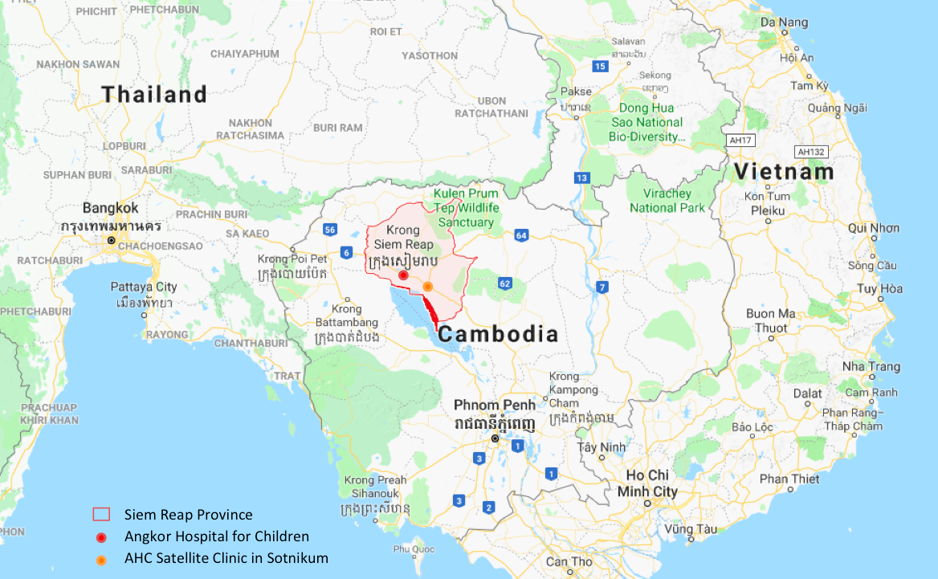
Figure 1. Map of Cambodia
Siem Reap Province is outlined with red. The location of Angkor Hospital for Children (AHC) and the Satellite Clinic in Sotnikum are indicated with red and orange circles, respectively. (Source: Google map) (Google, n.d.)

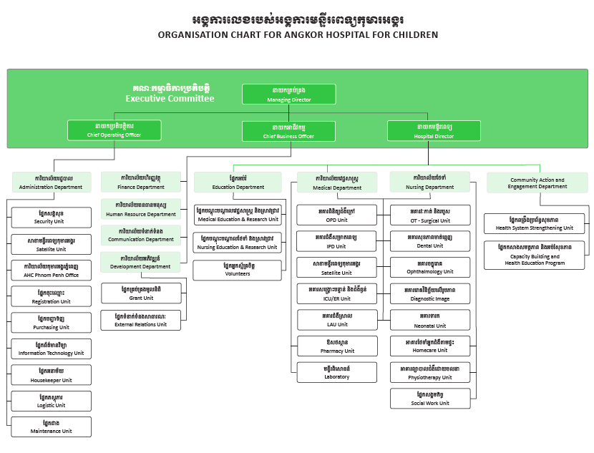
Figure 2. Organizational Chart at Angkor Hospital for Children

Table 1. The number of patients, healthcare workers, and people in communities served by Angkor Hospital for Children from 2013 to 2016

 | 2016 | 2015 | 2014 | 2013
TREATMENTS
Total patients treated | 179699 | 186358 | 168226 | 145842
Outpatient | 127900 | 132133 | 125732 | 115570
Inpatient | 3603 | 4656 | 4575 | 3622
ER/ICU | 21832 | 27915 | 21410 | 11243
Surgical care (minor) | 1685 | 1321 | 1658 | 1663
Neonatal Unit | 452 |  |  | 337
Dental Unit | 68840 | 14782 | 13967 | 12384
Eye Clinic | 15408 | 14074 | 12570 | 10504
HIV/Homecare | 2411 | 1887 | 2524
Physiotherapy | 3437 | 3517 | 3370 | 2856
Social work | 3573 | 3330 | 1441 | 1385
Laboratory (blood tests) | 100214 | 108447 | 97875 | 96416
Satellite Clinic
Inpatient | 1601 | 1385 | 1658 | 1586
Outpatient | 28954 | 25017 | 21232 | 18498
ER | 960 | 926 | 659 | 574
EDUCATION
Healthcare professionals/ students trained | 641
Continuing education sessions | 120
Residency | 47
PREVENTION
Community health education sessions (beneficiaries) | 199  (16976)
Village & school education | 187846
ER: emergency room, ICU: Intensive care unit.
(Source: Angkor Hospital for Children Annual Report 2013, 2015, and 2016)

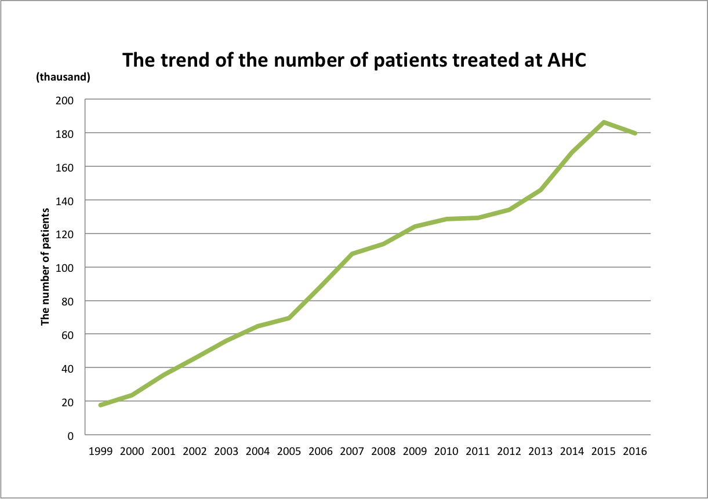
Figure 3. The trend of the number of patients treated by Angkor Hospital for Children from 1999 to 2016
The numbers of patients for 1999 to 2012 are outpatients treated in each year, and those for 2013 to 2016 are the number of the total patients treated.
(Source: Friends Without A Border Supporting Angkor Hospital for Children Annual Report 2010, 2011, and 2012, Angkor Hospital for Children Annual Report 2013, 2015, and 2016)

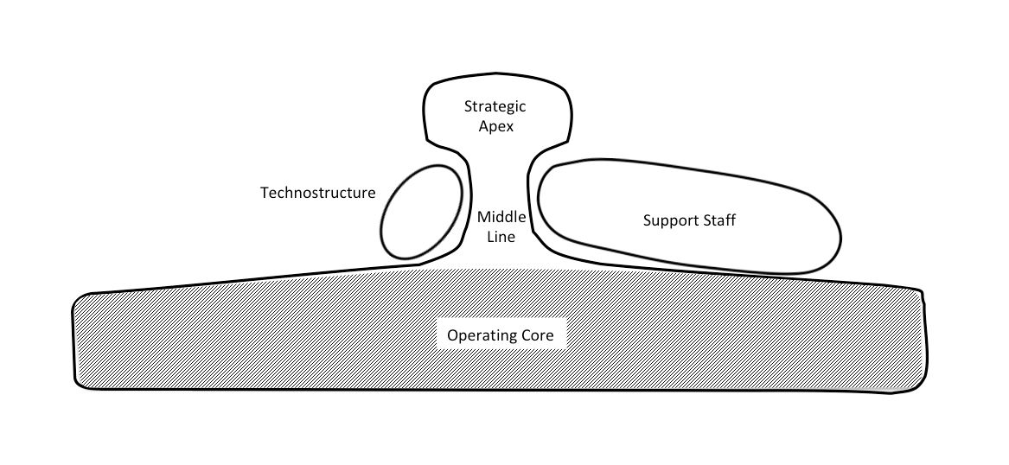
Figure 4. The diagram of the professional bureaucracy type in Mintzberg's structure in fives
The diagram of the professional bureaucracy type in Mintzberg’s structure in fives. The diagram indicates the relationships and balance of five basic parts of organization (large operation core), and vertical and horizontal decentralization (shadow).
Adapted from Structure in 5's: A Synthesis of the Research on Organization Design by Mintzberg (Mintzberg, 1980)

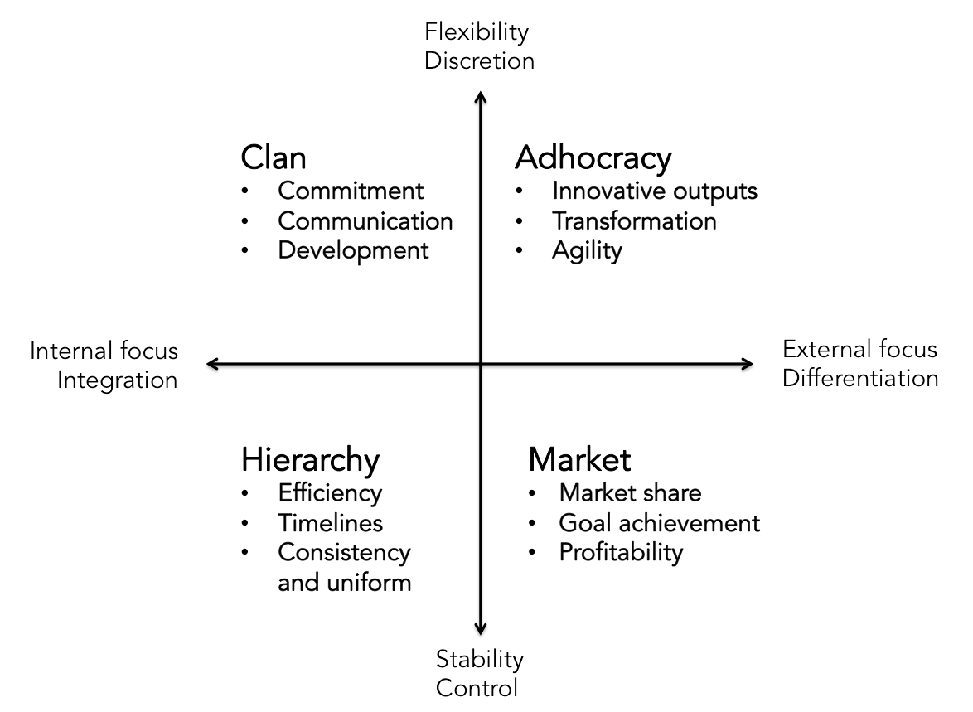
Figure 5. The Competing Values Framework
Adapted from Diagnosing and Changing Organizational Culture: Based on the Competing Values Framework (3) p.46 by Cameron, K. S., & Quinn, R. E. (2011). (Cameron & Quinn, 2011).

Table 2. Demographics of Questionnaire Respondents
Demographics | All Employees  (N=516) | Questionnaire Respondents  (N=267)
Age, n (%)
18-25 | 95 (18.4) | 50 (18.7)
26-30 | 190 (36.8) | 84 (31.5)
31-35 | 83 (16.1) | 54 (20.2)
36-40 | 69 (13.4) | 30 (11.2)
41-45 | 39 (7.6) | 20 (7.5)
46-50 | 13 (2.5) | 9 (3.4)
51-55 | 5 (1.0) | 4 (1.5)
More than 55 years old | 13 (2.5) | 6 (2.2)
Unknown/no answer | 9 (1.7) | 10 (3.7)
Gender, n (%)
Male | 280 (54.2) | 141 (52.8)
Female | 236 (45.7) | 124 (46.4)
No answer |  | 2 (0.8)
Department, n (%)
Medical (Medical/Nursing) | 365 (70.7) | 176 (65.9)
Non-medical | 151 (29.3) | 89 (33.3)
No answer |  | 2 (0.8)
Years of employment, n (%)
Less than 1 year | 57 (11.0) | 23 (8.6)
1-3 years | 181 (35.1) | 91 (34.0)
4-6 years | 99 (19.2) | 57 (21.3)
7-9 years | 45 (8.7) | 26 (9.7)
10-12 years | 40 (7.8) | 27 (10.1)
More than 12 years | 81 (15.7) | 40 (15.0)
Unknown/ no answer | 13 (2.5) | 3 (2.2)

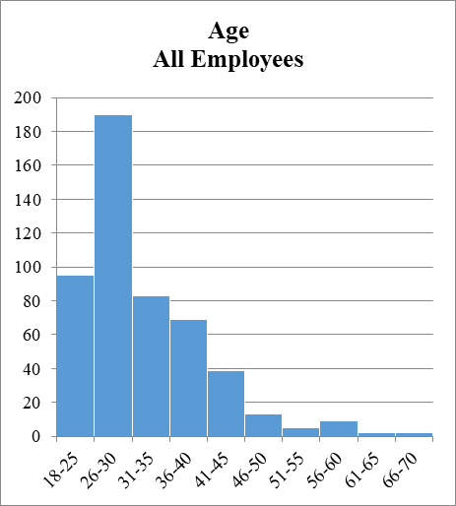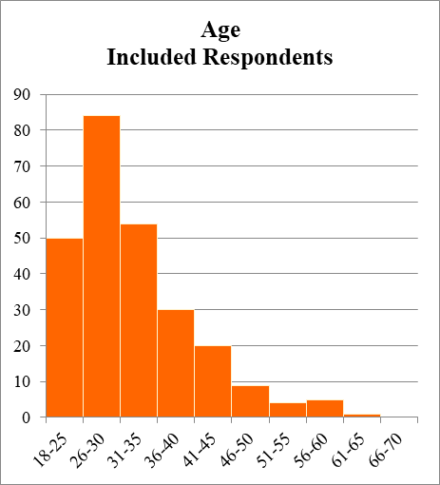
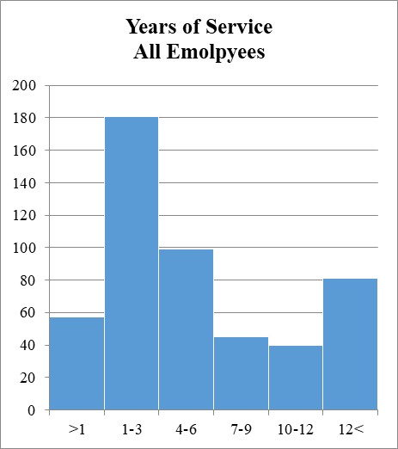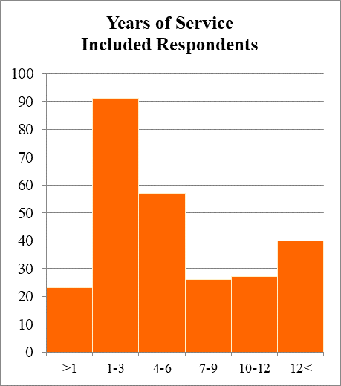
Figure 6. Distributions of age and years of service
Distributions of age and years of services for all employees and included respondents. The distributions for included respondents are similar to those for all employees at AHC.

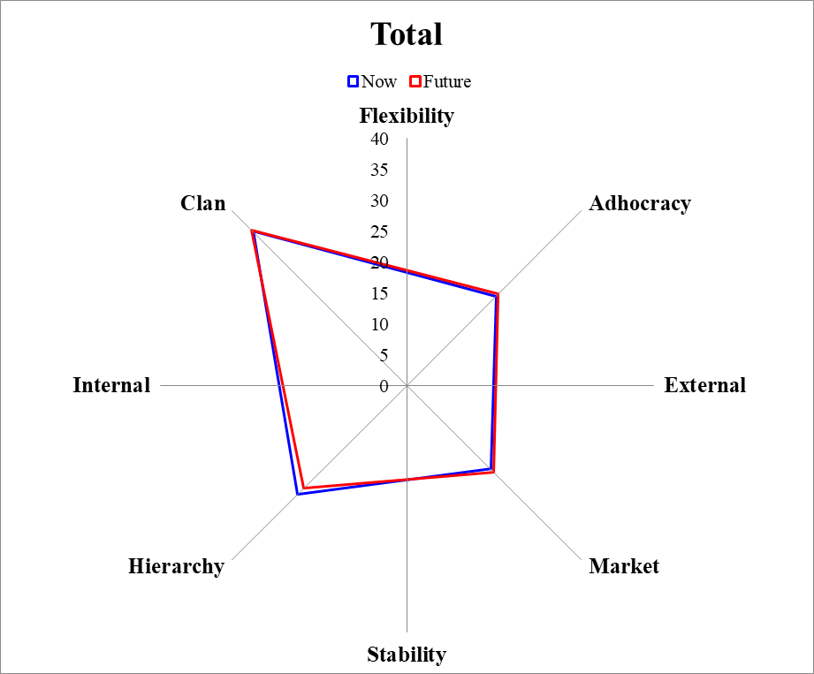
 | Now | Future
Clan | 35.30 | 35.63
Adhocracy | 20.47 | 20.97
Market | 19.20 | 19.83
Hierarchy | 25.03 | 23.57

Figure 7. The graph of organizational culture (Total) at AHC
Now is the current culture perceived by the employees. Future is the culture that the employees prefer in the future.

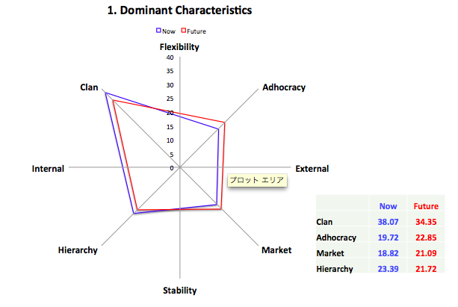
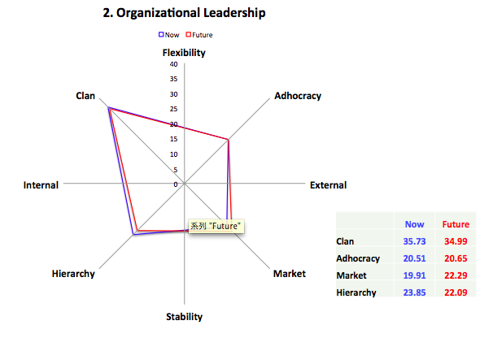
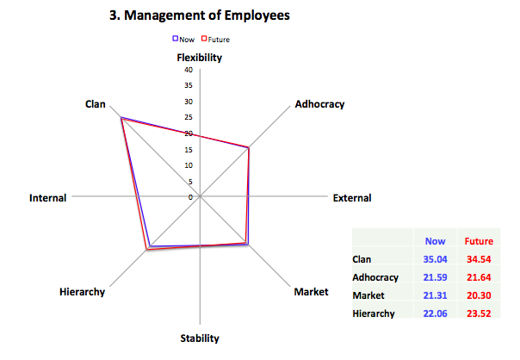
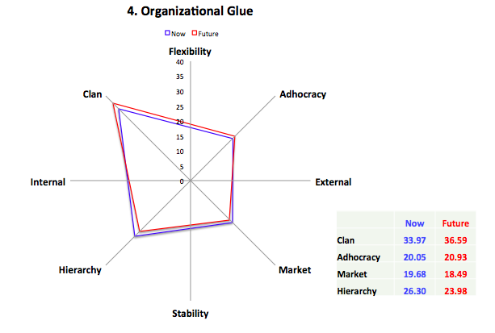

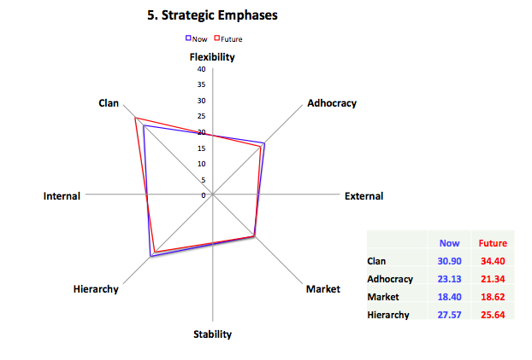

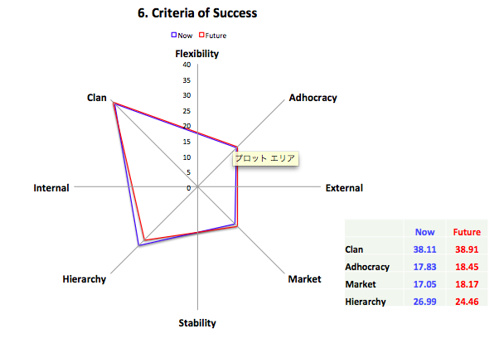
Figure 8. The graphs of organizational culture by items

Table 3. Demographics of interview participants
Semi- Structured Interviewees (N=13)
Gender | Male | 9
 | Female | 4
Age | 20s | 2
 | 30s | 9
 | 40s | 1
 | 50s | 1
Affiliation | Medical | 7
 | Non-medical | 6
Years of Services | Less than 1 year | 1
Years of Services | 1-3 years | 2
Years of Services | 4-6 years | 2
Years of Services | 7-9 years | 2
Years of Services | 10-12 years | 1
Years of Services | More than 13 years | 5
Length of Interviews | Median (mins) | 62
Length of Interviews | Range (mins) | 40-100

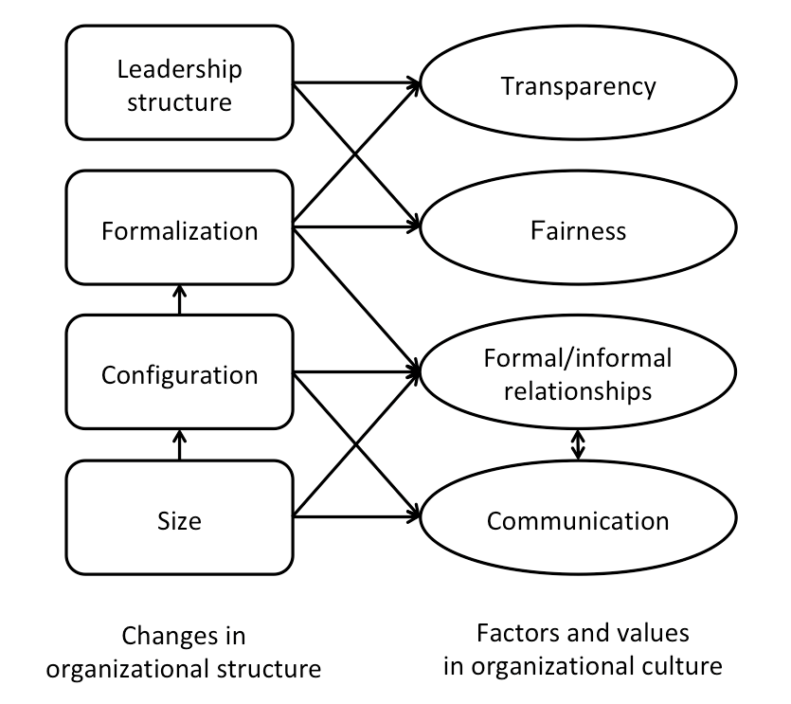
Figure 9. The relationship between dimensions of organizational structure and factors of organizational culture

BIBLIOGRAPHY
Acorn, S., Ratner, P. A., & Crawford, M. (1997). Decentralization as a determinant of autonomy, job satisfaction, and organizational commitment among nurse managers. Nurs Res, 46(1), 52-58.
Angkor Hospital for Children (AHC) (n.d). Retrieved from http://angkorhospital.org/
Allaire, Y., & Firsirotu, M. E. (1984). Theories of Organizational Culture. Organization Studies, 5(3), 193-226. doi:10.1177/017084068400500301
Archampong, D., Borowski, D., Wille-Jorgensen, P., & Iversen, L. H. (2012). Workload and surgeon's specialty for outcome after colorectal cancer surgery. Cochrane Database Syst Rev(3), Cd005391. doi:10.1002/14651858.CD005391.pub3
Azizollah, A., Abolghasem, F., & Mohammad Amin, D. (2015). The Relationship Between Organizational Culture and Organizational Commitment in Zahedan University of Medical Sciences. Glob J Health Sci, 8(7), 195-202. doi:10.5539/gjhs.v8n7p195
Bergs, J., Hellings, J., Cleemput, I., Zurel, Ö., De Troyer, V., Van Hiel, M., . . . Vandijck, D. (2014). Systematic review and meta‐analysis of the effect of the World Health Organization surgical safety checklist on postoperative complications. BJS, 101(3), 150-158.
Bilal, A., & Ahmed, H. M. (2016). Organizational Structure as a Determinant of Job Burnout: An Exploratory Study on Pakistani Pediatric Nurses. Workplace Health Saf. doi:10.1177/2165079916662050
Building Trust in Local Doctors and Healthcare. (2016). Khmer Times. Retrieved from http://www.khmertimeskh.com/news/28746/building-trust-in-local-doctors-and-healthcare/
Burns, T., & Stalker, G. M. (1961). The management of innovation. London: Tavistock Publications.
Cameron, K. S., & Quinn, R. E. (2011). Diagnosing and Changing Organizational Culture : Based on the Competing Values Framework (3). Hoboken, US: Jossey-Bass.
Campbell, S. L., Fowles, E. R., & Weber, B. J. (2004). Organizational structure and job satisfaction in public health nursing. Public Health Nurs, 21(6), 564-571. doi:10.1111/j.0737-1209.2004.21609.x
Carney, M. (2004). Middle manager involvement in strategy development in not-for profit organizations: the director of nursing perspective--how organizational structure impacts on the role. J Nurs Manag, 12(1), 13-21.
Choi, Y. S., Seo, M., Scott, D., & Martin, J. (2010). Validation of the organizational culture assessment instrument: An application of the Korean version. Journal of Sport Management, 24(2), 169-189.

Central Intelligence Agency (CIA) (2017, November 06, 2017). The World Factbook. Retrieved from https://www.cia.gov/library/publications/the-world-factbook/geos/cb.html
Dalton, D. R., Todor, W. D., Spendolini, M. J., Fielding, G. J., & Porter, L. W. (1980). Organization Structure and Performance: A Critical Review. Academy of Management. The Academy of Management Review, 5(1), 49.
Daly, J. P., & Geyer, P. D. (1995). Procedural fairness and organizational commitment under conditions of growth and decline. Social Justice Research, 8(2), 137-151. doi:10.1007/BF02334688
Dent, E. B., & Goldberg, S. G. (1999). Challenging “Resistance to Change”. The Journal of Applied Behavioral Science, 35(1), 25-41. doi:10.1177/0021886399351003
du Bois, A., Rochon, J., Pfisterer, J., & Hoskins, W. J. (2009). Variations in institutional infrastructure, physician specialization and experience, and outcome in ovarian cancer: a systematic review. Gynecol Oncol, 112(2), 422-436. doi:10.1016/j.ygyno.2008.09.036
Dubois, C.-A., Bentein, K., Mansour, J. B., Gilbert, F., & Bédard, J.-L. (2014). Why some employees adopt or resist reorganization of work practices in health care: associations between perceived loss of resources, burnout, and attitudes to change. International journal of environmental research and public health, 11(1), 187-201. doi:10.3390/ijerph110100187
Fleit, S. A. (2008). The influence of organizational structure on hospital social work practice and professional identity. (Dissertation/Thesis), ProQuest Dissertations Publishing. Retrieved from http://pitt.summon.serialssolutions.com/2.0.0/link/0/eLvHCXMwnV2xTsMwED3RsqAOgADRFqQTe6Cp47qZGICID2CPcrYjIoFTqDrw99ixXUUUdegYWYouivXsu3v3HgCb38-SP5iw1CKTRFSlpFQ6y0lWGdHS6Y_lmjpyYZ9kGVUhwt-OINkht2qlK5o_2DycOXdJ_rj6SpyLlOu2BkuNARynXDDum7f_Ze8uLZrby7wIIjzxOd_B5O6gKU4hckY7PaZGfW7HpXf1Gw8N-wxGz70u_DkcaXMBym4YbKJlCbY1tr0xzeoDvdLs5tuuGXwPdiPoa-7o6F0YJ66wMgpXPc0PbPw48M8l3BUvb0-vSQy6DHt5XW4jZlcwNK3R14C81gtOwiZLnGUyq-2xnzIp1cJChKqFHMN0z4sme1encOJJGa7OcQND-3X61kvP_gIFobeB
Fourcade, A., Blache, J.-L., Grenier, C., Bourgain, J.-L., & Minvielle, E. (2011). Barriers to staff adoption of a surgical safety checklist. BMJ Quality &amp; Safety. doi:10.1136/bmjqs-2011-000094
General Population Census of Cambodia 2008. Provisional Population Totals. (2008). Retrieved from http://www.stat.go.jp/english/info/meetings/cambodia/pdf/pre_rep1.pdf.
Ghiselli, E. E., & Siegel, J. P. (1972). LEADERSHIP AND MANAGERIAL SUCCESS IN TALL AND FLAT ORGANIZATION STRUCTURES. Personnel Psychology, 25(4), 617-624. doi:10.1111/j.1744-6570.1972.tb02304.x
Giri, V. N., & Pavan Kumar, B. (2010). Assessing the impact of organizational communication on job satisfaction and job performance. Psychological Studies, 55(2), 137-143. doi:10.1007/s12646-010-0013-6
Goldhaber, G. M. (1993). Organizational communication: Brown & Benchmark Madison, WI.
Google. (n.d.). Siem Reap Province, Cambodia. Retrieved from https://www.google.com/maps/place/Siem+Reap+Province,+Cambodia/@13.4684325,103.4803916,9z/data=!3m1!4b1!4m5!3m4!1s0x3110170b07d4a0f5:0x5ddbd370ce73acb9!8m2!3d13.6915377!4d104.1001326?hl=en
Grilli, R., Minozzi, S., Tinazzi, A., Labianca, R., Sheldon, T. A., & Liberati, A. (1998). Do specialists do it better? The impact of specialization on the processes and outcomes of care for cancer patients. Ann Oncol, 9(4), 365-374.
Harrison, R. (1972). organization's character. Business Review.
Hatch, M. J., & Cunliffe, A. L. (2013). Organization theory: modern, symbolic and postmodern perspectives: Oxford university press.
Haynes, A. B., Weiser, T. G., Berry, W. R., Lipsitz, S. R., Breizat, A.-H. S., Dellinger, E. P., . . . Gawande, A. A. (2011). Changes in safety attitude and relationship to decreased postoperative morbidity and mortality following implementation of a checklist-based surgical safety intervention. BMJ Quality &amp; Safety, 20(1), 102-107. doi:10.1136/bmjqs.2009.040022
Helfrich, C. D., Li, Y.-F., Mohr, D. C., Meterko, M., & Sales, A. E. (2007). Assessing an organizational culture instrument based on the Competing Values Framework: Exploratory and confirmatory factor analyses. Implementation Science, 2(1), 13-13. doi:10.1186/1748-5908-2-13
Heritage, B., Pollock, C., & Roberts, L. (2014). Validation of the organizational culture assessment instrument. PLoS One, 9(3), e92879. doi:10.1371/journal.pone.0092879
Hillner, B. E., Smith, T. J., & Desch, C. E. (2000). Hospital and physician volume or specialization and outcomes in cancer treatment: importance in quality of cancer care. J Clin Oncol, 18(11), 2327-2340. doi:10.1200/jco.2000.18.11.2327
Hughes, R. (2008). Patient safety and quality: an evidence-based handbook for nurses. Agency for Healthcare Research and Quality, Rockville, MD.
Igo, T., & Skitmore, M. (2006). Diagnosing the organizational culture of an Australian engineering consultancy using the competing values framework. Construction Innovation, 6(2), 121-139. doi:10.1108/14714170610710659
Jafree, S. R., Zakar, R., Zakar, M. Z., & Fischer, F. (2016). Nurse perceptions of organizational culture and its association with the culture of error reporting: a case of public sector hospitals in Pakistan. BMC Health Serv Res, 16, 3. doi:10.1186/s12913-015-1252-y
Kalliath, T. J., Bluedorn, A. C., & Gillespie, D. F. (1999). A Confirmatory Factor Analysis of the Competing Values Instrument. Educational and Psychological Measurement, 59(1), 143-158. doi:10.1177/0013164499591010
Karlöf, B., & Lövingsson, F. H. (2007). Reorganization. Springer Science and Business Media, Berlin.
Kawano, T., Taniwaki, M., Ogata, K., Sakamoto, M., & Yokoyama, M. (2014). Improvement of teamwork and safety climate following implementation of the WHO surgical safety checklist at a university hospital in Japan. J Anesth, 28(3), 467-470. doi:10.1007/s00540-013-1737-y
Konovsky, M. A., & Cropanzano, R. (1991). Perceived fairness of employee drug testing as a predictor of employee attitudes and job performance. J Appl Psychol, 76(5), 698-707. doi:10.1037//0021-9010.76.5.698
Longest, B. B., Jr., & Darr, K. (2008). Managing health services organizations and systems (Vol. 5th). Baltimore: Health Professions Press.
Mannion, R., Davies, H. T., & Marshall, M. N. (2005). Cultural characteristics of "high" and "low" performing hospitals. J Health Organ Manag, 19(6), 431-439. doi:10.1108/14777260510629689
Maximini, D. (2015). The Scrum Culture: Springer Internatinal Publishing Swithzland.
McGrew, L. (1990). Health Care In Cambodia. Cultural Survival Quaterly Magazine. Retrieved from https://www.culturalsurvival.org/publications/cultural-survival-quarterly/health-care-cambodia
Mintzberg, H. (1980). Structure in 5's: A Synthesis of the Research on Organization Design. Management science, 26(3), 322-341.
Mitchell, S. M. (2001). Quality of care in health networks and health systems: The impact of inter -organizational structure on patient outcomes. (Dissertation/Thesis), ProQuest Dissertations Publishing. Retrieved from http://pitt.summon.serialssolutions.com/2.0.0/link/0/eLvHCXMwpV1NS8QwEB10vYiC36irMHivJptUixcP6uIP8L6kTQoLmqh1Qf-9k05Tlip7EXpJS0KGDi-ZzLwXADW5FNkAE6QujapzK7W0hTJiUtJKVGqKRYrKXhs1KLLsSf3d704o2UK3DVU8Nb-KOT3CViHu3t6zeI1UTLd2d2qsw4akjYLk7O1f4buOCUBN_p1UeLr2zS9Qblea6Q6kYoBWkGluX3u-9EDA8T_z3oWth6U8_B6sOb8P23yEh8xMOoAv1tf4xlBjLBDDuUemTaLn4vEGjbfpHWtCN7dInodMvow9ox7FB2ZhifNpXpBlaxc0aPDYabtiWHySBa45hIvp4_P9U5YMm3Ue38x6q9QRjHzw7hjQlIQgtCPUtaG4zeaEDbLOXV4VhZTKiRMYrxjodOXXMWxyOVh8zmBE03bnLFD7AyBwwlM
Nazarian, A., Irani, Z., & Ali, M. (2013). The Relationship between National Culture and Organisational Culture: The Case of Iranian Private Sector Organisations. Journal of Economics, Business and Management, 11-15. doi:10.7763/JOEBM.2013.V1.3
O’Grady, E. T. (2008). Advanced practice registered nurses: The impact on patient safety and quality.
Papaconstantinou, H. T., Jo, C., Reznik, S. I., Smythe, W. R., & Wehbe-Janek, H. (2013). Implementation of a Surgical Safety Checklist: Impact on Surgical Team Perspectives. The Ochsner Journal, 13(3), 299-309.
Parmelli, E., Flodgren, G., Beyer, F., Baillie, N., Schaafsma, M. E., & Eccles, M. P. (2011). The effectiveness of strategies to change organisational culture to improve healthcare performance: a systematic review. Implement Sci, 6, 33. doi:10.1186/1748-5908-6-33
Piderit, S. K. (2000). Rethinking Resistance and Recognizing Ambivalence: A Multidimensional View of Attitudes toward an Organizational Change. The Academy of Management Review, 25(4), 783-794.
Pilav, A., & Jatić, Z. (2017). The impact of organizational culture on patient satisfaction. Journal of Health Sciences, 7(1), 9. doi:10.17532/jhsci.2017.411
Pugh, D. S., Hickson, D. J., Hinings, C. R., & Turner, C. (1968). Dimensions of Organizational Structure. Administrative Science Quarterly, 13(1), 65.
Quinn, R. E., & Rohrbaugh, J. (1981). A Competing Values Approach to Organizational Effectiveness. Public Productivity Review, 5(2), 122-140. doi:10.2307/3380029
Reed, H., & Keely, C. B. (2001). Forced migration & mortality (I. ebrary Ed.). Washington, D.C: National Academy Press
Sarros, J. C., Gray, J., Densten, I. L., & Cooper, B. (2005). The Organizational Culture Profile Revisited and Revised: An Australian Perspective. Australian Journal of Management, 30(1), 159-182. doi:10.1177/031289620503000109
Schein, E. H. (1985). Organizational culture and leadership (1st ed.). San Francisco: Jossey-Bass Publishers.

Schminke, M., Ambrose, M. L., & Cropanzano, R. S. (2000). The effect of organizational structure on perceptions of procedural fairness. J Appl Psychol, 85(2), 294-304.
Scott, T., Mannion, R., Davies, H., & marshall, M. (2003a). Healthcare performance and organisational culture: Radcliffe Publishing.
Scott, T., Mannion, R., Davies, H., & Marshall, M. (2003b). The quantitative measurement of organizational culture in health care: a review of the available instruments. Health services research, 38(3), 923-945.
Serenko, A., Bontis, N., & Hardie, T. (2007). Organizational size and knowledge flow: a proposed theoretical link. Journal of Intellectual Capital, 8(4), 610-627. doi:10.1108/14691930710830783
Sokunthea, H. (2017, April, 6, 2017). Study Shines Light on Growing Cambidian Consumer Class. The Cambodia Daily. Retrieved from https://www.cambodiadaily.com/business/study-shines-light-on-growing-cambodian-consumer-class-127614/
Stevens, F., Diederiks, J., & Philipsen, H. (1992). Physician satisfaction, professional characteristics and behavior formalization in hospitals. Social Science & Medicine, 35(3), 295-303. doi:https://doi.org/10.1016/0277-9536(92)90026-M
Stordeur, S., D'Hoore, W., Group, N. E.-S., the, N.-S. G., Medicinska och farmaceutiska, v., Institutionen för medicinska, v., . . . Uppsala, u. (2007). Organizational configuration of hospitals succeeding in attracting and retaining nurses. Journal of Advanced Nursing, 57(1), 45-58. doi:10.1111/j.1365-2648.2006.04095.x
Ukawa, N., Tanaka, M., Morishima, T., & Imanaka, Y. (2015). Organizational culture affecting quality of care: guideline adherence in perioperative antibiotic use. Int J Qual Health Care, 27(1), 37-45. doi:10.1093/intqhc/mzu091
van Dijk, R., & van Dick, R. (2009). Navigating Organizational Change: Change Leaders, Employee Resistance and Work-based Identities. Journal of Change Management, 9(2), 143-163. doi:10.1080/14697010902879087
Wagner, C., Mannion, R., Hammer, A., Groene, O., Arah, O. A., Dersarkissian, M., . . . Consortium, D. U. P. (2014). The associations between organizational culture, organizational structure and quality management in European hospitals. International Journal for Quality in Health Care, 26(suppl_1), 74-80. doi:10.1093/intqhc/mzu027
Weber, M., Gerth, H., & Mills, C. W. (1958). From Max Weber: essays in sociology. New York Book: Oxford University Press.
World Health Organization (WHO) (n.d.). WHO Surgical Safety Checklist. Patient safety. Retrieved from http://www.who.int/patientsafety/topics/safe-surgery/checklist/en/
Willem, A., Buelens, M., & De Jonghe, I. (2007). Impact of organizational structure on nurses’ job satisfaction: A questionnaire survey. International Journal of Nursing Studies, 44(6), 1011-1020. doi:http://dx.doi.org/10.1016/j.ijnurstu.2006.03.013
World Bank. (2017, October 2017). The Workd Bank in Cambodia. Retrieved from http://www.worldbank.org/en/country/cambodia/overview
Xue, D., Zhou, P., Bundorf, M. K., Huang, J. X., & Chang, J. L. (2013). The association of strategic group and organizational culture with hospital performance in China. Health Care Manage Rev, 38(3), 258-270. doi:10.1097/HMR.0b013e3182678f9a
Zachariadou, T., Zannetos, S., & Pavlakis, A. (2013). Organizational culture in the primary healthcare setting of Cyprus. BMC Health Serv Res, 13, 112. doi:10.1186/1472-6963-13-112

