VALIDATION OF A REAL-TIME POLYMERASE CHAIN REACTION ASSAY FOR SENSITIVE QUANTIFICATION OF FRANCISELLA TULARENSIS STRAINS

by
Megan Beary
BS Biology, Clarion University of Pennsylvania, 2016

Submitted to the Graduate Faculty of
the Department of Infectious Diseases and Microbiology
Graduate School of Public Health in partial fulfillment
of the requirements for the degree of
Master of Public Health

University of Pittsburgh
2018

UNIVERSITY OF PITTSBURGH
Graduate School of Public Health

This essay is submitted

by

Megan Beary

on

April 13, 2018
and approved by

Essay Advisor:
Douglas S. Reed, PhD _______________________________________
Associate Professor
Department of Immunology
School of Medicine
University of Pittsburgh

Essay Readers:
Amy L. Hartman, PhD _______________________________________
Assistant Professor
Infectious Diseases and Microbiology
Graduate School of Public Health
University of Pittsburgh

Jeremy J. Martinson, DPhil _______________________________________
Assistant Professor
Infectious Diseases and Microbiology
Graduate School of Public Health
University of Pittsburgh

Copyright © by Megan Beary
2018
Douglas S. Reed, PhD

VALIDATION OF A REAL-TIME POLYMERASE CHAIN REACTION ASSAY FOR SENSITIVE QUANTIFICATION OF FRANCISELLA TULARENSIS STRAINS

Megan Beary, MPH
University of Pittsburgh, 2018

ABSTRACT
Tularemia, caused by the Gram-negative bacterium Francisella tularensis, is a life-threatening human and animal disease. F. tularensis has a wide geographical distribution, a variety of vectors and reservoirs, and a low infectious dose, causing it to be considered a potential biological weapon and public health threat. There is currently no FDA-approved vaccine for F. tularensis. A sensitive and specific quantification method is needed to accurately detect and quantify bacterial isolates. A review of the literature has shown that real-time PCR can more sensitively quantify F. tularensis genomes than traditional plating methods. In order to contribute to the development of a vaccine, we have done the following: evaluated four sets of primers for use in real-time PCR with F. tularensis, enhanced the genomic DNA extraction protocol with an extra spin step and with 10 minutes added to the incubation period to make it more efficient, and enhanced quantification done by the Nanodrop™ One Spectrophotometer by heating samples to 63⁰C before reading. The evaluation of primers and the method validation of genomic DNA extraction and quantification will allow us to develop PCR standards for four subspecies of F. tularensis initially, and eventually will allow us to quantify bacterium in infected animal tissues. The public health significance of this work is to further vaccine development for an extremely infectious disease in humans and animals.

TABLE OF CONTENTS
preface ix
1.0 Introduction 1
1.1 Francisella tularensis 1
1.1.1 Bacteria 1
1.1.2 Subspecies 2
1.1.2.1 Type A, subspecies tularensis 2
1.1.2.2 Type B subspecies holarctica 3
1.1.2.3 Subspecies novicida 3
1.1.3 Epidemiology 4
1.1.4 Clinical Disease 5
1.1.5 Treatment and Vaccines 7
1.2 Real-time, quantitative PCR 8
1.2.1 Significance 8
1.2.2 Methodology 11
1.2.3 Benefits versus plating 12
1.3 PUBLIC HEALTH SIGNIFICANCE 14
1.3.1 Potential use as a bioweapon 14
1.4 Specific Aims 16
2.0 MATERIALS AND METHODS 17
2.1 BACTERIA CULTURE 17
2.1.1 Bacterial Strains Used 17
2.1.2 Broth Cultures and Agar Plates 17
2.2 BIOSAFETY 18
2.2.1 BioSafety Level 3 (BSL-3) Procedures 18
2.2.2 BioSafety-Level 2 (BSL-2) Procedures 18
2.3 GENOMIC DNA EXTRACTION 19
2.4 DNA Analysis 19
2.5 POLYMERASE CHAIN REACTION 20
3.0 Results 22
3.1 Evaluation of Primers 22
3.2 Nanodrop Validation 25
3.3 Genome to CFU Ratios 27
3.3.1 Nucleic Acid Concentration and Purity Ratios 27
3.3.2 Theoretical versus Actual Yield 31
4.0 DISCUSSION and future directions 33
bibliography 35
List of tables
Table 1. Sequences for the forward and reverse primers and the probes used for real-time PCR with Francisella tularensis 21
Table 2. PCR data for four primers used on U112 22
Table 3. PCR data for four primers used on LVS 23
Table 4. Nanodrop readings were first taken in triplicate with several different quantities of genomic S4∆clpB DNA, and then taken in triplicate with dilutions made of the genomic DNA and nuclease free water. 26
Table 5. NanoDrop information for 3 dilutions of U112 using the old extraction method (top) and new extraction method (bottom) 28
Table 6. NanoDrop information for 3 dilutions of LVS using the old extraction method (top) and new extraction method (bottom) 29
Table 7. NanoDrop information for 3 dilutions of S4∆clpB using the old extraction method (top) and new extraction method (bottom) 30
Table 8. NanoDrop information for 3 dilutions of SCHU S4 using the old extraction method (top) and new extraction method (bottom) 31
Table 9. Comparison of genomes per μL yielded with actual CFU per μL 32
List of figures
Figure 1. 23kDa primer/probe with U112 (left) and LVS (right) 23
Figure 2. tul4 primer/probe with U112 (left) and LVS (right) run in triplicate 24
Figure 3. fopA primer/probe with U112 (left) and LVS (right) run in triplicate 24
Figure 4. IsFt2 primer/probe with U112 (left) and LVS (right) run in triplicate 25
preface
I would like to thank my essay and lab advisor, Dr. Doug Reed who has mentored me for the entirety of my time in the Graduate School of Public Health. He has given me the opportunity to learn a variety of lab skills under his direction, and I am grateful for his willingness to answer questions at any time of the day.
I would also like to thank the members of Reed Lab: Katherine Willett and Jennifer Bowling for the countless hours spent teaching me about PCR and for completing the DNA extractions that could only be done in BSL-3, Henry Ma for the guidance and knowledge about the essay writing process, and Jennifer Burwinkle for the perseverance and teamwork during shared experiments, and the unending support during my time in the lab.
Finally, I would like to thank my essay readers, Dr. Amy Hartman and Dr. Jeremy Martinson, for looking at my project from a fresh perspective and offering their ideas to improve my work.

Introduction

Francisella tularensis

Bacteria
Tularemia, caused by the Gram-negative bacterium Francisella tularensis, is a life-threatening human and animal disease. F. tularensis is a facultative, intracellular bacterium (Kingry & Petersen, 2014) that has been shown to target many cell types throughout the body including macrophages, dendritic cells, monocytes, and neutrophils (Bosio & Dow, 2005; Hall, 2008). It was first isolated from ground squirrels in 1911 in Tulare County, California, that were dying of an unknown, plague-like illness (J. Wayne Conlan & Oyston, 2007). There are four subspecies of Francisella tularensis, two of which cause human disease: subspecies tularensis (Type A) is the most virulent in humans but found only in North America while subspecies holarctica (Type B) is the most ubiquitous across the globe but is not as virulent in humans. Recently, Type A strains have been further subdivided into clades A1a, A1b, and A2 (S. Cowley & K. Elkins, 2011). This distinction was made based on regional distribution and genetic differences (J. Wayne Conlan & Oyston, 2007). Subspecies mediasiatica and novicida are avirulent in immunocompetent humans. This work will look at one virulent strain and three attenuated strains of Francisella tularensis.

Subspecies

Type A, subspecies tularensis
SCHU S4 is the prototype Type A strain that was first isolated from a human case of tularemia in 1951. For humans, Type A strains pose a significant health concern due to the low infectious dose; SCHU S4 can cause disease by inhalation of just 15 cfu (S. Cowley & K. Elkins, 2011; Cowley, Myltseva, & Nano, 1996; Twine et al., 2012). For this reason there are concerns about the potential use of type A strains as a bioweapon (Pechous 2009). Type A strains are less lethal to humans when infection occurs in the skin, eyes, or gastrointestinal tract (J. Wayne Conlan & Oyston, 2007). SCHU S4 has been shown to produce disease in rabbits that is consistent with human pneumonic tularemia (Reed et al., 2011), making it desirable for vaccine research. In the United States, SCHU S4 can only be worked with in a BSL-3 laboratory that is approved for work with tier 1 select agents.

S4∆clpB
A clpB-deleted mutant of SCHU S4 has been created that is attenuated in animals and humans (Barrigan et al., 2013). In Francisella tularensis, clpB is a heat shock protein that provides environmental resistance to oxidative, ethanol, and acid stressors (Meibom et al., 2008). The deletion of clpB weakens the SCHU S4 strain, reducing its ability to survive outside its host and increasing its ability to be cleared by the immune system (Twine et al., 2012). The S4∆clpB mutant has been shown to be attenuated in mice following intradermal, intraperitoneal, or oral inoculation (J. Wayne Conlan et al., 2010; Stinson, Smith, Cole, Barry, & Reed, 2016; Twine et al., 2012). Unlike SCHU S4, S4∆clpB can be worked with in a BSL-2 laboratory even though it is only deficient in one gene from SCHU S4. It is safe to work with in BSL-2 because it “fails to revert back to a virulent strain after in vivo passage or after co – culturing with a different mutant strain that possesses the clpB gene (Select Agents and Toxins Exclusions, 2018).” This strain is referred to as the S4∆clpB throughout.

Type B subspecies holarctica
The Live Vaccine Strain (LVS) is an attenuated strain of Francisella tularensis subspecies holarctica, also referred to as “Type B”. LVS was derived from a type B isolate in the former Soviet Union that was given to the United States in the 1950s and further passaged to create ‘LVS’. LVS demonstrates inconsistency in its ability to confer protection with only a 60 – 80% protection rate in humans. It also causes a fever in humans, making it a less desirable vaccine candidate. These inconsistencies suggest that it may have the potential to revert to a more virulent form (Rockx-Brouwer et al., 2012). A greater understanding of how this strain generates an immune response needs to be attained (Sanapala et al., 2012).

Subspecies novicida
A third attenuated strain of Francisella tularensis was used in this project. Francisella novicida strain U112, referred to as U112 throughout, is naturally avirulent in humans, (Barker et al., 2009; Sanapala et al., 2012) only causing disease in humans who are immune compromised or have other underlying health problems (Barker et al., 2009). Novicida strains are unique in their lack of a capsule and sensitivity to complement. U112 is of interest because it is an attenuated strain of Francisella tularensis that still infects and replicates in macrophages (Anthony, Gu, Cowley, Leung, & Nano, 1991).

Epidemiology
F. tularensis has a wide geographical distribution and a variety of vectors and reservoirs. A wide range of arthropods act as vectors of F. tularensis. In the United States, transmission has mostly been attributed to ticks, with the disease being detected in at least 13 species of ticks. Transmission has also been attributed to certain species of mosquitos, flies, and fleas in different regions of the world. There are also several mammals that can contract F. tularensis such as hares, prairie dogs, mink, ground squirrels, rabbits, beavers, muskrats, and rodents such as voles and mice. Rodents are thought to be a main vector for the spread of F. tularensis to humans. It has been shown that there is a link to rodent population density as well as tularemia outbreaks in rodents with outbreaks of the disease in humans (Sjostedt, 2007).
F. tularensis has been known to cause disease globally, with the highest distribution of tularemia cases occurring in the northern hemisphere. In the United States, most cases occur in the west annually (Sjostedt, 2007). Ticks are common vectors throughout both the eastern and western United States. In the western United States, deer flies are also a common vector (Petersen, Mead, & Schriefer, 2009). F. tularensis tularensis (Type A) is the subspecies that is most commonly found in the United States (Sjostedt, 2007). In an analysis of more than 300 cases in the USA, 74% of tick transmitted disease was found to be caused by Type A tularemia. Also, Type A tularemia is the predominant type found in Arkansas, Missouri, and Oklahoma which have the highest incidence of tick-borne tularemia. Among type A strains, type A1 generally occurs at lower elevations than type A2 (Petersen et al., 2009). F. tularensis holarctica (Type B) is more ubiquitous as it is found throughout the entire northern hemisphere (Sjostedt, 2007). It is mostly transmitted by mosquitos rather than ticks or flies (Petersen et al., 2009). F. tularensis mediasiatica has only been isolated in Kazakhstan and Turkmenistan. F. tularensis novicida has been found in Australia, Spain, and the USA (Sjostedt, 2007).

Clinical Disease
In humans, Francisella tularensis can cause a spectrum of diseases dependent on infection route, with all forms having in common a fever that can be as high as 104⁰F(Schmerk, Duplantis, Howard, & Nano, 2009). Symptoms usually develop within 3 or 4 days, but can sometimes take as long as 10 days to manifest (Tularemia). The forms of this disease include ulceroglandular, glandular, oculoglandular, oropharyngeal, pneumonic, and typhoidal (Schmerk et al., 2009), with pneumonic and typhoidal tularemia posing the most substantial threat of morbidity and mortality (Hall, 2008). In a histopathological sense, tularemia resembles many characteristics of tuberculosis (TB). The lungs, liver, lymph nodes and spleens of a person infected with tularemia develop granulomas similar to those seen in a person infected with tularemia (J. Wayne Conlan & Oyston, 2007).
Ulceroglandular and glandular tularemia are the most common forms of the disease (Anda, 2007), with ulceroglandular comprising about 75% of all cases of tularemia (Tularemia). Humans can acquire these forms of tularemia in three ways: vector – borne transmission, direct contact with an infected animal, or in an indirect manner such as touching tools that have been used on infected animals. Following exposure to the bacteria, a fever will develop followed by symptoms that are dependent upon the form of tularemia that has been acquired. Ulceroglandular tularemia refers to a disease that results in swelling of a regional lymph node and an ulcer developing at the site of the exposure, while the term glandular tularemia refers to swelling of a regional lymph node with no ulcer (Anda, 2007).
The next most common form is typhoidal tularemia which is sometimes called septicemic tularemia. Between 10 – 15% of cases are typhoidal, and it is also the most serious form. The most common feature of typhoidal tularemia is pneumonia, but it is also characterized by fever, exhaustion, and weight loss. It is most often acquired by ingestion (Tularemia).
On the other hand, oculoglandular tularemia is one of the rarest forms of tularemia. This form of tularemia is acquired through bacteria coming into contact with the eye. Complications include fever, conjunctivitis, swelling of the eyelids, photophobia, and discharge from the eye (Anda, 2007). This can occur when from a splash of infected blood or handling an infected carcass and then rubbing the eye (Tularemia).
Oropharyngeal tularemia is acquired through ingestion of contaminated food or water (Anda, 2007). The pathology of this disease can include sore throat, nausea, vomiting, and diarrhea (Tularemia). The sore throat allows the disease to easily be mistaken as strep throat, causing treatment with ineffective antibiotics and a delay in the correct treatment (Anda, 2007). This disease form is also rare, and most commonly caused by ingesting undercooked meat from an infected animal (Tularemia).
A severe form of tularemia is caused by inhaling aerosolized particles of F. tularensis, causing pneumonic tularemia. Pneumonic tularemia can cause symptoms such as a cough, chest pain, an increased respiratory rate, nausea, and vomiting. Respiratory tularemia can be broken into type A disease and type B disease based upon the subspecies of F. tularensis causing the disease. Type A disease has a sudden onset that can include a high fever, cough, pharyngitis, chest pain, headache, sweating, drowsiness, and weakness. At its most severe stage, mental deterioration and pulse-temperature dissociation may be seen. Type B disease, on the other hand, is less likely to produce symptoms of pneumonia (Anda, 2007).

Treatment and Vaccines
Diagnosis of tularemia comes from a combination of signs, symptoms, and recent history of arthropod bite or recent environmental exposure to F. tularensis (Tularemia). In severe cases of tularemia where hospitalization is required, gentamicin should be given as a first choice whether the patient is an adult, child, or pregnant women even though gentamicin is not approved for use during pregnancy in many other situations (Anda, 2007). Streptomycin is also considered a treatment of choice (Tularemia). In milder cases of tularemia, ciprofloxacin should be given to adults, children, and pregnant women (Anda, 2007). If treatment is started in a timely manner, the mortality rate for tularemia is only 1-2%. However, if patients are left untreated, one-third will die from complications such as pneumonia, meningitis, or peritonitis (Tularemia).
F. tularensis has recently been found to show resistance to gentamycin resistance at ambient temperature (26⁰C) as opposed to mammalian body temperature (37⁰C) (Loughman et al., 2016). Streptomycin and tetracycline – resistant strains of F. tularensis have only been developed in the laboratory. Antibiotic resistant strains of F. tularensis are not currently a clinical concern, but they are a concern for use in bioterrorism (Anda, 2007).
Vaccine development began in the former Soviet Union in the 1930s. In the USA and Europe there are currently research efforts to develop a vaccine for Francisella tularensis. This vaccine would be of importance to individuals who could be exposed to a deliberate release of the disease as well as researchers who work closely with the highly virulent strains. LVS, meant to be a potential vaccine candidate, has been tested in trials that were conducted in the USA in the 1950s and 1960s where volunteers were challenged with the SCHU S4 strain up to one year after being immunized with LVS. Volunteers who had been immunized had less severe disease symptoms as compared to volunteers who had not been immunized (Anda, 2007).
Non-human primates and rabbits have been shown to mimic the human disease the most accurately (Sjostedt, 2007). Mice are also used as animal models of the disease because they develop granulomas that are comparable to lesions that develop in human tissues (S. C. Cowley & K. L. Elkins, 2011). However, mice are uniformly susceptible to the disease regardless of the subspecies and strain (Sjostedt, 2007). F. tularensis has even been shown to infect and replicate in Drosophila melanogaster. Due to isolation of Francisella spp. from wild and cultivated fish, there have been recent efforts to establish F. tularensis infection in zebrafish (S. C. Cowley & K. L. Elkins, 2011).

Real-time, quantitative PCR

Significance
Rabbits have been shown to be a relevant model of human pneumonic tularemia due to the similarity of disease manifestation to what is seen in humans (Sjostedt, 2007). Our laboratory is testing a number of potential tularemia vaccines in the rabbit model, particularly live attenuated strains of F. tularensis. One objective of our current studies is to discern whether differences in dissemination and persistence might explain why some live attenuated vaccines protect rabbits better than others. In order to detect potentially small numbers of bacteria in rabbit tissues, a sensitive method is needed for detecting the presence and number of F. tularensis in various rabbit tissues such as the spleen, liver, and kidney after infection. The current protocol for detecting and quantifying bacteria in rabbit tissues or rabbit blood includes making dilutions and then plating on agar using the drop method. The drop method is when a predetermined amount of culture, typically 10μL in this case, is pipetted at the top of an agar plate and the plate is tipped so that the drop will run down the length of the plate. This allows the 10μL of culture to be spread across the plate so the individual colonies can be counted. The culture must be diluted to the point where the colonies are not too close together to count. From these dilutions, the number of bacteria in the undiluted culture can be calculated. While this method is a standard procedure to quantify bacteria in rabbit blood or tissues, it may not catch partial genomes or bacteria that is not replicating. One potential method to better achieve this goal is real-time, quantitative PCR.
PCR was initially developed in the mid-1980s as a mechanism for amplification of nucleic acid sequences into a large number of identical copies that can be more easily analyzed (Kubista et al., 2006). Traditional PCR includes 3 stages. First, there is the exponential stage where the PCR product is exactly doubling at every cycle. Then, there is a linear stage where the reaction begins to slow down and the PCR product is no longer being doubled at every cycle. Finally, there is a plateau stage where the reaction has stopped and the end – point detection occurs. This is where the traditional PCR system measures the reaction. During the exponential stage, real-time PCR first measures a threshold line. The threshold line indicates where fluorescent intensity must reach to be above background level. Then, real-time PCR demonstrates which PCR cycle the sample must reach to cross the threshold line. This is the Cycle Threshold (CT) value. If a sample fails to cross the threshold line, the sample may be contaminated, or there might not be a sufficient quantity of DNA present in the sample. Due to differences in reaction kinetics, traditional PCR can produce variable results. Three samples which have identical amounts of DNA in the beginning could produce different results by the plateau phase. Because of the analytical limitations in this initial PCR method, real-time PCR was created. In real-time PCR, the fluorescence of probes is registered during the course of the reaction, allowing amplification to be measured during the exponential phase rather than the plateau phase and compared to the amount of DNA molecules created ("Real-time vs. Digital PCR vs. Traditional PCR,"). This allows for a more accurate measurement because there must be specific hybridization between the probe and the target in order for a fluorescent signal to be generated. Unlike the original PCR method, real-time PCR allows for the amount of DNA initially in the sample to be calculated (Kubista et al., 2006). The accumulation of PCR product is monitored by a fluorescent reporter molecule. While the probe is intact, the quencher reduces the fluorescence of the reporter. When the probe is cleaved, the reporter and quencher are separated, allowing the fluorescence to be measured ("Real-time vs. Digital PCR vs. Traditional PCR,").
Today, real-time PCR is used for many applications such as diagnosing diseases, cloning and sequencing genes, detecting pathogens, and even to identify criminals in forensic medicine (Garibyan & Avashia, 2013). There are several advantages to using real-time PCR over traditional PCR. It quantifies and detects DNA as the reaction is running, and it does not require any post-PCR processing like traditional PCR which is read using a gel. In traditional PCR, data is not collected until the very end of the reaction in the plateau phase. In RT-PCR, data is collected in the exponential phase of the reaction which allows for more accurate quantification by registering probes that are only fluoresced when the complementary DNA strand is constructed ("Real-time vs. Digital PCR vs. Traditional PCR,").

Methodology
There are several components that are required for a real-time PCR assay. Primers comprised of short, defined sequences of DNA target the specific DNA sequence that the assay is looking to detect without amplifying non-specific DNA (Garibyan & Avashia, 2013). Primers should be about 18-24 nucleotides. Primer pairs should have compatible melting temperatures that are within 1⁰C (Real-time PCR handbook, 2016). Then, sequence specific probes are cleaved by the DNA polymerase, causing them to fluoresce only if the complement DNA has bound to the target DNA. This allows the DNA to not only be detected but also quantified. Other key components of a PCR assay include template DNA, nucleotides, and DNA polymerase (Garibyan & Avashia, 2013). Template DNA contains 10 – 1,000 copies of template nucleic acid which is equivalent to 100pg – 1μg of genomic DNA (Real-time PCR handbook, 2016). The DNA polymerase uses the nucleotides to build the complementary DNA indicated by the primers (Garibyan & Avashia, 2013).
The real-time PCR process has 3 steps: denaturation, annealing, and extension. Denaturation occurs when the reaction is heated above the melting point of the complementary DNA strands, causing them to separate from the target DNA strand. Once the strands have been separated, the temperature is lowered which allows annealing to occur. During this process, the primers are able to bind to the target DNA sequence that had previously been separated from the complementary sequence. Finally, extension of the primers occurs when the temperature is raised again, prompting the DNA polymerase to add nucleotides to the primers and the probes to cleave from the target strand (Garibyan & Avashia, 2013). CT values are measured based on the fluorescence of the probes once they have been cleaved. The CT values indicate the amount of DNA that was in the sample from the start. A smaller CT value indicates a larger amount of DNA in the sample, indicating that fewer cycles of replication were necessary to amplify the DNA. A larger CT value indicated a smaller amount of DNA in the sample, indicating that more cycles of replication were necessary to amplify the DNA.

Benefits versus plating
In order to determine the accuracy of PCR classification, multi-locus variable-number tandem repeat analysis (MLVA) was compared to real-time PCR of common F. tularensis isolates found in the USA and Europe in one study. MLVA is a type of DNA fingerprinting that allows DNA fragments to be compared for relatedness. PCR is done to detect the variable – number tandem repeat arrays (VNTR) which indicates the DNA region needed for this fingerprinting. Then, the PCR product is analyzed using capillary electrophoresis which determines the size of the DNA fragments. The MLVA data output, an electropherogram, allows the sizes of the DNA fragments to be determined, ultimately telling how closely the DNA fragments are related ("Multiple Locus Variable-number Tandem Repeat Analysis (MLVA)," 2017). Out of 119 isolates, 32 of the isolates generated insufficient MLVA data in this experiment. Included in these 32 isolates was the well-known F. tularensis subsp. novicida U112 strain which illustrates a need for additional typing research with F. tularensis. MLVA was successful for 87 isolates, and the real-time PCR assay correctly identified 85 out of those 87 isolates. The multiplex RT-PCR assay sensitivity was approximately 114 organisms for subtypes A.I, A.II, and novicida assays, and approximately 1136 organisms for type B assays (Gunnell et al., 2012).
Another study sought to validate the specificity of a real-time PCR assay for F. tularensis. To determine the specificity of the assay, 87 human and animal bacterial organisms were checked for cross-reactivity. Organisms were selected that either originated from the same infection sites as F. tularensis (respiratory tract and wounds), were vector-borne organisms, or were potentially cross-reactive bacteria such as Brucella and Legionella. None of the organisms were cross-reactive in the assay. This assay also determined the sensitivity of the four genes used that were considered for use in our assay: 23kDa, ISftu2, tul4, and fopA (Versage, Severin, Chu, & Petersen, 2003).
RT-PCR allows genomes to be quantified rapidly, while traditional plating methods require a 48-hour incubation period and only quantify bacterial colonies (Garibyan & Avashia, 2013). Perhaps the most important benefit of PCR is its ability to detect and quantify a wider range of bacteria in a sample. Utilizing a fluorogenically labeled probe in RT-PCR enhances sensitivity by at least 7 orders of magnitude when compared with conventional PCR (Versage et al., 2003). With plating, there will be some dilutions that are too saturated with bacteria to quantify, while other dilutions contain too few bacteria for plating to detect.
Experiments with the primary goal of comparing different quantification methods have shown that the plate counting method underestimates the number of bacterial cells by two Log₁₀ than the quantification done by the PCR method (Ricchi et al., 2017). Another study analyzed 46 carcasses by both plating and real-time PCR. F. tularensis was isolated from 40 out of the 46 carcasses with plating, and 46 out of 46 carcasses with real-time PCR. This demonstrated a statistically significant difference in sensitivity between plating and real-time PCR. (Versage et al., 2003) PCR is also versatile in regard to the type of specimens that can be used to perform an assay. It is able to quantify DNA in fresh, frozen, unpreserved, or formalin-fixed tissues of animals that have died from tularemia (WHO guidelines on tularemia: epidemic and pandemic alert and responses, 2007).

PUBLIC HEALTH SIGNIFICANCE
In humans, Francisella tularensis can cause a spectrum of diseases dependent on infection route, with all forms having in common a fever that can be as high as 104⁰F (Schmerk et al., 2009). The forms of this disease include ulceroglandular, glandular, oculoglandular, oropharyngeal, pneumonic, and typhoidal (Schmerk et al., 2009), with pneumonic tularemia posing the most substantial threat of morbidity and mortality (Hall, 2008). Both the United States (prior to 1969) and the former Soviet Union evaluated F. tularensis as a potential offensive biological weapon(Dennis, Inglesby, Henderson, & et al., 2001; Pechous 2009). Due to its low infectious dose by the respiratory route and history as a biological weapon, Francisella tularensis has been designated as a Tier 1 select agent by the U.S. Department of Health and Human Services (Select Agents and Toxins List, 2017). Due to its high virulence, propagation of this strain requires a biosafety level 3 laboratory to prevent lethal exposure through inhalation (Hajjar et al., 2006).

Potential use as a bioweapon
A deliberate biological warfare attack with Francisella tularensis could be difficult to prove because it is a naturally occurring disease. Additional information must be obtained to determine if an outbreak is deliberate or natural. For instance, a strain of Francisella isolated in a region where that strain is uncommon, or an isolate that has been genetically manipulated should prompt suspicion of the origins of the strain. A strain with unusual antibiotic resistance should also raise suspicion. A deliberate release of Francisella may also involve an unusually high incidence of oropharyngeal or pneumonic manifestations, indicating a deliberate release of aerosols or contamination of food and water (WHO guidelines on tularemia: epidemic and pandemic alert and responses, 2007).
According to the World Health Organization in 1969, “an aerosol release of 50 kg of F. tularensis over an urban area with a population of nearly 5 million individuals would result in 250,000 incapacitating casualties and 19,000 deaths.” An attack like this would not only be detrimental due to the loss of human life, but also to the economy. The Centers for Disease Control and Prevention (CDC) has estimated that this type of release would result in a cost of $5.4 billion for every 100,000 people exposed (Pechous, McCarthy, & Zahrt, 2009).
Although there has been an increased interest in tularemia research in recent years, especially after the anthrax letters in 2001 (Pechous 2009), there are no licensed vaccines. In particular, very little is known about the immune response against pneumonic tularemia in human and animal hosts in comparison to other pneumonic diseases. Early studies to develop a vaccine began in the 1940s and were made of killed, whole—cell F. tularensis. After these vaccines were shown to have low efficacy in humans, LVS was developed through passaging a virulent F. tularensis subsp. holarctica strain in vitro and in vivo in the 1950s. LVS was able to protect against high-dose subcutaneous and low-dose aerosol challenge with the virulent SCHU S4 strain. F. novicida has also been studied for its ability to confer adequate protection as a vaccine with very little success. However, infection-vaccination studies with F. novicida have shown that mutants unable to escape from the phagosome do not function well as live vaccine candidates which is an important insight moving forward in vaccine development (Pechous et al., 2009).
Our efforts to develop a procedure for use of real-time PCR with F. tularensis and to determine the limits of detection and limits of quantification for PCR in rabbit tissues will allow us to quantify infection in rabbit tissues. Infection can be compared among different tissues in rabbits that have been infected with the virulent SCHU S4 strain of F. tularensis post vaccination or without vaccination with this PCR assay.

Specific Aims
Specific Aim 1: To compare quantification of F. tularensis using real-time PCR with other quantification methods in the literature.
Specific Aim 2: To evaluate four sets of primers for use in real-time PCR with F. tularensis for detection and quantification of cultured bacteria.
Specific Aim 3: To improve genomic DNA extraction and NanoDrop™ One Spectrophotometry validation methods for F. tularensis.

MATERIALS AND METHODS

BACTERIA CULTURE

Bacterial Strains Used
Isolates of F. tularensis, including recombinant mutants generated as potential vaccine strains, were used in these studies. U112, an isolate of subsp. novicida, was obtained from the Biodefense & Emerging Infections Repository (BEI); SCHU S4, a type A isolate, was obtained from the Dynport Vaccine Company; S4∆clpB, a derivative of SCHU S4, was given to us by Wayne Conlan at the National Research Council Canada; LVS, an attenuated type B isolate, was given to us by Gerald Nau, formerly at the University of Pittsburgh. Low passage stocks were generated and are stored frozen at -80ºC in glycerol until used.

Broth Cultures and Agar Plates
Bacterial colonies were grown for 24 hours (U112) and 48 hours (all other strains) on Cysteine Heart Agar (CHA) plates. Broth cultures were made by inoculating 5mL of PBS with bacteria colonies grown on a CHA plate and mixing with a vortex. The Optical Density (OD) of this mixture was taken and considered acceptable at around 0.077. Then, 500μL of the mixture was added to 25mL of Brain Heart Infusion broth supplemented with Ferric pyrophosphate and L-Cysteine. All broth cultures were placed in a 37⁰C shaker at 200 RPM for 18 hours to allow for adequate growth of the bacteria. The optical density was taken again for the broth culture.

BIOSAFETY

BioSafety Level 3 (BSL-3) Procedures
This study was fully approved by the University of Pittsburgh IACUC, and research is fully compliant with rules, regulations, and recommendations stipulated by the Animal Welfare Act and the Guide for the Care and Use of Laboratory Animals. The Regional Biocontainment Lab is fully accredited by AAALAC International. Due to the classification of Francisella tularensis SCHU S4 and S4∆aroD as select agents, laboratory work with these strains must be conducted in a Class II biosafety cabinet inside a BSL-3 facility with personnel wearing scrubs, closed-front Tyvek gown, bonnet, two pairs of gloves, suite-dedicated boots, and a powered air-purifying respirator (PAPR). Growth, preparation, and DNA extraction of SCHU S4 was done in BSL-3 by Katherine Willett and Jennifer Bowling.

BioSafety-Level 2 (BSL-2) Procedures
The LVS, U112, and S4∆clpB strains of Francisella tularensis can be worked with in a Biosafety-level 2 setting. Work with these strains is conducted in a biological safety cabinet and gloves and a spill-proof gown are worn at all times while handling these strains.

GENOMIC DNA EXTRACTION
Genomic DNA was extracted from the 10⁰, 1:2, and 1:4 dilutions using a QIAamp DNA mini kit in accordance with the manufacturer’s instructions (Qiagen, Germantown, Maryland) with the addition of 10 minutes to the 70⁰ incubation and an extra dry spin step. For BSL-3 isolates, once the genomic DNA has been extracted, it is plated on cysteine heart agar for one week, and plates are checked for growth. This is done to ensure that no living bacteria are present so that the extracted DNA can be safely exported out of BSL-3 and into BSL-2. Genomic DNA extraction of the three attenuated strains of Francisella tularensis can be done in BSL-2 space also using a QIAamp DNA mini kit.

DNA Analysis
Purified DNA was analyzed using a NanoDrop™ One Spectrophotometer (Thermo Scientific™). Samples were first heated to 63⁰C. Then, the NanoDrop™ One was calibrated with 1μL of the elution buffer AE. Each sample was read in 1μL quantities three times with calibration in between. For each read, the nucleic acid concentration, A260/A230 purity ratio, and A260/A280 purity ratios are reported. Nucleic acid concentration is reported in ng/μL. An A260/A230 can indicate contamination in a sample by protein or phenol(Matlock, 2015). A ratio between 1.8 and 2.2 is generally accepted as pure ("NanoDrop One User Guide," 2017). In my experiments, a low A260/A230 ratio might indicate residual phenol or guanidine from nucleic acid extraction. A high A260/A230 ratio could be the result of a contaminated blank measurement or use of an incorrect blanking solution. An A260/A280 ratio, indicating phenol contamination, around ~1.8 is generally accepted as pure for DNA ("NanoDrop One User Guide," 2017). A low A260/A280 ratio may also be caused by residual phenol or a very low concentration of nucleic acid in the sample. High A260./A280 ratios, however, do not indicated an issue in the sample (Matlock, 2015).

POLYMERASE CHAIN REACTION
Primers and probes were selected from a paper by Versage, et al²⁶. The sequences of the primers and probes used are listed in Table 1. The four genes chosen for real-time PCR in this paper were 23kDa, tul4, fopA, and IsFtu2. 23kDa is a gene that encodes a protein expressed when macrophages are infected. Tul4 and fopA genes encode outer membrane proteins in Francisella. ISFtu2 is an insertion element-like sequence (Versage et al., 2003). The primer concentrations used were 500nM and the probe concentrations used were 100nM. Light Cycler Fast Start DNA master hybridization probe mix was used in each reaction at a final concentration of 1x. Each of the four primers was tested on DNA from LVS and U112. The final volume per well was 20μL and the thermocycling conditions were the following: 50⁰C for 2 minutes, 95⁰ C for 10 minutes, 45 cycles at 95⁰C for 10 seconds, 60⁰C for 30 seconds, and 45⁰C for 5 minutes (Versage et al., 2003). Standard curves were created from the cycle threshold (CT) values for each primer and R² values were calculated by the QuantStudio™ 6 Flex Real-Time PCR System. The 23kDa and tul4 primers were chosen for use in RT-PCR.

Table 1. Sequences for the forward and reverse primers and the probes used for real-time PCR with Francisella tularensis

ISFtu2 | Forward | TTGGTAGATCAGTTGGTGGGATAAC
 | Reverse | TGAGTTTTACCTTCTGACAACAATATTTC
 | Probe | AAAATCCATGCTATGACTGATGCTTTAGGTAATCCA
23kDa | Forward | TGAGATGATAACAAGACAACAGGTAACA
 | Reverse | GGATGAGATCCTATACATGCAGTAGG
 | Probe | TCAGTTCTCACATGAATGGTCTCGCCA
Tul4 | Forward | ATTACAATGGCAGGCTCCAGA
 | Reverse | TGCCCAAGTTTTATCGTTCTTCT
 | Probe | TTCTAAGTGCCATGATACAAGCTTCCCAATTACTAAG
FopA | Forward | ATCTAGCAGGTCAAGCAACAGGT
 | Reverse | GTCAACACTTGCTTGAACATTTCTAGATA
 | Probe | CAAACTTAAGACCACCACCCACATCCCAA

Results

Evaluation of Primers
Four primers were tested for use in the PCR assay: 23kDa, fopA, tul4, and IsFtu2. Each of the four primers was tested on genomic DNA from the LVS and the U112 strains, with LVS being the focus. The 23kDa andtTul4 primers were chosen for use in the remainder of the experiments as they had the highest r ² values. This means that the triplicate sets of data points lie within the closest proximity to one another for these two primers. Tables 2 and 3 show all the criteria that were taken into consideration when choosing primers. It is important to note that 23kDa and tul4 were considered better primers for LVS while 23kDa and fopA were considered better for U112. However, 23kDa and tul4 were chosen for use for all strains in order to remain consistent.

Table 2. PCR data for four primers used on U112
 | 23kDa | tul4 | fopA | IsFtu2
r² | 0.996 | 0.987 | 0.996 | 0.995
Slope | -3.153 | -2.514 | -3.138 | -3.186
y-intercept | 13.714 | 17.201 | 15.404 | 9.323
Efficiency | 107.56% | 149.88% | 108.31% | 106.00%
Error | 0.055 | 0.096 | 0.057 | 0.072

Table 3. PCR data for four primers used on LVS
 | 23kDa | tul4 | fopA | IsFtu2
r² | 0.993 | 0.993 | 0.991 | 0.985
Slope | -3.188 | -3.059 | -2.902 | -3.004
y-intercept | 14.586 | 15.115 | 15.241 | 8.013
Efficiency | 105.91% | 112.27% | 121.12% | 115.22%
Error | 0.078 | 0.071 | 0.076 | 0.102

To test the four primers on genomic DNA, all four primers were run on one PCR plate for LVS and then run again on one plate for U112. This was done to reduce variability that would be introduced by running the four primers on different plates. Dilutions ranging from 10⁰ – 10⁻⁵ of LVS and U112 were plated 12 times for each of the four primer and probe combinations to be run in triplicate. The standard curves (below, Figures 1-4) show three points at each dilution. These three points represent the cycle threshold (CT value) for each of the triplicate dilutions. The precision of the four primer/probe sets was determined from the standard curves.

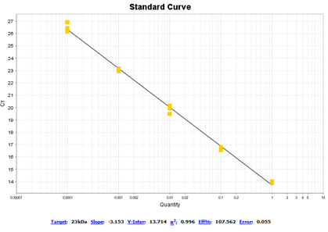
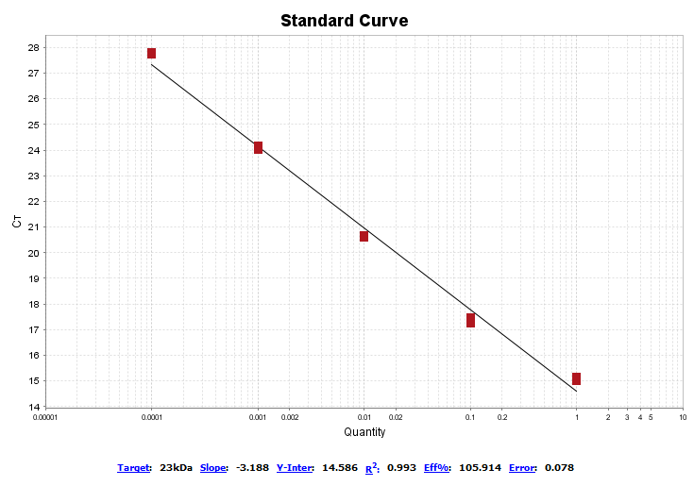
Figure 1. 23kDa primer/probe with U112 (left) and LVS (right)
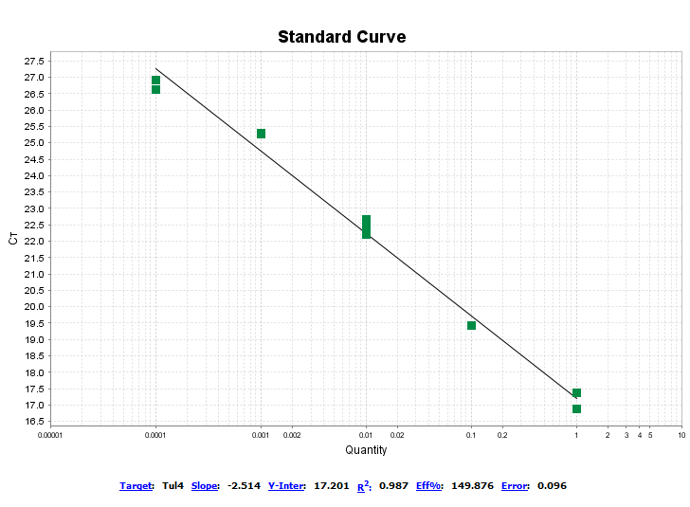
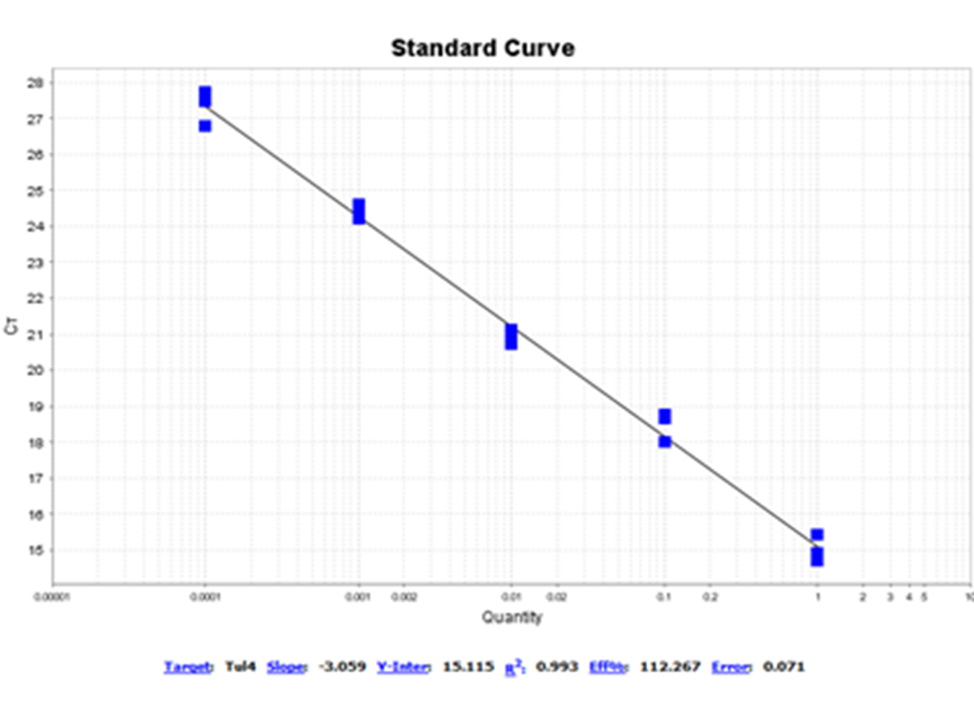
Figure 2. tul4 primer/probe with U112 (left) and LVS (right) run in triplicate

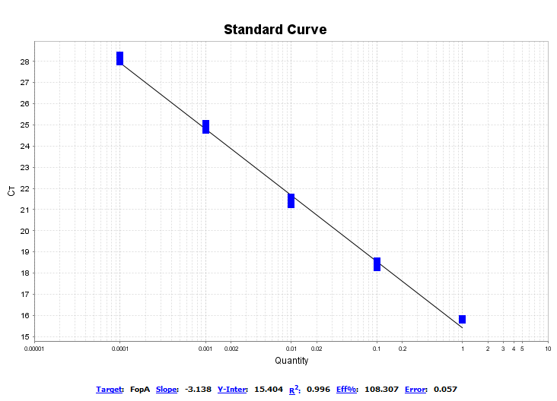
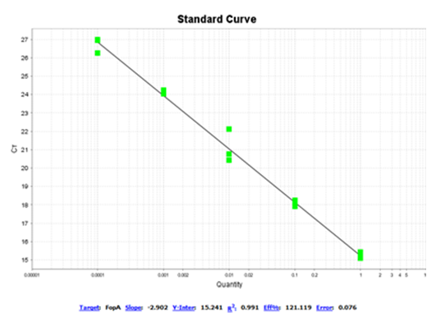
Figure 3. fopA primer/probe with U112 (left) and LVS (right) run in triplicate

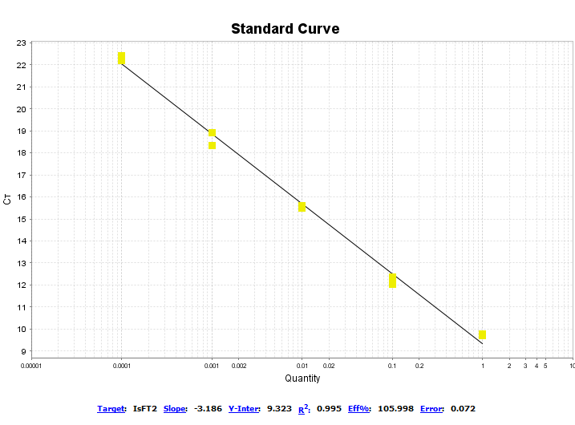
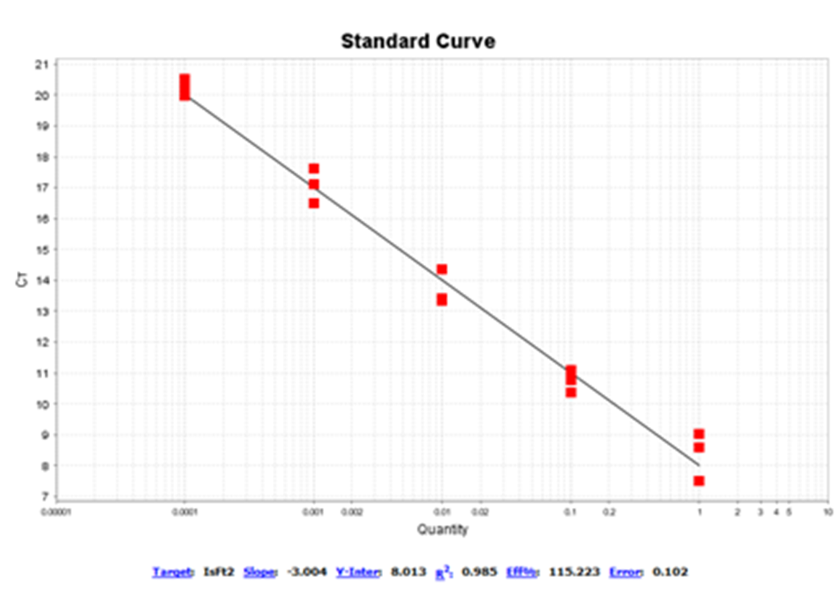
Figure 4. IsFt2 primer/probe with U112 (left) and LVS (right) run in triplicate

Nanodrop Validation
Review of the genomic DNA quantification data showed some discrepancies in Nanodrop values for genomic DNA that came from the same extractions. For this reason, it was necessary to alter the procedure by which NanoDrop™ values were collected. Initially, I had used 1μL of extracted genomic DNA on the NanoDrop™ spectrophotometer to determine how many nanograms of DNA were in the sample. The procedure was altered by doing NanoDrop™ readings using 1.5μL, 2μL, and 1μL heated to 63⁰C as opposed to 1μL at room temperature. It was determined that the NanoDrop™ readings are more reproducible when the sample is heated to 63⁰C before doing the reading on the NanoDrop™ spectrophotometer. It is thought that this relaxes the DNA and allows it to be read more accurately. These results were further validated by testing dilutions of the DNA. The results of this validation can be seen in Table 2 and this procedure will be used moving forward in future experiments.

Table 4. Nanodrop readings were first taken in triplicate with several different quantities of genomic S4∆clpB DNA, and then taken in triplicate with dilutions made of the genomic DNA and nuclease free water.

Nanodrop consistency testing with S∆clpB
Quantity Validation |  |  | Dilution Validation
 | (ng/uL) | 260/280: |  | (ng/uL) | 260/280:
1μL | 41.9 | 1.82 | 0 Dilution | 53.4 | 1.72
1μL | 40.9 | 1.87 | 0 Dilution | 49.6 | 1.82
1μL | 49.7 | 1.83 | 0 Dilution | 49.4 | 1.83
Average | 44.16667 | 1.84 | Average | 50.8 | 1.79
CV | 8.906939 | 1.174047 | CV | 3.6226178 | 2.774612
1.5μL | 44.2 | 1.79 | 1:2 Dilution | 22.5 | 1.85
1.5μL | 48.4 | 1.79 | 1:2 Dilution | 25.3 | 1.69
1.5μL | 47.6 | 1.74 | 1:2 Dilution | 24.4 | 1.96
Average | 46.73333 | 1.773333 | Average | 24.066667 | 1.833333
CV | 3.896291 | 1.329148 | CV | 4.8496237 | 6.046651
2μL | 42.1 | 1.77 | 1:4 Dilution | 13.5 | 1.86
2μL | -0.5 | 3.06 | 1:4 Dilution | 13.1 | 1.71
2μL | 43.5 | 1.78 | 1:4 Dilution | 13.2 | 1.98
Average | 28.36667 | 2.203333 | Average | 13.266667 | 1.85
CV | 71.98525 | 27.49328 | CV | 1.2811607 | 5.970465
1μL @ 63⁰C | 46.3 | 1.79 | 1:10 Dilution | 6.6 | 1.43
1μL @ 63⁰C | 46.6 | 1.83 | 1:10 Dilution | 5.8 | 1.72
1μL @ 63⁰C | 47.0 | 1.84 | 1:10 Dilution | 7.1 | 1.56
Average | 46.6 | 1.82 | Average | 6.5 | 1.57
CV | 0.614891 | 1.186949 | CV | 8.2371171 | 7.55433

Genome to CFU Ratios

Nucleic Acid Concentration and Purity Ratios
Initially, genomic DNA extraction was done following the QIAamp DNA mini kit in accordance with the manufacturer’s instructions (Qiagen, Germantown, Maryland). After analyzing the extraction data, we noticed that the A260/A230 and A260/A280 purity measures were not within the desired standard range of 2.0 and 1.8, respectively. In order to increase the nucleic acid purity and reduce phenol contamination and excess proteins, an extra dry spin was added to the protocol as well as a longer incubation period. The comparison between the old and new extraction methods can be seen below (Tables 4-7).

Table 5. NanoDrop information for 3 dilutions of U112 using the old extraction method (top) and new extraction method (bottom)

Dilution 0 |  |  |  | Average | CV
ng/uL | 188.5 | 179.5 | 189.4 | 185.8 | 2.4%
260/280 | 1.99 | 2 | 1.98 | 1.99 | 0.4%
260/230 | 1.73 | 1.73 | 1.73 | 1.73 | 0%
Dilution 1:2 |  |  |  | Average | CV
ng/uL | 89.6 | 90.4 | 89 | 89.66667 | 0.63%
260/280 | 1.99 | 1.97 | 1.98 | 1.98 | 0.41%
260/230 | 1.64 | 1.61 | 1.61 | 1.62 | 0.87%
Dilution 1:4 |  |  |  | Average | CV
ng/uL | 30.2 | 31.2 | 30.8 | 30.73333 | 1.3%
260/280 | 2.19 | 2.07 | 2.12 | 2.126667 | 2.3%
260/230 | 1.27 | 1.21 | 1.25 | 1.243333 | 2.0%
Dilution 0 |  |  |  | Average | CV
ng/uL | 50.5 | 50.4 | 50.9 | 50.6 | 0.42%
260/280 | 1.88 | 1.92 | 1.91 | 1.903333 | 0.89%
260/230 | 1.62 | 1.62 | 1.61 | 1.616667 | 0.29%
Dilution 1:2 |  |  |  | Average | CV
ng/uL | 43 | 44.5 | 44.7 | 44.06667 | 1.7%
260/280 | 1.92 | 1.94 | 1.96 | 1.94 | 0.84%
260/230 | 1.71 | 1.69 | 1.66 | 1.686667 | 1.2%
Dilution 1:4 |  |  |  | Average | CV
ng/uL | 25.8 | 27 | 27 | 26.6 | 2.1%
260/280 | 1.99 | 1.93 | 1.93 | 1.95 | 1.5%
260/230 | 1.54 | 1.51 | 1.48 | 1.51 | 1.6%

Table 6. NanoDrop information for 3 dilutions of LVS using the old extraction method (top) and new extraction method (bottom)

Dilution 0 |  |  |  | Average | CV
ng/uL | 36.2 | 43.2 | 51.7 | 43.7 | 14.5%
260/280 | 1.81 | 1.83 | 1.96 | 1.866667 | 3.5%
260/230 | 1.55 | 1.65 | 1.11 | 1.436667 | 16.3%
Dilution 1:2 |  |  |  | Average | CV
ng/uL | 48.2 | 50.3 | 50.5 | 49.66667 | 2.1%
260/280 | 1.96 | 1.9 | 1.9 | 1.92 | 1.5%
260/230 | 1.12 | 1.12 | 1.12 | 1.12 | 0%
Dilution 1:4 |  |  |  | Average | CV
ng/uL | 12.5 | 12.7 | 12.6 | 12.6 | 0.6%
260/280 | 2.08 | 2.1 | 2.05 | 2.076667 | 1.0%
260/230 | 0.8 | 0.79 | 0.79 | 0.793333 | 0.6%
Dilution 0 |  |  |  | Average | CV
ng/uL | 30.7 | 30 | 30.6 | 30.43333 | 1.0%
260/280 | 1.87 | 1.97 | 1.94 | 1.926667 | 2.2%
260/230 | 1.7 | 1.76 | 1.68 | 1.713333 | 2.0%
Dilution 1:2 |  |  |  | Average | CV
ng/uL | 24.5 | 22.8 | 23 | 23.43333 | 3.2%
260/280 | 1.87 | 1.9 | 1.92 | 1.896667 | 1.1%
260/230 | 1.47 | 1.63 | 1.61 | 1.57 | 4.5%
Dilution 1:4 |  |  |  | Average | CV
ng/uL | 10.4 | 11.3 | 10.8 | 10.83333 | 3.4%
260/280 | 1.89 | 1.9 | 2.14 | 1.976667 | 5.8%
260/230 | 0.88 | 0.85 | 0.87 | 0.866667 | 1.4%

Table 7. NanoDrop information for 3 dilutions of S4∆clpB using the old extraction method (top) and new extraction method (bottom)

Dilution 0 |  |  |  | Average | CV
ng/uL | 53.4 | 49.6 | 49.4 | 50.8 | 3.6%
260/280 | 1.72 | 1.82 | 1.83 | 1.79 | 2.8%
Dilution 1:2 |  |  |  | Average | CV
ng/uL | 22.5 | 25.3 | 24.4 | 24.06667 | 4.8%
260/280 | 1.85 | 1.96 | 1.9 | 1.903333 | 2.4%
Dilution 1:4 |  |  |  | Average | CV
ng/uL | 13.5 | 13.1 | 13.2 | 13.26667 | 1.3%
260/280 | 1.86 | 1.71 | 1.96 | 1.843333 | 5.6%
Dilution 0 |  |  |  | Average | CV
ng/uL | 68.5 | 68.2 | 68.7 | 68.46667 | 0.3%
260/280 | 1.86 | 1.88 | 1.88 | 1.873333 | 0.5%
Dilution 1:2 |  |  |  | Average | CV
ng/uL | 31.5 | 31.3 | 31.1 | 31.3 | 0.5%
260/280 | 1.88 | 1.99 | 2.05 | 1.973333 | 3.6%
Dilution 1:4 |  |  |  | Average | CV
ng/uL | 18.8 | 18 | 19 | 18.6 | 2.3%
260/280 | 1.78 | 2.02 | 1.91 | 1.903333 | 5.1%

Table 8. NanoDrop information for 3 dilutions of SCHU S4 using the old extraction method (top) and new extraction method (bottom)

Dilution 0 |  |  |  | Average | CV
ng/uL | 23.2 | 22 | 21 | 22.06667 | 4.1%
260/280 | 1.31 | 1.29 | 1.25 | 1.283333 | 1.9%
260/230 | 0.29 | 0.28 | 0.28 | 0.283333 | 1.7%
Dilution 1:2 |  |  |  | Average | CV
ng/uL | 16.2 | 15.2 | 15.2 | 15.53333 | 3.0%
260/280 | 1.51 | 1.57 | 1.55 | 1.543333 | 1.6%
260/230 | 0.37 | 0.37 | 0.36 | 0.366667 | 1.3%
Dilution 1:4 |  |  |  | Average | CV
ng/uL | 5.3 | 8.9 | 6.1 | 6.766667 | 22.8%
260/280 | 2.06 | 1.41 | 1 | 1.49 | 29.3%
260/230 | 0.28 | 0.32 | 0.36 | 0.32 | 10.2%
Dilution 0 |  |  |  | Average | CV
ng/uL | 103.1 | 100.5 | 96.7 | 100.1 | 2.6%
260/280 | 1.88 | 1.87 | 1.93 | 1.893333 | 1.4%
260/230 | 1.89 | 1.87 | 1.97 | 1.91 | 2.2%
Dilution 1:2 |  |  |  | Average | CV
ng/uL | 34.3 | 33 | 34.3 | 33.86667 | 1.8%
260/280 | 1.89 | 1.91 | 1.93 | 1.91 | 0.9%
260/230 | 1.2 | 1.19 | 1.17 | 1.186667 | 1.1%
Dilution 1:4 |  |  |  | Average | CV
ng/uL | 33.5 | 34.4 | 33.4 | 33.76667 | 1.3%
260/280 | 1.86 | 1.93 | 1.95 | 1.913333 | 2.0%
260/230 | 1.29 | 1.33 | 1.3 | 1.306667 | 1.3%

Theoretical versus Actual Yield
To further evaluate the quality of the DNA extraction, we calculated the genomes per microliter that were extracted. This was done by dividing the weight of one genome (Rohmer et al., 2007) from the average nanograms per microliter as determined by the NanoDrop™ One Spectrophotometer (see Tables 4-7). For each genomic DNA extraction, dilutions were plated in triplicate using the drop method with 10μL. Colony forming units (CFU) were determined by counting how many colonies grew per each 10μL drop. CFU per microliter were then calculated by accounting for the dilution factor and dividing by 10. The genome to CFU ration was then determined by dividing the genomes per microliter by CFU per microliter, allowing a percent yield to be determined.

Table 9. Comparison of genomes per μL yielded with actual CFU per μL
 | genomes/μL | CFU/μL | Genome:CFU Ratio | Percent Yield
U112 | 24405082.11 | 31666667 | 0.77068680 | 77.0686803
LVS | 14851843.98 | 27166667 | 0.54669364 | 54.6693643
S4∆clpB | 33368189.05 | 36166667 | 0.92262274 | 92.2622739
SCHU S4 | 48718640.75 | 72500000 | 0.67198125 | 67.1981252

DISCUSSION and future directions
For the present study, we have developed a protocol for more efficiently extracting genomic DNA, and more accurately quantifying genomic DNA using the NanoDrop method. We have also methodically selected two primers out of four that have shown the ability to sensitively detect and quantify Francisella tularensis DNA in preparation for the development of a real-time PCR assay.
To improve the quality of the data collected for samples of extracted, genomic DNA, the samples are now heated to 63⁰C before being read on the NanoDrop. This step was added after initial data analysis showed a lack of precision between measurements of the same genomic DNA sample. This is believed to relax the DNA in the sample which allows it to be read more accurately. Comparison of extraction data between the prior extraction method and the new method provides confidence in the precision of the protocol. At dilution 0, the coefficient of variance dropped from 2.4% to 0.42% for U112, from 14.5% to 1.0% for LVS, from 3.6% to 0.3% for S4∆clpB, and from 4.1% to 2.6% for SCHU S4.
To improve the genomic DNA extraction method, an extra dry spin was added as well as a longer incubation period. These steps were added after initial data analysis showed lower than desired A260/A230 and A260/A280 ratios. At dilution 0, the average A260/A280 ratios stayed roughly the same. However, at dilution 0, the A260/A230 ratio increased from 1.44 to 1.71 for LVS and increased from 0.28 to 1.91 for SCHU S4. It decreased from 1.73 to 1.62 for U112, and this information is unavailable for S4∆clpB. The difference in the A260/A230 ratios is most noticeable in the diluted samples. At dilution 1:4, the average A260/A230 ratio increased from 1.24 to 1.51 for U112, from 0.79 to 0.87 for LVS, and from 0.32 to 1.31 for SCHU S4. These increases are important in order to address purity in the more diluted samples.
In my experiments, genomic DNA was extracted from broth culture. When extracting genomic DNA from rabbit tissues, there are a few additional adjustments that should be made. First, the lysis time should be increased since the sample is coming from tissue. I would begin with a 1-3 hour lysis period, using a shaking water bath or rocking platform if this lysis period is not sufficient. Second, RNAase A should be used when working with tissues such as liver and kidney because they are transcriptionally active. While RNA will not affect RT-PCR, it will affect NanoDrop spectrophotometry measurements.
Once the genomic DNA extraction and quantification methods were standardized, we could determine the percent yield for each strain: 77% for U112, 55% for LVS, 92% for S4∆clpB, and 67% for SCHU S4. Future studies should aim to determine why the percent yield is so varied among strains and if the percent yield can be increased.
Now that the genomic DNA extraction method has been made more efficient, the NanoDrop reading methodology has been enhanced, and primers have been chosen, we can build on our ability to do PCR with Francisella tularensis. The next step in this process should be to develop a standard for SCHU S4, S4∆clpB, U112, and LVS. Then, we will be able to detect and quantify F. tularensis in rabbit tissues. In future experiments, NanoDrop spectrophotometry and RT-PCR should be supplemented with other quantification methods such as the Qubit. This will provide us with a more sensitive method than plating to quantify bacterial colonies and provide a more sensitive comparison among tissues within a rabbit or between different rabbits.

bibliography

