RESTACKING THE NURSING UNITS AT ALLEGHENY GENERAL HOSPITAL TO ACHIEVE GEOGRAPHIC PATIENT PLACEMENT

by
Peter G. Lewellen
BS, Duke University, 2008

Submitted to the Graduate Faculty of
the Department of Health Policy and Management
Graduate School of Public Health in partial fulfillment
of the requirements for the degree of
Master of Health Administration

University of Pittsburgh
2018

UNIVERSITY OF PITTSBURGH
GRADUATE SCHOOL OF PUBLIC HEALTH

This essay is submitted

by

Peter G. Lewellen

on

and approved by

Essay Advisor:
Samuel Friede, MBA _________________________________
Assistant Professor
Health Policy and Management
Graduate School of Public Health
University of Pittsburgh

Essay Reader:
Stephen R Wisniewski, PhD _________________________________
Vice Provost for Data and Information
Office of the Provost
University of Pittsburgh

Essay Reader:
Matthew G. Bauer, MHA _________________________________
Project Manager
Allegheny General Hospital
Allegheny Health Network
Copyright © by Peter G. Lewellen
2018
Samuel Friede, MBA
RESTACKING THE NURSING UNITS AT ALLEGHENY GENERAL HOSPITAL TO ACHIEVE GEOGRAPHIC PATIENT PLACEMENT
Peter G. Lewellen, MHA
University of Pittsburgh, 2018

ABSTRACT
Allegheny General Hospital’s Snyder Pavilion houses inpatient nursing units. The sixth through ninth floors lacked service line cohesion, leading to poor care coordination. Physicians and unit managers were spread over multiple floors, reducing their ability to build effective teams. Staff turnover was high. An initiative to restack the nursing units was created to achieve geographic alignment. A new Complex Medical Care Unit replaced the fractured medical telemetry and stepdown units. Several groups met formally throughout the process; however, communication with physicians was difficult due to lack of direct involvement. The project included efforts by many departments in the hospital as well as external contractors. A sequential implementation plan was created to incrementally move patients and staff to their new locations. Several floors underwent reconstruction as part of the project. Delays occurred partially due to these construction efforts, but in March 2018, the final unit moved. As of the time of writing, renovations continue for one unit which will be used for patient overflow in the interim. Once the units impacted by the restacking project stabilize, key performance metrics will be assessed, focusing on length-of-stay and staff retention. The project had public health relevance by improving the health outcomes and experiences of patients who receive care on the inpatient units.
TABLE OF CONTENTS
preface x
1.0 Introduction 1
1.1 geographic alignment 2
1.2 Medical Telemetry 3
1.3 Author’s Role 3
2.0 Literature Review 5
3.0 Allegheny General Hospital 7
3.1 Issues Identified Prior To Restacking 7
3.2 Geographic Placement Initiative 9
4.0 Objectives of restacking Initiative 11
4.1 Proposed Future Alignment 11
5.0 Methodology 14
5.1 Meetings 14
5.1.1 Clinical Leadership Meeting 15
5.1.2 Facilities Meeting 18
5.1.3 Telemetry Meeting 18
5.1.4 Ancillary Services Meeting 18
5.2 Timeline 20
5.3 Order of Restacking Steps 20
5.4 Performance Metrics 22
6.0 Implementation 23
6.1 Facilities Reconstruction 23
6.1.1 Eighth Floor Renovation 24
6.1.2 Unit 9C Renovation 24
6.1.3 Unit 6C Renovation 24
6.1.4 Unit 9A Renovation 25
6.2 Allocation of Office Space 25
6.3 Finance 26
6.4 Information Technology 27
6.4.1 Timeline for IT Support 28
6.4.2 Patient Placement 28
6.4.3 Pharmacy Labels 29
6.5 Supply Chain 30
6.6 Human Resources 30
6.7 Nursing Education 31
6.8 Regulatory Compliance 31
7.0 Results 32
7.1 Next Steps 32
8.0 Discussion 33
8.1 Competencies 34
8.2 Lessons Learned 35
9.0 Conclusion 36
bibliography 37
List of tables
Table 1: Unit Layout of the 6th-9th Floors of Snyder Pavilion (Pre-Restacking) 8
Table 2: Registered Nursing Turnover on Units 7A, 8A, and 8C from 1/1/16 to 2/21/17 9
Table 3: Unit Layout of the 6th-9th Floors of the Snyder Pavilion (Post-Restacking) 13
Table 4: Arrangement of Units after Restacking 22
List of figures
Figure 1: Summary of Unit Moves 12
Figure 2: Redesign on Medical Units Project Planner for the Clinical Leadership Meeting on 3/1/18 (Part 1 of 2) 16
Figure 3: Redesign on Medical Units Project Planner for the Clinical Leadership Meeting on 3/1/18 (Part 2 of 2) 17
Figure 4: Monitor Implementation Project Planner for the Telemetry Meeting on 12/4/17 19
Figure 5: 8-Step Plan to Achieve Geographic Alignment 21
Figure 6: Changes in the Cost Centers of Units on the Sixth through Ninth Floors 27
preface

I would like to thank my diligent coworkers at Allegheny General Hospital for their patience and hard work in restacking the medical units. Although we faced setbacks and delays, everyone saw the light at the end of the tunnel and the benefits that were possible if we could eventually make the moves happen. Specifically, thank you to Nathan Catalano, Matthew Bauer, and Duke Rupert for their advice and mentorship. Thank you to Ruth Lawton and Jill Donovan for scheduling multiple meetings with shifting schedules and invitee lists. Thank you to Marge DiCuccio and Colleen Reynolds for their vision and leadership in making the restacking project possible. Thank you to Annie Guzan and Louise Dobbins for lending their expertise in finance, EPIC, patient placement, and telemetry. Thank you also to my essay committee, Professor Friede, Dr. Wisniewski, and Mr. Bauer for their time and effort in editing this essay.

Introduction
Legislation, innovative medical technologies, means of easily accessing information electronically, and cultural shifts have all contributed toward a greater focus by healthcare on quality and outcomes. A purposeful emphasis to maximize quality and an overarching goal to improve health outcomes necessitates a rethinking of roles and relationships. Instead of the healthcare provider, the patient becomes the center of attention at all times. Certainly, physicians and other health professionals remain vital in delivering care. Their knowledge, expertise, and compassion are no less relevant or valued. However, their actions are recognized as part of a larger system. The contributions of others, including nurses, technicians, and support staff, combine with physician leadership toward more impactful care teams.
Building on the geographic patient placement imitative that had taken place at Allegheny General Hospital in 2016, hospitalist physicians were interested in expanding the use of care-team rounding. This was the impetus for the creation of a new Complex Medical Care Unit (CMCU) to replace previous medical telemetry units. Those units on the eighth floor had been nicknamed the “crazy 8’s” due to a high patient acuity compared to the nursing ratio. Physicians typically had patients on multiple floors and were difficult to locate. Turnover and dissatisfaction were high among nurses. A project to restack the nursing units at Allegheny General Hospital in Pittsburgh, PA was undertaken to maximize the effectiveness of its medical teams in order to improve outcomes, care quality, and staff satisfaction.
The aim of this essay is to detail the process that occurred to restack the nursing units. Hopefully, more hospitals will utilize geographic alignment of units in the future, which may involve similar initiatives. Through understanding the breadth of service line involvement necessary for the project, future endeavors may learn from the experience of this restacking initiative. Pitfalls such as lack of physician engagement and barriers with information technology can be anticipated and prevented.

geographic alignment
Although normal variations in bed availability at a hospital can cause overflow from one unit to another, lack of physical alignment of nursing units can cause patients to be scattered throughout the facility. Geographic alignment refers to the intentional placement of patients and physicians on specified hospital units. “The goal of such a care delivery model is to align multidisciplinary teams on home units and engage patients and their families in the creation of a treatment plan. Implementing such a model allows for enhanced coordination of care among hospital staff and promotes communication between care team members and their patients. Multidisciplinary teams typically include case management, nursing supervisors, physician leaders, and executive administrators.” (Bauer, 2017)

Medical Telemetry
Medical telemetry, also known as biotelemetry, involves remotely monitoring the vital signs of patients. Telemetry equipment in patient rooms can be attached to the wall or can be wireless, affording greater mobility. Either type of connection requires adequate infrastructure. Typically, the vital signs for multiple patients can be assessed in real-time from a single location on a nursing unit, reducing staffing needs and providing more responsive and timely medical care. To consolidate even further, some hospitals choose to use whole-house telemetry with one monitoring “war room” for the entire facility that can track all vital signs. Part of this restacking project involved installing telemetry equipment into newly renovated units. The hospital has a long-term goal of implementing a war room model, but each unit will first need to have adequate telemetry capabilities.

Author’s Role
The author acted as lead project manager throughout the restacking process. This required identifying and bringing together stakeholders, leading meetings, managing project planners, reallocating office space, and relaying and communicating decisions. Stakeholders were identified in multiple departments throughout the hospital and health network, including nursing and physician leadership, revenue integrity, information technology, clinical education, patient transportation, supply chain, regulatory compliance, patient placement, environmental services, pharmacy, residency training programs, case management, human resources, facilities, external construction contractors, external telemetry vendors, and internal telecommunications. Separate regularly scheduled meetings were held for clinical leadership, facility reconstruction, telemetry installation, and ancillary services that focused on information technology. This project provided the author an opportunity to enhance his analytical thinking, communication, systems thinking, professionalism, organizational awareness, information technology management, and leadership skills. (MHA in Health Policy and Management Competency Model, 2018)

Literature Review
Ongoing legislative changes and societal expectations have altered how medicine is practiced in the US. There is a greater focus on quality and improving patient outcomes. Team-based care leads to better clinical outcomes and patient satisfaction than uncoordinated care. Among the traits of high-functioning medical teams are positive communication patterns, elevated levels of collaboration, and coordination. (Lemieux-Charles & McGuire, 2006) Specifically, multisciplinary teams that include all levels of staff are consistently more effective due to breaking down communication barriers. (Epstein, 2014)
Despite the importance of cohesiveness, many hospitals struggle with building consistent care teams. Although nurses are typically assigned to several adjacent inpatient rooms, physicians often see a larger number of patients that may be spread throughout the hospital. Erratic patient placement can induce significant travel time for medical staff, reducing the opportunity to spend time with patients and their families. (Stein & Vermoch, 2014) Additionally, case managers and nursing staff find it more difficult to locate or communicate with physicians when they are seeing patients on multiple floors or units. An additional concern is that inefficiencies in the system result in work hour violations and poor educational experiences for medical residents. (Boxer, 2016) Some hospitalists in this type of environment have felt that their communication with other clinical staff suffered and their ability to operate effectively as a care team was non-existent. (Bauer, 2017)
Geographic alignment of patients and physicians onto units or floors helps to enhance coordination among care teams. Consultations can more frequently be face to face due to the improved ability to get to the patient’s bedside. (Boxer, 2016) Physicians get to know all the staff in their unit and develop better working relationships. This allows for more effective group rounding and quality improvement projects due to a sense of ownership over the unit. (Maguire, 2011) Physicians can benefit from decreased travel time, care team communication can be enhanced, staff satisfaction can be improved, and closer interaction with residents can create better teaching opportunities. Greater visbility and more consistent presence by physicians and residents reduces reliance on pagers as a means of communication. There is a belief that operational metrics such as length-of-stay and time-to-discharge can also be reduced, however this is not necessarily the case. (Bauer, 2017)

Allegheny General Hospital
Allegheny General Hospital (AGH) is a Level 1 Shock Trauma Center located in Pittsburgh, Pennsylvania. It has 576 licensed beds, approximately 800 physicians, and 5,000 staff members. It admits approximately 24,000 inpatients annually. (Allegheny General Hospital, 2018) Snyder Pavillion is an attached 12-floor facility housing the majority of inpatient beds in the hospital. AGH operates as part of the Allegheny Health Network, with sister hospitals and outpatient clinics throughout the western Pennsylvania region. It is part of an integrated delivery and finance system in Highmark Health. AGH handles the quaternary care needs of the network.

Issues Identified Prior To Restacking
Leadership at Allegheny General Hospital believed many of its problems to be caused by a lack of geographic alignment. Poor communication was rampant among care team members. Nurses and case managers had difficulty finding physicians, leading to delays in providing care and obtaining physician orders, including for discharge. These issues were anecdotal but widely perceived to be significant. Service lines were separated across the sixth through ninth floors of Snyder Pavilion. Nursing leadership was similarly fragmented as unit managers oversaw staff on multiple floors. This led to accusations of favoritism as managers’ offices were tied to a single unit. The arrangement of units and management on these floors can be seen in Table 1.

Table 1: Unit Layout of the 6th-9th Floors of Snyder Pavilion (Pre-Restacking)
Unit | Service | Unit Manager
6A | Oncology | A
6C | General Surgery | B
7A | Stepdown (Medical) | B
7C | Neurology | C
8A | Telemetry (Medical) | D
8C | Telemetry (Medical) | D
9A | Transplant Surgery | B
9C | Neurology/Stroke | C

The three primary medical units, consisting of 7A, 8A, and 8C, had minimal service line cohesion as they were used to house overflow from other units. Stroke patients were placed onto 8C, cardiology patients were on 8A, and 7A covered all service lines. Insufficient dedicated stepdown beds led to delays in accepting patients from the Intensive Care Units and the Emergency Department. Medicine patients were displaced throughout the 5th-12th floors of Snyder Pavilion. This caused unnecessary movement of patients, longer lengths of stay, and worsened patient experiences. The patient populations on 8A and 8C became too acute for the 4:1 or 5:1 patient to nursing assignments. Although 7A was on a 3:1 assignment, there were not enough beds. Staff were highly dissatisfied, with these three units experiencing upwards of 70% turnover when combining staff transferring to other units with those leaving the organization.
Table 2 shows the number of registered nurses who left the medical units between 1/1/16 and 2/21/17 on the three medical units. Costs were estimated at $6.85 million to replace and train nursing staff in just over a year. Additional costs (not shown) were incurred by a heavy reliance on travelling and per diem nurses, who are typically more expensive.

Table 2: Registered Nursing Turnover on Units 7A, 8A, and 8C from 1/1/16 to 2/21/17
 | Left AGH | Transferred to Another Unit | Totals | Replacement Costs ($)
8A Telemetry | 16 | 13 | 29 | 2.65 M
8C Telemetry | 18 | 12 | 30 | 2.74 M
7A Stepdown | 12 | 4 | 16 | 1.46 M
Totals | 46 | 29 | 75 | 6.85 M

Units 7A, 8A, and 8C were also integral to the residency training program. The lack of geographic alignment hindered learning opportunities for residents.

Geographic Placement Initiative
From July 2016 to December 2016, an initiative took place at Allegheny General Hospital to trial enhanced care delivery models by implementing geographic patient placement on specific units. Each impacted unit was staffed with nurses, care managers, social workers, and ancillary staff. Physicians were assigned to home units, although they also still had patients on other floors. Interdisciplinary rounding schedules were created to ensure all appropriate parties were involved in delivering care to their patients. However, the primary goal of reducing length of stay on these units was unsuccessful as it remained stagnant compared to the previous year. This was partially attributed to an inability to appropriately place patients on geographic units due to lack of bed availability. Although a specific number of beds had been identified for use by the initiative, other hospital services needed equipment on those units, and the targeted bed distribution was not met. Additionally, elevated census and lack of buy-in from executive leadership were identified as barriers to the program’s success. Geographic alignment was not complete, and physicians continued to have some of their patients on other units. Despite failing to lower the hospital’s average length of stay, both patients and staff reported higher levels of satisfaction. Enhanced communication created a cohesive atmosphere, promoted accountability and responsibility, and allowed for improvements in discharge planning. (Bauer, 2017)

Objectives of restacking Initiative
Although the previous trial initiative had failed to lower the hospital’s average length of stay, a larger implementation that promoted increased bed availability was believed to increase the likelihood of achieving this goal. Hospital leadership decided to restack the 6th-9th floor units of Snyder Pavilion to promote geographic alignment. This would reduce physician travel time to visit their patients and promote more collaborative and cohesive care teams. Improved communication among team members and more consistent physician presence would improve throughput and help to decrease length of stay.
Staff dissatisfaction and high turnover rates on certain nursing units were viewed as unsustainable. The second objective was to improve staff satisfaction and registered nurse retention on the affected medical units. This would decrease the reliance on per diem and travelling nurses.

Proposed Future Alignment
In February 2017, hospital staff were notified of the proposed changes to Snyder Pavilion. The transitions are outlined in Figure 1. Most units’ staff were to move in their entirety; however, some individuals had the option of choosing to stay at their current locations based upon the layouts and numbers of beds on the units. There was initially significant pushback by the nursing union due to safety concerns, however it was alleviated through achieving an understanding that additional education and training would be given to nurses moving to higher-acuity units. New protocols and admission criteria would also be created for the affected units.

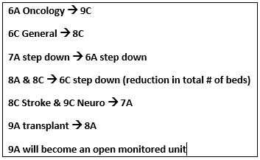
Figure 1: Summary of Unit Moves

The medical telemetry and step-down units would be consolidated into a Complex Medical Care Unit (CMCU) that would cover a single floor. The patient to nursing assignment would be 3:1 for this entire unit. Training and education specific to the patient population would be offered to these nurses. The stroke and cranial patients would be moved to 7A, creating a neuro/cranial unit on the same floor as the Neurosciences Intensive Care Unit (NICU).
To address concerns of bias and to promote team cohesion, each nursing manager would be responsible for units from complimentary service lines across a single floor. Where possible, the managers’ offices would be relocated to the middle of the floors, to 6B, 8B, and 9B, rather than in a unit on one side of the floor. (The manager on the 7th floor would stay in her current office just inside the entrance to 7C.) Table 3 shows the unit layout and managerial oversight after the restacking project would be completed.
Table 3: Unit Layout of the 6th-9th Floors of the Snyder Pavilion (Post-Restacking)
Unit | Service | Unit Manager
6A | Complex Medical Care Unit | D
6C | Complex Medical Care Unit | D
7A | Neurology/Stroke | C
7C | Neurology | C
8A | Transplant Surgery | B
8C | General Surgery | B
9A | Medical Telemetry | A
9C | Oncology | A

Some of the floors in the Snyder Pavilion had gone without facility facelifts for many years. As part of the restacking process, construction would occur on several units. This included refurbishments of hallway wallpaper, plaster, paint, and plastic coatings. Patient rooms would have wallpaper removed and be painted. New sinks and vanities would be added. On some units, the nursing stations would be replaced. During this construction, telemetry capabilities and wiring would be added to most units in accordance with the hospital’s long-term goal of whole-house telemetry.

Methodology
Because this initiative impacted numerous departments throughout the hospital, it was necessary to identify representatives from among internal stakeholders that would be able to provide feedback as the plan developed as well as to bring information back to their coworkers. Most components of the project were handled internally, including clinical education, pharmacy, regulatory compliance, patient placement, transportation, case management, and human resources. An in-house crew was responsible for renovations to the 8th floor, while external contractors were hired for construction projects on the other floors. External vendors were also utilized for telemetry purchase and installation. Information technology was handled off-site by Highmark Health Solutions, which was not part of the Allegheny Health Network, but was owned by the same parent organization Highmark Health.

Meetings
Four series of meetings were utilized to keep the plan on track. The author acted as overall project manager, leading the clinical and ancillary service meetings while participating in the telemetry and facilities components.

Clinical Leadership Meeting
The executive sponsor for the restacking project was the Chief Nursing Officer. She began holding a weekly clinical leadership meeting just prior to the author’s involvement with this project which continued throughout the initiative. The purpose was to make decisions regarding the scope of the project and the timeline of implementation. A focus was placed upon issues that could affect patient care, especially staffing and education. Progress from ancillary services and other meetings were also discussed. Figures 2 and 3 show an example of the project planner used, as put together and used by the author. Names have been redacted for privacy.
Membership at this meeting included the Chief Nursing Officer, the unit managers of the affected floors, the director of operations responsible for patient placement and telemetry, the director of nursing, the manager of the per-diem pool of nursing staff, the director of nursing education, educators from each unit, the director of human resources, and the director of finance who interacted with the unit cost centers. The director of facilities also attended some of these meetings to give updates on renovations. As physicians often had patients on several different floors, the nursing unit managers were believed to have a greater understanding of the needs of their units. Physician input was only indirectly elicited outside of the meeting.
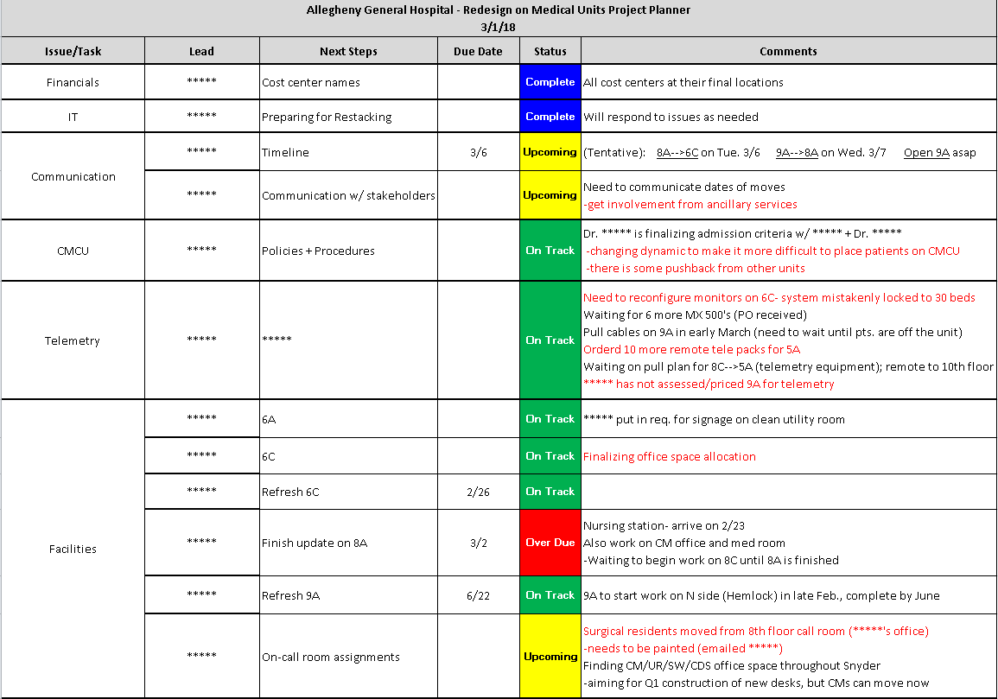
Figure 2: Redesign on Medical Units Project Planner for the Clinical Leadership Meeting on 3/1/18 (Part 1 of 2)
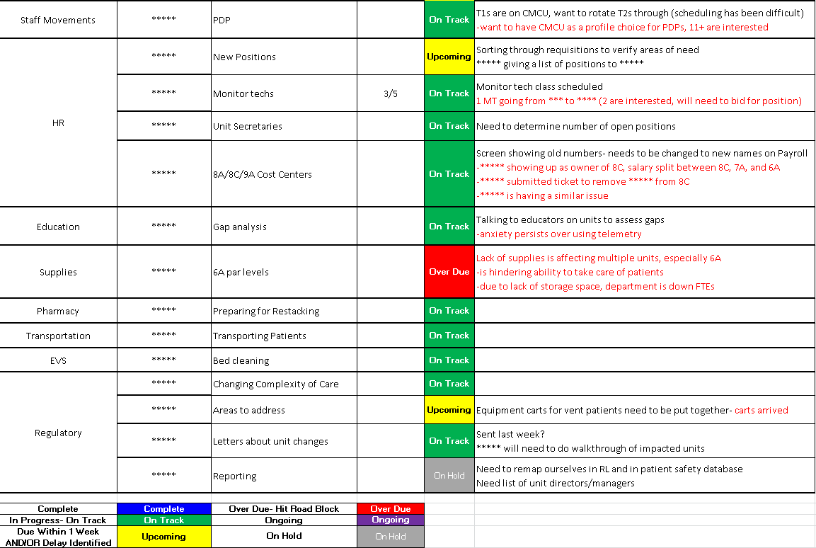
Figure 3: Redesign on Medical Units Project Planner for the Clinical Leadership Meeting on 3/1/18 (Part 2 of 2)

Facilities Meeting
Consultations were held with the lead contractors of the external construction crews. The directors of facilities and of nursing attended and would set up additional meetings as necessary.

Telemetry Meeting
Meetings focused on telemetry typically occurred over a conference call. Attendees included the director of operations responsible for patient placement and telemetry, the manager of telecommunication wiring, information technology representatives from Highmark Health Solutions, and consultants from two external telemetry companies. Figure 4 depicts an example project planner created and used by the author during these calls.

Ancillary Services Meeting
This meeting occurred biweekly for most of the duration of the project. Representatives were included from nursing, facilities, revenue integrity, information technology, clinical education, patient transportation, environmental services, pharmacy, case management, human resources, facilities, and clinical documentation. As information technology was not part of the clinical leadership meeting, the bi-weekly touchpoint for ancillary services was where most decisions regarding technology were made. The majority of each meeting was dedicated to IT. Most other attendees gave brief updates and used this meeting to stay up-to-date on the progress of the project. This meeting was the primary means of communication among all the departments.
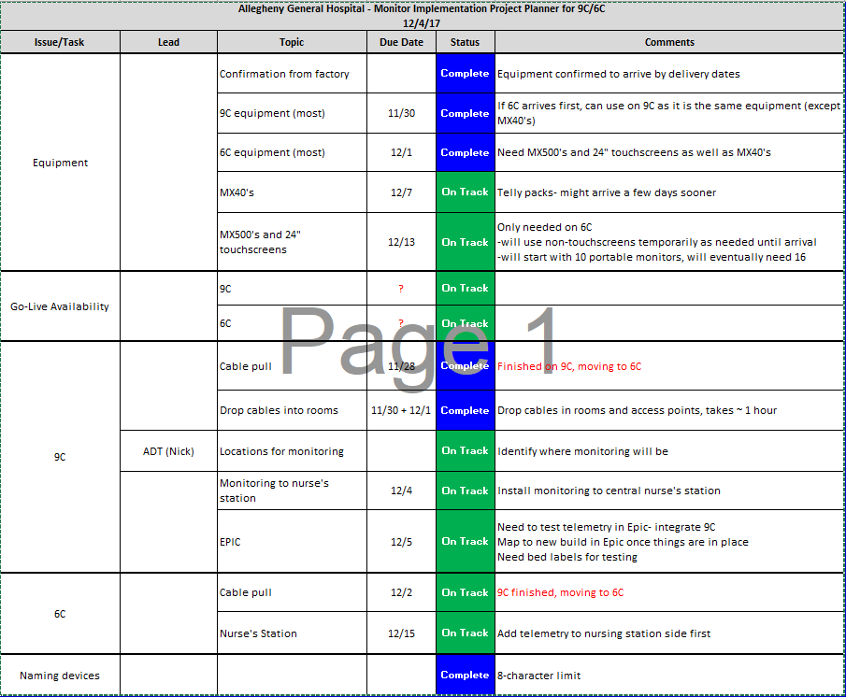
Figure 4: Monitor Implementation Project Planner for the Telemetry Meeting on 12/4/17

Timeline
Moving units as part of the restacking project was contingent upon two key issues: patient census and completion of construction projects. A high patient census would make it difficult to move patients as there would be fewer available staff to help facilitate the process, and there would be increased demand for transportation and monitoring. Units could not be moved until the place they were moving to was finished. Typically, half of a unit would be closed using partitions while it was being renovated. The general and transplant surgery patients that began on units 6C and 9A respectively were immunocompromised, so these populations were not able to be on floors undergoing renovation. A sequential plan to move units was created around this limitation to protect these patients.
The initial timeline for the restacking project was to begin moving patients in September of 2017 and complete the last step by January of 2018. However, construction delays pushed the date of the first move to December 20, 2017. The last unit moved on March 9, 2018. As of the time of writing this essay, 9A is still under construction and will be used for overflow telemetry until the unit fully opens in June of 2018.

Order of Restacking Steps
The original restacking plan did not include the sixth floor. The CMCU was to be created on units 8A and 8C. However, the discovery that the eighth floor was not able to have compressed air nozzles installed forced a change to the project. The sixth floor had compressed air capability, so it was added to the scope of the project. Final locations for the units were reallocated, ensuring that each new floor had all the necessary utilities. The Chief Nursing Officer and the director of nursing made these decisions with the guidance of the clinical leadership meeting. A new plan to sequentially achieve geographic alignment was created that consisted of eight unit moves. These eight steps are diagrammed in Figure 5 along with the day each step occurred. The order was created to avoid having immunocompromised patients be exposed to dust from construction. An additional consideration was the use of both internal and external construction crews, as they worked on separate units concurrently. Although the timeline was pushed back several times, the order and substance of the plan did not change once the sixth floor was determined to be in-scope. Dates for completion of facility reconstruction were approximately one week prior to the unit transfers. Table 4 shows the location of the units after the moves.
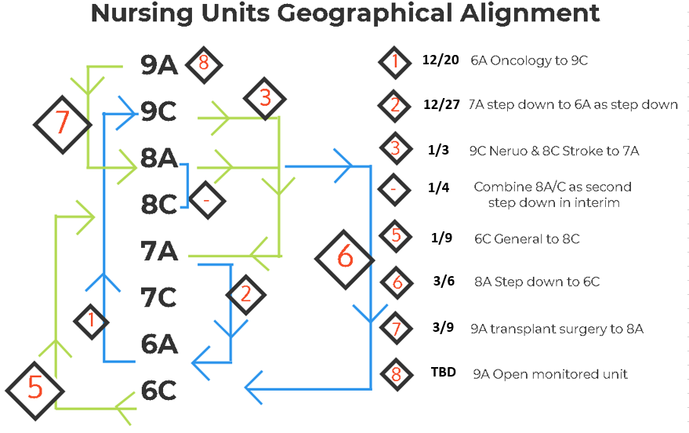
Figure 5: 8-Step Plan to Achieve Geographic Alignment
Table 4: Arrangement of Units after Restacking
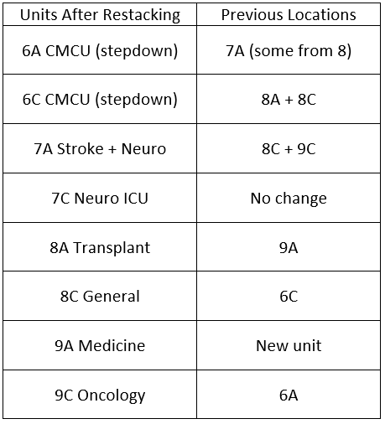

Performance Metrics
Successful implementation of the restacking plan would lead to geographically aligned units. The key metrics used to measure success would be retention rate of staff and unit-specific average length of stay for patients. The goal for the CMCU would be to have a retention rate equal to the other nursing units. The average length of stay goal would be a LOS Index of 1.0.

Implementation
With nearly every department in the hospital impacted by the restacking project, complications arose. Some were due to unforeseeable construction delays or by late receipt of ordered materials. For the unit movements to occur smoothly and in sequence, numerous tasks needed to be completed.

Facilities Reconstruction
After the discovery that compressed air would not be available on the eighth floor, the new plan required construction on unit 6C as a home for the CMCU. The sixth floor would have been renovated eventually, but not until after the restacking plan was complete. Moving up this timeline meant that the internal facilities crew would not be able to complete everything themselves. Contracts for outside construction crews were placed and bid upon. The director of facilities received and evaluated these bids. Although each unit project was separate, the same contractor won the bids for units 6C, 9A, and 9C. Units 6A, 7A, and 7C had been updated recently and did not need additional renovation. 8A and 8C would be finished by the internal facilities team.

Eighth Floor Renovation
Unit 8A was originally planned to be finished by the first quarter of 2017. However, a potential delay occurred with the discovery of asbestos in the flooring. The cost to replace the flooring was prohibitive, so the tiles were left alone. Additionally, the decision was made to replace the central nursing station. The order was placed with a company overseas, but the materials did not arrive until three months after the scheduled date. The unit was not finished until the beginning of March 2018, over a year later than originally anticipated. The internal facilities team began renovations on Unit 8C the next week. Construction will continue even after the patient populations have moved.

Unit 9C Renovation
The external contractor began working on Unit 9C in August 2017. Part of the challenge was the presence of a four-room epilepsy monitoring unit with different requirements than the other patient rooms. Construction on this unit was completed in November 2017. However, patient movements did not occur until the next month because of high census and because the space on other units was not available yet for the current population to move.

Unit 6C Renovation
Once Unit 9C was finished, half of the patient population on 6C was temporarily relocated there due to their immunocompromised status. Construction on 6C included a new nursing station, installation of telemetry, and a new nurse call system. This nursing station arrived quickly, and renovation was completed by the end of February 2017.

Unit 9A Renovation
Construction on 9A began in March 2018 with an anticipated completion date in June 2018. At the time of writing, half of the unit remains open to be used for overflow telemetry until then.

Allocation of Office Space
Prior to the restacking project, the arrangement of offices was inconsistent from one floor to the next. Managers oversaw staff on multiple units and did not have office space in each of them. This was inconvenient and led to accusations of favoritism. The supervisors’ offices were also located in different rooms across units, making it difficult for per-diem or new staff to know where to go or who to speak with. Acuity and the number of patient beds available to service lines changed during the restacking, necessitating a reevaluation of the number of case managers, educators, and pharmacist spaces on each unit. Consequently, some of the offices throughout the sixth through ninth floors were reallocated.
To free up the central office near the elevators for the new manager of the eighth floor, space needed to be found for the chief surgical residents that previously occupied that room. Anesthesia was willing to consolidate their two on-call rooms used by CRNAs, allowing the surgical residents to move in. Minor maintenance and IT expertise was required to accommodate these moves.
Hospital-wide services with offices on the impacted units were moved to other floors or non-clinical spaces. This allowed educators, case managers, and nursing supervisors to have separate offices on floors six through nine. Previously shared spaces had led to difficulties, as non-supervisors would need to step out of the room during union negations or when private disciplinary actions occurred. Confidential discussions with patients by case managers were difficult to handle in these shared spaces. Office space for unit-aligned pharmacists was also found to increase their presence on the inpatient floors.

Finance
For the most part, as units moved they took their old cost centers with them. However, the sixth floor CMCU became a single unit from a financial perspective, with a combined cost center to simplify staffing and purchasing. The old 8C number was retired. The changes and movements of cost centers are depicted in figure 6.

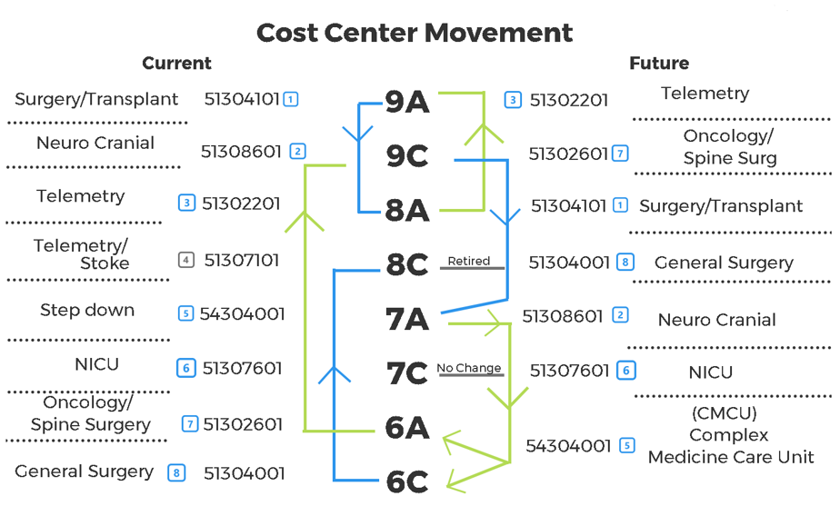
Figure 6: Changes in the Cost Centers of Units on the Sixth through Ninth Floors

Information Technology
Support from the information technology team at Highmark Health Solutions was vital for the success of the restacking project. Many changes needed to occur on the back-end, including updating the cost centers and phone numbers for each unit to match their final locations, altering the work environments for the electronic health record system, and repurposing the workstations on wheels (WOWs) used by clinical staff. Devices such as computers and printers were left in their previous locations, but IT still needed to update where the WOWs could print.

Timeline for IT Support
It was impractical to make all the technical changes concurrently with the patient and staff movements. Devices needed to be set-up beforehand to allow for printing to the proper floors, as well as having the correct EPIC environment access. The IT team was mostly off-site and found it most efficient to update several units at once. This occurred in three blocks: steps 1-4 were done simultaneously, step 5 was completed individually, and steps 6-8 were again simultaneous.
For the first five steps of the eight-part implementation, IT changes occurred several days, or in some cases weeks, after the unit transitions. During the interim, staff needed to sign into the cost centers tied to the previous tenants of their units. Signs were posted near each sign-in clock to help prevent confusion. Unit managers had to share information with each other, as there was some difficulty aligning the correct access to managerial software.
The IT team needed to finish their tasks prior to February 2018 because they were assisting with a major project at one of AGH’s sister hospitals. After 2/8/18, the EHR work environment would be locked for over a month. Therefore, for the last three steps of the implementation, the IT changes happened before the patients and staff moved to their new units. Similar actions were necessary to assist staff that were assigned to temporarily incorrect cost centers, including posting signs near the time clocks.

Patient Placement
The EHR work environment was used by patient placement to know which beds were occupied on each unit. During the interim phases in which units were not using their final cost centers, duplicate beds were appearing in the system. Despite only having 576 licensed beds, at times over 800 were listed as unoccupied. This was a challenge to patient placement as they could not see the true occupancy of each unit. It was not possible to delete the old environments because they contained the clinical and financial records of patients. This issue was unanticipated as no previous initiatives had separated physical patient movement from the IT backend transition. As it was a significant obstacle to the patient placement office, Highmark Health Solutions managed to hide the old environments without deleting them, maintaining the information they contained.

Pharmacy Labels
An additional obstacle occurred when the word “new” was added to the digital title of each unit. This was done to clearly differentiate them from the pre-move units, but “new” was inserted into any mention of the unit in the system. Pharmacy labels were restricted to a certain number of characters, and this change to unit names altered the way that information was displayed and printed. This made it difficult for pharmacists to verify that they were using the correct medications. Pharmacists were involved throughout the planning process, but this issue was unanticipated. Once identified, the pharmacists were able to work around it by temporarily using shorter nomenclature on labels, but the concern was that it could lead to medication errors. As soon as the old IT environments could be hidden, the “new” labels were removed; no patient impact was identified.

Supply Chain
Most of the supplies in use were common across all the nursing units. However, there were some differences, particularly for the CMCU. Although predicted changes to par levels were identified well before the units moved, the sixth floor continued to have trouble with getting the necessary supplies for several weeks afterwards. Part of the difficulty lay in a smaller storage room on unit 6A compared to the eighth floor. The manager for the CMCU, the nurse supervisors, and management of the supply chain department met several times to ensure that the correct amount of supplies were delivered thereafter.

Human Resources
When news of the restacking plan was first shared with hospital staff, an initial concern was that people would need to reapply for their positions on the new units. For the most part, units that moved took everybody with them without incident, but there were some positions that did not align with the staffing needs post-move. Some units had more secretaries than they needed, and others did not have enough. Similarly, there were not enough monitor technicians on most units except for 8A, which had too many for its future needs. Those with the least seniority were asked to apply for positions on other units. This only impacted a handful of staff and did not result in any downsizing or removal of positions. Requisitions for new monitor technicians were also created.

Nursing Education
Acuity levels and the types of patients on each unit changed during the restacking process. This necessitated additional education for nursing staff. All nurses moving from 8A or 8C onto the CMCU required a three-day complex care class that included respiratory training. The changes to patient acuity altered the requirements for the per-diem pool of staff as well. These courses took place throughout the summer and fall of 2017. Additionally, staff on 9C took a course on caring for epilepsy patients. Many nurses throughout the CMCU, 8C, and 9A required additional training with telemetry.

Regulatory Compliance
Changing the complexity of care provided by creating the CMCU required notifying the Department of Health. Notification was also given during construction due to temporary reductions in the numbers of licensed beds.

Results
Due to the reconstruction delays, the eight-step plan did not finish until March 2018, the same time that this essay is being finalized. Although, except for unit 9A, patients and staff are in their final locations, teams have not yet had the opportunity to work together long enough to improve care coordination. As such, measurement of the key performance indicators is outside of the time window for this initiative.

Next Steps
Unit 9A will continue to house overflow telemetry patients until construction is complete, scheduled for 6/22/18. Afterwards, other floors in Snyder Pavilion will be assessed for potential renovation. AGH will continue toward its long-term goal of whole-house telemetry.
Once the units impacted by the restacking project stabilize, key performance metrics will be assessed. Average length-of-stay for each unit will be tracked monthly, and staff retention will be monitored on an annual basis. Particular attention will be paid to the CMCU, as the precursor units had shown the highest staff turnover before the unit moves.

Discussion
The two most challenging aspects to the restacking initiative were communication and telemetry installation. Because there was no direct physician engagement during any of the meetings, communication became strained at times. Nursing leadership attended medical rounds on the units as well as physician leadership meetings, during which they shared updates as to the progress of the unit moves. However, sometimes the information did not spread to all physicians. During the fifth step in the implementation plan, the medical directors for the hospital were unaware as to the date of the move until it happened, which initially hampered care team rounding. The ancillary services meeting became the primary source for communication for several departments, which became problematic if their representatives missed anything.
At the beginning of the project, leadership had identified a new company with which they wished to contract for telemetry services. This partnership continued to develop over several months and partial installation occurred on unit 6C. Another company would continue to provide services for other floors, but any future additions would be with the new partner. However, in November 2017 this agreement rapidly fell apart due to pricing disagreements and concerns over the type of equipment being used. The new partner needed to remove their equipment on 6C, but with no incentive for future business, they did not retrieve the monitors for several weeks, causing delays. An expanded contract with the other company was pursued.

Competencies
Through this project, the author had an opportunity to improve upon numerous competencies of healthcare leadership. Analytical thinking was necessary whenever a barrier to the success of the imitative was identified. An example was in finding office space for unit managers on their new floors; creative solutions were required to find alternative spaces for existing tenants. Opportunities to work on communication were abundant, through leading meetings, coordinating with off-site stakeholders by phone and email, and by creating project planners that could be followed by team members in different departments. Understanding systems thinking was vital to bring together all the disparate stakeholders throughout the hospital. As a matrixed organization, the Allegheny Health Network encourages structurally diverse teams, and it was important to gain an understanding of who needed to be involved in the decision-making process. This also required organizational awareness. Through leading meetings with stakeholders from different departments, professionalism was key to handling conflicts, such as existed between the supply chain team and the newly formed CMCU. Information technology management was necessary as the IT team was integral to successful completion of the project. Leadership skills were also important to gather consensus and keep the team on track. There was a tendency at the nursing leadership meeting to discuss unrelated issues occurring at the hospital; it was necessary to steer the conversation back to the project and hold team members accountable for their contributions.

Lessons Learned
If a similar initiative were to occur in the future, direct physician inclusion should be sought. Although the nursing leadership of the hospital had a solid understanding of clinical workflows, lack of physician involvement gave the appearance that the restacking was being done solely for the benefit of the nurses. Utilizing physician representation would be in line with the Allegheny Health Network’s plan to emphasize physician leadership. Additionally, this would have fostered better communication with the doctors who were impacted by the moves. Some of them were only loosely aware of the restacking timeline, particularly as delays pushed back the dates of the unit moves.
An additional opportunity would be to hold a regularly scheduled, brief meeting designed to keep representative stakeholders appraised of the progress of the project. It could be held as a presentation rather than a discussion and could occur as a conference call. The ancillary services meeting was intended to serve this purpose, but it grew to encompass too many attendees, and its scope expanded to house the entirety of information technology and decision making for several other departments. This led to reduced attendance by other service lines and a breakdown in communication.
A further recommendation would be to have the lead project manager for this scale of project be available full-time at the hospital. For most of the duration of the restacking initiative, the author was only on-site around twenty hours per week and was not able to address emergent issues. Sometimes the project timeline shifted without the knowledge of the project manager, which had a compounding ripple effect as communication with other stakeholders was subsequently delayed.

Conclusion
Given the lack of care team coordination, decentralized service lines in Snyder Pavilion, and high staff turnover, achieving geographic alignment of the nursing units was a laudable goal. An eight-part implementation plan was created to sequentially move patients and staff to service-aligned floors. Although the timeline for implementation was pushed back due to construction delays, all the units were successfully moved with no known negative impact on patient care. Case management, clinical educators, pharmacists, medical residents, and unit managers shifted to new locations on the units with the aim of improving cohesive teamwork and care coordination. The key performance metrics of length of stay and staff retention will be evaluated after the last unit move has occurred and the units have a chance to stabilize. This project had public health significance as geographic patient placement is associated with patient-centered care, improved communication between cohesive care teams and families, and improved outcomes.
bibliography
Allegheny General Hospital. (accessed February 3, 2018). Retrieved from Allegheny Health Network: https://www.ahn.org/locations/allegheny-general-hospital
Bauer, M. G. (2017). Enhancing Care Delivery Models: The Implementstion of Geographic Patient Placement. University of Pittsburgh.
Boxer, R. M. (2016, May 12). 5th Times a Charm: Creation of Unit-Based Teams at BWH. Slides provided by Brigham and Women's Hospital.
Epstein, N. E. (2014). Multidisciplinary in-hospital teams improve patient outcomes: A review. Surg Neurol Int. 5(Suppl 7), S295-S303.
Lemieux-Charles, L., & McGuire, W. L. (2006, June). What Do We Know about Health Care Team Effectiveness? A Review of the Literature. Medical Care Research and Review, Vol. 63 No. 3, pp. 263-300.
Maguire, P. (2011, July). Options for geographic units and multidisciplinary rounds. Retrieved from Today's Hospitalist: https://www.todayshospitalist.com/options-for-geographic-units-and-multidisciplinary-rounds/
MHA in Health Policy and Management Competency Model. (accessed February 3, 2018). Retrieved from University of Pittsburgh Graduate School of Public Health: http://www.publichealth.pitt.edu/Portals/0/HPM/MHACompetencyGraphicBubbles.pdf
Stein, J., & Vermoch, K. (2014). Emory Hospital Unit Redesigned for Teamwork Sees Improved Outcomes. Emory Healthcare.

