OUTCOMES IN THE POPULATIONS OF THE OUTPATIENT CLINIC (OPC) AND THE PREGNANCY RECOVERY CENTER (PRC) AT MAGEE-WOMENS
HOSPITAL OF UNIVERSITY OF PITTSBURGH MEDICAL CENTER (UPMC)

by
Nina A. Yacovoni
BA, Environmental Studies, University of Pittsburgh, 2016

Submitted to the Graduate Faculty of
the Department of Health Policy & Management
Graduate School of Public Health in partial fulfillment
of the requirements for the degree of
Master of Public Health

University of Pittsburgh
2018

by
Nina A. Yacovoni
BA, Environmental Studies, University of Pittsburgh, 2016

Submitted to the Graduate Faculty of
the Department of Health Policy & Management
Graduate School of Public Health in partial fulfillment
of the requirements for the degree of
Master of Public Health

University of Pittsburgh
2018

UNIVERSITY OF PITTSBURGH
GRADUATE SCHOOL OF PUBLIC HEALTH

This essay is submitted
by
Nina A. Yacovoni
on

April 23, 2018
and approved by

Essay Advisor:
Elizabeth Van Nostrand, JD _______________________________________
Director, JD/MPH Program
Assistant Professor
Health Policy and Management
Graduate School of Public Health
Associate Director for Law and Policy
Center for Public Health Practice
Adjunct Professor
School of Law
University of Pittsburgh

Essay Readers:

Martha Ann Terry, PhD _______________________________________
Associate Professor
Director, MPH Program
Behavioral and Community Health Sciences
Graduate School of Public Health
University of Pittsburgh

Melissa J. Young, BSN, RNC-OB _______________________________________
Director of Women’s Health Services
Magee-Womens Hospital of UPMC
Pittsburgh, Pennsylvania

Copyright © by Nina A. Yacovoni
2018

ABSTRACT
Elizabeth Van Nostrand, JD

OUTCOMES IN THE POPULATIONS OF THE OUTPATIENT CLINIC (OPC) AND THE PREGNANCY RECOVERY CENTER (PRC) AT MAGEE-WOMENS HOSPITAL OF UNIVERSITY OF PITTSBURGH MEDICAL CENTER (UPMC)
Nina A. Yacovoni, MPH
University of Pittsburgh, 2018

This study examines no-show rates for one unit within the outpatient clinic (OPC) and the Pregnancy Recovery Center (PRC) at Magee-Womens Hospital of University of Pittsburgh Medical Center (UPMC). By unit, this study looked at no-show rates, number of patients in each unit, and types of appointments attended. It also looked at whether patients at the PRC received a long-acting reversible contraceptive (LARC) after giving birth and if they attended their post-partum appointments. The public health relevance of this study is that for treatment of pregnant women with substance use disorder (SUD), there are many barriers to receiving care including fear of having their children taken away should they try to receive care and inadequate rehabilitation services offered.
Maps were created using QGIS and GeoDa software to analyze where the patients come from in relation to where the PRC and OPC are. The zip codes where patients come from were looked at and compared to the number of visits to both the selected unit within the OPC and the PRC to examine if home location had effects on no-show rates. Several more maps were also made showing percent poverty of females living in Allegheny County, households without a vehicle in Allegheny County, and all six of Magee’s current PRCs in the Western Pennsylvania region.
This study found that socioeconomic status (SES) does not seem to have an effect on no-show rates for the PRC patients. It also found that pregnant women who have SUD may be less likely to miss their doctor’s appointments than pregnant women who do not have SUD. Limitations to this study were recognized and recommendations on further research and changes to care of pregnant women who have SUD were made to Magee-Womens Hospital of UPMC, healthcare organizations and administrators and policymakers.

TABLE OF CONTENTS
_Toc17125693preface viii
1.0 Introduction 1
2.0 Literature Review and Hypotheses 6
2.1 hypothesis 6
2.2 The opioid crisis in allegheny county and nationally 7
2.3 Medication-Assisted Treatment (MAT) 9
2.4 Contraception Services for women who have sud 10
2.5 Economic Impact of no-shows 11
2.6 Socioeconomic status and utilization of healthcare 13
3.0 Methods 15
3.1 No-show data 15
3.2 map creation using qgis and geoda 16
4.0 Findings/Results 19
4.1 no-show data by unit 19
4.2 maps 20
5.0 Discussion 28
6.0 Conclusions, Recommendations and Public Health Implications 30
Bibliography 36

List of figures
Figure 1: Chart of Number of Overdose Deaths by Year and Drug in the U.S. 2
Figure 2: Map of Females Living in Poverty in Allegheny County Ages 18-64 and Visits to Magee's PRC 21
Figure 3: Map of PRC Locations with Two and Five Mile Buffers and Selected Zip Codes Where Patients Are Coming From 22
Figure 4: Map of Number of Visits by Zip Code for the PRC and PAC units within the Outpatient Clinic at Magee-Womens Hospital of UPMC and Inset of Allegheny County 24
Figure 5: GeoDa Gi* Cluster Map of Households with No Vehicles 26
Figure 6: GeoDa Gi* Cluster Map of Percent Poverty of Females Aged 18-64 26

preface
The author would like to thank the essay advisor, Elizabeth Van Nostrand, for her immense help and willingness in reviewing this study. The author would also like to thank the second and third readers, Martha Terry and Melissa Young, respectively, for their insight, perspective, and helpfulness in looking at this study through a different lens. Finally, the author would like to thank several staff at Magee-Womens Hospital of UPMC including, Patty Genday, Stephanie Bobby, and Michelle Corna for allowing her to use the data and for their support in this work and all other work that the author has done at Magee.

Introduction
According to the National Institute on Drug Abuse (NIDA), more than 90 Americans die every day from an opioid-related overdose, and more than 33,000 people died of a drug overdose in 2015 in the United States (U.S.) (Opioid Overdose Crisis, 2018). Opioids are defined by the National Institute on Drug Abuse as “heroin, synthetic opioids such as fentanyl, and pain relievers available legally by prescription, such as oxycodone (OxyContin®), hydrocodone (Vicodin®), codeine, morphine” and methadone (Opioids). Dealing with the opioid epidemic is challenging not only because tens of thousands of people are now addicted to prescription pills and heroin, but also because of the many different and unforeseen effects that come from such a large number of people being addicted to opioids. These range from the number of people being incarcerated increasing, to people losing their jobs or families due to addiction and a multitude of other issues.
The number of opioid-related deaths has increased substantially since the 1990s, and the epidemic seems to be only growing. According to NIDA, a death from an opioid overdose occurs
when it has been medically determined that a person died from taking too much of a drug or the wrong drug was given and then taken (Intentional vs. Unintentional, 2017). Overdoses can be
intentional or unintentional, but both are still counted when looking at overall drug overdoses (Intentional vs. Unintentional, 2017). The following chart was published by the Centers for Disease Control and Prevention (CDC) in September 2017, and it shows the number of overdose deaths by drug in the U.S. for almost the past two decades (Overdose Death Rates, 2017).
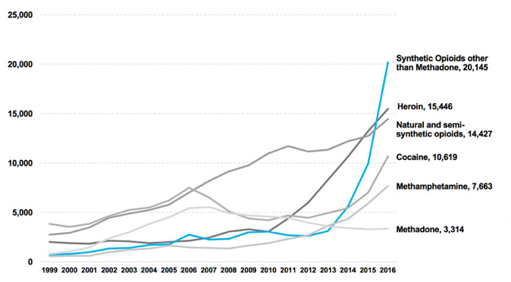

Figure 1: Chart of Number of Overdose Deaths by Year and Drug in the U.S.
  - Reprinted from Overdose Death Rates in National Institute on Drug Abuse, 2017. Retrieved February 22, 2018 from https://www.drugabuse.gov/related-topics/trends-statistics/overdose-death-rates.

It is clear from this chart that the number of overdose deaths has been increasing substantially since the mid-2000s. The highest increase has been in the number of overdose deaths from synthetic opioids such as fentanyl and carfentanyl, which are far more powerful and deadly than heroin. While the number of overdose deaths has been rising, the demographics of the people who most commonly become addicted to opioids and overdose has been changing. According to a retrospective study published in the Journal of the American Medical Association (JAMA) Psychiatry, (Cicero, Ellis, Surratt, & Kurtz, 2017) the demographics of people who become addicted to opioids have been rapidly changing over the past 50 years and especially in the last two decades. The demographics of people who previously were addicted to opioids began with heroin, were predominantly young men (mean age 16.5 years), and no one race was prevalent from the 1960s through the 1980s. The majority of people who now become addicted to opioids first start with prescription opioids and then move to heroin because it is more readily available and cheaper. The majority (over 75% for all variables) of the people who now become addicted to opioids are white, live in rural areas, and in their early twenties. The study analyzed data from almost 3,000 participants in an ongoing survey study to examine the drug patterns of people entering substance abuse programs across the country (Cicero, Ellis, Surratt, & Kurtz, 2017).
Looking at Allegheny County overdoses more closely, the number of overdose deaths due to heroin has been steadily increasing since the late 2000s, following the national trend. In 2016, 650 people in Allegheny County died of a drug overdose, up from 424 in 2015. In addition, for the first time, in 2016 fentanyl became the number one drug responsible for overdoses. It was found in the bodies of over 63% of those who had overdosed (View Overdose). Fetanyl is up to 100 times more potent than heroin, and one can overdose from just three milligrams compared to 30 milligrams of heroin. This creates even more problems because most heroin users do not know their heroin may be cut with fentanyl and can end up inadvertently overdosing (Bond, 2016).
According to one investigation by Vice News (Krishnan, 2016), fentanyl is being added to heroin more and more by dealers. It is cheap and dealers can make it themselves with non-prescription ingredients, said a doctor who specializes in treating addiction and overdose victims that was quoted in the article (Krishnan, 2016). This may be part of the reason for the recent spike seen nationally in deaths caused by fentanyl.
Substance abuse and addiction present many problems for people, but these problems may become even greater and more complicated for pregnant women due to potential harm to the fetus from drug use during pregnancy. One local organization addressing the opioid epidemic among pregnant women is the Pregnancy Recovery Center (PRC) at Magee-Womens Hospital of the University of Pittsburgh Medical Center (UPMC). The PRC is located within the outpatient clinic (OPC) at Magee and is an outpatient rehabilitation center. It is one of the first places in the country to open a multidisciplinary center for care for pregnant women with substance use disorder (SUD) and has now expanded to the Women’s Recovery Center (WRC), which treats non-pregnant women who have SUD. It is a multidisciplinary center because more than just healthcare providers work there. Social workers and others in the OPC and providers within the PRC specifically work at the PRC to bring the women enrolled in the program the care they need. The PRC was opened in 2014 and has seen successful results in the women who have stayed in the program (Bobby, England & Krans, 2017).
Since the PRC opened, 131 women have given birth. Of these, 81 newborns did not require any medication treatment for neonatal abstinence syndrome (NAS) while 50 newborns did require some sort of medication for NAS (Bobby, England, & Krans, 2017). The effects of NAS are explained more in the literature review. The average number of days that a PRC patient stays in the hospital after a vaginal delivery (one to two days) or C-section (three to four days) is the same as the number of days a non-substance dependent patient stays at Magee after delivery (S. Bobby, Personal Communication, November 9, 2017).
The no-show rates for the OPC at Magee are used as a comparison to the PRC’s no-show and compliance with care rates. In this study, compliance with care is defined as patients attending their appointments. Healthcare is a major cost in this country, and high no-show rates are partially to blame for such high costs. One study published in the journal BMC Health Services Research (Feng, Kheirkhah, Sharafkhaneh, Tavakoli-Tabasi, & Travis, 2015) used a retrospective cohort method to look at fiscal years 1997-2008 for no-show rates and fiscal costs at ten large healthcare organizations. They found that the cost of no-shows for the ten clinics was almost 15 million dollars, and that the average cost of each patient missing an appointment was $196 in 2008 (Feng, Kheirkhah, Sharafkhaneh, Tavakoli-Tabasi, & Travis, 2015).
No-show rates seem easy to fix because it is intuitive that calling and texting patients multiple times to remind them of their appointments should lead to fewer patients missing their appointments. Fixing high no-show rates is something that could have a tremendous effect on healthcare costs. In this study, the no-show rates of the patients with certified physician assistants (PA-C) of the orange unit (one unit amongst six within the OPC at Magee) are looked at and compared to the no-show rates of the PRC. Several variables, including distance patients travel, socioeconomic status (SES), and distance to one of six PRC locations, will be examined to see why the PRC patients are more compliant with their care including the medical home model of the PRC which is different from how the OPC delivers care and the distance patients have to travel to get to the PRC. The orange unit was chosen because it has a similar number of patients as the PRC. The OPC as a whole has far more patients than the PRC, and a comparison of these two patient populations would not be appropriate in terms of numbers.
This study will focus on outcomes in both the orange unit of the OPC and the PRC in terms of no-show appointment rates, post-partum appointment rates, rates of women who return to the program after they deliver, and the number of women who chose long-acting reversible contraception (LARCs) after they delivered. The number of women who chose LARCs after they delivered will be looked at only for patients in the PRC because this data was not available for women in the orange unit of the OPC. The PRC also encourages their patients to receive LARCs after delivery so this will be looked at as a further marker of success in implementation of new programs amongst this population.

Literature Review and Hypotheses

hypothesis
Higher compliance with care and lower no-show rates are expected in the PRC than in the orange unit of the OPC. The women in the PRC who have SUD are at a unique time in their lives when they may be ready to receive treatment for an addiction and want to comply with care for the health of their baby. The women in the OPC may not be dealing with substance abuse and may not feel as much of a need to fully comply with care in order to have a healthy baby. The OPC is also not a medical home model like the PRC where all of the patient’s care is in one place. This may also affect the no-show rate of the OPC because these patients may have multiple appointments at different locations which could lead to patients skipping appointments in the OPC out of fatigue or frustration.
It is expected that the women at the PRC will attend all of their prenatal appointments regardless of where they are coming from geographically in Pennsylvania or what their socioeconomic status is. Higher compliance with care is also expected for the women at the PRC since all services that the patients use are at Magee (some are also at the Western Psychiatric Institute and Clinic (WPIC) of UPMC, but that is close to Magee, about a half mile away).

The opioid crisis in allegheny county and nationally
Among other problems that the opioid epidemic has given rise to, NAS is a major problem that hospitals all over the country have had to encounter. As the opioid epidemic grows, more women are developing SUD and continue to have SUD during their pregnancies. NAS occurs when a pregnant woman uses addictive substances during her pregnancy, and her baby suffers from withdrawal when it is born because it is also addicted (Dramatic Increases, 2015). According to NIDA, every 25 minutes, a baby is born suffering from opioid withdrawal in the U.S. There has been a five-fold increase in babies born with NAS since 2000. This has major consequences for mothers, their newborn babies, and healthcare systems. The average length of stay in hospitals is eight times higher for babies born with NAS than for babies born without NAS, and the average cost of stay is almost 20 times higher for babies born with NAS (Dramatic Increases, 2015).
A study published in the New England Journal of Medicine (Tolia et al., 2015) in 2015 looked at NAS across the country from 2004 until 2013 by looking at Neonatal Intensive Care Unit (NICU) admissions. The number of infants admitted for NAS in NICUs rose from seven cases per 1,000 admissions to the NICU to 27 cases per 1,000 admissions, and the total percentage of days that infants spent in the NICU due to NAS nationwide rose from 0.6% to 4% (Tolia et al., 2015). The number of infants being admitted to NICUs across the country for NAS is rising, and among other things, costs for the care of these infants are increasing dramatically.
Another study (Patrick et al., 2012) of infants born with NAS looked at total hospital costs for treating infants with NAS and found that they rose from $190 million in 2000 to $720 million in 2009, adjusted for inflation. This study examined pediatric discharge reports for the years 2000, 2003, 2006, and 2009 across the country using the Healthcare Cost and Utilization Project's (HCUP) Kids' Inpatient Database (KID). The KID is a database that has been used widely for analyses of conditions and hospitalizations in children and keeps track of 80% of pediatric discharges and 10% of uncomplicated births (Patrick et al., 2012).
While rising costs are an issue that healthcare providers have to deal with, pregnant women with SUD may also fear legal repercussions for them and their children. Twenty-four states and the District of Columbia still have laws that consider substance use and abuse during pregnancy to be child abuse. Three of the biggest states, in terms of population, with these laws are Colorado, Texas and Washington (Substance Use, 2018). While Pennsylvania does not consider substance use and abuse during pregnancy to be child abuse, it is not likely that many pregnant women with SUD in Pennsylvania know this, and they may be afraid of having their children taken away should they seek care.
In addition, 23 states and the District of Columbia require physicians to report suspected substance abuse by pregnant women, and Pennsylvania is amongst these states (Substance Use, 2018). However, these laws can actually prevent women from seeking treatment if they fear they may be put in jail or have their baby taken away from them. Children born with NAS and children whose parents are addicted face risks of entering the foster system. This has become a major problem in recent years, and pregnant women who have SUD may be less likely to try to find doctors who will treat them out of fear that the doctors will be forced to report them to social services and will take their children away (Ockerman, 2017). With the opioid epidemic affecting so many people, new solutions are being explored that focus on treatment for the mother and the baby and do not criminally punish the mothers.

Medication-Assisted Treatment (MAT)
Both methadone and buprenorphine are used in treating pregnant women who have SUD. Buprenorphine is a drug that can be given safely to pregnant women, like methadone, but buprenorphine acts as a partial agonist whereas methadone is a full agonist. This means that buprenorphine is able to stop withdrawal symptoms without producing a notable effect of euphoria on the user. Methadone also stops withdrawal symptoms, but it is possible to overdose on methadone (Remski & Whelan, 2012). There were about 3,300 overdoses from methadone in 2015, but as Figure 1 on page two shows, this number is decreasing while the number of overdoses from heroin and other synthetic non-methadone opioids, namely fentanyl, is rapidly increasing (Prescription, 2016).
Both methadone and buprenorphine do not rule out the possibility of NAS once the baby is born, but they do help stabilize the mother so she is not reliant on opioids or illicit drugs and she can improve her mental health, if necessary. According to Jones et al. (2010), babies born to women who were treated with buprenorphine during their pregnancies required 89% less morphine and spent, on average, 43% less time in the hospital than babies born to women treated with methadone. This group of babies also spent 58% less time in the hospital receiving treatment for NAS than babies born to mothers who were treated with methadone (Jones et al., 2010).
One major obstacle to treatment of pregnant women with SUD is compliance with care. Often, pregnant women will drop out of programs for reasons such as falling back into substance abuse, living far away from centers providing care, and care being too expensive for them to afford. New models of care are being explored to see if behavioral health and mental health therapy can help women comply with care, including the PRC at Magee-Womens Hospital of UPMC. PRC patients can stay in treatment and enter into the WRC after they have their babies, if they choose.

Contraception Services for women who have sud
A study (Miller, et al. 2010) looked at 1,278 pregnant women were surveyed in Northern California. Fifty-three percent of the women reported physical or sexual partner violence. Nineteen percent reported pregnancy coercion, and 15% reported birth control sabotage. Pregnancy coercion and birth control sabotage can include partners verbally or physically threatening women to become pregnant, throwing away their preferred method of birth control or refusing to use contraception. Approximately a third of all the women who participated in this study experienced partner violence as well as pregnancy and birth control coercion. Within this population, over 40% of women reported having at least one unintended pregnancy (Miller, et al. 2010).
Heil et al. (2011) published a study that examined unintended pregnancies in women with SUD. This study looked at 946 women in different cities throughout the U.S and internationally who were screened for potential enrollment in an opioid treatment study. It found that, amongst this population, almost 86% of pregnancies were unplanned. The study reported that (as cited in Mohllajee, Curtis, Morrow & Marchbanks, 2007) the percentage of women who reported their pregnancies as unwanted was 27%, nearly three times higher than the percentage of unwanted pregnancies in the general population The study also noted that almost 90% the women in the study had a history of prior drug treatment, but that many of those programs did not offer contraceptive services (Heil et al., 2011).
Offering contraceptive services during drug treatment can be a way to prevent future unintended and unwanted pregnancies for women who are dealing with SUD especially if they are fearful of pregnancy coercion or birth control sabotage from their partners. Black & Day (2016), found that substance abuse services for women are growing in terms of need. However, these services usually lack any mention of contraception even though women who have SUD and become pregnant can have multiple complications. These can be due to the drugs they use having adverse effects in their pregnancy and on the fetus. This study stated that women with SUD face even more barriers to access for receiving birth control, including LARCs, than women in the general population. This can be due to several factors including, “misperception of fertility, intimate partner violence with reproductive coercion, fear of losing custody of children, and denial or embarrassment regarding their substance use” (Black & Day, 2016, p. 30).
Another factor that can contribute to women with SUD not receiving LARCs is that providers do not understand the risks of contraception for someone who has a substance abuse disorder. Black & Day (2016) noted the high prevalence of viral hepatitis among people with SUD and how that may make a provider hesitate before prescribing contraception even if there is no contraindication amongst medications. Another factor is that women in substance abuse recovery programs are often referred to an external clinic or third party provider for contraception access and services. This may pose an issue because often, the women in these programs are traveling a significant amount of time, and they cannot carve out more time in their days to go to these other providers. Some have even argued that referral to an external clinic or third party provider is equivalent to service denial (Black & Day, 2016).

Economic Impact of no-shows
The average no-show rate of healthcare appointments in the U.S. is about 42% (Lacy, Paulmann, Reuter, & Lovejoy, 2004). This is a significant number considering the economic costs and administrative frustrations this can have on healthcare organizations both at a local practice level and at the broader organization-wide level. According to an investigative article on patient no-shows that ran in 2014 in the Pittsburgh Post-Gazette, no-shows could be costing the healthcare system more than $150 billion a year (Toland, 2013). One study (Kaplan-Lewis, & Percac-Lima, 2013) looked at the no-show rate of primary care appointments over a period of five months at a community health center in Chelsea, Massachusetts. According to the study, patients cited several reasons for missing their appointments such as issues getting to the hospital, forgetting appointments, and miscommunication such as not realizing they needed to call and cancel an appointment or calling the clinic to cancel and not getting through (Kaplan-Lewis, & Percac-Lima, 2013). These reasons why patients do not show up for appointments can typically be applied broadly across many populations as these are issues that face many people.
No-show rates vary widely by physician practice, but no-shows can prove especially costly when patients miss pre-surgical consultations, and a surgery either has to be rescheduled or cancelled. Being more aware of the specific needs of the patient population may be one specific solution to help improve no-show rates. One example given in the Pittsburgh Post-Gazette (Toland, 2013) article was a Missouri outpatient psychiatric clinic that noticed public transportation shuts down early in the city so the clinic stopped booking patients for late appointments. Other clinics try to reserve time in their days for walk-ins or patients who show up very late (Toland, 2013). The goal is to try to see as many patients as possible, but a high no-show rate may complicate this if many patients are not even showing up to their appointments.
No-shows pose a significantly high barrier to lowering costs in healthcare. Like so many other things in healthcare, high no-show rates seem easy to change because theoretically, telling people to show up for their appointments multiple times before their appointments should make it more likely that they will show up to said appointments. Unfortunately, there are many different challenges to fixing the problem and lowering costs. Looking at the treatment of pregnant women with SUD and high no-show rates, it is interesting to see how two seemingly non-related issues actually are related and may play a role in creating new programs that may help those suffering from SUD.

Socioeconomic status and utilization of healthcare
Socioeconomic status (SES) has been looked at as something that may also affect no-show rates and that may affect utilization of healthcare. According to a study that was published in Health Affairs (Kangovi, et. al, 2013) that examined access to and utilization of healthcare amongst people of low SES, patients cited ambulatory care (care at physicians’ offices) being less accessible due to lack of transportation as opposed to hospital care. This was especially true if the physician referred them to one or more specialists. Several direct patient quotes were included that described their difficulties with healthcare access including, “Transportation is hard. Every time I use the van service, [it] will get me there late, maybe 20 minutes late, and I’m marked as a no-show…You have to call them in the morning to get an appointment the same day, like, whenever they can fit you in, instead of just being about to actually set up an appointment.” (Kangovi, et. al, 2013, p. 1200) The study surveyed 64 patients that were on Medicaid and agreed to participate in the survey while hospitalized in the Philadelphia region.
One main reason that patients often cite and that has been mentioned several times already in this study is lack of access to transportation to get to appointments. If one does not have access to a car, it may make them less inclined to attend appointments especially if public transportation can make the trip significantly longer than if they had a car. Syed, Gerber, and Sharp (2013) conducted a literature review of studies that have already been done on transportation and access to healthcare because they found there to be a limited amount of research on these two potentially connected topics. They found that “patients with a lower SES had higher rates of transportation barriers to ongoing health care access than those with a higher SES” (Syed, Gerber, and Sharp, 2013, p. 989). The study noted that, ultimately, barriers to transportation access may mean worse health outcomes in the long-run since patients may not be able to attend all of their appointments and get to pharmacies to receive prescription drugs they need. Patients missing follow-up appointments can lead to higher costs in the long run if these patients end up having to go to the emergency department for major adverse health events (such as a heart attack or stroke) (Syed, Gerber, and Sharp, 2013).

Methods

No-show data
No-show rate reports for the PRC and for the orange unit of the OPC were obtained using an electronic medical record tool called Epic at Magee. Epic is a scheduling device and many different reports can be run on it relating to patients and unit flows. On Epic, reports were run under the Scheduling tab called Dept Appts. The specified dates and units were entered, and the reports were run. On the reports, under the Appointment Totals tab, the completed vs. no-show rates for both units and the visit type by percentage were found as well as totals for the number of appointments and the number of patients.
After these reports were run, the no-show rates and percentage of total appointments by type within each clinic were examined. The total number of appointments for return obstetrical (OB) patients and appointments for the specified time frame was collected from Epic. For both clinics, the majority of type of appointment was return OB appointments – pregnant women who are returning for regular care during their pregnancies.
In addition to the Epic reports, Stephanie Bobby, a nurse who is the patient care manager in the PRC, was consulted. These meetings consisted of looking through Epic for patients in the PRC who gave birth from January 2017 until July 2017 and the follow-up care that they received. A de-identified list of patients was made that included data related to how far along the women were in their pregnancies when they began treatment at the PRC, if they attended their post-partum appointments, if they chose to receive a LARC at this appointment, and if they chose to stay in the program after they had delivered. Ms. Bobby also provided information on patient deliveries and if the patients received opioids after they delivered or not. Twenty-two patients delivered between January 2017 and July 2017. The no-show rates of both units, the types of appointments in each unit by percentage and the number of patients in each unit were compared from the reports obtained in Epic which were best way to obtain accurate data on no-show rates.

map creation using qgis and geoda
Requests for reports were put in to the Epic team and a data request form was filled out. This form requests specific information such as who the report requester is, contact information, why the information is wanted, what units are being looked at and a few other questions to ensure patient confidentiality. The zip codes from which patients are coming and the number of patients from each zip code were requested, and a report with all these data was obtained. This information was used in mapping analyses that is included in the Results section.
Software called QGIS was used, which turns data into color-coded maps for better visualization. Four maps were created from the data obtained from Magee, and these maps also incorporated data that shows Allegheny County and the surrounding areas and demographic data on Allegheny County in particular. One variable of interest that was included on the maps was the percent of females that live in poverty in Allegheny County. This variable was calculated using information from American FactFinder which provided data on all people who live at or below the poverty line in Allegheny County. Calculations were made using this data to find the number of females aged 18-64 who live at or below the poverty line by census tract in Allegheny County.
Locations of the six current Magee PRCs were included in several maps, and the Pennsylvania zip codes are in the background as a reference for all maps. A tool in QGIS called “Fixed Distance Buffer” was also used which creates buffers of a specified distance around points. Though the areas in and around Allegheny County are focused on in the maps, there are more points of data outside Allegheny County. The author chose to zoom in on the areas surrounding Allegheny County to make the maps easier to see.
The zip code reports that were provided from Epic were used in different ways when creating these maps in QGIS. The data on all zip codes from which patients in the PRC and in the orange unit of the OPC are coming from are incorporated as well as the number of visits to the PRC by zip code. Those zip codes were then converted into points on the figure using a function in QGIS called geoprocessing using the latitude and longitude of each zip code.
After the maps were created, the number of zip codes from which patients are coming from to get to the PRC within Allegheny County and in the city of Pittsburgh were counted. The number of visits by zip code were then noted and added to see if there was any difference in number of visits by zip code in Allegheny County versus number of visits by zip code in the city of Pittsburgh.
Another software called GeoDa was also used to create Gi* Cluster maps using data from the ACHD’s website that reflected two variables of interest: the percentage of households with no vehicle in Allegheny County by census tract and the percentage of females aged 18-64 who live at or below the poverty line in Allegheny County by census tract. Maps of these particular variables were created in QGIS and then uploaded into GeoDa which is a statistical analysis tool for GIS maps. Two Gi* cluster maps were created in GeoDa.
QGIS was used in this project because it is a good tool for visualizing data. Variables of interest were distance that patients travel to get to Magee’s PRC, the percent of women in Allegheny County who live at or below the poverty line by census tract, the percentage of households with no vehicle in Allegheny County by census tract, and the number of visits to the PRC by zip code. QGIS was the best tool to visualize these variables. GeoDa was used because it analyzes the data in the QGIS maps and shows the areas of high vs. low concentration of the chosen variables.

Findings/Results

no-show data by unit
Looking at the data obtained from Epic and the PRC showed that 137 patients delivered since the beginning of the PRC in 2014. From January 2017 until July 2017, 22 patients delivered. Of these, eight were taken as patients in the PRC in their first trimester, nine patients were taken in their second trimester, four patients were taken in their third trimester, and one patient was taken at an unknown point in her pregnancy. If the patients deliver at Magee, they are not offered opioids after birth. However, a few patients have delivered at other hospitals and have been offered opioids. These patients have actually refused opioids after they have given birth because they do not want to take opioids again and risk falling back into substance abuse (S. Bobby, Personal Communication, November 9, 2017). All but three of these 22 patients attended their post-partum appointments. Forty-one percent chose to receive LARCs one received a tubal ligation, and the other 12 chose another form of birth control, such as oral contraceptive pills or the Depo-Provera shot, or they did not choose to go on any type of birth control (S. Bobby, Personal Communication, November 9, 2017).
The no-show rate of the PRC is 11.3% lower than the no-show rate of the orange unit of the OPC, 25.9%. Ninety-five patients were enrolled in the PRC program and 652 total appointments from January 2017 until June 2017. The percent of return patient appointments at the PRC was 78.7% (Epic…No-Show Rates and Appointment Totals of PRC Unit, 2017) There were 515 patients seen in the orange unit and 1,297 total appointments from January 2017 until July 2017. The percent of return OB patient appointments at the orange unit was 62.1% (Epic…No-Show Rates and Appointment Totals of Orange Unit, 2017)
The lower no-show rate of the PRC is interesting. As stated in the literature review, there are many barriers to care that pregnant women with SUD often face that may lead to them not receiving care. However, the women at the PRC are complying with their care given the low no-show rate. Another motivation that may be driving these women is that once their baby is born, the women can stay on in the program, and, perhaps most importantly, their baby is not taken away from them.

maps
Figure 2 used the zip code reports that were provided from Epic. It shows the number of visits by zip code for the PRC only and the percentage poverty of females aged 18 to 64 by census tract in Allegheny County. The percentage poverty variable was calculated using data from American FactFinder from a table called “B17001. Poverty Status in the Past 12 Months by Sex by Age”. The American FactFinder Poverty Status table provided data on the number of females ages 18 to 64 who live at or below the poverty line in Allegheny County by census tract. This total was then divided by the total number of people living in each census tract and multiplied by 100 to determine the percentages. Locations of the six current Magee PRCs were included in this figure, and the Pennsylvania zip codes are in the background as a reference. There are more zip code visits to the PRC outside of the figure, but the areas in and around Allegheny County are focused on since that is the area of interest in this study.

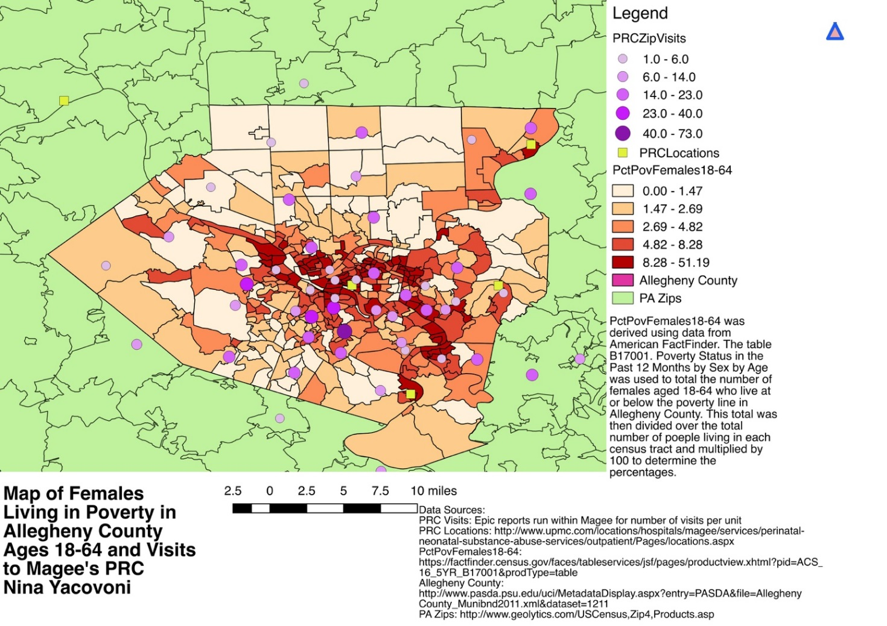

Figure 2: Map of Females Living in Poverty in Allegheny County Ages 18-64 and Visits to Magee's PRC

Looking at Figure 2, it can be seen that the percentage poverty among females ages 18 to 64 is relatively low, but it does tend to be higher within the city. The northwest, west, and southwest suburbs of Allegheny County have much lower poverty levels than within the city. However, there does not seem to be a correlation between higher percentage poverty and more visits to the PRC. In the northwest and southwest suburbs of Allegheny County where the percentage poverty is quite low, the number of visits to the PRC is still high in the 14 to 23 visits per zip code range.
Figure 3 also used the zip code reports that were provided from Epic. However, the variable, number of visits (such as one to five visits, five to 10 visits), was not separated. There is only one point in each zip code where the patients were coming from as opposed to number of visits by zip code as in Figure 2. These specific zip codes were highlighted and then saved as their own shapefile on the figure to make it easier to see the area of each zip code. All six of the Magee PRCs in the area are also included. A tool in QGIS called “Fixed Distance Buffer” created two-mile and five-mile buffers around each PRC location. Pennsylvania roads were also included in this figure.
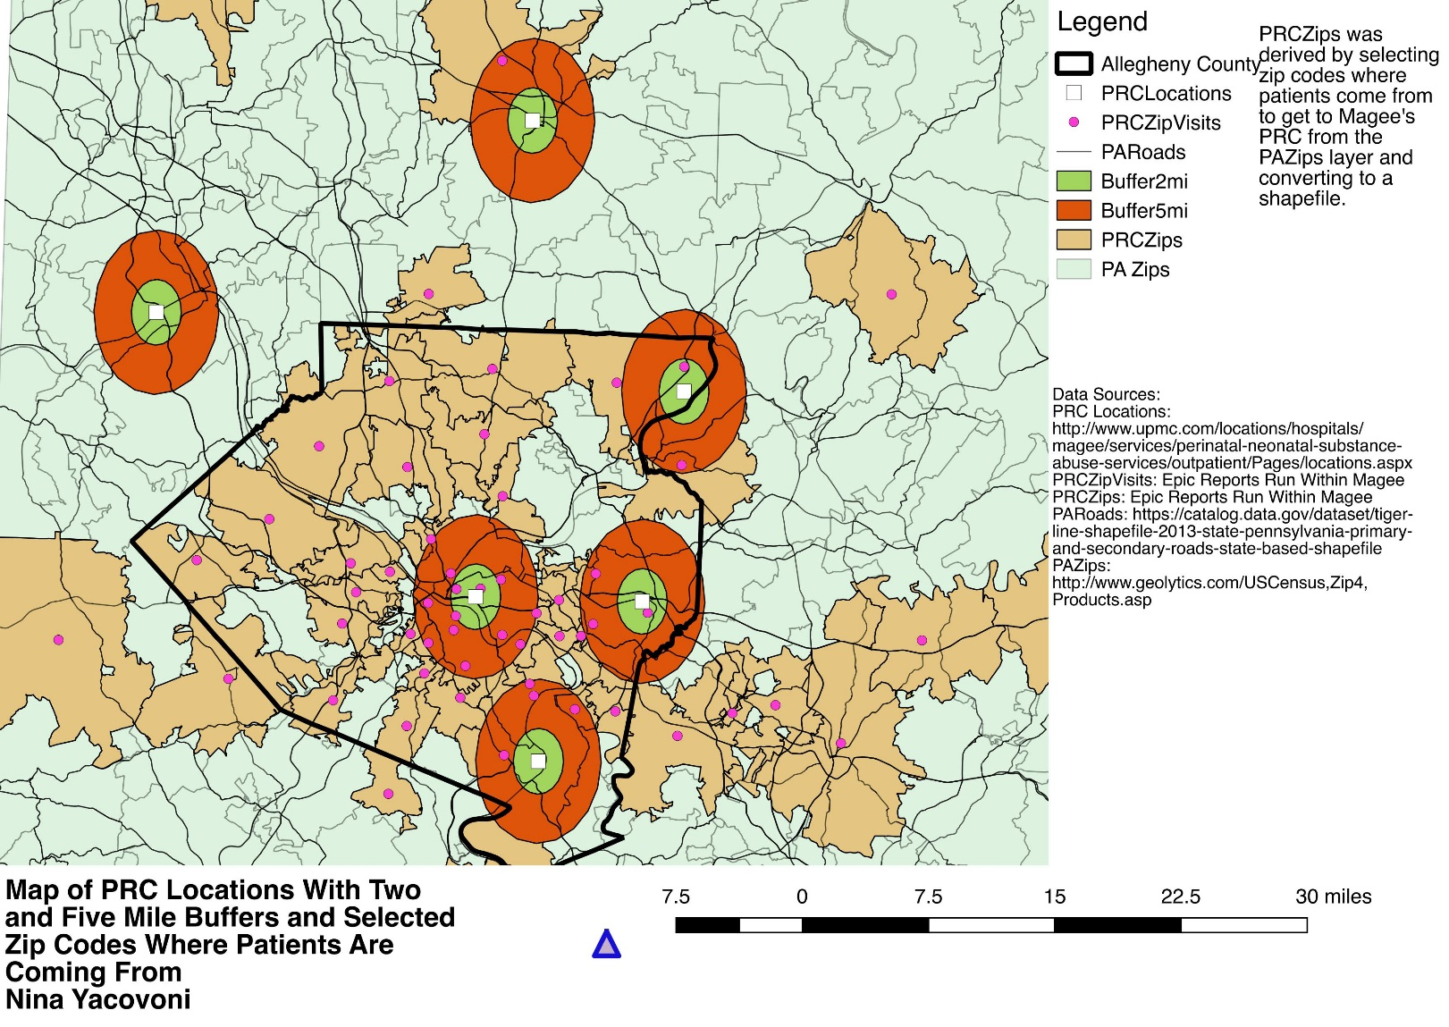

Figure 3: Map of PRC Locations with Two and Five Mile Buffers and Selected Zip Codes Where Patients Are Coming From

Each zip code from which at least one patient is coming to Magee’s Oakland PRC is represented by a small circle, and most of the PRCs do not have many zip codes where patients are coming from within the two- or five-mile buffers. The Magee Oakland location, in the center of the map, has the most patients from zip codes within a five-mile range. However, the other five PRCs have four or fewer patients from zip codes within a five-mile range. The further outside of Allegheny County the PRCs are, the fewer patients from zip codes these PRCs have within a five-mile range.
This figure is zoomed in in so that the buffers were visible around the PRCs, but there are many zip codes not seen on this figure, especially in the northwest and south-central regions of the state. Though the zip codes are only for patients coming to Magee’s PRC in Oakland, it is telling that the other five PRCs have only 10 total zip codes that patients are coming from to get to Magee’s PRC in Oakland. One would think that building more PRCs might help increase access to care and treatment, but there are a number of zip codes that are well outside the five-mile buffer area of all the PRCs in the region.
Figure 4 was made using the zip code reports that were provided from Epic. These reports showed the number of visits by patients in the orange unit of the OPC and in the PRC from each
zip code. Those zip codes were then converted into points on the figure using a function in QGIS called geoprocessing using the latitude and longitude of each zip code. This figure also includes
the locations of all six of Magee’s current PRC locations, including the one located in Magee in Oakland, Port Authority bus routes, roads throughout Pennsylvania, Allegheny County zip codes
and Pennsylvania zip codes. The figure covers the whole of western Pennsylvania and ends in the central region. An inset on the figure shows Allegheny County and the surrounding areas for better
visualization of where these zip codes are in terms of Magee and how many visits per zip code there are.
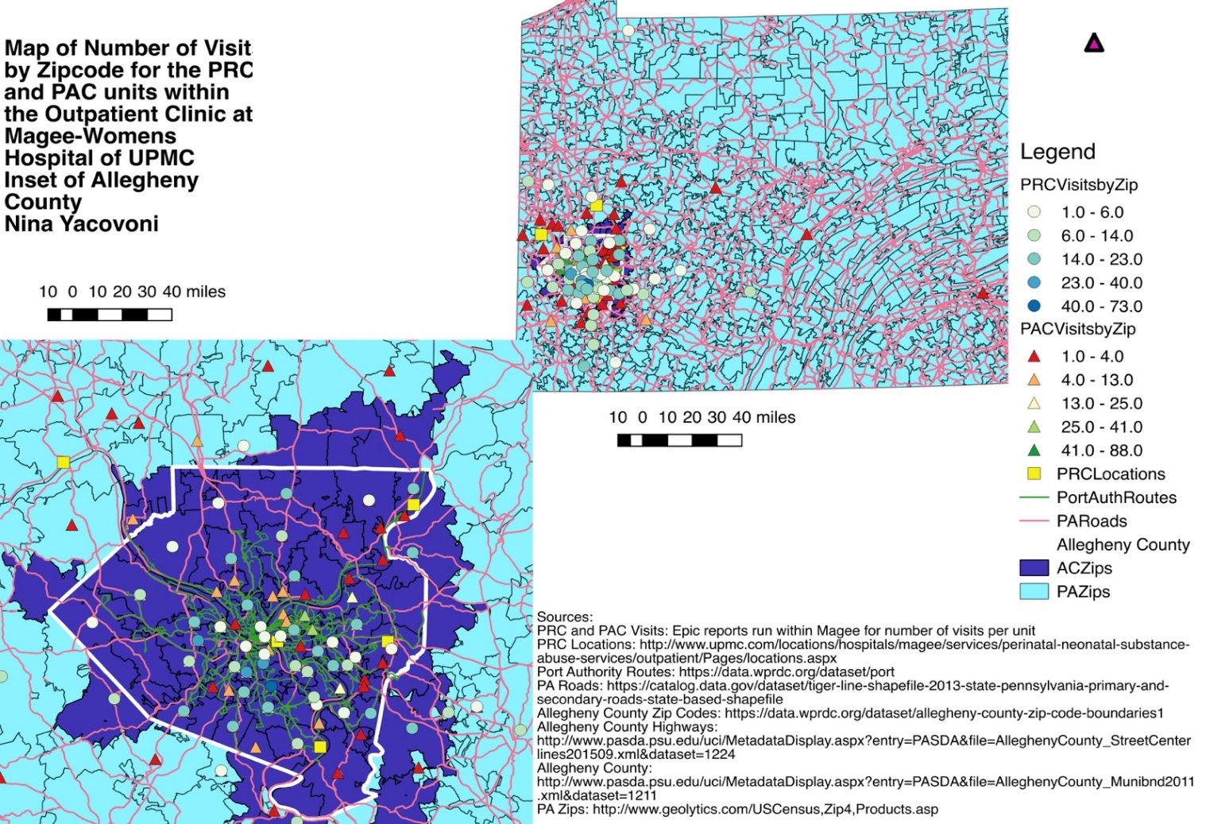

Figure 4: Map of Number of Visits by Zip Code for the PRC and PAC units within the Outpatient Clinic at Magee-Womens Hospital of UPMC and Inset of Allegheny County

From Figure 4, one can see that patients are coming from a variety of different zip codes to get to both the orange unit of the OPC and to the PRC. This is important because the no-show rates of the OPC are high as compared to the PRC. Yet in both units, some patients are traveling from near the Erie and Harrisburg areas to get to Magee. Some patients in both units are coming from as far away as the Erie area, and the south-central areas of the state. Though these zip codes count for smaller number of visits, they are still significant when thinking about the no-show rates and the distance some patients will travel to get care at both the orange unit of the OPC and the PRC. The inset shows the areas in and around Allegheny County for greater clarity. From the inset, it can be seen that a number of patients at the PRC come from the northwest, west and southwest suburbs, typically wealthier areas.
There are 31 zip codes in Allegheny County where patients are coming from to get to the PRC for a total of 434 appointments. There are 11 zip codes in the city of Pittsburgh where patients are coming from to get to the PRC for a total of 149 appointments. In order to see if there are more visits by zip code in Allegheny County versus more visits by zip code in Pittsburgh, the following calculations were made: 434/31 = 14, and 149/11 = 13.5 These numbers are very close and show that there is no significant difference in the number of visits to the PRC by location within Allegheny County and the city of Pittsburgh. There are 34 more zip codes outside of Allegheny County and Pittsburgh where patients are coming from to get to the PRC at Magee in Oakland (Epic…No-Show Rates and Appointment Totals of PRC Unit, 2017).
Looking at Figure 4, it is clear that many patients at the OPC come from within Allegheny County where they can take a Port Authority bus or are close to major highways if they have a car. However, a good number of patients that are still coming from outside of Allegheny County or closer to the edges of the county in the east and southeast sections of the county. Patients in these areas probably take over an hour to get to Magee especially if they are taking the bus. Location is something that could be contributing to the high no-show rates of patients in the orange unit of the OPC along with patient’s attitude towards care.
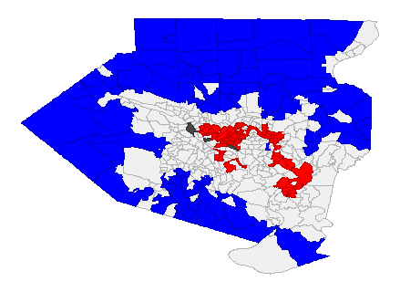
The two GeoDa Gi* Cluster maps are Figures 5 and 6. Figure 5 used data from the ACHD’s website that reflected the percentage of households with no vehicle in Allegheny County by census tract and was then converted into a map in QGIS. This map and the percent poverty map (Figure 2) were then uploaded into a software called GeoDa. The two Gi* cluster maps are included that show high and low areas for percentage poverty of females in Allegheny County ages 18-64 by census tract and households without a vehicle in Allegheny County by census tract.
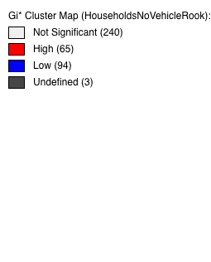

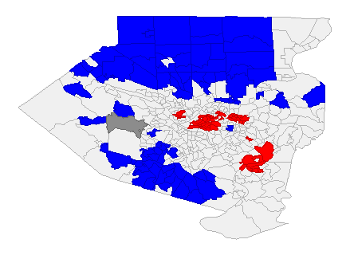
Figure 5: GeoDa Gi* Cluster Map of Households with No Vehicles
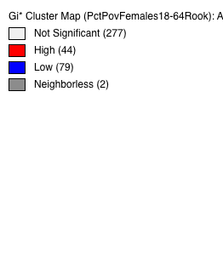

Figure 6: GeoDa Gi* Cluster Map of Percent Poverty of Females Aged 18-64
The blue areas on Figures 5 and 6 are low areas which means that those census tracts and their neighbors are below the average. The red areas are high areas which means that those census tracts and their neighbors are above the average. It is interesting to see the similarities between Figures 5 and 6. The high areas for percentage poverty and households without a vehicle tend to cluster in the city and in the southeast regions of Allegheny County whereas the low areas for percentage poverty and households without a vehicle tend to cluster in the northwest, west and southwest suburbs of the county.
Comparing Figure 4 to Figure 5, it can be seen that a significant number of OPC and PRC patients are coming from within the city and the southeastern areas of Allegheny County. The distance these patients have to travel by bus may be contributing to the no-show rates of the orange unit of the OPC and the OPC overall. In Pittsburgh, public transportation can be more time-consuming than driving, and the further out from the city one lives, the less inclined they may be to take the bus to attend their appointments.

Discussion
Comparing the no-show rates of the two units, that of the orange unit of the OPC is higher than that of the PRC. It is also known anecdotally by staff at Magee that the no-show rate for the OPC as a whole has been around 30% for years. This is an issue for many reasons but one is lost revenue. As discussed in the literature review, no-shows are a major reason for monetary losses and staff dissatisfaction. In this case though, the problem is worse if a patient is pregnant and misses a potentially very important check-up.
Distance was also mentioned earlier as contributing to high no-show rates. It is very interesting to see the PRC no-show rate so low even though this population often travels from significant distances to get to Magee. This may be partially explained by the fact that these women may be motivated to receive care to protect their baby and therefore may be willing to drive long distances to receive care. Some of the patients at the orange unit of the OPC are also traveling from significant distances to get to Magee, but that no-show rate is significantly higher, possibly because the women at the OPC may not be dealing with SUD.
Research from the literature review and data collection helped to focus this study more on the PRC and the locations where those women come from as well as the statistical/mapping analyses that came from that data. The PRC has a low no-show rate even though some of these women travel from two to three hours away to receive care. Most of the issues looked at in this paper are complicated and show that there is still a lot to be done to improve healthcare because many of these issues overlap in such complex ways.
Within Allegheny County and the city of Pittsburgh, there are a high number of visits to the PRC, but there is no significant difference between number of visits by zip code within Allegheny County where the percentage poverty tends to be lower and number of visits by zip code within the city of Pittsburgh tends to be higher. This suggests that pregnant women who have SUD come from both low and high SES backgrounds. Care can still be divided amongst economic lines though. For example, a pregnant woman with SUD may live in a high poverty area and not have access to a car. Even if she has health insurance, this does not guarantee that she will receive care. If instead this woman lives in a wealthier area of Allegheny County and has access to a car, this also does not guarantee that she will receive care. This is because pregnant women who have SUD may be afraid of having their baby taken away from them and also may not know that care is available to them and can be given safely during pregnancy.
While there are many contributing factors to no-show rates in healthcare, and to the orange unit of Magee’s OPC specifically, several of these factors have been examined in this study. It is not uncommon for patients both in the PRC and OPC to come from distant locations to get to Magee for care. As seen in Figure 4, there were at least 10 visits where patients were coming from the middle and northwestern areas of Pennsylvania. The significant distances being traveled by patients may partially be explained by care not being available in rural areas and/or better care being available in urban centers. While UPMC is a major healthcare system in the area, it does not have the funds to provide all rural areas in Pennsylvania with quality healthcare, especially with the types of specialized and localized care that are offered at the PRC.
What these maps showed is a need for quality care facilities in the more rural areas of the state. It also showed how public transportation and lack of access to a car can affect no-show rates in healthcare in Pittsburgh where public transportation can often be unreliable. The maps were most helpful in analyzing the results, especially Figure 3 that showed two- and five-mile buffers around each PRC location.

Conclusions, Recommendations and Public Health Implications
This study began by examining pregnant women with SUD, the care available to them and what barriers they may face when trying to receive care. It also looked at no-show rates in healthcare and examined several variables to hypothesize as to why Magee’s PRC has such a low no-show rate compared to a unit within Magee’s OPC. Literature was examined to explain the background of the opioid epidemic, how pregnant women with SUD are treated in the legal system, what types of care is available to these women as well as a background on the causes and costs of no-show rates in healthcare.
Data were looked at from Epic to compare the orange unit of the OPC’s no-show rate to the PRC’s no-show rate, and several maps were also created in QGIS and GeoDa using data from Epic. These maps were created to examine the distances patients are coming from to get to both the PRC and the OPC and to examine the percent of females ages 18-64 who live at or below the poverty line in Allegheny County by census tract and the number of households that do not have access to a car in Allegheny County by census tract. From looking at the data from Epic and the maps, it was seen that some patients from both the OPC and PRC travel up to three hours away to get to Magee, but the PRC’s no-show rate is much lower. This lower no-show rate may be due to the fact that, besides Magee’s other PRC locations in Allegheny County, there is no comparable center where they can receive quality care like they do at the PRC.
This study showed several things – that the patient population of the PRC is comprised of women from both low SES and high SES, that there is a need for more centers like the PRC, and that pregnant women who have SUD may be less likely to miss their doctor’s appointments than pregnant women who do not have SUD. What this study showed is that when trying to improve healthcare outcomes, variables in addition to patients’ health should be looked at including, where the patients live, if they have access to a car or public transportation, if the patients are unemployed, and past health issues that could impede their future health and well-being.
Overall, this study showed that many issues in healthcare are complex. Unfortunately, the opioid epidemic is showing no signs of slowing down, and the need for care in the population of pregnant women with SUD will only be growing in the next few years. The major recommendation from this study is to build more centers like the PRC both in the Western Pennsylvania region and nationally. The author would also recommend that clinicians not turn away pregnant women with SUD as can sometimes happen and was mentioned in the literature review and instead try to help them as much as possible. Pregnancy is a short time in a woman’s life when she is often motivated to make many changes for the better. Capitalizing on this drive to change can help these women live successful lives in the long-term.
The high no-show rate in the OPC must be reduced to improve care for patients and staff satisfaction. Since high no-show rates are a major issue in healthcare, collaborating with other units or hospitals that have either successfully lowered their no-show rates or are trying new initiatives to tackle these high rates might prove beneficial in finding new solutions to this unfortunately old problem.
There were several limitations in this study. One of these was that the OPC as a whole could not be compared to the PRC as a whole since the volume of patients seen at the OPC is more than 10 times that of the volume of patients seen at the PRC. The orange unit has many more patients than the PRC seen during the given timeframe (January – June 2017), but it was the unit closest to the smaller number of patients seen in the PRC (Epic…No-Show Rates and Appointment Totals of Outpatient Clinic, 2017), The orange unit of the OPC may also just have a significantly higher rate of no-shows than the other units in the OPC, or there could be other units that are contributing to the high no-show rate as well.
Another limitation was that only data from the Magee PRC located in Oakland were used. Data from the five other PRC locations were not used due to time constraints. The PRC is also a relatively new program that may just be seeing many successes due to the staff being enthusiastic and patients willing to participate in all parts of the program. The OPC has been around at Magee for many years. It would be useful to look at the no-show rates and rates of women who stay in the PRC program after they give birth in five to 10 years and compare that no-show rate to the OPC’s.
Another limitation was that the author could not find studies on the perception of laws regarding if pregnant women who have SUD seek out care, and there was a limited amount of current studies on transportation and how that may affect patients’ access to healthcare. Most of these types of studies that were found were from the 1990s or 1980s. Law and perception of laws are a difficult thing to quantify and study. Further research could begin to examine substance use and abuse laws around the country and how people may perceive these when trying to get care.
A limitation to the maps that were created is that zip code data for the maps were only used for Magee’s PRC and not the five other PRCs located throughout the region. Having these data to look at where the patients at all the PRCs are coming from would be helpful especially with two- and five-mile buffers. Another limitation of the maps was that only the demographics of Allegheny County were looked at. Allegheny County has many data sources for the health of its residents; however, neighboring counties do not have such data. It was difficult to find demographic data on neighboring counties like Butler, and oftentimes, these data simply did not exist. Demographic data on neighboring counties were not included in the final maps created.
This study points to opportunities for further research, such as continuing to monitor the success of the PRC now that any woman can join, not just pregnant women, for several years, and noting how many women who have SUD continue to join. Seeing how the opioid epidemic is handled nationally will be very interesting, and perhaps, one day there will not be such a large need for the PRC in the area and the country. A similar further study could also continue to monitor the no-show rate in the different units of the OPC as new initiatives are implemented and as the years go on.
Another opportunity for further research is examining how pregnant women who have SUD, or even all people who have SUD, perceive laws surrounding treatment and rehabilitation for SUD in their states. Some people who have SUD may believe that they cannot receive rehabilitation without being committed of a crime. Pregnant women who have SUD may worry that their children will be taken away from them should they choose to receive care. Understanding how people perceive laws can help to further inform outreach efforts by local and state agencies that are working to combat the opioid epidemic.
One recommendation from this study is to include integrated contraception service delivery in treatment programs for pregnant women with SUD so that contraceptive services are provided during treatments. As was stated in the literature review (as cited in Mohllajee, Curtis, Morrow & Marchbanks, 2007), the percentage of women who have unwanted pregnancies is nearly three times as high in women with SUD than in the general population. Providing integrated contraception service delivery in treatment programs may be one way to decrease this unwanted pregnancy rate. Integrated contraception service delivery is already done at the PRC since it is housed within Magee’s OPC where contraception service delivery already occurs.
However, integrated contraception service delivery can be time-consuming and expensive. It may include bringing on new staff who have expertise in contraceptive care and substance use disorders and changing the current model of treatment. As the Substance Abuse study that was mentioned in the literature review that looked at existing models of care for pregnant women with SUD said, “The long-term benefits of contraception uptake in (substance abuse) populations are likely to be substantial, although there has been limited economic evaluation in this area. It is important to note that in the absence of dedicated resources, perceptions of increased workload can make clinic staff reticent toward new programs and may impede success” (Black & Day, 2016, p. 31).
Another recommendation from this study is that on the policy level, several policies could work to help the opioid epidemic. Removing children from households negatively affects women and leads to very hard times for new mothers and possible relapsing. In states such as Kentucky where they currently take away children born to mothers with SUD, a possible policy change could be to leave children with their mother if she agrees to receive treatment during her pregnancy and continues with treatment after she has given birth. Another possible policy would be requiring all doctors to treat pregnant women with SUD who are seeking treatment or, at the very least, to refer them to a center where they could receive quality care.
As has been seen time and again in healthcare, punitive policies often do more harm than good and creating policies that encourage people to seek out treatment without punishment can often help the most vulnerable populations. This study ended up looking at several different variables as to why care for pregnant women with SUD can be difficult to obtain and why no-show rates can be so high in healthcare organizations. It would help policymakers to look at these wide range of reasons before enacting new legislation instead of acting on what they think might be most helpful which happens all too often.
A final recommendation from this study is for healthcare administrators and organizations to provide care and create clinics for pregnant women with SUD, or at the very least, begin to explore this idea. If there is a large healthcare organization in an area, it can reach out to local women’s shelters and substance abuse rehab centers to see what the current model of care is for these women in the area. These organizations and administrators can also reach out to more rural hospitals and see if telemedicine there might improve care for these women if needed. This problem is worth looking into especially since the opioid epidemic shows no signs of slowing down. If an infant receives quality care from their first day of life and is allowed to stay with their mother, this will most likely lead to positive life outcomes.

Bibliography
Black, K. I., & Day, C. A. (2016). Improving Access to Long-Acting Contraceptive Methods and Reducing Unplanned Pregnancy among Women with Substance Use Disorders. Substance Abuse: Research and Treatment, 10s1, 27-33. doi:10.4137/sart.s34555
Bobby, S., England, M. V., & Krans, E. (2017, September 25). The Pregnancy Recovery Center. Lecture presented at Attacking the Opioid Crisis...UPMC's System Approach to Make a Difference in Magee-Womens Hospital of UPMC, Pittsburgh.
Bond, A. (2016, September 29). Why fentanyl is deadlier than heroin, in a single photo. STAT. Retrieved November, 2017, from https://www.statnews.com/2016/09/29/fentanyl-heroin-photo-fatal-doses/
Cicero TJ, Ellis MS, Surratt HL, Kurtz SP. The Changing Face of Heroin Use in the United States A Retrospective Analysis of the Past 50 Years. JAMA Psychiatry. 2014;71(7):821- 826. doi:10.1001/jamapsychiatry.2014.366

Dramatic Increases in Maternal Opioid Use and Neonatal Abstinence Syndrome. (2015, September). Retrieved November, 2017, from https://www.drugabuse.gov/related-topics/trends-statistics/infographics/dramatic-increases-in-maternal-opioid-use-neonatal-abstinence-syndrome
Epic Systems Software. (2017). No-Show Rates and Appointment Totals of Outpatient Clinic. [Data File]. Retrieved from Magee-Womens Hospital of UPMC
Epic Systems Software. (2017). No-Show Rates and Appointment Totals of Orange Unit. [Data File]. Retrieved from Magee-Womens Hospital of UPMC
Epic Systems Software. (2017). No-Show Rates and Appointment Totals of PRC Unit. [Data File]. Retrieved from Magee-Womens Hospital of UPMC
Heil, S. H., Jones, H. E., Arria, A., Kaltenbach, K., Coyle, M., Fischer, G., . . . Martin, P. R. (2011). Unintended pregnancy in opioid-abusing women. Journal of Substance Abuse Treatment, 40(2), 199-202. doi:10.1016/j.jsat.2010.08.011
Households Without A Vehicle [CSV File]. (2016). Pittsburgh: Allegheny County Health Department.

Intentional vs. Unintentional Overdose Deaths. (2017, February). Retrieved March 14, 2018, from https://www.drugabuse.gov/related-topics/treatment/intentional-vs-unintentional- overdose-deaths

Jones, H.E., Kaltenbach, K., Heil, S.H., Stine S.M., Coyle, M.G., Arria, A.M.,…Fischer, G. (2010). Neonatal abstinence syndrome after methadone or buprenorphine exposure. New England Journal of Medicine, 9(363), 24th ser., 2320-2331. doi:10.1056/NEJMoa1005359
Kangovi, S., Barg, F. K., Carter, T., Long, J. A., Shannon, R., & Grande, D. (2013). Understanding Why Patients Of Low Socioeconomic Status Prefer Hospitals Over Ambulatory Care. Health Affairs, 32(7), 1196-1203. doi:10.1377/hlthaff.2012.0825
Kaplan-Lewis, E., & Percac-Lima, S. (2013). No-Show to Primary Care Appointments. Journal of Primary Care & Community Health, 4(4), 251-255. doi:10.1177/2150131913498513
Kheirkhah, P., Feng, Q., Travis, L. M., Tavakoli-Tabasi, S., & Sharafkhaneh, A. (2015). Prevalence, predictors and economic consequences of no-shows. BMC Health Services Research, 16(13). doi:10.1186/s12913-015-1243-z
Krishnan, M. (2016, June 23). Why Are Dealers Cutting Fentanyl into Recreational Drugs? VICE. Retrieved February 19, 2018, from https://www.vice.com/en_us/article/avazbe/why-are-dealers-cutting-fentanyl-into-recreational-drugs
Lacy, N. L., Paulmann, A., Reuter, M. D., & Lovejoy, B. (2004). Why We Dont Come: Patient Perceptions on No-Shows. The Annals of Family Medicine, 2(6), 541-545. doi:10.1370/afm.123
Miller, E., Decker, M. R., Mccauley, H. L., Tancredi, D. J., Levenson, R. R., Waldman, J., . . . Silverman, J. G. (2010). Pregnancy coercion, intimate partner violence and unintended pregnancy. Contraception, 81(4), 316-322. doi:10.1016/j.contraception.2009.12.004
Mohllajee, A. P., Curtis, K. M., Morrow, B., & Marchbanks, P. A. (2007). Pregnancy Intention and Its Relationship to Birth and Maternal Outcomes. Obstetrics & Gynecology, 109(3), 678-686. doi:10.1097/01.aog.0000255666.78427.c5
Ockerman, E. (2017, August 13). Pregnant women addicted to opioids face tough choices, fear treatment can lead to separation and harm. The Washington Post. Retrieved November, 2017, from https://www.washingtonpost.com/national/pregnant-women-addicted-to-opioids-face-tough-choices-fear-treatment-can-lead-to-separation-and-harm/2017/08/13/8844e51a-6d78-11e7-b9e2-2056e768a7e5_story.html?utm_term=.0b979e17869c
"Opioids." National Institute on Drug Abuse. Accessed March 2, 2018. https://www.drugabuse.gov/drugs-abuse/opioids/opioid-crisis.
Opioid Overdose Crisis. (2018, January). Retrieved November, 2017, from https://www.drugabuse.gov/drugs-abuse/opioids/opioid-crisis
Overdose Death Rates | National Institute on Drug Abuse (NIDA). (2017, September). Retrieved February 19, 2018, from Overdose Death Rates | National Institute on Drug Abuse (NIDA). Retrieved February 22, 2018, from https://www.drugabuse.gov/related-topics/trends-statistics/overdose-death-rates
Patrick, S. W., Schumacher, R. E., Benneyworth, B. D., Krans, E. E., Mcallister, J. M., & Davis, M. M. (2012). Neonatal Abstinence Syndrome and Associated Health Care Expenditures. JAMA, 307(18), 1934-1940. doi:10.1001/jama.2012.3951
Prescription Opioid Overdose Data. (2016). Retrieved February 20, 2018, from https://www.cdc.gov/drugoverdose/data/overdose.html
Substance Use During Pregnancy. (2018, February 1). Retrieved February 20, 2018, from https://www.guttmacher.org/state-policy/explore/substance-use-during-pregnancy
Syed, S. T., Gerber, B. S., & Sharp, L. K. (2013). Traveling Towards Disease: Transportation Barriers to Health Care Access. Journal of Community Health, 38(5), 976-993. doi:10.1007/s10900-013-9681-1
Toland, B. (2013, February 24). No-shows cost health care system billions. Pittsburgh Post-Gazette. Retrieved November, 2017, from http://www.post-gazette.com/business/businessnews/2013/02/24/No-shows-cost-health-care-system-billions/stories/201302240381
Tolia, V. N., Patrick, S. W., Bennett, M. M., Murthy, K., Sousa, J., Smith, P. B., . . . Spitzer, A. R. (2015). Increasing Incidence of the Neonatal Abstinence Syndrome in U.S. Neonatal ICUs. New England Journal of Medicine, 372(22), 2118-2126. doi:10.1056/nejmsa1500439
View Overdose Death Data. (n.d.). Retrieved November, 2017, from https://www.overdosefreepa.pitt.edu/know-the-facts/view-overdose-death-data/
Whelan, P. J., & Remski, K. (2012). Buprenorphine vs methadone treatment: A review of evidence in both developed and developing worlds. Journal of Neurosciences in Rural Practice, 3(1), 45-50. doi:10.4103/0976-3147.91934

