OCCUPATIONAL LUNG DISEASE AND THE RESURGENCE OF PROGRESSIVE MASSIVE FIBROSIS

by

Kyla D. Joubert

BA, Louisiana State University, 2009

MD, Louisiana State University Health and Sciences Center, 2013

Submitted to the Graduate Faculty of the

Multidisciplinary MPH Program

Graduate School of Public Health in partial fulfillment

of the requirements for the degree of

Master of Public Health

University of Pittsburgh

2018

UNIVERSITY OF PITTSBURGH

Graduate School of Public Health

This essay is submitted

by

Kyla D. Joubert

on

April 23, 2018

and approved by

Essay Advisor:
David N. Finegold, MD
Director, Multidisciplinary Master of Public Health
Professor, Human Genetics
Graduate School of Public Health
University of Pittsburgh

Essay Reader:
Jeremy J. Martinson, DPhil
Assistant Professor, Infectious Diseases and Microbiology
Assistant Professor, Human Genetics
Graduate School of Public Health
University of Pittsburgh

Copyright © by Kyla D. Joubert
2018

David N. Finegold, MD

OCCUPATIONAL LUNG DISEASE AND THE RESURGENCE OF PROGRESSIVE MASSIVE FIBROSIS

Kyla D Joubert, MPH

University of Pittsburgh, 2018

ABSTRACT

Occupational lung diseases are caused by the inhalation of inorganic dust leading to subsequent inflammation and fibrosis of lung tissue. Asbestosis, silicosis, and coal workers’ pneumoconiosis are the most common forms of occupational lung disease. These diseases range in severity from clinically asymptomatic to end stage lung disease. There is no cure for these diseases; only symptomatic treatment exists. Lung transplantation is an option; however, the five-year survival remains one of the lowest among transplanted organs at approximately 50%. Despite federal regulation aimed at creating safer work place environments, occupational lung diseases persist today which makes this a significant public health problem. Coal workers’ pneumoconiosis in its most severe form, progressive massive fibrosis, was once thought to be nearly eradicated. Unfortunately, however, the United States has seen a resurgence of the disease over the past decade. This essay aims to discuss the current state of the occupational lung diseases in the U.S. and to provide insight into potential factors contributing to the increasing incidence of progressive massive fibrosis among coal miners.

TABLE OF CONTENTS
preface vii
1.0 Introduction 1
1.1 asbestosis 1
1.1.1 Regulation and Surveillance 2
1.1.2 Public Health Significance 3
1.2 SILICosis 4
1.2.1 Regulation and Surveillance 5
1.2.2 Public Health Significance 6
1.3 COAL WORKERS’ PNEUMOCONIOSIS 7
1.3.1 Resurgence of Progressive Massive Fibrosis 8
1.3.2 Regulation and Surveillance 9
1.3.3 Public Health Significance 9
bibliography 12

List of figures

Figure 1. Asbestosis: Number of deaths, crude and age-adjusted death rates, U.S. residents age 15 and over, 1968-2014 4
Figure 2. Silicosis: Number of deaths, crude and age-adjusted death rates, U.S. residents age and over, 1968-2014 7
Figure 3. Coal Workers’ Pneumoconiosis: Number of deaths, crude and age-adjusted death rates, U.S. residents age 15 and over, 1968-2014 11

preface
I would like to thank Norihisa Shigemura MD PhD, Christopher R. Ensor PharmD, James D. Luketich MD, and David N. Finegold MD for shaping and fostering my interest in public health and occupational lung disease.

1.0 Introduction
In the United States, chemical exposures and other occupational illnesses are conservatively estimated to account for 50,000 to 60,000 worker deaths annually. (1) The occupational lung diseases develop from exposure to inorganic dusts and damage to the lung may progress long after the causative exposure. (2) Asbestosis, silicosis, and coal workers’ pneumoconiosis represent the classic mineral dust pneumoconioses and remain among the most common causes of occupational lung disease (OLD) worldwide, and in the U.S., occupational illnesses and injuries cost the federal government more than $300 billion annually. (3, 4)

1.1 Asbestosis
Asbestos is made up of fibrous minerals that occur naturally in the environment. (5) These fibers may be found at low levels within the air, water, and soil. (5) Because of properties such as high tensile strength, flexibility, resistance to chemical and thermal degradation, and electrical resistance, asbestos became popular commercially during the 1800s. (5, 6) In the 1940s, during World War II, asbestos use greatly increased within the shipbuilding industry, thus, the occupational exposure to Americans peaked from the 1940s to 1970s. (5) Inhalation of asbestos fibers leads to various medical conditions including asbestosis, benign pleural disease, and malignancies such as mesothelioma. (5) In 1989, the EPA banned all new uses of asbestos. (5) However, it was not until 2002 that domestic mining finally ceased, and asbestos is now only imported. According to the 2016 US Geological Survey, most of the asbestos use today is now confined to the chloralkali industry and the production of chlorine and sodium hydroxide.

1.1.1 Regulation and Surveillance
The Occupational Safety and Health Administration (OSHA) implements and manages occupational safety and health standards for U.S. workers handling asbestos. (7) OSHA mandates that no employee is to be exposed to an airborne concentration of asbestos in excess of 0.1 fiber per cubic centimeter (f/cc) of air as an eight-hour time-weighted average (TWA), and no employee is to be exposed to an airborne concentration of asbestos in excess of 1.0 f/cc as averaged over a sampling period of 30 minutes, the excursion limit. (7) For employees whose exposures are foreseen to exceed the TWA or excursion limit, monitoring levels of exposure should take place at least every 6 months. (7) In addition, employers must notify affected employees within 15 working days after receipt of results revealing excess exposure limits. (7) Employees are to be supplied with and required to use an approved respirator in areas where airborne concentrations are in excess of the TWA or excursion limit. (7) OSHA also requires that all employers institute a medical surveillance program for employees who are or at risk of asbestos exposure above the PEL. This non-mandatory annual surveillance program is offered at no cost to the employee and must be performed under the supervision of a licensed health care provider. The tests required include but are not limited to, a respiratory questionnaire, chest roentgenogram, and pulmonary function testing. The physician’s opinion related to asbestos exposure must be made available to both the employee and employer. (8)

1.1.2 Public Health Significance
Asbestosis is the condition caused by inhalation of asbestos dust leading to interstitial fibrosis of the lung pleura and parenchyma. (9) After exposure to large quantities of asbestos and a lag period ≥20 years, signs and symptoms such as inspiratory crackles, digital clubbing, dry cough, and exertional dyspnea develop. The risk of developing asbestosis is estimated to be 1% after a cumulative dose of 10 fiber-year/m³. (5) Pulmonary function testing reveals restrictive defects, reduced lung volumes, and impaired gas exchange. The specific pathologic finding associated with asbestosis is the presence of asbestos bodies in the lung. (9) Computed tomography (CT) findings include subpleural dot-like opacities, curvilinear subpleural lines, ground class opacification, and interlobular septal thickening. As the disease becomes more advanced, honeycombing within the peripheral posterior lung may be seen. (10) The diagnosis of asbestosis can be made 90% of the time when the patient has a history of asbestos exposure and demonstration of interstitial fibrosis on chest imaging. (5) Currently no reliable information exists regarding the number of people presently at risk for asbestos exposure in the U.S. (5) The most recent death rate available through the Centers for Disease Control and Prevention (CDC) includes an age-adjusted rate of about 4.5 deaths per million. This rate has declined steadily from its peak in 2000 of 6.5 per million. (Fig 1) In the United States, asbestos-related illnesses are a significant drain on the economy. The legal and medical costs, and government programs such as public assistance, social security, disability, and unemployment account for several billion dollars annually. (3)

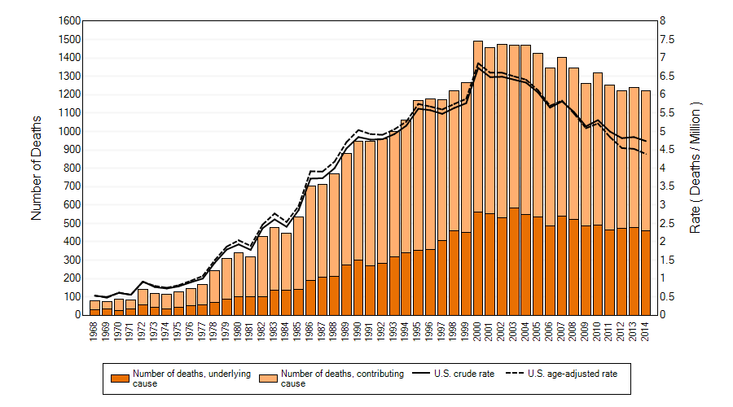

Figure 1. Asbestosis: Number of deaths, crude and age-adjusted death rates, U.S. residents age 15 and over, 1968-2014

Source: NIOSH 2017. Work-Related Lung Disease Surveillance System (eWoRLD). 2017-915 U.S. Department of Health and Human Services, Centers for Disease Control and Prevention, National Institute for Occupational Safety and Health, Respiratory Health Division, Morgantown, WV. Available at: <https://wwwn.cdc.gov/eworld/Data/915> April 21, 2018.

1.2 Silicosis

Silica is found in sand, sandstone, and granite and is also a major component of clay, shale, and slate. Industries and occupations including construction, sandblasting, and mining expose workers to crystalline silica. (11) When fine dusts are produced from cutting, grinding, and polishing these materials, crystalline silica is aerosolized and can be inhaled. (4) Silicosis is caused by the inhalation of crystalline silicon dioxide with quartz being the most common crystalline form. (9) Additional conditions associated with exposure to crystalline silica include lung cancer, non-malignant respiratory diseases, and kidney disease. (11, 12) Beginning in the 1700s, silicosis was identified among stone cutters and granite workers, yet it was not until the 1930s that the federal government recognized the need to create less hazardous work environments for these employees. (13) This was motivated by the industrial disaster associated with the construction of the Hawks Nest Tunnel near Gauley Bridge, West Virginia which resulted in hundreds of workers dying from silicosis while building the tunnel and another 1,500 contracting the disease within two years of working on the project. (13) However, as technology continued to evolve and working conditions varied, workers continued to be exposed to airborne silica dust. OSHA began the development of silica standards in the 1990s which took 19 years to go through the rule making process. (13) On March 24, 2016, OSHA announced the final rule that would protect workers from exposure to silica, and finally on September 23, 2017, OSHA began enforcement of the respirable crystalline silica standard. (13)

1.2.1 Regulation and Surveillance

OSHA has established the permissible exposure limit (PEL) to be 50 micrograms of respirable crystalline silica per cubic meter of air (50 µg/m³) as an 8-hour time-weighted average (TWA) in general industry. Firms are required to develop and install engineering and work practice controls that can meet the PEL in most of its operations without relying on respirators and only allows employers to rely on respiratory protection to protect their employees when engineering and work practice controls are not feasible or while they are being instituted. (12) Medical surveillance must be made available to employees exposed to respirable crystalline silica above for 25 µg/m³ as an 8-hour TWA or those required to use respirators for ≥30 days per year. (12) The written opinion of the licensed health care provider provided to the employer is to “only include recommended limitations on the employee's exposure to respirable crystalline silica and referral to a specialist if the employee provides written authorization. A separate written medical report is to be provided to the employee including this information as well as detailed information related to the employee's health.” (12)

1.2.2 Public Health Significance

The four main types of silicosis are simple silicosis, complicated silicosis, accelerated silicosis, and acute silicoproteinosis. These are differentiated by amount, intensity, and duration of exposure as well as symptomatology. (4, 10) Principally, silicosis is a slowly progressive fibrotic disease requiring up to 20 years to develop. The disease is characterized by dyspnea, restrictive pulmonary physiology, parenchymal infiltrates, and impaired gas exchange. (14) Comorbid conditions associated with silicosis include respiratory failure, pulmonary hypertension, and right heart failure. (10) Silicotic nodules tend to distribute in the upper lungs and on histopathologic examination, appear as “onion skin” lesions of concentrically arranged collagen fibers. Within these nodules are dust-laden macrophages and lymphoid cells. Silica crystals may be found in empty-cleft like spaces and are birefringent under polarized light. CT findings include focal soft-tissue masses with irregular margins and calcifications surrounded by emphysematous disease. (10) Approximately 2.3 million U.S. workers are at risk for exposure to respirable crystalline silica. (11) The number of deaths due to silicosis have steadily declined since the 1970s. (Fig 2) From 2005-2014, silicosis was listed as the underlying or contributing cause of death in over 1,100 death certificates in the U.S.; however, this is likely an underestimation of the true number of silica related deaths. (15, 16) OSHA estimates the coast of silica related morbidity and mortality to be greater than $8 billion annually, and the final rule on silica is estimated to provide annual net benefits over the next 60 years of $3.8 to $7.7 billion. (11, 16)
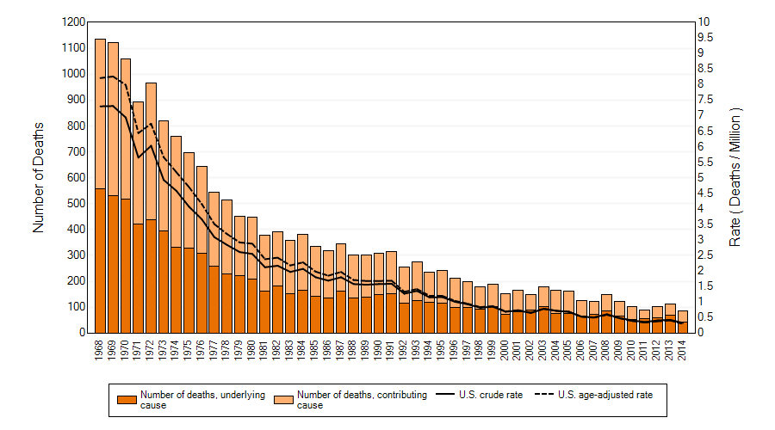
Figure 2. Silicosis: Number of deaths, crude and age-adjusted death rates, U.S. residents age and over, 1968-2014

Source: NIOSH 2017. Work-Related Lung Disease Surveillance System (eWoRLD). 2017-917 U.S. Department of Health and Human Services, Centers for Disease Control and Prevention, National Institute for Occupational Safety and Health, Respiratory Health Division, Morgantown, WV. Available at: <https://wwwn.cdc.gov/eworld/Data/917> April 21, 2018.

1.3 Coal Workers’ pneumoconiosis

Coal dust is made of carbon-containing particles, and during the process of coal mining, workers may also be exposed to silica-containing dust during rock drilling. (17) Before 1970, the prevalence of coals workers’ pneumoconiosis in longer tenured miners (≥30 years) exceeded 40% in various geographical areas. (18) This and the coal mine disaster at Farmington, West Virginia of 1968 in which 78 miners died during a coal mine explosion led to the enactment of the Federal Coal Mine Health and Safety Act of 1969. (18, 19) This act established the exposure limit for respirable coal mine dust and led to the creation of the National Institute for Occupational Safety and Health (NIOSH) administered Coal Worker’s Health Surveillance Program (CWHSP). The CWHSP began as a national monitoring program which offered free periodic chest radiographs to working underground coal miners (20). The overall prevalence of coal workers’ pneumoconiosis (CWP) among coal miners declined from 11.2% during 1970-1974, and then to 2% during 1995-1999. (18) The most severe and fatal form, progressive massive fibrosis (PMF) or “black lung”, was thought to be nearly eradicated. (19) However, between 2005-2006, the prevalence of CWP had increased to 3.3%.

1.3.1 The Resurgence of Progressive Massive Fibrosis
From 1990-1999, the CWHSP identified only 31 cases of PMF; however, a 2014 report noted a resurgence of PMF with 154 cases identified among CWHSP participants between 1998-2012 with most of these cases located in central Appalachia. (20). In February of 2017, “the director of a network of three federally funded black lung clinics (which primarily serve former miners, and are not affiliated with the CWHSP) in Southwest Virginia requested assistance to determine the burden of PMF in patients served by the clinics.” (21) Subsequently, a study by Blakley et al. between January 2013 and February 2017 identified 416 coal miners among approximately 11,200 observed during the study period meeting criteria for PMF. These were white men mostly residing in Kentucky or Virginia with a mean age of 61.8 (range, 38.6-88.7) who had a mean coal mining tenure of 27.9 years (range, 8-64). This now represents the largest cluster of PMF reported in the scientific literature. (21)

1.3.2 Coal Workers’ Regulation and Surveillance
In 2014, a federal rule from the U.S. department of labor improved protection for miners. This rule decreased the allowable dust concentration from 2.0 to 1.5 milligrams per cubic meter of air (mg/m³) at underground and surface coal mines and set concentration limits for air used to ventilate where miners work and for coal miners who have evidence of the development of pneumoconiosis to 0.5 mg/m³. It also required more-frequent sampling (every quarter) of dust levels, and expanded the CWHSP to include periodic lung function testing, respiratory health assessment questionnaires, and extended health surveillance to workers both underground and at surface coal mines. (22)

1.3.3 Public Health Significance

CWP is a consequence of inhalation of coal mine dust. The characteristic coal macule of CWP is typically found in the centrilobar region of the lung and is formed from the accumulation of dust particles engulfed by macrophages. (4) CWP may range in complexity from simple with no clinical signs or physical impairment to complex in which the patient displays multiple signs of chronic lung disease and severe physical disability. (4) Physiologic changes associated with PMF include severe airway obstruction, abnormalities in ventilation and perfusion, reduced diffusion capacity, hypoxia, pulmonary hypertension, and respiratory failure. (23) Histopathologic findings include areas of fibrotic lung tissue and alveoli containing pigment laden macrophages. (23) Simple CWP is similar radiographically to silicosis. Small nodules, <1 cm in size, are present within the upper and posterior lung zones and show greater disease burden on the right. All zones may be involved with more severe disease. (4, 10, 23) Complicated CWP or PMF describes the finding of irregular masses of fibrous tissue forming from the coalescence of coal macules >1 cm in size. (10, 23) CT is more sensitive than radiography in detecting disease.

During April-June 2016, the Mine Safety and Health Administration (MSHA) found that 99% of more than 20,000 operator-provided samples from underground coalmines were in compliance with the new dust standard. (24) However, only 17% of all working Kentucky miners were tested in the NIOSH surveillance program since 2011, and miners may have avoided the NIOSH testing because they worry it could cost them their jobs. (25) Mining jobs are high paying jobs in central Appalachia, and families rely on them as their source of income in an area where there are few other options for work. The current form of PMF overlaps with silicosis as the form of PMF being diagnosed in U.S. coal miners today is thought to be due to narrow seam mining. (26) The “thinner coal seams in central Appalachia are likely to blame for spikes in complicated black lung. The thickest seams are mostly gone. The thin seams that remain have coal embedded in rock, and that rock contains quartz. Cutting quartz and coal together results in mine dust that includes silica, which is especially toxic in lung tissue.” Protective masks, ventilation, and water sprays are supposed to reduce the dust burden to coal miners; however according the workers, even with proper safety gear, “one may breath so hard that the dust comes in around the mask and/or the respirators’ filters periodically become packed with dust requiring temporary removal.” (25) The resurgence of PMF has reached the mainstream media, and Howard Berkes, an NPR investigative reporter, is quoted as saying, “NIOSH has referred to it as one of the worst industrial workplace disasters in American history.” (27) More than $44 billion in federal compensation has been pain to coal miners disable by PMF and to their survivors since 1968. The most recent mortality data from the CDC reports death due to CWP to be 1 per million in 2014 and shows a steady decline since the 1980s. (Fig 3) This is likely an underrepresentation of the disease burden, however.
Although regulation strives to reduce occupational lung disease in the U.S., we continue to fail to accurately report the significance of these diseases, and it has been estimated that occupational illnesses and injuries could be “among the five leading causes of illness and death in our country.” (1) Occupational lung diseases require greater attention by clinicians, the public health community, and federal government. Further reform is needed to ensure the health of workers in these industries.

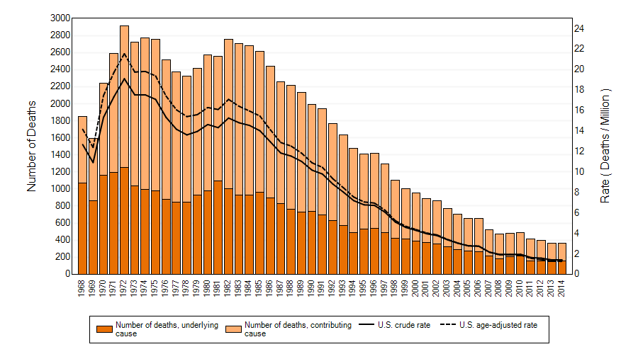
Figure 3. Coal Workers’ Pneumoconiosis: Number of deaths, crude and age-adjusted death rates, U.S. residents age 15 and over, 1968-2014
Source: NIOSH 2017. Work-Related Lung Disease Surveillance System (eWoRLD). 2017-916 U.S. Department of Health and Human Services, Centers for Disease Control and Prevention, National Institute for Occupational Safety and Health, Respiratory Health Division, Morgantown, WV. Available at: <https://wwwn.cdc.gov/eworld/Data/916> April 21, 2018.

bibliography
1. Woeppel P. Occupational Diseases in the United States: Workers; Compensation and OSHA, Our Failed Systems in Need of Overhaul 2012 [April 21, 2018]. Available from: http://workerscomphub.org/sites/default/files/resource-files/Occupational%20Diseases%20in%20the%20United%20States%20Workers%27%20Compensation%20and%20OSHA%2C%20Our%20Failed%20Systems%20in%20Need%20of%20Overhaul.pdf.
2. Cullinan P, Reid P. Pneumoconiosis. Primary care respiratory journal : journal of the General Practice Airways Group. 2013;22(2):249-52.
3. MesotheliomaGroup. 2018 [April 21, 2018]. Available from: https://www.mesotheliomagroup.com/09-25-17-asbestos-costs.html.
4. Seaman DM, Meyer CA, Kanne JP. Occupational and environmental lung disease. Clin Chest Med. 2015;36(2):249-68, viii-ix.
5. Solbes E, Harper RW. Biological responses to asbestos inhalation and pathogenesis of asbestos-related benign and malignant disease. Journal of investigative medicine : the official publication of the American Federation for Clinical Research. 2018;66(4):721-7.
6. National Institute of Occupational Safety and Health. Asbestos 2013 [April 21, 2018]. Available from: https://www.cdc.gov/niosh/topics/asbestos/.
7. U.S. Environmental Protection Agency. Asbestos Laws and Regulations 2016 [April 21, 2018]. Available from: https://www.epa.gov/asbestos/asbestos-laws-and-regulations.
8. Occupational Safety and Health Administration. Medical surveillance guidelines for asbestos - Non-Mandatory 1994 [April 21, 2018]. Available from: https://www.osha.gov/pls/oshaweb/owadisp.show_document?p_table=STANDARDS&p_id=10003.
9. Fujimura N. Pathology and pathophysiology of pneumoconiosis. Current opinion in pulmonary medicine. 2000;6(2):140-4.
10. Reid PA, Reid PT. Occupational lung disease. The journal of the Royal College of Physicians of Edinburgh. 2013;43(1):44-8.
11. National Institute of Occupational Safety and Health. Silica 2017 [April 21, 2018]. Available from: https://www.cdc.gov/niosh/topics/silica/.

12. Occupational Safety and Health Administration. Occupational Exposure to Respirable Crystalline Silica 2016 [April 21, 2018]. Available from: https://www.federalregister.gov/documents/2016/03/25/2016-04800/occupational-exposure-to-respirable-crystalline-silica.
13. Work Safety With Silica. Status of Regulatory Efforts 2018 [April 21, 2018]. Available from: https://www.silica-safe.org/regulations-and-requirements/status-of-regulatory-efforts/history.
14. Mao WJ, Chen JY, Zheng MF, Ye SG, Liu F, He YJ, et al. Lung transplantation for end-stage silicosis. Journal of occupational and environmental medicine. 2011;53(8):845-9.
15. Mazurek JM, Wood JM, Schleiff PL, Weissman DN. Surveillance for Silicosis Deaths Among Persons Aged 15-44 Years - United States, 1999-2015. MMWR Morbidity and mortality weekly report. 2017;66(28):747-52.
16. National Safety Compliance. FAQ on Respirable Crystalline Silica 2018 [April 21, 2018]. Available from: https://www.osha-safety-training.net/faq-on-respirable-crystalline-silica/.
17. American Lung Association. Pneumoconiosis Symptoms, Causes and Risk Factors 2018 [April 21, 2018]. Available from: http://www.lung.org/lung-health-and-diseases/lung-disease-lookup/pneumoconiosis/pneumoconiosis-symptoms-causes-risks.html.
18. Suarthana E, Laney AS, Storey E, Hale JM, Attfield MD. Coal workers' pneumoconiosis in the United States: regional differences 40 years after implementation of the 1969 Federal Coal Mine Health and Safety Act. Occupational and environmental medicine. 2011;68(12):908-13.
19. Blackley DJ, Crum JB, Halldin CN, Storey E, Laney AS. Resurgence of Progressive Massive Fibrosis in Coal Miners - Eastern Kentucky, 2016. MMWR Morbidity and mortality weekly report. 2016;65(49):1385-9.
20. Blackley DJ, Halldin CN, Laney AS. Resurgence of a debilitating and entirely preventable respiratory disease among working coal miners. American journal of respiratory and critical care medicine. 2014;190(6):708-9.
21. Blackley DJ, Reynolds LE, Short C, Carson R, Storey E, Halldin CN, et al. Progressive Massive Fibrosis in Coal Miners From 3 Clinics in Virginia. Jama. 2018;319(5):500-1.
22. Mine Safety and Health Administration. Lowering Miners' Exposure to Respirable Coal Mine Dust, Including Continuous Personal Dust Monitors 2014 [April 20, 2018]. Available from: https://www.federalregister.gov/documents/2014/05/01/2014-09084/lowering-miners-exposure-to-respirable-coal-mine-dust-including-continuous-personal-dust-monitors.
23. Hayes D, Jr., Diaz-Guzman E, Davenport DL, Zwischenberger JB, Khosravi M, Absher KJ, et al. Lung transplantation in patients with coal workers' pneumoconiosis. Clinical transplantation. 2012;26(4):629-34.
24. Mine Safety and Health Administration. MSHA finds nearly all respirable coal dust samplings comply with new standards to lower levels of respirable coal dust 2016 [April 20, 2018]. Available from: https://www.msha.gov/msha-finds-nearly-all-respirable-coal-dust-samplings-comply-new-standards-lower-levels-respirable.
25. Berkes H. Advanced Black Lung Cases Surge In Appalachia 2016 [April 20, 2018]. Available from: https://www.npr.org/2016/12/15/505577680/advanced-black-lung-cases-surge-in-appalachia.
26. Graber JM, Harris G, Almberg KS, Rose CS, Petsonk EL, Cohen RA. Increasing Severity of Pneumoconiosis Among Younger Former US Coal Miners Working Exclusively Under Modern Dust-Control Regulations. Journal of occupational and environmental medicine. 2017;59(6):e105-e11.
27. Holsopple K. A Surge of Black Lung Disease in Appalachia 2018 [April 20, 2018]. Available from: https://www.alleghenyfront.org/a-surge-of-black-lung-disease-in-appalachia/.

