THE IMPACT OF STATE FAMILY PLANNING POLICIES ON WOMEN’S AND CHILDREN’S HEALTH AND ECONOMIC OUTCOMES

by
Sushma Narra
BS, The Ohio State University, 2016

Submitted to the Graduate Faculty of
the Department of Health Policy & Management
Graduate School of Public Health in partial fulfillment
of the requirements for the degree of
Master of Health Administration

University of Pittsburgh
2018

UNIVERSITY OF PITTSBURGH
GRADUATE SCHOOL OF PUBLIC HEALTH

This essay is submitted
by
Sushma Narra

on

April 26, 2018
and approved by

Essay Advisor:
Marian Jarlenski, PhD, MPH _________________________________
Assistant Professor
Health Policy and Management
Graduate School of Public Health
University of Pittsburgh

Essay Reader:
Martha Ann Terry, PhD _________________________________
Associate Professor
Behavioral and Community Health Sciences
Graduate School of Public Health
University of Pittsburgh

ABSTRACT
Copyright © by Sushma Narra
2018
Marian Jarlenski, PhD, MPH
THE IMPACT OF STATE FAMILY PLANNING POLICIES ON WOMEN’S AND CHILDREN’S HEALTH AND ECONOMIC OUTCOMES
Sushma Narra, MHA
University of Pittsburgh, 2018
Background: Contraception access is strongly connected to women’s greater educational and professional opportunities, increased lifetime earnings, and improved reproductive health outcomes. The objective of this research is to compare state family planning policies in the United States to state-level health and social outcomes in order to expand public health policies regarding access to contraception.
Methods: This state-level policy analysis is an exploratory correlational study. Whether any relationship exists between state family planning policies and relevant outcomes among women and children was investigated. State-level data on five family planning policies and six outcomes were collected. It was hypothesized that women and children in states with a greater number of family planning policies in place would have more favorable health and social outcomes. A state was the unit of analysis. A bivariate correlation analysis using the Pearson’s Correlation Coefficient (PCC) to determine the direction and magnitude of the correlation between the number of state policies and each outcome was conducted.
Results: The findings show that there is a correlation between the number of state family planning policies and outcomes among women and children. Five of the six outcome variables have a relationship that was expected; two outcome variables (earnings among women and infant mortality) have a ρ>0.10 which is a high correlation value in policy research.
Conclusions: The general relationship trends seen between the number of policies and outcomes and the at least moderate PCC, justifies the need for future causal research. This analysis begins to draw conclusions between specific health and social outcomes in order to drive policy decisions to reduce barriers of access to contraception for women.

TABLE OF CONTENTS
preface ix
1.0 Introduction 1
1.1 Family Planning Health Benefits 1
1.2 Social and Economic Benefits of Family Planning 3
1.3 OBJECTIVE 4
2.0 History of Policies 5
3.0 Methods 8
3.1 Policy Variables 8
3.1.1 Medicaid Policy 8
3.1.1.1 Medicaid Family Planning Program 8
3.1.1.2 ACA Medicaid Expansion of Coverage 9
3.1.2 Insurance Policy 9
3.2 Outcome Variables 10
3.3 SOURCES 11
3.4 Statistical methods 12
4.0 Findings and Results 13
4.1 Discussion 22
5.0 Conclusion 26
Appendix A : FAMILY PLANNING POLICIES 28
Appendix B : HEALTH AND SOCIAL OUTCOMES 29
bibliography 30

List of tables
Table 1. Policy Variable Sources 11
Table 2. Outcome Variable Sources 11
Table 3. Raw Data of Family Planning Policies 28
Table 4. Raw Data of Health and Social Outcomes 29

List of figures
Figure 1. Timeline of Family Planning Policies 5
Figure 2. Number of Family Planning Policies in each State (Kaiser Family Foundation) 13
Figure 3. Number of States with each Family Planning Policy (Kaiser Family Foundation) 14
Figure 4. Correlation between Number of Family Planning Policies and Median Earnings among Women 15
Figure 5. Correlation Between Number of Family Planning Policies and Percentage of Reproductive-Aged Females Living in Poverty 16
Figure 6: Correlation Between Number of Family Planning Policies and Percent of Children in Poverty 17
Figure 7. Correlation Between Number of Family Planning Policies and the Rate of Unintended Pregnancy 19
Figure 8. Correlation Between Number of Family Planning Policies and Rate of Maternal Mortality 20
Figure 9. Correlation Between Number of Family Planning Policies and Rate of Infant Mortality Per 1,000 Live Births 21

preface
First and foremost, thank you to my incredible parents and sister for supporting me throughout every step of my schooling. Thank you, also, to my advising committee: Dr. Martha Terry and Dr. Jarlenski. Dr. Jarlenski, thank you for making my rough idea into a workable essay and for all of the time you’ve dedicated.

Introduction
Access to family planning methods is crucial for helping women plan and space births appropriately. Granting women, the freedom to decide when and whether to bear children yields a myriad of health, social, and economic benefits for women and their families. Currently, the range of FDA-approved methods are short acting hormonal methods (including “the pill”), long-acting reversible contraceptives (including the IUD), and contraceptive injections. Lack of access to contraceptives is disproportionately seen among low-income and minority women and is an important factor towards improving health equity. Federal and state policies have played a critical role in decisions regarding family planning access among women. This essay will analyze state-level policy in terms of family planning related policies, and state-level health and social outcomes. Ultimately, this research seeks to explore why family planning plays such a pivotal role in health and well-being in order to expand access through policy action.

Family Planning Health Benefits
The use of contraception allows women to delay, plan, space, and limit pregnancies, which improves health outcomes and enhances the lives of women and their families. Approximately half of all pregnancies in the United States are unintended (either unwanted or mistimed) (Finer and Zolna, 2011). Contraceptive methods improve health by reducing the number of unintended pregnancies, decreasing pregnancy and birth related morbidities, and reducing the proportion of short inter-pregnancy intervals.
Studies estimate that about 43% of unintended pregnancies result in abortion (Finer and Zolna 2011). The percentage of women at risk for unintended pregnancy who were using contraceptives increased from 78% in 1982 to 89% in 2006-2010. This increase in contraception use was accompanied by a decline in unintended pregnancy and abortion rates among this group of women (Jones, Mosher and Daniels, 2012). By preventing pregnancies and their resulting births, contraceptive methods decrease pregnancy and birth-related morbidity and mortality. Per 100,000 live births, 11 women aged 20-24, 24 women aged 35-39, and 55 women aged 40 years and older die as a result of pregnancy related issues; these rates are three to four times higher among African-American women (Jones, Mosher and Daniels, 2012).
Planning and spacing of births allow for a significant reduction of low birth weight births. A substantial body of research indicates that short inter-pregnancy intervals, defined as less than 18 months between a birth and subsequent pregnancy, are associated with a number of adverse outcomes for both mother and child, including increased risk of preterm birth, low birth weight, and preeclampsia (Conde-Agudelo, Rosas-Bermúdez, Kafury-Goeta , 2006). The potential association between pregnancy intentions and inter-pregnancy intervals is of particular interest. Pregnancies reported as mistimed or unwanted were significantly more likely to have short inter-pregnancy intervals compared to pregnancies reported as intended (Gemmill, & Lindberg,2013). Thus, increasing women's contraceptive use to reduce rates of unintended pregnancy would likely decrease the proportion of short inter-pregnancy interval pregnancies in the United States; in turn, this greatly benefits a woman’s reproductive health.

Social and Economic Benefits of Family Planning
Controlling family timing and size can also be key to unlocking opportunities for economic success, education and equality. Many leaders of the civil rights and women’s rights movements of the 1960s pointed to contraception as an important tool for social justice. They argued that reliable contraception could help women complete their education and join the workplace as full partners with men. It could also help families break cycles of poverty across generations, patterns often perpetuated by unintended pregnancies, especially among teenagers (Sonfield et al., 2013).
Social and economic gains for women that result from effective family planning are increased educational opportunities, workforce participation, economic stability, and well-being of families. Pregnancies and education are intertwined: “The link between women’s ability to plan their pregnancies and their academic achievement appears to be particularly strong when it comes to attending and completing college” (Sonfield et al., 2013 pg 2). Several influential studies with Bailey, Hershebein, and Miller state that young, single women from the late 1960s through the early 1970s indicate that this generation’s ability to obtain highly effective contraception was a significant factor behind more women investing in higher education (Bailey, Hershbein and Miller, 2012).
Greater access to education is a vital step in obtaining a job. An increase in education can also position one to successfully obtain a well-paying and secure career position. By delaying and controlling when to bear children, women are able to pursue higher education, obtain more financially stable, professional positions, and thus increase their overall earnings (Bailey, Hershbein and Miller, 2012). With the availability of more resources, women and their partners are better able to provide for their families. Birth control has had such a dramatic impact on women and families in this country, allowing women to invest in their futures and careers, giving them time and a choice when planning for families (Starbird, Norton, Marcus, 2016). This has yielded long lasting positive impacts to society and the economy, as a whole.

OBJECTIVE
The objective of this research is to compare state family planning policies in the United States to state-level health and social outcomes. To conduct this study, state-level data on five family planning policies and six outcomes (median earnings among women, percentage of females in poverty rate of unintended pregnancies, maternal mortality rate, infant mortality rate and percent of children in poverty) were collected. It was hypothesized that states with a greater number of family planning policies in place would have increased median earnings, decrease the percentage of females in poverty, reduce the rate of unintended pregnancies, decrease the maternal mortality rate, decrease the infant mortality rate, and decrease the percent of children in poverty.

History of Policies
Policies regarding family planning were shaped by the passage of Medicaid, Medicare, the decision of the landmark law Griswold v. Connecticut, Title X Family Planning Program, and The Affordable Care Act. Figure 1 displays the sequential timeline of events that affected family planning policies.

Figure 1. Timeline of Family Planning Policies

On June 7, 1965, the United States Supreme Court, in Griswold v. Connecticut struck down a Connecticut law that made the use of birth control by married couples illegal. The court’s landmark decision provided the first constitutional protection for birth control and paved the way for the nearly unanimous acceptance of the idea of contraception that now exists in this country. The court's recognition of an individual’s right to privacy in deciding when and whether to have a child in Griswold became the basis for later reproductive rights decisions (Planned Parenthood Federation of America, 2015).
Shortly after the Griswold v. Connecticut decision, Medicare and Medicaid were signed into law by President Lyndon Johnson on July 30, 1965. Medicaid remains a critical component of the U.S healthcare system and is instrumental in aiding family planning efforts. Medicaid is the nation’s major public financing program for providing health insurance coverage to the poor and plays a critical role in providing health coverage for low-income women and their children. Women comprise the majority of adult Medicaid beneficiaries today (Kaiser Family Foundation, 2017). Providing more than 25 million low-income women with health and long-term care coverage in 2014 and serving 9.4 million female contraceptive clients, Medicaid is the largest financier of publicly funded family planning services (Sonfield, 2012). Without these services, unintended pregnancy, teen pregnancy and abortion in the United States would be nearly two-thirds higher among women overall and close to twice as high among poor women (Sonfield, 2012).
The Title X Family Planning Program, or “Population Research and Voluntary Family Planning Programs” was enacted under President Richard Nixon in 1970 as part of the Public Health Service Act (Office of Population Affairs, 2018). Title X is the only federal grant program dedicated solely to providing individuals with comprehensive family planning and related preventive health services. Its overall purpose is to promote positive birth outcomes and healthy families by allowing individuals to decide the number and spacing of their children. Because cost can be a major barrier to contraception access, Title X operates by granting funds to a network of community-based clinics that provide contraceptive services, related counseling, and other preventive health services. These clinics fill in the much-needed gaps in the continuum of care for low-income women (National Women’s Law Center, 2016).
The most recent health reform that has shaped policies regarding contraception and family planning is the passage of the Affordable Care Act (ACA). The official name, The Patient Protection and Affordable Care Act, was signed into law by President Obama in 2012. Realizing the critical need for and importance of preventive health services for women, the ACA includes many provisions for improving women’s reproductive health. The ACA left it to the states to decide whether to expand Medicaid to increase eligibility for a greater population. Having basic insurance coverage allowed women to seek reproductive care and obtain prescriptions for contraception. Additionally, under the ACA’s birth control benefit, all health plans must provide coverage of birth control with no cost-sharing, such as out-of-pocket costs like deductibles, co-payments, and co-insurance (National Women’s Law Center, 2016). The birth control benefit also applies to populations newly covered through the Medicaid expansion (National Women’s Law Center, 2016).
Americans are more often subject to state laws, not federal laws. The federal government allows for great interpretation at the state level. The differences in interpretation across states allows for more disparities in health access across state entities. This is the motive behind focusing on policies and measurable results at the state-level.

Methods
First, a policy scan to analyze current policies in each state for the most recent year of data available (i.e., 2016) was conducted. Next, state-level data on relevant outcomes in the same time period were collected.

Policy Variables
Medicaid policy and insurance policy were central in the analysis. From Medicaid, the family planning program and states’ decisions on Medicaid expansion through the ACA were examined. In the realm of insurance policy, insurance coverage of prescription methods, prohibition of cost-sharing of contraceptives, and refusal provision of insurance coverage of contraceptives were examined.

Medicaid Policy

Medicaid Family Planning Program
Medicaid plays a primary role financing health care services and facilitating access to a broad a range of sexual and reproductive health services for millions of low-income women of childbearing age (Ranji, Bair and Salganicoff, 2016). With a sizeable group of women of reproductive age using Medicaid, this family planning program was enacted so states could provide some level of family planning services to them. By federal law, Medicaid enrollees get family planning care without copayments or other out-of-pocket costs (Ranji, Bair and Salganicoff, 2016). About half of states have programs that expand eligibility for family planning services to individuals otherwise ineligible for Medicaid (Sonfield, 2017). These Medicaid family planning expansions were pioneered by states in the mid-1990s as waiver programs that entailed approval from Centers for Medicare and Medicaid (CMS) (CMS, 2017). Congress granted states the authority under the ACA to initiate a Medicaid family planning expansion without a waiver. Data from Kaiser Family Foundation display the states that chose to expand family planning coverage to those whose incomes are too high to be eligible for Medicaid; the expansion is limited by amount of household incomes which is discretionary to each state (Kaiser Family Foundation, 2016).

ACA Medicaid Expansion of Coverage
The Affordable Care Act (ACA) expanded coverage for the poorest Americans by creating an opportunity for states to provide Medicaid eligibility, effective January 1, 2014, for individuals under 65 years of age with incomes up to 133% of the federal poverty level (FPL) (CMS, 2017). The U.S. Supreme Court ruled that Medicaid expansion was to be voluntary and at the discretion of each state. The data from Kaiser Family Foundation display whether or not the state has decided to expand Medicaid (Kaiser Family Foundation, 2016).

Insurance Policy
The three facets of insurance policy examined in this paper for each state were the insurance coverage of prescription methods, prohibiting cost sharing of contraceptives, and the refusal provision of insurance coverage of contraception. The ACA is the first law to set coverage requirements for health insurance across all markets. Currently 28 states require insurance plans that cover prescription drugs to cover contraceptives (Sobel, Beamesderfe and Salganicoff, 2016). The ACA’s focus on providing preventative services without cost sharing expands to contraception. Cost sharing is payment of any co-payment or deductible at the tim of service. Six states within their state jurisdiction prohibit cost sharing (Sobel, Beamesderfer, Salganicoff, 2016). Given that private insurance coverage differs across states, compliance with the contraceptive mandate is left to the discretion of the states. Twenty states allow certain employers and insurers to refuse to comply with the contraceptive coverage mandate and eight states do not permit refusal by any employees (Sobel, Beamesderfer and Salganicoff, 2016).

Outcome Variables
The outcomes of interest were median earnings of women, number of reproductive females in poverty, rate of unintended pregnancies, maternal mortality, number of children in poverty, and infant mortality. The median earnings among women in every state were obtained to explore the relationship between policies regarding contraceptive access and median earnings of women. The reproductive-aged females in poverty and children in poverty go hand in hand with availability of economic resources and earnings. Rate of unintended pregnancies is to evaluate the effectiveness of access to contraceptive methods and it is also an important factor for the number of children in poverty. Lastly, infant and maternal mortality are health outcomes that can be improved with contraception use.

SOURCES
Table 1 and Table 2 display the policy or outcome variables of interest and their corresponding data source and time period.
Table 1. Policy Variable Sources
Policy Variable | Data Source | Time Period
Medicaid Family Planning Program Expansion | Kaiser Family Foundation | January 2016
State Decision on ACA Medicaid Expansion | Kaiser Family Foundation | January 2016
Insurance Coverage- Prescription Methods | Guttmacher Institute | January 2018
Prohibits Cost Sharing of Contraceptives | Guttmacher Institute | January 2018
Refusal Provisions of Insurance Coverage for Contraceptives | Guttmacher Institute | January 2018

Table 2. Outcome Variable Sources
Outcome Variable | Data Source | Time Period
Median Earnings (Women) | United States Census Bureau | 2016
Reproductive Females in Poverty | National Women’s Law Center | 2016
Rate of Unintended Pregnancies (per 1000) | Guttmacher Institute | 2010
Maternal Mortality Rate per 100,000 births | Centers for Disease Control and Prevention | 2016
Children (3-12)  in Poverty (%) | National Women’s Law Center | 2016
Infant Mortality (per 1000 live births) | Centers for Disease Control and Prevention | 2016

Statistical methods
The unit of analysis was each individual state. The District of Columbia was excluded because it has a unique policymaking environment that is shaped by the U.S. Congress. Policies were chosen relating to contraceptive coverage and accessibility and were then evaluated on a per state basis. Each state was categorized as to whether or not it had each of the five family planning policies. Then, the number of policies for each state was summed. Health and socio-cultural outcomes such as reproductive-aged females in poverty and children in poverty were chosen based on outcomes most likely affected by a change in contraceptive access. These specific outcomes on a per-state basis were evaluated. State-level descriptive statistics were conducted. Finally, a bivariate correlation analysis using the Pearson’s Correlation Coefficient (PCC) was carried out. The PCC was calculated to determine the direction and magnitude of the correlation between the number of state policies and each outcome.

Findings and Results
Figure 2 shows the number of family planning policies that each state has adopted. As shown in this figure, only three states (New York, California and Oregon) have all five policies that were used in this study. Conversely, only four states have no policies (South Dakota, Kansas, Nebraska and Utah). The remaining 43 states have one to four of the policies. The states in the northeastern region of the United States generally adopted two or more policies. The west coast states have high adoption rates, from four to 5 policies. The states in the south and central United States have adopted the least number of policies adopted.
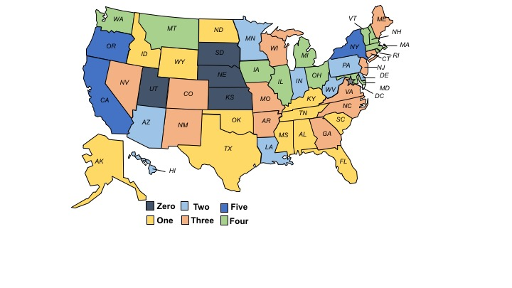
Figure 2. Number of Family Planning Policies in each State (Kaiser Family Foundation)

Figure 3 shows the number of states that have adopted each of the five family planning policies. A large majority of states adopted Medicaid expansion as a part of the Affordable Care Act. Over half of the states were also in support of the Medicaid Family Planning Program and having insurance coverage of prescription contraceptives. Only nine states prohibited cost sharing of contraceptives to patients.

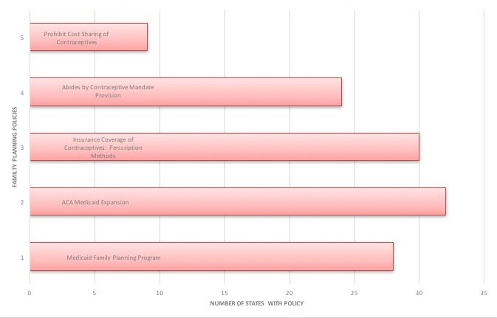
Figure 3. Number of States with each Family Planning Policy (Kaiser Family Foundation)

Figures 4 to 9 present the correlation plots of the number of policies adopted by each state graphed with an outcome variable. For each figure, the X-axis shows the number of state policies in place, and the Y-axis shows the outcome of interest. Each circle represents one state.
Figure 4 shows the relationship between median earnings of women in the US and the number of family planning policies. There is a moderate positive correlation with a ρ=0.1486..

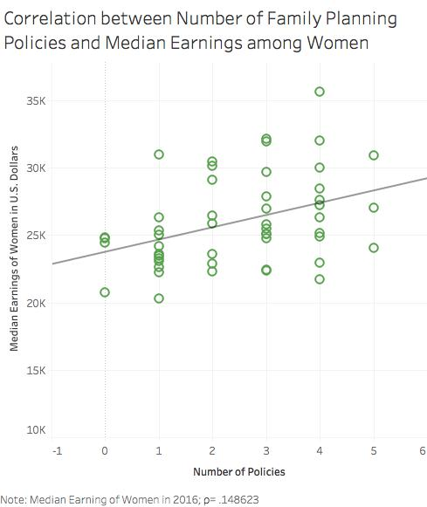

Figure 4. Correlation between Number of Family Planning Policies and Median Earnings among Women

Figure 5 shows the relationship between the percent of reproductive-aged females living in poverty and the number of family planning policies adopted by each state. The graph shows a slightly negative relationship between the two variables, suggesting that as the number of policies increases, the percent of reproductive aged females living in poverty decreases.
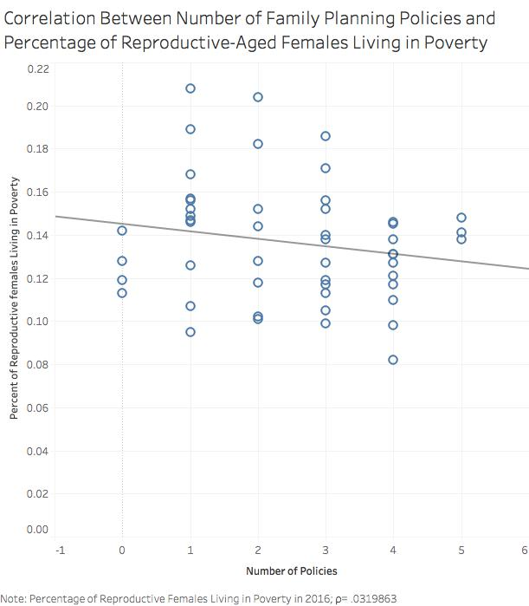

Figure 5. Correlation Between Number of Family Planning Policies and Percentage of Reproductive-Aged Females Living in Poverty

Similar to figure 5, figure 6 shows the relationship between percent of children in poverty and the relationship it has with the number of family planning policies. The figure shows a slightly negative correlation, as well.

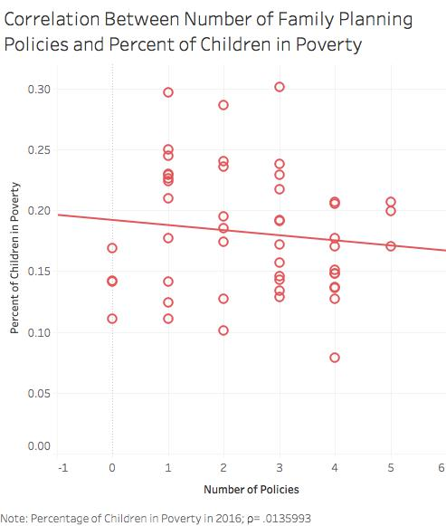

Figure 6: Correlation Between Number of Family Planning Policies and Percent of Children in Poverty
Figure 7 displays the relationship of the number of policies and the rate of unintended pregnancies (per 1000). The straight line alludes to the weak to no correlation; the Pearson’s correlation coefficient is as follows, ρ= .000618.

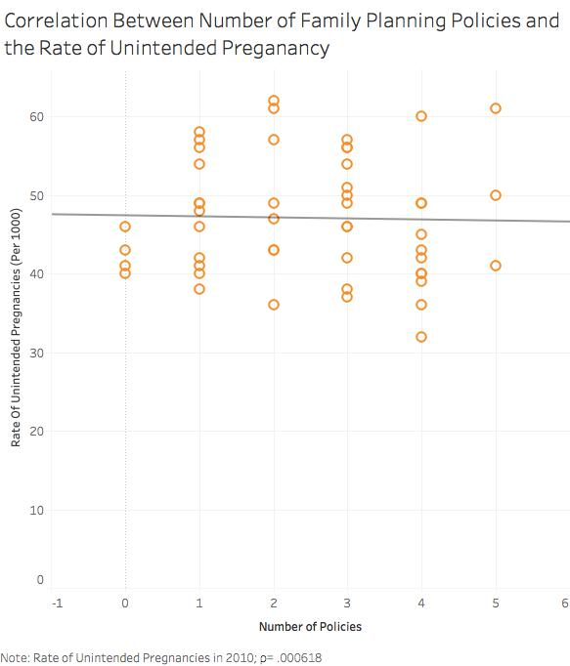

Figure 7. Correlation Between Number of Family Planning Policies and the Rate of Unintended Pregnancy

Figure 8 shows the correlation among the number of family planning policies and the rate of maternal mortality per 100,000 births. This graph excludes data from Vermont and Alaska as data was not made available in those states. As the line shows, the correlation is slightly negative correlation.
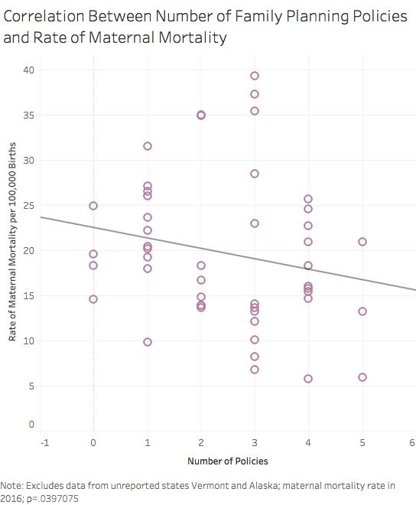

Figure 8. Correlation Between Number of Family Planning Policies and Rate of Maternal Mortality
Lastly, similar to figure 8, figure 9 shows the infant mortality rate per 1,000 live births and the number of family planning policies. The correlation is moderately strong and negative; the Pearson’s correlation coefficient is ρ=.1097866.
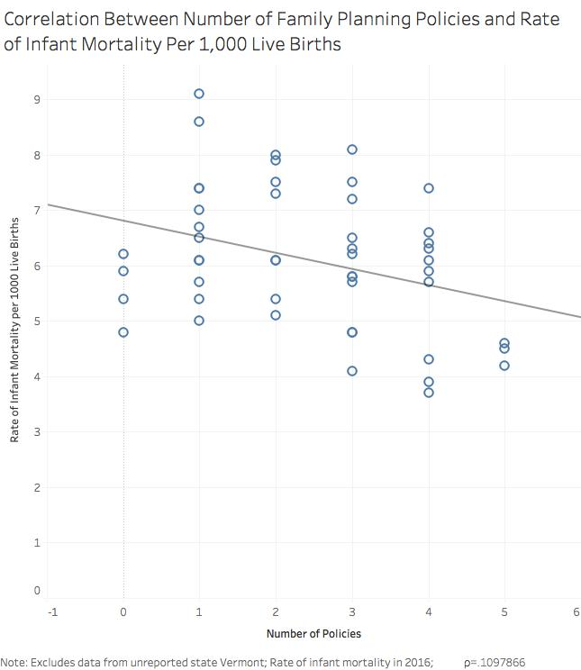

Figure 9. Correlation Between Number of Family Planning Policies and Rate of Infant Mortality Per 1,000 Live Births

Discussion
This state-level policy analysis was conducted to investigate possible correlations between state-level family planning policies and outcomes, in order to explore whether policy changes could improve contraception and family planning access. The family planning policies examined in this study had various rates of adoption among states. The findings show that there is indeed a correlation between the state family planning policies and outcomes for women and children. As expected, a positive correlation between the number of family planning policies and median earnings among women was observed. For outcome variables in figures 5 through 9, negative correlations (reproductive-aged females in poverty, maternal mortality, infant mortality, children in poverty, and unintended pregnancies), were expected and observed.
Figure 4 presents the correlation between median earnings among women and the number of family planning policies. By empowering women to plan and space their births appropriately, women are better able to attain and pursue higher education. This leads to greater earning potential and thus higher incomes, which were observed. Similar to earnings, when comparing family planning policies and number of reproductive females in poverty, a negative correlation is seen. This suggests that as more policies are implemented, women experience greater access to contraception, which can equate to higher incomes that help women escape the poverty threshold. For children in poverty outcome variable, it was expected to see a negative correlation with a greater number of family planning policies due a greater percentage of planned births with access to contraceptive methods. This enables women and families to provide more resources to their children. When discussing maternal mortality, access to contraception leads to fewer births and thus less pregnancy-related deaths such as maternal mortality. Infant mortality is decreased, in part, due to more family planning policies in place to drive greater access and usage to contraceptives. When inter-pregnancy intervals are higher, such as with effective contraception, there are fewer health complications for the infant.
A flat trend line and ρ= .00061, show that unintended pregnancy was not correlated with the number of family planning policies. This is in contrast to the expectation of a strong and positive correlation. A possible reason for this discrepancy is the nature of the state-level data on unintended pregnancy rates. This outcome is based on survey questions from the Pregnancy Risk Assessment Monitoring System (PRAMS) among women who have recently delivered a live birth. It is possible that, because this is a self-reported outcome that is changing over time, the unintended pregnancy rate measurement is noisier in terms of data reporting than other measures in our study.

Current research shows many similarities, but also a few distinctions. In the study funded by the Office of Population Affairs (OPA), in three study states (New York, Oregon, and Illinois), access to Medicaid family planning and related waivers was associated with a sizeable decrease in unintended and mistimed pregnancies and the resulting births (Finer and Zolna, 2011). This contradicts the data that unintended births are related to number of policies. This difference may be accounted for because of different study designs. In this study, policies were tallied and correlated with unintended pregnancy in all U.S. states; in the study mentioned above, a specific policy was analyzed and measured in three states to evaluate unintended pregnancy. The method by which data were studied and analyzed can account for the variation. In a more recent study with Georgia’s Department of Health, Medicaid and Title X policies were studied in conjunction with access to contraception (Dunlop et al. 2016). This study found a significant increase in the probability of Title X clients and Medicaid waiver women having access to and using of effective contraceptive methods such as LARCs. This is aligned with the hypothesis that with policy encompassing insurance and health care availability to low income populations, there will be greater usage of contraceptive methods, including LARCs. In a study conducted by Colorado Department of Public Health and Environment in 2016, the findings further reinforce this. A family planning initiative to improve access to contraception (especially among young women) was proposed by the Colorado Family Planning Initiative. This intervention utilized local, state, and federal funds to make LARC methods available without a cost barrier. This initiative significantly reduced unintended pregnancy rates by 40 percent among women aged 15-19 and 20 percent for women ages 20-24 between 2009 (Colorado Department of Public Health and Environment, 2017). The number of abortions was significantly reduced among women aged 15-19, by 50 percent, and aged 20-24, by 18 percent (Colorado Department of Public Health and Environment, 2017).

Another study from the Jacobs Institute of Women’s Health in 2016 shows the relationship between state-level Medicaid agencies and the Immediate Postpartum Long-Acting Reversible Contraception (IPLARC) policy implementation. When states add the device and insertion cost of a LARC into the labor and delivery payment bundle, many more women want the LARC and its associated long-term improved maternal and child health outcomes (Moniz et al, 2015).

This state-level policy analysis is an exploratory correlational study, that investigated whether any relationship exists between state family planning policies and relevant outcomes among women and children. This study does not establish that the number or types of policies cause a change in these outcomes. The PCC’s calculated across the various outcome variables quantifies the observational data collected. Five of the six outcome variables have the expected relationship; two outcome variables (earnings among women and infant mortality) have a ρ>0.10, a high correlation value within policy research. The general relationship trends between the number of policies and outcomes and the at least moderate PCC justifies the need for future causal research.

This policy analysis was done to conceptualize the effects of policies related to contraceptive access may have on social and health outcomes in the U.S. There is a sizeable amount of variation between states, as each has distinctive policy making abilities. This analysis begins to draw conclusions between specific health and social outcomes in order to drive policy decisions to reduce barriers of access to contraception for women.

Conclusion
The ability of women to decide when to bear children using contraceptives allows for a myriad of health, social, and economic benefits. Thus, the objective of this research is to compare the correlation between individual state family planning policies in the United States in relation to state-level health and social outcomes. This policy analysis is an exploratory correlation study. The five policies studied were centered around Medicaid and private insurance policy. The outcomes of interest were based on social, economic and health indicators of women and their children. The PCC calculated quantifies the observational data collected. Five of the six outcome variables have the expected relationship; two outcome variables (earnings among women and infant mortality) have a ρ>0.10, a high correlation value within policy research. The results illustrate the need for future causal research in this area of analysis.
This study has limitations. First, the analyses use state-level data that are vulnerable to ecological bias. Since our exposures of interest, state policies, are part of environmental context, rather than individual-level, there is no within-area variability in exposure that is a common source of ecological bias, however. Second, as stated previously, this is an exploratory study and cannot establish causal relationship. That is an important topic for future research. Third, the analyses are cross-sectional in nature, meaning that temporality between the adoption of the policies and outcomes cannot be established. It is possible that states with better outcomes among women and children are more likely to adopt family planning policies. Again, future research on this topic is warranted.
Policy barriers to contraceptive access can have long-lasting social and health outcomes. By minimizing the cost burden on women, greater contraceptive access and usage is seen among women. Affordable contraception access affects a family’s financial situation and is a vital component of equality for women. Low income women are disproportionately affected and hence the specific policies chosen for this study are largely public supports for women experiencing economic hardship and systemic biases. Contraception access is strongly connected to women’s greater educational and professional opportunities, increased lifetime earnings, and improved reproductive health outcomes. Birth control provides a sense of agency and empowerment for women which is favorable for all women, families, and society at large.

        - : FAMILY PLANNING POLICIES
Table 3. Raw Data of Family Planning Policies

        - : HEALTH AND SOCIAL OUTCOMES
Table 4. Raw Data of Health and Social Outcomes

bibliography
Bailey M, Hershbein B, and. Miller A, (2012). The Opt-In Revolution? Contraception and the Gender Gap in Wages. American Economic Journal: Applied Economics, American Economic Association, 4(3), 225-54.
Centers for Medicare and Medicaid, (2017). Affordable Care Act: Eligibility. Www. Medicaid.gov.com.
Centers for Disease Control and Prevention (2016). Pregnancy-Related Deaths. Retrieved fromhttps://www.cdc.gov/reproductivehealth/maternalinfanthealth/pregnancy-relatedmortality.html.
Colorado Department of Public Health and Environment, (2017). Taking the Unintended Out of Pregnancy: Colorado’s Success with Long-Acting Reversible Contraception. Colorado Prevention Services Division.
Conde-Aguadelo A, Rosas-Bermudez A, Kafury-goeta A (2006). Birth Spacing and Risk of Adverse Perinatal Outcomes: A Meta Analysis. JAMA, 295 (15), 1809-1823.
Dunlop A, Adams E, Hawley J, Blake S, Joski P, (2016). Georgia’s Medicaid Family Planning Waiver: Working Together with Title X to Enhance Access to and Use of Contraceptive and Preventive Health Services. Journal of Women’s Health Issues, 26 (6), 602-611.
Finer L, Zolna M (2011). Unintended Pregnancy in the United States: Incidence and Disparities, 2006. Journal of Contraception, 84 (5), 478-485.
Gemmill A, Lindberg L (2013). Short Interpregnancy Intervals in the United States. Obstetrics and Gynecology 122 (1), 64-71.
Jacobs Institute of Women’s Health (2017). Long-Acting Reversible Contraception (LARC): State-Level and Regional Research on Reducing Barriers to Access.
Jones J, Mosher W and Daniels K, (2012). Current Contraceptive Use in the United States, 2006–2010, and Changes in Patterns of Use Since 1995. National Center for Health Statistics.
Kaiser Family Foundation, (2016). Medicaid’s Role for Women. Retrieved from https://www.kff.org/womens-health-policy/fact-sheet/medicaids-role-for-women/
Moniz M, Dalton V, Davis M, Forman J, Iott B, Landgraf J, Chang T, (2015). Characterization of Medicaid Policy for Immediate Postpartum Contraception. Journal of Contraception, 92 (6), 523-531.
National Women’s Law Center, (2016). Medicaid is Vital for Women’s Jobs in Every Community.
National Women’s Law Center (2016). Poverty and Economic Security Data. Retrieved from https://nwlc.org/issue/poverty-economic-security/.
Office of Population Affairs, (2018). Title X Family Planning. Department of Health and Human Services.
Planned Parenthood Federation of America (2000). Griswold v. Connecticut: The Impact of Legal Birth Control and the Challenges that Remain.
Ranji U, Bair Y, Salganicoff A, (2016). Medicaid and Family Planning: Background and Implications of the ACA. Kaiser Family Foundation, Issue Brief.
Sobel L, Beamesderfer A, Salganicoff A, (2016). Private Insurance Coverage of Contraception. Kaiser Family Foudation, Issue Brief.
Sonfield A (2012). The Central Role of Medicaid in the Nation’s Family Planning Effort. Guttmacher Institute.
Sonfield A et al. (2013). The Social and Economic Benefits of Women’s ability to Determine Whether and When to Have Children. Guttmacher Insitute
Starbird E, Norton M, Marcus R, (2016). Investing in Family Planning: Key to Achieving the Sustainable Development Goals. Journal of Global Health: Science and Practice, 4(2), 191-210.
U.S. Census Bureau (2016). U.S. Economic Characteristics. Retrieved from https://factfinder.census.gov/faces/nav/jsf/pages/community_facts.xhtml.

