ENHANCEMENT OF REVENUE CYCLE MANAGEMENT: CASE IN CHANGE MANAGEMENT

by
Tanya Bahl
BDS, Panjab University, India, 2016

Submitted to the Graduate Faculty of
Department of Health Policy and Management
Graduate School of Public Health in partial fulfillment
of the requirements for the degree of
Master of Health Administration

University of Pittsburgh
2018

UNIVERSITY OF PITTSBURGH
GRADUATE SCHOOL OF PUBLIC HEALTH

This essay is submitted
by
Tanya Bahl

on

May 3, 2018
and approved by
Essay Advisor:
Wesley M. Rohrer, PhD ______________________________________
Associate Professor
Department of Health Policy and Management
Graduate School of Public Health
University of Pittsburgh

Essay Reader:
Dilhari DeAlmeida, PhD ______________________________________
Assistant Professor
Department of Health Information Management
School of Health and Rehabilitation Sciences
University of Pittsburgh

Essay Reader:
Donald Jones, MHA ______________________________________
Project Manager
Allegheny Health Network
Pittsburgh, Pennsylvania

Copyright © by Tanya Bahl
2018

ABSTRACT

Operations in revenue cycle are reliant upon information technology’s (IT) ability to efficiently optimize Allegheny Health Network (AHN) systems for revenue cycle end users i.e., customers. Revenue cycle operations at AHN lacked an issue management tool and change management process. Leadership had to rely heavily on email to resolve problems and the lack of a formalized issue request system resulted in operational losses. Therefore, developing an issue management system that was well-integrated with IT became a priority. This study is relevant to public health because revenue cycle operations directly impact the operations of the healthcare organization, affecting its ability to deliver care. An efficient revenue cycle bridges the business and the clinical sides of healthcare, and affects a wide range of the front as well as back-end processes of care delivery.

Wesley M. Rohrer

ENHANCEMENT OF REVENUE CYCLE MANAGEMENT: CASE IN CHANGE MANAGEMENT
Tanya Bahl, MHA
University of Pittsburgh, 2018

TABLE OF CONTENTS
1.0 Introduction 1
1.1 REVENUE CYCLE IN HEALTHCARE 3
1.2 INFORMATION TECHNOLOGY IN REVENUE CYCLE 10
1.3 CHALLENGES AND AREAS FOR IMPROVEMENT 13
2.0 LITERATURE REVIEW 17
3.0 DESIGN AND METHODOLOGY 27
3.1 METHODOLOGY 27
3.2 LIMITATIONS of the study 29
4.0 ISSUE MANAGEMENT project 30
4.1 PROBLEM STATEMENT 31
4.2 ACTION PHASE: PROPOSED 32
5.0 CONCLUSIONS AND RECOMMENDATIONS 37
bibliography 39

List of tables

Table 1. Components of Healthcare Revenue Cycle 5
Table 2. IT Components of the Revenue Cycle 10

List of figures

Figure 1. Integrated Revenue Cycle Model A 6
Figure 2. Integrated Revenue Cycle Model B 7
Figure 3. Integrated Revenue Cycle Model C 8
Figure 4. Flexibility of the 3 IRC Models Relative to Degree of Integration 9
Figure 5. Lewin’s Force Field Analysis 22
Figure 6. Lewin’s Three Step Change Process 24
Figure 7. Current State Process Map 32
Figure 8. Priority Levels for Issue Management 35
Figure 9. Future State Process Map 36

Introduction
Reimbursement for medical practices has been influenced by various trends and policy changes in the US healthcare industry during the past fifty years. More recently, the government’s emphasis on healthcare fraud and abuse and compliance has heightened the importance of accurate billing. Healthcare organizations struggle to control operational costs, while also providing high-quality care. Because of such issues, medical practices are striving to improve their revenue cycle processes through numerous approaches, including the use of current and emerging technologies. (Crocker, 2006)
The technology applied to the various aspects of the revenue cycle is constantly being adapted to align with changing regulations affecting this area of an organization. The aim of this essay is to discuss the relationships between information technology and revenue cycle management (RCM) based on my experience at Allegheny Health Network (AHN), and my review of the literature about best practices and the importance of this relationship in supporting the optimal functioning of a healthcare organization. These insights are supported by a discussion of these two functional areas and their relationship, subsequently leading to a case analysis of an application of change management and Lean Six Sigma practices at AHN to enhance revenue cycle management.

Problem Statement
Revenue cycle operations at AHN lacked an issue management tool and change management process.
Operations in revenue cycle relied on information technology’s (IT) ability to efficiently repair and optimize AHN systems for revenue cycle end users (customers). Before this project, there was a lack of a system in revenue cycle that was well-integrated with IT within Allegheny Health Network. Thus, leadership heavily relied on email to resolve problems. The lack of a formalized issue request system and the ease of issue request resulted in a high volume of open and unresolved IT tickets, which were assigned priorities on a subjective scale by the revenue cycle staff. The volume of tickets along with the number of uncharacteristically high priority items threatened the timely resolution of ticket requests and project completion. Additionally, the lack of a revenue cycle management tool further impeded the resolution of important issues, in addition to other limitations such as inefficient use of resources and suboptimal communication between the functional areas.

Public Health Relevance
This study is relevant to public health because revenue cycle operations directly impact the operations of the healthcare organization, affecting its ability to deliver care. An efficient revenue cycle bridges the business and the clinical sides of healthcare, and affects a wide range of the front as well as back-end processes of care delivery.

REVENUE CYCLE IN HEALTHCARE
The Healthcare Financial Management Association (HFMA) defines the revenue cycle as "a combination of administrative and clinical functions that contribute to the capture, management, and collection of patient service revenue." (Petouhoff & Colton, 2017) It includes the entire life cycle of a patient account from when the patient calls for an appointment or walks in to seek medical services, to the point when payments have been received and posted. Although the process may appear simple in practice, it consists of a sequence of steps that require team work and collaboration with different functional areas to be successful.
The process begins when a patient schedules an appointment. At this point, the front-end administrative staff is tasked with managing the scheduling, insurance eligibility verification and patient account creation. This step would ideally have the staff detailing information like medical history and insurance coverage which is key to optimal functionality and the life cycle of a patient account. After the patient has received medical services, the next step requires the provider and subsequently the coder to identify accurately the services provided. The coder then provides the corresponding ICD-10 code essential to completing the charge capture accurately. Charge capture entails the documentation, posting, and reconciliation of charges for services provided. It utilizes ICD-10, the International Classification of Diseases, Tenth Revision, which is a system currently used by healthcare providers to classify and code all diagnoses, symptoms and procedures recorded for all episodes of clinical care. Selection of the appropriate ICD-10 code is essential to prevent claims denials that block or delay reimbursement for services. In a hospital, this is further complicated by the fact that each patient may have unique insurance coverage and billing requirements that make the time intensive act of patient charge capture a complex process that, if done inefficiently, may lead to lost or delayed revenue. Patient charge capture in a hospital setting consists of complex and disjointed systems, operational activities, and clinical processes. While it is often clinically clear what patient services have been rendered, specific payer billing requirements and government regulations frequently drive how services should be documented in the patient record and subsequently reported on the patient bill (claim) in order to be paid. (Wexler & Bucci, 2018)
Once treatment has been completed and a claim has been created, it is sent to the payer, either government or private, for reimbursement. This processing is done by the back-end office, which is also responsible for tasks like payment posting, statement processing, and managing claims denials.
The provider is reimbursed by insurance companies based on the patient’s coverage and the payer contract; however, claims can be denied as a result of incorrect coding or incomplete patient accounts. Typically, a co-payment must be collected from the patient as well, depending on the coverage provided by her/his insurance policy. Although timeliness is a critical component in RCM, bills and claims often take long periods of time to process. In many instances, it can take months for claims to get resolved while they go back and forth between the payer and the provider for negotiation and clarification. Thus, it becomes vital to manage claims denials and other issues affecting reimbursement, especially since what might be considered as trivial problems, like a missing signature or an incorrect ICD-10 code, can lead to a claim being denied.
The processes that constitute the revenue cycle are detailed in the following Table 1:

Table 1. Components of Healthcare Revenue Cycle
FRONT END | BACK END
- Scheduling and Pre-registration  - Point-of-Service Registration  - Eligibility and Authorization Verification  - Upfront patient collections  - Encounter Utilization Review and Case Management | - Charge capture and coding  - Claims submission  - Contract management  - Third Party Follow-up  - Remittance processing and rejections  - Payment Posting and Collections
(Belliveau & Jacqueline, 2017)

The components are further classified into hospital billing and physician billing. While hospital billing would include all of the above mentioned components, physician billing would constitute only some, depending on the organizational structure. For example, the former would include billing of all claims associated with use of services at a facility, while the latter would only include billing of claims associated with work done by physicians, suppliers and other non-institutional providers. The entirety of these functions can be classified based on varying organizational structures. An integrated revenue cycle (IRC) involves the coordination of revenue cycle activities under a common leadership and team structure. HFMA (Colton & Davis, 2015) discusses three common team structures reflecting various degrees of revenue cycle integration:

Model A: Oversight by a single health system executive, with physician and hospital revenue cycles managed separately. This model (refer to Figure 1) offers minimal integration among the three models. All professional and hospital billing activity is managed independently, and the respective components of the revenue cycle belonging to these would continue to function independently as well. The appointment of a single revenue cycle leader becomes the only way to achieve integration in this model, and would require consistent monitoring of enterprise-level performance, establishing a single point of accountability, and providing a liaison to external parties on the part of the leader. Ideally, this model is capable of serving as a foundation for more advanced types of integration. (Colton & Davis, 2015)

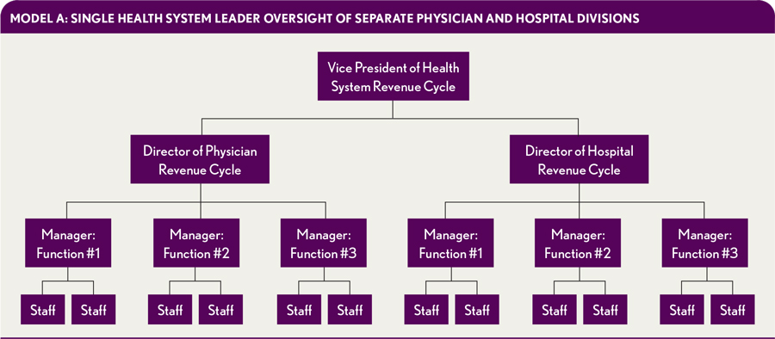
Figure 1. Integrated Revenue Cycle Model A

Model B: Oversight by a single health system leader, with a functional framework for management at the director level. Under this model (refer to figure 2), functions or components of the revenue cycle are assigned to directors, and each director would manage both professional and hospital billing components. Integration remains limited in this model. Although staff are separate for physician and hospital billing activities, focused management can allow leadership to identify potential improvements and efficiencies. (Colton & Davis, 2015)

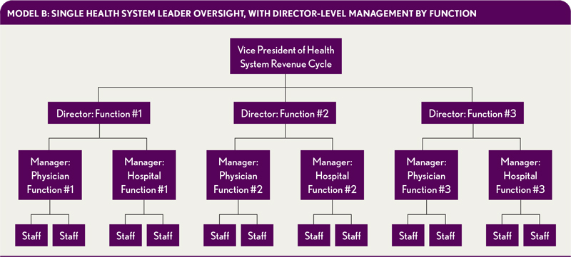
Figure 2. Integrated Revenue Cycle Model B

Model C: Complete integration of all processes. Under this model (refer to figure 3), all staff are acquainted in both hospital and physician billing components of their respective functional area. This model can allow full integration by an advanced recruitment process with higher levels of staff training, education, and monitoring. Directors and managers will have a much more flexible workforce for various functions (e.g., outstanding accounts receivable [A/R] follow-up, coded charts, denials appeals). (Colton & Davis, 2015)

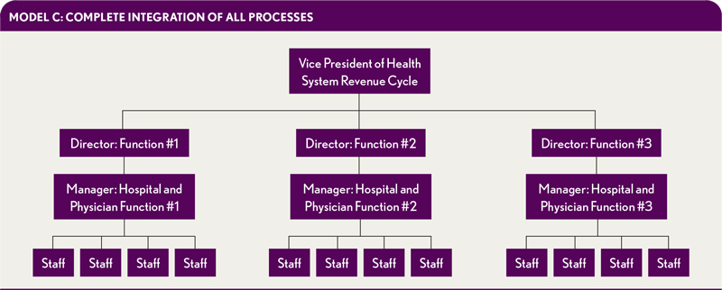
Figure 3. Integrated Revenue Cycle Model C

It is worth noting that the appropriateness of each model will depend on the organization’s operational, financial, and cultural constraints, i.e., not all models will work in every situation. At Allegheny Health Network (AHN), the revenue cycle functions as a combination of models A and C, with hospital billing and physician billing presenting as two separate entities with their own staff. However, the other functional areas representing Patient Access, Revenue Integrity, Single Billing Office, Health Information Management, Contract Management and Revenue Cycle Systems are structured as separate units, that communicate with each other through regular and informed interactions as required. The Chief Revenue Cycle Officer serves as the revenue cycle leader to ensure consistent monitoring of enterprise-level performance, to establish a single point of accountability and to provide a liaison to external parties. With daily scheduled meetings involving leaders at all levels of each functional area, there is a high degree of integration with this structure. This level of integration, however, does not mean that work is interchangeable, and hence, level of flexibility of staff to work in a different functional area is limited (corresponding to shaded area in Figure 4).
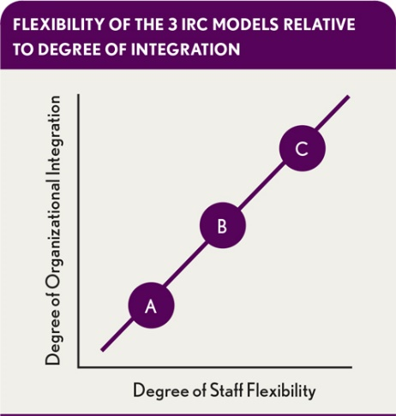
Figure 4. Flexibility of the 3 IRC Models Relative to Degree of Integration

Technology plays a major role in where and how integration and communication occur. A common patient-accounting platform, such as Epic at AHN, can offer more opportunities to integrate, as some tasks (e.g., changes in demographic information, insurance updates) can be completed just once within the patient account. However, certain specific tasks, even within the same revenue cycle component, can be fundamentally different when done for Hospital Billing or Physician Billing (e.g., use of different sets of forms to submit different types of claims, facility services or professional services, to CMS), hence justifying the separate staff.
Many claim denials can be avoided by training staff on completing upfront tasks, such as using billing forms and informing the patient about medical costs and payment components. However greater gains may be achieved by investing in revenue cycle software that automates coding and insurance verification. Also, regularly tracking claims and investigating causes of denials can lead to improved results.

INFORMATION TECHNOLOGY IN REVENUE CYCLE
Many providers, including AHN, use big data analytics and health IT solutions to operate successful healthcare RCM programs. With more payments being tied to value-based care models, healthcare organizations must report on numerous measures of quality care, patient satisfaction, robust health IT use, and healthcare costs in order to receive full reimbursement rates from payers.

Table 2. IT Components of the Revenue Cycle
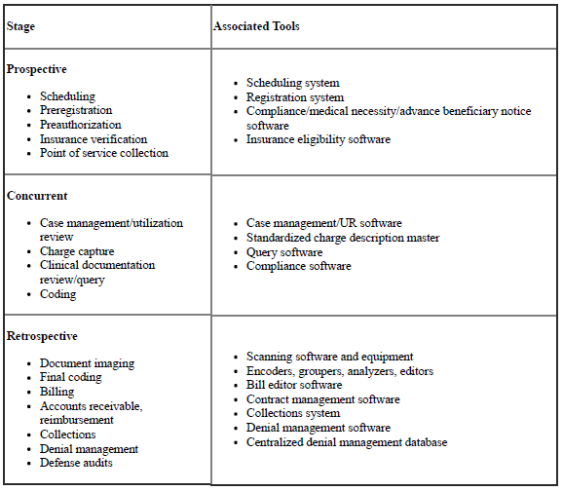
(Amatayakul, 2006)

For each stage of the revenue cycle, multiple software options are available to enhance efficient processing, and most of these are customizable to the organization’s structure and workflows. Table 2 elaborates some tools that can be used at specific stages throughout the life cycle of a patient account.
The revenue cycle uses a number of key performance indicators (KPIs), with Accounts Receivable (A/R) days being especially useful. For hospitals, the A/R days measure is the net of credit balances, uncollectible accounts allowances, charity care discounts, and third-party payer contractual allowances, according to HFMA’s MAP Keys initiative. This initiative defines industry-standard metrics or KPIs to track an organization's revenue cycle performance using objective, consistent calculations. Some of the key measures included in the net A/R days KPI are:
- A/R receivables outsourced to third-party companies, not including bad debt
- Medicare Disproportionate Share Hospital payments
- Medicare Indirect Medical Education paid on an account-by-account basis
- A/R associated with patient-specific third-party settlements
- Critical access hospital payments and settlements
Some providers may also create KPIs for payer performance, to understand better the payer mix and claims reimbursement rates from payers.
Big data analytics can help organizations manage large volumes of information and inform employees of RCM goals, especially through the use of dashboards and alerts. AHN uses a number of platforms for this purpose, essentially moving towards a common platform for all areas to access and study dashboard information applicable to them specifically.
RCM additionally includes the use of technology to keep track of any claims through their entire lifecycle, ensure payments are collected, and address any denied claims. RCM tools allow health care providers doing the billing to follow the process and identify any issues quickly, allowing for a steady stream of revenue. A system running effectively prevents denials of claims and maintains a visible, efficient billing process. Some systems used at AHN are:
- Epic: The Electronic Health Record software now implemented in most of their hospitals.
- Legacy system: The software that was developed by AHN to maintain their patient records before adopting Epic. It is still used to access data recorded prior to Epic installation or for the facilities not yet converted to Epic yet.
- SharePoint: The common platform used for information sharing throughout the organization.
- Tableau: It is used for data analysis and visualization.
- nThrive: It is a revenue cycle management software that provides technology, advisory information based on patterns and system usage, analytics and education programs, and helps coordinate financial data with clinical data.
- MedeAnalytics: It is a cloud-based analytics platform focused on healthcare.
- Cherwell: IT Service Management software that provides a portal to customize reporting and dashboards by offering tools needed to automate routine maintenance tasks and simplify delivery of IT services. In this case, it is being used for managing worklists for all Revenue Cycle employees, so that a significant part of the workflow can be automated.

Numerous vendors can be used for a specific purpose as well. One example of this is the outsourcing of some accounts receivable functions to different vendors who specialize in specific types of accounts, e.g., low dollar accounts, accounts older than 365 days, etc. This can result in saving significant time, money and labor for the organization. Another example is the use of claims scrubbers to generate clean claims. These vendors offer their services to review the data contained in each claim before it is submitted to a payer. The aim is to minimize or eliminate errors like use of wrong ICD-10 code, incorrect patient data, misidentified insurance data and other payer-specific issues so as to minimize rejection of claims.
Thus, the involvement of the IT Department plays a significant role in resolving issues, maintaining and updating the existing systems, assisting with implementation of new systems, and providing appropriate training. Therefore, an effective working relationship between these two departments is essential.

CHALLENGES AND AREAS FOR IMPROVEMENT
Some commonly faced challenges within RCM are billing and collections errors, effective use of health information technology applications, lack of staff training, failure to monitor the entire claims process and failure to have a financial policy defining processes for each stage of the revenue cycle. (Sampson, 2016)

Billing and collections errors
Hospitals must develop a good understanding of patient responsibility and capacity to pay, and devise more streamlined methods of collecting payments from their customers if they are to maintain financial stability in a quickly changing landscape. The job of a patient financial counselor is critical in this case, whose role is to assist patients in understanding their financial obligations and educating patients on payment options and available financial assistance. Often, they can help secure grants or financial aid for patients who need financial assistance. This activity falls under patient access and shows the importance of coordination between patient access and hospital billing within the revenue cycle.

Health information technology challenges
Some hospitals struggle to put information technology and billing infrastructure in place in a way that successfully manages claims as well as large outpatient networks. It can be challenging for an administrator to determine which systems should be adopted and what part of the work should be outsourced. In addition, it is imperative to use trusted platforms, since healthcare data is sensitive and includes clinical patient data as well as business data. While patient data sharing needs to abide by HIPAA regulations that provides data privacy and security provisions for safeguarding medical information, financial and operational data must be protected because of the competitive environment in healthcare. Another aspect of this challenge is that IT staff may not understand the language of revenue cycle staff, and vice-versa. So there needs to be an understanding and a willingness to explain to make the job easier for both entities.

Lack of staff training
Healthcare staff who are responsible for billing need to know how to properly capture a patient’s demographic information on the front-end, and how to translate that data to successful insurance claims. Although training might be costly and time consuming, it can save a healthcare organization money in the long run. One such targeted comprehensive training program at Community Health Network in Indianapolis showed a reduction of about 6 days in A/R and a reduction of 12% in Emergency Department eligibility denials bringing the cost of these denials down by almost 24% over the course of one year (Dillery, 2017). The transition to ICD-10 from ICD-9 may be more or less complete, but coders will be expected to apply effectively new codes and procedures as their contribution to the bottom line. A well-trained staff can reduce billing errors and make the whole process of billing more efficient.

Failure to monitor the entire claims process
A streamlined and efficient claims process can improve a revenue cycle and help a healthcare organization run smoothly. Failure to monitor the process closely can lead to the inability to determine when in the process an error was made or to identify other coding problems. This can be resolved either manually by the use of checklists or a similar review process, or it can be automated. Epic checks for a number of standard errors and displays error messages when it detects an error; the user can then decide to correct the problem or override it. Additionally, it is good practice for providers to receive automated alerts as to why a payer is routinely denying claims for a given procedure or code. Automating this process will save time which would otherwise have to be invested in identifying the cause.

Failure to have a financial policy
A financial policy can serve as a helpful tool for healthcare professionals involved in billing. It could include pre-defined processes for analyzing the financial capabilities of a patient, steps for determining a patient’s balance, information regarding denied claims and how to address them. Instituting a process for tracking and resolving denied claims is essential. Another component recommended by AHIMA (American Health Information Management Association) would be to provide guidance to patients regarding collection of copayments and unpaid balances, patient responsibilities regarding insurance requirements and financial arrangements for unpaid balances, charity care or other payment arrangements (Arends-Marquez, Knight, & Thomas-Flowers, 2014). Essentially, this policy would define the workflow for efficient revenue cycle functioning.
As discussed above, most of these challenges rely on a good working relationship between Revenue Cycle and IT, and emerging problems can be resolved with an effective change management policy in place.

LITERATURE REVIEW
By integrating the IT components listed in the table 2, organizations can enhance their ability to use data. Integrating the scheduling and registration systems makes data available faster and eliminates redundancy in data entry. Integrating a clinical electronic health record (EHR) system with HIM software applications streamlines coding and abstracting functions used by financial systems. (Rynberg, 2009)

Use of Document Imaging in Revenue Cycle
Research shows the best performing hospitals in RCM reported higher use of document imaging support. (Amatayakul, 2006) When integrated with the EHR, document imaging can support virtual and remote coding and allow efficient work distribution and management, and timely claims submission. Clinicians gain virtual access to entire patient records in EHR environments, letting them complete records post-discharge and supporting a timely coding process. A comprehensive EHR system that integrates scanned paper records can also support access by external auditors, thus speeding up the revenue cycle when reimbursement is reliant on the auditor’s review. By utilizing imaging, processing of release of information requests can be optimized as well, by eliminating the need for HIM staff to manually retrieve and copy paper records required for reimbursement justification or appeal of denied claims. (Rynberg, 2009)

Database Management
Another key factor in an efficient revenue cycle is capturing accurate data at the point of origin. For each IT component, a quality assurance process should be in place to validate data accuracy, preferably within 24 hours of the data being captured. For example, quality checks should be performed in patient registration to ensure accuracy in the collection of patient demographics and insurance information before erroneous data are used downstream. In clinical areas, automated rules can be applied in software systems to validate charge capture. For example, a rule that looks for anesthesia and recovery room charges whenever operating room charges are present prevents missed charges for services that are performed together. A hospital’s success in migrating data from one IT system to another—especially involving clinical data—is often related to its use of structured documentation. It is much easier and more reliable to interface discrete data elements across multiple systems, rather than work with textual or non-standardized data. (Rynberg, 2009)
Creating a centralized denial management database eliminates duplicate data entry and provides a single repository to support case tracking and report generation. For hospitals undergoing a Recovery Audit Contractor (RAC) review, a centralized denied claim database can improve their ability to manage the process from the initial request to final appeal activity. The Recovery Audit Program by CMS essentially performs a post-payment review so as to identify improper payments on Medicare claims, including overpayments or underpayments. This would include review of all Medicare claim and provider types, especially ones that have a high tendency for error based on CMS analysis. Additionally, this would include: “requesting, obtaining, storing, sharing, and paying for medical documentation (for complex reviews); communicating review statuses and results (via letters and a web-based portal) to providers; maintaining case files; participating in discussion periods with providers; and, sending claims for adjustment.” The Recovery Auditor frequently utilizes the organization’s data warehouse for all claims information in the Recovery Audit Program. (Centers for Medicare and Medicaid Services, 2016) Patient demographics, coding data, and billing data (including charges and reimbursement) can be interfaced to the denial management database to simplify data entry and reduce the possibility of data entry errors. (Rynberg, 2009)

Challenges Associated with IT Integration in Revenue Cycle
One of the challenges to implementing a strong RCM process is the cost of integrating systems. Interfacing independent systems or applications is expensive. Cost-benefit analyses can determine if the integration will result in a reasonable return on investment.
Another challenge is information security. Integration results in more widespread access to and use of data. It is critical that appropriate security measures be put into place to protect patient data at the highest level possible for all integration projects. Proactive planning against data breaches is imperative and technology partners should be selected by thoroughly vetting potential vendors and ensuring their security parameters are up to standard. Four critical safeguards that every cloud-based EMR system should have in place are as follows:
- HIPAA and HITECH compliance – these provide a regulatory roadmap for securing protected information, and further security controls must be tailored based on the organization’s needs
- An audit trail that provides critical clues – an audit trail is a system feature that tracks user actions to discourage hacking and other fraudulent activity
- State-of-the-art data centers – major cloud providers tend to possess high-security data centers, typically better than in-house ones
- Access to real-time expertise – any potential technology partner should have specialized staff trained in online security measures who can help proactively address a security threat (Jannenga, 2017)
HIM professionals are involved in many aspects of the revenue cycle. Understanding key components and how they interact leverages the use of e-HIM workflows in this vital process. Collaborative relationships that manage information between components and work toward the same goal provide a solid foundation for process effectiveness. (Rynberg, 2009)

Managing Change
Managing change effectively requires understanding the complexity of any significant change in process, structure, goals, etc. Change management requires evaluating, planning and implementing operations, tactics and strategies and to ensure that the change is worthwhile, relevant and likely to be effectively implemented. Managing change is a complex, dynamic and challenging process. It is never a choice between technological or people-oriented solutions but a combination of both. The manager must know the values that matter and focus on changing those as opposed to reacting to every opportunity for change. The change agent or manager must be clear about what is important and develop responses and proactive actions accordingly. (Al-Abri, 2007)
There is no "one best way" to manage change in an organization, and public-sector organizations need to introduce an approach to organization change which matches their requirements and situation. They must learn to overcome obstacles and cope with the chaos that naturally exists during the complex process of change. Leaders should help employees and other stakeholders structure and build effective teams by developing new organizational structures and creating a shared vision that focuses on authentic employees’ output. Such inspired and informed leadership is critical and essential for organizations to be successful. (Coram & Burnes, 2001)
Establishing a clear vision about the direction of the change process is another key element for assuring successful change. Measuring and monitoring outcomes of the change process is essential for recognizing whether the change process has fulfilled its purposes. Since change is continuing to happen in organizations and associated modifications are taking place, it is important for leadership and management to record and focus on the emerging problems due to change. This will help avoid them in the future so that the new administration system can help manage the change in the most appropriate manner. (Al-Abri, 2007)
There are global changes happening, and these drive individual organizations to change accordingly in order to survive and grow. To keep the organization functioning according to plan, managers and employees’ knowledge and skills should be upgraded, and necessary training on the changes in technology must be provided periodically. (Al-Abri, 2007)
Managing the change process within public health organizations is important because appropriately and systematically managing change is linked to improved organizational performance. However, change is difficult, and the change process poses formidable challenges for managers. Managers themselves face increased pressure to respond to environmental influences and provide the necessary leadership to their organizations in the change process. In fact, managing organizational change has become a key competency for healthcare managers. (Thompson, 2010)
Most organizations need a change agent to champion the detailed, complicated, and sensitive work necessary to integrate and consolidate. This leader should be fully invested in increasing revenues and efficiency while reducing costs associated with the revenue cycle. He or she will be responsible for making difficult staffing decisions, combining budgets, determining cost allocation methodologies, standardizing job codes, creating common policies and procedures, and facilitating other logistical details. This change agent will be an important leader throughout the organization’s transition to a transformed culture. (Colton & Davis, 2015)
Kurt Lewin’s Change Model
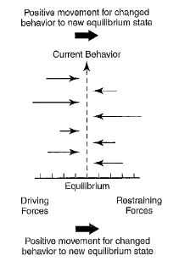
The influence of group dynamics on an individual's attitude toward change can be better understood by studying Kurt Lewin’s work and his model of Force Field Analysis. This model demonstrates change as “a series of forces working in different directions. In effect, some forces and interests within an organization desiring change may well be offset by forces and interests striving to maintain the status quo” (Ritter, 2016) (see Figure 5). Effective implementation of change requires an increase in the strength of the force for change, i.e., the driving forces. At the same time, a reduction or complete removal of the strength and position of opposing or the restraining forces is essential. A strong managerial understanding of the external and internal environments is required for adoption of this model. By identifying each force, it becomes possible to distinguish between forces and issues that may be changed and those that cannot be changed, and a realistic approach to planning change can be undertaken based on this understanding. (Ritter, 2016)
Figure 5. Lewin’s Force Field Analysis

Kurt Lewin’s 3 step process (Figure 6) is especially helpful for implementing planned change (Ritter, 2016). The three stages in the change cycle are as follows:
- Unfreeze: “Workers involved in perpetuating resistance acquire an understanding of variances that exist between current practices and behavior and desired activities and behavior.” (Ritter, 2016) For example, when managers effectively communicate the need for change and enforce driving forces, it would lead to unfreezing.
- Change: A change in policies, procedures and operating practices would occur in this stage. It is imperative that the employees involved understand the reasons for change and participate in designing a modified process. Implementing appropriate training would provide the workforce with the skills and knowledge needed to be effective and should increase the likelihood that they will buy into the change initiative.
- Refreeze: The final stage would see the changes being implemented and monitored, with modifications as necessary. New organizational goals would be reinforced by subsequent changes in daily activities, and continuous monitoring would ensure successful operating practices.
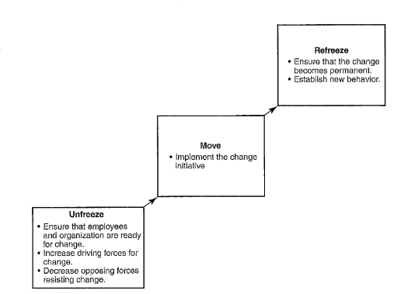
Figure 6. Lewin’s Three Step Change Process

Lean Six Sigma
Lean Six Sigma is a fact-based, data-driven philosophy of improvement that works by reducing variation, waste, and cycle time, while promoting the use of work standardization and flow. Lean and Six Sigma have the same general purpose of providing the customer with the best possible quality, cost, delivery, and nimbleness, with slightly different approaches. Lean focuses on waste reduction, whereas Six Sigma emphasizes reduction of variation. Lean achieves its goals by using less technical tools such as workplace organization and visual controls, while Six Sigma tends to use statistical data analysis and hypothesis tests. A combination of Lean and Six Sigma tools is used depending on the requirement of the project. Strong management support is an essentiality to make these approaches successful and sustainable. (Kubiak & Benbow, 2009)
The Lean approach aims to reduce the seven types of waste: overproduction, waiting, transportation, non-value-adding processes, inventory, motion, and costs of quality (scrap, rework and inspection). Projects using Six Sigma methodologies are divided into 5 phases: define, measure, analyze, improve and control (DMAIC), and each of these utilizes a specific set of tools for that particular phase. (Kubiak & Benbow, 2009)
There are numerous applications of Lean Six Sigma techniques in revenue cycle that have vast implications for cash flow and the financial viability of the organization. Some examples include: increasing the number of patients with insurance verified prior to visit, increasing registration accuracy, optimizing cash collections, and improving patient throughput. (Kirkland, 2014) The following example of Bethesda Healthcare System shows how the application of Lean Six Sigma techniques can improve outcomes and optimize revenue cycle.
Since it adopted the Lean/Six Sigma approach, Bethesda Healthcare System (an example cited by numerous organizations) has improved performance in a variety of ways. Achievements include reducing appointment scheduling time by 20 percent; decreasing DNFB (Discharged Not Final Billed) by 63 percent in only four months; increasing cash receipts by 28 percent in four months; and raising point-of-service collections by 120 percent over a period of six months. One key project success has been improvement in estimating patient payment responsibility and resulting cash collection. In particular, Lean/Six Sigma led the Bethesda Healthcare System to take better advantage of technologic tools and better execute supporting processes. The organization recognized the value of implementing a price estimator that would allow it to get a better handle on determining patient financial responsibility for its patient mix. The healthcare system consequently focused on identifying and eliminating routines that interfered with accurately estimating and collecting amounts due. The result was that point-of-service payment collection became more accurate and efficient.
Organizations that have implemented formal process improvement programs in health care point to a number of critical success factors: Focusing on training, seeking staff buy-in, planning for ongoing monitoring, and not underestimating the value of technology and staff support. (HFMA, 2012)

Lean Six Sigma and Change Management
Implementing Lean Six Sigma methodology is a challenging journey, and requires leadership as well as staff to understand and support the required changes. Team approach, "buy in" of the stakeholders, and the willingness of team members to change daily practice and to adapt new and innovative ways is essential for effective implementation. Six Sigma needs to be incorporated as part of the company's or hospital's culture to be most effective. This, however, is not easy, and leadership and staff would need to undergo immense training and education to completely understand the project. (Pocha, 2010)

DESIGN AND METHODOLOGY
The purpose of this project was to study the processes of coordination of the revenue cycle and information technology at Allegheny Health Network, based on the author’s management residency experience, in order to understand the key processes involved and implications for effective change management. This study has been supplemented by a review of related literature, including Kurt Lewin’s change management theory, in order to better understand the need for effective communication. Through this essay, the author aims to highlight the role of revenue cycle in healthcare, the importance of information technology components for this role, and the importance of effective communication and change management between these functional areas. Although the research related to this essay was done specific to the project, the author feels that it has wider applications for projects in different health care organizations and other functional areas.

METHODOLOGY
This descriptive study of a change management initiative was based on data collected through primarily qualitative methods. Through her residency at Allegheny Health Network’s Revenue Cycle, the author conducted observations to understand the nature of the problems to be addressed. She gained insights as to why issue management and proper communication between revenue cycle and information technology is essential that laid the groundwork for this essay.
The author identified key participants in the project, and obtained information through guided interviews. Among the interviewed participants were staff, analysts, supervisors, project managers and directors from revenue cycle, and a project manager and director from IT. These exchanges ranged casual impromptu conversations to scripted interviews. In addition to workflow related queries, the questions were related to features of current systems known or unknown to the staff and leadership, training for these systems, frequently faced issues, communication for urgent and non-urgent matters, and perceived reaction about the proposed changes. These interactions helped to shape the course of the project and how various components came together to lead to the final product.
Additionally, the author conducted analysis of some key documents in the project. These included an initial decision paper, a matrix containing all unresolved issues between revenue cycle and IT, and the Standard Operating Procedure (SOP) document, among others. The author was involved in researching for and preparing the decision paper for this project. This document identified and elaborated the major issues and possible solutions, including the rationale as well as the challenges for each. This document was presented to leadership and official buy-in was gained for part of the proposal, allowing timely implementation of this section. The SOP was then developed during the implementation phase, and included further information like identification of key stakeholders for each functional area, description of the future-state workflow including directions for specific circumstances, and brief explanation of the new system and its settings.

LIMITATIONS of the study
In conducting interviews, the author recognized that information provided by this method was self-reported by the interviewees and reflected the interests and biases of the interviewees. The author attempted to counter the effects of bias by including interviewees who likely have different perspectives. A more important limitation of the study was the constraints upon access to people who were directly involved in the project at AHN. Additionally, there was limited access to organizational information associated with the project due primarily to concerns about maintaining confidentiality.
The project was also limited by the length of the author’s residency. This limited the scope of the project and precluded a deeper study of the organization culture and how similar projects were implemented and received by the workforce in the past.

ISSUE MANAGEMENT project
Before the implementation of the Issue Management project at AHN revenue cycle, leadership heavily relied on email to resolve problems with 87% of IT requests being through email. There was a lack of any formalized issue request system and this allowed easy issue requests to IT from anyone in the revenue cycle department. This often led to vagueness related to these requests from IT’s perspective, which led to questions about changes in system tools, details on desired design and format of these tools, application of specific error codes and target customers, and related issues. The Director of Revenue Cycle Systems (RCS) serves as the primary contact for IT in revenue cycle, and most questions would be addressed to this person. Revenue cycle management at AHN utilizes a huddle approach for the resolution of such issues. These huddles occur in the morning every day and the Director of RCS would seek clarification from revenue cycle managers and determine priorities among the issues raised.
IT at AHN has a special unit in their hierarchy which specifically deals with revenue cycle operations (IT-Revenue Cycle). This group has responsibility for Epic modules concerned with revenue cycle (Hospital Billing, Physician Billing, Health Information Management, Patient Access, etc.). All requests received by IT revenue cycle would be directed to the concerned Epic team where triage would take place. If a designated team member could provide quick resolutions, a reply would be sent accordingly. However, if the request required team deliberation for resolution, the issue would be routed to a specific team with that responsibility. In addition to the Director of RCS, the teams reach out to other staff in revenue cycle based on the nature of the request or the project, which would either be the concerned director, manager or analyst in that area. In working toward resolution of an issue, once an end-result has been created in the form of an additional or modified feature in a system, or a training module, IT tests it in a testing environment to ensure it meets the users’ specifications before it is finally released. The testing environment is basically a dummy replica of the relevant section of the system being altered, where actions would only affect data in that environment, and the actual database would not be affected. Based on the decision made by the concerned IT team, these end-results are classified as either standard resolutions, which would be tested and then sent to the end-user and the target audience, or user-specific resolutions, which would be tested with the user in the testing environment before being released.

PROBLEM STATEMENT
Revenue cycle operations at AHN lacked an issue management tool and change management process.
Operations in revenue cycle relied on IT’s ability to efficiently repair and optimize AHN systems for revenue cycle end users (customers). For this purpose, IT divides these into three main buckets of work: tickets (used to solve routine system issues), updates (used to modify a system, usually Epic, to better adapt to staff’s workflows and process changes), and projects. Priority of these tasks is established with tickets being first, updates second, and projects last. Before this project, there was a lack of a system in revenue cycle that was well-integrated with IT (see figure 7). Thus, leadership heavily relied on email to resolve problems, with 87% of IT requests being through email. Additionally, the lack of a formalized issue request system and the ease of issue request resulted in a high volume of open and unresolved IT tickets, 300 on average, which were assigned priorities on a subjective scale by the revenue cycle staff. The volume of tickets along with the number of uncharacteristically high priority items threatened the timely resolution of ticket requests and project completion. Lastly, the lack of a revenue cycle management tool further impeded the resolution of important issues, in addition to other limitations such as inefficient use of resources and suboptimal communication between the functional areas.
Recognition of these existing problems and explaining their implications to the workforce would be a part of the first step in Lewin’s change management, unfreeze. The opposing forces for this change were limited since leadership and the workforce understood the utility of the project.

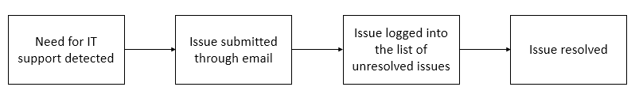
Figure 7. Current State Process Map

ACTION PHASE: PROPOSED
Cherwell is an IT Service Management software utility, that provides a portal to customize reporting and dashboards by offering tools needed to automate routine maintenance tasks and simplify delivery of IT services. The proposed solution for the problems being presented involved the use of the Cherwell Portal in numerous ways, and was presented in three parts.
The first part of the proposal was for revenue cycle leadership to review direct report tickets on Cherwell regularly. To demonstrate the high number of unnecessary, unresolved tickets, the Vice President of Clinical Revenue Cycle was asked to identify and eliminate non-required tickets for his functional area manually. This resulted in removing 80 tickets in a span of less than one week. If implemented effectively, automating and monitoring compliance with this process would reduce the volume of old tickets, duplicate tickets, tickets for issues that were no longer relevant and training related issues (e.g., inadequate training in certain areas, lack of targeted training based on job description) among others. The issue related to this proposal was that all leaders did not have the ability to view direct report tickets in the portal at that point of time.
Secondly, it was proposed that Cherwell operational worklists be customized and adopted. This would allow issues to be systematically logged and reviewed. An operational workgroup would be created, that would be managed by revenue cycle subject matter experts to develop processes to allow any employee to log operational issues and questions into a single worklist. Based on a specific subject line or setup, inquiries would automatically be uploaded into a worklist during normal business hours. For issues being logged during non-business hours, this would be manually done by the responsible IT team, so as to ensure that critical issues would be reviewed and addressed on a timely basis. Additional worklists would be utilized to allow issue categorization into broad fields like Hospital Billing, Physician Billing, Patient Access and Clinical Revenue Cycle, and these would receive specialized expert review. A similar Cherwell workgroup had demonstrated improvement by the Patient Access workforce by encouraging review of issues by subject matter experts, hence reducing the disconnect between revenue cycle and IT. It was anticipated that using worklists in this way would result in reducing the number of tickets, and capturing and managing all revenue cycle issues in an organized way. This process change would allow IT to access revenue cycle experts for issues related to operational research, planning and design. The usage of a task management tool would also allow operational sign-off by revenue cycle before the end-result is moved into production after testing by IT.
Thirdly, adoption of a revenue cycle change management policy was proposed. In essence, this would include a number of directives to guide the revenue cycle workforce’s actions when working on system issues. End users would have to use Epic’s issue submission tab to submit any Epic issues, while all other issues would be submitted through the Cherwell Portal. When system-wide changes affect other functional areas across the organization, it would be mandatory for operational owners to sign off on the end-results. Communication would occur in a defined manner: roles and responsibilities would be clearly defined for each of the Cherwell worklists, scheduled executive steering committees would be utilized, weekly advisory meetings would be required i.e., pre-defined HB and PB Epic huddles, any additional scheduled meetings, and an end-user communication plan would be established.
In entirety, this proposal was expected to benefit in the following ways: Streamline issue request system for revenue cycle end users by ease of access to own tickets, improve efficiency of issue management process, reduce number of IT tickets by eliminating redundant and expendable tickets, accelerate issue resolution and IT request processing, and ensure communication of changes implemented. Among the drawbacks identified were that Cherwell license costs approximately $100,000 annually, and the time invested in additional scheduled meetings. Leadership buy-in was quickly gained for most items in this proposal as the issues, once highlighted, were recognized as those impeding operational efficiency that should be resolved in a timely manner.
The first two parts of the proposal were implemented in April 2018, representing the second phase of change management, i.e., Change. As part of the implementation planning for this, a Standard Operating Procedure (SOP) was circulated, which was developed after meetings and deliberations with leaders and certain representative staff. This document recapped the background and defined goals for the project, which included identification of key stakeholders for each functional area, description of the action items and the future-state workflow, and a brief explanation of the new system and its settings. This distributed accountability to specific teams and leaders for the various functional areas. The scope of this initiative was defined as well, by identifying the following:
- System interactions – Interactions between Epic Direct software and Issue Management system
- Service Level Objective (SLO) – Defined business hours, Explained priority levels (see figure 8) (this chart is meant to explain to end-users how priorities should be assigned to issues, since there have been instances in the past where workforce has interpreted it in a different sense, like assigning priority level 1 to low urgency issues); Patient, Dollar and Compliance carry equal weight in assigning priorities to issues currently
- System flags – designed to alert users in cases of error
- Detailed communication plan – within revenue cycle, and between revenue cycle and IT
- Matrices explaining users involved in each functional area and related services and action items
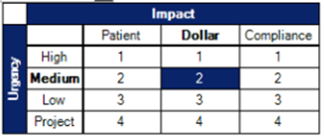
Figure 8. Priority Levels for Issue Management
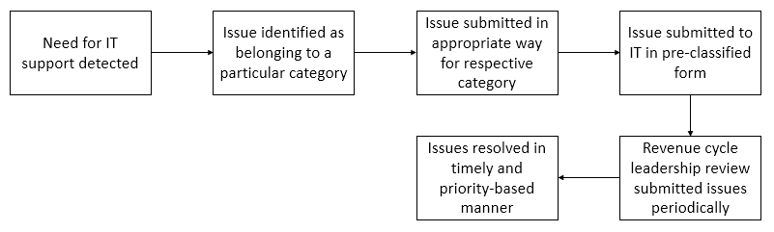
Figure 9. Future State Process Map

CONCLUSIONS AND RECOMMENDATIONS
Although it is yet to be seen how the final implementation of the issue management project will be received by staff and leadership, a number of factors suggest that the overall response will likely be positive. These factors include recognition of the problem by everyone leading to leadership buy-in, successful small-scale piloting of some aspects previously and the promise of ongoing, more effective communication. In identifying the revenue cycle team responsible for Cherwell, the project manager must ensure involvement of key players and representation of key functional areas, and ensure proper implementation of the formalized communication plan. The author believes that if the proposed communication plan closely models the existing pattern within revenue cycle, that would lead to very effective transmission of information on a timely basis. In addition to communication within revenue cycle, stakeholders must also consider formalized communication with IT. Language barriers surfaced numerous times during interviews, in reference to the technical details of the revenue cycle as well as the use of insider IT terminology. Thus, it is imperative that expectations and suggestions be relayed in an easy-to-understand as well as timely manner to ensure efficient interaction within this relationship.
In addition, expansion of services of a system that is already being used to some extent may prove to be more beneficial than implementing a novel one. However, it is imperative that adequate education and training be provided. Observations indicate that this was not the case prior to implementation resulting in deficiencies in usage, especially because some components of the software are not easy to understand. Thus, targeted and periodic training is strongly recommended, while also providing users with a guide to assign priority levels to their issues.
A cost estimate of about $100,000 annually was associated with buying Cherwell licenses. This amount is likely to increase with implementation of other sections of the proposal, especially training programs. Thus, the organization should weigh the likely benefits against the costs once implementation is completed to ensure the solution is worth the investment. This recommendation, in addition to training and education, and periodic follow-up, contribute toward the third phase of Lewin’s change model, refreeze, which would ensure successful and sustainable implementation.

bibliography
Al-Abri, R. (2007). Managing Change in Healthcare. Oman Medical Journal, pp. 9-10.
Amatayakul, M. (2006, March). Benchmarking RCM: Best Practices to Enhance the HIM Roles in Revenue. Journal of AHIMA 77, no. 3, pp. 46-49.
Arends-Marquez, A., Knight, N., & Thomas-Flowers, D. (2014). ICD-10's Impact Reaches Far Beyond Coding: Examining the New Code Sets' Revenue Cycle Implications. Journal of AHIMA 85, no.11, 74-76.
Belliveau, & Jacqueline. (2017, August 21). Exploring Key Components of the Healthcare Revenue Cycle. Retrieved from RevCycleIntelligence Web Site: https://revcycleintelligence.com/news/exploring-key-components-of-the-healthcare-revenue-cycle
Centers for Medicare and Medicaid Services. (2016, November 30). Statement of Work for the Part A/B Medicare Fee-For-Service Recovery Audit Program. Retrieved from CMS.gov: https://www.cms.gov/Research-Statistics-Data-and-Systems/Monitoring-Programs/Medicare-FFS-Compliance-Programs/Recovery-Audit-Program/Downloads/New_RAC-SOW-Regions-1-4-clean.pdf
Colton, B., & Davis, A. (2015, January). Integrating the Revenue Cycle for Improved Health System Performance. HFM Magazine.
Coram, R., & Burnes, B. (2001). Managing organisational change in the public sector - Lessons from the privatisation of the Property Service Agency. International Journal of Public Sector Management, Vol. 14 Issue: 2, 94-110.
Crocker, J. (2006). How to Improve Your Revenue Cycle Processes in a Clinic or Physician Practice. The American Health Information Management Association.
Dillery, S. (2017, April). Staff Engagement: Creating an Integrated Revenue Cycle Education Plan for All Patient Touch Points. Retrieved from Healthcare Business Insights Web Site: http://www.healthcarebusinessinsights.com/wp-content/uploads/2017/04/Staff-Engagement-Creating-an-Integrated-Revenue-Cycle-Education-Plan-for-All-Patient-Touch-Points.pdf?x38602
Gerber, J. S. (2016, May). The MEDCOR Group, Inc. Retrieved from The MEDCOR Group, Inc. Web site: https://medcorinc.com/why-healthcare-revenue-cycle-management-is-important/
Healthcare Financial Management Association (HFMA). (2012). Using Formal Process Improvement for Revenue Cycle Success. HFMA.
Jannenga, H. (2017, August 10). 4 Crucial data security measures every EMR must have in place. Retrieved from Becker's Healthcare: https://www.beckershospitalreview.com/healthcare-information-technology/4-crucial-data-security-measures-every-emr-must-have-in-place.html
Kirkland, A. (2014, June 19). Applying Lean Six Sigma to the healthcare revenue cycle. Retrieved from Healthcare Finance: http://www.healthcarefinancenews.com/blog/applying-lean-six-sigma-healthcare-revenue-cycle
Kubiak, T. M., & Benbow, D. W. (2009). What is Six Sigma? Retrieved from American Society for Quality: http://asq.org/learn-about-quality/six-sigma/overview/overview.html
Petouhoff, L., & Colton, B. (2017, March 8). Revenue Cycle Management: Maintaining Structure and Flexibility for Success. Retrieved from HFMA Web Site: http://www.hfma.org/Content.aspx?id=53168
Pocha, C. (2010). Lean Six Sigma in health care and the challenge of implementation of Six Sigma methodologies at a Veterans Affairs Medical Center. Quality management in healthcare.
Ritter, J. (2016). Managing Resistance to Change. In N. Borkowski, Organizational Behavior, Theory and Design in Health Care (pp. 408-413). Jones and Bartlett Learning, LLC.
Rynberg, S. J. (2009, March). Integrating IT Systems Strengthens the Revenue Cycle. Journal of AHIMA 80, no.3, pp. 54-55.
Sampson, C. (2016, May 4). Xtelligent Media, LLC. Retrieved from RevCycleIntelligence.com: https://revcycleintelligence.com/news/5-most-common-hospital-revenue-cycle-management-challenges
Thompson, J. M. (2010, March 1). Understanding and Managing Organizational Change: Implications for Public Health Management. Journal of Public Health Management and Practice, pp. 167-173.
Wexler, J., & Bucci, K. (2018). Eris Medical Technologies. Retrieved from Eris Medical Technologies Web site: http://www.erismed.com/wp-content/uploads/eris-charge-capture-white-paper.pdf

