SPATIAL MODELING OF THE SOCIAL AND ENVIRONMENTAL FACTORS
ASSOCIATED WITH THE PITTSBURGH MOSQUITO POPULATION

Landis Powell
Atrium Baccalaurei, Washington University in St. Louis, 2016

Submitted to the Graduate Faculty of
Environmental and Occupational Health
Graduate School of Public Health in partial fulfillment
of the requirements for the degree of
Master of Public Health

University of Pittsburgh
2018
UNIVERSITY OF PITTSBURGH
Graduate School of Public Health

This essay is submitted
by
Landis Powell
on
May 8th, 2018
and approved by

Essay Advisor:
James Peterson, PhD ________________________
Associate Professor
Environmental and Occupational Health
Graduate School of Public Health
University of Pittsburgh

Essay Readers:

Bill Todaro, MSc ________________________
Entomologist
Housing and Community Environment
Allegheny County Health Department
Pittsburgh, Pennsylvania

Joel M. Haight ________________________
Associate Professor
Industrial Engineering
Swanson School of Engineering
University of Pittsburgh

© Copyright 2018
Landis Powell

James Peterson, MPH

SPATIAL MODELING OF THE SOCIAL AND ENVIRONMENTAL FACTORS
ASSOCIATED WITH THE PITTSBURGH MOSQUITO POPULATION

Landis Powell, MPH
University of Pittsburgh, 2018

ABSTRACT

Mosquito-vectored pathogens are responsible for devastating human diseases, such as Zika virus, West Nile Virus (WNV) and Dengue virus. Zika has gained national attention in recent years because it can lead to birth defects if a woman is infected during her pregnancy. Because no vaccine exists to prevent or treat Zika, mosquito control is the most effective way to prevent this virus. Expectedly, concern for such diseases and their ability to spread within the United States has increased as mosquito habitats expand towards the East Coast due to climate change and increased temperatures. Baltimore, MD and Washington, DC have conducted studies in order to compare the density of mosquito habitat and pupae production across neighborhoods with varying poverty levels. No such research has examined mosquito prevalence in Pittsburgh, PA in relation to the population’s demographics or the physical environment. Improved knowledge of the social factors contributing to mosquito prevalence, such as poverty level and race and ethnicity, has public health relevance because it is necessary for effective mosquito control in urban environments. Pittsburgh-specific spatial data analysis and mapping will provide a better understanding of where mosquitoes lay their eggs, which will be helpful to the city when deciding how and where to concentrate their efforts. The number of mosquito eggs laid (2016-2017) were mapped against several factors, including: percent poverty and different ethnicities and races, public pools, highways, playgrounds, and other factors thought to be correlated with mosquito prevalence. Clustering of mosquito eggs and statistical relationships were determined using the spatial analysis program Geoda. Pittsburgh’s lower income residents were found to be at greater risk of exposure to mosquito-disease vectors; census tracts with a higher percent of black people and other minorities tended to host mosquito traps with a higher number of eggs. From these results, we infer that Pittsburgh’s lower income residents may be at greater risk for mosquito-vectored diseases. Public health officials should focus their efforts on spraying these identified areas and educating these community members on different ways to reduce the mosquito population and protect themselves.

TABLE OF CONTENTS
ACKNOWLEDGMENTS ………………………………………………………………………………..………………..…………. ix
INTRODUCTION ……………………………………………………………………………………………………………………….. 1
Mosquito-Borne Diseases and Public Health ………………………………………………………………… 1
QGIS and Public Health …………………………………………………………………………………..………….… 2
LITERATURE REVIEW …………………………………………………………………………………………………………..…… 4
Sociodemographic Variables Impact on Mosquito Prevalence ………………..…….…………….. 5
Stagnant Water as Mosquito Breeding Grounds …………………………………………………..……… 6
What do Playgrounds and Auto Body Shops Have in Common? ………….……………………….. 7
Major Roadways and Mosquito Prevalence …………………………………………………….…………… 8
METHODS AND DATA ……………………………………………………….……………………………..……………………… 9
Oviposition Trap Sampling Protocol …………………………………………………..………………………… 9
Mosquito Rearing and Larvae Identification ……………………………………....……………………… 11
Source of Additional Data Used for Maps ……………………………………………………………..…... 11
Study Area: Pittsburgh, PA …………………………………………………………….…………………………… 12
RESULTS AND INTERPRETATION ………………………………………………..…………………………………..……… 15

CONCLUSION ……………………………………………………………………………………………………….………………… 23
Mosquito Prevalence Patterns and Contributing Social Factors …………………….…………… 23
Environmental and Physical Factors …………………………………………………………………………… 24
Study Limitations and Suggestions …………………………………………………………………………….. 25
Research Significance ………………………………………………………….………….…………………………. 26
Mosquito Breeding Control Measures ……………………………………….……..……………………….. 26
BIBLIOGRAPHY ……………………………………………………………………………………………………..……………….. 28

LIST OF FIGURES
Figure 1. Oviposition Mosquito Trap ……………………………………………………………..………………………. 10

Figure 2. Examples of Oviposition Trap Sites ………………………………………………..……………………..… 11

Figure 3. Location of Oviposition Mosquito Traps in Pittsburgh (Summer 2016-2017) ……..…… 13

Figure 4. Location of All Mosquito Trap Sites in Pittsburgh Since 2004 ………………………….………. 14

Figure 5. Comparison of Two Data Frames of Race & Ethnicity in Relation to Mosquito
Prevalence …………………………….………………………………………………………………………….………….……….. 16

Figure 6. Poverty Level’s Impact on Mosquito Prevalence in Pittsburgh ……………..…….…………… 17

Figure 7. Impact of Auto Body Shop, Playground and Parks on Mosquito Prevalence ………….… 19

Figure 8. Number of Mosquito Eggs Collected LISA Cluster Map ………………….………………..………. 20

Figure 9. Moran’s I Value of Mosquito Clustering …………………………………….……………………………. 21

ACKNOWLEDGMENTS

I would like to thank Bill Todaro and Leah Lamonte at the Allegheny County Health Department for helping me collect the data used for this project, as well as allowing access to the West Nile Virus Control Program data. Dr. Christina Mair was fundamental in guiding me through the creation of these maps. I would also like to acknowledge Dr. James Peterson, my advisor.

INTRODUCTION
This chapter briefly highlights the public health significance of vector-borne diseases, specifically research relating to mosquitos. An explanation of how QGIS was implemented in this study is also included in this chapter.
Mosquito-Borne Diseases and Public Health
Mosquitos are the most common living organisms that can transmit infectious diseases. While bloodsucking their meals, the mosquito ingests disease-producing microorganisms from an already infected host, either animal or human, and then subsequently infects a new host through the next blood meal. Vector-borne diseases account for more than 17% of all infectious diseases world-wide (WHO, 2017), and approximately four million die from mosquito-borne diseases every year (WHO, 2018). Concern for such diseases and their ability to spread within the United States has increased as mosquito habitats expand towards the East Coast due to climate change. Increased temperatures, rainfall and occurrence of extreme weather events have all been associated with a higher prevalence of mosquito-borne disease transmission (Noji, 1997).
Fortunately, many of these diseases can be prevented through informed protective measures (WHO, 2017). In the case of certain mosquito-borne diseases, such as Zika, reducing mosquitos’ breeding ground and habitat is the most effective preventative measure because there is no vaccine for this virus (CDC, 2017).
Determining where to focus intervention efforts begins by understanding where the risk of disease transmission is greatest (Panditrao et al., 2006). In theory, an area with a higher mosquito prevalence is at greater risk for vector-borne disease transmission (Wilson, 2002). However, the mosquito population is dependent on many social, ecological, environmental and physical factors. For example, mosquito reproduction, development and behavior have been shown to be dependent on temperature, humidity and precipitation (Gage et al., 2008). However, human vulnerability is equally as important when determining the risk of mosquito-borne disease transmission. Therefore, this study will incorporate a variety of potential factors that might contribute to an increased mosquito population. Ecological and environmental factors relating to mosquito prevalence have already been widely investigated, and were therefore left out of this study (De Souza et al., 2010; Johansson, 2009). The social factors analyzed in this study include a comparison of two data frames of race and ethnicity, as well as poverty level. The physical factors included in these maps are major roadways, water features, play grounds, auto body shops and parks.
QGIS and Public Health
Quantum Geographic Information System (QGIS) is an essential tool for assessing the spatial relationship between these potential variables and the prevalence of mosquitoes. Mapping this data in QGIS allows for a visual representation of human vulnerability to these mosquito-borne diseases. Furthermore, the ultimate purpose of this research is to inform local public health policy and provide information to the general public on methods to reduce mosquito population. Spatial models rendered through QGIS allow the desired message of this study to be much more easily understood and therefore will likely have a larger impact. This type of spatial analysis also allows for multiple variables to be compared at once. The primary goal of this study is to gain a better understanding of the mosquito population in Pittsburgh and identify some of the social and physical factors that contribute to a higher prevalence of mosquitos. Ultimately, this information may be used by the Allegheny County Health Department to better direct their mosquito control program efforts.

LITERATURE REVIEW
In recent years, vector-borne diseases has come under intense scrutiny due to the dominant media coverage of the Zika virus outbreak. Mosquito borne diseases are a major public health concern worldwide. In recent years, the media has highlighted the potential dangers of mosquitos as their breeding grounds have expanded further into the United States. Climate change doesn’t necessarily predict mosquito prevalence (Reiter, P., 2001) or the vectors ability to transmit infectious disease because this phenomena has a plethora of uncharted implications. Nevertheless, increased temperatures, rainfall and occurrence of extreme weather events have all been associated with a higher prevalence of mosquito-borne disease transmission (Noji, 1997; Rossati et al., 2014).
Furthermore, sociodemographic characteristics of the population and physical features of the environment can affect mosquito prevalence in the area. In particular, this study focuses on how the number of mosquitoes in Pittsburgh relates to race and ethnicity and poverty level. In order to put this Pittsburgh-specific data and analysis into perspective, this introduction will review several papers that have examined similar variables in other cities. The environmental physical factors examined in this study include water features, highways, parks, auto body shops and playgrounds. This literature overview will provide a brief explanation as to why those variables were chosen.
The Aedes Albopictus mosquito is a notorious species because it is the most common human biting mosquito (Gratz, 2004). This invasive species is also drawn to small water-holding containers because the larvae can thrive in that environment. Ability to utilize man made trash as breeding ground makes this species especially dangerous because they can reproduce in the most urbanized areas, and therefore put many people at risk for infection. The aggressive daytime biting behavior of Aedes Albopictus, coupled with its expansive spread of has led to a noticeable increase in nuisance biting and complaints (LaDeau et al., 2013).

Sociodemographic Variables Impact on Mosquito Prevalence

From a public health standpoint, the most important vector-borne disease transmission cycle is the “urban epidemic cycle”, which takes place in densely populated large cities. Therefore, population density undoubtedly contributes to how mosquitoes breed in urban environments and ultimately the number of mosquitoes existing amongst the human population. However, several studies conducted within the United States have shown that areas with poorer economic conditions are correlated with a greater prevalence of mosquito-borne diseases. A study in Orange County, CA found that the per capita income was the most important predictor variable for the prevalence of West Nile Virus (Harrigan et al., 2010), and that this relationship remained constant throughout the years of data collected and analysis.
In a 2013 study, the density of mosquito habitats and pupae production were compared across neighborhoods in both Baltimore, MD and Washington, DC (LaDeau et al., 2013). It is important to note that these two cities are both temperate and similar in climate to Pittsburgh, PA. Although seven species were found in total, Aedes Albopictus was the only species that was found in every neighborhood (LaDeau et al., 2013). Interestingly, Aedes and Culex mosquitoes were both more likely to be sampled in lower income neighborhoods. These two species are both carriers for the most prominent mosquito-borne diseases. Aedes albopictus pupae were found to be less dense in container habitats in areas with lower percent poverty (LaDeau et al., 2013). Clearly abundance, as well as mosquito species composition, vary depending on the socioeconomic conditions of the communities they inhabit.
Census tracts with higher poverty levels may be associated with a denser mosquito population for a variety of reasons, for example property standard, a lack of local government intervention, and misinformation about nuisance mosquito control (Harrigan et al., 2010).

Stagnant Water as Mosquito Breeding Grounds

Aedes albopictus is also known as “container-breeding mosquitoes” because this species uses small water-holding containers as sites for oviposition and larval development (Yee, 2016). Mosquitoes typically lay their eggs directly above the water line (Hawley, 1988) on the walls of water-filled containers. However, in some instances, Aedes albopictus have been found to lay their eggs directly on the water surface (Hawley 1988). The eggs will eventually hatch when it rains and the water covers the eggs.
Although this study only examined Pittsburgh’s public pools, it is important to remember that neglected and unchlorinated pools have an even larger impact on mosquito prevalence. Pools that are not treated correctly can become eutrophic bodies of water that are capable of supporting a substantial number of immature mosquitoes (Harrigan et al., 2010). When water is contaminated with organic matter, such as human or animal waste and grasses, the mosquito larvae chances of survival increase because these bacteria provide nutrients for the larvae (Pelz-Stelinski, 2010). Water fountains often collect such grasses and leaves, and are therefore prime mosquito breeding grounds. Additionally, the FEMA flood zone around the Pittsburgh rivers was also mapped out in this study for similar reasons.

What Do Playgrounds and Auto Body Shops Have in Common?

Mosquitoes do not differentiate between a discarded tire at an auto body shop and a tire swing in a local playground. When selecting a breeding ground, mosquitoes are attracted to small, shaded containers (Yee, 2008) filled with stagnant water. Playgrounds and auto body shops are both tend to have tires, which are known to be a common habitat for a variety of mosquito species (Yee, 2008).
In 2003, a study was conducted in southern Manitoba at waste management and tire dealerships to determine how tires act as larval habitats for mosquitos. Over 25% of the 1,142 tires samples contained a total of 32, 474 mosquito larvae and pupae (McMahon et al., 2008). The shape of tires lends itself to capture rainwater and provide shade for the mosquito eggs. A cumulative literature review of various studies conducted within the Eastern United States determined that thirty-two different species of mosquitoes have been found breeding in this environment (Yee, 2008). Aedes albopictus, an invasive species that is known to be a secondary vector of Zika virus, West Nile virus and other infectious diseases, was most abundant in the south.
Tires are an especially important physical feature to include in vector dynamic studies because they are abundant in proximity to human populations. A high number of tires can also be found in landfills; creatives often use old tires as garden decoration; communities sometimes use tires to demarcate crosswalks and slow down vehicles. Examples of other common receptacles mosquitos frequently breed in include: buckets, wheel barrows, flower pots, unmaintained fountains, and unmaintained pools.

Major Roadways and Mosquito Prevalence

Mosquitos have been shown to travel by human-aided “jumps” using major roadways, which increases the dispersal of these pests. Gene flow of mosquitoes have been shown to be correlated with highways, as well as large bodies of water (Medley et al., 2014). This is likely because humans accidentally carry the mosquitoes from their breeding ground along these major roadways using the wind stream from semi-trucks and cars (Medley et al., 2014). Taking advantage of the wind tunnel allows the mosquitoes to travel outside of their usual range and therefore increases their opportunity to infect humans.
METHODS AND DATA
Oviposition Trap Sampling Protocol
Mosquito traps were set randomly throughout Pittsburgh, PA with the goal of placing as many traps as possible without clustering our data. Ideal trap placements were upwind of areas littered with discarded containers that held standing water and next to abandoned houses with overgrown and unkempt land. Furthermore, all the traps were placed in relatively open spaces because mosquitoes will follow a CO₂ plume to the trap. Carbon dioxide is denser than air and therefore lingers above the surface of the ground. The flow of the CO₂ plume is therefore disrupted by tall grass, which impeded the mosquitos’ ability to find the trap (AMCA, 2005). It was also important that the traps be placed in shade because mosquitoes do not respond to the heat of direct sun (Yee, 2008), as well as out of view from the public as to reduce human tampering. If mosquito larvae were directly sampled in the field, they were collected in a small glass container, labeled, returned to the lab, identified and preserved in ethanol.
We used basic plastic containers (Spring Star Inc., Woodinville, WA, USA) with dimensions (radius: 1.5’’ and height: 12’’) as traps; each possessed a screw-on lid and two small holes in each side for the mosquitos to enter and lay their eggs. We filled the trap with approximately 0.25 L of Oaktree infused rainwater and placed a red velvet pad for the mosquitos to lay their eggs. We stapled these pads to a Popsicle sticks to ensure that only half the pad remained below the surface of the imbued rainwater. Infusing the water with a mosquito attracting scent was accomplished by adding 6-8 oz. of trimmed oak tree leaves to two cups of rainwater and leaving the mixture to saturate for a week. Although the traps themselves were not labeled, we labeled the Popsicle sticks with sequential numbers that corresponded to GPS coordinates as well as a USI number that can be viewed on the state website (The Pennsylvania West Nile Virus Control Program, 2018).
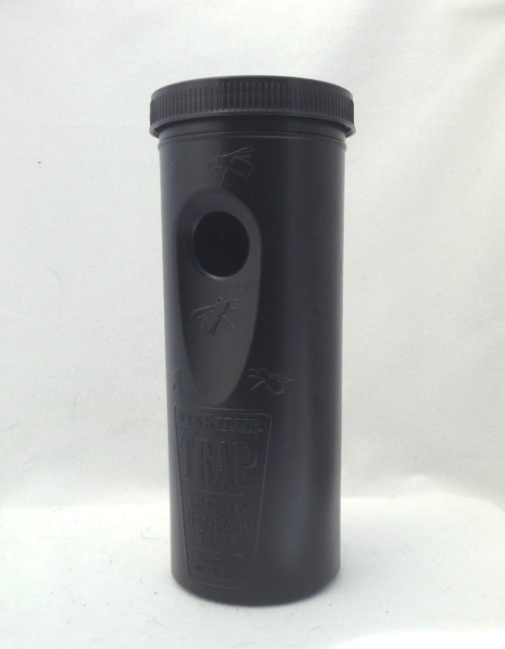
Figure 1. Oviposition Mosquito Trap
The traps remained in the field for 6-9 days. We collected the Popsicle sticks and velvet pads, and discarded the water in the plastic containers on site. The traps themselves were retained. The pads were brought back to the lab where the mosquito eggs were counted under a Duo Microscope (MFL 06 model) (C&A Scientific Inc., Manassas, VA, USA) and prepared for hatching.
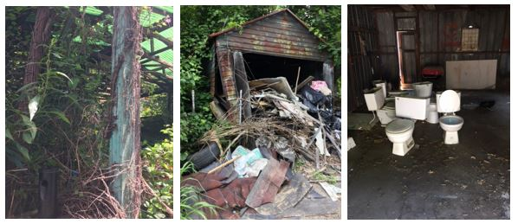
Figure 2. Examples of Oviposition Trap Sites
Mosquito Rearing and Larvae Identification
Each pad was placed into a standard 12 oz. white plastic cup and flooded with the Oaktree leave infused rainwater. The eggs were exposed to a photo period of 12:12 [L: D] using a timed UV light bulb (LCD Lighting, Inc., Orange, CT, USA). In order to ensure that the eggs had sufficient time to hatch, they remained flooded for approximately one week before they were ultimately thrown out. The cups were checked daily so that the larvae could be collected before pupating. The larvae that were collected were placed in a ceramic cups with tap water, microwaved for 10 seconds so that they would die and be placed under a microscope to be identified.
Source of Additional Data Used for Maps
Additional trap data were obtained from the Allegheny County Health Department, specifically the Pennsylvania West Nile Virus Control Program. Allegheny County census tracts (2010) were acquired from Esri and the Pittsburgh city boundary was retrieved from the Western Pennsylvania Regional Data Center (WPRCD). WPRCD also provided information regarding major roadways, water features, playgrounds and city parks. The Allegheny County census tracts were overlaid with the Pittsburgh city boundary, which allowed for a creation of a new layer: Pittsburgh city census tracts. The demographic information, such as race and ethnicity and percent poverty level, was data obtained from a 2016 census that was downloaded from American Fact Finder. Once the data was downloaded, the file was converted into a .csv file. The race and ethnicity data categorized each race and ethnicity separately. However, some of the minority percentages were so small that it was more efficient add them together and compare this combined value against the white non-Hispanic majority. The locations of relevant auto body shops were found using Yelp and then geocoded into QGIS.
Study Area: Pittsburgh, PA
Pittsburgh is the second largest city in Pennsylvania, with a population over 300,000 (2017). The city is 58.35 square miles and located at the confluence of the Allegheny, Monongahela and Ohio rivers. The abundance of water surrounding the city is conducive for mosquito breeding. Mosquito prevalence in Pittsburgh has become a greater concern in recent years as average temperatures continue to increase, thus allowing suitable habitats for these pathogen carrying vectors to expand. Mosquitos have integrated themselves into the metropolitan and residential communities, making it easy for them to transmit diseases to Pittsburgh residents.
Map 1 identifies the locations of the oviposition traps that were collected and analyzed for this study. All of these traps were collected in Pittsburgh during May through August (2016 and 2017). Although the Allegheny County Health Department does have mosquito data collection in Pittsburgh dating back for over a decade, many of these records are incomplete. Therefore, this map highlights the data points that have sufficient information on the number of eggs collected and are the only oviposition trap data points that were used for the remaining maps and analysis.
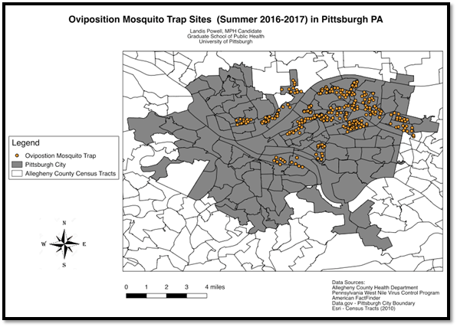
Figure 3. Location of Oviposition Mosquito Traps in Pittsburgh (Summer 2016-2017)
A limitation of this map is that the locations of the identified traps are not distributed evenly throughout Pittsburgh. The majority of the traps appear to be clustered in the Central and Eastern part of the city.
Image 4 demonstrates the aggregate of all of the different types of mosquito traps that have been set out in Pittsburgh since 2004. Unfortunately, not all of these data points contained pertinent information relating to the number of eggs or mosquitos collected, and therefore could not be used for this study. However, it is still important to showcase the magnitude of effort that the city of Pittsburgh has dedicated to understanding its mosquito population.
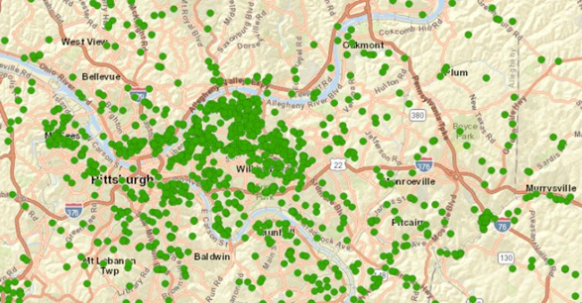
Figure 4. Location of All Mosquito Trap Sites in Pittsburgh Since 2004

RESULTS AND INTERPRETATION
For the purpose of this study, the number of mosquito eggs collected in the oviposition traps are interpreted as mosquito prevalence in that area. Map 2 shows how mosquito prevalence relates to race and ethnicity. The two demographic data frames being compared are white non-Hispanics and a combination of all other minorities. The first map (left) illustrates how the percentage of white non-Hispanic individuals within a census tract relates to the prevalence of mosquitos and the second map (right) demonstrates how the percentage of all minorities (Black, Hispanic, Asian, Pacific Islander etc.) relates to prevalence of mosquitoes. The comparison between these two different data frames indicates oviposition traps in census tracts with the higher percentages of minorities collected the greatest number of eggs. In other words, the traps that collected the greatest number of mosquito eggs were in census tracts with a large percent of minorities.
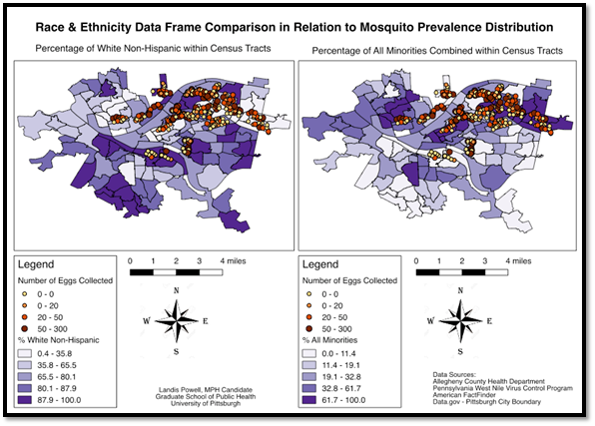
Figure 5. Comparison of Two Data Frames of Race & Ethnicity in Relation to Mosquito Prevalence
Interestingly, these two maps seemed to illuminate an underlying bias: the majority of oviposition traps that have been set in the last couple of years have been in census tracts with a higher percentage of minorities. This could introduce future problems within our analysis as it could lead us to conclude that census tracts with a larger percentage of minorities have more mosquitos simply because there were more traps placed in those locations. Clearly the Allegheny County Health Department has focused the bulk of its efforts relating to mosquitos in more vulnerable communities in recent years.
The primary purpose of Map 3 is to demonstrate the relationship between poverty level within census tracts and the number of mosquito eggs collected. Additional elements of this map include major roadways and water features. Mosquitos are known to use the winds and draft generated by high speed roads as a means of transport (Medley et al., 2014). Water features are important because mosquitos use resting water for their breeding grounds (DeLeau et al., 2013); non-operational public pools are especially well known to attract mosquitos (Harrigan et al., 2010). There are mosquito traps with few eggs in poor census tracts as well. In addition, mosquito prevalence does appear to be higher in areas closer to water features, specifically public pools. In terms of the highways as a mechanism of transport, there is not enough data to make a definitive conclusion. However, based off of the information we have, it appears that oviposition traps in census tracts with the higher percent poverty collected the greatest number of eggs.
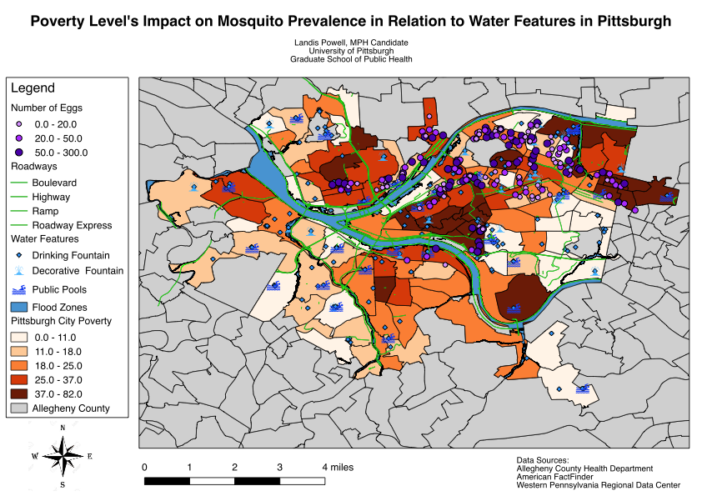
Figure 6. Poverty Level’s Impact on Mosquito Prevalence in Pittsburgh
The first potential reason explaining why mosquitos were denser in poorer communities is that these areas in Pittsburgh are characterized by older infrastructure and therefore often have ineffective water runoff systems. Along a similar vein, lower income communities might be less likely to invest in the upkeep of their home, which could lead to an accumulation of stagnant water. Both of these factors could contribute to poor draining, which leads to stagnant water, and therefore supports favorable breeding sites for mosquitoes. Lastly, areas with a higher percent poverty level are likely to be less educated and because income is positively correlated with education. Therefore, these areas might not be aware of preventative measures to reduce the mosquito population and they might not be aware that they can request pest control services, such as mosquito control.
In map 4, the number of mosquito eggs was dissolved onto the Pittsburgh census tracts to better illustrate the mosquito prevalence within each census tract. As mentioned earlier, a potential limitation is that census tracts might exhibit a higher mosquito prevalence simply because more traps were set in that area. Map 4 also includes Pittsburgh parks, playgrounds and auto body shops. Only playgrounds in census tracts directly adjacent (rook’s contiguity) to those with mosquito prevalence data are displayed in this map. Rook’s contiguity implies that census tracts that were connected merely by corners were not included. Playgrounds are important because swing tires and slides can collect and store still water, which mosquitos use as breeding grounds (Yee, 2008). Auto body shops can also attract mosquitoes because of their spare tires laying around (Yee, 2008). There is a ½ mile around the auto body shops because that is approximately the distance mosquitoes are known to travel away from their breeding ground. There is no clear trend between mosquito prevalence and playground and parks, but this map does suggest a relationship between auto body shops and mosquito prevalence. Auto body shops appear to be near or in census tracts with a higher number of mosquito eggs.
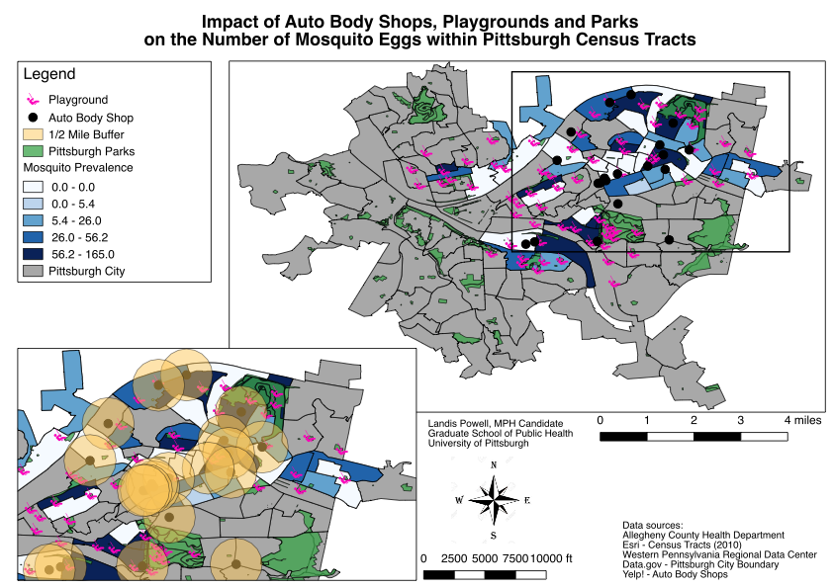
Figure 7. Impact of Auto Body Shop, Playground and Parks on Mosquito Prevalence
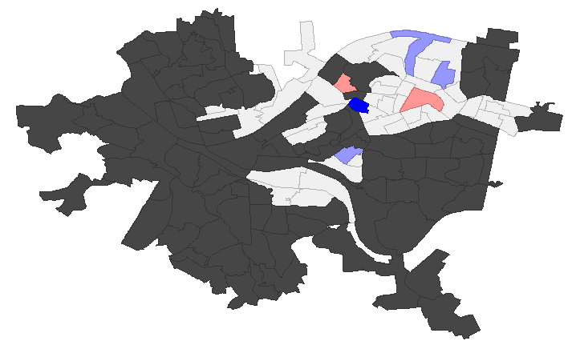
Although these four maps provide a useful foundation for understanding and visualizing the contributing social and physical factors of mosquito population in Pittsburgh, they do not provide any quantitative information, and as such are therefore rather subjective. As the final part of this study’s analysis, Geoda was used to construct a LISA cluster map. A LISA cluster map shows how the number of mosquito eggs clusters within Pittsburgh. For the purpose of this study, “High-High” areas indicate where the number of mosquito eggs collected is higher than general across the entire research area and the value for its neighbors is also higher than the general area. In short, the “high-high” category highlights where high rates cluster with high rates. The “low-low” category highlights where low rates cluster with low rates. A census tract labeled as “high-low” suggests that it has a greater number of mosquito eggs than average, but its neighbors have lower than average values. Therefore, “low-high” census tracts indicate that those areas have lower than average values but their neighbors have a greater number of mosquito eggs than average.

Figure 8. Number of Mosquito Eggs Collected LISA Cluster Map
This LISA map demonstrates the clustering of mosquito eggs throughout the census tracts using queen contiguity (i.e. adjacent census tracts include those connected through corners). It is interesting that there are no census tracts that have a higher than average number of eggs and are surrounded by similarly high census tracts (i.e. High-High). And there is only one census tract that has a lower than average number of mosquito eggs and is adjacent to similarly lower than average census tracts (i.e. the Low-Low category). Unfortunately, 41 of the 47 census tracts were determined to be statistically insignificant, and 92 census tracts were left undefined. Ultimately, this Geoda analysis indicates that more data is required; the Allegheny County Health Department should continue to focus its efforts on understanding the mosquito populations in Pittsburgh, PA.
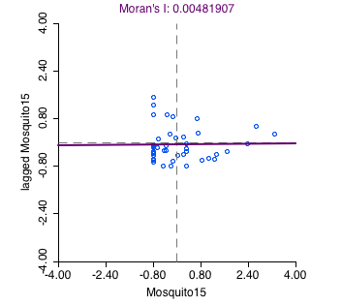
Figure 9. Moran’s I Value of Mosquito Clustering
The number of mosquito eggs with census tracts using Queen’s contiguity has a Moran’s l value of 0.004819 and a p-value of 0.005. The Moran’s I value is a spatial autocorrelation tool that takes into account census tract location and mosquito population simultaneously in order to evaluate a pattern. The pattern can be expressed as: clustered, dispersed or random. The pattern observed here is random because our value is very close to zero. This is considered statistically significant because the p-value is less than 0.05. Although both Queen and Rook Contiguity models were run, only the Queen contiguity is displayed here because mosquitos can travel 360 degrees from their breeding grounds.

CONCLUSION
This final section discusses the patterns associated with mosquito prevalence and clustering in Pittsburgh, as well as the contributing social and physical factors. Furthermore, this section also identifies possible limitations and biases associated with this study. Possible suggestions for future studies relating to this topic are described, as well as the overall significance of this study.
Mosquito Prevalence Patterns and Contributing Social Factors
As expected, the census tracts with the highest percent poverty level were also the areas that the oviposition traps collected the greatest number of eggs. In other words, the poorer communities have more mosquitos and are therefore presumably at a greater risk of contracting a vector-borne infectious disease. The relationship between mosquito prevalence and race and ethnicity was slightly more difficult to decipher. Ultimately, it appears as though traps set in census tracts that were predominantly white non-Hispanic collected less eggs than those set within census tracts with a higher proportion of minorities. However, it should be noted that oviposition mosquito traps were distributed unevenly throughout the census tracts. The majority of the mosquito traps were located in census tracts with a higher percentage of minorities, leading to a sampling discrepancy. As noted previously, the initial purpose of this data collection was to determine where nuisance mosquitos were located in Pittsburgh. As such, the sampling focus in on neighborhoods where the Aedes albopictus had been previously found and then trap placements radiated from there.
Geoda was used to examine the clustering of the collected mosquito eggs. A Moran’s I value was calculated to be 0.004819 with a p-value of 0.005. These values suggest- that there is a hardly any significant clustering; the mosquito population pattern is considered random. A LISA cluster map was also constructed in order to show how the number of mosquito eggs clustered within Pittsburgh. Between the Moran’s I value and the LISA cluster map, it seems that the number of mosquito eggs in a census tract has little effect on the mosquito population in surrounding areas. Due to the high number of statistically insignificant census tracts, we are unable to conclusively determine whether mosquito prevalence is influenced by neighboring census tracts versus being correlated to the demographic and the environmental factors of their breeding ground. As a pilot project, this report advanced the understanding of where mosquitos are located in Pittsburgh, however it is clear that more data is required to advance this research.
Environmental and Physical Factors
Mosquito prevalence did not appear to be higher in areas close to the specified water features, specifically public pools. This is a result that these pools are owned and maintained by the city. Therefore, they are properly chlorinated and cleaned regularly. In terms of the highways as a mechanism of transport, there is not enough data to make a definitive conclusion. Furthermore, there is no clear trend between mosquito prevalence and playground and parks, but Map 4 does suggest a relationship between auto body shops and mosquito prevalence. Auto body shops appear to be near or in census tracts with a higher number of mosquito eggs.
Study Limitations and Suggestions
The primary limitation of this study was the inconsistency of the oviposition trap locations. The uneven distribution of mosquito traps across the city could lead to a biased interpretation of the prevalence of mosquitos. Census tracts with more mosquito traps unsurprisingly collected more mosquito eggs and therefore suggested that those neighborhoods had a larger mosquito population in Figure 7. Another constraint with the trap data was the deviation in the frequency of trap collections. Some traps were left out for only four days, while others remained in the field for a week, and this information was not normalized to take this variance into account.
Another limiting factor was the lack of consideration for temperature and rainfall levels during collection, modeling and analysis of this data. For example, mosquito prevalence is approximately three times greater in August than in June (McMahon et al., 2008). This is likely due to the mosquito breeding cycle and weather difference between these months. Unfortunately, it is difficult collect this type of data in an uncontrolled setting and the weather varied drastically throughout the summer months.
Although mosquito control efforts by the Allegheny County Health Department were briefly addressed, this information was not taken into account when analyzing the mosquito population. This lack of consideration for active preventative measures could also be a potential limiting factor because mosquito control efforts in Pittsburgh that could have reduced the number of mosquito eggs collected in census tracts predicated to have a high abundance. Furthermore, the number of mosquito eggs collected in the traps may not have been the best variable for predicting the risk of human disease infection, however it is the best option available to date.
In order to improve this study and advance future mosquito research, more data needs to be collected around Pittsburgh. In particular, the location of mosquito traps should be mapped out with intention before being placed in the field.
Research Significance
As temperatures continue to increase, mosquitos’ habitats and breeding grounds will expand and mosquito-borne disease will become a greater concern for healthcare officials. Estimating vector-borne diseases through mapping is becoming of larger interest to researchers as these infectious disease continue to persist. This study was meant to provide a better understanding of the mosquito population in Pittsburgh and identify some of the contributing social and physical features that influence the prevalence of these pests. In other words, this study was meant to be a foundation for further risk estimation research. Although this study was not predicative, there were some quantitative aspects that could inspire some more dynamic investigation. Overall, poor minorities are at greatest risk of mosquito-borne disease exposure.
Mosquito Breeding Control Measures
An improved understanding of the relationship between sociodemographic and physical factors that delineate where mosquitoes breed is imperative for effective mosquito control. The most effective way to prevent mosquitoes breeding is to reduce their breeding grounds by remove standing water. The CDC recommends emptying and scrubbing containers that collect and hold water, such as vases, birdbaths, trash cans, once a week (CDC, 2012). Improving water sanitation by building or improving upon water distribution systems can also reduce the number of mosquitoes in a community and thus reduce the chance of spreading infectious diseases.

BIBLIOGRAPHY
Allegheny County Census Tracts 2010. Data.gov. https://catalog.data.gov/dataset/allegheny-county-census-tracts-2010-2710c

American FactFinder. United States Census Bureau. 2016. https://factfinder.census.gov/faces/nav/jsf/pages/searchresults.xhtml?refresh=t

American Mosquito Control Association (AMCA). 2005. Mosquito-Borne Diseases. http://www.mosquito.org/mosquito-information/mosquito-borne.aspx.

Centers for Disease Control and Prevention (CDC). 2012. Dengue Prevention.

Centers for Disease Control and Prevention (CDC). 2017. Zika Virus Treatment
https://www.cdc.gov/zika/symptoms/treatment.html

De Souza, D., Kelly-Hope, L., Lawson, B., Wilson M, Boakye D. 2010. Environmetnal Factors Associated with Distribution of Anopheles gambiae in Ghana; an Important Vector of Lymphatic Filariasis and Malaria. PLos ONE 5(3)

Gage K.L., T.R. Burkot R.R. Eisen and E.B. Hayes. 2008. Climate and Vector-borne Diseases. American Journal of Preventive Medicine 35(5): 436-450.

Gratz, N.G. 2004. Critical review of the vector status of Aedes albopictus. Medical and Veterinary Entomology. 18: 215-227

Harrigan R.J., Thomassen H.A., Buermann W., Cummings R.F., Kahn M.E., Smith T.B. 2010. Economic Conditions Predict Prevalence of West Nile Virus. PLoS ONE. 5(11)

Hawley WA. 1988. The biology of Aedes albopictus. J Am Mosquito Control Association Suppl.1:1–39.

Johansson M, Dominici F, Glass G. 2009. Local and Global Effects of Climate on Dengue Transmission in Puerto Rico. PLos Neglected Tropical Disease 2(2)

LaDeau SL, Leisnham PT, Biehler D, Bodner D. 2013. Higher mosquito production in low-income neighborhoods of Baltimore and Washington, DC: understanding ecological drivers and mosquito-borne disease risk in temperate cities. International Journal of Environmental Research and Public Health. 10:1505–1526.

McMahon, T.J.S., Galloway, T.D. Anderson, R.A... 2008. Tires as larval habitats for mosquitoes (Diptera: Culicidae) in southern Manitoba, Canada. Journal of Vector Ecology. 33(1):198-204

Medley, K.A., Jenkins, D.G., Hoffman, E., 2014. Human-aided and natural dispersal drive gene flow across the range of an invasive mosquito. Journal of Molecular Ecology. 24(2)

Noji, E.K. 1997. The Public Health Consequences of Disasters. New York: Oxford University Press.

Panditrao, M., P. Jeevan, and T. Akbar. 2006. Use of Geographic Information Systems (GIS) to Predict Vector-borne Disease Outbreaks: A crucial step towards cost effective prevention of diseases. Proposal submitted to the “Bears Breaking Boundaries” Contest.

Pelz-Stelinski K, Walker E, Kaufman M. 2010. Senescent leaf exudate increase mosquito survival and microbial activity. Journal of Ecological Entomology. 35(3)

Reiter P. 2001. Climate change and mosquito-borne disease. Environmental Health Perspective.109:141

Rossati A, Bargiacchi O, Kroumova V, Garavelli P.L. 2014. Vector Transmitted Disease and Climate Changes in Europe. InfezMed Journal 22(3): 179-92.

West Nile Virus Control Program. Allegheny County Health Department. http://www.wnvcp.state.pa.us/wnv/

Western Pennsylvania Regional Data Center (WPRDC). Datasets. https://data.wprdc.org/dataset

Wilson, M.L. 2002. Emerging and Vector-borne Diseases: Role of High Spatial Resolution and Hyperspectral Images in Analyses and Forecasts. Journal of Geographic Systems 4: 31- 42.

World Health Organization (WHO). Media Center. 2017. Vector-Borne Diseases Fact Sheet. http://www.who.int/mediacentre/factsheets/fs387/en/

World Health Organization (WHO). World Health Report Executive Summary. 2018. Insect Borne Disease.
Yee, DA. 2008. Tires as habitats for mosquitoes: a review of studies within the eastern United States. Journal of Medical Entomology. 45(4) 581-93

