Allyn Reynolds
ASRA Scholar
April 30, 2018
Uncle Tom’s Cabin

Uncle Tom’s Cabin, the landmark abolitionist novel by Harriet Beecher Stowe, was published in 1852. It was the best-selling novel of the 19th century, and the second best-selling book only following the Bible. Quickly, unauthorized versions targeted to children entered the market, as well as plays, dolls, and other items. Stowe’s work, while abolitionist in nature, became morphed by the racism of others through their mediums. The characters and adapted tales of Uncle Tom’s Cabin helped popularize numerous stereotypes about African-American such as the loving “mammy,” “pickaninny” wild black children, the “Uncle Tom” that dutifully serves whites, and “little Eva” who is Christ-like in her white purity and ability to redeem black people. The University of Pittsburgh archives houses a number of Uncle Tom’s Cabin offshoots, particularly in the Nesbitt and Curtis Collections. The Nesbitt Collection houses children’s literature archives with over thirty editions of Uncle Tom’s Cabin.
My academic inquiry began with the question: How was slavery depicted to children in the past? Previously, I have researched depictions of slavery in modern picture books for children and was dismayed at my findings. The progression to the past seemed excellent in enhancing my knowledge of racism in children’s literature. The large collection of UTC in Nesbitt made for a perfect fit in examining the storytelling process. Most modern works struggle with distilling heavy topics such as slavery to children while also preserving the truth of the injustice. More often than not, racist propaganda is created in the process.
One work I examined, Young Folks Uncle Toms Cabin by Grace Duffie Boylan and Ike Morgan, featured an exacerbated binary cover (see Image 1). On the left, the angelic white Eva elegantly points or lectures at Topsy. On the right, Topsy is depicted with wild hair in every direction, huge white lips, and a colored dress. The end result propagates to child readers the innocent, superiority of the white child to the monkey-like black child. Authors Boylan and Morgan’s work was published in 1902 after the Civil War yet it still conveyed that slaves were better off with their masters given that Uncle Tom lives due to the compassionate rescue by his original slave master. In the end, all slaves are freed on the plantation but decide to live their because they love their old masters.
Over and over again I was struck by the insidious ways books market themselves as moral stories that are actually clear representations of minstrel characters or other harmful stereotypes. In the Nesbitt Collection, there is a short picture book titled Topsy with it being an outline of her eating a watermelon while numerous rinds cover the floor surrounding her. Furthermore, another problematic image in the work contains Topsy playing with blackface dolls. The dichotomy between white and black, innocent and sinful, saved and condemned is highlighted through the characters of Topsy and Eva in most of the UTC children’s collection. One such work in Pitt’s collection is Little Eva Famous Children of Literature supposedly by Harriet B Stowe. Ms. Beecher-Stowe never authorized offshoots of her characters and as such the real author remains unknown. The introductory note elaborates on the simplified approach taken to communicate the story of Uncle Tom’s Cabin, “The part of Mrs. Stowe’s novel which is most certain to please a child is that relating to the beautiful life of little Eva. Children should certainly be encouraged to share the enjoyment which their elders find in standard works of fiction, and it is believed that there could hardly be a better introduction to the masterpieces of the imagination than a series of books like the present. The simple stories which would win and hold the attention of a child have been detached from their setting and presented in a plain, concise way. It is hoped that these tales will provide innocent amusement for the young reader, inculcate, without moralizing, wholesome ideals of life, and also pave the way for a wider familiarity with the works of the best English and American novelists.” Once again, the tale of slavery is taken through the lens of the white child for which only ignorance and misunderstanding can result.
Some archival works are more blatantly racist, such as Uncle Tom’s Cabin and other stories. The children’s novel contained only three images, with the cover counting as one. See Image 2. Depicting a minor scene from UTC where the white slave seller yells at slaves for the cover is strange. There are no main characters on the cover and the young slaves are depicted with monkey-like qualities.

So why do these depictions from one-hundred years ago matter? A quote by author Shomossi has stuck with me. “Whether we like it or not, whether we intend it or not, what children read or what is read to them will influence their world view” -N. Shomoossi (2007) An often-neglected incubator of hateful messages is children’s literature, where blatant misrepresentation or, more commonly, a lack of depiction at all, convey racist attitudes to America’s most vulnerable population: its children. Children’s literature has largely remained stagnant with depictions of African-Americans still transmitting altered historical narratives. One need only browse the children’s shelves at the bookstore to witness the lack of children of color featured in works. Afterall, if children of color cannot find themselves in stories, doesn’t it communicate to them on their value in society? Empathy, based upon authentic narratives, grants children the freedom to expand their minds and exercise their autonomy. The publishing world will change when racism is no longer allowed to hide under the veil of childhood “innocence” which will take the collective community around children’s books to call it out.
During my ASRA research, I better understood how the special collections library system works and the arduous task of preserving historical works. It does not seem easy but after working with the Nesbitt Collection, it most definitely is worth it!
A sincere and heartfelt thanks to the Office of Undergraduate Research and the University Library Systems, in particular the Department of Special Collections, all of whom made this project possible. Personal thanks to Clare Withers & Jeanann Haas for their endless support and guidance.

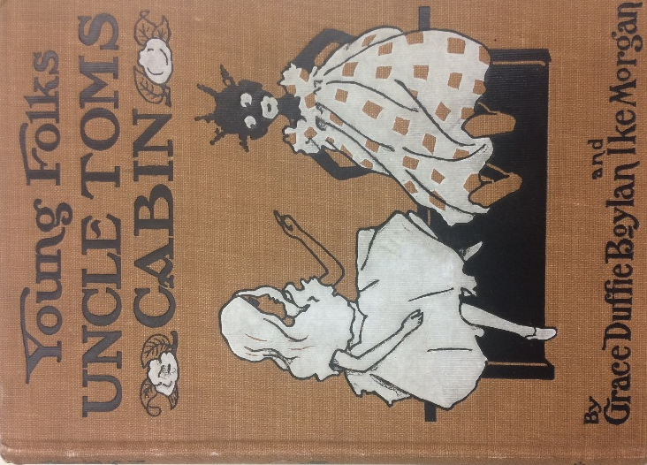
Image 1.

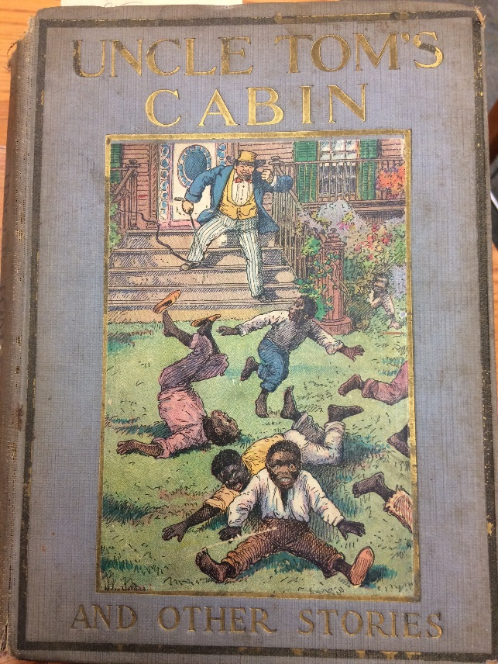
Image 2

