THE GUT MICROBIOME AND SUBCLINICAL HERPESVIRUS COINFECTION

IN HIV INFECTION

by
Juchul Hwang
MD, Catholic University of Korea, Medical College, Korea, 2011

Submitted to the Graduate Faculty of
Multidisciplinary MPH program
Graduate School of Public Health in partial fulfillment
of the requirements for the degree of
Master of Public Health

University of Pittsburgh

2018

UNIVERSITY OF PITTSBURGH
GRADUATE SCHOOL OF PUBLIC HEALTH

This essay is submitted

by

Juchul Hwang

on

August 8th, 2018

and approved by

Essay Advisor:
David Finegold, MD ______________________________________
Professor
Pediatrics, Medicine, Human Genetics
Director, Multidisciplinary MPH program
Medical School, Graduate School of Public Health
University of Pittsburgh

Essay Reader:
Alison Morris, MD, MS ______________________________________
Professor
Medicine, Immunology, and Clinical and Translational Research
Director, Center for Medicine and the Microbiome
Medical School
University of Pittsburgh

ABSTRACT
Copyright © by Juchul Hwang

2018

Background: Herpesvirus co-infection in HIV-infected individuals has been associated with increased immune activation in HIV infection. However, the issue of how it shapes and impacts immune system, or vice versa, has not been established yet.
David Finegold, MD

THE GUT MICROBIOME AND SUBCLINICAL HERPESVIRUS COINFECTION
IN HIV INFECTION

Juchul Hwang, MPH

University of Pittsburgh, 2018
Objective: To examine whether the alteration of microbial composition is associated with herpesvirus shedding in virally-suppressed HIV-infected individuals.
Methods: Blood, throat washing, semen, urine, and stool samples were obtained from virally-suppressed HIV-infected men who have sex with men (MSM) and 12 age-matched HIV-uninfected MSM from Multicenter AIDS Cohort Study (MACS). Herpesvirus shedding was measured by real-time PCR in all samples, and soluble markers of immune activation were measured by ELISA at four different time points over 24 weeks. Gut microbial profiles were evaluated by Illumina-based sequencing of the V4 hypervariable region of 16S rRNA gene using stool samples. PERMANOVA was performed to assess the association of microbial profiles with herpesvirus shedding rates at five body compartments and soluble immune markers.
Results: A trend was observed between the seminal herpesvirus shedding rate and gut microbial profiles although not significant. At the genus level, the seminal shedding rate positively correlated with the relative abundance of Blautia, and negatively correlated with Faecalibacterium. The relative abundance of Blautia positively correlated with plasma C-reactive protein level. No shedding rates from other body sites were associated with microbial profiles or immune markers.
Conclusion: We found a moderate evidence that gut microbial alteration is associated between herpesvirus shedding, but we did not find any evidence that it is associated with persistent immune activation. Therefore, future studies are needed to fully assess the role of microbiome in viral shedding and inflammation.
Public Health Significance: Despite the advent of effective combination of antiretroviral therapy, the overall life expectancy of HIV-infected individuals is shorter than the general population because of their high prevalence of non-communicable diseases. Thus, it is important to investigate the factors that impact the course of HIV disease and chronic immune activation.

TABLE OF CONTENTS
preface ix
1.0 Introduction 1
1.1 MICROBIOTA IN HIV 2
1.2 MICROBIAL TRANSLOCATION IN HIV 3
1.3 HERPESVIRUS COINFECTION IN HIV 4
2.0 OBJECTIVE 6
3.0 METHODS 7
3.1 STUDY SUBJECTS 7
3.2 EXPERIMENTAL PROTOCOLS 7
3.2.1 MEASUREMENT OF T CELL ACTIVATION AND IMMUNE MARKERS 7
3.2.2 MEASUREMENT OF HERPESVIRUS SHEDDING RATES 8
3.2.3 DNA EXTRACTION, AMPLIFICATION OF 16S RNA GENE 8
3.2.4 DNA PURIFICATION, AND ILLUMINA-BASED SEQUENCING 9
3.3 STATISTICAL ANALYSIS 10
4.0 RESULTS 11
4.1 Comparison between HIV-INFECTED and HIV-UNINFECTED groups 11
4.2 CORRELATION of microbial profiles WITH SEMINAL SHEDDING RATE 13
4.3 CORRELATION of microbial profiles WITH immune markers 18
5.0 DISCUSSION 21
6.0 PUBLIC HEALTH SIGNIFICANCE 25
bibliography 26

LIST OF TABLES
Table 1. Clinical characteristics of study participants 11
Table 2. Association between microbial profiles and shedding rates at each body compartment 14

LIST OF FIGURES
Figure 1. Comparison between HIV-infected and HIV-uninfected groups in gut microbial profiles 12
Figure 2. Heatmap of correlation coefficients of each shedding rates 14
Figure 3. Comparison of gut microbial profiles according to herpesvirus shedding rate in semen 15
Figure 4. Abridged model consisting of top ten OTUs with herpesvirus shedding rate in semen 16
Figure 5. Heatmap of correlation coefficients between top ten OTUs and herpesvirus shedding rates at each body sites 17
Figure 6. Comparison of gut microbial profiles according to soluble sCD14 level 19
Figure 7. Heatmap of correlation coefficients between top ten OTUs and soluble immune markers 20

preface

This research is supported by Center for Medicine and the Microbiome, University of Pittsburgh, and Division of Infectious Diseases, Department of Medicine, University of Pittsburgh. I would like to thank Dr. Morris to support this research, and Dr. Macatangay for providing his data. I would also like to thank Adam Fitch, Joseph Huwe, Kelvin Li, and other colleagues from Center for Medicine and the Microbiome, it would be impossible without their expertise and insights that greatly helped this research. Finally, I would appreciate Dr. Finegold supporting this essay, as well as, guiding me to finish all my courses and to prepare my future career.

Introduction
Since the advent of effective combination antiretroviral therapy (ART), the prognosis of human immunodeficiency virus (HIV) infection has dramatically improved.[1] Currently, HIV infection is considered as a non-fatal disease, because the plasma viral load can successfully be controlled by ART. Well-treated HIV-infected individuals often have undetectable plasma HIV RNA level with restoration of CD4+ T cell counts. Nonetheless, the virus is rarely eradicated from the host and remains latent in immune cells even after long-term treatment. Importantly, chronic HIV infection has been linked to increased risks of non-communicable diseases such as cardiovascular disease, diabetes, neurocognitive disorders, osteoporosis and malignancies,[2-7] as well as shorter life expectancy than general population,[8-10] which raises a serous public health concern. It has been proposed that the increased risk of non-AIDS-related diseases and the excess age-related mortality in treated HIV infection are attributed to persistent immune activation and prolonged inflammation measured by immune markers such as tumor necrosis factor alpha (TNFα), C-reactive protein (CRP), sCD163 and interleukin-6 (IL-6).[11-13]
Although the etiology of such ongoing immune activation is yet to be determined, several possible mechanisms have been suggested. First, disrupted integrity of the gut mucosal barrier by progressive depletion of CD4+ T cells may allow bacterial translocation into the bloodstream in the early course of HIV infection, which is associated with systemic immune activation and disease progression.[14] Second, HIV-associated immune dysfunction may accelerate co-infected viral replication and reactivation, which trigger further activation of T cells and other immune cells.[15] Third, disruption of gut epithelial immunity due to HIV infection may induce the alteration of gut microbial composition, resulting in metabolic dysfunction performed by microbiome.[16]

MICROBIOTA IN HIV
The human body carries trillions of microorganisms including bacteria, fungi, and viruses that commensally live with their human host.[17] This collection of microbial organisms from a defined environment is referred to as the microbiota. The totality of microbes, their genetic information, and the milieu in which they interact is referred to as the microbiome. The microorganisms living on humans can be classified into three categories: 1) symbionts, which promote human health), 2) commensals, which have no known effect on host, and 3) pathobionts, which have pathogenic potential to human health. It has long been recognized that some microorganisms could play an important role in absorption of certain nutrients such as vitamin B₁₂ in human health. Also, by the traditional culture methods in which letting them reproduce in a specific environment to detect target microbes, we were able to identify certain pathogenic microorganisms that can cause acute infectious diseases or chronic disorders. However, the advent of next-generation sequencing techniques targeting the hypervariable 16S rRNA region of bacteria, which allow bacterial communities to be characterized, have revolutionized our understanding of the complexity of microbial ecology in a variety of human organs. Currently, it is a general consensus that the microbiome has a tremendous effect on human health, and the critical role of the microbiota in human health and diseases has been increasingly investigated.[18-21] A number of studies reported that decreased microbial diversity and richness has been linked to increased risk of obesity, metabolic syndrome, diabetes mellitus, inflammatory bowel disease, cardiovascular diseases, and certain types of cancer.[22] As one of the proposed mechanisms, microbial metabolites produced by commensal microbial communities may have a huge impact on human health. For example, short chain fatty acids (SCFAs), the end product of fermentation from dietary fiber by anaerobic gut bacteria, may play a key role in regulation of host metabolism and immune function.[23]
Recently, HIV infection has been associated with decreased gut microbiome diversity and richness, loss of commensal bacteria, and increased pathogenic bacteria. and its association with chronic immune activation in HIV infection has also been reported.[24-26] Moreover, the HIV infection-related gut microbial dysbiosis, a condition of having seemingly abnormal microbial composition in the intestinal lumen, was associated with alteration of microbial metabolic pathways, such as increased kynurenine production, a tryptophan metabolite produced by commensal bacteria,[27] and decreased abundance of butyrate producing bacteria,[28] suggesting that reciprocal pathways between the gut microbiome and epithelial immune system may exist.

MICROBIAL TRANSLOCATION IN HIV
Microbial translocation from the intestine to the bloodstream has been known to cause systemic immune activation in HIV infection.[14] CD4+ T lymphocytes in the gut associated lymphoid tissue (GALT) are one of the primary targets of HIV, and thus the T cells are substantially depleted in concordance with rapid HIV replication in the early course of HIV infection.[19] After the period of acute HIV infection, HIV replication is reduced but not entirely suppressed despite ART,[29] because reservoirs of HIV provirus established in the early course of infection are unable to be eradicated.[30] During chronic HIV infection, CD4+ T lymphocytes are progressively depleted. Importantly, IL-17-secreting CD4+ T cells, which plays an important role in maintaining gut integrity and mucosal defense, are preferentially depleted during the course of infection.[27] As a result, a dysfunctional gut-blood barrier allows intestinal microbes to translocate from the intestinal lumen to the bloodstream, causing systemic low-grade inflammation and immune activation.[31, 32] This is evidenced by the fact that HIV patients often have increased plasma level of lipopolysaccharide (LPS), which is a major component of the outer membrane of Gram-negative bacteria. This chronic and persistent immune activation is thought to be a key feature to understand the non-AIDS-related comorbidities.

HERPESVIRUS COINFECTION IN HIV
Over the last decade, the role of asymptomatic herpesvirus coinfection in persistent immune activation, and its association with higher risk of non-communicable diseases in HIV infection have increasingly been highlighted.[20, 33] Latent herpesvirus shedding is frequently observed in the general population, and is thought to be more common in HIV-infected individuals.[34] Reactivation of genital cytomegalovirus (CMV) and Epstein-Barr virus (EBV), which are members of herpesvirus family, has been associated with higher HIV shedding in semen,[35] and higher HIV viral loads in the blood,[36] as well as, poor immune reconstruction after ART.[37] Lurain et al. reported high levels of immune activation measured by sCD14, which is secreted mainly from monocyte, in HIV-infected women, suggesting that monocyte can be an interaction site for both CMV and HIV.[38] Importantly, valganciclovir treatment for herpes co-infection in HIV disease successfully reduces CD8+ T cell activation, suggesting that herpesvirus co-infection may drive immune activation in HIV infection.[15] This is supported by the recent study by Maidji et al. that CMV replication in the gut epithelium may independently impact gut integrity by damaging epithelial tight junctions, possibly leading to accelerated microbial translocation.[39] This finding may explain that the association of subclinical herpesvirus infection with chronic immune activation in HIV infection. However, these studies only examined CMV and EBV, and thus our colleagues previously investigated whether other members of herpesvirus family have a role in HIV infection.[40] In the study, we reported that while higher EBV shedding rate was, although not significantly, associated with greater level of sCD14, but CMV shedding was not associated with any immune markers. Interestingly, the CMV shedding rate was inversely associated with T cell activation in HIV-infected individuals at particular time points, and HHV-6 shedding rates negatively correlated with IP-10 and sCD163, suggesting that low-level inflammation may drive herpesvirus reactivation. This inconsistency is considered to be due to the different patient characteristics, and/or the duration of the anti-retroviral treatment. Therefore, further study is needed to identify the role of herpesvirus co-infection in persistent immune activation and inflammation in HIV infection.

OBJECTIVE
Several previous studies proposed that herpesvirus co-infection in HIV is associated with chronic inflammation and immune activation. However, our previous study targeted for well-treated MSM did not support this association. As a follow-up study, we hypothesized that the gut microbiome may play an important role in the association between herpesvirus co-infection and chronic immune activation. Using the same studied subjects as the previous study, we aimed to investigate whether the reported herpesvirus shedding rates and immune activation are associated with altered gut microbial communities.

METHODS

STUDY SUBJECTS
Participants were recruited from the MACS, a prospective cohort of HIV-infected men who have sex with men (MSM), and HIV-uninfected MSM from the Pittsburgh site, as described [41]. Briefly, virally suppressed men on ART for at least 48 weeks with CD4⁺ T cell counts ≥ 500 cells/mm³, CMV IgG antibody (+) individuals were enrolled. Age-matched CMV IgG Ab(+) HIV-1 negative individuals were also enrolled as a control group. Participants who received acyclovir, valacyclovir, ganciclovir or valganciclovir were excluded. Samples including blood, throat washing, urine, semen, and stool were taken from participants at four visits (0, 4, 8, and 24 weeks) using sterile containers and were immediately frozen at -80°C until analysis. Final samples included 15 HIV-infected MSM and 12 age-matched HIV-uninfected controls. Written informed consent was obtained from all participants and this study was approved by the University of Pittsburgh Institutional Review Board (IRB# PRO12030691).

EXPERIMENTAL PROTOCOLS

MEASUREMENT OF T CELL ACTIVATION AND IMMUNE MARKERS
Peripheral blood mononuclear cells (PBMCs) were used to evaluate the percentage of T cell activation previously by our colleagues, as described.[40] Monoclonal antibodies (mAbs) used to stain and fix the samples included: anti-CD3 allophycocyanin (APC)-H7, anti-CD4 phycoerythrin (PE), CF594, anto-CD8 Alexa Fluor 700, anti-human leukocyte antigen D-related (HLA-DR), PE, anti-CD38 APC, all BD biosciences, and then analyzed using a BD LSRFortessa (BD Biosciences), and FlowJo version 10.0.7 software (TreeStar, Ashland, Oregon, USA). The plasma levels of soluble immune markers including sCD14, sCD163, interferon γ-induced protein 10 (IP-10), interleukin-6 (IL-6), and C-reactive protein (CRP) were measured by commercially available ELISA kits, and analyzed by ELX808 ELISA reader (Biotek, Winooski, Vermont, USA).

MEASUREMENT OF HERPESVIRUS SHEDDING RATES
A detailed protocol for detecting herpesvirus shedding performed by our colleagues was previously described.[40] Briefly, DNA extraction was performed for each sample using EasyMag (bioMerieux, Durham, North Carolina, USA). Then, real-time PCR was performed to quantify the extracted DNA. The master mix contained 5μL sample DNA or control, 10 μL of Taqman 2X Gene Expression Master Mix (Applied Biosystems, Foster City, California, USA), 1,2 μmol/L forward and reverse primers, and 0.3 μmol/L of probe. The thermal cycles were: 50ºC for 2 min, 95ºC for 10 min, followed by 45 cycles of PCR amplification, 95ºC for 15s and 60ºC for 1 min.

DNA EXTRACTION, AMPLIFICATION OF 16S RNA GENE
Sample handling was performed inside a UV hood to minimize contamination during DNA extraction and amplification. Stored fecal samples obtained from the study participants at each time-point were thawed at room temperature to remove a small portion from the top of a collection tube. DNA was extracted from the samples using Powersoil kit (MoBio, Carlsbad, CA) according to the manufacturer’s instructions as described [42]. We amplified the extracted DNA by polymerase chain reaction (PCR) targeting the hypervariable 16S V3 and V4 region using the following primers:
- 16S Amplicon PCR forward Primer = 5’,
TCGTCGGCAGCGTCAGATGTGTATAAGAGACAGCCTACGGGNGGCWGCAG
- 16S Amplicon PCR Reverse Primer = 5',
GTCTCGTGGGCTCGGAGATGTGTATAAGAGACAGGACTACHVGGGTATCTAATCC
The thermal cycles were: an initial denaturation at 98ºC for 5 min, followed by 30 cycles of 98ºC, 57ºC, and 72ºC for 30 seconds each, and a final extension at 72ºC for 5 min. The master mix per reaction contained 14.05μL of purified H₂O, 5μL of buffer, 0.5μL of dNTPs, 0.6μL of forward (515F) and reverse (785R) primers, and 0.25μL of DNA polymerase (Q5 Hifi Hotstart), with 4μL of template DNA. PCRs were performed in duplicates, as 4μL per reaction of each sample with a single barcode was amplified in duplicate 25μL reactions.

DNA PURIFICATION, AND ILLUMINA-BASED SEQUENCING
We combined duplicates and purified using the AMPure XP beads (Beckman) at a 0.8 : 1 ratio (beads : DNA) to remove primer-dimers. 5μL of remained PCR product from each barcoded amplicon was electrophoresed on 1.5% agarose gel to detect amplification success. The eluted DNAs were quantified using Qubit Fluorometer (Invitrogen). Then, all samples were pooled by combining 20ng of each purified band, then the pooled sample was purified with the MinElute PCR purification kit. The final sample pool was purified again with AMPure XP beads to remove all traces of primer dimers and finally cleaned using Purelink PCR Purification Kit (Life Technologies). We quantified the purified pool in triplicate on Qubit Fluorometer 2.0 (Invitrogen) prior to loading for the sequencing to evaluate DNA purity. The primers contain V3-specific priming sequences, sequences complementary to Illumina forward, reverse and multiplex sequencing primers. Pooled amplicons were quantified using Qubit Fluorometer 2.0 (Invitrogen). The pool was deluted to 15pM and spiked with 25% of the Illumina PhiX control DNA prior to loading the Miseq. Universal primers linked with indices and sequencing adaptors were used to amplify the V3-V4 regions of the 16S rRNA gene. The amplicons were sequenced on an illumine Miseq platform to obtain 300-bp paired-end reads.

STATISTICAL ANALYSIS
Descriptive statistics were calculated and comparisons in shedding rate and level of immune markers were performed using STATA/MP version 14 (StataCrop, College Station, TX). Data were tested for normality by Shapiro-Wilk test. For all skewed data, logarithmic transformation was performed. Raw 16S genomic data were processed using the R platform. Taxonomic classification was done with Silva database and the naïve Bayes classifier implemented in Mother based on similarity to phyla (80%) and genus (97%). Comparison in distance matrices between HIV-infected MSM and HIV-uninfected controls was conducted using the anosim method. Then, principal component analysis (PCA) and multidimensional scaling (MDS) were performed by using relative abundance data after additive log ratio (ALR) transformation to compare similarities among samples. The relationship between herpesvirus shedding rate and microbiota was assessed by Bray-Curtis distance-based permutational multivariate analysis of variance (PERMANOVA) with adonis in R. Statistical significance was defined using an alpha of P < 0.05 (two-sided).

RESULTS

Comparison between HIV-INFECTED and HIV-UNINFECTED groups
Table 1 shows clinical characteristics of of the HIV-infected and HIV-uninfected groups of study participants. The median age was 43 (range 26 – 50) in both groups. In the HIV-infected group, the median years of HIV infection was 9 years (range: 3 – 19 years), and the median years of viral suppression by ART was 7 years (range: 1 – 10 years). All the HIV-infected participants had more than 500 CD4+ T cell counts with median CD4+ T cell percentage of 36%, indicating that they had been virally suppressed. In the PCA and MDS plots in which normalized microbial abundances were plotted in a two-dimensional graph, not significant differences in microbial profiles were detected (P = 0.141) (Figure 1).

Table 1. Clinical characteristics of study participants
 | HIV(+), N = 15 | HIV(–), N = 12
Median age in years (range) | 43 (27 – 50) | 43 (26 – 50)
Median years of HIV infection | 9 (3 – 19)
Median years of ART suppression | 7 (1 – 10)
Median CD4+ T cell count (range) | 803 (533 – 1355) cells/µL
Median CD4+/CD8+ T cell ratio | 1.0 (0.5 – 1.6)
*All studied patients are CMV and EBV IgG antibody (+)

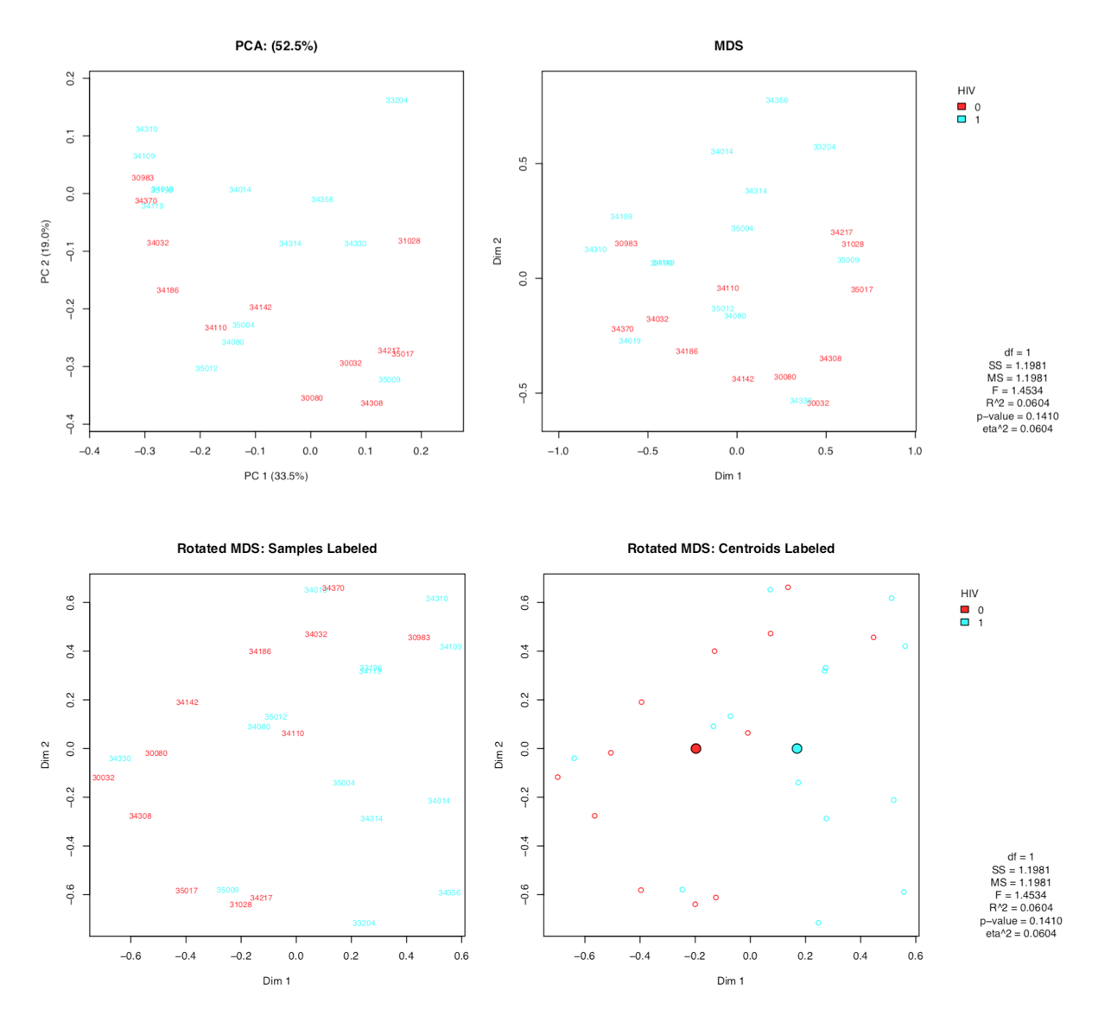
Figure 1. Comparison between HIV-infected and HIV-uninfected groups in gut microbial profiles
Comparison in distance matrices of microbiome between HIV-infected and HIV-uninfected MSM was performed. In the PCA plot, the first component (PC1) explains 33.5% of total variance, and the second component explains 19.0% of total variance. The numbers in the plots denote patients’ identification numbers. In the rotated MDS plot, centroids were created with red color for HIV-uninfected, and light blue color for HIV-infected MSM.

CORRELATION of microbial profiles WITH SEMINAL SHEDDING RATE
The shedding rate was calculated as [total number of (+) herpesvirus DNA / total number of specimens] throughout the study visits. Among the shedding rates at each sites, shedding rate in blood and urine had the strongest correlation (ρ = 0.53). Shedding rate in semen moderately correlated with shedding rate in urine (ρ = 0.40), and had relatively low correlation with that in other body sites (Figure 2). Our colleagues previously reported that although the HIV-infected group tended to have higher shedding rate in all sties, only the seminal shedding rate was statistically different between the two groups (p = 0.048).[40] In the present study, we found that shedding rate in semen was borderline, but not significantly, associated with microbial profiles (p = 0.090), while shedding rates in other body compartments were not using PERMANOVA modelling (Table 2). To visualize the association between microbial profiles and seminal shedding rate, we created PCA and MDS plots, as well as rotated MDS plot plots at operational taxonomic unit (OTU) (97%) level (Figure 3). When comparing the centroids created in the rotated multidimensional scaling plots with various colors, we could identify a clustering of samples, although not significant, according to seminal shedding rate.

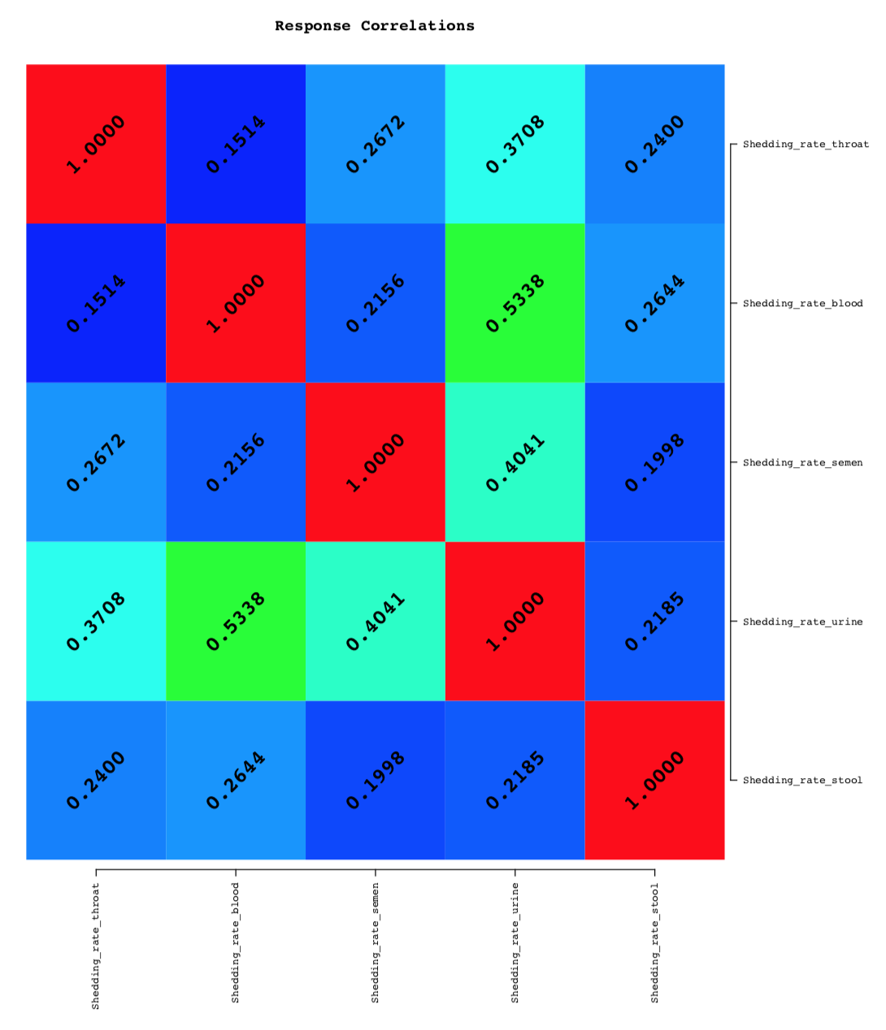
Figure 2. Heatmap of correlation coefficients of each shedding rates
Correlation coefficients are represented as color gradients.

Table 2. Association between microbial profiles and shedding rates at each body compartment
Body Compartment | R² | P-value
Throat | 0.03 | 0.712
Blood | 0.06 | 0.126
Semen | 0.07 | 0.090
Urine | 0.03 | 0.737
Stool | 0.01 | 0.987

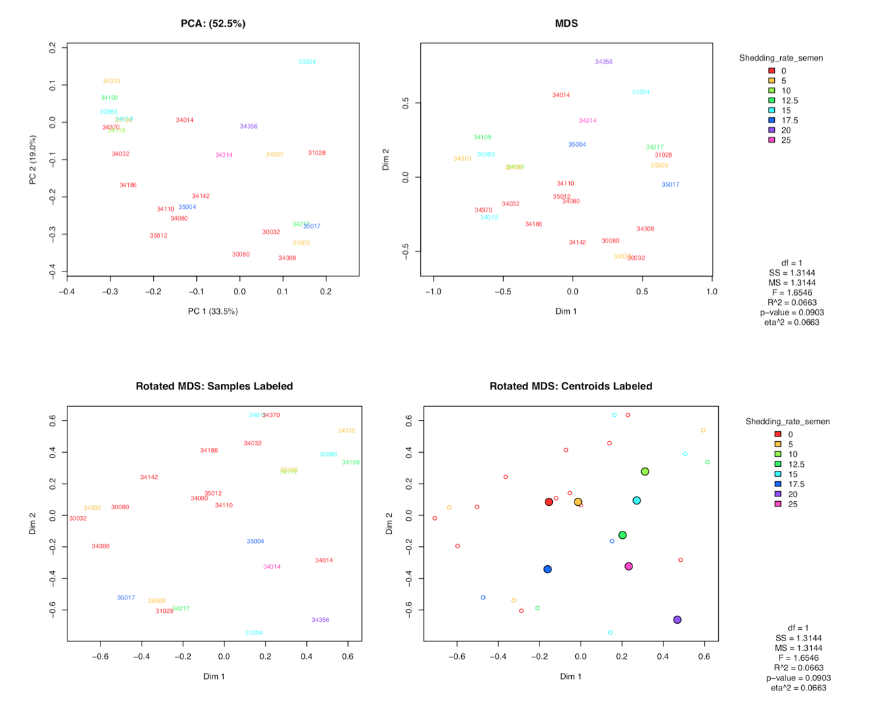
Figure 3. Comparison of gut microbial profiles according to herpesvirus shedding rate in semen
Comparison in distance matrices of microbiome according to the shedding rate in semen was performed. In the PCA plot, the first component (PC1) explains 33.5% of total variance, and the second component explains 19.0% of total variance. The numbers in the plots denote patients’ identification numbers. In the rotated MDS plot, centroids were created with various colors.

Next, we identified most abundant top ten Operational Taxonomic Units (OTUs): Prevotella, Bacteroides, Faecalibacterium, Blautia, Lachnoclostridium, Dialister, Ruminococcaceae, Lacnnospiraceae_unclassified, Subdoligranulum, and Eubacterium coprotanoligenes. The top two OTUs belong to Bacteroidetes phylum, and the rest of the OTUs belong to Firmicutes phylum. Then, we used these top ten genera as predictors of shedding rates as univariate responses. In the abridged model consisting of the top ten OTUs to assess the association with seminal shedding rate (Figure 4), a trend, although not significant, was identified (R² = 0.31, P = 0.107). In our further analysis to examine which genus is responsible for the relationship, Faecalibacterium genus was negatively associated with seminal shedding rate (β = -2.10, p = 0.04), and Blautia genus was positively associated with the rate (β = 5.77, p = 0.05) (Figure 5), although the significances disappeared after controlling for false discovery rate.

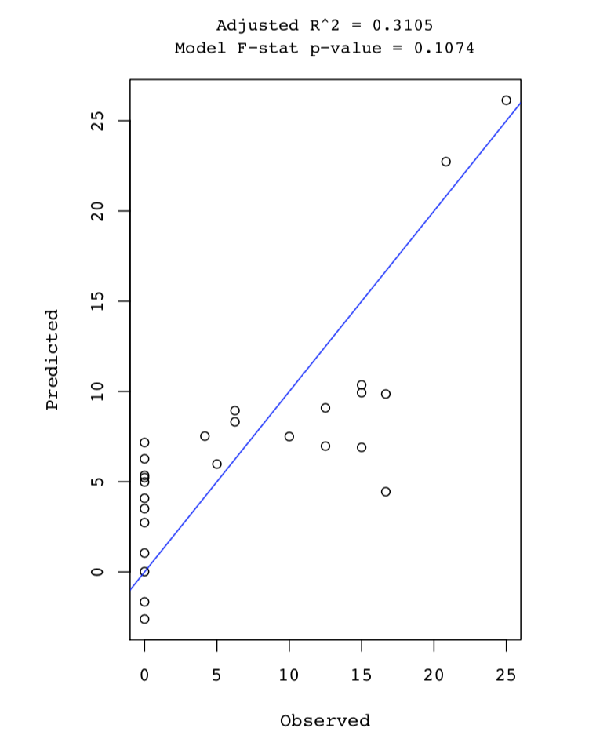
Figure 4. Abridged model consisting of top ten OTUs with herpesvirus shedding rate in semen

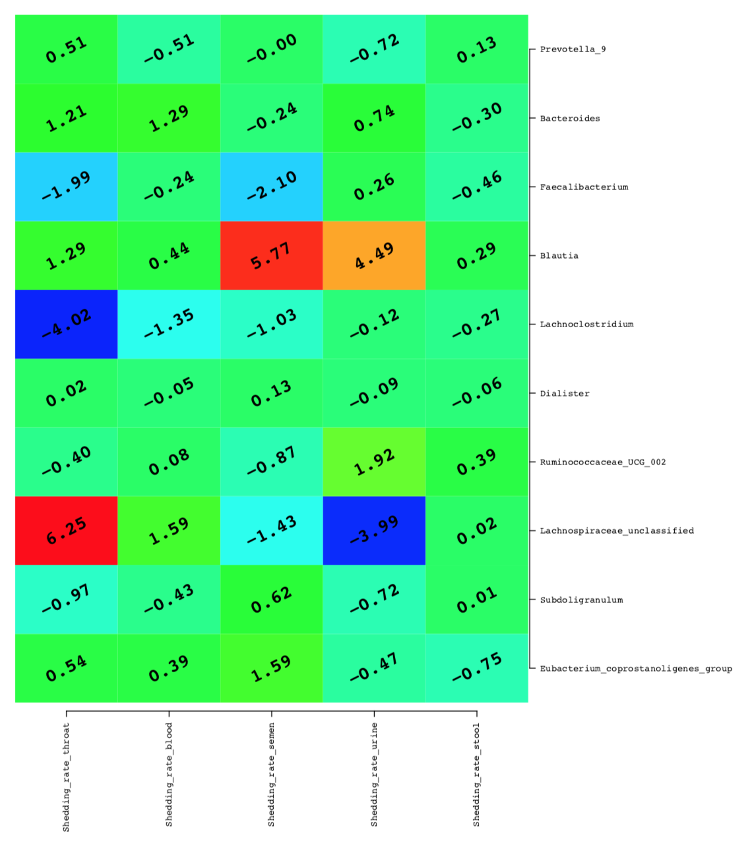
Figure 5. Heatmap of correlation coefficients between top ten OTUs and herpesvirus shedding rates at each body sites
Correlation coefficients are represented as color gradients.

4.3 CORRELATION of microbial profiles WITH immune markers
Our colleagues previously found that the log-transformed plasma level of sCD14 was borderline, but not significantly different between the groups (P = 0.087). In the present study, we compared the similarity matrix of microbial profiles with each immune marker. In the analysis of PERMANOVA, no significant difference in relative abundances of microbial communities according to the levels of sCD14 was found (Figure 6). We identified the top ten OTUs and tested if there was any association of relative abundance of each genus with different immunologic parameters (Figure 7). CRP was positively associated with abundance of Blautia (β = 0.42, p = 0.02), although it was no longer significant after controlling for false discovery rate.

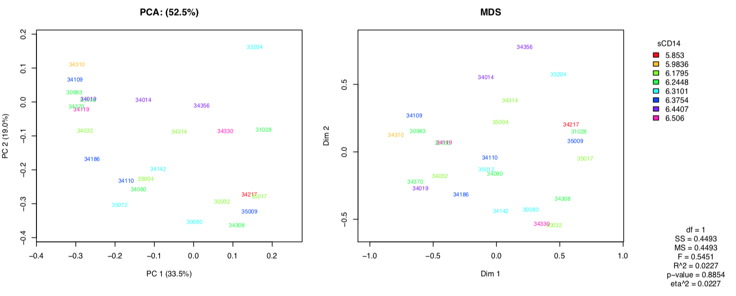
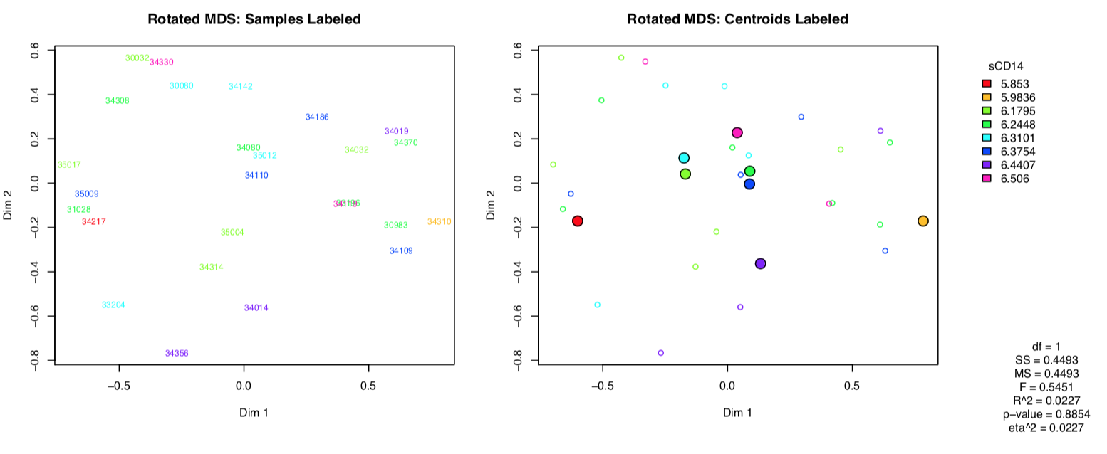
Figure 6. Comparison of gut microbial profiles according to soluble sCD14 level
Comparison in distance matrices of microbiome according to the plasma level of sCD14 was performed.

Figure 7. Heatmap of correlation coefficients between top ten OTUs and soluble immune markers
Correlation coefficients are represented as color gradients.

DISCUSSION
In the present study, we aimed to determine whether the gut microbial composition of both HIV-infected and HIV-uninfected age-matched MSM was associated with co-infected herpesvirus shedding rate and immune markers. Over the decade, several large-scale studies examined the microbial characteristics in HIV-infected individuals compared to uninfected ones with different methods and found that there may be a significant difference in microbiome composition, and these differences have been associated with persistent immune activation in HIV infection.[24-26] In a study by Dillon et al. using gut mucosal samples, investigators found a greater abundance of Proteobacteria and a smaller abundance of Firmicutes in HIV-infected individuals at the phylum level, and an increased abundance of Prevotella and a decreased abundance of Bacteroides at the genus level, which were associated with disease-related immune activation.[43] Similarly, other studies also reported that HIV-infection was associated with increased abundance of Prevotella and decreased abundance of Bacteroides at the genus level. [16, 27, 44, 45] Interestingly, in a study by McHardy et al, HIV-infected, virally suppressed individuals by ART have microbiome composition closer to the uninfected individuals compared to HIV-infected, untreated individuals, although the restoration appeared to be incomplete.[46] This finding may in part explain the reason we observed non-significant difference in the microbial profiles between ART-treated HIV-infected and HIV-uninfected MSM.
We report, for the first time, that, although not significant, there was a modest trend of the shedding rate in semen with gut microbial communities. In serial studies by Gianella et al., asymptomatic CMV shedding in semen was associated with a greater level of immune activation markers and higher HIV load in untreated,[47] and ART-treated[21] HIV-infected individuals. In addition to these observations, our finding suggests that microbial dysbiosis may be associated with seminal herpesvirus shedding in chronic HIV infection. Of note, we did not find any significant association between herpesvirus shedding rate in other body compartments and gut microbial profiles, except in semen. This is a conflicting result to previous study which reported that subclinical CMV reactivation in the gut epithelium may play a role in host immune activation in HIV-infected individuals through its capability to disrupt gut epithelial barrier.[39] Given that each body compartment has a different drug penetration rate with the lowest rate in the genital tract,[48] and seminal CMV shedding is highly prevalent in ART-received HIV-infected individuals,[35] it is possible that the associations of microbial profiles with shedding rates in other body sites were substantially attenuated by ART itself, different sample types, and/or tissue immunological characteristics. For example, throat washings and stool may have much higher bacterial load than viral load, possibly leading to experimental error to detect herpesvirus shedding in the laboratory setting. Moreover, in the blood, because of the active immune system, shedding rate in the blood can be underestimated. For another possibility, given that the male genital tract is a major shedding site for CMV in our participants,[40] CMV may be more capable to impact the host immune system and gut microbial profiles than other members of the herpesvirus family. Collectively, latent herpesvirus shedding in HIV infection may be associated with host immune system dependent on the shedding sites. Although our study does not support that gut microbiome communities may have a modulating effect on the association, further research targeted at untreated HIV-infected individuals with more comprehensive methodological approach is warranted to fully assess the effect of the gut microbiome on herpesvirus shedding and immune activation.

In the genus level, we found that Faecalibacterium was negatively associated with seminal shedding rate, and Blautia was positively associated with the seminal shedding rate. However, we did not observe any significant association between identified top ten genus and herpesvirus shedding rate in stool or other shedding sites. Faecalibacterium belongs to the Firmicutes phylum, and is one of the most abundant genera in human gut microbiome. Zhou et al. recently reported that the abundance of Faecalibacterium was markedly decreased in individuals with acquired immune deficiency syndrome (AIDS).[49] Also, Ling et al. reported that the abundance of Faecalibacterium was greater in ART-treated HIV-infected individuals than untreated patients.[25] In addition to these findings, our finding that Faecalibacterium genus was negatively associated with seminal shedding rate suggests that there may be a crosstalk between this genus and the host-immune system. In contrast, the association between the abundance of Blautia and the HIV appears controversial in the literature. In a study by San-Juan-Vergara et al, the abundance of Blautia was increased in HIV-infected individuals and correlated with disease severity. However, Dubourg et al. reported that several genera including Ruminococcus, Blautia, and Faecalibacterium were less abundant in HIV-infected individuals.[50] Regarding the association of the relative abundance of Blautia with other diseases, conflicting results have also been reported. In a study by Jenq et al., the increased abundance of Blautia was associated with reduced graft-versus-host disease (GVHD), and improved survival in patients received bone marrow transplantation. The authors suggested that Blautia may exert anti-inflammatory effect on intestinal mucosa. However, other authors reported that this genus was associated with increased intestinal permeability in patients with multiple sclerosis,[51] and Crohn’s disease.[52] Thus, future research is needed to clarify the role of Blautia in maintaining intestinal integrity and in interaction with mucosal immune system.

This study has several limitations. First, because of small sample size, we could not achieve a large statistical power when analyzing the data. Second, because of the study design, the casualty of the associations cannot be determined. Third, our study did not control for the factors that potentially impact gut microbial composition, such as diet. Last, due to limited data, we were not able to assess the relationship between microbial profiles and shedding rate of each members of herpesvirus, such as CMV. Nevertheless, our study has a number of strengths and adds to the current literature on HIV and the role of herpesvirus coinfection. First, our study is the first that we are aware of that focuses on the role of gut microbiome in the pathogenesis of chronic HIV infection in MSM. Additionally, we were able to examine the shedding rates of different body sites, and their relation to gut microbial characteristics. Finally, our comprehensive statistical approaches allowed us to better understand the association between herpesvirus shedding rates and gut microbial composition.
In conclusion, we first report that seminal herpesvirus shedding is associated with altered gut microbiome. However, our study does not support the hypothesis that the gut microbiome may play an important role in the association between herpesvirus co-infection and chronic immune activation. Therefore, future studies with large sample size with comprehensive methodological approaches are warranted to identify the role of microbiome in the pathogenesis of HIV infection.

PUBLIC HEALTH SIGNIFICANCE
Despite the advent of the effective combination of antiretroviral therapy, the life expectancy in treated HIV-infected patients is shorter than general population because of their higher prevalence of non-AIDS related diseases. This is mainly attributed to chronic inflammation and immune activation in the disease. Although microbial translocation has become one of the major causes of the persistent immune activation, other factors, such as herpesvirus co-infection, may also impact the course of the disease. Despite the significant effect of herpesvirus co-infection on persistent immune activation in HIV infection, the issue of how it shapes and impacts immune system, or vice versa, has not been established yet.
Over the decade, microbiome studies have generated increasing attention because of the potential role to impact human health. In HIV infection, a number of studies reported that there is an alteration of gut microbiome. Moreover, previous preclinical studies suggested that herpesvirus co-infection may accelerate microbial translocation and immune activation. However, our previous study reported that herpesvirus shedding negatively correlated with immune markers such as IP-10 and sCD163. Due to this controversy, we aimed to investigate whether altered microbial composition underlie the conflicting reports. It is important to understand the role of microbiome and the herpesvirus co-infection in HIV-associated persistent immune activation, which may become targets for therapeutic intervention in the future.

bibliography
1. Michaels SH, Clark R, Kissinger P: Declining morbidity and mortality among patients with advanced human immunodeficiency virus infection. The New England journal of medicine 1998, 339(6):405-406.
2. Islam FM, Wu J, Jansson J, Wilson DP: Relative risk of cardiovascular disease among people living with HIV: a systematic review and meta-analysis. HIV medicine 2012, 13(8):453-468.
3. Beyrer C, Baral SD, van Griensven F, Goodreau SM, Chariyalertsak S, Wirtz AL, Brookmeyer R: Global epidemiology of HIV infection in men who have sex with men. Lancet (London, England) 2012, 380(9839):367-377.
4. Manji H, Jager HR, Winston A: HIV, dementia and antiretroviral drugs: 30 years of an epidemic. Journal of neurology, neurosurgery, and psychiatry 2013, 84(10):1126-1137.
5. Paik IJ, Kotler DP: The prevalence and pathogenesis of diabetes mellitus in treated HIV-infection. Best practice & research Clinical endocrinology & metabolism 2011, 25(3):469-478.
6. Brown TT, Qaqish RB: Antiretroviral therapy and the prevalence of osteopenia and osteoporosis: a meta-analytic review. AIDS (London, England) 2006, 20(17):2165-2174.
7. Bonnet F, Chene G: Evolving epidemiology of malignancies in HIV. Current opinion in oncology 2008, 20(5):534-540.
8. Egger M, May M, Chene G, Phillips AN, Ledergerber B, Dabis F, Costagliola D, D'Arminio Monforte A, de Wolf F, Reiss P et al: Prognosis of HIV-1-infected patients starting highly active antiretroviral therapy: a collaborative analysis of prospective studies. Lancet (London, England) 2002, 360(9327):119-129.
9. Legarth RA, Ahlstrom MG, Kronborg G, Larsen CS, Pedersen C, Pedersen G, Mohey R, Gerstoft J, Obel N: Long-Term Mortality in HIV-Infected Individuals 50 Years or Older: A Nationwide, Population-Based Cohort Study. Journal of acquired immune deficiency syndromes (1999) 2016, 71(2):213-218.
10. Samji H, Cescon A, Hogg RS, Modur SP, Althoff KN, Buchacz K, Burchell AN, Cohen M, Gebo KA, Gill MJ et al: Closing the gap: increases in life expectancy among treated HIV-positive individuals in the United States and Canada. PloS one 2013, 8(12):e81355.
11. Goicoechea M, Smith DM, Liu L, May S, Tenorio AR, Ignacio CC, Landay A, Haubrich R: Determinants of CD4+ T cell recovery during suppressive antiretroviral therapy: association of immune activation, T cell maturation markers, and cellular HIV-1 DNA. The Journal of infectious diseases 2006, 194(1):29-37.
12. Duprez DA, Neuhaus J, Kuller LH, Tracy R, Belloso W, De Wit S, Drummond F, Lane HC, Ledergerber B, Lundgren J et al: Inflammation, coagulation and cardiovascular disease in HIV-infected individuals. PloS one 2012, 7(9):e44454.
13. McKibben RA, Margolick JB, Grinspoon S, Li X, Palella FJ, Jr., Kingsley LA, Witt MD, George RT, Jacobson LP, Budoff M et al: Elevated levels of monocyte activation markers are associated with subclinical atherosclerosis in men with and those without HIV infection. The Journal of infectious diseases 2015, 211(8):1219-1228.
14. Brenchley JM, Price DA, Schacker TW, Asher TE, Silvestri G, Rao S, Kazzaz Z, Bornstein E, Lambotte O, Altmann D et al: Microbial translocation is a cause of systemic immune activation in chronic HIV infection. Nature medicine 2006, 12(12):1365-1371.
15. Hunt PW, Martin JN, Sinclair E, Epling L, Teague J, Jacobson MA, Tracy RP, Corey L, Deeks SG: Valganciclovir reduces T cell activation in HIV-infected individuals with incomplete CD4+ T cell recovery on antiretroviral therapy. The Journal of infectious diseases 2011, 203(10):1474-1483.
16. Vazquez-Castellanos JF, Serrano-Villar S, Latorre A, Artacho A, Ferrus ML, Madrid N, Vallejo A, Sainz T, Martinez-Botas J, Ferrando-Martinez S et al: Altered metabolism of gut microbiota contributes to chronic immune activation in HIV-infected individuals. Mucosal immunology 2015, 8(4):760-772.
17. Ley RE, Peterson DA, Gordon JI: Ecological and evolutionary forces shaping microbial diversity in the human intestine. Cell 2006, 124(4):837-848.
18. Hatano H: Immune activation and HIV persistence: considerations for novel therapeutic interventions. Current opinion in HIV and AIDS 2013, 8(3):211-216.
19. Marchetti G, Tincati C, Silvestri G: Microbial translocation in the pathogenesis of HIV infection and AIDS. Clinical microbiology reviews 2013, 26(1):2-18.
20. Lederman MM, Funderburg NT, Sekaly RP, Klatt NR, Hunt PW: Residual immune dysregulation syndrome in treated HIV infection. Advances in immunology 2013, 119:51-83.
21. Gianella S, Massanella M, Richman DD, Little SJ, Spina CA, Vargas MV, Lada SM, Daar ES, Dube MP, Haubrich RH et al: Cytomegalovirus replication in semen is associated with higher levels of proviral HIV DNA and CD4+ T cell activation during antiretroviral treatment. Journal of virology 2014, 88(14):7818-7827.
22. Cong J, Zhang X: How human microbiome talks to health and disease. European journal of clinical microbiology & infectious diseases : official publication of the European Society of Clinical Microbiology 2018.
23. Andoh A: Physiological Role of Gut Microbiota for Maintaining Human Health. Digestion 2016, 93(3):176-181.
24. Mudd JC, Brenchley JM: Gut Mucosal Barrier Dysfunction, Microbial Dysbiosis, and Their Role in HIV-1 Disease Progression. The Journal of infectious diseases 2016, 214 Suppl 2:S58-66.
25. Ling Z, Jin C, Xie T, Cheng Y, Li L, Wu N: Alterations in the Fecal Microbiota of Patients with HIV-1 Infection: An Observational Study in A Chinese Population. Scientific reports 2016, 6:30673.
26. Liu J, Williams B, Frank D, Dillon SM, Wilson CC, Landay AL: Inside Out: HIV, the Gut Microbiome, and the Mucosal Immune System. Journal of immunology (Baltimore, Md : 1950) 2017, 198(2):605-614.
27. Vujkovic-Cvijin I, Dunham RM, Iwai S, Maher MC, Albright RG, Broadhurst MJ, Hernandez RD, Lederman MM, Huang Y, Somsouk M et al: Dysbiosis of the gut microbiota is associated with HIV disease progression and tryptophan catabolism. Science translational medicine 2013, 5(193):193ra191.
28. Dillon SM, Kibbie J, Lee EJ, Guo K, Santiago ML, Austin GL, Gianella S, Landay AL, Donovan AM, Frank DN et al: Low abundance of colonic butyrate-producing bacteria in HIV infection is associated with microbial translocation and immune activation. AIDS (London, England) 2017, 31(4):511-521.
29. Evering TH, Mehandru S, Racz P, Tenner-Racz K, Poles MA, Figueroa A, Mohri H, Markowitz M: Absence of HIV-1 evolution in the gut-associated lymphoid tissue from patients on combination antiviral therapy initiated during primary infection. PLoS pathogens 2012, 8(2):e1002506.
30. Strain MC, Little SJ, Daar ES, Havlir DV, Gunthard HF, Lam RY, Daly OA, Nguyen J, Ignacio CC, Spina CA et al: Effect of treatment, during primary infection, on establishment and clearance of cellular reservoirs of HIV-1. The Journal of infectious diseases 2005, 191(9):1410-1418.
31. Merlini E, Bai F, Bellistri GM, Tincati C, d'Arminio Monforte A, Marchetti G: Evidence for polymicrobic flora translocating in peripheral blood of HIV-infected patients with poor immune response to antiretroviral therapy. PloS one 2011, 6(4):e18580.
32. Nazli A, Chan O, Dobson-Belaire WN, Ouellet M, Tremblay MJ, Gray-Owen SD, Arsenault AL, Kaushic C: Exposure to HIV-1 directly impairs mucosal epithelial barrier integrity allowing microbial translocation. PLoS pathogens 2010, 6(4):e1000852.
33. Lichtner M, Cicconi P, Vita S, Cozzi-Lepri A, Galli M, Lo Caputo S, Saracino A, De Luca A, Moioli M, Maggiolo F et al: Cytomegalovirus coinfection is associated with an increased risk of severe non-AIDS-defining events in a large cohort of HIV-infected patients. The Journal of infectious diseases 2015, 211(2):178-186.
34. Naeger DM, Martin JN, Sinclair E, Hunt PW, Bangsberg DR, Hecht F, Hsue P, McCune JM, Deeks SG: Cytomegalovirus-specific T cells persist at very high levels during long-term antiretroviral treatment of HIV disease. PloS one 2010, 5(1):e8886.
35. Gianella S, Smith DM, Vargas MV, Little SJ, Richman DD, Daar ES, Dube MP, Zhang F, Ginocchio CC, Haubrich RH et al: Shedding of HIV and human herpesviruses in the semen of effectively treated HIV-1-infected men who have sex with men. Clinical infectious diseases : an official publication of the Infectious Diseases Society of America 2013, 57(3):441-447.
36. Gianella S, Anderson CM, Var SR, Oliveira MF, Lada SM, Vargas MV, Massanella M, Little SJ, Richman DD, Strain MC et al: Replication of Human Herpesviruses Is Associated with Higher HIV DNA Levels during Antiretroviral Therapy Started at Early Phases of HIV Infection. Journal of virology 2016, 90(8):3944-3952.
37. Gomez-Mora E, Massanella M, Garcia E, Giles D, Bernado M, Urrea V, Carrillo J, Ouchi D, Puig J, Negredo E et al: Elevated humoral response to cytomegalovirus in HIV-infected individuals with poor CD4+ T-cell immune recovery. PloS one 2017, 12(9):e0184433.
38. Lurain NS, Hanson BA, Hotton AL, Weber KM, Cohen MH, Landay AL: The Association of Human Cytomegalovirus with Biomarkers of Inflammation and Immune Activation in HIV-1-Infected Women. AIDS research and human retroviruses 2016, 32(2):134-143.
39. Maidji E, Somsouk M, Rivera JM, Hunt PW, Stoddart CA: Replication of CMV in the gut of HIV-infected individuals and epithelial barrier dysfunction. PLoS pathogens 2017, 13(2):e1006202.
40. Agudelo-Hernandez A, Chen Y, Bullotta A, Buchanan WG, Klamar-Blain CR, Borowski L, Riddler SA, Rinaldo CR, Macatangay BJC: Subclinical herpesvirus shedding among HIV-1-infected men on antiretroviral therapy. AIDS (London, England) 2017, 31(15):2085-2094.
41. Kaslow RA, Ostrow DG, Detels R, Phair JP, Polk BF, Rinaldo CR, Jr.: The Multicenter AIDS Cohort Study: rationale, organization, and selected characteristics of the participants. American journal of epidemiology 1987, 126(2):310-318.
42. Caporaso JG, Lauber CL, Walters WA, Berg-Lyons D, Huntley J, Fierer N, Owens SM, Betley J, Fraser L, Bauer M et al: Ultra-high-throughput microbial community analysis on the Illumina HiSeq and MiSeq platforms. The ISME journal 2012, 6(8):1621-1624.
43. Dillon SM, Lee EJ, Kotter CV, Austin GL, Dong Z, Hecht DK, Gianella S, Siewe B, Smith DM, Landay AL et al: An altered intestinal mucosal microbiome in HIV-1 infection is associated with mucosal and systemic immune activation and endotoxemia. Mucosal immunology 2014, 7(4):983-994.
44. Mutlu EA, Keshavarzian A, Losurdo J, Swanson G, Siewe B, Forsyth C, French A, Demarais P, Sun Y, Koenig L et al: A compositional look at the human gastrointestinal microbiome and immune activation parameters in HIV infected subjects. PLoS pathogens 2014, 10(2):e1003829.
45. Sun Y, Ma Y, Lin P, Tang YW, Yang L, Shen Y, Zhang R, Liu L, Cheng J, Shao J et al: Fecal bacterial microbiome diversity in chronic HIV-infected patients in China. Emerging microbes & infections 2016, 5:e31.
46. McHardy IH, Li X, Tong M, Ruegger P, Jacobs J, Borneman J, Anton P, Braun J: HIV Infection is associated with compositional and functional shifts in the rectal mucosal microbiota. Microbiome 2013, 1(1):26.
47. Gianella S, Strain MC, Rought SE, Vargas MV, Little SJ, Richman DD, Spina CA, Smith DM: Associations between virologic and immunologic dynamics in blood and in the male genital tract. Journal of virology 2012, 86(3):1307-1315.
48. Trezza CR, Kashuba AD: Pharmacokinetics of antiretrovirals in genital secretions and anatomic sites of HIV transmission: implications for HIV prevention. Clinical pharmacokinetics 2014, 53(7):611-624.
49. Zhou Y, Ou Z, Tang X, Zhou Y, Xu H, Wang X, Li K, He J, Du Y, Wang H et al: Alterations in the gut microbiota of patients with acquired immune deficiency syndrome. Journal of cellular and molecular medicine 2018, 22(4):2263-2271.
50. Dubourg G, Lagier JC, Hue S, Surenaud M, Bachar D, Robert C, Michelle C, Ravaux I, Mokhtari S, Million M et al: Gut microbiota associated with HIV infection is significantly enriched in bacteria tolerant to oxygen. BMJ open gastroenterology 2016, 3(1):e000080.
51. Chen J, Chia N, Kalari KR, Yao JZ, Novotna M, Paz Soldan MM, Luckey DH, Marietta EV, Jeraldo PR, Chen X et al: Multiple sclerosis patients have a distinct gut microbiota compared to healthy controls. Scientific reports 2016, 6:28484.
52. Palm NW, de Zoete MR, Cullen TW, Barry NA, Stefanowski J, Hao L, Degnan PH, Hu J, Peter I, Zhang W et al: Immunoglobulin A coating identifies colitogenic bacteria in inflammatory bowel disease. Cell 2014, 158(5):1000-1010.

