HEPATITIS C IN PREGNANCY: MAXIMIZING REPORTING ACCURACY IN EFFORT TO APPROPRIATELY TEST AND TREAT INFANTS EXPOSED

by
Stephanie Snodgrass

BS, Clinical Laboratory Science, University of Kansas, 2012

Submitted to the Graduate Faculty of

Department of Infectious Diseases and Microbiology

Graduate School of Public Health in partial fulfillment

Of the requirements for the degree of

Master of Public Health

University of Pittsburgh
2018

ABSTRACT
UNIVERSITY OF PITTSBURGH
GRADUATE SCHOOL OF PUBLIC HEALTH

This essay is submitted
by
Stephanie Snodgrass

on

August 6th, 2018
and approved by

Essay Advisor:

Jeremy J. Martinson, DPhil _________________________________
Assistant Professor, Infectious Diseases and Microbiology
Assistant Professor, Human Genetics
Graduate School of Public Health
University of Pittsburgh

Essay Reader:

Kristen J. Mertz, MD, MPH _________________________________
Medical Epidemiologist

Bureau of Assessment, Statistics, and Epidemiology
Allegheny County Health Department
Pittsburgh, Pennsylvania

Copyright © by Stephanie Snodgrass
2018
Jeremy J. Martinson, DPhil

HEPATITIS C REPORTING IN PREGNANCY: MAXIMIZING REPORTING ACCURACY IN EFFORT TO APPROPRIATELY TEST AND TREAT INFANTS EXPOSED
Stephanie Snodgrass, MPH
University of Pittsburgh, 2018

Hepatitis C (HCV) is a chronic blood-borne pathogen which can remain asymptomatic in infected patients for decades, but which eventually leads to severe liver damage if left untreated. Due to the asymptomatic nature of this virus, many individuals are unaware of their infection leaving potential for additional viral transmission. While efforts have been put in place to close the gap between the actual number of infections and the number of reported infections, many studies suggest there is still much work to be done, including improving testing and reporting of infants exposed to HCV through vertical transmission. With HCV treatments for children three years of age and older on the horizon, improving testing and reporting of HCV infection in children is more important than ever if the damaging effects of this virus on these children are to be prevented. Treatment is imperative to the elimination of HCV, but without accurate disease identification and reporting through public health research and subsequent intervention, these treatments most likely will not be initiated, therefore leaving the population susceptible to this virus.

TABLE OF CONTENTS
preface viii
1.0 Introduction 1
2.0 BACKGROUND 3
2.1 HCV GENOTYPE EPIDEMIOLOGY 3
2.2 OVERVIEW OF HCV LIFE CYCLE, THE HUMAN IMMUNE RESPONSE, AND DISEASE PROGRESSION 3
2.3 HCV IN PREGNANCY AND VERTICAL TRANSMISSION 9
2.4 HCV REPORTING THROUGHOUT THE UNITED STATES 14
2.5 CURRENT GUIDELINES FOR INFANT SCREENING 16
2.6 POTENTIAL FOR UNDERREPORTING OF HCV— ADULTS AND CHILDREN 16
2.7 VALIDITY OF BIRTH CERTIFICATE REPORTING— OREGON, 2015 19
3.0 METHODS 21
4.0 RESULTS 22
5.0 DISCUSSION 25
6.0 CONCLUSION 30
bibliography 31

List of tables
Table 1: Summary of evidence: effect of mode of delivery, labor management strategies, or breastfeeding practices on risk for mother-to-child transmission of HCV 14
Table 2: Comparison of women identified with HCV infection on infant's birth certificates in 2015 with female HCV cases reported to the ACDP program- Oregon, 2001-2015 23
Table 3: Ongoing pediatric clinical trials with direct-acting antiviral agents 27

List of figures
Figure 1: HCV life cycle 5
Figure 2: Natural history of HCV infection 8
Figure 3: State requirements for reporting chronic cases of HCV infection. CDC, Centers for Disease Control and Prevention 15
Figure 4: Live births from HCV infected mothers versus total live births according to Oregon birth certificate data by birth year 20
Figure 5: Number of infants born to HCV infected women per 1,000 live births by County - 2015 24
Figure 6: Oregon Opioid Overdose Deaths by County - 2011-2015 24

preface
I would like to thank my preceptor, Dr. Ann Thomas, for her continuous guidance during my internship at the Oregon Health Authority and throughout the remainder of my graduate school career. I would also like to thank my advisor, Dr. Jeremy Martinson, who has been an integral part of my success as a student through his unceasing advice and direction. Finally, I would like to thank Dr. Kristen Mertz for her aid throughout my essay and internship experiences. These individuals have shaped my graduate degree experience and encouraged me to pursue my specific interests within the public health field.

Introduction
In 2015, an estimated 71 million people worldwide were living with hepatitis C (HCV), including 1.75 million persons newly infected that year, with a global incidence rate of 23.7 per 100,000 people (World Health Organization, 2017). In the United States, the reported incidence rate for HCV was 1.0 new infection per 100,000 persons per year equaling approximately 3,000 cases in 2016. HCV is considered the most common chronic blood-borne pathogen in the United States (U.S. Preventive Services Task Force, 2016). Because HCV is a chronic disease that potentially can remain asymptomatic for decades, most individuals are unaware of their infection. In light of this, many reports suggest that the previously listed statistics are significantly underestimated. Centers for Disease Control (CDC) estimates that the previously stated reported US statistic is 13.9 times less than the actual number of cases of acute HCV for 2016, resulting in an additional unreported 38,200 acute HCV cases (Centers for Disease Control: Division of Viral Hepatitis, 2016; Versalovic et. al, 2011). In 2013, the US Preventative Services Task Force (USPSTF) updated the screening recommendations for the US population to include a one-time screening of all individuals born between 1945 and 1965 due to the high prevalence rate (3-4%) in this birth cohort (U.S. Preventive Services Task Force, 2016). In 2016, 148,932 new reports of confirmed past or present HCV infection by states and jurisdictions were submitted to CDC, which may be a result of this recommendation therefore partially resolving this underestimation (Centers for Disease Control and Prevention (CDC), 2016). However, recent studies have indicated the need to screen additional underserved populations who do not have easy access to healthcare and are at high-risk for infection; these populations include but are not limited to first generation migrants, incarcerated persons, and the homeless population (Zuure et al., 2014).
Other reports suggest significant underreporting of perinatal HCV infection, therefore imposing a deficiency in quality of care for infants exposed to this virus through the birthing process (Kuncio, Newbern, Johnson, & Viner, 2016). With an estimated 6% vertical transmission rate, many children may acquire this virus without provider knowledge and eventually develop the symptoms of chronic HCV later in life potentially resulting in the need for a liver transplant due to liver cirrhosis, all of which could have been prevented with the current treatments available to children 12 and over in the United States (US Food & Drug Administration, 2017; Wirth et al., 2017). This paper will provide an overview of HCV in pregnancy, describe the current research involving efforts in reducing vertical transmission, assess current reporting methods for maternal HCV in the United States, and offer potential interventions for increased detection of vertical transmission of HCV in infants exposed.

BACKGROUND

HCV GENOTYPE EPIDEMIOLOGY
The Hepatitis C virus is a single-stranded RNA virus classified within the Flaviviridae family and genus Hepacivirus. As of 2014, there are 7 known genotypes (GT) and more than 67 subtypes by genome sequence heterogeneity of HCV. The rapid mutation of the virus produces these genotypes while the high error prone rate of these mutations causes the multitude of variants within each genotype. GT1 accounts for 75% of infections in the United States followed by GT2 and GT3 with 13.5% and 5.5% of infections respectively. GT4 is present predominantly in the Middle East and North and Central Africa, while GT5 is found in South Africa. GT6 is most commonly present in areas throughout Asia, and GT7 originated in Central Africa (El-Guindi, 2016; Versalovic et. al 2011; Murphy et al., 2015; Smith et al., 2014).

OVERVIEW OF HCV LIFE CYCLE, THE HUMAN IMMUNE RESPONSE, AND DISEASE PROGRESSION
Upon infection of HCV into the host, the virions circulate throughout the bloodstream until they reach target hepatocytes, liver cells-- the most common cell type for HCV replication --where the virion attaches and gains entry into the cell through interactions with cell surface receptors including LDL-R, SRB1, and CD81. Once inside the target cell, following receptor-mediated endocytosis, the virus releases its RNA genome into the target cell cytoplasm by fusing its membrane with an acidic compartment within the cell. This RNA is then translated, yielding a single polyprotein precursor which is then further processed by cellular and viral proteases where it is cleaved into 10 viral proteins, including 3 structural proteins and 7 non-structural proteins. The non-structural proteins recruit the viral genome into an RNA replication complex where subsequent HCV RNA genome replication occurs producing many copies of HCV RNA. Following replication, the new viral genomes are packaged within the endoplasmic reticulum, where each copy acquires an envelope and envelope glycoproteins, E1 and E2. The envelopes then undergo maturation to form lipoviral particles. Finally, the new virions are released from the hepatocyte through exocytosis (Figure 1) where they will infect additional host cells and cause gradual damage to the liver (Dustin, Bartolini, Capobianchi, & Pistello, 2016).
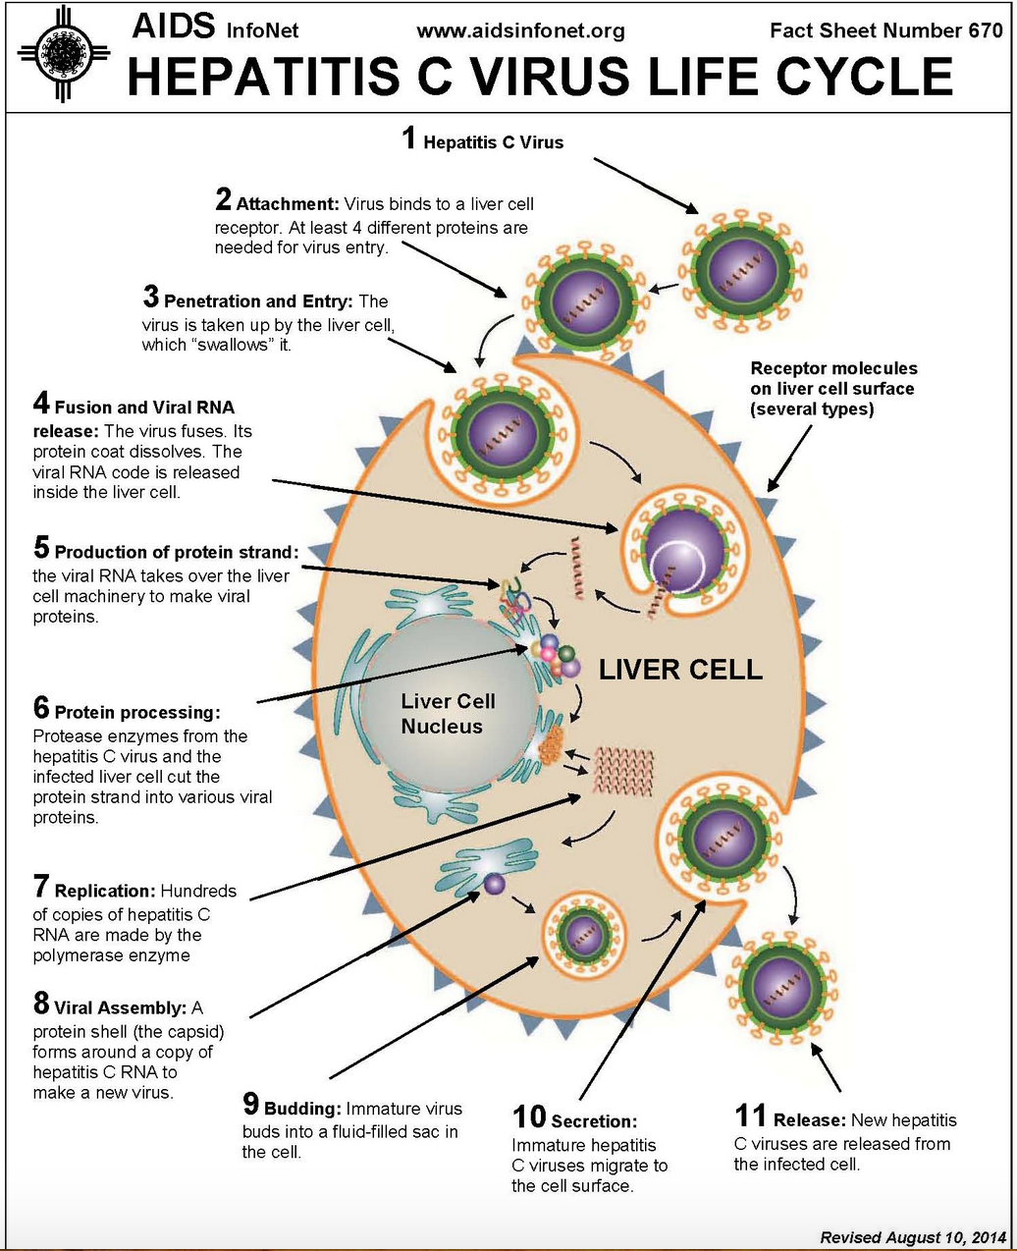
Figure 1: HCV life cycle

In the first few days after inoculation in the host, the viral load exponentially increases to between 10⁵ and 10⁷ IU/ml, where it plateaus for several weeks, likely due to the innate immune response. In response to a viral infection, the innate immune response reacts to the pathogen with type I and type III interferons produced by the virus-infected cells, dendritic cells, and macrophages, and type II interferons which are produced by natural killer (NK) cells and antigen-specific T cells (CD4+ and CD8+). These interferons stimulate genes, which are called interferon stimulated genes (ISGs) and are specifically responsible for controlling a viral infection. For an infection with HCV specifically, ISGs are strongly induced during the first several weeks of infection; however, it remains unclear as to which specific cells and types of interferon are the sources of production and responsible for ISG production respectively. Nonetheless, the interferon system is ineffective at clearing an HCV infection alone (Heim & Thimme, 2014).
While the exact mechanisms for ISG production in HCV infection are unclear, there is strong evidence for the role of NK cells in the control of HCV infection. In response to viral infection, NK cells not only produce interferon as previously mentioned, but also contain cytolytic effector functions to induce apoptosis in virus-infected cells. Several studies have shown the direct influence of NK cells in their role in controlling HCV infection, including a study of healthcare workers who were exposed to HCV, which reported that an early NK response to the infection resulted in the prevention of an infection in those healthcare workers (Heim & Thimme, 2014; Nattermann, 2011; Werner et al., 2013). 6-8 weeks after exposure, the gene expression switches from IFN I/III to IFN-γ and the adaptive immune response begins with the recruitment of HCV specific T-cells that target viral epitopes to assist in elimination of the virus. In addition to T-cell responses, anti-viral neutralizing antibodies are also produced in an attempt to inhibit viral entry into host cells and subsequent replication of the virus. Also during this time, Alanine aminotransferase (ALT) levels begin to spike, due to the damage of the liver caused by the indirect immune response effects of the virus (Heim & Thimme, 2014; Hughes, Page, & Kuller, 2017).
Approximately 30% of patients will be able to clear the infection with these immune responses in the acute phase of HCV therefore allowing ALT levels to return to normal. If the virus is able to escape all of these immune defenses, the patient will develop chronic hepatitis C. The virus is capable of remaining in the patient’s liver for decades gradually causing increased damage to the liver and putting the patient at increased risk for liver fibrosis, cirrhosis, liver failure, and hepatocellular carcinoma as time progresses. Between 10-20% of people with chronic HCV will develop cirrhosis over 20-30 years of infection, with a 1-5% increased risk for hepatocellular carcinoma for every year of infection and a 3-6% annual risk of hepatic decompensation putting the patient at significant risk of death without a liver transplant (Centers for Disease Control: Division of Viral Hepatitis, 2016). Patients who develop a chronic infection continue to demonstrate evidence of an activated immune response. While the innate response of high levels of ISG expression are only seen in some patients, the adaptive immunity -- HCV specific neutralizing antibodies and T-cell responses -- are present in most. Figure 2 illustrates the natural history of HCV disease progression explained above:
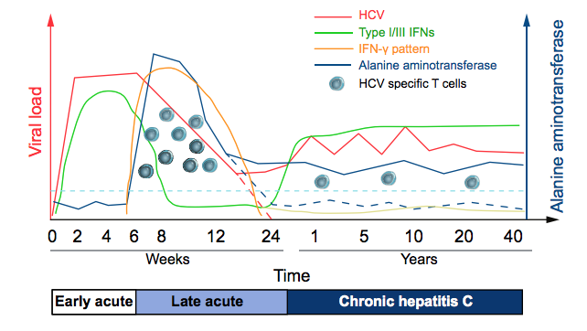
Figure 2: Natural history of HCV infection
(Heim & Thimme, 2014)

Many study results with suggestions as to why the virus is able to persist even in the presence of these continuous heightened responses. One example is that those who are chronically infected with HCV have NK cells with impaired antiviral effector functions due to the chronic exposure to the virus, affecting the efficiency in viral clearance. With regard to the adaptive immunity responses, different studies suggest a variety of possibly explanations including the rapid and frequent mutation of the virus, which allows the virus to escape the neutralizing antibodies and T-cells. It has also been suggested that there is direct cell to cell transfer of the virus to avoid neutralization (Brimacombe et al., 2011; Timpe et al., 2008). In addition, several groups have specific mechanisms outlined for how the ongoing replication of HCV may result in CD8+ T cell failure. While much about the persistence of HCV still requires confirmation in additional studies, there is growing evidence for the mechanisms which result in chronic HCV (Heim & Thimme, 2014).
HCV is most commonly transmitted through contaminated blood or body fluids so high-risk factors include sharing needles for IV drug use, receiving a blood transfusion before 1992, receiving hemodialysis, receiving unregulated tattoos, occupational exposure, and vertical transmission from HCV infected mothers to infants during birth. Less commonly, HCV can also be transmitted during sexual intercourse with increased risk in men who have sex with men (MSM). In addition, a new report suggests HCV transmission occurs through sharing straws for nasal drug use (Fernandez et al., 2016), but this has yet to be confirmed by the CDC. Upon transmission, 15-30% of those infected will spontaneously clear the virus within the first six months after exposure while 70-85% will develop a chronic infection (Centers for Disease Control: Division of Viral Hepatitis, 2016). Those who do not clear the virus may be asymptomatic for years due to the chronic nature of the virus, remaining unaware of their infection and allowing the potential for further spread.

HCV IN PREGNANCY AND VERTICAL TRANSMISSION
Because there is approximately a 6% vertical transmission rate of HCV from mother to infant during childbirth, a variety of studies have been performed not only to elucidate potential biological mechanisms responsible for this transmission rate, but also to assess the current methods of perinatal monitoring in women with HCV in order to make recommendations in efforts to reduce fetal/infant exposure.
To understand biological mechanisms potentially responsible for this transmission rate, we must first discuss how pregnancy affects an HCV infection. When a woman infected with HCV becomes pregnant, her once elevated ALT levels begin to decline along with an increase in viral load. Because ALT levels rise from injury to the liver due to the human immune response rather than the virus itself, scientists postulate the reason for this decline is because pregnancy causes maternal immunosuppression in order to prevent the rejection of the fetus whose human leukocyte antigen (HLA) genotype differs from the mother (Gervais et al., 2000; Paternoster et al., 2001; Wejstal, Widell, & Norkrans, 1998). In terms of potential routes of exposure in utero, there are many possible scenarios including but not limited to HCV transmission across the placenta or injury to the placenta (Prasad & Honegger, 2013), transportation of HCV through maternal mononuclear cells (Azzari et al., 2000, 2008), or HCV infection of trophoblasts (Mostafavi, Arshad, Qiang, Bradrick, & Jhaveri, 2012; Nie et al., 2012). Also, virions may have the potential to enter the fetal bloodstream without any of these methods as an estimated 10¹³ to 10¹⁴ virions circulate through the placental bed daily (Babik, Cohan, Monto, Hartigan-O’Connor, & McCune, 2011). With the previous statements in consideration, fetuses may have a higher risk of HCV transmission the more similar their HLA type is to their mother. Fetal alloimmune responses target maternal mononuclear cells, but if the HLA types are similar enough then these maternal HCV-infected cells will remain undetected and enter the fetal bloodstream (Azzari et al., 2000, 2008; Indolfi & Resti, 2009).
Another point Prasad mentions is that considering some viral particles enter the fetal bloodstream during pregnancy, it is uncertain which immune mechanisms are responsible for an HCV transmission rate of 2-8% when human immunodeficiency virus (HIV) has a mother-to-child transmission rate of 25% (Prasad & Honegger, 2013). This issue has prompted researchers to delve into research regarding the immune response between mother and child that reduces HCV transmission. Hurtado and colleagues conducted a study to determine and quantify the presence of innate immune cells in the placenta, cord blood, and decidua of women who were HCV positive compared to pregnant women who were negative for the virus. They found higher concentrations of NK T and γδ T cells and greater cytotoxicities of NK T and NK cells when comparing placental tissue to cord blood in HCV-negative women. HCV infection further enhanced all of the previously listed results, except NK cell activation marker expression was decreased. As HCV infection has been shown to alter NK cells resulting in chronic infection, these phenotypic changes are anticipated. However, the NK cells still exhibited strong interferon production. These study results suggest that placental immune cells play an active role in the antiviral response to HCV in efforts to prevent transmission to the fetus (Hurtado et al., 2010).
Following delivery, some HCV-positive mothers have been reported to experience a decline in viral load 1 to 3 months postpartum (H H Lin & Kao, 2000). In some cases the woman is even able to clear her chronic infection within this time period (Hattori et al., 2003). Researchers have discovered these women have enhanced HCV specific T-cell IFN-γ-producing responses (Honegger, Prasad, & Walker, 2012) which would suggest that these cells are being restored allowing an immune boost and subsequent viral decline.
Not only is research into mother and child immune responses in HCV infection important, but it is also important to evaluate current fetal/pregnancy monitoring methods for HCV-infected women to decrease infant HCV exposure. A systematic review was conducted by Cottrell and colleagues to advise the USPSTF on making current national recommendations for reducing the risk for mother-to-infant transmission of HCV where the mode of delivery, methods for labor management, and breastfeeding were evaluated. Researchers selected 444 articles for full-text review, and 18 of those articles met the inclusion criteria. With regard to the mode of delivery, cesarean versus vaginal delivery, results conflicted on whether elective cesarean would be beneficial or not for HCV-positive women (Cottrell, Chou, Wasson, Rahman, & Guise, 2013). The Cochrane database agrees there is no good evidence to support using elective cesarean section as a standardized delivery method for these women to reduce HCV transmission (McIntyre, Tosh, & McGuire, 2006). Labor management methods, such as internal fetal monitoring and prolonged duration of ruptured membranes, have been shown to increase mother to child transmission (MTCT) in individual studies, though the metanalysis concluded there was insufficient evidence for an association between internal fetal monitoring and the increased risk of HCV transmission.
However, there was high consistency between the articles reviewed for the duration of ruptured membranes. Studies show a statistically significant association between greater than six hours between membrane rupture and delivery and MTCT (Mast et al., 2005; Spencer et al., 1997). Mast’s study, in particular, concluded women who had more than 6 hours between membrane rupture and delivery were at 9.3 times increased odds (95% CI 1.5-179.7) of transmitting the virus to their infants when compared to those who had less than 6 hours between rupture and delivery (Mast et al., 2005). The broad 95% confidence interval is most likely due to the small sample size of HCV infected infants in this study (9). Because HCV has a 6% transmission rate, studies assessing risk factors require large sample sizes. The study would have required over 1,000 HCV-positive mothers under observation to have a sample size large enough to result in a narrower 95% confidence interval.
The 14 journal articles reviewed by Cottrell and colleagues regarding breastfeeding in this metanalysis concluded there is no association between breastfeeding and an increased risk for MTCT (Cottrell et al., 2013). There are virions present in breastmilk and colostrum, (Kumar & Shahul, 1998; Ho Hsiung Lin et al., 1995) but the quantity is too low to infect the child (Prasad & Honegger, 2013). The only instances in which breastfeeding should be avoided is when the mother’s nipples are cracked or bleeding or the mother has an HIV coinfection (Cottrell et al., 2013; Prasad & Honegger, 2013). Table 1 summarizes the evidence for the current USPSTF recommendations.
Additional factors considered by individual studies include viral load, HIV coinfection, and amniocentesis. With respect to viral load, studies have shown that there is an increased risk for transmission as the maternal viral load increases (Mast et al., 2005; Molin et al., 2002; Steininger et al., 2003) and no lower limit for which viral load will not result in transmission to the infant has been determined (Prasad & Honegger, 2013). A meta-analysis reviewing results of the impact of HIV coinfection on HCV vertical transmission concluded mothers with an HIV coinfection were at 90% increased odds (OR 1.9, 95% CI 1.36-2.67) of HCV transmission to their infants when compared to mothers who had an HCV infection alone (Polis, Shah, Johnson, & Gupta, 2007). This increased transmission rate could be due to altered immunity of the placenta barrier or the HIV-infected trophoblasts in the placenta, which disturb the normal functions the placenta provides (Le Campion, Larouche, Fauteux-Daniel, & Soudeyns, 2012). Finally, limited data is available on the risk of MTCT through amniocentesis, but current results conclude there is no significant increase in vertical transmission (Delamare et al., 1999).

Table 1: Summary of evidence: effect of mode of delivery, labor management strategies, or breastfeeding practices on risk for mother-to-child transmission of HCV

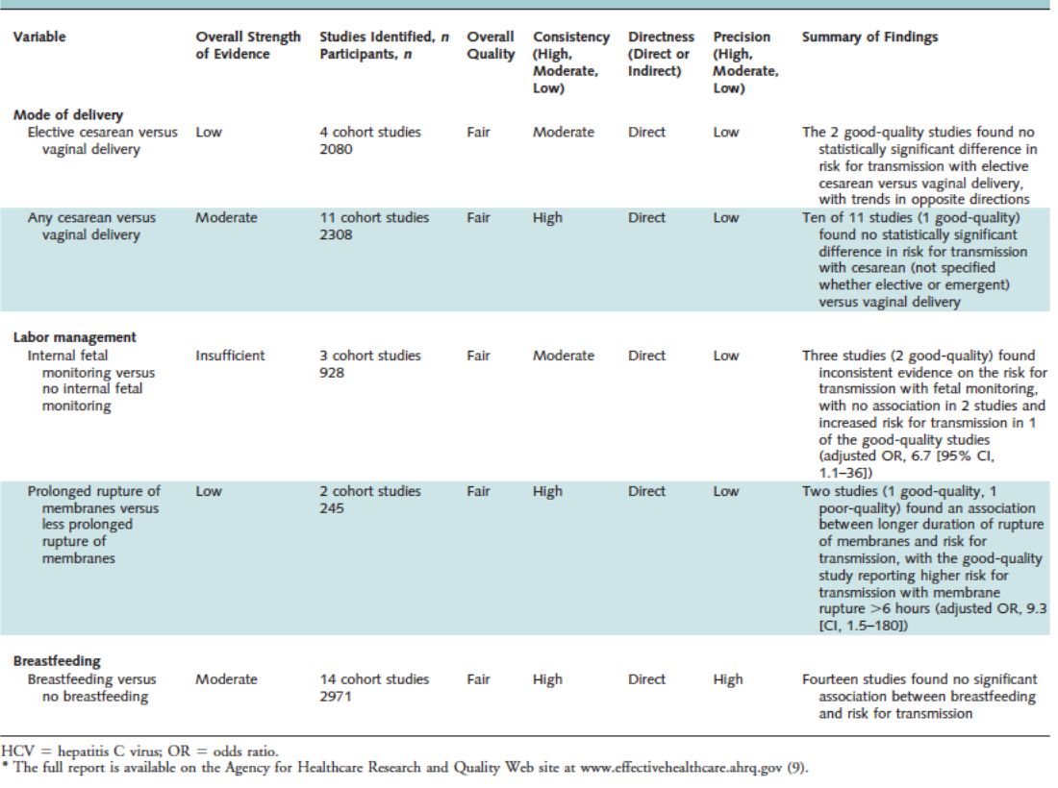
(Cottrell et al., 2013)

HCV REPORTING THROUGHOUT THE UNITED STATES
Reportable conditions vary by state throughout the United States. For HCV, only 5 states receive funding from the CDC for enhanced HCV surveillance (Colorado, Oregon, Minnesota, New York, and Connecticut), 29 states have some method of chronic HCV mandatory reporting, 8 states consider chronic HCV a reportable condition but have no method to manage this data, and 7 states do not consider HCV a reportable condition (Figure 3) (Delgado-Borrego et al., 2012). In Pennsylvania, positive HCV test results are reportable conditions through the Pennsylvania Electronic Disease Reporting System, or PA-NEDSS. In Allegheny County specifically, heath department staff investigated cases in 2015 and 2016 to determine specific risk factors and provide educational materials to prevent further spread of the virus; therefore, Pennsylvania would be included within the group of 29 states with some method of chronic HCV mandatory reporting method.

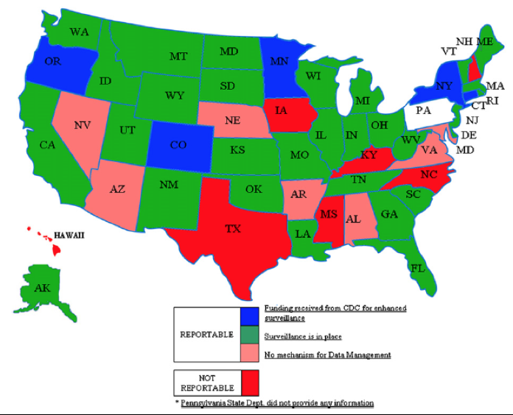
Figure 3: State requirements for reporting chronic cases of HCV infection. CDC, Centers for Disease Control and Prevention

(Delgado-Borrego et al., 2012)

CURRENT GUIDELINES FOR INFANT SCREENING
“Current guidelines from the American Association for the Study of Liver Diseases (AASLD) and the North America Society for Pediatric Gastroenterology, Hepatology and Nutrition (NASHGHAN) recommend that children born to HCV-positive women be tested for anti-HCV antibody after 18 months of age; screening before this age is unreliable due to the likely presence of maternal antibodies. Any positive antibody test should be followed by an HCV RNA test to conﬁrm that the child is infected. HCV RNA tests may also be performed after 2 months of age, with retesting after an additional 2 months, or performed once after 12 months of age” (Kuncio et al., 2016).

POTENTIAL FOR UNDERREPORTING OF HCV— ADULTS AND CHILDREN
Many recent studies have reported the likelihood of underreporting of HCV in many states, which results in subsequent lack of necessary follow-up treatment for these individuals who are infected with HCV. Delgado-Borrego and colleagues conducted a study to evaluate the accuracy of HCV reporting and subsequent treatment by analyzing expected vs. actual reported HCV cases in Florida and the United States as a whole. Florida was chosen for this study because the state requires reporting of all acute and chronic HCV cases to the Medical Emergency Relief International (MERLIN) database. Children ages 0-18 years and adults ≥ 19 years who tested positive for HCV antibodies (HCV-Ab) between January 1, 2000, and December 31, 2009, were selected for analysis. The authors assumed that the expected number of children younger than 19 years old who were positive for HCV-Ab in 2009 was 12,311 people, using the average NHANES III prevalence rate (0.3%) of HCV for children 6-12 years old (0.2%) and children 13-18 years old (0.4%) (Alter et al., 1999). After adjusting for the children who had aged into adulthood by 2009, 1444 children had been reported between 2000 and 2009, resulting in an 11.7% ascertainment rate for child HCV-Ab cases in Florida in 2009. Using a 2.0% seroprevalence rate for adults, calculated from age-group specific NHANES data from 1999-2002 (Armstrong et al., 2006), 166,857 of 288,685 expected HCV-Ab adults had been identified resulting in a 58% ascertainment rate of adult cases in 2009.
To evaluate active treatment for infection in children, the researchers narrowed the pediatric population to Miami-Dade County, where the expected number of HCV-Ab children in 2009 was 1,935 children, and 440 cases were reported to MERLIN between 2000 and 2009. The researchers sent questionnaires to every pediatric gastroenterologist in that county requesting information regarding the number of children being treated for HCV infection in 2009 and the previous five years leading up to 2009. They received a 100% response rate where 31 children were reported for receiving treatment for HCV in 2009 and an additional 55 had been treated in the previous five years. Therefore, only 1.6% of the expected number of HCV-Ab children were being treated in 2009 (31/1935) and 2.8% (55/1935) between 2004-2009.
For the nationwide study, the authors contacted each of the 50 state health department HCV coordinators to request the pediatric HCV-Ab case data between 2000 and 2009. Using the NHANES-based 0.3% prevalence rate of HCV in children 0-18 and unadjusted for children aging into adulthood during this time period, 19 states identified 0-20% of expected cases, one state identified 20-40%, one state identified 40-60%, and the remaining did not have sufficient data or did not respond to the survey. Overall, only 4.9% of expected cases had been identified nationwide.
Kuncio and colleagues conducted a study to assess follow-up testing on children born to HCV-infected mothers in Philadelphia. The researchers matched the city’s electronic hepatitis registry to birth records from 2011-2013 to determine the number of children born to HCV-infected mothers during this time period. Following this initial match, the infants born to HCV-infected mothers were then matched to the same hepatitis registry to determine if these infants had received any HCV testing after 20 months of age, in accordance with current North American Society for Pediatric Gastroenterology, Hepatology and Nutrition (NASPGHAN) guidelines that children born to HCV-infected mothers be tested for HCV-Ab after 18 months to allow for the clearance of maternal HCV antibodies.
Following the first match, 568 infants were identified as being born to HCV-positive mothers between 2011 and 2013. Those infants who were adopted, died, or moved were excluded from the study because there would be no reliable record of their follow-up testing in the registry used in this study (31 infants). The remaining 537 infants were then matched to the Hepatitis registry to evaluate follow-up testing. Of the 537 HCV-exposed infants, only 84 children (16%) had been tested, four of which were considered to have confirmed perinatal HCV infection according to the case definition outlined in the study. The study concluded that 453 of the exposed infants had not been tested, resulting in the potential for 23 expected infants to have become chronically infected with HCV through perinatal transmission but not identified (Kuncio et al., 2016). This study uses a 5% HCV MTCT rate, but if the most common estimate of 6% perinatal HCV transmission rate were used in this analysis, this would result in an additional 6 expected infants to have acquired the virus for a total of 29 infants.

VALIDITY OF BIRTH CERTIFICATE REPORTING— OREGON, 2015
Between 2008 and 2016, total live births in Oregon declined while the number of infants born to HCV-positive mothers increased over time, from 2.9 per 1,000 live births in 2009 to 3.9 per 1,000 live births in 2014, a 33% increase (Figure 5). This trend was also observed nationally with rates of live births from HCV-infected mothers increasing 89% from 1.8 to 3.4 per 1,000 live births among reporting states between 2009-2014 (Patrick, Bauer, Warren, Jones, & Wester, 2017). As previously described, studies suggest that exposed infants are not receiving adequate follow-up testing and treatment. During my internship at the Oregon Health Authority in the summer of 2017, I conducted a study to determine the accuracy of maternal HCV status on infants’ birth certificates in Oregon for 2015. The purpose of this study was to evaluate how accurate this reporting method is when compared to the state reportable conditions database, Oregon Public Health Epidemiology User System (ORHPEUS), in order to explain lack of follow-up care in exposed infants.
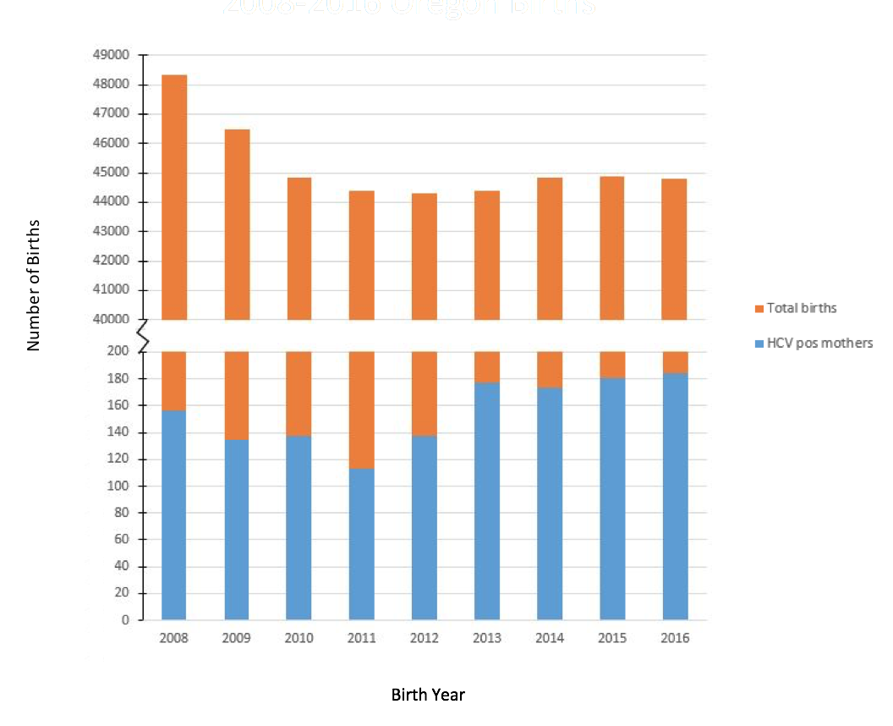
Figure 4: Live births from HCV infected mothers versus total live births according to Oregon birth certificate data by birth year

METHODS
Birth certificate data contains a plethora of information, including parental information such as mother and father name, age, race, contact information, level of education, and insurance type, and information regarding the pregnancy process such as method of delivery, maternal morbidities, or birth risk factors. Maternal infectious diseases are also included, with HCV being one of the seven infectious diseases monitored through this reporting method. Utilizing Linkplus 2.0, a probabilistic record linkage program for registry database linkage and deduplication, all Oregon live birth records from 2015 were matched with the ORPHEUS database of HCV-positive women of childbearing age from 2001-2015 using the mother’s first and last name and date of birth for matching variables between the two datasets. The program-generated matches were manually reviewed by me and my preceptor to confirm their accuracy. These matches were then compared to the original 2015 birth certificate data to determine the number of HCV-positive women delivering infants according to the state reporting system but not reported on the infant’s birth certificate as HCV positive.

RESULTS
Of the 44,712 women who gave birth in 2015, maternal HCV infection was recorded on the birth certificates of 181 (0.4%) infants. Of these, 150 (82.9%) certificates were matched to women with a positive HCV laboratory result reported to the state (Acute and Communicable Disease Prevention, ACDP) and 31 (17.1%) of the 181 women identified as HCV-positive on birth certificates had not been reported to ACDP between 2001–2015 (Table 2).
An additional 113 women with a positive HCV laboratory result reported to ACDP gave birth in 2015, but maternal HCV infection was not reported on their infant’s birth certificate. The linkage resulted in the identification of 263 women with HCV infection who gave birth in 2015, a 62% increase over the estimate of 181 women using birth certificates reporting method alone. Using an estimated 6% rate of perinatal HCV transmission, 18 of the 294 exposed infants would be expected to have acquired an HCV chronic infection. As of July 31, 2017 (at which time all children born in 2015 would have reached age 18 months, the recommended age for testing children born to HCV-infected mothers), ORPHEUS had recorded five positive HCV reports from infants born in 2015. Negative HCV tests are not reportable in Oregon, so it is unknown how many of the exposed infants were appropriately tested. However, the discrepancy between the number of reported positive results and the expected number based on estimates of perinatal transmission suggests that as many as 13 infants with HCV might not have been tested by age 18 months.
Table 2: Comparison of women identified with HCV infection on infant's birth certificates in 2015 with female HCV cases reported to the ACDP program- Oregon, 2001-2015

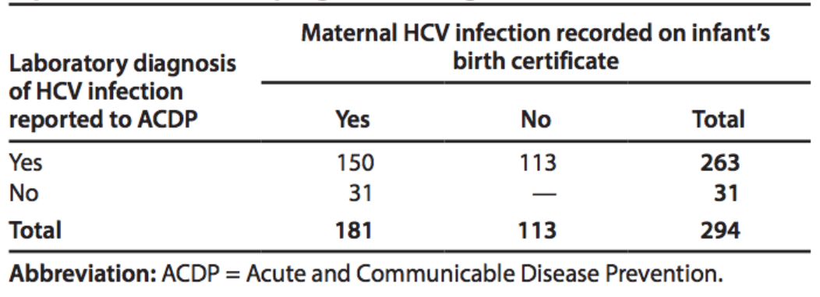

Using Epi Info 7, a geospatial map showing the number of infants born to HCV-positive women per 1,000 live births (Figure 6) was constructed using the current address listed on the infant’s birth certificate from all live births in 2015, now including the additional 113 HCV-positive women identified by ACDP, to identify the counties with the highest rates of maternal HCV infection. When compared to an Oregon opioid overdose map during the same time period (Figure 7), many similarities appear between the two maps suggesting the current opioid epidemic is not only affecting those who are addicted to opioids, but also likely harming future generations as well. The large discrepancy between these two maps in Malheur County may be due to the small population of this county.

Figure 5: Number of infants born to HCV infected women per 1,000 live births by County – 2015

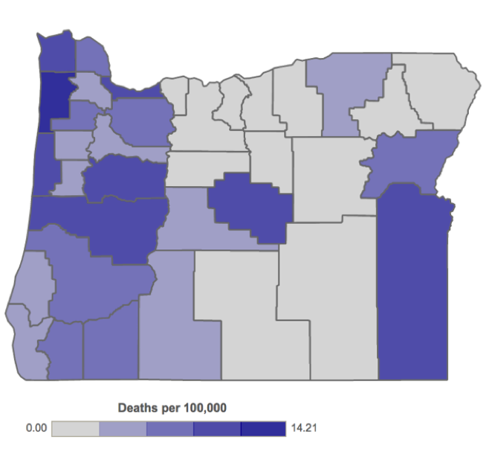
Figure 6: Oregon Opioid Overdose Deaths by County - 2011-2015
(Oregon Health Authority Opioid Overdose and Misuse: Public Health Division, n.d.)

DISCUSSION
Currently there is no treatment recommended for HCV-positive pregnant women due to lack of clinical trials in pregnancy for fear of teratogenic effects of the medication used to treat non-pregnant HCV-positive adults. Ribavirin, specifically, has been shown to cause embryocidal and teratogenic effects in many animal studies. Furthermore, drug companies strongly advise against conception before 6 months post-treatment with Ribavirin in both the female or male partner due to the risk of drug exposure to the fetus (US National Library of Medicine, 2015). Since pregnant women cannot be treated for HCV infection, accurate reporting and follow-up for perinatal HCV are imperative for infants exposed to the virus to receive the medical care they require.
As observed in the Florida, Philadelphia, and Oregon studies, there appears to be a significant deficiency in pediatric HCV exposure follow-up testing and reporting. Delgado and colleagues concluded only 11.7% of expected pediatric HCV-Ab cases were reported in Florida in 2009, a state that requires the reporting of both acute and chronic HCV infections, and only 1.6% of the expected children who developed chronic HCV in Miami-Dade County were actually being treated for HCV infection in 2009. In contrast, 58% of expected HCV-Ab-positive adults were reported in Florida during this time, illustrating a significant gap between case ascertainment of children and adults. In the United States as a whole, the study determined only 4.9% of expected pediatric cases were identified (Delgado-Borrego et al., 2012). Kuncio and colleagues demonstrated how maternal HCV is very prevalent (1% between 2011-2013) in Philadelphia and how 84% of these children exposed to HCV are not being adequately tested at 18 months of age (Kuncio et al., 2016). Finally, in Oregon, the birth certificate reporting method proved to be inaccurate as there were 62% more HCV-exposed infants identified after matching the birth certificate data for 2015 with the state reportable conditions database. However, the Oregon study did rely explicitly on reporting so there may also be some missing data that was not reported by either method.
The current recommended treatments available for HCV in children are direct acting antivirals (DAA), which have been approved for children 12 and older with genotypes 2 or 3 (US Food & Drug Administration, 2017; Wirth et al., 2017). Interferon treatments can cause adverse systemic complications in children such as flu-like illnesses and growth interruption (Sokal, 2017). Clinical trials are currently in process to develop FDA-approved treatments for HCV-infected children ages 3-11 with genotypes 1-6, some with anticipated study completion dates in 2018 (Table 3) (National Institute of Health, 2017; Sokal, 2017). With these new treatments on the horizon, accuracy of reporting of HCV-exposed children is of utmost importance in order to link them to specialty care for testing and treatment to prevent the chronic devastating effects of HCV, which include fibrosis, cirrhosis, hepatocellular carcinoma, and liver failure. Sokal also emphasizes the importance of treatment and cure before these children are of childbearing age in the on-going effort to eradicate viral hepatitis (Sokal, 2017; World Health Organization, 2017).

Table 3: Ongoing pediatric clinical trials with direct-acting antiviral agents
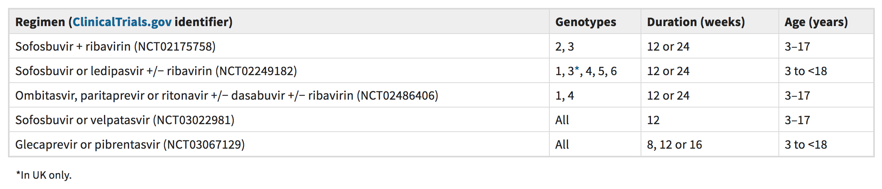
(Sokal, 2017)

The most recent treatments for children ≥ 12 years old have a 12-week sustained virologic response (SVR) rates of 44-59% for genotype 1 (pegylated interferon α-2a or α-2b plus ribavirin treatment) and 93-100% (DAA treatment) for genotypes 2 and 3 (Druyts et al., 2013; Wirth, 2012; Wirth et al., 2017). With respect to the Florida study, 10,867 expected HCV-Ab positive children less than 19 years old were not identified in 2009. Using the previously listed prevalence rates of genotypes 1 through 3 in the United States, 75%, 13.5%, and 5.5% respectively, if 80% of positive HCV-Ab tests resulted in chronic infection an estimated 6,521 children would have acquired genotype 1 and 1,652 children would possess genotypes 2 or 3. With the current SVR rates, 5,500 children would be cured of their infection if the estimated appropriate treatment were in effect in Florida alone. Early detection of HCV infection in children is important because treatments are generally more successful in children than adults (Druyts et al., 2013; Wirth, 2012). In addition, because HCV is a chronic disease, infections in children allow the virus more time to cause detrimental damage to the liver. While there are other barriers to successful treatment of patients with HCV, the most important barriers are lack of testing and referral (Volk, 2010), particularly in pediatrics, as was demonstrated in the Delgado-Borrego study.
A potential reason for this deficiency in reporting, testing, and subsequent treatment is the lack of universal screening for HCV in pregnant women; risk factor-based screening leaves room for potentially significant error if women do not communicate their risk factors to their doctors because, for example, they are embarrassed to disclose IV drug usage or do not understand the severity of the disease. Since HCV has been routinely screened for in blood products since 1992, the most common route of transmission for HCV-infected children is vertical transmission. In Wirth’s recent study of DAA treatment for younger children chronically infected with HCV, 73% of the study population had been infected by vertical transmission (Wirth et al., 2017). Therefore, screening women of childbearing age is being recommended by international organizations including the WHO and the European Association for the Study of the Liver (EASL) (European Association for the Study of the Liver, 2017; World Health Organization, 2017). However, current cost-effectiveness studies in the United States still recommend against universal screening over risk-factor based screening (Plunkett & Grobman, 2005).
Additional reasons for this testing and reporting deficiency include poor communication between the patient’s obstetrician and pediatrician and inaccurate electronic reporting methods. Communication between doctors is imperative to ensure children are appropriately tested. The pediatrician may be unaware of the mother’s status and the child may never be tested for infection (Kuncio et al., 2016; Mack et al., 2012). In addition, as was observed in the Oregon study, current electronic reporting methods are inaccurate therefore increasing the potential for gaps in follow-up medical care. The birth certificate reporting method in Oregon did not identify 113 HCV-positive women who gave birth in 2015; these maternal HCV infections were identified after matching the birth certificate data for 2015 with the state reportable conditions database prior to 2015.
Interventions targeting these barriers would be beneficial to improving reporting rates of maternal HCV infection and infant exposure. Improved communication between doctors and patients on the severity of HCV, the virus-specific risk factors, and its risk for vertical transmission is essential to educate women who are at risk for HCV to encourage mother/infant testing and open communication with their doctor. While screening for infection before pregnancy is ideal, universal screening during pregnancy allows for identification of patients who may not usually seek medical care otherwise (Kuncio et al., 2016). Even though current analysis concludes universal screening is not cost-effective (Plunkett & Grobman, 2005), new treatments are being developed for HCV infection which may motivate reevaluation of cost-effectiveness of universal HCV screening versus risk factor-based screening in pregnancy. There must also be improved communication between obstetricians and pediatricians regarding children who are exposed to HCV which could be emphasized through policy changes in hospitals or corresponding doctors’ offices. Hospital medical staff should relay these results to the infant’s pediatrician before or following delivery. Finally, interventions to improve data collection on birth certificates or other electronic reporting methods to ensure accurate results can be easily transferrable to pediatricians’ offices. In Oregon specifically, there are plans to create linked accounts between the mother and child in the state disease reporting system to better track exposed infants.

CONCLUSION

The opioid epidemic continues to affect the nation, and it may be responsible for the significant increase in percentage of children being born to HCV-positive mothers— an 89% increase between 2009 and 2014 in reporting states (Patrick et al., 2017). Studies suggest that HCV is not only being underreported in individuals nationwide due to the chronicity of the virus but also is being underreported in infants exposed to the virus through vertical transmission. As a result, exposed children are not receiving necessary follow-up screening and treatment leaving them susceptible to the damaging effects of HCV later in life. New treatments approved for HCV-infected children under 12 years old are currently in clinical trials, therefore making this deficiency even more relevant than before. Simple interventions such as improved communication between obstetricians, pediatricians, and patients and data collection quality control have the potential to help ameliorate the large gap in medical care to HCV-exposed children nationwide.

bibliography
Alter, M. J., Kruszon-Moran, D., Nainan, O. V, McQuillan, G. M., Gao, F., Moyer, L. A., … Margolis, H. S. (1999). The prevalence of hepatitis C virus infection in the United States, 1988 through 1994. N Engl J Med. https://doi.org/MJBA-410802 [pii]\n10.1056/NEJM199908193410802
Armstrong, G. L., Wasley, A., Simard, E. P., McQuillan, G. M., Kuhnert, W. L., & Alter, M. J. (2006). The prevalence of hepatitis C virus infection in the United States, 1999 through 2002. Ann Intern Med. https://doi.org/144/10/705 [pii]
Azzari, C., Moriondo, M., Indolfi, G., Betti, L., Gambineri, E., de Martino, M., & Resti, M. (2008). Higher risk of hepatitis C virus perinatal transmission from drug user mothers is mediated by peripheral blood mononuclear cell infection. J Med Virol. https://doi.org/10.1002/jmv.21023
Azzari, C., Resti, M., Moriondo, M., Ferrari, R., Lionetti, P., & Vierucci, A. (2000). Vertical transmission of HCV is related to maternal peripheral blood mononuclear cell infection. Blood.
Babik, J. M., Cohan, D., Monto, A., Hartigan-O’Connor, D. J., & McCune, J. M. (2011). The human fetal immune response to hepatitis C virus exposure in utero. The Journal of Infectious Diseases. https://doi.org/10.1093/infdis/jiq044
Brimacombe, C. L., Grove, J., Meredith, L. W., Hu, K., Syder, A. J., Flores, M. V., … McKeating, J. A. (2011). Neutralizing Antibody-Resistant Hepatitis C Virus Cell-to-Cell Transmission. Journal of Virology. https://doi.org/10.1128/JVI.01592-10
Cottrell, E. B., Chou, R., Wasson, N., Rahman, B., & Guise, J. M. (2013). Reducing risk for mother-to-infant transmission of hepatitis C virus: A systematic review for the U.S. preventive services task force. Annals of Internal Medicine. https://doi.org/10.7326/0003-4819-158-2-201301150-00575
Delamare, C., Carbonne, B., Heim, N., Berkane, N., Petit, J. C., Uzan, S., & Grange, J. D. (1999). Detection of hepatitis C virus RNA (HCV RNA) in amniotic fluid: a prospective study. J Hepatol. https://doi.org/S0168-8278(99)80031-2 [pii]
Delgado-Borrego, A., Smith, L., Jonas, M. M., Hall, C. A., Negre, B., Jordan, S. H., … Chung, R. T. (2012). Expected and actual case ascertainment and treatment rates for children infected with hepatitis c in florida and the united states: Epidemiologic evidence from statewide and nationwide surveys. Journal of Pediatrics, 161(5), 915–921. https://doi.org/10.1016/j.jpeds.2012.05.002

Druyts, E., Thorlund, K., Wu, P., Kanters, S., Yaya, S., Cooper, C. L., & Mills, E. J. (2013). Efficacy and safety of pegylated interferon alfa-2a or alfa-2b plus ribavirin for the treatment of chronic hepatitis C in children and adolescents: a systematic review and meta-analysis. Clinical Infectious Diseases : An Official Publication of the Infectious Diseases Society of America. https://doi.org/10.1093/cid/cis1031
Dustin, L. B., Bartolini, B., Capobianchi, M. R., & Pistello, M. (2016). Hepatitis C virus: life cycle in cells, infection and host response, and analysis of molecular markers influencing the outcome of infection and response to therapy. Clinical Microbiology and Infection : The Official Publication of the European Society of Clinical Microbiology and Infectious Diseases, 22(10), 826–832. https://doi.org/10.1016/j.cmi.2016.08.025
El-Guindi, M. A. (2016). Hepatitis C Viral Infection in Children: Updated Review. Pediatric Gastroenterology, Hepatology & Nutrition. https://doi.org/10.5223/pghn.2016.19.2.83
European Association for the Study of the Liver. (2017). EASL Recommendations on Treatment of Hepatitis C 2016. Journal of Hepatology, 66(1), 153–194. https://doi.org/10.1016/j.jhep.2016.09.001
Fernandez, N., Towers, C. V., Wolfe, L., Hennessy, M. D., Weitz, B., & Porter, S. (2016). Sharing of Snorting Straws and Hepatitis C Virus Infection in Pregnant Women. Obstetrics and Gynecology. https://doi.org/10.1097/AOG.0000000000001507
Gervais, a, Bacq, Y., Bernuau, J., Martinot, M., Auperin, a, Boyer, N., … Marcellin, P. (2000). Decrease in serum ALT and increase in serum HCV RNA during pregnancy in women with chronic hepatitis C. Journal of Hepatology.
Hattori, Y., Orito, E., Ohno, T., Sugauchi, F., Suzuki, S., Sugiura, M., … Mizokami, M. (2003). Loss of hepatitis C virus RNA after parturition in female patients with chronic HCV infection. J Med Virol. https://doi.org/10.1002/jmv.10471
Heim, M. H., & Thimme, R. (2014). Innate and adaptive immune responses in HCV infections. Journal of Hepatology, 61(1), S14–S25. https://doi.org/10.1016/j.jhep.2014.06.035
Honegger, J., Prasad, M., & Walker, C. (2012). Broadened virus-specific T-cell responses are associated with postpartum declines in hepatitis C viremia. In: Infectious Diseases Society of America Annual Meeting. San Diego, CA.
Hughes, B. L., Page, C. M., & Kuller, J. A. (2017). Hepatitis C in pregnancy: screening, treatment, and management. American Journal of Obstetrics and Gynecology, 217(5), B2–B12. https://doi.org/10.1016/j.ajog.2017.07.039
Hurtado, C. W., Golden-Mason, L., Brocato, M., Krull, M., Narkewicz, M. R., & Rosen, H. R. (2010). Innate immune function in placenta and cord blood of hepatitis C--seropositive mother-infant dyads. PLoS One. https://doi.org/10.1371/journal.pone.0012232
Indolfi, G., & Resti, M. (2009). Perinatal transmission of hepatitis C virus infection. Journal of Medical Virology. https://doi.org/10.1002/jmv.21437
James Versalovic, Karen C. Carroll, Guido Funke, James H. Jorgensen, Marie Louise Landry, D. W. W. (2011). Manual of Clinical Microbiology, 10th edition. Manual of Clinical Microbiology, 10th edition. https://doi.org/10.1128/9781555816728

Kumar, R. M., & Shahul, S. (1998). Role of breast-feeding in transmission of hepatitis C virus to infants of HCV-infected mothers. Journal of Hepatology. https://doi.org/10.1016/S0168-8278(98)80003-2
Kuncio, D. E., Newbern, E. C., Johnson, C. C., & Viner, K. M. (2016). Failure to Test and Identify Perinatally Infected Children Born to Hepatitis C Virus-Infected Women. Clinical Infectious Diseases, 62(8), 980–985. https://doi.org/10.1093/cid/ciw026
Le Campion, A., Larouche, A., Fauteux-Daniel, S., & Soudeyns, H. (2012). Pathogenesis of hepatitis C during pregnancy and childhood. Viruses. https://doi.org/10.3390/v4123531
Lin, H. H., & Kao, J. H. (2000). Hepatitis C virus load during pregnancy and puerperium. BJOG : An International Journal of Obstetrics and Gynaecology.
Lin, H. H., Kao, J. H., Hsu, H. Y., Ni, Y. H., Chang, M. H., Huang, S. C., … Chen, D. S. (1995). Absence of infection in breast-fed infants born to hepatitis C virus-infected mothers. The Journal of Pediatrics. https://doi.org/10.1016/S0022-3476(95)70356-X
Mack, C. L., Gonzalez-Peralta, R. P., Gupta, N., Leung, D., Narkewicz, M. R., Roberts, E. A., … Schwarz, K. B. (2012). NASPGHAN Practice guidelines: Diagnosis and management of hepatitis c infection in infants, children, and adolescents. Journal of Pediatric Gastroenterology and Nutrition, 54(6), 838–855. https://doi.org/10.1097/MPG.0b013e318258328d
Mast, E. E., Hwang, L.-Y., Seto, D. S. Y., Nolte, F. S., Nainan, O. V, Wurtzel, H., & Alter, M. J. (2005). Risk factors for perinatal transmission of hepatitis C virus (HCV) and the natural history of HCV infection acquired in infancy. The Journal of Infectious Diseases, 192(February), 1880–1889. https://doi.org/10.1086/497701
McIntyre, P. G., Tosh, K., & McGuire, W. (2006). Caesarean section versus vaginal delivery for preventing mother to infant hepatitis C virus transmission. Cochrane Database of Systematic Reviews. https://doi.org/10.1002/14651858.CD005546.pub2
Molin, G. D., D’Agaro, P., Ansaldi, F., Ciana, G., Fertz, C., Alberico, S., & Campello, C. (2002). Mother-to-infant transmission of hepatitis C virus: Rate of infection and assessment of viral load and IgM anti-HCV as risk factors. Journal of Medical Virology. https://doi.org/10.1002/jmv.2202
Mostafavi, A., Arshad, M., Qiang, G., Bradrick, S., & Jhaveri, R. (2012). Examining cells of trophoblastic origin for permissiveness for hepatitis C virus replication.
Murphy, D. G., Sablon, E., Chamberland, J., Fournier, E., Dandavino, R., & Tremblay, C. L. (2015). Hepatitis C virus genotype 7, a new genotype originating from Central Africa. Journal of Clinical Microbiology. https://doi.org/10.1128/JCM.02831-14
National Institute of Health. (2017). Home - ClinicalTrials.gov. U.S. National Library of Medicine.
Nattermann, J. (2011). NK cells in acute hepatitis C. Journal of Hepatology. https://doi.org/10.1016/j.jhep.2011.01.005
Nie, Q. H., Gao, L. H., Cheng, Y. Q., Huang, X. F., Zhang, Y. F., Luo, X. D., … Wang, Y. Y. (2012). Hepatitis C virus infection of human cytotrophoblasts cultured in vitro. J Med Virol. https://doi.org/10.1002/jmv.23380
Oregon Health Authority Opioid Overdose and Misuse: Public Health Division. (n.d.). Prescribing and Overdose Data for Oregon. Retrieved August 16, 2017, from https://www.oregon.gov/oha/ph/PreventionWellness/SubstanceUse/Opioids/Pages/data.aspx
Paternoster, D. M., Santarossa, C., Grella, P., Palć, G., Baldo, V., Boccagni, P., & Floreani, A. (2001). Viral load in HCV RNA-positive pregnant women. American Journal of Gastroenterology. https://doi.org/10.1016/S0002-9270(01)02697-1
Patrick, S. W., Bauer, A. M., Warren, M. D., Jones, T. F., & Wester, C. (2017). Hepatitis C Virus Infection Among Women Giving Birth — Tennessee and United States, 2009–2014. MMWR. Morbidity and Mortality Weekly Report, 66(18), 470–473. https://doi.org/10.15585/mmwr.mm6618a3
Plunkett, B. A., & Grobman, W. A. (2005). Routine hepatitis C virus screening in pregnancy: A cost-effectiveness analysis. In American Journal of Obstetrics and Gynecology. https://doi.org/10.1016/j.ajog.2004.10.600
Polis, C. B., Shah, S. N., Johnson, K. E., & Gupta, A. (2007). Impact of maternal HIV coinfection on the vertical transmission of hepatitis C virus: a meta-analysis. Clin Infect Dis. https://doi.org/10.1086/512815
Prasad, M. R., & Honegger, J. R. (2013). Hepatitis C virus in pregnancy. Am J Perinatol, 30(2), 149–159. https://doi.org/10.1055/s-0033-1334459
Smith, D. B., Bukh, J., Kuiken, C., Muerhoff, A. S., Rice, C. M., Stapleton, J. T., & Simmonds, P. (2014). Expanded classification of hepatitis C virus into 7 genotypes and 67 subtypes: Updated criteria and genotype assignment web resource. Hepatology. https://doi.org/10.1002/hep.26744
Sokal, E. M. (2017). Direct-acting antivirals for paediatric HCV: we got there. Nature Reviews Gastroenterology &Amp; Hepatology, 14, 452. Retrieved from http://dx.doi.org/10.1038/nrgastro.2017.92
Spencer, J. D., Latt, N., Beeby, P. J., Collins, E., Saunders, J. B., McCaughan, G. W., & Cossart, Y. E. (1997). Transmission of hepatitis C virus to infants of human immunodeficiency virus-negative intravenous drug-using mothers: Rate of infection and assessment of risk factors for transmission. Journal of Viral Hepatitis. https://doi.org/10.1046/j.1365-2893.1997.00073.x
Steininger, C., Kundi, M., Jatzko, G., Kiss, H., Lischka, A., & Holzmann, H. (2003). Increased Risk of Mother‐to‐Infant Transmission of Hepatitis C Virus by Intrapartum Infantile Exposure to Maternal Blood. The Journal of Infectious Diseases. https://doi.org/10.1086/367704
Timpe, J. M., Stamataki, Z., Jennings, A., Hu, K., Farquhar, M. J., Harris, H. J., … McKeating, J. A. (2008). Hepatitis C virus cell-cell transmission in hepatoma cells in the presence of neutralizing antibodies. Hepatology. https://doi.org/10.1002/hep.21959
U.S. Department of Health and Human Services, Centers for Disease Control and Prevention, Division of Viral Hepatitis (CDC). (2016). HCV FAQs for Health Professionals.
U.S. Department of Health and Human Services, Centers for Disease Control and Prevention (CDC). (2016). Statistics and Surveillance.

US Food & Drug Administration. (n.d.). Highlights of prescribing information for SOVALDI® (sofosbuvir) tablets, for oral use. Retrieved June 24, 2018, from https://www.accessdata.fda.gov/drugsatfda_docs/label/2017/204671s006lbl.pdf
US National Library of Medicine. (n.d.). Drug label information: Ribasphere-ribavirin tablet. Retrieved June 23, 2018, from https://dailymed.nlm.nih.gov/dailymed/drugInfo.cfm?setid=7dfd3fdd-efa4-4239-8cd7-ddf2de682328
U.S. Preventive Services Task Force. (2016). Final Recommendation Statement: Hepatitis C: Screening. Retrieved July 16, 2018, from https://www.uspreventiveservicestaskforce.org/Page/Document/RecommendationStatementFinal/hepatitis-c-screening%0A
Volk, M. L. (2010). Antiviral therapy for hepatitis C: why are so few patients being treated? The Journal of Antimicrobial Chemotherapy. https://doi.org/10.1093/jac/dkq157
Wejstal, R., Widell, A., & Norkrans, G. (1998). HCV-RNA levels increase during pregnancy in women with chronic hepatitis C. Scandinavian Journal of Infectious Diseases.
Werner, J. M., Heller, T., Gordon, A. M., Sheets, A., Sherker, A. H., Kessler, E., … Rehermann, B. (2013). Innate immune responses in hepatitis C virus-exposed healthcare workers who do not develop acute infection. Hepatology. https://doi.org/10.1002/hep.26353
Wirth, S. (2012). Current treatment options and response rates in children with chronic hepatitis C. World Journal of Gastroenterology. https://doi.org/10.3748/wjg.v18.i2.99
Wirth, S., Rosenthal, P., Gonzalez-Peralta, R. P., Jonas, M. M., Balistreri, W. F., Lin, C. H., … Schwarz, K. B. (2017). Sofosbuvir and ribavirin in adolescents 12-17 years old with hepatitis C virus genotype 2 or 3 infection. Hepatology. https://doi.org/10.1002/hep.29278
World Health Organization. (2017). Global hepatitis report, 2017. Who. https://doi.org/ISBN 978-92-4-156545-5
Zuure, F. R., Urbanus, A. T., Langendam, M. W., Helsper, C. W., Van Den Berg, C. H. S. B., Davidovich, U., & Prins, M. (2014). Outcomes of hepatitis C screening programs targeted at risk groups hidden in the general population: A systematic review. BMC Public Health, 14(1), 1–29. https://doi.org/10.1186/1471-2458-14-66

