ANIMAL BITE AND RABIES SURVEILLANCE IN ALLEGHENY COUNTY, PENNSYLVANIA, 2017

by
Erica E. Short
BS, Rochester Institute of Technology, 2017

Submitted to the Graduate Faculty of
Epidemiology
Graduate School of Public Health in partial fulfillment
of the requirements for the degree of
Master of Public Health

University of Pittsburgh
2018

UNIVERSITY OF PITTSBURGH
GRADUATE SCHOOL OF PUBLIC HEALTH

This essay is submitted
by
Erica E. Short

on

December 14, 2018
and approved by
Essay Advisor:
Nancy W. Glynn, PhD
Assistant Professor
Department of Epidemiology
Graduate School of Public Health
University of Pittsburgh

Essay Readers:
Kristen J. Mertz, MD, MPH
Medical Epidemiologist
Allegheny County Health Department
Pittsburgh, PA

Richard A. Saladino, MD
Chief, Division of Pediatric Emergency Medicine
Department of Pediatrics, University of Pittsburgh School of Medicine
Children’s Hospital of Pittsburgh of UPMC
Pittsburgh, PA

Betsy Schroeder, DVM, MPH
State Public Health Veterinarian
Pennsylvania Department of Health
Harrisburg, PA

Copyright © by Erica E. Short
2018

ABSTRACT

Background: Animal bites result in significant medical costs due to injury and infection. One per cent of emergency department visits in the United States are related to animal bites. Relatedly, 60-70 dogs, over 250 cats, and thousands of wild animals test positive for rabies in the U.S. each year. However, Pennsylvania has not had a human rabies case since 1984. Animal bite and rabies surveillance by local health departments, such as the Allegheny County Health Department (ACHD), is critical to rabies prevention efforts as staff recommend rabies post-exposure prophylaxis vaccination when necessary.
Nancy W. Glynn, PhD

ANIMAL BITE AND RABIES SURVEILLANCE IN ALLEGHENY COUNTY, PENNSYLVANIA, 2017
Erica E. Short, MPH
University of Pittsburgh, 2018

Methods: All animal bite report data and rabies test results from 2017 were obtained from the ACHD’s Oracle database. Data were imported into Microsoft Excel and deduplicated, and values were reclassified if the information was inconsistently reported. Analysis was completed using SAS, and figures were created in Excel.
Results: There were 1,883 mammal bites reported to ACHD in 2017, with dogs (71%) and cats (24%) involved in the majority of bites. Victims ranged from <1 to 100 years of age. In most 5-year age groups, females had more reported bites than males. Only 4 bite incidents involved an animal that tested positive for rabies; 3 involved stray cats and 1 involved a bat. Antibiotics were prescribed for 63% of reported bites, and a tetanus shot was given for 31%. A total of 104 (6%) people completed the rabies vaccine series (HRIG/HDCV), including the 4 people who were exposed to rabies positive animals. There were 13 people who completed HRIG/HDCV unnecessarily, ultimately costing between $39,000-$91,000.
Conclusion: The bite reporting system and current medical practices have continued to prevent human rabies in Allegheny County. The frequency of rabies positive animals fluctuates over time, but is relatively consistent. Requiring vaccination as a part of pet licensing may be a way to improve pet vaccination rates. Analysis of bite treatments indicated physicians may need decision help regarding animal bite post-exposure prophylaxis protocols to avoid unnecessary prescription of antibiotics, administration of tetanus boosters, and vaccination with the expensive HRIG/HDCV series. The high rabies case fatality rate and medical costs associated with animal bites and prophylaxis make continued surveillance and outreach important to protecting public health.

TABLE OF CONTENTS
1.0 Introduction 1
1.1 overview of animal bites in the united states 1
1.2 the rabies virus 2
1.3 epidemiology of rabies 4
1.4 Allegheny county health department surveillance 5
1.5 public health significance 6
2.0 objectives 7
3.0 methods 8
3.1 data sources 8
3.2 data cleaning 8
3.3 data analysis 10
3.4 geospatial analysis 10
4.0 results 11
4.1 distribution and demographics of animal bites 11
4.2 time trends 12
4.3 animals involved in bites 12
4.4 animal bite circumstances and anatomic location 13
4.5 pet information and dog breed representation 14
4.6 bite treatment and rabies prophylaxis 15
5.0 discussion 17
5.1 Burden and trends of animal bites 17
5.2 opportunities for education 18
5.2.1 Pet Vaccination 18
5.2.2 Dog Breeds 19
5.2.3 Rabies Prophylaxis 19
5.2.4 Other Bite Treatments 20
5.3 the role of the raccoon variant rabies virus 21
6.0 limitations 23
7.0 Public health recommendations 24
7.1 existing recommendations 24
7.2 potential future recommendations 24
8.0 conclusions 26
Appendix A TABLES 27
Appendix B FIGURES 33
bibliography 41
List of tables
Table 1: Number of each animal species involved in bite incidents, Allegheny County, 2017. 27
Table 2: The number of animals involved in bite incidents tested for rabies and the number positive for rabies, by animal species, Allegheny County, 2017. 28
Table 3: Reported circumstances of animal bites overall and stratified by dog and cat bites, Allegheny County, 2017. 29
Table 4: Number of dogs in each breed involved in reported animal bite incidents as compared to the number in each breed licensed in Allegheny County, 2017. 30
Table 5: Antibiotic type used to treat animal bite victims for all bites and stratified by dog and cat bites, Allegheny County, 2017. 31
Table 6: Reasons for receiving HRIG/HDCV, Allegheny County, 2017. 31
Table 7: Treatment combinations used to treat animal bite victims, Allegheny County, 2017. 32
List of figures
Figure 1: Map from the CDC depicting regions of the U.S. with specific, typical rabies wildlife reservoirs and associated virus variants (24). 34
Figure 2: Number of bites per 10,000 population, by zip code, Allegheny County, 2017. 35
Figure 3: Bite rate per 100,000 population by age group, Allegheny County, 2017. 36
Figure 4: Number of bites reported by sex and age group, Allegheny County, 2017. 36
Figure 5: The number of reported bites by month, Allegheny County, 2017. 37
Figure 6: The number of reported animal bites in Allegheny County over time (2013-2017). 37
Figure 7: Number of animals testing positive for rabies in the entire state of Pennsylvania and in Allegheny County, 1988 to 2017. 38
Figure 8: Bite location on the body. 39
Figure 9: Treatments received by bite victims, Allegheny County, 2017. 40
Figure 10: Treatments received by victims of dog and cat bites, Allegheny County, 2017. 40

Introduction

overview of animal bites in the united states
In the United States (U.S.), more than four million people are bitten by animals each year, and 10-20 people die from bite-related injury or infection (1, 2). Animal bites account for about 1% of emergency department (ED) visits in the U.S., with approximately 316,200 ED visits and 9,500 hospitalizations attributed to bites in 2008 (1).
The largest proportion of bites are from dogs, comprising 85-90% of the animal bites occurring in the United States (2), resulting in significant medical costs attributed to bites. The average cost of a dog-bite related hospitalization is about 50% higher than the average injury-related hospitalization, more than $18,000 versus $12,000, respectively (1). Given that 9,500 people with bite-related injuries are hospitalized each year, approximately $170 million is spent on animal bite-related hospitalizations, not including ED encounters for bites.
Cat bites make up the second largest proportion of animal bites, 5-10% of the total (2). Though dog bites are more likely to result in serious injury, cat bites can have up to a 50% infection rate, which is 5-10 times higher than the infection rate for dog bites (2).
There are some demographic variations of animal bites. Animal bites tend to occur more often during summer months when people spend more time outside in their community (3). The Midwestern U.S. has the highest rate of dog-bite related ED visits (109.9 per 100,000) followed by the Northeast (108.5 per 100,000), and the Northeastern U.S. has the highest rate of dog-bite related hospitalizations (3.9 per 100,000) (1). Males are typically bitten and present to an ED more frequently than females, 110 per 100,000 compared with 98 per 100,000, respectively (1, 4, 5). Children are at the greatest risk of animal bites, and they are also at higher risk of more severe injury or infection (1, 2, 6).

the rabies virus
Rabies is a nearly-always fatal bite-related infection, regardless of gender or age. The rabies virus is a single-stranded, enveloped, RNA virus of the Rhabdoviridae family (7). It is further classified as a lyssavirus and only infects mammals (7). Among infected mammals, the rabies virus is spread in saliva or brain/nervous system tissue, making bites the main route of infection (8). Incubation is typically two to three months but can range from one week to several years, and once symptoms manifest, the case fatality rate is almost 100% (9, 10).
The initial (prodromal period) symptoms are flu-like, including myalgias, fatigue, fever, and increased pain around the bite site (7). The acute neurologic period symptoms include central nervous system dysfunction, coma, and death (7). During the acute neurologic period, people may experience anxiety, agitation, convulsions, insomnia, hyperventilation, and hypersalivation (7). Depending on the predominant symptoms, cases may be classified as either “furious” or “paralytic” (7, 11). Hydrophobia is another sign of nervous system dysfunction associated with rabies, and in the 2008-2010 rabies outbreak in Bali, it was the most common sign, present in over 93% of cases (11). Animals also experience many of these symptoms, and are more likely to approach and bite humans during the “furious,” hyperactive period of disease.
Despite rabies having the highest case fatality rate of any infectious disease and being present in nearly every country, there is no proven treatment to consistently prevent death once symptoms appear (10, 12). Prevention of rabies is best achieved by avoiding contact with wild animals and vaccinating domestic animals, since vaccinated pets act as protective intermediaries between rabid wild animals and humans. Prevention can also be achieved by human vaccination. Pre-exposure prophylaxis vaccination is available and recommended for those in high-risk professions such as veterinarians, animal handlers, rabies laboratory workers, and spelunkers (13). Post-exposure vaccination is available for those who have been bitten by a rabid or unknown animal, or were otherwise exposed to the virus.
Virus-neutralizing antibodies and cell-mediated immunity are important for host defense (7), and those key immune responses are why two components of post-exposure prophylaxis vaccination are recommended. Human rabies immunoglobin (HRIG) is the first element of prophylaxis and provides rabies antibodies to inactivate the virus before it reaches the central nervous system (14, 15). The second component of prophylaxis is human diploid cell vaccine (HDCV), given in four doses over two weeks (15). When properly administered before symptoms appear, the HRIG/HDCV vaccine sequence is almost always effective at preventing progression to rabies in humans (16, 17). However, the vaccine is very expensive. The CDC estimates the cost of vaccination to be between $3,000-$7,000 per person (18). The estimated cost of rabies prevention in the U.S. each year, including vaccination, animal control, and testing, is estimated to be between $245-510 million (18, 19). Therefore, strategies to decrease exposure to the rabies virus have the potential to significantly decrease an element of health care cost.

epidemiology of rabies
Rabies is present in 150 countries and results in over 59,000 human deaths each year, of which more than half are children (9). About 95% of rabies cases occur in Africa and Asia, and globally, over 99% of cases are attributable to dog bites (9). In the United States, rabid dogs are much rarer because of pet vaccination. Most U.S. states require pet vaccination by a certain age, and although law enforcement can issue fines to owners who do not vaccinate according to state law (20), officers rarely go door-to-door to ensure compliance. In 2001, of all animal bites treated in an emergency department, only 8% of dogs and 45% of cats involved were reportedly vaccinated against rabies (21).
Although rare, the majority of human rabies cases in the U.S. are from wild animals (22). Public health efforts and medical advances, including the current vaccine series, have contributed to reducing the number of human rabies cases in the U.S. Each year in the U.S. there are only one to three cases of rabies in humans, but there are approximately 60-70 rabid dogs, over 250 rabid cats, and thousands of rabid wild animals reported (most commonly raccoons, bats, skunks, and foxes) (23). Common wildlife reservoirs for rabies usually have an associated rabies virus variant and occupied region. Figure 1 is a map depicting the regions typically affected by each wildlife reservoir/variant (23, 24). The bat variant of rabies is not shown, but it can be found across the continental U.S. (25).
In Pennsylvania, the raccoon and bat variant viruses are present, and the state reports approximately 400 rabid animals each year (23, 26). Even so, Pennsylvania has not had a human rabies case since 1984 (3). Animal bites are reportable by law in Pennsylvania, and local health departments are responsible for follow-up when possible.

Allegheny county health department surveillance
The Allegheny County Health Department (ACHD) investigates reports of animal bites in Allegheny County. Medical facilities and police are required by law to report animal bites to ACHD using a standardized form to document case information. The Immunization Program at ACHD is then responsible for contacting the bite victim and owner (where applicable) to obtain information not provided on the initial report, issue animal quarantines, and advise on post-exposure vaccination. If a dog or cat involved in a bite can be observed, a 10-day in-home quarantine is issued to monitor the animal for signs and symptoms of rabies. ACHD can also seek out vaccination records for an animal to check if it is up-to-date on rabies vaccination. If an animal is deceased or dies during quarantine, ACHD requests that the animal be officially tested for rabies in the county laboratory. Wild animals are euthanized and tested when possible. If a biting animal cannot be quarantined or tested, then staff advise victims on receiving post-exposure vaccination (HRIG/HDCV) and monitor their progress with the four-dose vaccine sequence to ensure the victim receives doses on the correct days and completes all the necessary doses.
ACHD makes an additional effort to quell rabies in the wildlife population and prevent further westward spread of the raccoon variant by participating in raccoon baiting annually each August. An oral rabies vaccine packet is encased in fishmeal; thousands of vaccine baits are then distributed throughout animal habitat in the county (27), in the hope that enough local raccoons will eat the vaccine to boost the population’s immunity and prevent the spread of the virus.

public health significance
When considering overall case reports of infectious diseases in the U.S., rabies may seem insignificant; however, rabies has the highest case fatality rate of any known infectious disease, and that alone warrants public health intervention. It is only responsible for 1-3 deaths in the U.S. each year, but as a zoonotic virus, rabies has the capability to infect a wide range of mammalian species and is not a candidate for eradication. There is also a large cost associated with rabies prevention due to vaccinations and animal control. Furthermore, rabies is associated with the broader public health issue of animal bites, which incur even greater costs to the health care system through hospitalizations and ED visits.

objectives
The purpose of this project was to examine the occurrence and trends of both animal bites and rabies risk and prophylaxis burden in Allegheny County for 2017. The information gleaned from evaluation of the data will be used to make public health recommendations and inform future intervention strategies.

methods

data sources
All animal bite report data for 2017 were obtained from the Allegheny County Health Department’s Oracle database. All rabies test results for 2017 were reported by the health department laboratory. Age-group population data were obtained from the U.S. Census, using the most recent five-year estimates (28). The Allegheny County Treasurer’s Office provided data on the number of dogs of each breed licensed in Allegheny County for 2017. Historical animal bite data were pulled from previous Allegheny County animal bite surveillance reports (29, 30). Historical rabies data for Pennsylvania and Allegheny County were obtained from the Pennsylvania Department of Agriculture.

data cleaning
All reports with a bite date in 2017 were exported to a Microsoft Excel spreadsheet. If the bite date was not provided, but the report date was in 2017, the record was included. After exportation, the data were cleaned to remove duplicate entries. Duplicate entries were identified using the victim’s first and last name, birth date, bite date, and bite description. Reports involving non-mammals (e.g., snakes, birds) were removed because non-mammals do not transmit rabies. Reports were excluded if neither victim residence, pet residence, nor place of bite were in Allegheny County.
After initial cleaning, the data were imported into SAS (version 9.4). Other data cleaning was then performed, including re-categorizing responses for certain fields and recoding misspelled values to a single, accurate value. If a bite date was missing, the report date was set as the bite date. The bite dates were then grouped by month. Except for children aged less than five years, reports were grouped into ten-year age intervals. These intervals aligned with census data and were used to calculate bite rates. For other age and sex analyses, five-year age groups were created.
Location of bite on the body was condensed into six categories: upper extremity, lower extremity, trunk, face/head/neck, multiple regions, and unknown. Antibiotics were recoded to a uniform, correct spelling for each type (e.g., “doxy” was recoded as “doxycycline”). Topical ointments were excluded as antibiotics.
If discrepancies arose for certain fields (example: HRIG/HDCV box marked “yes” but post-exposure prophylaxis (PEP) box marked “no,” or vice versa) the full description of the encounter was reviewed to determine the true values, and the coding was corrected. All reports for which the “rabies positive” box was marked were read in entirety to ensure the number of rabies positive animals was accurate.
The Allegheny County Treasurer’s Office dog license data contained the breeds for all dogs licensed in the county for 2017, including a “Mixed Breed” category as well as a “mix” option for many popular breeds (e.g., Akita, Akita Mix; Poodle, Poodle Mix). For calculations, breed-specific mixes were combined with the pure breed, and not considered “Mixed Breed;” for example, “Akita Mixes” were classified as Akitas. Dogs reported as simply “Mixed Breed” remained classified as such.

data analysis
SAS (9.4) was used to obtain frequencies for the variables of interest. Frequencies were imported to Microsoft Excel to create graphs and tables. Variables of interest included age, sex, zip code, month, body part bitten, treatment and prophylaxis (antibiotics, tetanus, HRIG/HDCV vaccine series), animal type (pet, stray, feral, wild), animal species, reason for bite, animal quarantine status, animal vaccination status, animal rabies test results, and dog breed. SAS was also used to perform a Wilcoxon rank-sum test to compare the age distributions by sex.

geospatial analysis
Victim zip codes were used to identify the number of individuals in each zip code who had been bitten compared with the total population in the zip code. Using these data, a map was created using ArcMap 10.5.1 as a geospatial representation of the number of residents bitten per 10,000 population by zip code area (bite victim density). These bite rates were calculated using U.S. census estimates for the population of each zip code area as the denominator, and the number of bites reported for Allegheny County residents as the numerator. ArcGIS® and ArcMapTM are the intellectual property of Esri and are used herein under license. ArcMapTM created four categories of rates for display with an equal number of zip codes per category (quartiles).

results

distribution and demographics of animal bites
In 2017, there were 1,883 mammal bites reported to the ACHD. Of the 1,883 reported mammal bites, 1,732 (92%) bite victims were Allegheny County residents; the remaining 151 (8%) of reported bites occurred in either Allegheny County or the animal’s owner lived in Allegheny County. Bite victim density by zip code can be seen for Allegheny County in Figure 2. The highest densities were seen in the southwest, northwest tip, and west-central regions of the county. Many of these zip code areas are located along rivers. It is important to note that the densities are by victim residence, not the actual location of where the bite occurred.
Victims ranged in age from younger than 1 year to 100 years, with a median of 33 years and a mean of 36.7 years. Bites per 100,000 population were highest among children 5-14 years and adults aged 25-34 years, followed by those aged 15-24 years and 35-44 years, respectively (Figure 3). Of the bite victims for whom the sex was known, 60% (1,098/1,824) were female and 40% (726/1,824) were male. In almost all five-year age groups, more females were reported than males (Figure 4). The exceptions were among children 0-4 years, 5-9 years, and 10-14 years, with male children aged 5-9 years having almost double the number of bite incidents as female children. Age distributions were significantly different by sex (p < 0.0001).
Bite report frequency increased with ambient temperatures, peaking in June and remaining higher in the summer and autumn as compared with the winter or early spring (Figure 5).

time trends
Animal bite data for Allegheny County was available from 2013 to 2017, and the number of bites reported each year has remained constant between 1,770 and 1,920 bites (Figure 6).
Historical rabies data were available for both Allegheny County and the entire state of Pennsylvania from 1988 to 2017. The number of rabies positive animals reported fluctuated in a relatively consistent manner, and despite large differences in the numbers reported in Allegheny County compared with the entire state at the beginning (1988-1991), the trendlines are very similar in shape and share many peak years (Figure 7). In 2017, the number of rabies positive animals reported is the second lowest on record for Pennsylvania (347 rabies positive animals reported). The number was also on the low side for Allegheny County (15 rabies positive animals reported).

animals involved in bites
Most bites were inflicted by dogs (70.6%) or cats (24.0%) (Table 1). The most common wild animals involved in bites were bats (1.3%) and raccoons (0.6%). In 1.6% of cases, the animal species involved was unidentified. All other species involved individually accounted for less than 0.5% of cases.
The ACHD lab tested 708 animals in 2017, with 2.4% (17/708) testing positive for rabies. Fifteen of those rabies-positive animals were from within Allegheny County. Of the 708 animals tested, 8.9% (63/708) were involved in reported bite incidents. Only 4 (6.3%) of those animals were positive for rabies, down from 20 positive exposures in 2015-2016 (Seresin, 2017). Stray/feral cats were responsible for 75% (3/4) positive exposures, and 25% (1/4) of the positive exposures was from a bat (Table 2).

animal bite circumstances and anatomic location
Circumstances under which animal bites occurred are shown in Table 3. Of 1,883 reports, 507 (26.9%) did not include the circumstances surrounding the incident. The most common situations reported were animals “getting spooked” (193/1,883; 10.2%), persons “playing with” the animals (154/1,883; 8.2%), and persons “breaking up a fight between” animals (137/1,883; 7.3%). The two descriptions for unprovoked bites included, “at a community area and animal came up and bit the victim” and “walking on the road,” and those situations comprised 141/1,883 (7.5%) bites. Bite incidents are also shown separately for dogs and cats in Table 3. There were five situations in which cat bites occurred more frequently than dog bites: performing a medical procedure, trying to capture the animal, bathing/grooming the animal, trying to put the animal in a crate, and giving medication to or cleaning a wound on the animal.
Information regarding the location of exposure on the body was missing for 192/1,883 (10%) reports, and those reports are not included in Figure 8. The majority of bites/scratches were to the upper extremities (arms and hands) (1,006/1,691; 60%), followed by lower extremities (legs and feet) (282/1,691; 17%) and face/head/neck (261/1,691; 15%) (Figure 8). Only 35/1,691 (2%) victims were bitten/scratched on the trunk of their body, while 107/1,691 (6%) victims were bitten/scratched on multiple body regions.

pet information and dog breed representation
Among dogs involved in bites/scratches, 64.3% (855/1,330) were reported to be previously vaccinated against rabies compared with 58.2% (263/452) of cats. Among cats, 68.6% of pet cats and 9.0% of stray cats were vaccinated. Only 57 (4.3%) dogs and 42 (9.3%) cats definitely had not received rabies vaccination. Vaccination information was not provided for 418 (31.4%) dogs and 147 (32.5%) cats. After a reported bite, 711 (50.4%) dogs were quarantined as compared with 234 (51.8%) cats. There were 160 (12.0%) dogs and 72 (15.9%) cats who did not get quarantined.
Information regarding breed was available for 755/1,330 (56.8%) dogs involved in bites. Table 4 contains dog breeds that were responsible for at least 8 bites in 2017 (greater than 1% of bites). Many other breeds make up the remaining 109/755 (14.4%) bites, but all have less than 8 bites attributed to them. Mixed breed dogs were the most commonly involved in bites (184/755; 24.3%), followed by Pit Bulls (160/755; 21.1%). Some of the breeds are overrepresented in bite reports relative to county license data.
Breeds that had a higher percentage of bite involvement as compared to the percent licensed in Allegheny County are bolded (Table 4). Most notable are: Pit Bulls (3.6% of licensed dogs, 21.1% of bites), mixed breed dogs (12.5% of licensed dogs, 24.3% of bites), and German Shepherds (4.9% of licensed dogs, 7.9% of bites). Conversely, Labrador Retrievers constituted 12.8% of licensed dogs in the county but only 4% of reported bites. The top three breeds (Mixed, Pit Bulls, and German Shepherds) made up over half of the 755 reports with breed information.

bite treatment and rabies prophylaxis
Antibiotics were prescribed for 1,188/1,883 (60.1%) animal bite/scratch victims and tetanus boosters were given to 588/1,883 (31.2%) victims (Figure 9). Most reports (724/1,188; 60.9%) did not specify the type of antibiotic prescribed. Of 464 bites for which the antibiotic prescribed was known, Augmentin (amoxicillin/clavulanic acid) was the most prescribed, given in 367 (79.0%) cases (Table 5).
A total of 117/1,883 (6.2%) bite victims received HRIG/HDCV in 2017 (Figure 9). Most of the recipients (104/117; 88.9%) completed the full vaccine series of HRIG/HDCV, including all the victims exposed to rabies positive animals (4/104; 3.8%). Of the victims who completed HRIG/HDCV, 87/104 (83.7%) did so because the animal involved in the exposure could not be observed for a quarantine period or tested for rabies (Table 6). The remaining 13/104 (12.5%) who completed the HRIG/HDCV sequence did so even though the animal was proven healthy and/or could have been quarantined or tested for rabies.
There were 534/1,883 (28.4%) victims who received more than one treatment (Table 7). The most common treatment combinations were antibiotic only (657/1,883; 34.9%) and antibiotic plus tetanus (466/1,883; 24.8%). There were 559 (29.7%) victims who did not receive any treatment (antibiotic, tetanus, or HRIG/HDCV). Receiving all three treatments was rare (30/1,883; 1.6%), but receiving tetanus plus HRIG/HDCV was the rarest (8/1,883; 0.4%).
Among those bitten by dogs, 868 (65.3%) were prescribed an antibiotic, 438 (32.9%) were administered a tetanus vaccine, 50 (2.7%) received PEP, and 388 (20.6%) were not prescribed any treatment. Among those bitten by cats, 294 (65%) were prescribed an antibiotic, 131 (29%) were given a tetanus vaccine, 31 (6.9%) received PEP, and 125 (27.7%) were not prescribed any treatment (Figure 10).

discussion

Burden and trends of animal bites
Overall, Allegheny County had 1,883 reported mammal bites in 2017 as compared with 1,912 reported mammal bites in 2016 (30). Dogs (70.6% of bites) and cats (24.0% of bites) continue to have the greatest involvement in animal bites. Although 1,883 mammal bites were reported in 2017, this is most likely a significant underestimation of the frequency of animal bites. For example, it is estimated that only about 17-18% of dog bites receive medical attention, and the conclusion in other locations is that animal bites are generally under-reported (31, 32).
For persons 15 years and older, the number of women being bitten by animals appears to be higher than the number of men in all five-year age groups. These numbers are conversely different than those seen elsewhere in the U.S. where males are reportedly bitten more often than females (1, 4, 5). However, in the first 14 years of life, the number of reported bites in Allegheny County is higher for males or approximately equal for males and females, which could be explained by previously observed animal bite epidemiologic trends. A study in Germany determined dog bites more commonly affect males and two thirds of the dog bites occurred in children and adolescents, while cat bites more commonly affect females and occur more in those aged 20-35 years (33). Bite counts for children in Allegheny County did not make up half of all bites as some previous literature suggested (2).
As expected from the literature, the majority of bites occurred during warmer summer months (3). While the number of animal bites has remained relatively consistent in the past five years, historical data for both the state and Allegheny County show the number of rabies positive animals reported each year has varied since 1988. Early differences between the state and county (1988-1991) are most likely because the raccoon variant of the rabies virus moved westward across the state and reached Allegheny County later than the eastern half of Pennsylvania. After 1991 a fluctuating pattern occurred for both the entire state of Pennsylvania and Allegheny County. It is possible the fluctuation may follow climate or weather patterns since the survival of young raccoons (the major terrestrial host of rabies virus in Pennsylvania) is, in part, dependent on the severity of the winter season (34, 35).

opportunities for education

Pet Vaccination
Dogs (70.6%) and cats (24.0%) continue to have the greatest involvement in animal bites. Vaccination status for these animals was not always available, but 64.3% of dogs and 58.2% of cats involved in bites were reported as being vaccinated against rabies. Although those pet vaccination rates are higher than the reported national average, they are still lower than desired. Pennsylvania law requires all dogs and cats be vaccinated against rabies by three months of age (20), but active enforcement is difficult.
More action is taken for dog licensing since dog owners must purchase a physical license tag from their local county treasurer (36). Licensing would therefore be an opportune time to provide education and resources for rabies vaccination to dog owners. However, cat owners would still be missed in this process. As previously mentioned, Pennsylvania typically has over 400 rabid animals reported each year (26), and pets can act as intermediary barriers between rabid animals and their human owners. Requiring pet vaccination as a component of pet licensing would increase vaccination coverage and further reduce human rabies risk.

Dog Breeds
According to the 2017 dog breed analysis, the top four breeds involved in bites has remained consistent compared with 2015-2016 (30). There is much debate about breed-associated behavior in dogs, and while it is concerning to see over 20% of the reported bites for 2017 caused by one breed, there are underlying factors to consider. For one, many people cannot accurately differentiate between Pit Bulls, Cane Corsos, Bulldogs, and Mastiffs, to name a few, which might be inflating the number of Pit Bulls reported in animal bites. These same “pit-type” breeds consistently have the highest intake at shelters (37). Since the history of any shelter animal can be unclear, providing some extra guidance to adoptive owners on training and public handling could make a difference in the number of reported bites from high-energy breeds like Pit Bulls, German Shepherds, and Labrador Retrievers.

Rabies Prophylaxis
The HRIG/HDCV series is necessary when the animal tests positive for rabies or if the animal cannot be observed for a 10-day quarantine period (21). HRIG/HDCV is a very expensive treatment; the CDC estimates it costs between $3,000-$7,000 per person (18), and these estimates may be low depending on the medical facility used and insurance coverage. In 2017, a total of 104 people completed the HRIG/HDCV series in Allegheny County, but 13 (12.5%) of those people had an invalid reason for receiving it, meaning at least $39,000-$91,000 were unnecessarily spent. Though a greater proportion of bite victims received the HRIG/HDCV series compared to 2015-2016 (6.2% vs. 5.2%), there was a slight improvement in 2017 compared with 2015-2016 regarding unnecessary vaccination (12.5% vs. 14.1%) (30).

Other Bite Treatments
In Allegheny County, about 63% of bite victims received an antibiotic in 2017, a 14% decline from 2015-2016 (30). General antibiotic recommendations regarding animal bites are to prescribe them for “high-risk” bite wounds and wounds to the hands, and to consider antibiotics for average-risk wounds (21). Most cat bites are considered “high-risk.” Cat fangs are typically long and sharp, resulting in deeper penetrative wounds with infection rates more than double that of dog bite wounds (38). Despite the increased risk of infection associated with cat bites, the antibiotic prescription rates for dogs and cats was approximately equal in Allegheny County for 2017 (65.3% for dogs, 65.0% of cats). This could be because reporting is largely done by medical facilities and people likely seek out medical care for more serious bites that require antibiotics. Augmentin is regarded as the antibiotic of choice for animal bites (21), and it was the most common antibiotic prescribed for animal bites in Allegheny County, making up at least 30.9% of prescribed antibiotics.
Approximately 31% of bite victims in Allegheny County received a tetanus shot in 2017, a decrease from 38.6% in 2015-2016 (30). Tetanus vaccination is recommended for those who have had fewer than 3 doses in their lifetime or who have not been vaccinated in more than 10 years for minor wounds and more than 5 years for all other wounds (21). Based on ACHD’s bite report data, it is unclear whether some bite victims received unnecessary tetanus vaccination, but providers are advised to check the Pennsylvania Statewide Immunization System (PA-SIIS), which contains vaccination records, before administering the vaccine to prevent over-vaccination with tetanus boosters.

the role of the raccoon variant rabies virus
Although domesticated animals contribute most to reported animal bites, no pets tested positive for rabies in Allegheny County in 2017. Wild animals continue to be the primary threat of human rabies. The raccoon variant of the rabies virus is present along the east coast of the U.S. and is the major variant in Pennsylvania (CDC). This strain has spread into the Northeastern corner of Ohio, but the remainder of Ohio has not yet reported positive tests for the racoon variant of rabies (39).
The role of raccoon variant rabies is illustrated by comparing Hamilton County, Ohio, to Allegheny County. Both Hamilton and Allegheny Counties have similar population sizes, and each county has a large city structure developed around riverways (Cincinnati and Pittsburgh, respectively). Just like the ACHD, the Hamilton County Health Department also requires animal bite reporting and issues 10-day quarantines for animals involved in a bite (40). However, these comparable counties do not have similar rabies data. In 2017, Hamilton had only 2 rabies positive animals, both of which were bats (41), compared to Allegheny’s 15 rabies positive animals, of which 40% were raccoons. This dramatic difference in rabies cases between Hamilton and Allegheny County emphasizes the importance of the raccoon baiting program which aims to prevent further westward spread of the variant.

limitations
The analyses of ACHD’s data was reliant on the completeness and accuracy of the animal bite reports. Some data fields had missing information. A presentation was given to the immunization program staff at ACHD to show where improvement in data entry might be made, but the staff is still limited by the cooperation of victims and animal owners in providing relevant information. In the geospatial analysis, some zip code areas cross into neighboring counties, and bite rates for those areas may be an underestimation since bites to residents of other counties were not included in this analysis. Due to the combination of pure dog breeds and breed-specific mixes (“Akita Mix” considered as Akita), some breeds’ contribution to reported bites may not be accurately represented in the bite data for 2017.

Public health recommendations

existing recommendations
- Encourage the public to avoid contact with wild animals (live or dead) and to refrain from taking in, feeding, and playing with wild animals to reduce risk of rabies exposure.
- Refresh education for medical providers on the protocol for rabies PEP. HRIG/HDCV is not immediately necessary if the animal involved in a bite is available for observation or testing. Encourage providers to review PA-SIIS prior to administering tetanus vaccines. Also encourage providers to use the electronic animal bite reporting form.
- Encourage all pet owners to abide by Pennsylvania state law and vaccinate their pets against rabies. Keeping pets current with vaccinations will not only protect them from disease, but will also protect their owners from rabies. Pet owners should also prevent pets from wandering outdoors unsupervised to decrease the chance for interaction with rabid wildlife.

potential future recommendations
Based on the above analysis, local health officials are advised to do the following:
- Ask for proof of vaccination when licensing dogs. Dog owners are already required to license their pets, and because vaccination is also required by law, it is reasonable to require dog owners to show vaccination records at the time of licensing. The intended outcome is an increase in dog vaccination rates and improved protection of pets and owners from rabies.
- Require licensing and proof of vaccination for outdoor cats.
- Educate the public on capturing a bat or contacting a service to capture a bat if it is found inside an inhabited dwelling. The bat should also be submitted for rabies testing at the ACHD laboratory. Ruling out rabies will prevent unnecessary anxiety and medical costs for PEP.
- Improve public understanding of animal bite reporting. Public outreach education should focus on the message regarding the importance of animal bite reporting. Bite victims are strongly encouraged to obtain animal owner contact information when possible. Animal owners should be reminded that the health department is concerned only with the health of the bite victim and animal, and the animal will not be taken away by the health department. Cooperation from all parties involved is greatly appreciated.

conclusions
Although there are typically fewer than 20 animals that test positive for rabies in Allegheny County each year, rabies infection continues to be a danger to the wildlife in the region and a threat to humans and pets. Furthermore, rabies prevention provides the potential for considerable reductions in related medical costs each year. The number of animal bites in Allegheny County, PA has remained steady between 1,770-1,920 bites annually for the past five years, but it is likely animal bites are largely under-reported. Pet vaccination rates in the county are suboptimal despite Pennsylvania State Law. Annual analysis of the animal bite and rabies surveillance data provides important information that can inform future public health efforts and policy as per recommendations. Vigilant animal bite reporting and rabies surveillance are critical to maintain a human rabies-free Pennsylvania and impede this deadly public health threat.
        - TABLES

Table 1: Number of each animal species involved in bite incidents, Allegheny County, 2017.
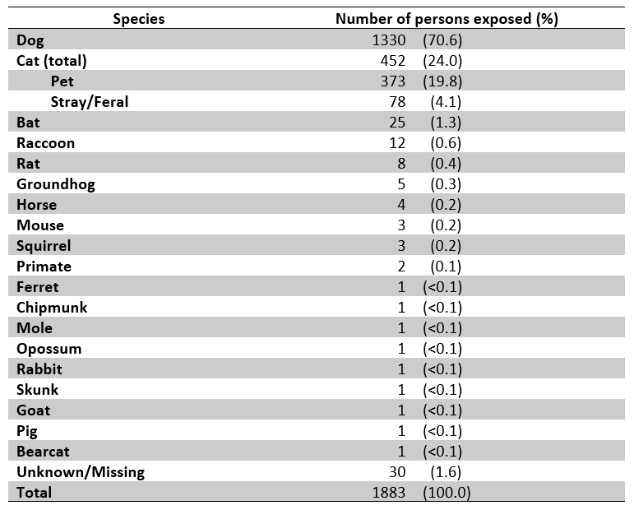

Table 2: The number of animals involved in bite incidents tested for rabies and the number positive for rabies, by animal species, Allegheny County, 2017.
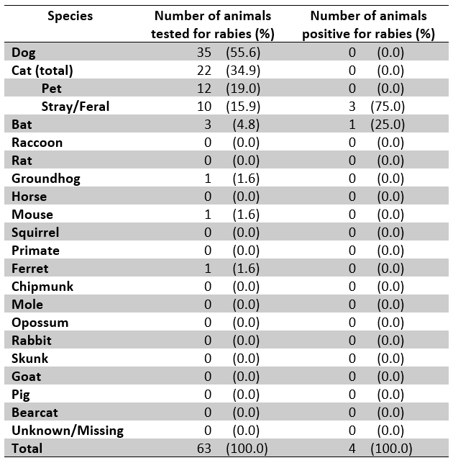

Table 3: Reported circumstances of animal bites overall and stratified by dog and cat bites, Allegheny County, 2017.
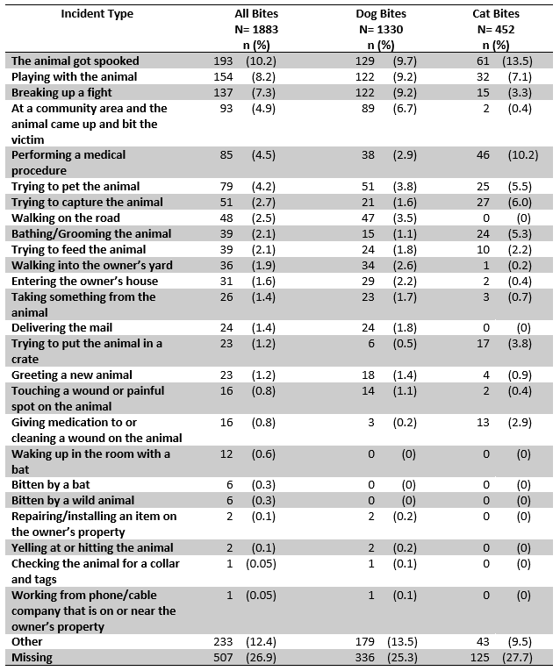

Table 4: Number of dogs in each breed involved in reported animal bite incidents as compared to the number in each breed licensed in Allegheny County, 2017.
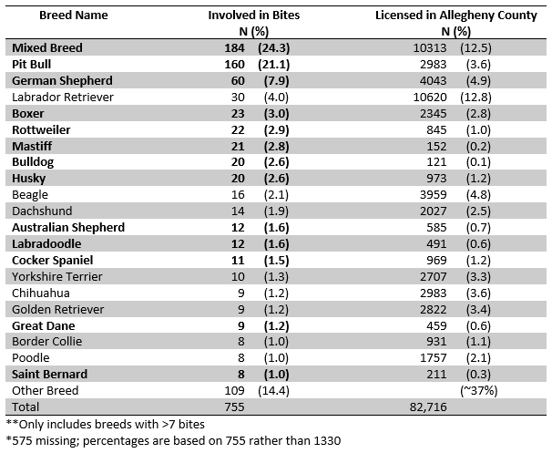

Table 5: Antibiotic type used to treat animal bite victims for all bites and stratified by dog and cat bites, Allegheny County, 2017.
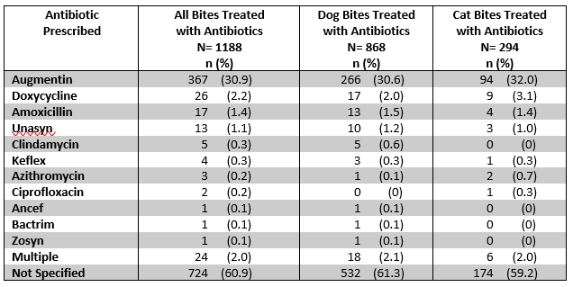

Table 6: Reasons for receiving HRIG/HDCV, Allegheny County, 2017.
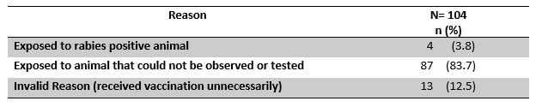

Table 7: Treatment combinations used to treat animal bite victims, Allegheny County, 2017.
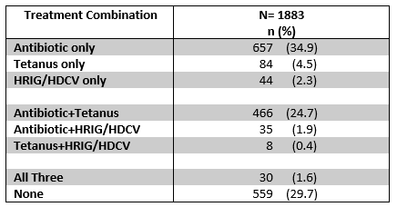
        - FIGURES

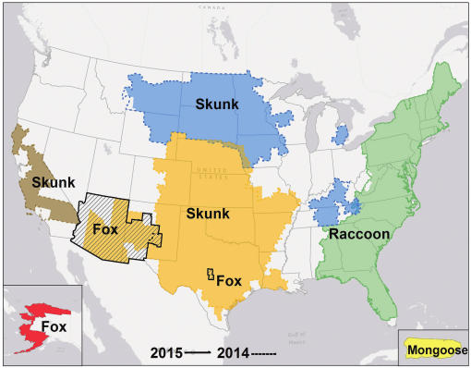
Figure 1: Map from the CDC depicting regions of the U.S. with specific, typical rabies wildlife reservoirs and associated virus variants (24).

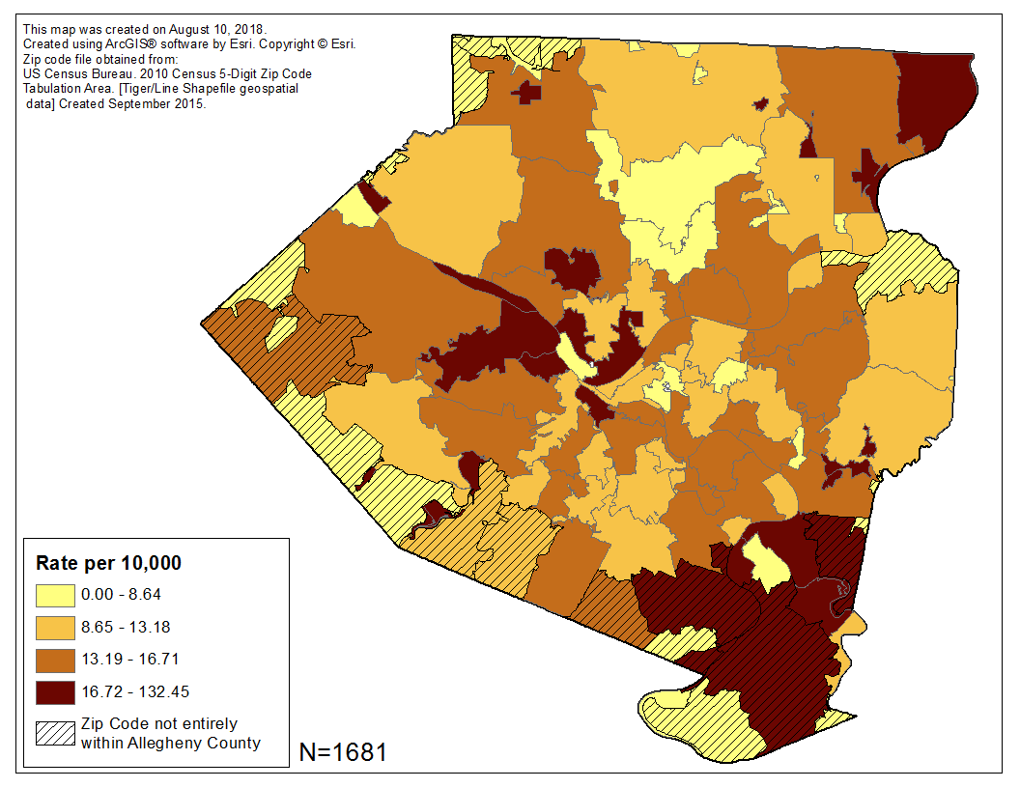
Figure 2: Number of bites per 10,000 population, by zip code, Allegheny County, 2017.
*The zip code of victim residence was available for 1,681 (89.3%) of reported bites.
**Bite rates for zip codes not entirely within Allegheny County may be an under-estimation.

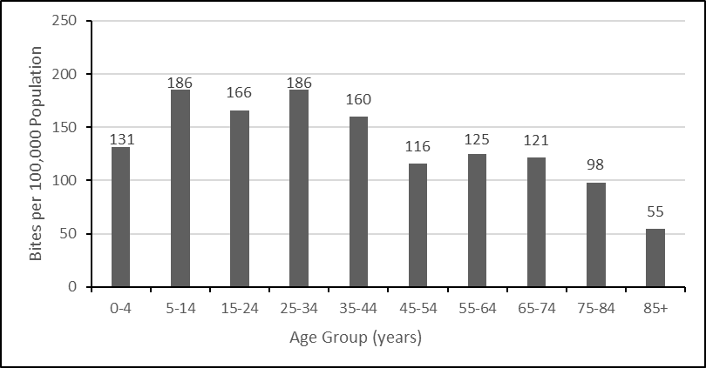
Figure 3: Bite rate per 100,000 population by age group, Allegheny County, 2017.

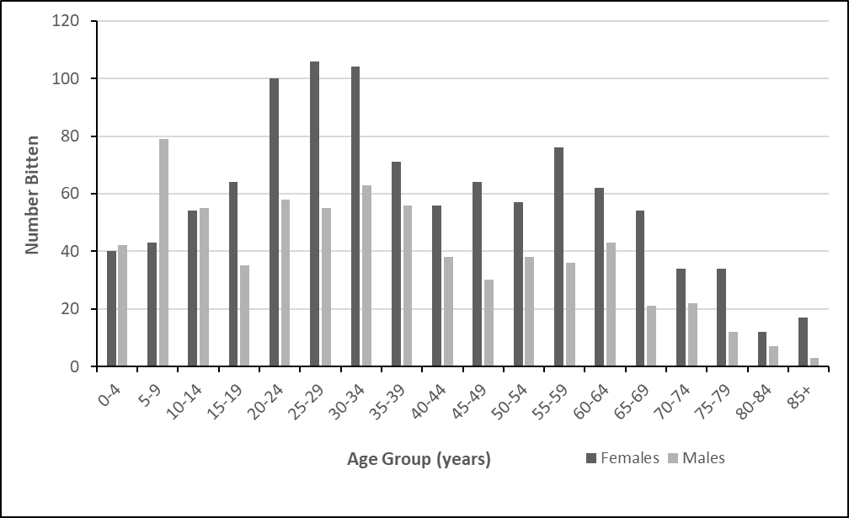
Figure 4: Number of bites reported by sex and age group, Allegheny County, 2017.
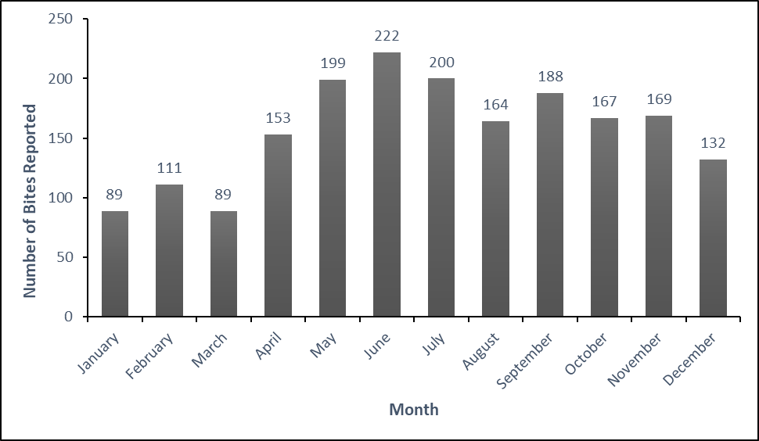
Figure 5: The number of reported bites by month, Allegheny County, 2017.

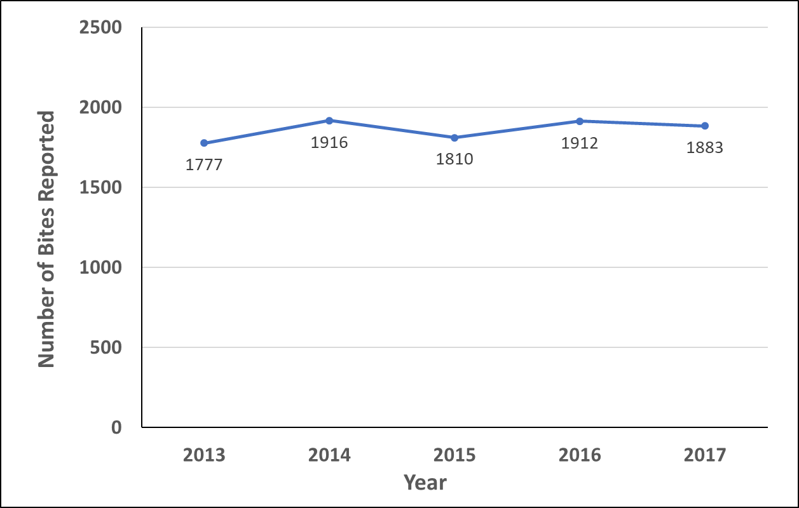
Figure 6: The number of reported animal bites in Allegheny County over time (2013-2017).
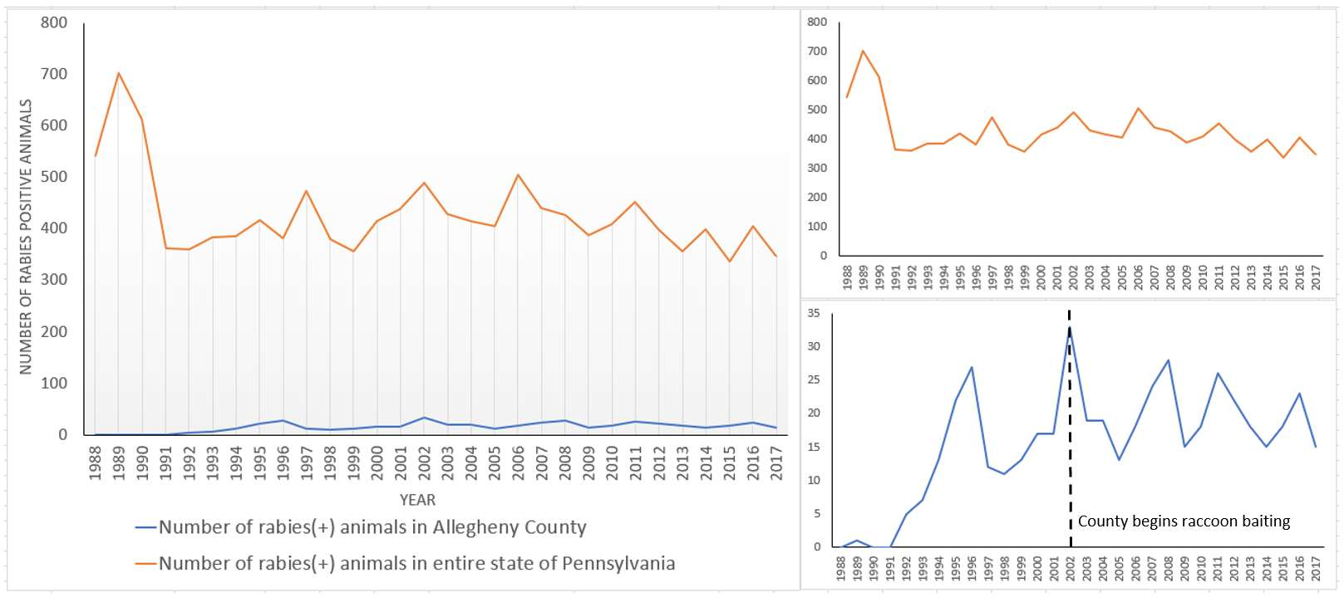
Figure 7: Number of animals testing positive for rabies in the entire state of Pennsylvania and in Allegheny County, 1988 to 2017.

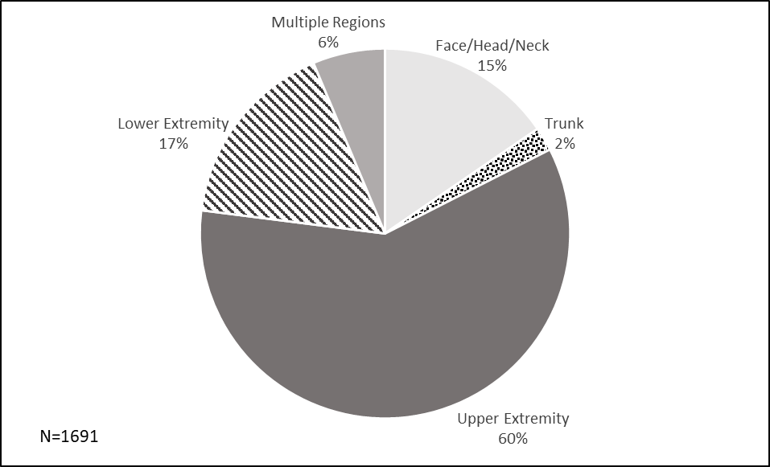
Figure 8: Bite location on the body.
* Upper extremities were defined as shoulders, arms, forearms, wrists, or hands. Lower extremities were defined as hip, thigh, leg, ankle, or foot. Trunk exposure was defined as any part of the body not included as an upper extremity, lower extremity, face, head, or neck.

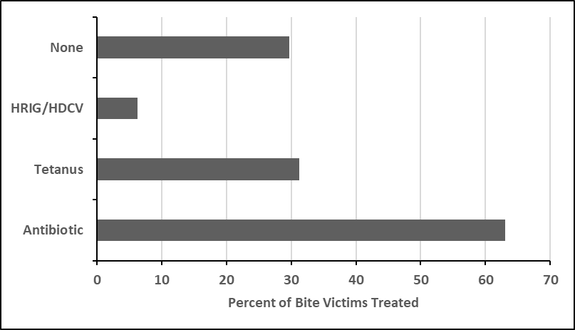
Figure 9: Treatments received by bite victims, Allegheny County, 2017.
*534 people received more than one treatment

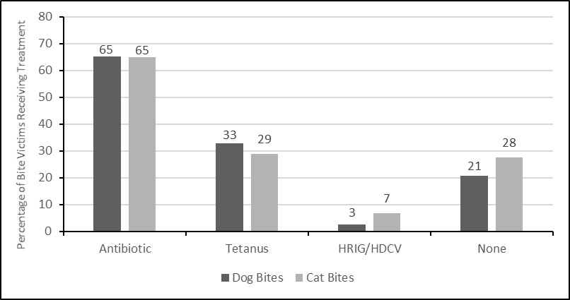
Figure 10: Treatments received by victims of dog and cat bites, Allegheny County, 2017.
bibliography

