EXAMINING THE EFFECT OF INORGANIC ARSENIC EXPOSURE ON MUSCLE MASS USING THE NATIONAL HEALTH AND NUTRITION SURVEY

by
Mikaela Kosich
BS, Computational Chemistry and Sociology, Harvey Mudd College, 2016

Submitted to the Graduate Faculty of
the Department of Epidemiology
Graduate School of Public Health in partial fulfillment
of the requirements for the degree of
Master of Public Health

University of Pittsburgh
2018

UNIVERSITY OF PITTSBURGH
GRADUATE SCHOOL OF PUBLIC HEALTH

This essay is submitted
by
Mikaela Kosich

on

December 15th, 2018
and approved by

Essay Advisor:
Iva Miljkovic, MD, PhD
Associate Professor
Epidemiology
Graduate School of Public Health
University of Pittsburgh

Essay Readers:

Aaron Barchowsky, PhD
Professor
Environmental and Occupational Health
Graduate School of Public Health
University of Pittsburgh

Fabrisia Ambrosio, PhD, MPT
Associate Professor
Physical Medicine and Rehabilitation
School of Medicine
University of Pittsburgh

ABSTRACT
Copyright © by Mikaela Kosich
2018

Objective: Chronic inorganic arsenic exposure and loss of muscle mass are both public health problems affecting millions of individuals in the US. This study aims to explore the relationship between the two.
Iva Miljkovic, MD, PhD

EXAMINING THE EFFECT OF INORGANIC ARSENIC EXPOSURE ON LEAN MASS USING THE NATIONAL HEALTH AND NUTRITION SURVEY

Mikaela Kosich, MPH
University of Pittsburgh, 2018
Methods: The association between inorganic arsenic exposure and appendicular lean mass (ALM) was assessed via the 2005-2006 NHANES data on 1007 adults. Arsenic exposure was assessed via urinary laboratory measurements. ALM was measured via dual-energy X-ray absorptiometry (DXA). All models were adjusted for participant age, race/ethnicity, height, and gender.
Results: We conducted a comparison between the quartiles of arsenic exposure. No significant association was found in non-adjusted analyses or after adjusting for age, race/ethnicity, height, and gender. However, there after additionally adding creatinine to the model there was a marginal significant difference in ALM between the lowest and highest quartiles of arsenic exposure (p=0.0539).
Conclusions: The association between inorganic arsenic exposure and ALM seem to be greatly affected by inclusion of a creatinine. While no statistically significant results were achieved, there are interesting trends that invite further exploration.

TABLE OF CONTENTS
Preface viii
1.0 Introduction 1
1.1 Health Consequences of Arsenic exposure 1
1.2 Muscle Decline as a measure of disease risk 3
2.0 Methods 6
2.1 Study Population 6
2.1.1 Urine Arsenical Measurements 6
2.1.2 DXA Lean Mass Measurements 7
2.2 Statistical analyses 8
3.0 Results 10
3.1 Descriptive analysis 10
3.2 Linear Regression Analyses 13
4.0 Discussion 15
4.1 Limitations 16
4.2 Future work 17
5.0 Conclusion 19
bibliography 20

List of tables
Table 1. Participant Characteristics 10
Table 2: Continuous Linear Models 13
Table 3: Linear Model of Quartiles 13
Table 4: Adjusted Means for Exposure Quartiles 14

List of figures
Figure 1: Overall Distribution of Appendicular Lean Mass 11
Figure 2: Distribution of ALM (kg) for upper and lower 50% of inorganic arsenic exposure 11
Figure 3: Distribution of ALM by inorganic arsenic exposure quartiles 12

Preface
I would like to thank Dr. Barchowsky, Dr. Miljkovic, and Dr. Ambrosio for all of their help and guidance throughout this process. I would also like to thank Ryan Cvejkus for help with statistical analyses.

Introduction
The World Health Organization lists arsenic in the top ten chemicals of major public health concern due to its worldwide prevalence and potential for large-scale negative human health effects.¹ The majority of these exposures occur through contaminated drinking water, although exposure may also occur from food, and especially rice, consumption. Over 200 million individuals across the globe are at risk of disease, morbidity, and mortality related to arsenic exposure.² A recent report estimated that in Pakistan alone, over 60 million individuals regularly consume drinking water which contains arsenic over the WHO recommended safe limit of 10 µg/L.³ In the United States, it is estimated that over 3.7 million individuals drink water from wells that exceed this standard for arsenic contamination. While municipal water supplies have reduced their levels of contamination since the adoption of the 10 µg/L standard by the EPA in 2001, private water supplies and foodborne exposure remain significant public health concerns.

Health Consequences of Arsenic exposure
Inorganic arsenic has been used as an intentional poison for millennia, as it has no color, odor, or taste, and thus remained undetected by victims. It has been referred to as the “King of poisons and the poison of Kings.” The symptoms of acute arsenic poison mimic those of other illnesses that were common at the time, such as cholera, and thus the poisoning often went unrecognized. Interestingly, both this harmful inorganic arsenic and organic compounds containing arsenic, classed together as arsenicals, have also been used in medicine since the times of the ancient Chinese. In the early 1800s, arsenicals were used to treat a wide variety of conditions, from psoriasis to tuberculosis.⁴. Today, it is still used in rat poisons, pesticides and herbicides,⁵ as well as a frontline and adjuvant cancer chemotherapeutic.⁴
Inorganic arsenic exposure is associated with several negative health effects, making the widespread exposure a major public health concern.⁶ Human population studies and molecular analysis in animal models have linked early life arsenic exposure with a variety of cancers, including lung, liver, kidney, skin, and bladder cancers later in life.⁷ High (>100 µg/l in drinking water) arsenic exposure has been consistently found to be a risk factor for cardiovascular and metabolic diseases. A recent meta-analysis examined the dose-response relationship quantitatively and found increased pooled relative risks of cardiovascular disease and coronary heart disease between low-moderate and high levels (5-100 μg/L) of drinking water arsenic.⁸ Animal and human studies have shown that arsenic exposure contributes to increased oxidative stress in cardiac and vascular tissues.⁹ Associations with inorganic arsenic exposure and respiratory problems have been found as well. In utero exposure is associated with increased frequency and severity of respiratory tract infections throughout the lifespan, and association later in life is correlated with decreased lung function.¹⁰ In addition, there is significant evidence linking inorganic arsenic exposure with diabetes. NHANES participants with diabetes were found to have 28% higher total arsenic concentrations¹¹.
Previous epidemiological studies have found that muscle wasting, weakness, impaired gate, and sensorimotor deficits are associated with both acute and chronic arsenic exposure¹². Parvez et. Al. found an inverse association between blood arsenic levels and motor and muscle function in 8-11 year old children¹³. While the mechanism by which this occurs is still poorly understood.¹⁴ There is a great need to determine whether environmental factors, such as arsenic, cause disease or worsen disease outcomes by promoting muscle quality decline and loss of lean body mass.

Muscle Decline as a measure of disease risk
Muscle mass and muscle quality declines are increasingly understood to be key players in loss of physical function with aging. Increasing life expectancy results in higher prevalence of age-related disorders, including loss of muscle mass.¹⁵ It is estimated that older adults lose between 0.4%-2.6% muscle mass annually.¹⁶ This decline in muscle mass can lead to lack of strength and power required to participate in daily life and lead to serious disability.¹⁷ A recent study linked declines in muscle mass to be a significant predictor for reduced quality of life due to reduced mobility.¹⁸
There is an ever increasing among of evidence that skeletal muscle decline is associated with mortality, particularly in the elderly.¹⁹ Multiple studies have found that type 2 diabetic patients experienced greater age-related muscle mass and strength declines than nondiabetic counterparts.^{20,21} Others have found that as strength and muscle mass decline, risk for insulin resistance and prediabetes increases.^{22,23} There is a growing body of evidence linking poor muscle quality with metabolic disorders, such as type 2 diabetes.²⁴ In men without diabetes, muscle fat infiltration (myosteatosis) is associated with insulin resistance and excess insulin in the blood (hyperinsulinemia).²⁵ As lean muscle is a major site of glucose storage and disposal, it makes sense that lean muscle may interact with the pancreas and regulate insulin secretion.²⁶

Changes to muscle quality can include myosteatosis, or infiltration of the muscle tissue by fat, which may be responsible for the negative outcomes seen with aging. A recent study found a significant association between skeletal muscle density and all-cause mortality as well as cardiovascular mortality.²⁷ A second study in men of African ancestry supports this, finding that all-cause mortality was significantly associated with greater intramuscular fat and lower muscular density, markers of myosteatosis.²⁸
The overall mechanism between these associations is not well characterized. However, it has been shown that myosteatosis leads to activation of proteolytic systems, increasing inflammation and lipolysis, and decreasing myokine secretion and blood flow, leading to metabolic changes.²⁹ Recent work has shown that in-utero arsenic exposure affects gene expression, including proinflammatory cytokine TNF-α.³⁰ Given the known associations between diabetes and arsenic, and between diabetes and myosteatosis, as well as the lack of complete mechanistic understanding of either, it is logical to investigate the potential links between environmental arsenic exposure and muscle quality decline.
Currently, there is not a singular definition for muscle quality. Measures used in previous works have included functional tests that measure force production and body composition tests to measure, for example, proportional amounts of intramuscular fat. Imaging measures in research include MRI, CT and DXA, which are relatively inexpensive and non-invasive, but carry the serious limitation of being unable to directly measure lipid content within and around myocytes and muscle fibers.²⁹ This is important since, as indicated above, increased myosteatosis is associated with cardiovascular and metabolic disease or worsened disease outcomes. The growing realization of the importance of lean body mass and myosteatosis in disease risk has prompted calls for improved accessible and standardized clinical assessment of muscle mass and quality.^{14,29} Unfortunately, the data available for correlating muscle quality with environmental exposures were collected at times when non-standardized or poorly developed measures of muscle quality were made. Thus, this study uses DXA measures of lean mass in participants in the National Health and Nutrition Examination Survey (NHANES), who also had measures of arsenic exposure, to begin to answer the question of whether environmental exposures contribute to disease by affecting muscle mass; and consequently, compromise muscle health and quality.

Methods

Study Population
The human cohort used in this study was taken from the 2005-2006 NHANES data, which is conducted in 2 year cycles by the National Center for Health Statistics. NHANES uses a complex stratified four stage sampling design to reach a representative sample of non-institutionalized US civilians. General demographic data is collected via computer-assisted personal interviews. The 2005-2006 cycle includes over-samples of low-income individuals, African Americans, Mexican Americans, and those in the 12-19 and 60+ year age groups.³¹ The overall response rate in the 2005-2006 survey was 77%.³² For the purposes of this analysis, children and those who were missing arsenic or DXA measurements were excluded.

Urine Arsenical Measurements
Urinary speciated arsenicals were measured in a subsample of one third of the 2005-2006 NHANES study population, excluding those under 6 years old. Total urinary arsenic was determined via inductively coupled-plasma dynamic reaction cell-mass spectrometry (ICP-DRC-MS). The concentrations of speciated arsenicals were determined via high performance liquid chromatography (HPLC) coupled to an ICP-DRC-MS. Detection limits were 0.74 µg/L for total arsenic and 0.4 µg/L for arsenobetaine.³³
Urinary total arsenic concentration is generally regarded as an insufficient marker of exposure to disease promoting arsenicals as a result of this measure including harmless arsenicals from seafood, such as arsenobetaine and arsenolipids.³⁴ Therefore, NHANES reports the levels of these harmless arsenicals and arsenobetaine was subtracted from total urinary arsenic to account for harmless organic compounds often contained in fish, shellfish, and seaweed. A recent analysis of NHANES arsenical data found very little arsenocholine and trimethylarsine oxide. Thus, total arsenic minus arsenobetaine is approximately equal to the total inorganic arsenic (largely dimethylarsenic acid) in urine.³⁵ Measures of other minor organic arsenic compounds that may result from complex metabolism of consumed seafood, such as arsenolipids and aresenosugars, were not available. Inorganic arsenic concentrations in urine have been found to correlate with arsenic exposure via drinking water.^{36,37}
Adjustment for urinary creatinine is often used to normalize to the dilution of the urine that varies with hydration. However, creatinine levels are not independent of arsenic levels since they share the same one carbon metabolic pathways and recent work suggests that correcting for creatinine may produce misleading interpretation of the impact of arsenic health effects.³⁸ In addition, creatinine levels are also linked to muscle mass changes and thus may complicate interpretation of muscle quality as well.³⁹

DXA Lean Mass Measurements
Lean mass was measured using dual-energy X-ray absorptiometry (DXA) scans taken with a Hologic QDR-4500A fan-beam densitometer (Hologic, Inc, Bedford, Massachusetts) administered via Hologic Discovery v12.4 software at the NHANES mobile examination center. Participants were scanned with an x-ray source using a fan-beam scan geometry in three one minute long passes while positioned supine with feet held neutral and hands flat by their sides. Participants who self-reported pregnancy or had a positive pregnancy test, had used a radiographic contrast material in the past 7 days, weighed over 300lbs, or were over 6’5” were not scanned.⁴⁰
As the QDR-4500A was found to underestimate fat mass and overestimate lean mass⁴¹ the NHANES DXA lean mass measurements were decreased by 5% and the equivalent weight in kilograms were added to fat mass, in order to maintain consistency in overall mass while accounting for this overestimation. NHANES DXA data was imputed via the IVEware software developed by the Survey Methodology Program at the University of Michigan’s Institute of Survey Research. Five complete records containing measured and/or imputed values were created for each participant, each with a different set of imputed data. If a participant had valid data for a given DXA variable, the value is the same for all 5 imputation versions.⁴⁰
The DXA generated whole-body lean mass represents some parameters other than muscle, such as organ weight. For that reason, for the purposes of this study, we were interested in the appendicular lean mass (ALM). This was calculated as the sum of the lean mass, excluding bone mass, from the arms and legs⁴².

Statistical analyses
All analyses were conducted using SAS 9.4. Due to the complex sampling scheme of NHANES, SAS survey procedures were used where appropriate. Multiple imputation analysis procedures were used to address the multiply imputed DXA measurements.
Linear models were fit using SAS survey regression and analyzed using the multiple imputation function in order to account for the complex sampling scheme of NHANES and the imputation of missing DXA measurements. All models were adjusted for height, age, and gender, as they are known predictors of ALM. In arsenic research, it is common to adjust for creatinine in order to account for varying urine dilution. However, creatinine is also correlated with overall lean body mass. All models are presented both with and without adjustment for creatinine, as there is not a clear scientific consensus on whether this adjustment is appropriate due to its role in 1-carbon metabolism and correlations with overall muscle mass.³⁹

Results
Table 1. Participant Characteristics
 | Median (IQR)
N | 1007
Age (years) | 43.1 (31.5-53.3)
Gender | 50.9% (509) male  49.1% (498) female
Height (cm) | 169.2 (162.3-176.7)
Appendicular Lean Mass (kg) | 22.5 (17.2-27.0)
Total Arsenic (µg/L) | 9.0 (4.6-18.5)
Inorganic Arsenic (µg/L) | 6.2 (3.1-11.0)

Descriptive analysis
To understand whether there is an association between urinary inorganic arsenic and appendicular lean mass, first the data was visual inspected in total via histogram. Then, the data was split into quartiles by inorganic arsenic exposure, in order to see if there was a difference between the trends. The histograms below show the distribution of appendicular lean mass.
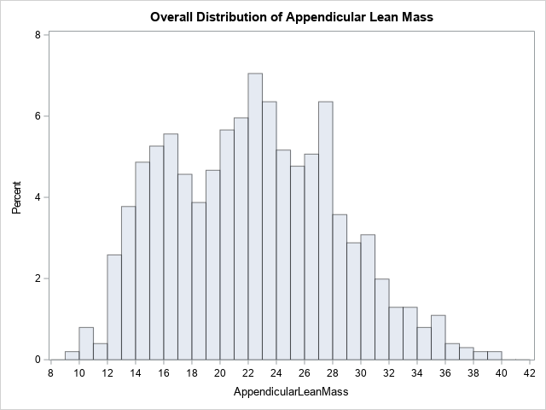
Figure 1: Overall Distribution of Appendicular Lean Mass

The graph in Figure 1 shows the distribution of ALM across all exposure groups. However, graphing the population with arsenic exposure below the median (Figure 2, left) and the upper 50% (Figure 2, right) separately begins to suggest some differences. Of note, in the higher exposure group, we being to see a larger proportion of individuals with higher ALM (particularly over 22 kg).

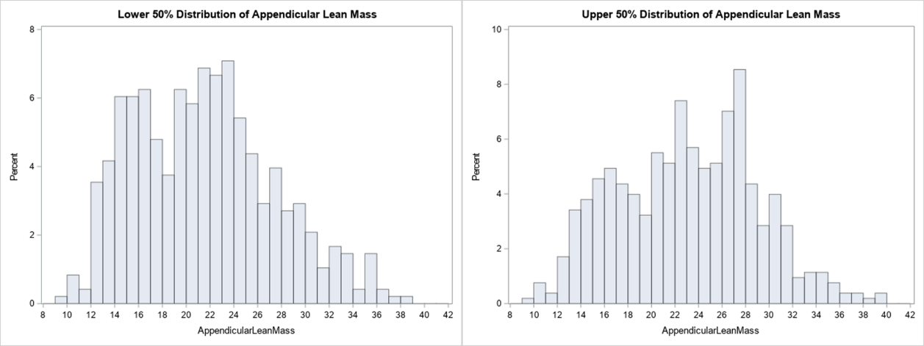
Figure 2: Distribution of ALM (kg) for upper and lower 50% of inorganic arsenic exposure
When data is further broken down into exposure quartiles (Figure 3, below) the trend is amplified. We can see that there are no individuals in the first quartile who have ALK over 34kg, but multiple participants up to 40kg in the fourth quartile.
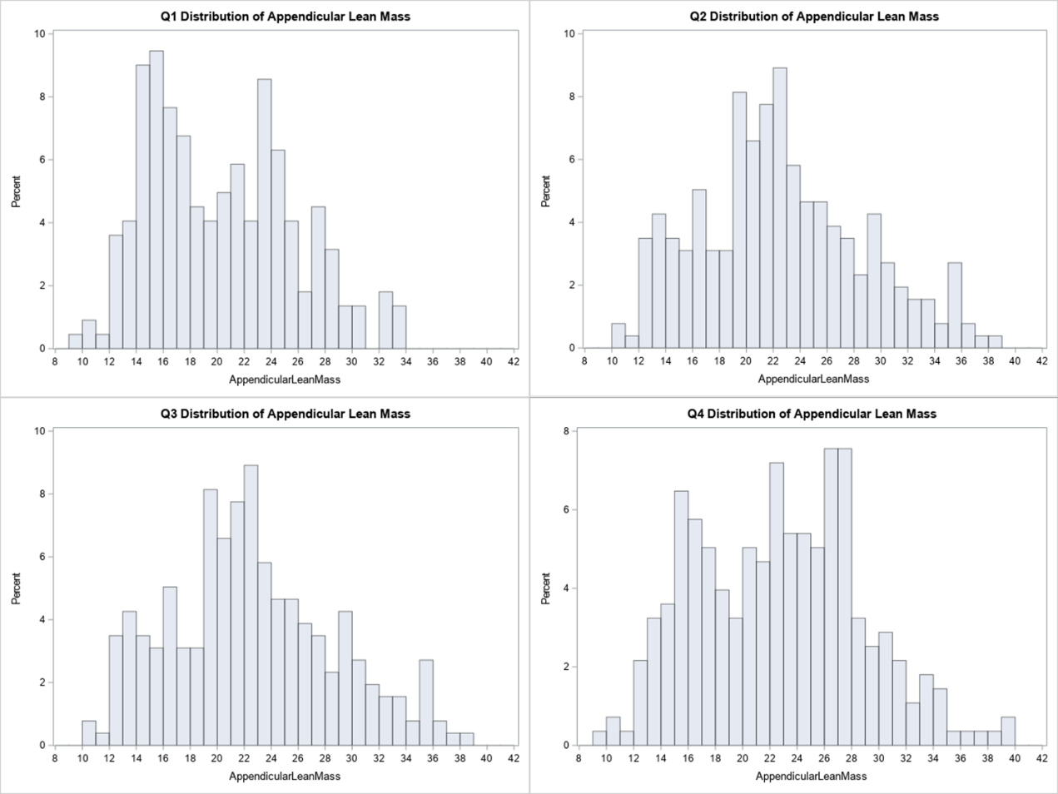
Figure 3: Distribution of ALM by inorganic arsenic exposure quartiles

Linear Regression Analyses
Table 2: Continuous Linear Models
 | Regression Coefficient (95% CI) | Adjusted Mean ALM (kg) | P value for regression coefficient
Creatinine unadjusted | 0.0014  (-0.0093, 0.0122) | 23.04 | 0.7931
Creatinine Adjusted | -0.0086  (-0.0229, 0.0057) | 22.94 | 0.2379

Since the frequency distributions suggested an increasing trend in ALM with arsenic exposure, a linear model was fit to attempt to quantify this relationship. This model was adjusted for age, gender, race/ethnicity, and height. While a 1 µg/L increase in urinary inorganic arsenic levels was associated with 4 gram increase in ALM in this model, the relationship was not statistically significant (p=0.5608). It is possible that a linear model may not be sufficiently complex to explain the relationship.
Next, a comparison between the quartiles of arsenic exposure was conducted. No significant association was found. The regression coefficients representing the average kilogram change in ALM between quartile 1 and quartiles 2, 3, and 4 of inorganic arsenic exposure are listed in the table 3 below. We do see marginal significance between quartiles 1 and 4 in the creatinine adjusted models.
Table 3: Linear Model of Quartiles
 | Regression Coefficients (p value) | Creatinine adjusted  Regression Coefficients (p value)
Q1 to Q2 | 0.3462 (0.1371) | -0.15341 (0.5898)
Q1 to Q3 | 0.6404 (0.2609) | -0.2456 (0.5959)
Q1 to Q4 | 0.3371 (0.3731) | -0.7757 (0.0539)
Table 4: Adjusted Means for Exposure Quartiles
 | Adjusted Mean (kg) | Adjusted Mean including creatinine (kg)
Q1 | 22.66 | 23.27
Q2 | 23.01 | 23.11
Q3 | 23.30 | 23.02
Q4 | 23.00 | 22.49

Discussion
This study is exploratory and novel, as the existing literature on the association between appendicular lean mass (or other markers of muscle mass/quality) and arsenic exposure is extremely limited. The premise for studying this relationship; however, is highly significant since there is a growing realization that decline of muscle quality, loss of lean mass, and increases of myosteatosis are strong indicators risk for musculoskeletal, but also metabolic diseases such as diabetes and cardiovascular disease. The number of studies that investigate the role of any environmental contaminant in diminishing muscle mass and quality and increasing myosteatosis is negligible. While no statistically significant associations were found, this can be explained by inadequate sample sizes to detect small changes, especially given the high variability with higher exposures. However, upon visual inspection, it seems there is a trend of increasing appendicular lean mass with increasing inorganic arsenic exposure, indicating the potential for a protective effect of low level exposure. This preliminary assessment is surprising; although the limitations of the study suggest that more analyses are needed in larger cohorts with a greater range of arsenic exposures before conclusive interpretations can be made.

Limitations
As this study is preliminary, there are some significant limitations, particularly in the measurements of arsenic and the clinical assessment of muscle composition. Subtracting arsenobetaine from total urinary arsenic accounts for a large portion of the harmless organic arsenic. However, those who have high levels of arsenobetaine have high intake of seafood that may have positive nutritional effects on ALM. Re-evaluating the data focusing on the correlation between arsenobetaine and ALM may resolve this possibility. There is a substantial body of epidemiological studies that implicate the methylated organic arsenicals created from metabolism of ingested inorganic arsenic in significantly contributing to disease risk.^{4,34} The NHANES measure of speciated urinary arsenicals includes the monomethyl and dimethyl arsenic metabolites and it would be important to determine how the levels of these metabolites correlate to ALM, as their contributions would be masked by using total urinary arsenic as the exposure marker. Another limitation is that urine measurements from a single time point are not ideal to assess chronic exposure. In addition, the sampling design did not include a large number of individuals with high urinary inorganic arsenic, limiting power on the upper levels of exposure.
DXA measures are subject to error, as fat versus lean muscle composition can only ber assessed in pixels containing no bone. In those that do contain bone, DXA uses proprietary equations to infer the amount of fat based on the relative density. DXA quantifies fat, rather than adipose tissue. 80% of adipose tissue is composed of fat (ref). On the other hand, fat can be distributed in tissue other than adipose tissue, such as muscle.⁴³ Determining clinical markers of muscle quality is challenging given the new realization of the importance of both lean muscle mass and myosteatosis in disease promotion.^{14,29} There are a number of ways to measure muscle mass and quality, varying in both quality and expense. DXA measurements are limited as they measure tissue density and lean mass, but fail to show intra and extra muscular fat content.
In addition, it is common in arsenic research to adjust for urine creatinine to account for varying urine dilution. However, creatinine is highly correlated with lean body mass, which proves to be problematic here. In addition, without another marker to adjust for urine dilution, creatinine is also correlated with arsenic exposure. However, it is impossible to discern whether this correlation is simply due to hydration, or due to arsenic-induced changes in body mass that then cause changes in creatinine excretion. Without more information, it is difficult to discern whether the creatinine adjusted models are correct. As they have the opposite trend of the non-creatinine adjusted models, the answer to this question is critical to interpretation of results.³⁹

Future work
There are several opportunities for future work in this area. In particular, applications of more advanced statistical methods would be useful in understanding
Repeat and further analyses on data from a study with a larger sample size and more clear clinical endpoints would be useful. In particular, this cohort would not only be larger in size, but have significantly more participants who have higher exposure levels. The vast majority of those sampled by NHANES had exposure levels that were quite low. The overlap between arsenic measurement collection and relevant DXA measurements in NHANES is limited to two cycles. A study which uses CT imaging to assess ALM would be a logical next step. In addition, adjustment for other analytes in urine should be considered. It is possible that there are interactions between arsenic and other metals occurring here. In addition, it would be helpful to study this prospectively, in order to measure and control for other potential confounds, like diet, that are difficult to measure in a cross-sectional study like NHANES. A prospective cohort study would also give a clear picture of arsenic exposure over time and chronic exposure-though if the main source is the drinking water in the home, as is most common. In addition, a study containing measures of strength and fat mass in addition to lean mass, such as the combination of subcutaneous fat, intermuscular fat, isokinetic muscle torque, and cross sectional area used by Delmonico et. Al.⁴⁴ would better reveal the effect of arsenic exposure on muscle quality.
Overall, this work is preliminary and exploratory, yet it identified the complexity of associating an environmental exposure with disease risk and sets the stage for a number of different avenues for further investigation.

Conclusion
This preliminary exploration has highlighted the need for a more thorough investigation of the association between inorganic arsenic exposure and muscle quality. It is possible that inorganic arsenic exposure may increase appendicular lean mass, but more work is needed to draw definitive conclusions.

bibliography
1. World Health Organization. International Programme on Chemical Safety: Ten chemicals of major public health concern. https://www.who.int/ipcs/assessment/public_health/chemicals_phc/en/. Published 2010.
2. Naujokas MF, Anderson B, Ahsan H, et al. The broad scope of health effects from chronic arsenic exposure: Update on a worldwide public health problem. Environ Health Perspect. 2013;121(3):295-302. doi:10.1289/ehp.1205875
3. Podgorski JE, Eqani SAMAS, Khanam T, Ullah R, Shen H, Berg M. Extensive arsenic contamination in high-pH unconfined aquifers in the Indus Valley. Sci Adv. 2017;3(8). doi:10.1126/sciadv.1700935
4. Hughes MF, Beck BD, Chen Y, Lewis AS, Thomas DJ. Arsenic exposure and toxicology: A historical perspective. Toxicol Sci. 2011;123(2):305-332. doi:10.1093/toxsci/kfr184
5. States JC. Arsenic: Exposure Sources, Health Risks, and Mechanisms of Toxicity. Hoboken, NJ: John Wiley & Sons, Inc; 2016.
6. Arsenic NRCD on E and LSB on ES and TC on I. Critical Aspects of EPA’s IRIS Assessment of Inorganic Arsenic. Washington, D.C.: National Academies Press; 2014. doi:10.17226/18594
7. Bailey KA, Smith AH, Tokar EJ, et al. Mechanisms underlying latent disease risk associated with early-life arsenic exposure: Current research trends and scientific gaps. Environ Health Perspect. 2016;124(2):170-175. doi:10.1289/ehp.1409360
8. Moon KA, Oberoi S, Barchowsky A, et al. A dose-response meta-analysis of chronic arsenic exposure and incident cardiovascular disease. Int J Epidemiol. 2017. doi:10.1093/ije/dyx202
9. Cosselman KE, Navas-Acien A, Kaufman JD. Environmental factors in cardiovascular disease. Nat Rev Cardiol. 2015;12(11):627-642. doi:10.1038/nrcardio.2015.152
10. Sanchez TR, Perzanowski M, Graziano JH. Inorganic arsenic and respiratory health, from early life exposure to sex-specific effects: A systematic review. Environ Res. 2016;147:537-555. doi:10.1016/j.envres.2016.02.009
11. Navas-Acien A, Silbergeld EK, Pastor-Barriuso R, Guallar E. Rejoinder: Arsenic exposure and prevalence of type 2 diabetes updated findings from the national health nutrition and examination survey, 2003-2006. Epidemiology. 2009;20(6):816-820. doi:10.1097/EDE.0b013e3181afef88
12. Chakraborti D, Mukherjee SC, Pati S, et al. Arsenic groundwater contamination in Middle Ganga Plain, Bihar, India: A future danger? Environ Health Perspect. 2003;111(9):1194-1201. doi:10.1289/ehp.5966
13. Parvez F, Wasserman GA, Factor-Litvak P, et al. Arsenic exposure and motor function among children in Bangladesh. Env Heal Perspect. 2011;119(11):1665-1670. doi:10.1289/ehp.1103548
14. Prado CM, Purcell SA, Alish C, et al. Implications of low muscle mass across the continuum of care: a narrative review. Ann Med. September 2018:1-19. doi:10.1080/07853890.2018.1511918
15. Goodpaster BH, Park SW, Harris TB, et al. The loss of skeletal muscle strength, mass, and quality in older adults: the health, aging and body composition study. J Gerontol A Biol Sci Med Sci. 2006;61(10):1059-1064. http://www.ncbi.nlm.nih.gov/pubmed/17077199.
16. Mitchell WK, Williams J, Atherton P, Larvin M, Lund J, Narici M. Sarcopenia, Dynapenia, and the Impact of Advancing Age on Human Skeletal Muscle Size and Strength; a Quantitative Review. Front Physiol. 2012;3. doi:10.3389/fphys.2012.00260
17. Kalyani RR, Corriere M, Ferrucci L. Age-related and disease-related muscle loss: the effect of diabetes, obesity, and other diseases. lancet Diabetes Endocrinol. 2014;2(10):819-829. doi:10.1016/S2213-8587(14)70034-8
18. Trombetti A, Reid KF, Hars M, et al. Age-associated declines in muscle mass, strength, power, and physical performance: impact on fear of falling and quality of life. Osteoporos Int. 2016;27(2):463-471. doi:10.1007/s00198-015-3236-5
19. Seidell JC, Visscher TL. Body weight and weight change and their health implications for the elderly. Eur J Clin Nutr. 2000;54 Suppl 3:S33-9. http://www.ncbi.nlm.nih.gov/pubmed/11041073.
20. Leenders M, Verdijk LB, van der Hoeven L, et al. Patients With Type 2 Diabetes Show a Greater Decline in Muscle Mass, Muscle Strength, and Functional Capacity With Aging. J Am Med Dir Assoc. 2013;14(8):585-592. doi:10.1016/j.jamda.2013.02.006
21. Tieland M, Trouwborst I, Clark BC. Skeletal muscle performance and ageing. J Cachexia Sarcopenia Muscle. 2018;9(1):3-19. doi:10.1002/jcsm.12238

22. Atlantis E, Martin SA, Haren MT, Taylor AW, Wittert GA. Inverse associations between muscle mass, strength, and the metabolic syndrome. Metabolism. 2009;58(7):1013-1022. doi:10.1016/j.metabol.2009.02.027
23. Srikanthan P, Karlamangla AS. Relative Muscle Mass Is Inversely Associated with Insulin Resistance and Prediabetes. Findings from The Third National Health and Nutrition Examination Survey. J Clin Endocrinol Metab. 2011;96(9):2898-2903. doi:10.1210/jc.2011-0435
24. Miljkovic I, Zmuda JM. Epidemiology of myosteatosis. Curr Opin Clin Nutr Metab Care. 2010;13(3):260-264. doi:10.1097/MCO.0b013e328337d826
25. Miljkovic I, Cauley JA, Wang PY, et al. Abdominal myosteatosis is independently associated with hyperinsulinemia and insulin resistance among older men without diabetes. Obesity. 2013. doi:10.1002/oby.20346
26. Mizgier ML, Casas M, Contreras-Ferrat A, Llanos P, Galgani JE. Potential role of skeletal muscle glucose metabolism on the regulation of insulin secretion. Obes Rev. 2014;15(7):587-597. doi:10.1111/obr.12166
27. Miljkovic I, Kuipers AL, Cauley JA, et al. Greater Skeletal Muscle Fat Infiltration Is Associated With Higher All-Cause and Cardiovascular Mortality in Older Men. Journals Gerontol Ser A Biol Sci Med Sci. 2015;70(9):1133-1140. doi:10.1093/gerona/glv027
28. Zhao Q, Zmuda JM, Kuipers AL, et al. Greater skeletal muscle fat infiltration is associated with higher all-cause mortality among men of African ancestry. Age Ageing. 2016. doi:10.1093/ageing/afw062
29. Correa-de-Araujo R, Harris-Love MO, Miljkovic I, Fragala MS, Anthony BW, Manini TM. The Need for Standardized Assessment of Muscle Quality in Skeletal Muscle Function Deficit and Other Aging-Related Muscle Dysfunctions: A Symposium Report. Front Physiol. 2017;8(FEB):1-19. doi:10.3389/fphys.2017.00087
30. Fry RC, Navasumrit P, Valiathan C, et al. Activation of inflammation/NF-κB signaling in infants born to arsenic-exposed mothers. PLoS Genet. 2007;3(11):2180-2189. doi:10.1371/journal.pgen.0030207
31. National Center for Health Statistics. NHANES 2005-2006 Overview. https://wwwn.cdc.gov/nchs/nhanes/continuousnhanes/overview.aspx?BeginYear=2005.
32. National Center for Health Statistics. NHANES Response Rates and Population Totals. https://wwwn.cdc.gov/nchs/nhanes/responserates.aspx.

33. National Center for Health Statistics. National Health and Nutrition Examination Survey - 2005-2006 Data Documentation, Codebook, and Frequencies Arsenics - Total & Speciated - Urine (UAS_D). https://wwwn.cdc.gov/Nchs/Nhanes/2005-2006/UAS_D.htm. Published 2009. Accessed October 20, 2018.
34. Jones MR, Tellez-Plaza M, Vaidya D, et al. Estimation of Inorganic Arsenic Exposure in Populations with Frequent Seafood Intake: Evidence from MESA and NHANES. Am J Epidemiol. 2016. doi:10.1093/aje/kww097
35. Caldwell KL, Jones RL, Verdon CP, Jarrett JM, Caudill SP, Osterloh JD. Levels of urinary total and speciated arsenic in the US population: National Health and Nutrition Examination Survey 2003-2004. J Expo Sci Environ Epidemiol. 2009;19(1):59-68. doi:10.1038/jes.2008.32
36. Caceres DD, Pino P, Montesinos N, Atalah E, Amigo H, Loomis D. Exposure to inorganic arsenic in drinking water and total urinary arsenic concentration in a Chilean population. Environ Res. 2005;98(2):151-159. doi:10.1016/j.envres.2005.02.007
37. Middleton DRS, Watts MJ, Hamilton EM, et al. Urinary arsenic profiles reveal exposures to inorganic arsenic from private drinking water supplies in Cornwall, UK. Sci Rep. 2016;6(1):25656. doi:10.1038/srep25656
38. Hinwood AL, Sim MR, de Klerk N, Drummer O, Gerostamoulos J, Bastone EB. Are 24-Hour Urine Samples and Creatinine Adjustment Required for Analysis of Inorganic Arsenic in Urine in Population Studies? Environ Res. 2002;88(3):219-224. doi:10.1006/enrs.2002.4339
39. Gamble M V., Liu X. Urinary creatinine and arsenic metabolism [1]. Environ Health Perspect. 2005;113(7). doi:10.1289/ehp.113-a442a
40. National Center for Health Statistics. National Health and Nutrition Examination Survey - 2005-2006 Data Documentation, Codebook, and Frequencies Dual-Energy X-ray Absorptiometry - Whole Body (DXX_D). https://wwwn.cdc.gov/Nchs/Nhanes/2005-2006/DXX_D.htm#Protocol_and_Procedure. Published 2016. Accessed October 20, 2018.
41. Schoeller DA, Tylavsky FA, Baer DJ, et al. QDR 4500A dual-energy X-ray absorptiometer underestimates fat mass in comparison with criterion methods in adults. Am J Clin Nutr. 2005;81(5):1018-1025. doi:10.1093/ajcn/81.5.1018
42. Heymsfield SB, Smith R, Aulet M, et al. Appendicular skeletal muscle mass: measurement by dual-photon absorptiometry. Am J Clin Nutr. 1990;52(2):214-218. doi:10.1093/ajcn/52.2.214
43. Shen W, Wang Z, Punyanita M, et al. Adipose Tissue Quantification by Imaging Methods: A Proposed Classification. Obes Res. 2003;11(1):5-16. doi:10.1038/oby.2003.3
44. Delmonico MJ, Harris TB, Visser M, et al. Longitudinal study of muscle strength, quality, and adipose tissue infiltration. Am J Clin Nutr. 2009;90(6):1579-1585. doi:10.3945/ajcn.2009.28047

