Title Page
Influenza Vaccine Effectiveness among Outpatients in Pittsburgh: Combined Results from Five Seasons of the US Flu Vaccine Effectiveness Network Study 2011-2016

by

Emily Bobyock

BS in Biological Sciences, Drexel University, 2017

Submitted to the Graduate Faculty of

Epidemiology

Graduate School of Public Health in partial fulfillment

of the requirements for the degree of

Master of Public Health

University of Pittsburgh

2018
Committee Membership Page
UNIVERSITY OF PITTSBURGH

Graduate School of Public Health

This essay is submitted

by

Emily Bobyock

on

December 13, 2018

and approved by

Essay Advisor:
G.K. Balasubramani, PhD
Research Assistant Professor
Department of Epidemiology
Graduate School of Public Health
University of Pittsburgh

Essay Readers:

Mary Patricia Nowalk, PhD, RD
Associate Professor
Department of Family Medicine
School of Medicine
University of Pittsburgh

Wilbert Van Panhuis, MD PhD
Assistant Professor
Departments of Epidemiology and Biomedical Informatics
Graduate School of Public Health and School of Medicine
University of Pittsburgh

Copyright © by Emily Bobyock

2018

Abstract
Influenza Vaccine Effectiveness among Outpatients in Pittsburgh: Combined Results from Five Seasons of the US Flu Vaccine Effectiveness Network Study 2011-2016

Emily Bobyock, MPH

University of Pittsburgh, 2018

Abstract

Background: Influenza has had a large impact in the US, with an estimated 30.9 million cases and 14.5 million influenza-related medical visits throughout 2016-2017. Vaccination is recommended for all individuals >6 months old, but vaccine effectiveness (VE) varies by age, circulating influenza strains, and high-risk medical conditions. VE also varies by season, and national estimates are reported each year by the CDC. VE results specific to Pittsburgh have not been evaluated. The objective of this study was to estimate influenza VE among outpatients in Pittsburgh with acute respiratory illness (ARI) during the 2011-2016 seasons and to compare estimates among different age groups and influenza subtypes.
Methods: Data were gathered from the Pittsburgh site of the CDC’s US Flu VE Network study. Secondary analyses were conducted on 6,453 subjects >6 months old. Enrollees were outpatients with ARI and cough ≤7 days duration during 2011-2016. Vaccination status was defined as receipt of >1 dose of any influenza vaccine according to medical records, immunization registries, and/or self-report. Influenza status was determined by RT-PCR. A test-negative design was used. Chi-square statistics were calculated to compare baseline characteristics by vaccination status for categorical variables, and t-tests or Wilcoxon rank-sum statistics were used for continuous variables. VE estimates were calculated using odds ratios obtained from multivariable logistic regression models adjusted for age, sex, race/ethnicity, time from illness onset to enrollment, self-rated health status, high-risk conditions, and calendar time. Data were analyzed using SAS 9.4 software.
Results: Overall VE was 39% (95% CI= 31%-45%). VE was highest for influenza A (H1N1)pdm09 (2009 H1N1 virus) (VE= 53%, 95% CI= 44%-61%) and lowest for influenza A (H3N2) (VE= 27%, 95% CI= 13%-38%). VE was highest in the >50 age group and varied by season. The 2013-2014 vaccine provided the most protection against influenza (VE= 51%, 95% CI= 34%-63%) and 2011-2012 provided the least (VE= 30%, 95% CI= -26%-61%).
Conclusion: Results indicate influenza vaccination reduces the risk of infection with influenza A and B viruses. Although the level of protection varies by subtype, season, and age, this study provides support to the public health benefit of seasonal vaccination against influenza.
Table of Contents
1.0 Introduction 1
1.1 Influenza History and Burden in the United States 1
1.2 Pathogen Background 2
1.3 Influenza Vaccines 5
1.4 Vaccine Effectiveness and Evaluation 8
1.5 Public Health Significance 11
1.6 Gaps in Knowledge 11
1.7 Summary and Objectives 12
2.0 Methods 13
2.1 Influenza Vaccination History 13
2.2 Laboratory Methods 14
2.3 Statistical Analysis 15
3.0 Results 17
3.1 Overall Vaccine Effectiveness 18
4.0 Discussion 20
Appendix Tables and Figures 23
Bibliography 32
List of Tables
Table 1: Description of multivariable logistic regression models 23
Table 2: Comparison of baseline characteristics by vaccination status 25
Table 3: Adjusted vaccine effectiveness against medically attended, laboratory-confirmed influenza by age group, 2011-2016 27
Table 4: Risk factors independently associated with influenza status 28
Table 5: Adjusted vaccine effectiveness against medically attended influenza A and B by season, 2011-2016 28
List of Figures
Figure 1: Enrollment flow chart 29
Figure 2: Temporal distribution of influenza-like illness (ILI) cases testing positive for influenza infection and negative for influenza infection, 2011-2016 29
Figure 3: Temporal distribution of influenza subtypes, 2011-2016 30
Figure 4: Vaccine effectiveness (95% CI) against influenza A by age group, 2011-2016 30
Figure 5: Vaccine effectiveness (95% CI) against influenza A and influenza B in Pittsburgh and the US, by season 31

Introduction

Influenza History and Burden in the United States
Seasonal influenza affects a significant proportion of the United States population. Each year, an average of 5%-20% of individuals in the United States will become infected with influenza, causing anywhere from 9.2 million to 35.6 million illnesses during a single season.^{1,2} These viruses are present year-round in the population but are the most common during fall and winter.³ The timing and duration of an influenza season in the Northern Hemisphere varies each year, but cases generally start to increase in October, peak between December and February, and taper off by May.³ While seasonal influenza presents an annual disease burden, pandemic influenzas have had a historically significant impact in the United States and worldwide.
An influenza pandemic is caused by a global outbreak of an influenza A virus that differs from the seasonal viruses in current or recent circulation.⁴ The 1918-1919 pandemic was the largest and most deadly in recent history.⁴ It was estimated to have infected 500 million people, or one-third of the world’s population at the time.⁴ There were 50 million deaths as a result, 675,000 of which were in the United States.⁴ During this time, there were no influenza vaccines or antibiotics to treat secondary infections, so public health efforts were focused on isolation, promoting hygiene, and prevention of crowding.⁴ Additional pandemics occurred during 1957-1958 and 1968-1969, each resulting in over 1 million deaths worldwide and 100,000 in the United States.⁴ The virus responsible for the 1968 pandemic still circulates seasonally.⁴ The first influenza pandemic of the 21st century was identified in southern California in 2009.⁵ This virus was evolutionarily related to the virus that caused the 1918 pandemic, meaning adults older than age 60 had some immunological protection against the new virus.^{4,5} This left children and younger adults at greatest risk, with 73% of cases occurring in individuals 24 years of age and younger.⁵ The Centers for Disease Control and Prevention (CDC) estimated that the 2009 pandemic resulted in 60.8 million illnesses, almost 275,000 hospitalizations, and over 12,000 deaths within the United States.⁴
The 2009 pandemic changed the way influenza burden is evaluated in the United States.² Previously, estimates of influenza burden were based on evaluations performed every few years and focused on mortality and hospitalizations.² The CDC now provides annual estimates of influenza burden and the burden prevented by vaccination in order to capture seasonal variation.² Current estimates also include data from influenza-related outpatient medical visits and symptomatic illness within the community.² This change was an improvement in surveillance methodology because although death is the most severe outcome of influenza, non-hospitalized illnesses represent the largest societal burden.⁵

Pathogen Background
The causative agent of influenza is a group of RNA viruses in the Orthomyxoviridae family that are antigenically and genetically diverse.⁶ The three different types of influenza viruses capable of infecting humans are referred to as A, B, and C.⁷ Influenza A viruses infect a wide range of animals that includes birds, which serve as the natural reservoir, swine, horses, humans, among others.⁶ Influenza B and C viruses almost exclusively infect humans; however, influenza C viruses only cause mild respiratory illness and are not responsible for seasonal epidemics.⁶ Influenza A viruses can be classified by subtype based on two different glycoproteins found on the surface of the viral particles: hemagglutinin (HA) and neuraminidase (NA).⁶ There are 18 different HA and 11 different NA subtypes known.⁷ The subtypes that currently circulate among humans are influenza A (H1N1) and influenza A (H3N2) viruses, which can be further differentiated by strain.⁷ Influenza B viruses are divided into lineages, rather than subtypes, and strains.⁷ Influenza B viruses that currently circulate among humans belong to the B/Yamagata and B/Victoria lineages.⁷ Influenza viruses are named in the following order, as designated by the World Health Organization (WHO): virus type (A, B, or C), host animal, geographic location of isolation, isolation number, year of isolation, and subtype in parentheses if an influenza A virus.⁶
Influenza viruses have the ability to evade preexisting immunity in humans because of high mutation rates that can alter their HA and NA components.⁶ HA proteins bind to receptors on host cells to initiate infection.⁶ Upon infection with an influenza virus, the host’s immune system generates antibodies against the HA proteins, which prevents binding and subsequent re-infection.⁶ However, influenza viruses undergo genetic drift, or small mutations that occur continuously over time as the virus replicates.⁸ The accumulation of these mutations produces genetically different viruses that the immune system no longer recognizes, resulting in limited or failed antibody binding.^{6,8} The consequences of genetic drift are that influenza vaccines need to be updated and administered each year to be effective.⁸ Another phenomenon, called genetic shift, is a sudden and more drastic change that occurs when an influenza virus acquires a new HA subtype, which may originate from an influenza A virus found in a different animal.⁶ Genetic shift is responsible for influenza pandemics, since the emergence of a vastly different virus means most people have little to no immunity.⁸ Influenza B viruses only undergo genetic drift, which is why all pandemics are caused by an influenza A virus.⁸
Infection with an influenza virus can cause acute respiratory illness (ARI) characterized by the sudden onset of high fever, inflammation of mucous membranes in the nose, cough, headache, malaise, and inflammation of the upper respiratory system.⁶ Influenza is transmitted by contaminated respiratory droplets from coughing, sneezing, or talking and can spread within a six foot radius.⁹ An individual becomes infected when these droplets enter the mouth or nose or are inhaled into the lungs.⁹ Less frequently, the virus can also be transmitted when an individual touches his or her face after coming into contact with a contaminated surface.⁹ Symptoms generally arise about two days after exposure, but an individual is contagious one day before and five to seven days after symptoms arise.⁹ Children and individuals with compromised immune systems may remain contagious for even longer.⁹ Illness usually lasts seven to ten days, but even after most symptoms subside, weakness and fatigue can persist for several weeks.⁶ Certain groups, such as the very young (less than 6 months of age), adults 65 years and older, and individuals with chronic health conditions (cardiac, metabolic, or pulmonary diseases) are at greater risk of influenza-related complications, hospitalization, and mortality.^{10,11} Serious cases of influenza can worsen underlying health conditions such as COPD and asthma or result in secondary bacterial pneumonia infections.¹¹ Most influenza deaths are due to secondary infections or cardiovascular disease, and between 70%-80% of these deaths occur among adults 65 years of age and older.^{11,12}
A number of laboratory methods can be used to diagnose influenza which include viral culture, detection of viral antigens or genetic material in clinical specimens, and evaluation of specific antibody levels in the blood or respiratory secretions.⁶ Antiviral drugs can be used as prophylaxis or treatment but must be administered regularly during times of high influenza activity in order to effectively prevent illness.⁶ However, annual vaccination remains the most effective strategy for preventing influenza.¹⁰

Influenza Vaccines
Influenza vaccines have been available for over 70 years; the first vaccine was developed in 1938 and administered to United States soldiers during World War II.¹³ There have been many advances in influenza vaccine development since that time. Today, the CDC recommends that all individuals 6 months of age and older are vaccinated against influenza.¹² Influenza vaccines are generally effective, inexpensive, and well-tolerated. ¹⁰ Millions of vaccines are administered each year, with very few symptoms or adverse reactions reported aside from mild pain and redness at the injection site.¹⁰ Since 1978, influenza vaccines have been trivalent, meaning they provide protection against three different influenza viruses: influenza A(H3N2), influenza A(H1N1) and one of the two influenza B lineage viruses.^{13,14} In 2012, a new quadrivalent vaccine became available, which provides protection against two influenza B viruses in addition to the two influenza A viruses.¹³
There are two main vaccine types available: inactivated influenza vaccines (IIV) and live attenuated influenza vaccines (LAIV).¹⁴ IIV can include inactivated whole or split viruses or antigen subunits (HA and NA proteins).¹⁵ Split viruses refer to virus particles that have been disrupted using laboratory techniques such as administration of diethyl ether or detergent treatment.¹⁵ Meta-analyses have shown that despite varying vaccination components, safety and immunogenicity are similar among the different IIV formulations.¹⁵ These vaccines are able to elicit a local and systemic immune response and are administered intramuscularly or subcutaneously.¹⁰ IIV are safe for use in all individuals 6 months of age and older, including pregnant women and those with underlying health conditions.¹⁴ There are also specialized high-dose IIV available for individuals in the 65 and older age group that contain four times the amount of viral antigens as a standard dose vaccine.¹² This elicits a stronger immune response.¹² LAIV consist of live viruses that have been attenuated, or weakened.¹⁴ These vaccines are administered in the form of a nasal spray, inducing both a mucosal and systemic immune response that is more similar to the response elicited by natural exposure to an influenza virus.^{10,14} LAIV was found to cause wheezing in children under the age of 2, so these vaccines are only approved for use in healthy individuals aged 2-49.^{14,15}
The Global Influenza Surveillance and Response System (GISRS), an effort that includes 141 national influenza centers in 111 countries, 6 WHO collaborating centers, and 4 WHO regulatory laboratories, regularly analyzes data from influenza samples they collect around the world.¹⁴ Each year the WHO uses this information on the most common and recently circulating viruses to predict which three or four influenza strains should be included in the vaccine for the upcoming season.^{14,16} This prediction is typically made in the February preceding the influenza season for which the vaccine will be developed.¹⁶ One week later, the Vaccine and Related Biological Products Advisory Committee (VRBPAC) reviews this recommendation to determine the composition of the US influenza vaccine.¹⁶ Additionally, the Advisory Committee on Immunization Practices (ACIP) makes annual recommendations regarding influenza vaccination, based on the findings of ongoing studies.¹⁷ The Food and Drug Administration (FDA) tests and approves all new vaccines before distribution.¹⁸ The entire production process takes about 6 months, with tens of millions of doses needed by late summer.^{14,16}
Chicken eggs have been used in the manufacturing process for over 70 years to make both IIV and LAIV.¹⁸ To produce IIV, influenza virus is cultured in embryonated hen eggs, removed and purified from the allantoic fluid, and inactivated with the use of chemicals such as formaldehyde or b-propiolactone.¹⁰ LAIV are developed similarly, except embryonated hen eggs are injected with influenza viruses as well as antibodies to their surface glycoproteins.¹⁰ Because these vaccines may contain trace amounts of egg protein, individuals who have an anaphylactic allergy to eggs should not receive either of these influenza vaccines.¹⁰ There are additional problems with using eggs for influenza vaccine development. Viral strains need to be modified through recombination with laboratory viral strains to enable their growth within eggs.¹⁵ Recombination can result in egg-adaptive mutations in the HA protein that ultimately create a mismatch between the influenza strain in the vaccine and the strain in circulation.^{15,19} Studies have shown that vaccines that contained strains with egg-adaptive changes also had poor efficacy.¹⁶ Another concern is the large volume of quality chicken eggs that are needed for vaccine development because each egg only yields about one dose.¹⁶ This introduces quantitative limits that would be particularly problematic in the case of a pandemic where large scale production of vaccines would be needed in a timely manner.¹⁵ A lack of eggs would also be a major concern during a large avian outbreak of influenza, which would severely impact the supply of eggs needed in vaccine development.¹⁹ These issues highlight the need for new influenza vaccine options.
New influenza vaccines should improve efficacy, the duration of the immune response, and vaccine coverage rates.¹⁰ As recently as 2016, the FDA approved the use of cell based vaccines for influenza.¹⁸ These vaccines use animal cells rather than chicken eggs for the growth of viruses, resulting in a much faster production process.¹⁸ However, mismatch is still a concern with this method because viruses have to be adapted for growth in the animal cells.¹⁵ Recombinant vaccines, which don’t use eggs in any phase of the production process, were approved by the FDA in 2013.¹⁸ This type of vaccine is created by isolating the HA gene from an influenza virus for recombination with components of a virus that grows in insect cells.¹⁸ This virus is introduced into insect cells for replication.¹⁸ The HA protein can then be isolated and purified for use in a vaccine.¹⁸ There are many benefits to this process. Recombinant vaccine is the only 100% egg-free option in the United States and has the shortest production time because the HA protein can be changed quickly as needed.^{16,18} Additionally, proteins are much easier to manufacture than viruses.¹⁶ The only part needed from the virus is the genetic code, which doesn’t need to be altered from the original strain and avoids the mismatch problem that occurs due to egg-adaptive changes.¹⁶ One limitation is that recombinant vaccines require 3 times the dose needed in non-recombinant vaccines.¹⁵ The ultimate goal is to create a universal influenza vaccine that will provide long-lasting immunity to cross-reactive strains.¹⁹ Several vaccine candidates, including DNA-based vaccines that induce host production of HA protein, have been shown to create cross-reactive immunity in animals and are undergoing clinical testing in humans.^{15,19}

Vaccine Effectiveness and Evaluation
Vaccine efficacy refers to how well a vaccine works under ideal, controlled settings such as a randomized clinical trial.²⁰ Vaccine efficacy for influenza ranges from 60%-90%.¹⁰ In most cases, randomized controlled trials (RCT) are no longer used to study the effect of different formulations of the current seasonal influenza vaccines because the benefits have been widely demonstrated and vaccination is recommended in all individuals 6 months of age and older.²¹ Instead, annual vaccines are evaluated through observational studies for vaccine effectiveness (VE), which is a measure of disease reduction within a population under real world conditions.^{21,22} VE estimates can provide insight into the success of vaccination programs.²⁰ The CDC cites that vaccination reduces the risk of influenza illness among the general population by 40%-60% when the vaccine is a good match to the circulating viruses.²² However, VE differs by virus type and subtype.²² Vaccines tend to be more effective for preventing infection with influenza B and influenza A(H1N1) viruses compared to influenza A(H3N2).²² The majority of severe illnesses and 80% of influenza-related deaths are caused by H3N2 viruses.¹¹ A study that looked at average VE during the 2004-2015 influenza seasons found the following estimates: 33% (95% confidence interval [CI] = 26%–39%) for H3N2 viruses, 61% (95% CI = 57%–65%) for H1N1 viruses, and 54% (95% CI = 46%–61%) for influenza B viruses.²² That same study showed even lower VE of 23% (95% CI= 2% to 40%) for H3N2 viruses that were antigenically different from the vaccine virus.²²
In addition to variations between influenza virus types and seasons, VE depends on factors of the vaccinated individual such as age and underlying health conditions.²² Similar VE has been demonstrated in children and healthy adults.²² However, vaccination tends to offer less protection against influenza in older adults.¹⁰ This may be due to a reduced antibody response from decreased immune functioning in older age, but studies that have shown similar VE among healthy older adults and younger adults suggest reduced VE may be more related to underlying health conditions.¹⁰ The CDC estimates that in adults 65 years of age and older, vaccination reduces medically attended influenza (illness that results in a healthcare encounter) by more than 60% for illnesses caused by influenza B or influenza A(H1N1) and 24% for illnesses caused by influenza A(H3N2).²² One study showed that high-dose vaccine was 24% more effective than standard dose vaccine in preventing influenza among the 65 and older population.¹²
Influenza VE estimates are generated each year through the CDC’s US Flu VE Network, which was established in the 2003-2004 influenza season.²³ The network conducts observational studies across five sites in the United States to evaluate medically attended, laboratory confirmed influenza.^{22,23} These studies utilize a test-negative design.²⁴ In this design, all study subjects are outpatients seeking care for ARI and all subjects are tested for influenza.²⁴ Influenza status is determined by using the CDC real-time reverse transcription polymerase chain reaction (RT-PCR), which is the gold standard for diagnosing influenza.^{22,25} This is the most sensitive and specific diagnostic test available and can provide results within hours.²⁵ Those who test positive for influenza are selected as cases and those who test negative serve as controls.²¹ VE is then estimated by comparing the odds of vaccination among influenza positive outpatients who present with acute respiratory illness (ARI) to the odds of vaccination among influenza negative outpatients who present with ARI.²³ Estimates indicate the percentage of influenza-related medical visits that were prevented by vaccination and are adjusted for potential confounders which usually include study site, age, sex, medical conditions, and days from illness onset to enrollment.²³ Annual influenza VE estimates may differ depending on the study design, measurement of outcomes, and study population.²² The benefit of the US Flu VE Network is that results can be compared between these studies because the same outcome measure is used.²²
The test-negative design of the network differs from a traditional case-control study design where influenza positive cases are identified and controls are asymptomatic individuals who are then randomly selected from the same population.²¹ Estimates of VE from test-negative studies tend to be less biased than those from other case-control studies, assuming that the rates of non-influenza ARI do not differ based on vaccination status.²¹ The limitation of using a case-control or cohort study to estimate VE is that healthier adults may be more likely to receive influenza vaccinations, resulting in an observed protective effect that is due in part to confounding.²⁶ The test-negative design avoids this problem by only including individuals who exhibit health-care seeking behavior.²⁶ Because all influenza cases and controls are laboratory confirmed, this also limits bias due to misclassification of the infection status.²⁴

Public Health Significance
Influenza remains a significant burden worldwide. The WHO estimates that influenza causes up to 1 billion infections and 300,000-500,000 deaths each year.¹⁹ Influenza illness presents a financial burden as well. Estimated costs to society and the healthcare system average $11.2 billion for a single influenza season.²⁷ While influenza vaccines are inexpensive and effective, vaccination coverage rates are only 42-47% in the United States.^{2,10} Estimates based on the 2011-2016 influenza seasons indicate that vaccination prevents anywhere from 1.6 - 6.7 million influenza illnesses, 790,000 - 3.1 million outpatient visits, 39,000 - 87,000 hospitalizations, and 3,000-10,000 deaths each year.² Despite these benefits, influenza remains the leading cause of mortality among vaccine preventable diseases in the United States.¹⁰ Improvements in vaccines and vaccination coverage rates are necessary to further reduce the disease burden.

Gaps in Knowledge
National estimates of influenza VE are reported each year by the CDC and vary by season. However, results specific to Pittsburgh have not been evaluated. Pittsburgh’s participation in the US Flu VE Network provides a consistent framework to enable evaluation of overall influenza VE as well seasonal comparisons. VE estimates may also differ geographically due to different circulating influenza strains. Influenza A(H3N2) was the predominant virus in circulation during the 2014-2015 season and was responsible for a large number of influenza-related outpatient visits and hospitalizations.²⁸ Viral analyses showed that most of the H3N2 viruses circulating in the US were antigenically different from the H3N2 vaccine virus for that season.²⁸ However, there were higher levels of vaccine-similar viruses in circulation at the Pittsburgh site compared to other US sites.²⁸ Overall VE for this season was 19% (95% CI = 10%-27%) but only 6% (95% CI = -5%-17%) for illnesses caused by H3N2 viruses.²⁹ The 2014-2015 influenza season highlights that geographic differences in circulating virus exist and may result in differing VE estimates. Because influenza vaccines are updated each year, annual evaluations of VE are essential in determining vaccine success and informing future vaccine development.

Summary and Objectives
The analysis of this paper will focus on influenza illness in Pittsburgh that resulted in an outpatient medical visit to evaluate VE. The CDC estimate for the annual number of influenza-related outpatient medical visits is 4.3 – 16.7 million.² These outpatient visits contribute largely to the economic burden of influenza.³⁰ Influenza vaccination is the best method for preventing influenza illness and related medical visits, making annual evaluations of influenza VE essential to informing public health decisions and vaccination programs. The objectives of this study were to estimate influenza VE among outpatients in Pittsburgh who presented with ARI during the 2011-2016 influenza seasons and to compare these estimates among different age groups and virus types.

Methods
Secondary data analyses were performed using data previously collected as part of the CDC’s US Flu VE Network study, for which detailed study methods have been described.^{29,31–34} Selected participants were recruited from the study’s Pittsburgh site, which consisted of University of Pittsburgh Medical Center (UPMC) ambulatory and urgent care clinics, during the 2011-2016 influenza seasons. Eligible participants were outpatients ≥6 months old seeking care for symptoms of ARI and a cough less than 7 days duration. Patients who had received antiviral medication in the 7 days prior to enrollment, were younger than 6 months old, or had enrolled in the study during the previous 14 days, were not eligible for enrollment. Data on demographics, symptoms, health status, and self-report of influenza vaccination during the current season were collected during patient interviews. High-risk conditions identified by International Classification of Diseases code (Version 10 [ICD-10]) assigned to a medical encounter during the year prior to enrollment were used to determine the presence of underlying health conditions associated with an increased risk of severe influenza.^{31,35}

Influenza Vaccination History
The virus strains included in the 2011-2012 Northern Hemisphere influenza vaccine were A/California/7/2009 (H1N1)-like, A/Perth/16/2009 (H3N2)-like, and B/Brisbane/60/2008-like antigens.³⁶ The strains in the 2012-2013 trivalent vaccine were A/California/7/2009 (H1N1)–like virus, an H3N2 virus antigenically like the cell-propagated prototype virus A/Victoria/361/2011, and a B/Massachusetts/2/2012–like virus.³⁷ The quadrivalent vaccine contained an additional B/Brisbane/60/2008–like virus.³⁷ The 2013-2014 and 2014-2015 vaccines had the same composition: A/California/7/2009-like (2009 H1N1) virus, an A/Texas/50/2012-like (H3N2) virus, and a B/Massachusetts/2/2012-like (B/Yamagata lineage) virus in the trivalent formulation and an additional B/Brisbane/60/2008-like (B/Victoria lineage) virus in the quadrivalent formulation.³⁸ The strains contained in the 2015-2016 trivalent vaccine were A/California/7/2009 (H1N1)-like virus, an A/Switzerland/9715293/2013 (H3N2)-like virus, and a B/Phuket/3073/2013-like (Yamagata lineage) virus.³⁵ The quadrivalent vaccine contained the same additional Victoria lineage virus as the previous 2 seasons.³⁵ Vaccination status was defined as receipt of at least one dose of any 2011-2016 seasonal influenza vaccine according to medical records, immunization registries, and/or self-report.

Laboratory Methods
Nasal and throat swabs were collected from consenting participants ≥2 years old and nasal swabs only were collected from children <2 years old. These specimens were tested for influenza, followed by additional testing for virus type if influenza positive, using RT-PCR with CDC provided primers and probes. Patients who tested positive for influenza were assigned as cases and patients testing negative for influenza were assigned as controls.

Statistical Analysis
Participants enrolled outside the influenza circulation periods (January 20, 2012 - April 23, 2012; November 29, 2012 - March 24, 2013; December 2, 2013 - March 20, 2014; November 25, 2014 - March 8, 2015; November 27, 2015 - April 12, 2016) were excluded from analyses. Chi-square statistics were calculated to compare baseline characteristics by vaccination status for categorical variables, and t-tests or Wilcoxon rank-sum statistics were calculated for continuous variables.
A test-negative design was used to estimate VE by comparing the odds of vaccination among RT-PCR confirmed influenza cases to the odds of vaccination among controls. Using odds ratios obtained from multivariable logistic regression models, VE estimates were calculated as VE = 100% * (1 – OR). A logistic regression model, using any RT-PCR confirmed influenza A or B as the dependent variable and vaccination status as the independent variable of interest, was performed to assess overall VE against any influenza A or B virus for all ages ≥ 6 months.
In addition to this overall model, separate logistic regression models were run to compare VE by relevant subgroups. For example, a logistic regression model was performed for each of the 4 strata of age groups (6 months-4 years, 5-17 years, 18-49 years, and ≥50 years) to compare VE against any influenza A or B virus by age. Similarly, comparisons by season were made using separate logistic regression models for each of the 5 different seasons (2011-2012, 2012-2013, 2013-2014, and 2015-2016), with any influenza A or B as the dependent variable for each model. To compare VE estimates by influenza virus subtypes/lineages (A(H3N2), A(H1N1)pdm09, B/Victoria, and B/Yamagata), iterations of the aforementioned logistic regression models were also performed. For these subtype/lineage-specific models, the independent variable of interest was vaccination status, while the dependent variables were specific to each laboratory-confirmed influenza virus type. As with the overall model for any influenza A or B, stratified logistic regression models for the 4 age groups were also performed for each virus type.
The logistic regression models were adjusted a priori for age, sex, race/ethnicity, time from illness onset to enrollment, self-rated health status (defined by 4 categories: fair/poor, good, very good, and excellent), any high-risk condition as determined by ICD-10 codes, and calendar time (illness onset date in bi-weekly intervals). Inclusion of these adjustment variables is standard with CDC US Flu VE network estimations as required by network protocols. A summary of these models can be found in the appendix in table 1. To test other potential confounders, a stepwise logistic regression analysis was performed to test the effect of any variables that differed significantly by vaccination status, as determined by the Chi-square, t-tests, and Wilcoxon rank-sum tests, on RT-PCR confirmed influenza status. These variables were not adjusted for in the models used to estimate VE because their inclusion did not change the overall adjusted VE by >5%.³¹ Data were analyzed using SAS version 9.4 (SAS Institute, Cary, NC, USA). Statistical significance was set at p <0.05.

Results
There were 6,573 outpatients seeking care for ARI who were enrolled at the Pittsburgh site of the CDC’s Flu VE Network from January 28, 2012 - July 19, 2016 (Figure 1). Because 120 influenza-negative patients (2%) were enrolled outside the periods of influenza circulation, they were excluded from analyses. Of the 6,453 remaining patients, 25% (n=1,590) were influenza positive and 75% (n=4,863) were influenza negative. Of the influenza cases, 48% (n=766) were infected with A(H3N2), 35% (n=559) with A(H1N1) pdm09, 10% (n=152) with B/Yamagata, and 4% (n=68) with B/Victoria viruses. In addition, 31 influenza A viruses could not be subtyped, and 11 influenza B viruses had no lineage identified.
During the 2011-2012 season, influenza positive cases peaked in March (Figure 2), with A(H3N2) as the dominant virus in Pittsburgh (Figure 3). Influenza positive cases peaked in January during the 2012-2013 season, with A(H3N2) as the dominant virus. There was also a secondary peak of influenza B in March of this season. Influenza A(H1N1) was the dominant virus during the 2013-2014 season, and the peak number of cases occurred in January. Influenza cases peaked in late November of the 2014-2015 season, and A(H3N2) was the dominant virus in circulation until March. Influenza B became the dominant virus in the later half of the season. Peak number of cases occurred in March of the 2015-2016 season, with A(H1N1) the dominant strain throughout the season.
The proportion of patients who were vaccinated varied by age, sex, health insurance, subjective social status, self-reported smoking status, self-reported household smoking, any high-risk condition, self-reported asthma, symptoms of fever, fatigue, and sore throat, baseline ability to perform usual activities, baseline sleep quality, year of enrollment, and influenza status (Table 2). The proportion of outpatients with ARI who were vaccinated with any 2011-2016 seasonal influenza vaccine was 46% among influenza positive cases and 59% among influenza negative controls.

Overall Vaccine Effectiveness
Estimated VE against any influenza virus throughout 2011-2016 was 39% (95% CI = 31%-45%) after adjustment for potential confounders (Table 3). Additional risk factors were identified that varied by vaccination status and were independently associated with influenza status, but they did not change the odds ratio (Table 4). VE was determined by age group and was found to be statistically significant among patients of each age group, ranging from 24% (95% CI= 1%-42%) among 5-17 year olds to 47% (95% CI= 33%-58%) among patients 50 years of age and older. VE estimates were also determined by season and were statistically significant for every season except 2011-2012. VE ranged from 30% (95% CI= -26%-61%) during 2011-2012 to 51% (95% CI= 34%-63%) during 2013-2014 (Table 5).
Overall VE estimates against influenza A(H1N1)pdm09, A(H3N2), B/Yamagata, and B/Victoria viruses were statistically significant. As shown in Figure 4, VE was highest against influenza A(H1N1)pdm09 viruses and lowest against influenza A(H3N2) viruses. VE against A(H1N1)pdm09 viruses was 53% (95% CI= 44%-61%), ranging from 28% (95% CI= (-30%- 60%) among children 6 months to 4 years old to 61% (95% CI= 44%-73%) among adults 50 years of age and older. VE was not statistically significant in children 17 years old and under. Estimated VE against A(H3N2) viruses was 27% (95% CI= 13%-38%) overall and ranged from 18% (95% CI= -15%-42%) among patients ages 5-17 years to 47% (95% CI= 9%-69%) among children ages 6 months-4 years. VE against influenza B/Yamagata viruses was 37% (95% CI= 11%-56%). Estimates ranged from 26% (95% CI= -47%-63%) among children ages 5-17 years to 49% (95% CI= 6%-73%) among adults 50 years of age and older, the only age group for which VE was statistically significant. Overall VE against influenza B/Victoria viruses was 52% (95% CI= 19%-71%).

Discussion
During the 2011-2016 influenza seasons, vaccination provided moderate protection and reduced influenza illness among outpatients in Pittsburgh by 39%. Protection was greater among adults 50 years of age and older, reducing influenza by 47%. A greater protective effect was observed in older adults for all virus types, except H3N2. Instead, VE (47%) was highest among young children under the age of 5. Interim estimates from the 2017-2018 influenza season show VE against H3N2 was also higher among young children, suggesting that vaccinated children in this age group may be better protected against circulating H3N2 viruses.³⁹ VE also varied by virus type; vaccination provided significantly less protection against H3N2 viruses (27%) compared to H1N1 viruses (53%) and B/Victoria viruses (52%). This is consistent with previous studies, which have shown that VE is typically lower for H3N2 viruses.²² Influenza A(H3N2) strains were the predominant viruses circulating in Pittsburgh during 3 of the 5 seasons studied, which is why overall VE was on the lower end of influenza VE estimates cited by the CDC.
The 2011-2012 influenza season in Pittsburgh was similar to the influenza season throughout the US for that year. Nationally, influenza-like illnesses (ILI) remained very low throughout the season and peaked in March, on the later side.⁴⁰ H3N2 was the predominant virus in circulation, and estimated VE in Pittsburgh was 30%, but nonsignificant, compared to 47% nationally (Figure 5).⁴⁰ Estimated VE may have been nonsignificant in this study due to a smaller number of ILI in Pittsburgh because of the mild influenza season. H3N2 was the predominant virus again in both Pittsburgh and throughout the US during the 2012-2013 influenza season.⁴¹ ILI activity was similar, with peak cases in late December in the US and early January in Pittsburgh; there was a second peak of influenza B cases later in the season.⁴¹ Overall VE estimates were slightly lower in Pittsburgh (42%) compared to the US (49%).²³ VE was highest during the 2013-2014 influenza season in both Pittsburgh and the US at 51% and 52%, respectively.²³ Seasonal activity was also comparable, with predominant H1N1 activity, followed by influenza B later in the season, and peak cases of ILI at the end of December.⁴² Estimated VE (33%) was higher in Pittsburgh compared to the US (19%) during the 2014-2015 season, consistent with the genetic differences among circulating strains of H3N2 in Pittsburgh compared to the other US Flu VE Network sites.^{23,28} H3N2 viruses were predominant throughout both Pittsburgh and the US, but the H3N2 viruses throughout the majority of the US had genetically drifted from the vaccine strain, while the viruses in Pittsburgh retained more similarity.²⁸ Therefore, the higher VE observed in Pittsburgh would have been expected. Additionally, influenza activity peaked earlier in Pittsburgh compared to the US overall (late November versus late December).⁴³ The 2015-2016 influenza season was milder in comparison to the previous 3 seasons. In the US, H3N2 viruses predominated in the earlier part of the season, but H1N1 viruses became more common later in the season and caused peak influenza activity in March.⁴⁴ While there were a number of H3N2 cases in Pittsburgh, H1N1 was the predominant strain in circulation throughout the entirety of the season, and also led to peak activity in March. Estimated VE from the Pittsburgh site (38%) was lower than the overall estimate (48%) cited by the CDC.²³ These results indicate that both seasonal and regional differences in influenza activity exist, highlighting the importance of annual estimates in order to improve the effectiveness of future influenza vaccines.
Strengths of this study include the test-negative design that utilizes the highly specific method of RT-PCR to diagnose influenza, limiting misclassification of the outcome status. Additionally, patients were screened and enrolled prospectively according to well-defined clinical guidelines. A number of potential confounding factors were controlled for in the logistic regression models. These included any high-risk health conditions, which can increase both the risk of infection and likelihood or access to vaccination, and calendar time to account for any vaccine waning effect that may occur throughout the season.²⁶ However, it is possible that residual confounding still exists. In particular, the effects of prior infection or vaccination are unknown. Vaccine type was also not accounted for, which may impact VE. While overall sample sizes were fairly large, some of the age group strata of specific virus types were small, reducing the power to precisely estimate VE.
Despite variations by age, season, and virus type in the level of protection offered by influenza vaccination, the results of this study support the benefit of annual vaccination against influenza. Vaccination was shown to successfully reduce the overall burden of influenza among the outpatient population in Pittsburgh. In general, vaccination was shown to be particularly effective in adults 50 years of age and older. This emphasizes the need to promote vaccination among older adults, a group at higher risk for influenza-related complications and mortality. VE estimates in Pittsburgh were generally similar to overall US estimates. However, differences were noted in the 2014-2015 season when there were regional differences in the strains of H3N2 virus in circulation. These results indicate the importance of genetic characterization of circulating influenza viruses in determining VE as well as informing vaccine development. If regional differences in circulating virus are predicted, it may be important to offer different influenza vaccines in the future. The most recent influenza season was the most severe season since the 2009 pandemic, with nearly 50 million illnesses, 23 million related healthcare visits, and 80,000 deaths.⁴⁵ Influenza remains a large disease and economic burden, making annual studies of VE and improvements to influenza vaccines a necessity.

Appendix Tables and Figures

Table 1: Description of multivariable logistic regression models
Model | Dependent Variable | Independent Variables
Overall: influenza A or B for all ages ≥ 6 months | RT-PCR positive for any influenza A or B virus | Vaccination status, age, sex, race/ethnicity, self-rated general health status, any high-risk condition, interval from onset to enrollment, calendar time
Overall for each season (yrs)
2011-2012¹;  2012-2013;  2013-2014;  2015-2016 | RT-PCR positive for any influenza A or B virus | Vaccination status, age, sex, race/ethnicity, self-rated general health status, any high-risk condition, interval from onset to enrollment, calendar time
Influenza A or B for each age group (yrs)
6 months-4;  5-17;  18-49;  ≥50 | RT-PCR positive for any influenza A or B virus | Vaccination status, sex, race/ethnicity, self-rated general health status, any high-risk condition, interval from onset to enrollment, calendar time
Influenza A(H1N1)pdm09 for all ages ≥ 6 months | RT-PCR positive for influenza A (H1N1)pdm09 | Vaccination status, age, sex, race/ethnicity, self-rated general health status, any high-risk condition, interval from onset to enrollment, calendar time
Influenza A(H1N1) for each age group (yrs)
6 months-4;  5-17;  18-49;  ≥50¹ | RT-PCR positive for influenza A (H1N1)pdm09 | Vaccination status, sex, race/ethnicity, self-rated general health status, any high-risk condition, interval from onset to enrollment, calendar time
Influenza A(H3N2) for all ages ≥ 6 months | RT-PCR positive for influenza A (H3N2) | Vaccination status, age, sex, race/ethnicity, self-rated general health status, any high-risk condition, interval from onset to enrollment, calendar time
Influenza A(H3N2) for each age group (yrs)
6 months-4²;  5-17²;  18-49;  ≥50¹ | RT-PCR positive for influenza A (H3N2) | Vaccination status, sex, race/ethnicity, self-rated general health status, any high-risk condition, interval from onset to enrollment, calendar time
Influenza B/Yamagata for all ages ≥ 6 months | RT-PCR positive for influenza B/Yamagata | Vaccination status, age, sex, race/ethnicity, self-rated general health status, any high-risk condition, interval from onset to enrollment, calendar time
Influenza B/Yamagata for each age group (yrs)
6 months-4^{1,2};  5-17²;  18-49;  ≥50^{1,2,3} | RT-PCR positive for influenza B/Yamagata | Vaccination status, sex, race/ethnicity, self-rated general health status, any high-risk condition, interval from onset to enrollment, calendar time
Influenza B/Victoria for all ages ≥ 6 months | RT-PCR positive for influenza B/Victoria | Vaccination status, age, sex, race/ethnicity, self-rated general health status, any high-risk condition, interval from onset to enrollment, calendar time
¹ Hispanic ethnicity not included due to missing frequencies
Table 1 Continued
² Self-rated general health status not included due to missing frequencies
³ Race not included due to missing frequencies

Table 2: Comparison of baseline characteristics by vaccination status
 |  |  | Vaccination Status
Characteristic | Total  N (%) |  | No  N (%) |  | Yes  N (%) |  | p-value
Age Group |  |  |  |  |  |  | <0.001
6 months-4 years | 947 (15) |  | 312 (11) |  | 635 (18)
5-17 years | 1162 (18) |  | 590 (21) |  | 572 (16)
18-49 years | 2647 (41) |  | 1425 (50) |  | 1222 (34)
≥ 50 Years | 1697 (26) |  | 542 (19) |  | 1155 (32)
Sex |  |  |  |  |  |  | <0.001
Male | 2668 (41) |  | 1282 (45) |  | 1386 (39)
Female | 3785 (59) |  | 1587 (55) |  | 2198 (61)
Insurance Plan |  |  |  |  |  |  | <0.001
Public | 2910 (46) |  | 1250 (44) |  | 1660 (47)
Private | 3129 (49) |  | 1446 (51) |  | 1683 (47)
Both | 264 (4) |  | 74 (3) |  | 190 (5)
Neither | 86 (1) |  | 64 (2) |  | 22 (1)
Subjective Social Status; range = 1 (low) to 9 (high) |  |  |  |  |  |  | 0.005
1-4 | 936 (16) |  | 433 (16) |  | 503 (15)
5 | 1884 (32) |  | 875 (33) |  | 1009 (31)
6 | 1318 (22) |  | 601 (23) |  | 717 (22)
7-9 | 1809 (30) |  | 744 (28) |  | 1065 (32)
Self-reported Smoking Status (18+ years) |  |  |  |  |  |  | <0.001
Every day | 589 (13) |  | 332 (17) |  | 257 (11)
Some days | 220 (5) |  | 117 (6) |  | 103 (4)
Not at all | 3611 (82) |  | 1551 (78) |  | 2060 (85)
Self-reported household smoking |  |  |  |  |  |  | <0.001
No | 4911 (76) |  | 2104 (74) |  | 2807 (79)
Yes | 1517 (24) |  | 749 (26) |  | 768 (22)
Any high-risk condition |  |  |  |  |  |  | <0.001
No | 4394 (68) |  | 2235 (78) |  | 2159 (60)
Yes | 2059 (32) |  | 634 (22) |  | 1425 (40)
Self-reported asthma diagnosis |  |  |  |  |  |  | <0.001
No | 4907 (77) |  | 2260 (80) |  | 2647 (74)
Yes | 1491 (23) |  | 580 (20) |  | 911 (26)
Fever |  |  |  |  |  |  | <0.001
No | 2692 (42) |  | 1102 (38) |  | 1590 (44)
Yes | 3761 (58) |  | 1767 (62) |  | 1994 (56)
 |  |  | Vaccination Status
Characteristic | Total  N (%) |  | No  N (%) |  | Yes  N (%) |  | p-value
Fatigue |  |  |  |  |  |  | 0.02
No | 1693 (26) |  | 712 (25) |  | 981 (27)
Yes | 4760 (74) |  | 2157 (75) |  | 2603 (73)
Sore Throat |  |  |  |  |  |  | <0.001
No | 2138 (33) |  | 877 (31) |  | 1261 (35)
Yes | 4315 (67) |  | 1992 (69) |  | 2323 (65)
Baseline Ability to perform usual activities |  |  |  |  |  |  | <0.001
Not at all (0-5) | 2816 (49) |  | 1376 (53) |  | 1440 (46)
Somewhat (6-8) | 2100 (37) |  | 897 (35) |  | 1203 (38)
Able (9) | 822 (14) |  | 314 (12) |  | 508 (16)
Baseline Sleep Quality |  |  |  |  |  |  | 0.002
Worst (0-4) | 3791 (59) |  | 1752 (61) |  | 2039 (57)
Mild (5-6) | 1265 (20) |  | 554 (19) |  | 711 (20)
Moderate (7-8) | 888 (14) |  | 353 (12) |  | 535 (15)
Normal (9) | 509 (8) |  | 210 (7) |  | 299 (8)
Year of Enrollment |  |  |  |  |  |  | <0.001
2011-2012 | 704 (11) |  | 278 (10) |  | 426 (12)
2012-2013 | 1166 (18) |  | 498 (17) |  | 668 (19)
2013-2014 | 1192 (19) |  | 588 (21) |  | 604 (17)
2014-2015 | 1574 (24) |  | 676 (24) |  | 898 (25)
2015-2016 | 1817 (28) |  | 829 (29) |  | 988 (28)
Influenza Status |  |  |  |  |  |  | <0.001
RT-PCR negative | 4863 (75) |  | 2007 (70) |  | 2856 (80)
RT-PCR positive | 1590 (25) |  | 862 (30) |  | 728 (20)
 | N | Mean (SD) | n | Mean (SD) | n | Mean (SD)
Baseline Severity= 0 (worst health) to 100 (best health) | 6446 | 59 (20) | 2865 | 58 (20) | 3581 | 60 (20) | 0.001
Age (yrs) | 6453 | 32 (23) | 2869 | 30 (19) | 3584 | 34 (25) | <0.001
Table 2 Continued

Table 3: Adjusted vaccine effectiveness against medically attended, laboratory-confirmed influenza by age group, 2011-2016
 | Influenza positive |  | Influenza negative |  | Unadjusted |  | Adjusted*
Influenza  (subtype)/Age group | N vaccinated  /Total | (%) | N vaccinated  /Total | (%) | VE % | 95% CI | VE % | 95% CI
Influenza A and B
All ages ≥6 months | 728/1590 | 46 | 2856/4863 | 59 | 41 | (34, 47) | 39 | (31, 45)
6 months–4 | 79/140 | 56 | 556/807 | 69 | 42 | (16, 59) | 37 | (8, 57)
5–17 | 142/317 | 45 | 430/845 | 51 | 22 | (-2, 40) | 24 | (1, 42)
18–49 | 251/684 | 37 | 971/1963 | 50 | 41 | (29, 51) | 39 | (27, 49)
≥50 | 256/449 | 57 | 899/1248 | 72 | 49 | (36, 59) | 47 | (33, 58)
Influenza A (H1N1) pdm09
All ages ≥6 months | 216/559 | 39 | 2856/4863 | 59 | 56 | (47, 63) | 53 | (44, 61)
6 mos–4 | 32/53 | 60 | 556/807 | 69 | 31 | (-22, 61) | 28 | (-30, 60)
5–17 | 29/68 | 43 | 430/845 | 51 | 28 | (-18, 56) | 35 | (-11, 61)
18–49 | 80/280 | 29 | 971/1963 | 50 | 59 | (46, 69) | 57 | (43, 67)
≥50 | 75/158 | 48 | 899/1248 | 72 | 65 | (51, 75) | 61¹ | (44, 73)
Influenza A (H3N2)
All ages ≥6 months | 393/766 | 51 | 2856/4863 | 59 | 26 | (14, 36) | 27 | (13, 38)
6 mos–4 | 35/65 | 54 | 556/807 | 69 | 47 | (12, 68) | 47² | (9, 69)
5–17 | 85/181 | 47 | 430/845 | 51 | 15 | (-18, 38) | 18² | (-15, 42)
18–49 | 128/297 | 43 | 971/1963 | 50 | 23 | (1, 40) | 22 | (-2, 40)
≥50 | 145/223 | 65 | 899/1248 | 72 | 28 | (2, 47) | 33¹ | (7, 52)
Influenza B/Yamagata
All ages ≥6 months | 69/152 | 45 | 2856/4863 | 59 | 42 | (19, 58) | 37 | (11, 56)
6 mos–4 | 5/9 | 56 | 556/807 | 69 | 44 | (-112, 85) | 37 ^{1,2} | (-152, 84)
5–17 | 18/39 | 46 | 430/845 | 51 | 17 | (-58, 57) | 26² | (-47, 63)
18–49 | 22/58 | 38 | 971/1963 | 50 | 38 | (-7, 64) | 34 | (-17, 63)
≥50 | 24/46 | 52 | 899/1248 | 72 | 58 | (24, 77) | 49^{1,2,3} | (6, 73)
Influenza B/Victoria
All ages ≥6 months | 26/68 | 38 | 2856/4863 | 59 | 57 | (29, 73) | 52 | (19, 71)
* Multivariable logistic regression models adjusted for age, sex, race/ethnicity, self-rated general health status, any high risk condition, interval from onset to enrollment, and calendar time.
¹ Hispanic ethnicity excluded due to missing frequencies
² Self-rated general health status excluded due to missing frequencies
³ Race excluded due to missing frequencies

Table 4: Risk factors independently associated with influenza status
Variables | OR | 95% CI | p-value
Vaccination | 0.6 | (0.5, 0.7) | <0.001
Fever | 3.1 | (2.7, 3.6) | <0.001
Fatigue | 1.2 | (1.01, 1.39) | 0.04
Sore Throat | 0.8 | (0.7, 0.9) | <0.001
Baseline Ability to Perform Usual Activities |  |  | <0.001
Not at all | 1.6 | (1.2, 1.9)
Somewhat | 1.1 | (0.9, 1.4)
Able to perform | REF | REF
Influenza Season |  |  | <0.001
2011 | REF | REF
2012 | 4.7 | (0.9, 25.6)
2013 | 3.3 | (0.6, 18.0)
2014 | 4.4 | (0.8, 23.8)
2015 | 2.3 | (0.4, 12.7)
Baseline Severity | 0.991 | (0.987, 0.994) | <0.001
Age | 1.01 | (1.007, 1.013) | <0.001

Table 5: Adjusted vaccine effectiveness against medically attended influenza A and B by season, 2011-2016
 | Influenza positive |  | Influenza negative |  | Unadjusted |  | Adjusted*
Any influenza  A or B virus | N vaccinated  /Total | (%) | N vaccinated  /Total | (%) | VE % | 95% CI | VE % | 95% CI
Overall | 728/1590 | 46 | 2856/4863 | 59 | 41 | (34, 47) | 39 | (31, 45)
Season (yrs)
2011-2012 | 27/53 | 51 | 399/651 | 61 | 34 | (-15, 62) | 30¹ | (-26, 61)
2012-2013 | 184/378 | 49 | 484/788 | 61 | 40 | (24, 54) | 42 | (24, 55)
2013-2014 | 111/310 | 36 | 493/882 | 56 | 56 | (43, 66) | 51 | (34, 63)
2014-2015 | 240/479 | 50 | 658/1095 | 60 | 33 | (17, 46) | 33 | (15, 48)
2015-2016 | 166/370 | 45 | 822/1447 | 57 | 38 | (22, 51) | 38 | (20, 53)
* Multivariable logistic regression models adjusted for age, sex, race/ethnicity, self-rated general health status, any high risk condition, interval from onset to enrollment, and calendar time.
¹ Hispanic ethnicity excluded due to missing frequencies

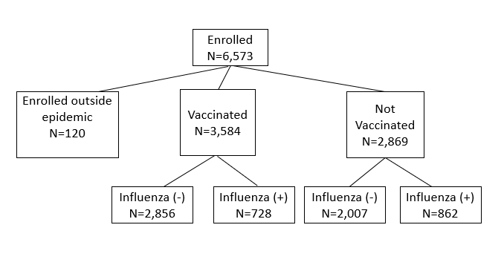

Figure 1: Enrollment flow chart
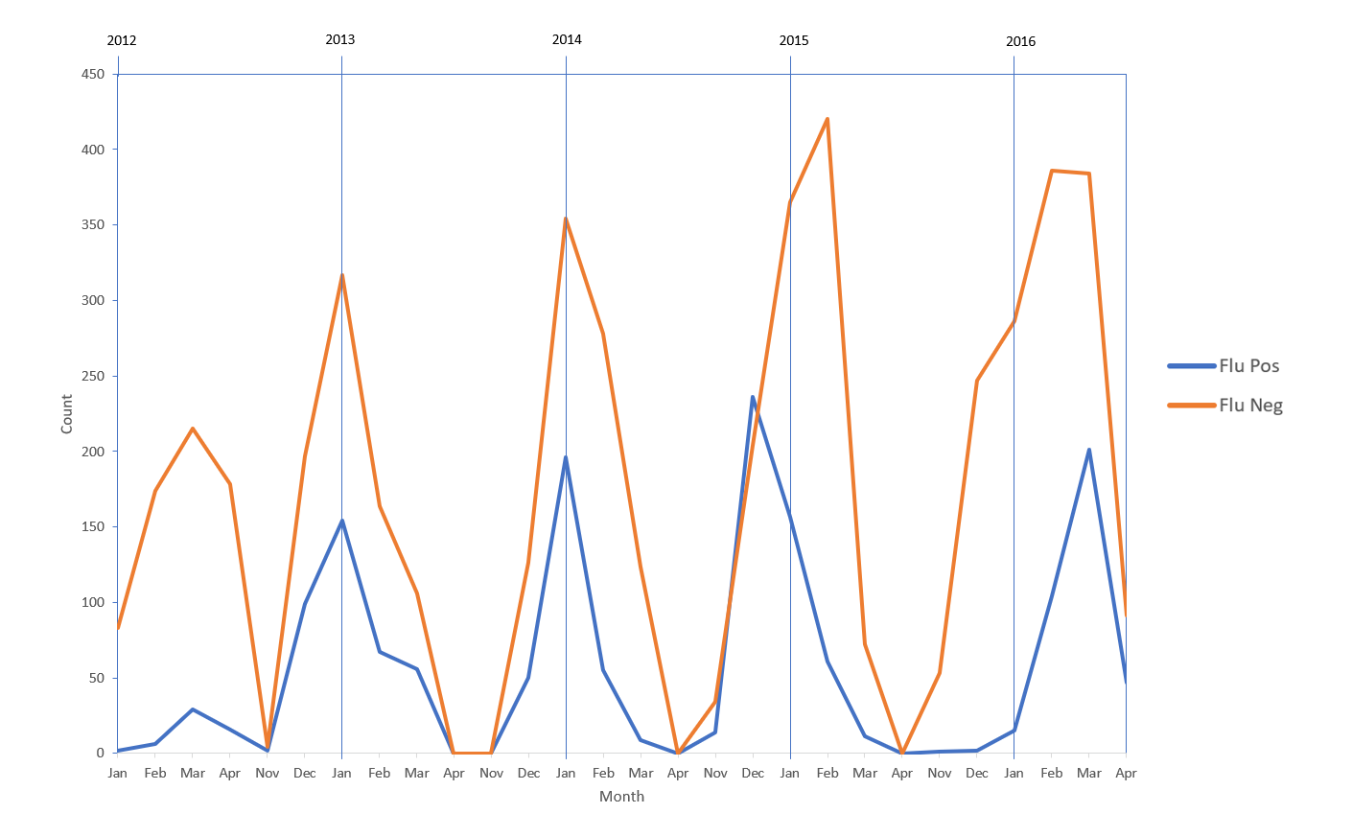

Figure 2: Temporal distribution of influenza-like illness (ILI) cases testing positive for influenza infection and negative for influenza infection, 2011-2016
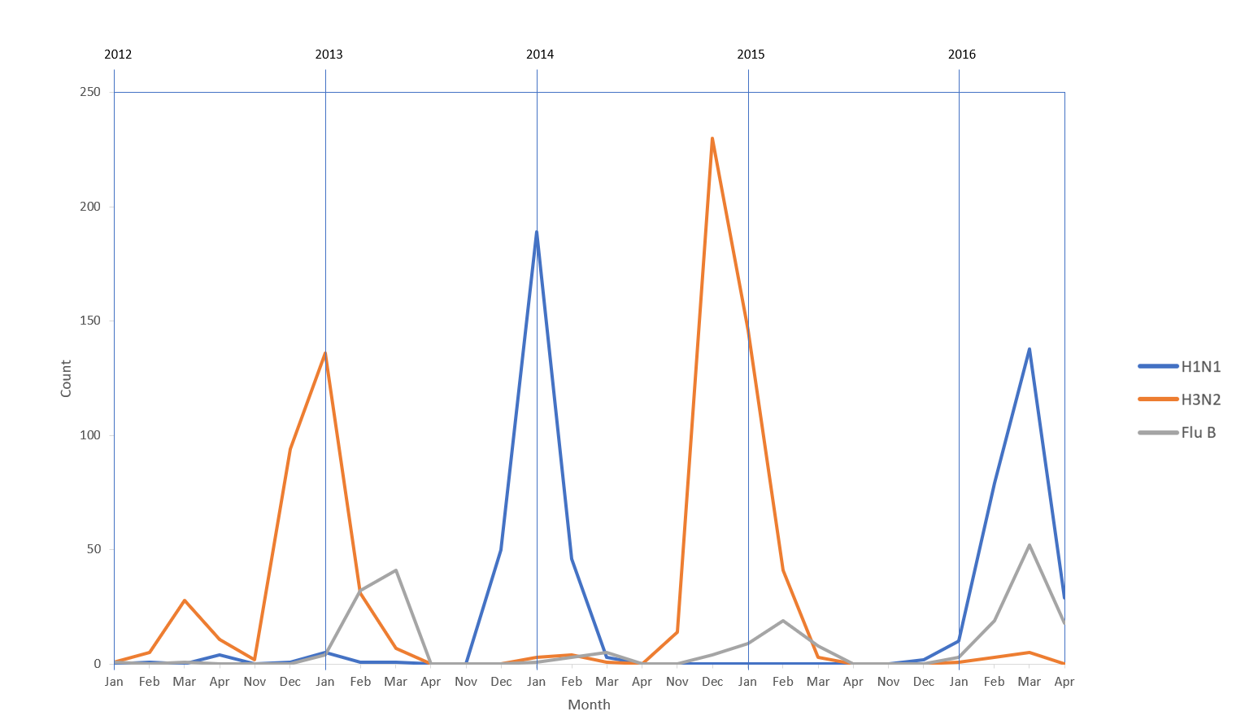

Figure 3: Temporal distribution of influenza subtypes, 2011-2016
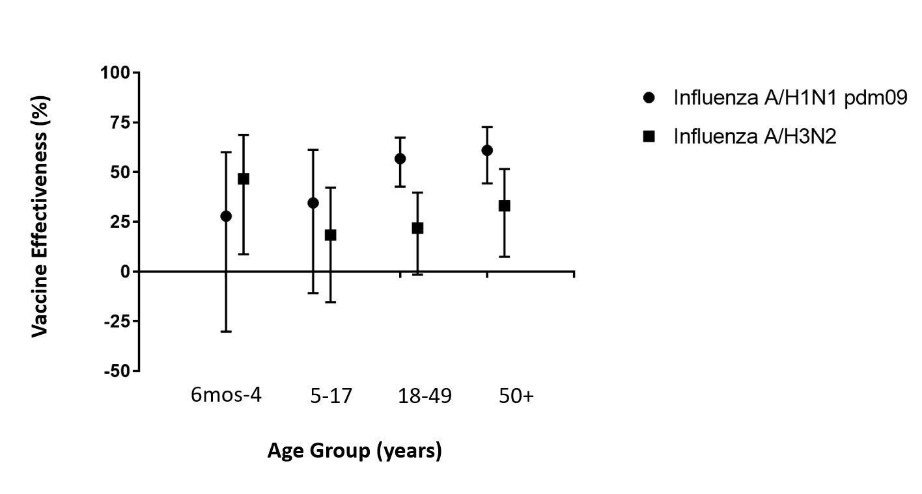

Figure 4: Vaccine effectiveness (95% CI) against influenza A by age group, 2011-2016

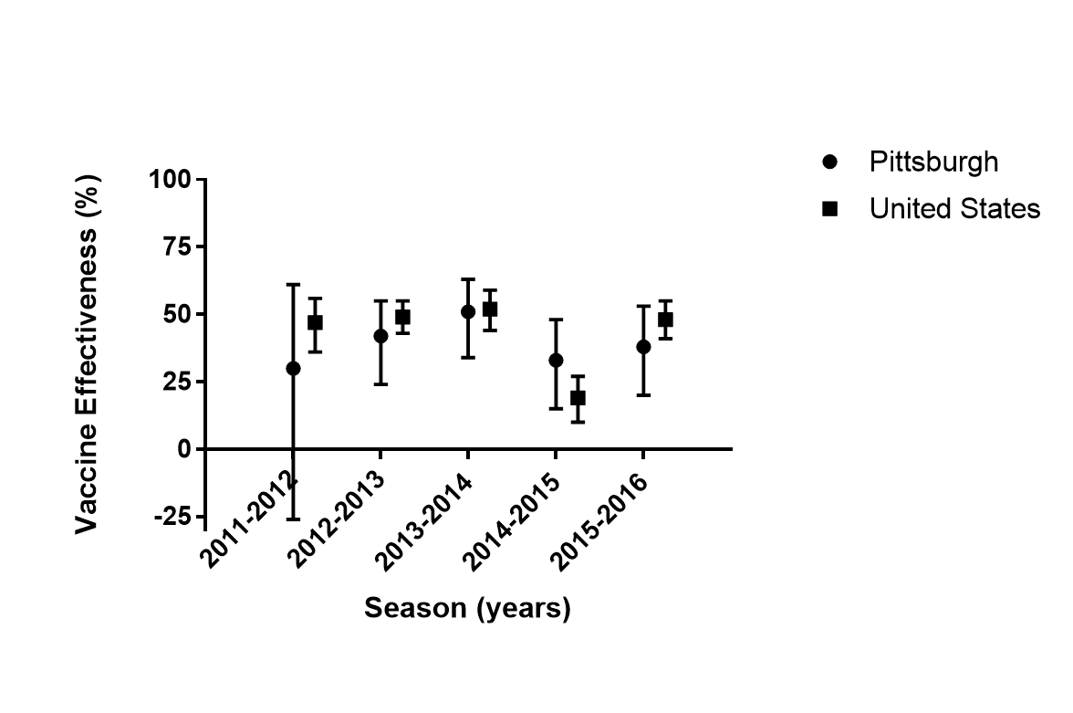

Figure 5: Vaccine effectiveness (95% CI) against influenza A and influenza B in Pittsburgh and the US, by season

Bibliography
1. U.S. Department of Health and Human Services, Centers for Disease Control and Prevention (CDC). Flu Infographic. https://www.cdcfoundation.org/businesspulse/flu-prevention-infographic. Accessed October 23, 2018.
2. Rolfes MA, Foppa IM, Garg S, et al. Annual estimates of the burden of seasonal influenza in the United States: A tool for strengthening influenza surveillance and preparedness. Influenza Other Respir Viruses. 2018;12(1):132-137. doi:10.1111/irv.12486
3. U.S. Department of Health and Human Services, Centers for Disease Control and Prevention (CDC). The Flu Season | Seasonal Influenza (Flu). https://www.cdc.gov/flu/about/season/flu-season.htm. Published July 12, 2018. Accessed September 30, 2018.
4. U.S. Department of Health and Human Services, Centers for Disease Control and Prevention (CDC). Past Pandemics | Pandemic Influenza (Flu). https://www.cdc.gov/flu/pandemic-resources/basics/past-pandemics.html. Published August 10, 2018. Accessed September 30, 2018.
5. Jhung MA, Swerdlow D, Olsen SJ, et al. Epidemiology of 2009 Pandemic Influenza A (H1N1) in the United States. Clinical Infectious Diseases. 2011;52(suppl_1):S13-S26. doi:10.1093/cid/ciq008
6. Taubenberger JK, Morens DM. The Pathology of Influenza Virus Infections. Annu Rev Pathol. 2008;3:499-522. doi:10.1146/annurev.pathmechdis.3.121806.154316
7. U.S. Department of Health and Human Services, Centers for Disease Control and Prevention (CDC). Types of Influenza Viruses | Seasonal Influenza (Flu). https://www.cdc.gov/flu/about/viruses/types.htm. Published September 27, 2017. Accessed October 7, 2018.
8. U.S. Department of Health and Human Services, Centers for Disease Control and Prevention (CDC). How the Flu Virus Can Change: “Drift” and “Shift” | Seasonal Influenza (Flu). https://www.cdc.gov/flu/about/viruses/change.htm. Published September 27, 2017. Accessed October 7, 2018.
9. U.S. Department of Health and Human Services, Centers for Disease Control and Prevention (CDC). How Flu Spreads | Seasonal Influenza (Flu). https://www.cdc.gov/flu/about/disease/spread.htm. Published August 27, 2018. Accessed October 7, 2018.
10. Cox RJ, Brokstad KA, Ogra P. Influenza Virus: Immunity and Vaccination Strategies. Comparison of the Immune Response to Inactivated and Live, Attenuated Influenza Vaccines. Scandinavian Journal of Immunology. 2004;59(1):1-15. doi:10.1111/j.0300-9475.2004.01382.x
11. Rothberg MB, Haessler SD. Complications of seasonal and pandemic influenza. Critical Care Medicine. 2010;38:e91. doi:10.1097/CCM.0b013e3181c92eeb
12. U.S. Department of Health and Human Services, Centers for Disease Control and Prevention (CDC). Fluzone High-Dose Seasonal Influenza Vaccine | Seasonal Influenza (Flu). https://www.cdc.gov/flu/protect/vaccine/qa_fluzone.htm. Published October 5, 2018. Accessed October 9, 2018.
13. What is the History of Influenza Vaccine Use in America? - NVIC. National Vaccine Information Center (NVIC). https://www.nvic.org/vaccines-and-diseases/influenza/vaccine-history.aspx. Accessed October 15, 2018.
14. Types of seasonal influenza vaccine. http://www.euro.who.int/en/health-topics/communicable-diseases/influenza/vaccination/types-of-seasonal-influenza-vaccine. Published October 9, 2018. Accessed October 9, 2018.
15. Soema PC, Kompier R, Amorij J-P, Kersten GFA. Current and next generation influenza vaccines: Formulation and production strategies. European Journal of Pharmaceutics and Biopharmaceutics. 2015;94:251-263. doi:10.1016/j.ejpb.2015.05.023
16. Buckland BC. The development and manufacture of influenza vaccines. Hum Vaccin Immunother. 2015;11(6):1357-1360. doi:10.1080/21645515.2015.1026497
17. Grohskopf LA. Prevention and Control of Seasonal Influenza with Vaccines: Recommendations of the Advisory Committee on Immunization Practices—United States, 2018–19 Influenza Season. MMWR Recomm Rep. 2018;67. doi:10.15585/mmwr.rr6703a1
18. U.S. Department of Health and Human Services, Centers for Disease Control and Prevention (CDC). How Influenza (Flu) Vaccines Are Made | Seasonal Influenza (Flu). https://www.cdc.gov/flu/protect/vaccine/how-fluvaccine-made.htm. Published September 24, 2018. Accessed October 13, 2018.
19. Lambert LC, Fauci AS. Influenza Vaccines for the Future. New England Journal of Medicine. 2010;363(21):2036-2044. doi:10.1056/NEJMra1002842
20. Weinberg GA, Szilagyi PG. Vaccine Epidemiology: Efficacy, Effectiveness, and the Translational Research Roadmap. J Infect Dis. 2010;201(11):1607-1610. doi:10.1086/652404
21. Haber M, An Q, Foppa IM, Shay DK, Ferdinands JM, Orenstein WA. A Probability Model for Evaluating the Bias and Precision of Influenza Vaccine Effectiveness Estimates from Case-Control Studies. Epidemiol Infect. 2015;143(7):1417-1426. doi:10.1017/S0950268814002179
22. U.S. Department of Health and Human Services, Centers for Disease Control and Prevention (CDC). Vaccine Effectiveness - How Well Does the Flu Vaccine Work? | Seasonal Influenza (Flu). https://www.cdc.gov/flu/about/qa/vaccineeffect.htm. Published October 12, 2018. Accessed October 21, 2018.
23. U.S. Department of Health and Human Services, Centers for Disease Control and Prevention (CDC). Seasonal Influenza Vaccine Effectiveness, 2004-2018 | Seasonal Influenza (Flu). https://www.cdc.gov/flu/professionals/vaccination/effectiveness-studies.htm. Published September 25, 2018. Accessed October 21, 2018.
24. Jackson ML, Nelson JC. The test-negative design for estimating influenza vaccine effectiveness. Vaccine. 2013;31(17):2165-2168. doi:10.1016/j.vaccine.2013.02.053
25. Chartrand C, Leeflang MMG, Minion J, Brewer T, Pai M. Accuracy of Rapid Influenza Diagnostic Tests: A Meta-analysis. Annals of Internal Medicine. 2012;156(7):500. doi:10.7326/0003-4819-156-7-201204030-00403
26. Sullivan SG, Tchetgen Tchetgen EJ, Cowling BJ. Theoretical Basis of the Test-Negative Study Design for Assessment of Influenza Vaccine Effectiveness. Am J Epidemiol. 2016;184(5):345-353. doi:10.1093/aje/kww064
27. Putri WCWS, Muscatello DJ, Stockwell MS, Newall AT. Economic burden of seasonal influenza in the United States. Vaccine. 2018;36(27):3960-3966. doi:10.1016/j.vaccine.2018.05.057
28. Flannery B, Zimmerman RK, Gubareva LV, et al. Enhanced genetic characterization of influenza A(H3N2) viruses and vaccine effectiveness by genetic group, 2014–2015. J Infect Dis. 2016;214(7):1010-1019. doi:10.1093/infdis/jiw181
29. Zimmerman RK, Nowalk MP, Chung J, et al. 2014-2015 Influenza Vaccine Effectiveness in the United States by Vaccine Type. Clin Infect Dis. 2016;63(12):1564-1573. doi:10.1093/cid/ciw635
30. Matias G, Haguinet F, Lustig RL, Edelman L, Chowell G, Taylor RJ. Model estimates of the burden of outpatient visits attributable to influenza in the United States. BMC Infectious Diseases. 2016;16(1):641. doi:10.1186/s12879-016-1939-7
31. Jackson ML, Chung JR, Jackson LA, et al. Influenza Vaccine Effectiveness in the United States during the 2015–2016 Season. N Engl J Med. 2017;377(6):534-543. doi:10.1056/NEJMoa1700153
32. Ohmit SE, Thompson MG, Petrie JG, et al. Influenza vaccine effectiveness in the 2011-2012 season: protection against each circulating virus and the effect of prior vaccination on estimates. Clin Infect Dis. 2014;58(3):319-327. doi:10.1093/cid/cit736
33. McLean HQ, Thompson MG, Sundaram ME, et al. Influenza Vaccine Effectiveness in the United States During 2012–2013: Variable Protection by Age and Virus Type. J Infect Dis. 2015;211(10):1529-1540. doi:10.1093/infdis/jiu647
34. Gaglani M, Pruszynski J, Murthy K, et al. Influenza Vaccine Effectiveness Against 2009 Pandemic Influenza A(H1N1) Virus Differed by Vaccine Type During 2013–2014 in the United States. J Infect Dis. 2016;213(10):1546-1556. doi:10.1093/infdis/jiv577
35. Grohskopf LA, Sokolow LZ, Olsen SJ, Bresee JS, Broder KR, Karron RA. Prevention and Control of Influenza with Vaccines: Recommendations of the Advisory Committee on Immunization Practices, United States, 2015–16 Influenza Season. MMWR Morb Mortal Wkly Rep. 2015;64(30):818-825.
36. U.S. Department of Health and Human Services, Centers for Disease Control and Prevention (CDC). Prevention and Control of Influenza with Vaccines: Recommendations of the Advisory Committee on Immunization Practices (ACIP), 2011. https://www.cdc.gov/mmwr/preview/mmwrhtml/mm6033a3.htm. Accessed October 25, 2018.
37. U.S. Department of Health and Human Services, Centers for Disease Control and Prevention (CDC). Prevention and Control of Seasonal Influenza with Vaccines. https://www.cdc.gov/mmwr/preview/mmwrhtml/rr6207a1.htm. Accessed October 25, 2018.
38. U.S. Department of Health and Human Services, Centers for Disease Control and Prevention (CDC). Influenza Activity — United States, 2013–14 Season and Composition of the 2014–15 Influenza Vaccines. https://www.cdc.gov/mmwr/preview/mmwrhtml/mm6322a2.htm. Accessed October 25, 2018.
39. Flannery B. Interim Estimates of 2017–18 Seasonal Influenza Vaccine Effectiveness — United States, February 2018. MMWR Morb Mortal Wkly Rep. 2018;67. doi:10.15585/mmwr.mm6706a2
40. U.S. Department of Health and Human Services, Centers for Disease Control and Prevention (CDC). 2011-2012 Influenza Season | Seasonal Influenza (Flu). https://www.cdc.gov/flu/pastseasons/1112season.htm. Published July 27, 2017. Accessed October 30, 2018.
41. U.S. Department of Health and Human Services, Centers for Disease Control and Prevention (CDC). The 2012-2013 Influenza Season | Seasonal Influenza (Flu). https://www.cdc.gov/flu/pastseasons/1213season.htm. Published April 7, 2017. Accessed October 30, 2018.
42. U.S. Department of Health and Human Services, Centers for Disease Control and Prevention (CDC). 2013-2014 Influenza Season | Seasonal Influenza (Flu) | CDC. https://www.cdc.gov/flu/pastseasons/1314season.htm. Published July 27, 2017. Accessed October 30, 2018.
43. U.S. Department of Health and Human Services, Centers for Disease Control and Prevention (CDC). What You Should Know for the 2014-2015 Influenza Season. https://www.cdc.gov/flu/pastseasons/1415season.htm. Published February 18, 2016. Accessed October 31, 2018.
44. U.S. Department of Health and Human Services, Centers for Disease Control and Prevention (CDC). CDC. What You Should Know for the 2015-2016 Influenza Season. https://www.cdc.gov/flu/about/season/flu-season-2015-2016.htm. Published October 3, 2017. Accessed October 31, 2018.
45. U.S. Department of Health and Human Services, Centers for Disease Control and Prevention (CDC). Estimated Influenza Illnesses, Medical visits, Hospitalizations, and Deaths in the United States — 2017–2018 influenza season | Seasonal Influenza (Flu). https://www.cdc.gov/flu/about/burden/estimates.htm. Published October 30, 2018. Accessed November 1, 2018.

