CONDUCTING THE FEDERALLY MANDATED COMMUNITY HEALTH NEEDS ASSESSMENT FOR A SMALL NON-PROFIT HOSPITAL

by

Gregory Higgins

BSW, Marshall University, 2011

Submitted to the Graduate Faculty of

Behavioral and Community Health Sciences

Graduate School of Public Health in partial fulfillment

of the requirements for the degree of

Master of Public Health

University of Pittsburgh

2018

UNIVERSITY OF PITTSBURGH

Graduate School of Public Health

This essay is submitted

by

Gregory Higgins

on

December 13, 2018

It was approved by

Essay Advisor:
Mary Hawk, DrPH
Associate Professor
Behavioral and Community Health Sciences
Graduate School of Public Health
University of Pittsburgh

Committee Member:
Jeremy Martinson, DPhil
Assistant Professor
Infectious Diseases and Microbiology
Human Genetics
Graduate School of Public Health
University of Pittsburgh

Copyright © by Gregg Higgins

2018

Mary Hawk, DrPH

CONDUCTING THE FEDERALLY MANDATED COMMUNITY HEALTH NEEDS ASSESSMENT FOR A SMALL NON-PROFIT HOSPITAL

Gregg Higgins, MPH

University of Pittsburgh, 2018

Abstract

Per the requirements in the Affordable Care Act of 2010, any medical facility receiving federal funds must perform a community health needs assessment (CHNA) every three years. The main objective of this assessment is to develop and implement a program that acts as a community benefit to the public health of the target population. This essay reflects the CHNA experiences at The Children’s Home of Pittsburgh (TCH), which aimed to establish the needs of its patient population. Results from the needs assessment will be used to establish interventions to meet the identified needs, within range of TCH’s services. TCH crafted community surveys and disseminated those surveys to agencies that serve the pediatric population. Providers who received the surveys administered them to their clients then returned them to TCH. The initial surveys showed 28% of respondents chose “access to basic needs for families” as their most pressing concern ranked out of seven possible choices with “basic parenting skills” at 20%. Key informant interviews with professionals that serve the pediatric community supported those results. With this in mind, TCH seeks to implement a program available to the community offering new parent education and a support group for parents held at TCH. This essay will also discuss the obstacles and challenges we faced during the CHNA process. The public health significance of the CHNA is that can be a very useful tool in improving care and public health outcomes. During the CHNA process, we ran into obstacles caused by our limitations as a small, niche hospital required to meet the same standards as a multi-billion-dollar hospital. The CHNA could benefit hospitals in serving their specific populations better by altering their requirements based on factors like size and scope of services. The CHNA is designed to improve services offered by hospitals by creating a community benefit. Making it clearer who defines “community” and allowing hospitals to define what their “community benefit” would be would have a larger impact on the public health of the populations each hospital is trying to serve.

Table of Contents

1.0 Introduction 1
2.0 Background 2
2.1 Agency Background 2
2.2 Community Health Needs Assessment Background 3
3.0 Design, Methodology, and Data 5
3.1 Definition of the Community Served by TCH 6
3.2 Community Profile 6
3.3 Focus Groups 7
3.4 Steering Committee 8
3.5 Community Surveys 9
3.6 Key Informant Interviews 11
4.0 Findings 13
4.1 Community Profile 13
4.2 Steering Committee Findings 15
4.3 Interview Results 16
4.4 Community Survey Results 16
5.0 Discussion & Conclusions 19
5.1 Support Groups for Caregivers of Medically Fragile Children 20
5.2 New Parent Classes and Education Series for Families 21
5.3 Implementation and Evaluation 23
5.3.1 Coordination of Activities and the Community Health Fellow 23
5.3.2 Recommended Timeline of Activities 23
5.3.3 Evaluation 24
5.4 Limitations 25
5.5 Challenges & Usefulness of the Community Health Needs Assessment 26
Appendix A: Community Survey 28
Appendix B: Key Informant Interview Script 30
Bibliography 32

List of Tables

Table 1: Suggested Implementation Timeline 24

List of Figures

Figure 1: The Children's Home CHNA Process 5
Figure 2: Community Survey Results 17

Introduction

Hospitals that receive non-profit tax benefits have been required in some way to provide their surrounding communities with a community benefit since 1913 (Skinner, et al 2017). Essentially, if a hospital had non-profit status, they needed to help their communities in exchange for that status. Originally, a community benefit was considered as “free or reduced-cost care to patients unable to pay for it…to the extent of [a hospital’s] financial ability” (Internal Revenue Service, 2010). Eventually the meaning of “community benefit” was expanded and then required hospitals to “demonstrate a strong commitment to promoting the broader health of surrounding communities, beyond the hospital’s patient populations (Lunder, 2008).”

In order to further enforce these requirements, the Patient Protection and Affordable Care Act of 2010 included Community Health Needs Assessment (CHNA) as way of developing a community benefit and further established the consequences of not meeting the requirements of a CHNA. For example, if CHNA requirements were not met, a hospital could lose its 501(c)(3) status. Hospitals could also face an excise tax if they failed to meet those requirements. Unfortunately, these new regulations lacked any sort of guidance or details for designing or implementing CHNA’s (Skinner, et al 2017).

2.0 Background

2.1 Agency Background

The Children’s Home & Lemieux Family Center (TCH) is a non-profit hospital serving medically fragile children. Established in 1893, The Children’s Home of Pittsburgh & Lemieux Family Center has a mission to “promote the health and well-being of infants and children through services that establish and strengthen the family” (The Children’s Home and Lemieux Family Center). Serving over 900 people a year, three programs fill an essential community need in the care and support of children and families.

First, the Pediatric Specialty Hospital serves children from ages birth to 21. It is a 30-bed hospital that provides transition for medically-fragile children between the referring hospital to home with high-quality nursing care and hands-on caregiver education. The goal of this program is to reduce stress of parents and caregivers of medically fragile children and ensure they are ready for the transition to home where their child can fully heal, with reduced emergency room visits.

The second program available through TCH is adoption. It works to place infants in permanent homes. The final program is called Child’s Way. They offer childcare staffed by nurses who are specially trained to work with medically fragile children, as these children generally cannot attend other daycare facilities due to the nature of their disabilities. Most of the funding for TCH comes through Medicare/Medicaid and CHIP. They receive several Federal, State, and Foundation grants as well. Private insurance is less common, and a significant amount of those they serve do not have the resources to pay for services on their own.

2.2 Community Health Needs Assessment Background

TCH is a non-profit hospital; they, like every non-profit hospital in the United States, are required to conduct a community health needs assessment every three years. Section 501(c)(3) of the Internal Revenue Code requires this, mandating that every tax-exempt hospital must conduct this assessment and “adopt an implementation strategy to meet the community health needs identified through the CHNA” (Federal Register, 2013). This assessment is an effort to identify unmet health and wellness needs of the community using community input, internal resources, and data gathered from relevant sources.

In recent years, the community benefit of these hospitals has been called into question. Lobbyists and policymakers began questioning the ways that non-profit hospitals are benefitting their communities outside of the standard exchange of providing healthcare for reimbursement. Some amount of community benefit is expected given they are not required to pay taxes like for-profit hospitals (Pennel et al, 2015). With the Affordable Care Act of 2010 came these new community benefit requirements per a tri-annual Community Health Needs Assessment.

Though the Congressional Budget Office stated the overall value of non-profit hospitals’ exemptions was $12.6 billion in 2006 (Pennel C. L., 2014), studies show little difference between community benefits provided by non-profit and for-profit hospitals (Pennel et al, 2015). In fact, little research has been conducted on non-profit hospitals’ approaches to the CHNA (Principe et al, 2012). The few studies that have been conducted show that from the first cycle of 3-year assessments, population health outcomes identified in the assessments were not influenced by the prioritization of needs and community benefit developed and implemented through the CHNA (Pennel et al, 2016).

However, criticisms have come from smaller, more rural or more specialized non-profit hospitals with these relatively recent requirements. Larger non-profit hospitals generally have the financial means to pay staff in-house or hire consultants to complete their CHNA, whereas a smaller non-profit hospital, such as TCH, relies on staff that are already working full-time towards the operations of their respective hospitals (Pennel et al, 2016). Research conducted on rural and Appalachian hospitals demonstrates similar findings. Without the appropriate amount of personnel dedicated to this assessment, better funding to conduct the assessment, and further guidelines defining the process more clearly, the ability of a CHNA to influence the desired public health outcomes is limited (Skinner et al, 2017).

3.0 Design, Methodology, and Data

TCH conducted its Community Health Needs Assessment (CHNA) between September 2017 and May 2018. Methods consisted of a review of publicly available epidemiological data, input from a steering committee, community surveys, and key informant interviews with professionals working with TCH’s population. These processes took place seven months, and each are described in more detail below.

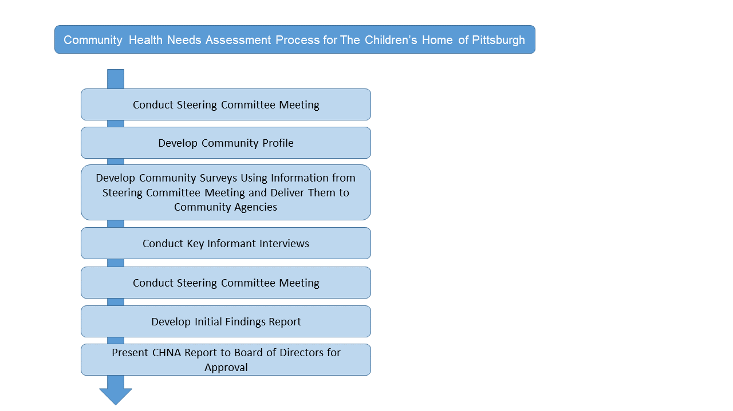
Figure 1: The Children's Home CHNA Process

3.1 Definition of the Community Served by TCH

While TCH serves children and families throughout Western Pennsylvania, its focus is in Allegheny County. It provides care for medically fragile children from birth to 21 years of age. The majority of the children come from hospitals in the area, such as Magee Women’s Hospital of UPMC, Children’s Hospital of Pittsburgh, and West Penn Allegheny Hospital. The IRS requires a non-profit hospital to use its geographic location in defining its community but allows for more defined populations based on “specialized functions” (Federal Register, 2013). Given the level of need common among many of those who utilize TCH’s services, the fact that TCH provides very specialized services, and that the amount of people it can serve is limited due to size and funding, we chose to define the community being served as medically fragile children and their families in Allegheny County.

3.2 Community Profile

Per requirements of a Community Health Needs Assessment, a community profile was developed. Community profile data were collected by reviewing reports from federal agencies (such as the CDC) and local agencies (e.g., Allegheny County Health Department) along with recorded data from TCH. Using these data, we highlighted community profile statistics and demographics of the target population. The data we used was limited to the pediatric population and those involved with the pediatric population (e.g., families, healthcare providers) in Allegheny County. We used this information to create a community profile showing the key statistics relevant to TCH’s population. These data were useful in supporting the need for a community benefit targeting TCH’s population.

3.3 Focus Groups

Using nominal group technique, TCH conducted two initial focus group meetings to determine issues and needs affecting the pediatric population and their families in its region. Nominal group technique is an alternative to brainstorming where the committee was divided into small groups and asked an open-ended question (Sample, 1984). After the small groups discuss the topic amongst themselves (in this case, the topic was about issues affecting TCH’s community), they present them to the larger group to discuss them further, identifying similarities and differences. The first focus group was comprised of TCH staff in leadership positions, including the Chief Financial Officer and the Medical Director along with the Foundation and Community Relations Manager. This group in turn identified professionals (listed in the latter portion of the next subsection) from different agencies who either worked with TCH’s population or were former colleagues of individual professionals at TCH. This second focus group, comprised of both TCH leadership staff and professionals they identified, then acted as a Steering Committee for other CHNA activities.

During both focus groups, participants were asked questions about needs facing the population TCH serves. Their responses were written down, collected, and then voted on anonymously. Where traditional focus groups are for qualitative data to help guide research without any deciding power, this nominal technique allowed for a decision to be made directing the method instead. Each meeting also included an overview of the CHNA.

3.4 Steering Committee

The Steering Committee consisted of the same participants in the focus group along with additional professionals who work with the same population as TCH, identified below. In addition to participating in the nominal group technique, the Steering Committee reviewed data collected via the provider surveys (described below) and made recommendations for meeting the identified needs, which is a requirement of the CHNA.

The steering committee was recruited by the Foundation and Community Relations Manager, Matt DeFrange, who was the lead in the CHNA process. Colleagues, specifically those who have experience with TCH’s population, were then contacted to be part of the steering committee.

The steering committee comprised the following individuals:

- Jo Ellen Welsh, Community Relations at East Liberty Family Health Care Center
- Suzanne Kingsley, Social Worker at The Children’s Home
- Kim Phillips, Chief Financial Officer at The Children’s Home
- Amy Donaldson, Medical Director at The Children’s Home
- Nancy Scopelitis, Public Health Nurse with Allegheny Health Department’s Maternal Child Health Program
- Adriana Useche-Benitez, Nurse at TADISO
- Dr. Regina Holley, Board President at Pittsburgh Public Schools
- Stacy Freeman-Pistella, Case Manager at UPMC Magee-Women’s Hospital Pregnancy Recovery Center and Women’s Recovery Center
- Tina Calabro, Disability Advocate and Parent of Medically Fragile Child
- Theresa Heck, Co-Founder and Occupational Therapist at Pediatric Therapy Specialists Inc. (TCH Board Member)
- Alissa Meade, President & CEO at Curavi Health (TCH Board Member)
- Gregg Higgins, University of Pittsburgh Graduate School of Public Health (Consultant)
- Matt DeFrange, Foundation & Community Relations Manager at The Children’s Home

3.5 Community Surveys

Over the course of 4 weeks 400 surveys (Appendix A) were distributed through several different social service agencies that serve the medically fragile population. These agencies agreed to administer these surveys to their clients. These agencies were chosen by utilizing the completed community profile as an initial, broad guide, then by consulting participants on the steering committee and by identifying agencies that cover a significant amount of Allegheny County and serve the target population. In attempting to ensure the survey was representative of the community that would need the benefit TCH would provide as a result of the CHNA, we chose service agencies (1) with whom TCH already had connections and (2) served low-income clients or were in low-income areas. It is commonly understood that people who are considered low-income commonly utilize services that fall under the “community benefit” definition. The 400 surveys were distributed between 7 different public service providers’ offices. The providers that were chosen to distribute surveys are the following:

- Hosanna House (50 surveys)
- Three (3) Allegheny County Women, Infant, and Children (WIC) offices (150 surveys)
- East Liberty Family Healthcare Center (100 surveys)
- Tadiso, Incorporated (outpatient opioid treatment facility) (50 surveys)
- Pittsburgh Public Schools (50 surveys)

The community survey was developed from the results of the focus groups. The results were aggregated by grouping similar topics. Attention was given to ensuring the topics were broad enough to be inclusive of all the identified community needs. This resulted in seven different community needs, which TCH identified as affecting its service population. The community survey asked participants to rate from 1 - 7 the needs they felt most important. It also asked participants their zip codes and offered room to suggest other issues they may face that was not listed on the survey.

Due to the purpose of the CHNA, the distribution sites were chosen because they serve mostly low-income and underserved individuals who overlap with TCH’s target population. The main product of a CHNA is the implementation of a community health and wellness benefit based on community findings; the people served by agencies listed above are those who would benefit most from a no-cost health and wellness plan if offered. The findings, discussed later, support this.

3.6 Key Informant Interviews

Interviews were held with a variety of professionals representing a cross-section of agencies that work in some capacity with TCH’s target population. An interview guide was developed by the Foundation and Community Relations Manager of TCH. Topics from the community surveys were incorporated into the interview script. Interviews were recorded and then searched for keywords relating to the needs already identified in the community surveys. The purpose of these interviews was to provide a qualitative perspective regarding barriers faced by the target population. This perspective helped in two ways. First, it simply provided perspective necessary to better understand the data from the community surveys. Second, it helped shape our focus moving forward on intervention recommendations, which are required by the CHNA. These interviews also served to aid in developing potential partnerships for this CHNA’s strategic implementation plan. Subjects of the interviews were chosen using steering committee individuals’ recommendations, as well as asking steering committee members to participate. The following individuals were chosen for these interviews:

- Jo Ellen Welsh, Community Relations at East Liberty Family Health Care Center
- Nancy Scopelitis, Public Health Nurse with Allegheny Health Department’s Maternal Child Health Program
- Adriana Useche-Benitez, Nurse at Tadiso, Incorporated (outpatient opioid treatment facility)
- Stacy Freeman-Pistella, Case Manager at UPMC Magee-Women’s Hospital Pregnancy Recovery Center and Women’s Recovery Center
- Theresa Heck, Co-Founder and Occupational Therapist at Pediatric Therapy Specialists Inc. (TCH Board Member)
- Dr. Jaime Tomko, UPMC
- Liana Verzella, Project Manager at Center for Inclusion Health Allegheny Health Network Decision Analyst at Greater Pittsburgh Food Bank
- Linda and Melissa Tessaro, parent and daughter with a disability

4.0 Findings

4.1 Community Profile

Allegheny County’s population is 1,225,365, where 18.9% are less than 18 years old and 5.3% under 5 years of age (Allegheny County Health Department, 2012-2016). Of the total population, 83% of residents in Allegheny County are Caucasian, with 13.2% African American. The remaining population is primarily of Asian or Hispanic descent. In Allegheny County, children are disproportionately living in poverty as compared to different age groups. For example, 18.7% of children in Allegheny County under 5 years old are living in poverty, whereas 7.8% of the elderly population (ages 65 or older) are living in poverty (U.S. Census Data, 2016).

Other key statistics:

- 6.6% of Allegheny County’s pediatric population are living with a disability (Allegheny County Health Department, 2015).
- 98.5% of children in Allegheny County are insured either through private or state and federal insurance.
- The infant mortality rate is 6.6 per 1,000 live births (Allegheny County Health Department, 2015).
- 7.7% of live births have a low birth weight (Allegheny County Health Department, 2015).
- Over 11% of births in Allegheny County are preterm (March of Dimes, 2015).

These statistics helped form a community profile that guided the CHNA process. Using this information helped in several ways. First, it is relevant to TCH’s target population and the need for TCH to exist. The CHNA is essentially a type of “equity audit.” It seeks to ensure that, first, “healthcare resources are being used in accordance with need” (Wright et al, 1998). The assessment requires a community profile be completed for this reason. Knowing the level of need in the pediatric population of Allegheny County along with the rate of children born who will need the services TCH offers, helped in the initial stages of forming the community surveys and guided which agencies received those surveys. It is reasonable to suggest a portion of children born preterm or at a low birth weight in Allegheny County will develop complications that will require use of TCH’s services. For instance, it is general knowledge that those who utilize social services such as WIC (Women, Infants, and Children) are most often from a low socioeconomic status and have insurance through the state. WIC is an agency that TCH knows, through referrals and from people on the steering committee, serves the pediatric population, including those considered medically fragile. This information led to the decision to distribute community surveys through WIC offices. Second, this information aided in the brainstorming session in offering ideas for issues to be included in the community survey. It offered an additional resource from which the steering committee could use. Finally, the CHNA simply requires the assessment includes a snapshot of the demographics in the community each hospital serves.

4.2 Steering Committee Findings

As noted in the Methods section above, the steering committee helped develop the community survey. After aggregating the data from the steering committee regarding what needs/issues should be included in said survey, we found the following needs were those that should be ranked:

- Basic parenting education
- Basic needs for families
- Substance abuse education
- Accessing public assistance
- Stress management for families/caregivers
- Support for families of special needs kids
- Access to care for kids

The steering committee was also responsible for providing recommendations based on community survey findings. After the initial survey findings were presented to the steering committee, the steering committee gave the following recommendations to address the identified needs:

- Providing support group models
- Respite for parents with child care
- Addressing basic needs

The Steering Committee was involved in the process from the very beginning. They were participants in the initial focus group to develop the community survey, and they review results from the community profile review, interviews, and community surveys in order to develop recommendations for strategies to address the needs identified through the CHNA methods.

4.3 Interview Results

Similar needs were identified via the key stakeholder interviews conducted with professionals working with our pediatric population. Some of the overarching themes that emerged included access to care, health disparities among those with lower socioeconomic status, food insecurity, and ways in which the opioid epidemic is affecting children and families locally. Some of the interviews provided potential ideas for addressing the needs we found from the surveys. For example, providing support groups for caregivers of medically fragile children was an idea that came from many of the interviewees.

4.4 Community Survey Results

The surveys asked participants to rank, from 1 - 7, issues previously developed by the Steering Committee and staff of TCH. The graph below represents the results from those surveys. Due to confusion in the responses (discussed in the “Limitations” section below) we averaged the issues chosen as the number 1 most important with the issues chosen as number 2 regarding importance to the participant. This means we added the total amount of every time a participant ranked an issue number 1 with every time a participant ranked an issue number 2 then divided by 2. For example, if the total amount of times Question 1 (Q1) was ranked as number 1 (most important to the participant) equaled 75, and the amount of times Question 1 (Q1) was ranked as number 2 (second most important) equaled 60, we would average those two totals. We did this for each of the seven (7) questions. The graph below represents those results:

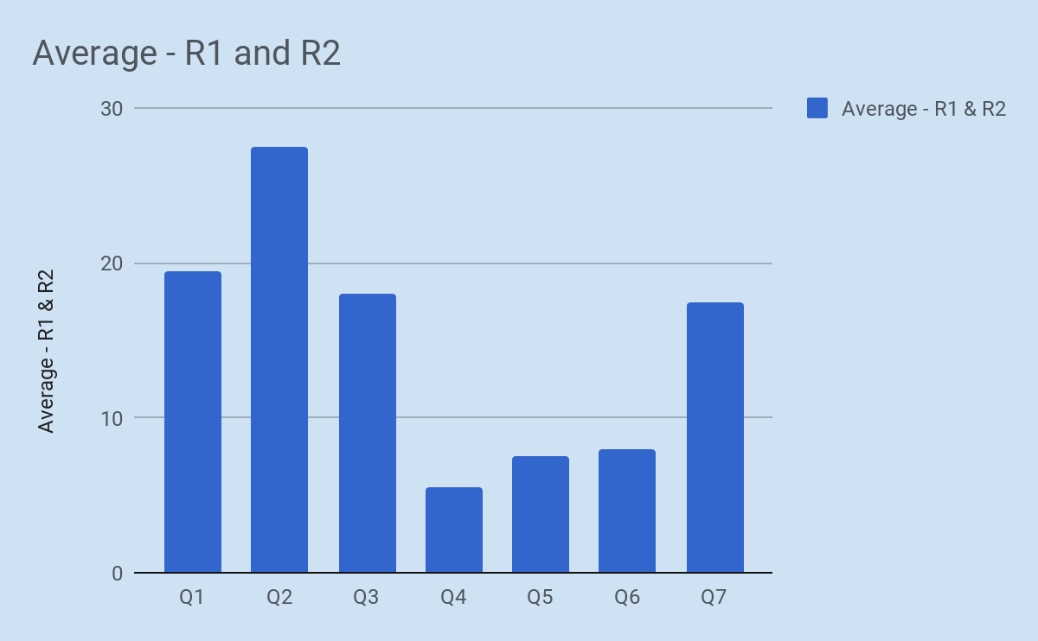
Figure 2: Community Survey Results

- Q1: Basic parenting skills and education for new families
- Q2: Trouble affording food, transportation, and other basic needs
- Q3: Substance abuse help and education for families with addiction problems
- Q4: How to apply for public assistance programs like SNAP
- Q5: Stress management for families/caregivers
- Q6: Support and education for families who have kids with disabilities and/or health disorders
- Q7: Access to healthcare for all kids

For the purposes of this CHNA and regarding the scope of what TCH is able to implement as an agency, importance was given to the top two ranked responses. To emphasize the perceived urgency of an issue, we used the issues ranked first most frequently. Given the broad nature of those issues in the survey, specifically the two options about basic needs and basic parenting skills, respondents experienced some confusion in ranking what they felt was the most important first and second highest issues. In an attempt to avoid procedural bias, it felt pertinent to highlight those issues ranking second most important (2) as well. This was done to ensure feasibility. TCH is a small hospital with limited resources. The goal here was to assure we would be able to address the most pressing needs identified given our limitations, which will be discussed later in this essay. The graph above represents averages of these rankings, where issues were prioritized in the following order:

- Basic needs for families
- Basic parenting skills /education for new families
- Substance abuse help and education
- Access to healthcare
- Support for families with special needs
- Accessing public assistance

Using the method of averaging the results described at the beginning of this section, Q2 (basic needs) ranks first being selected as number 1 and number 2 importance almost 28% of the time. The second is Q1 (basic parenting skills) with about 20%, and similar result for third between Q3 (substance abuse) and Q7 (access to healthcare) at about 18% each.

5.0 Discussion & Conclusions

Our results show that family support and parenting education are the most urgent needs facing families with medically fragile children. Using this information and considering the proficiencies and scope of TCH, a recommended program plan was developed. The steering committee developed the issues that would be ranked on the community survey. From the survey responses and the key informant interviews, basic needs were identified as most important. After presenting this information to the steering committee, recommendations were made based on these findings and based on what services TCH is capable of providing. As previously stated, the CHNA requires a recommended implementation plan for possible programming to address identified needs. TCH considered the urgency and feasibility of each identified need to determine programming. Input from community members and feedback from key stakeholders indicated a need for support for families of medically fragile children and education around parenting and access to basic resources. The Children’s Home will offer an education series and a support group open to the community, with simultaneous childcare to accommodate children with special needs and siblings and providing access to resources to address basic needs.

5.1 Support Groups for Caregivers of Medically Fragile Children

Support Groups will be designed to:

- Alleviate emotional stress and isolation for caretakers of medically fragile children by sharing personal experiences and encouraging healthy coping mechanisms.
- Provide practical advice and tips in raising a child with special needs to promote best emotional/social development of their child.
- Provide education with special guest speakers and experts in areas where families of medically fragile children often struggle (e.g., post-op care, crisis situations, etc.).
- Create a forum to share and disseminate community resources currently available to families of medically fragile children.
- Provide childcare with engaging activities in a safe space to promote development for children while parents attend class time.
- Provide a respite for parents and caretakers to enjoy and learn with their peers while their child is safely cared for nearby.

In addition, groups will:

- Connect families not yet familiar with The Children’s Home’s services to programs such as Child’s Way, our day care for medically fragile children,
- Ensure TCH is up-to-date on issues affecting families of children with special needs,

Potential Collaborating Agencies for Support Groups:

- Achieva
- School for the Blind
- The Children’s Institute
- Every Child, Inc.
- The Watson Institute

5.2 New Parent Classes and Education Series for Families

Basic parenting education was among the top needs identified by community members. In targeting this area, it was determined The Children’s Home could also use an education-based intervention to alleviate other areas of need for community members, including basic needs for families, and assistance in accessing resources/public assistance.
Classes will be designed to:

- Prepare new families with best practices and techniques in parenting.
- Bring in speakers and experts to discuss a range of topics, including but not limited to nutrition, baby’s first year, stress relief and coping mechanisms, etc.
- Help with basic needs by providing attendees incentive items – such as gift cards to buy new baby needs – in return for attending sessions.
- Provide childcare with engaging activities to promote development for children while parents attend class time.
- Provide a respite for parents to learn and engage with peers while their child is safely cared for nearby.
- Provide a forum for families to learn and share community resources available to them.

In addition, classes will:

- Further establish TCH as a leader in educational excellence for children and families
- Build a network of like-minded agencies and organizations to collaborate with The Children’s Home.
- Connect families to other services offered by TCH.

Potential Collaborating Agencies for Education Series:

- Allegheny County Maternal/Child Health Program
- Greater Pittsburgh Food shelf
- Pittsburgh Community Food Bank
- Community Human Services
- Family Resources
- Arsenal Family & Children’s Center

5.3 Implementation and Evaluation

5.3.1 Coordination of Activities and the Community Health Fellow

Partnering with a local educational institution, The Children’s Home will host a Community Health Fellow to execute and evaluate programming related to the implementation plan. Focusing on education-based interventions, the fellow will execute and evaluate Support Group and Education Series activities, including coordination of guest speakers and topics, evaluations of programming and further improving the program.

5.3.2 Recommended Timeline of Activities

The Children’s Home will offer Support Group Sessions and the Education Series for New Families on an ongoing basis, once per month on a rotating yearly basis. Programming began on November 15, 2018, per CHNA requirements. The following is its timeline:

Table 1: Suggested Implementation Timeline

Activity | Deadline
Finalize implementation plan for authorization by the Board of The Children’s Home | May 25th
Present implementation plan for board approval | June 6th
Develop materials to disseminate to community and agencies for Support Group and Education Series | July 1st
Create a master calendar of activities for support group and education series respectively | August 1st
Create a partnership with an educational institution for The Children’s Home Community Health Fellow, with job description and curriculum objectives | August 1st
Develop an evaluation system/material for programming | October 1st
Meet with potential coordinating partners about programming available and how to best work together | October 1st
Share marketing materials with outside agencies and community groups to advertise programming and dates | October 1st
Programming begins. | November 15th

5.3.3 Evaluation

Measuring outcomes of the planned programs will be completed primarily using surveys. Because one of the main desired outcomes is increased education and decreased stress among parents, group facilitators will administer pre- and post-surveys at each of the support group meetings. These surveys will gauge perceived reduction or increase of stress. Another goal of this program is increased education regarding new parenthood. This will be assessed with pre-test at the beginning of the program, with a follow-up test 6 months and 12 months into the program. Near the end of the first year of implementation, a focus group will be held with participants as part of internal development to help improve the program.

5.4 Limitations

Upon reviewing the initial survey results, it became clear that respondents did not fully understand the ranking mechanism. Many participants only ranked needs they thought were important, while others marked all needs as important, which made those surveys unusable. Often the results showed participants marking two of the issues at the same level of importance. Future surveys could benefit from a simpler, more visual ranking system and simpler language. Another limitation regarding the community surveys was retention. Of the 400 surveys disbursed, only 300 were returned completed. East Liberty Family Health Care Center reported they lost the 100 surveys we had disbursed to them.

Regarding the focus groups and the steering committee, there was potential for bias. The focus group involved everyone who would comprise the steering committee. The focus groups’ main goal was to help develop the community survey, while the steering committee would be the guiding force approving that survey and then suggesting responses to that survey’s results. It would have been helpful to have input from more objective participants who did not have any sort of authoritative voice in the CHNA process.

5.5 Challenges & Usefulness of the Community Health Needs Assessment

Healthcare is transitioning increasingly toward population-based care, and CHNAs have the potential to be useful in improving population health. TCH will use the findings from its CHNA to bolster and expand a support group offered to anyone with a medically fragile child. Ideally, this will bring in that target population by providing a benefit to the community that satisfies CHNA requirements.

The Children’s Home of Pittsburgh is still a small, 30-bed specialized non-profit hospital. The “one size fits all” approach to the CHNA policy added confusion to our processes. The largest challenge we faced in the CHNA process involved development of the community surveys. When identifying community needs, the CHNA requirements are the same for TCH as they are for a large hospital with the resources to address almost any need that community identifies. The CHNA requires we address whatever need the community identifies. We had to make the community surveys inclusive enough to cover every need that could potentially be identified as most urgent while understanding we may be required to develop an intervention to address an issue well outside our abilities. The capabilities of TCH developing a community benefit to address, for example, substance abuse (as this was a need identified by the community, but not as urgent, according to the surveys), are slim to none. With this in mind, there was some biased reasoning behind making the issues on the survey as broad as possible. Even when we were defining the “community” in “community survey,” we were never certain whether or not it was too specific and, thus, not in line with CHNA requirements. What we needed was clarity and perhaps a better definition of community and what is considered a community benefit.

Results of the CHNA did not significantly shift TCH’s services away from those already provided. Rather, its services were expanded. Identifying the medically fragile pediatric population’s needs in the community allowed TCH to serve more people who may not have ever used its services before. The majority of people who use TCH’s services come from The Children’s Hospital UPMC or other hospitals in the area as direct referrals. This means if a caregiver of a medically fragile child is not coming directly from the Children’s Hospital UPMC, for instance, they would normally not interact with TCH. Upon review of the literature on the CHNA it often results in a hospital either expanding already existing services [such as with TCH) or creating a new intervention altogether (Pennel, 2014)]. For a small, resource-scarce hospital like TCH, it made sense to simply offer more of what it is effective in and to more people as long as it was meeting the needs identified by the CHNA, instead of developing an intervention TCH lacks the expertise and resources to implement. Offering support and education are services TCH already provides for its patients and their caregivers. The results from this CHNA underscored the fact that TCH offers appropriate and much-needed services to the medically fragile pediatric population in Allegheny County.

Appendix A: Community Survey
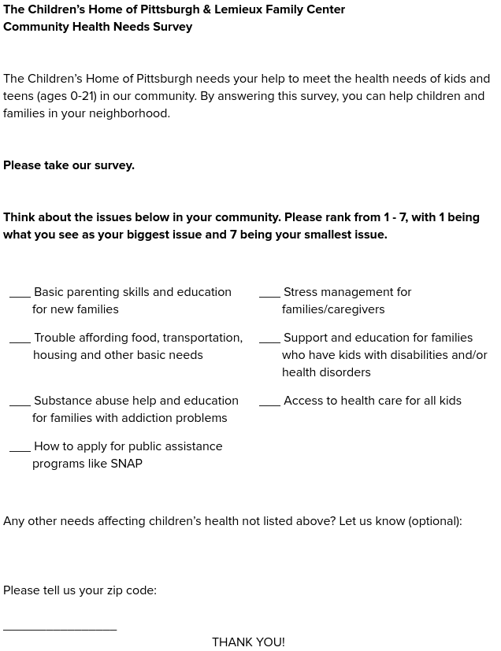

Appendix B: Key Informant Interview Script

Children’s Home of Pittsburgh
Community Health Needs Assessment
Key Informant Interview

Name:________________________________
Date:_________________________________
Interviewer:____________________________
Occupation of Interviewee: _____________________________________

Q1: Explain the current role you play at (insert organization) and how long you’ve been in the field.

Q2: Given your experience and background, what are some of the biggest issues facing the pediatric population (0-21) in our community? And/or, are there any issues identified by The Children’s Home that stand out to you in particular? (2-4 issues)

Q3: Of those, which would you say is your biggest concern? What do you believe is happening at a social / community level that’s causing this issue? (What do you see in your day-to-day work)

Q4: What are some of the actions happening at the community-level that are addressing this issue, if any? How could it be addressed more effectively?

Q5: If The Children’s Home of Pittsburgh were to address that issue for the public, are there ways in which we could leverage existing efforts to help with the problem, such as working with another organization?

Q6: Are there any other issues affecting our pediatric community not discussed you would like to see The Children’s Home of Pittsburgh look into?

Bibliography

Allegheny County Health Department. (2012-2016). Retrieved from http://www.achd.net/aci/index.html?hcn=DisparitiesDashboard

Allegheny County Health Department. (2015, May). 2008-2012 infant mortality birth cohort study. Retrieved from http://www.achd.net/biostats/pubs/pdf/2015_Birth_Cohort_Report_FINAL.pdf

Federal Register. (2013, April) "Community Health Needs Assessments for Charitable Hospitals." Academic OneFile.

Internal Revenue Service (2010) Revenue Ruling, 56-185.

Lunder E, Liu EC. (2008, July) Congressional Research Service, Order Code RL34605, Tax-Exempt Section 501(c)(3) Hospitals: Community Benefit Standard and Schedule H.

Manchester, A. (2012, March). Caring for Medically Fragile Children. Kai Tiaki Nursing New Zealand, 18(2).

March of Dimes. (2015, March). Born too soon and too small in Pennsylvania. Retrieved from https://www.marchofdimes.org/peristats/pdflib/195/42.pdf

Noyes, J., Hartmann, H., Samuels, M., & Southall, D. The experiences and views of parents who care for ventilator-dependent children [Electronic version]. Journal of Clinical Nursing, 8, 440-450.

Pennel, C. L. (2014). Nonprofit Hospitals' Approach to Community Health Needs Assessment: A Mixed Methods Study Doctoral dissertation, Texas A&M University

Pennel, DrPH, C. L., McLeroy, PhD, K. R., Burdine, DrPH, J. N., & Matarrita-Cascante, PhD, D. (2015, March). Nonprofit Hospitals’ Approach to Community Health Needs Assessment [Electronic version]. American Journal of Public Health, 105(3), 103-113.

Pennel, DrPH, C. L., McLeroy, PhD, K. R., Burdine, DrPH, J. N., Matarrita-Cascante, PhD, D., & Wang, PhD, J. (2016). Community Health Needs Assessment: Potential for Population Health Improvement [Electronic version]. Population Health Management, 19(3), 178-186. doi:10.1089/pop.2015.0075

Pennsylvania Department of Health. (2016). Pennsylvania and county health profiles. Retrieved from http://www.statistics.health.pa.gov/HealthStatistics/VitalStatistics/CountyHealthProfiles/Documents/County_Health_Profiles_2016.pdf

Principe, PhD, K., Adamas, PhD, E. K., Maynard, CNMT, J., & Becker, PhD, E. R. (2012, February). The Impact of the Individual Mandate and Internal Revenue Service Form 990 Schedule H on Community Benefits from Nonprofit Hospitals. American Journal of Public Health, 102(2), 229-237.

Sample, J. A. (1984, March). Nominal Group Technique: An Alternative to Brainstorming [Electronic version]. Journal of Extension, 22(2).

Skinner, PhD, D., Franz, PhD, B., & Kelleher, MD, K. (2018). What Challenges Do Nonprofit Hospitals Face in Taking on Community Health Needs Assessments? A Qualitative Study from Appalachian Ohio [Electronic version]. The Journal of Rural Health, 34, 182-192.

The Children's Home and Lemieux Family Center. (n.d.). Retrieved from http://www.childrenshomepgh.org/who-we-are/

U.S. Census Data (2016). Retrieved from: https://www.factfinder.census.gov/faces/

U.S. Department of Health and Human Services, Centers for Disease Control and Prevention (CDC). (2017, November). Birth defects. Retrieved May 1, 2018, from https://www.cdc.gov/ncbddd/birthdefects/facts.html

Wright, J., Williams, R., & Wilkinson, J. R. (1998). Development and importance of health needs assessment. BMJ (Clinical research ed.), 316(7140), 1310-3.

