Title Page
Endometrial Pathology in Bariatric Surgery Candidates from Three Institutions

by

Jinghui Ju

BMed, Qingdao University, China, 2014

MS, University of Southern California, 2016

Submitted to the Graduate Faculty of

the Department of Epidemiology

Graduate School of Public Health in partial fulfillment

of the requirements for the degree of

Master of Public Health

University of Pittsburgh

2019
Committee Membership Page
UNIVERSITY OF PITTSBURGH

Graduate School of Public Health

This essay was submitted

by

Jinghui Ju

on

April 10, 2019

and approved by

Essay Advisor: Faina Linkov, PhD, Associate Professor, Department of Obstetrics, Gynecology & Reproductive Sciences, School of Medicine, Department of Epidemiology, Graduate School of Public Health, University of Pittsburgh

Wendy C. King, PhD, Associate Professor, Department of Epidemiology, Graduate School of Public Health, University of Pittsburgh

Noah Rindos, MD, Assistant Professor, Department of Obstetrics, Gynecology & Reproductive Sciences, Magee-Womens Hospital of UPMC, Pittsburgh, Pennsylvania

Copyright © by Jinghui Ju

2019

Abstract
Faina Linkov, PhD

Endometrial Pathology in Bariatric Surgery Candidates from Three Institutions

Jinghui Ju, MPH

University of Pittsburgh, 2019

Abstract

Background: Obesity has been shown to have public health impact on increasing risk for pre-malignant and malignant changes in the endometrium. However, little is known about the prevalence of endometrial pathology in women with severe obesity, a population that may be less likely to obtain gynecologic care.
Methods: This study was designed to describe the prevalence of endometrial pathologies in women with severe obesity undergoing bariatric surgery, and to compare it with the prevalence of endometrial pathologies in the general population. We collected histologic and demographic data from three US cohorts of women with severe obesity, who were asymptomatic for gynecologic conditions, and had no history of endometrial cancer. Endometrial samples were obtained by Pipelle aspiration before or during bariatric surgeries. Logistic regression was used to assess the relationship between body mass index (BMI) and endometrial anomalies (hyperplasia, metaplasia and polyp) and proliferative endometrium. A systematic literature search of endometrial pathology in the general population was performed using PubMed to extract prevalence data.
Results: Among 104 women who had sufficient endometrial biopsies for diagnosis from three cohort studies, the median of age and BMI of the sample were 38.0 years and 45.9 kg/m², respectively. Endometrial biopsy results were: proliferative (44.2%), secretory (24.0%), inactive (17.3%), hyperplasia (8.7%), and metaplasia or endometrial polyp (5.8%). After adjusting for age and race, an increase in BMI by 1 kg/m² was associated with 11% greater odds of having endometrial anomalies or proliferative endometrium (p < 0.01). Our sample appeared to have higher prevalence of anomalies excluding polyps (10.6%), hyperplasia (8.7%) and proliferative endometrium (44.2%) compared to the general population from published studies (anomalies excluding polyps: 0.8% to 7.3%, pooled hyperplasia prevalence: 4.1%, pooled proliferative endometrium prevalence: 18.1%).
Conclusion: Among this sample of female bariatric surgery candidates, higher BMI was related to greater odds of endometrial pathologies or proliferative endometrium. Furthermore, endometrial pathologies appeared to be more common compared to the general population. More thorough examination of the relationships between levels of obesity and endometrial pathology are needed to better characterize high cancer risk groups who may benefit from introducing screening or preventive measures.

Table of Contents
1.0 Introduction 1
1.1 Normal Histology of Endometrium 1
1.2 Common Types of Endometrial Pathology and the Role of Estrogen 2
1.3 Screening and Diagnosis of Endometrial Pathology: Pipelle and Dilation and Curettage (D&C) 4
1.4 Obesity and Gynecologic Disease 5
1.5 Bariatric Surgery as A Model for Gynecologic Pathology Prevention 6
1.6 Gap in Knowledge 7
1.7 Public Health Significance 8
2.0 Objectives 9
3.0 Methods 10
3.1 Study Participants and Measurements 10
3.2 Statistical Methods 12
3.3 Literature Search and Comparison with Published Paper 13
4.0 Results 14
4.1 Comparison across the Three Institutions and between Sufficient and Insufficient Biopsies 14
4.2 Factors Related to Endometrial Histology 16
4.3 Literature Search and Comparison Our Data with Published Work 18
5.0 Discussion 22
Bibliography 25
List of Tables
Table 1 Comparison of general characteristics of study participants (N=104) by institution 15
Table 2 Comparison and combination of biopsy results of study participants by institution 16
Table 3 Related papers on endometrial pathology prevalence 20
List of Figures
Figure 1 Study participant selection 11
Figure 2 Distribution of biopsy results sorted by BMI 17
Figure 3 Study flow of literatre search and selection 19
Figure 4 Comparison of the endometrial hyperplasia prevalence 21
Figure 5 Comparison of the proliferative endometrium prevalence 21

Introduction

Normal Histology of Endometrium
The endometrium is the innermost part of the uterus. On the basis of structure, it is composed of a single layer of columnar epithelium plus lamina propria [1]. The lamina propria is a layer of connective tissue that varies in thickness according to hormonal influences [1]. According to function, it has a functional layer and a basal layer. The functional layer, which is adjacent to the uterine cavity, thickens and sheds during a menstrual cycle and allows implantation of fertilized eggs [1]. The basal layer, which is below the functional layer, is not shed at any point during the menstrual cycle, and provides the regenerative functional layer after the menstrual loss [1].
Under the influence of estrogen, the endometrial lining undergoes cyclic regeneration during the menstrual cycle. A menstrual cycle, on average, takes 28 days, and consists of three phases: the proliferative phase, the secretory phase, and the menstrual phase [2]. During the proliferative phase, growth of the endometrium and maturation of ovarian follicle are regulated and supported by estrogen [2]. An important feature of this estrogen-dominant phase of endometrial growth is the increase in ciliated cells and microvillous cells [2]. Ovulation occurs around day 14, during the secretory phase. At this time, the endometrium continues to thicken as it stimulated by both estrogen and progesterone [2]. During this stage, active secretory events take place within the glandular cells with progression of vacuoles from intracellular to intraluminal appearance. In the absence of fertilization and implantation, the withdrawal of estrogen and progesterone eventually causes the stroma to crumble, which is known as menstruation or the menstrual phase [2].
Proliferative endometrium is generally considered a benign condition with little risk of transformation into endometrioid-type adenocarcinoma. It might be found more often in women with obesity and irregular menstrual cycles. Disordered proliferative endometrium is associated with anovulatory cycles and persistent estrogen stimulation, wherein the endometrium is proliferative but shows focal gland irregularities (dilatation and branching) which is a similar but a mild form compared to hyperplasia [3]. It has been suggested that the state of proliferative endometrium, resulting from obesity and overweight [4, 5] may be associated with pathological processes of the endometrium [3]. Some authors have suggested that there is continuum between disordered proliferative endometrium and simple hyperplasia [3, 6], potentially implying that proliferative endometrium may be considered a proliferative anomaly in women with obesity (especially in a postmenopausal patient).

Common Types of Endometrial Pathology and the Role of Estrogen
Endometrial cancer is the fourth most commonly occurring cancer among U.S. women with about 61,880 new cases expected to be diagnosed and an estimated 12,160 deaths in 2019 [7]. It is a disease in which malignant cells form in the endometrium. The main risk factors for endometrial cancer include obesity, exposure to unopposed estrogen, impaired ovulatory function/infertility, advanced age and family history [8]. Sheikh et al. suggested that the incidence of endometrial cancer will increase to 42.13 cases per 100,000 population by 2030 due to the increasing rates of obesity among younger women, after accounting for the stable smoking rates and decreasing hysterectomy rates. [9]. Abnormal vaginal bleeding, especially in postmenopausal women, is the most common symptom of endometrial cancer and endometrial hyperplasia (EH) [10]. Other manifestations may include pelvic pain during or pain with intercourse or urination [10].
EH is a condition of abnormal thickening of endometrium [11]. Similar to endometrial cancer, it is often caused by excess estrogen without counterbalancing effects of progesterone [11]. EH, particularly complex hyperplasia with atypia, is a known precursor of endometrial cancer [12]. It shares common risk factors with EC and co-exists with a malignancy in up to 43% of cases [10, 13]. Approximately 8% - 29% of untreated complex hyperplasia with atypia progress to endometrial cancer, suggesting that EH plays an important role in the progression to endometrial cancer [14].
Endometrial polyp is a benign condition caused by a localized overgrowth of endometrial tissue, containing glands, stroma and blood vessels [11]. They are often associated with abnormal uterine bleeding, although many women are asymptomatic [15]. In a case-control study including 281 participants, researchers found that obesity was an independent risk factor for endometrial polyp [16]. Torres et al. found that endometrial polyps were independently associated with a higher risk for subsequent endometrial cancer in a nested case-control study [17]. However, the exact prevalence of endometrial polys in general population is not clear. Endometrial metaplasia, another type of abnormal endometrium, refers to the replacement of normal epithelium at a given site by mature benign epithelium inappropriate to that site [11]. Generally, there are no significant signs and symptoms related to endometrial metaplasia. However, both endometrial polyps and metaplasia often co-exist with endometrial cancer in previous research and may all stem from the same risk factors rather than being premalignant precursors [18].

Screening and Diagnosis of Endometrial Pathology: Pipelle and Dilation and Curettage (D&C)
Based on the current American Cancer Society (ACS) recommendations [19], there is no sufficient evidence to support screening for endometrial cancer in asymptomatic women, with the exception of women with or at risk for hereditary nonpolyposis colorectal cancer (HNPCC), who are recommended to be offered annual screening for endometrial cancer with endometrial biopsy starting at age 35 [19]. In addition, ACS suggests that at the time of menopause, all women should be informed about the risks and symptoms of endometrial cancer and encouraged to report unexpected bleeding or spotting to their physicians [19].
For women experiencing postmenopausal vaginal bleeding, evaluation should be conducted through the use of either a pelvic ultrasound or an endometrial biopsy [19]. An ultrasound can be offered to women who underwent endometrial biopsy but tissue was insufficient for diagnosis, given that an endometrial thickness of 4 mm or less obtained from transvaginal ultrasonography has at least a 99% negative predictive value for endometrial cancer [20, 21].
Pathological diagnosis of endometrial tissue is essential for definitive diagnosis of endometrial pathology. According to the American College of Obstetricians and Gynecologists Practice Bulletin 149, there are two common endometrial tissue sampling methods: endometrial Pipelle sampling and Dilation and Curettage (D&C) with or without a hysteroscopy [21]. Endometrial Pipelle sampling, also known as endometrial biopsy, is a highly accurate examination of endometrial cancer and hyperplasia, with a positive predictive value 81.7% and a negative predictive value of 99.1%. In this procedure, a small amount of endometrium is removed by suction through a very thin flexible tube, which is inserted into the uterus. However, by using the Pipelle method, it is often difficult to obtain sufficient samples for pathological diagnosis, particularly in women with overweight or obesity [22, 23]. Elsandabesee et al. reported that adequate endometrium tissue were obtained from only 34% participants using Pipelle sampling [24]. If the endometrial tissue obtained by the Pipelle method is insufficient for histopathological diagnosis, D&C either with or without hysteroscopic guidance is another option. During this approach, the cervix is dilated, and a curette is inserted and used to scrape the uterine lining, from which the sampled tissue will be sent for histological evaluation under a microscope [21].

Obesity and Gynecologic Disease
According to the World Health Organization, overweight and obesity in adults is defined as excessive fat accumulation that present a risk to health [25]. The body mass index (BMI), a widely used measure of weight status, is a person’s weight in kilograms (kg) divided by the square of height in meters (m²) [25]. An adult with a BMI between 25 and 30 is considered overweight. A BMI 30 or higher indicates obesity in adulthood. Obesity is commonly subdivided into three categories based on BMI level: Class 1 obesity (BMI 30-<35 kg/m²); Class 2 obesity (BMI 35-<40 kg/m²); Class 3 obesity BMI ≥40 kg/m²). Severe obesity is defined as class 3 obesity or at least class 2 obesity with an obesity-related comorbidity [26].
Worldwide prevalence of obesity has almost doubled between 1980 and 2014 [27]. In 2016, 39% and 13% of adults aged 18 years and over were overweight and obese. In the United States, obesity affected about 93.3 million (39.8%) of adults in the years 2015 and 2016 [28]. Obesity is associated with chronic diseases, including diabetes, cardiovascular diseases and certain types of cancer [29]. With the epidemic and the uptrend of obesity among both adolescents and adults in the US, we expect that the prevalence of obesity will keep growing among reproductive-aged women, which could potentially lead to higher levels of gynecologic pathology [30, 31]. In a meta-analysis investigating the relation between BMI and endometrial cancer risk, including 25 cohort studies, 28 case-control studies, and one pooled study, Shaw et al. estimated that compared to normal weight (BMI < 25 kg/m²), obesity was associated with a 2.6-fold increase in the risk of developing endometrial cancer, while at least class 2 obesity was associated with a 4.7-fold increase [32]. Moreover, in a case-control study of 892 women, Epplein et al. reported that obesity was associated with higher prevalence of endometrial hyperplasia. Specifically, compared with women with normal BMI, women with severe obesity (BMI ≥ 40 kg/m²) had a 23-fold (95% CI: 6.6, 79.8) increase in risk of complex hyperplasia and a 13-fold (95% CI: 1.9, 86.9) increase in risk of hyperplasia with atypia [33].

Bariatric Surgery as A Model for Gynecologic Pathology Prevention
Bariatric surgery is an operation for weight-loss that involves surgical alterations to the digestive system. In the US, two bariatric surgical procedures are being widely used today [34]. The Roux-en-Y gastric bypass, which accounted for approximately 21% of primary bariatric procedures in 2017, involves reducing the stomach to a smaller size and attaching it to the middle of the small intestine, bypassing a section of small intestine. Weight loss is achieved via limiting the physical intake of food, malabsorption of calories and changing the secretion of gastrointestinal hormones which are related to the regulation of appetite and satiety [35, 36]. The sleeve gastrectomy, which accounted for approximately 69% of primary bariatric procedures in 2017, involves removal of most of the stomach, leaving only a banana-shaped pouch [35-37]. Weight loss is achieved via limiting the physical intake of food, and changes to the secretion of gastrointestinal hormones, although to a lesser extent than with Roux-en-Y gastric bypass [38]. The adjustable gastric band is a less popular bariatric procedure compared to the above two categories, which accounted for only 3% in 2017 but accounted for more than one third of primary bariatric procedures in 2011 [34]. In this procedure, an inflatable band is placed around the upper part of the stomach, dividing the stomach into a small and a big pouch and reducing the feeling of hunger as well as calories consumed [38].
Bariatric surgery has been shown to be the most effective intervention for individuals with severe obesity [39-41]. Individuals with a severe obesity are suitable candidates for such surgery [42]. In addition to significant weight loss, bariatric surgery also alleviates many obesity-related disorders, such as type 2 diabetes [43], cardiovascular disease [44], and certain cancers [45]. It has also been suggested that bariatric surgery can be used as a model for endometrial cancer prevention [46, 47].

Gap in Knowledge
Although researchers have provided important information on the prevalence of endometrial pathologies in asymptomatic women [46, 48, 49], the data have never been combined or compared across multiple institutions and populations with severe obesity. In addition to endometrial cancer and hyperplasia, the prevalence of endometrial polyps and metaplasia in the population of women with obesity are also important to know, because these conditions often co-exist with endometrial cancer in previous research and may all stem from the same risk factors rather than being premalignant precursors [18]. Furthermore, women with severe obesity are found more often to have anovulatory cycles and proliferative endometrium [4, 5], which has been related to the occurrence of simple hyperplasia [6], implying the importance of evaluating the prevalence of proliferative endometrium in women with obesity.

Public Health Significance
Given recent increases in both the prevalence and severity of obesity, the population burden of endometrial cancer is expected to continue to rise. In younger women, the combination of proliferative endometrium and obesity could potentially increase the risk of endometrial pathologies and infertility [4, 5]. Taking the increased risk arising from undiagnosed endometrial pathologic and pre-pathologic conditions into consideration, screening and chemoprophylaxis in women with obesity of any age may be a cost-economic way to decrease the burden of endometrial pathology, as well as endometrial cancer morbidity and mortality by avoiding gynecologic surgery [50].

Objectives
The primary objective of this study was to more accurately describe the endometrial histopathology, particularly the prevalence of endometrial conditions sharing risk factors with endometrial carcinoma, in women who were cancer-free and severely obese in three cohorts of bariatric surgery subjects to inform clinicians and researchers on whether screening or prevention strategies may be warranted in this high-risk population group. The secondary goal of this study was to conduct a systematic literature search on the prevalence of endometrial pathology and histology in the general population to evaluate whether the prevalence of endometrial anomalies differs in women with severe obesity versus the general population.

Methods

Study Participants and Measurements
We combined demographic (age and race), BMI and pathologic information of participants from three independent cohort studies in Minnesota [48], Virginia [49] and Pennsylvania [46] for a total sample of 124 women. All the three studies were approved by the Institutional Review Board of their respective institutions. The key criterion for the selection of these studies was approval for bariatric intervention. The University of Pittsburgh Human Research Protection Office (HRPO) approved this study through a full board review (Protocol: PRO08080042).
Details about each study, along with basic inclusion and exclusion criteria, are provided in Figure 1. In all three institutions, a minimum BMI of 35 was an requirement to be approved for the bariatric surgery programs, which is similar to most bariatric programs in the US and a common insurance requirement for coverage [51]. For all the three cohorts, women with any known high endometrial risk other than obesity were excluded from the studies, including history of endometrial cancer or hyperplasia, post-menopausal use of hormone replacement, use of tamoxifen, and history of gynecological surgery (including endometrial ablation).
Endometrial tissue was obtained before or during the bariatric intervention using the Pipelle method. Acquired specimens were formalin-fixed, embedded in paraffin, sectioned, and stained using standard hematoxylin and eosin stain preparation. Each specimen was reviewed by the pathologist(s) in their respective institutions, who were blinded to the participants’ health histories, age, and BMI. Specimens were considered to be insufficient if there was not enough tissue for pathologists to render a diagnosis. All sufficient specimens were divided into three key categories as follows: “anomalies”, “proliferative endometrium” and “other findings”. The “anomalies” group was primarily defined as: endometrial hyperplasia (with and without atypia), endometrial metaplasia or endometrial polyp. However, it was also defined excluding polyps for comparison with other studies. The “proliferative endometrium” group had women with proliferative findings only. The “other findings” group comprised the followings: inactive endometrium and secretory endometrium. In this study, regarding the logistic regression analysis, both the “anomalies” group and the “proliferative endometrium” group were results of interest. Other details about study methods of each study have been described in previously published manuscripts [46-49].

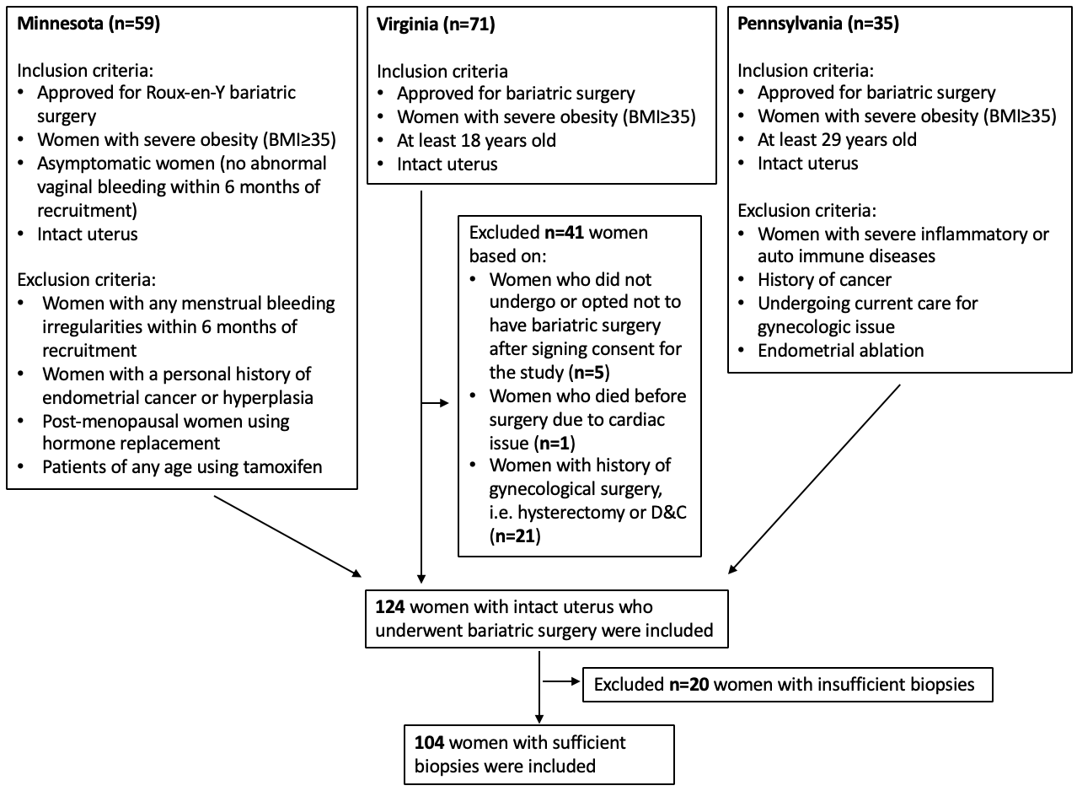

Figure 1 Study participant selection

Statistical Methods
Descriptive statistics were reported as mean (range) or median (range) for continuous variables and n (%) for categorical variables. The Chi-square test was used for detecting differences in biopsy sufficiency across the three institutions. The Wilcoxon rank sum test was used to test for differences in age and BMI between subjects with sufficient versus insufficient biopsies. Comparison of variables among the three studies were made using Kruskal-Wallis tests for continuous variables (age and BMI), and Chi-square tests for categorical variable (race) to assess whether there were relevant differences among participants across the three institutions that would preclude combining results.
The Wilcoxon rank sum test was used to test for differences in age and BMI between subjects with biopsy results of interest (“anomalies” including polyps and “proliferative endometrium”) or not. The distribution of BMI was also evaluated by more fine-grained histology categories (endometrial hyperplasia, endometrial metaplasia or polyp, proliferative endometrium, secretory endometrium, and inactive endometrium). Multivariable logistic regression was used to assess the relationship between BMI and the results of interest adjusting for age. The linearity assumption of the logistic regression model was checked using a partial residual plot. The quadratic relationship between BMI and log odds ratio of endometrial biopsy result of interest was evaluated by incorporating a quadratic effect of BMI in the logistic regression model. Data analyses were performed using Stata/SE 14.2. A two-tailed p-value less than or equal to 0.05 was considered statistically significant.

Literature Search and Comparison with Published Paper
A systematic literature search for publications on the prevalence of endometrial pathology in the general population was performed in PubMed, by using the following search strategy: (((((endometrial pathology) OR endometrial histology) OR endometrial hyperplasia)) AND ((asymptomatic) OR no symptom)) AND prevalence. The criteria for inclusion in the review were as follows: observational studies containing information on the prevalence of endometrial pathologies in the general population and published in English after January 1, 1990. We extracted and compared prevalence of anomalies and proliferative endometrium in our sample and in the papers selected from the literature search. Random-effect models were used to calculate pooled estimates with 95% confidence intervals (CIs) for selected studies from the literature search. Two-sample tests of proportions were used to compare the prevalence of endometrial hyperplasia and proliferative endometrium between our sample and the selected studies.

Results

Comparison across the Three Institutions and between Sufficient and Insufficient Biopsies
Among 124 women undergoing bariatric surgery from three cohort studies, 104 (83.9%) had endometrial biopsies that were sufficient for diagnosis. There was not a statistically significant interinstitutional difference in biopsy sufficiency (n=54; 91.5% at Minnesota; n=22; 73.3% at Virginia; and n=28; 80.0% at Pennsylvania; p=0.07). Wilcoxon rank sum test showed that the 20 (16.1%) participants with insufficient biopsies were significantly older than the 104 participants with sufficient biopsies (median 45.5 years versus 38.0 years, p = 0.02), but BMI did not differ significantly by the sufficiency of the biopsy (median 43.9 kg/m² versus 45.9 kg/m², p = 0.43).
The remaining analysis was conducted among the 104 women with sufficient samples. The median (range) of age and BMI were 38.0 years (20.0–63.0 years) and 45.9 kg/m² (35.7–80.1 kg/m²), respectively. Patient demographics are shown in Table 1. There was no significant difference in age (p = 0.52) or BMI (p = 0.16), but there was a significant difference in race distribution (p = 0.02) across the three cohorts.

Table 1 Comparison of general characteristics of study participants (N=104) by institution
 | Minnesota  (n=54) | Virginia  (n=22) | Pennsylvania  (n=28) | p-value
Age (years) | 40.5 (20.0-60.0) | 38.1 (21.0-63.0) | 38.0 (30.0-62.0) * | p = 0.52**
BMI (kg/m²) | 45.4 (36.0-64.3) * | 46.3 (40.7-80.1) * | 46.1 (35.7-66.1) * | p = 0.16**
Race |  |  |  | p = 0.02***
White | 51 (94.4%) | 17 (77.3%) | 20 (71.4%)
African American | 3 (5.6%) | 4 (18.2%) | 8 (28.6%)
Other | 0 (0.0%) | 1 (4.5%) | 0 (0.0%)
* Median (range). ** p-value is based on Kruskal-Wallis test. *** p-value is based on Chi-square test.

The percentage of participants who were equal or greater than 52 years old and the distribution of endometrial histologies by institution is shown in Table 2. Overall, 25.0% of women were at least 52 years old, which is the average age of menopause for women in the US. Total prevalence of endometrial anomalies in our study was 14.4% (15/104) or 10.6% (11/104) excluding endometrial polyps. The prevalence of any hyperplasia was 8.7% (9/104), including eight subjects with hyperplasia without atypia and one subject with atypical hyperplasia. Six participants (5.8%) had evidence of other anomalies including: 2 participants with metaplasia and 4 participants with endometrial polyps. Forty-six participants (44.2%) showed evidence of proliferative endometrium, which was the most common histology. Forty-three subjects did not have any anomalies or proliferative endometrium: secretory (25/104; 24.0%) and inactive (18/104; 17.3%). No participants presented with endometrial cancer.

Table 2 Comparison and combination of biopsy results of study participants by institution
 | Minnesota  (n=54) | Virginia  (n=22) | Pennsylvania  (n=28) | Total  (n=104)
Age ≥ 52 | 13 (24.1%) | 6 (27.3%) | 7 (25.0%) | 26 (25.0%)
Biopsy results
Anomalies excluding polyps  Endometrial hyperplasia  Endometrial metaplasia  Anomalies including polyps  Endometrial polyp | 4 (7.4%)  4 (7.4%)  NR  4 (7.4%)  NR | 3 (13.6%)  3 (13.6%)  NR  3 (13.6%)  NR | 4 (14.3%)  2 (7.1%)  2 (7.1%)  8 (28.6%)  4 (14.3%) | 11 (10.6%)  9 (8.7%)  2 (1.9%)  15 (14.4%)  4 (3.8%)
Proliferative endometrium | 24 (44.4%) | 13 (59.1%) | 9 (32.1%) | 46 (44.2%)
Other findings  Secretory endometrium  Inactive endometrium | 26 (48.1%)  14 (25.9%)  12 (22.2%) | 6 (27.3%)  6 (27.3%)  NR | 11 (39.3%)  5 (17.9%)  6 (21.4%) | 43 (41.3%)  25 (24.0%)  18 (17.3%)
NR, not reported.

Factors Related to Endometrial Histology
Age distribution did not significantly differ by the presence of the groups of interest (“anomalies” group and “proliferative endometrium” group), as a comparison to the “other findings” group (39.0 years versus 38.0 years, p = 0.97), based on the result of Wilcoxon rank sum test. BMI distribution was significantly different, with subjects with endometrial anomalies or proliferative endometrium having higher degree of obesity than their counterparts with “other findings” (median 46.4 kg/m² versus 44.5 kg/m², p = 0.006). Distribution of BMI by the more fine-grained endometrial histology categories is shown in Figure 2. Participants with hyperplasia had the highest BMI compared to any other histology categories and the group with inactive endometria had the lowest BMI. With adjustment for age and race, higher BMI was associated with higher odds of anomalies and/or proliferative endometrium (adjusted OR = 1.11, 95% CI [1.03, 1.19], per 1 kg/m²; p = 0.007). A linear association between BMI and log odds ratio of endometrial biopsy of interest was confirmed by graphing a partial residual plot. A quadratic association with BMI was not detected. These data suggest that for every 1 kg/m² increase in BMI, there was a corresponding and compounding 11% increase risk of having anomalies and/or proliferative endometrium.

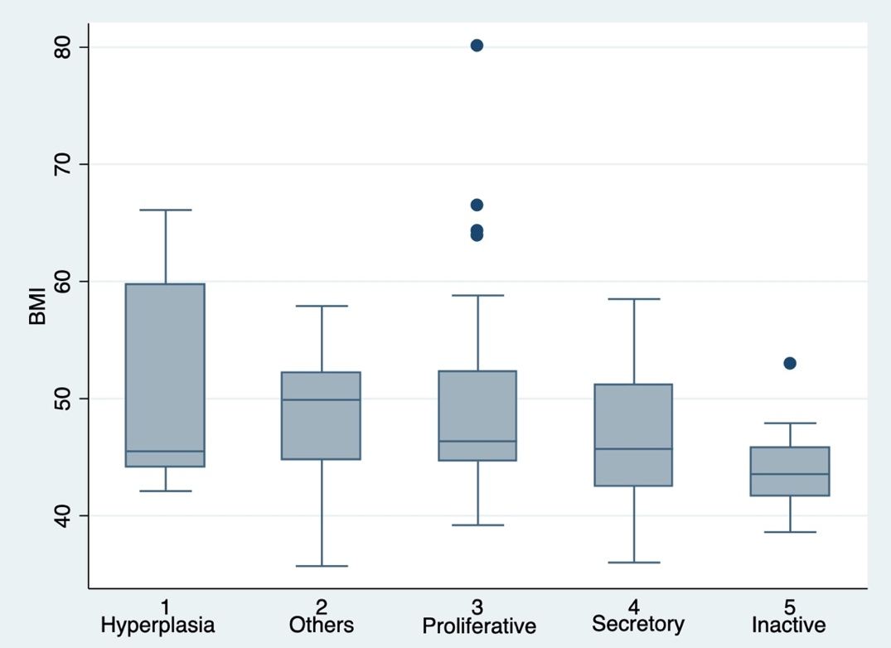
Others: endometrial metaplasia or endometrial polyp

Figure 2 Distribution of biopsy results sorted by BMI

Literature Search and Comparison Our Data with Published Work
We identified 183 articles in the initial literature search; of these five met criteria for inclusion (Figure 3). Selected studies were from different countries, including United States [52, 53], Turkey [54], Greece [55], and India [56]. Although the included subjects from the literature search did not have irregular vaginal bleeding and history of endometrial malignancy or pathology, they were at least 10-year older than our participants on average and many of them were perimenopausal or postmenopausal at the time of recruitment. In contrast to the women with severe obesity in our sample, participants included from the 5 articles were in normal weight or overweight. The prevalence of anomalies (endometrial cancer, hyperplasia, endometrial polyp, and metaplasia) in the 5 articles ranged from 2.4% to 7.3% [52-56] (Table 3), which appear lower than ours (14.4%; 95% CI: 8.3%, 22.7%). Since only one of the five articles reported endometrial polyp finding, to avoid the impact of polyps on our sample, comparison of anomalies excluding endometrial polyp was also performed. Excluding endometrial polyps, the prevalence of anomalies (endometrial cancer, hyperplasia, and metaplasia) in the 5 articles ranged from 0.8% to 7.3% [52-56], which is still lower than ours (10.6%; 95% CI: 5.4%, 18.1%). The pooled prevalence of hyperplasia (4.1%; 95% CI: 1.2%, 8.5%) in asymptomatic women in those published studies was significantly lower compared to the prevalence of our sample (8.7%; 95% CI: 4.0%, 15.8%) (p=0.02) (Figure 4). In addition, we also found that the pooled prevalence of proliferative endometrium (18.1%; 95% CI: 9.3%, 29.2%) from the literature was significantly less than the prevalence in our sample (44.2%; 95% CI: 34.5%, 54.3%) (p<0.01) (Figure 5). Serious heterogeneity was showed in both the hyperplasia prevalence (I²=96.0%) and the proliferative endometrium prevalence (I²=97.7%) among selected studies.

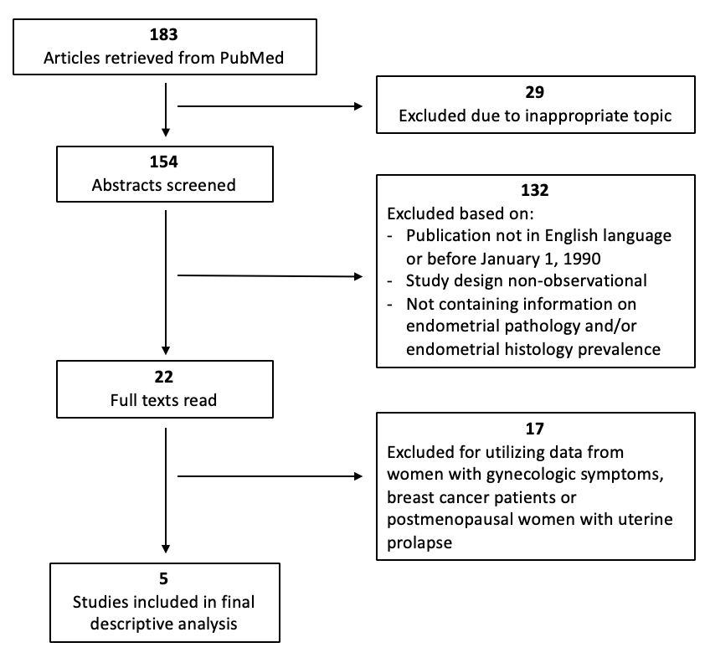

Figure 3 Study flow of literatre search and selection

 | [46-49, 57]  Our sample  (n=104) | [52]  Archer, 1991  (n=606) | [53]  Korhonen, 1996  (n=2,768) | [54]  Gol, 2009  (n=556) | [55]  Grigoriadis, 2014  (n=333) | [56]  Awale, 2018  (n=55)
General characteristics
Country | US | US | US | Turkey | Greece | India
Mean age (years) | 38.0* (range: 20.0-63.0) | 52.1±5.7 | 52.0* (range:40.0-66.0) | 52.5±6.6 | 63.6 ±10.0 | 51.1 ± 11.9
Mean BMI (kg/m²) | 45.9* (range: 35.7–80.1) | NR | 24.2 | 28.7 ± 4.8 | 26.9 ± 4.1 | NR
Endometrial biopsy results
Anomalies  Hyperplasia  Other pathologies  Cancer  Proliferative | 15  (14.4%; [8.3%, 22.7%])  9 (8.7%; [ 4.0%, 15.8%])  6 (5.8%; [ 2.1%, 12.1%])**  /  46  (44.2%; [ 34.5%, 54.3%]) | 42  (6.9%; [5.0%, 9.3%])  41 (6.8%; [4.9%, 9.1%])  NR  1 (0.2%; [0.0%, 0.9%])  133  (21.9%; [18.7%, 25.5%]) | 67  (2.4%; [1.9%, 3.1%])  19 (0.7%; [0.4%, 1.1%])  46 (1.7%; [1.2%, 2.2%])***  2 (0.1%; [0.0%, 0.3%])  696  (25.1%; [23.5%, 26.8%]) | 33  (5.9%; [4.1%, 8.2%])  30 (5.4%; [3.7%, 7.6%])  NR  3 (0.5%; [0.1%, 1.6%])  37  (6.7%; [4.7%, 9.1%]) | 9  (2.7%; [1.2%, 5.1%])  9 (2.7%; [1.2%, 5.1%])  NR  /  NR | 4  (7.3%; [2.0%, 17.6%])  4 (7.3%; [2.0%, 17.6%]))  /  /  12  (21.8%; [11.8%, 35.0%])

Table 3 Related papers on endometrial pathology prevalence
Other pathologies, endometrial metaplasia and polyps; NR, not reported; /, none. * median. ** 2 endometrial metaplasia and 4 endometrial polyps. *** 46 endometrial polyps.

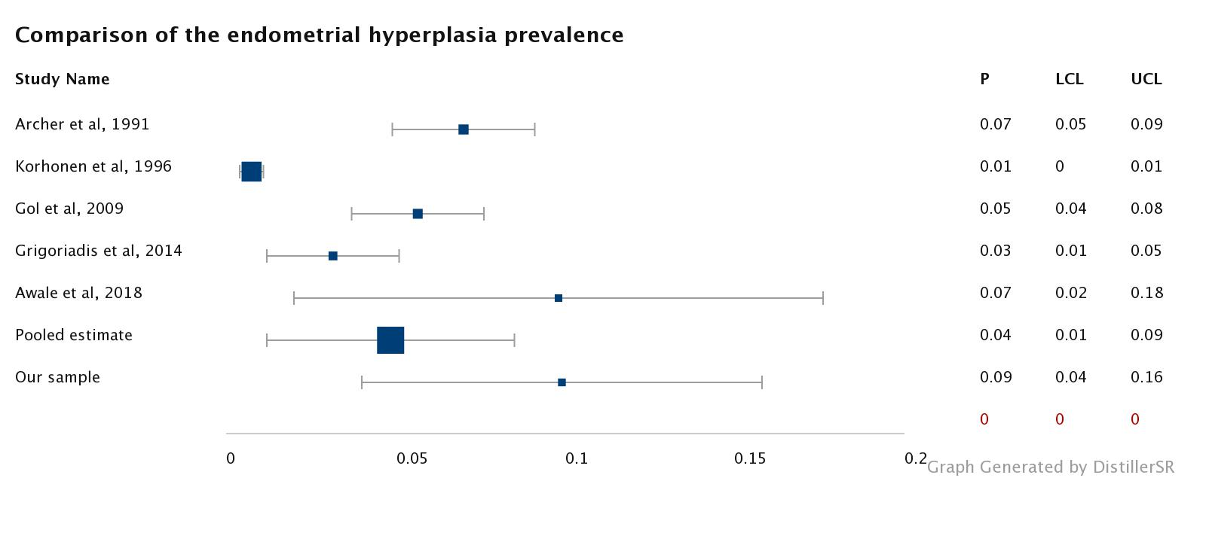
P: prevalence; LCL: lower confidence level; UCL: upper confidence level.

Figure 4 Comparison of the endometrial hyperplasia prevalence

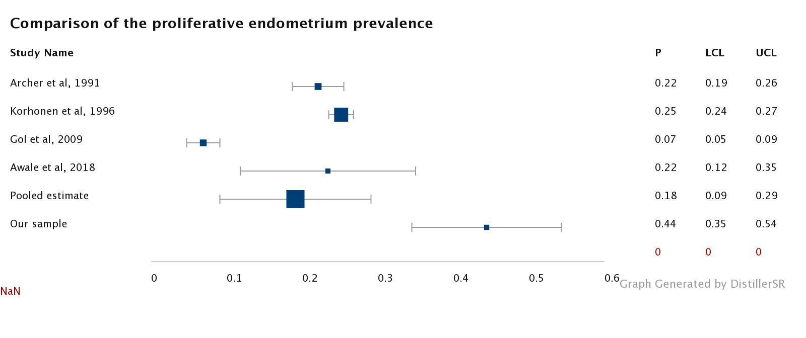
P: prevalence; LCL: lower confidence level; UCL: upper confidence level.

Figure 5 Comparison of the proliferative endometrium prevalence

Discussion
Our study confirmed the hypotheses that the odds for anomalies and proliferative endometrium increases linearly with BMI among women with severe obesity or even worse and that women with severe obesity have a higher prevalence of anomalies and proliferative endometrium. Taken together with the recent trends in the epidemic of severe obesity (especially among women under the age of 40) [58, 59], these data suggest that screening of individuals who are asymptomatic with severe obesity may be a practical route to decreasing the burden of endometrial pathology, as well as endometrial cancer morbidity and mortality. Also there may be potential cost savings of avoiding gynecologic surgery if effective interventions, such as annual serum screening for endometrial cancer in a high-risk population (i.e. obesity and age≥ 45), can be used in women with proliferative pathologies before they transform to cancers [50].
Comparison of endometrial pathologies (endometrial cancer, hyperplasia, endometrial polyp, and metaplasia) between previously published studies and our study revealed that the prevalence of anomalies in our sample (14.4%; 95% CI: 8.3%, 22.7%, with polys, 10.6%; 95% CI: 5.4%, 18.1%, without polys) was much higher than the previously reported prevalence (2.4% to 7.3% with polyps, 0.8% to 7.3% without polyps). The pooled prevalence of hyperplasia in asymptomatic women from those published studies was 4.1% (95% CI: 1.2%, 8.5%), which was significantly lower than the prevalence in our sample (8.7%; 95% CI: 4.0%, 15.8%) (p=0.02), despite the fact that samples in the published studies were slightly older, reflecting that older age is a commonly accepted risk factor for endometrial cancer [60]. Among the five selected studies, a serious heterogeneity (I²=96.0%) has been found in the prevalence of hyperplasia, which indicated a substantial diversity among the prevalence. Meanwhile, we found the pooled prevalence of proliferative endometrium (18.1%; 95% CI: 9.3%, 29.2%) in the published studies was statistically significantly lower compared to 44.2% (95% CI: 34.5%, 54.3%) observed in our study (p<0.01). Among the four selected studies, a serious heterogeneity (I²=97.7%) was found in the prevalence of proliferative endometrium, which indicated a substantial diversity among the prevalence. Of the 104 participants, 26 (25.0%) were at least 52 years old, which is the average age of menopause for women in the US. Since women with obesity are likely to have more anovulatory cycles with lower progesterone levels [4, 5], and some participants with severe obesity in our study reported irregular menstrual cycles, we can hypothesize that some of the proliferative endometrium findings could represent disordered proliferative endometrium. In women with severe obesity, the combination of proliferative endometrium and obesity could potentially increase the risk of unexpected endometrial pathologies and low fertility [4, 5].
This is one of the first studies to combine endometrial pathology results from bariatric surgery candidates across three US health systems. One of the strengths of this study is that the participants of the three cohorts included in our study share many characteristics, including severe obesity (BMI≥35), intact uteruses, no history of endometrial cancer, and being healthy enough to meet the bariatric program acceptance criteria. Most participants did not have gynecologic symptoms, such as abnormal vaginal bleeding and pelvic pain. The other strength is that all endometrial samples were obtained using a Pipelle suction curette following the same protocol. Therefore, the three groups of participants are very comparable despite different exclusion criteria and geographical locations across the three cohort studies [46-49, 57]. However, the following limitations should be considered. First, even after combining the three US cohorts, our study sample size was still relatively small, which could reduce statistical power. Second, due to lack of full medical record for every participant included in our sample, we were not sure if the proliferative endometrium finding could be considered to be in disordered pattern, although some participants reported abnormal menstrual cycles at the time of recruitment. Third, regardless of age and BMI, individual-level information on the reproductive history and menopausal status of our sample and those selected studies was not available, which might confound the prevalence of endometrial biopsy result.
Since our study demonstrated a high prevalence of endometrial pathologies in women with severe obesity, it is possible that this particular group of women (especially younger women wishing to retain fertility or to recover from infertility), may benefit from endometrial pathology screening and/or chemoprophylaxis with progesterone compounds. Larger and more thorough examination of relationships between levels of obesity and endometrial pathology are needed to better characterize high cancer risk groups who may benefit from introducing new screening measures. Additionally, future research efforts should focus on evaluating the cost-effectiveness of EC screening in high-risk women and identifying characteristics of women who can benefit from screening or prevention activities (progesterone therapy). For instance, young women with severe obesity can potentially preserve fertility and reduce healthcare expenditures from the introduction of EC preventive activities so that the number of pathologies requiring endometrial surgical interventions would be greatly reduced.

Bibliography
1. Fritz, M.A. and L. Speroff, Clinical gynecologic endocrinology and infertility. 8th ed. 2011, Philadelphia: Wolters Kluwer Health/Lippincott Williams & Wilkins. x, 1439 p.
2. Guyton, A.C. and J.E. Hall, Textbook of medical physiology. 11th ed. 2006, Philadelphia: Elsevier Saunders. xxxv, 1116 p.
3. Ducatman, B.S., Pathologic diagnosis of the abnormally bleeding patient. Clin Obstet Gynecol, 2005. 48(2): p. 274-83.
4. Boon, J., et al., Histological patterns in endometrial samples from perimenopausal women. Maturitas, 1999. 32(3): p. 155-9.
5. Giviziez, C.R., et al., Obesity and anovulatory infertility: A review. JBRA Assist Reprod, 2016. 20(4): p. 240-245.
6. McCluggage, W.G., My approach to the interpretation of endometrial biopsies and curettings. J Clin Pathol, 2006. 59(8): p. 801-12.
7. Key Statistics for Endometrial Cancer. 2019 [cited 2019 April 2]; Available from: https://www.cancer.org/cancer/endometrial-cancer/about/key-statistics.html.
8. What Are the Risk Factors for Uterine Cancer? [cited 2019 April 2]; Available from: https://www.cdc.gov/cancer/uterine/basic_info/risk_factors.htm.
9. Sheikh, M.A., et al., USA endometrial cancer projections to 2030: should we be concerned? Future Oncol, 2014. 10(16): p. 2561-8.
10. American Cancer Society., Cancer facts & figures. The Society: Atlanta, GA. p. volumes.
11. Blaustein, A. and R.J. Kurman, Blaustein's pathology of the female genital tract. 6th ed. 2011, New York, NY: Springer. xv, 1246 p.
12. Lacey, J.V., Jr. and V.M. Chia, Endometrial hyperplasia and the risk of progression to carcinoma. Maturitas, 2009. 63(1): p. 39-44.
13. Trimble, C.L., et al., Concurrent endometrial carcinoma in women with a biopsy diagnosis of atypical endometrial hyperplasia: a Gynecologic Oncology Group study. Cancer, 2006. 106(4): p. 812-9.
14. Sobczuk, K. and A. Sobczuk, New classification system of endometrial hyperplasia WHO 2014 and its clinical implications. Prz Menopauzalny, 2017. 16(3): p. 107-111.
15. Uterine polyps. 2018 [cited 2019 March 25]; Available from: https://www.mayoclinic.org/diseases-conditions/uterine-polyps/symptoms-causes/syc-20378709.
16. Serhat, E., et al., Is there a relationship between endometrial polyps and obesity, diabetes mellitus, hypertension? Arch Gynecol Obstet, 2014. 290(5): p. 937-41.
17. Torres, M.L., et al., Risk factors for developing endometrial cancer after benign endometrial sampling. Obstet Gynecol, 2012. 120(5): p. 998-1004.
18. Andersen, W.A., et al., Endometrial metaplasia associated with endometrial adenocarcinoma. Am J Obstet Gynecol, 1987. 157(3): p. 597-604.
19. Smith, R.A., et al., American Cancer Society guidelines for the early detection of cancer: update of early detection guidelines for prostate, colorectal, and endometrial cancers. Also: update 2001--testing for early lung cancer detection. CA Cancer J Clin, 2001. 51(1): p. 38-75; quiz 77-80.
20. The American College of Obstetricians and Gynecologists Committee Opinion No. 734: The Role of Transvaginal Ultrasonography in Evaluating the Endometrium of Women With Postmenopausal Bleeding. Obstet Gynecol, 2018. 131(5): p. e124-e129.
21. Practice Bulletin No. 149: Endometrial cancer. Obstet Gynecol, 2015. 125(4): p. 1006-26.
22. Piatek, S., G. Panek, and M. Wielgos, Assessment of the usefulness of pipelle biopsy in gynecological diagnostics. Ginekol Pol, 2016. 87(8): p. 559-64.
23. Adambekov, S., et al., Patient and provider factors associated with endometrial Pipelle sampling failure. Gynecol Oncol, 2017. 144(2): p. 324-328.
24. Elsandabesee, D. and P. Greenwood, The performance of Pipelle endometrial sampling in a dedicated postmenopausal bleeding clinic. J Obstet Gynaecol, 2005. 25(1): p. 32-4.
25. Obesity: preventing and managing the global epidemic. Report of a WHO consultation. World Health Organ Tech Rep Ser, 2000. 894: p. i-xii, 1-253.
26. What is Obesity? [cited 2019 March 10]; Available from: https://www.obesityaction.org/get-educated/understanding-your-weight-and-health/what-is-obesity/.
27. WHO. Global status report on noncommunicable diseases 2014. 2014 [cited 2019 Feburary 27]; Available from: http://apps.who.int/iris/bitstream/10665/148114/1/9789241564854_eng.pdf?ua=1.
28. Hales, C.M., et al., Prevalence of Obesity Among Adults and Youth: United States, 2015-2016. NCHS Data Brief, 2017(288): p. 1-8.
29. Guidelines (2013) for managing overweight and obesity in adults. Preface to the Expert Panel Report (comprehensive version which includes systematic evidence review, evidence statements, and recommendations). Obesity (Silver Spring), 2014. 22 Suppl 2: p. S40.
30. Fryar CD, C.M., Ogden CL. Prevalence of overweight and obesity among children and adolescents aged 2–19 years: United States, 1963–1965 through 2013–2014. 2016 [cited 2019 March 10]; Available from: https://www.cdc.gov/nchs/data/hestat/obesity_child_13_14/obesity_child_13_14.htm.
31. Fryar CD, C.M., Ogden CL. Prevalence of overweight, obesity, and extreme obesity among adults aged 20 and over: United States, 1960–1962 through 2011–2014. 2016 [cited 2019 March 10]; Available from: https://www.cdc.gov/nchs/data/hestat/obesity_adult_13_14/obesity_adult_13_14.htm.
32. Shaw, E., et al., Obesity and Endometrial Cancer. Recent Results Cancer Res, 2016. 208: p. 107-136.
33. Epplein, M., et al., Risk of complex and atypical endometrial hyperplasia in relation to anthropometric measures and reproductive history. Am J Epidemiol, 2008. 168(6): p. 563-70; discussion 571-6.
34. Estimate of Bariatric Surgery Numbers, 2011-2017. 2018 [cited 2019 Feburary 27]; Available from: https://asmbs.org/resources/estimate-of-bariatric-surgery-numbers.
35. Sawaya, R.A., et al., Vitamin, mineral, and drug absorption following bariatric surgery. Curr Drug Metab, 2012. 13(9): p. 1345-55.
36. Meek, C.L., et al., The effect of bariatric surgery on gastrointestinal and pancreatic peptide hormones. Peptides, 2016. 77: p. 28-37.
37. Bays, H.E., et al., Lipids and bariatric procedures part 1 of 2: Scientific statement from the National Lipid Association, American Society for Metabolic and Bariatric Surgery, and Obesity Medicine Association: FULL REPORT. J Clin Lipidol, 2016. 10(1): p. 33-57.
38. Surgery, A.S.f.M.a.B. Bariatric Surgery Procedures. 2018 [cited 2019 Feburary 27]; Available from: https://asmbs.org/patients/bariatric-surgery-procedures.
39. Weiner, R.A., [Indications and principles of metabolic surgery]. Chirurg, 2010. 81(4): p. 379-94; quiz 395.
40. Picot, J., et al., The clinical effectiveness and cost-effectiveness of bariatric (weight loss) surgery for obesity: a systematic review and economic evaluation. Health Technol Assess, 2009. 13(41): p. 1-190, 215-357, iii-iv.
41. Colquitt, J.L., et al., Surgery for weight loss in adults. Cochrane Database Syst Rev, 2014(8): p. CD003641.
42. Mechanick, J.I., et al., Clinical practice guidelines for the perioperative nutritional, metabolic, and nonsurgical support of the bariatric surgery patient--2013 update: cosponsored by American Association of Clinical Endocrinologists, the Obesity Society, and American Society for Metabolic & Bariatric Surgery. Endocr Pract, 2013. 19(2): p. 337-72.
43. Sheng, B., et al., The Long-Term Effects of Bariatric Surgery on Type 2 Diabetes Remission, Microvascular and Macrovascular Complications, and Mortality: a Systematic Review and Meta-Analysis. Obes Surg, 2017. 27(10): p. 2724-2732.
44. Kokkinos, A., et al., Improvement in cardiovascular indices after Roux-en-Y gastric bypass or sleeve gastrectomy for morbid obesity. Obes Surg, 2013. 23(1): p. 31-8.
45. Schauer, D.P., et al., Association Between Weight Loss and the Risk of Cancer after Bariatric Surgery. Obesity (Silver Spring), 2017. 25 Suppl 2: p. S52-S57.
46. Kaiyrlykyzy, A., et al., Endometrial histology in severely obese bariatric surgery candidates: an exploratory analysis. Surg Obes Relat Dis, 2015. 11(3): p. 653-8.
47. Linkov, F., et al., Bariatric surgery-induced weight loss changes immune markers in the endometrium of morbidly obese women. Surg Obes Relat Dis, 2014. 10(5): p. 921-6.
48. Argenta, P.A., et al., Bariatric surgery and endometrial pathology in asymptomatic morbidly obese women: a prospective, pilot study. BJOG, 2013. 120(7): p. 795-800.
49. Modesitt, S.C., et al., Women at extreme risk for obesity-related carcinogenesis: Baseline endometrial pathology and impact of bariatric surgery on weight, metabolic profiles and quality of life. Gynecol Oncol, 2015. 138(2): p. 238-45.
50. Havrilesky, L.J., G.L. Maxwell, and E.R. Myers, Cost-effectiveness analysis of annual screening strategies for endometrial cancer. Am J Obstet Gynecol, 2009. 200(6): p. 640 e1-8.
51. Who is a Candidate for Bariatric Surgery? 2019 [cited 2019 March 12]; Available from: https://asmbs.org/patients/who-is-a-candidate-for-bariatric-surgery.
52. Archer, D.F., et al., Endometrial morphology in asymptomatic postmenopausal women. Am J Obstet Gynecol, 1991. 165(2): p. 317-20; discussion 320-2.
53. Korhonen, M.O., et al., Histologic classification and pathologic findings for endometrial biopsy specimens obtained from 2964 perimenopausal and postmenopausal women undergoing screening for continuous hormones as replacement therapy (CHART 2 Study). Am J Obstet Gynecol, 1997. 176(2): p. 377-80.
54. Gol, K., et al., Endometrial patterns and endocrinologic characteristics of asymptomatic menopausal women. Gynecol Endocrinol, 2001. 15(1): p. 63-7.
55. Grigoriadis, T., et al., Vaginal hysterectomy for uterovaginal prolapse: what is the incidence of concurrent gynecological malignancy? Int Urogynecol J, 2015. 26(3): p. 421-5.
56. Awale, R., et al., Uterine Prolapse: Should Hysterectomy Specimens be Subjected for Histopathological Examination? J Midlife Health, 2017. 8(4): p. 179-182.
57. Argenta, P., et al., Hormone receptor expression patterns in the endometrium of asymptomatic morbidly obese women before and after bariatric surgery. Gynecol Oncol, 2014. 133(1): p. 78-82.
58. Hales, C.M., et al., Trends in Obesity and Severe Obesity Prevalence in US Youth and Adults by Sex and Age, 2007-2008 to 2015-2016. JAMA, 2018. 319(16): p. 1723-1725.
59. Ladabaum, U., et al., Obesity, abdominal obesity, physical activity, and caloric intake in US adults: 1988 to 2010. Am J Med, 2014. 127(8): p. 717-727 e12.
60. Ali, A.T., Risk factors for endometrial cancer. Ceska Gynekol, 2013. 78(5): p. 448-59.

