Title Page
Telemedicine: A Race to Catch Up

by
Evan Roman
BS Biobehavioral Health, Pennsylvania State University, 2016

Submitted to the Graduate Faculty of
Health Policy and Management
Graduate School of Public Health in partial fulfillment
of the requirements for the degree of
Master of Health Administration

University of Pittsburgh
2019

Committee Membership Page
UNIVERSITY OF PITTSBURGH
GRADUATE SCHOOL OF PUBLIC HEALTH

This essay is submitted
by
Evan Roman

on

April 16, 2019

and approved by

Essay Advisor:
Kevin D. Broom, PhD, MBA
Vice Chair of Education
Director, MHA and MHA/MBA Programs
Graduate School of Public Health
University of Pittsburgh

Essay Readers:

Annmarie Lyons, MHS
Executive Administrator
Department of Anesthesiology and Perioperative Medicine
University of Pittsburgh Medical Center

Michael Donahoe, MD
Executive Vice Chair of Clinical Affairs
Department of Medicine
University of Pittsburgh Medical Center

Copyright © by Evan Roman
2019

Abstract
Kevin Broom, PhD, MBA

Telemedicine: A Race to Catch Up

Evan Roman, MHA
University of Pittsburgh, 2019

Abstract

Across the United States, health care organizations are in pursuit of achieving the Institute for Healthcare Improvement’s (IHI) Triple Aim Initiative: reducing per capita expenditure, improving the health of populations, and increasing the quality of care provided. Unlike other industries, health care consumers are less informed about the services being provided. However, like other industries, convenience is a characteristic that all patients factor in when managing their care. One of the major goals of telemedicine is to enhance the delivery of health care to geographically disadvantaged and medically underserved populations, thereby providing an improved quality of care while decreasing costs. The purpose of this essay is to show the capabilities that telemedicine can provide, its public health importance, how it benefits both patients and providers, obstacles to overcome, and why it is not being used to its full potential today. Additionally, this essay will introduce University of Pittsburgh Medical Center (UPMC) and how UPMC’s Department of Medicine (DOM) is addressing telemedicine with a look into one specific program – Outpatient Parenteral Antibiotic Therapy (OPAT).
Table of Contents
Acronyms viii
1.0 Introduction 1
1.1 Background 1
1.2 Modern Telemedicine 4
1.3 Types of Telemedicine 5
1.4 Benefits and Risks 8
1.4.1 Benefits 8
1.4.2 Risks 9
1.5 Telemedicine Reimbursement 11
1.5.1 Medicare 11
1.5.2 Medicaid 13
1.5.3 Private Payer 14
2.0 University of Pittsburgh Medical Center 16
2.1 Department of Medicine 16
2.2 Outpatient Parenteral Antibiotic Therapy (OPAT) 17
3.0 Conclusions and Recommendations 21
Bibliography 22

List of Tables
Table 1. Number of Plans Covering or Not Covering Telehealth Services in 2017 11
Table 2. State Coverage of Telehealth Modalities in Medicaid, October 2017 14
List of Figures
Figure 1. List of Federal Agencies Used to Unify a Definition for Telehealth 2
Figure 2. Depiction of Asychronous vs Synchronous Use 7
Figure 3. Medicare Coverage of Telemedicine 13
Figure 4. Four Telehealth Delivery Pathways of Commercial Insurance Plans 15
Figure 5. UPMC Department of Medicine Telehealth Service Locations 17
Figure 6. OPAT Stakeholder Swim Line 20

Acronyms
University of Pittsburgh Medical Center (UPMC)
Department of Medicine (DOM)
Department of Health and Human Services (DHHS)
Agency for Healthcare Research and Quality (AHRQ)
Centers for Disease Control and Prevention (CDC)
Centers for Medicare & Medicaid (CMS)
Food and Drug Administration (FDA)
Health Resources and Services Administration (HRSA)
Indian Health Service (IHS)
National Institutes of Health (NIH)
Office of the Assistant Secretary for Preparedness and Response (OASPR)
World Health Organization (WHO)
National Aeronautics and Space Administration (NASA)
Electrocardiograph (EKG)
Health Insurance Portability and Accountability Act (HIPAA)
Health Information Technology for Economic and Clinical Health Act (HITECH)
Remote Patient Monitoring (RPM)
Health Professional Shortage Area (HPSA)
Outpatient Parenteral Antibiotic Therapy (OPAT)
Intravenous (IV)
Skilled Nursing Facility (SNF)
Infectious Disease (ID)
Peripherally Inserted Central Catheter (PICC)

Introduction
As a Master of Health Administration (MHA) student and administrative resident at UPMC’s Department of Medicine (DOM), telemedicine has revealed the endless amount of opportunity for growth across the health care industry. I have developed a continued interest on the potential to increase system efficiency while simultaneously addressing patients facing barriers to access. An increase in systems efficiency is accompanied by hesitation associated with care quality, efficacy, and population demographics, as well as government regulation restrictions. Through my graduate education and experience at UPMC, I have observed how telemedicine can impact these issues.

Background
The emerging trend of consumerism in health care has created a demand for providing more accessible care to the patients being served. Accessibility is one of the most frequent barriers to populations receiving adequate care. Telemedicine’s purpose aims to address the issues of a growing aging population and the shortage of health care providers while incorporating evolving technological abilities.
To fully understand the complexities of telemedicine, it is important for both consumers (patients) and providers to become familiar with the language used in defining telemedicine and the false interchangeability with the term “telehealth” that confuses even the most informed consumers. This confusion stems from the slight variability seen in the hundreds of organizations that define these terms.
A study conducted by the World Health Organization (WHO) adopted the following description of telemedicine after examining 104 peer-reviewed articles that included definitions of the word. Per the WHO, telemedicine is defined as “the delivery of health care services, where distance is a critical factor, by all health care professionals using information and communication technologies for the exchange of valid information for diagnosis, treatment and prevention of disease and injuries, research and evaluation, and for the continuing education of health care providers, all in the interests of advancing the health of individuals and their communities” (Ryu, 2012).
The Department of Health and Human Services (DHHS) found overlap in definitions across multiple federal agencies (see Figure 1). The DHHS’s effort combined the different definitions and defines telehealth as “the use of electronic information and telecommunications technologies to support long-distance clinical healthcare, patient and professional health-related education, public health, and health administration” (Doarn, 2014).

Federal Agencies
Department of Health and Human Services | Health Resources and Services Administration
Agency for Healthcare Research and Quality | Indian Health Services
Centers for Disease Control and Prevention | National Institutes of Health
Centers for Medicare and Medicaid | Office of the Assistant Secretary for Preparedness and Response
Food and Drug Administration

Figure 1. List of Federal Agencies Used to Unify a Definition for Telehealth

Using these combined sources, definitions for telemedicine and telehealth can be derived as the following:
Telemedicine refers to the utilization of technologies to remotely diagnosis, monitor and treat patients.
Telehealth refers to the application of technologies to assist patients manage their illness through better self-care, access to education, and support systems.
This paper will focus mainly on the application of telemedicine. One of the earliest forms of telemedicine was first utilized in the late 1960s. At that time, the National Aeronautics and Space Administration (NASA) aimed to determine if the human body could function in space. To examine this, scientists performed test flights sending animals to space attached with medical monitoring systems to analyze their biometric data (Smith & Yvette, 2013). This was the earliest example of remotely monitoring vital signs. As time progressed, different specialty areas of care began to incorporate telemedicine practices across the country. Radiology departments began to send imagines via telephone lines. Neurological exams were sent between providers using “interactive” telemedicine. Telemedicine eventually evolved to be used between general practitioners and mental health facilities via the use of televisions.
In the 1990s, the rise of the Internet resulted in an explosion of information. At this time, the Health Insurance Portability and Accountability Act (HIPAA) was enacted to increase patient confidentiality and secure patient information. Patient information, medical images, real-time audio and video consultation, vital signs and other body measurements could now be digitally transmitted. Transmission of patient data and medical information via unsecure information channels increased the possibility of violating HIPAA. Ambiguity arose regarding means of handling this new form of care and information. Considering this ambiguity, a requirement was enacted for health care professionals and providers to treat all telehealth-related information to the same standard as historical and established medical care (Ridings, 2016). The Health Information Technology for Economic and Clinical Health Act (HITECH) was created in 2009 to regulate the process of storing patient information within a proper infrastructure and helped pave the way for telemedicine adoption (HHS, 2017).

Modern Telemedicine
Patients constantly experience barriers to accessible care and treatment. These barriers include long wait times to next appointment, transportation or mobility constraints, and privacy concerns. These challenges are heightened by the amount of numerous follow-up visits in which patients are expected to attend. Telemedicine’s goal is to address these issues through its different modalities.
Technology and telemedicine are advancing faster than ever before. Currently, according to the American Hospital Association, roughly 76% of U.S. hospitals connect with patients and consulting practitioners at a distance using video and other electronic capabilities (American Hospital Association, 2019). Additionally, it is estimated that nearly seven million patients utilized telemedicine capabilities in 2018. As technology becomes even more incorporated with everyday life and in health care, patients and providers across the country will become more exposed to the options telemedicine offers.
Telemedicine’s provision of care is facilitated and dependent on two unique relationships: patient-to-provider and provider-to-provider. These relationships, which in most instances are formed in person, are essential to optimizing patient outcomes. Patient-to-provider is a trust-based relationship that relies on the provider to utilize sound medical judgement to place the patient’s welfare above the provider’s own self-interest or obligation. This relationship exists in the form of digital visits (E-visits), wearable technology and secure messaging. Provider-to-provider is a relationship where a consultation between two providers occur to advise or give opinion regarding care management/evaluation. This relationship exists in the form of digital consults (E-consults), electronic health records, and second opinion consults. Both relationships rely on trust. Technology and telemedicine provide more options and improvements to enhance this relationship.
Technology has many functions in healthcare. These functions include document/data storage, predictive analytics, communications and robotic/surgical support. Recent advancements in telehealth and telemedicine reveal a glimpse at its future potential. Some notable advancements recently cleared by the FDA include medical device accessories that uses the Apple Watch to capture an electrocardiograph (EKG) - enabling detection of heart issues, remote programming capabilities for cochlear hearing implants, and ingestible “smart pills” with digital sensors designed to monitor medication adherence (Singer, 2017).

Types of Telemedicine
When telemedicine is discussed, many delivery methods can be envisioned. There are three methods of telemedicine delivery: asynchronous delivery, synchronous delivery, and remote patient monitoring.

Asynchronous Delivery
Otherwise referred to as “Store-and-Forward”, asynchronous telemedicine takes a patient’s digital medical information and data in one location and allows it to be transmitted for interpretation by a provider at another site location or time. Instead of coming in for a routine check-up or follow-up appointment, a patient is either seen as a walk-in visit or schedules a virtual visit. On the day of their visit they answer questions that a provider would normally ask and will usually receive a response within the next few days. This care delivery form does not require simultaneous presence of both the patient and provider. Through this delivery method, digital images, documents, and pre-recorded videos can be securely passed from the patient’s location to the provider so long as they comply with HIPAA guidelines initiated by the individual health organization’s internal legal entity. This method increases a provider’s ability to see more patients by performing diagnoses and consultation when face-to-face visits are either unnecessary or inconvenient. Additionally, it reduces wait time to next appointment and no-show rates by eliminating the need for coordinating schedules.
Synchronous Delivery
Live, real-time communication between provider and patient is synchronous communication. This two-way interaction can exist via telephone, live video or other audiovisual technology. This method enhances patient access and convenience by limiting travel requirements by the patient. In many instances, travel is still required by the patient, however, instead of traveling to a city that may be located far away or involve heavy traffic, the patient travels to a tele-consult center located near the patient. This allows for a physician with specific expertise to consult with the patient in an approved location convenient for them. Both aspects attract providers and patients alike. Figure 2 shows the difference between the delivery forms.

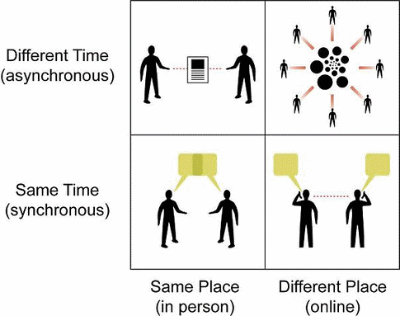
Figure 2. Depiction of Asychronous vs Synchronous Use
(Source: Smith)

Remote Patient Monitoring
Remote Patient Monitoring (RPM) is the collection of medical and personal health information from a patient that is in one location and electronically transferring it to a provider in another location for monitoring purposes. It can incorporate components of asynchronous delivery where health information is examined at a different time and location or can be used to monitor real-time health measures. Active monitoring of a patient creates potential to have better real-time management of a patient’s conditions. This method provides in-home equipment that monitors a patient’s key measures associated with their condition. In most cases, 24-hour nurse care is impractical and unnecessary. RPM addresses patients with increased care needs who also are attributed to having high health care costs.

Benefits and Risks
Health care services provided via telemedicine present both benefits and risks. These benefits and risks have implications at both the small and large-scale level.

Benefits
Convenience/accessibility
Telemedicine’s convenience attracts providers and patients alike. It, by definition, allows for the breakdown of geographical barriers between provider and patient. Patients located in areas with few providers or providers who do not offer expertise needed to treat their condition can be provided necessary services that were previously unavailable. Additionally, it reduces patients travel obligations which often limits care when transportation or a patient’s physical mobility is an issue.
Increased Engagement
From a consumer’s perspective, higher connectivity to accessible care is indicative of higher engagement in care management. Eliminating travel and wait times is an attractive feature for patients across the age spectrum. With a strong relationship with their provider, patients are more vested in managing their care.
Cost Saving
The U.S. spends more on health care than any other developed nation (Sawyer & Cox, 2018). Much of this spending is both unnecessary and avoidable (CDC, 2019). Telemedicine is linked to a reduction of costs through better chronic disease management, fewer or shorter in-patient stays, health professional staffing, unnecessary emergency room visits, non-adherence to medication and an increase in efficiency of doctor visits (URAC, 2017). According to URAC, telemedicine visits are less expensive than in-person clinic visits. Due to this reduced expense, private insurance companies and state-run programs have begun to increase the scope coverage for telemedicine-related services.

Risks
Cross-State Practice

As technology advances and utilization of telemedicine increases, professional boards relating to state credentialing and licensure often encounter issues providing care to patients in different states. The Interstate Medical Licensure Compact allows physicians to practice telemedicine across state lines with greater ease. Unless located in one of the nineteen states that has adopted this compact, a provider rendering health care services to a patient located in another state must host a valid and unrestricted license for the state where the patient is located, even when the provider is not physically in that state (Stewart, 2017). Access to care is limited when a physician cannot practice across state lines. This stipulation may deter providers from going out of their way to get an additional license necessary to provide cross-state care. The ideology behind telemedicine is based on treating the patient as if it was an in-person visit. States not included in this compact are restricted to care within their state lines.
Establishing Provider-Patient Relationships

As a precursor to a provider treating a patient, many states believe a valid relationship between the patient and provider must be established before telemedicine services can be provided. In most states, this relationship must consist of one in-person encounter. An in-person provider-patient examination is an important component of care continuity and maintaining the relationship (Doherty, 2016). However, this requirement should be revisited in the future to limit specific specialties to this practice. Other areas of care may utilize provider-to-provider consultation, so care can progress.
Coverage and Reimbursement

Most laws regarding coverage and reimbursement were written before the use of telemedicine. Coverage and reimbursement of telemedicine services are different at the federal, state and commercial level. These differences will be explored later in this paper. Since the criterion related to coverage and reimbursement is ambiguous and inconsistent, obstacles present themselves when treating patients across the payor mix and state lines. These obstacles include insurance coverage as a patient, reimbursement for services rendered as a provider, different state licensing and credentialing laws, and constantly changing policy and regulation. Table 1 compares the different types of telehealth services covered and not cover by 48 different insurance plans.

Table 1. Number of Plans Covering or Not Covering Telehealth Services in 2017
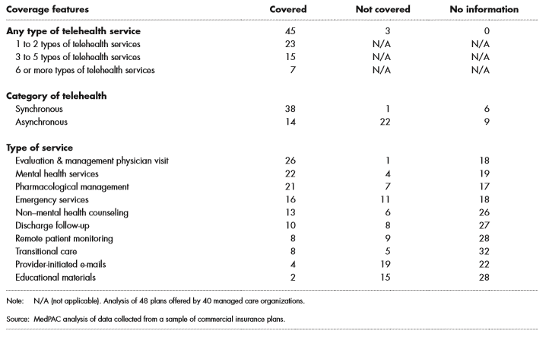(Source: MedPac)

Telemedicine Reimbursement

Medicare
In earlier years, reimbursement for services provided to patients with Medicare, a federally-run program that provides health coverage for individuals 65 years or older or have severe disability, had strict requirements. There were few services provided via telemedicine that would be reimbursable by insurance companies. However, as the industry continues to grow, these strict requirements are expanding to a wider, yet still limiting, list.
Reimbursement for telemedicine services is dependent on three major criteria that a Medicare beneficiary (patient) must meet (see Figure 3). First, the patient must receive services at an Originating Site. Authorized sites include: physician or practitioner office, hospital, critical access hospital, rural health clinics, federally qualified health centers, hospital-based renal Dialysis Centers, skilled nursing facilities, and community mental health centers. The second criteria states that the Originating Site must reside in a Health Professional Shortage Area (HPSA). A HPSA is a geographic area, population, or facility with a shortage of primary care, dental, or mental health providers and services (Health Professional). Finally, to be reimbursed, only the following providers can bill for a telemedicine procedure: physician, nurse practitioner, physician assistant, nurse midwife, clinical nurse specialist, clinical psychologist, clinical social worker, and registered dietitian or nutrition professional.
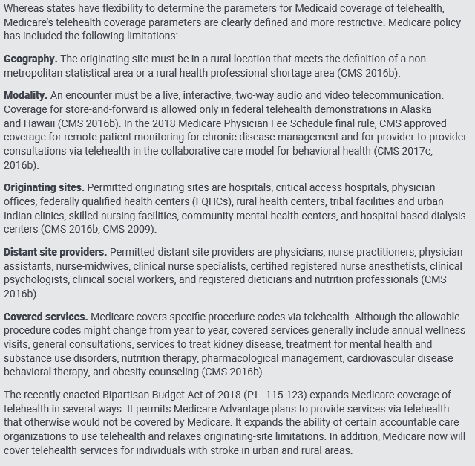
Figure 3. Medicare Coverage of Telemedicine

(Source: Telehealth in Medicare)

Medicaid
Medicaid is an insurance program run by both state and federal governments that provides health coverage for low income individuals. Each state’s governing body determines eligibility requirements. As seen in Table 2, coverage and reimbursement vary greatly state to state. When assessing a state-run program as a patient, the following factors should be considered to determine eligibility: services provided, eligible providers, state-to-state licensing, and location restrictions.

Table 2. State Coverage of Telehealth Modalities in Medicaid, October 2017
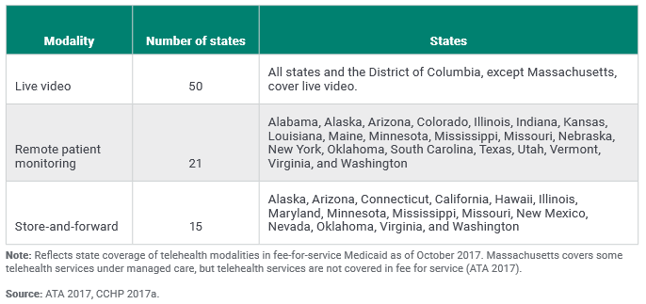
(Source: ATA)

Private Payer
Like Medicaid with each state having autonomy to develop different reimbursement and eligibility policies, each private payer handles telemedicine reimbursement differently. Recently, after recognizing benefits of the service, many larger insurance companies are expanding coverage of telemedicine services (see Figure 4). Today, thirty states plus the District of Columbia require private insurers to cover telemedicine with the same coverage that they use for in-person visits.

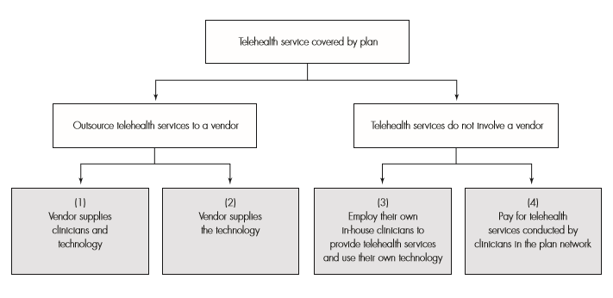
Figure 4. Four Telehealth Delivery Pathways of Commercial Insurance Plans

(Source: MedPac)

University of Pittsburgh Medical Center
UPMC is a world-renowned, evolving health care organization providing patients with accessible care at 40+ hospital locations with over 8,500 licensed beds. In the last few years, telemedicine is an area experiencing extraordinary growth within the system – providing subspecialty clinical services in over 35 areas. This expansion is possible through the collaborative work of the organization’s different divisions (Health Services, Insurance Services, International, Enterprise, and Corporate).

Department of Medicine
UPMC’s Department of Medicine (DOM) is the largest clinical department within the organization. The DOM provides innovative care through its ten divisions, 1900 employees, and nearly eighty outpatient locations. Responding to the needs of the patient population, the DOM has been utilizing advanced technology and telemedicine in the form of 21 existing programs. These services are comprised of ten inpatient programs, eleven outpatient programs, with an additional nine future program requests. Currently, the DOM provides telemedicine services at twelve locations and in five divisions (Endocrinology, Gastroenterology, General Internal Medicine, Infectious Diseases, Nephrology, Pulmonary Medicine, Rheumatology) (see Figure 5). One specific program, Outpatient Parenteral Antibiotic Therapy (OPAT), aims to address high readmissions rates and their associated costs to the system in a patient population within the Infectious Disease (ID) division.
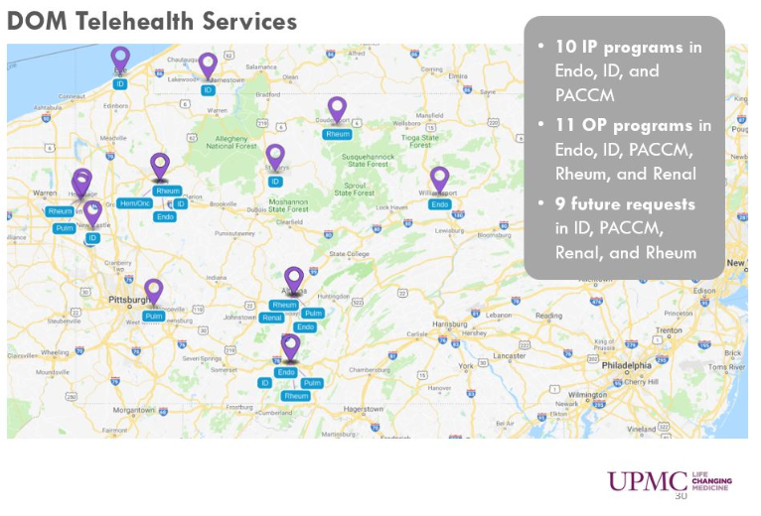

Figure 5. UPMC Department of Medicine Telehealth Service Locations

Outpatient Parenteral Antibiotic Therapy (OPAT)
The OPAT program was designed by ID physician, Dr. Kathleen Sheridan, to monitor patients that require intravenous (IV) antibiotics to treat various types of infections after discharge from the hospital. Most patients receive six weeks of IV antibiotics, which requires regular monitoring for side effects related to antibiotic use and the need for dose adjustments based on changing renal & hepatic function. Patients on IV antibiotics may receive these at home with the aid of a caregiver or at a skilled nursing facility (SNF). Patients on IV antibiotics have a high 30-day readmission rate, but this rate can be reduced if patients are evaluated by an ID provider. The provider can assess for worsening infection, antibiotic related toxicity, and peripherally inserted central catheter (PICC) line complications. This assessment has been shown to reduce the 30-day readmission rate significantly. Many patients are not able to attend the ID clinic for follow up; roughly 20.2% are seen in ID clinic at this time. The average readmission rate for the 9,998 patient encounters is 33.0%. Through the facilitation of home health nurses, technology and pharmacy, telemedicine visits provide the capability to bring the ID provider to the patient and return the patient to their normal activities (see Figure 6).
Telemedicine visits eliminate several barriers to visit-compliance. These barriers include transportation concerns, immobility of the patient, and caregiver availability (particularly related to employment). Using telemedicine, providers can visualize wounds and, PICC lines, assess cardiac & respiratory status and complete a detailed physical exam and then discuss any concerns with the patient, the caregiver and the home nurse concurrently. It also allows for the ability to provide real time orders to home health for wound care concerns, lab orders, & medication adjustments to minimize delays. This approach provides a unique multidisciplinary team approach to caring for our patients. The belief is that by increasing visit compliance rate through the telemedicine visit, there will be a decrease in the 30-day readmission rate which will reduce costs associated with readmissions, emergency room visits, clinic visits, transportation, and improve the patient experience and satisfaction.
Preliminary piloting of this program without the utilization of telemedicine has occurred from January 2015 to December 2018. The goal during this time frame was to determine the impact that the ID follow-up has in relation to 30-day return rates. Analysis of 30-day return rate of patients with and without a follow-up visit show that patients without a follow-up have a 65.8% return rate compared to 16.7% in those with a follow-up visit, a difference of 49.1%. Considering these findings, next steps have been initiated to scale-up this program to incorporate telemedicine into care and bring the follow-up visit to the patient. Although it is in the early stages, a workgroup has been formed integrating stakeholders from the Department of Medicine leadership, ID division, Health Plan, and finance. The focus has been to identify a broader patient population, review clinical efficiencies, analyze and develop new workflows, and model payment structures. By bringing the follow-up visit to the patient, remotely monitoring vitals, and addressing questions related to care, the system can expect significant savings. Financial modeling for the four-year program expansion projects estimates of roughly $415 cost savings per patient discharged and a total of $20,000 in avoided readmission costs per month. As patient volume increases, the program will expand going from two hospital locations in year one to four hospital locations by year four. The total four-year net incremental savings for the system is estimated $390,000. The implementation date is set for later this year.
This is one example of the DOM and UPMC’s response to better serve its patient population. By incorporating telemedicine practices into treatment plans, patients will experience better outcomes that are more accessible and convenient to them. Providers can be more involved in care management due to the increase in follow-up visits. Lastly, the system will avoid unnecessary hospital readmissions resulting in a reduction in expenditure.

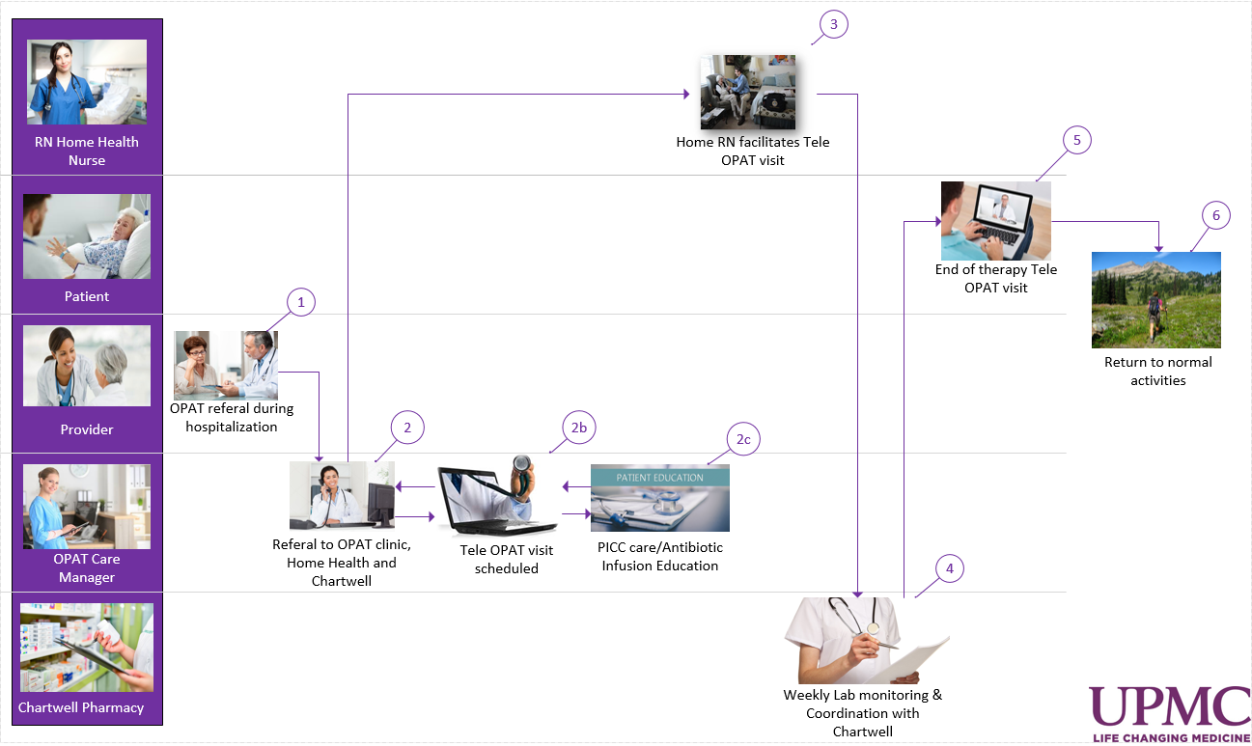

Figure 6. OPAT Stakeholder Swim Line

Conclusions and Recommendations
Telemedicine’s growth over the past few decades forecasts a future of hope and uncertainty. As time progresses, consumerism will become a greater demand than it already is. Patients want to receive care when and where it is convenient for them. Providers want to keep established patient relationships and improve patient outcomes. Health systems want to reduce unnecessary visits and the costs associated. Giving the findings from the OPAT program and overall benefits mentioned, telemedicine may be one way to avoid these uncertainties.
The restrictions on coverage both in federally and state-run programs impinge on the potential benefits and access that telemedicine has to offer. Moving forward, the importance of education and policy regulation relating to telemedicine is paramount. The future of medical management, health management and wellness are not in a hospital. The future of these aspects of care is in outpatient facilities utilizing telemedicine. Government officials must fine-tune details relating to reimbursement, state barriers, and eligible providers. In doing so, the following result is expected: improved health outcomes, increased quality of care, and decreased per capita expenditure. The technology is in place; now it is just a race to catch up.

Bibliography
“About Telemedicine.” About Telemedicine - ATA Main, 2019, www.americantelemed.org/about/about-telemedicine.

Doarn, Charles R., et al. “Federal Efforts to Define and Advance Telehealth—A Work in
Progress.” Telemedicine and e-Health, vol. 20, no. 5, 2014, pp. 409–418.,
doi:10.1089/tmj.2013.0336.

Doherty, Robert. “Must Telemedicine Disrupt the Patient-Doctor Relationship?” ACP Internist, 1 Jan. 2016, acpinternist.org/archives/2016/01/washington.htm.

“Fact Sheet: Telehealth.” American Hospital Association, Feb. 2019,
www.aha.org/system/files/2019-02/fact-sheet-telehealth-2-4-19.pdf.

“Health and Economic Costs of Chronic Disease | CDC.” Centers for Disease Control and Prevention, Centers for Disease Control and Prevention, 11 Feb. 2019, www.cdc.gov/chronicdisease/about/costs/index.htm.

“Health Professional Shortage Area (HPSA) Application and Scoring Process.” HRSA Bureau of
Health Workforce, 1 Mar. 2019, bhw.hrsa.gov/shortage-designation/hpsa-process.

Health and Human Services Office of the Secretary, Office for Civil Rightsr. “HITECH
Act Enforcement Interim Final Rule.” HHS.gov, US Department of Health and Human Services, 16 June 2017
www.hhs.gov/hipaa/for-professionals/special-topics/hitech-act-enforcement-interim-final-rule/index.html.

“Information on Medicare Telehealth.” Centers for Medicare & Medicaid Services, 15 Nov. 2018,
www.cms.gov/About-CMS/Agency-Information/OMH/Downloads/Information-on-
Medicare-Telehealth-Report.pdf.

“Mandated Report: Telehealth Services and the Medicare Program.” MedPac, Mar. 2018,
www.medpac.gov/docs/default-source/reports/mar18_medpac_ch16_sec.pdf?sfvrsn=0.

Ridings, Allan. “Telehealth and HIPAA—What Physicians’ Offices Need to Know to Be
Compliant.” Medical Professional Liability Association, May 2016,
www.mplassociation.org/docs/OnlineExtra/2016_Online_Extra_Telehealth.pdf.

Ryu, Seewon. “Telemedicine: Opportunities and Developments in Member States: Report on the
Second Global Survey on EHealth 2009 (Global Observatory for EHealth Series, Volume
2).” Healthcare Informatics Research, vol. 18, no. 2, 2012, p. 153.,
doi:10.4258/hir.2012.18.2.153.
Sawyer, Bradley, and Cynthia Cox. “How Does Health Spending in the U.S. Compare to Other Countries?” Peterson-Kaiser Health System Tracker, 7 Dec. 2018, www.healthsystemtracker.org/chart-collection/health-spending-u-s-compare-countries/.

Singer N, “How big tech is going after your health care,” New York Times, Dec 26, 2017, Service Line Strategy Advisor research and analysis

Smith, Robert L. “Synchronous vs Asynchronous Communication and Why It Matters to You as
a Doctor.” IMedicalApps, 28 May 2012, www.imedicalapps.com/2012/05/synchronous-
asynchronous-communication/#.

Smith, Yvette. “A Brief History of NASA's Contributions to Telemedicine.” NASA, NASA, 16
Aug. 2013, www.nasa.gov/content/a-brief-history-of-nasa-s-contributions-to-
telemedicine/.

Stewart, Marki. “Practicing Telemedicine Across State Borders: New Expedited Licenses Permit Physicians to Expand Practice.” Arizona Telemedicine Program, 11 May 2017, telemedicine.arizona.edu/blog/practicing-telemedicine-across-state-borders-new-expedited-licenses-permit-physicians-expand.

Team, Family Health. “Have You Tried Using Telemedicine? 7 Pros and Cons.” Health Essentials
from Cleveland Clinic, Health Essentials from Cleveland Clinic, 3 Feb. 2017,
health.clevelandclinic.org/have-you-tried-usingtelemedicine-7-pros-and-cons/.

“Telehealth Benefits.” Telehealth Benefits - ATA Main,
www.americantelemed.org/main/about/about-telemedicine/telemedicine-benefits.
“Telehealth in Medicaid.” MacPac, Mar. 2018, www.macpac.gov/wp-
content/uploads/2018/03/Telehealth-in-Medicaid.pdf.

“Telehealth Offers Cost Savings Opportunities for Hospitals and Patients.” URAC, 4 May 2017, www.urac.org/blog/telehealth-offers-cost-savings-opportunities-hospitals-and-patients.

“Telemedicine at UPMC.” UPMC, 2019, www.upmc.com/healthcare-
professionals/physicians/telemedicine.

