Title Page
ADDRESSING THE OPIOID EPIDEMIC THROUGH AN EVALUATION OF OVERDOSE PREVENTION POLICIES AT COLLEGES AND. UNIVERSITIES IN ALLEGHENY COUNTY, PENNSYLVANIA AND ACROSS THE UNITED STATES

by

Molly Shiflet

BS Health Science, Clemson University, 2017

Submitted to the Graduate Faculty of

the Department of Health Policy & Management

Graduate School of Public Health in partial fulfillment

of the requirements for the degree of

Master of Public Health

University of Pittsburgh

2019
Committee Membership Page
UNIVERSITY OF PITTSBURGH

Graduate School of Public Health

This essay is submitted

by

Molly Shiflet

on

April 11, 2019

and approved by

Essay Advisor:
Gerald Barron, MPH
Associate Professor
Health Policy and Management
Graduate School of Public Health
University of Pittsburgh

Essay Readers:

Jeanine Buchanich, MEd, PhD
Research Associate Professor
Biostatistics
Graduate School of Public Health
University of Pittsburgh

Alison Simmons, MPH
Opioid Surveillance Coordinator
Allegheny County Health Department
Pittsburgh, Pennsylvania

Copyright © by Molly Shiflet

2019

Abstract
Title Page
Gerald Barron, MPH

ADDRESSING THE OPIOID EPIDEMIC THROUGH AN EVALUATION OF OVERDOSE PREVENTION POLICIES AT COLLEGES AND UNIVERSITIES IN ALLEGHENY COUNTY, PENNSYLVANIA AND ACROSS THE UNITED STATES

Molly Shiflet, MPH

University of Pittsburgh, 2019

ABSTRACT

The opioid epidemic plaguing the United States is the greatest public health emergency the nation has experienced since the AIDS epidemic, and it is by far the worst addiction crisis in American history. The extremely high number of overdose deaths makes this drug crisis deadlier than gun violence, car crashes, and AIDS, none of which have killed as many individuals in a single year. The public health significance of this crisis is clear given the devastatingly high number of opioid overdose deaths experienced by individuals of all races, ages, genders, and socioeconomic statuses. In addition to the human cost, the economic costs attributable to opioid misuse, overdose, and death are extensive. In order to address this complex problem, it is essential that leaders across all sectors – including government, law enforcement, healthcare, and education – take action to combat the opioid crisis. Thus, it is imperative that colleges and universities play a role in a collaborative effort through the implementation of comprehensive and effective policies pertaining to opioid overdose prevention. The objective of this essay is to critically examine the wide array of opioid-related polices on college campuses throughout the U.S. in order to form the basis for the development of broad policy recommendations. These policy recommendations can then be utilized to evaluate Allegheny County colleges and universities based on the comprehensiveness of their overdose prevention policies. The evaluation of these colleges is done in a gradebook style format, with each college receiving a final letter grade of A through F. Further, the administration at these institutions and others across the country should be encouraged to utilize the gradebook in order to help drive future policy decisions aimed at reducing non-medical opioid use and, subsequently, fatal overdoses.
TABLE OF CONTENTS
1.0 INTRODUCTION 1
1.1 OBJECTIVE 3
2.0 LITERATURE REVIEW 4
2.1 OPIOIDS BASICS 4
2.2 NALOXONE 4
2.3 HISTORY OF THE OPIOID EPIDEMIC 6
2.4 THE OPIOID EPIDEMIC – PENNSYLVANIA 8
2.5 THE OPIOID EPIDEMIC – ALLEGHENY COUNTY, PA 10
2.6 THE OPIOID EPIDEMIC – COLLEGES AND UNIVERSITIES 11
2.7 MEDICAL AMNESTY POLICIES 13
2.8 DRUG EDUCATION 15
2.9 STIGMA ASSOCIATED WITH OPIOID MISUSE 17
2.10 COLLEGIATE RECOVERY PROGRAMS 18
2.11 EXAMPLES OF CAMPUS OPIOID OVERDOSE PREVENTION PROGRAMS AND INITIATIVES 20
2.11.1 WASHINGTON STATE UNIVERSITY 20
2.11.2 UNIVERSITY OF TEXAS AT AUSTIN 22
2.11.3 UNIVERSITY OF PITTSBURGH 23
3.0 METHODOLOGY 25
3.1 CAMPUS POLICIES GRADEBOOK 26
29
3.2 DISCUSSION OF CAMPUS GRADEBOOK 30
4.0 RECOMMENDATIONS 31
4.1 MEDICAL AMNESTY POLICY 31
4.2 DRUG EDUCATION 32
4.3 SUBSTANCE USE TREATMENT AND RECOVERY RESOURCES 32
4.4 NALOXONE ACCESSIBILTY AND TRAINING 33
5.0 CONCLUSION 34
BIBLIOGRAPHY 35
LIST OF TABLES
Table 1: Frequency of Drug Categories in Drug-Related Overdose Decedents’ Toxicology Results, Pennsylvania, 2017 8
Table 2: American College Health Association (ACHA) Guidelines - Opioid Prescribing in College Health, 2016 12
Table 3: Transforming Youth Recovery 2017 Census for Recovery Support in Higher Education 20
Table 4: Sample of recommendations found in the University of Pittsburgh Task Force Report – Opioid Use Disorder: Prevention, Treatment, and Recovery 24
Table 5: Allegheny County Colleges and Universities, Student Population, 2016 26
Table 6: Colleges were Evaluated Based on their Responses of “Yes” Or “No” to these Statements 28

LIST OF FIGURES
Figure 1: Age-Adjusted Drug Overdose Mortality Rate per 100,000 individuals in 2017 1
Figure 2: Number of drug overdose deaths, 1980-2017 2
Figure 3: Trend showing the number of overdose deaths due to prescription opioids, heroin, and synthetic opioids from 1999-2017 7
Figure 4: Rate of Drug-Related Overdose Deaths per 100,000 people, Pennsylvania, 2017 10
Figure 5: Campus Policy Gradebook 29

INTRODUCTION
The devastating opioid epidemic sweeping across America is the worst addiction epidemic in American history. On October 16, 2017, the United States Department of Health and Human Services officially declared the opioid epidemic a public health emergency. Over 70,000 people in the United States died from drug overdose in 2017, and the majority of those deaths, approximately 70%, involved an opioid (Centers for Disease Control and Prevention, 2018a). The states with the highest rates of death due to overdose were West Virginia (57.8 per 100,000), Ohio (46.3 per 100,000), and Pennsylvania (44.3 per 100,000). All three of these states had significant increases in drug overdose death rates from 2016 to 2017 (Figure 1).

Figure 1: Age-Adjusted Drug Overdose Mortality Rate per 100,000 individuals in 2017

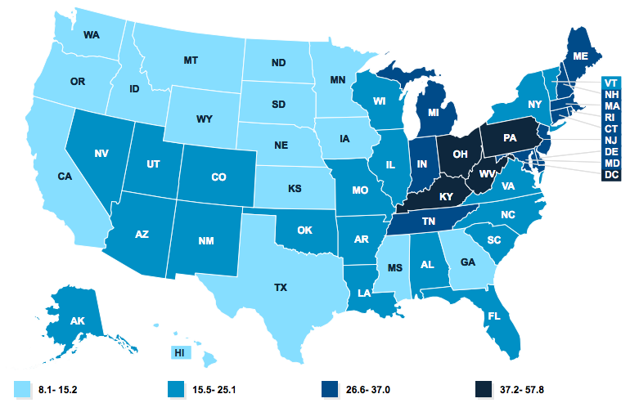
(Kaiser Family Foundation)

Based on this information, it is evident that Allegheny County, Pennsylvania is situated in an area that has experienced some of the worst consequences of the opioid epidemic. The opioid crisis does not discriminate – its negative effects have been felt by all people regardless of age, race, gender, or socioeconomic status. From 2016 to 2017, there was an increase in opioid overdose deaths among both males and females, individuals aged 25 and older, non-Hispanic whites, non-Hispanic blacks, and Hispanics (Scholl, 2018). The extremely high number of overdose deaths makes this drug epidemic deadlier than gun violence, car crashes, and AIDS, none of which have killed as many individuals in a single year. Despite widespread efforts in the past few years to address the opioid epidemic, the number of overdoses has continued to rise across the country (Figure 2).

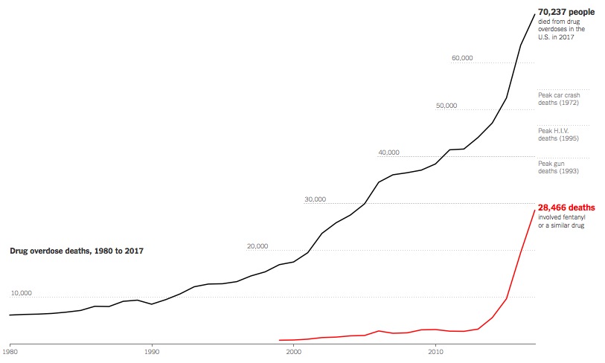

Figure 2: Number of drug overdose deaths, 1980-2017
(The New York Times)

OBJECTIVE
The objective of this research is to critically examine the wide array of opioid overdose prevention policies on college and university campuses throughout the United States in order to develop a set of broad policy recommendations. These recommendations will be utilized to evaluate the overall comprehensiveness of the policies currently in place at colleges in Allegheny County, Pennsylvania. In order to more effectively relay the results of the evaluation of Allegheny County colleges, a visual gradebook format will be utilized. Each college will be given a final letter grade of A through F based on the thoroughness of their policies. The ultimate goal of this research is for Allegheny County colleges and universities, and potentially others across the country, to utilize the gradebook to help drive future policy decisions aimed at mitigating the opioid epidemic.

LITERATURE REVIEW

OPIOIDS BASICS

Opioids are a class of drugs that work in the brain to reduce the sensation of pain throughout the body while also having the ability to produce a euphoric effect. Opioids act by attaching to specific proteins in the body called opioid receptors. These receptors can be found in the brain, spinal cord, and digestive tract (National Institute of Health, 2018). When opioids attach to the receptors, the neurotransmitter dopamine is released. Drugs classified as opioids can be further broken down into one of three categories: natural, semi-synthetic, and fully synthetic. Natural opioids are opioids that can be extracted directly from the poppy plant. Some of the most common natural opioids include morphine, opium, and codeine. Semi-synthetic opioids are synthesized from natural opioids, and they include drugs such as heroin, hydrocodone, and oxycodone. Drugs classified as synthetic opioids are entirely laboratory manufactured and are designed to mimic the chemical makeup of natural opioids. The most commonly recognized synthetic opioids are fentanyl, methadone, and tramadol (Centers for Disease Control and Prevention, 2017).

NALOXONE
While opioid overdoses are frequently fatal, they are often a preventable cause of death. An opioid overdose can be reversed with the use of the drug naloxone. Naloxone, also known by the brand name Narcan, is an opioid antagonist used to counter the effects of an opioid overdose. Opioids directly affect the region of the brain that regulates breathing. When an individual exceeds a certain threshold of opioids in their system, their breathing drastically slows and eventually stops. Naloxone, which has stronger affinity to opioid receptors in the brain than opioids, is able to knock the opioid molecules off the receptors and take their place. Once this occurs, the individual experiencing an overdose is able to start breathing normally again (National Institute on Drug Abuse, 2017). Naloxone comes in a variety of forms – it can be injected into the muscle, vein, or under the skin, or sprayed into the nose. It is important to note that naloxone only works for opioid overdoses. If an individual is overdosing on another substance, naloxone will not reverse the overdose, nor will it produce any harmful side effects. Naloxone was created in 1960, and it became widely used by hospitals and emergency responders after its FDA approval in 1971 (Winstanley, 2016).
While naloxone is highly effective at reversing an overdose, delays in administering the life-saving drug can increase the chances of death. Thus, the response time for emergency responders to the scene of an overdose is critical. Oftentimes there are delays in emergency responder arrival in rural areas, which is problematic when it comes to the utilization of naloxone to reverse an overdose (Wermeling, 2015). This is one reason why numerous programs have been developed with a primary purpose of distributing naloxone to individuals at risk of overdose. In addition, individuals who use opioids might be afraid to call for medical help if they witness and/or are involved with an overdose (Lankenau, 2013). Providing at risk individuals with naloxone increases the chance that the person overdosing will receive the life-saving drug, even if emergency responders are not involved.

HISTORY OF THE OPIOID EPIDEMIC
An examination of the history of the opioid epidemic reveals that significant increases in overdoses have occurred in waves over the past two decades. The first wave began in the late 1990s when there was an increase in demand for better treatment of pain and requests for the development of pain management standards (Jones, M. R., 2018). The Joint Commission (TJC) published guidelines for pain management which required physicians to provide adequate pain control for their patients. As a result, physicians began to rely more heavily on opioid medications (Baker, 2017). Hospital administrators supported this upsurge in opioid prescribing due to a widespread fear of losing federal funding and potentially lowering patient satisfaction ratings if TJC benchmarks for pain management were not met (Jones, M. R., 2018). Recognizing the financial opportunity, pharmaceutical companies began pushing mass amounts of prescription opioids into the market under the false advertisement that they were both safe and effective for treating pain (Kolodny, 2015).
The second wave began in 2011 with the rapid increase in number of overdose deaths involving heroin. In an attempt to curb the overprescribing of opioids that had been mounting over the past decade, laws were put in place to reduce the rates of opioid prescribing throughout the nation. While these laws did help to stabilize the rate of opioid prescribing, the rates of heroin use began to rise. Some researchers argue that this reduction in prescribing caused individuals, particularly those already addicted to opioids, to turn to heroin as a replacement (National Academies of Sciences, Engineering, and Medicine, 2017). Numerous studies found that people addicted to prescription opioids are at a much higher risk of using heroin (Kolodny, 2015).
The third wave of overdose deaths began in 2013, with a drastically higher number of deaths involving synthetic opioids – primarily illicitly manufactured fentanyl and its numerous analogs. Fentanyl, an extremely potent synthetic opioid analgesic, is often mixed with other substances – with or without the user’s knowledge – in order to increase the euphoric effects of the original substance. Fentanyl is significantly cheaper than heroin which is another reason why it is often mixed in with other substances. In recent years, it has become more common for fentanyl to be mixed with heroin, which is then passed off or sold as pure heroin. People who are unaware of the presence of fentanyl in heroin are at higher risk of overdosing because the substance they are ingesting is much more potent than they think. Fentanyl is approximately 50 times more potent than heroin (DEA, 2018) (Figure 3).
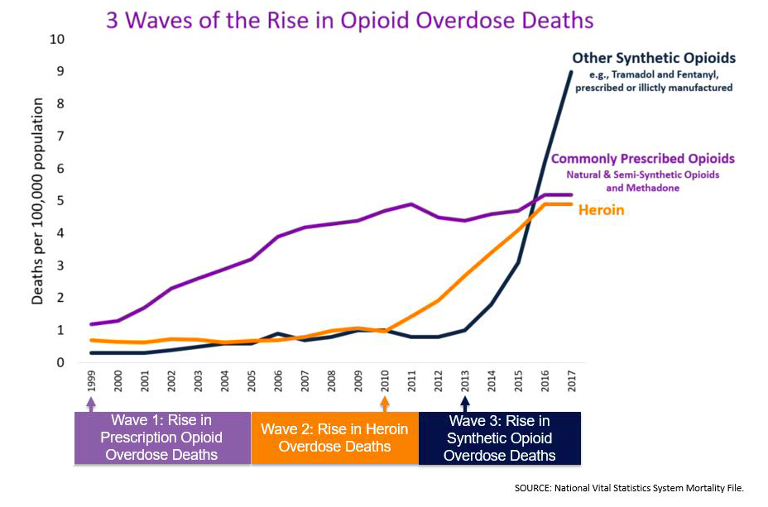

Figure 3: Trend showing the number of overdose deaths due to prescription opioids, heroin, and synthetic opioids from 1999-2017

Centers for Disease Control and Prevention)

THE OPIOID EPIDEMIC – PENNSYLVANIA
In 2017, 5,456 drug-related overdose deaths were reported by coroners and medical examiners in Pennsylvania. This number represents a rate of 43 deaths per 100,000 people (DEA, 2018). Toxicology reports from 2017 reveal that fentanyl and heroin, both opioids, were the two most prevalent drugs found in the decedents (Table 1).

Table 1: Frequency of Drug Categories in Drug-Related Overdose Decedents’ Toxicology Results, Pennsylvania, 2017

Drug Category | Percent Reported Among 2017 Decedents
Fentanyl | 67%
Heroin | 38%
Cocaine | 32%
Benzodiazepines | 31%
Prescription Opioids | 20%
Ethanol | 19%
FRSs and NPSOs | 18%
Other Illicit Drugs | 11%
(DEA, Pennsylvania Coroner/ Medical Examiner Data)

In 2016, individuals age 15-24 years saw a 380% increase in the presence of fentanyl in toxicology reports compared to other age groups (DEA, 2017). Further, increased fentanyl availability and misuse contributed to a 65% overall increase in drug-related overdose deaths in Pennsylvania between 2015 and 2017. In this same timeframe, individuals age 25-54 years accounted for 75% of Pennsylvania’s overdose deaths despite the fact that this age group only accounted for 40% of the entire population (DEA, 2018). Due to the increase in preventable overdose deaths experienced throughout the state, Pennsylvania lawmakers decided to take legal action to address the problem. In September of 2014, Act 139 was signed into law by the Governor of Pennsylvania. This law provides limited immunity from prosecution for people who seek emergency medical care for a person experiencing a drug overdose. The law also allows first responders including law enforcement officers, firefighters, and EMS workers to carry and administer naloxone. Further, given that friends and family members of people at risk of opioid overdose might be in a position to provide immediate aid in the event of an overdose, the law permits those family members and friends to obtain a prescription for naloxone (Allegheny County Department of Human Services, 2016). In January of 2018, the Pennsylvania governor signed a 90-day statewide disaster declaration, which has since been continued, in an effort to fight the opioid epidemic plaguing the state. The intent of the declaration was to enhance state response, increase access to substance use treatment, and save lives (Commonwealth of Pennsylvania, 2018).
Despite the fact that opioid prescribing rates have declined nationally in recent years, the opioid prescribing rates are still extremely high in certain areas throughout the country. In both 2014 and 2015, Pennsylvania had the 6th highest opioid prescribing rate of all states throughout the country. In 2016, the national prescribing rate was 66.5 prescriptions per 100 persons, and Pennsylvania’s prescribing rate was 69.5 prescriptions per 100 persons (DEA, 2018). Data also reveals that in 2016, approximately 60% of counties in Pennsylvania had prescribing rates above the national average (DEA, 2018).

THE OPIOID EPIDEMIC – ALLEGHENY COUNTY, PA
Allegheny County is situated in a part of the United States that has experienced some of the highest overdose death rates. In 2017, there were a total of 737 overdose deaths in Allegheny County (OverdoseFreePA, 2019). The 2017 overdose death rate was 60 deaths per 100,000 people, which is much higher than the state-wide average across Pennsylvania. In fact, the overdose death rate in Allegheny County ranks as the 5th highest of all counties in Pennsylvania (DEA, 2018) (Figure 4).
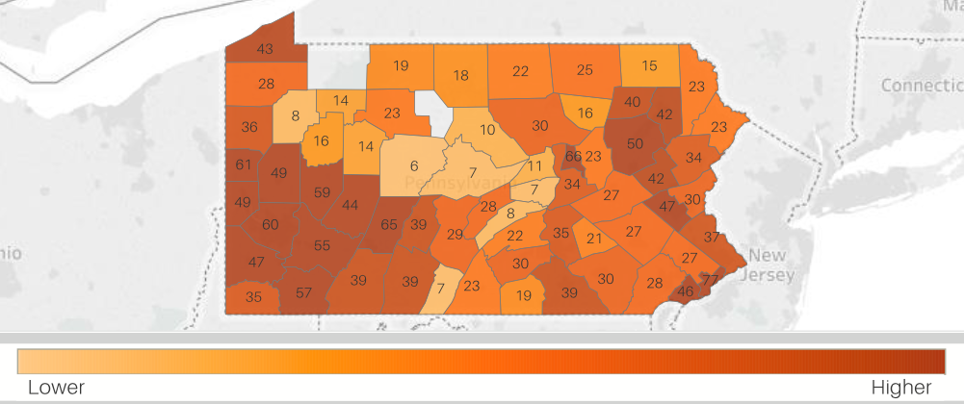

Figure 4: Rate of Drug-Related Overdose Deaths per 100,000 people, Pennsylvania, 2017

(DEA, Pennsylvania Coroner/Medical Examiner Data)

The year 2017 was also the fourth consecutive year in which fatal overdoses were higher than in any previous year (Allegheny County Department of Human Services, 2018). Fentanyl and its analogs have contributed to an increasingly large portion of opioid-related overdose deaths in recent years. In 2016, fentanyl was a contributing factor in 63% of overdose deaths in Allegheny County, up from 30% in the prior year of 2015. In 2017, fentanyl was a contributing factor in 74% of all overdose deaths that occurred in the county (OverdoseFreePA, 2019). In response to the consistent increase in overdose deaths over the past decade, Allegheny County has established an increasing number of naloxone programs. In 2016, there were 10 municipal police departments in the county with known naloxone programs. As of June 2017, this number had increased to 68 municipal police departments with naloxone programs (Allegheny County Department of Human Services, 2018).

THE OPIOID EPIDEMIC – COLLEGES AND UNIVERSITIES
Despite the fact that the opioid epidemic disproportionately affects individuals with less education, college students are by no means immune to the crisis (Ho, 2017). Over the past two decades, the use of opiates by college students has risen dramatically (Malone, 2017). In fact, one study reported that the use of certain prescription opioids (e.g. Oxycontin, Percocet, and Vicodin) increased 350% among college students between 1993-2005 (Malone, 2017). According to a 2015 systematic review, the prevalence of non-medical opioid use among the college age population is between 7 and 12% (Johnston, 2016). As the rate of opiate use increases, so too does the risk of overdose and death. In addition, the conversion from prescription opioid use disorder to heroin was reported at 2-3% among students (Johnston, 2016). Studies also reveal that nonmedical use of prescription opioids was higher among students who were white and attended highly competitive colleges (Malone, 2017). However, there is a widespread consensus among researchers and addiction experts that the actual prevalence of opioid misuse among college students is significantly higher than the reported numbers (University of Pittsburgh Opioid Abuse Prevention and Recovery Task Force, 2018). Most data are collected through self-reported surveys, and given that there is such a negative stigma surrounding opioid use, it is reasonable to conclude that many people do not report their opioid use (University of Pittsburgh Opioid Abuse Prevention and Recovery Task Force, 2018). In addition to underreporting of opioid use, it is believed that college student overdose deaths are underreported to universities as well (Hill, 2018). Patient privacy laws as well as stigma often prevent families from sharing cause of death information with their loved-one’s university. The American College Health Association (ACHA) recognized the seriousness of the opioid issue when, in 2016, they released a set of guidelines for opioid prescribing in college health centers (Table 2). The guidelines were developed to educate college health professionals on ways to maximize safety and reduce potential for opioid misuse, as well as to help them identify ways in which they can assist students with substance use disorder with rehabilitation and recovery (American College Health Association, 2016).

Table 2: American College Health Association (ACHA) Guidelines - Opioid Prescribing in College Health, 2016

Major Categories: | Guidelines/Considerations:
Acute Prescriptions | - Avoid opioids when possible  - Prescribe opioids for time-limited use only.  - Discuss the risks and dangers of opioid medications in detail with the patient, including the risk of addiction and overdose.  - Prescribe opioids in low doses and small quantities  - Consider close follow-up for confirmed discontinuation.  - Screen for substance abuse, poorly-controlled depression, family history of substance abuse, concomitant use of benzodiazepines, and other major psychiatric disorders.
Chronic Pain | - Prescribers should consider opioid therapy only if expected benefits for both pain and function outweigh the risks.  - Before beginning therapy, establish treatment goals and how and when medication will be discontinued.  - Many experts recommend a written contract with the patient outlining treatment expectations prior to beginning therapy.  - Prescribers should educate patients on risks and realistic benefits of opioid therapy.  - Untreated substance use disorders, poorly controlled psychiatric disease, and erratic treatment adherence should be considered as contraindications for opioid prescriptions.  - When starting therapy, prescribe the lowest effective dose.  - Patients should be evaluated every three months, at a minimum, for benefits and harms.
Overdose | - Add naloxone to the emergency box or cart  - Ensure that health center staff has adequate expertise and equipment to manage the airway of an unconscious patient  - Ensure the health center has adequate expertise and equipment to provide intravenous fluid support  - Ensure that emergency response, including EMS system activation, has been planned and appropriately drilled
Recovery from Addiction | - Stay alert for signs of addiction and have in place a plan for intervention and treatment referral  - Options for treatment include inpatient detoxification with abstinence, naloxone depot injections, daily methadone dosage, or office-based buprenorphine/naloxone sublingual preparation  - Collegiate recovery communities can be vital to the success and retention of students returning from residential recovery
Table 2 Continued

MEDICAL AMNESTY POLICIES
Medical amnesty policies, also known as Good Samaritan policies, have been adopted by many colleges and universities throughout the United States. These policies are designed to eliminate barriers for students who need to seek medical assistance for themselves or a fellow student in drug and/or alcohol related emergencies. Under these policies, students are typically provided some level of immunity from academic and legal consequences if they call campus police or other emergency services. The primary objective of a medical amnesty policy is to prevent unnecessary death as a result of inaction (University of Virginia, 2007). While numerous universities have some sort of medical amnesty policy in place, they vary greatly in terms of scope and likely effectiveness. Many medical amnesty policies only protect students in alcohol related emergencies and do not address medical emergencies related to drug use. As a result, students may be less likely to call emergency services in the case of an opioid overdose. In addition, medical amnesty policies differ in regards to who the policy protects from academic and legal sanctions. The most comprehensive policies protect the person experiencing the medical emergency, the person who calls emergency services, and any potential bystanders. However, some policies do not protect all of the students involved, thus reducing the likelihood that students will seek medical assistance. Even when a university adopts a comprehensive medical amnesty policy, there are still barriers that prevent such policies from being effectively utilized. One reason is that students are not fully educated on the policy. Research shows that many students are reluctant to utilize medical amnesty policies because they are unclear of the specific details regarding who/what is covered under the policy. While there is minimal research evaluating the effectiveness of medical amnesty policies in drug-related emergencies at colleges, studies have shown that these policies are effective when utilized in alcohol-related emergencies. One study in particular showed that medical amnesty policy implementation led to a modest increase in seeking help in the case of an emergency. In addition, having a medical amnesty policy in place did not increase the incidence of drinking or overall consumption of alcohol (Haas, 2018). An earlier study conducted at Cornell University revealed that in the first two years after a medical amnesty policy was implemented, there were gradual increases in calls to emergency services during alcohol-related emergencies. The results also indicate that, following the enactment of the medical amnesty policy, students were less likely to report fear of getting an intoxicated person in trouble as a barrier for calling for help (Lewis, 2006).

DRUG EDUCATION
Over the past decade, epidemiologic studies have revealed that heavy alcohol use and its associated negative consequences continue to be a problem amongst college students in the United States. In response to this issue, many universities across the United States are now using online programs or courses to address the problem and ultimately reduce both hazardous drinking and alcohol-related problems on college campuses. The online course AlcoholEdu for College has been the subject of numerous studies in order to gauge its effectiveness. Most of these studies show that AlcoholEdu for College appears to have beneficial short-term effects for the most common type of alcohol-related problems among freshmen. In addition, the program is shown to be more effective at universities with higher rates of student course completion (Paschall, 2011). Most of these studies concluded that AlcoholEdu for Colleges should be mandatory for incoming freshman due not only to its effectiveness, but also because it is brief, low-cost, and requires no class time to administer (Paschall, 2011). Given the positive results associated with AlcoholEdu for College, many people are calling for the creation of similar web-based courses with a primary focus on drugs. In July of 2017, Maryland passed the Start Talking Maryland Act of 2017. Under this law, colleges that accept state funding are required to have a heroin and opioid prevention plan that includes drug education for all incoming full-time students (General Assembly of Maryland, 2017). Little research has been done in examining the effectiveness of drug education programs at colleges; however, numerous national studies have been conducted to explore the effectiveness of drug education programs in public schools and communities (National Institute on Drug Abuse, 2014). Drug education programs have been in existence for decades, yet the subject matter and approaches have changed and continue to change as new research is conducted. In the past, the goal of many drug education programs was to completely deter the use of drugs through fear and misinformation. Drug use was portrayed as being morally wrong, or a personal flaw or weakness rather than a medical illness. Research has since shown that abstinence-based drug education programs are ineffective (Lilienfeld, 2014). Not only do abstinence-based drug education programs not deter drug use, but these programs leave individuals ill-equipped to recognize the signs of a drug overdose and the knowledge of how to respond, both of which are potentially life-saving information.
Students for Sensible Drug Policy (SSDP) is an advocacy and education organization that focuses on reforming drug policy. While this nonprofit organization focuses on both national and international drug policies, a portion of their work specifically targets campus drug policy and reform. For example, SSDP developed a peer-to-peer drug education program called “Just Say Know.” This program provides college students with evidence-based drug information and teaches them how to recognize and address dangerous behaviors associated with drug use. The program has an entire segment dedicated to opioids, and students are taught how to recognize and respond to an opioid overdose (Students for Sensible Drug Policy, 2017). The “Just Say Know” program, and SSDP as a whole, places considerable value in the principles of harm reduction. Harm reduction encompasses a wide range of strategies aimed at minimizing the negative consequences associated with drug use. Harm reduction policies and practices focus on positive change and on working with people without judgement, discrimination, or requiring that they stop using drugs as a precondition of support (Harm Reduction Coalition, 2017). Some examples of harm reduction activities include needle and syringe distribution/recovery programs and education services that communicate safer behavior to people who use drugs.

STIGMA ASSOCIATED WITH OPIOID MISUSE
The social stigma surrounding opioid misuse and addiction is all too prevalent in modern day society. Several studies have found that substance use disorders are more highly stigmatized than other health conditions (Livingston, 2012). Despite the increasingly widespread impact the opioid epidemic has had throughout the nation, stigma remains a major barrier in our attempts to address the problem. Individuals suffering from opioid addiction may refuse to seek help from friends, family, and medical professionals due to the pervasive stigma associated with opioid use. Research shows that stigma contributes to an array of adverse outcomes for people with substance use disorders, such as non-completion of substance use treatment, poor mental and physical health, and delayed recovery and reintegration processes (Olphen, 2009). In addition, the stereotypes associated with substance use treatment options, such as methadone maintenance, can also lower the likelihood that an individual will utilize such treatment options. Stigma can also affect the public’s perception of harm reduction strategies and interventions, such as needle exchanges, and prevent these public health interventions from being successfully implemented. One of the most effective ways to combat stigma and its negative consequences is through education. Individuals need to be properly educated about the science behind substance use disorders, the effectiveness of evidence-based treatment methods, and the importance of utilizing non-stigmatizing language.

COLLEGIATE RECOVERY PROGRAMS
Collegiate Recovery Programs (CRPs) strive to create a supportive environment in which resources, community, and housing is provided to students who are trying to maintain their recovery from addictive behaviors. CRPs enable students in recovery from drug or alcohol use disorders to participate in a continuing care program without having to sacrifice or postpone their pursuit of higher education. The first CRPs were started at a handful of universities in the 1980’s, and while their models varied substantially, they shared a common goal of improving outcomes for students who had developed dependencies on alcohol and other drugs. Rutgers University was one of the first colleges in the country to develop a Collegiate Recovery Program. Rutgers University has been, and continues to be a model for other universities across the country as they work to create their own CRPs. The Rutgers University Recovery Housing Program was founded in 1988, and it was the first on-campus college housing in the United States for students recovering from drug and alcohol addiction.
In 2010, the number of CRP’s being implemented across the country rapidly increased. One reason for this sudden expansion is that the Office of National Drug Control Policy declared its goal of expanding community-based recovery support models, including those at colleges and universities throughout the nation (Association of Recovery in Higher Education, 2017). As a result, dozens of CRPs are now in operation, and new programs are in the planning phase at numerous colleges and universities. In general, a CRP offers services such as drug-free housing, individual and group counseling, relapse prevention skills development, and sober leisure activities.
Since 2013, the nonprofit organization Transforming Youth Recovery (TYR) has played a key role in the growth of CRPs nationally. TYR’s mission is to improve access to prevention, intervention, and recovery resources for youth as they progress from childhood to college. As part of their effort to achieve this mission, TYR provides grants to colleges and universities across the country to establish Collegiate Recovery Programs. The organization has provided to universities over 120 grants to universities, each of which are accompanied by three years of technical assistance and mentorship to assist with student recruitment and early stage growth (Transforming Youth Recovery, 2018). Transforming Youth Recovery’s 2016 Impact Report revealed that over 50,000 college students are currently participating in campus recovery programs (Transforming Youth Recovery, 2016).
In 2017, TYR conducted a survey in which over 100 colleges and universities participated. Results of this survey showed that universities are offering a diverse variety of prevention, treatment, and recovery support services and resources for students in recovery from substance use disorders (Jones, E., 2018). On average, each university stated that they offer at least ten different practices/services for students involved in the program. Some of the most commonly offered practices include: coordinate events to raise awareness on campus, organize sober social events for the recovery community and beyond, offer peer mentoring support, and provide a registered student club or organization. The most frequently offered practices/services are listed in the table below (Table 3). The survey revealed that only 11% of the respondents offer sober living housing as part of their services, and 40% of respondents still define their program as being in the “early stages” of development (Jones, E., 2018).

Table 3: Transforming Youth Recovery 2017 Census for Recovery Support in Higher Education
Practices/ Services | Percent of Schools that Offer (N=127)
Coordinate events to raise awareness on campus | 74%
Organize sober social events for the recovery community | 72%
Advocacy efforts undertaken for student needs | 71%
Host on-campus 12-step or other mutual aid support group | 66%
Staff and students attend conferences | 54%
Have a registered student organization or club | 50%
Offer peer mentoring support | 50%
Promote community service and other volunteer opportunities | 45%
Give presentations on recovery resources in the community | 43%
Schedule group meetings other than formal/clinical group meetings | 43%

Given that CRPs have only become popular in the past decade, there is a need for more research to evaluate the effectiveness of such programs. It is however promising that the minimal research that has been completed confirms that CRPs are successful in supporting college students in their recovery. A study conducted in 2014 showed that across 29 CRPs nationwide, the average relapse rate was only 8% and academic achievement (GPA and graduation) surpassed the university’s overall averages (Laudet, 2014).

EXAMPLES OF CAMPUS OPIOID OVERDOSE PREVENTION PROGRAMS AND INITIATIVES

WASHINGTON STATE UNIVERSITY
The Washington State University College of Pharmacy conducted a very unique study on their campus in 2014 (Panther, 2016). With funding from the university president, the College of Pharmacy was able to initiate a naloxone safety net project on campus. During the start of fall semester, project facilitators heavily advertised the availability of an overdose education and prevention training session available to students. Advertisements were placed in the campus newspaper and around campus in an effort to create more awareness of the project. In order to recruit participants, a drug overdose simulation was staged on campus in a very popular location so that many students would be in the area to witness it. The elaborate simulation featured a fake crime scene, a mannequin inside a body bag, crime tape blocking off the scene, and a campus police car meant to appear as if it was responding to the scene of an overdose. As curious students gathered to watch the simulation, they were approached by university pharmacy students seeking to recruit participants for the naloxone safety net project. The pharmacy students, who were previously trained in overdose prevention and naloxone rescue, also answered many questions students had about opioid overdose. All in all, 150 students were recruited to participate in the project. These students all took part in an hour-long training program. This program included information about the opioid epidemic, overdose risk factors, prevention techniques, and step-by step instructions on how to respond to an overdose, including the administration of naloxone. Participants then divided into small groups and were encouraged to practice the overdose response techniques they had learned. One thing that made this project so unique was its use of a large-scale audience training model and the fact that pharmacy students aided in the training of their fellow students. This approach made it possible for a large number of people to be trained in overdose response in a very short amount of time. The results from a post-survey given to the student participants was overwhelmingly positive. The majority of respondents agreed that the training session provided them with the necessary skills to act in an overdose situation (Panther, 2016).

UNIVERSITY OF TEXAS AT AUSTIN
In 2016, the University of Texas (UT) at Austin developed and implemented a collaborative model for opioid overdose prevention. The model was based primarily around the goal of increasing naloxone accessibility and awareness on the UT campus. The Wellness Network Committee on Substance Safety and Overdose Prevention (COSSOP) was created on the university in response to reports of numerous student overdose deaths over winter break. As part of their effort to achieve the goal of improving overdose preparedness across campus, COSSOP worked diligently to make naloxone available in numerous locations. Naloxone was made available at the campus pharmacy through the enactment of a standing order. In addition, naloxone was placed in all of the residence halls across campus, and resident advisors were trained in how to administer naloxone. Given that campus police officers are often the first responders to emergencies on campus, similar training sessions, along with naloxone, were made available to all campus police officers. Finally, students from the College of Pharmacy developed a service-learning program in which free naloxone was provided to students as well as peer education regarding opioids and overdose prevention. A recent evaluation of this project at UT Austin indicated that while achieving campus-wide overdose preparedness is important, it is also crucial that resources be distributed in the most effectual way possible (Hill, 2018). As of July 2018, none of the naloxone that was given to campus police or placed in residence halls had been utilized; however, three students who attended the training sessions and received free naloxone reported that the naloxone was used to successfully reverse a suspected opioid overdose. Researchers involved in the analysis of this program concluded that further research needs to be done in order to more accurately calculate the optimal resource allocation of naloxone on college campuses. Educating the student population as well as campus police about opioid overdose response and prevention has the potential to save lives in the future (Hill, 2018).

UNIVERSITY OF PITTSBURGH
In June of 2018, the Opioid Abuse Prevention and Recovery Task Force at the University of Pittsburgh released a 48-page report titled “Opioid Use Disorder: Prevention, Treatment, and Recovery.” Throughout the report, the task force presented dozens of recommendations for strategies the university can take to address the opioid epidemic more effectively going forward. The comprehensive report focused on six core categories: screening, prevention and education, treatment, recovery, public safety, and data improvement (University of Pittsburgh Opioid Abuse Prevention and Recovery Task Force, 2018). The table below provides examples of recommendations from each of the six core categories focused on in the report (Table 4).
Due to the recent release of the University of Pittsburgh Opioid Abuse Prevention and Recovery Task Force Report, a thorough evaluation of the report’s impact on the campus community has yet to occur. In the fall of 2018 the University began conducting a campus-wide climate survey on alcohol and drug use in order to better estimate the number of students who are struggling with addiction or are in recovery. The results of this survey, in conjunction with the task force report, will be used to aid university officials in the development of strategies to address the opioid epidemic.

Table 4: Sample of recommendations found in the University of Pittsburgh Task Force Report – Opioid Use Disorder: Prevention, Treatment, and Recovery

Category | Specific Recommendations
Screening and Assessment | The Student Health Service should conduct a campus-wide climate survey regarding alcohol and drug use during the fall 2018 semester.
Prevention and Education | The University should expand current media and awareness campaigns to further increase awareness of risk factors, opioid and prescription misuse, and addiction.
Treatment | The Student Health Service and other appropriate University staff should receive additional training to better assess and manage students with opioid and other substance use disorders.
Recovery | The University should accelerate the implementation of its CRP, by adopting the lifecycle of a recovery community model suggested by Transforming Youth Recovery.
Public Safety | Campus police and student health service professionals on all campuses should continue to have naloxone immediately available and should be appropriately trained and regularly re-trained in its administration
Data Improvement | The University should consider a shared access data repository or data cataloging effort to enhance ongoing evaluation activities and to provide insights and potential longitudinal analysis of specific questions such as current and changing student health needs.

METHODOLOGY
Numerous sources were used in the creation of this report. The methodology is based largely on data and statistics found in journal articles and reports. A comprehensive literature search was conducted using PubMed and Google Scholar. The key words used to gather information included: “medical amnesty policy,” “opioid overdose prevention college campuses,” “naloxone accessibility universities,” and “opioid epidemic history.” A significant portion of the data regarding overdose rates within Pennsylvania were gathered from the website OverdoseFreePA. OverdoseFreePA, a collaboration between county and state partners throughout the commonwealth of Pennsylvania, provides a data repository of facts and statistics concerning opioid overdose and substance use disorder. The majority of the Allegheny County-specific data was accessed through the Allegheny County Health Department. Data collected from these sources was utilized to demonstrate the scope of the opioid epidemic at the national, state, and county levels. A portion of the data regarding naloxone policies at Allegheny County colleges was collected and provided by the Allegheny County Health Department. Information about specific policies at each of the Allegheny County colleges and universities was primarily collected from an internet search. The official websites for all of the colleges within the county were used to collect a large portion of data. Any information that was not available on university websites was collected through alternate methods, primarily phone interviews with employees and staff.
After conducting a thorough literature review of opioid overdose prevention policies in place at universities throughout the United States, an analysis of Allegheny County colleges and universities was conducted. Prior to any data collection, a list was compiled of all the 2-year and 4-year colleges and universities within Allegheny County. This list consisted of 26 institutions, the majority of which were small community colleges. In order to narrow the scope of the research, the decision was made to focus only on 4-year colleges, in addition to the largest community college in the county, Community College of Allegheny County. With an annual student enrollment of over 17,000 individuals, we found it essential to include this community college in our analysis due to its large presence in the area. Within Allegheny County there are nine colleges and universities that offer 4-year degree programs. These nine universities include: Carlow University, Carnegie Mellon University, Chatham University, Duquesne University, LaRoche College, Point Park University, Penn State University Greater Allegheny, Robert Morris University, and the University of Pittsburgh. The table below displays the student population at each of the colleges and universities included in the gradebook analysis (Table 5).

Table 5: Allegheny County Colleges and Universities, Student Population, 2016
College/ University: | Student Population:
Carlow University | 2,300
Carnegie Mellon University | 14,000
Chatham University | 1,200
Community College of Allegheny County | 17,200
Duquesne University | 9,500
LaRoche University | 1,600
Point Park University | 3,300
Penn State Greater Allegheny | 500
Robert Morris University | 5,400
University of Pittsburgh | 19,300

CAMPUS POLICIES GRADEBOOK
The evaluation of Allegheny County colleges’ opioid overdose prevention policies is presented as a table, called a gradebook (Figure 5). The framework for the gradebook was based broadly on a college policy grading tool established by the Students for Sensible Drug Policy (SSDP) organization. The data collection for the gradebook was completed in July of 2018. All of the general recommendations can be divided into four main areas of focus: Medical Amnesty Policies, Drug Education, Narcan Accessibility/Training, and Substance Use Treatment/Recovery Resources. In order to incorporate the general recommendations into the gradebook, a variety of statements were created. These statements are intended to serve as a method of evaluating a college’s “success” or “failure” at meeting all of the general recommendations. The decision to use a gradebook style format was made for numerous reasons. The format allows for comparisons to be made between all of the universities. It is important to note that this gradebook was not designed with the intention of being a highly scientific and exhaustive analysis of the colleges. Rather, its simplistic design was chosen in order to create a visually appealing and easy-to-understand resource for the general public. The straightforward, single-point system was chosen in order to simplify the results of the gradebook. While some policies may have more “weight” in terms of their effectiveness at preventing opioid overdoses, that was not taken into consideration for this gradebook. Colleges were awarded a single point for each statement in which their response was “yes,” and no points were awarded if the answer was “no.” In addition, half a point was awarded if the answer to a question was somewhere between a “yes” and a “no.” For example, one of the statements has to do with whether the college has a collegiate recovery program (CRP). If a college has a CRP in the development stages, but it is not officially in operation, then the response would be “in progress” and half a point would be awarded. Below is list of the statements included in the gradebook analysis (Table 6), followed by the actual gradebook analysis of Allegheny County colleges (Figure 5).

Table 6: Colleges were Evaluated Based on their Responses of “Yes” Or “No” to these Statements

Core Topic Area: | Statement/Question:
Medical Amnesty Policy | The school has a medical amnesty policy that applies to drugs.
 | The medical amnesty policy shields the victim AND the caller from disciplinary charges.
 | The medical amnesty policy is easily accessible to students and clearly stated.
Drug Education | The school has a drug education program that includes information about opioids.
 | The drug education program includes harm reduction (not purely abstinence based)
 | The drug education program includes efforts to reduce negative stigma.
 | The drug education program is mandatory for students to participate in.
Naloxone Accessibility/ Training | Campus police officers carry Narcan.
 | Narcan is available in the student health center.
 | Resident advisors are equipped with Narcan and trained in how to use it.
 | Narcan is available in places on campus other than the student health center.
Substance Use Treatment/ Recovery Resources | The school has a collegiate recovery program (CRP).
 | The school offers recovery housing on or off campus.
 | Students are referred to harm reduction organizations (i.e. Prevention Point) if there is concern for intravenous drug use (IVDU).
 | Information about treatment options/recovery resources are easily accessible to students.
 | The school has a club/organization that focuses on drug education or a related topic.

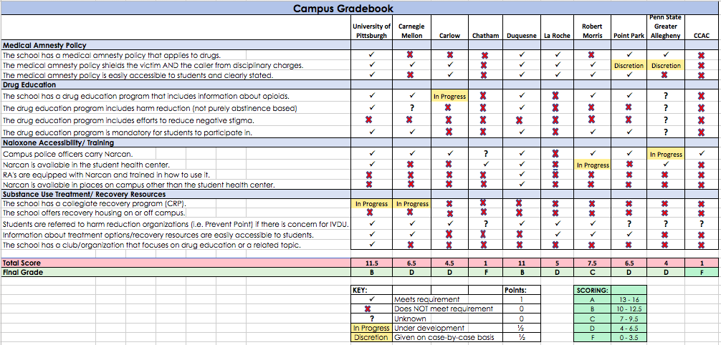

Figure 5: Campus Policy Gradebook

DISCUSSION OF CAMPUS GRADEBOOK
Upon completion of the gradebook evaluation, it became evident that there are numerous potential areas of improvement for all of the colleges. One main area in need of improvement among all of the colleges is the establishment of a Collegiate Recovery Program. Only two of the ten colleges are in the beginning stages when it comes to the development of a CRP. Given the immense benefit CRPs provide to students in recovery and the growing popularity of CRPs on campuses throughout the country, it is essential that Allegheny County colleges implement them.
Another key area for improvement involves the effort by colleges to address and reduce the stigma surrounding substance misuse and addiction. While many Allegheny County colleges have drug education programs that include information about opioids, the issue of stigma is not being adequately addressed. Stigma is likely a major barrier for students when it comes to an individual choosing to seek help, so it is imperative that colleges include stigma reduction strategies and training in the drug education programs that they offer to students.
Overall, the majority of Allegheny County colleges have comprehensive medical amnesty policies which can play a critical role in preventing unnecessary deaths due to drug overdose. It is important to note that altering a medical amnesty policy is not resource intensive, thereby making these policies and effective opportunity for potential improvement.

RECOMMENDATIONS
A thorough analysis of the relevant literature reveals that there are numerous ways in which colleges and universities can play a role in mitigating the negative effects of the opioid epidemic. Through the implementation of campus policies and programs, institutions of higher education have the ability to aid in the prevention of opioid overdoses among their student body and the community as a whole. A single overdose death can have far reaching negative consequences in the form of emotional and mental distress among friends, classmates, and other members of the campus community. While endless amounts of recommendations could be offered, this essay will focus on providing brief, concise recommendations in four core topic areas. These four topic areas were chosen due to their projected effectiveness, ease of implementation, popularity among universities nationally, and feasibility in terms of the resources they require and their anticipated acceptance by university officials. The four areas of focus are: medical amnesty policy, drug education, recovery resources, and naloxone training and accessibility.

MEDICAL AMNESTY POLICY
A university’s medical amnesty policy should be explicitly stated and publicized on the school's official website, in the Student Handbook, and in major campus facilities, including dormitories and cafeterias. In addition, students should be educated on the policy during orientation to ensure that all students entering the school are made aware of its existence. The policy should protect victims, callers, and bystanders in both alcohol and drug related emergencies from legal and school sanctions.

DRUG EDUCATION
A university’s drug education curriculum should be mandatory for all students to participate in during orientation. Rather than being purely abstinence based, the drug education curriculum should include harm reduction information and strategies. In addition, a large focus should be placed on addressing and reducing the negative stigma surrounding substance misuse and addiction.

SUBSTANCE USE TREATMENT AND RECOVERY RESOURCES
Colleges and universities should offer a wide range of resources to assist students recovering from drug addiction and/or overdose. Resources should include recovery housing, peer support groups, free counseling/therapy sessions, and off-campus treatment recommendations. Much of this can be accomplished through the establishment of a comprehensive Collegiate Recovery Program (CRP). The availability of these resources should be thoroughly advertised online and in popular buildings on campus. Students should not face any barriers that could potentially deter them from seeking help, such as confusion about who to contact or what resource options are available to them. The school should work to accommodate students who are in treatment or recovery when it comes to their academic schedules.

NALOXONE ACCESSIBILTY AND TRAINING
Naloxone (Narcan), the opioid overdose reversal drug, should be readily available on the school’s campus. Given the likely financial constraints facing colleges, resources should be allocated in a way that is deemed most effective and feasible. Colleges should consider making naloxone available in the student health center and other popular locations on campus. Campus security should be equipped with naloxone and be thoroughly trained in how to use it. Naloxone training should be made available to students and staff, and the availability of such training sessions should be thoroughly advertised. This includes posting information on the school’s website and on bulletin boards around campus.

CONCLUSION
In conclusion, the opioid epidemic is a public health crisis that has been plaguing the United States for many years, and it will continue to do so if rigorous action is not taken to slow its destructive path. Allegheny County, Pennsylvania is situated in an area of the nation that has been especially hard hit by the opioid epidemic, and there is an overwhelming consensus that steps need to be taken to reduce the number of overdose deaths. The opioid crisis impacts people of all races, age, gender, and socioeconomic status, which means college students are not immune to its devastating effects. One way to affect positive change is through the enactment of evidence-based policies at all levels of society, including at institutions of higher education. Thus, it is imperative that colleges and universities develop and implement comprehensive and effective policies pertaining to opioid overdose prevention in order to reduce the number of overdose deaths.

BIBLIOGRAPHY
Allegheny Department of Human Services, & Allegheny County Health Department. (2018, February). Opioid-Related Overdose Deaths in Allegheny County, 2015–2016 Update. Retrieved January 10, 2019, from https://www.alleghenycountyanalytics.us/wp-content/uploads/2018/02/ACDHS-Opioid-Overdose-Deaths-Report-021518.pdf
Allegheny County Department of Human Services, & Allegheny County Health Department. (2016, July). Opioid-Related Overdose Deaths in Allegheny County: Risks and Opportunities for Intervention. Retrieved January 27, 2019, from https://www.alleghenycountyanalytics.us/wp-content/uploads/2017/04/Opiate-Related-Overdose-Deaths-in-Allegheny-County.pdf
Allegheny County Health Department. (2018). Information About Opioids. Retrieved January 8, 2019, from http://www.alleghenycounty.us/Health-Department/Programs/Special-Initiatives/Overdose-Prevention/Information-About-Opioids.aspx
American College Health Association. (2016, October). ACHA Guidelines: Opioid Prescribing in College Health. Retrieved January 29, 2019, from https://www.acha.org/documents/resources/guidelines/ACHA_Opioid_Prescribing_in_College_Health.pdf
Association of Recovery in Higher Education. (2017). The Collegiate Recovery Movement: A History. Retrieved January 17, 2019, from https://collegiaterecovery.org/the-collegiate-recovery-movement-a-history/
Baker, D. W. (2017, March 21). History of the Joint Commission’s pain standards: Lessons for today’s prescription opioid epidemic. Retrieved March 5, 2019, from https://jamanetwork.com/journals/jama/article-abstract/2606790
U.S. Department of Health and Human Services, Centers for Disease Control and Prevention (CDC) (2018-a). Opioid Overdose. Retrieved from https://www.cdc.gov/drugoverdose/data/statedeaths.html
Centers for Disease Control and Prevention. (2017, August 28). Opioid Overdose - Commonly Used Terms. Retrieved January 29, 2019, from https://www.cdc.gov/drugoverdose/opioids/terms.html
Centers for Disease Control and Prevention. (2018, October 3-b). U.S. Opioid Prescribing Rate Maps. Retrieved January 25, 2019, from https://www.cdc.gov/drugoverdose/maps/rxrate-maps.html
Commonwealth of Pennsylvania. (2018, January 10). Governor Wolf Declares Heroin and Opioid Epidemic a Statewide Disaster Emergency. Retrieved January 27, 2019, from https://www.governor.pa.gov/governor-wolf-declares-heroin-and-opioid-epidemic-a-statewide-disaster-emergency/
DEA Philadelphia Division, & University of Pittsburgh. (2017, July). Analysis of Overdose Deaths in Pennsylvania, 2016. Retrieved January 28, 2019, from https://www.overdosefreepa.pitt.edu/wp-content/uploads/2017/07/DEA-Analysis-of-Overdose-Deaths-in-Pennsylvania-2016.pd_-1.pdf
DEA Philadelphia Division, & University of Pittsburgh. (2018, September). The Opioid Threat in Pennsylvania. Retrieved January 17, 2019, from https://www.overdosefreepa.pitt.edu/wp-content/uploads/2018/10/PA-Opioid-Report-Final.pdf
General Assembly of Maryland. (2017). Heroin and Opioid Education and Community Action Act of 2017 (Start Talking Maryland Act). Retrieved January 26, 2019, from http://mgaleg.maryland.gov/webmga/frmMain.aspx?pid=billpage&stab=01&id=HB1082&tab=subject3&ys=2017RS
Haas, A. L., PhD, Wickham, R. E., PhD, McKenna, K., Morimotot, E., & Brown, L. M., PhD. (2018). Evaluating the Effectiveness of a Medical Amnesty Policy Change on College Students’ Alcohol Consumption, Physiological Consequences, and Helping Behaviors. Retrieved January 17, 2019, from https://www.jsad.com/doi/full/10.15288/jsad.2018.79.523
Harm Reduction Coalition. (2017). Principles of Harm Reduction. Retrieved January 29, 2019, from https://harmreduction.org/about-us/principles-of-harm-reduction/
Hill, L. G., PharmD, Holleran Steiker, L. K., PhD, Mazin, L., BS, & Kinzly, M. L. (2018, November). Implementation of a collaborative model for opioid overdose prevention on campus. Retrieved January 16, 2019, from https://www.researchgate.net/publication/330228277_Implementation_of_a_collaborative_model_for_opioid_overdose_prevention_on_campus
Ho, J. Y. (2017, March 21). He Contribution of Drug Overdose to Educational Gradients in Life Expectancy in the United States, 1992–2011. Retrieved March 5, 2019, from https://link.springer.com/article/10.1007/s13524-017-0565-3
Johnston, L. D., O’Malley, P. M., Miech, R. A., Bachman, J. G., & Schulenberg, J. E. (2016). Monitoring the Future national survey results on drug use, 1975-2015: Overview, key findings on adolescent drug use. Ann Arbor: Institute for Social Research, The University of Michigan.
Jones, E. (2018). Findings from Transforming Youth Recovery’s 2017 Collegiate Recovery Census. Retrieved January 28, 2019, from https://www.transformingyouthrecovery.org/wp-content/uploads/2018/07/ARHE-Recovery-Census-20180711.pdf
Jones, M. R., Viswanath, O., Peck, J., Kaye, A. D., Gill, J. S., & Simopoulos, T. T. (2018). A Brief History of the Opioid Epidemic and Strategies for Pain Medicine. Pain and therapy, 7(1), 13-21.
Kaiser Family Foundation. (2018). Opioid Overdose Death Rates and All Drug Overdose Death Rates per 100,000 Population (Age-Adjusted) | The Henry J. Kaiser Family Foundation. Retrieved March 28, 2019, from https://www.kff.org/other/state-indicator/opioid-overdose-death-rates/?activeTab=map&currentTimeframe=0&selectedDistributions =opioid-overdose-death-rate-age-adjusted&sortModel=%7B%22colId%22:%22 Location%22,%22sort%22:%22asc%22%7D
Kolodny, A., Courtwright, D. T., Hwang, C. S., Kreiner, P., Eadie, J. L., Clark, T. W., & Alexander, G. C. (2015). The Prescription Opioid and Heroin Crisis: A Public Health Approach to an Epidemic of Addiction. Retrieved January 5, 2019, from https://www.annualreviews.org/doi/abs/10.1146/annurev-publhealth-031914-122957
Lankenau, S. E., Wagner, K. D., Silva, K., Kecojevic, A., Iverson, E., McNeely, M., & Kral, A. H. (2013). Injection drug users trained by overdose prevention programs: responses to witnessed overdoses. Journal of community health, 38(1), 133-41.
Laudet, A., Harris, K., Kimball, T., Winters, K. C., & Moberg, D. P. (2014). Collegiate Recovery Communities Programs: What do we know and what do we need to know?. Journal of social work practice in the addictions, 14(1), 84-100.
Lewis, D. K., & Marchell, T. C. (2006). Safety first: A medical amnesty approach to alcohol poisoning at a U.S. university. Retrieved January 18, 2019, from https://health.cornell.edu/sites/health/files/docs/safety-first-cornell-medical-amnesty.pdf
Lilienfeld, S. O., & Arkowitz, H. (2014, January 1). Why "Just Say No" Doesn't Work. Retrieved March 18, 2019, from https://www.scientificamerican.com/article/why-just-say-no-doesnt-work/
Livingston, J. D., Milne, T., Fang, M. L., & Amari, E. (2012, January). The effectiveness of interventions for reducing stigma related to substance use disorders: A systematic review. Retrieved February 16, 2019, from https://www.ncbi.nlm.nih.gov/pmc/articles/PMC3272222/
Malone, P., MD. (2017, October). Dealing with the Opioid Epidemic in College Students. Retrieved January 6, 2019, from https://jaacap.org/article/S0890-8567(17)30633-0/pdf
National Academies of Sciences, Engineering, and Medicine. (2017, July 13). Pain Management and the Opioid Epidemic: Balancing Societal and Individual Benefits and Risks of Prescription Opioid Use. Retrieved March 5, 2019, from https://www.ncbi.nlm.nih.gov/books/NBK458661/
National Institute of Health. (2018, May 22). How opioid drugs activate receptors. Retrieved January 25, 2019, from https://www.nih.gov/news-events/nih-research-matters/how-opioid-drugs-activate-receptors
National Institute on Drug Abuse. (2014, March). Lessons from Prevention Research. Retrieved March 18, 2019, from https://www.drugabuse.gov/publications/drugfacts/lessons-prevention-research
National Institute on Drug Abuse. (2017, March). Naloxone for Opioid Overdose: Life-Saving Science. Retrieved January 23, 2019, from https://www.drugabuse.gov/publications/naloxone-opioid-overdose-life-saving-science/naloxone-opioid-overdose-life-saving-science
Olphen, J. V., Eliason, M. J., Freudenberg, N., & Barnes, M. (2009, May). Nowhere to go: How stigma limits the options of female drug users after release from jail. Retrieved February 5, 2019, from https://www.ncbi.nlm.nih.gov/pmc/articles/PMC2685368/
OverdoseFreePA. (2019). Death Data: Allegheny County. Retrieved January 19, 2019, from https://www.overdosefreepa.pitt.edu/know-the-facts/view-overdose-death-data/
Panther, S. G., Bray, B. S., & White, J. R. (2016, November). The implementation of a naloxone rescue program in university students. Retrieved January 16, 2019, from https://www.japha.org/article/S1544-3191(16)30885-8/pdf
Paschall, M. J., Antin, T., Ringwalt, C. L., & Saltz, R. F. (2011). Effects of AlcoholEdu for college on alcohol-related problems among freshmen: a randomized multicampus trial. Journal of studies on alcohol and drugs, 72(4), 642-50.
The New York Times. (2018, November 29). ‘The Numbers Are So Staggering.’ Overdose Deaths Set a Record Last Year. Retrieved February 12, 2019, from https://www.nytimes.com/interactive/2018/11/29/upshot/fentanyl-drug-overdose-deaths.html
Transforming Youth Recovery. (2016). Transforming Youth Recovery: Impact Report 2016. Retrieved March 18, 2019, from https://www.transformingyouthrecovery.org/wp-content/uploads/2017/09/2016_Impact_Report.pdf
Transforming Youth Recovery. (2018). Recovery in Higher Education. Retrieved March 18, 2019, from https://www.transformingyouthrecovery.org/areas-of-focus/recovery-in-higher-education/
University of Pittsburgh Opioid Abuse Prevention and Recovery Task Force. (2018, May 31). Opioid Use Disorder: Prevention, Treatment, and Recovery. Retrieved January 27, 2019, from https://www.chancellor.pitt.edu/sites/default/files/2018-Report-Opioid-Use-Disorder.pdf
Wermeling D. P. (2015). Review of naloxone safety for opioid overdose: practical considerations for new technology and expanded public access. Therapeutic advances in drug safety, 6(1), 20-31.

Table percentages do not total 100% because more than one of these drugs is often found in decedents.

