Title Page
A Guide to Surgical Site Infections in Acute Care Hospitals

by

Ashlyn CaDell Lancaster

BS, College of William & Mary, 2017

Submitted to the Graduate Faculty of

Infectious Diseases and Microbiology

Graduate School of Public Health in partial fulfillment

of the requirements for the degree of

Master of Public Health

University of Pittsburgh

2019
Committee Membership Page
UNIVERSITY OF PITTSBURGH

Graduate School of Public Health

This essay is submitted

by

Ashlyn CaDell Lancaster

on

April 18, 2019

and approved by

Essay Advisor: Jeremy Martinson, DPhil, Assistant Professor, Infectious Diseases and Microbiology, Human Genetics, Graduate School of Public Health, University of Pittsburgh

Essay Reader: Mohamed H. Yassin, MD, PhD, Associate Professor of Medicine, Infectious Diseases, Department of Medicine, University of Pittsburgh

Copyright © by Ashlyn CaDell Lancaster

2019

Abstract
Jeremy Martinson, DPhil

A Guide to Surgical Site Infections in Acute Care Hospitals

Ashlyn CaDell Lancaster, MPH

University of Pittsburgh, 2019

Abstract
Surgical site infections (SSI) are a common healthcare associated infection (HAI). Surgical site infections are defined a infections that occur 30 days after surgery with no implant, or within 90 days if an implant is placed and infection is related to surgery. The classification of surgical site infections is widely used for pay-for-performance comparisons, public reporting and interfacility comparison. Surgical site infections are of public health importance due to the fact that they are associated with substantial morbidity that can put a patient’s life at risk, increase the number of days the patient is in the hospital and increase healthcare costs. The prevention of surgical site infections entails measures aimed at bacterial elimination, infection control policy adherence and patient education on wound care. Surveillance is a tool used to ensure that hospital systems and the interventions taken to reduce the risk of surgical site infections are working. The aim of this document is to develop the knowledge, skills and attitudes of entry-level infection preventionists regarding surgical site infections. Upon completion of reading this document, an infection preventionist should have an understanding of: SSI definition, financial burden, risk factors, causative agents, appropriate prevention strategies and surveillance methods.

Table of Contents
Abbreviations viii
1.0 Introduction 1
1.1 Impact of Surgical Site Infections 1
2.0 Methods 3
3.0 Classification of Surgical Site Infections 4
4.0 Causative Agents 6
4.1 Bacteriology of Staphylococcus aureus 7
4.2 Bacteriology of Klebsiella spp. 9
5.0 Risk Factors 10
6.0 Prevention Strategies 15
7.0 Surveillance 18
Appendix A : World Health Organization Surgical Safety Checklist 20
Appendix B : NHSN Surgical Site Infection Criteria 21
Appendix C : NHSN Recommended Surveillance Periods 25
Bibliography 26
List of Tables
Table 1 Distribution and percentage of pathogenic isolates associated with SSI and resistant to selected antimicrobial agents, NHSN 2009-2010 6
Table 2 National Healthcare Safety Network Surgical Site Infection Rates for Selected Procedures Detected on Admission or Re-Admission, 2014 10
Table 3 Surgical Site Infection Risk Factors 11
Table 4 Selected Risk Factors for and Recommendations to Prevent Surgical Site Infections 12
List of Figures
Figure 1 Centers for Disease Control and Prevention's National Healthcare Safety Network classification for surgical site infection 5

Abbreviations
AMINOS………………………………………………………………………..Aminoglycosides
CDC……………………………...……………….Centers for Disease Control and Prevention
DIP.………………………………………………………..…………......Deep Incision Primary
DIS.………………………………………………..............……………Deep Incision Secondary
ESC2………………………………………………………………………….ES Cephalosporins
ESC4………………………………………………………Extended-spectrum Cephalosporins
FQ3……………………………………………………………………………Fluoroquinolones
HAI.…………………………………………………………… Healthcare Associated Infection
MDR1…………………………………………………………......Multidrug Resistance 1 Gene
MDR2……………………………………………………………..Multidrug Resistance 2 Gene
MSSA.………………………………………….Methicillin-Susceptible Staphylococcus aureus
MRSA.……………………………………………Methicillin-Resistant Staphylococcus aureus
NA…………………………………………………………………….…………….Not Available
NHSN.…………………………………………………….National Healthcare Safety Network
OX/METH………………………………………………………….………Oxacillin/Methicillin
PIP…………………………………………………………….………………………Piperacillin
PIP/TAZ…………………………………………………….…………Piperacillin/Tazobactam
SSI.……………………………………………………..…………………Surgical Site Infection
VAN……………………………………………………….………………………....Vancomycin
VRE.………………………………………………………Vancomycin-Resistant Enterococcus
WHO.……………………………………………………………….World Health Organization

Introduction
Approximately 27 million surgical procedures are performed in the United States each year, with up to 5% of inpatient surgery patients resulting in surgical site infections [1]. Surgical site infections are defined as infections that occur up to 30 days after surgery with no implant, or within 90 days if an implant is placed and infection is related to surgery. Infections are classified as either superficial (typically followed for 30 days regardless of surgery type), organ/space (followed for 30 or 90 days) infections to differentiate those that occur at the incision site from those related to the organ or space manipulated during surgery. This definition is used for research, quality improvement, and public reporting. Surgical site infections (SSI) are a common healthcare associated infection (HAI). The aim of this document is to develop the knowledge, skills and attitudes of entry-level infection preventionists regarding surgical site infections. Upon completion of reading this document, an infection preventionist should have an understanding of: SSI definition, financial burden, risk factors, causative agents, appropriate prevention strategies and surveillance methods.

Impact of Surgical Site Infections
Surgical site infections are associated with substantial morbidity that can put a patient’s life at risk, increase the number of days in the hospital and increase healthcare costs. On average, surgical site infections will result in approximately one additional week of hospitalization and increased risk of death 2-to-11 fold increase in the risk of mortality [1]. Most patients make a full recovery from an SSI but 77% of mortality in patients with an SSI can be attributed to the infection [2]. The impact of an SSI on both the patient and healthcare system is different based on the causative agent. For example, Superficial incisional SSIs often do not require hospitalization and are inconsistently diagnosed by post-discharge surveillance systems [1]. The cost to treat complications associated with surgical site infections can be as much as $20,785 per patient and with an annual cost of $10 billion [3]. It is important to note that these estimates are probably an understatement given patient follow-up can be difficult post-discharge.

Methods
A comprehensive literature review was conducted in databases: PubMed, Google Scholar, PittCat+ and Cambridge Core to compile and analyze literature. The following search terms were used: surgical site infection, SSI, surgery infection prevention strategies, preoperative prevention, perioperative prevention, postoperative prevention, surgical site infection risk factors, HAI surveillance, and post-discharge surveillance methods. The articles were screened for publication within the past 10 years and availability in English. The World Health Organization’s Global guidelines on the Prevention of Surgical Site Infections was essential in gaining knowledge of the current prevention strategies for surgical site infections.
To find literature about the causative agents Staphylococcus aureus and Klebsiella spp., a search in Pubmed and Cambridge Core was completed. Additionally, the 20th edition of the Control of Communicable Diseases Manual was used to find the incubation period, transmission modes and methods of diagnosis specific to the pathogen.

Classification of Surgical Site Infections
SSIs are classified into three types depending on the depth of the infection penetration into the wound: superficial incisional, deep incisional and organ/space (Figure 1 [4]). The classification of surgical site infections is widely used for pay-for-performance comparisons, public reporting and interfacility comparison.
Classification 1: Superficial incisional
- Infection occurs within 30 days after an operative procedure
- Involves only skin or subcutaneous tissue at the incision site
Classification 2: Deep incisional
- Infection occurs within 30 or 90 days after an operative procedure
- Involves deep soft tissues of the incision
- Deep incision primary (DIP)–SSI identified in a primary incision in a patient who has had an operation with 1 or more incisions
- Deep incision secondary (DIS)—SSI identified in a secondary incision in a patient who has had an operation with more than 1 incision
Classification 3: Organ/space
- Involves any part of the body, excluding the skin incision, fascia, or muscle layers, that is opened or manipulated during the operative procedure

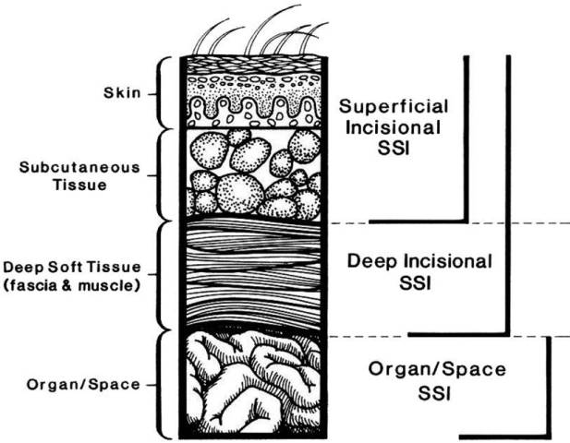

Figure 1 Centers for Disease Control and Prevention's National Healthcare Safety Network classification for surgical site infection

Causative Agents
Table 1 provided by the WHO displays the leading pathogens associated with SSI and their resistance to various antimicrobial agents reported to NHSN during 2009 to 2010 [5]. Staphylococcus aureus and Klebsiella spp. are discussed in further detail to provide insight into the differences between the highest and lowest ranked pathogens associated with SSI.

Table 1 Distribution and percentage of pathogenic isolates associated with SSI and resistant to selected antimicrobial agents, NHSN 2009-2010
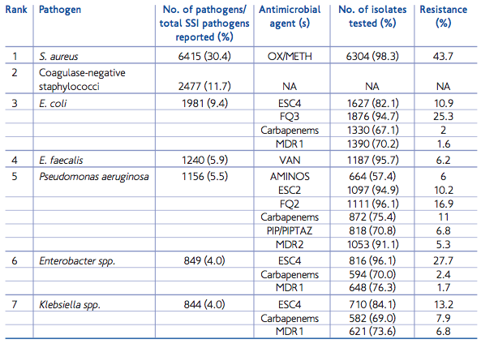

Bacteriology of Staphylococcus aureus
Staphylococcus aureus is a Gram-positive bacterium and a leading HAI pathogen worldwide. Strains of staphylococci can be identified through whole genome sequencing and antibiotic resistance profiling. Colonization occurs in the anterior nasal passage but airborne spread is rare. Transmission is through skin-to-skin contact with a person who has a purulent lesion, is an asymptomatic carrier of a pathogenic strain or with shared items/surfaces [6].
Staphylococcus aureus expresses a number of virulence factors that help to establish infection by facilitating tissue attachment, tissue invasion, host immune response evasion and induction of toxinosis. Microbial Surface Components Recognizing Adhesive Matrix Molecules (MASCRAMM) are cell surface proteins which interact with host molecules such as collagen, fibronectin and fibrinogen thus facilitating tissue attachment. Staphylococcal protein A, fibronectin-binding proteins A and B, collagen-binding protein and clumping factor A & B belong to MASCRAMM [7]. Microbial Surface Components Recognizing Adhesive Matrix Molecules are also involved in host immune evasion.
Extracellular adherence protein, hyaluronate lyase, leukocidin and staphylokinase are extracellular enzymes that cause tissue destruction that promotes bacterial spread into host tissues [8]. Specifically, Extracellular adherence protein is an exoprotein that binds to host cell matrix, plasma proteins and endothelial cell adhesion molecule ICAM-1. Protein A and polysaccharide microcapsule are surface factors that inhibit the phagocytic engulfment of Staphylococcus aureus. Protein A binds to the Fc portion of immunoglobulin preventing opsonization and limiting the host immune response. However, when the bacterium is phagocytosed, the production of carotenoids and catalase enhances the bacterium’s survival in the phagocyte due to biochemical properties. Toxic shock syndrome toxin-1, exfoliative toxins A and B, Staphylococcal enterotoxins and Alpha-hemolysin are exotoxins that damage host tissues [10]. Staphylococcal enterotoxins are toxins that cause toxic shock-like symptoms and have been implicated in food poisoning and several allergic and autoimmune diseases. Exfoliative toxins are serine proteases that selectively recognize and hydrolyze desmosomal cells in the skin [9].
The ability to acquire resistance to multiple antibiotic classes makes Staphylococcus aureus challenging to treat. Methicillin-Resistant Staphylococcus aureus (MRSA) carries a mecA gene that codes for penicillin-binding protein 2a (PBP2a). PBP2a is a transpeptidase that catalyzes synthesis of peptidoglycan in the bacterial cell wall. Bacterial cell wall synthesis is essential to bacterial growth, division and maintenance of cellular structure. β-lactam antibiotics, such as methicillin and penicillin, inactivate PBP2a as a result of irreversible acylation of an active site serine. Unfortunately, β-lactam antibiotics have a low affinity towards PBP2a resulting in antibiotic evasion. Due to the presence of mecA, MRSA is resistant to nearly all β-lactam antibiotics.

Bacteriology of Klebsiella spp.
The Klebsiella spp. are Gram-negative bacteria that are normally found in the human intestines. With a varying incubation period of 1-3 weeks, Klebsiella spp. can be diagnosed from the examination of blood, mucus or urine samples [11]. In particular, Klebsiella pneumoniae is of concern as it has a high degree of antibiotic resistance and can cause various HAIs. Klebsiella pneumoniae is the most common carbapenem-resistant Enterobacteriaceae species in the United States with high morbidity, high mortality and resistance to nearly all antibiotics [12]. Klebsiella pnemoniae can accumulate many antibiotic resistance genes by horizontal transfer of genetic elements through plasmids. After acquiring a plasmid encoding a carbapenemase gene, Klebsiella pneumonia becomes resistant to carbapenem antibiotics and causes hard to treat infections [13]. Resistance to carbapenem antibiotics is alarming because carbapenem antibiotics are typically used as a last line of defense medication. Additionally, carbapenem resistance has been linked to an up-regulation in efflux pumps, an alteration of the outer membrane, and increases production in extended-spectrum beta-lactamase enzymes in the organism [12].

Risk Factors
There are various patient-related and procedural related factors that affect a patient’s risk of developing a surgical site infection. Table 2 shows that the risk of infection varies by procedure type while Table 3 lists SSI risk factors [2-4]. The recommendations listed in Table 4 were adapted from Strategies to prevent surgical site infections in acute care hospitals: 2014 update by D.J. Anderson and should be consistently applied. Surgical site infection risk factors are classified as preoperative, perioperative and postoperative.
Preoperative risk factors can be categorized as non-modifiable and modifiable. The non-modifiable factors, such as age and gender, can obviously not be changed. Fortunately, there are several modifiable preoperative risk factors, such as nutritional status, diabetes, and tobacco use that can be changed to favor a positive surgical outcome. A patient’s albumin levels can determine the nutrition status of a patient pre-surgery. Albumin levels less than 3.5 mg/dL have been found to delay wound healing by having a less competent immune response to infection, thus leading to readmission of the patient into the hospital [3]. Diabetes is a surgical site infection risk factor due to two primary mechanisms. The first is the possibility of compromising the body’s microvasculature, which will reduce tissue perfusion and impair cellular-level functions. The second mechanism is that with decreased microcirculation there is also reduced activity of cellular immunity functions of chemotaxis and phagocytosis. Across many surgical fields, smoking has been identified as a risk factor for complicating wound healing. Nicotine causes peripheral vasoconstriction which induces tissue hypovolemia and hypoxia[2].
In regards to perioperative risk factors, a longer procedure time may increase the probability of adverse outcomes including surgical site infections. According to Cheng et al., across various procedures, patients who developed a SSI had an average procedure time 30 minutes longer than patients without a SSI. A key perioperative risk factor is the incomplete sterilization of surgical equipment and environmental surfaces. This contamination could be a result of inadequate maintenance of autoclave components, poor handling practices by staff, and lapses in inspection of surgical sets. Sterilization is an important process that destroys microorganisms on the surfaces of instruments that are used during surgery. Proper sterilization of surgical equipment is critical to prevent infection and transmission of diseases across patients.
Furthermore, appropriate surgical wound management in the postoperative time frame is required to prevent complications such as surgical site infections. After a patient is discharged from a hospital or outpatient surgery setting, caregivers should educate relatives on how to properly care for the surgical site and recognize signs of early infection.

Table 2 National Healthcare Safety Network Surgical Site Infection Rates for Selected Procedures Detected on Admission or Re-Admission, 2014
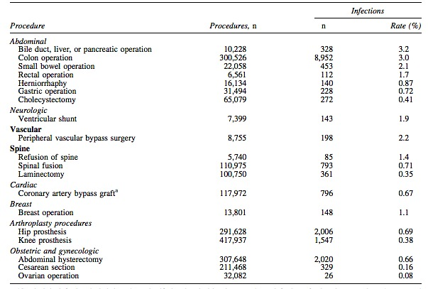

Table 3 Surgical Site Infection Risk Factors
Category | Risk Factor
Preoperative | Non-Modifiable  Age  History of skin or soft tissue infection  Modifiable  Diabetes  Obesity  Tobacco Use  Length of pre-operative hospitalization  Staphylococcus aureus nasal carriage  Preoperative albumin level  Immunosuppression  Inadequate skin preparation  Inappropriate antibiotic choice, timing, and weight-based dosing  Hair removal method
Perioperative | Operating Room Ventilation  Organ Site  Urgency of Procedure  Procedure Duration  Blood Transfusions  Increased Operating Room Traffic  Contaminated Environmental Surfaces  Non-Sterile Equipment  Inappropriate surgical scrubbing and gloving
Postoperative | Wound Care

Table 4 Selected Risk Factors for and Recommendations to Prevent Surgical Site Infections
 | Risk Factor | Recommendation
Patient Related | Age  Glucose control  Obesity  Smoking cessation  Staphylococcus aureus nasal carriage  Hypoalbuminemia | No formal recommendation. Relationship to increased risk of SSI may be secondary to comorbidities or immunosenescence.  Control serum blood glucose levels for all surgical patients, including patients without diabetes. Patients with diabetes mellitus, glycosylated hemoglobin A1c levels should be reduced to less than 7% before surgery, if possible.  Increase dosing of prophylactic antimicrobial agent for morbidly obese patients.  Encourage smoking cessation within 30 days of procedure.  The application of Mupirocin nasal ointment twice a day for 5-7 days before surgery or from the day of hospital admission till the day of surgery.  No formal recommendation. Although a noted risk factor, do not delay surgery for use of total parenteral nutrition.
Procedure Related | Hair removal  Preoperative infections  Surgical scrub  Skin preparation  Antimicrobial prophylaxis  Blood transfusion | Do not remove unless hair will interfere with the operation. If hair removal is necessary, remove outside the OR by clipping. Do not use razors.  Identify and treat infections remote to the surgical site prior to elective surgery. Do not routinely treat colonization or contamination.  Use appropriate antiseptic agent to perform preoperative surgical scrub. Most products instruct to scrub the hands and forearms for 2-5 minutes.  Wash and clean skin around incision site. Use a dual agent skin preparation containing alcohol, unless contraindications exist.  Administer within 1 hour of incision to maximize tissue concentration  Blood transfusions increase the risk of SSI by decreasing macrophage function. Reduce blood loss and need for blood transfusion to the greatest extent possible.
Operating Room Related | Ventilation  Traffic  Environmental surfaces  Sterilization of surgical equipment | Follow American Institute of Architects’ recommendations for proper air handling in the operating room.  Minimize operating room traffic.  Use an EPA-approved hospital disinfectant to clean visibly soiled or contaminated surfaces and equipment.  Sterilize all surgical equipment according to published guidelines. Minimize the use of immediate-use steam sterilization.

Prevention Strategies
Prevention of SSIs can be achieved by better preoperative preparation of the surgical site, adherence to infection control protocols while performing surgery, and antibiotic prophylaxis. The prevention of surgical site infections entails measures aimed at eliminating bacterial and fungal contamination caused by the patient’s endogenous skin flora, operative staff and operating room. The incorporation of preoperative skin preparation with antiseptic agents decreases SSIs because the patient's skin is colonized with bacteria, fungi and viruses-up to 3 million per square centimeter of skin. Commonly used skin antiseptics include alcohol, chlorhexidine-alcohol and povidone-iodine [14]. The overall rate of SSIs is significantly lower when chlorhexidine-alcohol is used during skin preparation (9.5%) compared to povidone-iodine (16.1%) [14]. In a 30-day follow up SSI study conducted in 2010, chlorhexidine-alcohol was significantly more protective than povidone-iodine against both superficial incisional infections (8.6% vs. 4.2%) and deep incisional infections (3% vs. 1%) but not against organ-space infections (4.4% vs. 4.5%) [14].
Secondly, effective preoperative prevention strategies include the proper removal of hair, administration of antibiotic prophylaxis and treatment of Staphylococcus aureus nasal carriage. The CDC recommends not removing any hair unless it will interfere with the procedure[15]. Shaving causes microscopic cuts in the skin that can allow for the introduction of microorganisms into the body. If necessary, hair removal should be done outside of the operating room using clippers or a depilatory cream. The administration of antimicrobial prophylaxis should be done within one hour before the surgical procedure to maximize tissue concentration [16]. The reasoning behind the use of antibiotic prophylaxis is that the agent will assist the host immune-defenses by suppressing microorganism growth at the surgical site. According to CDC SSI guidelines, the antimicrobial agent used during surgery should be specific to the pathogens frequently associated with causing infections for a specific procedure. Another preoperative prevention strategy is the treatment of Staphylococcus aureus nasal carriers because nasal carriage of Staphylococcus aureus is a risk factor for subsequent infection in a patient. This pathogen has been repeatedly shown to be a large proportion of HAIs originating from the patient’s own flora [10]. The treatment entails the application of Mupirocin nasal ointment twice a day for 5-7 days before surgery or from the day of hospital admission till the day of surgery [15].
Maintaining normothermia, antimicrobial stewardship and adhering to a surgery checklist are perioperative prevention strategies hospitals can utilize. Normothermia is defined as having a body temperature within the range of 36°C to 37.3°C [17]. The maintenance of a normal core body temperature, normothermia, is a crucial component of patient safety. If a patient experiences even a mild form of hypothermia, evidence has shown that there can be an increase in the surgical site infection risk rate (19% vs. 6%) [18]. Hypothermia may directly or indirectly inhibit neutrophil function that will lead to subcutaneous vasoconstriction followed by tissue hypoxia, and poor wound healing [15]. Furthermore, hypothermia can increase the loss of blood during surgery that may result in wound hematomas, a blood clot in the wound, or blood transfusion. Wound hematomas and blood transfusions can increase the risk of a patient getting a SSI. In regards to antimicrobial stewardship, perioperative personnel may inadvertently transfer microbial contaminants to patients by touching door handles, computer keyboards, light fixtures and other surgical room equipment. Therefore, hand hygiene of all personnel interacting with the patient is of high importance. A prevention strategy for perioperative personnel is the proper donning of surgical gowns, masks, and latex-free gloves especially when contact with the patient’s skin is expected. To further ensure best practices to improve patient safety are followed, a surgical safety checklist can be used. Specifically, the World Health Organization has a 19-item surgical safety checklist that involves perioperative personnel ranging from the anesthetist to the surgeon. The WHO Surgical Safety Checklist can be found in Appendix A. The WHO created the checklist with the intent of aiming to decrease errors, adverse events and increase teamwork and communication in surgery. Given that hospitals may have varying procedural guidelines to follow, the WHO does encourage modifications and additions to its checklist to fit local practice.
The risk of infection continues even after the patient leaves the hospital. Postoperative prevention strategies rely heavily on the education of the patient and relatives regarding proper incision care and recognition of signs of SSI. They should be made aware of the importance of reporting symptoms to their surgeon or primary care provider. This strategy can be implemented through easy-to-read take-home materials.

Surveillance
Surveillance is a tool to ensure that hospital systems are working properly and that interventions taken to reduce the risk of HAIs are working. The most accurate method of surveillance for SSI is the daily observation of the surgical site by the physician, registered nurse or infection control practitioner starting 24 to 48 hours after surgery until discharge. The coordination of postdischarge SSI surveillance between the hospital’s infection control department, the surgical unit and the patient’s care team is vital to the accurate collection of statistical data. The statistics will include the incidence of surgical site infections by types of patients, surgeries and surgeon performing the surgery. Considering that more than half of all surgeries are performed in outpatient settings and more than 65% of all inpatient surgery SSIs are identified after the patient leaves the facility, it is very easy to significantly underestimate SSI rates and miss serious infection issues [19].
Methods of surveillance to prevent surgical site infection prior to surgery are direct observation audits of operating room personnel and environmental cleaning practices. The direct observation audits of the operating room personnel will assess adherence to hand hygiene, patient skin preparation, surgical attire, operative techniques and level of operating room traffic. Also, this surveillance will identify lapses in infection control due to not closely following operating room protocols. Additionally, the performance of direct observation audits of environmental cleaning practices will involve the review of instrument sterilization logs and maintenance logs of the operating room ventilation systems, which will show results of temperature, humidity and air pressure testing.
Most importantly, the outcome data and data analysis from these surveillance methods should be shared with all stakeholders so that there is agreement on the data validity and universal involvement in ongoing and episodic improvement activities. Since more than 90,000 readmissions annually are a result of surgical site infections, SSIs have been used as a pay-for-performance metric and ultimately a focus of quality improvement efforts [20]. Accurate measurements in patient safety can be a challenge to collect, but the development of standard metrics that allow for tracking and comparison of infection rates over time has made it simpler. The CDC’s NHSN is the largest HAI reporting system in the United States. The CDC’s National Healthcare Safety Network has developed standards for reporting surgical site infection measurements, which include a surgical site infection report form, criteria required for reporting a surgical site infection and recommended surveillance periods for specific operative procedures (Appendix B-C). Through the NHSN, facilities, states and regions are provided with data that will measure the progress of prevention efforts and identify areas of improvement.
In conclusion, the on-going research to understand the biology behind surgical site infections and strict adherence to the application of proven methods to decrease the rate of SSIs is instrumental to further reduce the health and financial consequences related to SSIs.

        - : World Health Organization Surgical Safety Checklist
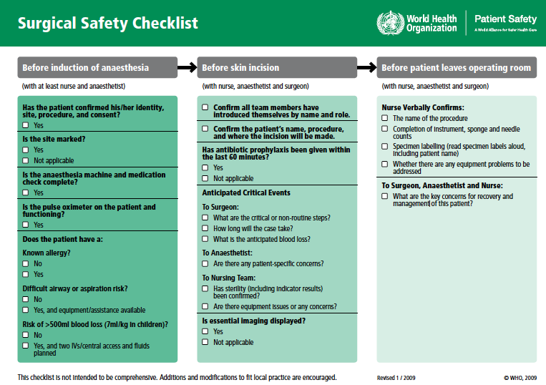

        - : NHSN Surgical Site Infection Criteria

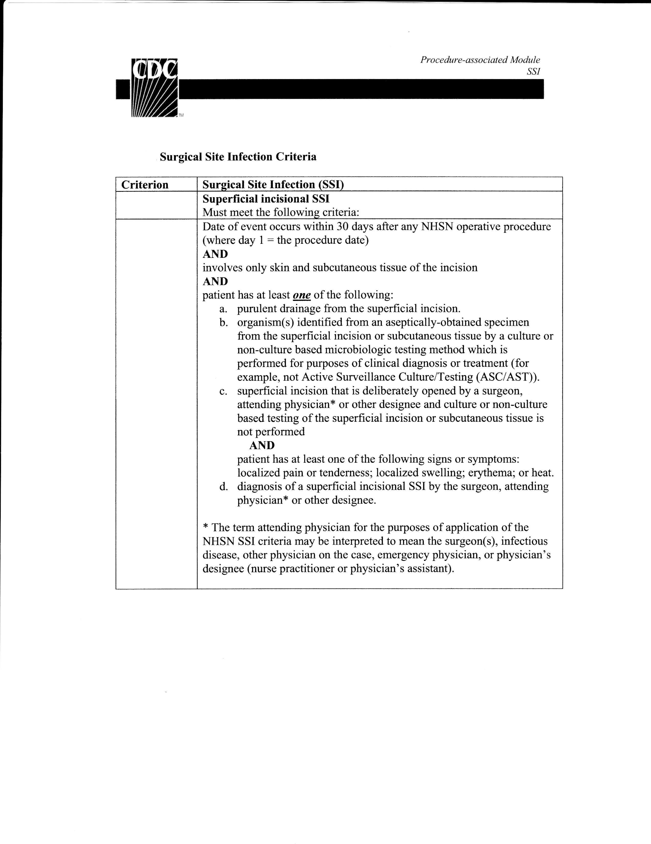
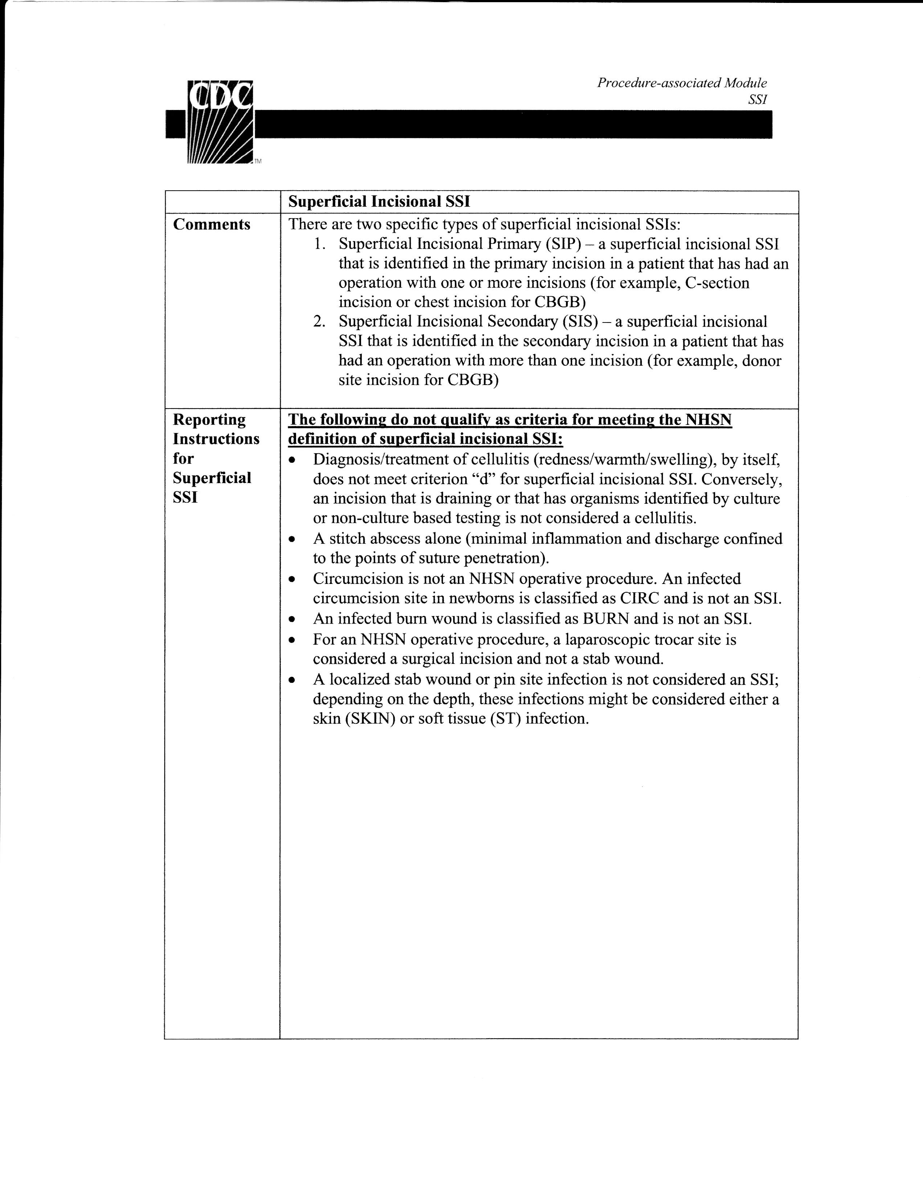
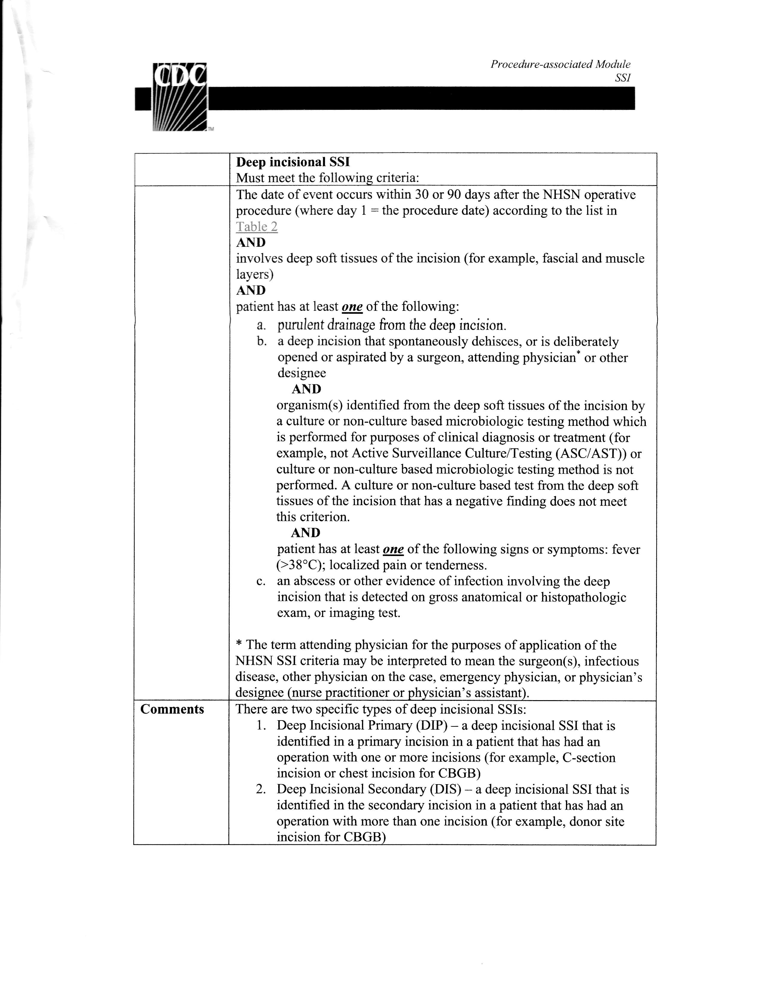
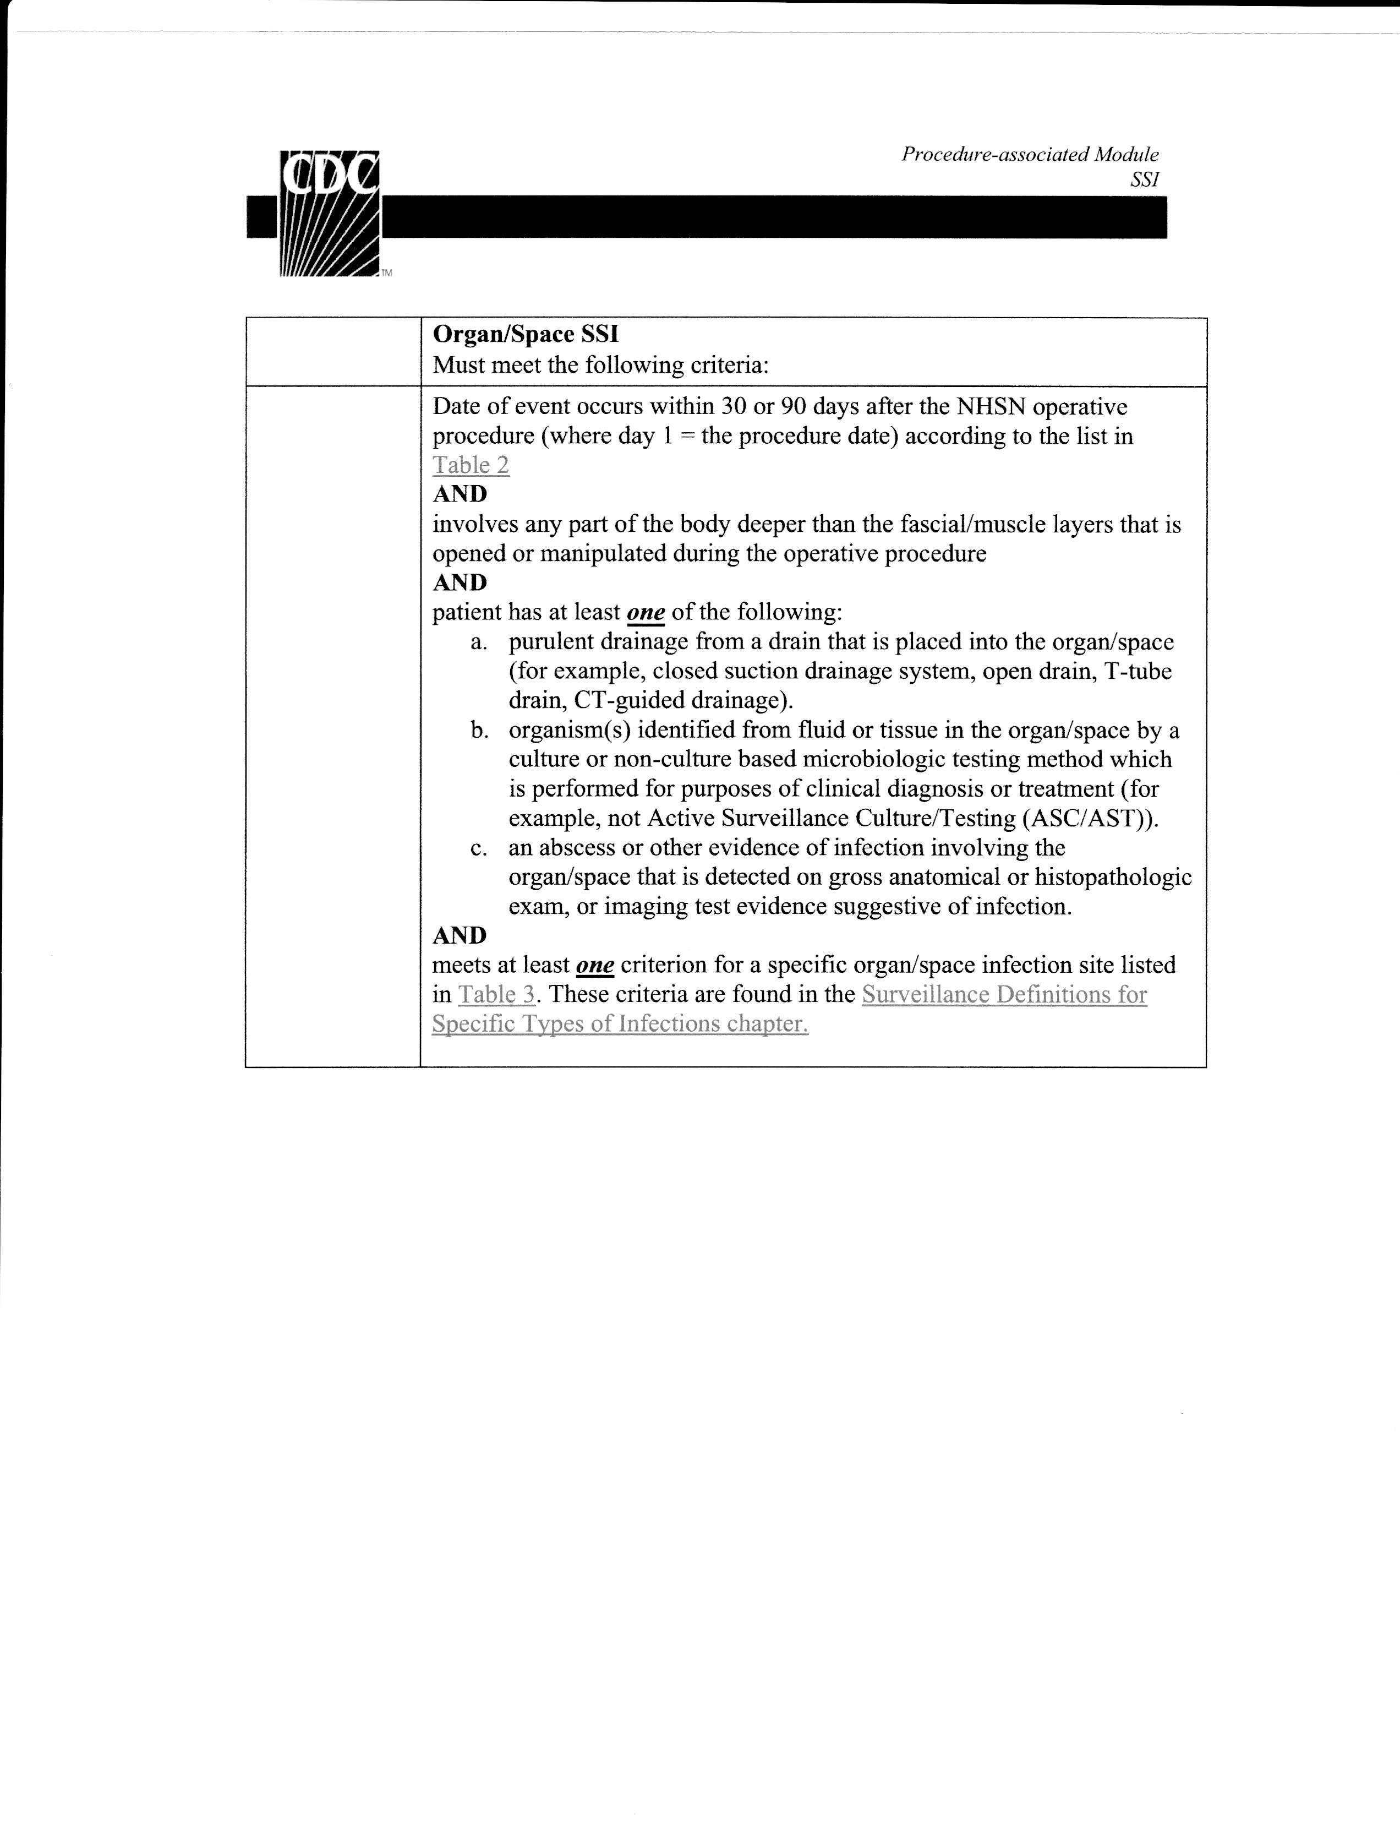
        - : NHSN Recommended Surveillance Periods

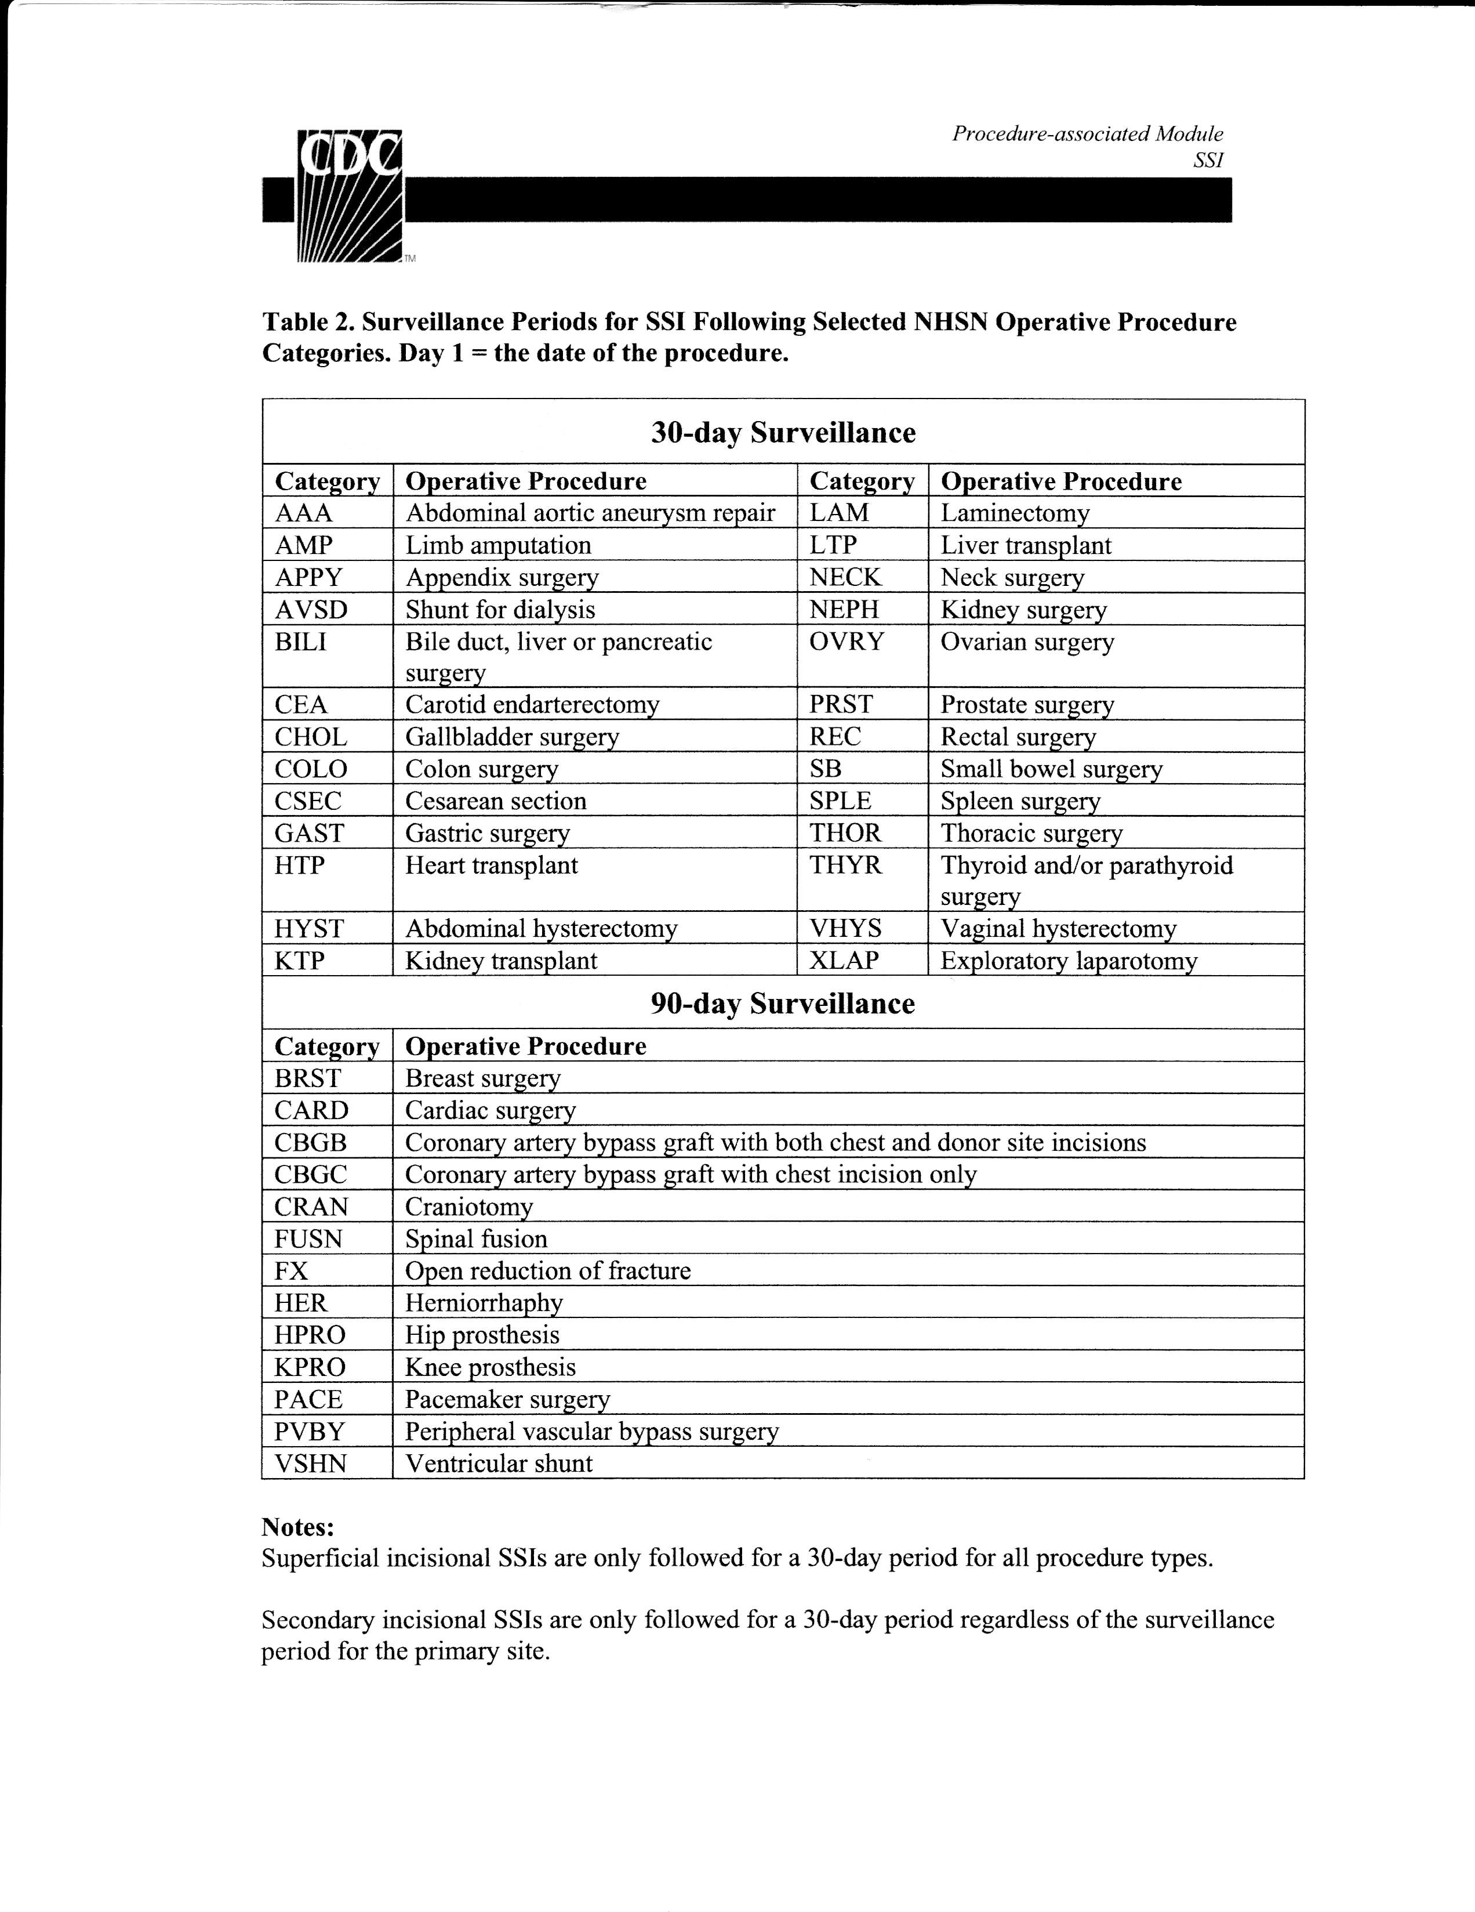

Bibliography
1. Solomkin, J.S., et al., Introduction to the Centers for Disease Control and Prevention and the Healthcare Infection Control Practices Advisory Committee Guideline for the Prevention of Surgical Site Infections. Surg Infect (Larchmt), 2017. 18(4): p. 385-393.
2. Ban, K.A., et al., Executive Summary of the American College of Surgeons/Surgical Infection Society Surgical Site Infection Guidelines-2016 Update. Surg Infect (Larchmt), 2017. 18(4): p. 379-382.
3. Nasser, R., et al., Risk Factors and Prevention of Surgical Site Infections Following Spinal Procedures. Global Spine J, 2018. 8(4 Suppl): p. 44S-48S.
4. National Healthcare Safety Network, C.f.D.C.a.P., Surgical Site Infection (SSI) Event. 2017, Centers for Disease Control and Prevention.
5. Organization, W.H., Global Guidelines for the Prevention of Surgical Site Infection. 2018, World Health Organization.
6. Harbarth, S., Staphylococcal Diseases, in Control of Communicable Diseases Manual, D.L. Heymann, Editor. 2015, American Public Health Association: Washington, DC. p. 570-575.
7. Vazquez, V., et al., Fibrinogen is a ligand for the Staphylococcus aureus microbial surface components recognizing adhesive matrix molecules (MSCRAMM) bone sialoprotein-binding protein (Bbp). J Biol Chem, 2011. 286(34): p. 29797-805.
8. Edwards, A.M., et al., Staphylococcus aureus extracellular adherence protein triggers TNFalpha release, promoting attachment to endothelial cells via protein A. PLoS One, 2012. 7(8): p. e43046.
9. Bukowski, M., B. Wladyka, and G. Dubin, Exfoliative Toxins of Staphylococcus aureus. Toxins, 2010. 2(5): p. 1148-1152.
10. Fernando, S.A., T.J. Gray, and T. Gottlieb, Healthcare-acquired infections: prevention strategies. Intern Med J, 2017. 47(12): p. 1341-1351.
11. Heymann, D., Control of Communicable Diseases Manual. 20th ed. 2014: APHA.
12. Jacob, J.T., Vital signs: carbapenem-resistant Enterobacteriaceae. MMWR Morb Mortal Wkly Rep, 2013. 62(9): p. 165-70.
13. Nordmann, P., G. Cuzon, and T. Naas, The real threat of Klebsiella pneumoniae carbapenemase-producing bacteria. Lancet Infect Dis, 2009. 9(4): p. 228-36.
14. Darouiche, R.O., et al., Chlorhexidine–Alcohol versus Povidone–Iodine for Surgical-Site Antisepsis. New England Journal of Medicine, 2010. 362: p. 18-26.
15. Anderson, D.J., et al., Strategies to prevent surgical site infections in acute care hospitals: 2014 update. Infect Control Hosp Epidemiol, 2014. 35 Suppl 2: p. S66-88.
16. Epstein, N.E., Preoperative measures to prevent/minimize risk of surgical site infection in spinal surgery. Surg Neurol Int, 2018. 9: p. 251.
17. Bindu, B., A. Bindra, and G. Rath, Temperature management under general anesthesia: Compulsion or option. Journal of Anaesthesiology Clinical Pharmacology, 2017. 33: p. 306-316.
18. Hooper, V.D., et al., ASPAN's evidence-based clinical practice guideline for the promotion of perioperative normothermia: second edition. J Perianesth Nurs, 2010. 25(6): p. 346-65.
19. Dancer, S.J., et al., Surgical site infections linked to contaminated surgical instruments. J Hosp Infect, 2012. 81(4): p. 231-8.
20. Medina-Polo, J., et al., Prevention of healthcare-associated infections (HAIs) in a surgical urology ward: observational study-analysis of the problem and strategies for implementation. World J Urol, 2019.

