**FACTORS IMPACTING LOCAL OBESITY RATES IN PENNSYLVANIA**

by

Jerome P. Givi

B.S. Biological Sciences, University of Pittsburgh, 2017

Submitted to the Graduate Faculty of

Human Genetics

Graduate School of Public Health in partial fulfillment

of the requirements for the degree of

Master of Public Health

University of Pittsburgh

2019

UNIVERSITY OF PITTSBURGH

GRADUATE SCHOOL OF PUBLIC HEALTH

This essay is submitted

by

Jerome P. Givi

on

April 17, 2019

and approved by

Essay Advisor:

Candace Kammerer, PhD

Associate Professor

Department of Human Genetics

Graduate School of Public Health

University of Pittsburgh

Essay Reader:

Elizabeth Van Nostrand, JD

Director, MPH and JD/MPH Programs

Department of Health Policy and Management

Graduate School of Public Health

University of Pittsburgh

**ABSTRACT**

Copyright © by Jerome P. Givi

2019

Candace Kammerer, Ph.D.

**FACTORS IMPACTING LOCAL OBESITY RATES IN PENNSYLVANIA**

Jerome P. Givi, MPH

University of Pittsburgh, 2019

County-level data related to health is critically important for local and state public health departments. This information enables public health professionals to gain a better understanding of the health problems in their county and how they differ from and are like surrounding counties. County-level health-related data enables trends in health outcomes to be observed and enables professionals to elucidate the upstream factors that are related to and may contribute to those outcomes. Once problems are found and their causes are identified, interventions that specifically fit the needs of individual counties can be implemented to resolve those issues.

The Pennsylvania Department of Health (PADOH) has compiled health-related data and integrated them into an Enterprise Data Dissemination Informatics Exchange (EDDIE) tool. This publicly available interactive web tool enables users to organize county-level health-related data so that relationships between these factors can be elucidated. Using this tool, along with other publicly available data sources, I have investigated the relationship between local health-related factors and obesity rates in Pennsylvania counties and created a predictive model using multivariate linear regression (adjusted R2=0.5753) that predicts county obesity rate. The results of my research may aid local public health officials in developing interventions aimed at decreasing obesity rates in the state.

TABLE OF CONTENTS

preface ix

1.0 OBESITY: BACKGROUND 1

1.1 COMORBIDITIES 2

1.2 socioeconomic and racial/ethnic disparities 4

2.0 risk factors influencing obesity 6

2.1 Smoking 6

2.2 access to recreation 7

2.2.1 WALKWORKS 7

2.2.2 PARKS 7

2.3 Health Insurance 8

2.4 POVERTY 9

2.5 CRIME RATE 10

2.6 POPULATION DENSITY 11

3.0 Methods 13

4.0 Results 18

4.1 Correlation analyses of obesity rate and each potential predictor variable 18

4.1.1 SMOKING 18

4.1.2 ACCESS TO RECREATION 18

4.1.3 HEALTH INSURANCE 18

4.1.4 POVERTY 19

4.1.5 CRIME 19

Data on Type I crime rates in Pennsylvania counties comes from the Uniform Crime Reporting Program. The crime rate did not significantly correlate with obesity (r=-0.1920; p=0.1195). 19

4.2 Multiple regression analySes 19

5.0 Conclusions and Future directions 21

Appendix A RAW DATA USED IN ANALYSES 23

Appendix B FREQUENCY HISTOGRAM OF EACH VARIABLE 29

Appendix C CORRELATION OF EACH VARIABLE WITH OBESITY 30

bibliography 31

List of tables

Table 1. County Data Summary and Sources 14

Table 2 Correlation Matrix Values of All Variables 16

Table 3 Regression Model Summary Table 20

List of figures

Figure 1 Frequency Histogram of County Population Density 15

# OBESITY: BACKGROUND

Body mass index (BMI) is a measure derived from the mass and height of an individual. The Centers for Disease Control and Prevention (CDC) defines obesity as having a BMI over 30 (Centers for Disease Control and Prevention, 2016). Based on data from the National Health and Nutrition Examination Survey, the CDC estimates that the percentage of adults in the U.S. population who are obese has been steadily increasing for over a decade and was nearly 40% in 2015-16 (Hales, Carroll, Fryar, & Ogden, 2017).

Pennsylvania has not been able to avoid this nationwide trend in increasing obesity rates. Currently, 31.6% of adults and 13.7% of children are obese. Two health issues that are strongly correlated with obesity are hypertension and heart disease. In Pennsylvania, 32% of adults have hypertension and the leading cause of death is heart disease, with a current mortality rate of 176.2 per 100,000 (State of Obesity, 2018).

Obesity is a condition with many comorbidities that alters quality of life and shortens life expectancy (Lung, Jan, Tan, Killedar, & Hayes, 2018). Obesity and its comorbidities incur physical, mental, and financial burdens on the individuals and society. For example, the annual amount of medical spending on obesity and the health problems associated with was $147 billion in 2009, representing about a 9.1% increase in annual medical spending at the time (Finkelstein, Trogdon, Cohen, & Dietz, 2009). Some of this cost can be attributed to increased health care time and resources spent on treating individuals with health issues related to obesity (Raebel et al., 2004). The additional time and resources spent on treatment puts further stress on an already over-extended health care system with an insufficient number of healthcare providers (Association of American Medical Colleges, 2018). As the proportion of medical providers per individual in the United States and Pennsylvania continues to decrease, it is important to minimize risk factors, such as obesity, for higher usage rates of these resources. Understanding the public health factors that are related to local obesity rates can guide policymakers’ decisions and help lower obesity rates.

## COMORBIDITIES

One of the comorbidities strongly associated with obesity is diabetes mellitus, a group of chronic conditions that are characterized by increased blood glucose levels. Type II diabetes mellitus (T2DM) is caused by decreased production or effectiveness of the hormone insulin, which is important in regulating blood glucose levels. Keeping blood glucose levels within a normal range is important, as deviations from normal levels can negatively affect many systems in the body, including the heart, blood vessels, nerves, eyes, and kidneys (Mayo Clinic, 2018). Therefore, diabetic patients must constantly monitor their blood glucose levels and manage it through diet, exercise, and medication. The total economic cost associated with diabetes in 2017 was $327 billion, which includes direct medical costs and costs due to loss of productivity (Centers for Disease Control and Prevention, 2017c).

Being obese is one of the main risk factors for developing T2DM; 50% of diabetic patients are obese and the risk of developing T2DM is increased by approximately 300% in individuals with BMI of 30 or greater (Abdelaal, le Roux, & Docherty, 2017). According to the American Diabetes Association, T2DM accounts for 90-95% of all diabetes cases (Centers for Disease Control and Prevention, 2017c). 30.3 million Americans, 9.4% of the total population, had diabetes in 2015. 1.5 million new cases of diabetes are diagnosed every year and over 84 million American adults have prediabetes, a risk factor for developing T2DM classified by slightly elevated blood glucose levels. Diabetes was the seventh leading cause of death in the United States, with 79,353 death certificates listing it as the primary cause of death. Diabetes was mentioned as a cause of death in 252,806 death certificates.

Other common comorbidities seen in obese individuals are cardiovascular disease and stroke. Obesity is associated with several factors that increase one’s risk of cardiovascular disease, including T2DM, high blood LDL cholesterol levels, low HDL cholesterol levels, and high blood pressure (Cleveland Clinic, 2019). Obesity is also associated with increased inflammation, which contributes to buildup of the plaque in arteries that eventually cause heart attack. Every year, about 735,000 U.S. adults have a heart attack and 610,000 die of heart disease, making it the leading cause of death in the United States (Centers for Disease Control and Prevention, 2019). Heart disease also costs the United States approximately $200 billion each year in medical costs and lost productivity.

The kidneys execute many functions in the body, including waste excretion, balancing body fluids, regulating blood pressure, producing hormones, and more. Obesity is highly associated with chronic kidney disease (CKD), the gradual loss of kidney function. Two of the major risk factors for CKD are diabetes and hypertension; nearly half of all individuals with CKD also have diabetes and/or cardiovascular disease (National Institute of Health, 2019). CKD is usually asymptomatic, thus many individuals with CKD are not aware of their condition; a definitive diagnosis is only made through blood and urine tests. CKD may progress to total kidney failure, which is fatal without dialysis or a kidney transplant.

Thirty million Americans are estimated to have CKD by the CDC and over 661,000 have kidney failure and are either on dialysis or live with a transplanted kidney (Centers for Disease Control and Prevention, 2017b). CKD accounts for greater than one-half of all deaths caused by end-stage renal disease. In 2016, Medicare spent $79 billion to treat individuals with CKD and an additional $35 billion to treat individuals with end-stage renal disease.

Obesity also increases an individual’s risk of 13 different types of cancer. These cancers, in total, account for approximately 40% of all cancers diagnosed in the United States (Centers for Disease Control and Prevention, 2017a). The American Cancer Society estimates that 8% of all cancer cases and 7% of all cancer deaths in the United States are attributable to excess body weight (American Cancer Society, 2019). The mechanism that drives these associations is unclear and is likely different for different cancer types.

Many other comorbidities make obesity a serious public health problem. These include, but are not necessarily limited to, obesity-hypoventilation syndrome, nonalcoholic fatty liver disease, subfertility, gastroesophageal reflux disease, problems with physical function, and body image problems (Abdelaal et al., 2017).

## socioeconomic and racial/ethnic disparities

Obesity rates differ between different populations. According to the CDC, Hispanics and non-Hispanic blacks have the highest age-adjusted rates of obesity at approximately 47%, followed by non-Hispanic whites at 37.9% and non-Hispanic Asians at 12.7% (Centers for Disease Control and Prevention, 2018a). Adult women have a higher prevalence of obesity in all ethnicities except for non-Hispanic white. Obesity is also inversely associated with education, as the obesity rate among adults who have gone through post-secondary education is about 21.5%, compared to 33% in those who have not (The State of Obesity, 2019b). Similar associations with education are seen among different ethnicities. Also, differences in obesity rates are seen among populations with different incomes. Approximately 1 in 3 adults earning less than $15,000 per year are obese, compared to less than 1 in 4 who earn over $50,000.

A similar trend is seen in children, as the obesity rates in Latino, African American, white, and Asian children are 25.8%, 22.0%, 14.1%, and 11.0%, respectively (The State of Obesity, 2019a). Unlike adults, there are no significant differences in obesity rates between boys and girls of the same ethnicity. Also, children with parents with a college degree is just 9.5%, compared to the 30.4% of children with parents with less than 12 years of education. The trend with income is also consistent between children and adults, as children living in a household below the federal poverty level are 2.7 times more likely than children living in households earning over 400% of the federal poverty level.

# risk factors influencing obesity

## Smoking

Smoking cigarettes harms nearly every organ in your body and is linked to numerous poor health outcomes. Smoking is responsible for over 480,000 deaths per year, including 42,000 deaths from secondhand smoke exposure (Centers for Disease Control and Prevention, 2018b). The government collects about $25.8 billion in cigarette taxes per year, but the overall economic costs attributed to smoking are estimated at over $300 billion (Hall & Doran, 2016). Eighteen percent of Pennsylvania adults smoked in 2016, whereas the national rate was 17.1% (Truth Initiative, 2018). Smoking is associated with increased metabolic rate, reduction of appetite, and lower body weight (Chiolero, Faeh, Paccaud, & Cornuz, 2008). In fact, numerous studies across a wide variety of populations have reported that smoking cessation is associated with weight gain; a fact that influences some individuals’ decision to continue smoking (Bush, Lovejoy, Deprey, & Carpenter, 2016). However, a retrospective cohort study with electronic medical record data of over 700,000 Israelis shows that smoking confers a greater risk for myocardial infarction than obesity (Dicker, Feldman, Benis, & Hoshen, 2016). I hypothesize that counties with high proportions of adults who smoke will have lower rates of obesity. If my hypothesis is supported in this study, this can provide additional evidence to counties for including weight management support in offered smoking cessation programs. Understanding how the rates of these two negative health outcomes are related can provide a starting point for counties and other investigators to continue research into the dynamic between these factors.

## access to recreation

It has become increasingly evident that the built environment plays a role in obesity rates, a relationship likely mediated at least somewhat by physical activity (Papas et al., 2007). It is therefore an aim of this study to investigate the relationship between both local walking paths supported by the WalkWorks program and local parks and county obesity rates.

### WALKWORKS

The Pennsylvania Department of Health and the University of Pittsburgh Graduate School of Public Health Center for Public Health Practice have partnered to create the WalkWorks program. This program’s goal is to increase individuals’ opportunity for physical activity in Pennsylvania by identifying and promoting the use of safe walking routes. The program encourages the use of these routes by offering community walking groups and helping develop walk-to-school programs. The program also works to increase the number of safe walking routes by influencing local policies. There are currently 80 WalkWorks paths covering over 115 total miles in 17 different Pennsylvania counties (Pennsylvania Department of Health, 2019). Although there is no publicly available data on how frequently these paths are used, high availability of these paths should lead to increased physical activity and, ideally, lower obesity rates in counties.

### PARKS

Previous studies have shown variable degrees of relationship between access to local parks and physical activity and obesity rates in various populations, particularly in youth. Hughey, et al. demonstrated that increased availability to local parks and playgrounds were associated with lower obesity rates among many subpopulations of 3rd-5th grade youth in a southeastern U.S. county, with variations by socioeconomic status and race/ethnicity (Morgan Hughey et al., 2017). A cross-sectional study of children in Brazil found that living closer to parks and playgrounds was positively associated with their use. Living closer to parks was also associated with lower BMI among the low-income families included in this study (Rossi et al., 2018).

In the United States, 18.5% of youth aged 2-19 are obese (The State of Obesity, 2019a). This is a major public health issue, as childhood obesity is a risk factor for adult obesity and cardiovascular disease (Allcock, Gardner, & Sowers, 2009). Providing individuals, particularly youth, a place to undergo physical activity is important in preventing obesity.Therefore, the relationship between availability of parks with obesity rate will be investigated. Locations and information about all playgrounds, basketball courts, tennis courts, swimming pools, sports fields, and pavilions in Pennsylvania are kept track of by the Pennsylvania Parks and Recreation department and can be found at http://maps.dcnr.pa.gov/localparks/. Each of these recreation areas are included in the definitions of parks in this paper.

## Health Insurance

Health care access’s impact on obesity rates will be evaluated by investigating the correlative relationship between obesity rates and the proportion of adults age 18-64 without health insurance. Previous studies have shown that not having health insurance is a significant barrier to health care access, as 20% of nonelderly adults without coverage say they had gone without care in the past year due to cost, compared to about 5% of insured adults. 49% of uninsured have no usual place to receive care, compared to only 12% of insured (Kaiser Family Foundation, 2017). It is hypothesized that counties with higher proportions of uninsured will have higher rates of obesity.

## POVERTY

There are many previous studies that demonstrate a relationship between poverty and obesity in the United States. A study of over 3,000 counties showed that counties with the highest rates of poverty had obesity rates 145% greater than wealthy counties (Levine, 2011). This relationship between poverty and obesity has been attributed to many corresponding factors that will also be analyzed in this study. This includes poor access to fresh food and factors that lend to sedentary behavior, such as increased crimes and less availability of exercise areas and equipment (Thorp, Owen, Neuhaus, & Dunstan, 2011).

Childhood poverty is a distinctly important measure to analyze, and evidence suggesting its relationship with obesity is growing. Longitudinal data from the National Institute of Child Health and Human Development Study of Early Child Care and Youth Development demonstrated a strong relationship between poverty prior to age 2 and adolescent obesity risk (Lee, Andrew, Gebremariam, Lumeng, & Lee, 2014). Populations of different races have shown to have differing obesity rates. One study by Rogers, et al. using Massachusetts school district data determined the effect that race and income had, both independently and interacting, on obesity rates in students. There were higher rates of obesity in low-income students, as well as African American and Hispanic students. However, the relationship between race and obesity was not seen when the researchers controlled for income, suggesting that low socioeconomic status plays a more significant role in childhood obesity than race (Rogers et al., 2015). As childhood obesity is a risk factor for adult obesity and cardiovascular disease, this is a major problem (Allcock et al., 2009).

## CRIME RATE

The United States Department of Justice has a Uniform Crime Reporting Program that keeps accurate database on the number and types of crimes that have taken place in regions; data is submitted by local law enforcement agencies. Reported crimes are broken down into the categories Part I and Part II. Part I offenses are more serious, violent crimes such as murder, rape, aggravated assault, arson, etc., and are what will be analyzed in this study (United States Department of Justice, 2016). Perhaps related to poverty, crime has been shown to be linked to obesity. A large cross-sectional study in Chicago demonstrated that repeated exposure to violent crime was related to obesity and high blood pressure among individuals (Tung et al., 2018). The study used geocoded crime counts to estimate the exposure to violent crimes. The quartile containing the highest violent crime rate had a crime rate of 84 per 1000 persons, over four times the national average and approximately four times the crime rate of the lowest quartile area in the study. Individuals in the highest quartile violent crime areas had 53% higher adjusted odds of obesity than those in the lowest quartile. Those living in the highest quartile areas for nonviolent crimes had 41% higher adjusted odds of obesity compared to those in the lowest quartile. Another study from the Jackson Heart Study investigated the differences in obesity rates among African American women based on perceived neighborhood safety. It was found that women who strongly disagreed that their neighborhoods are safe had higher BMI compared to women who felt their neighborhood was safe (Pham do, Ommerborn, Hickson, Taylor, & Clark, 2014). Also, data from the National Institute of Child Health and Human Development Study of Early Child Care and Youth Development show that a mother’s perception of neighborhood safety is somewhat predictive of obesity among their third-grade children when controlling for gender, race, and income (Bacha et al., 2010).

Other studies have investigated why crime is related to obesity, and many suggest that crime discourages physical activity. A meta-analysis of studies investigating childhood obesity found that children living in unsafe areas engaged in 0.13 less hours of physical activity per week (An, Yang, Hoschke, Xue, & Wang, 2017). Another study of Boston residents living in low-income housing showed that women who perceived their neighborhood as unsafe walked nearly 1,000 less steps per day than women who felt their communities were safe. That study also showed that perceiving one’s neighborhood as unsafe was related to decreased physical activity self-efficacy in both men and women (Bennett et al., 2007).

## POPULATION DENSITY

The Center for Rural Pennsylvania defines rural counties as counties with less than 284 persons per square mile, the average population density of the state. The remaining counties are considered urban. By this definition, Pennsylvania has 48 rural counties and 19 urban counties (The Center for Rural Pennsylvania, 2018). The lives of people living in rural and urban areas is very different because of the different environments. Those differences are reflected in differences in population health outcomes between these areas. Rural Americans experience significant health disparities in many areas, including higher incidence of disease and disability, lower life expectancies, and higher rates of pain and suffering. These disparities are linked to differing access to healthcare, socioeconomic status, and health-related behavior (Rural Health Information Hub, 2018). Previous studies have also reported a higher prevalence of obesity in rural populations, as well as disparities in obesity-related factors like physical activity (Trivedi et al., 2015). This study will determine whether this relationship between population density and obesity rates is seen in Pennsylvania counties. Analyzing how the other factors related to obesity included in this study differ between urban and rural counties can aid in understanding the mechanism of potential disparities in obesity rates.

# Methods

*Data:*

The data used in this analysis came from a variety of well-established sources (Table 1). The Behavioral Risk Factor Surveillance Survey (BRFSS) is an annual telephone survey conducted by the CDC. Over 40,000 adult interviews covering health-related risk behaviors, chronic diseases, and use of preventative surveys are conducted each year, making it the largest annually conducted health survey system in the world (<https://www.cdc.gov/brfss/index.html>). The Pennsylvania Department of Conservation & Natural Resources maintains an updated record of all publicly available playgrounds, sports fields, and pavilions in Pennsylvania, which was used as data regarding parks. The Small Area Income and Poverty Estimates (SAIPE) Program, run by the U.S. Census Bureau, produces single year estimates for county and state median incomes and poverty using data from the American Community Survey (ACS). The ACS is an ongoing phone survey conducted by the U.S. Census Bureau that tracks many variables and is used to assist data-driven policy decisions. All state, county, and local law enforcement agencies in Pennsylvania are mandated to submit crime data to the Pennsylvania Uniform Crime Reporting System, and the data from these reports are publicly available online. Lastly, county population estimates were generated from the Pennsylvania State Data Center at Penn State Harrisburg; EDDIE uses this resource on non-decennial census years.

The median county obesity rate was 33%, with a range of 18-39%. The population density had much variation, ranging from 11.8-11,700.5 persons per square mile. The median of county median income was $49,028; Chester county had the highest median income at $88,995. Also, ranging from 6 to 693, the number of local parks varied significantly between counties. Individual data for each of the 67 PA counties separately is given in Appendix A.

Table 1. County Data Summary and Sources

|  |  |  |  |  |
| --- | --- | --- | --- | --- |
| Variable | Median | Range (min, max) | Source | Link |
| Obesity Rate (%) | 33 | 18, 39 | Behavioral Risk Factor Surveillance Survey (BRFSS) | <https://www.cdc.gov/brfss/> |
| Smoking Rate (%) | 21 | 11, 24 | BRFSS | <https://www.cdc.gov/brfss/> |
| Number of WalkWorks Paths | 0 | 0, 12 | PA Department of Health | <https://www.health.pa.gov/topics/programs/WalkWorks/Pages/WalkWorks.aspx> |
| Total Length of all WalkWorks Paths | 0 | 0, 4.23 | PA Department of Health | <https://www.health.pa.gov/topics/programs/WalkWorks/Pages/WalkWorks.aspx> |
| Number of Local Parks | 48 | 6, 693 | PA Department of Conservation & Natural Resources | <http://maps.dcnr.pa.gov/localparks/> |
| Number of Parks per Square Mile | 0.063 | 0.014, 2.336 | PA Department of Conservation & Natural Resources | <http://maps.dcnr.pa.gov/localparks/> |
| Percent of Adults Age 18-64 Without Health Insurance | 10 | 6, 18 | BRFSS | <https://www.cdc.gov/brfss/> |
| Poverty Rate (%) | 12.6 | 5.8, 25.3 | The Small Area Income and Poverty Estimates (SAIPE) | <https://www.census.gov/data/datasets/2017/demo/saipe/2017-state-and-county.html> |
| Children Under 5 Living in Poverty (%) | 22.4 | 7.8, 36.6 | American Community Survey | <https://www.phaim1.health.pa.gov/EDD/WebForms/ChildLdPoverty.aspx> |
| Median Income ($) | 49,028 | 36594, 88995 | American Community Survey | https://datausa.io/profile/geo/pennsylvania/ |
| Crime Rate (per 100,000) | 1557.7 | 779, 4160 | PA Uniform Crime Reporting System | <http://www.paucrs.pa.gov/UCR/Reporting/Annual/AnnualSumArrestUI.asp> |
| Population Density (persons per square mile) | 142.6 | 11.8, 11700.5 | Pennsylvania State Data Center at Penn State Harrisburg | <https://www.phaim1.health.pa.gov/EDD/WebForms/PopCntySt.aspx> |

**Table 1 Continued**

*Statistical methods*

All descriptive and statistical analyses were done using StataSE 15.0 statistical software (<https://www.stata.com/>).

*Descriptive analyses*: First, I assessed frequency histograms of each variable independently to identify any outliers (Appendix B). The only outlier that warranted exclusion of a county was seen in population density, in which Philadelphia County had a density of nearly 12,000 persons per square mile, compared to the median value of 142.6 persons per square mile and the next highest value of about 3,000 persons per square mile (**Figure 1**). This finding prompted Philadelphia County to be excluded from further analyses.



Figure 1 Frequency Histogram of County Population Density

Next, I estimated the correlations (and significance) between each pair of potential predictor variables (**Table 2**). As can be seen, two pairs of variables were highly correlated (r) with each other: (1) WalkWorks paths and total length of all WalkWorks paths (r=0.9837, p< 0.001), and (2) population density and local parks per square mile (r=0.9695, p<0.001). Thus, I excluded one member of each of these two pairs in the subsequent analyses. I chose to include

total number of WalkWorks paths and the density of parks in the stepwise multiple regression analyses, because they are more easily modified as part of a public health intervention.

Table 2 Correlation Matrix Values of All Variables

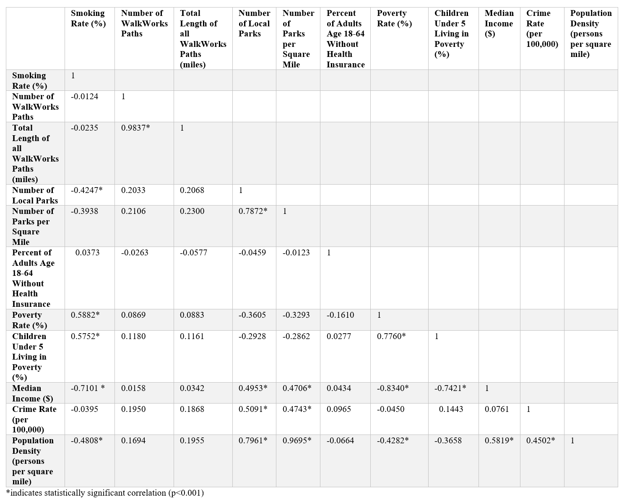

*Assessment of individual predictor variables:*

To assess each possible predictor of obesity rate, I calculated correlation coefficient and plotted county obesity rate against each potential predictor values (Appendix C).

*Assessment of multiple predictor variables*

*Multivariable regression analyses*: A forward and reverse stepwise regression was then done to generate the best predictive model. Each variable that remained in the best model had to have a significance value of p≤0.05. Forward stepwise regression begins with an empty model and variables are added one by one in order of which improves the model the most, that is, significantly increases the r2 for prediction. Reverse stepwise regression is the opposite; the model begins with all possible predictor variables and removes least significant ones one by one, until all remaining variables are significant at p≤0.05. For example, the starting model for reverse regression was:

$\hat{obesity rate}= \hat{β₀}-(\hat{β₁)}\left(smoking rate\right)-(\hat{β₂)}\left(number of WalkWorks paths\right)+(\hat{β₃})(total length of all WalkWorks paths)+\hat{\left(β₄\right)}\left(number of local parks\right)+ \hat{\left(β₅\right)}\left(number of parks per square mile\right)+ \hat{\left(β₆\right)} \left(percent of adults age 18-64 without health insurance\right)+(\hat{β₇)} \left(poverty rate\right)+(\hat{β₈)} \left(percent children under 5 living in poverty\right)+(\hat{β₉)} \left(median income\right)+(\hat{β₁₀)} \left(crime rate\right)+ ε$

The above model also contains the maximum number of variables that could have been includein the model by the forward stepwise regression analyses.

# Results

## Correlation analyses of obesity rate and each potential predictor variable

### SMOKING

The percent of the population who smoke correlated significantly with obesity rate across counties (r=0.5920; p<0.001).

### ACCESS TO RECREATION

The total number of parks and number of parks per square mile, as well as the total number of WalkWorks paths and the cumulative length of all WalkWorks paths were analyzed for a relationship with obesity. Both the total number of parks (r=-0.5018, p<0.001) and the number of parks per square mile (r=-0.4649; p=0.001) in counties showed significant negative correlations with obesity rates. Neither the number (r=-0.1242; p=0.3168) nor cumulative length (r=-0.1654; p=0.1809) of WalkWorks paths were shown to significantly correlate at the county level.

### HEALTH INSURANCE

County data regarding the percent of adults age 18-64 without health insurance was available on the PADOH EDDIE tool. Although the correlative relationship of this statistic with obesity was positive (r=0.1738) as expected, it was not significant (p=0.1596).

### POVERTY

Three different measures of the financial well-being of counties were analyzed for a relationship with county obesity rates: median income, the percent of the population in poverty, and the percent of children under five living in poverty. A strong negative correlation was seen between median income and obesity (r=-0.6465; p<0.001). Significant positive correlations were also seen in the analysis of poverty (r=0.3938; p=0.0010) and childhood poverty (r=0.3935; p=0.0010) with obesity. A positive correlation was also seen between poverty and obesity at the region level (r=0.4528; p=0.0230).

### CRIME

### Data on Type I crime rates in Pennsylvania counties comes from the Uniform Crime Reporting Program. The crime rate did not significantly correlate with obesity (r=-0.1920; p=0.1195).

## Multiple regression analySes

Both forward and reverse stepwise multiple regression analyses gave the same final predictive model. The variables that best predicted obesity levels among counties were parks per square mile ( = -2.440043, CI: -4.821, -0.058, p=0.045), median income ( = -0.0002256, CI: -0.00029; -0.00016, p<0.001), and the percent of adults with no health insurance ( = 0.4247075, CI 0.187; 0.662, p=0.001) (**Equation 1**).

**Equation 1**: Obesity Rate Multivariate Regression Equation

$$\hat{obesity rate}= \hat{40.055}-(\hat{2.440043)}\left(parks per square mile\right)-(\hat{0.0002256)}\left(median income\right)+(\hat{0.4247075})(percent of adults with no health insurance)$$

This model has a F test statistic of 30.35 (p<0.001), a R2 value of 0.5949, and an adjusted R2 value of 0.5753 (**Table 3**).

Table 3 Regression Model Summary Table

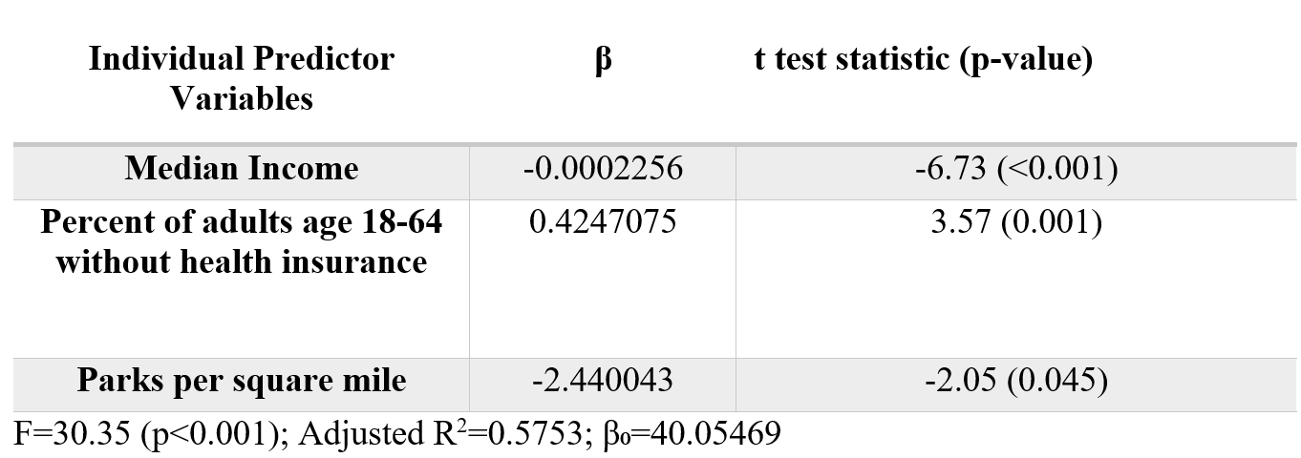

# Conclusions and Future directions

The results of this study may aid public health policies and programs aimed at decreasing obesity rates by identifying variables that relate to obesity rates in Pennsylvania.

Numerous individual factors showed strong, significant pairwise correlations with obesity. Several potential predictor variables were not included in the final model, although they were strongly and significantly correlated with obesity: percent of adults who smoke (r=0.604, p<0.001), number of local parks (r=-0.480, p<0.001), percent of people in poverty (r=0.550, p<0.001), and percent of children under five living in poverty (r=0.471, p=0.001). The variables that were included in the final model were parks per square mile, percentage of adults age 18-64 with no health insurance, and median income (**Table 3**). Although median income would be a challenging target in public health policies or programs, modifying the other two variables (i.e., increase the number of parks per square mile and increasing the percentage of the population with health insurance) is plausible.

The model predicts that increasing the relative number of parks in counties would decrease the county obesity rate significantly (r2=0.2321, p<0.001). Building parks would have many additional benefits. First, developing more parks, especially *accessible* parks, may enable children to increase their physical activity, thus reducing childhood obesity, which is a particular public health concern. However, the relationship between the density of parks and childhood obesity has not been well studied. In addition, building more accessible, local parks may encourage people to get outside, interact with others, and may also provide spaces for community events. This improvement in community environment might lead to improvements in other aspects of population health, separate from obesity. Also, minimum physical education requirements for children is legislated at the state level and each school district develops individual policies within that framework. Studying the relationship between the requirements of these policies and district childhood obesity rates in the state would be relevant to this discussion and to guiding future action.

The number of parks per square mile is a crude proxy of park availability. Future studies could use other measures of park availability, such as spatial analyses, park usage data, or objective coding methods, to better understand whether the accessibility of parks is the proximate cause in this relationship. Also, more studies should be conducted to determine how park accessibility relates to obesity at the individual level, rather than the population level. Also, a cost-benefit analyses would be necessary before the beginning of any program aimed at increasing the density of parks. If building additional parks is too expensive, an alternative may be modifying existing parks to improve quality and accessibility, would be more logical and cost-effective.

This model also highlights a potential public health benefit of greater access to health insurance, as it predicts that decreasing the percentage of adults with no health insurance would decrease county obesity rates (r2=0.0702, p=0.032). This information would be useful for proponents of increasing access to insurance programs like Medicaid and should be followed up with studies consisting of person-level data, rather than population, so that a more direct relationship can be examined.

* + - * 1. **RAW DATA USED IN ANALYSES**

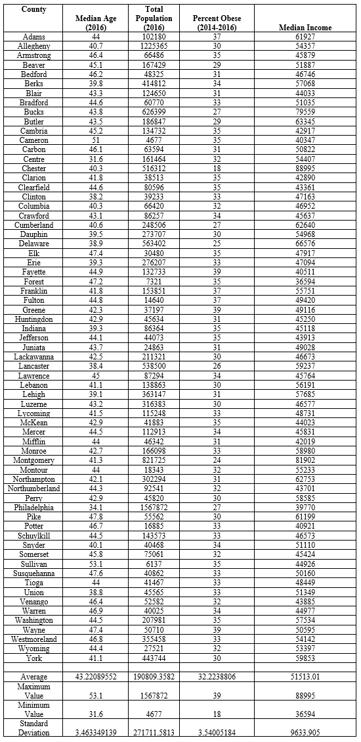

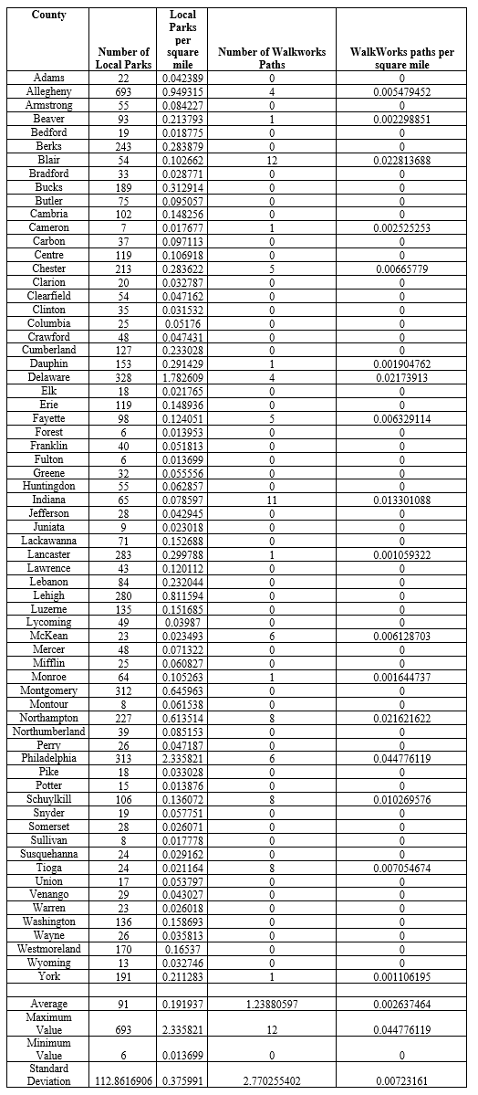

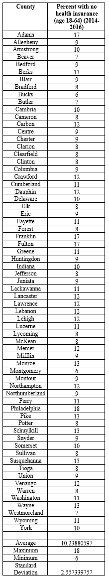

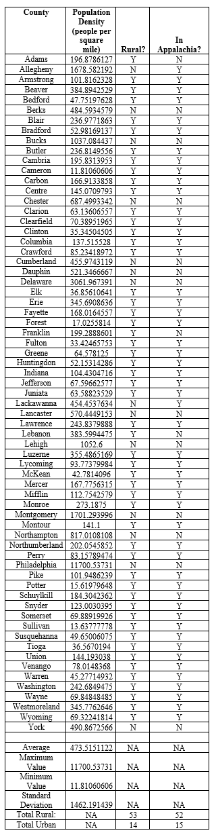

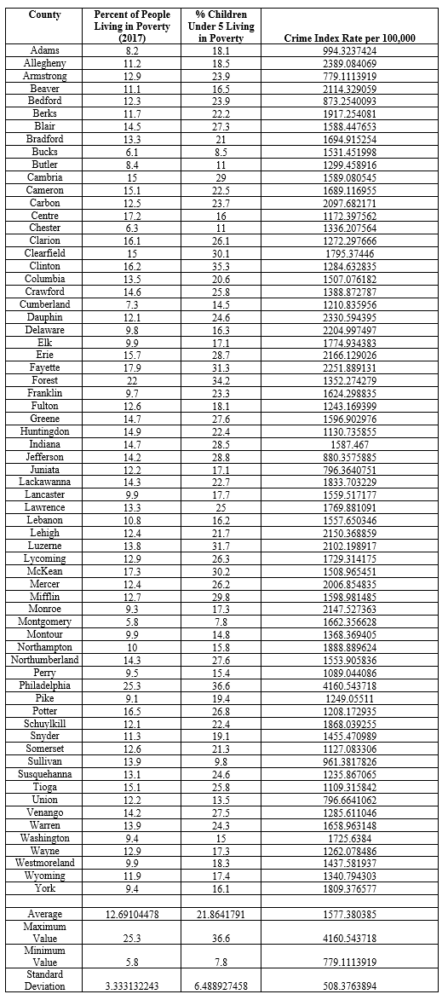

* + - * 1. **FREQUENCY HISTOGRAM OF EACH VARIABLE**

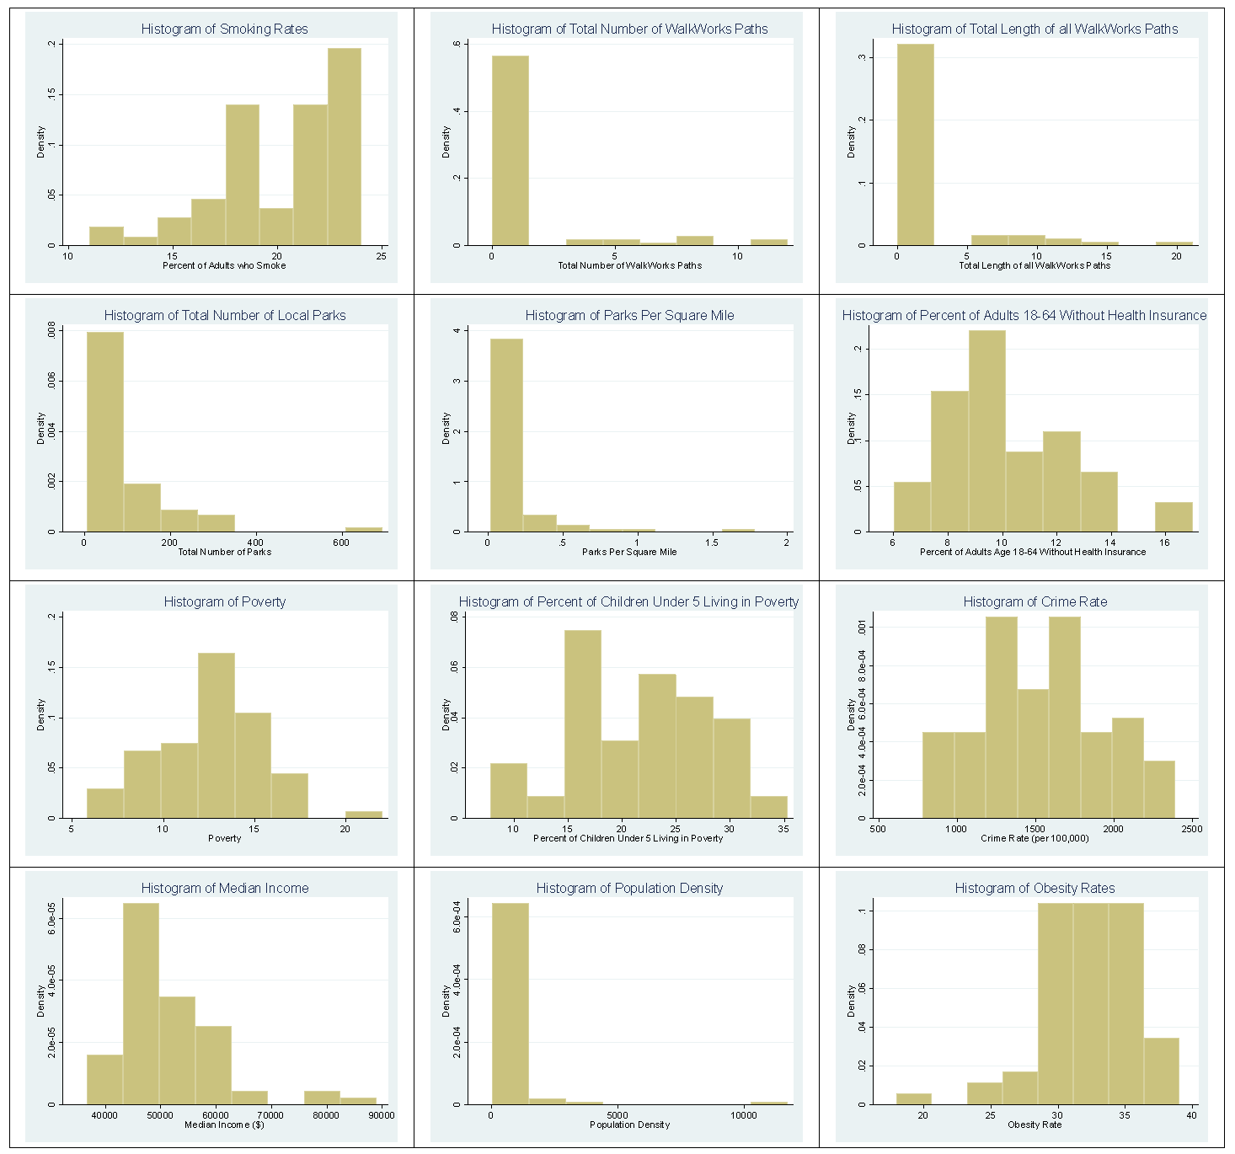

* + - * 1. **CORRELATION OF EACH VARIABLE WITH OBESITY**

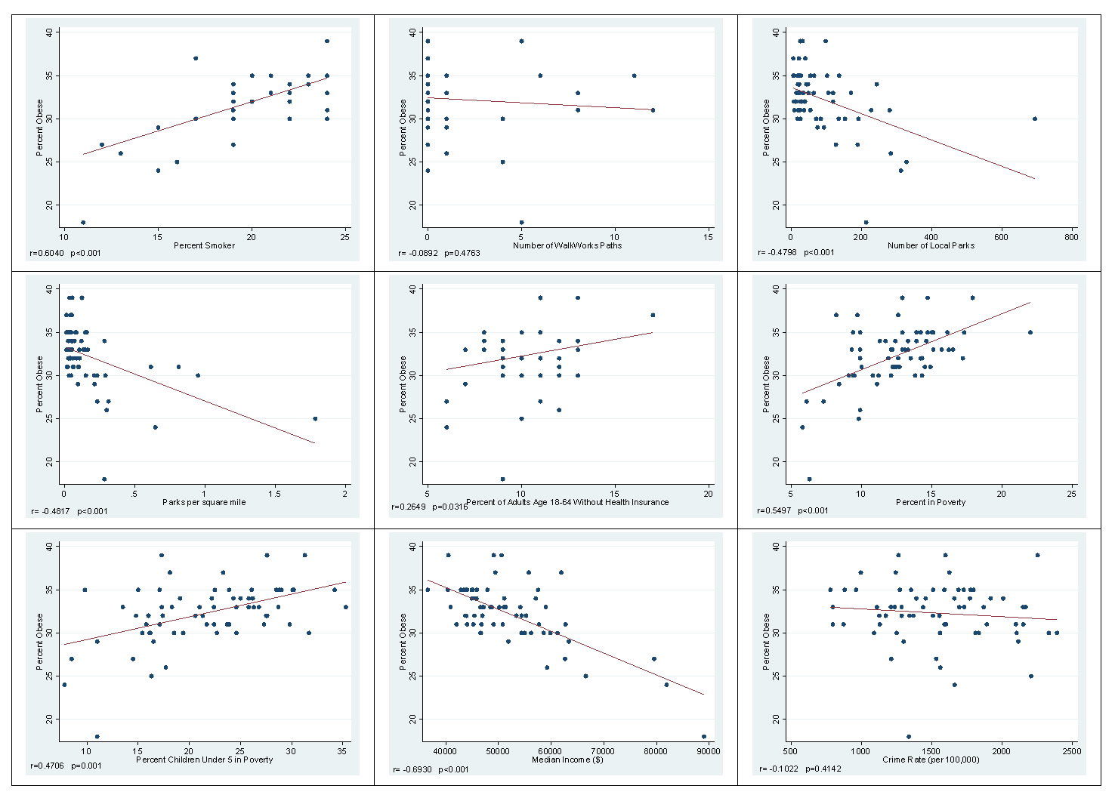

# bibliography

Abdelaal, M., le Roux, C. W., & Docherty, N. G. (2017). Morbidity and mortality associated with obesity. *Ann Transl Med, 5*(7), 161. doi:10.21037/atm.2017.03.107

Allcock, D. M., Gardner, M. J., & Sowers, J. R. (2009). Relation between Childhood Obesity and Adult Cardiovascular Risk. *Int J Pediatr Endocrinol, 2009*, 108187. doi:10.1155/2009/108187

American Cancer Society. (2019). Does body weight affect cancer risk? Retrieved from <https://www.cancer.org/cancer/cancer-causes/diet-physical-activity/body-weight-and-cancer-risk/effects.html>

An, R., Yang, Y., Hoschke, A., Xue, H., & Wang, Y. (2017). Influence of neighbourhood safety on childhood obesity: a systematic review and meta-analysis of longitudinal studies. *Obes Rev, 18*(11), 1289-1309. doi:10.1111/obr.12585

Association of American Medical Colleges. (2018). New Research Shows Increasing Physician Shortages in Both Primary and Specialty Care. Retrieved from <https://news.aamc.org/press-releases/article/workforce_report_shortage_04112018/>

Bacha, J. M., Appugliese, D., Coleman, S., Kaciroti, N., Bradley, R. H., Corwyn, R. F., & Lumeng, J. C. (2010). Maternal perception of neighborhood safety as a predictor of child weight status: The moderating effect of gender and assessment of potential mediators. *Int J Pediatr Obes, 5*(1), 72-79. doi:10.3109/17477160903055911

Bennett, G. G., McNeill, L. H., Wolin, K. Y., Duncan, D. T., Puleo, E., & Emmons, K. M. (2007). Safe to walk? Neighborhood safety and physical activity among public housing residents. *PLoS Med, 4*(10), 1599-1606; discussion 1607. doi:10.1371/journal.pmed.0040306

Bush, T., Lovejoy, J. C., Deprey, M., & Carpenter, K. M. (2016). The effect of tobacco cessation on weight gain, obesity, and diabetes risk.

Centers for Disease Control and Prevention. (2016). Defining Adult Overweight and Obesity. Retrieved from <https://www.cdc.gov/obesity/adult/defining.html>

Centers for Disease Control and Prevention. (2017a). Cancers Associated with Overweight and Obesity Make up 40 percent of Cancers Diagnosed in the United States. Retrieved from <https://www.cdc.gov/media/releases/2017/p1003-vs-cancer-obesity.html>

Centers for Disease Control and Prevention. (2017b). National Chronic Kidney Disease Fact Sheet, 2017. Retrieved from <https://www.cdc.gov/kidneydisease/pdf/kidney_factsheet.pdf>

Centers for Disease Control and Prevention. (2017c). National Diabetes Statistics Report, 2017.

Centers for Disease Control and Prevention. (2018a). Adult Obesity Facts.

Centers for Disease Control and Prevention. (2018b). Health Effects of Cigarette Smoking.

Centers for Disease Control and Prevention. (2019). Heart Disease Facts. Retrieved from <https://www.cdc.gov/heartdisease/facts.htm>

Chiolero, A., Faeh, D., Paccaud, F., & Cornuz, J. (2008). Consequences of smoking for body weight, body fat distribution, and insulin resistance. *Am J Clin Nutr, 87*(4), 801-809. doi:10.1093/ajcn/87.4.801

Cleveland Clinic. (2019). Obesity & Heart Disease. Retrieved from <https://my.clevelandclinic.org/health/articles/17308-obesity--heart-disease>

Dicker, D., Feldman, B. S., Benis, A., & Hoshen, M. (2016). Obesity or smoking: Which factor contributes more to the incidence of myocardial infarction? Authors' Reply. *Eur J Intern Med, 34*, e25-e26. doi:10.1016/j.ejim.2016.06.025

Finkelstein, E. A., Trogdon, J. G., Cohen, J. W., & Dietz, W. (2009). Annual medical spending attributable to obesity: payer-and service-specific estimates. *Health Aff (Millwood), 28*(5), w822-831. doi:10.1377/hlthaff.28.5.w822

Hales, C. M., Carroll, M. D., Fryar, C. D., & Ogden, C. L. (2017). Prevalence of Obesity Among Adults and Youth: United States, 2015-2016. Retrieved from <https://www.cdc.gov/nchs/data/databriefs/db288.pdf>

Hall, W., & Doran, C. (2016). How Much Canthe USA Reduce Health Care Costs by Reducing Smoking?

Kaiser Family Foundation. (2017). Facts about the Uninsured Population. Retrieved from <https://www.kff.org/uninsured/fact-sheet/key-facts-about-the-uninsured-population/>

Lee, H., Andrew, M., Gebremariam, A., Lumeng, J. C., & Lee, J. M. (2014). Longitudinal associations between poverty and obesity from birth through adolescence. *Am J Public Health, 104*(5), e70-76. doi:10.2105/AJPH.2013.301806

Levine, J. A. (2011). Poverty and obesity in the U.S. *Diabetes, 60*(11), 2667-2668. doi:10.2337/db11-1118

Lung, T., Jan, S., Tan, E. J., Killedar, A., & Hayes, A. (2018). Impact of overweight, obesity and severe obesity on life expectancy of Australian adults. *Int J Obes (Lond)*. doi:10.1038/s41366-018-0210-2

Mayo Clinic. (2018). Diabetes.

Morgan Hughey, S., Kaczynski, A. T., Child, S., Moore, J. B., Porter, D., & Hibbert, J. (2017). Green and lean: Is neighborhood park and playground availability associated with youth obesity? Variations by gender, socioeconomic status, and race/ethnicity. *Prev Med, 95 Suppl*, S101-S108. doi:10.1016/j.ypmed.2016.11.024

National Institute of Health. (2019). Kidney Disease Statistics for the United States. Retrieved from <https://www.niddk.nih.gov/health-information/health-statistics/kidney-disease>

Papas, M. A., Alberg, A. J., Ewing, R., Helzlsouer, K. J., Gary, T. L., & Klassen, A. C. (2007). The built environment and obesity. *Epidemiol Rev, 29*, 129-143. doi:10.1093/epirev/mxm009

Pennsylvania Department of Health. (2016). Enterprise Data Dissemination Informatics Exchange. Retrieved from <https://www.phaim1.health.pa.gov/EDD/>

Pennsylvania Department of Health. (2019). WalkWorks. Retrieved from <https://www.health.pa.gov/topics/programs/WalkWorks/Pages/WalkWorks.aspx>

Pham do, Q., Ommerborn, M. J., Hickson, D. A., Taylor, H. A., & Clark, C. R. (2014). Neighborhood safety and adipose tissue distribution in African Americans: the Jackson Heart Study. *PLoS One, 9*(8), e105251. doi:10.1371/journal.pone.0105251

Raebel, M., Malone, D., Conner, D., Xu, S., Porter, J., & Lanty, F. (2004). Health Services Use and Health Care Costs of Obese and Nonobese Individuals. *JAMA Intern Med*.

Rogers, R., Eagle, T., Sheetz, A., Woodward, A., Leibowitz, R., Song, M., . . . Eagle, K. (2015). The Relationship between Childhood Obesity, Low Socioeconomic Status, and Race/Ethnicity: Lessons from Massachusetts. *Childhood Obesity*.

Rossi, C. E., Correa, E. N., Neves, J. D., Gabriel, C. G., Benedet, J., Rech, C. R., & Vasconcelos, F. A. G. (2018). Body mass index and association with use of and distance from places for physical activity and active leisure among schoolchildren in Brazil. Cross-sectional study. *Sao Paulo Med J, 136*(3), 228-236. doi:10.1590/1516-3180.2017.0347020118

Rural Health Information Hub. (2018). Rural Health Disparities. Retrieved from <https://www.ruralhealthinfo.org/topics/rural-health-disparities>

State of Obesity. (2018). The State of Obesity in Pennsylvania. Retrieved from <https://stateofobesity.org/states/pa/#policies>

The Center for Rural Pennsylvania. (2018). Rural Urban Definitions.

The State of Obesity. (2019a). National Obesity Rates & Trends. Retrieved from <https://stateofobesity.org/obesity-rates-trends-overview/>

The State of Obesity. (2019b). Socioeconomics and Obesity. Retrieved from <https://stateofobesity.org/socioeconomics-obesity/>

Thorp, A. A., Owen, N., Neuhaus, M., & Dunstan, D. W. (2011). Sedentary behaviors and subsequent health outcomes in adults a systematic review of longitudinal studies, 1996-2011. *Am J Prev Med, 41*(2), 207-215. doi:10.1016/j.amepre.2011.05.004

Trivedi, T., Liu, J., Probst, J., Merchant, A., Jones, S., & Martin, A. (2015). Obesity and obesity-related behaviors among rural and urban adults in the USA

Truth Initiative. (2018). Tobacco use in pennsylvania.

Tung, E. L., Wroblewski, K. E., Boyd, K., Makelarski, J. A., Peek, M. E., & Lindau, S. T. (2018). Police-Recorded Crime and Disparities in Obesity and Blood Pressure Status in Chicago. *J Am Heart Assoc, 7*(7). doi:10.1161/JAHA.117.008030

United States Department of Justice. (2016). Offense Definitions. Retrieved from <https://ucr.fbi.gov/crime-in-the-u.s/2015/crime-in-the-u.s.-2015/resource-pages/offense-definitions/offensedefinitions_final.pdf>