Title Page
LEAN THINKING IN LONG TERM CARE STAFFING AND SCHEDULING

by

Jennie Laeng

BA Psychology, University of Nebraska-Lincoln, 2017

Submitted to the Graduate Faculty of

the Department of Health Policy and Management

Graduate School of Public Health in partial fulfillment

of the requirements for the degree of

Master of Public Health

University of Pittsburgh

2019
Committee Membership Page
UNIVERSITY OF PITTSBURGH

Graduate School of Public Health

This essay was presented

by

Jennie Laeng

on

April 8, 2019

and approved by

Essay Advisor:

Julia Driessen, PhD
Associate Professor
Department of Health Policy and Management
Graduate School of Public Health
University of Pittsburgh

Essay Readers:

Stephen Albert, PhD MSPH, MA
Professor and Chair
Department of Behavioral and Community Health Sciences
Graduate School of Public Health
University of Pittsburgh

Lisa Malosh, MHA, MBA
Senior Director of Organizational Improvement
Presbyterian SeniorCare Network
Washington, Pennsylvania

Copyright © by Jennie Laeng

2019

Abstract
Title Page
LEAN THINKING IN LONG TERM CARE STAFFING AND SCHEDULING

Jennie Laeng, MPH

University of Pittsburgh, 2019

ABSTRACT

To survive the ever-changing healthcare realm, long term care entities are beginning to follow the hospital industry’s lead towards lean thinking, a business methodology that strives to maximize value by decreasing waste. A long-term care network in Western PA began its lean journey a few years ago working to continuously improve processes and performance to offer residents the highest quality of care. With a growing US aging population and an increasingly insufficient nursing and direct care workforce, this network looked towards lean thinking to combat the challenge. The public health relevance is clear with a need to build a long-term care system that is reliable and sustainable to serve some of the most vulnerable individuals in the US. This essay examines the staffing and scheduling process improvement journey of two skilled nursing communities, aiming to improve staffing processes and reduce agency staff utilization. Both campuses successfully implemented the improvements of building a standardized master schedule, incorporating a team huddle into weekly operations and creating a process to obtain accurate daily care hours. With these improvements, the primary goal of reducing agency use and cost was achieved; with Campus A completely eliminating agency use and Campus B reducing agency spending by over $20,000 in five months. This essay shows how influential lean thinking can be in improving process efficiency, accuracy and cost control in long term care.

TABLE OF CONTENTS
1.0 PROCESS IMPROVEMENT 1
1.1 BACKGROUND 1
1.2 LEAN IN LTC 3
1.3 LEANFORWARD 4
2.0 NURSE STAFFING AND SCHEDULING 6
2.1 PUBLIC HEALTH SIGNIFICANCE 6
2.2 WORKFORCE SHORTAGE 7
2.3 AGENCY WORKFORCE 10
3.0 NURSE STAFFING AND SCHEDULING IMPROVEMENT PROJECT 11
3.1 PURPOSE STATEMENT 11
4.0 METHODS 12
4.1 MEASURES 12
4.2 PROCEDURE 13
5.0 RESULTS 14
6.0 DISCUSSION 18
APPENDIX A OBSERVATION QUESTIONS 22
APPENDIX B SCHEDULES 24
B.1 Staffing Totals 25
B.2 Open Positions 25
BIBLIOGRAPHY 26
LIST OF TABLES
Table 1 Minimum PA nurse staffing 8
LIST OF FIGURES
Figure 1 Staffing and Scheduling Overview 13
Figure 2 Average PPD Reporting 16
Figure 4 Campus A Agency Cost 17
Figure 5 Campus B Agency Cost 17

PROCESS IMPROVEMENT
Improving processes and performance within an organization is not a novel idea, however, it has become a more common and necessary transition for healthcare entities over the past decade. With changing payment structures and government regulations, and an emphasis on efficiency and quality of care, healthcare settings have adapted through methods of process and performance improvement. While many methods exist for improving processes, Lean management is one of the more utilized and influential continuous improvement strategies in healthcare today (Brandao de Souza, 2009). Lean is a philosophy and management method with two central components. The first is to offer customers the maximum value by eliminating waste, or aspects do not add value to the customer, and the second is to respect human beings (Ohno, 1998; Womack & Jones, 1996). Respect for human beings is explained by lean experts as a system where “workers are allowed to display in full their capabilities through active participation in running and improving their own workshops” (Sugimori, Kusunoki, Cho & Uchikawa, 1977).

BACKGROUND
While lean management concepts existed in manufacturing systems like Henry Ford’s production system and other American production methods, The Toyota Motor Corporation is credited as the creators of the lean production or management system (Holweg, 2007). The roots of the Toyota lean philosophy date back to early 19th century innovations, but the lean management system as it is known today began in the late 1940s with the creation of the Toyota Production System in a Japanese production plant (Emiliani, 2006; Ohno, 1988).
Toyota’s success through their lean philosophy has not only spread to production companies worldwide, but has also been shown to have translational effects to healthcare settings (Graban, 2011; Spear, 2005; Young, Brailsford, Connell, Davis, Harper & Klein, 2004). The idea of lean thinking made its way into healthcare through promising results from the Virginia Mason Medical Center in Seattle, Washington. Through their adoption and implementation of lean, the Virginia Mason Medical Center reduced staff walking distances by 34 miles, patient lab result wait times by 85%, cut inventory costs by 51% saving $1 million, decreased medication errors, reduced temporary staffing and overtime expenses by $500,000 in one year and increased productivity by 93% (Black, 2008; Weber, 2006). Each of these results positively affect patients through improvements in efficiency and overall quality of care.
While Virginia Mason Medical Center was one of the initial lean adopters in healthcare, the lean philosophy has become a more widely accepted practice. Organizations around the United States and the United Kingdom promote lean management including the Institutes for healthcare improvement and the NHS confederation (Teich & Faddoul, 2013). According to a Joint Commission national survey, 69% of hospitals report using lean principles to some extent, with 12% utilizing lean throughout the entire organization (Shortell, Blodgett, Rundall & Kralovec, 2018).

LEAN IN LTC
While successful adoption of lean in healthcare has existed primarily among hospitals, there is a significant opportunity in the realm of long term care. As the second most regulated industry next to nuclear energy (Allen, 2011), skilled nursing facilities must provide extremely high quality of care and do so efficiently in order to continue operating and to protect some of the most vulnerable older adults. The most recent quality enhancing regulation comes from Section 6102(c) of the Affordable Care Act requiring skilled nursing facilities to “develop Quality Assurance and Performance Improvement (QAPI) programs” (American Health Care Association, 2018). This regulation provides a natural transition for lean methodology to become widely utilized in long term care.
As the lean philosophy expands into aging services, there is a need for more research and organization reporting of lean case studies in long term care. An article published by LeadingAge (2017) examined a successful lean implementation at Wellspring, a skilled nursing facility in Flint, MI. Wellspring initially implemented lean into their admission process. By completing a root cause analysis, observational studies, data collection and process mapping they were able to fully understand the problem and take steps to improve process inefficiencies. They were ultimately able to narrow the admission process from 40 minutes down to 15 minutes and save $31,000 annually. After roughly seven months of operating under the new admission process at all five wellspring facilities, admission rates increased by 1% which translates to a $305,000 yearly operating revenue increase (McGee & Logan, 2017).
While the Wellspring case study only looks at one lean improvement project, it offers the example that making process changes at any point in operations can greatly impact the organization. By reducing the time spent on the admission process and generating more operating revenue, skilled nursing facilities are able to spend more time and money directly aimed at adding value to their residents.

LEANFORWARD
The network examined in this essay is a not-for-profit long-term care entity that delivers a continuum of services for older adults in Western Pennsylvania. More specifically, their services include, personal care, skilled nursing and rehabilitation, specialized Alzheimer’s and dementia care, continuing care retirement communities, home and community-based services, and affordable and supportive housing.
The Network’s lean journey began in 2016 with the incorporation of performance improvement (PI) into their strategic plan and the hiring of a performance improvement specialist. By consulting with and learning from other healthcare performance improvement teams, the Network created their LEANforward PI initiative. This initiative is based upon the belief that those who are closest to the work are the best equipped to drive the process towards continuously improving quality, safety, efficiency and resident and employee satisfaction. A primary element of LEANforward is the belief that problems are a result of bad processes, not a result of bad people, stressing the idea that processes, not people are to be blamed. By adopting lean methods and tools, the Network strives towards a higher level of performance through standardizing and simplifying processes, as well as cultivating a continuous employee-based problem solving culture.
Not only was LEANforward adopted to improve processes, but it is also a mechanism to enhance person centered culture by engaging team members to learn, lead and affect change. One of the central components of LEANforward is the Lean Leader Group. This diverse group of leaders, made up of nursing home administrators to IT staff members to nurse managers, meets quarterly to learn how to use lean thinking, tools and strategies to engage in various improvement projects. Additionally, the PI department holds educational sessions that are open to all staff members and a quality fair each year to observe and commend the completed and ongoing organizational wide improvement projects from the previous year.

NURSE STAFFING AND SCHEDULING

PUBLIC HEALTH SIGNIFICANCE
It is easy to view lean management as a manufacturing strategy unrelated to public health; however, by utilizing lean thinking, quality and system efficiency may be improved which directly benefit the public’s health. The United States population of older adults 65+ is expected to increase from 49.2 million in 2016 to 78 million by 2035, outnumbering children under age 18 for the first time in U.S. history (US Census Bureau, 2018). Recent data suggest that slightly over half of American’s 65 and older today will require some long-term services and supports (LTSS), with about one in seven expected to have needs extending beyond five years (Favreault & Dey, 2016). Chronic and disabling conditions that appear in old age, such as Alzheimer’s disease and related disorders (ADRD) and cancers raise concern of whether the long-term care system can effectively meet the population’s needs (National Center for Health Workforce Analysis, 2017).
Alzheimer’s disease is now considered a public health crisis and a worldwide epidemic affecting 1 in 3 older adults 85+ (Alzheimer’s Association, 2016). Having Alzheimer’s disease increases a person’s risk of becoming a nursing home resident, which is alarming considering the expected prevalence of the disease with the increasing aging population (Alzheimer’s Association, 2018). However, with the rise in home and community-based services and the desire to age in place, many of the people that enter nursing homes are older and sicker (Genworth, 2018).
Without a cure for ADRD, better treatments for existing chronic conditions, or improved assistance for informal caregivers, the LTSS system may be increasingly relied upon in the coming years, further burdening the current infrastructure and financing systems. In 2010, older adult LTSS costs were about 1.3 percent of the total GDP and CBO projections expect costs to double that number to about 3 percent by 2050, including costs to informal caregivers, private and public payors (CBO, 2013). With a growing need for LTSS and declining supply of workers, the long-term care realm will be greatly challenged in the coming years. While lean management may not solve every problem with 100% certainty, it is a strategy that can reduce this burden through building effective processes, eliminating waste and improving efficiency and cost containment.

WORKFORCE SHORTAGE
With the broad goal of making aging easier, the Network’s lean improvement projects seek to tackle process problems that ultimately affect residents. One process problem affecting residents in aging service communities across the nation is the increasing nurse and direct care workforce shortage. As the population ages with life expectancies and chronic conditions increasing, the challenge of having enough qualified nursing and direct care workers is rapidly approaching. While there are many workers that contribute to a successful LTSS industry, nurses and direct care workers are the backbone of the workforce. Direct care workers including nursing assistants, home health aides, personal care aides and psychiatric assistants make up 71% of the LTSS, with the demand expected to grow from 2.3 million workers in 2015 to 3.4 million in 2030 (National Center for Health Workforce Analysis, 2017a). Additionally, the LTSS nursing workforce demand, including registered nurses (RN) and licensed practical nurses (LPN), is expected to grow 46% each from 2015 to 2030, with Pennsylvania expected to experience a growth rate of 33% for RNs and a 34% for LPNs (National Center for Health Workforce Analysis, 2017b).
While researchers and policy makers strive to mitigate the effects of the future workforce shortage, nursing home administrators, staff and residents are already feeling the impact of staffing shortages. In 2001 a CMS study found that the minimum RN and LPN hours needed to provide adequate daily resident care was 4.1 to 4.85 hours, and that 97% of nursing homes were not meeting this standard (CMS & Abt Associates, 2001). This finding is still relevant today, with 1 in 8 nursing homes cited in health inspections as having too few nurses since 2014 (Rau, 2018). Although there is no optimal or gold standard staffing number, Pennsylvania regulations require a minimum of 1:20 nursing staff employees to residents, two nursing service personnel on duty at all times and a total of 2.7 hours of direct care (PPD) for each resident in each 24-hour period. The minimum nurse staffing ratios for PA are listed in Table 1.

Table 1 Minimum PA nurse staffing
Census | Day | Evening | Night
59 and under | 1 RN | 1 RN | 1 RN or 1 LPN
60/150 | 1 RN | 1 RN | 1 RN
151/250 | 1 RN and 1 LPN | 1 RN and 1 LPN | 1 RN and 1 LPN
251/500 | 2 RNs | 2 RNs | 2 RNs
501/1,000 | 4 RNs | 3 RNs | 3 RNs
1,001/Upward | 8 RNs | 6 RNs | 6 RNs

(Pa Code § 211.12)
To address concerns in staffing level reporting, the ACA required Medicare to collect and report staffing data from nursing home payroll records (Wells & Harrington, 2013). In 2018, Kaiser Health News reported that more than 14,000 nursing home payroll records revealed 70% had lower staffing levels than their previous reports indicated (Rau, 2018). Research has shown that fewer RN and CNA staffing results in more total deficiencies, serious deficiencies and quality of care deficiencies, all of which place residents in harm’s way and increase the likelihood of adverse consequences (Harrington, Zimmerman, Karon, Robinson, & Beutel, 2000; Kim, Kovner, Harrington & Green, 2009). Inversely, greater staffing levels are related to lower deficiency scores and a greater quality of care (Hyer, Thomas, Branch, Harman, Johnson, Weech-Maldonado, 2011).
While staffing levels clearly impact resident care, staffing characteristics play a large role in quality of care as well (Castle & Anderson, 2011; Lerner, Johantgen, Trinkoff, Storr & Han, 2014). Nursing homes are challenged with high turnover rates (Kayyali, 2014), demanding workloads (Lapane & Hughes, 2007), and lower employee wage benefits (Scales, 2018). High turnover rates not only negatively affect residents, but are also costly (O’Connell & Kung, 2007) and with the decreasing number of long-term care workers, nursing homes must retain as many skilled workers as possible. Additionally, as home and community based opportunities increase, older adults are not entering nursing homes until they are much older and sicker, requiring high acuity nursing care (Levins, 2017). Another reason that the long-term care industry is beginning to experience workforce shortage and greater turnover rates is compensation. While compensation is not the sole driver of retention, it plays a significant factor for many professionals (Bryant, 2017). A LeadingAge Ohio report (2016), indicated that 7 out of 10 direct care workers that left their jobs, did so for better pay.

AGENCY WORKFORCE
With the challenges in long term care staffing characteristics, communities are increasingly unable to fill their staffing needs, resulting in a reliance on temporary contracted nurses, known as agency nurses and nursing assistants (Seo & Spetz, 2013). While some research suggests agency staffing could be an asset in mitigating the growing workforce demand (Xue, Smith, Freund & Aiken, 2012), others question the quality of care and cost effectiveness of utilizing contracted nursing staff. Various studies suggest that increased agency use is associated with decreased quality of care (Bourbonniere, Feng, Intrator, Angelelli, Mor & Zinn, 2006; Bae, Mark & Fried, 2010; Lu & Lu, 2016). Additionally, using agency workers is counter-intuitive to the person-centered care principles that many nursing homes have adopted, which prioritize having certified nursing assistants care for the same residents each day to build rapport and foster better communication and care. Although agency staff use is not completely in line with person-centered principles, it may be a cost-effective model in moderation (Stratman, Roth & Gilland, 2004; Lu & Lu, 2016). However, regularly relying on agency staff can increase costs significantly (Xue, Chappel, Freund, Aiken & Noyes, 2015). Not only has research questioned the cost effectiveness and quality of care provided by contracted nurses, there is also evidence that internal staff satisfaction is decreased with the use of agency staff (King, Svensson & Wei, 2017). Therefore, it may be in the best interest of skilled nursing facilities and other long-term care communities to limit their reliance on agency staff in order to uphold the quality of care, person-centered principles and to keep costs down.

NURSE STAFFING AND SCHEDULING IMPROVEMENT PROJECT
In order to attend to increasing agency use, build a stronger nursing workforce and promote a higher quality of care, the Network initiated a nursing staffing and scheduling improvement project in 2017. While it is important to improve processes in every LTSS sector, the Network chose to begin the improvement project with skilled nursing communities because of their high agency staff utilization and cost, as well as their willingness to undertake the project. This essay examines the nursing staffing and scheduling process improvement journey of Campus A, a 150-bed skilled nursing community and Campus B, a 193-bed skilled nursing community.

PURPOSE STATEMENT
The staffing and scheduling improvement project had a multifold purpose; to improve communication, to develop standardized practices and policies throughout the organization, to decrease inaccuracies in care hour reporting and to ultimately reduce agency use and labor expenses.

METHODS

MEASURES
Initial qualitative observations of staffing schedulers, administrators and directors of nursing were recorded to understand the problems and root causes. The document used to record these observations is included in Appendix A.
Three process outcomes, scheduling clarity, open position accuracy and communication were measured by the implementation and standardization of the new processes. The primary measurements of the improvement project included patient per day (PPD) calculations (PPD = census ÷ accurate daily care hours) reported by staffing schedulers and agency nursing costs reported on invoices. The PPD calculations were averaged from a week prior to the process implementation and a week post process implementation. The PPDs were taken from the staffing schedulers’ daily reports of scheduled staff work times, which were then reconciled with the Kronos time clock system to reflect accurate employee work times. Snapshot data of agency nursing invoices from July 2018 through November 2018 were recorded to examine trends for each campus.
The observations were recorded prior to the initiation of the project. The PPD calculations were recorded before the project began and after this aspect of the project was fully in place. The agency invoice data were collected retrospectively.

PROCEDURE
Performance Improvement staff began this project May 2017 at Campus A and April 2018 at Campus B. Lean thinking stresses the importance of observing and understanding the root causes of problems before implementing solutions, therefore the first step was to observe the staffing and scheduling process at each campus and take the time to receive input from the employees involved in the daily staffing and scheduling process. Following the observations, Figure 1 was developed to outline the all-encompassing performance improvement project. The red boxes highlight the initial project efforts which are the focus of this paper.

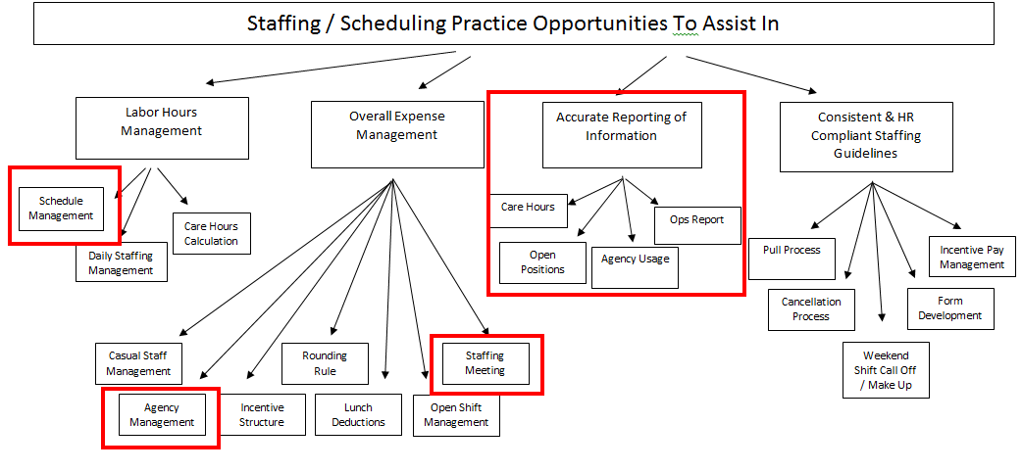

Figure 1 Staffing and Scheduling Overview

In a gradual rollout process, the performance improvement team worked with the staffing and scheduling team to build a standardized master schedule, start a staffing and scheduling team huddle or meeting, and creating a process for obtaining accurate care hours. These procedures were standardized and worked into daily and weekly operations.

RESULTS
Before the process improvements were implemented, the processes were inconsistent and unstandardized with each aspect accumulating to affect the performance and sustainability of the entire staffing and scheduling process. This section will walk through the targeted improvement areas before and after the process implementations.
The initial root causes of the staffing and scheduling problems were established through qualitative observations of staffing schedulers, directors of nursing and nursing home administrators. These results included twelve unique suggestions:
- Open positions are not accurate making it difficult for HR personnel to recruit to meet staffing needs
- Staff schedules change every two weeks making it difficult for team members to plan for their personal needs (childcare, MD appointments, etc.)
- Team members are listed to work in multiple places and it is difficult for them to know where they should be and what time
- “Overstaffed” on some days and “understaffed” on other days
- Routine “pulling” of staff from their home floors to other floors leading to frustration
- Inconsistent scheduling practices across the network (ex: reviewing shift trades for overtime, make-up day for a weekend call-off, etc.)
- Creating new schedules to meet employee requests that are not in the best interest of the community staffing pattern or resident care needs
- Missed meal break trends are not routinely reviewed to determine ways to assist staff so that they are able to take their breaks
- Incremental / “creep” overtime / total overtime is not routinely reviewed
- Staff have “scheduled” overtime as part of their standard schedule
- Agency costs continue to increase
- There is significant duplication throughout the processes
While this essay does not examine all twelve of these suggestions and their corresponding process improvements, they will all be attended to throughout the staffing and scheduling improvement journey.
The first target improvement was to build a standardized master schedule. Comparing the previous Campus B nursing schedule to the current standard master schedule (Appendix B), shows the evident improvements in clarity and information. The current master schedule is a 2 page, four-week repeating electronic schedule, with monthly adaptations based on holidays and requested personal or vacation days. The master schedule also includes a section that automatically calculates the number of employees scheduled by shift and neighborhood corresponding with a color that alerts staffing team members of days and shifts that are overstaffed (see Appendix B1). It also includes a section of specific open positions that HR employees can utilize for recruitment and hiring purposes. This section is a visual tool used to hire prospective employees directly into a scheduled position that fits with the staffing pattern needed to provide the best care for the residents at that time (see Appendix B2).
The second target improvement was to create a staffing team huddle. Huddle attendees include nursing home administrators, directors of nursing, HR Personnel, staffing schedulers and any other person the team views as an important staffing and scheduling communication outlet. At these meetings, standardized forms used as visual tracking tools are completed once or twice each week which have improved the communication transfer between departments. The tracking tools include new and pending job applicants, recruitment initiatives, terminations and resignations, light duty and leave of absence, schedule change (e.g. daylight shift to evening shift) or status change requests (e.g. part-time to full-time), miscellaneous updates, and agency use tracking. The inclusion of this meeting and the attendance of key team members has improved communication transfer and timely staffing and scheduling decision making.
The third target improvement initiative, to report accurate care hours, has shown significant improvement resulting in a process that has produced accurately reported care hours and PPD calculations on each campus since it was adopted into practice. Figure 2 shows PPD calculations before and after the standardized reconciliation process. Before the reconciliation process, the reported PPDs were utilized for decision making and to monitor the budget. The Before column in Figure 2 shows the variation between the reported PPD, the actual PPD, and the budgeted PPD which is problematic. The After column shows the improvement in care hour reporting, with the reported PPD reflecting actual care hours.

Figure 2 Average PPD Reporting

The fourth and final primary target improvement, reducing agency use and cost, yielded success on both campuses. This target is not a process itself, but a product of each of the improvement initiatives mentioned earlier that result in the elimination of agency staff usage and cost. At Campus A, agency use has been completely eliminated since October, 14th, 2018. The cost of agency nursing went from an average of $17,598.71 per month from July to September to $0 from November to present day (Figure 4).

Figure 4 Campus A Agency Cost
At Campus B, agency use has been trending downward since July, however, there is not total agency elimination as Campus A has experienced (Figure 5).

Figure 5 Campus B Agency Cost

DISCUSSION
While this improvement project did not begin with a complete and clear understanding of all of the scheduling and staffing problems, the lean strategy of asking questions and observing the work uncovered a wide range of inconsistencies, waste and improvement areas. Upon discovery of problems, the team was able to utilize lean strategies to gradually improve the process in the best way suitable for the employees.
By working to establish a standardized master schedule, significant room for improvement was uncovered. The previous process required a total of 8 handwritten schedules as shown in Appendix B, including 1 for nurses and 1 for CNAs on each of the 4 floors of Campus B. Nurses and CNAs who did not regularly work on one floor had to locate each floor’s schedule to view their upcoming work shifts. The staffing scheduler also had the task of managing eight pages of a handwritten schedule that changed significantly each month. This process led to inevitable mistakes such as, placing a team member on more than one floor during a shift, staff arriving to work when they were not scheduled and not showing up when they were scheduled, wasted time writing and re-writing the schedules to make changes and correct mistakes, wasted direct care worker time searching for schedules rather than tending to residents, and so on.
It was also uncovered on each campus that the HR team was not previously recruiting for specific existing open positions, which was resulting in overstaffing on some days and understaffing on others. With the new process in place, team members are able to view where the staffing needs are and hire applicants to meet each specific open position. In this way, the Network can obtain the proper staffing patterns needed to achieve optimal person-centered resident care. Additionally, team members have experienced less confusion and frustration with their schedules because the process is well-known and standardized leaving no room for bias or unfair scheduling practices.
The staffing and scheduling team huddle has provided a necessary framework to communicate information such as when a CNA is injured and deemed light duty or when a schedule change is desired. The meeting attendees are then able to discuss modifications to the team members work and whether or not the schedule change request can be accommodated at that time. This meeting has also reduced the waste, confusion and incomplete information transfer from emails between the staffing and scheduling team.
The improvement initiative of reconciling care hours attempts to generate meaningful data that administrators and senior directors can utilize for data driven decision making. With an unstandardized process of reporting direct care hours and subsequent inaccuracies of direct care hours and PPD calculations, important decisions regarding budgeting and staffing were being made based upon data that were unreliable. With the new process in place, budgeted PPDs will likely become more in line with accurate PPD calculations to improve planning and cost control.
Finally, while the agency reduction process as a whole looked slightly different on each campus, both were successful in decreasing the usage and cost of agency staffing. At Campus A, agency was gradually reduced to the point of elimination eleven months after implementation. At Campus B, the usage trend line is continuing downward, however the need for agency staff has not been eliminated yet. While similar standardized practices were utilized at each campus, Campus B is a slightly larger skilled nursing community with a higher average census, which may be a contributing factor to Campus B’s slower elimination of agency staff. Additionally, Campus B began the project with a significantly higher agency staff usage than Campus A and has experienced a greater turnover rate in CNAs and nurses. With the staffing and scheduling standardized practices and policies in place, Campus B is expected to continue to experience a decreasing trend of agency staffing and ultimate agency use elimination. Although no data were tracked pertaining to a specific quality metric for this project, it is believed that having Network trained employees consistently serving residents rather than agency staff members that person-centered quality of care is enhanced.
While this essay examines the many positives of the staffing and scheduling improvement project, there are limitations. One being that the data collected for agency spending was in the form of invoices and therefore only included the invoices that have been processed. Because of this, the agency cost data presented in the essay may not be complete. Additionally, higher agency use is expected in the summer months because of increased staff vacations, therefore the improvement project success may be heightened by an existing downward trend in agency usage form July to November. Lastly, there were no quantitative elements built into the project to measure communication improvements, time saved, or staff satisfaction, all of which would be beneficial to track for continuous improvement.
This staffing and scheduling improvement project stressed the importance of recognizing that standardized processes are important however, allowing flexibility in some of the process gives different campuses the ability to do what works best for them. For example, while both campuses practice a staffing and scheduling team huddle, each one includes a different number of people in the meetings and they transfer slightly different information.
Moving forward, it is important to note that an essential piece of lean thinking is continuous improvement. Just as this project challenged practices and policies that were not working, the new standardized process should continue to be questioned and adapted to eliminate waste and facilitate the best possible resident care. While a standard master schedule, weekly huddle, and direct care hours reconciliation process are fully in place on each campus, the entire staffing and scheduling process is much more complex and improvements will continue to be made. The Network’s Leanforward initiative hopes to continue to challenge the existing long-term care framework and push for continuous improvement to fulfill the mission of making aging easier.

APPENDIX A OBSERVATION QUESTIONS
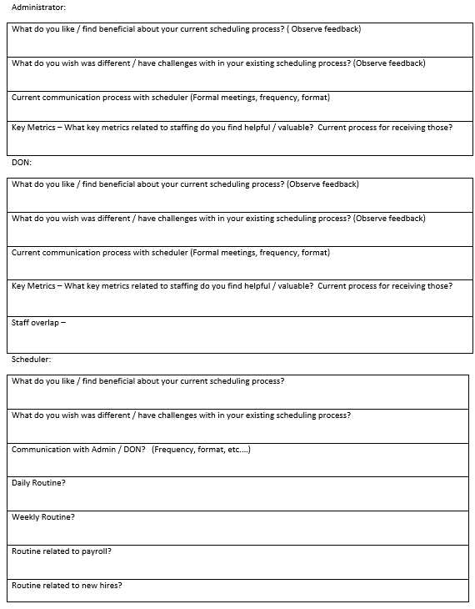
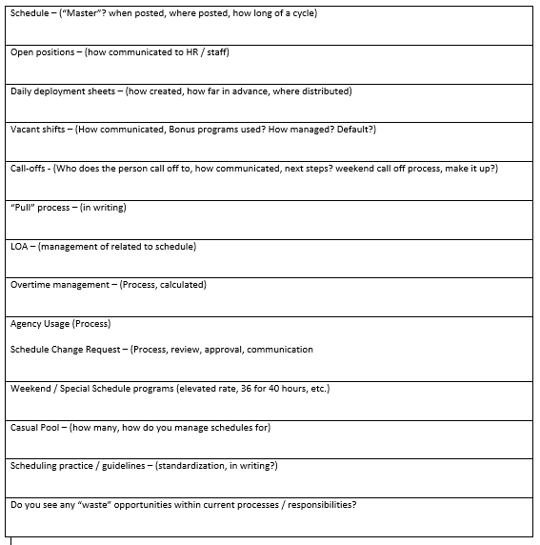

APPENDIX B SCHEDULES
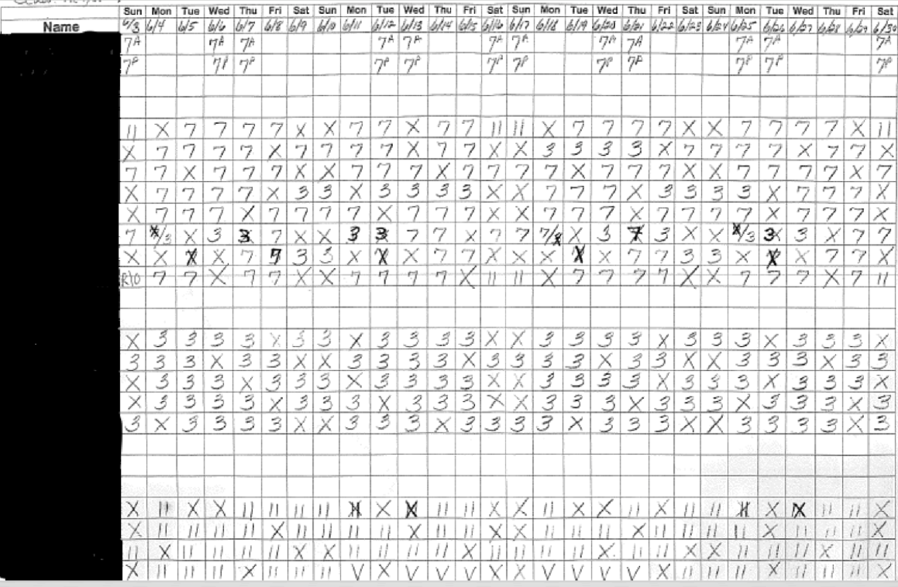
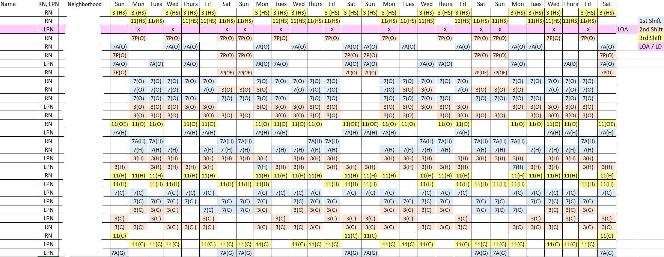

B.1 Staffing Totals

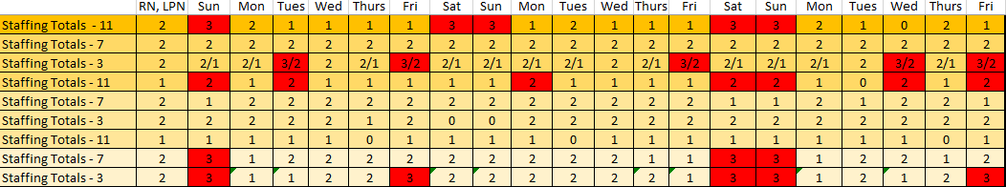

B.2 Open Positions

BIBLIOGRAPHY
Allen, J. E. (2011). Nursing home administration. Springer Publishing Company.
Alzheimer’s Association. (2016). A Public Approach to Alzheimer’s and other Dementias. Retrieved January 22, 2019, from https://www.cdc.gov/aging/aginginfo/pdfs/Module1-Alzheimers-Disease-Public-Health-Crisis.pdf
Alzheimer’s Association. 2018 Alzheimer’s Disease Facts and Figures. Alzheimers Dement 2018;14(3):367-429.
American Health Care Association. (2018). Quality Assurance/Performance Improvement (QAPI). Retrieved December 26, 2018, from https://www.ahcancal.org/quality_improvement/qapi/pages/default.aspx
Bae, S. H., Mark, B., & Fried, B. (2010). Use of temporary nurses and nurse and patient safety outcomes in acute care hospital units. Health Care Management Review, 35(4), 333-344.
Black, C. (2008). To build a better hospital, Virginia Mason takes lessons from Toyota plants. Seattle Post-Intelligencer.
Bourbonniere, M., Feng, Z., Intrator, O., Angelelli, J., Mor, V., & Zinn, J. S. (2006). The use of contract licensed nursing staff in US nursing homes. Medical Care Research and Review, 63(1), 88-109.
Brandao de Souza, L. (2009). Trends and approaches in lean healthcare. Leadership in health services, 22(2), 121-139.
Bryant, O. A. (2017). Employee Turnover in the Long-Term Care Industry.
Castle, N. G., & Anderson, R. A. (2011). Caregiver staffing in nursing homes and their influence on quality of care: Using dynamic panel estimation methods. Medical care, 545-552.
Congressional Budget Office (2013). Rising Demand for Long-Term Services and Supports for Elderly People. Washington, DC: Congressional Budget Office.
Emiliani, M. L. (2006). Origins of lean management in America: the role of Connecticut businesses. Journal of management History, 12(2), 167-184.
Favreault, M., & Dey, J. (2016). Long-Term Services and Supports for Older Americans: Risks and Financing Research Brief. Retrieved January 25, 2019, from https://aspe.hhs.gov/basic-report/long-term-services-and-supports-older-americans-risks-and-financing-research-brief
Genworth. (2018). Cost of Care Trends & Insights. Retrieved January 22, 2019, from https://www.genworth.com/aging-and-you/finances/cost-of-care/cost-of-care-trends-and-insights.html
Graban, M. (2011). Lean hospitals: improving quality, patient safety, and employee satisfaction. CRC Press.
Harrington, C., Zimmerman, D., Karon, S. L., Robinson, J., & Beutel, P. (2000). Nursing home staffing and its relationship to deficiencies. The Journals of Gerontology Series B: Psychological Sciences and Social Sciences, 55(5), S278-S287.
Holweg, M. (2007). The genealogy of lean production. Journal of operations management, 25(2), 420-437.
Hyer, K., Thomas, K. S., Branch, L. G., Harman, J. S., Johnson, C. E., & Weech-Maldonado, R. (2011). The influence of nurse staffing levels on quality of care in nursing homes. The Gerontologist, 51(5), 610-616.
Kayyali, A. (2014). The impact of turnover in nursing homes. AJN The American Journal of Nursing, 114(9), 69-70.
Kim, H., Harrington, C., & Greene, W. H. (2009). Registered nurse staffing mix and quality of care in nursing homes: A longitudinal analysis. The Gerontologist, 49(1), 81-90.
Kim, H., Kovner, C., Harrington, C., Greene, W., & Mezey, M. (2009). A panel data analysis of the relationships of nursing home staffing levels and standards to regulatory deficiencies. Journals of Gerontology: Series B, 64(2), 269-278.
King, D., Svensson, S., & Wei, Z. (2017). Not always a quick fix: The impact of employing temporary agency workers on retention in the Australian aged care workforce. Journal of Industrial Relations, 59(1), 85-103.
LeadingAge Ohio. (2016). The Long-Term Care Workforce Crisis: Caregivers Needed. Retrieved January 15, 2019, from https://www.leadingageohio.org/aws/LAO/asset_manager/get_file/147860?ver=14775
Lerner, N. B., Johantgen, M., Trinkoff, A. M., Storr, C. L., & Han, K. (2014). Are nursing home survey deficiencies higher in facilities with greater staff turnover. Journal of the American Medical Directors Association, 15(2), 102-107.
Levins, H. (2017). U.S. Nursing Homes Struggle in Ever-Tougher Market. Retrieved January 25, 2019, from https://ldi.upenn.edu/news/us-nursing-homes-struggle-ever-tougher-market
Lu, S. F., & Lu, L. X. (2016). Do mandatory overtime laws improve quality? Staffing decisions and operational flexibility of nursing homes. Management Science, 63(11), 3566-3585.
McGee, M., & Logan, M. (2017, September & October). Incorporating Lean Management Principles in Skilled Nursing. LeadingAge Magazine, 7(5). Retrieved from
https://www.leadingage.org/magazine/september-october-2017/Bringing-Lean-Management-Principles-to-Skilled-Nursing-V7N5
National Center for Health Workforce Analysis. (2017a). Long-Term Services and Supports: Direct Care Worker Demand Projections, 2015-2030. Rockville, MD.
National Center for Health Workforce Analysis. (2017b). Long-Term Services and Supports: Nursing Workforce Demand Projections, 2015-2030. Rockville, MD
O'Connell, M., & Kung, M. C. (2007). The Cost of Employee Turnover. Industrial Management, 49(1).
Ohno, T. (1988). Toyota production system: beyond large-scale production. crc Press.
Rau, J. (2018). 'Like A Ghost Town': Erratic Nursing Home Staffing Revealed Through New Records. Retrieved January 19, 2019, from https://khn.org/news/like-a-ghost-town-erratic-nursing-home-staffing-revealed-through-new-records/
Scales, K. (2018). Growing a Strong Direct Care Workforce: A Recruitment and Retention Guide for Employers. Bronx, NY: PHI. Retrieved from https://phinational.org/resource/growing-strong-direct-care-workforce-recruitment-retention-guide-employers/
Seo, S., & Spetz, J. (2013). Demand for temporary agency nurses and nursing shortages. INQUIRY: The Journal of Health Care Organization, Provision, and Financing, 50(3), 216-228.
Shortell, S. M., Blodgett, J. C., Rundall, T. G., & Kralovec, P. (2018). Use of lean and related transformational performance improvement systems in hospitals in the United States: Results from a national survey. Joint Commission Journal on Quality and Patient Safety.
Spear, S. J. (2005). Fixing health care from the inside, today. Harvard business review, 83(9), 78.
Stratman, J. K., Roth, A. V., & Gilland, W. G. (2004). The deployment of temporary production workers in assembly operations: a case study of the hidden costs of learning and forgetting. Journal of Operations Management, 21(6), 689-707.
Sugimori, Y., Kusunoki, K., Cho, F., & Uchikawa, S. (1977). Toyota production system and kanban system materialization of just-in-time and respect-for-human system. The International Journal of Production Research, 15(6), 553-564.
Teich, S. T., & Faddoul, F. F. (2013). Lean management—the journey from Toyota to healthcare. Rambam Maimonides Medical Journal, 4(2). Teich & Faddoul, 2013
US Census Bureau. (2018). An Aging Nation: Projected Number of Children and Older Adults. Retrieved January 25, 2019, fromhttps://www.census.gov/library/visualizations/2018/comm/historic-first.html
U.S. Centers for Medicare and Medicaid Services (CMS), Abt Associates Inc. (2001) Appropriateness of Minimum Nurse Staffing Ratios in Nursing Homes. Report to Congress: Phase II Final. Volumes I–III. Baltimore, MD: CMS.
National Center for Health Workforce Analysis. (2017a). Long-Term Services and Supports: Direct Care Worker Demand Projections, 2015-2030. Rockville, MD.
National Center for Health Workforce Analysis. (2017b). Long-Term Services and Supports: Nursing Workforce Demand Projections, 2015-2030. Rockville, MD
28 Pa Code § 211.12.
Weber, D. O. (2006). Toyota-style management drives Virginia Mason. Physician executive, 32(1), 12-18.
Wells, J., & Harrington, C. (2013). Kaiser commission on medicaid and the uninsured: Implementation of Affordable Care Act provisions to improve nursing home transparency, care quality, and abuse prevention. Retrieved from https://kaiserfamilyfoundation.files.wordpress.com/2013/02/8406.pdf
Womack, J. P., & Jones, D. T. (1996). Lean Thinking, Simon and Schuster. New York.
Xue, Y., Chappel, A. R., Freund, D. A., Aiken, L. H., & Noyes, K. (2015). Cost outcomes of supplemental nurse staffing in a large medical center. Journal of nursing care quality, 30(2), 130-137.
Xue, Y., Smith, J., Freund, D. A., & Aiken, L. H. (2012). Supplemental nurses are just as educated, slightly less experienced, and more diverse compared to permanent nurses. Health Affairs, 31(11), 2510-2517.
Young, T., Brailsford, S., Connell, C., Davies, R., Harper, P., & Klein, J. H. (2004). Using industrial processes to improve patient care. Bmj, 328(7432), 162-164.

