A SYSTEMATIC REVIEW OF THE IMPLEMENTATION AND USE OF the ABAQIS QUALITY MANAGEMENT SYSTEM AT PRESBYTERIAN SENIORCARE NETwoRK AND ITS IMPLICATIONS

by

Abigail Monyei

BS, Pennsylvania State University, 2011

Submitted to the Graduate Faculty of

the Department of Health Policy and Management

Graduate School of Public Health in partial fulfillment

of the requirements for the degree of

Master of Public Health

University of Pittsburgh

2019

UNIVERSITY OF PITTSBURGH
GRADUATE SCHOOL OF PUBLIC HEALTH

This essay is submitted

by

Abigail Monyei

on

April 10, 2019

and approved by

Essay Advisor:

Howard B. Degenholtz, PhD
Associate Professor
Health Policy and Management
Graduate School of Public Health
University of Pittsburgh

Essay Readers:

Steven M. Albert, PhD, MS
Professor and Chair
Behavioral and Health Community Sciences
Graduate School of Public Health
University of Pittsburgh

John Zaharoff, MHA, NHA
Senior Director
Presbyterian SeniorCare Network
Oakmont, Pennsylvania

Copyright © by Abigail Monyei

2019
Howard B. Degenholtz, PhD

A SYSTEMATIC REVIEW OF THE IMPLEMENTATION and use OF THE ABAQIS QUALITY MANAGEMENT SYSTEM AT PRESBYTERIAN SENIORCARE NETWORK AND ITS IMPLICATIONS

Abigail Monyei, MHA

University of Pittsburgh, 2019
ABSTRACT

Organization: Presbyterian SeniorCare Network (PSCN) is a non-profit faith-based network of living and care options, that has been serving the needs of approximately 6,500 older adults every year in 10 counties in Western PA for over 85 years. PSCN offers a comprehensive continuum of care and service options to meet the needs of older adults.
Problem: Presbyterian SeniorCare Network decided to adopt and implement the Abaqis quality management system five years ago across their seven skilled nursing facilities in hopes of holding themselves accountable in providing the best quality of care to their residents. PSCN is currently Quality and Performance Improvement (QAPI) accredited at all of their skilled nursing facilities but only four of the facilities have reached advanced level accreditation. PSCN wants all of their facilities to be advanced level and is struggling to get all of their assessments and corrective action items done in a timely fashion. This essay examines if the Abaqis system is being used for its intended use as a compliance, prevention, and quality improvement system or if it just being used reactively as an alert system at the different skilled nursing facilities at PSCN.
Goals: The goals of this paper are: 1) Examine the current use and implementation process of the Abaqis Quality Management System at Presbyterian Care Network. 2) Gain a deeper understanding of how the system fits in with their overall quality improvement goals. 3) Provide a summary of lessons learned from this review and potential recommendations that the organization can stay on task with their assessments and action plans and receive the QAPI advanced accreditation at all of their skilled nursing facilities.
Public Health Relevance: The Abaqis system is effective in reducing deficient practice in facilities designated by CMS to have Substandard Quality before implementation of Abaqis, and included facilities designated as Special Focus Facilities based on prior survey results. The use of the Abaqis system at PSCN will improve a resident’s quality of care and quality of life of because the web-based assessments identify quality problems and cause staff to investigate root causes of quality problems.

TABLE OF CONTENTS
preface xi
1.0 Introduction 1
1.1 public health relevance 2
1.2 background on abaqis 4
1.2.2 MANAGE QAPI 7
1.2.3 PATIENT SATISFACTION 7
1.2.4 Monitor Readmissions 9
2.0 IMPLEMENTATION AT PSCN 10
2.1 METHODS 11
2.2 A LOOK AT ABIQIS ACROSS THE NETWORK (FINDINGS) 12
2.2.1 Customer Satisfaction 12
2.2.2 Hospital Readmission Rates 14
2.2.3 QAPI Investigation Progress 15
2.2.4 QAPI Accreditation Status 16
3.0 DISCUSSION 18
4.0 RECOMMENDATIONS 20
5.0 COnclusion 21
Appendix A CUSTOMER SATISFACTION DATA 22
Appendix B HOSPITAL READMISSION RATES 23
Appendix C QAPI INVESTIGATION SNAPSHOT 25
Appendix D ACCREDITATION STATUS SNAPSHOT 26
Appendix E QAPI ACTIVITY PER COMMUNITY 27
bibliography 41

List of tables
Table 1 Abaqis QAPI Data 11
Table 2 QAPI Accredidation Checklist 18

List of figures
Figure 1 Customer Satisfaction Data 13
Figure 2 Customer Satisfaction Data 13
Figure 3 Hospital Readmission Rates 30 Day 14
Figure 4 Hospital Readmission Rates 100 Day 15
Figure 5 Investigation Snapshot Progress 16
Figure 6 QAPI Accreditation Status 17

preface

I would like to thank Howard B. Degenholtz, PhD, Steven M. Albert, PhD, MS and John Zaharoff, MHA for their guidance, review, insight and editorial comments.

Introduction
Presbyterian SeniorCare Network (PSCN) is a nonprofit, charitable organization established in 1928. It is headquartered in Oakmont, Pennsylvania. They are the largest eldercare provider in the Pittsburgh area. PSCN is currently the 4th largest health and social service nonprofit in the Pittsburgh area and the 36th largest not-for profit multi-site senior living organization in the U.S. providing market-rate and affordable housing (Presbyterian SeniorCare Network. n.d).
Currently, PSCN uses a continuum of care and services approach to organize and analyze the services that are offered by the organization. PSCN continuum of care models includes home and community-based services, continuing care retirement communities, affordable supportive housing, personal care, and rehabilitation/skilled nursing care. For this paper I will be focusing on the seven skilled nursing communities. These nursing facilities range in size from 25-500 beds, offer skilled and long-term care, dementia specialty programs, and end of life and palliative care. (Presbyterian SeniorCare Network, 2019). The goal of this paper is to provide an in-depth review of Presbyterian SeniorCare Networks use of the Abaqis system across the network to improve the quality of care in their skilled nursing facilities.

public health relevance
In November 2001, the Centers for Medicare & Medicaid Services (CMS) announced plans for the Nursing Home Quality Initiative, a new strategy to improve the quality of care in the nation's nursing homes, (Kissam, et al., 2003). This initiative is a four-pronged effort. First, CMS and state survey and certification agencies continue their existing regulatory enforcement efforts. Second, CMS promotes consumers' access to new information about the quality of care in specific nursing homes, in the form of publicly-reported Quality Measures available on CMS's website for consumers, http://www.medicare.gov. Third, nursing home stakeholders collaborate to promote and support efforts to improve nursing home quality of care. Fourth, Quality Improvement Organizations (QIOs) offer community-based quality improvement assistance programs to nursing home providers seeking to improve their performance on the Quality Measures, (Kissam, et al., 2003). Releasing performance outcome information (Quality Measures data) gives consumers additional information to consider when selecting a nursing home, and consequently, may also spur efforts to improve the quality of care provided in nursing homes overall.
In 2016, the Centers for Medicare & Medicaid Services (CMS) published revised Requirements of Participation (RoP) in Medicare and Medicaid for skilled nursing facilities, which introduced a “competency-based staffing approach.” Requirements for clinical staff assessments, demonstration of competencies, and competency-based education (among other requirements) were spread across three phases set to go into effect in November 2016, November 2017, and November 2019, respectively (Providigm, 2019). The third phase requires all skilled nursing facilities to have programs in place to assess competencies, provide competency-based education, and document their effectiveness. If flagged for substandard compliance, admissions can be frozen and financial penalties would be placed on the organization (Centers for Medicare & Medicaid Services & Telligen, 2017)).
Quality Assurance and Performance Improvement (QAPI) is an efficient method that healthcare systems use to determine quality related issues and begin reformatory processes. (Kramer, Fish, Min, Schreuder, & Kramer, 2013). Although the Affordable Care Act requires that nursing homes have an acceptable QAPI plan within a year of new regulations, even without these regulations CMS encourages nursing homes to embrace the QAPI principles: “…a more basic reason to build care systems based on a QAPI philosophy is to ensure systematic, comprehensive, data-driven approach to care.” (Survey-and-Cert-Letter 13-05; QAPI at a Glance), (Kramer, Fish, Min, Schreuder, & Kramer, 2013).
It is important for the leaders of nursing homes to monitor their care and services. The Nursing Home Quality Initiative encourages them to do just that. Administrators should utilize data from multiple sources, such as feedback from staff, residents, families, as well as performance indicators to monitor a wide range of care processes and outcomes. They should review the findings against benchmarks and/or targets the facility has established for performance to create a resource-rich source of information that will support good decision-making. Once an organization knows where they stand, they will know where their areas of opportunity or need are. They can then compare those needs to the opportunities that are being presented to them. Each organization needs to decide if the tools, resources, and educational and partnering opportunities offered to or requested of them, will benefit their organization, staff, residents, and other stakeholders, and to select those that will be most useful (Centers for Medicare & Medicaid Services & Telligen, 2017).

background on abaqis
Providigm is a Denver based company focused on quality assurance and performance improvement, primarily serving skilled nursing facilities. The goal of this company is to assist providers in meeting the evolving requirements of healthcare consumers and policy makers. One of the services Providigm offers is Abaqis. Abaqis is a patented quality management system for nursing homes that uses a web-based application to guide staff in assessing resident quality of care and quality of life, identifying quality problems, and investigating root causes of quality problems. Currently, over 2,000 skilled nursing facilities use Providigm’s Abaqis to achieve better outcomes and compliance with RoP, (Providigm, 2019).
Providigm’s Abaqis Quality Management System offers a rigorous method for conducting QAPI that has been implemented in nursing centers over the last seven years. The Abaqis system is well suited to performance improvement in nursing centers because implementation can be systematized at the center level, so the work is shared by an array of staff and uses person-centered quality measures that are aligned with the extensive regulations that nursing centers are evaluated on in their annual survey process. Measurable implementation standards can be specified for all aspects of the web-based Abaqis system enabling real-time monitoring of use, as well as review of the findings of the QAPI process. Developing use standards that are realistic for nursing centers to implement is a challenge given the center variation in staffing, organizational oversight, and commitment to QAPI (Lin et al., 2018).
The Abaqis QAPI system is based on similar data elements to the Quality Indicator Survey (QIS) utilized by state agencies to ensure facilities are in compliance with federal regulations for quality of care and life. The Abaqis system includes the following types of assessments: 1) resident interviews; 2) family interviews; 3) resident observations; 4) record audits of residents in current census; 5) record audits of admissions; and 6) staff interviews (Kramer, Fish, Min, Schreuder, & Kramer, 2013). The reports from these six assessments inform the user about potential systemic quality problems in the facility, and a performance improvement stage is then provided to identify the root cause of problems and initiate corrective action. To determine if facilities met the QAPI accreditation standards, a year of facility data on Abaqis use was compared with quantitative standards. These standards included criteria for whether the facility QAPI process was comprehensive, i.e., all assessment types were conducted; continuous, i.e., assessments were completed throughout the year; coverage was adequate, i.e., a sufficient sample of residents was assessed; and corrective action was conducted. Only facilities that meet criteria for all four of these standards receive accreditation (Kramer, Fish, Min, Schreuder, & Kramer, 2013).
Providigm’s QAPI accreditation program was launched in the spring of 2013 to recognize those nursing centers meeting a basic level of implementation. Implementation in accordance with the accreditation standards was found to be associated with considerable improvements in survey performance (Lin et al., 2018). In the two years since implementing the accreditation program and accrediting about 1500 Centers either fully or provisionally, the standards appear to provide an excellent initial level to begin QAPI processes but reach a ceiling as centers improve their performance. The accreditation standards were intended to ensure that facilities were implementing systematic QAPI that involved comprehensive assessment of quality, conducted continuously throughout the year, with sufficient coverage of the residents admitted to and residing long-term in the facility, and involving corrective action of identified concerns. All assessments and corrective actions were reported in the Abaqis web-based QAPI system, (Lin et al., 2018). Providigm’s Basic QAPI Accreditation and Advanced QAPI Accreditation programs are based on four standards for excellence in continuously improving quality of care and life for nursing home residents. The four standards, or Four C’s, are evaluated quarterly for a period comprising the preceding twelve months (four quarters). The Four C’s are as follows:
- Comprehensive – There are a sufficient number of QAPI assessments completed by the facility staff and entered into the abaqis web-based program. The assessments consist of the admission record review, census record review, family interview, resident interview, resident observation and staff interview.
- Continuous – The quality activities are not done just during the survey window. Quality activities are performed on an ongoing basis.
- Coverage – There are a sufficient number of unique residents assessed through resident observations and/or a census record review. The same resident assessments cannot be used repeatedly.
- Corrective – Areas that have been identified as needing improvement are going through an improvement process (Providgm, "Providigm QAPI Accreditation Standards", n.d.). These are known as Investigation activities.

1.2.1 Compliance with Regulations
Abaqis guides nursing facilities through the full regulation and pinpoints potential areas of non-compliance, identifies root causes of potential deficiencies, and targets areas for corrective action. For long-term care providers needing assistance with completing their Abaqis assessments and investigations, Providigm offers Compliance Audit reviews. Providigm offers a compliance audit that consists of a team of three Abaqis trainers (all of whom are qualified surveyors) being sent to conduct a complete Abaqis review of the facility; this includes Abaqis QAPI assessments and Customer Experience, and completion of Critical Element Pathways, triggered tasks, and all mandatory tasks. Upon completion of the audit, a brief written summary of findings is provided, along with more detailed documentation within the Abaqis Investigation reports (Providigm, "abaqis - Skilled Nursing Facility Quality Management Software", n.d.).

MANAGE QAPI
Nursing facilities must be actively monitoring for compliance with current industry standards and continuously pursuing quality improvement. The hardest part of monitoring compliance is proving that one is actually doing it. Abaqis can help nursing facilities prove that. Abaqis fulfills all Five Elements of QAPI required by CMS, with easy-to-use tools to help a nursing facility complete their QAPI Plan and Facility Assessment, (Providigm, "abaqis - Skilled Nursing Facility Quality Management Software", n.d.).

PATIENT SATISFACTION
With Abaqis, nursing facilities can get real time feedback that results in real satisfaction. Satisfaction is captured from the residents through resident and family interviews. Resident interviews are broken in categories of A-Q questions, where resident either answers “yes or no”. Some of these categories include: choices, activities, dignity, participation in care plan, building and environment, abuse, and food quality. Residents are asked two satisfaction questions and to provide comments if they choose. To ensure accurate responses, the questions require the interviwer to show the resident visual scales. The satisfaction questions are:
1. “Overall, how satisfied are you with this facility? Choose the number that best describes your rating of the overall satisfaction”.
2. “Would you recommend this facility to others? Choose the number that best describes how likely you are to recommend this facility”.
Residents are asked to choose a number 1-10, with one being extremely dissatisfied and 10 being extremely satisfied.
Family interviews are also broken down into categories A-Q. Some of the categories include: personat property, pain recognition and management, notification of change, and costs and personal funds. Interviewee’s must answer, “yes, no, or I do not know”. There are three general satisfaction questions at the end of the interview. They are as follows:
1. “Overall, how satisfied are you with this facility”?
2. “Are you unlikely or likely to recommend this facility to others”?
3. “Is there anything else you would like to share about your life at this facility? Comments:”
Question one is broken into part a and b. Interviewee’s are to answer “dissatisfied or satisfied” to the initial prompt and depending on the answer they will be prompted to move on to answer the rest of the questions. Question two is also a three part question. It is to be answered with the response “unlikely or likely” and depending on the answer they will be prompted to move on to answer the rest of the questions.
The things that keep residents happy and satisfied are what can make or break recommendations for a facility. Abaqis helps identify problems, so that a facility can make changes whether big or small — that help improve quality of life and increase customer satisfaction, (Providigm, "abaqis - Skilled Nursing Facility Quality Management Software", n.d.).

Monitor Readmissions
Many skilled nursing facilities want to demonstrate value and quality to referral partners, and in order to do that they need to provide meaningful data. This data is also relevant to CMS and payers such as commercial and Medicare Part C plans. These payers monitor readmission rates and have Value Based Plans (VBP) or Pay for Performance (P4P) programs. By tracking a nursing facility’s raw and risk-adjusted readmission rates and uncovering readmission trends, abaqis provides them with the actionable data needed to reduce readmission rates and be a preferred partner, (Providigm, "abaqis - Skilled Nursing Facility Quality Management Software", n.d.).

IMPLEMENTATION AT PSCN
Abaqis was brought to PSCN five and a half years ago (personal communication, Virginia Burke, RN and Clinical Quality/Education Director at Presbyterian SeniorCare Network). Before it was ever used in Pennsylvania, James Pieffer (Senior Vice President) and Celeste Golonski (Vice President for Strategic Initiatives) became interested in the system because they felt it would help them learn more about the Quality Indicator Survey. Companies like Press Ganey and Gallup Consulting offer resident and family satisfaction surveys for nursing homes, but that is all that they offered. They did not offer the comprehensive services Abaqis offered to get nursing homes ready for the Quality Indicator Survey.
QIS is an amended long-term care survey process that was developed under CMS’s supervision through a multi-year contract. It represents an effort to uniform how the survey process measures nursing home compliance with federal standards and the interpretive guidelines that define those standards. “This two-staged survey process uses an automated process that guides surveyors through a structured investigation intended to allow surveyors to systematically and objectively review all regulatory areas and subsequently focus on selected areas for further review” (Centers for Medicare & Medicaid Services, 2007). Applying the methodology of the Quality Indicator Survey, Abaqis lets providers collect a baseline set of data that assesses a facilities compliance against the complete federal regulation. Abaqis then compares the facilities data to a validated threshold of allowable negative answers—providing a high statistical likelihood of compliance or non-compliance (Providigm, n.d.). In addition to learning more about Abaqis, they also thought the Abaqis system had better patient and customer satisfaction assessments then what they were currently at the time and it was cheaper to subscribe to them than any other vendor.

METHODS
At PSCN, the internal lead for the Abaqis system is responsible for training across all skilled nursing communities. Frontline nursing staff, nurse managers, social workers and Registered Nurse Assessment Coordinators have access to the Abiqis system. Burke trains the “champion” at each skilled nursing facility and then the champion trains the rest of the staff. She has also set up electronic education mandatories for the staff to complete on usage and knowledge of the Abaqis system. Interviews with residents and resident families/representatives are usually conducted by the management team and they start the interview process at the beginning of the quarter before the survey window. Interviews can indirectly lead to care investigations because residents and families can identify areas of concern staff may have accidentally overlooked during daily living activities. The following table is a general summary of all Abaqis QAPI activity each year in aggregate across the system at PSCN.
Table 1 Abaqis QAPI Data

ACTIVITIY | 2014 | 2015 | 2016 | 2017 | 2018
PIP’s | 2 | 1 | 6 | 11 | 11
Facility Assesments | 0 | 0 | 0 | 0 | 9
QAPI Plans | 0 | 0 | 0 | 0 | 12
Facility Tasks | N/A | N/A | 0 | 32 | 55
Care Investigations | N/A | N/A | 19 | 76 | 256
Basic Accreditation | 0% | 0% | 100% | 100% | 100%
Advanced Accreditation | 0% | 0% | 42% | 57% | 57%

A LOOK AT ABIQIS ACROSS THE NETWORK (FINDINGS)

Customer Satisfaction
The charts below displays the average likelihood of recommendation for residents and families and customer satisfaction summary data for all facilities starting from April 1, 2018- March 31, 2019. Over a 12- month period residents across the network 53.2% were extremely likely to recommend the facility to others. According to PSCN Abaqis’s systems data, that was higher than the national average at only 38.7% extremely likely. Families of residents at PSCN were 42.7 % extremely likely to recommend the facility to others. This was also higher than the national average of 36.5%.

Figure 1 Customer Satisfaction Data

Figure 2 Customer Satisfaction Data

Hospital Readmission Rates
The chart below displays 30-day and 100-day Raw and Risk-adjusted hospital readmission rates for all facilities from October 1, 2018 to January 1, 2018. PSCN skilled nursing facilities stayed below the national readmission rates for both raw and risk adjusted readmissions.

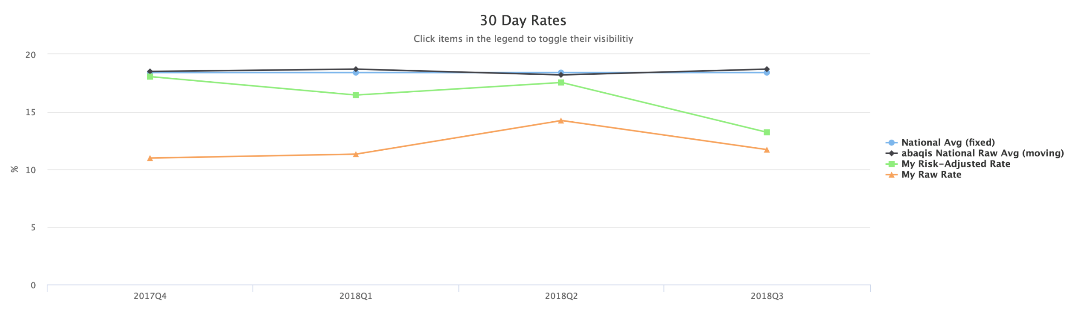

Figure 3 Hospital Readmission Rates 30 Day
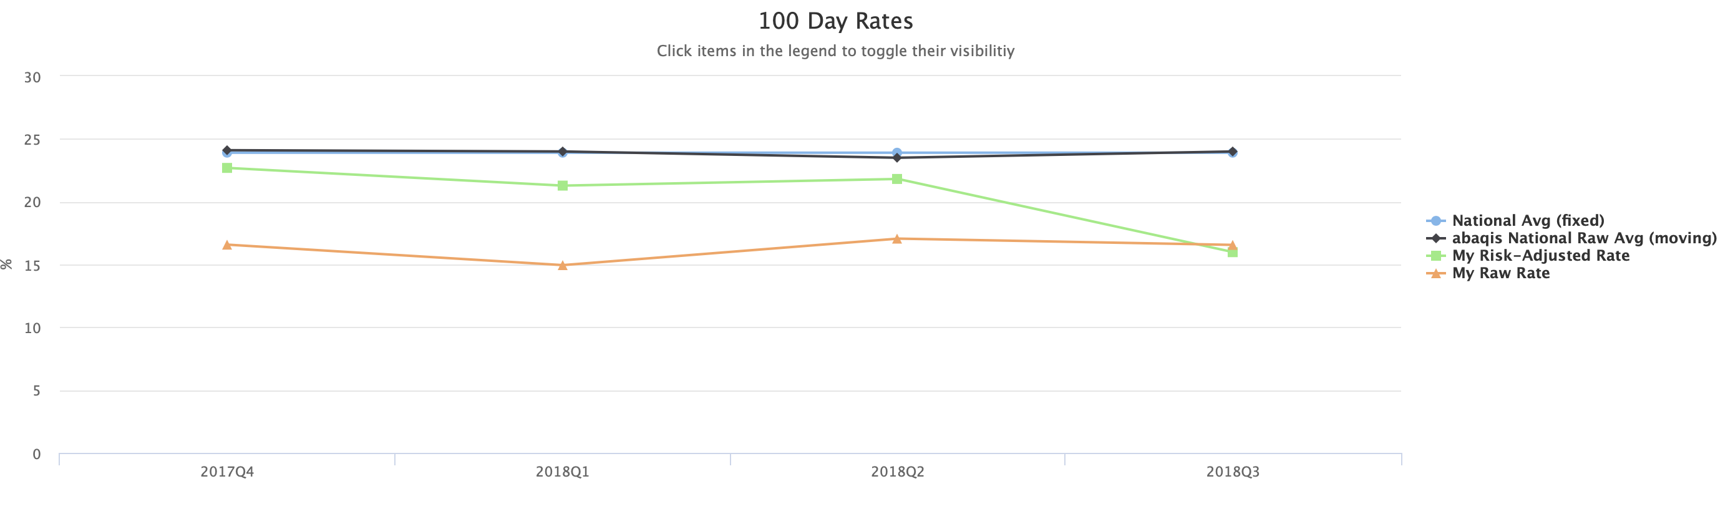

Figure 4 Hospital Readmission Rates 100 Day

QAPI Investigation Progress
The figure below displays the current progress of QAPI Investigations for the most recently created Investigation Snapshot for all facilities. This pie chart looks at the average number of residents completed in each prioritized resident-level investigation across all facilities, and then it gives you the percentage of facilities by the average number of residents completed per investigation. Resident-level investigations (e.g., Accidents, Choices) contain one or more residents who provided negative responses for the corresponding care area in the QAPI Assessment. In this snapshot below, the green section shows that 28.7% percent of facilities have completed an average of 3 residents in their prioritized resident-level investigations. Abuse and Unnecessary Medication are excluded from this chart because they are a high priority and almost always result in an investigation. The report displays their data separately. In the resident-level speedometer below, 56% of all prioritized investigations (e.g., Accidents, Choices, etc) across all facilities have at least one resident completed. In the facility-level speedometer, 33% of all prioritized investigations across all facilities have been completed. Ideally, a facility would want to be at 100% for each investigation level.

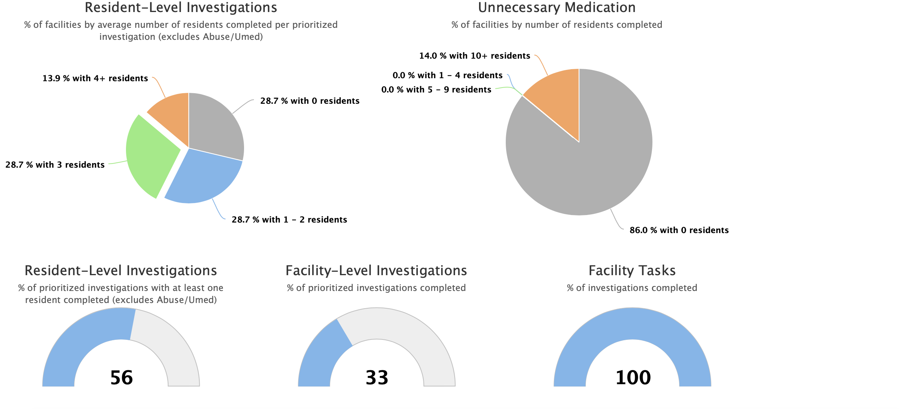

Figure 5 Investigation Snapshot Progress

QAPI Accreditation Status
The figure below displays the most recent accreditation status and the progress toward current quarter accreditation for all facilities. Providgm bases their accreditation level awards on the progress of each facility. All PSCN skilled nursing facilities have met the basic standards of accreditation, but only 57.1% are meeting advanced standards.

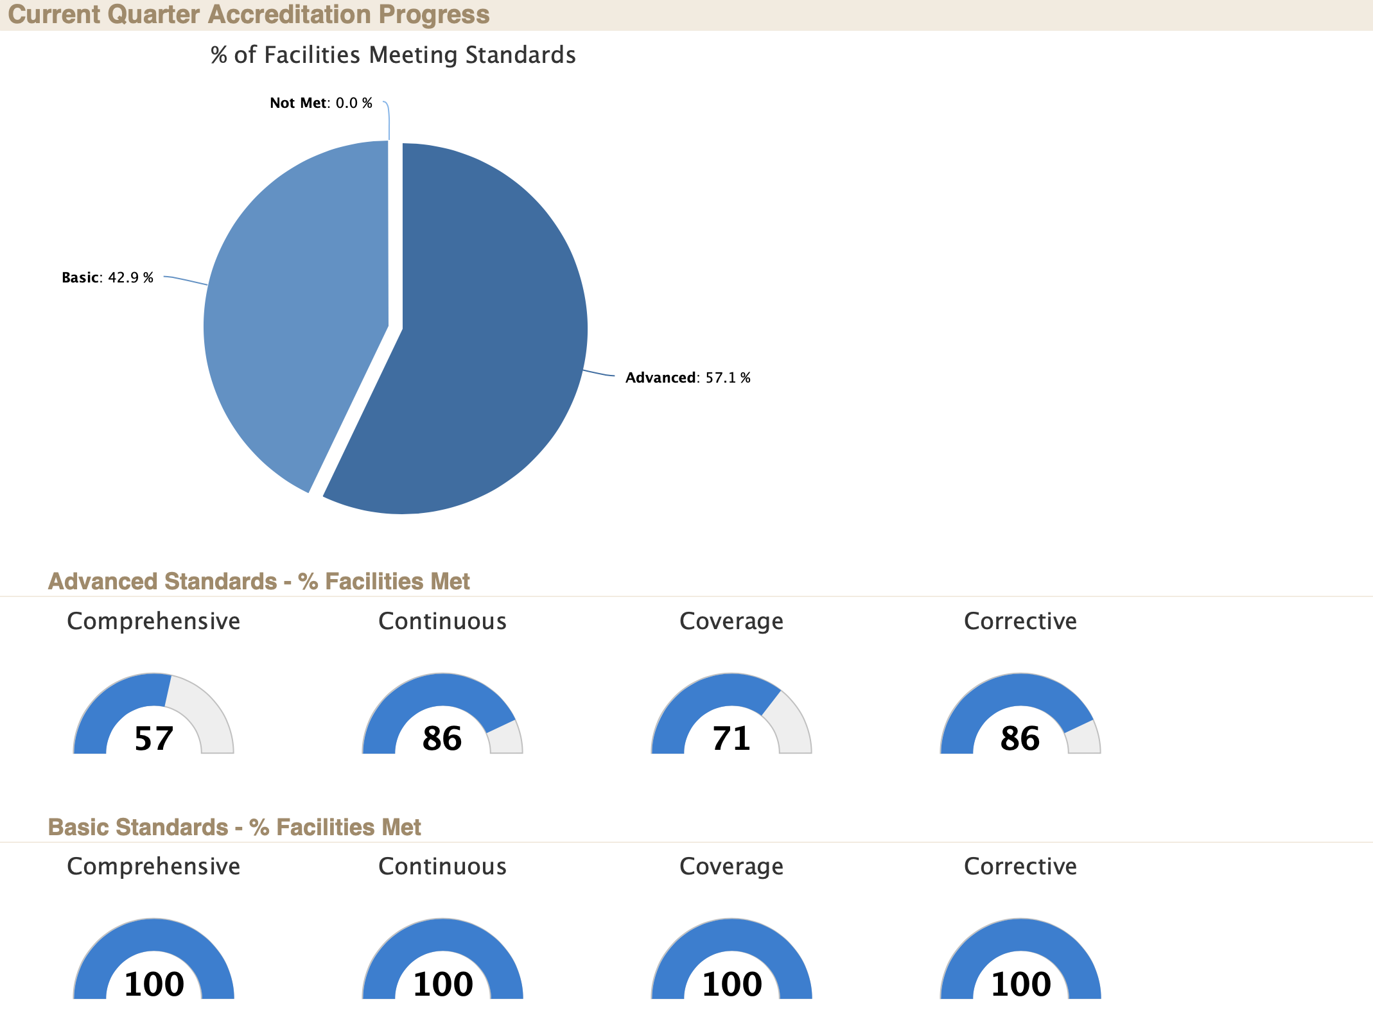

Figure 6 QAPI Accreditation Status

DISCUSSION
For a skilled nursing facility to reach the basic level of QAPI Accreditation, they have to complete the following checklist shown in the table below:

Table 2 QAPI Accredidation Checklist

Basic QAPI Accreditation (Complete the following) :
5 of each: Resident, Family & Staff Interviews, Resident Observations, & Census Record Reviews (Must complete in 50% of all evaluated quarters)
Resident Observations or Census Record Reviews for 30% of the average daily census or 30 Resident
1 Full Investigation
All 9 Facility Tasks
Advanced QAPI Accreditation (Complete the following) :
20 of each: Resident, Family & Staff Interviews, Resident Observations, & Census Record Reviews (must use two random samples & complete in 75% of all evaluated quarters
Resident Observations OR Census Record Reviews for 50% of the average daily census or 50 Resident
2 Investigations, all 9 Facility Tasks, & 1 PIP OR 4 Investigations & 2 sets of all 9 Facility Task
A complete Facility and QAPI Plan that is marked as formal
("QAPI: Your Checklist for QAPI Accreditation").

By wanting to achieve accreditation, whether basic or advanced level, skilled nursing facilities study the issues at hand through observations, investigation and interviews, and then a root cause analysis (RCA) is formed to help direct a plan of action. RCA’s should reveal several underlying factors. At PSCN a Performance Improvement Project (PIP) team comes up with recommendations for interventions on whatever issues they find. Some of these recommendations have included protocals, new programs, and even standing orders. The interventions are then implemented in the designated areas where the issues lie. The PIP team then collects data from the staff on the progress of the interventions. If the intervention works, then it is expanded in other areas of the facility. When it is time for the annual survey, they hope to have no deficiencies in the areas that they initially identified before the intervention. Using QAPI allowed them to find and correct progressive issues before they escalated to major problems. By also getting to the root cause of an issue with a resident, one can stop hospital readmissions because they are finding the underlying cause and solving it instead of just sending the resident to the hiospital everytime the same issue arrises
Elmwood Gardens, Shenango on the Green, Longwood at Oakmont, and Manchester Commons are all of the skilled nursing facilities that have earned advanced QAPI accreditation across the network. When comparing them to the other skilled facilities across the network we see that the The Willows has no QAPI Plan in place, Oakwood Heights is missing facility tasks, and Southmont has an incomplete QAPI Plan. Advanced accreditation does not mean that a facility has a better 5- star rating or that it has a direct effect on key organizational performance indicators such as occupancy or private pay, but it does mean that Elmwood Gardens, Shenango on the Green, Longwood at Oakmont, and Manchester Commons are constantly looking at processes to make their residents comfortable, happy, and healthy and constantly assessing themselves.

RECOMMENDATIONS
At communities with basic accreditation, the Abaqis champions had changed. The new champions had not been trained at the same time as the champions at the advanced level facilities. I recommend better communication between Abaqis champions and the management team interviewers, the retraining of the Abaqis champions, coordination and inclusion, and the reevaluation of the ability to use the system. I encourage Abaqis champions to send out weekly emails to the management team interviewers to remind them to get their interviews and investigations done in the allotted time frame. I suggest campuses with basic accreditation have retraining sessions on the purpose of Abaqis and how the system works. A test should be given at the end of the session to asses their readiness in navigating the system. Champions should be retrained every two years or sooner depending on any system updates. I advise multiple champions of implementation of use of the ABAQIS system at each of the basic level facilities. I also encourage that there should also be an accountability form that should be implemented if staff are not completing investigations or PIPs in the allotted time frame given. Lastly, facility results should be reviewed between clinic managers and engagement of decision making on how to make the QAPI process and Abaqis use better should also be conducted.

COnclusion
This review gave an overview of what the ABAQIS web-based quality assurance system is and how it seeks to improve quality in skilled nursing facilities. The review also identified how ABAQIS is being used at all of Presbyterian SeniorCare Network’s skilled nursing facilities and how the different levels off accreditation correlates to quality.
In conclusion, the ABAQIS system has been a very influential part of quality improvement at Presbyterian Seniorcare Network. It has helped them identify and analyze trends that cause readmissions , resolve residents’ area of concerns—or triggers—before they could develop into more serious problems, implement QAPI processes across the network, earn Providigm QAPI Accreditation, based on standards for excellence in continuously improving quality of care and life , be completely prepared for the QIS survey process and aware of any issues the QIS survey is likely to uncover, and quickly highlight residents at risk by reviewing the thresholds and analysis of a QIS survey.
        - CUSTOMER SATISFACTION DATA

The table below displays the average likelihood of recommendation for residents and families and customer satisfaction summary data for all facilities starting from April 1, 2018- March 31, 2019

Facility | State |  | ResidentResponses | ResFES |  | ResSatSomewhat |  | ResSatVery |  | ResSatExtremely |  | ResRecSomewhat |  | ResRecVery |  | ResRecExtremely
The Willows at Presbyterian SeniorCare Oakmont Campus | PA | 44 |  | 51.2 | 20.9 |  | 51.2 |  | 23.3 |  | 4.7 |  | 34.9 |  | 55.8
Elmwood Gardens | PA | 36 |  | 41.7 | 16.7 |  | 38.9 |  | 36.1 |  | 16.7 |  | 30.6 |  | 47.2
Manchester Commons | PA | 25 |  | 84 | 8 |  | 16 |  | 72 |  | 0 |  | 8 |  | 88
Oakwood Heights | PA | 44 |  | 43.2 | 15.9 |  | 40.9 |  | 40.9 |  | 11.4 |  | 40.9 |  | 45.5
Shenango Presbyterian SeniorCare | PA | 17 |  | 64.7 | 5.9 |  | 41.2 |  | 52.9 |  | 5.9 |  | 29.4 |  | 64.7
Longwood at Oakmont | PA | 33 |  | 6.5 | 21.9 |  | 43.8 |  | 18.8 |  | 9.7 |  | 38.7 |  | 29
Southmont of Presbyterian SeniorCare Washington Campus | PA | 27 |  | 38.5 | 34.6 |  | 30.8 |  | 30.8 |  | 30.8 |  | 23.1 |  | 42.3
Family Responses | FamFES | FamSatSomewhat | FamSatVery | FamSatExtremely | FamRecSomewhat | FamRecVery | FamRecExtremely
51 | 37.3 | 11.8 | 52.9 | 33.3 | 15.7 | 43.1 | 39.2
41 | 22 | 9.8 | 73.2 | 17.1 | 7.3 | 65.9 | 24.4
56 | 53.6 | 7.1 | 57.1 | 35.7 | 5.4 | 37.5 | 55.4
59 | 67.8 | 5.1 | 33.9 | 61 | 5.1 | 27.1 | 67.8
29 | 58.6 | 3.4 | 41.4 | 55.2 | 3.4 | 37.9 | 58.6
42 | 19 | 21.4 | 57.1 | 19 | 16.7 | 54.8 | 23.8
27 | 29.6 | 11.1 | 66.7 | 22.2 | 14.8 | 55.6 | 29.6

        - HOSPITAL READMISSION RATES
The table below displays 30-day and 100-day Raw and Risk-adjusted hospital readmission rates for all facilities from October 1, 2018 to January 1, 2018

Facility | State | DateStart | DateEnd | Risk Adjusted 30 Day | Raw 30 Day | Risk Adjusted 100 Day | Raw 100 Day
The Willows at Presbyterian SeniorCare Oakmont Campus | PA | 2018-01-01 | 2018-03-31 | 17.1 | 14.9 | 21 | 17.8
The Willows at Presbyterian SeniorCare Oakmont Campus | PA | 2018-04-01 | 2018-06-30 | 22.9 | 19.8 | 25.9 | 22.4
The Willows at Presbyterian SeniorCare Oakmont Campus | PA | 2018-07-01 | 2018-09-30 | 17.9 | 14 | 19.4 | 15
The Willows at Presbyterian SeniorCare Oakmont Campus | PA | 2018-10-01 | 2018-12-31 | 12.9 | 9.8
Southmont of Presbyterian SeniorCare Washington Campus | PA | 2018-01-01 | 2018-03-31 | 24.7 | 20.9 | 26.7 | 22.6
Southmont of Presbyterian SeniorCare Washington Campus | PA | 2018-04-01 | 2018-06-30 | 18.4 | 15.6 | 25 | 21.2
Southmont of Presbyterian SeniorCare Washington Campus | PA | 2018-07-01 | 2018-09-30 | 15.7 | 13.2 | 15.5 | 12.9
Southmont of Presbyterian SeniorCare Washington Campus | PA | 2018-10-01 | 2018-12-31 | 16.8 | 15
Shenango Presbyterian SeniorCare | PA | 2018-01-01 | 2018-03-31 |  | 0 |  | 6.7
Shenango Presbyterian SeniorCare | PA | 2018-04-01 | 2018-06-30 | 21.7 | 17.9 | 26.7 | 22.2
Shenango Presbyterian SeniorCare | PA | 2018-07-01 | 2018-09-30 |  | 4.2 |  | 8.3
Shenango Presbyterian SeniorCare | PA | 2018-10-01 | 2018-12-31 |  | 17.4
Oakwood Heights | PA | 2018-01-01 | 2018-03-31 | 20.1 | 16.1 | 20.1 | 16.1
Oakwood Heights | PA | 2018-04-01 | 2018-06-30 |  | 12 |  | 12
Oakwood Heights | PA | 2018-07-01 | 2018-09-30 |  | 22.7 |  | 42.1
Oakwood Heights | PA | 2018-10-01 | 2018-12-31 | 4.2 | 3.3
Manchester Commons | PA | 2018-01-01 | 2018-03-31 | 17.8 | 13.8 | 20.3 | 15.9
Manchester Commons | PA | 2018-04-01 | 2018-06-30 | 13.5 | 9.2 | 17.5 | 12.2
Manchester Commons | PA | 2018-07-01 | 2018-09-30 | 13.9 | 10.7 | 15.6 | 12
Manchester Commons | PA | 2018-10-01 | 2018-12-31 | 6.8 | 4.8
Longwood at Oakmont | PA | 2018-01-01 | 2018-03-31 | 6.7 | 2.9 | 19.9 | 9.4
Longwood at Oakmont | PA | 2018-04-01 | 2018-06-30 |  | 15 |  | 16.7
Longwood at Oakmont | PA | 2018-07-01 | 2018-09-30 |  | 12.5 |  | 13.6
Longwood at Oakmont | PA | 2018-10-01 | 2018-12-31 |  | 4.3
Elmwood Gardens | PA | 2018-01-01 | 2018-03-31 | 12.3 | 10.5 | 19.7 | 16.2
Elmwood Gardens | PA | 2018-04-01 | 2018-06-30 | 11.2 | 10.2 | 13.9 | 12.8
Elmwood Gardens | PA | 2018-07-01 | 2018-09-30 | 5.4 | 4.8 | 13.4 | 11.9
Elmwood Gardens | PA | 2018-10-01 | 2018-12-31 | 16.2 | 16.7
        - QAPI INVESTIGATION SNAPSHOT
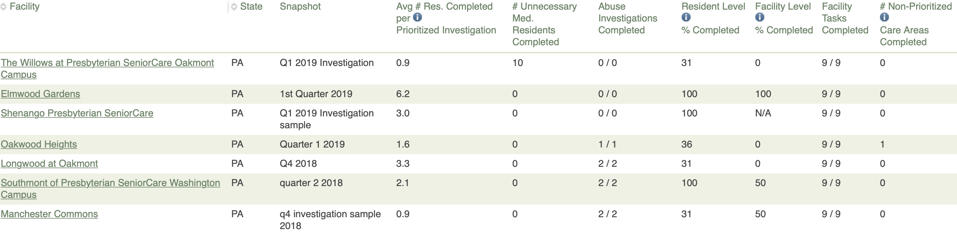
        - ACCREDITATION STATUS SNAPSHOT
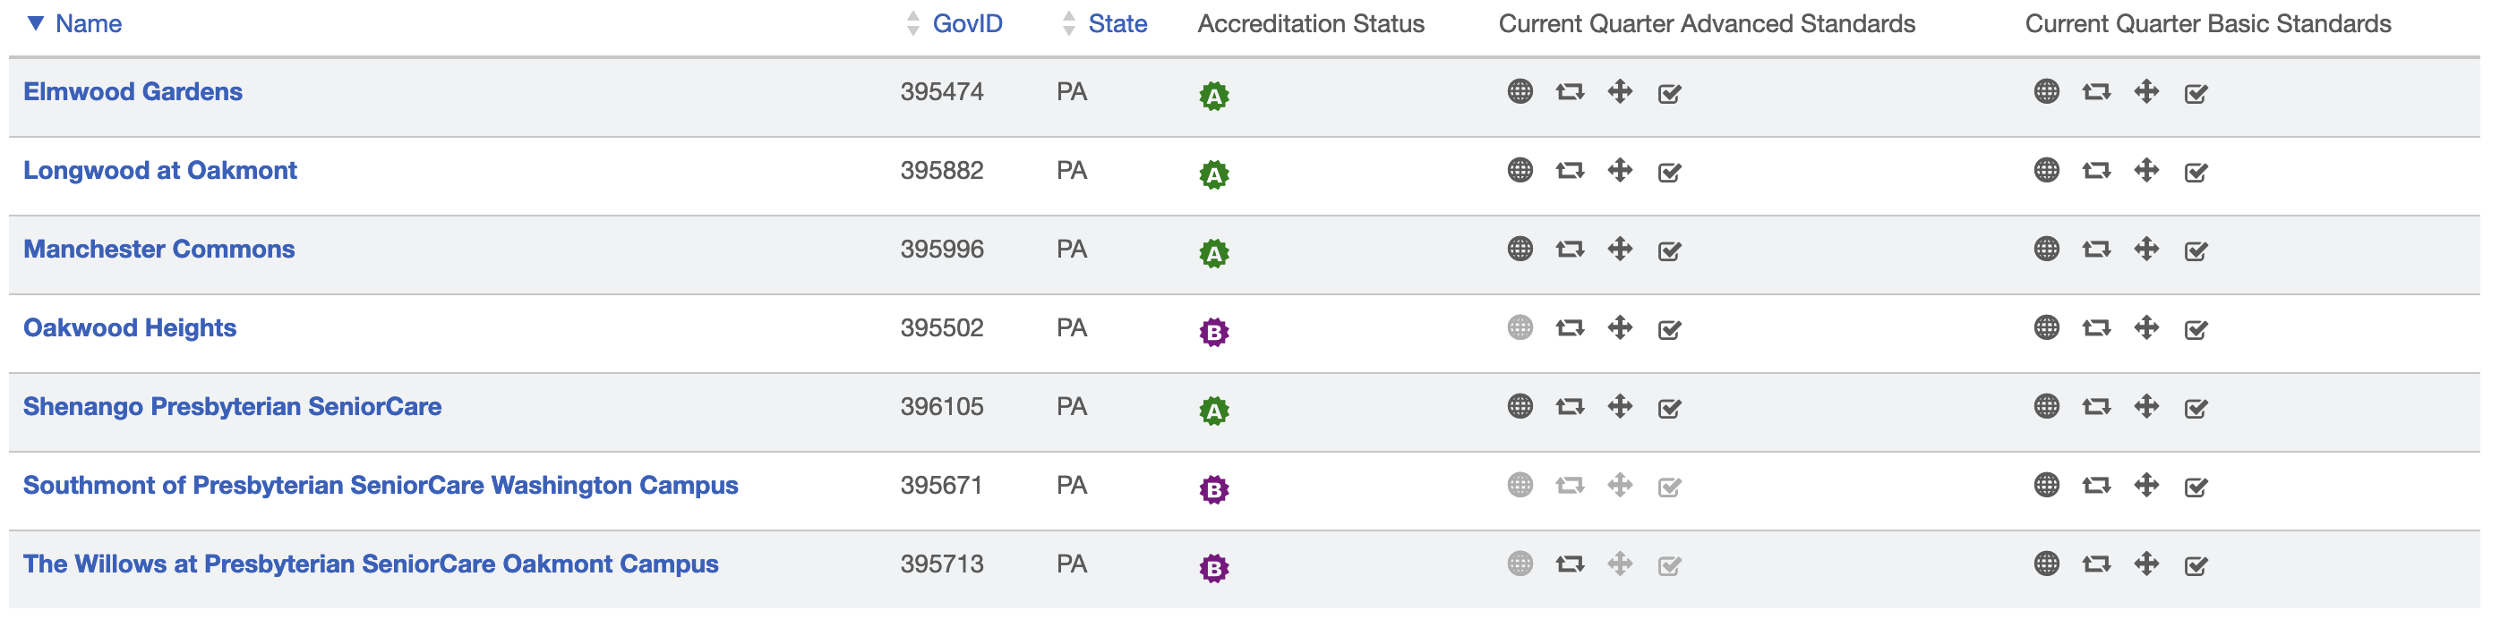

        - QAPI ACTIVITY PER COMMUNITY
LONGWOOD
Reporting Period
Start Date: 2018-03-22
End Date: 2019-03-22
- Random QAPI Samples
- Q2 2018
  - Start Date: 2018-04-04
  - Total Assessments: 230
  - Assessments Types: Resident Interview, Family Interview, Resident Observation, Staff Interview, Census Review, Admission Interview
- Q3 2018
  - Start Date: 2018-10-04
  - Total Assessments: 230
  - Assessments Types: Resident Interview, Family Interview, Resident Observation, Staff Interview, Census Review, Admission Interview
- Investigation Snapshots
- Q2 2018
  - Start Date: 2018-04-01
  - Care Area Investigations:
    - Activities
    - Resident Council President / Representative Interview
    - Pressure Ulcer / Injury
    - Medication Administration
    - Medication Storage and Labeling
    - Choices
    - Dining Observation
    - Kitchen/Food Service Observation
    - Sufficient and Competent Nurse Staffing Review
    - Unnecessary Medication Use
    - Abuse
    - Infection Control and Immunizations
    - Quality Assessment and Assurance Review
    - SNF Beneficiary Protection Notification Review
- Q4 2018
  - Start Date: 2018-10-01
  - Care Area Investigations:
    - Pressure Ulcer / Injury
    - Skin Conditions (non-pressure related)
    - Choices
    - Dining Observation
    - Resident Council President / Representative Interview
    - Bladder or Bowel Incontinence
    - Infection Control and Immunizations
    - Kitchen/Food Service Observation
    - Sufficient and Competent Nurse Staffing Review
    - Abuse
    - Nutrition
    - Medication Administration
    - Quality Assessment and Assurance Review
    - Medication Storage and Labeling
    - SNF Beneficiary Protection Notification Review
- Ad Hoc Facility Tasks
- QAPI Plans
- Longwood at Oakmont QAPI Plan
  - Created: 2018-08-06
- Longwood at Oakmont QAPI Plan
  - Created: 2019-01-17
- Longwood at Oakmont QAPI Plan
  - Created: 2019-01-17
- Longwood at Oakmont QAPI Plan
  - Created: 2019-01-17
- Longwood at Oakmont QAPI Plan
  - Created: 2019-01-17
- Longwood at Oakmont QAPI Plan
  - Created: 2019-01-17
- Longwood at Oakmont QAPI Plan
  - Created: 2019-01-17
- Longwood at Oakmont QAPI Plan
  - Created: 2019-01-17
- Facility Assessments
- Hanna Health Center 2018
  - Created: 2018-06-11
- Hanna Health Center 2019
  - Created: 2018-11-29
- QAPI Self-Assessments
- Created: 2018-06-22
  - Score 104
- PIPs
- Pressure Injuries
  - Created: 2018-07-18
  - Care Area/Category: Pressure Ulcers
- Lifestyle Engagement
  - Created: 2018-08-17
  - Care Area/Category: Activities
- Grievance Log Process
  - Created: 2019-01-21
  - Care Area/Category: Grievance process

ELMWOOD GARDENS
Reporting Period
Start Date: 2018-03-22
End Date: 2019-03-22

- Random QAPI Samples
- 3rd Quarter 2018
  - Start Date: 2018-07-02
  - Total Assessments: 230
  - Assessments Types: Resident Interview, Family Interview, Resident Observation, Staff Interview, Census Review, Admission Interview
- 1st Quarter 2019
  - Start Date: 2019-01-03
  - Total Assessments: 230
  - Assessments Types: Resident Interview, Family Interview, Resident Observation, Staff Interview, Census Review, Admission Interview
- Investigation Snapshots
- 3rd quater 2018
  - Start Date: 2018-07-02
  - Care Area Investigations:
    - Infection Control and Immunizations
    - Medication Storage and Labeling
    - Dining Observation
    - Resident Council President / Representative Interview
    - Kitchen/Food Service Observation
    - Sufficient and Competent Nurse Staffing Review
    - Environmental Observations
    - Behavioral and Emotional Status
    - Accidents
    - Personal Funds Review
    - Pressure Ulcer / Injury
    - Abuse
    - Nutrition
    - Activities of Daily Living
    - Bladder or Bowel Incontinence
    - Activities
    - Skin Conditions (non-pressure related)
    - Death
    - Medication Administration
    - Quality Assessment and Assurance Review
    - Choices
    - Personal Property
    - Dignity
    - Notification of Change
    - Participation in Care Planning
    - Privacy
    - SNF Beneficiary Protection Notification Review
- 1st Quarter 2019
  - Start Date: 2019-01-03
  - Care Area Investigations:
    - Personal Funds Review
    - Hydration
- Ad Hoc Facility Tasks
- QAPI Plans
- Elmwood Gardens QAPI Plan
  - Created: 2018-08-06
- Elmwood Gardens QAPI Plan
  - Created: 2018-09-28
- Facility Assessments
- Elmwood Gardens Sept 2018
  - Created: 2018-09-28
- QAPI Self-Assessments
- Created: 2018-06-22
  - Score 110
- PIPs

SHENANGO
Reporting Period
Start Date: 2018-03-22
End Date: 2019-03-22

- Random QAPI Samples
- Q3 Investigation
  - Start Date: 2018-07-02
  - Total Assessments: 165
  - Assessments Types: Resident Interview, Family Interview, Resident Observation, Staff Interview, Census Review, Admission Interview
- Q1 2019
  - Start Date: 2019-01-17
  - Total Assessments: 125
  - Assessments Types: Resident Interview, Family Interview, Resident Observation, Staff Interview, Census Review, Admission Interview
- Investigation Snapshots
- Q3 Investigation
  - Start Date: 2018-07-02
  - Care Area Investigations:
    - Dining Observation
    - Resident Council President / Representative Interview
    - Kitchen/Food Service Observation
    - Sufficient and Competent Nurse Staffing Review
    - Unnecessary Medication Use
    - Accidents
    - Nutrition
    - Bladder or Bowel Incontinence
    - Infection Control and Immunizations
    - Death
    - Medication Administration
    - Quality Assessment and Assurance Review
    - Medication Storage and Labeling
    - SNF Beneficiary Protection Notification Review
- Q1 2019 investigation sample
  - Start Date: 2019-03-05
  - Care Area Investigations:
    - Medication Administration
    - Medication Storage and Labeling
    - SNF Beneficiary Protection Notification Review
    - Resident Council President / Representative Interview
    - Pressure Ulcer / Injury
    - Activities of Daily Living
    - Bladder or Bowel Incontinence
- Ad Hoc Facility Tasks
- QAPI Plans
- Inventory
  - Created: 2018-03-29
- Shenango QAPI Plan
  - Created: 2018-04-06
- Shenango QAPI Plan
  - Created: 2018-04-06
- Shenango QAPI Plan
  - Created: 2018-04-06
- Facility Assessments
- Shenango 2018
  - Created: 2018-05-10
- Shenango 2019
  - Created: 2018-11-29
- QAPI Self-Assessments
- Created: 2018-06-22
  - Score 109
- PIPs

THE WILLOWS
Reporting Period
Start Date: 2018-03-22
End Date: 2019-03-22

- Random QAPI Samples
- Q3 2018
  - Start Date: 2018-07-02
  - Total Assessments: 230
  - Assessments Types: Resident Interview, Family Interview, Resident Observation, Staff Interview, Census Review, Admission Interview
- Q1 2019
  - Start Date: 2019-01-02
  - Total Assessments: 230
  - Assessments Types: Resident Interview, Family Interview, Resident Observation, Staff Interview, Census Review, Admission Interview
- Investigation Snapshots
- Q3 2018 investigation
  - Start Date: 2018-07-02
  - Care Area Investigations:
    - Medication Storage and Labeling
    - Resident Council President / Representative Interview
    - Infection Control and Immunizations
    - Death
    - Medication Administration
    - Dining Observation
    - Kitchen/Food Service Observation
    - Sufficient and Competent Nurse Staffing Review
    - Accidents
    - Pressure Ulcer / Injury
    - Abuse
    - Activities of Daily Living
    - Quality Assessment and Assurance Review
    - SNF Beneficiary Protection Notification Review
- Q1 2019 Investigation
  - Start Date: 2019-01-02
  - Care Area Investigations:
    - Pressure Ulcer / Injury
    - Dental Status and Services
    - Nutrition
    - Infection Control and Immunizations
    - Death
    - Medication Administration
    - Quality Assessment and Assurance Review
    - Dining Observation
    - SNF Beneficiary Protection Notification Review
- Ad Hoc Facility Tasks
- Investigation: QAA and QAPI Plan Review
  - QAA and QAPI Plan Review Q1 2019
    - Created: 2019-03-15
- QAPI Plans
- Facility Assessments
- The Willows 2019
  - Created: 2018-11-29
- QAPI Self-Assessments
- Created: 2018-06-22
  - Score 110
- PIPs
- Resident/Caregiver Education Process
  - Created: 2018-04-10
  - Care Area/Category: Decrease length of SNF stay and hospital readmission rate
- Decreasing inpatient and post-discharge readmissions
  - Created: 2018-04-26
  - Care Area/Category:
- Increasing discharge function score
  - Created: 2018-04-26
  - Care Area/Category:
- Decreasing length of patient stay
  - Created: 2018-04-26
  - Care Area/Category:
- medication reconciliation discharge orders
  - Created: 2018-06-29
  - Care Area/Category: Clinical

MANCHESTER COMMONS
Reporting Period
Start Date: 2018-03-22
End Date: 2019-03-22

- Random QAPI Samples
- Q2 2018
  - Start Date: 2018-04-24
  - Total Assessments: 227
  - Assessments Types: Resident Interview, Family Interview, Resident Observation, Staff Interview, Census Review, Admission Interview
- Q4 2018
  - Start Date: 2018-10-01
  - Total Assessments: 229
  - Assessments Types: Resident Interview, Family Interview, Resident Observation, Staff Interview, Census Review, Admission Interview
- Investigation Snapshots
- Q2 2018
  - Start Date: 2018-06-01
  - Care Area Investigations:
    - Pressure Ulcer / Injury
    - Medication Administration
    - Dining Observation
    - Resident Council President / Representative Interview
    - Kitchen/Food Service Observation
    - Sufficient and Competent Nurse Staffing Review
    - Nutrition
    - Activities of Daily Living
    - Positioning, Mobility and Range of Motion
    - Infection Control and Immunizations
    - Quality Assessment and Assurance Review
    - Medication Storage and Labeling
    - SNF Beneficiary Protection Notification Review
- q4 investigation sample 2018
  - Start Date: 2018-10-01
  - Care Area Investigations:
    - Medication Storage and Labeling
    - Medication Administration
    - Dining Observation
    - Resident Council President / Representative Interview
    - Kitchen/Food Service Observation
    - Sufficient and Competent Nurse Staffing Review
    - Personal Funds Review
    - Abuse
    - Activities of Daily Living
    - Infection Control and Immunizations
    - Death
    - Quality Assessment and Assurance Review
    - Choices
    - Dignity
    - SNF Beneficiary Protection Notification Review
- Ad Hoc Facility Tasks
- Investigation: Dining Observation
  - Dining process change, Dining review on Eagle Ridge.
    - Created: 2019-03-04
- QAPI Plans
- Manchester Commons QAPI Plan
  - Created: 2018-11-29
- Facility Assessments
- Manchester Commons 2019
  - Created: 2018-11-29
- QAPI Self-Assessments
- Created: 2018-06-22
  - Score 111
- PIPs
- Side Rail Reduction
  - Created: 2018-05-16
  - Care Area/Category: Safety

SOUTHMONT
Reporting Period
Start Date: 2018-03-22
End Date: 2019-03-22

- Random QAPI Samples
- Q2 2018
  - Start Date: 2018-09-24
  - Total Assessments: 230
  - Assessments Types: Resident Interview, Family Interview, Resident Observation, Staff Interview, Census Review, Admission Interview
- Investigation Snapshots
- Q2 2018
  - Start Date: 2018-09-24
  - Care Area Investigations:
    - Dining Observation
    - Resident Council President / Representative Interview
    - Kitchen/Food Service Observation
    - Sufficient and Competent Nurse Staffing Review
    - Accidents
    - Personal Funds Review
    - Pressure Ulcer / Injury
    - Abuse
    - Dental Status and Services
    - Nutrition
    - Activities of Daily Living
    - Bladder or Bowel Incontinence
    - Infection Control and Immunizations
    - Activities
    - Pain Recognition and Management
    - Death
    - Medication Administration
    - Discharge
    - Quality Assessment and Assurance Review
    - Medication Storage and Labeling
    - Choices
    - Personal Property
    - Dignity
    - Notification of Change
    - Participation in Care Planning
    - Privacy
    - SNF Beneficiary Protection Notification Review
- Ad Hoc Facility Tasks
- QAPI Plans
- Southmont QAPI Plan
  - Created: 2019-01-02
- Facility Assessments
- Southmont Presbyterian Senior Care 2018
  - Created: 2018-06-11
- Southmont Presbyterian Senior Care 2019
  - Created: 2018-11-29
- QAPI Self-Assessments
- Created: 2018-06-22
  - Score 116
- PIPs
- Part B supply usage
  - Created: 2018-06-28
  - Care Area/Category: clinical

OAKWOOD HEIGHTS
Reporting Period
Start Date: 2018-03-22
End Date: 2019-03-22
- Random QAPI Samples
- Q3 2018
  - Start Date: 2018-07-02
  - Total Assessments: 230
  - Assessments Types: Resident Interview, Family Interview, Resident Observation, Staff Interview, Census Review, Admission Interview
- Q1 2019
  - Start Date: 2019-01-02
  - Total Assessments: 230
  - Assessments Types: Resident Interview, Family Interview, Resident Observation, Staff Interview, Census Review, Admission Interview
- Investigation Snapshots
- Q3 2018
  - Start Date: 2018-07-02
  - Care Area Investigations:
    - Sufficient and Competent Nurse Staffing Review
    - Behavioral and Emotional Status
    - Medication Storage and Labeling
    - Dining Observation
    - Resident Council President / Representative Interview
    - Kitchen/Food Service Observation
    - Unnecessary Medication Use
    - Abuse
    - Nutrition
    - Infection Control and Immunizations
    - Medication Administration
    - Quality Assessment and Assurance Review
    - Choices
    - SNF Beneficiary Protection Notification Review
- Q1 2019
  - Start Date: 2019-01-02
  - Care Area Investigations:
    - Dining Observation
    - Medication Storage and Labeling
    - Resident Council President / Representative Interview
    - Kitchen/Food Service Observation
    - Sufficient and Competent Nurse Staffing Review
    - Accidents
    - Abuse
    - Nutrition
    - Activities of Daily Living
    - Infection Control and Immunizations
    - Pain Recognition and Management
    - Physical Restraints
    - Death
    - Medication Administration
    - Quality Assessment and Assurance Review
    - SNF Beneficiary Protection Notification Review
- Ad Hoc Facility Tasks
- QAPI Plans
- Oakwood Heights QAPI Plan 2018
  - Created: 2018-03-29
- Facility Assessments
- Oakwood Heights 2018
  - Created: 2018-05-08
- Oakwood Heights 2018
  - Created: 2018-10-05
- QAPI Self-Assessments
- Created: 2018-06-22
  - Score 116
- PIPs
- Identifiable Equipment
  - Created: 2018-04-23
  - Care Area/Category: Nursing/Social Services
- Discharge process-laundry
  - Created: 2018-05-01
  - Care Area/Category: Discharge
- Splinting
  - Created: 2018-07-11
  - Care Area/Category: Specialized Rehabilitative or Restorative Services
- Housekeeper Standardization of task flow
  - Created: 2018-07-12
  - Care Area/Category: Environmental Observations
- MDS submission
  - Created: 2018-07-27
  - Care Area/Category: MDS
- Dining Services Supply Storage Room
  - Created: 2018-08-03
  - Care Area/Category: Storage room the to the left of the main kitchen door
- Woodside DS Two Seating Meals
  - Created: 2018-08-21
  - Care Area/Category: Dining Observation
- Med cart/medication storage
  - Created: 2018-09-11
  - Care Area/Category: nursing
- Dining Service Dishwashing Procedure
  - Created: 2018-10-21
  - Care Area/Category: Sanitation and Infection Control
- Standardized Filing Cabinets on Nursing Units
  - Created: 2019-02-06
  - Care Area/Category: Nursing

bibliography
Centers for Medicare & Medicaid Services. (2007, December). Evaluation of the Quality Indicator Survey (QIS) Contract #500-00-0032, TO#7 [PDF].

Centers for Medicare & Medicaid Services, & Telligen. (2017, August 28). Nursing Home Quality Initiatives Questions and Answer[PDF].

Kissam, S., Gifford, D., Parks, P., Patry, G., Palmer, L., Wilkes, L., . . . Barnette, L. (2003, May 16). Approaches to quality improvement in nursing homes: Lessons learned from the six-state pilot of CMS's Nursing Home Quality Initiative. Retrieved from https://www.ncbi.nlm.nih.gov/pmc/articles/PMC166131/

Kramer, A. M., MD, Fish, R., MBA, Min, S., PhD, Schreuder, I., MSMD, & Kramer, P., BS. (2013, April). QAPI Accreditation: Impact on Survey Performance[PDF]. Providigm, LLC.

Kramer, A. M., MD, Fish, R., MBA, Schreuder, I., MS, & Kramer, P., BS. (2018, May 11). The Effect of Continuous Quality Improvement Using the abaqis Quality Management System on Nursing Home Survey Results. Retrieved from https://www.providigm.com/the-effect-of-continuous-quality-improvement-using-the-abaqis-quality-management-system-on-nursing-home-survey-results/

Lin, M., PhD, Meadow, M., MPH, Fish, R., MBA, Min, S., PhD, & Kramer, A., MD. (2018, May 11). Relationship Between abaqis Use and Both Survey Performance and Occupancy. Retrieved from https://www.providigm.com/relationship-between-abaqis-use-and-both-survey-performance-and-occupancy-2/

Presbyterian SeniorCare Network. (n.d.). Presbyterian Seniorcare PA. Retrieved from https://www.srcare.org/presbyterian-seniorcare-pa

Providigm. (2019, January 17). HealthStream Acquires Providigm to Drive Quality Outcomes via Workforce Training for the Nation's Skilled Nursing Facilities. Retrieved from https://www.providigm.com/healthstream-acquires-providigm/

Providigm. (n.d.). Abaqis - Skilled Nursing Facility Quality Management Software. Retrieved from https://www.providigm.com/solutions/skilled-nursing/

Providgm. (n.d.). Providigm QAPI Accreditation Standards. Retrieved from https://www.providigm.com/company/about-history/providigm-qapi-accreditation-standards/

Providigm. (n.d.). What Can Abaqis Do For You? [PDF]. Medline.

Providigm (n.d.).QAPI: Your Checklist for QAPI Accreditation [PDF].

