A POLICY ANALYSIS:
THE STATE OF HOUSING INSECURITY IN PENNSYLVANIA

by
Iman A. Farid
BS, Rochester Institute of Technology, 2017

Submitted to the Graduate Faculty of
Health Policy and Management
Graduate School of Public Health in partial fulfillment
of the requirements for the degree of
Master of Public Health

University of Pittsburgh
2019

UNIVERSITY OF PITTSBURGH
GRADUATE SCHOOL OF PUBLIC HEALTH

This essay was submitted
by

Iman Farid

on

April 26th, 2019
and approved by

Essay Advisor:
Wesley M. Rohrer, Ph.D., MBA
Associate Professor, Public Health Education
Co-Director, Doctoral Program, Health Services Research & Policy
Health Policy and Management
Graduate School of Public Health
University of Pittsburgh

Essay Reader:
Noble A-W. Maseru, Ph.D., MPH
Professor
Director, Center for Health Equity
Associate Dean for Diversity and Inclusion, Office of the Dean
Behavioral and Community Health Sciences
Graduate School of Public Health
University of Pittsburgh

Copyright © by Iman Farid
2019
Wesley M. Rohrer, Ph.D., MBA

A POLICY ANALYSIS:
THE STATE OF HOUSING INSECURITY IN PENNSYLVANIA

Iman Farid, MPH
University of Pittsburgh, 2019
ABSTRACT
Housing insecurity remains a constant problem within the United States despite efforts to address the root causes of the issue. Once such effort regards affordable housing (including the area of rental assistance). The federal government in partnership with States has allocated dollars to fund programs and provide homes to individuals who are financially insecure. A common source of truth across these programs is the correlation between having a stable home and improvements in health and wellbeing. The perspective of public health relevance has been further supported by studies that have observed results in which if individuals are able to live in adequate housing within affluent neighborhoods, they are able to avoid succumbing to environmental toxins, acute and chronic conditions, injuries, and cognitive fragility.
Even with an abundance of Federal and State-financed housing programs, the demand for these resources far outweighs the supply. The State of Pennsylvania serves to illustrate a unique perspective as the housing market allows community-based and public organizations to address the needs of specific subpopulations. To encompass a variety of perspectives within this study, individuals both utilizing and managing housing assistance programs were interviewed. Their input outlined the importance of advocacy and community engagement in bringing awareness to the scope of housing insecurity within the Pittsburgh area.
The Making Affordable Housing Work Act of 2018, introduced by Dr. Ben Carson, has the goal of improving rental assistance programs overseen by the U.S. Department of Housing and Urban Development (HUD). The policy not having passed or been implemented has gained an abundance of opposition from key stakeholders due to the punitive implications of changing rent structures and income reporting for constituents, as well as the addition of work requirements. These factors are hypothesized to create additional barriers for individuals already struggling to maintain basic necessities of shelter.

TABLE OF CONTENTS
Preface viii
1.0 Introduction 1
1.1 Public Health relevance 2
1.2 sustainable development goal #11 3
1.3 limitations of study 4
2.0 Literature review 5
2.1 housing insecurity in pennsylvania 5
2.2 the importance of housing 6
2.3 what is affordable housing? 7
2.4 History of federal affordable housing policies 7
2.5 affordable housing programs 9
2.5.1 HOME 9
2.5.2 CDBG 9
2.5.3 Homelessness Assistance Grants 10
2.5.4 Housing Choice Vouchers 10
2.5.5 Public Housing 10
2.5.6 Rental Assistance Demonstration 11
2.5.7 National Housing Trust Fund 11
2.5.8 Low-Income Housing Tax Credits 11
2.6 affordable housing in pennsylvania 12
3.0 discrimination in housing 14
4.0 observations from the field 16
4.1 bethlehem haven 16
4.2 personal Narratives 18
4.3 the impact of disability 19
4.4 Summary of learnings 20
5.0 policy analysis: make affordable housing work act 21
5.1 Policy goals and amendments 22
5.2 stakeholders affected 24
6.0 policy critique of making affordable housing work act of 2018 26
6.1 Potential Benefits 26
6.2 areas in need of improvement 28
6.3 recommendations 30
7.0 conclusions: an advocacy perspective 33
APPENDIX: MAKING AFFORDABLE HOUSING WORK ACT OF 2018 35
bibliography 57

Preface
I would like to acknowledge my essay advisor, Dr. Wesley Rohrer, and the reader, Dr. Noble Maseru, for their guidance and consistent feedback throughout this process. I greatly appreciate their expertise and time dedication to this portion of my graduate career. Their passion for advocacy, equity, and policy has further invigorated my purpose in the public health field and will continue to fuel my efforts by working with low-income and underprivileged communities.
I am grateful to the Department of Health Policy and Management for providing me with numerous opportunities to discover my interests in health policy and public health, and the ability to learn interdisciplinary skills and apply them in a ‘real-world’ environment. The ongoing support and dedication of faculty, staff and colleagues have been unlimited, and I am very privileged to be a part of this program and its alumni.

Introduction
Most Americans spend up to 90% of their time indoors, with an estimated two-thirds spent at home⁴. Housing ultimately fills a basic human need for shelter, which is essential to the well-being of both parents and children. Housing insecurity does not have a standard definition but it encompasses a number of challenges, such as people struggling to pay rent, overcrowding, moving frequently, staying with relatives, or spending more than 30% of their household income on housing costs. A homeless individual or family is often thought of as lacking a fixed, regular, and adequate nighttime residence⁷. Regardless of definition, poor quality housing has been observed to contribute to health problems such as chronic diseases and barriers for normal childhood development⁴. In the context of community and poverty clustering, an abundance of housing insecurity in one area can lead to further economic and resource insecurity. A by-product of poverty clustering can result in the deterioration of a community’s social cohesion, which has been defined as a trusting network of relationships and shared values or norms of residents in a neighborhood.
Housing, identified by the Federal government, is a broad and complex subject intersected by many disciplines such as finance, economics, politics, and social services. To address every component of housing, organizations such as the U.S. Department of Housing and Urban Development (HUD) and Public Housing Agencies (PHA) were implemented²⁷. The HUD is the principal Federal agency responsible for implementing and enforcing regulations for programs aimed at increasing homeownership, supporting community development, and enhancing non-discriminatory access to affordable housing. This organization also holds a considerable amount of authority regarding financing and the allocation of funds through grants or tax credits to State Housing Authorities. PHAs, often at a more local level, provide rental assistance to low-income families¹.
The Federal government has put forth sustainable evidence-based policies to enforce and regulate housing programs across the nation. These programs support many different types of agencies dealing directly with the provision of housing to chronically and periodically homeless individuals. Policies, however, do not usually follow an efficient, logical timeline, and can typically take an extended period to implement. It has also been observed that in certain states, housing policies do not take into consideration the housing market and taxing infrastructure. State governments have a unique opportunity and responsibility to change housing landscapes by partnering and funding boots-on-the-ground organizations. These organizations can provide valuable insight as to what the specific needs are for the community. And thus, the government can put into place specific sustainable policies to address those needs.

Public Health relevance
Housing is an important social determinant of health, and substandard living conditions have been identified as a major public health issue. An increasing body of evidence has linked housing quality to infectious disease morbidity, chronic illnesses, injuries, poor nutrition, and mental disorders. The lack of adequate and affordable housing has forced many low-income tenants to use an inordinate amount of resources to obtain shelter, leaving less for other necessities such as food, transportation, education, or healthcare services. In addition to the condition of the housing unit itself, the home site may also be a determinant of health. As referenced by the Robert Wood Johnson Foundation, neighborhoods that are impoverished may have an absence of sidewalks and street design, green spaces and recreational sites, and walkable facilities such as schools, hospitals, and shopping malls. Conditions in the built environment can contribute to an overall community profile of poor health³.
Over the years, interest in housing as a determinant of health has fluctuated due to housing-related infections, social unrest, class conflict, business interest in maintaining a healthier workforce, and economic downturns leading to crises in housing availability and quality. Amidst these changes, the roles and responsibilities of public health agencies have remained constant. They have an important role in continuing to monitor the development and enforcement of federal, state, and local housing codes.

sustainable development goal #11
The concept of housing insecurity can be applied to an international scale through the scope of Sustainable Development Goals (SDG). SDGs, also known as Global Goals, have led approximately 170 countries and territories to develop action plans to end poverty, protect the planet, and ensure that all communities enjoy peace and prosperity. SDGs enacted for the time period of January 2016 to 2030, are overseen by the United Nations Development Program. This organization’s main responsibilities include adherence of constituents to the 17 outlined SDGs and fostering partnerships between governments, private sector organizations, civil societies, and citizens³⁶. SDG #11, listed as sustainable cities and communities, has been identified to make cities inclusive, safe, resilient, and sustainable. Sub-goal #11.1 further indicates that by 2030, participants are to ensure access to adequate, safe, affordable housing with basic services, and upgrading infrastructure for sub-standard housing¹⁴.

limitations of study
Although the following topics are relevant to housing insecurity, a detailed discussion of each one will exceed the scope of this study. Blight, definitions of homelessness, natural disaster displacement, home-ownership vouchers, foreclosure response and recovery, housing discrimination, inclusionary zoning, and specific sub-populations, such as senior citizens, individuals with disabilities, and protected Native Americans and Alaska Natives.

Literature review

housing insecurity in pennsylvania
Homelessness and housing insecurity have been identified as an important problem to address across the Commonwealth. Through reports from the Housing Assistance Program and Pennsylvania Housing Alliance, it was estimated that 16,200 Pennsylvanians were homeless on any given day. In 2018, school districts reported 13,000 children to be housing insecure and were also observed to utilize State-provided services. These statistics can be equated to approximately 11.1 housing insecure individuals per 10,000 people in the general population³⁵. Within the State of Pennsylvania (PA) the chief cause of homelessness and housing insecurity is due to the scarcity of affordable homes. This scarcity is related to high housing market prices in which individuals cannot sustain payment (including rent, mortgages, etc.)¹⁸. As an example, reported in 2016, the fair market rent of a 2-bedroom apartment in PA cost $941. To afford this rate, an individual would need to earn $17.25 an hour, but in reality, an average renter in PA made $13.66. If an individual is making a minimum wage, it equates to $7.25 an hour, requiring someone to work more than 2 full time, minimum wage jobs to just afford a place to live²².
Additional consideration should regard the substantial size of PA’s population (~27%) living in rural communities. These areas often face many of the same challenges as cities and suburbs, including blight, foreclosure, homelessness, and lack of available housing³¹. It is common for lower density populations to have a lack of service providers, non-profit developers, and local housing trust funds. This further isolates individuals and exacerbates their dire living conditions.
The Commonwealth has a number of programs funded through the Department of Human Services to aid in addressing the needs of the homeless. Programs such as PA Transition of HOME, SSI/SSDI Outreach Access and Recovery, and Housing Assistance provides supplementary resources in addition to federally funded programs¹⁹.

the importance of housing
Access to decent, affordable housing reduces stress, environmental toxins, and infectious disease – which in turn can lead to an improvement in both physical and mental health. An illustration of the impact of adequate housing can be observed through cases of lead exposure to childhood development. Lead poisoning has been found to irreversibly damage the brain and nervous system development for young children, often resulting in cognitive disabilities⁴. A report published by Child Trend found that one-third of the nation’s housing stock, or approximately 37 million residencies, contained substantial levels of lead (i.e. paint, pipes)³². The difficulty in addressing this contaminant stems from its prevalence in the community, more specifically, that approximately 52% of all homes built before 1978 have some source of this toxin³².
In the context of a built structure, housing also works to reduce the number of individuals bearing the natural environment through unsheltered accommodations. It serves as a building block and self-empowerment tool that can lead to new opportunities for those who cannot afford to make changes for themselves.

what is affordable housing?
Housing is commonly considered to be “affordable” when a family spends less than 30% of its income on renting or buying a residence⁴. The implementation and development of affordable housing programs have worked to address two primary goals. The first, stated in Title II of the Housing Act of 1949, is for every American family to reside in a decent home and a suitable living environment. The second goal, applied more broadly, works to improve community development¹⁵. Through increasing economic and racial diversity, these programs aimed to change the demographic composition of neighborhoods. Following these changes, affordable housing programs created positive spillover effects by targeting neighborhood revitalization and repopulation by increasing demand for local jobs and businesses, raising property values, reducing crime, and using existing public infrastructure more efficiently.

History of federal affordable housing policies
The affordable housing initiative began in the 1930s to alleviate housing hardships caused by the Great Depression. The institution formerly known as the National Housing Agency was created within the same time period to manage housing construction and finance programs. Congress created the Federal Housing Administration in 1934, which expanded affordable homeownership to a broader segment of the public and helped set up mortgage insurance schemes.
The U.S. Housing Act, introduced in 1937, sought to address the housing needs of low-income individuals through the introduction of public housing. After an extended period, Congress elevated housing to a cabinet-level agency of the Federal Government, and thus created the U.S. Department of Housing and Urban Development, which succeeded the Housing and Home Financing Agency. Through its inception, the HUD provided subsidies to PHAs that assisted in paying the difference between revenue from rents and the cost of adequately maintaining a housing unit. Shortly afterward, Congress passed the Brooke Amendment in 1969, which detailed a limit on the percentage of income that a resident of public housing could be expected to pay for rent. The 1974 Housing and Community Development Act made substantial changes to housing programs by focusing on block grants and increasing local authority. Additionally, this Act also created both Section 8 rental assistance programs and community development block grants. Subsequently, the 1990 Cranston-Gonzales National Affordable Housing Act created the Comprehensive Affordable Housing Strategy that put pressure on jurisdictions to prioritize housing needs to better determine how different block grants should be allocated. Additionally, it created the HOME Investments Partnership Program which has become an important federal grant²⁷.
Within recent years, particularly 2017 – 2018, there have been a number of housing policies enacted to target different aspects of affordable housing. The Affordable Housing Credit Improvement Act, sponsored by Senator Cantwell (D – WA) and Representative Tiberi (R – Ohio) on March 7th, 2017 and referred to the Committee on Finance, served to amend the 1986 IRS code to increase state allocations for low-income household tax credits, to modify the cost of living adjustments and to revise the requirements for tenant eligibility. The Access to Affordable Housing Act, sponsored by Representative DelBene (D – WA) on October 31st, 2017 and referred to the House Committee on Ways and Means, would amend the IRS code to increase state allocations for the low-income housing tax credit. And finally, the Rural Housing Preservation Act of 2018, sponsored by U.S. Senator Shaheen (D – NH) and Representative Kuster (D – NH) on March 20th, 2018 and referred to the Committee on Banking, Housing, and Urban Affairs, was created to offer provisions to extend rental assistance for multifamily rural development rental housing programs⁹.
Most recent updates indicate these policies to be in deliberation and thus have not been passed or implemented.

affordable housing programs

HOME
The HOME Investments Partnerships program authorized through the Cranston-Gonzales National Affordable Housing Act of 1990 (NAHA), assists state and local governments in providing low-income families with affordable housing opportunities⁹. With a federal allocation of $1.36 billion this program provides the largest federal block grant to organizations that foster collaboration and partnerships between state and local nonprofit authorities. Activities financed by the grant, include the construction, purchase and/or rehabilitation of affordable housing for rent/homeownership or direct rental assistance¹⁷.

CDBG
The Community Development Block Grant, issued by the 1974 Housing and Community Development Act, allocated $3.3 billion to fund support projects that address community and development priorities; such as housing, water, infrastructure, and human services needs^{9, 27}.

Homelessness Assistance Grants
The Homelessness Assistance Grants serve families in need of affordable housing. These grants received $2.5 billion, of which $80 million were dedicated to addressing youth homelessness. Trends of funding for this HUD program have increased over time, particularly from FY2017 as there was approximately $130 million more budgeted⁹.

Housing Choice Vouchers
Housing Choice Vouchers, formerly known as Section 8, were created by the 1974 Housing and Community Development Act to help low-income families obtain safe, decent, and affordable private housing through landlord reimbursement⁹. This form of rental assistance, receiving $22 billion for FY2018, is commonly used as recipients have the freedom to choose where to live within their financial constraints. However, the individual bears the burden of re-applying annually through the HUD and finding a landlord who would accept subsidy and voucher payments.

Public Housing
Public Housing programs provide decent and secure rental housing for eligible low-income families, elderly people, and persons with disability⁹. Eligibility criteria for public housing are based on annual gross income, authorized elderly and/or disability benefit documentation, and U.S. citizenship or eligible immigration status. PHAs have the responsibility of overseeing operational and administrative functions such as assuring compliance with leases, periodic re-examinations of family income (at least once every 12 months), transferring families from one unit to another, and terminating leases when necessary²¹.

Rental Assistance Demonstration
The Rental Assistance Demonstration program provides tools to PHAs to help in preserving and improving public housing properties, primarily through maintenance⁹. This program also enables PHAs to leverage public and private funding in order to reinvest in the stock of public housing²⁹.

National Housing Trust Fund
The National Housing Trust Fund, enacted under the Housing and Economic Recovery Act of 2008, provides a state-administered formula grant to increase and preserve affordable housing supplies.⁹. Efforts that are supported include the acquisition, new construction, or reconstruction of rental units².

Low-Income Housing Tax Credits
The Low-Income Housing Tax Credit program was created in 1986 and is currently the largest source of new affordable housing in the U.S¹⁶. Tax incentives are provided to encourage developers to create units, and tax credits generally differ by state as they are based on population rates. After determining the supply and demand for units and overseeing the state’s application process and affordable housing goals, funds are distributed to the primary financing agency⁹.

affordable housing in pennsylvania
Pennsylvania’s housing infrastructure and market are managed by approximately 90 PHAs that work to serve local level activity²⁸. They oversee and allocate funds toward Public Housing, CDBG, HOME, Housing Choice Voucher, USDA Rural Housing, and Urban Redevelopment programs¹¹. Affordable housing eligibility, as outlined by the Federal Government and adopted by the State, are largely based on household income. Additional eligibility criteria include criminal records, outstanding balances with landlords or other housing authorities, and income limits²⁸.
The following process – established by the HUD’s Public Housing Program – must be followed and enforced by the applicant and housing authority (HA) representative²¹.
1. Applications must include the names of all persons residing in the unit (sex, date of birth, relationship to family head), present address and telephone number, family characteristics, veteran status or other circumstances that may qualify for selection preferences, names and addresses of current or previous landlords, anticipated income for the next 12 months and sources of that income, and employer and bank names and addresses.
2. To verify documentation the HA representative will need to acquire birth certificates and tax returns.
3. Once all necessary documentation has been submitted, the HA representative may visit the applicant’s home and interview family members to gain an understanding of the condition of the residence.
Housing Choice Vouchers, being a highly utilized program, will be reserved as an example to further explain housing affordability within PA. For years, PHAs have had to close voucher applications as the demand for housing units far exceeded the supply. New applicants for Section 8 housing are often deferred if waiting lists are deemed to be too lengthy. Those that have been placed on the waiting list, either through a lottery system (in Pittsburgh) or by a first come first serve basis (in Philadelphia), may have to wait up to a year or more before their necessary documentation is approved for a voucher²⁸. The federal fiscal budget for 2017 – 2018 allocated $22 billion towards this essential program. This has equated to approximately 2,499,910 housing choice vouchers nationwide, of which 90,447 were issued in South Western Pennsylvania alone^{9, 26}.

discrimination in housing
Social constructs of prejudice and discrimination have existed since the origin of housing programs. Common case examples of housing discrimination include: steering potential renters or buyers away from certain neighborhoods, refusing to rent or sell property based on disabilities, marketing and advertisement of units targeted to particular races, changes or fluctuations in security deposits based on physical appearance, and refusal of allowing service animals within the compound or unit. Prior to the signing of the Fair Housing Act of 1968; landlords, real estate agents, home sellers, builders, and mortgage lenders had the ability to discriminate based on race, color, religion, sex, national origin, familial status, and disability as it related to the purchase, rental, leasing, sale, or financing of a residence or housing unit²⁵. This behavior resulted in larger concentrations of segregated neighborhoods, discriminatory housing patterns, and uneven or neglected community development.
Despite efforts from the Department of Fair Employment and Housing to enforce laws that guard against discrimination, individuals members of disadvantaged groups continue to meet barriers with finding adequate units to live within high-opportunity and affluent neighborhoods^{10, 34}. Additional barriers to housing discrimination link to education, employment, and economic growth. In 2017 alone, approximately 28,843 housing discrimination complaints were reported; 56.7% of which were based on having a disability, and 18.5% of which was on the basis of race²⁵. Rates of discrimination against those with disabilities mainly regard the factor of accommodation for mobility and basic functionality. In cases of renting housing units, landlords must allow tenants to make reasonable modifications to their living units such as lowering countertops, modifying kitchen appliances, and installing ramps for wheelchair access. These modifications can be costly, and thus it can prove to act as a deterrent. Additional factors of discrimination, mainly on the basis of race, have contributed to racial segregation within communities and restricting people of color to live in less desirable areas. These problems, extended to health outcomes have been linked to contributing to higher rates and risk of mortality, low birth weights, and cancer development.
Gentrification, a geographic and economic factor, has also been linked as a by-product of housing discrimination. As urban populations develop, cities have experienced an increase in housing property values, with a subsequent shortage of affordable housing units. By reducing housing choices and increasing expenses, populations already vulnerable to gentrification have even more limited relocation options, pushing them often too low-income neighborhoods and sub-standard housing. Individuals more at risk of being displaced include adults over the age of 65, people with disabilities, single mothers, and people of color. The nature of displacement itself can drastically affect and alter the mental and physical well-being of an individual, mainly through behavioral and societal factors. Studies have shown lasting poor health outcomes based solely on separation from existing social networks in the neighborhood²⁵. These health outcomes include stress, depression, anxiety, suicidal tendencies, addiction, stroke, etc¹⁰.
Gaps remain consistent even with the introduction of anti-discrimination policies that largely disregard accountability for both landlords/developers and enforcement executive authorities. As an example, Housing Choice Vouchers were introduced to help low-income families move out of low-income neighborhoods and into decent, safe homes¹⁰. A consistent barrier they must face entails the limited housing options they are shown by landlords that have properties in more established neighborhoods. In practice, landlords continue to hold considerable power in deciding if voucher holders can use housing benefits to cover the cost of rent that may consequently determine where voucher holders can live.

observations from the field
The author had the opportunity to speak with a number of practitioners within organizations in Pittsburgh that offer housing assistance. They shared their perspectives on navigating Pittsburgh’s housing market and further outlined problems they faced as community-based organizations. Below you will find a series of observations and narratives (referenced by the Pennsylvania Housing Finance Agency) as it relates to housing insecurity.

bethlehem haven
Bethlehem Haven, founded in 1981 as a part of Pittsburgh Mercy Family Care, seeks to provide a continuum of care for women who experience homelessness and empower constituents through self-sufficiency. This organization strives to end homelessness through collaboration with the community, and with the people they serve. The organization currently located in Uptown Pittsburgh consists of approximately 96 beds split between 2 buildings, including transitional housing spaces²⁰. They currently provide the following housing programs – each to target different aspects of homelessness: (1) The Medical Respite program includes acute and post-acute medical care for patients experiencing homelessness or those who are unstably housed. This program provides a temporary housing solution for patients who are not sick enough to stay in the hospital. (2) The Permanent Supportive Housing program provides permanent housing and supportive services for women diagnosed with severe mental illness. (3) Rapid Re-Housing provides services to identify houses, assist with the move in, and provide short-term rental assistance. As the tenant becomes more self-sufficient, services are slowly tapered; however, the option for a case and aftercare management remains available. Finally, (4) the Safe At Home program offers expense and basic assistance to women who are experiencing homelessness for the first time. This program is prioritized for women over the age of 50 years old with young children but does have a small portion of funds for single custodial fathers²⁰.
As a part of this observation, I interviewed the Chief Officer of Philanthropic Engagement and Strategic Initiatives, as she had a unique insight as to the organization’s funding opportunities and constituent outcomes impact. The operational processes of the organization are funded through a number of donors, consisting of local hospital systems, foundations, and individuals. These sources have contributed hundreds of thousands of dollars, which have been allocated towards administrative projects, building renovation and expansion, and housing space upkeep. Medical respite spaces are paid for by local hospital systems as they are far less costly, as compared to a patient staying in the hospital for a few weeks. Other services, mainly dental and primary care wellness, are maintained by Pittsburgh Mercy and Dr. Jim Withers’ Operation Safety Net. This program is open to all homeless individuals and operates out of the basement area of Bethlehem Haven.
In discussing the history of Bethlehem Haven, the Chief Officer alluded to the political climate of operating a housing shelter within Pittsburgh. Homelessness is often stigmatized or ignored within communities. Residents do not like housing shelters to open in their vicinity and push back through legal action to halt any expansion. Bethlehem Haven has a unique circumstance as they have been able to open 2 buildings within the Uptown community as the demographic majority of those served consists of single child-less adults. Since the organization’s conception, there has been a noticeable increase in community buy-in and support that has allowed the shelter to stay open. The Chief voiced concern about and reluctance to expand into other communities such as Squirrel Hill or Bloomfield, due to the demographics and adverse public reaction already received in response to their campaign.
The organization’s current goal is to provide temporary transitional housing spaces for individuals. Currently, constituents stay at the facility for an average of 6 weeks and may be left to find their own housing accommodations if not already arranged by the organization. Even with these available services, there remains a considerable housing deficiency within Pittsburgh. Property values have been on a consistent rise, resulting in low-income individuals using a substantial amount of their resources to keep living in the same unit. Another problem within the housing infrastructure is the lack of developers investing in land within and surrounding the city. They do not have an incentive or immediate return on investment to build or renovate properties for affordable housing. The Chief described the real-estate market as a profit-making business, even when addressing the needs of vulnerable populations. Only a few landlords, among many, will change how they conduct business and take into consideration their renters’ situation and financial stability.

personal Narratives
Nilda Figueroa, a devoted mother, sacrificed many amenities in her life to provide for her three children¹². Now, at the age of 67, she has the responsibility of caring for her special needs daughter, Sarah. Through the years, making ends meet for her daughter and for herself had been a struggle. She lived in a duplex in Columbia, Lancaster County – in which she was expected to pay not only rent but also a share of her utilities. During the winter, Nilda and Sarah spent most of their time in the upstairs bedrooms. Paying for heating was too expensive and poor insulation in the home led to many drafty nights. Finding an adequate level of income became an overbearing barrier for Nilda. She made the effort to secure employment whenever possible, but the bills she owed continued to increase while her income did not¹².
Her affordable housing plight changed dramatically when she qualified for senior housing in Columbia’s Saint Peter Apartments, owned and managed by the Housing Development Corporation MidAtlantic. The rent of $434 a month provided leniency and relief, as it was a cost well within Nilda’s budget. She also did not have to worry about increases in rent, as the Complex’s rates were set by a federal government contract overseen by the Pennsylvania Housing Finance Agency. After many years of struggling, Nilda could finally breathe a sigh of relief as her financial stresses lessened. She knew at this stage of her life, that both she and her daughter would be well-taken care of¹².

the impact of disability
Davee grew up in the Hill District of Pittsburgh and liked to stay busy working odd jobs to help his mother pay the ever-growing expense of overdue bills³³. He appreciated the life he had, even as he suffered 13 strokes and a seizure that eventually degraded his health and well-being. Eventually, his health led to the bilateral amputation of his legs and paralysis on his right side that kept him from performing the odd jobs that he held. Living on disability income, Davee struggled to find an apartment that could accommodate his needs while also meeting his limited budget. With the possibility of having to live in a shelter, a series of persistent phone calls revealed handicap-accessible units as a part of Uptown Lofts on Fifth. This multifamily apartment building was managed by ACTION-Housing Inc. and funded in part by tax credits awarded by the Pennsylvania Housing Finance Agency. Davee’s transition to his new unit was further safeguarded by contributions from Potter’s House Ministries that provided a substantial security deposit. After suffering health consequences into his adulthood, Davee finally found his way home³³.

Summary of learnings
The narratives provided above underscore the importance of advocacy, community engagement, and the availability of affordable housing for disparaged individuals. Persons that have experienced homelessness or housing insecurity have often been stigmatized and blamed for their circumstances. On one account, homelessness and housing insecurity may be regarded as a personal or moral failing, i.e., the individual brought it upon herself/himself by failing to live according to a work ethic, being undisciplined, indulging in an undesirable lifestyle. On the other hand, these conditions are seen as consequences of poverty, racism and other societal failures over which the individual has very limited control. Organizations such as Bethlehem Haven and the Pennsylvania Housing Finance Agency have worked to address the social dynamics of the community and bring awareness to the conditions of housing insecurity. Through the programs they offer, they allow individuals like Nilda and Davee an opportunity for self-empowerment and to become more independent and in control of their own lives.

policy analysis: make affordable housing work act
U.S. Department of Housing and Urban Development Secretary Dr. Ben Carson introduced the “Making Affordable Housing Work Act of 2018” [Appendix] to amend the Housing Act of 1937 and to introduce new rent reforms and standards⁶. The bill, yet to receive congressional approval, was introduced on April 25th, 2018. Its origins stemmed from the 2018 and 2019 President’s Budget Requests, which proposed rent reforms such as raising or formalizing minimum rents, eliminating reimbursements for utility services, and freezing administrative fees for one year²⁴.
The Act received opposition from organizations as it was viewed as a form of punitive action against the poor. Disciplines of these organizations ranged from housing authorities, advocacy groups, and health outcomes subject matter experts. A few examples include: The National Low Income Housing Coalition, National Housing Law Project, National Leased Housing Association, National Alliance on Mental Illness, Consortium for Citizens with Disabilities Housing Task Force, and the National Housing Trust Fund.
The Act has not received any further updates since its introduction; however, the President has been continuously working to move certain provisions forward; one example being the addition of work requirements. This reflects a punitive mindset that fails to recognize the barriers to regular employment that confront many of those otherwise eligible for housing support.

Policy goals and amendments
The overall goal of the “Making Affordable Housing Work Act” is “to amend the United States Housing Act of 1937 and other Acts to improve rental assistance programs at the Department of Housing and Urban Development” (pg. 1). Recommendations and proposed changes have been sectioned by the following items: rent structures and verifications, rent calculations, work requirements, and other considerations. Below you will find specific changes as a part of the HUD legislative proposal²⁴:
- Tenant Rent Contribution
  - For all rental assistance programs (excluding elderly and disabled households): change in tenant rent contribution from 30% of adjusted income to 35% of gross income
  - For elderly or disabled households: continued payment of 30% of gross income
- Minimum Tenant Rent
  - For all rental assistance programs (excluding elderly and disabled households): set minimum as the amount earned from working at least 15 hours per week at federal minimum wage (approximately $150)
  - For elderly and disabled households: set minimum rent contribution at $50 per month
- Income Verifications
  - For all rental assistance programs: reduce the frequency of family income reviews used to calculate tenant rent contributions from annual to triennial
  - For all rental assistance programs: prohibit interim reexaminations that result in higher family rents, providing incentives for increased earnings
  - For elderly or disabled households: maintain a 10% decrease threshold for at-request reexaminations. This provision pertains to income limits that define the maximum amount a household can earn to qualify to receive assistance. In instances where income falls outside of a pre-determined bracket, individuals will need to be re-evaluated.
- Alternative Rent Structures
  - For all rental assistance programs: allow for the creation of the following rent structures:
    - Tiered – rents are determined within income bands with the intent to relieve administrative burdens
    - Stepped – rents are increased gradually on a pre-determined schedule to incentivize self-sufficiency over time
    - Time escrows – rent increases due to change in income levels
- Rent and Income Calculations
  - For all rental assistance programs: minimum rents for non-elderly and non-disabled households would be increased to approximately $150 per month
- Work Requirements
  - For all rental assistance programs: allow PHAs and owners to impose work requirements on families and individuals. Excluding families or individuals that are disabled, or 65 years or older.

- Definition of Certain Households
  - For all rental assistance programs: redefine elderly/disabled households to require all adult household members to be 65 years or older/disabled, excluding caregivers and live-in aides
- Impact on Elderly and Disabled Households
  - For all rental assistance programs: change to a rent structure of 30% of gross income
- Impact on New vs. Existing Assisted Households
  - For all rental assistance programs: remove “hold harmless” provisions for newly-assisted seniors
- Hardship Exemptions
  - Move exemptions currently in place for public housing and voucher programs to the project-based rental assistance programs

stakeholders affected
The Affordable Housing Work Act hopes to reduce the number of dependents relying on rental assistance programs, and indirectly address poverty barriers that may be present. The addition of restrictions and provisions can be seen to target different groups of stakeholders, including program dependents, PHAs and landlords, state-based housing authorities, and the U.S. HUD. A common point of criticism for the Act regards the increase in percent expenditure towards rent, which has been seen to only target (and potentially punish) low-income individuals. Outside of the financial impact, there has been no health outcomes research conducted to predict the impact on the physical and mental well-being of an individual with these added stresses. With the addition of work requirements, PHAs and landlords will need to cover the additional overhead costs of staff and technological infrastructure to maintain records of tenants. If tenants are required to have work, landlords or PHAs may have a more stable stream of income through the rental collection as there may be more effort in seeking permanent employment opportunities. With the role of allocating funds to local organizations, State-based housing authorities may need to spend less money on rental assistance programs, if tenants are able to pay a larger portion of their rent. This change would be evident in the long term, as individuals would be tapered off of these programs over time. Finally, the U.S. HUD and the Federal budget would be affected in that there could be a reduction in spending allocated to housing programs. If individuals are capable of spending their resources on rent and other necessities, the state and federal government will have less need to invest in rental assistance and could potentially fund other departments and programs.

policy critique of making affordable housing work act of 2018

Potential Benefits
This policy, though faulty in some areas, has the following positive qualities²³:
- Section 2: Rental Payments Amendments
  - Hardship Exemption – Page 3 Lines 10 – 23: states that a PHA or owner “shall immediately grant” an exemption for any family unable to pay the rent due to financial hardship. This section allows leniency for the family and provides enough time for stability. Criteria as a part of this step also include the death of a family member, loss of employment, and other situations as necessary.
  - Waiting Period – Page 4 Lines 8 – 18: states that a family “may not be evicted during a 90-day period for nonpayment of rent”. This time period of approximately 3 months allows an individual to secure an employment opportunity more readily and provides time to pay off the outstanding debt that may have prompted the eviction notice.
  - PHA – and Owner – Established Rents – Page 5 Lines 10 – 22: states that a PHA or owner can establish an alternative family rent structure that is “appropriate for the local housing market”. This distinction is important for local-level activity as there will be differences in taxing infrastructure and property values, which can incentivize housing developers and/or landlords to purchase housing units.
  - Family Income Review Frequency – Page 7 Lines 6 – 10: this section provides a change in policy to review submitted paperwork upon “initial provision of housing assistance” and “every 3 years thereafter”. This proves to reduce administrative burdens on both families and housing agencies. It will, however, become more crucial to adhere to deadlines as it is potential for families to lose coverage from rental assistance programs.
  - Interim Reexaminations In General – Page 7 Lines 12 – 15: states that PHAs or owners are “only required to conduct an interim reexamination of income if it has decreased by 20% or more”.
- Section 3: Low-Income Housing Assistance Amendments
  - Tenant-Based Assistance – Page 16/17 Lines 15 – 23 & 1 – 5 – states the maximum subsidy a PHA can pay on behalf of a family. This section outlines the flexibility for the said subsidy, allowing the family to adhere to the 35% income standard.
- Section 5: Housing for the Elderly
  - Hold Harmless for Elderly and Disabled Families – Page 19 Lines 10 – 16: has re-defined age parameters to include individuals 62 years of age or older receiving assistance. This provision has allowed a broader range of inclusivity for housing assistance.
- Section 6: Supportive Housing for Persons with Disabilities
  - Hold Harmless for Elderly and Disabled Families – Page 20 Lines 4 – 10: has included amendments in the Cranston-Gonzales National Affordable Housing Act, such as: helping families save for a down payment to purchase a home, extending and strengthening partnerships among all levels of government and the private sector, and expanding/improving federal rental assistance for very low-income families⁸. These statements further protect vulnerable individuals that rely on housing programs, and foster collaboration amongst state and federal authorities.

areas in need of improvement
The following points have received criticism for excluding individuals that are living within disadvantaged communities and creating barriers for maintaining housing and subsequently impacting health.
- Section 2: Rental Payments Amendments
  - Income Limits – Page 2 Lines 1 – 2: states that a “family shall be of low-income”; but does not explicitly state at what percentage below the Federal Poverty Limit (FPL) would be appropriate and included. There is also a lack of calculations that would clarify low-income vs. very low-income.
  - Rent for Families – Page 2 Lines 14 – 19: this portion changes a family’s monthly rent to include “35% of monthly income or 35% of the amount earned by an individual working 15 hours for 4 weeks”. This provision serves as a substantial burden for families that may have low paying jobs. A factor not considered within the requirement regards a realistic number of hours individuals work on average. Hours are often unstable and can fluctuate greatly week by week.
  - Secretary – Established Rents – Page 5 Lines 1 – 9: establishes alternative family rent structures such as tiered rents, stepped rents, or time escrow. These structures aim to taper families off of rental assistance within a pre-determined time period. This can lead to added stresses of either maintaining current employment or having to seek other opportunities that may pay better. There are also no definitions that provide clarity on how long these pre-determined time periods can be. Can PHAs set a time period of 6 months, and will families need to be responsible for paying a full amount of rent even if they are financially unstable?
  - Minimum Work Requirements – Page 6 Lines 8 – 16 – states that PHAs or owners “may establish work requirements” except for individuals that are at least 65 years of age or persons with disabilities. The introduction of these provisions aims to reduce the number of individuals dependent on federal and state resources. Secondarily it serves to incentivize low-income individuals to become more self-sufficient through finding jobs that are higher paying and potentially more stable. This provision follows Section 1115 waivers issued by the Centers for Medicare and Medicaid Services that imposed work requirements for beneficiaries receiving Medicaid³⁰. Current studies have concluded that work requirements have little to no significance in increasing work for low-income individuals and even may contribute to the worsening of health for a vast majority⁵.
  - Definition of Elderly Family – Page 10 Lines 15 – 17 – requires every adult member of the household to be over 65 years of age²⁴. This presents a substantial barrier for individuals that live with extended family members or those that may share housing accommodation (commonly known as overcrowding).
  - Definition of Disabled Family – Page 11 Lines 1 – 4 – requires every adult member of the household to be disabled, except for caregivers or live-in aides. The same barrier explained above.
- Section 3: Low-Income Housing Assistance Amendments
  - Section 8 Assistance – Page 15/16 Lines 10 – 11 – provides edits to change 30% of adjusted income to 35% of income. Criticisms for this change are specified above in ‘Rent for Families’. This section heading has not stayed current with the change of the program from Section 8 to Housing Choice Voucher.

recommendations
Based on literature review and past housing policy outcomes, the following recommendations should be adopted to ensure that both the Federal government and State-based housing authorities implement and enforce policies that uphold equal protection for individuals.
- Recommendation #1 – Addressing Work Requirements
  - CMS should invest in providing affordable housing recipients access to employment-related services and training resources. These services can be built through partnerships between the State Department of Health and the Department of Housing Finances.
  - Rationale – Efforts to provide employment services have already been implemented within Wyoming, particularly to address the addition of Medicaid work requirements. The State Department of Health in partnership with the Department of Workforce Services implemented the Strategy for Health, Access, Responsibility, and Employment (SHARE) Plan in efforts to (1) support the payer and provider system, (2) improve access to healthcare coverage, (3) encourage responsibility of beneficiaries, and (4) provide access to employment services¹³.
- Recommendation #2 – Addressing Punitive Actions against Low-Income Individuals and Families
  - To encompass both grass root efforts and state-based legislation; state-elected officials and housing authorities should hold public hearings to address the obstructive nature of policies that are passed by the Federal government, and ways in which the state and local governments can resolve unintended consequences. To drive meaningful impact, stakeholders should interview community members and compile personal stories of affordable housing recipients, more specifically; of individuals working, those on disability, and actively finding employment opportunities. By sharing personal narratives and bringing awareness to the punitive nature of recent housing laws; there may be enough opposition to gain the attention of agency heads including U.S. HUD Secretary Dr. Carson and congressional decision makers.
  - Rationale – The Federal government is responsible for setting general policies and guidelines for safety net and social service programs across the nation. It is then the responsibility of States, explicit in the 10th amendment, to use discretion when establishing said policies and providing additional funding avenues. Problems arise in that there is a legislative disconnect between the reality of when a policy is written and downstream unintended consequences. In the current state, an unnecessary onus is often placed on low-income families to find accommodations within the vicinity of their residence (i.e. employment) that allow them to continue to utilize public benefit programs.
- Recommendation #3 – Displacement of Public Housing Authority/Landlord Accountability
  - Revise State housing laws to ensure that PHAs or landlords investing in the affordable housing market must have an equitable portion of subsidized housing units available in middle to high-income neighborhoods. If PHAs or landlords are willing to participate in the mixed-income housing market, they must accommodate low-income families reliant on rental assistance programs.

- Recommendation #4 – Lack of Affordable Housing Units in Affluent Neighborhoods
  - State housing authorities must develop new incentive plans for housing developers to build or renovate housing units in affluent neighborhoods.
  - Rationale – Developers rely on loans and other resources to finance construction or renovation of residential units before they receive rental installments. By using a combination of federal or state programs such as tax credits, housing trust funds, local zoning decisions, and public land contributions, the most effective means of encouraging developers is.
- Recommendation #5 – Changing Affordable Housing Culture to Encompass a Social Determinant of Health Mindset
  - Current efforts to target affordable housing beneficiaries have more often taken place after they have already experienced episodes of housing insecurity or homelessness. To better align with the public health model, interventions should be started much earlier, when an individual has been identified to live in areas that are disparaged and/or when they start to experience financial instability. The most efficient avenue of changing the ‘culture and mindset’ of the community would be through collaborative communication plans that streamline information from community-based organizations to State housing authorities.

conclusions: an advocacy perspective
The concept of a home for disparaged individuals is often absent due to the current shortage of affordable housing stock within the United States. It is the goal of housing authorities, and more broadly of public health professionals, to end this notion by developing sustainable interventions and policies to aid individuals in health improvement. Affordable housing is just one avenue to reduce the growing number of persons spending their nights on the streets or in unaccommodated shelters. Despite improvements in health and stability for individuals that are housing insecure, affordable housing programs remain underfunded and given low priority by lawmakers. Uninformed and ideological responses from political representatives, particularly Dr. Carson, prove to add additional barriers and risks for organizations that work to improve and empower the needy and truly needy. With Dr. Carson’s sponsorship of the Making Affordable Housing Work Act, it brings to light the absence of reality in which he holds for those in unfavorable circumstances. Public benefit program beneficiaries, in a broader sense, are blamed for the circumstances in which they must face on a daily basis. There are often feeble efforts to bring personal stories to the attention of individuals in authority. Even rarer are opportunities for community members to participate in face-to-face discussions in public forums. The lack of broader engagement of the vulnerable stakeholders and/or their advocates results in their perspective not being adequately considered when proposing legislation and sets the policy up for failure and pushback.
To conclude, I believe that with the passing of the Affordable Housing Work Act, thousands of individuals will lose an opportunity to become self-sufficient and take their own lives and health into their own hands. The community will suffer tremendously and it will only be brought to attention once again after more studies have observed long-term health outcomes and detriment.
APPENDIX: MAKING AFFORDABLE HOUSING WORK ACT OF 2018
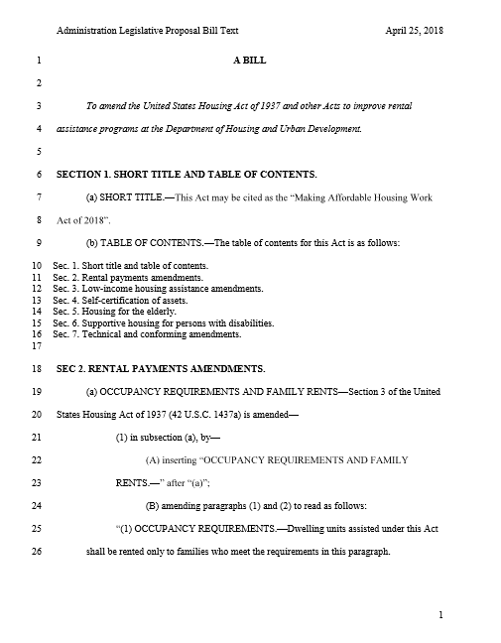

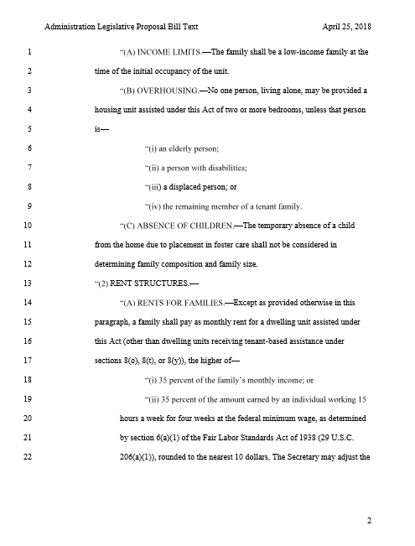

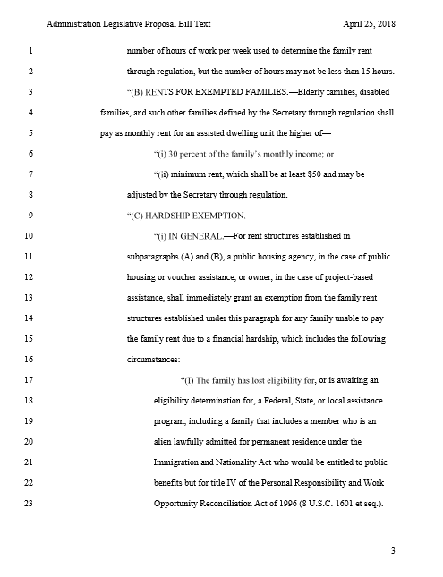

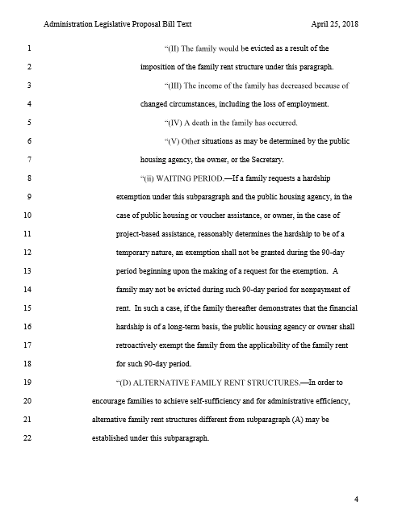

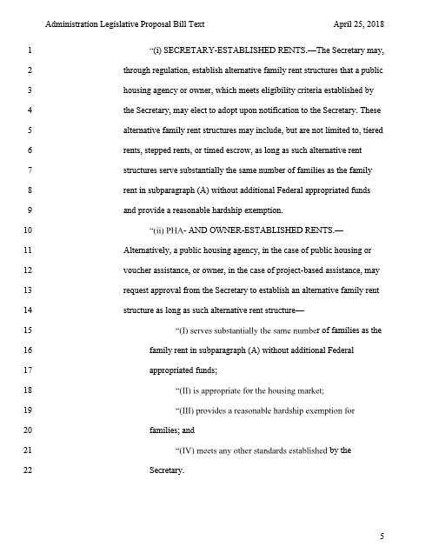

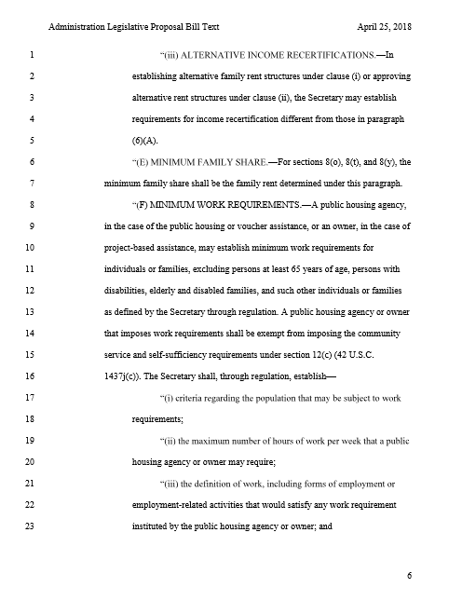

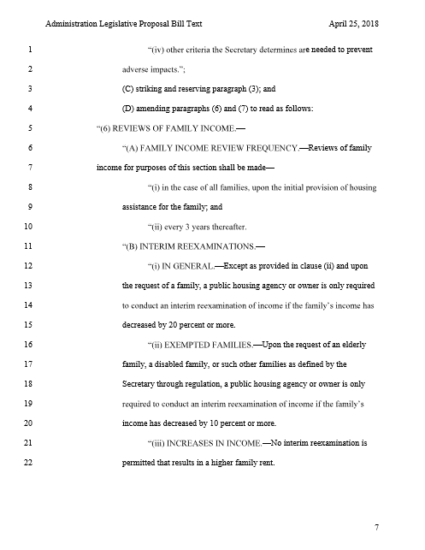

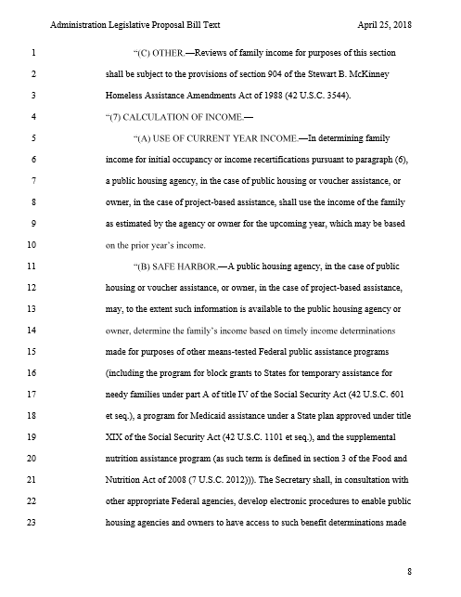

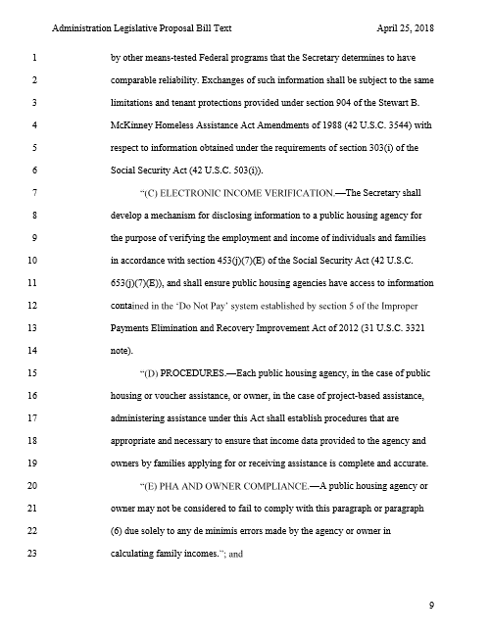

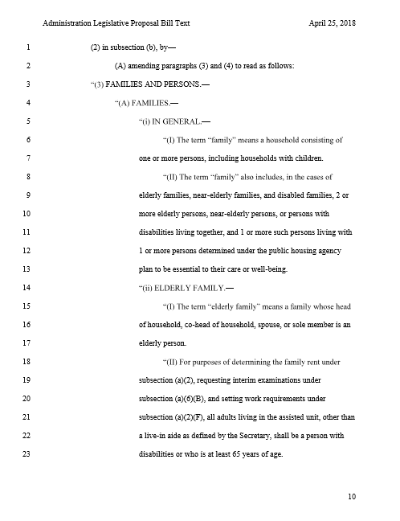

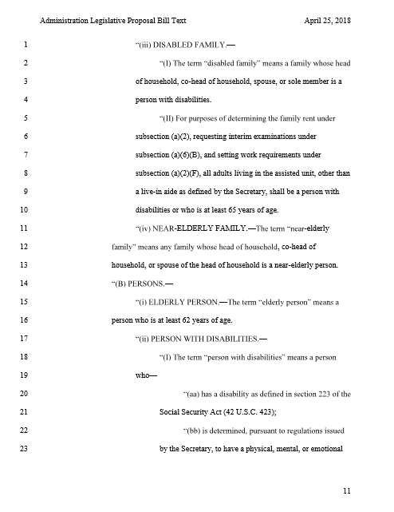

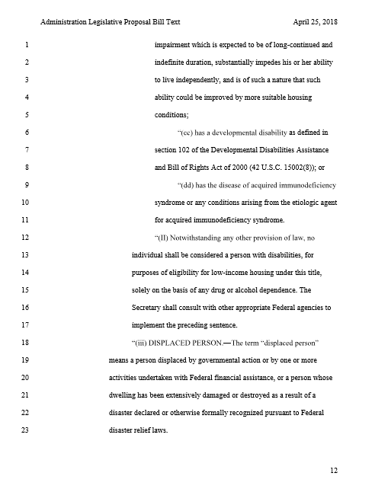

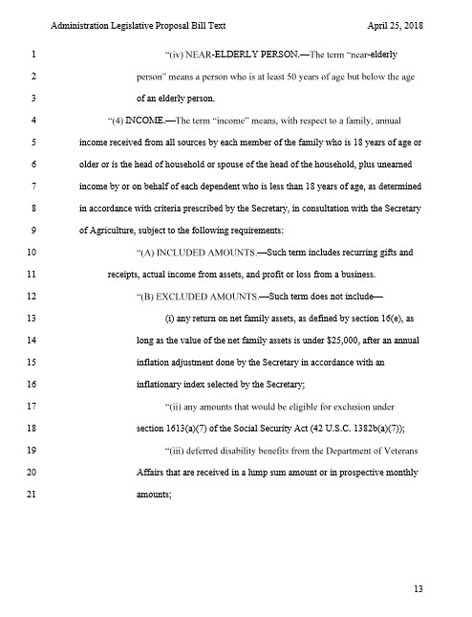

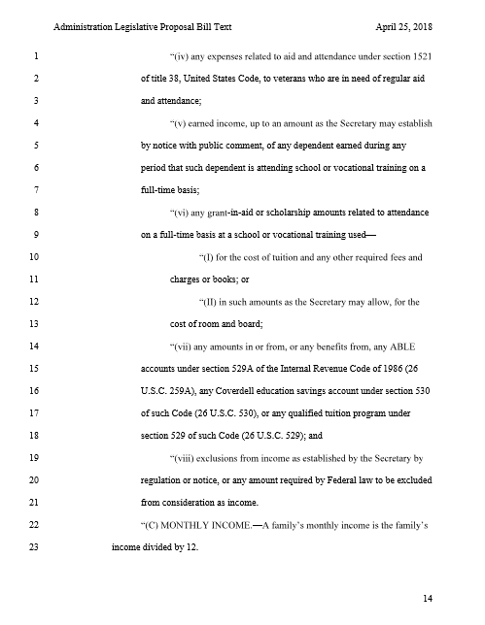

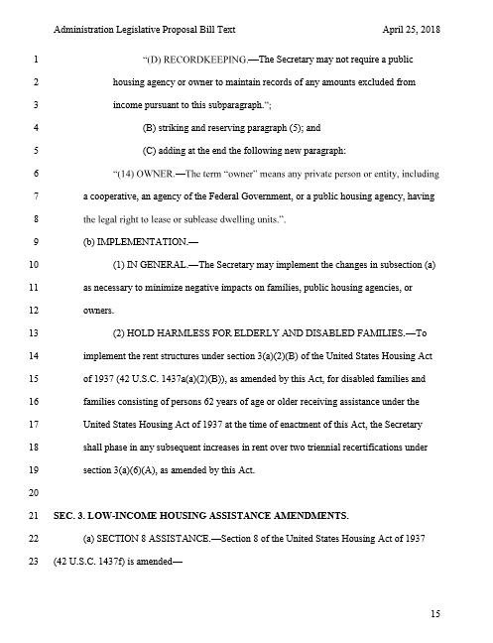

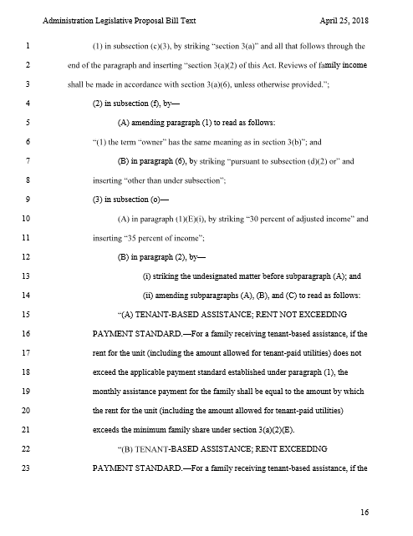

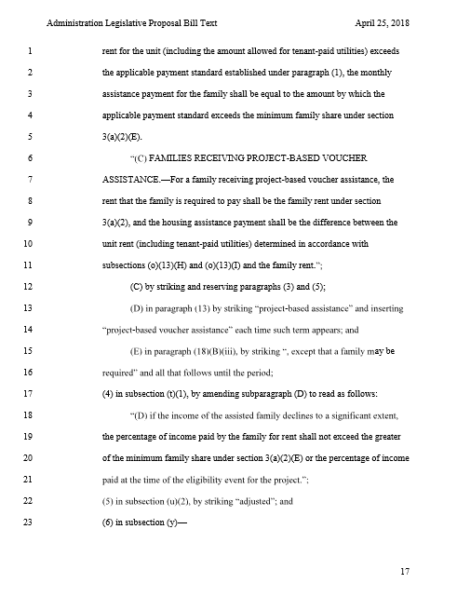

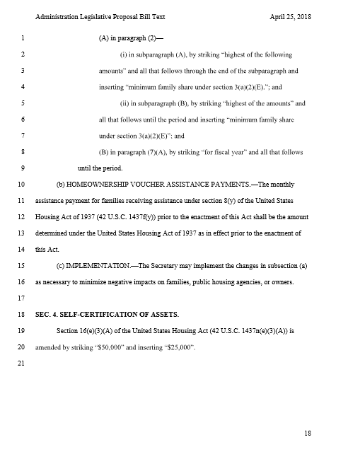

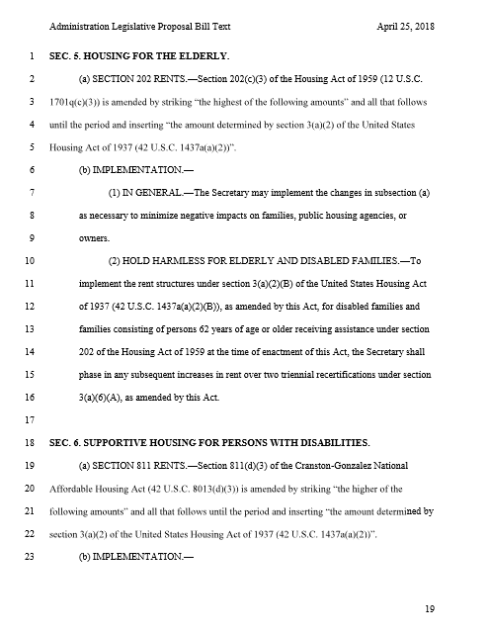

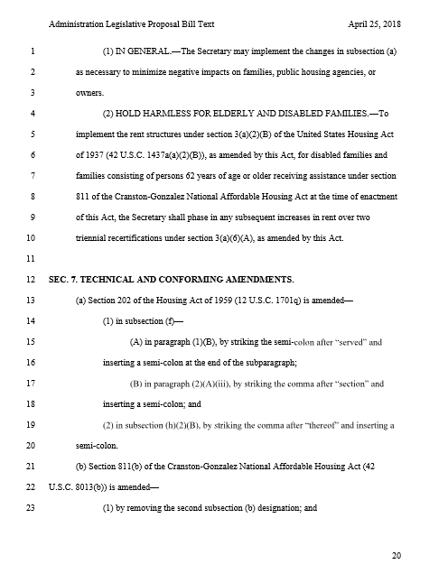

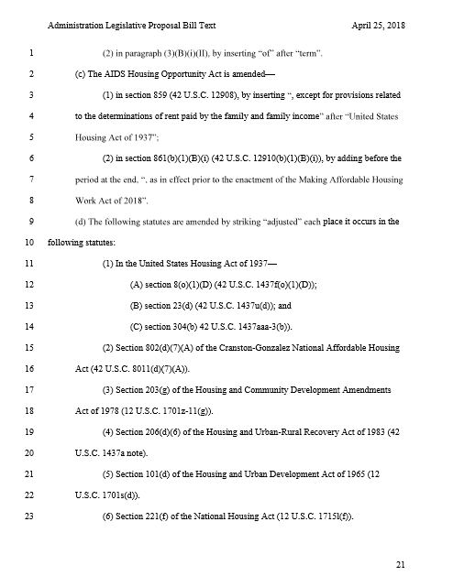

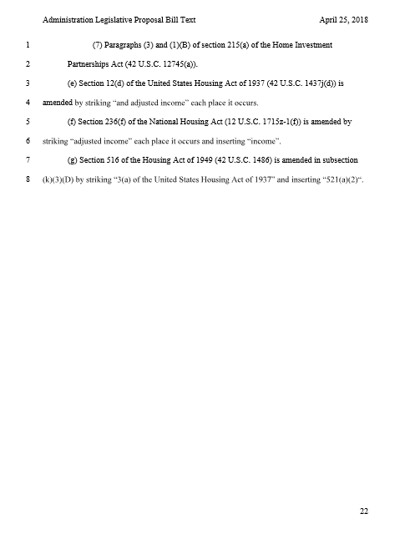

bibliography
[1] “About the Housing Choice Voucher Program” Philadelphia Housing Authority. http://www.pha.phila.gov/housing/housing-choice-voucher.aspx
[2] “Affordable Housing” U.S. Department of Housing and Urban Development. December 2018. https://www.hud.gov/program_offices/comm_planning/affordablehousing/
[3] Braveman P, Cubbin C, Egerter S, Pedregon V. “Neighborhoods and Health” Robert Wood Johnson Foundation. May 2011. https://www.rwjf.org/en/library/research/2011/05/neighborhoods-and-health-.html
[4] Braveman P, Dekker M, Egerter S, Sadegh-Nobari T, Pollack C. “How Does Housing Affect Health?” Robert Wood Johnson Foundation. May 2011. https://www.rwjf.org/en/library/research/2011/05/housing-and-health.html
[5] Callow A. “Six Reasons Work Requirements Are a Bad Idea for Medicaid”. Families USA. February 2018. https://familiesusa.org/blog/2018/02/six-reasons-work-requirements-are-bad-idea-medicaid
[6] Capps K. “Why HUD Wants to Raise the Rent” City Lab. April 2018. https://www.citylab.com/equity/2018/04/hud-ben-carson-work-requirements-rent-hikes/558920/
[7] “Changes in the HUD Definition of Homeless” National Alliance to End Homelessness. January 2012. http://endhomelessness.org/wp-content/uploads/2012/01/changes-in-hud-definition-homeless.pdf
[8] “Cranston-Gonzalez National Affordable Housing Act. Title 42” Cornell Legal Information Institute. Section §12703. 1990. https://www.law.cornell.edu/uscode/text/42/12703
[9] Daniel D. “Affordable Housing Federal Programs and Legislation”. National Association of Counties. May 2018. https://www.naco.org/articles/affordable-housing-federal-programs-and-legislation
[10] “Exposing Housing Discrimination” Urban Institute. February 2013. https://www.urban.org/features/exposing-housing-discrimination
[11] “Federal Housing Budget” Housing Alliance of Pennsylvania. June 2017. http://fe0.6e7.myftpupload.com/issues/federal-housing-budget/
[12] Figueroa N. “A Devoted Mother Gets a Helping Hand” Pennsylvania Housing Finance Agency.
[13] Forslund, T. “The SHARE Plan: Wyoming’s Strategy for Health, Access, Responsibility, and Employment” Wyoming Department of Health. November 2014. https://health.wyo.gov/wp-content/uploads/2016/04/16454_SHAREPlan.pdf
[14] “Goal 11: Make Cities Inclusive, Safe, Resilient and Sustainable” United Nations Development Programme. January 2016. https://www.undp.org/content/undp/en/home/sustainable-development-goals/goal-11-sustainable-cities-and-communities.html
[15] “Goals of Affordable Housing Programs” New York University Directory of NYC Housing Programs. 2005. http://furmancenter.org/coredata/directory/goals-of-affordable-housing
[16] Hollar M. “Low-Income Housing Tax Credits” U.S. Department of Housing and Urban Development. June 2018. https://www.huduser.gov/portal/datasets/lihtc.html
[17] “HOME Investment Partnerships Program” HUD Exchange. July 2013. https://www.hudexchange.info/programs/home/
[18] “Homelessness” Housing Alliance of Pennsylvania. March 2019. https://housingalliancepa.org/issues/homelessness/
[19] “Homelessness in PA – Homeless Information” Pennsylvania Department of Community and Economic Development. https://dced.pa.gov/housing-and-development/community-services/homelessness-in-pa/
[20] “Housing Programs” Bethlehem Haven. https://bethlehemhaven.org/housing-programs/
[21] “HUD’s Public Housing Program” U.S. Department of Housing and Urban Development. https://www.hud.gov/topics/rental_assistance/phprog
[22] Leighton K. “How Much Do Renters Need to Earn to Live in Pennsylvania?” Pennsylvania Association of Realtors. January 2016. https://www.parealtor.org/justlisted/much-renters-need-earn-live-pennsylvania/
[23] “Making Affordable Housing Work Act of 2018” U.S. Department of Housing and Urban Development. April 2018. https://www.hud.gov/sites/dfiles/Main/documents/RentReformLegislativeText.pdf
[24] “Making Affordable Housing Work Act of 2018: HUD’s Proposed Rent Reforms and Work Requirements” National Affordable Housing Management Association. May 2018. https://www.nahma.org/wp-content/uploads/2014/06/HUDs-Rent-Reform-Proposal.pdf
[25] Mehdipanah R, Ramirez J, Abedin S, Brown S. “Housing Discrimination and Health: Understanding Potential Linking Pathways Using a Mixed-Methods Approach” Journal of Social Sciences. September 2018.
[26] “National and State Housing Fact Sheets & Data” Center on Budget and Policy Priorities. March 2019. https://www.cbpp.org/research/housing/national-and-state-housing-fact-sheets-data
[27] Pelletiere D, Canizio M, Hargrave M, Crowley S. “A Brief Historical Overview of Affordable Rental Housing” National Low Income Housing Coalition. October 2015. https://nlihc.org/sites/default/files/Sec1.03_Historical-Overview_2015.pdf
[28] “Pennsylvania’s Section 8 Housing Program” Eligibility. February 2019. https://eligibility.com/section-8/pennsylvania-pa-section-8-benefits
[29] “Rental Assistance Demonstration (RAD)” U.S. Department of Housing and Urban Development. December 2018. https://www.hud.gov/RAD
[30] “Requirements in Medicaid: How We Got Here” Med Page Today. April 2018. https://www.medpagetoday.com/publichealthpolicy/medicaid/72296
[31] “Rural Housing” Housing Alliance of Pennsylvania. March 2017. http://fe0.6e7.myftpupload.com/issues/rural-housing/
[32] Sacks V, Balding S. “The United States Can and Should Eliminate Childhood Lead Exposure” Child Trends. February 2018. https://www.childtrends.org/publications/united-states-can-eliminate-childhood-lead-exposure
[33] Satchell D. “An Affordable Apartment Turns Hardship into Happiness” Pennsylvania Housing Finance Agency.
[34] “State Law Prohibits Discrimination in Housing” California Department of Fair Employment and Housing. https://www.dfeh.ca.gov/housing/
[35] “State of Homelessness – Pennsylvania” National Alliance to End Homelessness. December 2018. https://endhomelessness.org/homelessness-in-america/homelessness-statistics/state-of-homelessness-report/
[36] “Sustainable Development Goals” United Nations Development Programme. January 2016. https://www.undp.org/content/undp/en/home/sustainable-development-goals.html

