INTERIOR WAYFINDING AT UPMC PASSAVANT HOSPITAL: A SURVEY OF PATIENT AND EMPLOYEE OPINION AND RECOMMENDATIONS UTILIZING BEST PRACTICES

by
Melissa Lynn Kus
BS, BBA, Kent State University, 2017, 2017

Submitted to the Graduate Faculty of
Health Policy and Management
Graduate School of Public Health in partial fulfillment
of the requirements for the degree of
Master of Health Administration

University of Pittsburgh
2019

UNIVERSITY OF PITTSBURGH
GRADUATE SCHOOL OF PUBLIC HEALTH

This essay is submitted
by
Melissa Kus

on

April 10, 2019
and approved by
Essay Advisor:
Kevin Broom, PhD, MBA
Associate Professor, Director of MHA and MHA/MBA Programs, Vice Chair for Education
Health Policy and Management
Graduate School of Public Health
University of Pittsburgh

Essay Reader:
Martha Ann Terry, PhD
Associate Professor
Behavioral and Community Health Sciences
Graduate School of Public Health
University of Pittsburgh

Essay Reader:
Keith Lorenz, MHA
Senior Director, Ancillary Services
UPMC
Pittsburgh, Pennsylvania

Copyright © by Melissa Kus
2019
ABSTRACT
Kevin Broom, PhD, MBA

INTERIOR WAYFINDING AT UPMC PASSAVANT HOSPITAL: A SURVEY OF PATIENT AND EMPLOYEE OPINION AND RECOMMENDATIONS UTILIZING BEST PRACTICES

Melissa Kus, MHA
University of Pittsburgh, 2019

The purpose of this study was to determine patients’ and employees’ perception of wayfinding at UPMC Passavant and provide subsequent recommendations for the signage in the hospital. The public health significance of this study surrounds the patient experience. A patient that gets lost in a hospital can associate the negative experience with their overall experience at the facility. If they are unable to find their way to their destination, any existing anxiety they have can be compounded. In addition, if the operating room is running late because a scheduled patient could not find their way, hundreds of dollars per minute can be wasted, which feeds into already high healthcare costs. Because of this, studying wayfinding at UPMC Passavant is key.
Data were collected through two separate surveys for employees and patients. The patient surveys were distributed and collected at the outpatient check-in areas for UPMC Passavant’s imaging services, diagnostic interventional radiology, medical building lab, outpatient lab, and the Heart & Vascular Institute. The employee surveys were distributed through internal email using Qualtrics software. The surveys were distributed and collected over the course of five business days.
The patient survey had a response rate of 14.91% and the employee survey had a response rate of 24.85%. The major finding of this study was that both employees and patients found the wayfinding at UPMC Passavant acceptable. Of employees surveyed, 64.56% found the signage acceptable, 29.57% found it poor, and 5.87% found it excellent. Of patients surveyed, 55.38% found the signage acceptable, 39.81% found it excellent, and 4.81% found it poor. This shows that employees have a more negative opinion of the signage than patients.
While patients’ perception of the signage is more positive than expected, there is still room to address issues surrounding the signage at UPMC Passavant. Simple changes based on best practice such as appropriate sign placement, making the signs patient-centered, and alphabetizing can enhance the quality of the signage. Next steps include collecting qualitative feedback on patients’ and employees’ signage preferences. Doing so will help UPMC Passavant improve the current state of wayfinding and make appropriate changes while considering patients’ feedback.

TABLE OF CONTENTS
preface x
Definitions of Technical Terms and Acronyms xi
1.0 Introduction 1
1.1 UPMC PassavanUPt 2
1.2 Relevant health Care problem 3
1.3 rationale for Exploring wayfinding 4
1.4 The UPMc Experience 4
1.5 Objectives 5
2.0 Literature Review 7
2.1 Wayfinding and Health Outcomes 7
2.2 Wayfinding Best Practices 7
2.2.1 Signage 8
3.0 methods 10
3.1 Hypothesis/Expected Outcomes 10
3.2 Survey of Patients at UPMC Passavant 11
3.2.1 Rationale for Patient Survey 12
3.3 Survey of Employees at UPMC Passavant 13
3.3.1 Rationale for Employee Survey 16
4.0 FIndings And results 17
4.1 Results of Patient Survey 17
4.2 Results of Employee Survey 20
5.0 Discussion 23
5.1 congruence between major findings and hypotheses 25
6.0 conclusions, Limitations, recommendations, and public health implications 27
6.1 conclusions based on analysis 27
6.2 recommendations for UPMC Passavant 28
6.2.1 Signage Design 28
6.2.2 Sign Placement 29
6.2.3 What to Include 30
6.3 Study limitations 31
6.4 opportunities for further research 32
6.5 public health relevance 33
Appendix A SURVEY USED TO COLLECT PATIENT OPINION OF WAYFINDING AT UPMC PASSAVANT 35
Appendix B SURVEY USED TO COLLECT EMPLOYEE OPINION ON WAYFINDING AT UPMC PASSAVANT 37
bibliography 39
List of tables
Table 1 Breakdown of Response to Patient Survey by Age Range 18
List of figures
Figure 1 Survey Distributed to Patients of UPMC Passavant 12
Figure 2 Survey Distributed to Employees of UPMC Passavant 14
Figure 3 Employee Survey Questions as Viewed on a Cellular Phone 15
Figure 4 Patient's Reported Parking Lot 19
Figure 5 Patient Opinion of UPMC Passavant’s Signage to Navigate the First Floor 19
Figure 6 Graph of Employee Perception of Internal Wayfinding on UPMC Passavant First Floor 20
Figure 7 Pie Chart of Where Employees Most Often Encounter Lost Patients 21
Figure 8 Destination Employees Identify as Most Frequent Lost Patient Destination 22
Figure 9 Opinion of UPMC Passavant’s Wayfinding Based on Whether the Patient Previously Visited the Office 25
preface
First and foremost, thank you to my mom and dad for your endless support in helping me achieve my goals. I owe everything to you and love you both dearly. Thank you also to Dr. Terry for being a reader for my essay, but more importantly your passion for public health. It was a pleasure getting to learn from you. Dr. Broom, thank you for your guidance throughout my time in the MHA program and for dedicating so much to my essay. Thank you to Keith Lorenz for every challenge and opportunity you presented me with. You have helped me grow professionally more than I could have hoped for in the course of a year. Finally, thank you to everyone I have worked with at UPMC Passavant for guiding and teaching me throughout this journey.
Definitions of Technical Terms and Acronyms
DIR: Diagnostic Interventional Radiology
HVI: Heart & Vascular Institute
UPMC: University of Pittsburgh Medical Center
UPMC Experience: UPMC’s movement to radically change the patient and employee experience via accountability, kindness, and positivity in partnership with the Studer Group.
Wayfinding:
S/T Buildings: The two medical buildings at UPMC Passavant
Studer Group: Consulting group that focuses on healthcare coaching and culture transformation

1.0 Introduction
The term “wayfinding” was first coined by Kevin A. Lynch in his 1960 book, The Image of the City. In this book, Lynch defines wayfinding as “a consistent use and organization of definite sensory cues from the external environment” (1960, p. 3). The concept of wayfinding was expanded in 1992 when graphic designer Paul Arthur and environmental psychologist Romedi Passini published the book, Wayfinding: People, Signs and Architecture. This book serves as a wayfinding guide of descriptions, illustrations, and lists in the context of how people use signs and other cues to find their way in different environments (Arthur & Passini,1992). However, little research has been conducted on wayfinding and it is not a concept with which everyone. Today, Oxford Dictionaries defines wayfinding as “the process or activity of ascertaining one’s position and planning and following a route” (Oxford Dictionaries, 2019). Simply put, wayfinding is how people decide which direction to go to reach their destination.
Every person encounters aspects of wayfinding on a daily basis. However, so many are unfamiliar with the concept they so regularly interact with. Wayfinding is experienced through driving and reading traffic signs, making one’s way through a shopping mall, and travelling through a new city. One place that wayfinding is particularly important is hospitals. Unlike the stroll one may take when touring a museum, navigating through a hospital often anticipates frightful situations and leads to feelings of tension and anxiety. When hospitals have gone through multiple renovations, the problem is only exacerbated. One such hospital is University of Pittsburgh Medical Center Passavant (UPMC Passavant). Because of this, a study on the current state of wayfinding and subsequent recommendations for best practices was designed for UPMC Passavant.

UPMC PassavanUPt
UPMC Passavant is a community hospital located in McCandless, Pennsylvania, a suburb about 20 minutes north of Pittsburgh, Pennsylvania. UPMC Passavant originated in the North Side of Pittsburgh in 1894 and moved to its McCandless location in February 1964. UPMC Passavant is Magnet recognized and has 437 licensed beds and 21 operating rooms. The hospital sees about 22,500 admissions and 17,000 procedures annually. The emergency department has 62,000 annual visits. UPMC Passavant uses a professional practice model that exemplifies the priorities of the hospital. One of the key components of the model is patient- and family-centered care, showing that the patient experience is of utmost importance to the organization.
UPMC Passavant has over 2,000 employees, many of which are members of the surrounding community. The hospital provides over $22 million dollars in community benefit contributions, over $10 million in free and reduced care, and over $6 million in community health and education annually. UPMC Passavant also has a supporting foundation, the UPMC Passavant Hospital Foundation. In 2018, the foundation funded 22 grant projects valued at $341,000 and hospital first impressions valued at $12 million.
Key services at UPMC Passavant include the UPMC Heart & Vascular Institute, UPMC Hillman Cancer Center at UPMC Passavant, UPMC Magee-Womens Hospital Specialty Services at UPMC Passavant, and UPMC Passavant GI and Colon Center. The study described in this paper focuses on the first floor of UPMC Passavant. The services found on the first floor include pathology laboratory testing, emergency medicine, the sleep center, radiology/imaging services, heart and vascular, diagnostic and interventional radiology, and respiratory.

Relevant health Care problem
The layout of a hospital can be compared to a maze, particularly when the hospital has had structural additions and renovations over the years. Because of this, patients can face great difficultly in attempting to navigate to an appointment or clinic. When a patient is feeling stress and anxiety about a procedure or appointment they have, getting lost on the way only exacerbates that anxiety. Not only should employees of the hospital be willing to offer their help in navigating a lost patient, but the signage throughout the hospital should be sufficient in directing patients on their own.
The experiences a patient has with wayfinding can greatly impact the patient experience. A patient struggling to make their way to their destination can supersede the rest of their experience during their visit. Hospitals that have been around for many years often go through departmental moves and building additions. This makes the wayfinding experience all the more challenging. UPMC Passavant has had several additions through the years that make navigation through the halls less straightforward. The main tower and S Medical Building were built in 1968. The North Pavilion and Support Services Building were built in 1992, and the South Pavilion in 2012. These additions, alongside departments being shifted around throughout the years, can cause disjointed signage and flow.

rationale for Exploring wayfinding
Hospital wayfinding can have a negative impact on patient experience. Patients who have lost their way can frequently be found roaming the halls of UPMC Passavant. Employees often share anecdotal stories about the patients they find lost. Not only is it a stress-provoking inconvenience for all patients, it increases challenges for the elderly and disabled. Sometimes the individual lost in the hall has a difficult time walking and can become very frustrated when they are escorted a great distance because they went the wrong way. UPMC Passavant wants to make the wayfinding better to positively affect patient experience. Wayfinding is also directly related to an initiative called “The UPMC Experience.”

The UPMc Experience
UPMC is implementing Studer Group initiatives branded as the UPMC Experience. One prong of this initiative is the four “key behaviors” that are expected of all employees. These include the 10:5 Rule, which notes that if an employee is within ten feet of another person, the employee should smile and if the employee is within five feet, they should greet the other person. The second of the key behaviors is to start every meeting with a win. This means that before diving into the contents of the meeting that often focus on problems facing the organization, the team begins the meeting by sharing some of the positive things that are happening in their department. The third key behavior is to treat the hospital like home. This means that it is every employee’s responsibility to pick up stray trash in the hallway and keep their own areas neat and clean. The fourth rule, the focus for this paper, is that employees are to help individuals who are lost in the hospital by taking them where they need to go.

Objectives
The objective of this essay is to provide baseline data about patient and employee perceptions of the internal wayfinding experience at UPMC Passavant, and will reference best practices to provide pointed recommendations for the signage at UPMC Passavant. The project and essay also serve to improve the signage and show patients that the hospital is actively working to fix the problem. While changing the physical signs on the walls can take a while to be implemented, gathering the opinions of patients can happen immediately. The patients then see that the problem is actively being addressed and also see that their opinion is valuable to UPMC Passavant.
Not only does the essay aim to provide recommendations to positively affect the patient experience, but also improve the employee experience. Employees currently have to do extra work in order to navigate patients to their destinations. Allowing patients to become more self-sufficient in their navigation allows for employees to be more efficient with their time. Similar to patients being encouraged that action is being taken, employees will be encouraged by the action steps as well. Many employees of UPMC Passavant have been with the hospital for many years and have long since recognized the signage problem. The signage project at UPMC Passavant sat for about three years before being renewed this past summer. Because the project was dormant for so long, employees of UPMC Passavant will likely be excited to see a positive change and appreciate the steps being taken to make progress.
The essay focuses on the first floor of UPMC Passavant because the current project is focused there and the needs are the greatest. The patient starts their navigation experience on the first floor. If the experience starts out poorly, it is unlikely to get progressively better when navigating throughout the rest of the hospital. Because helping guide people and providing directions are focuses of the UPMC Experience, it is the opportune time for UPMC Passavant to address their signage challenges.

Literature Review

Wayfinding and Health Outcomes
A 2009 study, The Impacts of the Built Environment on Health Outcomes (Codinhoto, May, Tzortzopoulos, Kagioglou, Aouad, & Cooper), was conducted to better understand and identify which characteristics of the built environment affect patients’ health outcomes. The study proposed a framework to categorize characteristics of the built environment and relate them to health. The four categories of the built environment in the framework are ergonomics, materials and ambience, art and aesthetics, and services. The health outcomes were grouped together under three levels: psychological, physical, and physiological. The study found that at each of the levels, a number of variables impact health independently or alongside other variables. The study also points out that several environmental characteristics can affect one health outcome and one environmental characteristic can affect several health outcomes. Essentially, there are many interworking relationships between health and the built environment at various levels.

Wayfinding Best Practices
A 2011 study, Color and Wayfinding: A Research in a Hospital Environment (Rangel & Mont' Alvao), discusses the importance of color choice when making signage decisions in a healthcare setting. The study discussed that users affirm positive and negative sensations when in a hospital environment. The study found that subjects preferred soft colors and low saturation for hospital environments.
Wayfinding in Hospital: A Case Study (Martins, & de Melo, 2014), a case study from Brazil, points out that in order to have effective wayfinding the system cannot solely rely on graphics. An effective system takes into account all aspects of a route to guide someone to their destination. The articles states that effective wayfinding not only promotes the physical and mental health of users, but also the financial health of the institution because staff are wasting time guiding patients instead of performing their job tasks.
Heylighen and Pintelon (2016) developed and tested a wayfinding questionnaire that could be edited for use across different hospitals. Through the questionnaire they developed, the authors found that patients disliked having to follow a color path without understanding the significance of the color, and when different colors used were too similar. The study also showed that many users found the signs at their destination unclear and they had to ask staff if they had arrived. The development of the questionnaire provides a solid starting point for a wayfinding team and also provides an end goal to work toward. The questionnaire was also found to uncover concerns that the wayfinding team would not have identified otherwise.

Signage
Improving and Analyzing Signage Within a Healthcare Setting (Rousek & Hallbeck, 2011) analyzed a variety of standardized healthcare pictograms and their color contrasts. The study found that the types of color contrasts, complexities, and inclusion of human forms can help or hinder signage. The study states that the complexity of the signage needs to be limited to prevent excessive amounts of cognitive processing. In contrast, if the signage is too broad or abstract, the user could interpret multiple meanings from one sign. The study found that the use of human-like figures should be considered during signage design because it can help with user comprehension levels. This study also found that color contrast can improve comprehension. The authors also stress standardization in order to speed the cognitive thought process when detecting signage.

methods
The purpose of the study conducted was to provide baseline data on the perceptions of both employees and patients of the signage at UPMC Passavant. The baseline data are then used to make site-specific recommendations for the current signage improvement project at UPMC Passavant. The study design was to utilize two different surveys. One was directed to patients and the other to UPMC Passavant employees. Two separate surveys were conducted to effectively reach two populations affected by the signage situation at UPMC Passavant.

Hypothesis/Expected Outcomes
The expected outcome for both the patient and employee surveys was that perception of the existing signage is poor. It was hypothesized that patients are most frequently found by employees in the S/T buildings. This is based on anecdotal and observed evidence throughout the hospital. It was also hypothesized that employees will report that they usually take people where they need to go. This is based on the expectation that has been set forth by UPMC Passavant leadership to do so.

Survey of Patients at UPMC Passavant
The patient survey was developed by Melissa Kus and conducted on paper. The surveys were distributed by Kus to the staff at imaging registration, the main information desk, outpatient lab, medical building lab, diagnostic and interventional radiology, and the Heart & Vascular Institute. Surveys were distributed by staff to the patients from Monday, March 18, 2019, through Friday, March 22, 2019. The surveys were distributed during normal business hours of each department. This prevents bias in the survey because all the populations that visit each department have the opportunity to be captured. The surveys were distributed to each patient who visited the desk in each respective area with the expectation that some patients would not return them. Employees were given a short script to explain the survey. The patients were then given a survey asking them six questions. Figure 1 shows the survey distributed to patients on half sheets of paper. Patients were instructed to return the survey to where they originally picked it up at the conclusion of their visit. The employees then stored the surveys in a folder until they were picked up by Kus at the end of the week.

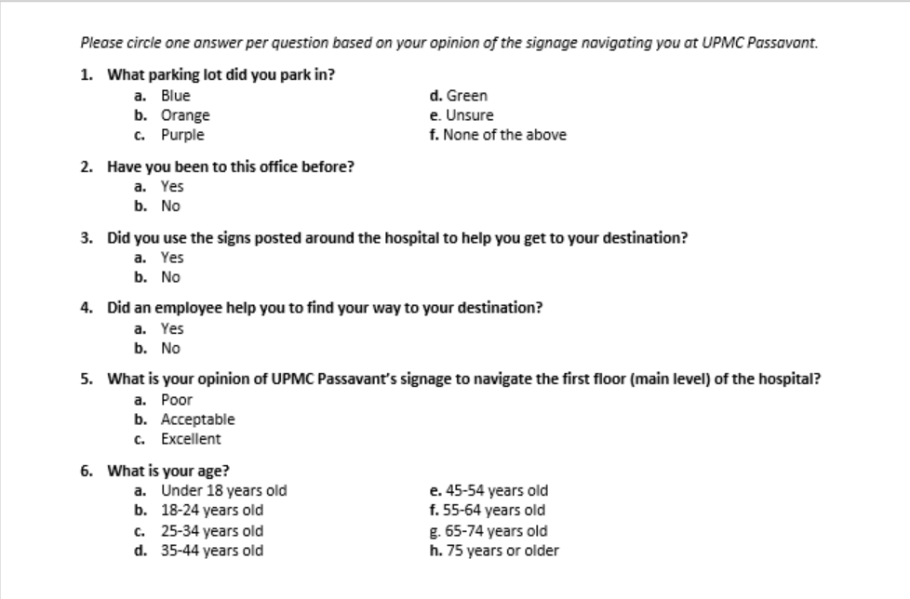

Figure 1 Survey Distributed to Patients of UPMC Passavant

Rationale for Patient Survey
The goal of the patient survey was to collect information on patients’ opinions of the signage at UPMC Passavant and also to show that the hospital is addressing the issue of signage. The survey was purposely kept short and simple so that it was easy for all populations to understand. The survey asks where the patient started their wayfinding experience, whether they had visited their destination before, and whether they actually utilized the signs. The survey then seeks to determine whether an employee helped them, which aligns with the UPMC Experience and their overall opinion of the signage. The survey collects one piece of demographic data, age, because there could be a potential correlation between age and opinion of signage.

Survey of Employees at UPMC Passavant
The employee survey was developed by Kus and conducted online using Qualtrics survey software. The survey was distributed through UPMC’s internal email to all employees of UPMC Passavant. The email contained a link that took employees to the Qualtrics survey. The survey was distributed during the same time frame as the patient survey. It was sent using a listserv of all UPMC Passavant users, so it was sent to all employees at the same time. The survey was sent to all employees who are employed under UPMC Passavant’s business unit. This means that employees of other business units that also work in the building, such as human resources who falls under corporate services, were not included. Figure 2 shows the survey as it appeared to employees when viewing in a web browser, and Figure 3 shows an example of a question as it would appear to employees on a cellular phone. The first question determines the employee’s overall perception of UPMC Passavant’s wayfinding. The second question captures how many times per week the employee encounters a lost patient and the third question captures how often the employee takes these lost patients where they need to go. The fourth question determines where employees most often encounter lost patients and the final question determines where the patients that employees find lost are most often trying to go.

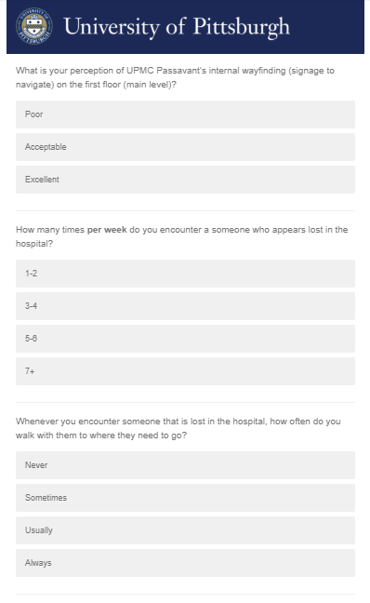
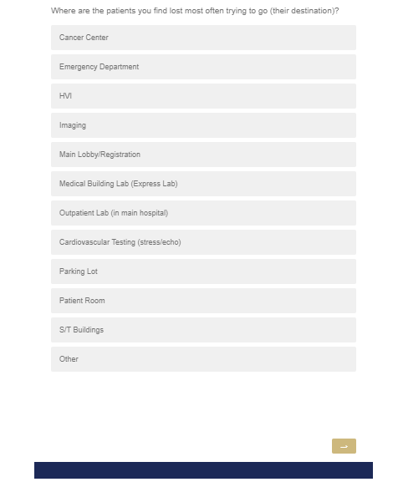
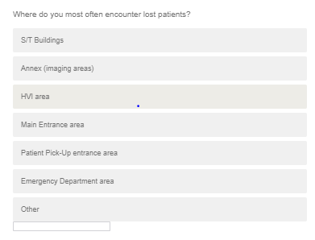

Figure 2 Survey Distributed to Employees of UPMC Passavant
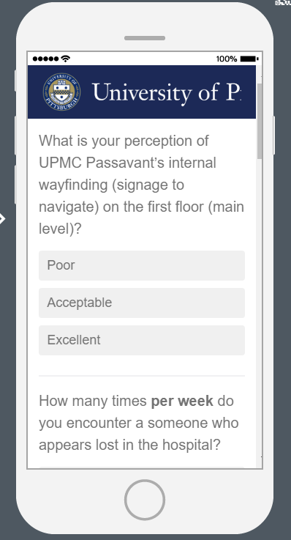
Figure 3 Employee Survey Questions as Viewed on a Cellular Phone

Rationale for Employee Survey
The employee survey was distributed to collect employees’ opinions on the signage at UPMC Passavant. Their perspective is important because they are in the hospital every day and have first-hand experiences of finding individuals struggling to navigate throughout the hospital. It is timely because hospital leadership explicitly expects that employees help lost patients navigate where they need to go in accordance with the UPMC Experience. The employees also provide insight because the perception of the signage could vary based on what part of the hospital the employee works in.
The survey was kept short to increase likelihood of employees responding. Many surveys are distributed throughout UPMC Passavant so survey fatigue is always a possibility. The survey was distributed through an email that linked employees to the survey on Qualtrics. Employees had the ability to take the survey either on a computer or mobile device. Every employee of UPMC Passavant has an email, so no one who falls under the UPMC Passavant business unit would be excluded from the survey.

FIndings And results

Results of Patient Survey
Five hundred twenty-four responses were collected for the survey of patients’ perception on the signage at UPMC Passavant. The overall response rate for the patient survey was 14.91%. The surveys were collected at six different locations: the outpatient lab, medical building lab, DIR, HVI, information desk, and imaging registration. The response rates for the outpatient lab, medical building lab, DIR, HVI, information desk, and imaging registration were 2.07%, 24.86%, 64.41%, 34.54%, 34.49% and 6.99%, respectively. The most surveys were collected at the main information desk, followed by imaging registration and then HVI. The only piece of demographic data collected was the patient’s age range. More than half (55.47%) of the responses came from individuals 55 years or older. No responses were collected from individuals under 18 years old. Table 1 shows the complete breakdown of patient responses by age.

Table 1 Breakdown of Response to Patient Survey by Age Range
Age Range | Count of Reponses | % of Total Responses
< 18 years old | 0 | 0.00%
18-24 years old | 6 | 1.15%
25-34 years old | 17 | 3.26 %
35-44 years old | 39 | 7.49%
45-54 years old | 59 | 11.32%
55-64 years old | 111 | 21.31%
65-74 years old | 160 | 30.71%
75 + | 129 | 24.76%

The parking location used most frequently by patient respondents was the Purple Lot. 25.83% of patient respondents were unsure what lot they parked in. Figure 4 shows patient respondents’ reported parking lots. Of the patients who responded, 82.82% had previously been to the office they were visiting. Sixty-six percent of patients indicated that they did use the signage to help them navigate to their destination and 35.63% received help from an employee. Figure 5 shows patient perception of the signage at UPMC Passavant. Fifty-five percent of patient respondents indicated that the signage is acceptable. Forty percent of patient respondents indicated that they found the signage to be excellent and only 4.82% found it to be poor.

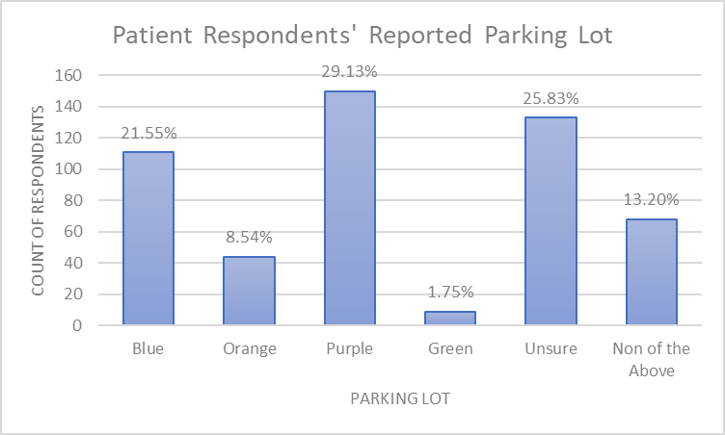

Figure 4 Patient's Reported Parking Lot

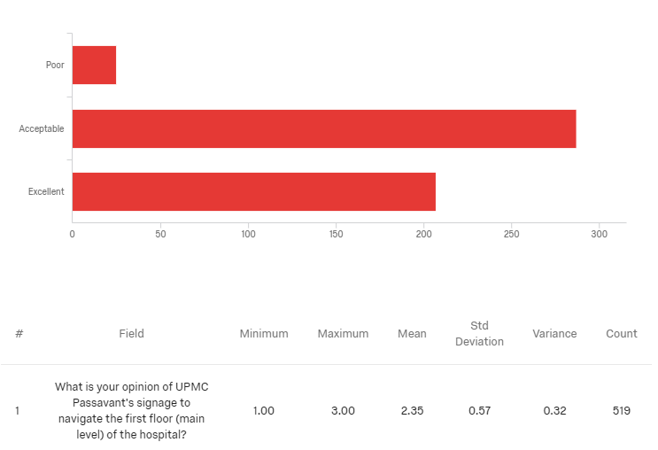

Figure 5 Patient Opinion of UPMC Passavant’s Signage to Navigate the First Floor

Results of Employee Survey
There were 455 responses collected for the survey of employees’ perception of wayfinding at UPMC Passavant. The employee response rate was 24.85%. Figure 6 shows a graph of the results of employee perception of UPMC Passavant’s internal wayfinding on the first floor. The majority (64.56%) of respondents said that their perception of UPMC Passavant’s internal wayfinding on the first floor was acceptable while 29.57% said their perception was poor. Only 5.87% of respondents said their perception of internal wayfinding on UPMC Passavant’s first floor was excellent.
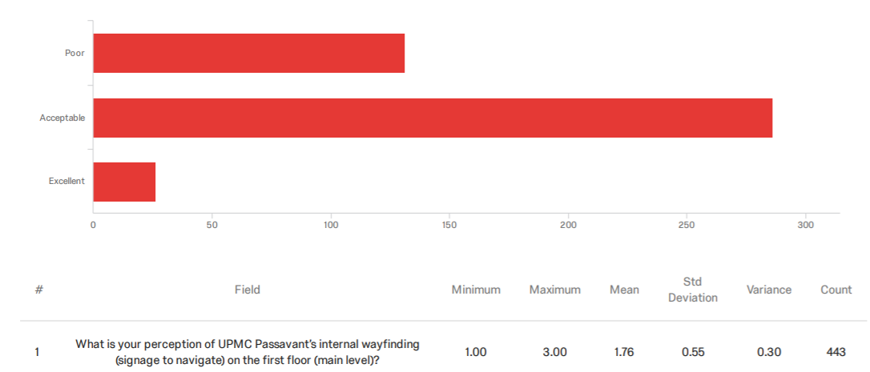

Figure 6 Graph of Employee Perception of Internal Wayfinding on UPMC Passavant First Floor

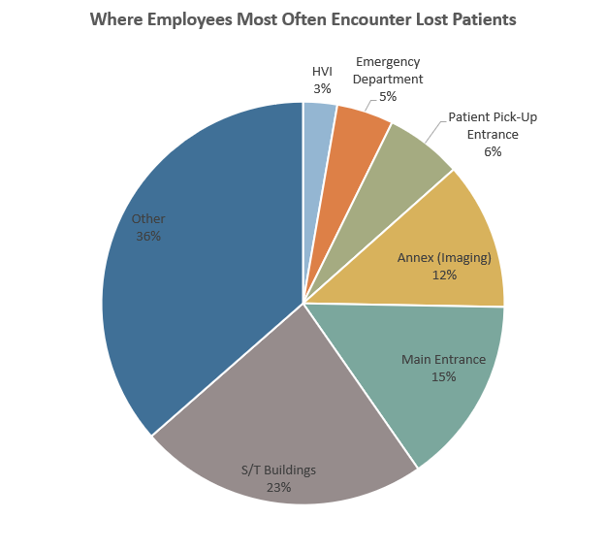
Of employees surveyed, 34.53% reported most often finding patients lost in the hospital one to two times per week. Thirty percent of respondents reported finding individuals lost three to four times per week. Of the employees who responded, 86.89% said that they usually or always help patients navigate where they need to go. The fourth question asked employees where they most often find lost patients. Figure 7 shows a pie chart of those locations. The options given were the S/T buildings, annex (imaging areas), Heart and Vascular Institute area, main entrance area, patient pick-up entrance area, emergency department area, and other with the option to type an answer. The majority, 36.45%, of respondents chose “other,” and 23.23% chose the S/T buildings.

Figure 7 Pie Chart of Where Employees Most Often Encounter Lost Patients

Figure 8 shows a pie chart of what employees surveyed identified as lost patients’ most frequent destinations. The respondents reported that patients they encountered lost were most often trying to find a patient room.
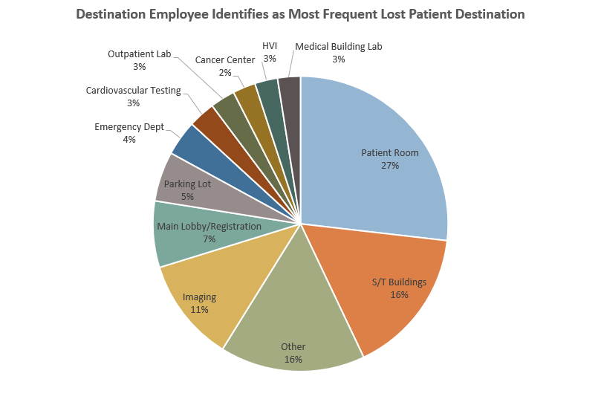

Figure 8 Destination Employees Identify as Most Frequent Lost Patient Destination

Discussion
The majority of both patient and employee respondents indicated that they found the signage at UPMC Passavant to be acceptable. The most frequent response from patients was that the signage was acceptable (55.30%), followed by excellent (39.88%), then poor (4.82%). In contrast, the most frequent response from employees was that the signage was acceptable (64.56%), followed by poor (29.57%), then excellent (5.87%). While both groups found the signage to be acceptable, the patients overall were more positive about the signage while the employees overall were more negative.
Employees most often chose “other” for where they most frequently find lost individuals. They had the option to type in a comment when choosing “other” on this question. The typed responses were primarily places not on the first floor, such as surgery or the patient units. Employees indicated that lost individuals were most often trying to find a patient room. The majority of responses to both these questions indicate that many of the lost individuals whom employees encounter are not patients, but visitors. It also indicates that the signage issues are not concentrated on the first floor, but rather spread to the rest of the hospital.
Thirty six percent of patient respondents indicated that an employee helped them find their way to their destination. This means that at least 186 patients were taken to their destination by an employee over the course of a week. This supports the data provided by employees that the majority usually or always help lost patients find their destination. The age range responses collected from the patient survey are consistent with the patient population at UPMC Passavant. Pediatric patients are transferred out to UPMC Children’s Hospital of Pittsburgh, so it is expected that no responses would be collected from individuals under 18.
One interesting finding is that 82.82% of patients indicated that they had visited the office in which they took the survey previously, but 65.71% of patients still used the signage to help them find their destination. This could mean that even when a patient has previously been to a location, the inside of the hospital may be confusing enough that they still need to use the signs. It could also mean they had to park in a different parking lot or knew their way but wanted to confirm they were going in the correct direction.
In analyzing whether patients had previously visited the office, it was important to analyze if this had an effect on the perception of the signage. Figure 9 shows patients’ perceptions of UPMC Passavant’s signage stratified by whether the patient had previously visited the office. Of patients that had previously visited the office, only 3% indicated their perception of the signage was poor. Of patients that had not previously visited the office, 14% indicated their perception was poor. While this is still the minority, patients that had not previously visited the office more often indicated that their perception of the signage was poor than those who previously visited.

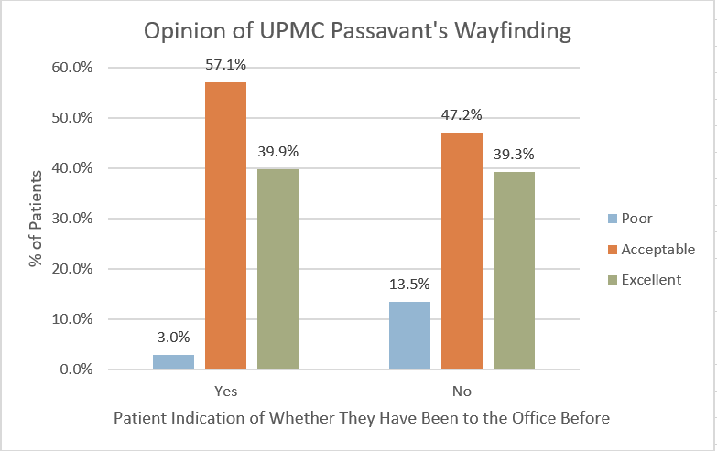

Figure 9 Opinion of UPMC Passavant’s Wayfinding Based on Whether the Patient Previously Visited the Office

congruence between major findings and hypotheses
The hypothesized perception of UPMC Passavant’s wayfinding from both employees and patients was that the signage would be considered poor. The majority of both patients and employees found the signage to be acceptable. The finding that employees found the signage to be acceptable was unexpected based on the negative feedback that is regularly received by UPMC Passavant leadership.
Employees indicated both the S/T buildings and imaging as locations that lost patients are frequently trying to find. This aligns with previously received anecdotal feedback and expectations because both of these locations are a significant walk from the main information desk. Therefore, if a patient comes in the front doors to the hospital, it is very likely they could get lost trying to navigate themselves to either of these destinations. The S/T buildings are also directly next to each other and patients are often confused as to which they are supposed to be in.
Some findings are ambiguous in nature because they could have numerous root causes. For example, most employee respondents indicated that they usually took people where they need to go. It is unclear if this answer reflects reality, or if the majority of employees selected it because they know it is what they are supposed to be doing. Thirty-four percent of patients said they did not use the signs to help them find their destination. It is unclear whether this is due to the signage being poor, or because the patient was already familiar with the hospital.

conclusions, Limitations, recommendations, and public health implications

conclusions based on analysis
This study enables UPMC Passavant leadership to have an awareness of the true perceptions of employees and patients, rather than just anecdotal evidence. By providing this baseline evidence, educated decisions can be made on signage recommendations. While the overall perception of the wayfinding at UPMC Passavant is acceptable, there is still room for improvement. This study has shown that the current state of the wayfinding at UPMC Passavant was not as poor as expected, but there is still a gap between “acceptable” and “excellent.” This gap shows opportunity for UPMC Passavant to improve its wayfinding experience. Improving the signage would allow patients to more easily find their way and free up time for employees.
The study has identified key areas, such as imaging registration and the S/T buildings, that need to be of focus for improved signage. Thirty percent of the employees indicated that they encounter lost patients three to four times per week. Employees also typed in various areas throughout the hospital in which they encounter lost patients. If wayfinding on the first floor of the hospital was clearer, patients could more easily identify their way to their destination even if it is not on the first floor rather than getting immediately lost.
The study has shown that the employees are clearly engaged in helping patients find their destinations. This provides confirmation that UPMC Experience implementation has shown success thus far. This will not need to be a primary area of focus following this study. Employees have made the patient the center of their attention in this regard which positively contributes to the patient experience. While there is room for improvement, it is important that UPMC Passavant ensures they do not make changes that negatively impact patients’ perceptions of the wayfinding experience in the hospital.

recommendations for UPMC Passavant
The recommendations for best practice are focused around consistency and simplicity for the patient. The recommendations for UPMC Passavant rely on the literature, feedback from the surveys, and site-specific needs. Prior to sign implementation, it is important for UPMC Passavant to collect more qualitative data from patients based on their signage plans. These qualitative data can include direct feedback or additional surveys from patients. Collecting these data will ensure the following recommendations make a positive improvement in perception.

Signage Design
One of the key issues with the existing signage at UPMC Passavant is that it is not consistent. Various makeshift signs throughout the hospital were put in as temporary placeholders but have quickly become permanent. When different styles of signs are used, it forces the brain to have to process more information before understanding. Utilizing consistent signage throughout the hospital allows a person to move from one sign to the next and quickly comprehend what move they need to make next. Another gap in consistency is that some signs are not in alphabetical order and others are. To help patients easily find a location listed on a sign, it is recommended that all signs have locations listed in alphabetical order.
The literature provides several guidelines for signage design that are applicable to the signage at UPMC Passavant. The signs should use soft colors and low saturation, but have enough contrast so they are easy to read. UPMC Passavant’s current signage design fits these criteria. The current signs are a subtle beige color with a dark brown border. The words and arrows are written in black on the signs, providing enough contrast to read while remaining simple. The signage uses color coding for the different sets of elevators throughout the hospital. This is useful because the color of each elevator on the sign is also across each of the elevator doors. The style of the signage at UPMC Passavant is good, but the key is to focus on consistency.

Sign Placement
Too many signs placed around the hospital can quickly become too much for the brain to process. UPMC Passavant currently has some signs that are in the middle of a hallway wall that is not at any type of intersection. It is highly unlikely that someone walking down the hallway would even notice the sign, let alone turn to read it. It is definitely possible to provide too much signage. Rather than having a sign every 15 feet just for the sake of doing so, it is recommended that signs be placed only at intersections throughout the hospital. These intersections could be where two hallways meet or where a doorway meets a hall, for example.
The literature discusses an issue with signage in which people are often unsure of whether they have arrived at their destination. UPMC Passavant has signage that helps with this, but only in some locations. While the signs that direct people are on the walls, UPMC Passavant also has destination signs that hang from the ceiling. The signs have a star and simply state the name of the department. For example, upon arriving to the MRI suite, one can look up and see a sign on the ceiling perpendicular to the doorway that has a star and says “MRI.” This can be found in patient care areas and is recommended only for places in which patients would take themselves. Entries to areas restricted to employees do not need to have the destination sign as this would clog up the hallway. These are currently at some locations within UPMC Passavant, but a walk-through should be completed to see where they are missing.

What to Include
To make the wayfinding experience optimal for patients, the signage should be as simple as possible. The signage should include arrows to surrounding patient care areas, nearby elevators, and access to nearby buildings. The signs should also point the visitor in the general direction of the main hospital or information desk. This is a central point that not only gives the visitor a sense of direction, but is one of the most common destinations of someone visiting the hospital.
The signage should include only information that is pertinent to the patient. For example, the lobby area of the hospital currently has signs pointing toward the emergency department. However, the emergency department can be entered without an employee escort only through the emergency room entrance on the outside of the hospital. This means that the existing signs are leading patients somewhere they cannot access. Another example of this is the employee health clinic at UPMC Passavant. Currently signs direct people to the clinic, but only employees would ever need to go there. Because these are not relevant to patients, they should be removed from the signage so patients have to read through fewer when trying to find their way.

Study limitations
There are several limitations in this study. First, post implementation surveys cannot be collected at this time for data comparison. It would be very beneficial to understand how improved signage affects patients’ and employees’ perceptions. However, time constraints on this study limit that ability. The response rate for the patient survey utilized the patient volume for the five days in which the survey was distributed. It would have been ideal to have the response rate based on the actual number of surveys passed out versus collected rather than utilizing volumes. A major limitation was the low response rates from the outpatient lab (2.07%) and imaging registration (6.99%).
The responses for how often employees encounter lost patients may depend on what their work environment is like. Not every employee is exposed to the same number of patients on a daily basis. An individual who works in a secluded office in the hospital would have less opportunity to encounter a lost patient than would a nurse who is regularly out and about. Therefore, the number of lost patients encountered is highly dependent on how much the employee walks about the hospital.
Another major limitation is that patients who are very familiar with the hospital may not have an objective opinion of the signage at UPMC Passavant. If they already know how to get to their destination, the signage can seem like it is more effective than it truly is. This is because the patient would already have an understanding of the context opposed to someone who has never been in that space. Patients may also not want to admit that they did not understand the signage or that they needed help.

opportunities for further research
There are several opportunities for further research on wayfinding at UPMC Passavant. As previously mentioned, there is opportunity to collect feedback from patients on proposed changes before implementation. Such a study could include personal interviews where patients are presented with the proposed signage. The patient would have the opportunity to provide feedback on items to add or remove from the signs, in addition to the overall aesthetic. This will ensure that the new signage is not having an adverse effect.
This study was limited to the first floor of the hospital. There is opportunity to expand the study to the entire hospital, including the patient units. The data collected on the patient survey point to an opportunity for better wayfinding on the outside of and surrounding UPMC Passavant. The data showed that many patients parked in a lot that was not the most convenient to their desired destination. It also showed that 25.83% of patients were unsure of what parking lot they parked in. This indicates that the exterior signage guiding people could be better.
There is also opportunity to do a post survey after the new signage is implemented at UPMC Passavant. This would allow hospital leadership to see if there is a change in perception following implementation. It would also be interesting to conduct similar studies at other UPMC hospitals. Conducting this same study and then implementing the recommended post implementation survey could provide insight to what hospitals are successful with their wayfinding. Then, best practice could be developed for the system and signage could be consistent.

public health relevance
Studying the perception of the signage at UPMC Passavant is of public health relevance. First, patients being frustrated and unable to find their destination can prevent them from wanting to come back to the hospital for routine checkups or other care they need. It also can affect patient outcomes. There is often already significant stress on patients when coming to the hospital for visits, tests, or procedures. The added anxiety of one being unable to find their way could cause an unpleasant experience for the patient.
Another area of public health relevant to this study is access. If a patient gets lost and then is late for an appointment, it creates a ripple effect in the clinic they are visiting. If the first patient of the day is late, the clinic either has to make up that time by cutting a patient’s time short, or run late the rest of the day. If a clinic is consistently running late, they may decrease the number of available slots in a day, which means less available appointments. If a patient is late getting into surgery, hundreds of dollars per minute can add up in the cost of delay in the operating room. When this happens over and over again, it can significantly increase health care costs.
Patients are the reason hospitals exist and should be at the heart of everything a hospital does. Not only should a patient receive excellent clinical care, but their entire experience should be excellent. Collecting patient feedback and incorporating it into a project surrounding UPMC Passavant’s facility reflects the hospital’s patient-centered care. Hospitals can always find ways to improve. Often, leaders can get caught up in the clinical aspects of a patient’s experience and forget about all the other details that affect their stay. Hospitals everywhere could take the time to consider patients’ journeys, both with their health and through the hospital halls.
        - SURVEY USED TO COLLECT PATIENT OPINION OF WAYFINDING AT UPMC PASSAVANT
            - What parking lot did you park in?
              - Blue
              - Orange
              - Purple
              - Green
              - Unsure
              - None of the above
            - Have you been to this office before?
              - Yes
              - No
            - Did you use the signs posted around the hospital to help you get to your destination?
              - Yes
              - No
            - Did an employee help you to find your way to your destination?
              - Yes
              - No
            - What is your opinion of UPMC Passavant’s signage to navigate the first floor (main level) of the hospital?
              - Poor
              - Acceptable
              - Excellent
            - What is your age?
              - Under 18 years old
              - 18-24 years old
              - 25-34 years old
              - 35-44 years old
              - 45-54 years old
              - 55-64 years old
              - 65-74 years old
              - 75 years or older
        - SURVEY USED TO COLLECT EMPLOYEE OPINION ON WAYFINDING AT UPMC PASSAVANT
            - What is your perception of UPMC Passavant’s internal wayfinding (signage to navigate) on the first floor (main level)?
              - Poor
              - Acceptable
              - Excellent
            - How many times per week do you encounter someone who appears to be lost in the hospital?
              - 1-2
              - 3-4
              - 5-6
              - 7+
            - Whenever you encounter someone this is lost in the hospital, how often do you walk them to where they need to go?
              - Never
              - Sometimes
              - Usually
              - Always
            - Where do you most often encounter lost patients?
              - S/T Buildings
              - Annex (imaging area)
              - HVI area
              - Main Entrance area
              - Patient Pick-Up entrance area
              - Emergency Department area
              - Other
            - Where are the patients you find lost most often trying to go (their destination)?
              - Cancer Center
              - Emergency Department
              - HVI
              - Imaging
              - Main Lobby/Registration
              - Medical Building Lab (Express Lab)
              - Outpatient Lab (in main hospital)
              - Cardiovascular Testing (stress/echo)
              - Parking Lot
              - S/T Buildings
              - Other
bibliography
Arthur, P., & Passini, R. (1992). Wayfinding: People, Signs and Architecture. New York, NY: McGraw-Hill, Inc.
Codinhoto, R., May, D., Tzortzopoulos, P., Kagioglou, M., Aouad, G., & Cooper, R. (2009). The impacts of the built environment on health outcomes. Facilities, 27(3/4), 138-151.
Greenroyd, F. L., Hayward, R., Price, A., Demian, P., & Sharma, S. (2017). A tool for signage placement recommendation in hospitals based on wayfinding metrics. Indoor and Built Environment, 27(7), 925-937.
Johanes, M., & Yatmo, Y. A. (2018). Application of Visibility Analysis and Visualisation in Hospital Wayfinding Sign Design. DIMENSI (Journal of Architecture and Built Environment), 45(1).
Lynch, K. (1960). The Image of the City. Cambridge, Massachusetts: Massachusetts Institute of Technology.
Martins, L. B., & de Melo, H. F. V. (2014). Wayfinding in Hospital: A Case Study, Cham.
Morag, I., Heylighen, A., & Pintelon, L. (2016). Evaluating the inclusivity of hospital wayfinding systems for people with diverse needs and abilities. J Health Serv Res Policy, 21(4), 243-248.
Oxford English Dictionary Online. (2019). Retrieved from https://en.oxforddictionaries.com/definition/wayfinding
Rangel, M., & Mont' Alvao, C. (2011). Color and wayfinding: a research in a hospital environment. Proceedings of the Human Factors and Ergonomics Society Annual Meeting, 55(1), 575-578.
Rousek, J. B., & Hallbeck, M. S. (2011). Improving and analyzing signage within a healthcare setting. Appl Ergon, 42(6), 771-784.

