Title Page
Enhancing the Patient Experience: A Challenge for Leadership in Health Care

by

Kelsey Louise Hooker

B.S. Health Information Management, University of Pittsburgh, 2016

Submitted to the Graduate Faculty of
the Department of Health Policy and Management
Graduate School of Public Health in partial fulfillment
of the requirements for the degree of
Master of Health Administration

University of Pittsburgh

2019
Committee Membership Page
UNIVERSITY OF PITTSBURGH

Graduate School of Public Health

This essay is submitted

by

Kelsey Louise Hooker

on

April 17, 2019

and approved by

Wesley M Rohrer, PhD, MBA, Associate Professor, Health Policy and Management, Graduate School of Public Health, University of Pittsburgh

Dilhari DeAlmeida, PhD, RHIA, Associate Professor, Health Information Management, School of Health and Rehabilitation Sciences, University of Pittsburgh

Anna Voelker, MHA, Visiting Assistant Professor, Health Policy and Management, Graduate School of Public Health, University of Pittsburgh

Copyright © by Kelsey Louise Hooker

2019

Abstract
Wesley M Rohrer, PhD, MBA

Enhancing the Patient Experience: A Challenge for Leadership in Health Care

Kelsey Louise Hooker, MHA

University of Pittsburgh, 2019

Abstract
Organization: The University of Pittsburgh Medical Center (UPMC), is a $19 billion not-for-profit Integrated Delivery and Finance System based in Pittsburgh, Pennsylvania with 80,000 employees, 40 hospitals, 600 clinical locations and 3.4 million Health Plan members. This case study was completed with UPMC’s Community Medicine division, a subset of the UPMC Health Services Division, comprised of Primary Care and Specialty practices, whose doctors devote 100% of their time to clinical practice and do not engage in research or education. CMI has 224 sites, 469 physicians, 225 APPs, and administrative support staff.
Problem: A Health System as large as UPMC struggles to sustain a high standard of satisfactory care delivery. To address this challenge in 2018 UPMC engaged The Studer Group for its expertise in enhancing the patient experience. The Community Medicine Division, to align with the UPMC corporate strategy, formed a Patient Experience Committee to improve patient experience, employee engagement, and Press Ganey patient satisfaction scores.
Goals: The goals of this paper are to: 1) Examine the literature for best practices in implementing patient experience in healthcare. 2) Design a model for divisions to improve patient experience scores, across all specialties of care. 3) Provide a summary of lessons learned from this study and methods that health care organizations can use to prevent problems and address challenges to sustained quality of care.
Outcomes: Since the conception of the Patient Experience Committee, Community Medicine Incorporated, CMI, experienced a 0.5% increase in the Press Ganey Patient Satisfaction scoring and a 1.3% increase in office staff scoring, the primary focus of the committee. Feedback from the staff indicates a very positive response to the Committee’s initiatives and requests that they be continued. The Committee’s meetings have been widely accepted, well attended, and participatory, resulting in enthusiasm to sustain this initiative.
Lessons Learned: A committee with this charge has a considerable opportunity to address a range of issues relevant to the patient care experience. The ‘Triple Aim’ framework of providers, staff, and patients is a useful model to guide implementation of such change strategies to create a culture centered on enhanced patient experience. Each organization is unique in their structure, but similar in that both patients and employees expect that their basic needs will be met. This framework can be applied to any healthcare organization as a model for patient experience improvement.
Public Health Relevance: Implementing a Patient Experience Committee within an organization/division entails that key decision makers are accountable for all the direct care and support services within their domain that affect the patient experience. By engaging mangers at all levels, a strategy for insuring a sustained commitment to enhanced patient care and patient satisfaction is more likely to be achieved and sustained. This will contribute to the overall health and well-being of our population being served as well as the longer-term viability of the health care system as large Fortune 500 companies, like Amazon, continue to penetrate the market.

Table of Contents
1.0 Introduction 1
2.0 Literature Review 3
2.1 The Disney Model 3
2.2 What Other Literature Says 5
2.3 What Other Organizations Are Doing 8
3.0 Problem Statement 10
4.0 Limitations 11
5.0 Case Analysis and Methods 12
5.1 Stay Interviews 17
5.2 Manager Retreat 19
5.3 Manager Swap 20
5.4 Front Desk Meetings 21
5.5 Patient Satisfaction 101 Training 22
6.0 Findings 23
6.1 Stay Interviews 25
6.2 Manager Retreat 25
6.3 Manager Swap 26
6.4 Front Desk Staff Meeting 27
6.5 Patient Satisfaction 101 Training 27
7.0 Public Health Relevance 29
8.0 Analysis 30
9.0 Conclusion 32
10.0 Recommendations 33
Appendix Supplementary Materials 35
Bibliography 37
List of Tables
Table 1: Press Ganey Results 23
List of Figures
Figure 1: Maslow's Hierarcy of Needs 7
Figure 2: CMI Organizational Chart 12
Figure 3: Patient Experience Triple Aim 13
Figure 4: Press Ganey Comment Form 16
Figure 5: Manager Retreat Agenda 35
Figure 6: Patient Satisfaction 101 Handout 36

Introduction
Patient Satisfaction is a focus of healthcare today as patients are ‘shopping around’ for their care now more than ever. Patient satisfaction is not a new concept, yet there are articles, emerging research, and organizations shifting their focus toward the patient’s experience, which can be attributed to that fact that patients are beginning to experience the cost burden of health care as insurance firms, health plans, Managed Care Organizations, and the government tighten their payment models. Consequently, it’s essential that healthcare organizations provide an experience that predisposes patients to choose their organization for their care. Marketing oneself as a patient-centric provider is distinct from actually understanding what that means and how to provide a patient care experience that is both clinically effective and personally rewarding to patients by addressing their needs. Many organizations have put an emphasis on the patient-centric care but have ignored the fact that employees are at the center of this model and their satisfaction must be addressed concurrently.
UPMC decided to take this challenge head on, and hire an external consulting firm, The Studer Group, in the fall of 2017. The Studer Group’s work promotes ‘building a sustainable culture that promotes accountability, fosters innovation, and consistently delivers a great patient experience and the best quality outcomes over time by installing an execution framework called Evidence-Based Leadership SM” (Studer Group). Much of their work is centered around the ‘soft skills’ building of employees that are often overlooked in the busyness that clinical operations entail. Due to the size of UPMC, the initiative has been hospital-based, but the entire organization is trying to engage in the work remotely. Community Medicine Incorporated, CMI, a subset of the Health Services Division established its own Patient Experience Committee, comprised of the senior leaders of the division to promote similar initiatives in their own department.
Although a primary goal is to increase the division’s Press Ganey scores, other goals of this committee are more subjective relating to the organization’s culture. Therefore, this effort relies on surveys and internal communication for outcomes analysis. The employees are the focus of the Studer Group and the CMI Patient Experience Committee’s efforts as they are the face of the organization, ultimately creating the UPMC experience for our patients. CMI has the best patient experience scores in the system achieving a 92% rating, placing the department in the 95th percentile nationally, while UPMC overall reaches a 74% satisfaction rating, placing them in the 50th percentile nationally. The committee’s goal is to sustain and continually improve high Press Ganey scores by increasing the efforts on part of staff and administration to deliver care that patients consider to be of highest quality and addressing factors that are diminishing the scores.

Literature Review

The Disney Model
If Disney Ran Your Hospital: 9 ½ Things You Would Do Differently, by Fred Lee (2004) is a popular book recognized in 2005 by the American College of Health Executives and widely referenced by health care executives today. Lee lays the foundation for a successful patient experience under the framework of SHARE: (S)ense people’s needs before they ask; (H)elp each other out; (A)cknowledge people’s feelings; (R)espect the dignity and privacy of everyone, and (E)xplain what’s happening. The author goes on to explain that being in the top percentile within your comparison group is not indicative of having satisfied patients, since the true measure of having satisfied patients is reflected by the percentage who give you the ‘top box score.” Disney only announces the percentage of 5/5 scores that they receive, because they are measuring their success by loyalty of patients who give a 5/5 ratings.
Although a common reaction is that the customers of Disney are much different than those of a health system, Lee disputes that contention. He recognizes that healthcare systems have a much more demanding customer, and do not have creative ways to create customer loyalty like discounts and frequent flyer perks. Rather he states that the core of what creates a loyal patient is somebody doing something special, service beyond what is expected. Hospital executives, managers, providers, and support staff must envision a trip to the office, the hospital, or the lab as an experience not just a service, in the same way that a trip to Disney is an experience. The health care experience beyond the clinical intervention is created by a complex of factors associated with staff interactions with patients including language, nonverbal actions and behaviors like tone of voice, facial expressions, and responsiveness to questions and concerns.
It’s no surprise that even the highest functioning organizations make errors and our best employees have bad days, but what distinguishes a sophisticated organization from one that underperforms is its service recovery model. A strong service recovery program should automatically trigger appropriate action when staff recognize a situation that is frustrating to patients whether they complain or not. Lee suggests that highly service-oriented organizations such as Disney minimize the chance of bad experiences through scripted development. How does a non-theatrical environment set the stage for patients? Although it seems to be a simple process of mapping and designing clinical workflows that lead to desired outcomes, this is too often incomplete. The missing piece often is the integrating vision that ensures that each ‘scene’ in the clinical workflow contributes to the overall performance offered to and experienced by the patient. In practice this results in an experience that is worthy of a patient satisfaction rating of 5/5.
Disney’s three-tiered model of care correlates the type of patient care with the evaluation score received. The lowest tier is competence which results in a 1-3 score (dissatisfied-neutral). The second tier is courtesy which results in a 4 (satisfied). The top tier is compassion which results in a 5 (very satisfied). In answering the question of how we get our staff to provide a compassionate experience, one response is to instill inspiration among the staff. One way to inspire and retain employees is through empowering them to make decisions, and increasing their autonomy in decision making. Lee notably states that, “a manager’s success is not measured by what he can do, but by what his people can do without him.” A great way to manage this in a large organization is to host focus groups with key frontline staff to engage them in training and open access and opportunities for conversation with key administration. Since it may not be realistic to conduct focus groups of this caliber as often as desirable, the momentum achieved may be sustained by daily huddles to remind members of progress made, where they could improve and to give staff the opportunity to ask questions and offer suggestions.
With all of this in mind, the key to this approach is effective leadership. Leaders must role model behaviors to influence their employees to follow suit. No member of the ‘cast’ can be out of step with the purpose of the enterprise, including management that plays a vital role in hiring, retaining, and managing talent. Lee suggests the need to focus on the role of the receptionists as they the first (and perhaps most lasting) impression that patients have of their care experience and of the provider organization. This suggests that effective selection, hiring and training of these staff are essential. To be inspired to go above and beyond expected performance in healthcare staff must internalize the realization that they are an essential part of an enterprise unlike any other in which: “you heal hearts, minds, and bodies of broken people.”

What Other Literature Says
Disney is not the only organization placing attention on improvement of the customer experience. In 2001 the Institute of Medicine targeted six goals for improving healthcare, one of which was patient-centered care (JAMA). This aim strives to improve health outcomes by closing the gap between patient expectations as a consumer and their actual medical needs. Because consumers are not always equipped to evaluate technical competency, they tend to rely on peripheral elements of the encounter such as friendliness and the quality of personal interactions. The IOM suggests the following actions to help patients feel like they’re a key player in their medical care:
- Implement shared decision making to ensure that patients' preferences and cultural values will have a bearing on clinical decisions.
- Measure how services or products of a company meet or exceed the anticipated expectations of the customer.
- Provide comfort, emotional support, education, and consider the patient's perspective in the synthesis of the clinical decision-making process.
The IOM is not the only major healthcare regulating organization with its eyes on this subject matter. In 2010, the National Institutes of Health (NIH) published an article that discusses patient satisfaction as one of the top indicators for quality of care and that providers must treat their patients like healthcare consumers. The term “consumer” refers to someone who chooses an organization for care because the patient perceives that the organization has established trust, quality, loyalty among those they serve, and if satisfied with the service they receive will maintain their loyalty to that provider. The NIH suggests resources and actions necessary to create a satisfied and loyal patient including: a strong, responsive telephone service, a clean, inviting, and up-to-date office space, short wait times, a positive doctor-patient interaction, appropriate patient education, efficient problem-solving of patient issues, and an office accepting of and responsive to patient feedback. Although patient satisfaction may be only a proxy for the true quality of care a patient receives, it is extremely important for a healthcare provider to master.
Gallup, a leading global analytics firm with 35 million responses in their employee engagement database, comments on the three best ways to improve both the employee and the customer experience. They discuss that the first step for any organization is meeting the basic human needs. Referring to Maslow’s Hierarchy of Needs (Figure 1) below, the organization must at least meet psychological and safety needs, which include things like livable wages, breaks in their workday, job security, and retirement benefits. The organizations who are most successful in employee engagement are at the top of the pyramid proving fulfillment and meaning to their employees in the performance of their jobs.
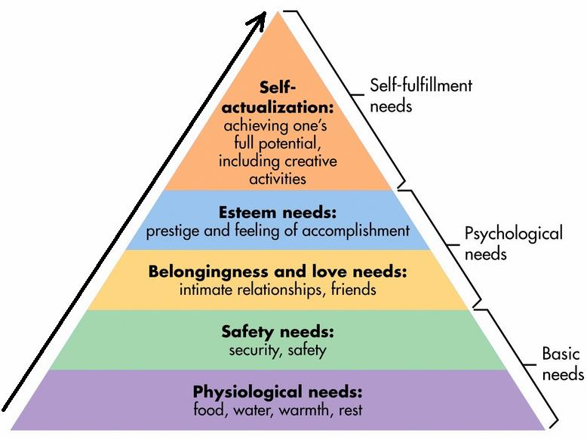

Figure 1: Maslow's Hierarcy of Needs
Gallup suggests three actionable items for organizations to foster a high-level of employee engagement:
- Emphasize individual strengths- focusing on strength-based feedback rather than weakness or correction
- Empower employees with exceptional workplace culture- recognizing that the manager alone accounts for 70% of the culture that they promote and enforce with their staff
- Customer-centricity at the center of your business model- putting first customers’ needs, wants, and perceptions
Gallup notes that this is the start for employee engagement but is not all inclusive and unfortunately many organizations don’t even do these basic things. Shifting organizational cultures towards employee-centricity is the first step in patient satisfaction. Employees are the face of the organization and if they’re dissatisfied then that will directly impact the patients as well. Many organizations who have begun addressing the patient-centered care model have started the process of change with their employees and noticed the effects. Large healthcare organizations have already begun to implement these models of patient experience as discussed in the following section.

What Other Organizations Are Doing
The Cleveland Clinic is a leader in placing emphasis on the patient experience. They were one of the first academic medical centers to appoint a Chief Executive Officer of Patient Experience and establish an Office of Patient Experience. This office is lead by a Medical Director who spearheads patient initiatives for the entire health system. Additionally, they analyze data to ensure patient-centered care is being delivered consistently throughout the health system. Additionally, the office monitors local and national HCAHP scores of top performers to compare models of care delivery for best practices. The Cleveland Clinic posts their eleven major initiatives online for transparency, the most notable including “The Voice of the Patient Advisory Council” and their “Patient Experience Empathy and Innovation Summit. “ This conference is experiencing its 10th year with attendees from almost all 50 states who come together to collaborate on the patient experience in conjunction with the new innovations.
Kaiser Permanente, the largest non-profit organization in the United States, is taking a different approach. They have instituted what they call ‘health hubs’ in certain locations where they beta test new technologies such as touch screens, and leather chairs that are embedded with technology, high-functioning mobile apps, tablets that are direct interfaces with the pharmacy of the patient, telemedicine consults and other innovations. Their model supports a concierge-like service starting from the waiting room through to the exam rooms—so that the patient feels like she/he is in a high-class hotel or store, rather than a doctor’s office. They feel that having everything at the patient’s fingertips when they want it is their claim to high satisfaction ratings. For example, these testing hubs have stations where the patient can measure his/her vital signs and obtain nutrition counseling while you’re waiting to be roomed. Then the patient receives a text message alerting him/her that your exam room is ready, very similar to a restaurant. Their model seems to be a hybrid model integrating the ‘favorite’ aspects of other customer service industries.
Although Amazon is not a healthcare provider, much can be learned from their service strategy and customer-centered model. The basis of their mission is providing what the customer wants and what keeps them satisfied: hassle free, fast, personalized, and affordable services. This seems consistent with what patients want from their healthcare system. Amazon also excels at what they call ‘customer empowerment’ (Collomb) which means allowing customers to review products and read what others have to say which lends to transparency and accountability on behalf of the service provider. Lastly, they succeed with loyalty which is gained not only by their high-quality services and ease of use, but through their customer service response when something goes wrong. The healthcare field has mimicked these tactics through things like Press Ganey surveys and public sharing of the results, but they’ve not yet mastered the ‘hassle-free, transparent, and personalized’ model for which patients are searching. As Amazon and other companies begin to enter the healthcare market, more organizations are placing emphasis on their patient satisfaction so as to keep and grow their consumer base.

Problem Statement
In recent years, there has been increased attention on particular aspects of healthcare— cost, access, delivery and payment models, pricing, and satisfaction. As healthcare reform continues to be a major and contentious public policy priority, and competition among provider systems accelerates, organizations are focusing more intensely on and making greater investments in improving the experience of their patients. UPMC, as the focus of this case study, has consulted with a national agency, The Studer Group, for guidance to enhance the patient experience. Specifically, UPMC’s goal is to increase the patient experience scores through tangible, meaningful, and calculated changes. Although UPMC Community Medicine is not involved in this initiative directly, they have developed their own approach to address the challenges with patient experience that they too are facing while incorporating the tools from the UPMC Experience with Studer Group. This commitment led to the birth of the CMI Patient Experience Committee in January 2018. Since the goal for UPMC is to reach the top percentile scoring on a national level, the goal of this committee is to make measurable progress consistent with this corporate goal and strategy.

Limitations
The committee yielded more impactful results once administrators and directors from each subset of Community Medicine Division got involved at three months into the conception of the committee. However, some directors weren’t consistently involved in attending the meetings and unfortunately their group of staff members did not have the opportunity to engage in all of the initiatives set forth, thus the scores could have possibly been impacted stronger would they have been. Additionally, all initiatives were new to the division and ‘tested’ for efficacy, rather than being implemented based on proven success. Additionally, we experienced varied levels of engagement from not just directors, but staff and physicians. Those persons who were excited by and fully engaged in making the initiatives successful yielded better outcomes than those practices who were less involved.

Case Analysis and Methods
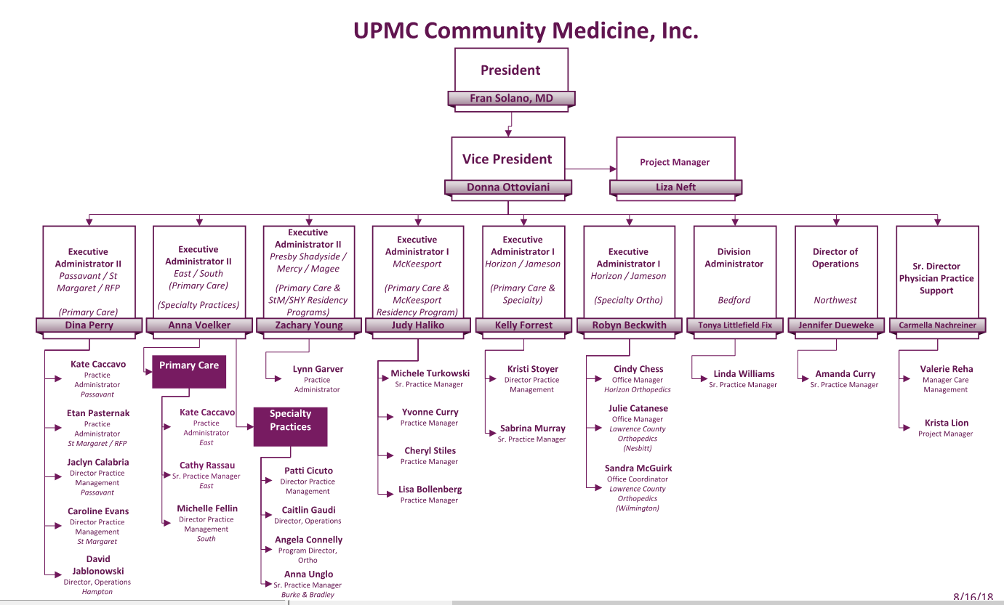
The case study was completed with UPMC’s Community Medicine Inc division, a subset of the UPMC Health Services Division, comprised of Primary Care and Specialty practices, who’s doctors are 100% involved in clinical procedure rather than research or education. CMI has 224 sites, 469 physicians, 225 APPs, and administrative support staff. Figure 2 displays CMI’s organizational chart. The department is divided into regions— North, South, East and Central Pittsburgh along with Horizon Jameson, Bedford, and Northwest.

Figure 2: CMI Organizational Chart
This study of patient experience outcomes in UPMC Community Medicine Inc. was composed of the three main components which are considered critical success factors in creating a positive patient experience and what is commonly termed the triple aim. These components include: physicians, patients, and staff.
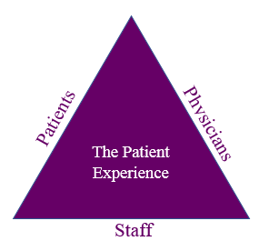

Figure 3: Patient Experience Triple Aim

Large organizations like UPMC struggle to incorporate initiatives centered around the ‘triple aim’ of patient satisfaction because it’s not a departmental function, there’s no one person or team accountable for its implementation. For this initiative to be successful, management must create a organizational culture centered around the patient’s experience. Recognizing this fact, while aligning with the inpatient Studer Group work, CMI conceptualized what is now known as the Patient Experience Committee. Its inauguration was January 2018, beginning with only a small group of three people in the department who wanted to address the topic directly. Over the course of three months, the committee tripled in size and now includes administrative and director level personnel from each subgroup in the department. Originally, changes were small in nature and only affected those groups of people whose administrators were involved in the committee. Over a period of three months, the entire department engaged in the committee’s initiatives, which is a major contributor to the success of the committee and subsequent outcomes.
The committee meets bi-weekly, with required in-person attendance, except for the regional directors travel restraints; live participation leads to greater engagement and rich discussion. The meetings tend to be brainstorming sessions and cultivate creative thinking and application of concepts given the vast variety of in-office cultures that make up the Community Medicine Network. Many of the practices in CMI have been acquired overtime and units kept their own personality and flavor, which means that initiatives stemming form the committee cannot be “one-size fits all”. Most initiatives are given guidelines, with considerable flexibility in application. Communications are sent to all managers via email on a bi-weekly basis as well, and required actions are expected to be enforced by the directors who sit on the committee. This is a critical piece to the success of the initiatives because when the committee did not encompass all subgroups in its initial stages, there was extreme disconnect and low levels of participation by those groups who did not participate in the committee. One can attribute this to the fact that those who did not participate may not have understood the meaning of and importance behind the operational rollout, nor were managers/ practices held accountable to participate.
The committee’s primary focus has been on staff engagement, although the perspectives of all three stakeholder groups have been considered and addressed in some fashion. The Press Ganey survey provides data on opportunities for improvement and is analyzed monthly by the committee. The six domains of the survey include: recommend provider, rate provider, provider communication quality, access to care, office staff, and care coordination. When analyzing the domains and comments, we noted a trend of satisfaction with providers and patients’ claim that they remain with a particular practice because of their satisfaction with one or more physicians who have treated them. CMI’s survey results indicated that the primary areas of negative perceptions were directed toward office staff, not the physicians. Thus the primary focus of this case study was on employees, although the providers were still engaged as they are an important piece of the “Patient Experience Triple Aim: Physicians, Patients, Staff.”
Physicians
The committee recognizes the crucial role of the physicians in the success of healthcare and thus they were an important piece of the committee’s focus. One of the first initiatives after the conception of the Patient Experience Committee was the creation of a sub-committee termed the CMI Patient Satisfaction Physician Advisory Committee, comprised of key members in physician leadership. Like the administrative committee, leaders were added to the committee as it began to develop, including not just those with lead physician titles, but also those who excel in their own patient satisfaction scores. The committee meets quarterly and is meant to serve as a think-tank for new ideas for physicians who struggle with patient satisfaction scores. Initiatives of the committee included addressing physician burnout, patient handoff during physician retirement, and the creation of a comprehensive specialty practice list for increased patient access and referral processes.
Patients
Although it may not be seem intuitive, patients play a crucial role in their own satisfaction. Although the 66-item Press Ganey survey may seem lengthy and cumbersome to complete, it plays an important role in analyzing and comparing care delivery against national benchmarks, and also serves as a constructive forum for patients’ voices to be heard. The committee developed a Press Ganey comment analysis process centered on service recovery, process improvement, staff recognition, and best practice sharing. The managers of each practice are required to review their comments monthly to identify both outstanding actions and opportunities for improvement. Figure 3 below, displays the form used by managers in each of the 224 CMI sites. There are three major actions the managers should take when filling out the forms: (a) complete service recovery calls on negative comments and action plans for prevention of reoccurrences, (b) submit comments to the committee when staff or providers go above and beyond their daily call of duty, and (c) review all comments at staff meetings.
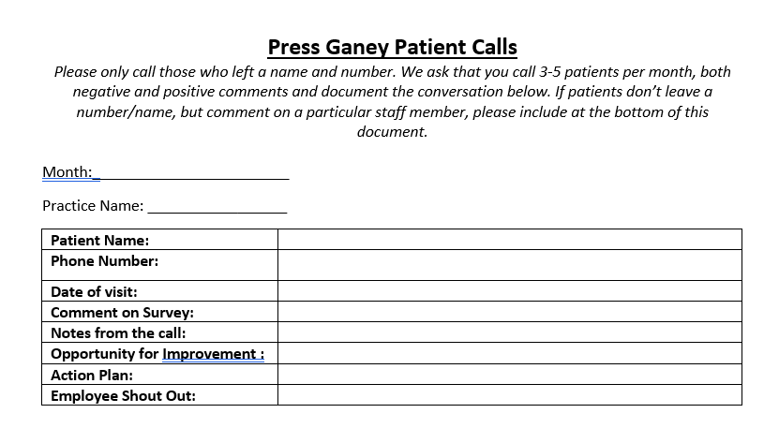

Figure 4: Press Ganey Comment Form
The comments that are submitted to the committee are deidentified and voted on by committee members with the top five chosen for recognition. The purpose of deidentifying the comments is so that those voting are focused on the substance of the employee’s behavior rather than voting influenced by personal bias or favoritism. When voting is complete an email goes out to the entire department along with the Vice President to recognize them by name and by action, not only to commend the efforts of our staff and providers, but to inspire the entire team to go above and beyond.

Staff
The staff was the primary focus of the case study not only because they are the largest target of complaints from patients, but more importantly because of the amount of time they spend interacting with patients. Additionally, literature refers to the importance of employee engagement and satisfaction and its direct impact on patient satisfaction. Healthcare continues to struggle with finding and retaining quality staff as the minimum wage in other industries begins to rise, while ours does not. However, the expectations for performance of the front-line staff rises. To be a competitor in the market for quality employees, to retain employees, and to expect that they will provide a quality experience to patients means as an organization we must provide a culture and experience that addresses the top of Maslow’s hierarchy and provides employees a high level of satisfaction and fulfillment. Simply recognizing this fact is not enough, as initiatives must also be put into place. The committee conducted a set of initiatives as part of the study listed below.

Stay Interviews
Stay interviews are used by organizations as a retention tool for staff engagement. In the CMI department employee ‘check-ins’ are not standard beyond the 90-day check-in and yearly performance evaluations. The idea behind implementing stay interviews, was to give managers an optional tool to use to keep employees engaged, feel like their voices are being heard, and so that their performance evaluations do not come as a surprise. The stay interview questions were formatted to be a hybrid of Studer Group’s suggested questions consistent with those in relevant literature.
The interview questions are as follows:
- Has this job met your expectations? How? Where has it fallen short?
- Do you feel supported in your role? Do you have the tools you need to be successful?
- When you travel to work each day, what things do you look forward to? What do you like most about working here? What parts of your job are the most challenging? What do you like least about working here?
- What are you learning here? Is there anything else you’d like to be learning here that you are not? How do you learn best? Doing? Observing? Attending training? Do you feel like you could advance your career here if you want to? What aspects of your performance would you like more feedback on?
- Which coworkers have been especially helpful to you? Do you feel supported by your coworkers?
- Why do you stay here? Is that the only reason? How much does the type of work you do impact your stay? How much do you stay because you like working with our customers? Our team?
- When was the last time you thought about leaving our team? What prompted it? Does this still concern you? On a scale from 1-10 (leaving ASAP – staying for the foreseeable future), how would you rate your intention to leave? What is the single most meaningful action we could take to address this issue?
- What can we do to make your experience at work better for you? What should we do more of? Less of? What goes on that frustrates you? Is there anything that strikes you as unfair or unreasonable? Do you feel like your concerns are truly heard when you have them?
- What would you like to accomplish over the next year? Personally? Professionally?
The questions are asked in an interview setting one-on-one with the manager or director and the employee with notes documented. Documenting on the stay interviews provides a basis for tracking change from one quarter to the next (or at whatever frequency chosen), but also allows for identifying trends and patterns in answers from employees. If many are satisfied or dissatisfied by the same things, it may mean an opportunity for improvement or best practice sharing by the leadership team.

Manager Retreat
The CMI Patient Experience Committee hosted its first manager retreat in November 2018 for all administrative staff with at least one direct report. The purpose of the retreat was to host managers from the entire department, including the outskirt regions such as Altoona and Hermitage, in a forum to learn necessary skills, network with one another, build a sense of community, and interact with the leadership team. The retreat was a day-long event with presentations from the President and Vice President of the division, as well as external guests. Figure 5 Manager Retreat Agenda, in the appendix provides an overview of the day. The agenda was strategically designed to cover the current initiatives and training needs of the department. The content will be variable from year-to-year depending on organizational initiatives and healthcare construct (i.e. Shared Savings, Accountable Care Organizations, etc.)

Manager Swap
The manager swap was designed to be a complete role swap for a whole or half day where managers spend time in one another’s position. The goal of the swap was to identify areas of opportunity and barriers to providing a positive patient experience, share best practices, put a fresh set of eyes in practices to learn from each other, and foster staff engagement and sharing of ideas. The swaps were organized on a bi-annual basis and assigned by directors; to ensure that placements are strategic so that managers have the opportunity to learn what other managers are experiencing and/or develop new skills. Once the swap is complete, the managers are asked to complete a form and submit it to their director. The form is an adaptation of the Studer Group rounding tool used in the hospital and includes the following questions:
- What is working well?
- Thinking about Best Practices to share, what is one thing that caught your eye to share with others?
- Providers/Staff who you recognized are doing a great job and why.
- Opportunities for improvement? Barriers/Issues to resolve?
- Quality or Safety (either a great approach or opportunity for improvement)?
- Staff Feedback: (what have you heard from the staff today? Questions from them? Things they think we need to address?)
- What was your experience from a patient perspective? (Office cleanliness, frontline staff interactions, workflow etc.)
The directors are expected to review the outcomes and discuss how to implement suggested changes that are likely to be successful. Additionally, notes should be tracked comparatively to the previous swap to look for common themes.

Front Desk Meetings
The Front Desk Meetings were designed to give office assistants a forum, similar to the manager retreat, to network with peers from other practices and have an opportunity to meet and interact with the CMI Executive Team. The meetings were held on a bi-annual basis in five different locations around the city for easy access for the staff who live in the neighboring suburbs. The executive team was present, along with a representative from the Revenue Cycle Division to answer the questions that the staff may have. For an organization as large as UPMC, there’s often a disconnect between departments, so partnering with Revenue Cycle showed our employees that their initiatives were important to our department and should be followed and valued. At the end of the five meetings, minutes were sent to all employees and managers so that the information was not limited to just those who had the opportunity to attend. To foster engagement in these forums, we played a game of bingo themed with departmental topics, and the staff were required to bring up a question, comment, or feedback about the topic to check the space with a small prize given to the winners. It was a great ice breaker and source of excitement to what otherwise could have become a tedious session of question and answers. The meetings went the entire 90 minutes for each session as the staff had much that they wanted to discuss and have answered.

Patient Satisfaction 101 Training
The Patient Satisfaction 101 training was created by the committee, primarily due to low Press Ganey scores in the office staff category and also as a means to align with training being done on the inpatient side. The two questions that feed into the Press Ganey ‘office staff’ category include:
- During this visit, were clerks and receptionists at this provider's office as helpful as you thought they should be?
- During this visit, did clerks and receptionists at this provider's office treat you with courtesy and respect?
In the training we focused on the phrase ‘a patient can leave healthy, but not happy,’ because the doctor may have addressed all of the patient’s concerns, but our staff did not smile, say hello, ask them what they need, etc. The training is designed to remind staff that while they are performing their everyday job, the patients they interact with may be anxious, frightened, possibly anticipating some bad news, and the way they respond to the patient’s needs will shape their perception of the entire visit. The training covers Studer Groups’ AIDET communication framework (Acknowledge, Introduce, Duration, Explanation and Thank), and gives staff tangible takeaways on how to communicate with patients within the AIDET framework. Figure 6 in the appendix displays the handout given to the staff at the completion of the training.

Findings
The Patient Experience Committee implemented and monitored many initiatives and the results, both quantitative and qualitative, provide measures of the positive outcomes of the committee. Data sources include Press Ganey survey results, anonymous Survey Monkey questionnaires, and staff interviews. The committee was established in January 2018, so the 2017 Press Ganey scores are reflective of an environment without committee influence while the 2018 scores are presumably affected by the committee’s efforts. Table 1.0 below demonstrates the change in scores in the six Press Ganey domains.

Table 1: Press Ganey Results
Domain | 2017 (1661 responses) | 2018 (1723 response)
Rate Provider | 93.4 | 93.5
Recommend Provider | 94.5 | 95.5
Access to Care | 90.3 | 89.8
Provider Communication | 96.5 | 97.0
Office Staff | 92.5 | 93.8
Care Coordination | 79.4 | 80.2
Average | 91.1 | 91.6

UPMC Community Medicine has seen an improvement in the Press Ganey survey results from 2017 to 2018, and one might contend that this intervention had an impact on the scores. There was an improvement in each of the six domains from calendar year 2017 to 2018. There was a 0.5% increase in the overall Press Ganey scores which is an encouraging improvement, but the greatest impact is seen with a 1.3% increase in office staff scoring. Much of the focus of the committee was centered around the office staff which is apparent and reflective in the scoring improvement. The color designations in Table 1.0 represent where CMI ranks as compared to its national counterparts; office staff scoring is still red for 2018, indicating there is still a major need for focus by the committee as red indicates falling into the 50th percentile nationally. The dark green colors indicate placing in the 95th percentile and light green indicates falling into the 75th percentile. It appears that CMI dropped in the ‘access to care’ domain, but the color went from light green to dark green, indicating that the although the score dropped, CMI moved into the 95th percentile meaning this is a national challenge for everyone and we are meeting the challenge with ‘top ranking’ access to care. In addition, care coordination is light green indicating that CMI is not in the top percentile rank for that category and that attention should also be placed on care coordination in future iterations. The questions that feed into the ‘care coordination’ category include:
- In the last 3 months, when this provider ordered a blood test, x-ray, or other test for you, how often did someone from this provider's office follow-up to give you the results?
- During this visit, did this provider have your medical records?
- In the last 3 months, how often did you and anyone on your health care team talk about all the prescription medicines you were taking?
This study does not provide hard statistical data for outcomes and since we are not testing a hypothesis, outcomes were subjective, and primarily measured through observations, internal discussions, and surveys. Press Ganey scores were a focus for enhancement, however the biggest goal was to influence employee morale due to its strong correlation with the patient experience, thus the surveys of the employees proved to be an important source of outcomes data. At the conclusion of each initiative an anonymous Survey Monkey was distributed, and the results are presented in the summaries to follow.

Stay Interviews
We found that by making the stay interviews optional at the discretion of the practice managers, were not widely utilized and thus no findings or conclusions can be shared about their efficacy. In future iterations, they should be required on a bi-annual basis.

Manager Retreat
The manager retreat survey was answered by 77 of 103 managers, a 75% response rate, for those who attended the retreat. On a five-point scale, when asked to rank the overall benefit of the experience the mean response was a 4.6 out of 5. The favored presentations were the Generational Differences presentation which highlighted the key differences in the five generations that make up the workforce today and how to best interact with someone depending on their generation. The provider panel was comprised of four physicians who are on the physician advisory panel for the committee and served as an opportunity to interface with physician leaders on management topics and their expectations of managers from a provider’s perspective. The less favored presentations were those on finance, perhaps because the presenters were dry and presented at a high level and the AIDET presentation from Studer because many felt that they did not need training. To proactively address the constructive feedback, the committee decided to implement very detailed finance webinars to build upon the topics presented at the retreat. A crucial part of the retreat was the leadership presence of our department President and Vice President which sent a message about the culture of Community Medicine that is supportive, engaging, and inclusive.
Another piece of feedback was that managers should be polled prior to the retreat for topics of interest. For this first retreat, management strategically chose to develop the agenda based on what were perceived to be the biggest gaps in knowledge for the management team, however, in coming years, polling managers for topics of interest may foster more engagement in conversation and group activities. It would also be beneficial to have sessions that are as interactive as possible to promote team-building and group interaction. Lastly, the retreat concept would benefit from a theme, an example being ‘jeopardy’ to keep everyone engaged and on their toes when presented with a day’s worth of information.

Manager Swap
A formal survey was not given to managers about the manager swap, however verbal feedback suggests that the managers were very satisfied with the process. They enjoyed being able to join a practice who may be double in size or half the size and observe how to adapt and efficiently meet their goals. They also learned new, more efficient ways to do things that they hadn’t know about. The goal was to place a fresh set of eyes on a practice that managers are used to seeing daily and it ended up being very eye opening for some. One example is a practice in which the manager always entered through the back door rather than the waiting room. The observer entered through the waiting room and noticed unapproved, unframed signs hanging in the waiting room that staff had put up on their own. After the first trial run, managers did request that we complete these again on a bi-annual basis with different practices each time the swap occurs, allowing them to meet new people and learn from them.

Front Desk Staff Meeting
The Front Desk meetings were designed as an opportunity to engage with staff who interact the most with our patients, listen to their frustrations, give them opportunity to network with administrative staff, and share best practices. Additionally, the office staff received poor Press Ganey scores throughout the whole division on items that could likely be addressed through forums of this nature. As shown in the appendix, 92% of the 80 attendees were satisfied with the meeting. When asked for open ended feedback, staff suggested longer meetings and smaller group sessions that were more frequent than twice a year; otherwise responses were overwhelmingly positive. In summary the survey suggests that staff appreciated the opportunity to voice their concerns to administration, but also to learn from others who experience similar obstacles and have found ways to overcome them.

Patient Satisfaction 101 Training
A very similar, anonymous survey was given to the attendees of the first Patient Experience 101 lecture. Because only 20 staff attended, the results are not necessarily representative of those in the department who have not yet attended. However, most respondents indicated that the training met or exceeded their expectations. When asked to provide open feedback, some of the attendees asked for additional practice-based examples on how to best implement the communication tools, while other criticisms were about the physical location where the meeting was held. To have a better sense of the efficacy of the training, more sessions should be held.

Public Health Relevance
Implementing a Patient Experience Committee within an organization/division entails that key decision makers are accountable for all the direct care and support services within their domain that affect the patient experience. By engaging mangers at all levels, a strategy for insuring a sustained commitment to enhanced patient care and patient satisfaction is more likely to be achieved and sustained. This will contribute to the overall health and well-being of our population being served as well as the longer-term viability of the health care system as large Fortune 500 companies, like Amazon, continue to penetrate the market.

Analysis
The case study findings are indicative of the committee’s initial goals being met, which includes improvement in patient satisfaction scores along with operational improvement from the implementation of the CMI Patient Experience Committee. We termed The Patient Experience as a triple aim, indicative of not just one key player, but of the team of essential components in the care delivery model; including the providers, the staff, and the patients themselves. When working in tandem, improvements in the patient care experience are more likely. During this study, overall Press Ganey scores rose 0.5% in the one year that the committee was implemented, a modest increase that suggests that the work of the committee had some impact.
The committee largely placed its focus on the staff, understanding that they are the primary representatives of the practice and the patient’s initial interaction with the health care system; i.e. they are the face of the organization. Consequently. it seemed reasonable to focus efforts on the office staff who first interact with the patients. When analyzing the Press Ganey results, office staff was the only category that received a ‘red’ rating indicating an unsatisfactory ranking below the 50th percentile as compared to national benchmarks. Although the 2018 results still yield a ‘red’ rating, there has been an improvement in the scoring by 1.3% which is a trend in the right direction.
A challenge of the committee and something that wasn’t as successful as we had hoped was the physician advisory committee. The group only represented a small fraction of the department and although conversation in the meetings was rich, it was not properly disseminated to the other hundreds of physicians. Additionally, because patients are generally satisfied with their providers, which is also reflected in the providers scores, a small portion of the committee’s time was dedicated to this initiative. I do believe that greater provider engagement in the committee and formalized dissemination of information would have led to more robust outcomes from the advisory committee. Another challenge that was experienced early on, but organically dissolved through time was impactful changes were not made across the department due to lack of involvement from administrators. As more attention was placed on the committee and the work being done, all of the regional administrators became involved and all groups were held to the same level of accountability.
A key success factor of the committee was having a ‘committee lead’ who served in a project management role to maintain minutes, accountability, and a strict timeline for initiative implementation and follow up. Additionally, there was support from the President and Vice President for the administrators to spend time away from the routine, executive duties and invest of this strategic initiative.

Conclusion
This kind of broad-based approach to employee engagement and patient satisfaction in the ambulatory care environment is very challenging and requires strategic engagement. Overall, the goal of this case study was to initiate action to address a systemic issue of ‘patient satisfaction.’ Improving the overall scores is a movement in the right direction, and seeing a larger increase in the office staff scoring is enough to deem the committee a success. The committee will continue in 2019 and the coming years through further iterations of the processes and new developments in the years forthcoming. Those initiatives that were overwhelmingly successful such as the manager retreat, front desk forum, and manager swaps will remain and for those initiatives that were less effective such as the physician advisory committee, will be analyzed for improvement or elimination.

Recommendations
I recommend that the committee repeat those initiatives which were successful on an annual basis, while continuing to beta test new ideas as there is always opportunity for improvement. As the data demonstrates the committee was successful in achieving an improvement in the patient experience, but much work is left to be done. The committee plans to complete a more in-depth analysis of those struggling practices in the department to focus the committee’s expertise in area of need rather than every initiative being a broad, department wide approach. Additionally, I would suggest that meetings continue on a bi-weekly basis with required attendance as much of the time is spent brainstorming how to best implement an initiative in the varying practice cultures. Much of the time should still be spent on office staff and tangible ways to improve the scores and get the department out of the ‘red’ on a national level. How patients are treated morally goes much further than physically, and spending time with soft-skill building and putting a greater emphasis on a building a team will those skills is imperative. My last suggestion would be to develop a focus/initiative around the hiring/recruiting process and training managers on how to properly screen applicants who will fit into the culture, and how to best set expectations before the job is offered, which will help get in front of the many ‘behavioral/personality’ issues that are sometimes uncorrectable.
This was a case study completed for its impact on a particular department and was molded to fit their needs. However, developing a Patient Experience Committee is achievable in any department or organization based on an identified area for improvement. Major non-profit healthcare organizations across the country have programs in place to address ‘the patient experience’ in a capacity that best fits their organization. Given increasing competition and current health policy priorities, it’s imperative that all healthcare organizations implement a model to address and shift their culture toward patient-centered care.

Appendix Supplementary Materials
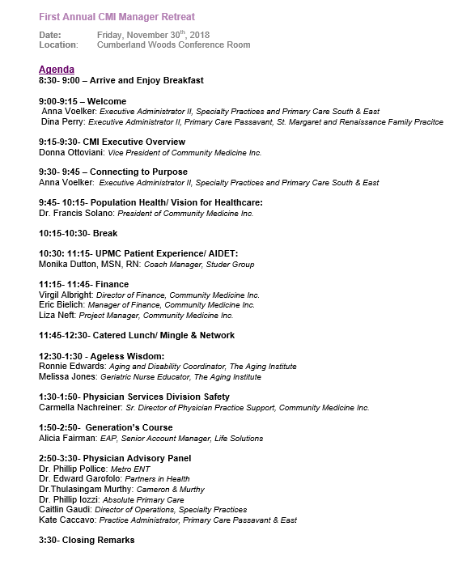

Figure 5: Manager Retreat Agenda

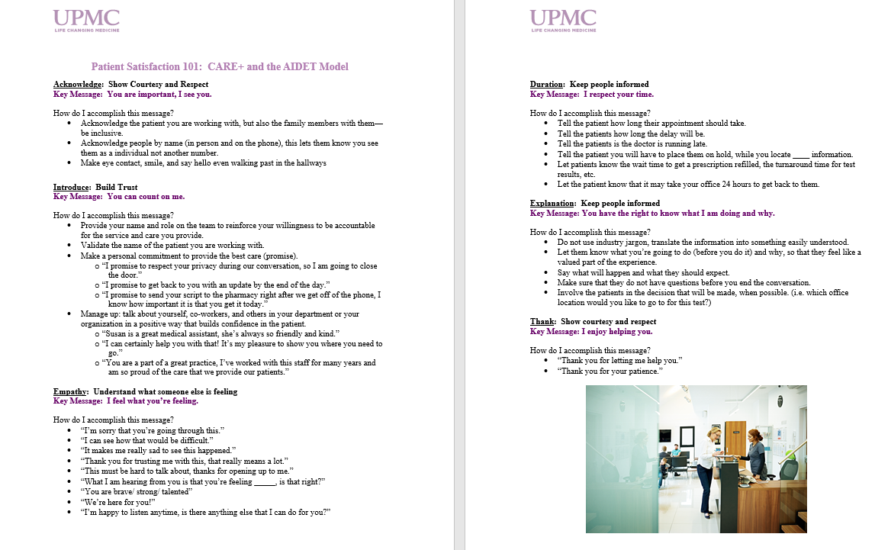

Figure 6: Patient Satisfaction 101 Handout

Bibliography
Bond, and Kupfer. “Patient Satisfaction and Patient-Centered Care Necessary but Not Equal.”
JAMA Network, 2012.
Cleveland Clinic. “Office of Patient Experience.” 2019.
https://my.clevelandclinic.org/departments/patient-experience/depts/office-patient-experience.
Collomb, Jermone. “3 Customer-Centric Lessons from Amazon.” MyFeelBack, 2018.
https://www.myfeelback.com/en/blog/customer-centric-lessons-amazon
Grafstein, Dan. “3 Ways to Improve Your Employee and Customer Experience.” Gallup
February 2019.https://www.gallup.com/workplace/246572/ways-improve-employee-customerexperience.aspx?g_source=link_WWWV9&g_medium=TOPIC&g_campaign=item_&g_content=3%2520Ways%2520to%2520Improve%2520Your%2520Employee%2520and%2520Customer%2520Experience
Lee, Fred. “If Disney Ran Your Hospital: 9 1/2 Things You Would Do Differently.” Second
River Healthcare Press, 2004.
“Next Generation Patient Experience 2019.” Kaiser Permanente, 2019.
https://patientexperience.wbresearch.com/kaiser-permanente-using-health-hubs-to-test-patient-experience-innovation-ty-u
Prakash, Bhnau. Patient Satisfaction. NCIB, 2010.
Studer Group. “About Studer.” 2019. https://www.studergroup.com/

