Title Page
The Effects of Soy Isoflavones on Arterial Stiffness: A Systematic Review and Meta-Analysis of Randomized Controlled Trials

by

Brian W. Man

BS, Health Information Management, University of Pittsburgh, 2017

Submitted to the Graduate Faculty of

the Department of Epidemiology

Graduate School of Public Health in partial fulfillment

of the requirements for the degree of

Master of Public Health

University of Pittsburgh

2019
Committee Membership Page
UNIVERSITY OF PITTSBURGH

Graduate School of Public Health

This essay is submitted

by

Brian W. Man

on

April 24, 2019

and approved by

Essay Advisor:

Akira Sekikawa, MD, MPH, PhD, PhD
Associate Professor
Department of Epidemiology
Graduate School of Public Health
University of Pittsburgh

Essay Readers:

Emma Barinas-Mitchell, PhD
Assistant Professor
Department of Epidemiology
Graduate School of Public Health
University of Pittsburgh

Yue-Fang Chang, PhD
Research Associate Professor
Department of Neurological Surgery
University of Pittsburgh

Copyright © by Brian W. Man

2019

Akira Sekikawa, MD, MPH, PhD, PhD

The Effects of Soy Isoflavones on Arterial Stiffness: A Systematic Review and Meta-Analysis of Randomized Controlled Trials

Brian W. Man, MPH

University of Pittsburgh, 2019

Abstract

Background: Recent studies indicate a possible association between soy isoflavones, a class of phytoestrogens, and arterial stiffness, a significant predictor of future cardiovascular events. We hypothesize that the supplementation of soy isoflavones compared to a placebo, would significantly reduce arterial stiffness.
Objective: To evaluate the effect of soy isoflavones on arterial stiffness through the qualitative and quantitative analysis of relevant randomized controlled trials (RCTs).
Methods: Selected studies were included in the systematic review process if they met the following criteria: participants were human subjects, primary treatment intervention was soy isoflavones, primary outcome was arterial stiffness, and the study was an RCT. Qualitative information extracted included study location, study design, sample size, population characteristics, intervention duration and dose, washout period, and the mean and standard deviation/error of baseline and after placebo or intervention. Studies of arterial stiffness based on pulse wave velocity (PWV), systemic arterial compliance (SAC), augmentation index (AI), and cardio-ankle vascular index (CAVI) were included in this review. Standardized mean difference (SMD) was used to synthesize the quantitative results. A subgroup analysis was conducted by intervention duration (<6 weeks vs. ≥6 weeks) and gender (women only vs. men only vs. combined).
Results: A significant association that favored the positive effect of soy isoflavones on arterial stiffness was observed (Overall SMD: -0.37, 95% CI: -0.53, -0.21, p-value<0.01). A statistically significant effect was seen for PWV (SMD: -0.38, 95% CI: -0.71, -0.05), SAC (SMD: -0.39, 95% CI: -0.68, -0.11), and CAVI (SMD: -0.43, 95% CI: -0.83, -0.02), but not AI (SMD: -0.36, 95% CI: -0.85, 0.13). The subgroup analysis showed no significant difference between treatment effects of soy isoflavones on arterial stiffness for intervention duration and gender.
Conclusion: Intake of soy isoflavones significantly reduced arterial stiffness. Therefore, soy isoflavones should be considered as a future intervention for arterial stiffness reduction.
Public Health Significance: Arterial stiffness has major health implications for its connection to various adverse cardiovascular outcomes such as hypertension, chronic kidney disease (CKD), coronary heart disease (CHD), stroke, dementia, and all-cause mortality.

Table of Contents
Preface ix
1.0 Introduction 1
2.0 Methods 3
2.1 Literature Search and Study Selection 3
2.2 Quality Assessment 4
2.3 Data Collection and Synthesis 4
3.0 Results 7
4.0 Discussion 9
Appendix A Tables and Figures 13
Appendix B Figure Legends 29
Bibliography 30
List of Tables
Table 1. Study Characteristics 18
Table 2. Study Outcome Measurements and Results 19
Table 3. Risk of Bias Assessment 20
Supplemental Table 1. Search Strategy....................................................................................... 27
List of Figures
Figure 1. Article Retrieval and Selection 14
Figure 2. Funnel Plot of Each Subgroup 15
Figure 3. Forest Plot of Each Measurement of Outcome 16
Figure 4. Subgroup Analuysis by Intervention Duration and Gender 17
Supplemental Figure 1a. Forest Plot of Each Measurement of Outcome Excluding Teede 2003 (Pulse Wave Velocity).................................................................................................................. 21
Supplemental Figure 1b. Forest Plot of Each Measurement of Outcome Excluding Richter 2017 (Pulse Wave Velocity).................................................................................................................. 22
Supplemental Figure 1c. Forest Plot of Each Measurement of Outcome Excluding Teede 2001 (Pulse Wave Velocity).................................................................................................................. 23
Supplemental Figure 1d. Forest Plot of Each Measurement of Outcome Excluding Teede 2003 (Systemic Arterial Compliance) .................................................................................................. 24
Supplemental Figure 1e. Forest Plot of Each Measurement of Outcome Excluding Teede 2001 (Systemic Arterial Compliance) .................................................................................................. 25
Supplemental Figure 1f. Forest Plot of Each Measurement of Outcome Excluding Richter 2017 (Augmentation Index) .................................................................................................................. 26

Preface
I would like to acknowledge the following individuals for their unique contributions to this research and Master’s essay. Special thanks to my essay readers Akira Sekikawa, MD, PhD, Emma Barinas-Mitchell, PhD, and Yuefang Chang, PhD. I would also like to convey great appreciation to Daisuke Sugiyama, MD, PhD and Xiao Zhang, MS for their significant work in various aspects of the research process. Lastly, I would like to express my deepest gratitude to my research mentor Akira Sekikawa, MD, PhD and Chendi Cui, MS for their constant guidance week in and week out along with their counsel and encouragement in all facets of the research.

Introduction
Arterial stiffness, also known as the loss of arterial elasticity, is closely associated with biological aging and therefore affects primarily middle to older populations. [1] As the human body ages over time, the elastin structures within the walls of arteries become frayed as a result of repeated cycles of mechanical stress. [1] The physical stiffening of arteries has major health implications for its connection to various adverse cardiovascular and other health outcomes such as hypertension, heart failure, chronic kidney disease (CKD), coronary heart disease (CHD), stroke, dementia, and all-cause mortality. [2-4]
Soy isoflavones, a class of phytoestrogens, are one of the richest sources of isoflavones in human diet. [5] Recent meta-analyses have suggested an inverse association of soy intake with cardiovascular risk factors such as improved blood pressure and cholesterol levels. [6-9] A recent observational study has also demonstrated a greater supplementation of soy isoflavones in Japanese men was associated with reduced arterial stiffness, independent of systemic inflammation. [10] This development in research has stimulated further interest into the effect of soy isoflavones on arterial stiffness, a significant predictor of future cardiovascular events independent of traditional cardiovascular risk factors. [3, 11, 12]
Randomized controlled trial (RCTs) have been conducted in recent years to study the effect of soy isoflavones on arterial stiffness. [13-21] However, the quantity of studies conducted remains limited and results have been inconsistent with some studies showing either a significant positive effect [13-15, 18, 20] or no significant effect. [16, 17, 19, 21] A recent systematic review conducted by Pase et al. examined dietary and nutrient interventions, including soy isoflavones, as a means of reducing arterial stiffness. They concluded that soy isoflavone supplementation was one of a few scientific methods of reducing arterial stiffness. [22] Our review aims to build upon this research by specifically investigating soy isoflavones as an intervention and performing a meta-analysis of RCTs.
The purpose of this systematic review and meta-analysis was to evaluate the effect of soy isoflavones on arterial stiffness through the qualitative and quantitative analysis of relevant RCTs. The hypothesis was that the supplementation of soy isoflavones through its various forms, compared to a placebo, would significantly reduce arterial stiffness. The public health significance of this research is to determine if soy isoflavones can be considered as a future intervention for arterial stiffness reduction to further minimize the risk of developing adverse cardiovascular outcomes such as hypertension, chronic kidney disease (CKD), coronary heart disease (CHD), stroke, dementia, and all-cause mortality.

Methods

Literature Search and Study Selection
The systematic review was conducted abiding by the Preferred Reporting Items for Systematic Reviews and Meta-Analyses guidelines and the protocol was registered with PROSPERO (CRD42019126128). [23] A search in PubMed, Embase, clinicaltrials.gov, and reference articles was performed using one or more of the following search terms for isoflavones (flavones, flavonoids, genistein, coumestrol, pterocarpans, daidzein, equol, soy, soya), arterial stiffness (vascular stiffness, elasticity, arterial pressure, blood pressure, pulse wave analysis, wave reflections, augmentation index, arterial compliance, cardio-ankle vascular index, carotid femoral pulse wave velocity, brachial ankle pulse wave velocity, pulse pressure, pulse wave velocity), and RCTs (randomized controlled trial, controlled clinical trials as topic, clinical trial, clinical study, placebos, double-blind method). (Supplemental Table 1) The search was limited to studies published between January 1966 through February 2019 in human subjects and in the English language.
Each of the selected studies were included in the systematic review process if they met the following criteria: participants were human subjects, primary treatment intervention was soy isoflavones, primary outcome was arterial stiffness, and the study was a RCT. A reference list of included articles and similar systematic reviews was also searched. However, no additional articles were included.
A review of titles, abstracts and full-texts of each article was conducted by five investigators (AS, BM, CC, DS, XZ) using a two-step method. The first step was a general approach as titles and abstracts that did not meet the inclusion criteria were screened out. The second step was more comprehensive as full texts of the remaining articles were thoroughly read and also excluded if they did not meet the inclusion criteria. Any discrepancies that arose during the screening process were discussed by all the investigators.

Quality Assessment
This assessment comprised of seven criteria including random sequence generation (selection bias), allocation concealment (selection bias), blinding of participants and personnel (performance bias), blinding of outcome assessment (detection bias), incomplete outcome data (attrition bias), selective reporting (reporting bias), and a category for other bias. [24] Investigators were able to input either high risk of bias, low risk of bias, or unclear risk of bias for each criteria under each study.

Data Collection and Synthesis
Information extracted from each article included year of publication, study location, study design, total sample size (number of women, number of men), study population characteristics (e.g., postmenopausal status, age, hypertensive status), intervention duration (weeks), intervention dose, washout period (weeks), and the mean and standard deviation/error of both at baseline and after placebo and treatment intervention. Measurement of outcome data was extracted for pulse wave velocity (PWV), systemic arterial compliance (SAC), augmentation index (AI), and cardio-ankle vascular index (CAVI).
A series of calculations were executed to standardize the data in terms of standard deviation (SD) as some articles reported standard error of mean (SE) or confidence intervals (CI). [24] Converting SE to SD was calculated by $SD=SE ×\sqrt{N}$ and converting 95% CI to SD was calculated by $SD=\sqrt{N} ×(upper limit-lower limit)/3.92$. [24] The mean change from baseline to after placebo or treatment was calculated by $\overline{X_{c}}= \overline{X_{a}}- \overline{X_{b}}$, and the standard deviation of change was calculated by $S_{c}=\sqrt{S_{a}^{2}\text{+ }S_{b}^{2}-2*corr*S_{a}*S_{b}}$. [24] For one article (Tormala 2008), data was given separately in terms of equol producers and non-equol producers. [19] Therefore, combining both data into one mean and standard deviation was calculated by $\overline{X_{c}}= \frac{{(N}_{a} × \overline{X_{a}}) + {(N}_{b} ×\overline{{ X}_{b}})}{{(N}_{a}+ N_{b })}$ and $SD=\sqrt{\frac{\left(N_{a}-1\right){SD}_{a}^{2}+\left(N_{b}-1\right){SD}_{b}^{2}+ \frac{N_{a}N_{b}}{N_{a}+ N_{b}} ( {\overline{X_{a}}}_{}^{2}+ {\overline{X_{b}}}_{}^{2}-2\overline{X_{a}}\overline{X_{b}} )}{{(N}_{a}+{ N}_{b}-1)}}$. [24]
The standardized mean difference (SMD) was used to synthesize the results, which was $SMD= \frac{\overline{X_{treatment}}- \overline{X_{control}}}{S_{pooled}}$, where $S_{pooled}=\sqrt{\frac{\left(n_{treatment}-1\right)*S_{treatment}^{2}+\left(n_{control}-1\right)*S_{control}^{2}}{n_{treatment}+n_{control} }}$. [24] The outcome measurements were assessed in different ways. Results across all of the studies were standardized to a uniform scale before being combined. Therefore, the SMD demonstrated the size of the treatment effect relative to the variability observed for each study. A summary SMD statistic was calculated by a random effects model. For the systemic arterial compliance outcome, we multiplied its SMD by -1 to make the direction of results consistent with the other three outcomes. Therefore, negative values represented a positive effect of the treatment intervention. Heterogeneity of the studies was assessed and the I² statistic was calculated to describe the percentage of variation across each study that may be due to heterogeneity than chance. A forest plot was generated for each of the four measurements of outcomes individually before the data was pooled together for overall analyses. In addition, a funnel plot was generated to identify potential biases or systematic heterogeneity.
To assess whether the effect of soy isoflavones on arterial stiffness differed by various study characteristics, a subgroup analysis was conducted by intervention duration (<6 weeks vs. ≥6 weeks) and gender (women only vs. men only vs. combined). The SMD, 95% CI, and I² statistics were calculated and a forest plot was generated. A sensitivity analysis was also conducted to determine if there was a significant difference in overall SMD between the four measurements of outcomes. For the three studies with two outcome measurements, data for one measurement of outcome was removed at a time to determine its effect on overall results. [16-18] The removal process was then applied to the other outcome measurement. All analysis was conducted by Cochrane’s Review Manager 5 program with a significant p-value <0.05. [24]

Results
The initial search yielded a total of 998 citations (548 in PubMed, 449 in Embase, and 1 in clinicaltrials.gov). (Figure 1) After an initial exclusion of 90 duplicate articles, 908 citations were reviewed. Of the 908 remaining articles, 896 were excluded for the following reasons: not human subjects (n=127); unrelated to soy isoflavones (n=474); unrelated to arterial stiffness (n=184); and not a randomized controlled clinical trial (n=111). During the screening of the remaining twelve full-text articles, an additional three were excluded because the outcome studied was unrelated to arterial stiffness. These exclusions left nine articles for full review and assessment.
The study characteristics, outcome measurements and results are summarized in Tables 1 and 2. Seven studies were crossover design and had washout periods lasting 0 to 4 weeks [13-16, 18-20] while two studies were parallel design [17, 21]. Three studies included only women [14, 19, 21], one study included only men [13], and five studies included both women and men [15-18, 20]. Across all studies, there were 288 women and 209 men with participants primarily in their 40s and 50s. Though our publication search parameters were large (1966-2018), included studies were all published between 1997 and 2017. Three studies were based in the United States, three in Australia, while one study in each of Finland, Japan, and the United Kingdom. Intervention duration ranged from 24 hours to 12 weeks. Intervention dose ranged from 10 mg to 85 mg. Soy isoflavones were administered through either tablet, powder (beverage), or food (nuts) form.
The funnel plot of each of the four subgroup measurements of outcomes (PWV, SAC, AI, CAVI) showed a low risk of publication bias as most data points were precise and close to the center. (Figure 2) The primary result of the quality assessment showed an overall low risk of bias for each study. One study had three criteria with a high risk of bias [15] while the other eight studies had either one [16, 17, 20] or two [13, 14, 18, 19, 21] out of the seven criteria. (Table 3) The two parallel design trials had a higher risk of performance bias. [17, 21] One study in particular only reported positive results for a subgroup (equol producers) at a specific time period rather than complete results over the entirety of the intervention period. [13]
Overall, the results showed a significant positive effect of soy isoflavones on arterial stiffness. (Figure 3) The overall SMD was -0.37 (95% CI: -0.53, -0.21). A statistically significant effect was seen for PWV (SMD: -0.38, 95% CI: -0.71, -0.05), SAC (SMD: -0.39, 95% CI: -0.68, -0.11), and CAVI (SMD: -0.43, 95% CI: -0.83, -0.02). However, no significant effect was found for AI (SMD: -0.36, 95% CI: -0.85, 0.13). The overall I² was 35%, which indicated low to medium heterogeneity among these studies.
The subgroup analysis showed no significant difference in treatment effects of soy isoflavones on arterial stiffness by intervention duration (<6 weeks and ≥6 weeks) and gender (women only studies, combined gender studies, and the men only study). (Figure 4) Additionally, the sensitivity analysis showed no significant difference in overall SMD value between PWV, CAVI, AI, and SAC. (Supplemental Figure 1a through 1f)

Discussion
This systematic review and meta-analysis of RCTs found that supplementation of soy isoflavones significantly reduced arterial stiffness. The subgroup analysis revealed similar results as the treatment effect of soy isoflavones did not differ by intervention duration or gender. The sensitivity analysis also showed no significant difference among the four measurement of outcomes leading to the same conclusion of a beneficial effect of soy isoflavones on arterial stiffness. This study is the first systematic review and meta-analysis to assess the effect of soy isoflavones on arterial stiffness.
The potential risk of bias among included RCTs was minimal as a majority of criteria were marked as low risk of bias. However, possible explanations for some studies marked as high risk of bias were warranted. A few studies experienced participant withdrawals which could have led to a higher risk of attrition bias. [13, 16] In the Hazim et al. study [13], incomplete data could have led to a higher risk of reporting bias. Additionally, one study was funded by a pharmaceutical company. [20] Some limitations and differences between individual trials include small sample sizes, short intervention duration, varied intervention dose, characteristics between study population (gender, weight, equol producing), and modality of intervention (tablet, drink, nuts). This may have affected standardization when combining individual study results, but we accounted for this using a random effects model.
The rise of noninvasive methods has seen an increased usage of arterial stiffness measurements. [3, 11] PWV is the rate at which pressure waves, generated by the systolic contraction of the heart, moves along the arterial tree. [25] PWV is also known to predict cardiovascular end points independent of blood pressure and other risk factors such as diabetes, smoking, and blood lipid profile. [12] CAVI is a measurement that reflects the stiffness of the ascending aorta to the ankle arteries, largely independent of blood pressure. [26] SAC is measured by ultrasound as a relationship between pressure (carotid artery) and volume (outflow into aorta). [27] AI is a measurement derived from the ascending aortic pressure waveform. [28] Each of the four measurement of outcomes pointed towards a positive effect of soy isoflavones on the reduction of arterial stiffness. The significant effect of soy isoflavones was observed in PWV, CAVI, and SAC, but not in AI. Although no significant effect was seen with AI, it still showed a positive effect and the I² value for heterogeneity did not differ between each outcome. (Figure 3)
The biological mechanisms by which soy isoflavones reduce arterial stiffness are currently not well understood. However, there may be three possible explanations for this association including anti-inflammatory effects, atheroprotective qualities, and estrogenic effects. Current research suggests a link between inflammation and its role in the stiffening of large arteries as increased levels of inflammatory markers such as erythrocyte sedimentation rate, C-reactive protein, and interleukin-6 are associated with cardiovascular events. [29] Soy isoflavones are known to exert anti-inflammatory effects as it down-regulates cytokine-induced regulators, which are signaling molecules that mediate and regulate inflammation, in the immune system. [30] Secondly, a recent study based in Japan has suggested a significant inverse association between equol, a metabolite from daidzein, producers with coronary artery calcification, which is a biomarker of atherosclerosis. [31] This may suggest soy isoflavones to be a factor in atheroprotective properties. Additionally, soy isoflavones could also stimulate estrogenic activity through selectively binding to estrogen receptor-β (ER-β) expressed in the vasculature. [32] It has been demonstrated that ER-β has a critical, inhibitory effect on vascular smooth muscle cell (VSMC) proliferation. [33] VSMC proliferation is known to contribute to the etiology of various cardiovascular diseases. [34] Future research is needed to understand the mechanisms behind the potential anti-inflammatory, atheroprotective, and estrogenic effects of soy isoflavones and its further effect on reducing arterial stiffness.
In current research, arterial stiffness is recognized as an important factor in the pathophysiology of adverse cardiovascular outcomes such as CKD, CHD, stroke, and all-cause mortality. [3, 12] A study by Mattace-Raso et al. concluded that arterial stiffness, measured by PWV, is an independent predictor of CHD and stroke. [4] Recent studies have also found that greater arterial stiffness, measured by PWV, in elderly adults is significantly associated with 15-year risk of incident dementia and that arterial stiffness is significantly associated with the deposition of cerebral β -amyloid in the brain, which is associated with neurodegeneration. [2, 35, 36]
The current study results should be interpreted in light of several key strengths and limitations. Strengths include that the review was performed with a systematic methodology and the quantitative analysis standardized the results across each study. Previous systematic reviews in the same field have also provided a firm basis for our research. [22] Limitations of included RCTs have also impacted the current study. These include small sample sizes and short intervention periods. Because arterial stiffness and other adverse cardiovascular outcomes are chronic, a longer observation period is needed. Generalizability could not be applied to other areas including intervention duration, sample size and gender ratios, and washout periods. Additional limitations include differences in measurements of outcomes used in each study and therefore, the reflection of different arterial mechanisms. Furthermore, some outcome measurements (e.g., AI) may not be the ideal measure of arterial stiffness. Though some of these study characteristics vastly differed, the I² measurement for heterogeneity was consistently low to moderate. Also, attempts to reach out to authors of one study to clarify information and obtain additional results were not met with a response. [13]
This study revealed that soy isoflavones have a positive, significant effect towards reducing the stiffness of arteries than the control group. The public health significance is that with the known association between arterial stiffness and adverse health outcomes such as CKD, CHD, stroke, and all-cause mortality, soy isoflavones should be considered as a future intervention for arterial stiffness reduction to further minimize the risk of developing these disease outcomes. Future studies containing a greater sample size and diverse study population should implement longer intervention periods to evaluate the long-term clinical relevance of these results.

        - Tables and Figures
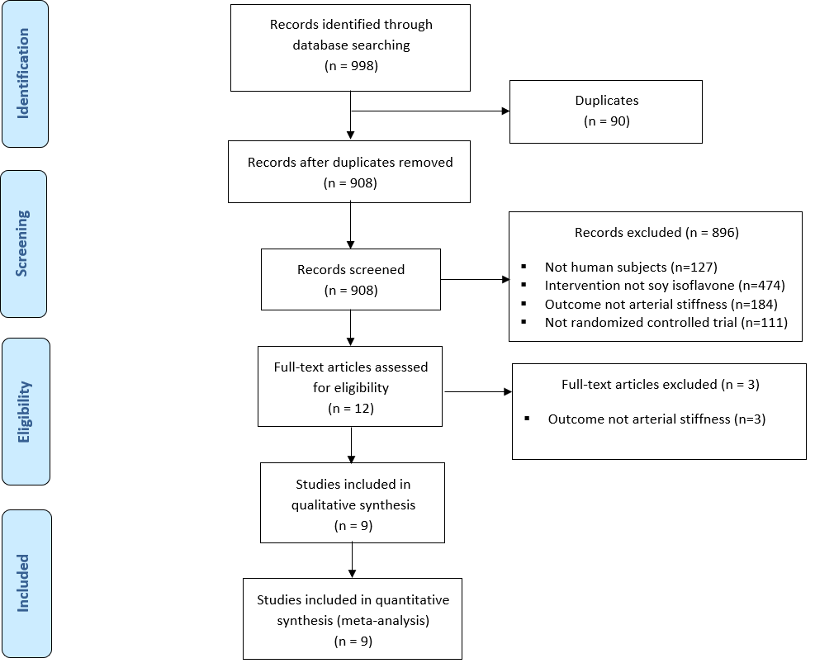

Figure 1. Article Retrieval and Selection

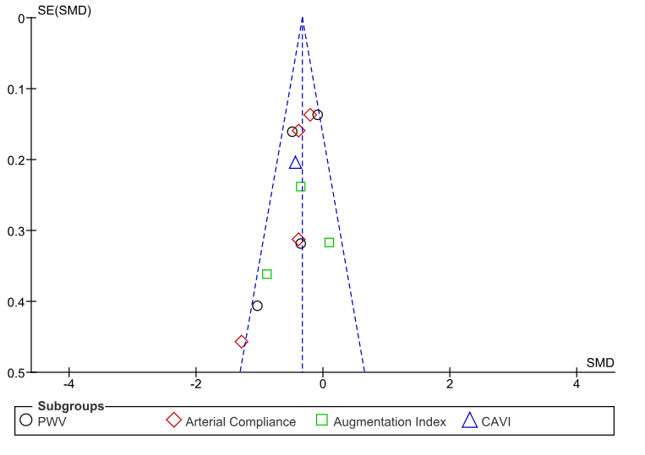

Figure 2. Funnel Plot of Each Subgroup
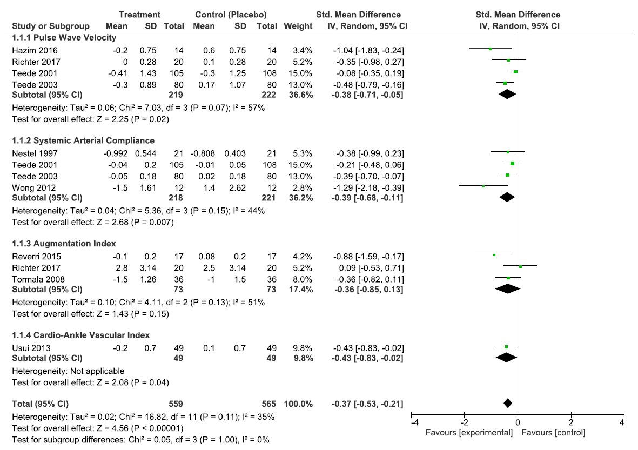
SD: Standard Deviation; IV: Inverse Variance; CI: Confidence Interval

Figure 3. Forest Plot of Each Measurement of Outcome
Source # studies I² SMD, 95% CIª

Duration
< 6 weeks 3 0% -0.70, (-1.10, -0.30)
≥ 6 weeks 6 28% -0.31, (-0.46, -0.16)

Gender
Women only 3 43% -0.56, (-1.04, -0.08)
Men only 1 N/A -1.04, (-1.83, -0.24)
Combined 5 22% -0.30, (-0.45, -0.15)

a: I²= statistical heterogeneity, SMD= standardized mean difference, CI= confidence interval

Figure 4. Subgroup Analysis by Intervention Duration and Gender

Table 1. Study Characteristics
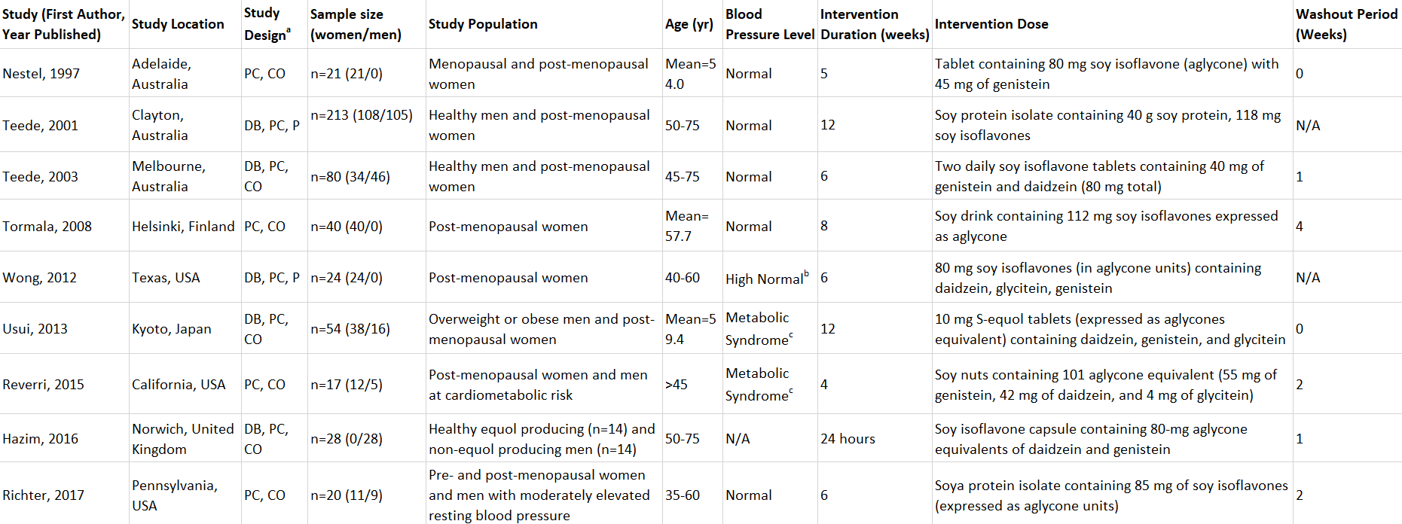
ª: DB: double-blind; PC: placebo-controlled; P: parallel design; CO: crossover design
^{b}: High normal: Systolic Blood Pressure: 130 -139 mmHg or Diastolic Blood Pressure: 85 -89mmHg
^{c}: Metabolic syndrome criteria: Systolic Blood Pressure >130 mmHg or Diastolic Blood Pressure> 85 mmHg

Table 2. Study Outcome Measurements and Results
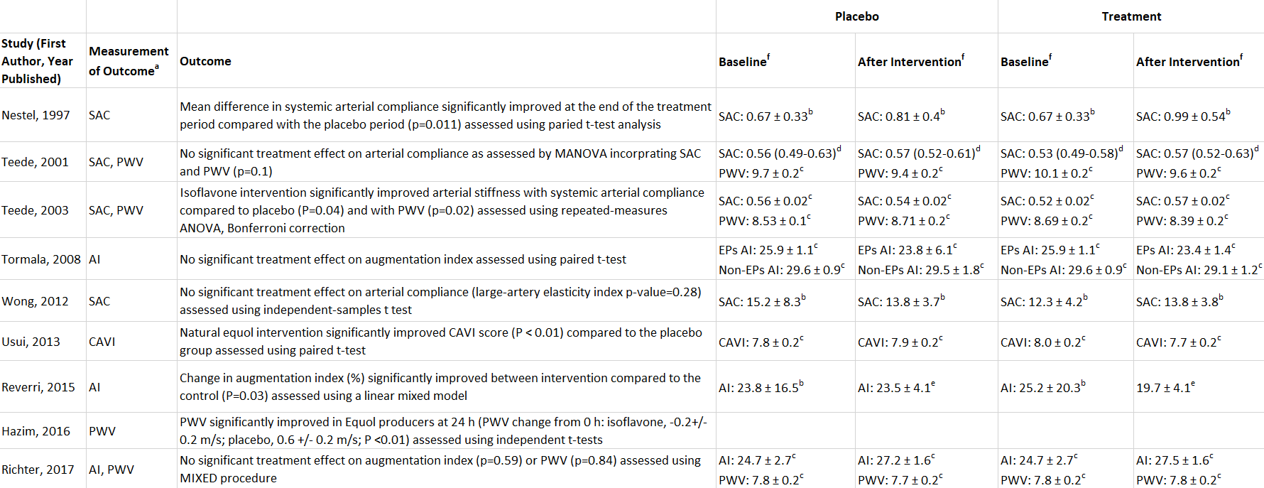
ª: SAC: systemic arterial compliance; PWV: pulse-wave velocity; AI: augmentation index; CAVI: cardio-ankle vascular index; EPs: equol producers; Non-EPs: non-equol producers
^{b}: mean ± standard deviation
^{c}: mean ± standard error of mean
^{d}: mean (confidence interval)
^{e}: least squares mean ± standard error of mean
^{f}: Units: SAC (mm/Hg), PWV (m/s), AI (%), CAVI (units)

Table 3. Risk of Bias Assessment
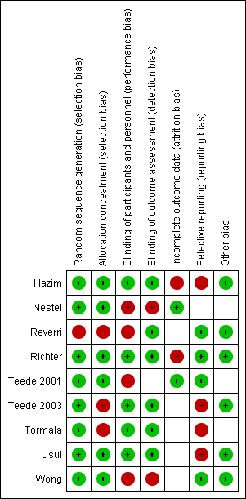

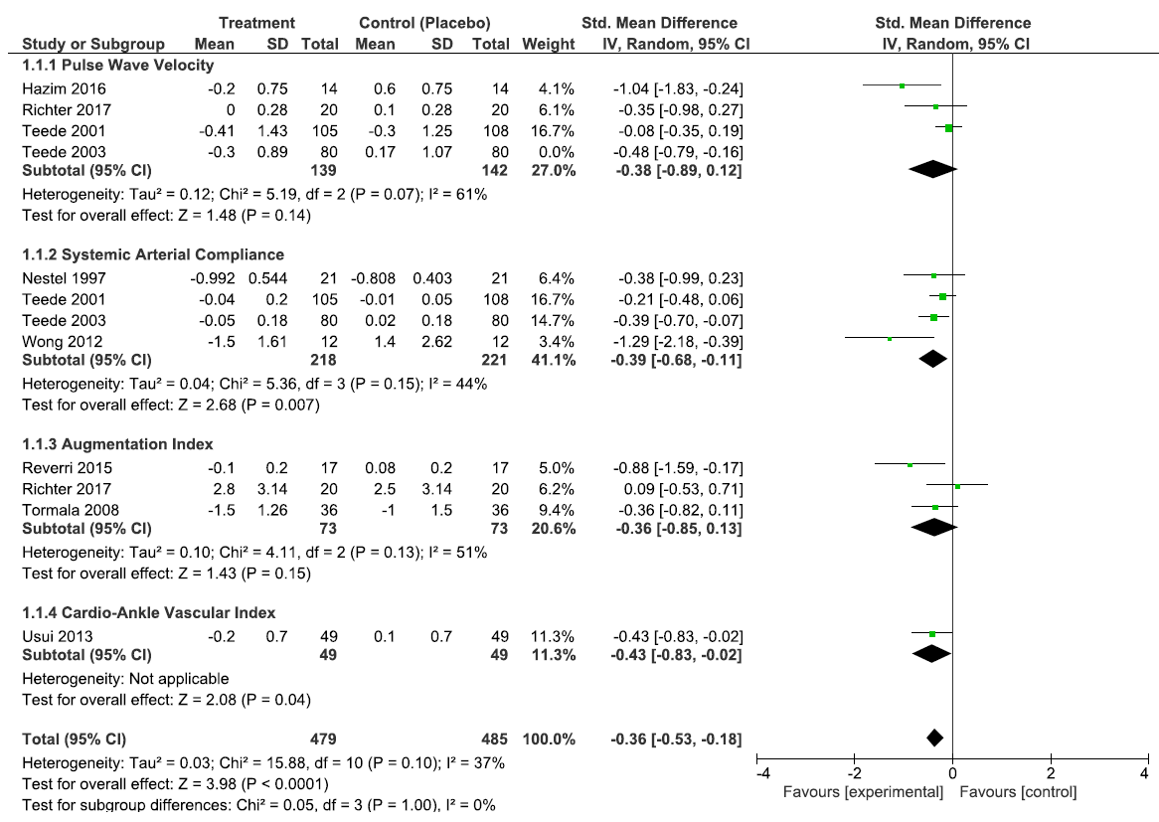

Supplemental Figure 1a. Forest Plot of Each Measurement of Outcome Excluding Teede 2003 (Pulse Wave Velocity)
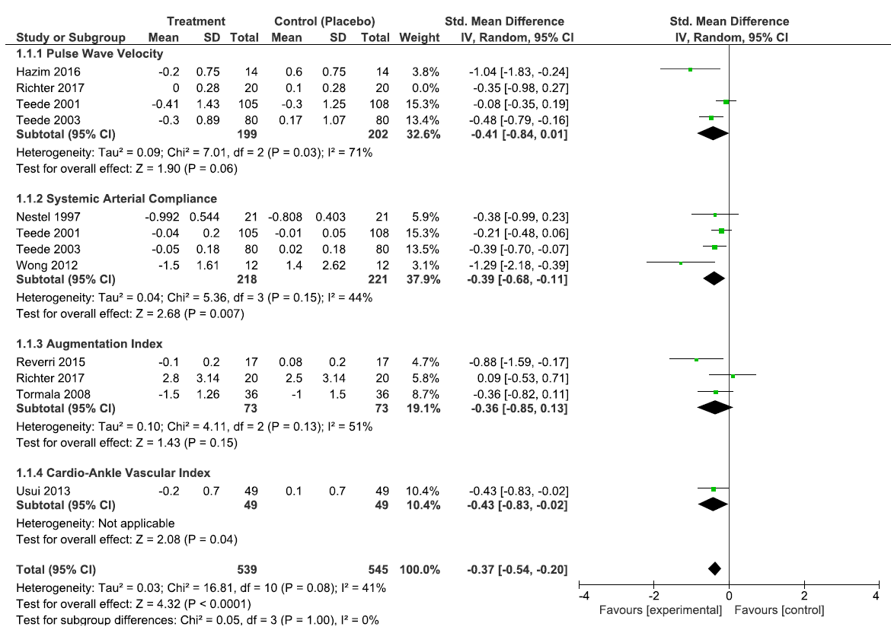

Supplemental Figure 1b. Forest Plot of Each Measurement of Outcome Excluding Richter 2017 (Pulse Wave Velocity)

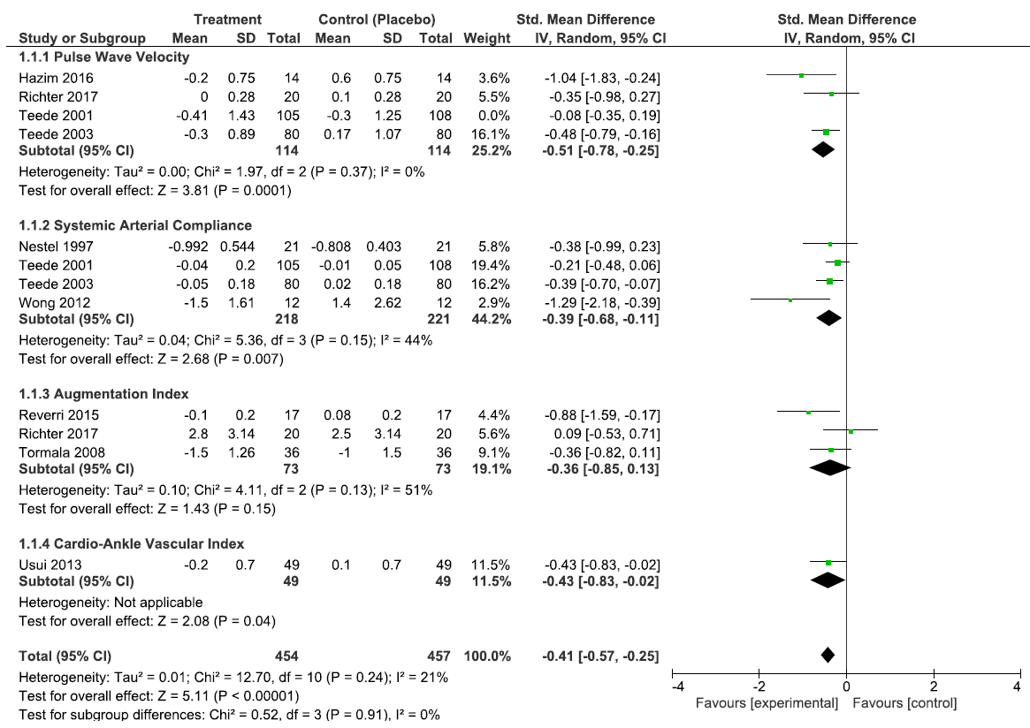

Supplemental Figure 1c. Forest Plot of Each Measurement of Outcome Excluding Teede 2001 (Pulse Wave Velocity)

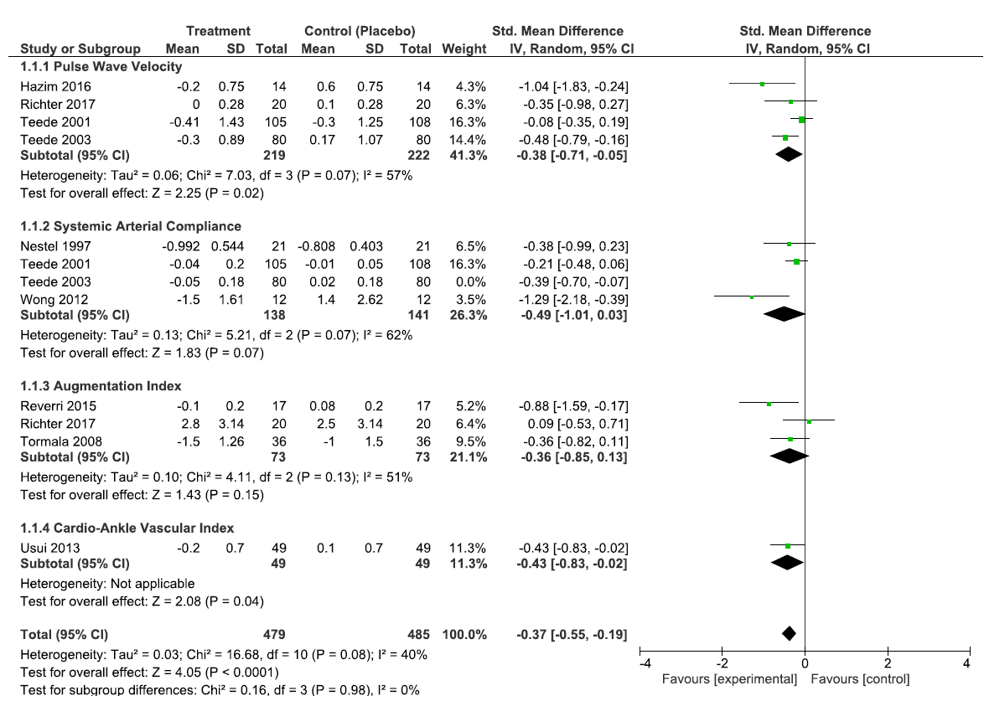

Supplemental Figure 1d. Forest Plot of Each Measurement of Outcome Excluding Teede 2003 (Systemic Arterial Compliance)

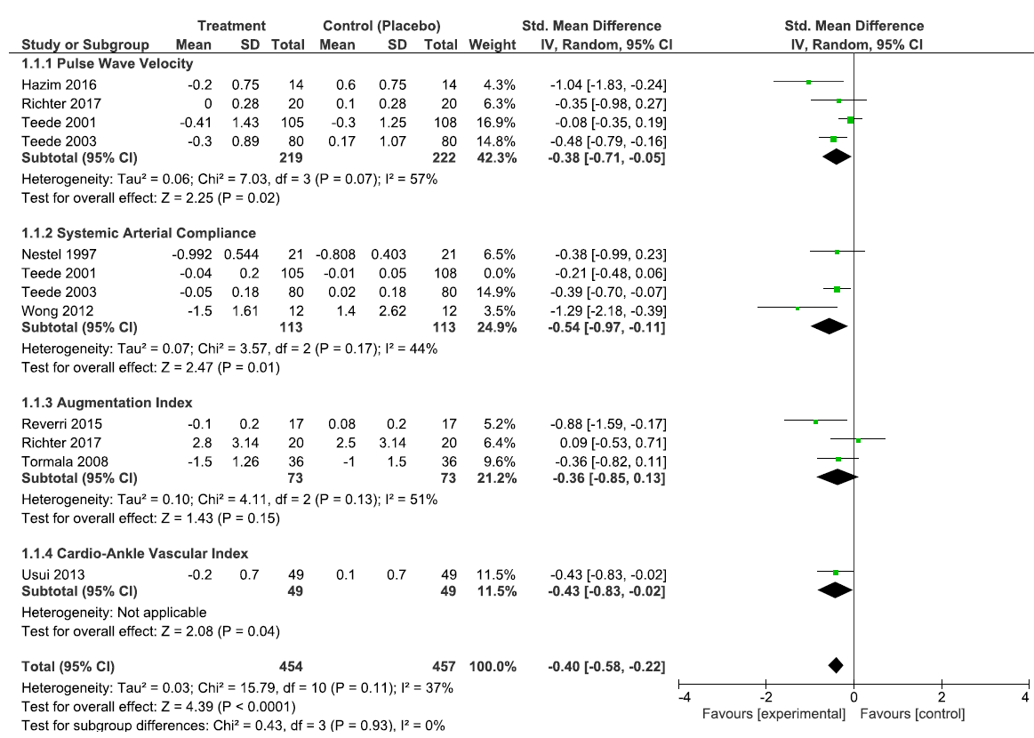

Supplemental Figure 1e. Forest Plot of Each Measurement of Outcome Excluding Teede 2001 (Systemic Arterial Compliance)

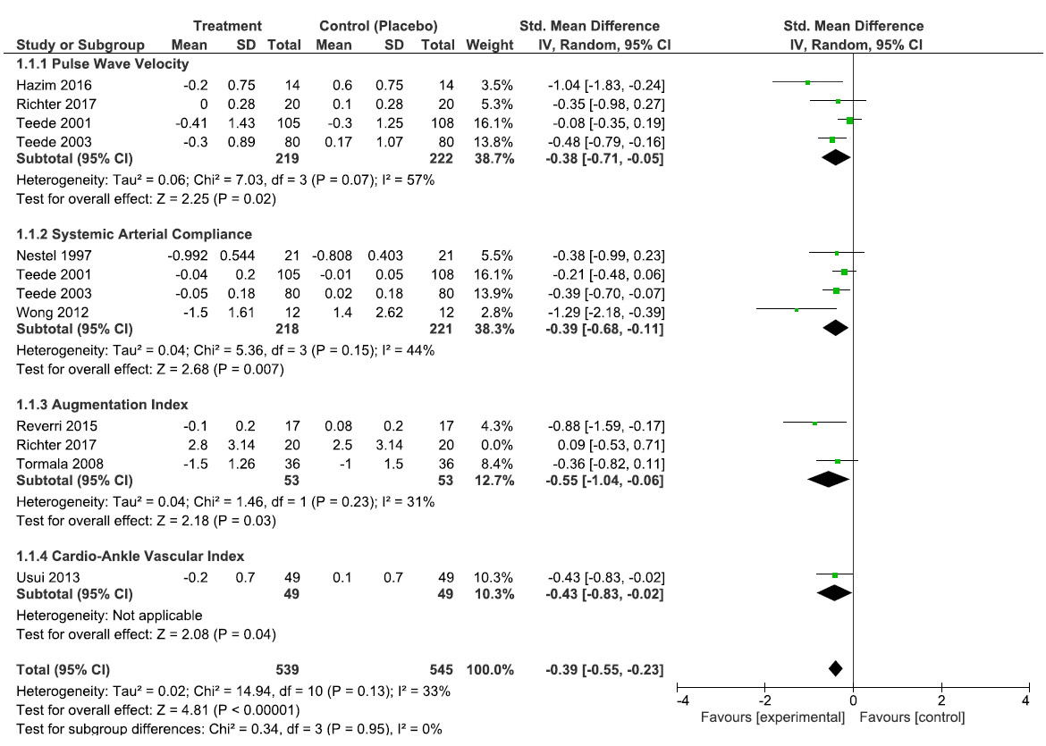

Supplemental Figure 1f. Forest Plot of Each Measurement of Outcome Excluding Richter 2017 (Augmentation Index)

Supplementary Table 1. Search Strategy
Query | Source | Results | Date
(isoflavones[MH] OR flavones[MH] OR flavonoids[MH] OR genistein[MH] OR coumestrol[MH] OR pterocarpans[MH] OR daidzein[MH] OR equol[MH] OR soy[TIAB] OR soya[TIAB]) | PubMed | 119553 | 2/23/19
(vascular stiffness[MH] OR elasticity[MH] OR arterial pressure[MH] OR blood pressure[MH] OR pulse wave analysis[MH] OR wave reflections[TIAB] OR augmentation index[TIAB] OR arterial compliance[TIAB] OR cardio-ankle vascular index[TIAB] OR carotid femoral pulse wave velocity[TIAB] OR brachial ankle pulse wave velocity[TIAB] OR pulse pressure[TIAB] OR pulse wave velocity[TIAB]) | PubMed | 349302 | 2/23/19
(randomized controlled trial[PT] OR controlled clinical trial[PT] OR clinical trial[PT] OR clinical study[PT] OR randomized[TIAB] OR placebo[TIAB] OR randomly[TIAB] OR trial[TIAB] OR blind[TIAB] OR groups[TIAB] OR controlled clinical trials as topic[MH] OR randomized controlled trial[MH] OR placebos[MH] OR double-blind method[MH]) | PubMed | 3110348 | 2/23/19
(isoflavones[MH] OR flavones[MH] OR flavonoids[MH] OR genistein[MH] OR coumestrol[MH] OR pterocarpans[MH] OR daidzein[MH] OR equol[MH] OR soy[TIAB] OR soya[TIAB]) AND (vascular stiffness[MH] OR elasticity[MH] OR arterial pressure[MH] OR blood pressure[MH] OR pulse wave analysis[MH] OR wave reflections[TIAB] OR augmentation index[TIAB] OR arterial compliance[TIAB] OR cardio-ankle vascular index[TIAB] OR carotid femoral pulse wave velocity[TIAB] OR brachial ankle pulse wave velocity[TIAB] OR pulse pressure[TIAB] OR pulse wave velocity[TIAB]) AND (randomized controlled trial[PT] OR controlled clinical trial[PT] OR clinical trial[PT] OR clinical study[PT] OR randomized[TIAB] OR placebo[TIAB] OR randomly[TIAB] OR trial[TIAB] OR blind[TIAB] OR groups[TIAB] OR controlled clinical trials as topic[MH] OR randomized controlled trial[MH] OR placebos[MH] OR double-blind method[MH]) | PubMed | 548 | 2/23/19
('isoflavone':ab,ti OR 'flavone':ab,ti OR 'flavonoid':ab,ti OR genistein:ab,ti OR 'coumestrol':ab,ti OR 'pterocarpans':ab,ti OR 'daidzein':ab,ti OR 'equol':ab,ti OR 'soybean':ab,ti OR 'isoflavone'/exp OR 'flavone'/exp OR 'flavonoid'/exp OR 'genistein'/exp OR 'coumestrol'/exp OR 'pterocarpan derivative'/exp OR 'daidzein'/exp OR 'equol'/exp OR 'soybean'/exp) | Embase | 194350 | 2/23/19

Supplemental Table 1 Continued
('arterial stiffness':ab,ti OR 'elasticity':ab,ti OR 'arterial pressure':ab,ti OR 'blood pressure':ab,ti OR 'pulse wave':ab,ti OR 'wave reflection':ab,ti OR 'augmentation index':ab,ti OR 'artery compliance':ab,ti OR 'cardio ankle vascular index':ab,ti OR 'carotid femoral pulse wave velocity':ab,ti OR 'brachial ankle pulse wave velocity':ab,ti OR 'pulse pressure':ab,ti OR 'arterial stiffness'/exp OR 'elasticity'/exp OR 'arterial pressure'/exp OR 'blood pressure'/exp OR 'pulse wave'/exp OR 'augmentation index'/exp OR 'artery compliance'/exp OR 'pulse pressure'/exp) | Embase | 768848 | 2/23/19
('randomized controlled trial':ab,ti OR 'controlled clinical trial':ab,ti OR 'controlled study':ab,ti OR 'clinical trial':ab,ti OR 'placebo':ab,ti OR 'clinical trial (topic)'/exp OR 'controlled clinical trial (topic)'/exp OR 'randomized controlled trial (topic)'/exp OR 'multicenter study (topic)'/exp OR 'phase 1 clinical trial (topic)'/exp OR 'phase 2 clinical trial (topic)'/exp OR 'phase 3 clinical trial (topic)'/exp OR 'phase 4 clinical trial (topic)'/exp) | Embase | 773867 | 2/23/19
('isoflavone':ab,ti OR 'flavone':ab,ti OR 'flavonoid':ab,ti OR genistein:ab,ti OR 'coumestrol':ab,ti OR 'pterocarpans':ab,ti OR 'daidzein':ab,ti OR 'equol':ab,ti OR 'soybean':ab,ti OR 'isoflavone'/exp OR 'flavone'/exp OR 'flavonoid'/exp OR 'genistein'/exp OR 'coumestrol'/exp OR 'pterocarpan derivative'/exp OR 'daidzein'/exp OR 'equol'/exp OR 'soybean'/exp) AND ('arterial stiffness':ab,ti OR 'elasticity':ab,ti OR 'arterial pressure':ab,ti OR 'blood pressure':ab,ti OR 'pulse wave':ab,ti OR 'wave reflection':ab,ti OR 'augmentation index':ab,ti OR 'artery compliance':ab,ti OR 'cardio ankle vascular index':ab,ti OR 'carotid femoral pulse wave velocity':ab,ti OR 'brachial ankle pulse wave velocity':ab,ti OR 'pulse pressure':ab,ti OR 'arterial stiffness'/exp OR 'elasticity'/exp OR 'arterial pressure'/exp OR 'blood pressure'/exp OR 'pulse wave'/exp OR 'augmentation index'/exp OR 'artery compliance'/exp OR 'pulse pressure'/exp) AND ('randomized controlled trial':ab,ti OR 'controlled clinical trial':ab,ti OR 'controlled study':ab,ti OR 'clinical trial':ab,ti OR 'placebo':ab,ti OR 'clinical trial (topic)'/exp OR 'controlled clinical trial (topic)'/exp OR 'randomized controlled trial (topic)'/exp OR 'multicenter study (topic)'/exp OR 'phase 1 clinical trial (topic)'/exp OR 'phase 2 clinical trial (topic)'/exp OR 'phase 3 clinical trial (topic)'/exp OR 'phase 4 clinical trial (topic)'/exp) | Embase | 449 | 2/23/19
Condition or disease: Cardiovascular Disease  Other terms: Soy Isoflavone | Clinicaltrials.gov | 15 | 2/23/19

        - Figure Legends
Figure 1. Flowchart documenting the process of article selection through identification, screening, exclusion, and inclusion phases. (Fig 1)
Figure 2. Funnel plot of each of the four subgroup measurements of outcomes (pulse wave velocity, arterial compliance, augmentation index, cardio-ankle vascular index score) to identify potential publication bias. (Fig 3)
Figure 3. Standardized mean difference (SMD) in arterial stiffness was presented for each study, displayed by four measurements of outcomes (pulse wave velocity, arterial compliance, augmentation index, cardio-ankle vascular index score). The summary SMD was calculated by a random effects model. (Fig 2)
Figure 4. Subgroup analysis by intervention duration and gender was calculated with the SMD and 95% CI and displayed by a forest plot. (Fig 4)
Supplemental Figure 1a-f. Standardized mean difference (SMD) in arterial stiffness was presented for each study, displayed by four measurements of outcomes. Studies with multiple measurements of outcomes were removed individually to determine their effect on overall results. The summary SMD was calculated by a random effects model. (Sup 1)

Bibliography
1. Townsend, R.R., et al., Recommendations for Improving and Standardizing Vascular Research on Arterial Stiffness: A Scientific Statement From the American Heart Association. Hypertension, 2015. 66(3): p. 698-722.
2. Cui, C., et al., Aortic Stiffness is Associated with Increased Risk of Incident Dementia in Older Adults. J Alzheimers Dis, 2018. 66(1): p. 297-306.
3. Vlachopoulos, C., K. Aznaouridis, and C. Stefanadis, Prediction of cardiovascular events and all-cause mortality with arterial stiffness: a systematic review and meta-analysis. J Am Coll Cardiol, 2010. 55(13): p. 1318-27.
4. Mattace-Raso, F.U., et al., Arterial stiffness and risk of coronary heart disease and stroke: the Rotterdam Study. Circulation, 2006. 113(5): p. 657-63.
5. Messina, M., Soy and Health Update: Evaluation of the Clinical and Epidemiologic Literature. Nutrients, 2016. 8(12).
6. Wang, Q., et al., Soy isoflavone: The multipurpose phytochemical (Review). Biomed Rep, 2013. 1(5): p. 697-701.
7. Taku, K., et al., Soy isoflavones lower serum total and LDL cholesterol in humans: a meta-analysis of 11 randomized controlled trials. Am J Clin Nutr, 2007. 85(4): p. 1148-56.
8. Liu, X.X., et al., Effect of soy isoflavones on blood pressure: a meta-analysis of randomized controlled trials. Nutr Metab Cardiovasc Dis, 2012. 22(6): p. 463-70.
9. Zhuo, X.G., M.K. Melby, and S. Watanabe, Soy isoflavone intake lowers serum LDL cholesterol: a meta-analysis of 8 randomized controlled trials in humans. J Nutr, 2004. 134(9): p. 2395-400.
10. Uemura, H., et al., Inverse association between soy food consumption, especially fermented soy products intake and soy isoflavone, and arterial stiffness in Japanese men. Sci Rep, 2018. 8(1): p. 9667.
11. Ohkuma, T., et al., Brachial-Ankle Pulse Wave Velocity and the Risk Prediction of Cardiovascular Disease: An Individual Participant Data Meta-Analysis. Hypertension, 2017. 69(6): p. 1045-1052.
12. Vlachopoulos, C., et al., Prediction of cardiovascular events and all-cause mortality with brachial-ankle elasticity index: a systematic review and meta-analysis. Hypertension, 2012. 60(2): p. 556-62.
13. Hazim, S., et al., Acute benefits of the microbial-derived isoflavone metabolite equol on arterial stiffness in men prospectively recruited according to equol producer phenotype: A double-blind randomized controlled trial. American Journal of Clinical Nutrition, 2016. 103(3): p. 694-702.
14. Nestel, P.J., et al., Soy isoflavones improve systemic arterial compliance but not plasma lipids in menopausal and perimenopausal women. Arteriosclerosis, Thrombosis, and Vascular Biology, 1997. 17(12): p. 3392-3398.
15. Reverri, E.J., et al., Soy provides modest benefits on endothelial function without affecting inflammatory biomarkers in adults at cardiometabolic risk. Mol Nutr Food Res, 2015. 59(2): p. 323-33.
16. Richter, C.K., et al., Effects of isoflavone-containing soya protein on ex vivo cholesterol efflux, vascular function and blood markers of CVD risk in adults with moderately elevated blood pressure: a dose-response randomised controlled trial. Br J Nutr, 2017. 117(10): p. 1403-1413.
17. Teede, H.J., et al., Dietary soy has both beneficial and potentially adverse cardiovascular effects: A placebo-controlled study in men and postmenopausal women. Journal of Clinical Endocrinology and Metabolism, 2001. 86(7): p. 3053-3060.
18. Teede, H.J., et al., Isoflavones reduce arterial stiffness: A placebo-controlled study in men and postmenopausal women. Arteriosclerosis, Thrombosis, and Vascular Biology, 2003. 23(6): p. 1066-1071.
19. Tormala, R., et al., Equol production capability is associated with favorable vascular function in postmenopausal women using tibolone; no effect with soy supplementation. Atherosclerosis, 2008. 198(1): p. 174-8.
20. Usui, T., et al., Effects of natural S-equol supplements on overweight or obesity and metabolic syndrome in the Japanese, based on sex and equol status. Clinical Endocrinology, 2013. 78(3): p. 365-372.
21. Wong, W.W., et al., Effect of soy isoflavone supplementation on nitric oxide metabolism and blood pressure in menopausal women. American Journal of Clinical Nutrition, 2012. 95(6): p. 1487-1494.
22. Pase, M.P., N.A. Grima, and J. Sarris, The effects of dietary and nutrient interventions on arterial stiffness: a systematic review. Am J Clin Nutr, 2011. 93(2): p. 446-54.
23. Preferred Reporting Items for Systematic Reviews and Meta-Analyses (PRISMA). 2015; Available from: http://www.prisma-statement.org/.
24. Collaboration, T.C., Cochrane Handbook for Systematic Reviews of Interventions Version 5.1.0, G.S. Higgins JPT, Editor. 2011 p. http://handbook.cochrane.org.
25. Pereira, T., C. Correia, and J. Cardoso, Novel Methods for Pulse Wave Velocity Measurement. J Med Biol Eng, 2015. 35(5): p. 555-565.
26. Matsushita, K., et al., Cardio-ankle vascular index and cardiovascular disease: Systematic review and meta-analysis of prospective and cross-sectional studies. J Clin Hypertens (Greenwich), 2019. 21(1): p. 16-24.
27. Laskey, W.K., et al., Estimation of total systemic arterial compliance in humans. J Appl Physiol (1985), 1990. 69(1): p. 112-9.
28. Wilkinson, I.B., et al., The influence of heart rate on augmentation index and central arterial pressure in humans. J Physiol, 2000. 525 Pt 1: p. 263-70.
29. Yu, J., et al., Isoflavones: Anti-Inflammatory Benefit and Possible Caveats. Nutrients, 2016. 8(6).
30. Chacko, B.K., et al., Revealing anti-inflammatory mechanisms of soy isoflavones by flow: modulation of leukocyte-endothelial cell interactions. Am J Physiol Heart Circ Physiol, 2005. 289(2): p. H908-15.
31. Ahuja, V., et al., Significant inverse association of equol-producer status with coronary artery calcification but not dietary isoflavones in healthy Japanese men. Br J Nutr, 2017. 117(2): p. 260-266.
32. Morito, K., et al., Interaction of phytoestrogens with estrogen receptors alpha and beta. Biol Pharm Bull, 2001. 24(4): p. 351-6.
33. Watanabe, T., et al., Estrogen receptor beta mediates the inhibitory effect of estradiol on vascular smooth muscle cell proliferation. Cardiovasc Res, 2003. 59(3): p. 734-44.
34. Wang, D., et al., Vascular smooth muscle cell proliferation as a therapeutic target. Part 1: molecular targets and pathways. Biotechnol Adv, 2018. 36(6): p. 1586-1607.
35. Hughes, T.M., et al., Pulse wave velocity is associated with beta-amyloid deposition in the brains of very elderly adults. Neurology, 2013. 81(19): p. 1711-8.
36. Hughes, T.M., et al., Arterial stiffness and beta-amyloid progression in nondemented elderly adults. JAMA Neurol, 2014. 71(5): p. 562-8.

