**Optimizing Hospital Stock Room and Operating Room Supply Chain Through Automation and Simulation**

by

**John Cordier**

BS, BA University of Pittsburgh, 2014, 2014

Submitted to the Graduate Faculty of

Health Policy and Management

Graduate School of Public Health in partial fulfillment

of the requirements for the degree of

Master of Health Administration

University of Pittsburgh

2019

Committee Membership Page

UNIVERSITY OF PITTSBURGH

Graduate School of Public Health

This essay is submitted

by

**John Cordier**

on

April 26, 2019

and approved by

**Essay Advisor:** Mark Roberts, MD, MPP, Department Chair, Health Policy and Management, Graduate School of Public Health, University of Pittsburgh

**Essay Reader:** Haimanti Banerjee, PhD, Clinical Assistant Professor, Marketing and Business Economics, Katz Graduate School of Business, University of Pittsburgh

Copyright © by John Cordier

2019

Abstract

Mark Roberts, MD, MPP

**Optimizing Hospital Stock Room and Operating Room Supply Chain Through Automation and Simulation**

John Cordier, MHA

University of Pittsburgh, 2019

**Abstract**

The supply rooms serving an operating room suite at a hospital have to provide equipment and supplies for procedures every day. The public health importance of having the right equipment and supplies in the stock room is critical to the efforts of any surgical procedure. Patients put their faith in the physician, physician assistants, nurses, and other members of the surgical team with the expectation that they are going to do the best possible job in the operating room. The ability of the physician and his or her team to do their job to the best of their abilities is dependent on having the correct equipment and supplies to do the procedure. The inventory and supply chain management team are tasked with ensuring each surgical team is equipped with the right equipment and supplies for each procedure they perform. The number and diversity of procedures and the different practices of individual surgeons leads to a large number of different items that need to be stored in a limited space. This limited space is further stressed due to the presence of items that have not been in use for long periods of time. To improve the availability of goods for procedures and use of the stock room, operating room data analysis, process engineering, and inventory management methods from industrial engineering were applied to identify and organize operating room dedicated inventory items and create an inventory management policy. Inventory models were used to establish that the revised material handling and inventory policies will lead to improved availability of required items in the surgical suite.

Table of Contents

Preface viii

1.0 Introduction 1

1.1 Rationale for the Essay 2

1.2 Objectives for the Essay 3

2.0 Literature Review 4

3.0 Hypothesis 7

3.1 Expected Outcomes 7

4.0 Design, Methodology, and Data 8

4.1 Process Analysis 8

4.2 Material Handling and Inventory Simulation 8

4.3 Visual Cues 10

4.4 Dead Stock Identification 10

4.5 Inventory Location Analysis 11

5.0 Findings and Results 12

5.1 Process Improvements 12

5.2 Simulation of Inventory 14

5.3 Visual Cues 16

5.4 Dead Stock Identification 17

5.5 Items Without Locations Analysis 17

6.0 Analysis 18

6.1 Process Improvement 18

6.2 Simulation 18

6.3 Visual Cues 19

6.4 Dead Stock Identification 20

6.5 Items Without Locations Analysis 20

7.0 Discussion 21

8.0 Conclusion 23

Bibliography 24

List of Figures

Figure 1 Numerical assumptions for simulation model. 9

Figure 2 Spaghetti diagram showing current walking paths for workers replenishing O.R. supply room. 13

Figure 3 Spaghetti diagram showing walking paths for workers replenishing O.R. supply room based on proposed item locations. 13

Figure 4 Example of simulation model parameters for stock items. 14

Figure 5 Inventory cost reduction equation. 15

Figure 6 Inventory ordering policy optimization tool. 15

Figure 7 Example of visual cues for small items in bins. 16

Figure 8 Example of visual cue for large items. 16

Figure 9 Example report of items without assigned storage locations. 20

# Preface

This essay describes a project conducted at St. Clair Hospital in Pittsburgh, Pennsylvania. The design and execution of the study were performed in the spring and summer of 2018. The project was coordinated through the Health Systems Engineering Capstone course with the University of Pittsburgh Graduate School of Public Health and Swanson School of Engineering. The experience at St. Clair Hospital revealed common issues hospital experience related to inventory management. Excess inventory and dead stock items were wasting space and opportunities to decrease inventory costs to free up other capital. Dead stock refers to any item that has been on the shelf for over a year without being used. Another problem was wasted time during the restocking process of the supply rooms. The excess motion and lack of standardized procedures caused employees to waste time when they could be completing other tasks. The primary objective of the project was to help St. Clair Hospital reduce inventory on hand.

The methodology for this project required the use of industrial engineering principles learned through the certificate program. A process analysis, observations, and interviews with employees provided information about the issues St. Clair Hospital experienced. Through an analysis of process maps, visual cues, and spaghetti diagrams recommendations were provided on how to improve the operating room and stock room stocking and picking processes. An inventory level analysis enabled a simulation model to identify cost savings by identifying dead stock and reorder points.

# Introduction

St. Clair Hospital is a 328-bed community hospital in Mount Lebanon, PA that annually performs more than 11,000 surgical procedures. St. Clair Hospital is a member of the Mayo Clinic Care Network and prides itself on being rated in the top decile of hospitals in the areas of patient safety, clinical outcomes, patient satisfaction, and value. The hospital is known for its continuous efforts to enhance its services and technology to ensure its patients’ needs are met.

The Supply Chain Department at St. Clair Hospital has many responsibilities, including the inventory management of supplies used in the operating room (O.R.) that annually supports more than 11,000 surgical procedures. The supplies and equipment used in the O.R. are housed in one large primary supply room and multiple small supply rooms within the O.R. suite. To ensure the O.R. staff has access to the supplies and equipment they need; these rooms are replenished daily.

The Supply Chain Department at St. Clair Hospital did an examination of the historical O.R. supply room restocking process and identified potential opportunities for improvement. Some of the issues they identified to be improved included: non-standardized ways of managing inventory levels, difficulty finding items, unidentified dead stock, and space utilization in the O.R. supply rooms. These issues result in the O.R. supply rooms not facilitating ease of access for the necessary supplies for the O.R. and supply chain staff. The inefficiencies of the supply chain process resulted in a number of work arounds which included nurses having to go into the O.R. supply room for supplies during surgeries and high inventory costs.

To better understand how to improve the O.R. and stock room supply chain, the St. Clair Hospital partnered with the University of Pittsburgh’s Graduate School of Public Health and Swanson School of Engineering on a collaborative study to provide recommendations. The team from Pitt included two Masters of Health Administration students, two Industrial engineering students, and a Pitt faculty mentor. The project with St. Clair Hospital was to be completed over four months and deliver recommendations or tools on how to improve the O.R. supply chain processes at the hospital.

## Rationale for the Essay

Hospitals in the United States are being forced to tighten operating budgets.16 A volume-based approach to managing this trend manifests with hospitals attempting to do more with less. An alternative to evaluating and making changes to an operating budget by volume-based metrics, is to look at process improvement areas and other inefficiencies that cause excess waste.9 One major area that has come under scrutiny for excess waste in hospitals is the management of supplies and inventory. If a hospital is able to reduce the inventory on hand, it can have a positive financial impact. What this can enable a hospital to do, is reinvest the cost savings into activities that can generate more revenue.(2,12)

The positive financial impact is not the only reason for a hospital to improve supply chain efficiencies. When a hospital improves the efficiency of the supply chain, it is also looking out for the best interest of patients.(2,3,7) An improved supply chain can result in a higher quality of care for patients because clinicians have the equipment and supplies that they want, when and where they need it. This enables clinicians to focus on patient care rather than managing others or being daunted with the task of asking if there are enough of the size of scalpels to perform a particular procedure. Additionally, enhancing the supply chain minimizes the risk of error during a procedure because the correct equipment and supplies are being utilized. Further, when the clinical and supply chain staff work in tandem and they trust in one another, employees are happier, and patients receive better care.(2,8)

From a healthcare administrator’s perspective, the supply chain provides an essential function for running a hospital. Managing the large variety of items used by clinicians is a complex and variable duty of supply chain managers.16 If a decision related to the supply chain can make a positive financial impact, improve efficiency, decrease waste, and provide better care for patients, it is something an administrator must consider. The St. Clair Hospital case provides an opportunity to evaluate how to improve the supply chain of a hospital in the top decile of rankings across a number of operations and patient satisfaction categories. The study and outcomes from this case provide examples of how a hospital administrator can use industrial engineering principles and simulation to improve the management of equipment, supplies, and inventory at a hospital.

## Objectives for the Essay

The objectives of the essay are to provide a background on relevant O.R. stock room and supply chain issues hospitals experience, discuss the study, methods, and outcomes of a study of inventory management at St. Clair Hospital, and provide a discussion on the use of simulation as a management tool for healthcare administrators in supply chain and inventory management.

# Literature Review

As operating rooms are a financial hub in any hospital, accounting for 60-70% of revenue and around 40% of a hospital’s costs, administrators are pushed to maximize operating room efficiency.8 O.R. inefficiencies can be attributed to a long list of causes, that can include employee issues, material and supply management issues, limited technology, limited space, variation in operating room schedules, and impaired process flow.10 Managers are under increased pressure to reduce waste, standardize production steps, and lower personnel costs by adopting principles that for decades have been used in manufacturing in order to optimize O.R. efficiency.17 Operations research principles have been widely used to resolve O.R. scheduling and planning issues, but research into inventory management in a hospital setting is not as developed.8 Areas of increased scrutiny in operating room management include large inventory costs and variation in costs for the same operating room procedure. These two areas fall under the management of supply chain departments and depend on the supply chain department to work in tandem with clinical staff.

It is accepted that the role of the supply chain department at a hospital is to establish policies and systems to deliver equipment and supplies. Previous work in systems process analysis and simulation modeling have advanced inventory management in hospital settings. The Little and Coughlan note that supply chain policies must be reviewed and managers need to be prepared and anticipate changes to the supply chain based on adjustments to a hospitals infrastructure.12 By standardizing supply chain processes and utilizing simulation, costs can be controlled and variation in costs by procedure and waste can be decreased in the system. These methods of managing the supply chain result in positive financial outcomes and provide more value to patients.17

Hospitalshave limited space for supplies and inventory and store supplies across a number of locations.1 One way to improve supply and inventory management in the O.R. is to review and analyze the supply chain processes within a hospital.The most common systems to study in O.R. supply chain management are the stocking of supply rooms, space utilization, cost analysis by procedure by physician, use of pick carts, item location tracking, and visual cues.1 A study on inventory allocation revealed the most common way items are allocated is based on employee experience rather than an optimized method. The same study found that employee mediated allocation resulted in increased frequencies of nurses having to go between the O.R. and stock room during surgeries. This inefficiency not only wastes time, but increases the risk of infection for patients.1

In 2017, a study at a Wisconsin hospital showed surgical cost savings by recommending a standardized pick list for common procedures. In this study, the authors collected surgical supply data on laparoscopic cholecystectomy procedures for a 6-month period to develop a standard pick list for the procedure. For the next 6-months, surgeons used the suggested standardized pick list, which decreased the cost of disposable supplies per case by 32%.18 This study showed that even though surgeons have preferences for what supplies and equipment they use, that when the supply chain staff provides education and works with surgeons that cost savings can be achieved. Further, alternative visual cue and stocking models have been implemented to improve processes. 2-bin and 2-bin Kanban models showed evidence of improved processes and are now standard operating principles applied by managers for managing the inventory of medical supplies.11

A different method of increasing efficiencies in supply and inventory management use simulation models to identify optimal levels of inventory and cost savings. Simulation models use mathematical models to identify changes in inventory and demand then identify unused inventory to save costs. The method proposed by Little and Coughlan proposes a constraint-based model to determine optimal stock levels.12 Using simulation models, managers can meet the demand of supplies while reducing excessive inventory which increases working capital.14 Another study showed how simulation was able to reduce the number of reusable supplies in inventory by simulating the base-stock levels for stockouts.4 Tan and Karabati used a base-stock model to determine base-stock levels that maximized profits subjected to service level constraints.19 Another study recommends 10 guidelines for decreasing costs through supply chain management. The study found that improving supply room processes, utilizing data, and running simulations could result in annual inventory reductions of over $530,000. Other simulations have been used to determine the order quantity that minimizes the sum of purchase, orderings, and inventory costs for equipment.5

To add to the literature on simulation, automated software is another way to improve supply and inventory management in operating rooms. Integrating simulation tools into existing infrastructure that can automate ordering is yet another way managers can optimize the O.R. supply chain.(9,15) Automated inventory management systems have been shown to streamline the hospital supply chain. Through the implementation of automated systems, hospitals are able to lower the cost of inventory and free up cash to be redistributed. Hospitals that have implemented automated systems have shown to decrease time wasted by nurses going to and from stock rooms from the operating room.(2,4)

# Hypothesis

St. Clair Hospital has inefficiencies in their supply chain between the supply room, stock room, and inventory management system that lead to waste. Waste from the system manifests in the form of time moving and finding items, excess inventory, and dead stock. The waste caused by these inefficiencies create cost savings opportunities for St. Clair Hospital if they can be identified and policies or systems are implemented to reduce the inefficiencies in the future.

## Expected Outcomes

The most likely outcomes of the study will be that the St. Clair Hospital supply chain staff wastes time moving between the main stock room and O.R. supply room, dead stock will be found in the O.R. supply room, the process of using pick carts is not being optimized to save time, and the clinical staff has workarounds for getting supplies needed for procedures.

Alternative outcomes may include identifying manual process that are part of the process of identifying ordering points, that St. Clair Hospital has opportunities to improve space utilization in the O.R. supply room and in the stock room, and St. Clair Hospital will benefit from implementing an automated system for inventory management.

# Design, Methodology, and Data

The study uses a multi-method approach to study the St. Clair Hospital supply chain specifically with the O.R. stock room. The study was designed with the St. Clair Hospital supply chain manager and jointly overseen by a University of Pittsburgh faculty member to provide guidance on methods.

## Process Analysis

For the process analysis, the study began by interviewing supply chain staff to gain an understanding of the current stocking and picking processes. Specific questions related to the layout of the rooms, stocking of the O.R. supply room, how the pick carts are utilized, and what indicators are used for identifying when supplies need to be transferred between the stock room and O.R. supply room or when to order more supplies. The study will use process maps, interviews, and process observations to evaluate potential for improvement. The process analysis techniques applied include lean principles and analysis of value-added steps.

## Material Handling and Inventory Simulation

A simulation model was created in a Microsoft Excel spreadsheet using VBA to support decision making for selecting optimal reorder and order up to points. This model was created assuming an (s,S) model such that once the inventory drops below level s, it is reordered to level S. In order to test and validate the model, three data sources will be used. The following data sources were used in creating this simulation model:

* Inventory Audit Data – which represents the inventory on the shelf in the OR supply rooms on 2/28/18
* Purchase Order Data – which represents the purchasing data for non-stock items for the past year
* Storeroom Order Data – which represents ordering data for stock items from the central supply room for the past year

Many assumptions were used in the development of this simulation model. Changing these assumptions will change the output of the simulation model. As such, many of these assumptions were worked into the model such that they can change based on user input. For example, the assumed lead time of 0 or 2 days can be easily changed within the spreadsheet.The assumptions used in the model are shown in **Error! Reference source not found.**:

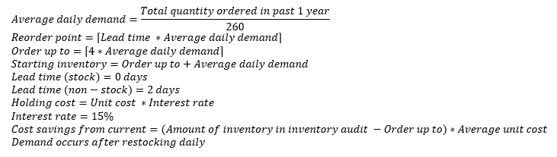

Figure 1 Numerical assumptions for simulation model.

## Visual Cues

The approach for assessing visual cues included assessing the processes outlined by the St. Clair Hospital supply chain staff and through observations. The objective of assessing visual cues is to make recommendations for simplifying ways for St. Clair supply chain staff to identify items in the O.R. supply rooms to be replenished, to reduce the need for counting, and to facilitate restocking to set order up to values.

## Dead Stock Identification

It was indicated by the Supply Chain department that there was an expected issue of unidentified dead stock in the O.R. supply rooms. Dead stock is defined as items which are currently sitting on the shelf in the O.R. supply rooms but have not been ordered in the past year. These are items which are infrequently used and may not need space in the OR supply rooms. In order to approach this issue, the following data was used:

* Inventory Audit Data – which represents the inventory on the shelf in the OR supply rooms on 2/28/18
* Purchase Order Data – which represents the purchasing data for non-stock items for the past year
* Storeroom Order Data – which represents ordering data for stock items from the central supply room for the past year

To identify dead stock, items which were present in the inventory audit data on 2/28/18 were compared to the ordering data. Items which were not ordered in the past year but were present in the audit data were flagged as dead stock. The supply chain staff support this method to identify dead stock.

## Inventory Location Analysis

The purpose of the items without locations analysis was to identify items which are frequently used in the O.R., but do not have a specified location in the O.R. supply rooms. These items would need to be requested and brought to the O.R. rooms separately from the normal flow of O.R. inventory. As such, providing frequently used items with a location in the O.R. supply rooms can reduce unnecessary flow of people and materials. This analysis used storeroom order data which included ordering data for stock items from the central supply room by the O.R. suite for the past year.

The approach of this analysis was to create a list of the items which have locations in the data listed as NA (i.e. not specified). From there, summary values, such as a count of the number of times the items were ordered, were collected. This list will be provided to the Supply Chain Department, so the items could be considered as candidates for locations in the O.R. supply rooms.

# Findings and Results

The study found five key areas for improvement that were consistent with the hypotheses and expected outcomes. An attempt to discuss the supply chain process with clinical staff and get clinical input was blocked by the manager of the project at St. Clair Hospital, but anecdotal evidence did reveal workarounds by nurses and physician assistants to get supplies from the O.R. stock room. The key findings confirmed the hypotheses and if each is addressed, there will be a positive financial impact.

## Process Improvements

In St. Clair Hospital, there is a main supply room with large storage areas that serves the hospital as a whole. The O.R. suite is also served by an O.R. supply room and additional smaller supply closets. On a daily basis, the O.R. suite staff reviews the supply requirements as presented by the surgical staff for the day’s scheduled procedures. These requirements can be met from the O.R. supply rooms, or through a special trip to the main supply room. When the day’s surgical procedures have been resourced, the O.R. supply rooms are restocked from the main supply room.

The current process does not promote a standardized put away process. Therefore, the employee restocks items based on the order he picks them from a large supply cart. The process currently used by the employee is depicted in Figure 2:

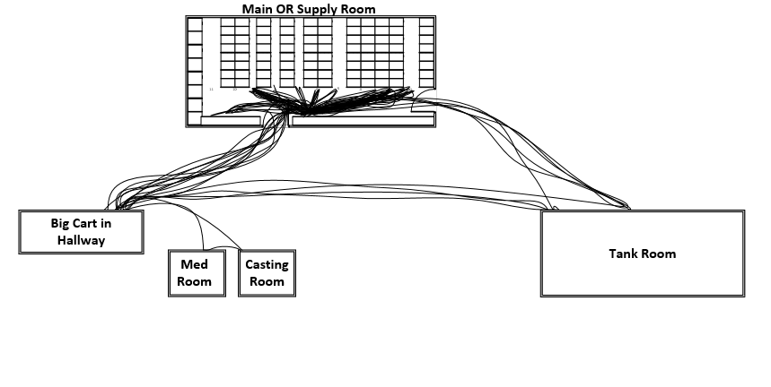

Figure 2 Spaghetti diagram showing current walking paths for workers replenishing O.R. supply room.

The result of this analysis is that a more efficient process would have these items organized before the put away process. The items could be placed into totes based on room or aisle. The improved process would reduce walking and is demonstrated in a spaghetti diagram in Figure 3:

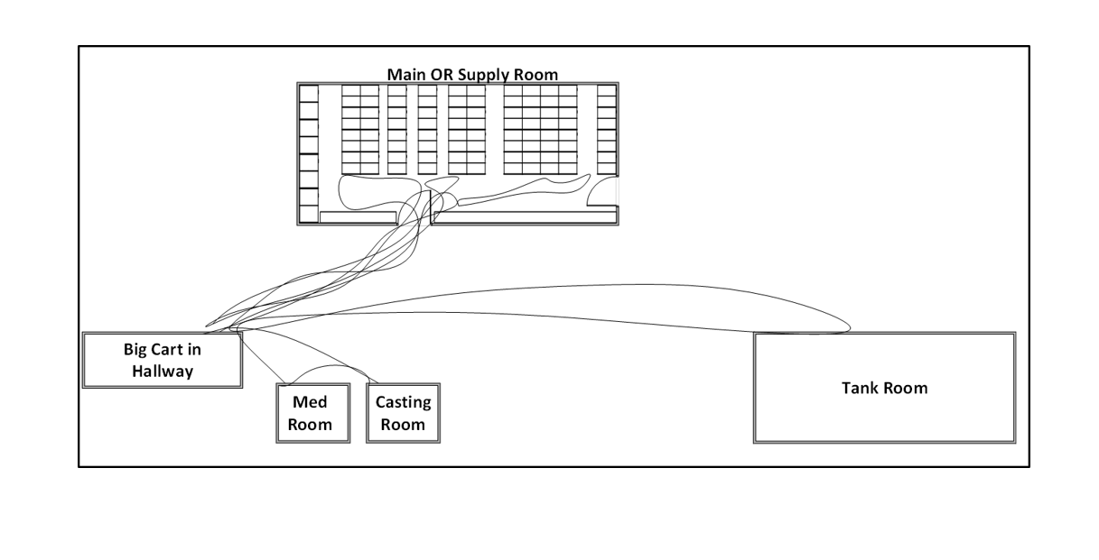

Figure 3 Spaghetti diagram showing walking paths for workers replenishing O.R. supply room based on proposed item locations.

The measured improvement for the process improvement for material handling is a 59% reduction in walking. The reduction of walking translates to cost savings because the employee can do the same work on a shorter shift. This improvement is visually represented with the spaghetti diagram. The quantitative result was calculated using observations compared to the recommended process.

## Simulation of Inventory

The purpose of creating the inventory simulation model was to support the Supply Chain Department's decision making when setting reorder points and order up to levels for supplies in the O.R. supply rooms. The final simulation model allows for the user to input the material code they are interested in simulating, as shown in Figure 4. There is also an option to enter a reorder point and order up to point (if nothing is entered, the value to test is calculated based on the order up to and reorder point equations shown in Figure 4.

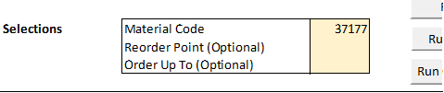

Figure 4 Example of simulation model parameters for stock items.

To find the optimal reorder point and order up to values, the user inputs a weight associated with restocks, stockouts, and the cost of holding. This is to give flexibility so that the user can determine which of these considerations are most important. For instance, for a very high value or physically large item, it might be important to reduce the cost of holding. On the other hand, for an item which would create a dire situation in the case of a stockout, a large weight might need to be placed on stockouts. From there, the model determines which combination of reorder points and order up to levels minimizes each of these considerations. Since the order up to value represents the maximum inventory of the item, this is then compared to current inventory level from the inventory audit on 2/28/18. This is multiplied by the average unit cost, to find the estimated savings of inventory on hand, as shown in Figure 5. An example of finding the optimal reorder point and order up to level can be found in Figure 6. As shown in Figure 6, a button gives the user the option to save the entry, which will then be logged into a new sheet to be used for later reference or comparison.



Figure 5 Inventory cost reduction equation.

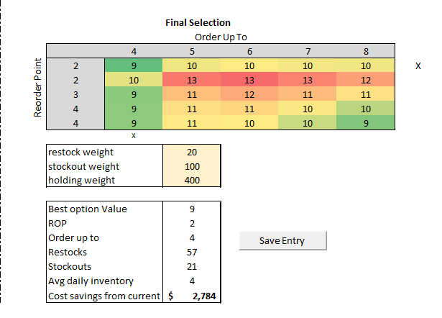

Figure 6 Inventory ordering policy optimization tool.

## Visual Cues

Based on observations of the O.R. supply rooms at St. Clair Hospital, it was found that many small items were kept in bins of various sizes. To facilitate identifying and using a set reorder point and order up to values, it is recommended to place a simple card inside of the bins to denote that the reorder point has been reached. This is illustrated in Figure 7:

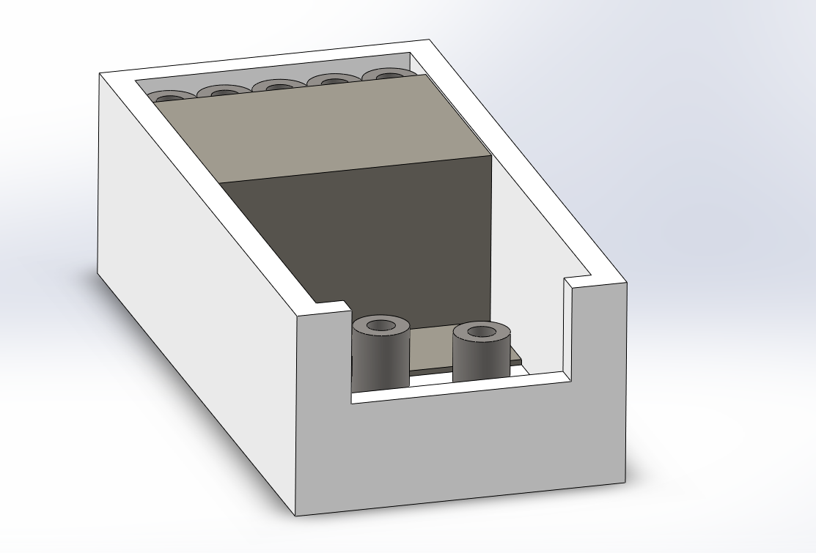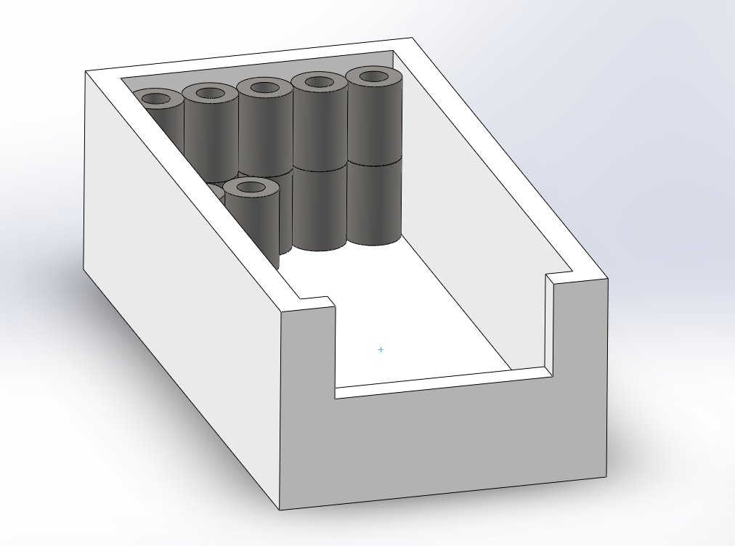

Figure 7 Example of visual cues for small items in bins.

For larger items which are not kept in bins, a parking lot style visual cue can be used for denoting order up to values and reorder points depicted in Figure 8:

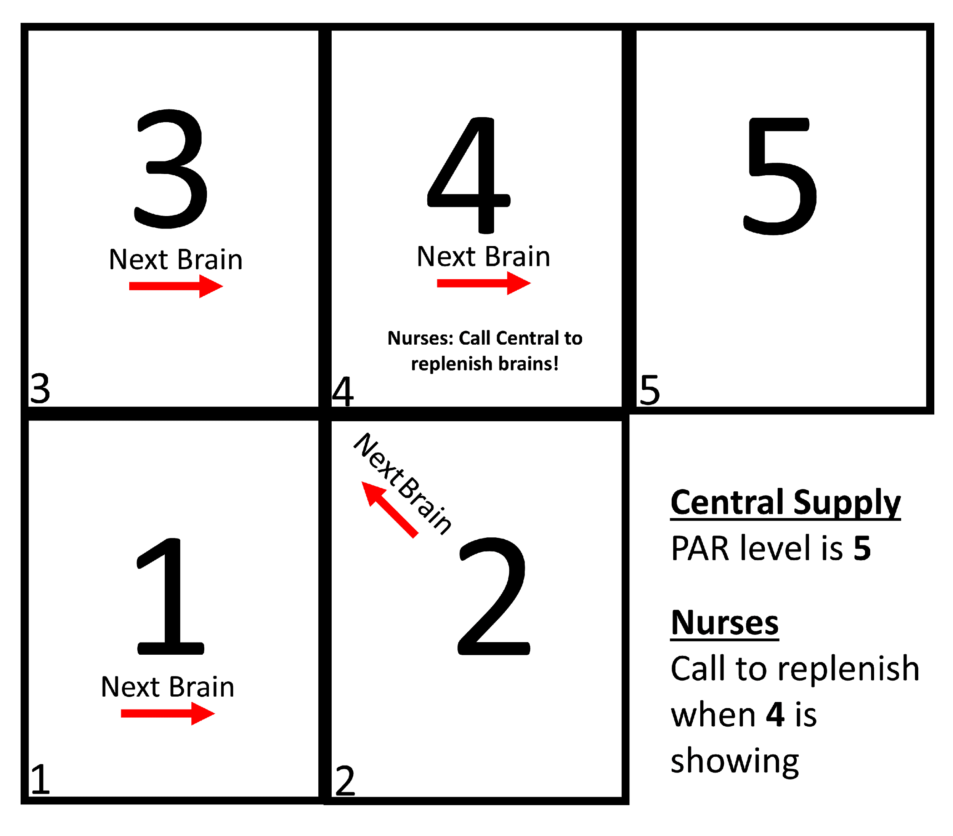

Figure 8 Example of visual cue for large items.

## Dead Stock Identification

The dead stock identification analysis was conducted in Microsoft Excel. The results of the analysis were that over 1,500 different items were identified as not having been ordered in the past year and flagged as dead stock, equating to 32% of the value of the value of the inventory in the O.R. supply rooms. This list can be reviewed for items that are used in procedures that are not performed or have been revised to not require those items, which can be removed, or if they are required for rare procedures. Items required for rare procedures can be moved out of the main O.R. supply room to one of the smaller supply closets or into the main hospital supply area.

## Items Without Locations Analysis

The final result of this analysis was a simple list of items which are ordered to the O.R. but do not have specified locations in the O.R. supply rooms. This list was created using pivot tables in Microsoft Excel. The Supply Chain Department can use this list to compare summary values for the various items, such as the number of times an item has been requested in the past year, and determine which items should be given standard locations.

# Analysis

St. Clair Hospital has several opportunities to improve the efficiency of their O.R. supply room processes and inventory management processes. If the simulation model is fully utilized, St. Clair Hospital will be able to save thousands if not millions of dollars by improving their inventory management system. Further, supply chain staff will be able to save time doing their daily tasks.

## Process Improvement

The analysis of the processes involved in stocking the O.R. supply room, utilizing pick carts, and locating items for the next day surgeries can all be improved. By reorganizing the pick carts and changing the location of the most used items by surgical area in the O.R. supply room, supply chain staff will save time by not going back and forth between the stock room and O.R. supply room. These findings are consistent with what is found in the literature and would be expected with a supply chain staff that has employees who have worked on the O.R. supply chain for over 20 years.

## Simulation

To demonstrate the potential for cost savings in the simulation model, an example will be detailed for a Ureteral Stent (6FRX26 Polaris, Material Code 37177). This is a non-stock item with an assumed lead time of two days, and an average unit cost of $139.20 per EA. As of the 2/28/18 inventory audit, there were 24 EA of this item on the shelf.

After running the simulation model (simulating 1,000 trials of one year for each of 25 combinations of order up to values and reorder points), it was found that the optimal order up to value is 8, with a reorder point of 4. This had an average of 0 stockouts and 42 restocks. When comparing the order up to value, which represents the theoretical maximum inventory level for this item, to the current inventory level, the excess 16 items correspond to a value of $2,227 which are currently on the shelf but do not need to be.

This is just one example of an item that could provide the Supply Chain Department an opportunity to reduce the amount of money tied up in inventory. By running this simulation for more of the high-value, frequently-used items, there is a large potential for inventory reduction.

## Visual Cues

The improvement of visual cues will improve the reorder and restock process. There is no exact quantitative value, but the visual cues will improve productivity by reducing the time spent on these processes. The card at the reorder point means the employee does not need to count the items in the bin if the quantity is larger than the reorder point. Also, the visual guide on the side of each aisle will help new employees save time because they will not need to search for items in the aisles one by one.

## Dead Stock Identification

The results of the dead stock identification analysis showed that 32% of the value of the stock in the O.R. supply rooms is expected to be dead stock, equating to about $765,000. As a result, removing these items has the potential of reducing the amount of money tied up in inventory by up to $765,000. Additionally, this has implications to freeing up space in the supply rooms for other items which are frequently used which can improve the stocking and picking processes.

## Items Without Locations Analysis

Figure 9 shows an example highlighting the top three items on the results list have been requested greater than 60 times in the past year but do not have a specified location in storage. Assuming that there are 260 workdays in the year (weekdays), this equates to greater than 23% of the days. Specifying locations for these items within the O.R. supply room would result in improvements in requesting these materials as well as the labor savings associated with moving the materials.

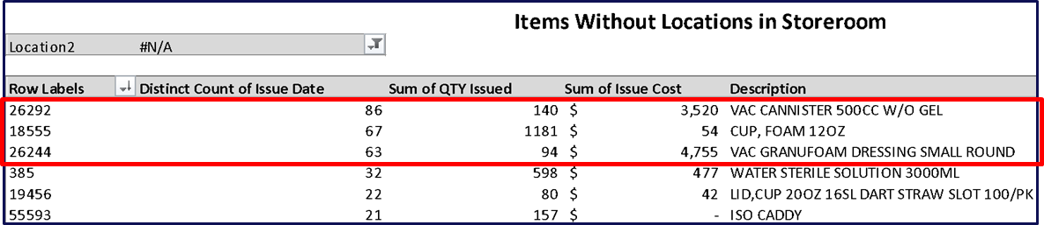

Figure 9 Example report of items without assigned storage locations.

# Discussion

The project worked with the Supply Chain Department at St. Clair Hospital and faculty at the University of Pittsburgh to identify issues and develop recommendations to improve the supply chain and inventory management at the hospital. Recommendations were given for many of the issues identified. Implementation strategies were also included for the recommendations discussed. Deliverables included a simulation model, process maps, and other charts that indicate potential savings and solutions.

The key action steps for St. Clair Hospital to take are to identify dead stock and relocate dead stock items to alternate storage areas, rearrange the O.R. supply room to increase the space for the most highly utilized items, identifying an area to store all items that currently do not have a location assigned to them, implement a system using visual cues for restock or reorder points, and use the inventory simulation to identify restock and reorder points based on PAR values.

The results of the study indicate that time and money can be saved though process improvements, inventory analysis, and use of the simulation model. The inefficient processes can be improved with a more standardized and organized approach to stock and pick items using small totes. Dead stock and items without locations were identified through inventory analysis. Also, a simulation model is able to determine optimal reorder points and order up to levels using input client data.

The use of simulation is shown to be a useful decision support technique for hospital administrators. If a simulation model is able to determine optimal reorder points and order up to levels and the model is integrated with other supply chain management software, it can save time for the manager by automating the ordering process. The use of simulation and automation make the system more reliable and gives managers the ability to focus on other issues rather than recurring tasks. The simulation model developed as part of this study can also be used by other supply chain managers to identify cost savings opportunities by reducing dead stock and excess inventory.

A limitation of the study was not involving the clinical staff. Knowing the workarounds and perspective from the clinical staff will be important when implementing changes to the O.R. supply room. If the clinical staff is reliant on themselves to retrieve supplies for procedures and the location of the supplies is changed, that is a major risk for the patient that can be avoided.

# Conclusion

The supply chain department at any hospital is an important component to the patient experience that is easily looked over. Tasked with equipping the clinical staff with the proper equipment and supplies for surgical procedures, supply chain departments enable a higher quality of care to be provided to patients. Additionally, as operating costs become more scrutinized, it is increasingly important for the supply chain staff to work with clinicians and utilize electronic health records and data to improve inventory management to save hospitals thousands to millions of dollars depending on the size of the organization.

Supply chain managers need to utilize industrial engineering principles to improve supply and inventory management procedures. The decision-making processes of supply chain managers can also be simplified using simulation models. The study provided evidence of financial benefits by using simulation models and analyzing current supply chain processes, especially those that do not involve automated processes and require significant employee effort.

St. Clair Hospital should not only implement new processes to stock the O.R. supply room, reorganize the O.R. supply room, and utilize the simulation model to improve inventory management, but consider two additional methods to optimize their inventory management system. First, the Supply Chain Department should consult with the clinical staff in the O.R. on what changes to the processes the clinical staff recommends. Second, automated technologies to include automated, weight-based inventory management systems should be evaluated by the Supply Chain Department as alternative solutions to improving their inventory management systems.

# Bibliography

1. Ahmadi, E., Masel, D. T., & Hostetler, S. (2019). A robust stochastic decision-making model for inventory allocation of surgical supplies to reduce logistics costs in hospitals: A case study. *Operations Research for Health Care,20*, 33-44. doi:10.1016/j.orhc.2018.09.001

2. Arndt, R. Z. (2018, July 26). Hospital supply inventory management creating a cottage industry for technology. Retrieved April 24, 2019, from https://www.modernhealthcare.com/article/20180728/TRANSFORMATION02/180729935/hospital-supply-inventory-management-creating-a-cottage-industry-for-technology

3. Bentley, T. G., Effros, R. M., Palar, K., & Keeler, E. B. (2008). Waste in the U.S. Health Care System: A Conceptual Framework. *Milbank Quarterly,86*(4), 629-659. doi:10.1111/j.1468-0009.2008.00537.x

4. Diamant, A., Milner, J., Quereshy, F., & Xu, B. (2017). Inventory management of reusable surgical supplies. *Health Care Management Science,21*(3), 439-459. doi:10.1007/s10729-017-9397-3

5. Fineman SJ, Kapadia AS (1978) An analysis of the logistics of supplying and processing sterilized items in hospitals. Comput Oper Res 5(1):47–54

6. Groover, M. P. *Work systems: The methods, measurement and management of work*. Pearson, 2014. Print.

7. Harrell, C. (1990). A simple process for controlling operating room specialized inventory. Hospital materiel management quarterly. 12. 65-8.

8. Healey, T., El-Othmani, M. M., Healey, J., Peterson, T. C., & Saleh, K. J. (2015). Improving Operating Room Efficiency, Part 1. *JBJS Reviews,3*(10), 1. doi:10.2106/jbjs.rvw.n.00109

9. Hospital Inventory Management. (n.d.). Retrieved April 24, 2019, from https://www.impinj.com/library/solution-briefs/hospital-inventory-management-arc-healthcare-technologies/

10. Inventory Management Concerns In The Healthcare Industry. (2017, December 19). Retrieved April 24, 2019, from http://www.waspbarcode.com/buzz/inventory-healthcare-industry/

11. Kanet, J., & Wells, C. (2018). Setting bin quantities for 2-Bin Kanban systems (version 3). *Omega*. doi:10.1016/j.omega.2018.08.010

12. Little, J., & Coughlan, B. (2008). Optimal inventory policy within hospital space constraints. *Health Care Management Science,11*(2), 177-183. doi:10.1007/s10729-008-9066-7

13. Nahmias, Steven and Tava L. Olsen. *Production and Operations Analysis.* Waveland Pr., 2015. Print.

14. Quereshy, F. A., & Milner, J. (2012). Quantitative Analysis of Operating Room Inventory Management Practices at a Tertiary Cancer Center. *Journal of Oncology Practice,8*(2), 68-69. doi:10.1200/jop.2011.000439

15. Reeves, C. (2019, January 15). 3 Essential Tips for Effective Hospital Inventory Management - Camcode. Retrieved April 24, 2019, from https://www.camcode.com/asset-tags/hospital-inventory-management/

16. Rosales, C. R., Magazine, M., & Rao, U. (2015). The 2Bin system for controlling medical supplies at point-of-use. *European Journal of Operational Research,243*(1), 271-280. doi:10.1016/j.ejor.2014.10.041

17. Rothstein, D. H., & Raval, M. V. (2018). Operating room efficiency. *Seminars in Pediatric Surgery,27*(2), 79-85. doi:10.1053/j.sempedsurg.2018.02.004

18. Simon, K. L., Frelich, M. J., & Gould, J. C. (2018). Picking apart surgical pick lists – Reducing variation to decrease surgical costs. *The American Journal of Surgery,215*(1), 19-22. doi:10.1016/j.amjsurg.2017.06.024

19. Tan B, Karabati S (2013) Retail inventory management with stock-out based dynamic demand substitution. Int J Prod Econ 145(1):78–87