SOCIODEMOGRAPHIC PREDICTORS OF MEASLES IMMUNIZATION EXEMPTION:
WASHINGTON STATE, 2013-2018

by
Xinying Liu
BMed in Public Health, Fudan University, China, 2017

Submitted to the Graduate Faculty of
Department of Epidemiology
Graduate School of Public Health in partial fulfillment
of the requirements for the degree of
Master of Public Health

University of Pittsburgh
2019

UNIVERSITY OF PITTSBURGH
GRADUATE SCHOOL OF PUBLIC HEALTH

This essay is submitted
by
Xinying Liu

on

April 26 2019
and approved by

Essay Advisor:
Wilbert van Panhuis, MD, PhD
Assistant Professor of Epidemiology and Biomedical Informatics
Department of Epidemiology
Graduate School of Public Health
University of Pittsburgh

Essay Reader:
Robert Krafty, PhD
Associate Professor
Department of Biostatistics
Graduate School of Public Health
University of Pittsburgh

Essay Reader:
Evelyn O Talbott, DrPH, MPH
Professor
Department of Epidemiology
Graduate School of Public Health
University of Pittsburgh

Copyright © by Xinying Liu
2019
ABSTRACT
Background: Measles immunization is one of the school-entry requirements in Washington State, but parents can exempt their children from immunization based on religious, personal- belief and medical reasons. Vaccine hesitancy is a growing issue in the United States. In the 2019 Washington measles outbreak, most cases were unvaccinated children.
Wilbert van Panhuis, MD, PhD

SOCIODEMOGRAPHIC PREDICTORS OF MEASLES IMMUNIZATION EXEMPTION:
WASHINGTON STATE, 2013-2018

Xinying Liu, MPH
University of Pittsburgh, 2019

Methods: We used 2013-2018 measles immunization exemption data from the Washington Department of Public Health to examine the change over time. We used spatial lag regression models to analyze the relationship between economical, race, education and population predictors and school districts-level measles exemption rates.
Results: The percentage of students with measles exemption increased to 4.10% in school year 2017-2018. In the spatial lag regression model, measles exemption rate increased with 2.94% for each 10000 USD increase in median household income ( 95%CI: 1.96%-3.41% ).
Conclusions: Measles exemptions for students in Washington are more common in areas with a higher income.
Public Health Relevance: The 2019 Washington measles outbreak brought concerns to measles vaccination exemptions. In recent years, the proportion of exemptions based on religious and personal belief is rising. But recent data and Washington data were little covered for research. We analyzed exemption data to help future immunization work.
TABLE OF CONTENTS
1.0 Introduction 1
2.0 METHODS 3
2.1 DATA 3
2.2 Mapping and plot 4
2.3 ordinary least squares 6
2.4 spatial lag model 10
2.5 software 10
3.0 RESULTS 11
3.1 basic information 11
3.2 ORDINARY LEAST SQUARES 14
3.3 spatial regression 15
4.0 DISCUSSION 17
4.1 Limitations 19
5.0 CONCLUSION 20
bibliographY 22
List of tables
Table 1. Association between measles exemption rate and predictors in ordinary least squares 7
Table 2. Results of heteroskedasticity tests in ordinary least squares 8
Table 3. Results of spatial dependence tests in ordinary least squares 9
Table 4. Characteristics of School Districts: Washington, School Year 2017-2018 14
Table 5. Association between measles exemption rate and predictors in ordinary least squares 15
Table 6. Association between measles exemption rate and predictors in spatial lag model: Washington, school year 2013-2014 to 2017-2018 16

List of figures
Figure 1. Logged measles exemption percentage and predictors: School Year 2017-2018 5
Figure 2. MMR exemption rates change by school year: Washington 11
Figure 3. MMR Exemption Percentages by school year: Washington, 2013-2018 13

Introduction
In the 1980s, the United States enacted laws requiring mandatory vaccination against measles. (Goldstein, Suder et al. 2019) In 2000, public health officials declared measles eliminated from the U.S. According to the herd immunity theory, if a large percentage of a population gets immunity after vaccination, the virus transmission pathway will be blocked, and individuals without immunity can alsobe protected (Fine 1993). The law on mandatory vaccination is also intended to protect those who have weakened immune systems and are allergic to vaccine components, including newborns.
In the past years, measles epidemic have continued to occur in the United States. One reason for this is that the virus is highly contagious and can be transmitted through direct contact and through the air. A patient can easily transmit it to 12 to 18 people who are not immune (Guerra, Bolotin et al. 2017). Today in the United States, children are all required to get vaccinated for certain diseases before school entry, but all states allow children to get exempted based on different reasons. All states and DC allow medical exemptions, while religious exemptions are allowed in 47 states and DC, and personal belief exemptions are allowed in 17 states (Goldstein, Suder et al. 2019). The 2019 Washington measles outbreak brought concerns to measles vaccination exemptions. In recent years, the proportion of exemptions based on religious and personal belief is rising. According to data from the Center for Disease Control and Prevention, the proportion increased from 1.1% in 2009-2010 to 2.2% in 2017-18 (Mellerson, Maxwell et al. 2018). Washington is one of the states that allow a personal or religious exemption for the vaccine. In 2018, just 0.3%of Washington’s families with kindergartners used a religious exemption, while 3.7% of families used a personal belief exemption and 0.8% used a medical exemption (Mellerson, Maxwell et al. 2018). In 2017, only 88.5% of children aged 19-37 months in Washington were vaccinated with measles, mumps, and rubella (MMR) vaccine, while the national level is 91.50% (Hill, Elam-Evans et al. 2018). As the coverage of measles immunization needs to be 90%-95% to achieve herd immunity, the low coverage was hard to protect children in Washington (Funk, Knapp et al. 2018).
Several studies indicated some sociodemographic predictors are related to immunization exemption. Yang et al. used California data to find that personal belief exemptions are positively related to the percentage of White race and income (Yang, Delamater et al. 2016). Omer et al. found high-exemption regions had high population density and family members in Michigan from 1991 to 2004 (Omer, Pan et al. 2006). Besides race and income, Carrel and Bitterman found regions with more charter schools were more likely to be high-exemption clusters (Carrel and Bitterman 2015). Meanwhile, some studies showed low income and rural area as related predictors (Richards, Wagenaar et al. 2013). But recent data and Washington data were little covered. I investigated the economical, race, education and population predictors of variation in measles exemptions rates across school districts in Washington from 2013 to 2018.

METHODS

DATA
Washington measles immunization exemption data were obtained from the school year immunization data reported by Washington Department of Health. Data covered school year from 2013-2014 to 2017-2018. These school districts data were based on counts of students with a medical, personal belief or religious exemption in all grades (kindergartner through 12th grade). Data were reported to the Department of Health by the end of the year. Information for each school districts included the number of children enrolled. Exemption rates for measles, mumps, and rubella vaccination counted medical exemption, religious exemption and personal belief exemption, and separated rates for each reason were not available.
Economical, education and race data were drawn from the 2013–2017 American Community Survey 5-year estimate in Census Bureau. Our data used school district as unit. Variables included median household income, per capita income, median earnings, percentage of people with bachelor or higher degree and percentage of white race.
Population, land area data and school district shapefile were obtained from Small Area Estimate Program (SAEP) provided by Washington State Office of Financial Management. Also, school district was used as unit. Population were estimated for each year, and land area in square kilometers were provided.

Mapping and plot
GeoDa 1.12 was used to map exemption percentage based on school districts for each school year.
For analytical data, school districts without enrollment data and with none available meadian household income were excluded. Due to nonnormality and several school districts with zero measles exemption, exemption rates were log transformed The ratio of per capita income to median earnings was used as indicator of income inequality. The ratio of population to land area was used as population density. Scatter plot was used to depict the relationship between exemption rates and predictors in the raw data. Percentage of people with a bachelor or higher degree and population density were log-transformed. Figure 1 shows a general pattern in school year 2017-2018 that exemption rate is higher with higher white population percentage, college degree percentage or population density.
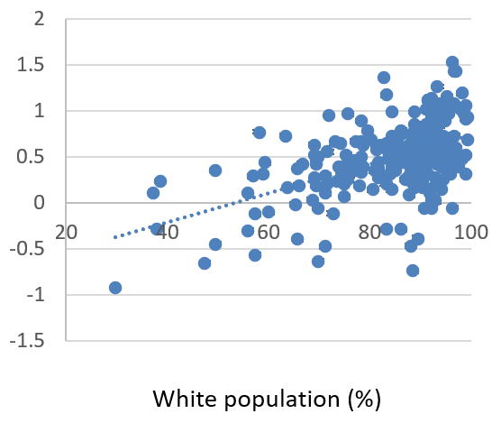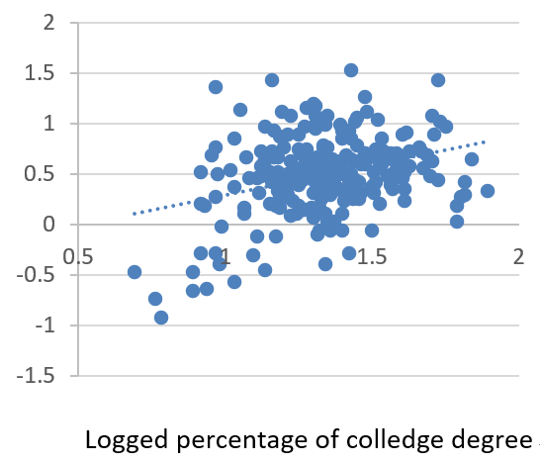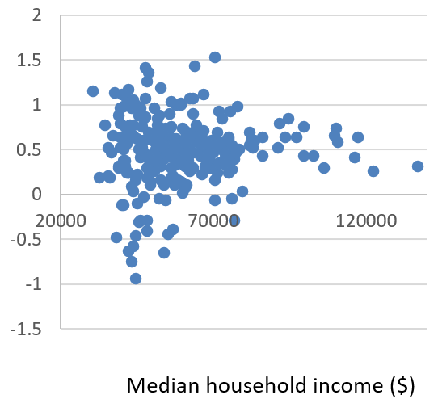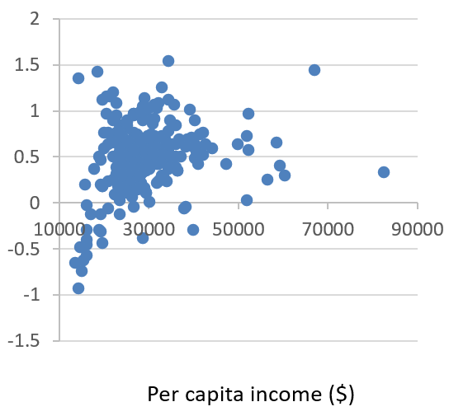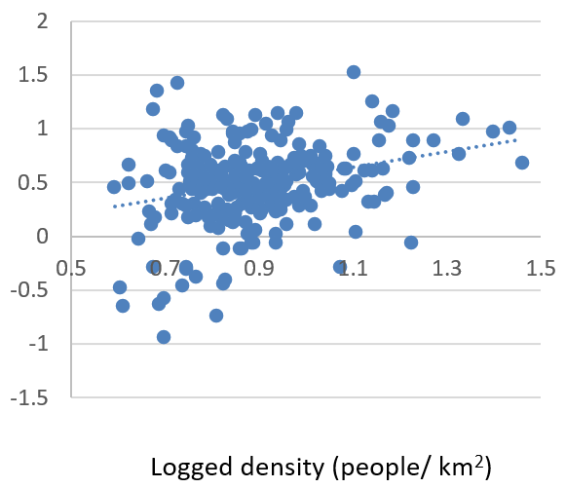
Figure 1. Logged measles exemption percentage and predictors: School Year 2017-2018

ordinary least squares
To examine to relationship between measles exemption rate and predictors, ordinary least squares was used to fit the linear regression in the each school year data. A model was given as:
, (1)
where the dependent variable is the measles immunization exemption percentage and 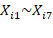 separately represented reported enrollment, percentage whites, percentage college degree, median household income, income inequality and population density. Table 1 shows the coefficients and significance. We can see that among the indicators, income inequality, % white and % college degree are positively related to exemption rate.

Table 1. Association between measles exemption rate and predictors in ordinary least squares
Characteristic | Regression coefficient (P value) |  |  |  |  | Average regression coefficient  (P value range)
School year | 2013-2014 | 2014-2015 | 2015-2016 | 2016-2017 | 2017-2018
Enrollment (per 1000people) | 3.453  (0.536) | 4.125  (0.723) | 1.667  (0.736) | 5.135  (0.235) | 3.417  (0.371) | 3.559  (0.235-0.736)
Median household income (per 10000USD) | 3.351 (0.345) | 2.015 (<0.001) | 2.203 (<0.001) | 1.456 (0.571) | 2.349 (0.948) | 2.275  (<0.001-0.948)
Income inequality | 0.235 (0.078) | 0.454 (0.108) | 0.453 (0.142) | 0.943 (0.314) | 0.267 (0.004) | 0.470  (0.004-0.314)
Percentage White | 0.210 (0.111) | 0.088 (<0.001) | 0.109 (<0.001) | 0.233 (0.226) | 0.014 (<0.001) | 0.131  (<0.001-0.226)
Percentage college degree | 0.555 (0.294) | 0.346 (<0.001) | 0.721 (<0.001) | 0.578 (0.247) | 0.355 (<0.001) | 0.511  (<0.001-0.294)
Population density (people/km2) | 0.001  (0.153) | 0.033  (0.079) | 0.100  (0.066) | 0.003  (0.059) | 0.016 (0.090) | 0.031  (0.059-0.153)

From the result of OLS in school year 2017-2018, the multicollinearity condition value is about 30, which indicates there might be a relationship between explanatory variables (Anselin 2005). To address this problem, we ran bivariate regressions to create new variables between white population and income, and degree and income.
Among the three heteroskedasticity tests, which test the variance in the error term, only the Breusch-Pagan test shows a low probability. There might be the existence of heteroskedasticity, as the spatial dependence in the data could well affect the error variance (Anselin 2005). For the three tests, the Breusch-Pagan and Koenker-Bassett tests are implemented as tests on random coefficients, which assumes a specific functional form for the heteroskedasticity. The KoenkerBassett test is essentially the same as the Breusch-Pagan test, except that the residuals are studentized, i.e., they are made robust to non-normality. Both test statistics indicate serious problems with heteroskedasticity in each of the trend surface specifications. The White test is a so-called specification-robust test for heteroskedasticity, in that it does not assume a specific functional form for the heteroskedasticity. Instead, it approximates a large range of possibilities by all square powers and cross-products of the explanatory variables in the model (Anselin 2005).

Table 2. Results of heteroskedasticity tests in ordinary least squares
Test | Value | P value
Random coefficients test
Breusch-Pagan test | 19.94 | 0.003
Koenker-Bassett test | 11.24 | 0.081
Specification Robust test
White | 38.23 | 0.074

To diagnose spatial autocorrelation, we run six spatial dependency tests of the model. The first statistics is Moran’s I. The first two (LM-Lag and Robust LM-Lag) pertain to the spatial lag model as the alternative. The next two (LM-Error and Robust LM-Error) refer to the spatial error model as the alternative. The last test, LM-SARMA, relates to the higher order alternative of a model with both spatial lag and spatial error terms (Anselin 2005).
In our model, strong spatial autocorrelation was shown as Moran’s I score is highly significant. The two Lagrange Multiplier tests, including the lag test for a missing spatially lagged explanatory variable and the error test for error dependence, are both significant and indicate strong spatial dependence. So we consider the Robust forms of the test statistics. While the Robust Lagrange Multiplier (error) test is not significant, which tests for error dependence in the possible presence of a missing lagged dependent variable, the Robust Lagrange Multiplier (lag) test is significant, which is the other way round. The robust tests indicate when lagged dependent variable is present the error dependence is also present (Pace and Gilley 1997).

Table 3. Results of spatial dependence tests in ordinary least squares
Test | P value
Moran's I (error) | <0.001
Lagrange Multiplier (lag) | <0.001
Robust LM (lag) | 0.007
Lagrange Multiplier (error) | <0.001
Robust LM (error) | 0.962
Lagrange Multiplier (SARMA) | <0.001

spatial lag model
From the above results, we identified the presence of spatial dependence. To address this problem, spatial regression was used to estimate by means of maximum likelihood of a spatial regression model that includes a spatially lagged dependent variable (Anselin 1988). A model was given as:
, (2)
besides variables in formula (1), represents the combined predictor of percent white and income inequality, represents the prevalence of degree with income inequality, represents the prevalence of degree with median household income, and Wy is a spatially lagged dependent variable for weights matrix W. In this model, any school districts sharing a boundary were defined as neighbors.

software
Analyses was performed with R 3.5.3 and GeoDa 1.12.

RESULTS

basic information
Figure 2 shows the exemption rates change by school year. The measles exemption percentage for students in Washington reached the peak of 4.38% in 2014-15, and it began to decline afterwards. But after the lowest value of 3.98% in 2016-17, it increased to 4.10% in school year 2017-18.
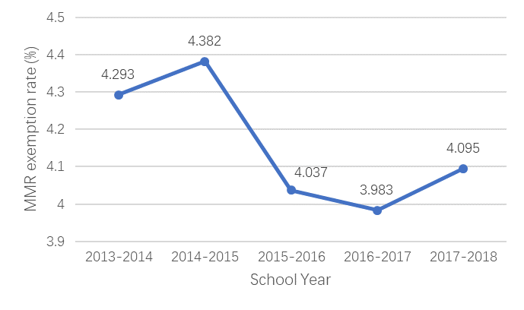
Figure 2. MMR exemption rates change by school year: Washington

Figures 3 shows the measles exemption map based on school districts. The number of school districts with ameasles exemption rate of zero increased from 13 in school year 2013-14 to 28 in 2016-17, but it declined to 18 in 2017-2018. The highest exemption rates in school year 2014-15 and 2015-16 are over 65%. Districts with high exemption percentages are most found in northeast, northwest and parts of southern boundary in Washington. The percentages generally appear to be high in the central point of large urban areas, including Seattle and Spokane, increasing in the suburban and exurban areas surrounding them.
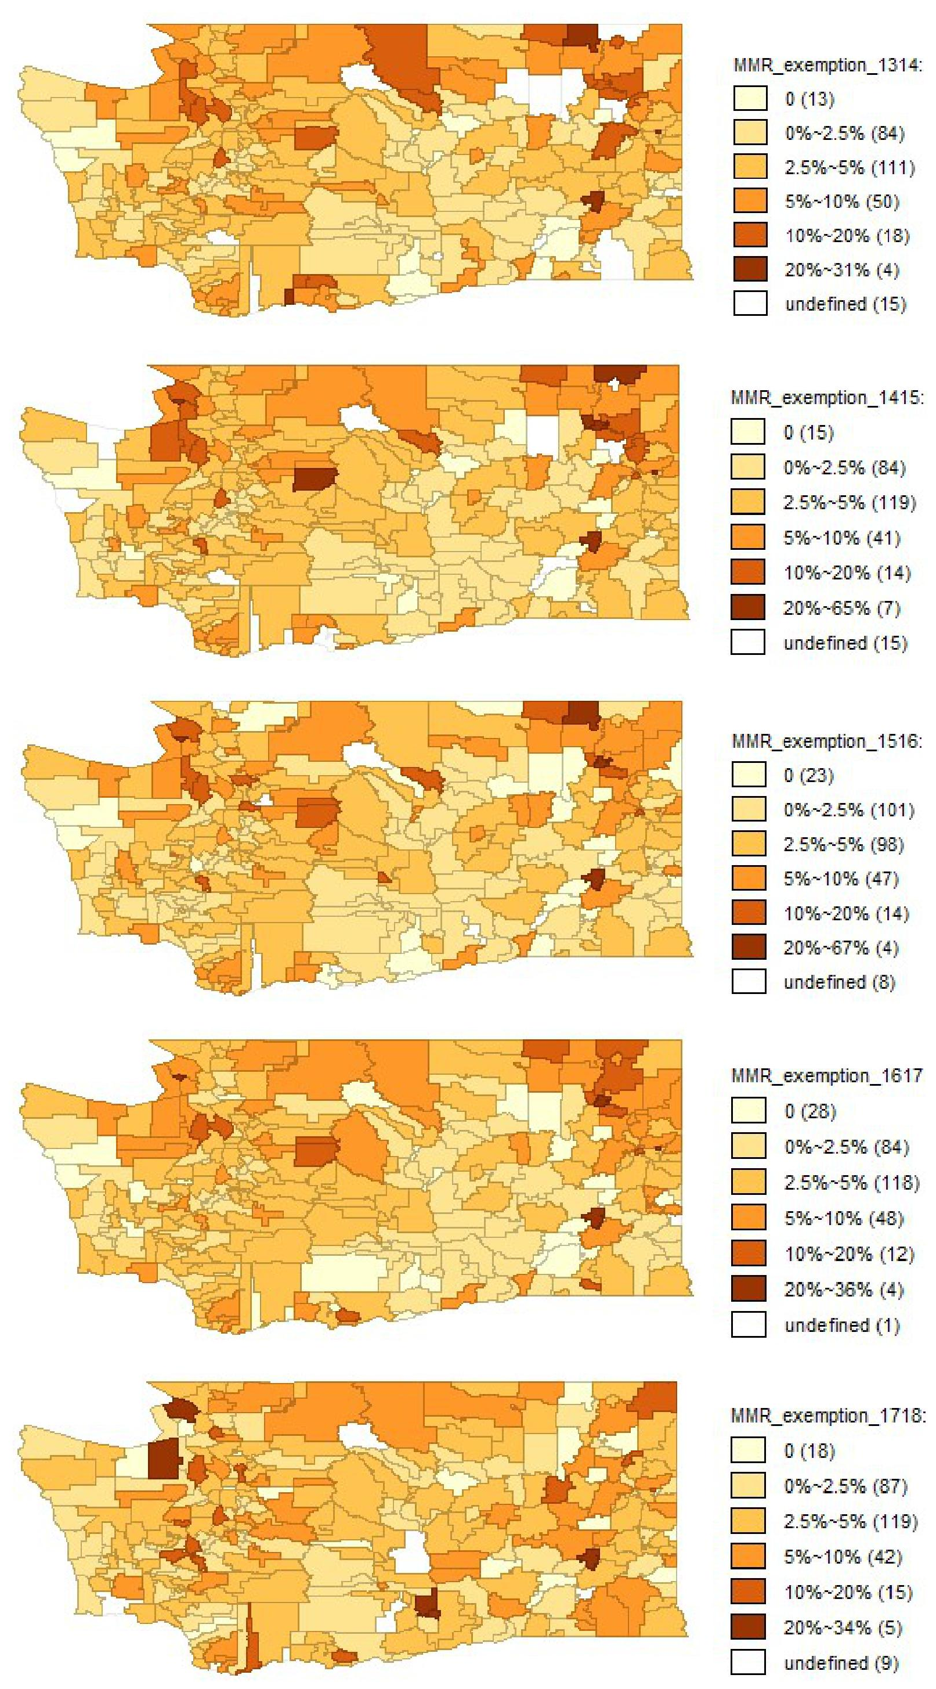
Figure 3. MMR Exemption Percentages by school year: Washington, 2013-2018
*undefined: school districts with non-available exemption data
Table 4 summaries the basic characteristics of the variables in the analytical data for school year 2017-2018.
Table 4. Characteristics of School Districts: Washington, School Year 2017-2018
Characteristics | No. (%) or Mean ± SD
% MMR vaccination exemptions | 4.10 ± 4.30
No. of enrolled students | 3823.82 ± 7322.28
Median household income, $, 2013-2017 | 58096.60 ± 17122.88
Per capita income-to-earnings ratio, 2013-2017 | 0.91 ± 0.24
% White population, 2013-2017 | 83.81 ± 15.29
% of population with college degree, 2013-2017 | 24.04 ± 12.77
Population density, 2018 (people per km²) | 194.181 ± 585.873

ORDINARY LEAST SQUARES
Table 1 shows the coefficients and significance. We can see that among the indicators, income inequality, % white and % college degree are positively related to exemption rate.

Table 5. Association between measles exemption rate and predictors in ordinary least squares
Characteristic | Regression coefficient (P value) |  |  |  |  | Average regression coefficient  (P value range)
School year | 2013-2014 | 2014-2015 | 2015-2016 | 2016-2017 | 2017-2018
Enrollment (per 1000people) | 3.453  (0.536) | 4.125  (0.723) | 1.667  (0.736) | 5.135  (0.235) | 3.417  (0.371) | 3.559  (0.235-0.736)
Median household income (per 10000USD) | 3.351 (0.345) | 2.015 (<0.001) | 2.203 (<0.001) | 1.456 (0.571) | 2.349 (0.948) | 2.275  (<0.001-0.948)
Income inequality | 0.235 (0.078) | 0.454 (0.108) | 0.453 (0.142) | 0.943 (0.314) | 0.267 (0.004) | 0.470  (0.004-0.314)
Percentage White | 0.210 (0.111) | 0.088 (<0.001) | 0.109 (<0.001) | 0.233 (0.226) | 0.014 (<0.001) | 0.131  (<0.001-0.226)
Percentage college degree | 0.555 (0.294) | 0.346 (<0.001) | 0.721 (<0.001) | 0.578 (0.247) | 0.355 (<0.001) | 0.511  (<0.001-0.294)
Population density (people/km2) | 0.001  (0.153) | 0.033  (0.079) | 0.100  (0.066) | 0.003  (0.059) | 0.016 (0.090) | 0.031  (0.059-0.153)

spatial regression
According to Table 1, income inequality, % white and % college degree are positively related to measles exemption rates. Table 5 shows the results of spatial lag model. Median household income is positively related to measles exemption rates. Comparing the results in spatial lag model to that in ordinary least squares, the Log-Likelihood increased from -52.6 in OLS to -36.8 in lag model. The Akaike info criterion decreased from 119.3 to 95.7, and Schwarz criterion decreased from 143.9 to 134.4. Compensating the improved fit for the spatially lagged dependent variable, the fit for the spatial lag specification was improved.

Table 6. Association between measles exemption rate and predictors in spatial lag model: Washington, school year 2013-2014 to 2017-2018
Characteristic | Regression coefficient (P value) |  |  |  |  | Average regression coefficient  (P value range)
School year | 2013-2014 | 2014-2015 | 2015-2016 | 2016-2017 | 2017-2018
Enrollment (per 1000people) | 4.413  (0.233) | 4.611  (0.145) | 3.444  (0.300) | 2.913  (0.290) | 2.946  (0.380) | 3.665  (0.233-0.380)
Median household income (per 10000USD) | 3.41 (<0.001) | 2.53 (<0.001) | 2.77 (<0.001) | 1.96 (<0.001) | 2.94 (<0.001) | 2.722  (<0.001)
Income inequality | 1.001 (0.078) | 2.542 (0.108) | 1.543 (0.142) | 2.343 (0.314) | 2.118 (0.068) | 1.909  (0.068-0.314)
Percentage White | 0.009 (0.123) | 0.035 (0.323) | 0.109 (0.367) | 0.133 (0.136) | 0.011 (0.175) | 0.059  (0.123-0.367)
Percentage college degree | 0.436 (0.356) | 0.432 (0.358) | 0.923 (0.435) | 0.234 (0.492) | 0.284 (0.719) | 0..462  (0.356-0.719)
Population density (people/km2) | 0.321  (0.053) | 0.333  (0.081) | 0.512  (0.066) | 0.111  (0.122) | 0.091  (0.077) | 0.274  (0.053-0.122)

DISCUSSION
We found that school districts of Washington with higher household income are associated with higher measles exemption rate in school year 2017-2018. Former research also showed that household income is a significant predictor (Yang, Delamater et al. 2016). But we didn’t find the positive effect of education and race.
In school year 2017-2018, the U.S. median exemption percentage of children enrolled in kindergarten with an exemption from one or more vaccines was 2.2%, while Washington is of 4.7%. And the U.S. median MMR vaccination coverage among children enrolled in kindergarten is 94.3%, while Washington is of 90.6% (Mellerson, Maxwell et al. 2018). In our data, although the exemption rate decreased for three school years, it increased again in school year 2017-18 and over 4% rate show the urgent vaccination exemption problem in Washington. Also, according to the map, we can find the number of school districts with zero measles exemption in school year 2017-18 is almost half of that in 2016-17. The coverage needs to be 90%-95% to achieve herd immunity for measles. Our maps show that most school districts with high exemption rates are clustered. For example, the Clark county, which has the most measles cases in the 2019 Washington measles outbreak, is always an area where the school districts with high exemption rates clustered
Previous studies have examined the characteristics of children with vaccination exemption, but only a small number of studies quantifiedthe relationships between exemption rates and sociodemographic predictors. Yutaro examined WHO country-level panel data, and US county-level and individual-level data to find that childhood vaccinate rates rise and falls as per capita income increases (Sakai 2018). Our study used spatial lag models to account for the spatial autocorrelation based on the results of ordinary least squares.
Our results showed that high-income parents were more likely to exempt their children from MMR vaccination. One possible explanation is that high-income parents have different sets of information. For example, high-income parents may perceive a greater risk of side effects from vaccination than middle-income parents. Or, high-income parents may better understand the concept of herd immunity and be more likely to use it. Either way, different sets of information may be the reason why high-income parents are less likely to be vaccinated. However, to achieve this, we need more than just different sets of information. On the contrary, we need parents at certain income levels to be systematically misled; otherwise we should not observe the different behaviors of different income groups on average. This systematic error message across income groups is possible, but somewhat suspicious. Therefore, a more reasonable explanation should assume that there is no differential set of information. Also, high-income parents may choose avoidance methods to reduce the risk of infection. Reich found that some mothers believe breastfeeding, organic food and careful monitoring of their children's social interaction, instead of vaccination, as methods to reduce the risk of infection (Reich 2014). In addition, some popular books on vaccines recommends natural foods, immune enhancement supplements, breastfeeding, and avoidance of day care and nurseries to promote vaccine hesitancy. Thirdly, high-income parents may have better access to medical services. Although the measles may be fatal, there are some vaccine-prevented diseases could be cured. High-income parents who live in areas with lower risk of infection or better access to medical facilities may choose treatment after infection and exempt their children for all vaccination.

Limitations
There are some limitations in our study. First, our study is based on school districts level, which don’t include individual- and school-level predictors that may be related to exemption.
Also, students in private schools are not drawn from defined school districts. To address those problem, both the school and other group level, like block groups and tracts, should be included in the analyses. Another limitation is the temporal mismatch between the exemption data (2013–2018) and the population covariate data (2013–2017). Because of data availability, this limitation is inevitable. However, significant changes in the socio-economic and demographic characteristics of the population living in geographic units as large as school districts usually do not occur in a short time.
Spatial regression in Geoda don’t include time variable. All school year data can’t be put together in one spatial regression, so we separately run spatial lag model for each school year.

CONCLUSION
The measles exemption rates show a decrease from school year 2014-15 to 2016-17, but an increase in school year 2017-18. And the average annual measles exemption rates are higher than the country level, which might be a reason of that measles coverage is not enough for measles herd immunity in the state. Following the measles outbreak of 2014–2015 that began in Disneyland, California legislators passed legislation repealing personal belief exemptions in the state. The Washington measles outbreak in 2019 shows a warning of possible outcomes. Researches showed that recent outbreaks of childhood diseases, such as measles and pertussis in North America and Europe, may be just the beginning of the wave of further outbreaks. Action should be taken for public health in Washington and nearby area.
Using school districts-level datasets, I provided evidence that high income parents are more likely to exempt their children from measles vaccination. I provided several plausible explanations including information access, avoidance measures, and medical care. My explanations are all focus on income, while it is even possible that the exemption rate is related to other income-related variables, which are not included in our models. The Washington outbreak of measles shows a serious public health concern in the U.S. The main reason is that vaccination coverages are not enough to achieve herd immunity. Commonly, low vaccination rates were thought to be related with low-income. More recently, there is a growing recognition that certain high-income groups choose not to vaccinate their children. Our study provides evidence for that there is systematic tendency for high-income parents to choose not to vaccinate their children.
bibliographY
Anselin, L. (1988). "Spatial econometrics: methods and models Kluwer Academic Publishers." Norwell, MA.

Anselin, L. (2005). "Exploring spatial data with GeoDaTM: a workbook." Center for spatially integrated social science.

Carrel, M. and P. Bitterman (2015). "Personal belief exemptions to vaccination in California: a spatial analysis." Pediatrics 136(1): 80-88.

Fine, P. E. (1993). "Herd immunity: history, theory, practice." Epidemiologic reviews 15(2): 265-302.

Funk, S., et al. (2018). "Target immunity levels for achieving and maintaining measles elimination." BioRxiv: 201574.

Goldstein, N. D., et al. (2019). "Trends and Characteristics of Proposed and Enacted State Legislation on Childhood Vaccination Exemption, 2011–2017." American Journal of Public Health 109(1): 102-107.

Guerra, F. M., et al. (2017). "The basic reproduction number (R0) of measles: a systematic review." The Lancet Infectious Diseases 17(12): e420-e428.

Hill, H. A., et al. (2018). "Vaccination coverage among children aged 19–35 months—United States, 2017." Morbidity and Mortality Weekly Report 67(40): 1123.

Mellerson, J. L., et al. (2018). "Vaccination Coverage for Selected Vaccines and Exemption Rates Among Children in Kindergarten - United States, 2017-18 School Year." MMWR Morb Mortal Wkly Rep 67(40): 1115-1122.

Omer, S. B., et al. (2006). "Nonmedical exemptions to school immunization requirements: secular trends and association of state policies with pertussis incidence." Jama 296(14): 1757-1763.

Pace, R. K. and O. W. Gilley (1997). "Using the spatial configuration of the data to improve estimation." The Journal of Real Estate Finance and Economics 14(3): 333-340.

Reich, J. A. (2014). "Neoliberal mothering and vaccine refusal: imagined gated communities and the privilege of choice." Gender & Society 28(5): 679-704.

Richards, J. L., et al. (2013). "Nonmedical exemptions to immunization requirements in California: a 16-year longitudinal analysis of trends and associated community factors." Vaccine 31(29): 3009-3013.

Sakai, Y. (2018). "The Vaccination Kuznets Curve: Do vaccination rates rise and fall with income?" Journal of health economics 57: 195-205.

Yang, Y. T., et al. (2016). "Sociodemographic predictors of vaccination exemptions on the basis of personal belief in California." American Journal of Public Health 106(1): 172-177.

