Title Page

**The Association of Physical Activity and Perceived Physical Fatigability on Gait Speed: The Long Life Family Study**

by

Sarah E. Martin

BS, King’s College, 2009

Submitted to the Graduate Faculty of

the Department of Epidemiology

Graduate School of Public Health in partial fulfillment

of the requirements for the degree of

Master of Public Health

University of Pittsburgh

2019

Committee Membership Page

UNIVERSITY OF PITTSBURGH

Graduate School of Public Health

This essay is submitted

by

**Sarah E. Martin**

on

June 22, 2019

and approved by

Pamela E. Toto, PhD, OTR/L, BCG, FAOTA, Associate Professor

Department of Occupational Therapy

School of Health and Rehabilitation Sciences, University of Pittsburgh

Robert M. Boudreau, PhD, Assistant Professor, Department of Epidemiology

Graduate School of Public Health, University of Pittsburgh

**Essay Advisor:** Nancy W. Glynn, PhD, Assistant Professor, Department of Epidemiology

Graduate School of Public Health, University of Pittsburgh

Copyright © by Sarah E. Martin

Year

Nancy W. Glynn, PhD

**The Association of Physical Activity and Perceived Physical Fatigability on Gait Speed:**

**The Long Life Family Study**

Sarah E. Martin, MPH

University of Pittsburgh, 2019

**Abstract**

The purpose of this paper was to determine if greater physical activity and lower perceived physical fatigability are independently associated with a faster gait speed, and thus a lower likelihood of having an activity limitation. The study population was two generations (proband and offspring) of adults enrolled in the Long Life Family Study, a study of exceptional longevity in families. Gait speed was assessed with a usual-paced 4 meter walk as an indicator of activity limitation. Physical activity, measured with the Framingham Physical Activity Index (total metabolic equivalents of a task per day) and perceived physical fatigability, assessed with the 10-item Pittsburgh Fatigability Scale were independent variables to examine their association on gait speed adjusted for age, gender, family structure, field center and health conditions. In both generations, greater physical activity was inversely associated with a lower perceived physical fatigability (proband: Q2=-2.1, Q3=-5.5, Q4=-7.5, p<0.001)(offspring: Q2=-1.7, Q3=-2.8, Q4=-4.0, p<0.001). Lower perceived physical fatigability was inversely associated with a faster gait speed (proband: beta=-0.013, p=0.03)(offspring: beta=-0.005, p<0.001). Physical activity and gait speed shared a strong dose response relationship (proband: Q2=0.1, Q3=0.28, Q4=0.21, p<0.001)(offspring: Q2=0.020, Q3=0.024, Q4=0.022, p=0.08). When both physical activity and perceived physical fatigability were included in the model with gait speed as the outcome, physical activity was independently associated with gait speed in the proband generation (Q2=0.095, Q3=0.26, Q4=0.17, p<0.001) but not in the offspring (Q2=0.015, Q3=0.017, Q4=0.01, p=0.4). Conversely, perceived physical fatigability was strongly associated with gait speed in the offspring generation (beta=-0.0057, p<0.001), but not in the proband generation (beta=-0.18, p=0.26). Physical activity and fatigability share a complex relationship with gait speed and further research is needed to reduce the public health burden due to the growing population of older adults and the increasing negative impact that activity limitations place on this population’s independence and quality of life.

Table of Contents

Abstract iv

1.0 Introduction 1

1.1 Activity Limitations in Older Adults 1

1.2 Physical Activity and Activity Limitations in Older Adult 2

1.3 Fatigue and Fatigability in Older Adults 5

1.3.1 Measurement of Fatigue and Fatigability 5

1.3.2 The Relationship between Fatigue/Fatigability and Activity Limitations 6

1.4 The Relationship between Physical Activity and Perceived Physical Fatigability 8

1.5 Gaps in Knowledge 10

1.6 Public Health Significance 10

2.0 Objectives 11

3.0 Methods 12

3.1 Study Population 12

3.2 Outcome Measure 13

3.3 Independent Variables 13

3.4 Other Covariates 14

3.5 Statistical Analysis 14

4.0 Results 17

4.1 Participant Characteristics 17

4.2 Relationship between Physical Activity and Perceived Physical Fatigability 19

4.3 Relationship between Perceived Physical Fatigability and Gait Speed 21

4.4 Relationship between Physical Activity and Gait Speed 23

4.5 Relationship of Physical Activity and Perceived Physical Fatigability on Gait Speed 25

5.0 Discussion 27

Bibliography 31

List of Tables

Table 1 Demographic Characteristics for Proband and Offspring: The Long Life Family Study 18

Table 2 Multivariable Analysis Examining the Association between Physical Activity Quartiles and Pittsburgh Fatigability Scale Physical Scores 21

Table 3 Multivariable Analysis Examining the Association between Physical Activity Quartiles and Gait Speed 25

Table 4 Multivariable Analysis Examining the Association between Physical Activity Quartiles and Pittsburgh Fatigability Scale Physical Scores with Gait Speed 26

List of Figures

Figure 1 The Analytic Sample: The Long Life Family Study 16

Figure 2 Conceptual Framework of the Relationship of Higher Physical Activity and Lower Perceived Physical Fatigability on Faster Gait Speed 16

Figure 3 Association between Physical Activity and Perceived Fatigability in Proband Generation: Long Life Family Study (N=330) 19

Figure 4 Association between Physical Activity and Perceived Fatigability in the Offspring Generation: Long Life Family Study (N=2095) 20

Figure 5 Association between Higher Perceived Physical Fatigability and Gait Speed in the Proband Generation: Long Life Family Study (N=330) 22

Figure 6 Association between Higher Perceived Physical Fatigability and Gait Speed in the Offspring Generation: Long Life Family Study (N=2095) 22

Figure 7 Association between Physical Activity and Gait Speed in the Proband Generation: Long Life Family Study (N=330) 23

Figure 8 Association between Physical Activity and Gait Speed in the Offspring Generation: Long Life Family Study (N=2095) 24

# Introduction

## Activity Limitations in Older Adults

One of the major undertakings in public health across the developed world is to prevent disability in a steadily growing population of older adults. The progression into disability is a complex chain of events, often involving underlying chronic disease in combination with the physical changes that come with aging (1). Just in the United States, 42% of the older adult population reported having one or more limitations with activities of daily living (2). As predicted by many demographers, the number of older adults are only going to increase in size, with disability increasing in this population (3). Whether older adults are disabled or not, restricted activity is not seen as a cause for seeking medical attention (4). One part of the complex outcome of disability --activity limitations or ”difficulties an individual may have in executing activities”-- are considered preventable through rehabilitative services (5). As such, identifying the clinical and subclinical signs of activity limitations are important steps towards developing programs of preventing disability and increasing the overall health and quality of life of this vulnerable population.

One of the most common ways to measure activity limitations is by measuring an older adult’s ability to walk. Since walking is a necessity for achieving most daily activities, measuring gait speed can be an excellent predictor of lower extremity function (4). In one study with subjects 80 years old or older, being unable to perform or complete a quarter-mile walk made doubled the risk of being unable to perform activities of daily living or being admitted to a nursing home (6). However, the ability to walk is a simplistic measurement, whereas measuring endurance and speed while walking can also provide further context into indicators of activity limitations.

Gait speed has been found to be strongly associated with a variety of outcomes including frailty, falls, morbidity, and mortality in older adults (7-10). Those with a gait speed less than 1 m/s have been found to be at a higher risk for persistent severe lower extremity limitation, hospitalization, and death. The ease at which gait speed can be measured as well as its validity for predicting a variety of disability-related outcomes make it a very useful tool for determining the risk for activity limitations (11).

## Physical Activity and Activity Limitations in Older Adult

Strong evidence has shown that increased physical activity levels in older adults is a predictor of independence, better quality of life, and the prevention of disease (12). Despite the known benefits of greater physical activity levels, trends show that it either stabilizes or decreases over the time across the average lifespan of an adult in the United States (13). The World Health Organization estimates that 3.2 million deaths are attributable to physical inactivity each year (14). The Health, Aging, and Body Composition (Health ABC), the Osteoarthritis Initiative (OAI), and the Lifestyle Interventions and Independence for Elders (LIFE) are among the several studies that demonstrate that physical activity is important for older adults to maintain independence.

In the Health, Aging, and Body Composition Study, 3075 men and women ages 70 to 79 had a physical activity assessment using a standardized questionnaire during the baseline visits that took place between April 1997 and June 1998 (15). Participants reported whether they did certain activities, such as yard work, 10 times in the past 12 months, whether they had carried out that activity in the last 7 days, and the time spend on that activity in the last 7 days. Endurance (e.g. fitness) was assessed using a timed, fast-paced 400 meter walk and function was assessed using the Established Populations for the Epidemiologic Studies of the Elderly battery, which was later renamed the Short Physical Performance Battery (SPPB) (15). The participants were classified into 3 activity groups: “inactive” (<1,000 kcal/wk of exercise and/or <2,719 kcal/wk of total physical activity), “lifestyle active” (<1,000 kcal/wk of exercise and >2,719 kcal/wk of total physical activity), and “exerciser” (> =1,000 kcal/wk of exercise) (15). Men in the inactive group took 41 seconds longer to complete the 400 m walk compared to the men in the exerciser group, whereas women in the inactive group took 52.6 seconds longer to complete the walk compared to female exercisers (p<0.001). When performing the SPPB, men in the inactive group had a two-fold greater odds of having a score of <10 (indicating functional impairment) compared to their male counterparts in the exerciser group. Women in the inactive group had a 2.5 greater odds of obtaining a SBBP score of <10 compared to their female counterparts in the exerciser group (15). This work from the Health ABC study shows strong evidence that maintaining an active lifestyle and/or consistent exercise is associated with reduced activity limitations for older men and women.

The OAI study evaluated objective physical activity levels (using GT1M Actigraph accelerometer) in a subset of 545 inactive adults at risk for osteoarthritis to estimate the total moderate to vigorous activity at baseline and two years later (16). Levels of activity were divided into 3 groups: those who met the US Department of Health and Human Services Guidelines, those who insufficiently increased their activity, and those who remained at the same level of inactivity. Function was also assessed at baseline and two years later using the Late Life Disability Instrument (LLDI) self-reported questionnaire. (16). Those who met the guidelines increased their LLDI scores by 10.31 points over the two years, those who increased physical activity insufficiently increased their score by 1.95 points, and those who remained inactive decreased their score by 1.15 points (p value for trend <0.001) (16). The OAI study demonstrated that physical activity, even insufficient activity, was associated with reduced activity limitations.

The final study, LIFE, was a clinical trial that recruited 1635 men and women aged 70 to 89 who were at a high risk for a physical disability based on the SPPB score of <10 (17). The trial was primarily a walking based intervention (N=818) with participants attending at least twice a week for 2 years, while the comparison group (N=817) attended health education workshops focusing on successful aging once per week for the 1st 6 months and at least once per month thereafter (17). The primary outcome for the LIFE study was to evaluate the impact of the physical activity intervention on the development of major and persistent mobility disability. Measured every 6 months, a major mobility disability was classified as the participant being unable to complete the usual-paced 400-meter walking test within 15 minutes without help from another person, a walker, or sitting during the walk. Persistent mobility disability was classified as either having a major mobility disability for two consecutive 400 m walk tests or having a major mobility disability followed by death (17). In the main LIFE study, the physical activity arm had an 18% lower risk of developing a mobility disability compared to the comparison group (HR:0.82, p=0.03) and a 28% lower risk of developing a persistent mobility disability (HR: 0.72, p= 0.006). The LIFE study findings indicated that a physical activity intervention focused on aerobic, strength, balance, and flexibility is a valuable treatment for preventing activity limitations in older adults (17).

## Fatigue and Fatigability in Older Adults

### Measurement of Fatigue and Fatigability

One of the most common underlying indicators of chronic disease among older adults is fatigue, which is defined as “a subjective lack of physical and/or mental energy that is perceived by the individual or caregiver to interfere with usual or desired activities” (18). Fatigue is often viewed as simply the feeling of being exhausted, but in older adults, this feeling can be an indicator for heart disease, cancer, and various neurological disorders (19). Unfortunately, there are methodological flaws with using fatigue as a predictor for health outcomes. There is no gold standard for measuring fatigue, and thus the differences in measurement tools, choice of time periods, the cut points determining fatigued vs not fatigued, and the prevalence of other chronic diseases in the cohort can cause misleading conclusions of the presence of fatigue in older adult populations (20-21).

One of the major problems with measuring fatigue is self-pacing bias. A majority of individuals adjust their activities to a tolerable level. For example, a healthy individual from the general population and an individual with fatigue related comorbidities may be inclined to report similar levels of fatigue within a specific time period. To reduce this bias, a newer construct, fatigability, has been introduced, which anchors the symptom of self-reported fatigue to intensity and duration of activity (22). Physical fatigability can be measured as either performance fatigability and perceived physical fatigability. The definition for performance fatigability is “the decline in force, endurance, power, speed, reactivity, or accuracy of performance of a given activity or task” and for perceived physical fatigability, it is “an individual’s self-reported whole body feeling of tiredness as a function of the duration and intensity of a demand task or activity” (23).

### The Relationship between Fatigue/Fatigability and Activity Limitations

Through various studies, fatigue and fatigability have both shown that relative levels of exhaustion are important for understanding ways to prevent activity limitations in older adults. In the InCHIANTI study, 1055 Italian adults ages 65 and older reported how many days in the past week they experienced the two statements: “I felt that everything I did was an effort” and “I could not get going.” (24). Both questions were taken from the Center for Epidemiologic Studies-Depression Scale. The participants were considered fatigued if they answered 3 or more days to either statement. The ability to perform daily activities was assessed using the SPPB score and the 400 m walk speed. Self-reported fatigue in older men was associated with lower SPPB score of 1.29 points (p<0.001) and in women, fatigue was associated with a lower score of 0.99 points (p<0.001). Self-reported fatigue in older men was associated with a slower walking speed of 0.07 m/s (p=0.027) and in women, fatigue was associated with a slower walking speed of 0.08 m/s (p<0.001) (24). The InCHIANTI study results showed that older adults with fatigue had significantly worse activity limitations compared to older adults that did not report fatigue.

While there are studies showing fatigue as a good indicator of older adult activity limitations, there are flaws in using this measurement. Performance and perceived physical fatigability have shown promising results in their relationship to activity limitations. Performance fatigability is often measured by timing a person to walk a specified length and identifying points where the participant has slowed down in response to fatigue. The Baltimore Longitudinal Study of Aging (BLSA) examined performance deterioration by having 605 community-dwelling men and women ages 60 and older complete a long-distance 400 m walk test as quickly as possible at a pace that can be maintained (25). Performance fatigability (i.e. deterioration) was classified in all participants that were either unable to complete the 400 m walk test or slowed down by 6.5% from lap 2 to lap 9. Mobility and function were assessed using a reported score of walking ability, measuring gait speed over a 6 m course, timed chair stands, and grip strength. Adults that maintained their 400 m pace and adults who slowed down had the most significant mean differences in their walking ability score (Slowed = 6.61, Maintained = 7.95, p<0.001), gait speed in m/s (Slowed = 1.05, Maintained = 1.10, p= 0.048), and chair stands in stands/s (Slowed = 0.38, Maintained = 0.42, p= 0.023). Whereas there were no significant differences between participants when measuring grip strength and rapid gait speed (25). Overall there are benefits to measuring fatigability this way, but it does require an open space, treadmill, or other supplies in order to measure fatigue for a study.

Perceived physical fatigability is an alternative to performance based measures of fatigability. Participants are instead asked to rate their fatigue after a fixed task (25). One example is the Study of Energy and Aging Pilot (SEA-P), where 36 community dwelling adults ages 70 to 89 measured their preferred gait speed through a 400m walk test and separated them into slow and fast walkers by whether they were above the median walking speed of 1.19 m/s (26). The SEA-P measured perceived physical fatigability by using the Situational Fatigue scale (SFS) which asked participants to rate their tiredness for activities of a fixed duration. Fast walkers item scores were 5.3 points lower compared to the slow walkers (p = 0.042). The SEA-P also measured fatigue by asking questions such as how often participants “felt physically tired during the day” in the past 4 weeks. This measurement showed no significant differences between slow and fast walkers (p > 0.2).  As a result, perceived physical fatigability provides a much stronger association for assessing the relationship between gait speed and fatigue compared to measuring only the frequency symptom of fatigue in relation to gait speed (26).

The Pittsburgh Fatigability Scale (PFS), introduced in 2014, is the only validated self-reported scale in older adults that includes both fatigue and demand in a single instrument. The PFS measures perceived physical fatigability by asking participants to rate their tiredness similarly to the SFS scale (27). However, the SFS is not validated in older adults due to the activities used in the scale, which were instead tested in college students (28). The PFS is also more robust by both measuring intensity and duration for each activity. Due to the specific activities used in the scale, the PFS has been found to be a robust and valid predictive indicator for mobility decline when compared to other self-reported global fatigue scales (29).

## The Relationship between Physical Activity and Perceived Physical Fatigability

Fatigability and physical activity have both been shown to play an integral role in predicting activity limitations among older adults. Despite the recently developed changes in measuring fatigue, the association of fatigability and physical activity shows promising results when explored in recent published research. In the BLSA, 577 participants wore an accelerometer for a full week to calculate their total logged activity, and measured their perceived physical fatigability by maintaining a slow paced walk on a treadmill for 5 minutes (31). Participants rated their perceived exertion using the Borg rating of perceived exertion (RPE) Scale. A significant negative association was found between physical activity and perceived fatigability (beta= -54.8, p<0.001) (31). These findings indicated that measurements of perceived physical fatigability, such as the RPE scale used here, are strongly associated with physical activity levels in older adults.

The Developmental Epidemiologic Cohort Study (DECOS) recruited 89 older adults, equipped them with an accelerometers, which they wore during a 4 m walk and two 400 m walks to measure median walking acceleration, the “in-the-lab” section (32). In order to obtain median walking acceleration “in-the-wild”, participants wore the accelerometers for 7 days while performing their daily routines. Perceived physical fatigability was assessed using the PFS. Higher perceived physical fatigability was associated with a 0.422 lower walking acceleration (p = 0.003) while “in-the-lab”, and similarly “in-the-wild”, higher fatigability was associated with a 0.551 lower walking speed (p<0.001) (32). The BLSA and DECOS study, among others, all show a strong inverse association between physical activity and perceived physical fatigability.

Overall, older adults reduce their levels of physical activity as they age. However, fatigue is one of the major contributors in reducing physical activity in older adults. Fatigue and reduced physical activity create a vicious cycle. The importance of measuring fatigability and physical activity together is indicated by their strong association with each other and their strong association with activity limitations.

## Gaps in Knowledge

Fatigability is regarded as a more sensitive measure of the tiredness that is associated with the various chronic diseases commonly found in the older adult population (30). However, no studies have examined the independent association between physical activity, perceived physical fatigability, and their association with physical function, particularly in a relatively healthy adult population. Since the concept of fatigability is novel, more studies and more analyses should explore the role it plays in the pathway between reduced physical activity and activity limitations.

## Public Health Significance

Older adults are living longer than ever before. The population of people over 65 in 2014 was 46.3 million and is projected to increase up to 98 million by 2060 (33). Disease and disability is largely associated with this vulnerable cohort, and as a result, the cost and demand for caregiving, assisted living, and hospitalization is only going to increase (2). Through various studies, both physical inactivity and fatigue are major contributing factors that lead to activity limitations and an overall lack of independence in this population. By understanding the relationship of physical activity, fatigability, and how they relate to preventable activity limitations can lead to the development of evidence-based interventions that bridge the barriers that older adults come across when maintaining their quality of life (4).

# Objectives

The objective of this research was to examine the association of perceived physical fatigability and physical activity on activity limitations in a relatively healthy older adult population. Our hypothesis is that lower perceived physical fatigability and greater physical activity are both independently associated with physical function (i.e. faster gait speed) in two generations of older adults enrolled in the Long Life Family Study.

# Methods

## Study Population

For this paper, data were obtained from the Long Life Family Study, a prospective cohort study that recruited families with exceptional longevity to examine both their genetic and physical characteristics. The Family Longevity Selection Score (FLoSS) was developed to standardize the overall family exceptionality and traits of longevity to determine eligibility (34). From 2006 to 2009, a total of  N= 4,953 adults --N=1,727 probands and N=3,226 offspring-- from 539 families were enrolled from four field centers, University of Pittsburgh, Boston University, Columbia University, and University of Southern Denmark (2). Field centers in the United States sent mailing brochures to older Medicare enrollees while in Denmark, participants were screened through the Danish National Register of Persons.

The baseline study measures were implemented in person (mainly home visits) using a standardized protocol. After Visit 1, telephone interviews were implemented annually to monitor changes in health, function, and vital status (35). Visit 2 was conducted from 2014 to 2017 where baseline measures were repeated and new measures, including the PFS and the Framingham Physical Activity Index (FPAI), were added. As part of Visit 2, additional family members who were unavailable to be enrolled at baseline were invited to enroll from existing families. All of the primary measures used in this analyses reported here were obtained during the second in-person visit.

## Outcome Measure

The outcome measure used for these analyses was physical function, determined by usual-paced gait speed. Gait speed was obtained during Visit 2 as part of the Short Physical Performance Battery (SPPB), which includes performing five chair stands, three balance tests, and a two timed usual-paced 4 meter walks. The fastest of the two walks was considered their usual gait speed in meters per second (11).

## Independent Variables

The first independent variable was perceived physical fatigability, measured by the Pittsburgh Fatigability Scale (PFS). The PFS is a validated self-administered 10 item scale of perceived fatigability in older adults. Participants rates from no fatigue to extreme fatigue (0-5) “they expected to feel immediately after completing each activity” and whether they have completed that activity in the past month. The PFS has physical and mental subscales, which are scored separately and range from 0 (none) to 50 (extreme) with higher scores indicating greater fatigability (24). Higher perceived physical fatigability was categorized as ≥ 15 points (36). While the scale measures both perceived physical and mental fatigability, only perceived physical fatigability was used in this analysis.

The second primary independent variable was self-reported physical activity, measured using the FPAI (37). Participants were asked to determine the number of hours spent in 5 specific activity levels --sleep, sedentary, moderate, and heavy-- for a typical day over the past year. The number of hours for all activity must total 24 hours. A physical activity score was calculated by multiplying the hours each activity was performed by its weighted metabolic equivalent of a task (MET). The MET equivalents for each activity were sleep (weighing factor [WF]= 1.0), sedentary (WF=1.1), slight (WF=1.5), moderate (WF=2.4), and heavy (WF=5.0) (37). The FPAI score was the sum of the MET-hrs/day across the five activity levels and the resulting FPAI scores were then divided into generation specific quartiles of physical activity. The quartiles were used to account for potential non-linearity, and to facilitate easier interpretation in the impact of physical activity on gait speed between generations.

## Other Covariates

Age was confirmed and validated by official documents such as a driver’s license or birth certificate at the baseline examination. Race and sex were both self-reported measures asked by questionnaire at baseline. Depression symptoms were determined using the 20 item Center for Epidemiologic Studies Depression Scale (CES-D) (38). Diabetes was defined as a HbA1C level of 6.5% or greater or taking diabetes related medication (39).  Prevalent diagnoses of heart disease, stroke, lung disease, and cancer were all obtained by a self-report of a physician’s diagnosis at baseline, during the follow-up questionnaires, and at Visit 2 (35).

## Statistical Analysis

Figure 1 depicts the derivation of the final analytic sample for these analyses. Of the N=4953 enrolled at baseline, N=2794 (56.4 %) completed a Visit 2. Additionally, 160 new family members were enrolled.  Of the N=2954, 529 participants were excluded from the analysis due to missing data for either the FPAI, PFS or gait speed. Thus, the total analytic sample was N=2425 (330 probands, 2095 offspring, including N=137 participants with imputed PFS physical score data).

All analyses were stratified by generational groups, probands and offspring due to the bimodal distribution. Chi-square tests and t-tests were used to examine the descriptive differences between probands and offspring. To understand the complex conceptual framework between the association of perceived physical fatigability and physical activity on gait speed, we first evaluated the separate pathways (Figure 2). We examined the role of physical activity on perceived physical fatigability and then separately examined both perceived physical fatigability and physical activity on gait speed. Generalized linear models were used to ascertain the relationship between quartiles of physical activity and PFS physical score, PFS physical score and gait speed, and quartiles of physical activity and gait speed. Finally quartiles of physical activity and the PFS were included in one final model to determine their independent relationships with gait speed. All four models were controlled for age, gender, family structure (due to family relatedness), depression, field center, heart disease, stroke, lung disease, cancer, diabetes, and arthritis as adjustment variables. SAS version 9.4 was used for all analyses.

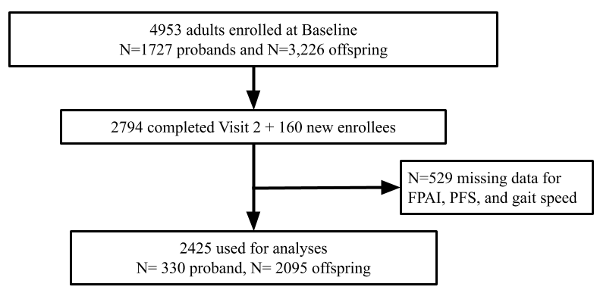

Figure 1 The Analytic Sample: The Long Life Family Study

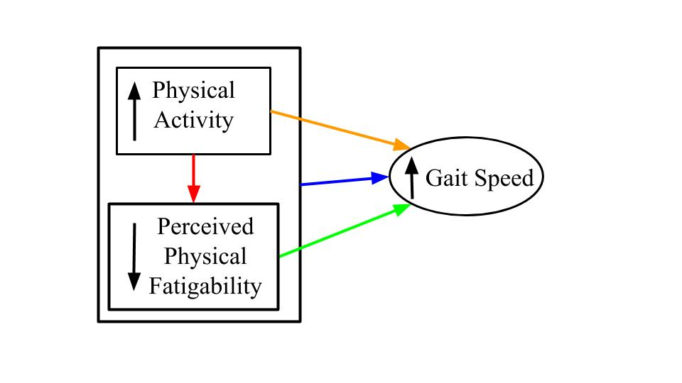

Figure 2 Conceptual Framework of the Relationship of Higher Physical Activity and Lower Perceived Physical Fatigability on Faster Gait Speed

# Results

## Participant Characteristics

The mean age of the probands (N=330) was 92.0 ± 7.1 years old, whereas the offspring (N=2095) were 68.0 ± 7.7 years old (Table 1). More than half of the participants were female, and almost all of them were white. The mean BMI was higher in the offspring generation, but the proband generation had a slower gait speed, higher perceived physical fatigability scores, and lower physical activity. Of the probands, 83.3% had higher physical fatigability compared with 32.4% of offspring. Depressive symptoms and a majority of the comorbidities were very low overall, but mostly higher in the proband group. 63.6% of probands suffered from arthritis and 48.8% had non-skin cancer. There were no significant differences in lung disease and diabetes between generational groups (Table 1).

Table 1 Demographic Characteristics for Proband and Offspring: The Long Life Family Study

|  |  |  |
| --- | --- | --- |
|  | Mean ± Standard Deviation or N (%) | |
| Proband Generation N= 330 | Offspring Generation N= 2095 |
| Age, years | 92 ± 7.1 | 68.0 ± 7.7 |
| Sex, Female | 204 (61.8) | 1116 (53.3) |
| Race, White | 326 (98.8)* | 2084 (99.6)* |
| Body Mass Index, kg/m2 | 26.1 ± 4.4 | 27.7 ± 5.2 |
| Usual-paced gait speed, m/s | 0.7 ± 0.49 | 1.1 ± 0.2 |
| Perceived Physical Fatigability, 0-50 pts | 25.3 ± 9.9 | 11.75 ± 8.0 |
| High Perceived Fatigability (≥15) | 275 (83.3) | 679 (32.4) |
| Physical Activity Index, MET-hrs/d | 30.48 ± 5.2 | 37.6 ± 7.1 |
| CES-D score, 0-20 pts | 4.39 ± 3.7 | 3.08 ± 3.5 |
| Heart Disease | 74 (22.4) | 111 (5.3) |
| Stroke | 62 (18.8) | 99 (4.7) |
| Lung Disease | 4 (1.2)* | 55 (2.6)* |
| Diabetes | 47 (14.2)* | 205 (9.8)* |
| Cancer (non-skin) | 161 (48.8) | 602 (28.7) |
| Arthritis | 210 (63.6) | 837 (40.0) |
| More than 1 Comorbidity | 76 (23.0) | 96 (4.6) |

* All variables were significantly different (p<0.05) except for race, lung disease, and diabetes
* Diabetes defined according to the American Diabetes Association 2018 classification of a HbA1c level of 6.5% or taking diabetes related medication

Abbreviations: MET = Metabolic equivalent of a task; CES-D = Centers for Epidemiologic Studies Depression Scale

## Relationship between Physical Activity and Perceived Physical Fatigability

We first evaluated the univariate association between PFS score and physical activity levels. In the proband generation, Figure 3 shows a strong linear relationship between greater quartiles of physical activity and lower PFS physical scores, with a 12 point difference between the highest and lowest quartiles. For the offspring generation (Figure 4), the relationship was similar, but PFS physical scores were nearly half of those for probands. There was a somewhat sharper drop in PFS from quartile 1 to 2 in the offspring compared to the probands.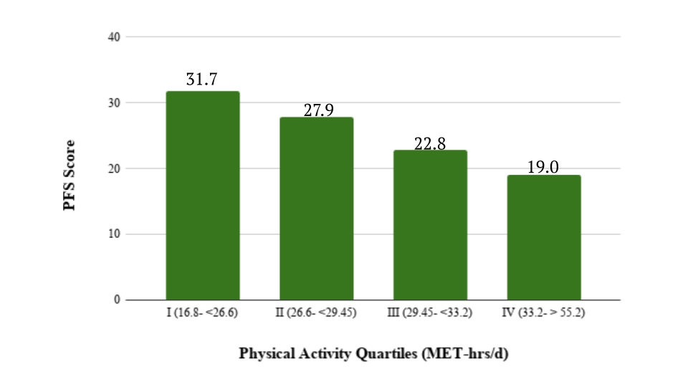

Figure 3 Association between Physical Activity and Perceived Fatigability in Proband Generation: Long Life Family Study (N=330)

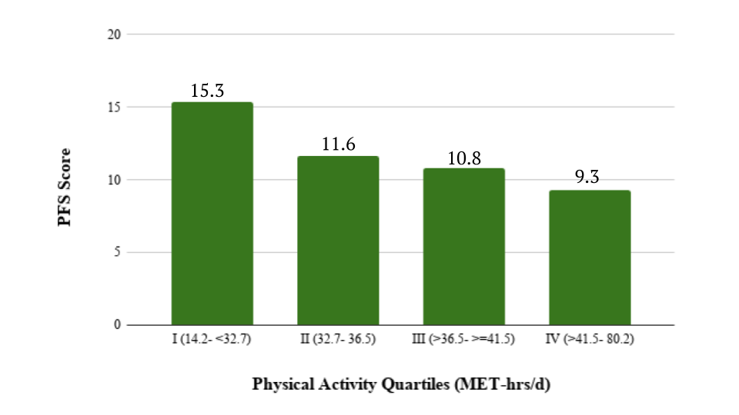

Figure 4 Association between Physical Activity and Perceived Fatigability in the Offspring Generation: Long Life Family Study (N=2095)

Table 2 presents the generalized linear model examining the relationship between physical activity and perceived physical fatigability adjusted for covariates. In the proband generation, a dose response relationship was clearly displayed. Greater physical activity in the highest quartile was associated with a 7.6 point lower PFS physical score when compared to physical activity in the lowest quartile. A similar trend followed in the offspring, with 4 point lower PFS physical score between the lowest and highest physical activity quartiles. Both analyses were adjusted for age, gender, family structure, depression, heart disease, stroke, lung disease, cancer, diabetes, arthritis, and field center.

Table 2 Multivariable Analysis Examining the Association between Physical Activity Quartiles and Pittsburgh Fatigability Scale Physical Scores

|  |  |  |  |  |  |
| --- | --- | --- | --- | --- | --- |
| Proband | | | Offspring | | |
| Physical Activity Quartiles (MET-hrs/d) | Coefficient* | P-value | Physical Activity Quartiles (MET-hrs/d) | Coefficient* | P-value |
| QI (16.8- <26.6) | reference |  | QI (14.2- <32.7) | reference |  |
| QII (26.6- <29.45) | -2.1 | 0.07 | QII (32.7- <=36.5) | -1.7 | <0.0001 |
| QIII (29.45- <33.2) | -5.5 | <0.0001 | QIII (>36.5- <=41.5) | -2.8 | <0.0001 |
| QIV (33.2-55.2) | -7.5 | <0.0001 | QIV (>41.5- 80.2) | -4.0 | <0.0001 |

*Adjusted for age, gender, family structure, depression, heart disease, stroke, lung disease, cancer, diabetes, arthritis, and field center

## Relationship between Perceived Physical Fatigability and Gait Speed

The univariate association between higher perceived physical fatigability and gait speed was also examined by fatigability status (Figures 5&6). Those with higher fatigability in both generations had slower gait speed than those with lower perceived physical fatigability.  The mean difference in gait speed between those with higher versus lower perceived physical fatigability was 0.32 m/s for probands (Figure 5) and 0.1 m/s for the offspring generation (Figure 6).

For the multivariable adjusted model for the proband generation, each one point lower PFS physical score was associated with a faster gait speed of 0.013 m/s (p= 0.03). For the offspring generation, each one point lower PFS physical score was associated with a faster gait speed of 0.005 m/s (p< 0.0001). Both analyses were adjusted for age, gender, family structure, depression, heart disease, stroke, lung disease, cancer, diabetes, arthritis, and field center.

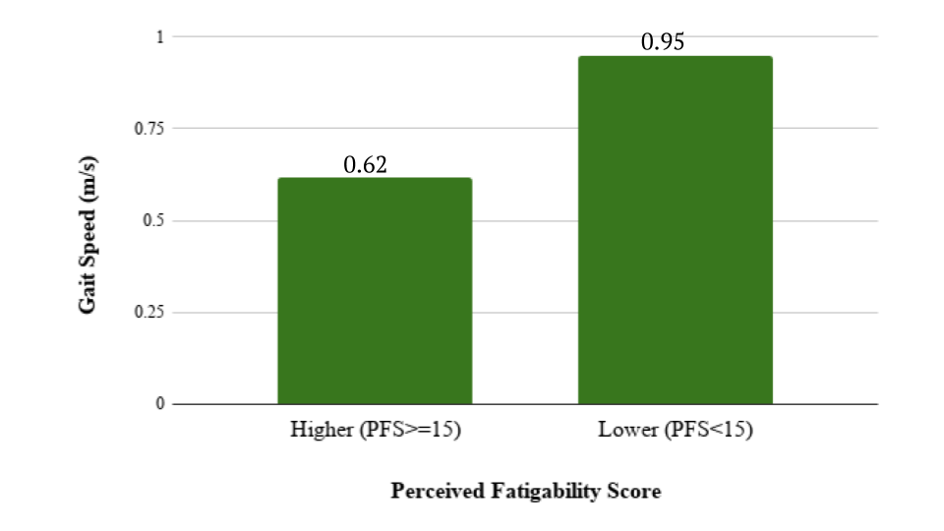

Figure 5 Association between Higher Perceived Physical Fatigability and Gait Speed in the Proband Generation: Long Life Family Study (N=330)



Figure 6 Association between Higher Perceived Physical Fatigability and Gait Speed in the Offspring Generation: Long Life Family Study (N=2095)

## Relationship between Physical Activity and Gait Speed

The univariate relationship between between physical activity and gait speed in the proband and offspring generations can be found in Figures 7 and 8.  For the probands (Figure 7), those in the highest quartile for physical activity had a faster gait speed by 0.36 m/s compared to those in the lowest quartile. The offspring generation displays a more gradual dose response relationship between gait speed and physical activity (Figure 8). As physical activity levels were greater, mean gait speed was faster, although the difference between the highest and lowest quartile was only 0.12 m/s.

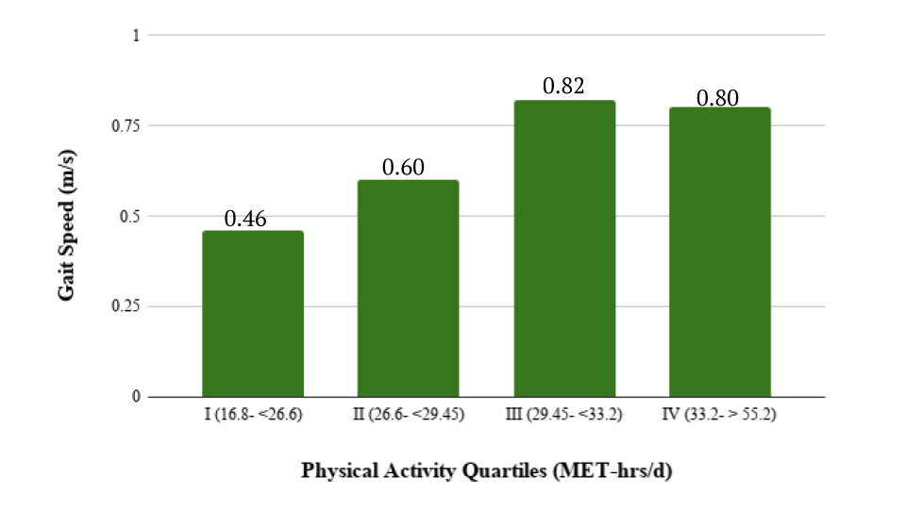

Figure 7 Association between Physical Activity and Gait Speed in the Proband Generation: Long Life Family Study (N=330)

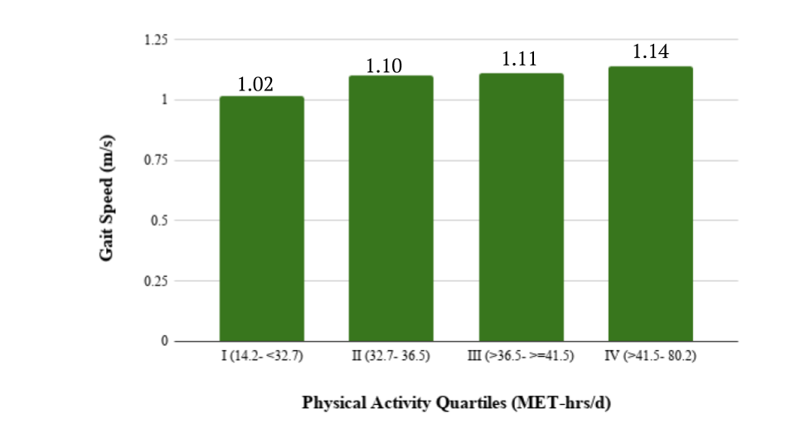

Figure 8 Association between Physical Activity and Gait Speed in the Offspring Generation: Long Life Family Study (N=2095)

Table 3 presents the multivariable relationship between physical activity and usual-paced gait speed in probands and offspring. In the proband generation, a dose response relationship was clearly displayed. Greater physical activity in the highest physical activity quartile is associated with 0.21 m/s faster gait speed compared to the lowest physical activity quartile after adjusting for age, gender, family structure, depression, heart disease, stroke, lung disease, cancer, diabetes, arthritis, and field center. For the offspring generation there was no relationship between physical activity and gait speed after adjusting for covariates, except for quartile III.

Table 3 Multivariable Analysis Examining the Association between Physical Activity Quartiles and Gait Speed

|  |  |  |  |  |  |
| --- | --- | --- | --- | --- | --- |
| Proband | | | Offspring | | |
| Physical Activity Quartiles (MET-hrs/d) | Coefficient* | P-value | Physical Activity Quartiles (MET-hrs/d) | Coefficient* | P-value |
| QI (16.8- <26.6) | reference |  | QI (14.2- <32.7) | reference |  |
| QII (26.6- <29.45) | 0.10 | 0.003 | QII (32.7- <=36.5) | 0.020 | 0.1 |
| QIII (29.45- <33.2) | 0.28 | 0.01 | QIII (>36.5- <=41.5) | 0.024 | 0.04 |
| QIV (33.2-55.2) | 0.21 | <0.0001 | QIV (>41.5- 80.2) | 0.022 | 0.08 |

*Adjusted for age, gender, family structure, depression, heart disease, stroke, lung disease, cancer, diabetes, arthritis, and field center

## Relationship of Physical Activity and Perceived Physical Fatigability on Gait Speed

Table 4 presents the final model examining the relationship between physical activity, PFS physical score, and their independent association on gait speed. In the proband generation, physical activity levels were independently associated with faster gait speed after adjusting for perceived physical fatigability and all other covariates. In this model, perceived physical fatigability was not independently, significantly associated with a faster gait speed in this older generation, after adjustment for physical activity and other covariates (age, gender, family structure, depression, heart disease, stroke, lung disease, cancer, diabetes, arthritis, and field center).

Table 4 presents the final model examining the relationship between physical activity, PFS physical score, and their independent association on gait speed. In the proband generation, physical activity levels were independently associated with faster gait speed after adjusting for perceived physical fatigability and all other covariates. In this model, perceived physical fatigability was not independently, significantly associated with a faster gait speed in this older generation, after adjustment for physical activity and other covariates (age, gender, family structure, depression, heart disease, stroke, lung disease, cancer, diabetes, arthritis, and field center).

Conversely, the multivariable model for the offspring generation shows that physical activity was not independently associated with gait speed after adjusting for PFS physical scores and all other covariates. However, we found a strong independent association between PFS physical scores and faster gait speed, with each one point lower PFS score associated with  0.0074 m/s faster gait speed (p<0.0001) after adjusting for physical activity levels, age, gender, family structure, depression, heart disease, stroke, lung disease, cancer, diabetes, arthritis, and field center.

Table 4 Multivariable Analysis Examining the Association between Physical Activity Quartiles and Pittsburgh Fatigability Scale Physical Scores with Gait Speed

|  |  |  |  |  |  |
| --- | --- | --- | --- | --- | --- |
| Proband | | | Offspring | | |
| Physical Activity Quartiles (MET-hrs/d) | Coefficient* | P-value | Physical Activity Quartiles (MET-hrs/d) | Coefficient* | P-value |
| QI (16.8- <26.6) | reference |  | QI (14.2- <32.7) | reference |  |
| QII (26.6- <29.45) | 0.095 | 0.005 | QII (32.7- <=36.5) | 0.015 | 0.22 |
| QIII (29.45- <33.2) | 0.26 | 0.005 | QIII (>36.5- <=41.5) | 0.017 | 0.15 |
| QIV (33.2-55.2) | 0.17 | <0.0001 | QIV (>41.5- 80.2) | 0.010 | 0.4 |
| PFS score | -0.18 | 0.26 | PFS score | -0.057 | <0.0001 |

*Adjusted for age, gender, family structure, depression, heart disease, stroke, lung disease, cancer, diabetes, arthritis, and field center

# Discussion

Our hypothesis on higher physical activity having a strong independent association with a faster gait speed after adjusting for PFS scores in the probands, the oldest cohort, was supported. However perceived physical fatigability was not strongly associated with faster gait speed in this cohort after adjusting for physical activity levels. Our hypothesis was also confirmed with perceived physical activity having a strong independent association with a faster gait speed in the offspring after adjusting for physical activity levels. Conversely, physical activity was not strongly associated after adjusting for PFS scores in the younger cohort.

To better understand the complex relationship by generation, we first examined for the probands the association between physical activity and activity limitations without perceived physical fatigability. When we examined the preliminary association between perceived physical fatigability and gait speed, the results indicated that there was a strong relationship. However, once physical activity was included in the model, perceived physical fatigability was no longer significant in the probands. It is plausible that the unanticipated finding could be explained by the small sample size and the tighter spread at the extreme levels of perceived physical fatigability, which resulted in a lack of sufficient variability in the proband’s cohort’s PFS scores. PFS scores of ≥15 points is the cut point for higher fatigability (35), and a large majority of the probands, over 80%, were classified with higher perceived physical fatigability. Further, for the proband generation of much older adults, in their late 80s and 90s overall, it may be at that age range, physical activity is a much more significant factor in determining the likelihood of having an activity limitation.

Further, our findings in the proband generation indicated the importance of maintaining a minimum level of physical activity above 26.6 MET-hrs/day (the 2nd quartile of physical activity). These results are comparable to the work in the Health ABC study, where men in the inactive group were twice as likely to have an activity limitation compared to their male counterparts in the exerciser group (15). Higher physical activity levels share a strong dose response relationship with faster gait speeds which corroborates with the OAI study, where those who aimed to increase their physical activity towards the US Department of Health and Human Services Guidelines reduced their risk of disability over a period of 2 years, whether they met the guidelines or insufficiently but did increase their activity (16). Our findings are also supported by the LIFE study results, which showed that a physical activity intervention (about 150 minutes/week) reduces the risk of developing an activity limitation compared to those who do not increase their activity (17).

Lastly, when looking just at the association between physical activity and perceived physical fatigability in the probands (Table 2), the findings indicated a strong dose-response relationship between all physical activity quartiles and PFS scores. These results corroborate with the DECOS study where higher perceived physical fatigability was associated with a slower walking speed (32).

In the offspring generation, the multivariate analysis of physical activity and perceived physical fatigability on gait speed provided surprising results. The preliminary analysis of the association between physical activity and gait speed without perceived physical fatigability was very weak (Table 3). Only the 3rd physical activity level quartile showed a significantly independent association between physical activity and gait speed when compared to the quartile with the lowest level of physical activity. Once perceived physical fatigability was added to the model, physical activity was no longer significant for any quartile. A factor to note for these results is that the physical activity data in the Long Life Family Study was collected through the FPAI, a self-reported measure, which has shown to have lower variability compared to objective measures (39). It must be emphasized that the offspring reported much higher levels of physical activity compared to the probands. The offsprings’ physical activity quartiles 2 through 4 ranged between 32.7-80.2 MET-hrs/day, whereas only the 4th quartile in the probands had a similar range of 33.2-55.2 MET-hrs/day. When taking the ranges of these quartiles into account, the lack of a strong relationship between physical activity and gait speed was likely due to the offspring going above a certain threshold of physical activity required to affect gait speed.

The importance of assessing perceived physical fatigability for its strong association with gait speed in older adults is shown from the results for the offspring. The findings were supported by the results of the BLSA study where the mean gait speed in those who maintained their pace was faster than those who slowed during the 400 meter walk (25). The association between perceived physical fatigability and gait speed also concurred with the SEA-P study findings, which also found that faster paced 400 meter walkers’ SFS item scores were 5 points lower compared to their slower counterparts scores (26).

Finally, we glean from this work that in the offspring the relationship of physical activity and perceived physical fatigability with gait speed was complex, while the findings between higher levels of physical activity and lower perceived physical fatigability show a strong dose response relationship. This evidence is supported by the BLSA study, which found that higher perceived physical fatigability was associated with progressively lower physical activity (31).

Overall, the strengths of this study include the large sample size in the offspring generation. The PFS provided a robust and validated measurement of perceived physical activity in this cohort (30). This study is also one of the very few that examines the association between physical activity and gait speed, while including the novel measurement of perceived physical fatigability.

There are some general limitations, such as the problems with carrying out a cross-sectional analysis. The causal direction of physical activity, perceived physical fatigability and their relationship to gait cannot be identified. Physical activity is a self-reported measurement, which may be under or overestimated which may partially explain the results in the offspring generation. The majority of the Long Life Family Study families are white, and the participants are exceptionally healthy, which is not very generalizable.

In conclusion, perceived physical fatigability is strongly independently associated with a faster gait speed in young, but not the oldest adults in the Long Life Family Study cohort after adjustment. Physical activity is strongly independently associated with a faster gait speed in the oldest adults, but not the younger adults in the cohort after adjustment. Future analyses will focus on conducting a mediation analysis to determine how the effect of physical activity occurs in the relationship between perceived physical fatigability and gait speed.

# Bibliography

1. Fried LP, Guralnik JM. Disability in Older Adults: Evidence Regarding Significance, Etiology, and Risk. 1997;45(1):92-100
2. Statistics F.I.F.o.A.-R. Older Americans 2008. Key Indicators of Well-Being. Washington, DC: U.S. Government Printing Office; 2008
3. Manini T. Development of physical disability in older adults. Curr Aging Sci. 2011;4(3):184–191.
4. Gill TM, Desai MM, Gahbauer EA, Holford TR, Williams CS. Restricted activity among community-living older persons: incidence, precipitants, and health care utilization. Ann Intern Med. 2001;135: 313–321.
5. World Health Organization. Towards a Common Language for Functioning, Disability, and Health. ICF. 2002. https://www.who.int/classifications/icf/icfbeginnersguide.pdf
6. Guralnik JM, Ferrucci L, Pieper CF, et al. Lower extremity function and subsequent disability: consistency across studies, predictive models, and value of gait speed alone compared with the short physical performance battery. J Gerontol A Biol Sci Med Sci. 2000;55:M221–M231.
7. Miller ME, Magaziner J, Marsh AP, et al. Gait Speed and Mobility Disability: Revisiting Meaningful Levels in Diverse Clinical Populations. J Am Geriatr Soc. 2018;66(5):954–961.
8. Castell MV, Sánchez M, Julián R, Queipo R, Martín S, Otero Á. Frailty prevalence and slow walking speed in persons age 65 and older: implications for primary care. BMC Fam Pract. 2013;14:86. Published 2013 Jun 19
9. Quach L, Galica AM, Jones RN, Procter-Gray E, Manor B, Hannan MT, Lipsitz LA. The nonlinear relationship between gait speed and falls: the Maintenance of Balance, Independent Living, Intellect, and Zest in the Elderly of Boston Study. J Am Geriatr Soc. 2011;59(6):1069–1073.
10. Afilalo J, Eisenberg MJ, Morin JF, Bergman H, Monette J, Noiseux N, Boivin JF. Gait speed as an incremental predictor of mortality and major morbidity in elderly patients undergoing cardiac surgery. J Am Coll Cardiol. 2010;56(20):1668–1676
11. Cesari M, Kritchevsky SB, Penninx BW, Nicklas BJ, Simonsick EM, Newman AB, Pahor M. Prognostic value of usual gait speed in well-functioning older people--results from the Health, Aging and Body Composition Study. J Am Geriatr Soc. 2005;53(10):1675–1680.
12. Sun F, Norman IJ, While AE. Physical activity in older people: a systematic review. BMC Public Health. 2013;13:449
13. Caspersen, CJ, Pereira, MA, Curran, KM. Changes in physical activity patterns in the United States, by sex and cross-sectional age. Med. Sci. Sports Exerc., 2000;32(9):1601–1609, 2000
14. World Health Organization. Diet and Physical Activity Factsheet. Secondary Diet and Physical Activity Factsheet. 2013.<http://www.who.int/dietphysicalactivity/factsheet_inactivity/en/index.html>
15. Brach JS, Simonsick EM, Kritchevsky S, Yaffe K, Newman AB. The association between physical function and lifestyle activity and exercise in the health, aging and body composition study. J Am Geriatr Soc 2004;52(4):502-9
16. Song J, Gilbert AL, Chang RW, et al. Do Inactive Older Adults Who Increase Physical Activity Experience Less Disability: Evidence From the Osteoarthritis Initiative. J Clin Rheumatol. 2017;23(1):26–32.
17. Pahor M, Guralnik JM, Ambrosius WT, et al. Effect of structured physical activity on prevention of major mobility disability in older adults: the LIFE study randomized clinical trial. JAMA. 2014;311(23):2387–2396.
18. Eldadah BA. Fatigue and fatigability in older adults. PM & R : the journal of injury, function, and rehabilitation 2010;2(5):406-13
19. Avlund K. Fatigue in older adults: an early indicator of the aging process? Aging clinical and experimental research 2010;22(2):100-15
20. Zengarini E, Ruggiero C, Perez-Zepeda MU, et al. Fatigue: Relevance and implications in the aging population. Exp Gerontol 2015;70:78-83
21. Alexander NB, Taffet GE, Horne FM, et al. Bedside-to-Bench conference: research agenda for idiopathic fatigue and aging. *J Am Geriatr Soc*. 2010;58(5):967–975.
22. RFA-AG-16-013: Development of Measures of Fatigability in Older Adults (R21). National Institutes of Health. https://grants.nih.gov/grants/guide/rfa-files/RFA-AG-16-013.html.
23. Vestergaard S, Nayfield SG, Patel KV, et al. Fatigue in a representative population of older persons and its association with functional impairment, functional limitation, and disability. J Gerontol A Biol Sci Med Sci. 2009;64(1):76–82.
24. Simonsick EM, Schrack JA, Glynn NW, Ferrucci L. Assessing fatigability in mobility-intact older adults. J Am Geriatr Soc 2014;62(2):347-51
25. Richardson CA, Glynn NW, Ferrucci LG, Mackey DC. Walking energetics, fatigability, and fatigue in older adults: the study of energy and aging pilot. J Gerontol A Biol Sci Med Sci. 2015;70(4):487–494.
26. Glynn NW, Santanasto AJ, Simonsick EM, et al. The Pittsburgh Fatigability Scale for Older Adults: Development and Validation. Journal of the American Geriatrics Society 2015;63(1):130-35
27. Yang CM, Wu CH. The situational fatigue scale: a different approach to measuring fatigue. Quality of life research : an international journal of quality of life aspects of treatment, care and rehabilitation 2005;14(5):1357-62
28. Manty M, de Leon CF, Rantanen T, et al. Mobility-related fatigue, walking speed, and muscle strength in older people. The journals of gerontology. Series A, Biological sciences and medical sciences 2012;67(5):523-9
29. Simonsick EM, Schrack JA, Santanasto AJ, Studenski SA, Ferrucci L, Glynn NW. Pittsburgh Fatigability Scale: One-Page Predictor of Mobility Decline in Mobility-Intact Older Adults. J Am Geriatr Soc 2018;66(11):2092-96
30. Wanigatunga AA, Simonsick EM, Zipunnikov V, et al. Perceived Fatigability and Objective Physical Activity in Mid- to Late-Life. The Journals of Gerontology: Series A 2018;73(5):630-35
31. Urbanek JK, Zipunnikov V, Harris T, Crainiceanu C, Harezlak J, Glynn NW. Validation of Gait Characteristics Extracted From Raw Accelerometry During Walking Against Measures of Physical Function, Mobility, Fatigability, and Fitness. *J Gerontol A Biol Sci Med Sci*. 2018;73(5):676–681.
32. Colby SL, Ortman JM. Projections of the Size and Composition of the U.S. Population: 2014 to 2060, Current Population Reports, P25-1143, U.S. Census Bureau, Washington, DC, 2014.
33. Sebastiani P, Hadley EC, Province M, et al. A family longevity selection score: ranking sibships by their longevity, size, and availability for study. Am J Epidemiol. 2009;170(12):1555–1562
34. Newman AB, Glynn NW, Taylor CA, et al. Health and function of participants in the Long Life Family Study: A comparison with other cohorts. Aging. 2011;3(1):63-76.
35. Rosso AL, Wasson E, J Santanasto A, et al. Neural Correlates of Physical and Mental Fatigability in Older Adults. Innov Aging. 2018;2(Suppl 1):199–200. Published 2018 Nov 11.
36. Tan ZS, Spartano NL, Beiser AS, et al. Physical Activity, Brain Volume, and Dementia Risk: The Framingham Study. J Gerontol A Biol Sci Med Sci. 2016;72(6):789–795.
37. An P, Miljkovic I, Thyagarajan B, et al. Genome-wide association study identifies common loci influencing circulating glycated hemoglobin (HbA1c) levels in non-diabetic subjects: the Long Life Family Study (LLFS). *Metabolism*. 2014;63(4):461–468.
38. Radloff LS. The CES-D scale: a self-report depression scale for research in the general population. Applied Psychological Measurement. 1977;1:385-401.
39. Dowd KP, Szeklicki R, Minetto MA, Murphy MH, Polito A, Ghigo E, et al. A systematic literature review of reviews on techniques for physical activity measurement in adults: a DEDIPAC study. Int J Behav Nutr Phys Act. 2018;15.