Clostridioides difficile Prevention in Health Care Settings and Future Improvement

by

Victoria Schmalstieg

BS, Biological Science, University of Pittsburgh, 2015

Submitted to the Graduate Faculty of

Infectious Diseases and Microbiology

Graduate School of Public Health in partial fulfillment

Of the requirements for the degree of

Master of Public Health

University of Pittsburgh

2019

UNIVERSITY OF PITTSBURGH

Graduate School of Public Health

This essay is submitted

by

Victoria Schmalstieg

on

August 9, 2019

and approved by

Essay Advisor:
Jeremy J Martinson, DPhil
Assistant Professor
Infectious Diseases and Microbiology, Graduate School of Public Health
University of Pittsburgh

Essay Reader:
Mohamed Yassin, MD
Associate Professor
University of Pittsburgh School of Medicine
Associate Professor
Infectious Diseases and Microbiology, Graduate School of Public Health
University of Pittsburgh

Copyright © by Victoria Schmalstieg
2019

Jeremy J Martinson, DPhil

Clostridioides difficile Prevention in Health Care Settings and Future Improvement

Victoria Schmalstieg, MPH

University of Pittsburgh, 2019

Abstract

Clostridium Difficile (CDI) is the leading nosocomial infection in healthcare facilities and continues to be a problem. Yet there are varying ways in which to prevent an infection in these facilities that could in fact be improved. This paper focuses on CDI prevention which includes environmental cleaning and hand hygiene (HH) as well as the antibiotic stewardship. This paper proposes to make suggestions to improve HH compliance by implementing more strict instructions for personnel as well as patients. Environmental cleaning could be improved if all facilities used sporicidal agents as well as more detailed cleaning on surfaces such as floors and toilets. The final suggestion is to stop the early use of antibiotics before a diagnosis is complete and proven to prevent early onset of a CDI. The addition of guidelines for Antibiotic Stewardship to educate both the healthcare workers and the patients is a huge step to prevent future infections. The prevention of this infection will increase patient safety and satisfaction as well as decrease hospital expenses. The implementation of these techniques could decrease the onset of infection which would improve patient’s safety and health while they are in healthcare facilities. This subject is of Public Health concern and importance because it is an ongoing issue in healthcare facilities and prevention could solve many issues to come.
Table of Contents
Preface viii
1.0 Clostridium Difficile Background 1
2.0 Infection Prevention 4
2.1 Environmental Cleaning 6
2.2 Hand Hygiene 8
2.3 Contact Precautions 10
2.4 Stewardship 10
3.0 Conclusion 14
Appendix A : Healthcare Hand hygiene posters 17
Appendix B : Hand Hygiene Compliance research data 19
Bibliography 20

List of Tables
Table 1 Hand Hygiene Compliance Chart 19

List of Figures
Figure 1 Clostridioides Difficile healthcare facility infection prevention chart 5
Figure 2 Cleaning products ability to eliminate Clostridium Difficile Spores 7
Figure 3 Hand Washing Technique CDIwith Soap and Water 17
Figure 4 Hand Washing Techniques with Hand Sanitizer 18
Figure 5 Hand Hygiene Compliance 19

Preface
I would like to take this opportunity to sincerely thank Dr. Jeremy Martinson and Dr. Mohamed Yassin for their help and understanding with writing this essay. Also thank you for the mentoring and Experience in the research field.

Clostridium Difficile Background
Clostridioides Difficile or C. Diff is a gram positive, anaerobic bacterium that produces a cytotoxin toxin A and B.⁵ The toxins of CDI bacteria are the pathogenic parts of the bacteria both of which cause specific problems. Along with the toxins, the bacteria can form spores that help it to survive in oxygen abundant areas.
Toxin A has both cytotoxic and enterotoxin qualities and has serious effects on the cells normal actions such as cell signaling. ¹² Toxin B also has cytotoxic characteristics that effect the cell structure and cell signaling like the Toxin A.¹² These toxins cause several symptoms in the body that make it difficult to deal with and even trickier to treat. Symptoms pertaining to the infection of C. Diff. include watery diarrhea which is the most common, fever, pain in the abdomen, and nausea that leads to loss of appetite. ¹² Even though there are symptomatic forms of this infection, there are also asymptomatic forms that are still transmissible and are more common in hospital settings.
According to NCBI research, infections acquired in hospitals are around 59% yearly whereas those that are acquired through community interaction are 41%.¹⁴ In 2012 alone there were 29,000 deaths that were caused by a Clostridium Difficile infection and about two-thirds of the infections were in patient care facilities.¹⁴ In 2015 there were close to 500,000 acquired infections where around 15,000 of those cases were fatal.¹
When CDI bacteria is spread it is through fecal matter either spread directly via contact with someone who has the infection or from contaminated environmental surfaces.² Because the bacteria form these spores, it can survive on a surface for long periods of time.⁵ Patients who stay in healthcare facilities have a higher risk of the infection than people who are not. There are many forms of high-risk patients which means those patients who are more in danger of getting the infection. Extended stays in hospitals for serious treatment or long stays in a nursing home facility or any other health care setting are risk factors. ₂₃ Another risk that could lead to an infection is if the person has any type of immunocompromised conditions. ₂₃ This could be anything from cancer to an autoimmune disorder or any other disorder that would cause the immune system to become weakened. Previous exposure to clostridium difficile through a previous infection can also cause someone to become more susceptible to having a return infection.₂₃ There are cases where healthy people will encounter the CDI bacteria and will not show any signs and will not have any symptoms of having the infection. These patients are termed as carriers and can in fact spread the infection to others even though they are not physically sick themselves.¹³
CDI is a serious infection for a couple of reasons that are very important. Symptomatically, if this infection is left untreated, it can lead to complications such as dehydration from the rapid and frequent watery diarrhea, the colitis can rupture the colon, and most severely can cause sepsis.¹⁴ Another severe characteristic is that CDI bacteria flourishes when someone is taking antibiotics. The antibiotics that people are taking knock out the normal flora in the gut and make the perfect environment for the bacteria to infect without being challenged. Antibiotics such as cephalosporins, fluoroquinolone’s, penicillin’s and clindamycin’s are the most common ones to lead to the infection.²⁰ If any of these symptoms are left untreated or are left to become more intense or severe, there is a large chance that the infection will overcome the patient leading to death.
The treatment of the infection is through antibiotic treatment or treatment of the symptoms caused by the infection. The antibiotics that can be used to treat the infection or prevent it from growing are metronidazole, vancomycin and fidaxomicin for mild/moderate infection. ²⁰ These antibiotics are recommended to be given by mouth. Supportive care is essential when caring for someone who is infected with techniques that help with rehydration, pain management, anti-nausea and any other patient specific treatments.⁵
CDI is a continued issue in many situations, especially in a Hospital setting. The most obvious risk factor that could lead to a CDI is that the patient is on any certain type of antibiotics such as fluoroquinolones. ¹⁷ These types of antibiotics are used to treat urinary tract infections and various types of respiratory infections. The next risk factor would be the age of the patient or person being treated.¹⁷ If a person who is the age of 65 or older is being treated or is taking antibiotics, they are more likely to have a CDI than someone that is younger than them.²³
There are many ways that this infection can be prevented. Prevention of the infection is the first step in any process and is the aim of this paper. The first way to prevent the spread of infection is to clean any are that meets a person that has the infection or anyone that encounters the healthcare workers that treat the infected. The cleaning agents that should be used are those that are able to kill spores and spore forming bacteria.⁶ Another form of prevention is to have healthcare professionals where gloves, gowns and masks that can be removed and thrown into a hazardous bin.⁶ The next form of prevention would be to wash hands and or any body part that encounters the infected patient with soap and water (not hand sanitizer).⁶ Along with infection prevention, healthcare facilities must consider how antibiotics are handled otherwise known as antibiotic stewardship.

Infection Prevention
Each Hospital is required to follow a specific protocol to prevent the spread or production of any infection. The CDC has guidelines on what should be done to make each patient’s stay as safe and as thorough as possible. When a patient has had more than 3 bowel movements in 24 hours or less then they are to be tested for CDI bacteria.⁹ The patient is to be put into an isolation room that is clearly marked with a sign so that others know that the patient could be infected.⁹ All personnel are to wear hospital grade gloves and a barrier gown when entering the room even in the case of a brief visit.⁶ If the patient has been confirmed to have an infection, they must be kept in isolation and protocol must be continued.⁹ Only certain antibiotics are to be used for treatment of the patients and no other ones are to be used. After the patient is discharged or transferred out of the room the room is to be cleaned thoroughly and disinfected.⁹ Also, it is recommended that in the case of a patient being transferred that the other room or facility should be informed of their condition so that they can take the correct measures.⁹
After patient contact and the removal of gloves, hospital personnel are to wash their hands with soap and water instead of hand sanitizer due to the alcohol in its ingredients not being able to destroy the bacterial spores.⁵ Isolation procedures may be continued after symptoms have disappeared or up until the patient is routinely discharged for the facility. Around 53% of infections are due to spread from symptomatic patients whereas 20% of these infections are due to asymptomatic patients which is a growing issue in these facilities.¹⁰
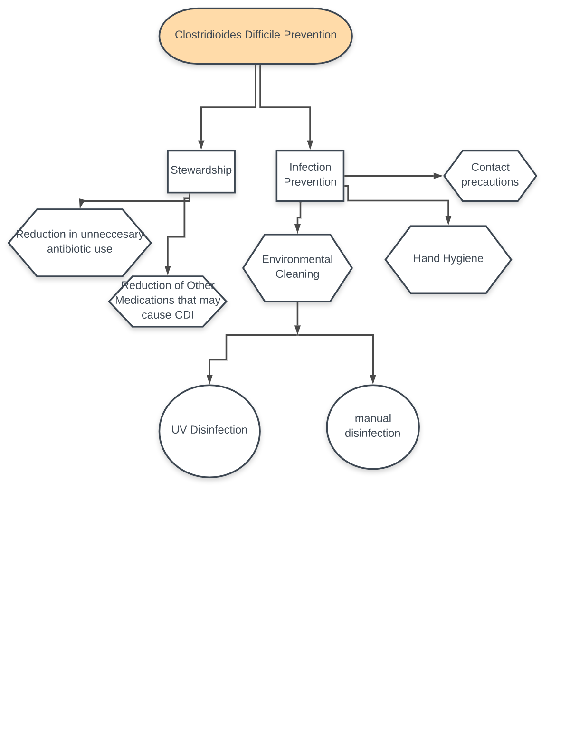
Infection prevention is a very important part of any healthcare facility. There are many methods that are useful in this area, but some are more effective than others. Figure 1 shows the chart of steps needed in hospital or healthcare facilities to prevent infection. The three methods that seem to be of most interest and importance are the products/techniques used to prevent an infection spread, hand hygiene, as well as the antibiotic stewardship.

Figure 1 Clostridioides Difficile healthcare facility infection prevention chart

Environmental Cleaning
Cleaning a patient’s room daily is a very important procedure that plays a large rule in preventing the spread of infection form patient to patient. When focusing on particular ways to clean and disinfect a room that housed a patient with a CDI, there are many different areas to consider. It is no mystery that cleaning is important but what could be more unknown is the cleaning products that are the most effective on the bacteria and its spores.
In recent studies it has been found that less than 50% of surfaces in hospital or health care facilities are thoroughly cleaned which leaves spore residues behind.²¹ Figure 2 shows the effect of each of the different types of cleaning agents on the spores within 1/5/10/15/20-minute increments after spraying the surface without wiping it.²¹ The use of non-sporicidal cleaning supplies has very little effect on the spores of Clostridium Difficile. The only way that these types of cleaning agents have any effect are when they are physically wiped which still only removes 3 log10 of the spores.²¹ The use of a chlorine based or sporicidal product without physically wiping the surface can remove around 3 log10 of the spores which is the same as using a non-sporicidal agent and wiping it away.²¹ This means that the physical wiping away of the sporicidal agent would clear a considerable amount of the spores especially if the person who is cleaning the surface is very thorough.

Figure 2 Cleaning products ability to eliminate Clostridium Difficile Spores
Another form of environmental cleaning is the use of UV light to eradicate any left-over spores in the room after physical cleaning is finished. The strongest form of sporicidal UV light is UV-C which has a wavelength of about 100-280 nm.³ The use of this type of UV light disrupts the replication process of the germ which stops it from being able to multiply on the surfaces and in the air.³ Since the spores of Clostridium Difficile can survive on surfaces for up to 5 months, it is very important to destroy them and stop them from being able to multiply.³
Although the use of these different cleaning products is very effective in the removal of the spores, some surfaces in healthcare facilities seem to be forgotten in the cleaning process. The two surfaces that seem to be ignored more times than not when cleaning are the floors and a thorough scrub of the patient’s toilets. People assume that the floors in healthcare facilities are not dangerous for spread of disease because they are not physically touched by their hands yet there is evidence that the floor is the perfect reservoir for germs to reproduce and spread. Floors are one of the surfaces in a hospital that are not ever considered clean or disinfected. A study conducted on the floors of a hospital in Cleveland found very interesting results. ⁷ When 120 room floors were swabbed for Clostridium Difficile, 86 of these rooms were positive for containing Clostridium Difficile spores. ⁷ Most of the rooms containing clostridium difficile contamination were those that were considered non-Clostridium Difficile Infection rooms. ⁷ This means that there was possible cross contamination from people shoes from walking from room to room. Hospital equipment such as blood pressure cuffs and call buttons often have times when they are in contact with the floor (41%) which is another chance for spread.³¹ Noncritical equipment, which is the equipment that makes contact with the physical skin of the patient and not necessarily a mucous membrane are often seen not to be thoroughly cleaned as well.³¹ Without these rooms being thoroughly cleaned the spores were able to thrive. ⁷ The other ignored surface is the toilets in the healthcare facilities. A study performed in a hospital was performed where both the toilets of those with Clostridium Difficile and those with non-Clostridium Difficile related diarrhea were swabbed.² They found that 10% of the spores that they recovered from the swabbing came from those toilets where patients did not have Clostridium Difficile.² The act of just flushing a toilet that contains spores could spread the infection to others. Therefore, cleaning is so important to do in these situations.

Hand Hygiene
Another very important part of infection prevention is that everyone involved in the care or that comes in to contact with the patient must wash their hands. An example of a hospitals hand hygiene protocol is from unpublished research data. This studies hospital uses educational services and examples to express the rules for hand hygiene in the hospital setting. There are points in each point of service to a patient in which the care provider is supposed to wash their hands in order to prevent infection.¹¹ Those points are before they enter the room, when leaving the room, before contact with a patient, after contact with a patient, before a procedure, and after a procedure.¹¹ These steps are a big way to prevent the spread of any infection, not just a CDI.
A study on the compliance of hand hygiene protocol was conducted at a hospital in 2018 in their rehabilitation facilities. The study was testing to see that if the automated hand hygiene compliance numbers or in person hand hygiene compliance records were more reliable. Around 500 visuals, in person samples were taken to see if personnel were washing their hands at the correct times when treating a patient. All personnel were monitored such as techs, nurses, physicians, etc. Any room that a patient could be in and could be in contact with personnel was considered in this study. All interactions with the 6 points of hand washing were recorded in the chart with dates and times. Number were used for visual that if the personnel washed their hands a “1” was marked and if they did not wash their hands a “0” was marked. The results to this test were compared to audits taken from the hospital internally by the staff. After the 500 samples were taken, it was found that there was only a 66% compliance rate. Yet the internal audits showed that out of 238 examples, 93% of them were compliant.
Not only is it important for the healthcare personnel to perform proper hand hygiene but it is also extremely important that the patients perform just as thorough hygienic procedures. Patients who are infected with Clostridium Difficile do not always have the opportunity or the correct utilities to practice proper hand hygiene when staying in health care facilities.¹⁰ In fact, a study performed at UPMC Shadyside found that only around 51% of patients are provided with proper hand hygiene techniques.¹⁰ Fixing this alone could improve the reduction of spread of the infection.

Contact Precautions
The CDC has certain recommendations for contact precautions of CP that they advise healthcare professionals to apply to their care. Contact precautions can include anything from wearing gloves to wearing a gown.³³ Other types of CP could include the use of single use equipment such as blood pressure cuffs, thermometers, and oxygen meters.³³ The one of most interest is that they recommend that contact precautions be discontinued after the patient has been diarrhea free for 48 hours.⁷ A study on CP was produced and found that CDI spores can be shed potentially weeks after the infection.⁷ Recommendations have changed to spreading the duration of CP past the 48 hours and to increase it to the entire hospital stay for the patient.⁷ Studies for this subject are still ongoing and there are not many of them to back up this assumption.

Stewardship
Antibiotic use has always been a controversial topic when it comes to Clostridium Difficile prevention and treatment. The use of antibiotics to treat other infections puts people at serious risk of contracting the infection and some antibiotics are used to treat the infection even if they are not entirely effective. Studies are starting to show that the antibiotic metronidazole is no longer seen as a first line drug treatment for a CDI. ²⁰ The first line treatment is now only vancomycin and fidaxomicin. ²⁰ The only time that a patient is to be treated with metronidazole is when they are unable to be treated with the other two antibiotics for any reason thus specified. ²² This treatment is only seen to be recommended in those with non-severe infection. This change in protocol is due to studies showing that the use of vancomycin and fidaxomicin showed a higher and faster cure of symptoms within the first month of treatment. ⁹ The removal of unnecessary medications and antibiotics could be a huge factor in preventing someone from having a repeat infection.
Extended use of CDI treatment is used in some facilities to hopefully prevent a reoccurrence of the infection. From January 2012 to December 2015 patients were followed in their CDI treatment journey to see if continued use of the antibiotics would prevent a reinfection.₁₇ In both the control groups (average of 14 days on treatment) and the experimental group (average of 24 days on treatment) showed the same amount or around the same amount of reoccurrence meaning that extending the duration of treatment had no effect on preventing a reoccurrence of the infection. ¹⁷
Healthcare facilities have an average of 60% of their patients being given antibiotics and around 73% of CDI occurring after antibiotic use. ⁸ Improper use of antibiotics could anything form prescribing too much antibiotics unnecessarily or prescribing antibiotics before an infection or a true reason to be treated with antibiotics.¹² One study performed presented that out of 62 patients treated with antibiotics prior to CDI, 45 of those patients were inappropriately treated with antibiotics even before they were diagnosed with an infection. ¹² Even after the patients were diagnosed with a CDI, 38% of them were continued on those antibiotics that caused the infection.¹³
APIC and SHEA which are the Association for Professionals in Infection Control and Epidemiology and the Society for Healthcare Epidemiology of America created a list of guidelines for Antibiotic Stewardship that could be useful.¹⁶ The guidelines that they created include ways to keep track of antibiotics by checking the right dose, what route they will be administering the drug, how long the patient is to be on the drug.¹⁶ Another technique that they introduced was that the prescriber of the antibiotic would have to get authorization before the drug could be administered.¹⁶ These Antimicrobial or Antibiotic Stewardship Programs are important because they implement an accountability factor for the healthcare professionals and the patients as well. The guidelines propose educational opportunities for both the healthcare professional and the patients for antibiotic use which would describe the guidelines in detail and help them to take the antibiotics correctly and for the right amount of time. ¹⁶
Not only are antibiotics known to cause a Clostridioides Difficile infection, but now studies are showing that there are other types of medications can cause these types of infections. Proton pump inhibitors are medications most use for treatment of gastrointestinal disorders and are known to have adverse side effects on the patient.²⁵ Since PPI’s inhibit gastric acid secretion, long term use of this medication can lead to pneumonia, kidney disease but most importantly it can lead to a CDI.²⁵ Analysis of patients who are put on PPI’s found that around 38.6% are at increased risk for a CDI than those that are not on PPI’s.⁵ Studies are still ongoing to really prove that these products cause CDI and there are very few that can prove it.²⁵
Prevention of CDI with the use of probiotics is another study that has been performed in several instances. Several studies were found to have patients that were given randomized doses of probiotics and these patients were compared to patients who were given placebos.¹² Each of the studies produced a result that the patients who received the probiotics had a significant amount less CDI cases than those that received the placebos.¹² Research on whether probiotics can prevent secondary CDI’s are not very common so there is not many instances to prove its efficacy.¹² Although there is still skepticism for the efficacy of this technique, future study could help to prove probiotics ability to prevent a CD infection or not prevent one.
Vaccines have been proven to be very effective against many different illnesses. CDI’s have never had a vaccine before and there are not many studies testing them on patients. One study suggests that a vaccine that is for CDI would target the toxins that are released during the infection, toxin A and toxin B.¹⁵ Future studies should be conducted to test this theory and see if it would be a serious preventative method.

Conclusion
Although preventative measures and treatment standards have vastly improved over the many years the infection has been around, there is always room for more improvement. This paper proposes to locate areas in protocol for prevention and find ways in order to improve. In a study that observed several different resources such as medical databases to find any trends for clinical practice guidelines or CPG’s the results found several reoccurring factors.²⁰ The main focuses that seem to create an effective guidance template are use of probiotics, antibiotic stewardship, bundle strategies and use of chlorinated cleaning products.²⁰
Environmental cleaning as reported above is extremely important in the prevention in spread of CDI. Proper use of cleaning supplies that include sporicidal ingredients is crucial to properly disinfect all areas of the healthcare facilities and should be mandatory. Assigning cleaning procedures for all of the staff involved with the patient will ensure that all equipment will get disinfected.³¹ Each room is to have the cleaning process started within 15 minutes of the patient being discharged from the room.³¹ Floors in the patient’s room should be thoroughly disinfected and ensured that no bacteria is left behind. Noncritical equipment in the patient’s room should be split between the personnel to clean to ensure all are cleaned efficiently. Implementation of weekly swabs in the rooms of patients (including the floors and toilets) should be used to ensure that every surface is disinfected and in no way can spread infection. If there are traces of the bacteria in the rooms then repeat cleaning will have to be done. UV light disinfection technology has proved to be useful in the past and should be continued to be used.
The introduction of more hospital check-ins by experienced and certified personnel could be a very useful solution to this problem. This paper proposes that two days out of each week at least, certified personnel should enter each section of the hospital and observe hand hygiene compliance whether it be unannounced or not. All of the data that these personnel collect should be calculated and reported back to the head of each section of the hospital. Guidelines that were released by the WHO recommend that healthcare workers should not have fake nails when working and natural nails should be kept short so that contaminants cannot hide underneath the nails. ²⁶ When an infected area of the patient is touched by the healthcare worker with their gloves, a new pair of gloves should be applied if the healthcare worker plans to make contact with other areas of the patient or the environment. ²⁶ Asymptomatic patients and healthcare workers should be tested for the infection every so often to ensure that they do not spread the infection by being carriers.³² Educational meetings on hand hygiene compliance and implementation should be offered monthly. Hand hygiene certification and recertification should be required. Classes on other forms of protocol such as cleaning techniques and the proper way to wear protective gear are also an idea that could be implemented.
Another way to improve hand hygiene in the facilities is to have proper products that the patients can use to practice hand hygiene easily accessible to them in all points of their stay. This includes having easily accessible sinks or portable hand washing stations, hand wipes for mealtimes and visible signs instructing the patient on proper hand hygiene as written in the IDSA-SHEA guidelines.¹⁶ The patient’s families could also be involved in the instruction on hand hygiene so that everyone that is in contact with the patient are thoroughly informed. One of the biggest issues here is accountability and if this can be corrected then the problem of infections could be improved tremendously. The inclusion of CP continuation may be a beneficial addition to the guidelines for healthcare professionals as well.
APIC and SHEA have recommendations to prevent the unnecessary use of antibiotics. ⁵ Those suggestion include “Audit, analysis, and reporting of data” in the healthcare facility. ⁵ The use of the guidelines that they created by studying the right dose/duration/purpose/administration route would help to increase the accountability and education for the healthcare facilities as well as the patients who are being treated there. Using these guidelines would decrease the use of unnecessary antibiotics. Possibly if studies continue, PPI usage could be decreased as well to prevent unnecessary CDI cases. There are obviously many other methods that could improve the prevention techniques for Clostridioides Difficile and there is no guarantee that these suggestions will solve everything. Yet the implementation of these improvements could at least make a slight difference.
        - : Healthcare Hand hygiene posters
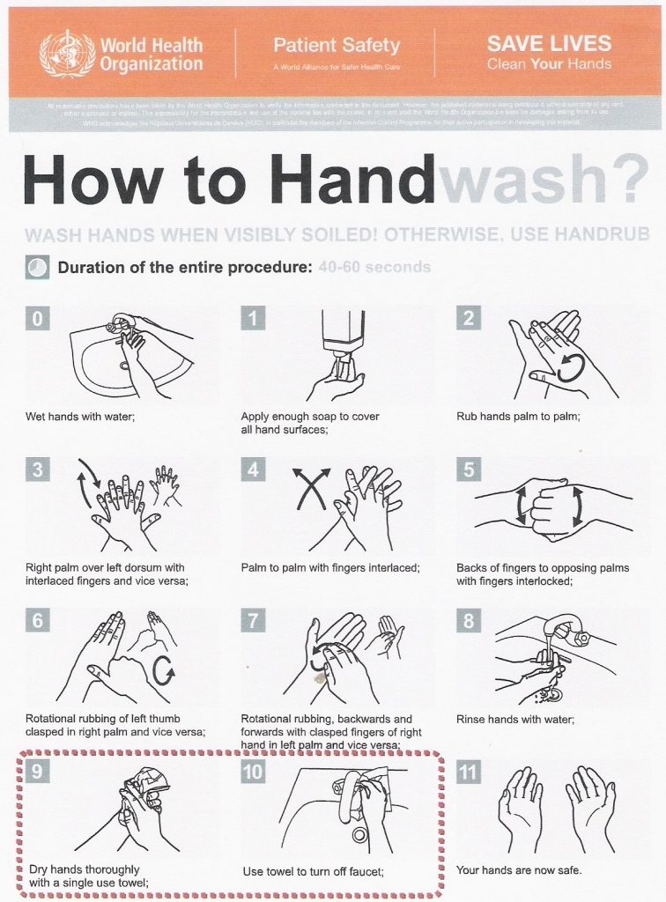

Figure 3 Hand Washing Technique CDIwith Soap and Water
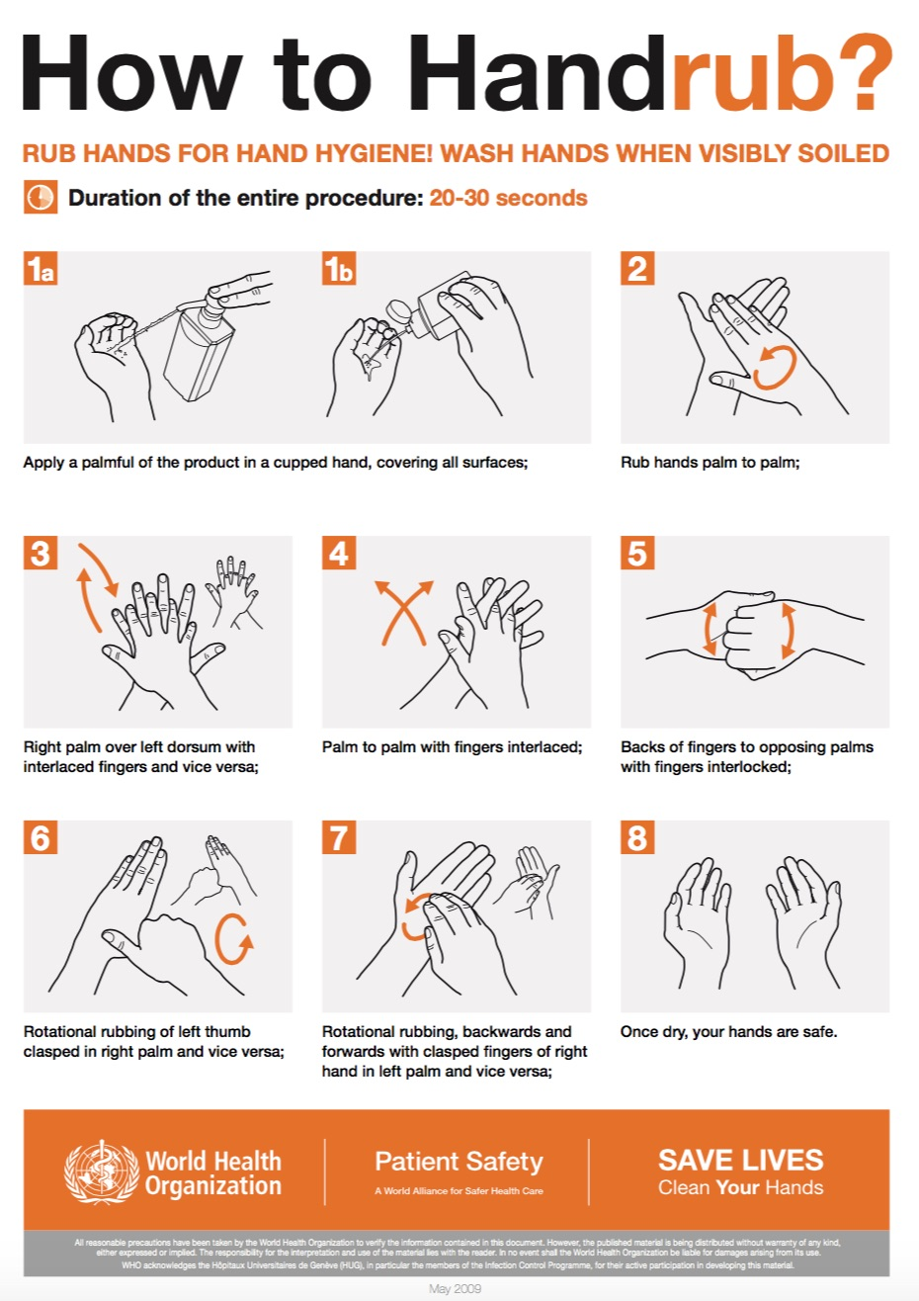

Figure 4 Hand Washing Techniques with Hand Sanitizer

        - : Hand Hygiene Compliance research data

Figure 5 Hand Hygiene Compliance

Table 1 Hand Hygiene Compliance Chart
Checkpoints | Washed Hands | Did not Wash Hands
Before Entering the Room | 295 | 205
Leaving the Room | 360 | 140
Before Patient Contact | 345 | 155
After Patient Contact | 330 | 170
Before a Procedure | N/A | N/A
After a Procedure | N/A | N/A

Bibliography
1)A Nurse-Driven Testing Protocol to Identify Community-Onset Clostridium difficile Infections in Hospitalized Patients Godbout, E. et al. (2018) International Journal of Infectious Diseases, Volume 73, 260
2)Alfa, M. J., Lo, E., Wald, A., Dueck, C., Degagne, P., & Harding, G. K. (2010). Improved eradication of Clostridium difficile spores from toilets of hospitalized patients using an accelerated hydrogen peroxide as the cleaning agent. BMC Infectious Diseases, 10(1). doi:10.1186/1471-2334-10-268
3)Alfa, M. J., Dueck, C., Olson, N., Degagne, P., Papetti, S., Wald, A., . . . Harding, G. (2008). UV-visible marker confirms that environmental persistence of Clostridium difficile spores in toilets of patients with C. difficile-associated diarrhea is associated with lack of compliance with cleaning protocol. BMC Infectious Diseases, 8(1). doi:10.1186/1471-2334-8-64
4)Aslam, A., Melendez, G., Wang, M., Stell, F., Kelly, P., Killinger, J., . . . Eagan, J. (2017). Enhanced Cleaning and Education to Prevent Transmission of Clostridium difficile in Pediatrics. Open Forum Infectious Diseases, 4(Suppl_1). doi:10.1093/ofid/ofx163.1016
5)Azab M, Doo L, Doo DH, Elmofti Y, Ahmed M, Cadavona JJ, Liu XB, Shafi A, Joo MK, Yoo JW. Comparison of the Hospital-Acquired Clostridium difficile Infection Risk of Using Proton Pump Inhibitors versus Histamine-2 Receptor Antagonists for Prophylaxis and Treatment of Stress Ulcers: A Systematic Review and Meta-Analysis. Gut Liver. 2017 Nov 15;11(6):781-788. doi: 10.5009/gnl16568. Review. PubMed PMID: 28506028; PubMed Central PMCID: PMC5669593.
6)Balsells, E., Shi, T., Leese, C., Lyell, I., Burrows, J., Wiuff, C., … Nair, H. (2019). Global burden of Clostridium difficile infections: a systematic review and meta-analysis. Journal of global health, 9(1), 010407. doi:10.7189/jogh.09.010407
7)Banach DB, Bearman G, Barnden M, Hanrahan JA, Leekha S, Morgan DJ, Murthy R Munoz-Price LS, Sullivan KV, Popovich KJ, Wiemken TL. Duration of Contact Precautions for Acute-Care Settings. Infect Control Hosp Epidemiol. 2018 Feb;39(2):127-144. doi: 10.1017/ice.2017.245. Epub 2018 Jan 11. Review. PubMed PMID: 29321078.
8)CDI Prevention Strategies. (n.d.). Retrieved from https://www.cdph.ca.gov/Programs/CHCQ/HAI/Pages/CDI_PREVENTION_STRATEGIES.aspx
9)Deshpande, A., Cadnum, J., Fertelli, D., Sitzlar, B., Thota, P., Mana, T., … Donskey, C. J. (2014). 1647: Are Hospital Floors an Underappreciated Reservoir for Transmission of Clostridium difficile and Methicillin-Resistant Staphylococcus aureus?. Open Forum Infectious Diseases, 1(Suppl 1), S440. doi:10.1093/ofid/ofu052.1193
10)Durovic A, Widmer AF, Tschudin-Sutter S. New insights into transmission of Clostridium difficile infection-narrative review. Clin Microbiol Infect. 2018 May;24(5):483-492. doi: 10.1016/j.cmi.2018.01.027. Epub 2018 Feb 7. Review. PubMed PMID: 29427800.
11)Endres, B., Bassères, E., Rashid, T., Chang, L., Alam, M. J., & Garey, K. W. (2017). A Protocol to Characterize the Morphological Changes of Clostridium difficile in Response to Antibiotic Treatment. Journal of visualized experiments : JoVE, (123), 55383. doi:10.3791/55383
12) Evans CT, Johnson S. Prevention of Clostridium difficile Infection With Probiotics. Clin Infect Dis. 2015 May 15;60 Suppl 2:S122-8. doi: 10.1093/cid/civ138. Review. PubMed PMID: 25922397.
13)FAQs for Clinicians about C. diff | CDC. (n.d.). Retrieved from https://www.cdc.gov/cdiff/clinicians/faq.html
14)Feigel, J., Pokrywka, M., Douglas, B., Hensler, A., & Grossberger, S. (2012). Expanding the Clostridium difficile Infection Prevention Bundle to Include Patient Hand Hygiene. American Journal of Infection Control, 40(5). doi:10.1016/j.ajic.2012.04.139
15)Ghose C, Kelly CP. The prospect for vaccines to prevent Clostridium difficile Probiotics. Clin Infect Dis. 2015 May 15;60 Suppl 2:S122-8. doi: infection. Infect Dis Clin North Am. 2015 Mar;29(1):145-62. Doi. 10.1016/j.idc.2014.11.013. Review. PubMed PMID: 25677708.
16)Irimia R, Gottschling M (2016) Recent Research from Mercy Hospital Highlight Findings in Clostridium difficile (Can improving patient hand hygiene impact Clostridium difficile infection events at an academic medical center?) Taxonomic revision of Rochefortia Sw. (Ehretiaceae, Boraginales). Biodiversity Data Journal 4: E7720. https://doi.org/10.3897/BDJ.4.e7720. (n.d.). doi:10.3897/bdj.4.e7720.figure2f
17)Lessa, F. C., Mu, Y., Bamberg, W. M., Beldavs, Z. G., Dumyati, G. K., Dunn, J. R., . . . Mcdonald, L. C. (2015). Burden of Clostridium difficile Infection in the United States. New England Journal of Medicine, 372(9), 825-834. doi:10.1056/nejmoa1408913
18)Loo VG. Environmental interventions to control Clostridium difficile. Infect Dis Clin North Am. 2015 Mar;29(1):83-91. doi: 10.1016/j.idc.2014.11.006. Epub 2015 Jan 5. Review. PubMed PMID: 25573675.
19)Loo, Vivian G; Bourgault, Anne-Marie; Poirier, Louise; Lamothe François; Michaud, Sophie; et al. The New England Journal of Medicine; Boston Vol. 365, Iss. 18, (Nov 3, 2011): 1693-1703. DOI:10.1056/NEJMoa1012413
20)Lytvyn L, Mertz D, Sadeghirad B, Alaklobi F, Selva A, Alonso-Coello P Johnston BC. Prevention of Clostridium difficile Infection: A Systematic Survey of Clinical Practice Guidelines. Infect Control Hosp Epidemiol. 2016 Aug;37(8):901-8. doi: 10.1017/ice.2016.104. Epub 2016 Jun 7. Review. PubMed PMID: 27267201.
21)Mada PK, Alam MU. Clostridium Difficile. [Updated 2019 Jun 4]. In: StatPearls [Internet]. /Treasure Island (FL): StatPearls Publishing; 2019 Jan-. Available from: https://www.ncbi.nlm.nih.gov/books/NBK431054/
22)Mcgoldrick, M. (2015). Hand Hygiene and Clostridium Difficile Infections. Home Healthcare Now, 33(6), 340-341. doi:10.1097/nhh.0000000000000248
23)Moody, J., Cosgrove, S., Olmsted, R., Septimus, E., Aureden, K., Oriola, S., . . . Trivedi, K. (2012). Antimicrobial Stewardship: A Collaborative Par/tnership between Infection Preventionists and Healthcare Epidemiologists. Infection Control and Hospital Epidemiology, 33(4), 328-330. doi:10.1086/665037
24) Nathalie Vernaz, Kirsteen Hill, Stephanie Leggeat, Dilip Nathwani, Gabby Philips, Pascal Bonnabry, Peter Davey, Temporal effects of antibiotic use and Clostridium difficile infections, Journal of Antimicrobial Chemotherapy, Volume 63, Issue 6, June 2009, Pages 1272–1275, https://doi-org.pitt.idm.oclc.org/10.1093/jac/dkp128
25)Nehra AK, Alexander JA, Loftus CG, Nehra V. Proton Pump Inhibitors: Review of Emerging Concerns. Mayo Clin Proc. 2018 Feb;93(2):240-246. doi:10.1016/j.mayocp.2017.10.022. Review. PubMed PMID: 29406201.
26)Pittet, D., Allegranzi, B., Boyce, J., & . (2009). The World Health Organization Guidelines on Hand Hygiene in Health Care and Their Consensus Recommendations. Infection Control & Hospital Epidemiology, 30(7), 611–622. doi: 10.1086/600379
27)Programs to improve hand hygiene reduced infections, increased compliance. (2014, October 09). Retrieved from https://www.sciencedaily.com/releases/2014/10/141009100936.htm
28)"Reports from Mercy Hospital Provide New Insights into Clostridium difficile (Sustained reduction in rates of hospital-onset Clostridium difficile infection using an automated electronic health record protocol)." Telemedicine Business Week 6 June 2018: 1102. Business Insights: Global. Web. 6 Aug. 2019.
29) (n.d.). Retrieved from https://www.pharmacytimes.com/contributor/marilyn-bulloch-pharmd-bcps/2018/02/new-treatment-guidelines-for-clostridium-difficile
30) Rutala, W., Gergen, M., & Weber, D. (2012). Efficacy of Different Cleaning and Disinfection Methods against Clostridium difficile Spores: Importance of Physical Removal versus Sporicidal Inactivation. Infection Control and Hospital Epidemiology, 33(12), 1255-1258. doi:10.1086/668434
31)Rutala WA, Weber DJ. Best practices for disinfection of noncritical environmental surfaces and equipment in health care facilities: A bundle approach. Am J Infect Control. 2019 Jun;47S:A96-A105. doi: 10.1016/j.ajic.2019.01.014. Review. PubMed PMID: 31146858.
32)Tschudin-Sutter S, Kuijper EJ, Durovic A, Vehreschild MJGT, Barbut F, Eckert C, Fitzpatrick F, Hell M, Norèn T, O'Driscoll J, Coia J, Gastmeier P, von Müller L, Wilcox MH, Widmer AF; Committee. Guidance document for prevention of Clostridium difficile infection in acute healthcare settings. Clin Microbiol Infect. 2018 Oct;24(10):1051-1054. doi: 10.1016/j.cmi.2018.02.020. Epub 2018 Mar 2. Review. PubMed PMID: 29505879.
33) Woods, K. L., & Mangino, J. E. (2014). 1374Environmental Cleaning at the Cornerstone of Decreasing Healthcare Acquired Infections, Including Clostridium difficile. Open Forum Infectious Diseases, 1(Suppl_1). doi:10.1093/ofid/ofu052.920
34) Your Risk of C. diff | CDC. (n.d.). Retrieved from https://www.cdc.gov/cdiff/risk.html
35) Yui, S., Ali, S., Muzslay, M., Jeanes, A., & Wilson, A. (2017). Identification of Clostridium difficile Reservoirs in The Patient Environment and Efficacy of Aerial Hydrogen Peroxide Decontamination. Infection Control & Hospital Epidemiology, 38(12), 1487-1492. doi:10.1017/ice.2017.227

