Allegheny County Health Department’s Mosquito Borne-Disease Control Program
2019 Program Summary & Development Plan

by

Kelsey E. Simon

BS, Biology, University of Pittsburgh, 2017

Submitted to the Graduate Faculty of the
Department of Infectious Diseases and Microbiology

Graduate School of Public Health in partial fulfillment

of the requirements for the degree of

Master of Public Health

University of Pittsburgh

2019

UNIVERSITY OF PITTSBURGH

Graduate School of Public Health

This essay is submitted

by

Kelsey E. Simon

on

November 18, 2019

and approved by

Joanne Russell, MPPM, Global Health
Graduate School of Public Health, University of Pittsburgh

Leah Lamonte, MS, Vector Control Specialist
Allegheny County Health Department, Pittsburgh, Pennsylvania

Essay Advisor: Jeremy Martinson, DPhil, Professor, Department of Infectious Diseases and Microbiology, Graduate School of Public Health, University of Pittsburgh

Copyright © by Kelsey E. Simon

2019

Allegheny County Health Department’s Mosquito Borne-Disease Control Program
2019 Program Summary & Development Plan

Kelsey E. Simon, MPH

University of Pittsburgh, 2019

Abstract

The purpose of this development plan is to summarize the Allegheny County Health Department’s Mosquito-Borne Disease Control Program (ACHD MDP), justify the existence of the program, and establish recommendations. A review of program literature was conducted leading to the identification of program theory, history, and background. Knowledge gained was used to develop strategic planning tools and program recommendations
The ACHD MDP is a division of the health department that was established in 2001 to combat West Nile Virus. West Nile Virus can present as serious neurological disease and lacks a vaccine and treatment options. It is necessary for programs like the MDP to exist within a county health department to protect vulnerable populations and the environment. Additionally, having an established infrastructure of vector control within a county health department makes it easier to introduce new systems of surveillance and emergency response, as demonstrated by the 2016 Zika epidemic. This is a high-quality program that carries out all ten of the essential public health services as defined by the Centers for Disease Control and Prevention (CDC). The program carries out five core activities. These activities include utilizing evidence-based methods of vector control, surveillance, code enforcement, community education, and training.
Several opportunities for improvement were identified using a logic model and Strengths, Weaknesses, Opportunities, and Threats analysis (SWOT). Recommendations for program development include establishing consistent program documentation, expanding the utilization of graduate student interns, capitalizing on Pittsburgh’s collegiate environment, expanding the monitoring and evaluation process, and increasing program visibility and community engagement.
Programs like the MDP contribute significantly to public health. In addition to combatting vector-borne diseases, diseases of public health concern, the MDP carries out the 10 Essential Services of Public Health. Also, this program aims to protect vulnerable populations and the environment as well as respond quickly and proactively to emerging diseases and epidemics. This program summary can function as a framework for other counties to establish their own programs, increasing overall public health capacity. This development plan can help guide the program to enhance effectiveness, consistency, and longevity, ultimately protecting the community and improving public health.

Table of Contents
1.0 Executive Summary 1
2.0 Purpose of Development Plan 3
2.1 Methods of Program Summary and Development Plan 4
3.0 Program Background 5
4.0 Disease Background 6
5.0 Disease Significance 8
6.0 Program Theory 10
6.1 Mission & Vision 10
6.2 Program Theories 10
7.0 Key Stakeholders & Stakeholder Utilization 12
8.0 Organizational Chart 14
9.0 Program Justification 16
9.1 Established Infrastructure 16
9.2 Protecting Vulnerable Populations and the Environment 16
9.3 Providing the 10 Essential Public Health Services 18
9.3.1 ES 1: Monitor health status to identify and solve community health problems 19
9.3.2 ES 2: Diagnose and investigate health problems and health hazards in the community 20
9.3.3 ES 3: Inform, educate, and empower people about health issues 20
9.3.4 ES 4: Mobilize community partnerships and action to identify and solve health problems 21
9.3.5 ES 5: Develop policies and plans that support individual and community health efforts 21
9.3.6 ES 6: Enforce laws and regulations that protect health and ensure safety 22
9.3.7 ES 7: Link people to needed personal health services and assure the provision of health care when otherwise unavailable 22
9.3.8 ES 8: Assure competent public and personal health care workforce 23
9.3.9 ES 9: Evaluate effectiveness, accessibility, and quality of personal and population-based health services 23
9.3.10 ES 10: Research for new insights and innovative solutions to health problems 23
9.4 Zika: A Case Study for Program Justification 24
10.0 Program Activities 28
10.1 Evidence Based Methods of Control 28
10.2 Mosquito Surveillance 31
10.2.1 West Nile Virus Mosquito Surveillance 32
10.2.2 West Nile Virus Dead Bird Surveillance 33
10.2.3 Asian Tiger Mosquito Surveillance 34
10.2.4 Surveillance Data Analysis and Utilization 35
10.3 Code Enforcement 37
10.4 Community Education 39
10.5 Training 40
10.6 Logic Model 42
11.0 Program & Evaluation Monitoring 45
11.1 MDP External Monitoring 45
11.2 MDP Internal Monitoring 47
12.0 SWOT Analysis 49
13.0 Recommendations 51
13.1 Recommendation 1: Establish Consistent Program Documentation 51
13.2 Recommendation 2: Expand the Utilization of Graduate Student Interns 52
13.3 Recommendation 3: Capitalize on Pittsburgh’s Collegiate Environment 52
13.4 Recommendation 4: Expand Monitoring and Evaluation Process 53
13.5 Recommendation 5: Increase Program Visibility and Community Engagement 55
14.0 Conclusion 57
Appendix: Monitoring Documents 59
Bibliography 65

List of Tables
Table 1 Logic Model for the 2019 MDP 43
Table 2 SWOT Analysis for the 2019 MDP 50
Appendix Table 1 Sample Monitoring and Evaluation Plan 62

List of Figures
Figure 1 West Nile Virus Transmission Cycle 7
Figure 2 Program Theory of Change 11
Figure 3 Stakeholder Map 13
Figure 4 Organizational Chart 15
Figure 5 The 10 Essential Services and Core Functions of Public Health 19
Figure 6 PA's WNV Control Program Database Data Flow 47

Appendix Figure 1 PA Arbovirus Weekly Surveillance Report¹⁹ 59
Appendix Figure 2 DEP Monthly Review of Allegheny County in the West Nile Control Program²⁰ 60
Appendix Figure 3 Allegheny County Health Department of Performance Monitoring Scorecard¹ 61

Preface
Acknowledgements
I would like to thank my thesis committee chair, essay advisor and faculty advisor Dr. Jeremy Martinson, my thesis committee member Joanne Russell, and my thesis committee member and preceptor Leah Lamonte. I would also like to thank the Pittsburgh Summer Institute, a partnership between the Allegheny County Health Department and the University of Pittsburgh’s Graduate School of Public Health, for the opportunity to complete my practicum with the Mosquito-Borne Disease Control Program.
List of Abbreviations
ACHD……Allegheny County Health Department
BGS……...BG Sentinel
Bs………..Bacillus sphaericus
Bti……….Bacillus thuringiensis israelensis
CDC……..Centers for Disease Control and Prevention
DEP……...Department of Environmental Protection
ES………..Essential Services
HCE……...Housing and Community Environment
IDM……...Infectious Diseases and Microbiology Department
IPM ………Integrated Pest Management
IMM……. ..Integrated Mosquito Management
MDP……. ..Mosquito-Borne Disease Control Program
NACCHO...National Association of County and City Health Officials
PA………...Pennsylvania
PIN………..Pre-Inspection Notice
SMART….. Specific, Measurable, Action-oriented, Realistic, Time-bound
SWOT….....Strengths, Weaknesses, Opportunities, Threats
WNV……..West Nile Virus
WNI………West Nile Virus Intern
WNND……West Nile Neuroinvasive Disease
VBD………Vector-Borne Disease
VC ………..Vector Control
VCI……….Vector Control Intern
VCP………Vector Control Program
VCS……....Vector Control Specialist
VI ………....Vector Index

Executive Summary
Purpose of Development Plan: The purpose of this development plan is to summarize the Allegheny County Health Department’s Mosquito-Borne Disease Control Program (ACHD MDP), justify the existence of the program, and establish recommendations to improve program effectiveness, consistency, and longevity.
Program & Disease Background: The ACHD MDP is a division of the health department that focuses on preventing mosquito-borne disease and nuisance. It was officially established in 2001 to combat West Nile Virus (WNV). One in 150 cases of West Nile present as serious neurological disease for which there is no treatment. WNV lacks vaccines and treatment options. It is a significant health concern for many reasons.
Program Theory and Organization: The program process theory was identified as: If evidenced based methods of vector control, surveillance, code enforcement, community education, and training are utilized within Allegheny County, then residents will have decreased risk of disease and increased enjoyment of their environment. This organization falls under the Housing and Community Environment Program of the ACHD. It also falls under the authority of the Pennsylvania Department of Environmental Protection.
Program Justification: It is necessary for programs like the MDP to exist within a county health department in order to protect both vulnerable populations and the environment. Additionally, having an established infrastructure of vector control within a county health department makes it easier to introduce new systems of surveillance and emergency response, as demonstrated by the 2016 Zika epidemic. This is a high-quality program that carries out all ten of the essential public health services as defined by the Centers for Disease Control and Prevention (CDC) and is a valuable component of the county’s public health infrastructure.
Program Activities: The program carries out five core activities. These activities include utilizing evidence-based methods of vector control, surveillance, code enforcement, community education, and training.
Monitoring and Evaluation: This program has multiple methods of external monitoring from several different organizations. These external organizations do not always share information and indicators making the monitoring process confusing. A system of internal monitoring and the completion of a process evaluation will help the program to maintain its high quality throughout the coming years.
Recommendations: Several opportunities for improvement were identified using a logic model and Strengths, Weaknesses, Opportunities, and Threats analysis (SWOT). Recommendations for program development include:
1. Establishing Consistent Program Documentation
2. Expanding the Utilization of Graduate Student Interns
3. Capitalizing on Pittsburgh’s Collegiate Environment
4. Expanding Monitoring and Evaluation Process
5. Increasing Program Visibility and Community Engagement

Purpose of Development Plan
As of Summer, 2019, the Allegheny County Health Department’s Mosquito-Borne Disease Control Program (ACHD MDP) had not been summarized or evaluated and has limited source documentation. There is a lack of awareness of the program mission, vision, goals, procedures, activities, and monitoring plans. It is necessary for documentation of this program to exist to ensure program consistency and success. Documentation will ensure continuity of program activities and maintenance of the program’s high quality throughout staff transitions. Additionally, there are only six county-run health departments and four municipal-run health departments in Pennsylvania (PA). Mosquito control programs at the county level are run through conservation districts or are a direct program under county governments. Programs outside of county health departments often lack resources, central guidance, and the community perspective of programs within a health department. This development plan can be used to as a framework for these programs as Allegheny County has expanded upon the basic requirements laid out by the Pennsylvania Department of Environmental Protection (PA DEP) for such programs. The Allegheny County iteration of a mosquito control program can be used as a model for the rest of Pennsylvania of how to run an effective, low resource, high impact, successful control program. Before distributing a program model based on the ACHD program to the rest of the state, the program needs to be well characterized and evaluated in order to describe why this iteration of the program could be adapted as a state framework. Also, the program depends on the utilization of summer interns to complete its mandated activities. It is difficult for summer interns to learn about the program, understand standard procedures, complete their work, and develop a research project within the four months that comprise the internship. This summary document and development plan will allow interns and new hires to become familiar with the program more quickly and be able to develop more independent projects within the timespan of their internship. Also, as funding for local health departments is declining, it will be necessary to justify the existence of this program and describe the specific benefits it provides to the community. This document aims to explain program relevance, justify its existence in a county health department, and document program activities to explain the necessity of the program. Finally, it is important to establish if this program is accomplishing its intended goals and outcomes. A plan for monitoring and evaluation will ensure the program maintains a high level of performance and is aware of possible shortcomings. This development plan aims to summarize the ACHD MDP, provide a template for other health departments, effectively familiarize new staff with the program, justify the existence of the program, and create a plan for program monitoring and evaluation.

Methods of Program Summary and Development Plan
First, a review of program literature was conducted. Program literature consulted include the Pennsylvania Mosquito-Borne Disease Program Manual, annual PowerPoint summaries, grant applications, the Allegheny County Pesticide Discharge Management Plan Guidance Document 2019, and various monitoring reports. Additionally, the program was observed during the 2019 mosquito season. Knowledge gained from the literature review and observation was used to identify and subsequently document program history, background, theory, organization, and primary activities. A program summary was then created. The program summary was used to develop the strategic planning tools (logic model and SWOT analysis) from which recommendations were identified and presented.

Program Background
The Allegheny County Health Department began in 1957. Throughout the 1960s and 70s, there was no official vector control program within the Housing and Community Environment Program (HCE). However, rat control was a major component of code enforcement and housing inspections⁵. In 1972, Hurricane Agnes hit Allegheny County, leaving behind floodwaters. These floodwaters led to an increase in the number of mosquitoes across the state, creating nuisance. In the years that followed, the state government was lobbied to establish mosquito control grants. In 1974, the Pennsylvania Vector Control Association was formed. In 1975, the PA House Bill 617 was passed, which included the appropriation of money to the PA DEP to disperse to local governments for vector control. The first county entomologist, Bill Todaro, was hired in 1976. He worked with housing staff to control rats, cockroaches, gypsy moths, mosquitoes, and other common pests, mainly focusing on nuisance control. He was one of the first individuals to incorporate the application of pesticides for mosquitoes into routine activities at ACHD. In 2001, the PA DEP established a grant for the surveillance of West Nile Virus. At the time, the virus was new to the state and an increasing public health concern. From 2001 on, the program was known as the West Nile Virus Control Program. This grant is historically significant as it raised awareness of WNV and has been the source of the program's longevity. The program still operates using funds from the state West Nile grant. However, as time has gone on, the West Nile Virus Control Program has expanded to include other mosquito-borne diseases. In 2017, the program's name was changed to the Mosquito-Borne Disease Control Program to reflect program expansion. Today, this program may be the most comprehensive mosquito-borne disease program in the United States.

Disease Background
West Nile Virus is a single stranded RNA virus belonging to the Flaviviridae family. WNV is also an arthropod-borne virus, or an arbovirus, meaning it is transmitted by arthropods, such as ticks or mosquitoes. WNV is like both Zika and Yellow Fever Virus as they are all flaviviruses and arboviruses. WNV first appeared in the US in New York City in 1999. Since then, it has spread throughout the country and has become endemic, or native, to the US. It has been endemic in Pennsylvania since 2001.
In humans, only 20 percent of WNV cases are symptomatic. Therefore, 80 percent of individuals that have contracted WNV are unaware that they have been exposed to the virus. Of all cases, 20 percent present as a fever. Most individuals do not seek treatment for this fever and attribute it to a cold or summer flu. One in 150 infected individuals contract the neuroinvasive form of the disease (West Nile Neuroinvasive Disease, WNND). WNND presents clinically as meningitis, encephalitis, and acute flaccid paralysis²⁴. These are serious neurological conditions that do not have many treatment options and may lead to death. Of West Nile cases reported to the CDC, 65 percent are neuroinvasive²⁸. Overall case fatality estimates for West Nile Disease are likely inaccurate due to a lack of clinical diagnosis and under reporting of milder disease³³. Infection is more serious in elderly and immunocompromised individuals. There is evidence that after the acute phase of WNV passes, there may be a period of chronic infection with long term neurological and renal sequelae¹⁰. The overall long-term consequences of WNV are currently unknown. There is no vaccine or treatment for WNV in humans.
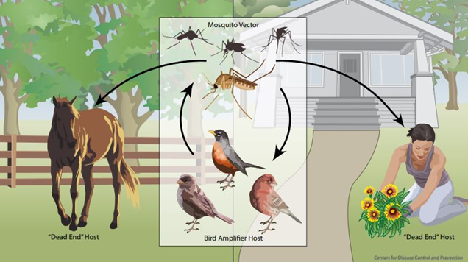
This virus has a complex transmission cycle. WNV typically resides in certain birds. These birds are affected by the virus. They are known as the amplifier host because they produce high levels of virus within their bloodstream. The Culex genus of mosquitoes, specifically the Culex pipiens in Pennsylvania, is the primary vector of this disease. Although the Culex mosquito is the primary vector, other mosquitoes, such as Aedes albopictus, are also able to transmit WNV. Therefore, all mosquito species must be monitored to identify when disease spreads to other species, particularly if humans are their primary sources of blood meals. Mosquitoes will take a blood meal from infected birds and consequently have the virus within their system. Despite exposure to the virus, mosquitoes are not affected by WNV. The mosquitoes will then take a blood meal from a human or a horse, transmitting the virus to the humans and horses through their bite. Humans and horses will then be affected by the virus. Humans and horses are known as dead end hosts of WNV because they do not have high enough levels of virus within their bloodstream to transmit the virus back to mosquitoes.

Figure 1 West Nile Virus Transmission Cycle
Depection of the WNV transmission cycle between the vector, amplifier host, and dead end host. ²⁸

Disease Significance
West Nile Virus is a public health concern for many reasons. WNV has caused over 3 million infections in the US, lacks vaccines and treatment options, is highly adaptable to new ecological niches, disproportionately affects the most vulnerable in populations, is slowly becoming more difficult to prevent with insecticides, and is a vector-borne disease. Since its introduction to the US in 1999 through 2013, WNV has been responsible for an estimated 3 million infections and more than 1900 reported deaths²². As of 2018, there have been 50,830 cases and at least 2,330 deaths reported to the CDC⁹. It is important to note that these numbers do not include cases that were not clinically diagnosed and then reported. There is no vaccine or treatment for this disease. Unknown viral ecology, biology, and pathogenesis makes vaccine and treatment development difficult²⁴. Additionally, since so few cases of West Nile are clinically diagnosed, there is a limited financial incentive for companies to develop a vaccine. Also, WNV is highly adaptable. Whole genome sequencing of WNV has shown that the virus is highly genetically stable and easily adapts to new niches via selection and mutation²⁴. This means that the virus can quickly become endemic to new areas. Its genetic stability may allow the virus to significantly alter its characteristics while still being able to infect individuals. We are unable to predict how this virus may change in the future. WNV also targets the most vulnerable, including the elderly and those in poverty²⁷. It disproportionately affects those in poverty, causing health disparities within communities²⁷. Similar to the issue of vaccine development, the development of new insecticides has been stalled. This is a concern because current insecticides are rapidly losing effectiveness²⁴. Vector-borne diseases are of increasing public health concern with globalization, climate change, and their complex transmission dynamics. Up to 98 percent of Americans remain at risk for WNV each year²². Due to the high levels of undiagnosed disease, lack of vaccines and treatment options, the highly adaptable nature of WNV, its propensity to target the most vulnerable, increasing importance of vector-borne diseases, and the large at-risk population, there is a pressing need for an ongoing system of surveillance and control aimed at arboviruses. Programs that are based on the surveillance and control of arboviruses lessen the impact of the challenges described above by responding proactively to epidemic seasons, reducing human disease risk.

Program Theory

Mission & Vision
Allegheny County Vision: A mosquito-borne, disease-free Allegheny County in which residents have increased enjoyment of their environment.
Allegheny County Mission: The mission of the Allegheny County Health Department’s Mosquito-Borne Disease Control Program is to identify, respond to, and prevent mosquito-borne disease and increase enjoyment of environment throughout Allegheny County while promoting the health and wellbeing of the community at large, especially the region's most vulnerable populations.
Pennsylvania Mission: The mission of the Mosquito-borne Disease Control Program is to reduce expected morbidity and mortality, health care costs, and the financial impact that these disease outbreaks would have upon Commonwealth industries such as agriculture, fishing, hunting, tourism, etc.¹⁷

Program Theories
Process Theory: If evidenced based methods of vector control, surveillance, code enforcement, community education, and training are utilized within Allegheny County, then residents will have decreased risk of disease and increased enjoyment of their environment.

Program Theory of Change:
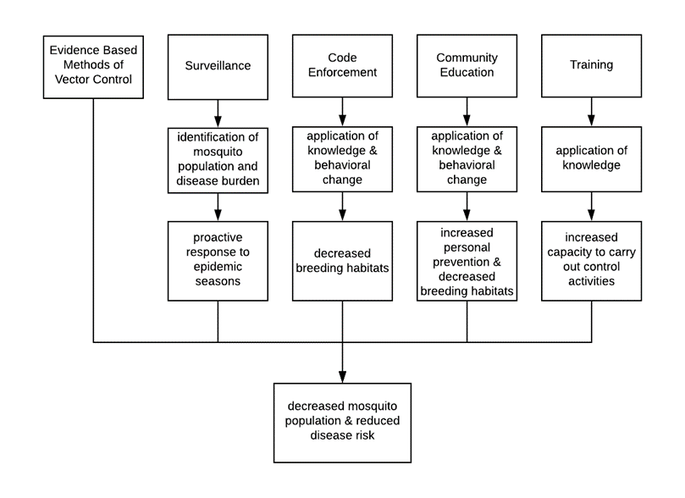

Figure 2 Program Theory of Change
This figure describes how program activities will lead to intended outcomes.

Key Stakeholders & Stakeholder Utilization
This development plan will be utilized by several key stakeholders in various ways (Figure 3). The ACHD MDP employees will utilize this document to understand program activities and discover areas of improvement. ACHD staff involved in mosquito control activities can use this document to better understand the program and their responsibilities. Allegheny County municipal staff are provided free trainings. This document can help educate municipal staff on disease relevance and program intricacies. The Pennsylvania Department of Environmental Protection (PA DEP) is responsible for guidance, funding, and oversight of the program. The PA DEP can use this plan to assess if the requirements for receiving grant funding are sufficient, as the ACHD MDP goes far beyond the basic requirements established by the DEP. Commercial pesticide outfits have an interest in this program because the MDP provides education and guidance to these companies when necessary. Commercial outfits play a complementary role to the MDP, directly reducing mosquito nuisance while interacting with and educating the public. This document can serve to educate companies on disease significance and how their companies are relevant to the overall goal of the program. Media and news surrounding mosquito-borne disease may be sensationalized or inaccurate. This document and subsequent activities may better educate the media on program facts. Individual community members have a vested interest in the success of this program as the program is well known and has a positive public perception. Home and business owners will be able to understand how the program operates and why their compliance is necessary. A published program plan and subsequent process evaluation will allow for transparency, continued public trust within the program, and will identify the health department as a reliable source of information as vector-borne diseases become a greater concern. It is important for this program to actively engage key stakeholders in order to appropriately represent and serve the community.
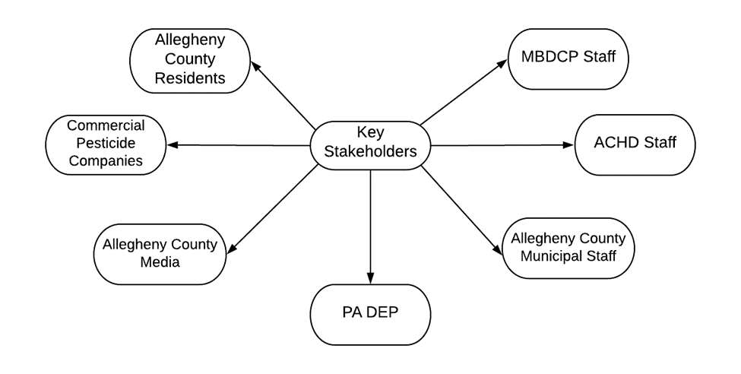

Figure 3 Stakeholder Map
This figure shows the key stakeholders of the MDP.

Organizational Chart
The Mosquito-Borne Disease Control Program of the Allegheny County Health Department is a part of the ACHD’s Housing and Community Environment Program (HCE) (Figure 4). The ACHD MDP is a part of the county’s Vector Control Program (VCP). The VCP employs two full time staff, a medical entomologist and a vector control specialist. These two employees report to the HCE Program Chief and the PA DEP’s Regional Officer (Figure 4). The PA DEP funds a portion of full-time employees’ salaries through an annual grant. In the summer, the program utilizes two interns to work on Asian Tiger and West Nile Virus activities. Typically, these interns are graduate students hired through the Pittsburgh Summer Institute, a joint program between the ACHD and the University of Pittsburgh’s Graduate School of Public Health.

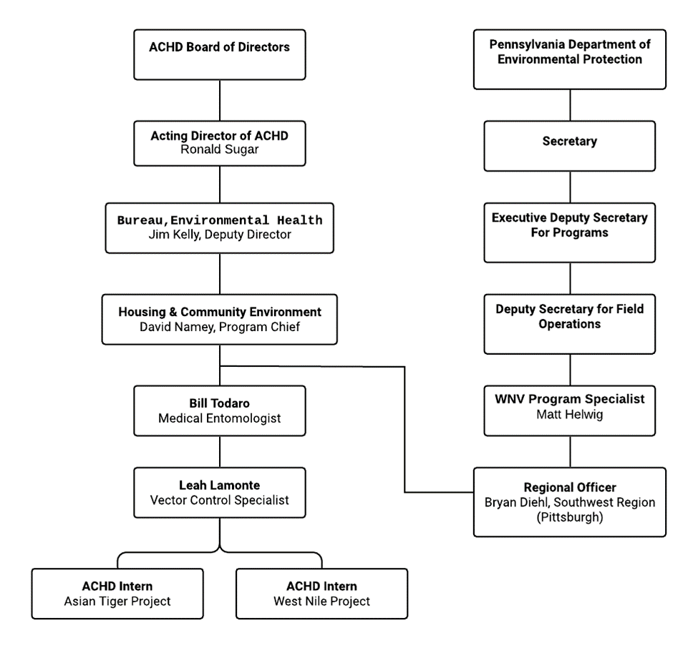

Figure 4 Organizational Chart
This figure shows the organizational hierarchy and authrority structure of the MDP. ¹⁶

Program Justification

Established Infrastructure
Historically, the ACHD MDP was started to protect the county from WNV. Vector borne diseases account for 17 percent of all infectious disease world-wide³². WNV is an example of just one vector-borne disease (VBD) that this program can identify and respond to. The ACHD MDP infrastructure is already well established and can easily expand into other vectors and diseases of public health concern. Other possible diseases include Lyme, Zika, Dengue, Malaria, Chikungunya, Yellow Fever, Eastern Equine Encephalitis, and Japanese Encephalitis. This program can serve as an infrastructure for other disease surveillance mechanisms. An example of this flexibility is with ticks, another vector of concern in Southwestern PA. The black-legged tick is the vector of Lyme Disease. Up to half of all ticks in southwestern PA have tested positive for Lyme Disease¹¹. This disease is seasonal, difficult to diagnose, and can present as a wide variety of symptoms. In 2019, the MDP expanded program activities to include tick surveillance. This program can easily expand to focus on other vectors of concern and is already beginning to successfully expand its range of vectors in order to promote public health.

Protecting Vulnerable Populations and the Environment
It is important that a health department takes the lead on vector control and disease management within a community in order to protect vulnerable populations and the environment. As previously stated, VBDs disproportionately affect those in poverty²⁷. A community health department has a duty to protect the most vulnerable populations from disease and nuisance. Oftentimes, these vulnerable populations are unable to afford companies that will control for disease vectors and nuisance mosquitoes. Equal access and usage of this program within the community may reduce disparities of VBD and nuisance mosquito exposure.
In addition to protecting the most vulnerable, health departments have a responsibility to protect the environment. The goal of this type of program is to affect the environment as little as possible while maintaining the safety of the public. The non-profit status of the program allows staff to do what is best for people and the environment, not the bottom line. The program uses methods that keeps mosquitoes in the food chain so they can still be used as a food source by other animals. Insecticide resistance is also important to local health departments. Application of adulticides, chemicals that are used to kill adult mosquitoes, are only used when mosquito populations and virus levels get so high that there is significant human risk. Commercial outfits tend to use adulticides frequently because it has an immediate, noticeable effect that customers can observe. Frequent adulticide applications do not treat the problem effectively at its source (reducing breeding grounds and keeping mosquitoes in their larval stages). Additionally, over-application promotes resistance to insecticides within the mosquito population. Similar to antibiotics, the more they are used, the less effective they become, and new public health insecticides are not being developed rapidly enough to solve this problem.

Providing the 10 Essential Public Health Services
In addition to the flexibility of the established program structure and the protection of vulnerable populations and the environment, the MDP carries out all 10 Essential Public Health Services (Figure 5). The 10 Essential Public Health Services and 3 Core Functions were developed in 1994 as a foundation for public health agencies and activities⁷. They have been used to describe, guide, and justify the existence of programs since their creation and remain the standard for public health practice today. The MDP conducts activities in all 10 of the Essential Services as well as the 3 core functions. It is necessary for this program to remain funded within a county health department in order to ensure these services are carried out to appropriately serve the community. The National Association of County and City Health Officials (NACCHO), acknowledges the importance and need for sustainably funded mosquito control programs in their 2017 Policy Statement¹². VCPs need to remain within a health department in order to serve the best interests of the public. Programs like the MDP operate on the front lines, protecting the public in real time in ways that positively and effectively impact communities. How the MDP conducts the essential services and core functions justifies the program’s existence and demonstrates the significance of this program. Each of the Essential Services (ES) and how the program carries them out is described below.
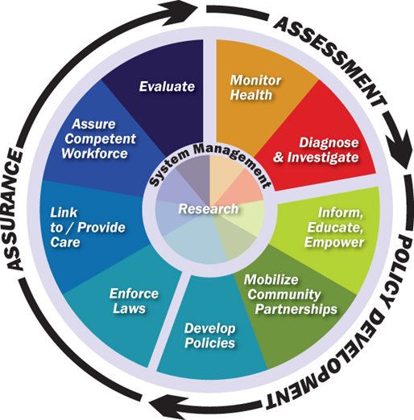

Figure 5 The 10 Essential Services and Core Functions of Public Health
This visual representation of the 10 essential services and core functions is widely used throughout the US. It presents this concept in a way that is easy to understand and describes the relationships between services and functions. ⁷

ES 1: Monitor health status to identify and solve community health problems
Many program activities complete ES1. The MDP is constantly monitoring levels of vector-borne disease throughout various populations. Community health concerns are identified and investigated. Data obtained from monitoring and surveillance activities is then used to direct interventions to solve these community health problems. These activities are further explained in the Program Activities section.

ES 2: Diagnose and investigate health problems and health hazards in the community
A majority of MDP activities fall under ES2. Surveillance is a main activity of the program. Surveillance is a systematic process of identifying the presence of disease or nuisance within a community. The program identifies vector-borne diseases within the mosquito, bird, and human populations. When recognized, these diseases are further investigated, and measures are taken to inform the public of the health hazard.

ES 3: Inform, educate, and empower people about health issues
The MDP carries out ES3 in multiple capacities. The program conducts community education activities to increase awareness of disease risk, methods of prevention, and methods of personal protections. The public is supplied with the information necessary to protect themselves and their families. Also, the community is informed when certain levels of disease are reached within a community and when control activities are performed.
Additionally, the MDP functions as a mechanism to communicate risk to public and mediate panic when new VBDs appear in a community. VBDs can incite panic within a community if there is not already a well-established authority that works for the public. The public is already aware and trusting of this program and look to the program as an authority that can provide guidance, as demonstrated by the 2016 Zika epidemic.

ES 4: Mobilize community partnerships and action to identify and solve health problems
The MDP partners with many organizations to carry out its activities. The PA DEP, the Pennsylvania Department of Agriculture, and the Pennsylvania Department of Health oversee the program and its activities. Locally, the program partners with municipalities to train and educate municipal staff. The local media also partners with the MDP to inform the public about program efforts, concerns, and publish successes. Employees of the MDP are also active members of the Pennsylvania Vector Control Association, a group that works to identify statewide concerns and develop solutions. Additionally, the MDP works with local commercial pesticide companies to educate staff. The program is also open to the concerns of community members and organizations and addresses them accordingly.

ES 5: Develop policies and plans that support individual and community health efforts
The program carries out ES5 by developing and adhering to policies related to mosquito control activities. These evidence-based policies set guidelines for when certain activities should take place and have been developed for maximum individual health and community safety. Plans for mosquito control surveillance and activities are developed and approved well before each season starts. Policies and restrictions for mosquito control activities have been developed and are strictly adhered to. For example, a Pesticide Discharge Management Plan that is compliant with Environmental Protection Agency requirements is drafted and followed each year by the program. These policies protect both the community and the environment. The program also engages in emergency response planning that involves both the local and state governments.

ES 6: Enforce laws and regulations that protect health and ensure safety
The MDP carries out ES6 through a process called code enforcement. Code enforcement ensures that individuals are adhering to the county code. The county code was established to protect the health of both the public and the environment. Violations of county code can lead to financial penalties. See the Program Activities section for a more in-depth description of the code enforcement process.

ES 7: Link people to needed personal health services and assure the provision of health care when otherwise unavailable
The MDP completes ES 7 by being a part of a county health department. This allows for quick and accurate linking of community members to care and other appropriate services. This program falls under the Housing and Community Environment program of the health department. The HCE program serves to link community members to appropriate resources within the county health department and the community. The HCE program also has a phone line that community members can call to address their needs and concerns.

ES 8: Assure competent public and personal health care workforce
The MDP carries out ES8 through its training activities. The program trains municipal, health department, and commercial pesticide company staff on effective methods of prevention and control. Some of these trainings result in trainees receiving various certifications. The program then provides continuing education in order to maintain certifications. All trainings are provided as a free service. Training activities are further described in the Program Activity section of this development plan.

ES 9: Evaluate effectiveness, accessibility, and quality of personal and population-based health services
The MDP and its associated organizations complete ES9 by regularly evaluating the effectiveness and quality of their programs and services. At a minimum, monthly and quarterly evaluations are held each year. The system of program monitoring and evaluation is further described in the Monitoring and Evaluation section.

ES 10: Research for new insights and innovative solutions to health problems
The program provides ES10 through a majority of its program activities. All program activities since 2001 have been well documented. This has established a historical record of many aspects of the program. Surveillance data is an example of one valuable resource that can lead to the development of new interventions. This dataset is invaluable as it spans many seasons and locations. It is doubtful that a program outside of a health department would have that type of longevity and program data. There are still many unknowns about VBDs and nuisance mosquitoes. Changing climate patterns, human behaviors, and systems ecology all affect mosquito populations in ways that may not be well documented and described. Due to the unpredictability of VBDs any system of data collection is significant. Annual data collection contributes to public health knowledge and is useful for analysis and future control activities.

Zika: A Case Study for Program Justification
Zika is a flavivirus that is transmitted by the Aedes mosquito, primarily Aedes aegypti. These mosquitoes are daytime biters that specifically target large mammals, including humans. Most cases of Zika result in mild fever but the disease can affect a fetus, causing congenital birth defects if passed to the fetus by the mother. A Zika epidemic began in Brazil in early 2015. By 2016, it had spread throughout the Americas, was declared a public health emergency by the World Health Organization, and the Centers for Disease Control and Prevention activated its response efforts to Level 1, the highest level within the organization¹².
The 2016 Zika epidemic can be used to demonstrate the utility of a well-established infrastructure of mosquito control within a county health department. The existence of the MDP allowed the county to be proactive, not reactive to this public health threat. In 2016, when local transmission of Zika in the mosquito population in Florida was identified, the MDP was awarded a Zika grant from the PA DEP in order to prepare for the epidemic season¹⁴. This grant focused on the Aedes albopictus (Asian Tiger) mosquito, an invasive species that was locally established in 2010. Although the Aedes aegypti mosquito, the primary vector of Zika, is not present in Allegheny County, the Aedes albopictus mosquito has the ability to transmit Zika. With grant and county funding the program was able to carry out several of the essential public health services during the epidemic season.
Throughout the epidemic season, the program carried out ES1 and ES2, to monitor health status to identify and solve community health problems and to diagnose and investigate health problems and health hazards in the community, respectively. Zika grant funding was used to increase trapping activities¹⁴. The program seamlessly added Zika to their surveillance activities, demonstrating how the infrastructure can be easily adapted to other disease surveillance mechanisms. Traps for the species of mosquito that had the potential to transmit Zika locally were set throughout the county. Samples from these traps were sent to the state DEP lab and tested for Zika. The trapping and testing of mosquitoes along with mandated reporting of human cases allowed the MDP to identify possible health hazards, human cases, and presence of Zika within the community. Fortunately, Zika virus was not found in any of the mosquitoes tested and the only human cases of Zika within the county were travel acquired.
Essential Service 3, to inform, educate, and empower people about health issues was also a part of the program’s Zika response. The program functioned as a method of risk communication to the public and reduced panic. The Zika epidemic was especially concerning because it was affecting some of the most vulnerable in our population, pregnant women and children. The public was able to look to the MDP as a well-known and trusted source of information. The ability to communicate actual risk for contracting Zika increased public trust in the health department and decreased panic. The MDP was able to quickly respond with information about Zika to appropriate communities. A significant amount of the funding obtained from the DEP grant was used to create and distribute educational materials¹⁴. These materials were distributed door to door in areas of high vector prevalence and Zika virus cases. Residents of these areas were also contacted and educated in person. Municipalities and community members were given products to treat standing water in addition to educational materials. The combination of education and products empowered individuals to make their properties safer and reduce disease risk. In addition to individual education activities a public education campaign was conducted with Lamar advertising. During July of 2016 and 2017, posters were hung in 6 bus shelters for one month in two neighborhoods of concern. The message of these advertisements was to dump or treat standing water to prevent mosquito breeding.
During the epidemic season, the MDP was also able to carry out ES4, to mobilize community partnerships to identify and solve health problems. The program partnered with many different organizations to ensure the safety of the community. The PA DEP provided funding to carry out preventive and surveillance activities. The PA Resources Council partnered with the MDP to conduct a one-day tire cleanup program in October 2016. Tires are one of the main sources of mosquito breeding environments for the Asian Tiger mosquito. Over 500 tires were collected and recycled. The MDP also partnered with other programs within the health department such as epidemiologists, public relations, and preparedness staff. Meetings were regularly held to discuss Zika control initiatives, objectives, and possible interventions.
The 2016 Zika epidemic led to increased data collection throughout Allegheny County. Data from the increased surveillance activities throughout the epidemic season can be used to conduct ES10, research for new insights and innovative solutions to health problems. Any data collected throughout this time period is useful as it adds information to the public health knowledge base that can be analyzed in the future.
Finally, the MDP carried out ES5, to develop policies and plans that support individual and community health efforts throughout this time period. Policies and plans were changed in response to the Zika epidemic. For example, the name of the program was changed from the West Nile Virus Surveillance Program to the Mosquito-Borne Disease Program to reflect the expansion of program activities. Additionally, trapping for the Asian Tiger mosquito became a standard program activity as a result of this outbreak. Since the epidemic, an emergency response process has been identified within the MDP.

Program Activities
The ACHD MDP has five main categories of activities: utilizing evidence-based methods of vector control, surveillance, code enforcement, community education, and training. These activities are further detailed below and in a logic model (section 10.6).

Evidence Based Methods of Control
The ACHD MDP uses methods of Integrated Pest Management (IPM). IPM is an evidence-based practice that is “effective and environmentally sensitive approach to pest management that relies on a combination of common-sense practices”²⁹. It exploits pest life cycles and their environmental interactions to reduce pest populations, while keeping economic and environmental costs low and protecting humans and their property. IPM practices can be utilized for Integrated Mosquito Management (IMM). Per the statewide program manual, “[IMM] efforts are implemented to control and maintain mosquito populations below thresholds that would facilitate WNV [disease] amplification and increase human risk. Control efforts will be based on protecting public and animal health using IMM tools to minimize environmental impacts,”¹⁷ The ACHD MDP utilizes four methods of IMM: source reduction, larval control, adult control, and insecticide resistance testing.
One aspect of IMM is source reduction. Source reduction is the practice of reducing breeding environments. Source reduction is preferred to other methods of control because it removes breeding sites, addressing the problem at its source. In the US in 2017, 42 percent of vector control programs did not utilize non-chemical methods of control (like source reduction)¹³. This is concerning because it is the most effective way of reducing mosquito populations. This practice helps to decrease mosquito populations and control where their eggs are laid while maintaining the integrity of the environment. For example, the Aedes albopictus (Asian Tiger) mosquito breeds in artificial containers. These containers are manmade and are located in, or close to residential areas. Removing these containers ensures that the mosquitoes will not lay eggs near residential areas and reduces human disease risk and nuisance. The ACHD MDP does not have the capacity to eliminate every artificial container in the county, therefore source reduction relies on an educated community to be successful. Effective educational materials must be developed and distributed throughout the county for individuals to be aware and take responsibility for source reduction on their property¹⁷. Source reduction activities are carried out in the field, through education, and code enforcement.
Larval control is another component of IMM. If breeding sites are accessible, larvicide can be used to reduce adult mosquito populations. Larvicide is an insecticide that specifically targets the larval growth stage of an insect. The ACHD MDP currently uses four different products: Bacillus thuringiensis israelensis, Bacillus sphaericus, Methoprene, and Spinosad¹⁷. Bacillus thuringiensis israelensis (Bti) and Bacillus sphaericus (Bs) are naturally occurring bacteria. Bti specifically targets larval mosquitoes, blackflies, and fungus gnats⁴. Both Bti and Bs paralyze the gut, starving the larvae⁴. Bti and Bs are not toxic to humans or animals⁴ (except larval mosquitoes, blackflies, and fungus gnats). They are safe for use and do not pose any threat to water safety or crop production⁴. Methoprene is an insect growth regulator that is effective against a variety of insects. It takes advantage of mosquito biology by mimicking juvenile hormone. This signals the mosquito to stay in the larval growth stage. Keeping mosquitoes in the larval growth stage prevents them from reaching adulthood, flying, and spreading disease, while keeping them in the food chain and minimizing environmental impact³⁰. Spinosad is a substance made from soil bacteria. Its components affect the nervous system of mosquitoes, causing paralysis, and death. It has been registered with the EPA since 1997 ¹⁴. The larvicide used and dosage chosen depends on mosquito life stage and application habitat¹⁷. Some larvicides last longer than others and some can withstand wet and dry seasons better than others. In Allegheny County, larval control is typically carried out from March 15 through October 31. Between March and May, approximately 60 wetlands are treated with long lasting larvicides³. The wetlands treated are in areas of historical nuisance concern and often report few nuisance complaints throughout the summer². In June, control activities shift to the Culex species of mosquito that carries WNV³. Larval control is used when necessary, as indicated by surveillance activities. Also, in June, the program recruits a team of ACHD employees in a weeklong effort to treat catch basins throughout the county. Each year around 10,000 catch basins are treated with Methoprene in active WNV neighborhoods²⁰.
Adult control is another method of IMM utilized by the program. Adult control methods are used to minimize biting and break the mosquito-bird transmission cycle¹⁷. Adult control is carried out using ultra-low-volume truck mounted sprayers or handheld equipment to apply adulticides in a targeted manner (insecticides that target the adult growth stage). The adulticide used is dependent on each situation. The MDP uses the product Zenivex. Zenivex is a synthetic pyrethroid chemical pesticide that is classified by the EPA as reduced risk²⁹. Adult control activities are carried out in the county from May 1 through October 31 each year. According to Mosquito-Borne Disease Control Program Manual, adult control is not considered a “last resort” that should only be used in outbreak years¹⁷. It should be used when necessary as indicated by county guidelines. Adult control activities are considered when vector index (VI) reaches the county wide threshold of 200 (VI will be further explained in the following surveillance section). All adult control activities are reviewed and approved by the PA DEP Regional Coordinator. The public and state representatives are notified, with special attention given to those that are on the state's hypersensitivity and beekeeping registries³.
Finally, insecticide resistance testing was officially introduced to the program in 2019. According to a 2017 NACCHO report on US mosquito control capabilities, 98 percent of vector control programs do not have adequate capabilities to perform pesticide resistance testing and only 14 percent of programs perform any kind of resistance testing¹³. Nationally, pesticide resistance testing is an aspect of IMM that needs improvement and is considered a top priority by NACCHO¹³. In 2019, the CDC began offering insecticide resistance testing kits, the CDC Bottle Bioassay, to vector control programs free of charge⁶. According to the CDC the “technique is simple, rapid, and economical, compared with alternatives. The results can help guide the choice of insecticide used for spraying,” ⁶. The kit comes with a full instruction manual complete with pictures, videos, and guidelines for usage. As previously discussed, insecticide resistance is increasing and presents a problem for vector control programs. Resistance testing allows programs to identify which insecticides mosquito populations are resistant to, increasing the effectiveness of available pesticides and reducing resistance selection pressure in local mosquito populations.

Mosquito Surveillance
Surveillance is the second component of the ACHD MDP and is an essential component of IMM. Surveillance is used to identify mosquito prevalence, mosquito population location, mosquito species, virus prevalence, and virus location. Information obtained from surveillance activities is used to quantify human disease risk, nuisance levels, and ultimately inform control decisions. Nationally, 52 percent of vector control programs need improvement in routine surveillance activities¹³. Only 54 percent of vector control programs conduct routine mosquito surveillance¹³. Consequently, only 85 percent of the vector control programs used data obtained from surveillance activities to make control decisions¹³. In a 2017 NACCHO report, treatment based on surveillance data and routine mosquito surveillance and species identification were identified as two of the top five priorities in vector control programs nationwide¹³. The MDP both conducts surveillance and uses subsequent data to make control decisions. The ACHD MDP completes three different surveillance activities annually: WNV mosquito surveillance, WNV dead bird surveillance, and Asian Tiger mosquito surveillance. In 2019, the state expanded to tick surveillance, the vector for Lyme disease. Tick surveillance is outside the scope of this program but demonstrates the utility of the MDP infrastructure. Mosquito surveillance is carried out annually between May and October. On average, 30,000 mosquitoes are collected each summer²⁰.

West Nile Virus Mosquito Surveillance
West Nile Virus surveillance is an important tool used by the MDP. As previously explained, WNV epidemics are hard to predict and there is no vaccine or treatment for WNND. Therefore, surveillance is the only way of identifying epidemic seasons and ensuring public safety. WNV surveillance is carried out through two different methods: larval sampling and adult sampling. Larval sampling is done in the field by identifying and sampling standing water where mosquito eggs are laid. Samples are obtained via dipping, a method where a cup like tool is used to collect the sample. The sample is then stored in 95 percent ethyl alcohol and sent to the state DEP lab. Larval sampling is done to determine breeding sources and as a pre-cursor to larvicide treatments. Larval samples are not tested for disease. At least 5 larval samples are taken each week beginning in June.
Adult surveillance is done via gravid trapping. Gravid traps use organic standing water to attract adult female mosquitoes looking for a place to lay their eggs. When the mosquito gets close to the water a fan pulls them into the collecting chamber of the trap. These traps are set in the afternoon and are picked up in the morning as the Culex mosquito is not as active during the day. Once the sample is collected, it is knocked down on dry ice, processed, and sent to the state DEP lab for arbovirus testing. Gravid trapping is used for disease testing, to monitor adult population numbers, and for assessing adulticide effectiveness. Gravid trapping is completed weekly at 20 fixed surveillance sites throughout the county. These surveillance sites have been chosen based on human population, history of infectivity, complaints, previous population surveillance history, proximity to susceptible populations, representation of habitat, reports bird, horse, or human arboviral illness, and confirmed infectivity in the mosquito population². These sites have remained the same since the 2016 Zika epidemic. Having consistent, fixed sites allows the program to compare data and analyze trends. Gravid trapping activities are completed mid-May through the end of September and are carried out by the Vector Control Specialist (VCS) and the vector control intern (VCI).

West Nile Virus Dead Bird Surveillance
Dead bird surveillance is used as an early warning system. It has been shown that WNV affected dead birds have been found up to three months before the reporting of human cases⁸. WNV affects birds and levels of viremia amplify within the population. Corvids (crows, jays, ravens) and raptors (birds of prey) have higher mortality rates from WNV than other species of birds. This means they are less likely to recover and become immune¹⁷. By monitoring WNV rates within these species, a more accurate characterization of virus levels and human risk can be determined. If a dead corvid or raptor is reported to the program with limited signs of decay, the animal will be dropped off or picked up by staff. Once obtained, oral swabbing will be used and the swab will be sent to the state lab along with regular sample shipments¹⁷.

Asian Tiger Mosquito Surveillance
Asian Tiger surveillance is another type of surveillance carried out by the ACHD MDP. Asian Tiger mosquitoes breed in artificial containers, are a nuisance, and have the capability to transmit disease. Although Asian Tiger mosquitoes do not typically carry disease in PA, they always have the potential to carry and transmit disease. The Asian Tiger mosquito is an invasive species in PA and is becoming an increasing nuisance. Therefore, surveillance is essential to identify the location of large populations and to prevent them from becoming an unbearable nuisance. Asian Tiger surveillance is done through oviposition traps and host seeking traps.
Oviposition traps are used to identify the presence of the Asian Tiger mosquito. They consist of an artificial container, a tongue depressor, a piece of felt, and bait. They are set in various locations throughout the county. The locations of these traps vary throughout the season in an attempt to establish the location of Asian Tiger populations. The traps are set, left for a few weeks, and then collected. The mosquito will lay its eggs in the stagnant water which adheres to the felt-wrapped tongue depressor. The tongue depressor, felt, and eggs are then brought back to the lab, flooded, and the eggs are reared to larvae. Once the larvae are large enough, their species is identified and recorded. Oviposition trapping is typically carried out by the county Entomologist and the Asian Tiger Intern.
Host-seeking traps are used to identify mosquito population levels and virus presence. These traps take advantage of a mosquito looking for a blood meal. BG Sentinel (BGS) traps use dry ice, which emits carbon dioxide, and a human lure to mimic human breathing and smell. BGS are used to trap the Asian Tiger mosquito because it is a daytime biter that specifically targets mammals, including humans. BGS are set in the afternoon and are collected after 24 hours. Once collected, the sample is knocked down, processed, and sent to the state DEP lab. BGS trapping is done biweekly at five fixed sites between June 3 and November 1. BGS trapping is carried out by the VCS and VCI.

Surveillance Data Analysis and Utilization
Samples sent to the lab are quantified, speciated, and then tested for virus levels. Not every sample that is collected is tested for virus, but every sample is quantified and speciated. There is a testing protocol that determines which samples are tested for virus. The protocol is used because virus testing is done through Polymerase Chain Reaction, a more expensive process, and it is not necessary to test each sample to get a representation of virus levels. State taxonomists identify the species of each individual mosquito sent to the lab. It is important to know the species of the mosquito because not all species transmit diseases. Preliminary data about the sample is entered into a statewide database before the sample is shipped. Results are recorded in the same database by the state lab. Once the program receives the results of the testing, a measure called Vector Index (VI) is calculated. Vector Index is a measurement of transmission risk that combines mosquito abundance and infection rate in order to predict human disease. This measure takes into account, positives, total number of mosquitoes, and different species. It is calculated as the minimum infection rate multiplied by the average trap density³¹. Mosquito samples are tested in pools via Polymerase Chain Reaction. If a pool tests positive for virus, it is assumed that at least one mosquito in the pool was infected by the virus. More than one mosquito in the sample could have been infected by the virus but the test used by the lab tests for virus presence, not quantity. Therefore, a minimum infection rate is used. Average trap density is calculated by taking the total number of mosquitoes collected within a time period and dividing it by the number of traps set in that time period. The formula is as follows:
VI = Minimum Infection Rate x Average Trap Density
Minimum Infection Rate: ((number of positive pools / total specimens tested)1000)
Average Trap Density: (total of mosquitoes collected in time period/traps set in time period)
VI is commonly used by vector control professionals to determine adult control decisions. It can be calculated over time throughout many locations or at one site. The ACHD MDP calculates VI weekly for the county (20 sites). The county has established categories of human disease risk based on VI. A VI of 0-200 is categorized as no risk, 200-600 is minimal risk, 600-1000 is moderate risk, and a VI of 1000 or higher is considered high risk². The county Pesticide Discharge Management Plan outlines the actions that can be taken at each level of risk. As risk increases, the severity of the intervention increases. Adult control activities are considered once VI reaches the threshold of 200. This is a county-wide threshold that was chosen based on historical records and consultation with the PA DEP. VI is only used in disease surveillance, not nuisance surveillance. Nuisance mosquitoes have different thresholds for control measures that can be found in the county Pesticide Discharge Management Plan². Adult control measures have been previously described.

Code Enforcement
The most unique aspect of the county’s MDP is code enforcement. Code enforcement is the process by which individuals are held to compliance with the law. The PA state law described below gives all PA counties the ability to create code enforcement programs. Enforcement is an effective way to reduce mosquito breeding habitats because it creates the possibility of a financial penalty for non-compliance. Financial penalties cause behavior change much quicker than other methods. Utilizing state and local laws as methods of mosquito control was a recent topic at the 2018 NACCHO Vector Control Summit. Summit documents state that vector control programs should understand their legal authority, the state or local law they are enforcing, and established infrastructure before adopting a system of code enforcement. They also encouraged working on education before regulation, stating "you can't regulate into 100 percent compliance"²⁵. Code enforcement should be considered by more counties across PA as a way of reducing mosquito populations, educating the public, and possibly generating income.
At the state level, Pennsylvania state law 16 P.S. 2150(b), states the county commissioners have "the power to eliminate all breeding places of mosquitoes, on private or public property, within the county and to do and perform all acts, including entry upon private or public property, and to carry out all plans which, in their opinion and judgment, may be necessary or proper for the elimination of breeding places of mosquitoes, or which will tend to exterminate mosquitoes with the county,”²⁶. In addition to the state law, the community must also follow Allegheny County code. The Allegheny County Health Department established a county health code and a system of code enforcement upon the creation of the department in 1957. Article VI establishes minimum standards of housing and community environment to protect Allegheny County residents. The issue of mosquitoes breeding in stagnant water is addressed in Section 650(d). This section of the code states, “no person shall maintain or permit to be maintained any artificial receptacle or pool, including but not limited to scrap tires or appliances, containing water in such condition that breeding of pest vectors therein may become a danger to the public health or create a nuisance”²⁶. Persistent failure to comply with any portion of Article VI can lead to legal action including a civil penalty of $2500 with an additional $250 fine per day after the compliance deadline.
Article VI is enforced by the HCE program which the MDP falls under. Code enforcement related to mosquito breeding habitat is carried out by the MDP staff. It is difficult for the VCS to identify all the code violations within the county; therefore, the community is used to report violations that are not identified by program staff. The program is largely complaint-based from county residents although violations can be cited on any property if observed upon inspection. Complaints are made to the MDP via an online complaint form on the Health Department’s website or through a phone call made to the Housing and Community Environment Program Office. Referred complaints are also received from the Department of Environmental Protection and the City of Pittsburgh’s 311 Office.
After a complaint is filed, program staff mail a Pre-Inspection Notice (PIN) to the property owner along with a copy of the PIN letter to the complainant. This notice informs the property owner of their supposed violation, the steps they can take to resolve it, and when the inspector will visit their property for an official inspection. After the deadline stated in the PIN letter is reached, a call is placed to the complainant to see if the complaint still remains. If so, the first inspection is conducted at the property and a Notice of Violation is mailed with a second deadline to become compliant. If the property is not compliant after the second inspection, a Penalty Assessment Warning letter is sent giving a third deadline. Failure to comply after the third inspection may result in legal action, including a penalty assessment of $2500 being filed²¹.
This process is an essential part of program success. Code enforcement is an effective way to complete source reduction activities by utilizing the public and therefore lessening the burden of source identification on the MDP. Code enforcement is also a practical tool for education. Educational messages shared during enforcement include the mosquito’s life cycle, “dumping or treating” stagnant water, the use of Mosquito Dunks, and the elimination of artificial containers that can hold water and pose a breeding threat. If individuals do not learn how to keep their properties safe, they can face a financial penalty. Most individuals are compliant with county code after they receive a Pre-Inspection Notice. Annually, the MDP program receives approximately 200 complaints. Of total complaints received, approximately 30 percent of complaints are resolved without having to complete an inspection. Knowledge gained by the community through code enforcement activities should lead to an application of that knowledge and behavioral change, decreased breeding habitats, and ultimately decreased mosquito population and reduced disease risk.

Community Education
Community education and engagement is a core component of ACHD MDP activities. Human behaviors directly impact mosquito populations, therefore an aware and engaged community is essential to program success. Education is especially relevant for the reduction of container breeding mosquitoes (Asian Tiger). Some of the goals of community education include “informing target audiences of the potential risk for WNV infection in PA , improving their knowledge of how the virus is transmitted, educating Pennsylvanians on methods to reduce their risk of contracting a mosquito-borne disease, and making Pennsylvanians part of the control program by encouraging them to eliminate mosquito breeding sites and report dead birds,”¹⁷. Educational events should be held just before and throughout mosquito season in order to increase the relevance of the information provided. Education is primarily focused on source reduction and individual safety practices. Common topics are how and where mosquitoes breed, how to keep your property mosquito-free, and methods of personal protection. Education is carried out through the distribution of educational materials, television coverage and interviews, and public education events. Educational materials have been developed to address a variety of topics including WNV, Zika virus, personal mosquito protection, source reduction around the home, and more recently ticks. The MDP is often featured on the local news during catch basin treatment or when human disease risk is high. Local news stories are a cost-effective way of educating the community as most of the population is reached. Public education events include the annual Allegheny County Health and Safety Fair, civic groups, and science fairs. Education is also carried out through surveillance and code enforcement. Both surveillance and code enforcement activities require field work and interaction with the public. The public is often curious as to what program staff are doing. Field work is an important opportunity to engage with the public one on one, establish trust, spread awareness, and provide education and answers to specific questions. An educated community should lead to the application of knowledge and behavioral change resulting in decreased breeding habitats and ultimately decreased mosquito population and reduced disease risk.

Training
Training is the final essential MDP activity. In a 2017 report, NACCHO recommended that vector control programs nationwide should provide consistent and quality training¹³. Vector control and pesticide applicator training is offered for free to both ACHD and municipal staff. Continuing education to maintain pesticide applicator certifications is also offered free of charge. Training is offered to municipal staff to increase the capacity of the MDP, educate and enable municipalities to appropriately control vectors within their boundaries, and to create partnerships within and between communities. Municipal and ACHD staff are trained on prevention and control activities such as the application of larvicides. Annually, the program trains certified pesticide applicators, uncertified staff, and registered pesticide technicians in the Spring³. There are four full day sessions held each year to allow certified pesticide applicators and registered technicians to obtain update credits and maintain their license³. Eight half-day training sessions are held every three years for staff to become certified pesticide applicators. After taking the training courses, trainees take exams, and upon passing, the staff become certified pesticide applicators or registered pesticide technicians. Certified pesticide applicators at the municipal level are used to help respond to mosquito complaints and to apply larvicide that the two full time staff members are unable to attend to. Trainees are informed of certification updates and future trainings through the US Postal Service. The MDP aims to have at least one certified pesticide applicator within a municipality. A record of certified applicators is regularly maintained. ACHD employees who are registered pesticide technicians are used to complete annual catch basin treatments. Conducting trainings for free builds capacity within municipalities and the MDP. It also allows municipalities to keep their control activities updated to best practices, ensuring environmental safety. Additionally, relationships within and between municipalities are created, increasing program visibility and stability. These trainings lead to increased capacity to carry out MDP activities by ACHD and municipal staff therefore leading to decreased mosquito population and reduced disease risk.

Logic Model
A logic model is a strategic planning tool that identifies program inputs, outputs, activities, outcomes, and impacts. It illustrates the relationships between program inputs and impacts and how these impacts are accomplished. This logic model was developed for this program development plan. It separates the program into its five program activities in order to accurately summarize the components of each activity. This model can be used to communicate the goals and activities of the program and can serve as a framework for future program planning and evaluation. In order for this logic model to be appropriately utilized by the program, outputs should have a target goal. Additionally, both the short- and long-term outcomes should be made SMART: specific, measurable, action-oriented, realistic and time-bound. These targets and outcomes will need to be set by MDP staff and funders.

Table 1 Logic Model for the 2019 MDP
 | Inputs | Activities | Outputs | Short Term Outcomes | Long Term Outcomes | Impact
Mosquito Control | -staff: vector specialist, entomologist, interns, certified pesticide applicators, health department staff  -PA DEP & ACHD Funding  -pesticides, application, and resistance testing supplies  -ACHD truck and supplies | -wetland early larvicide treatment  -larvicide treatment of known areas of high historical populations  -catch basin larvicide treatment  -adulticide control activities for disease and nuisance populations  -insecticide resistance testing | -larvicide treated wetlands  -larvicide treated high risk areas  -larvicide treated catch basins  -treatment of disease-carrying and nuisance mosquitoes  -identification of insecticide resistant mosquito populations | -reduced adult mosquito population  -reduced insecticide resistant mosquito population | -reduced adult mosquito population  -reduced human disease risk  -reduced nuisance  -ability to access well characterized records of mosquito populations within Allegheny county  -well educated public that shares mosquito prevention knowledge  -team of well-educated professional that can sustain the quality of the program | -reduced human cases of mosquito-borne diseases  -increased enjoyment of community environment
Surveillance | -staff: vector specialist, interns, entomologist  -trapping materials: traps, bait, batteries, mileage allowance, dry ice, courier service, ACHD truck  -PA DEP lab  -PA online database  -PA DEP & ACHD Funding | -gravid trapping weekly at 20 fixed surveillance sites (mid-May-September)  -biweekly BG Sentinel trapping at 5 fixed surveillance sites (June-October)  -weekly dipping of 5 varied sites (mid-May- calculated September)  -mosquito quantification, speciation, and virus testing by DEP labs | -weekly records of mosquito quantification, speciation, and virus levels  - vector index (measure of transmission risk and human disease risk)  -proactive response to epidemic seasons | -evidence based control decisions made based on vector index and nuisance populations  -appropriate control measures taken
Code Enforcement | -staff: vector specialist, county housing inspectors  -online complaint and management system (city, county, and state levels)  -citizen complaints  -inspection materials & forms  -ACHD truck and mileage allowance  -PA DEP & ACHD Funding | -citation and treatment of breeding habitats  -investigation of public complaints  -inspections & re-inspections of known breeding habitats  -issuing of fines for non-compliant properties | -record of cited properties  -reduced breeding habitats  -increased financial resources for ACHD | -reduced adult mosquito population
Community Education | -staff: vector specialist, interns, entomologist  -educational and promotional materials  -state and county websites  -county health fairs  -opportunities to talk to public  -public receptive to information  -PA DEP & ACHD Funding | -presentations on what the program does  -tabling at health fairs  -engaging with public while setting traps  -engaging with public while carrying out control activities  -identification services | -public is informed on what the program does, how to decrease breeding habitats, and how to reduce individual risk  -application of knowledge | -reduced breeding habitats  -increased personal prevention habits
Training | -staff:vector specialist, entomologist  -trainees: ACHD & municipal staff  -training materials: presentations, resource manuals, exams  -training space and AV equipment  -information distribution system (emails, interest list, US Post)  -PA DEP & ACHD Funding | -recruitment of trainees  -creation of updated training presentations  -training sessions held throughout mosquito  offseason | -increased number of certified  pesticide applicators and pesticide  registered technicians | -increased capacity for control activities
A logic model is used to identify the relationships between program inputs, outputs, activities, outcomes, and impacts. This logic model was created based on a 2019 summary of the MDP.
Table 1 Continued

Program & Evaluation Monitoring
The MDP is monitored primarily by external organizations. Internal monitoring is performed through the program the MDP is a part of, but not within the MDP. No consistent form of monitoring within the MDP is currently performed. Additionally, an evaluation of this program has never been conducted.

MDP External Monitoring
Currently, the MDP is monitored externally by multiple organizations. The PA DEP is concerned with mosquito surveillance, dead bird surveillance, and control issues and monitors the program to make sure the scope of work is being met and that grant funding is being used appropriately. The Pennsylvania Department of Agriculture is concerned with animal health and agricultural issues and conducts veterinary surveillance. The PA Department of Health is concerned with human health, personal risk, and protection issues and conducts human surveillance. A visual representation of this system has been created (Figure 6). These three external organizations work together to share relevant data and generate useful reports across the state¹⁸. The monthly reports generated and shared with the MDP are described below.
PA Weekly Arbovirus Surveillance Report¹⁹:
This weekly report from the PA DEP reports the number of WNV positive mosquito pools, birds, and horses. It also reports the number of confirmed or probable human cases of arboviral disease. Weekly and year to date data is presented in a table, graph, and mapped throughout the state. This report is distributed throughout the state by the state Bureau of Health’s Epidemiologist¹⁹. An example report is included in the appendix (Appendix Figure 1).
PA DEP Monthly Report²⁰:
The DEP also conducts a monthly review of the county. The county reports to the PA DEP Regional Officer the following four metrics each month via email: the number of complaints the county program received, the number of educational events the county program conducted, problems meeting the minimum scope of work (number of traps set, samples collected, etc.), and any other issues, comments, or concerns. This information is then compiled into a monthly report. This report is generated by the statewide database and county emails. It is then distributed by the PA DEP Regional Officer. This report generates the following metrics: weekly number and types of traps, the average number of adults per sample, the number and type of control events, the number of human cases, the number and sample identification number of non-human positives, if positives were appropriately dealt with, the number of valid complaints received by the county, the number of valid complaints received by the region, DEP Training events held by the program, DEP regional staff visits to the county, education events held by the county, outreach, and if the county has fulfilled its scope of work. The scope of work is determined by the number of larval samples collected, the number of gravid samples collected, the number of BGS samples collected, and the control activities taken²⁰. The scope of work is further explained in the activities section, the PA DEP grant, and the proposed monitoring document. An example report is included in the appendix (Appendix Figure 2).

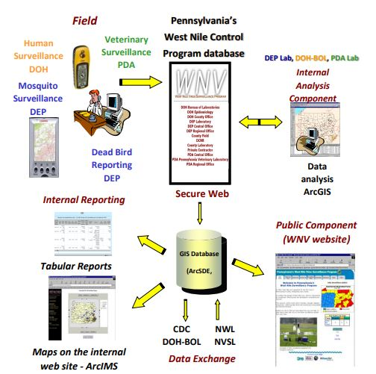

Figure 6 PA's WNV Control Program Database Data Flow

This figure depicts the flow of data and responsibilities within the PA WNV Control Program database. ¹⁸

MDP Internal Monitoring
Although program monitoring is done by several external organizations, there is currently no process of program monitoring within the MDP. However, the program is monitored by the ACHD HCE. This monitoring is done quarterly and falls somewhere between internal and external monitoring. An excerpt of the performance monitoring document can be referenced in the appendix (Appendix Figure 3). The MDP performance monitoring falls under goal two, “to prevent vector-borne disease, mitigate nuisance pests, and to maintain a wholesome community environment” and objective five, “mitigate the health risks associated with mosquitoes, ticks, and other public health pests”¹.This performance monitoring identifies four activities and the metrics that should be met by that activity. The activities described are as follows:
1. Survey approximately 50 known pest breeding sites. Treat with pesticide as needed. This is conducted Q2. In Q3, we will only treat these sites if necessary.
2. Treat approximately 8,000 catch basin mosquito breeding sites in the City of Pittsburgh by June 30, 2019.
3. In the 2nd quarter, West Nile virus gravid mosquito trapping is performed for the final 7 weeks of the quarter. At least 20 gravid traps should be set and collected per week. In the 3rd quarter, trapping is performed for the entirety of the quarter. At least 20 traps should be set and collected per week within the third quarter.
4. 100% of West Nile complaint surveillance reports received by the end of each quarter will be serviced by three weeks into the following quarter.

SWOT Analysis
A SWOT analysis is a strategic planning tool that is used to identify strengths, weaknesses, opportunities, and threats to an organization. Strengths and weaknesses are considered internal factors, something the organization has the power to change. Opportunities and threats are categorized as external factors. A SWOT analysis the MDP is a tool that helps to identify areas of both success and improvement. A SWOT analysis for the MDP in 2019 was created for this development plan and is presented in Table 2. This SWOT analysis is used to establish recommendations.

Table 2 SWOT Analysis for the 2019 MDP
 | Strengths | Weaknesses
Internal | 1. well defined methods and procedures  2. positive relationship with the community  3. history of success | 1.lack of personnel and limited intern hours  2.lack of consistent, comprehensive program documentation  3.lack of internal monitoring and assessment
 | Opportunities | Threats
External | 1. lack of partnerships with local universities  2. low community presence and engagement  3. low program visibility | 1. instability of funding  2. difficult to demonstrate program impact and effectiveness  3. unpredictable patterns of VBD prevalence and emergence
A SWOT analysis is used to identify strengths, weaknesses, opportunities, and threats to an organization. This analysis is for the 2019 MDP and is used to establish recommendations.

Recommendations
Throughout the process of conducting a program literature review, observing program activities, summarizing the program, creating a logic model, and conducting a SWOT analysis, areas of and opportunities for improvement have been identified. These recommendations aim to address concerns established in the SWOT analysis and ensure the continued success of the program for years to come.

Recommendation 1: Establish Consistent Program Documentation
In order to maintain program consistency and longevity, program documentation should be compiled, organized, and reviewed. First, a program bibliography should be developed. A program bibliography is a collection of source documents that can be referenced to answer any questions about the structure, activities, and history of the program.
In addition to a program bibliography, a well-organized and comprehensive digital file that contains all other relevant program documents should be created. This includes annual summaries, monitoring reports, educational presentations, grant applications, field notes, and other program resources. All hard copy materials (field notes, maps, etc.) should be digitized in order to protect program data.
After the creation of a program bibliography and a structured program file, a review of program documents should be conducted to ensure consistency and clarity throughout the program materials.

Recommendation 2: Expand the Utilization of Graduate Student Interns
Currently, paid graduate student interns are typically used to carry out mandatory program activities throughout the summer months of the Pittsburgh Summer Institute, a partnership of the Allegheny County Health Department and the University of Pittsburgh’s Graduate School of Public Health. The short time span of the Pittsburgh Summer Institute internship and the seasonality of program activities makes it difficult for interns to develop and carry out experiments in addition to their mandatory trapping activities. If the summer internships started earlier in the year, students would have the time to understand the program and develop experiments before the mosquito season begins. In addition to changing the timeline of the internship, the MDP can identify projects that unpaid interns can work on year-round. An annual meeting should be held in the offseason to establish program priorities and to create a running list of projects that interested graduate students can work on year-round. For example, digitizing program records, conducting a community knowledge survey, and reviewing educational materials for health literacy and cultural competency are all projects interns can complete in the winter. Expanding the use of graduate student interns may help alleviate the burden of limited program staff.

Recommendation 3: Capitalize on Pittsburgh’s Collegiate Environment
The MDP is in Pittsburgh, a city with many well-respected research universities. These universities can supply the program with talented graduate and undergraduate students that are willing to complete unpaid research projects to gain experience. Local undergraduates might be willing to perform surveillance activities for volunteer experience which would allow the paid graduate interns to work on more sophisticated projects. Undergraduates are also a resource that can be used to carry out countless program activities.
Additionally, the MDP should expand their relationship with the University of Pittsburgh’s Graduate School of Public Health. There is an Infectious Diseases and Microbiology Department (IDM) within the school that regularly includes guest lecturers in courses and holds weekly seminars. The program should reach out to IDM to inquire about giving guest lectures on vector-borne diseases and providing students with more experiential learning opportunities. Creating connections within IDM may inform students about the MDP and lead to increased student interest and involvement. Every department in the Graduate School of Public Health has something to offer the program. The Behavioral and Community Health Sciences department focuses on human behavior, a core component of mosquito control. The Biostatistics, Environmental and Occupational Health, Epidemiology, Health Policy and Management, and Human Genetics departments all have talented professors and students who have skills that can benefit the MDP.
Also, there are several centers and laboratories within the school that could partner with the program. For example, the Public Health Dynamics Lab conducts research in infectious disease modeling. A modeling project that outlines what may happen if MDP activities were not carried out may be a useful tool to justify program funding in the future.

Recommendation 4: Expand Monitoring and Evaluation Process
The external and ACHD HCE monitoring is extremely useful as it compiles data from various sources across the state and county, but it is not reported in a standard format that can be compared across organizations. Referring to Figure 6, the state system can be confusing to understand. Additionally, a lot of these external reports come through as an email, which can be difficult to track and refer to. A system of internal program monitoring should be added to the MDP in order to ensure a standard format of monitoring that can be compared across organizations and time periods. Internal monitoring can combine the two external monitoring plans and bring clarity and consistency to program goals and outcomes. This could be a low resource solution to the current complex, decentralized system of monitoring. An example internal monitoring form is included in the Appendix (Appendix Table 1). The logic model should be updated with output targets and SMART goals for outcomes by MDP staff and funders. Identifying and assessing these indicators will not add unnecessary strain to the program as indicators are already well defined and collected. This form should be completed monthly throughout mosquito season in order to assess program results and effectiveness. This system of monitoring may also be used to justify program existence.
Additionally, an evaluation of the Zika response from the perspective of the MDP should be conducted. This evaluation can be used to identify the most effective components of the Zika response. Also, policies for emerging VBDs can be established based on the most successful practices. This will allow the program to be prepared for future emerging infections. As mentioned in the evaluation section, a process evaluation should be conducted within the coming years to ensure program adherence to theory and implementation plan.
As the program has never been evaluated and is approaching its twentieth year, a program evaluation must be conducted to ensure program relevance, consistency, and adherence to program theory. It will be important for a process evaluation to be completed in the coming years to ensure maximum efficiency and capability throughout the program. A process evaluation should be completed rather than an impact evaluation because program impacts are determined by complex environmental and human behavioral factors. An impact evaluation would not properly characterize program success. A process evaluation will help the program to identify areas of redundancy and streamline processes in order to maximize capability and efficiency. A process evaluation may be particularly important within the coming years to demonstrate program relevance and justify funding.

Recommendation 5: Increase Program Visibility and Community Engagement
The MDP has a positive relationship with the community and is viewed as a trusted source of information. However, visibility of the program within the health department is low. Increasing community engagement may lead to increased visibility both within and outside of the health department. Additionally, being involved in more community events may increase community awareness and personal responsibility. MDP presence at school science fairs may get children interested in mosquito control and relay that message to their parents. Being present at more community events may also present opportunities to establish stronger partnerships within the community. For example, attending and presenting at a Department of Public Works meeting may lead to Department of Public Works staff dumping standing water or reporting a code violation, increasing the safety of the community. Another partnership that should be strengthened is with the media. Communicating program success through the media will increase program visibility and community trust. All communication with the media must take place through the ACHD’s public relations officer. The MDP will have to regularly work with this officer to establish program messages. Increasing program visibility and community engagement may be another method for ensuring stable funding.

Conclusion
This program summary and development plan was written to summarize the ACHD MDP, justify the existence of the program, and establish recommendations to improve this already high-quality program. Methods include a review of program literature, observation, creation of a program summary, the development of strategic planning tools, and identification of recommendations.
The MDP was officially established in 2001 to control and monitor West Nile Virus. Since then the program has expanded to include other vectors and vector-borne diseases. West Nile Virus is a public health concern as it can result in severe outcomes, has complex transmission dynamics, and there is no available human vaccine or treatment. The MDP has a mission and vision that center on reducing mosquito-borne disease risk and nuisance. This program has various stakeholders within the community that can utilize this development plan in various ways. The MDP falls under the Housing and Community Environment program of the Allegheny County Health Department. The program also reports to the state Department of Environmental Protection. Five primary program activities were identified: evidence-based methods of control, mosquito surveillance, code enforcement, community education, and training. Program monitoring is carried out by external organizations and the Housing and Community Environment program. A logic model and SWOT analysis were created to establish program recommendations. Five recommendations were identified: establishing consistent program documentation, expanding the utilization of graduate student interns, capitalizing on Pittsburgh’s collegiate environment, expanding the monitoring and evaluation process, and increasing program visibility and community engagement.
Programs like the MDP contribute significantly to public health. In addition to combatting vector-borne diseases, diseases of public health concern, the MDP carries out the 10 Essential Services of Public Health. Also, this program aims to protect vulnerable populations and the environment as well as respond quickly and proactively to emerging diseases and epidemics. This program summary can function as a framework for other counties to establish their own programs, increasing overall public health capacity. This development plan can help guide the program to enhance effectiveness, consistency, and longevity, ultimately protecting the community and improving public health.

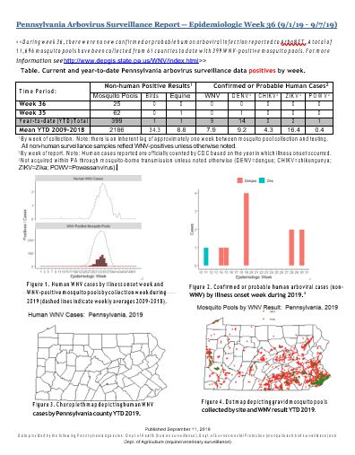
Appendix: Monitoring Documents

Appendix Figure 1 PA Arbovirus Weekly Surveillance Report¹⁹

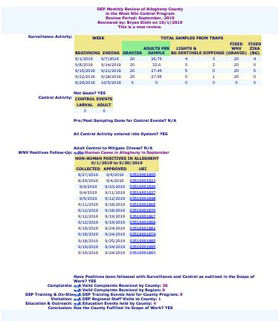

Appendix Figure 2 DEP Monthly Review of Allegheny County in the West Nile Control Program²⁰

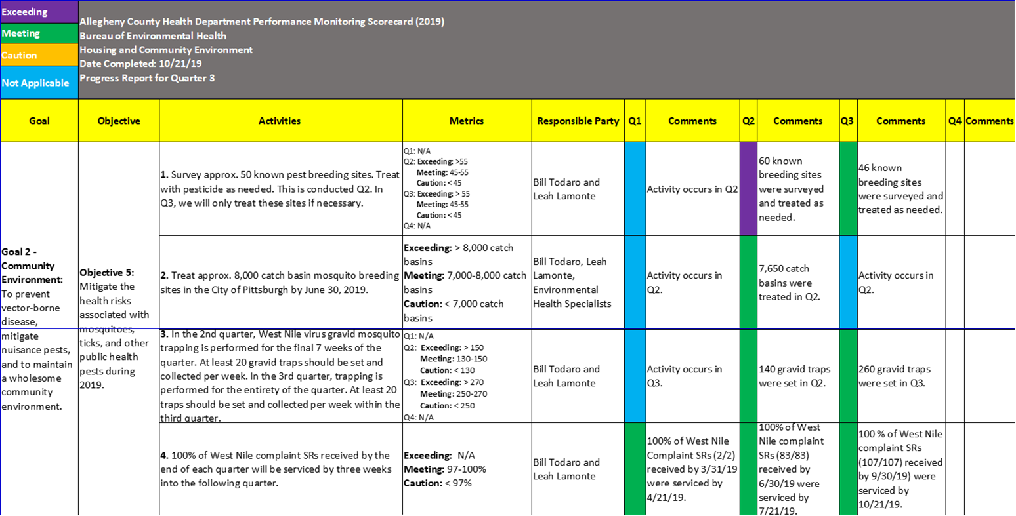

Appendix Figure 3 Allegheny County Health Department of Performance Monitoring Scorecard¹

Appendix Table 1 Sample Monitoring and Evaluation Plan
 | ACHD MBDCP M&E Plan
Indicator |  | Indicator Goal | Indicator Definition  (& unit of measurement) | Data Collection  Methods/Sources | Frequency & Schedule | Responsibilities | Information  Use/Audience
Activity 1: Evidence Based Methods of Mosquito Control
Indicator 1a |  |  | Wetland larvicide applications-number of wetlands treated with larvicide | MBDCP records | Annually | VCS | Staff & public, demonstrate program effectiveness and justify existence
Indicator 1b |  | 8,000 | Catch basin larvicide application-number of catch basins treated with larvicide | HCE Quarterly Performance Management | Annually | VCS | Staff & public, demonstrate program effectiveness and justify existence
Indicator 1c |  |  | Adulticide application-the number of times adulticide applications are made | MBDCP records | Annually | VCS | Staff & public, demonstrate program effectiveness and justify existence
Indicator 1d |  |  | Source reduction-number of sources eliminated | MBDCP records | Annually | VCS | Staff & public, demonstrate program effectiveness and justify existence
Indicator 1e |  | 1 | Insecticide resistance testing-number of times resistance testing is performed | MBDCP records | Annually | VCS | Staff & public, demonstrate program effectiveness and justify existence
Activity 2: Surveillance
Indicator 2a |  | 5 samples | Larval surveillance- number of larval samples collected | PA DEP Monthly Report/WNV Database | Weekly, June-September | VCI | Staff, evaluating adherence to state mandates
Indicator 2b  Appendix Table 1 Continued |  | 20 traps | West Nile Virus surveillance-number of gravid trap samples collected | PA DEP Monthly Report/WNV Database | Weekly, May-September | VCI | Staff, evaluating adherence to state mandates
Indicator 3b |  | 5 traps | Asian Tiger surveillance-number of BGS samples collected | PA DEP Monthly Report/WNV Database | Biweekly, June-November | VCI | Staff, evaluating adherence to state mandates
Activity 3: Code Enforcement
Indicator 3a |  |  | Complaint Resolution Rate-percent of complaints resolved by the public: # resolved by public/total complaints | MBDCP records | Monthly, May-November, end of month | VCS | Staff & public, justifies use of code enforcement system, functions as education
Indicator 3b |  |  | Pre-inspection Complaint Resolution Rate-percent of complaints resolved without inspection: # resolved w/o inspection/total complaints | MBDCP records | Monthly, May-November, end of month | VCS | Staff & public, justifies use of code enforcement system, functions as education
Indicator 3c |  | 97-100% | 3-week resolution rate: # serviced within 3 weeks/total complaints | HCE Quarterly Performance Management | Quarterly | VCS | Staff & public, justifies use of code enforcement system, functions as education
Activity 4: Education
Indicator 4a |  |  | Community Education events-number of educational events the program participates in | PA DEP Monthly Report/WNV Database | Monthly | VCS | Staff, assess educational capacity and coverage of the program
Indicator 4b |  |  | Media coverage-number of tv news or paper stories about the program | MBDCP records | Annually | VCS | Staff, assess educational capacity and coverage of the program
Activity 5: Training
Appendix Table 1 Continued
Indicator 5a |  |  | number of municipal governments that employ certified applicators in public health pesticide use categories | MBDCP/ health department records | Annually | VCS | Staff, assess capacity of the program
Indicator 5b |  |  | number of new trainees per year in each category | MBDCP records | Annually | VCS | Staff, assess capacity of the program
Indicator 5c |  |  | number of training sessions held per year | PA DEP Monthly Report/WNV Database | Annually | VCS | Staff, assess capability for training

Bibliography
1. Allegheny County Health Department. (2019). Allegheny County Health Department Performance Monitoring Scorecard (2019).
2. Allegheny County Health Department Vector Control Program. (2019). Pesticide Discharge Management Plan (Pdmp) Guidance Document 2019. Pesticide Discharge Management Plan (PDMP) Guidance Document 2019.
3. Allegheny County Mosquito-Borne Disease Control Program. (2019). 2019 Mosquito-borne Disease Control Grant Worksheet. 2019 Mosquito-borne Disease Control Grant Worksheet.
4. Bti for Mosquito Control. (2017, August 8). Retrieved from https://www.epa.gov/mosquitocontrol/bti-mosquito-control.
5. Building a Healthier Community, Allegheny County Health Department. (n.d.). Retrieved from https://historicpittsburgh.org/islandora/object/pitt:31735070059625/viewer#page/22/mode/2up.
6. CDC - Parasites - Education and Training - CDC Bottle Bioassay. (2019, February 14). Retrieved from https://www.cdc.gov/parasites/education_training/lab/bottlebioassay.html.
7. CDC - Public Health System and the 10 Essential Public Health Services - OSTLTS. (2018, June 26). Retrieved from https://www.cdc.gov/publichealthgateway/publichealthservices/essentialhealthservices.html.
8. Eidson, M., Kramer, L., Stone, W., Hagiwara, Y., Schmit, K., & New York State West Nile Virus Avian Surveillance Team (2001). Dead bird surveillance as an early warning system for West Nile virus. Emerging infectious diseases, 7(4), 631–635. doi:10.3201/eid0704.010405
9.Final Cumulative Maps and Data. (2019, October 9). Retrieved from https://www.cdc.gov/westnile/statsmaps/cumMapsData.html.
10. Garcia, M. N., Hasbun, R., & Murray, K. O. (2015). Persistence of West Nile virus. Microbes and Infection, 17(2), 163–168. doi: 10.1016/j.micinf.2014.12.003
11. Hutchinson, M. L., Strohecker, M. D., Simmons, T. W., Kyle, A. D., & Helwig, M. W. (2015). Prevalence Rates ofBorrelia burgdorferi(Spirochaetales: Spirochaetaceae),Anaplasma phagocytophilum(Rickettsiales: Anaplasmataceae), andBabesia microti(Piroplasmida: Babesiidae) in Host-SeekingIxodes scapularis(Acari: Ixodidae) from Pennsylvania: Fig. 1. Journal of Medical Entomology, 52(4), 693–698. doi: 10.1093/jme/tjv037
12. National Association of County and City Health Officials. (2010, July). STATEMENT OF POLICY Mosquito Control. Retrieved from https://www.naccho.org/uploads/downloadable-resources/07-10-Mosquito-Control.pdf.
13. National Association of County and City Health Officials. (2017). Mosquito Control Capabilities in the U.S. Mosquito Control Capabilities in the U.S. (pp. 1–25).
14. National Pesticide Information Center. (2014, August). Spinosad General Fact Sheet. Retrieved from http://npic.orst.edu/factsheets/spinosadgen.html.
15. Pennsylvania Department of Environmental Protection. (2016). Zika Virus Control Grant Program. Zika Virus Control Grant Program.
16. Pennsylvania Department of Environmental Protection. (2018, August 28). Pennsylvania Department of Environmental Protection Organizational Chart. Retrieved from http://files.dep.state.pa.us/AboutDEP/AboutDEPPortalFiles/ReorgPublic/Official OA Approved Chart Permit Office Reorg.pdf.
17. Pennsylvania Department of Environmental Protection. (2019). Mosquito-Borne Disease Program Manual. Mosquito-Borne Disease Program Manual (pp. 1–64).
18. Pennsylvania Department of Environmental Protection, Pennsylvania Department of Health, & Pennsylvania Department of Agriculture. (2019). Commonwealth of Pennsylvania West Nile Virus and other Arboviral Diseases: Surveillance, Prevention and Control. Commonwealth of Pennsylvania West Nile Virus and other Arboviral Diseases: Surveillance, Prevention and Control (pp. 1–54).
19. Pennsylvania Department of Environmental Protection. (2019). Pennsylvania Arbovirus Weekly Report. Pennsylvania Arbovirus Weekly Report (pp. 1–1).
20. Pennsylvania Department of Environmental Protection. (2019). Dep Monthly Review of Allegheny County in the West Nile Virus Control Program. DEP Monthly Review of Allegheny County in the West Nile Virus Control Program.
21. Pest and Vector Control. (2018). Retrieved from https://www.alleghenycounty.us/Health-Department/Programs/Housing-and-Community-Environment/Pest-and-Vector-Control.aspx.
22. Petersen, L. R., Carson, P. J., Biggerstaff, B. J., Custer, B., Borchardt, S. M., & Busch, M. P. (2012). Estimated cumulative incidence of West Nile virus infection in US adults, 1999–2010. Epidemiology and Infection, 141(3), 591–595. doi: 10.1017/s0950268812001070
23. Preliminary Maps & Data for 2019. (2019, October 29). Retrieved from https://www.cdc.gov/westnile/statsmaps/preliminarymapsdata2019/index.html.
24. Rizzoli, A., Jiménez-Clavero, M., Barzon, L., Cordioli, P., Figuerola, J., Koraka, P., … Tenorio, A. (2015). The challenge of West Nile virus in Europe: knowledge gaps and research priorities. Eurosurveillance, 20(20), 21135. doi: 10.2807/1560-7917.es2015.20.20.21135
25. Rodgers, K. (2018, September 7). 2018 Vector Control Summit: "Itching to Improve: Building Local Mosquito Control Capacity". Retrieved from https://essentialelements.naccho.org/archives/10241.
26. Rules and Regulations: Article VI Houses and Community Environment. (1996). Rules and Regulations: Article VI Houses and Community Environment.
27. Tackett, J., Charnigo, R., & Caldwell, G. (2006). Relating West Nile Virus Case Fatality Rates to Demographic and Surveillance Variables. American Journal of Epidemiology, 163(suppl_11). doi: 10.1093/aje/163.suppl_11.s202-b
28.Transmission. (2018, December 10). Retrieved from https://www.cdc.gov/westnile/transmission/.
29. United States Environmental Protection Agency. (2019, April 11). Integrated Pest Management (IPM) Principles. Retrieved from https://www.epa.gov/safepestcontrol/integrated-pest-management-ipm-principles.
30. US Environmental Protection Agency Office of Pesticide Programs. (n.d.). Fact Sheet Bacillussphaericus 2362, serotype H5a5b, strain ABTS 1743 (PC Code 119803). Retrieved from https://www3.epa.gov/pesticides/chem_search/reg_actions/registration/fs_PC-119803_06-May-14.pdf.
31. U.S. Department of Health and Human Services Public Health Service, Centers for Disease Control and Prevention, National Center for Emerging and Zoonotic Infectious Diseases, & Division of Vector-Borne Diseases. (2013, June 14). West Nile Virus in the United States: Guidelines for Surveillance, Prevention, and Control. Retrieved from https://www.cdc.gov/westnile/resources/pdfs/wnvguidelines.pdf.
32. Vector-borne diseases. (2017, October 31). Retrieved from https://www.who.int/news-room/fact-sheets/detail/vector-borne-diseases.
33. Yeung, M. W., Shing, E., Nelder, M., & Sander, B. (2017). Epidemiologic and clinical parameters of West Nile virus infections in humans: a scoping review. BMC Infectious Diseases, 17(1). doi: 10.1186/s12879-017-2637-9

