Title Page

**A Comparison and Contrast of European Healthcare Systems, their Financing, and Performance Metrics**

by

**William Patrick Powell**

BS Psychology, The Pennsylvania State University, 2018

Submitted to the Graduate Faculty of the

Department of Health Policy and Management

Graduate School of Public Health in partial fulfillment

of the requirements for the degree of

Master of Health Administration

University of Pittsburgh

2020

Committee Page

UNIVERSITY OF PITTSBURGH

Graduate School of Public Health

This essay is submitted

by

**William Patrick Powell**

on

April 6, 2020

and approved by

**Essay Advisor:**

Kevin Broom, PhD

Associate Professor and Director of MHA and MHA/MBA Programs

Health Policy and Management

Graduate School of Public Health

University of Pittsburgh

**Essay Reader:**

Joanne Russel, MPPM

Assistant Professor

Behavioral and Community Health Sciences

Graduate School of Public Health

University of Pittsburgh

Copyright © by William Patrick Powell

2020

**Abstract**

Kevin Broom, PhD

**A Comparison and Contrast of European Healthcare Systems, their Financing, and Performance Metrics**

William Patrick Powell, MHA

University of Pittsburgh, 2020

**Abstract**

This essay examines differences in the way healthcare systems of various European countries are run, such as by looking at the ways in which they are financed, in order to determine how these differences may or may not impact the health of the population according to various outcome metrics. After introducing the topic and examining the existing literature to provide background information on the subject and help to inform the understanding of the issues and the countries involved, there will be an analysis of the data coming from various sources. Data sources include the Organisation for Economic Co-operation and Development and Eurostat in order to determine how the systems differ across various metrics, and how they are similar. Results of the analyses revealed that the sample average of public systems had a higher life expectancy and higher spending than the sample average of insurance-based systems. However, this result lacked statistical significance, and thus it cannot be concluded that there is a difference in the systems by either the outcome measure life expectancy or the variable of spending per capita. Correlations between 5 spending and ownership variables, 8 capacity variables, and 5 outcome variables are displayed both for examination of the impact of variables on one another, as well as for the consideration of the audience. The information gleaned from this paper is important to public health as it allows us to view European countries and inspect their inputs and outputs in the field of healthcare, affording a better understanding of the existing evidence of what does and does not seem to work when considering health policies in the United States, and around the world.

Table of Contents

1.0 Introduction 1

2.0 Literature Review 7

3.0 Hypotheses or Expected Outcomes 10

4.0 Design, Methodology, and Data 11

5.0 Figures/Results 13

6.0 Analysis 32

7.0 Discussion 34

8.0 Conclusions, Recommendations, and Public Health Implications 35

Bibliography 36

List of Figures

Figure 1 Countries Sorted by Specialist Access (Gatekeeping) and System Type 13

Figure 2 Summary of Metrics 14

Figure 3 Correlation Table 16

Figure 4 Life Expectancy by Health System 18

Figure 5 Spending and Health Systems 19

Figure 6 Life Expectancy and Specialist Access 20

Figure 7 Spending and Specialist Access 21

Figure 8 Life Expectancy by Combination of Gatekeeping and System Type 21

Figure 9 Spending by Combination of Gatekeeping and System Type 22

Figure 10 T-Tests comparing Systems and Gatekeeping 23

Figure 11 T-test Examing Spending and System Type and Gatekeeping Status 24

Figure 12 Spending and Life Expectancy- Regression 24

Figure 13 Spending and Cancer Deaths- Regression 25

Figure 14 Bed Ownership and Life Expectancy 26

Figure 15 Bed Ownership and Spending 27

Figure 16 Bed Ownership and Life Expectancy- Regression 28

Figure 17 Spending and Years of Life Lost- Regression 28

Figure 18 Structural Variables and Life Expectancy- Multiple Regression 29

Figure 19 Structural Variables and Infant Mortality- Multiple Regression 30

# Introduction

Disagreement exists in the healthcare community, from politicians, to patients, and everyone in between, regarding the best way to run a system of healthcare. This includes not only the methods by which they are financed, but other factors such as the process of acquiring access to a specialist. By comparing how the governments of European countries and multinational state entities handle the healthcare of their relative populations, we can gain some insight into the proper way to manage the health of the population of our own country. This study aims to discover how various European countries differ in how they the handle the health of their people, and how variations in financing systems, mainly the difference between mandatory insurance paying for services and government payment for services, might cause differences in a variety of healthcare metrics. Another aim is to examine other differences in these systems, such as how access to specialists might alter health outcomes and costs, and service provision ownership. Structural variables will also be examined, to determine if more nurses, MRI machines, etc. lead to better outcomes and whether or not these variables impact the costs associated with maintaining health.

The logic behind the characteristics for inclusion was that these criteria would include countries in geographic proximity to one another, that had similar levels of economic development, and were large in terms of population. Also, the criteria were designed in order to exclude countries that did not meet the criteria mentioned, as well as excluding countries that may have stability issues (such as not being in control of all claimed territory). This paper will be examining 28 countries in the area of Europe: Austria; Belgium; Czech Republic; Denmark; Estonia; Finland; France; Germany; Greece; Hungary; Iceland; Ireland; Italy; Latvia; Lithuania; Luxembourg; Netherlands; Norway; Poland; Portugal; Russia; Slovak Republic; Slovenia; Spain; Sweden; Switzerland; Turkey; and the United Kingdom. The two countries most likely to be contested as being a part of Europe within this list are Russia and Turkey. The territory of both of these countries lies mainly outside of what is popularly perceived to be the boundaries of Europe. However, the largest city of each country lies within said borders of Europe. Also, Russia shares land borders with some of the countries included in our dataset, including Finland, Estonia, Latvia, and Lithuania. Through the exclave of Kaliningrad, Russia also shares a border with Poland. As for Turkey, it shares a land border with one country in our dataset, Greece. Due to these factors, as well as the similarity in some measures of these countries and those in the dataset, the decision to include them was made. Some countries that fall into what might be considered Europe were excluded. Albania, Andorra, Armenia, Azerbaijan, Belarus, Bosnia and Herzegovina, Bulgaria, Croatia, Cyprus, Georgia, Kazakhstan, Liechtenstein, Malta, Moldova, Monaco, Montenegro, North Macedonia, Romania, San Marino, Serbia, Ukraine, and Vatican City are widely recognized countries that could be considered to be in Europe, at least partially, that were not included in the data examination. The reason for this exclusion is that the main basis by which a country was included in the dataset was OECD membership and none of the excluded countries are OECD members (Organisation for Economic Co-operation and Development, 2019). However, this was not the only determination for inclusion, as there were OECD members that were not included, but those fall outside the boundaries of what is usually considered Europe. Also, a non-OECD member was included, Russia, which was included mainly by nature of population, which was also a contributing factor for Turkey, who although is in the OECD, is not fully in Europe. These countries are some of the largest by population in Europe, and were thus hard to ignore in this analysis.

Of the countries that were included 11 fell into this paper’s categorization of public healthcare systems. Public healthcare systems are those in which payment for services is at least partially handled directly through government expenditures, rather than through insurance mechanisms. These were the countries of Denmark (Olejaz et al., 2012), Finland (Keskimäki et al., 2019), Iceland (Sigurgeirsdóttir, Waagfjörð, & Maresso, 2014), Ireland (McDaid, Wiley, Maresso, & Mossialos, 2009), Italy (Ferré et al., 2014), Latvia (Mitenbergs et al., 2012), Norway Ringard, Sagan, Sperre Saunes,& Lindahl AK, 2013), Portugal (Simões, Augusto, Fronteira, & Hernández-Quevedo, 2017), Spain (Bernal-Delgado et al., 2018), Sweden (Anell, Glenngård,& Merkur, 2012), and the United Kingdom (Cylus et al., 2015). Therefore, seventeen of the countries fell into the category of insurance-based systems. See Figure 1 for a display of this information.

Insurance-based systems are those in which individuals are required to purchase health insurance, although there may also exist some direct payment by government for services. These were the countries of Austria (Bachner et al., 2018), Belgium (Gerkens & Merkur, 2010), Czech Republic (Alexa et al., 2015), Estonia (Habicht et al., 2018), France (Chevreul, Berg, Durand-Zaleski, & Hernández-Quevedo, 2015), Germany (Busse & Blümel, 2014), Greece (Economou, Kaitelidou, Karanikolos, & Maresso, 2017), Hungary (Gaál, Szigeti, Csere, Gaskins, & Panteli, 2011), Lithuania (Murauskiene, Janoniene, Veniute, van Ginneken, & Karanikolos, 2013), Luxembourg (Berthet et al., 2015), Netherlands (Kroneman et al., 2016), Poland (Sagan et al., 2011), Russia (Popovich et al., 2011), Slovak Republic (Smatana et al., 2016), Slovenia (Albreht et al., 2016), Switzerland (De Pietro et al., 2015), and Turkey (Tatar, et al., 2011).

Another way by which we can compare the healthcare systems is through more minor differences, such as their gatekeeping of specialists. This also has some nuance, as there may be services which are exempt from gatekeeping at the primary care physician level, or the way by which direct access to specialists is restricted or disincentivized may vary significantly in method and effectiveness. Therefore, each country was examined on a case by case basis to determine the level of which they controlled access to specialists, that being did they require a person to see a primary care physician or equivalent position before being able to see a more specialized physician. After examining the systems, we classified Austria (Bachner et al., 2018), Belgium (Gerkens & Merkur, 2010), Czech Republic (Alexa et al., 2015), Greece (Economou et al., 2017), Iceland (Sigurgeirsdóttir et al., 2014), Luxembourg (Berthet et al., 2015), Russia (Popovich et al., 2011), Sweden (Anell et al., 2012), Switzerland (De Pietro et al., 2015), and Turkey (Tatar et al., 2011) as being countries that did not engage in our conception of gatekeeping access to specialists. This means that the gatekeepers were Denmark (Olejaz et al., 2012), Estonia (Habicht et al., 2018), Finland (Keskimäki et al., 2019), France (Chevreul et al., 2015), Germany (Busse & Blümel, 2014), Hungary (Gaál et al., 2011), Ireland (McDaid et al., 2009), Italy (Ferré et al., 2014), Latvia (Mitenbergs et al., 2012), Lithuania (Murauskiene et al., 2013), Netherlands (Kroneman et al., 2016), Norway (Ringard et al., 2013), Poland (Sagan et al., 2011), Portugal (Simões et al., 2017), Slovak Republic (Smatana et al., 2016), Slovenia (Albreht et al., 2016), Spain (Bernal-Delgado et al., 2018), and the United Kingdom (Cylus et al., 2015). A visualization of how systems are labelled in their gatekeeping and system type can be seen in Figure 1.

The financing of healthcare in Europe is mainly done either through public funding of services, or mandatory enrollment in healthcare insurance. Although the exact services that are covered by what and to what extent vary by country, healthcare is generally provisioned in one of these manners. Well known examples of each will be described for background information. The National Health Service in the United Kingdom is an example of a system in which the government pays for many, but not all services directly (Grosios, Gahan, & Burbidge, 2010). This system is largely funded through taxation (Grosios et al., 2010). The NHS of the United Kingdom can have its principles summed up with the idea of providing free, equal care to everyone (Grosios et al., 2010). However, there also exist payments for National Insurance (Grosios et al., 2010). The other common way for countries in Europe and around the world to ensure healthcare coverage for the population is to use the model of mandatory insurance, and a well-known example of a country using such a system is Germany, in which individuals contribute a part of their income to the system of statutory health insurance (Busse, Blümel, Knieps, & Bärnighausen, 2017). The German healthcare system does possess some key principles, in that it focuses on the participant individuals having solidarity with each other through the shared risk pool with individuals supporting others, a system of self-governance, and the use of sickness funds ([Busse et al., 2017)](https://www.sciencedirect.com/science/article/pii/S0140673617312801). Although funding through taxes and funding through income-based contributions may at first appear different, it demonstrates some similarity between systems, especially with the widespread adoption of a system of income tax. There are some notable differences between the systems. Perhaps the most straightforward difference being the way in which healthcare is financed, with systems of government payment for services generally being funded through funds raised from taxation, while compulsory insurance systems use insurance premiums to fund services.

Many of the countries included in the data set were or are members of the European Union, Schengen area, and other organizations and related networks. Due to this, it is reasonable to assume some overlap between health and services in the various countries. For example, the European Health Insurance Card exists, which allows for individuals to get care in other countries of the European Union if they become sick while in those countries, and the person would have their services paid for by their country or its relevant payment system (Legido-Quigley, Glinos, Baeten,& McKee, 2007). Also, for members of the Schengen area, a region in which countries lack border checks with other members, which shares much of its membership with the European Union, people are able to freely travel over shared borders of countries that are also a part of the Schengen area. This means that they could in theory seek care outside their own country fairly easily and quickly, not accounting for the financing of their services. Financing of care outside one’s own country by said country appears to be rare though, as the expenditure for such care is less than 1% of the total expenditure for health (Legido-Quigley et al., 2007).

# Literature Review

There exist challenges when defining and categorizing health systems. With this in mind, a review of the literature was conducted in order to identify the ways by which previous studies have done so. This search focused on searching for articles that discussed healthcare systems and/or gatekeeping. Five articles were thus chosen. These choices were made with considerations to relevancy, as well as recency.

Work has been done in the area of finding ways to group systems of healthcare, with a previous study finding 27 different ways to group health systems (Wendt, Frisina, & Rothgang, 2009). The way by which the authors defined these 27 groupings was by having 3 categories and 3 dimensions in each category, which they identified the 3 topics of healthcare defining features of regulation, financing and provision (Wendt et al., 2009). Each of these categories had 3 possible options, these being state, societal, and private (Wendt et al., 2009). The identification of the role of financing and provision of services is a commonality with this paper, but regulation was kept out due to the complex nature of such an issue, and the paper itself mentions the regulation factor to be the most complicated and one that involves non-quantitative decision to categorize (Wendt et al., 2009). One combination they speak of and give an example of is the state healthcare system that they describe as ideal in the way in which it is purely state run, in which financing, provision, and regulation all fall under state control (Wendt et al., 2009). The example country provided for this system by their paper is the country of Denmark, and the United Kingdom, which was described earlier, was also deemed to be in the same category (Wendt et al., 2009). The classifications used here can help to inform the understanding of classifying health systems. However, this paper will use a more simplified method of classification, as this paper’s goal is to compare broad ideas of systems against each other with multiple examples in each, and specificity will not allow for large groupings in the small set of countries.

Literature also exists that examines European countries comparing them on derived variables they have created of efficiency and effectiveness [(](https://www.researchgate.net/profile/Corrado_Lo_Storto2/publication/320508371_Efficiency_vs_Effectiveness_a_Benchmarking_Study_on_European_Healthcare_Systems/links/59e90d8b0f7e9bc89b779aa8/Efficiency-vs-Effectiveness-a-Benchmarking-Study-on-European-Healthcare-Systems.pdf)lo Storto & Goncharuk, 2017). The results of their study found that Portugal, Poland, and Ireland were the most efficient systems of those they examined, with Lithuania, Norway, Switzerland, Germany, and Austria being the least efficient countries in their study (lo Storto & Goncharuk, 2017). For 2014, they found that Slovenia and Cyprus were the most effective countries, and the study concludes that the worst health systems in 2014 were those of Ukraine, Bulgaria, Switzerland, Lithuania, and Romania [(](https://www.researchgate.net/profile/Corrado_Lo_Storto2/publication/320508371_Efficiency_vs_Effectiveness_a_Benchmarking_Study_on_European_Healthcare_Systems/links/59e90d8b0f7e9bc89b779aa8/Efficiency-vs-Effectiveness-a-Benchmarking-Study-on-European-Healthcare-Systems.pdf)lo Storto & Goncharuk, 2017). The countries that did well in efficiency and effectiveness were Portugal, Sweden, and Cyprus [(](https://www.researchgate.net/profile/Corrado_Lo_Storto2/publication/320508371_Efficiency_vs_Effectiveness_a_Benchmarking_Study_on_European_Healthcare_Systems/links/59e90d8b0f7e9bc89b779aa8/Efficiency-vs-Effectiveness-a-Benchmarking-Study-on-European-Healthcare-Systems.pdf)lo Storto & Goncharuk, 2017). Also, the study did not find results that indicated that one metric was at the expense of the other, in that efficiency did not come at the expense of effectiveness, or the other way around [(](https://www.researchgate.net/profile/Corrado_Lo_Storto2/publication/320508371_Efficiency_vs_Effectiveness_a_Benchmarking_Study_on_European_Healthcare_Systems/links/59e90d8b0f7e9bc89b779aa8/Efficiency-vs-Effectiveness-a-Benchmarking-Study-on-European-Healthcare-Systems.pdf)lo Storto & Goncharuk, 2017).

Similarly to this paper, a previous study compared systems following the Beveridge model vs those following the Bismarck model ([Van Der Zee & Kroneman, 2007)](https://bmchealthservres.biomedcentral.com/articles/10.1186/1472-6963-7-94). The Beveridge model is a national health service and a Social Security health service ([Van Der Zee & Kroneman, 2007)](https://bmchealthservres.biomedcentral.com/articles/10.1186/1472-6963-7-94). In this study, these models correspond fairly closely with this paper’s conception of public systems and insurance-based systems, respectively. The study found that healthcare outcomes have been improving over time in Europe, regardless of which system was being used [([Van Der Zee & Kroneman, 2007)](https://bmchealthservres.biomedcentral.com/articles/10.1186/1472-6963-7-94)](https://bmchealthservres.biomedcentral.com/articles/10.1186/1472-6963-7-94). Much like this study, their work suffered from the problem of a limited number of possible countries to observe ([Van Der Zee & Kroneman, 2007)](https://bmchealthservres.biomedcentral.com/articles/10.1186/1472-6963-7-94). Although, they did find that both systems were similarly effective at cost containment, but that the Bismarck Model systems had slightly higher costs relative to GDP by the end of their time period (2003), with Bismarck systems averaging a cost of 10% of GDP, and Beveridge systems averaging 8% [([Van Der Zee & Kroneman, 2007)](https://bmchealthservres.biomedcentral.com/articles/10.1186/1472-6963-7-94)](https://bmchealthservres.biomedcentral.com/articles/10.1186/1472-6963-7-94). It was also found that individuals living under a Bismarck system were more satisfied with their healthcare system than were individuals under a Beveridge system, but there was a large amount of within group variation in the Beveridge model systems [([Van Der Zee & Kroneman, 2007)](https://bmchealthservres.biomedcentral.com/articles/10.1186/1472-6963-7-94)](https://bmchealthservres.biomedcentral.com/articles/10.1186/1472-6963-7-94). In terms of outcomes, the study found small differences with the Bismarck systems being slightly better in some outcome measurements [([Van Der Zee & Kroneman, 2007)](https://bmchealthservres.biomedcentral.com/articles/10.1186/1472-6963-7-94)](https://bmchealthservres.biomedcentral.com/articles/10.1186/1472-6963-7-94).

This paper will also examine the impact of the role of gatekeepers that primary care physicians may have in limiting access to specialist services. Some literature looks into why people decide to skip their primary care physician and go straight to a specialist (Kulu-Glasgow, Delnoij, & de Bakker, 1998). Their survey work indicates the most common reasons for going straight to a specialist: the individuals seeking care think that a general practitioner will not be adequate for their issue; facilities and services that the specialist had; saving time; and saving money (Kulu-Glasgow et al., 1998). Trying to save money by not going to a general practitioner is an interesting idea, in that specialists would likely cost more. Therefore, it might be reasoned that if an individual was to skip straight to a specialist, then this must be because they perceived that they will need to see one eventually, and thus it would be an unnecessary expense to first see the general practitioner. Redesigning incentive structures might be a way to combat this perception, and may be part of the reason gatekeeping structures exist. Existing literature discusses the practice of gatekeeping among members of the OECD [(](https://journals.sagepub.com/doi/full/10.1177/0011392112438333)Reibling & Wendt, 2012). The research they did found results of a mixed nature when concerning the effectiveness of gatekeeping at improving quality or cutting costs, but notes that there exists a common perception that gatekeeping does reduce costs [[(](https://journals.sagepub.com/doi/full/10.1177/0011392112438333)Reibling & Wendt, 2012)](https://journals.sagepub.com/doi/full/10.1177/0011392112438333).

# Hypotheses or Expected Outcomes

The null hypothesis is that there be will be no difference between the public systems and the insurance-based systems in terms of outcomes, while the alternative hypothesis is that there will be a difference. The expectation is that a difference may exist between the systems, as differences in the way by which systems are financed and the impact this has on other factors, can be reasonably expected to lead to some differences in outcomes. However, it is plausible that there will not be differences, in that there may have already have been switching by countries to one system, or the other if there were obvious differences, and that the differences between the two may be small enough to not cause dissatisfaction with one system in favor of the other. The author also believes that the differences between outcomes in the various systems will be explained by factors other than just purely the system type, and we will investigate such factors to attempt to determine if this is the case. The author also puts forward the null hypothesis that there will be no difference between gatekeeping systems and ones that do not gatekeep access to specialists, and an alternative hypothesis that there will be differences in outcomes. This expectation is coming from the idea that limiting access to expensive specialists will help reduce costs, but will delay those who truly need specialized care from accessing at an earlier point in their condition that may have had benefits to early treatment that may not be realized.

# Design, Methodology, and Data

The design and methodology behind this paper involved selecting a topic that the author believed to be of importance to the health of the general population, this being a review and comparison of European healthcare systems, in order to better understand the relationship between how health systems are structured and the outcomes they achieve. Within Europe, the main way services are paid for is through public funding, enrollment in a health insurance system, or a mixture of both. With this in mind, data were gathered that would inform me of the performance in various metrics across multiple countries, allowing me to compare countries against each other, with the main comparison being between countries that generally subscribed to an insurance model and countries that generally publicly funded services.

I examined the countries with statistical analysis conducted in Microsoft Excel to determine points of interest that will be presented in the paper. Some of the data were put through statistical analysis in order to determine whether or not the results were statistically significant. The statistical analyses used during this consisted of T-tests for comparing the groupings against each other. The group of gatekeeping systems was compared against the group of non-gatekeeping systems using this method, and the group of systems based upon a public system were compared against the grouping of countries using an insurance-based system. Linear regression was also used to examine the impact of variables on each other, mainly examining variables structural variables, as well as spending variables, and how they related to outcome variables. The data points being used for analyses vary with the year of data collection that was used, generally using 2017, but adjusting the year used based on data availability, balancing the number of countries with observations within a year with a year’s recency, and with the relevancy of the year of data to other metrics.

The data being used were retrieved mainly from the Organisation for Economic Co-operation and Development’s indicators, as well as from Eurostat. The OECD is an organization that facilitates communication between member countries, as well as non-member countries on issues of policy and provides statistical data as well ([U.S. Mission to the Organization For Economic Cooperation & Development, n.d](https://usoecd.usmission.gov/our-relationship/about-the-oecd/what-is-the-oecd/) .). The member countries of the OECD account for more than half of the world’s Gross Domestic Product (U.S. Mission to the Organization For Economic Cooperation & Development, n.d.). Eurostat is the department providing statistics on and for the European Union and its member countries (Eurostat, n.d.). Eurostat was used for data regarding bed ownership in hospitals, while the OECD data were used for outcome, structural, and spending data.

# Figures/Results

|  |  |  |  |
| --- | --- | --- | --- |
|  | Gatekeeper | Non-gatekeeper | Total |
| Insurance | Insurance and Gatekeeping (9)   * Estonia * France * Germany * Hungary * Lithuania * Netherlands * Poland * Slovak Republic * Slovenia | Insurance and No Gatekeeping (8)   * Austria * Belgium * Czech Republic * Greece * Luxembourg * Russia * Switzerland * Turkey | 17 |
| Public | Public and Gatekeeping (9)   * Denmark * Finland * Ireland * Italy * Latvia * Norway * Portugal * Spain * United Kingdom | Public and No Gatekeeping (2)   * Iceland * Sweden | 11 |
| Total | 18 | 10 |  |

Figure 1 Countries Sorted by Specialist Access (Gatekeeping) and System Type



Figure 2 Summary of Metrics

Source: Adapted from OECD (2020), Computed tomography (CT) scanners, https://data.oecd.org/healtheqt/computed-tomography-ct-scanners.htm; OECD (2020), Deaths from cancer, https://data.oecd.org/healthstat/deaths-from-cancer.htm; OECD (2020), Doctors’ consultations, https://data.oecd.org/healthcare/doctors-consultations.htm; OECD (2020), Health spending, https://data.oecd.org/healthres/health-spending.htm#indicator-chart; OECD (2020), Hospital beds, https://data.oecd.org/healtheqt/hospital-beds.htm; OECD (2020), Infant mortality rate, https://data.oecd.org/healthstat/infant-mortality-rates.htm; OECD (2020), Length of hospital stay, https://data.oecd.org/healthcare/length-of-hospital-stay.htm#indicator-chart; OECD (2020), Life expectancy at birth, https://data.oecd.org/healthstat/life-expectancy-at-birth.htm; OECD (2020), Magnetic resonance imaging (MRI) units, https://data.oecd.org/healtheqt/magnetic-resonance-imaging-mri-units.htm; OECD (2020), Nurses, https://data.oecd.org/healthres/nurses.htm; OECD (2020), Pharmaceutical spending, https://data.oecd.org/healthres/pharmaceutical-spending.htm#indicator-chart; OECD (2020), Potential years of life lost, https://data.oecd.org/healthstat/potential-years-of-life-lost.htm; OECD (2020), Suicide rates, https://data.oecd.org/healthstat/suicide-rates.htm#indicator-chart; Eurostat. (2019). Hospital Beds by Hospital Ownership [Data File]. Available from https://ec.europa.eu/eurostat/web/health/data/database

Figure 2 depicts the results of averaging multiple years of data from the countries across multiple metrics to form a table, which is divided by system type. The differences in these metrics may help to provide context for further discussion later, as will Figure 3, as they help to illustrate differences between systems that may interact with one another to produce differences between the systems, or to obscure differences between the systems, as we will later be discussing the lack of statistically significant differences between the systems. Some of the important metrics with this figure have been broken out into figures of their own for comparison. A point of interest in Figure 2 is that the sample average of pharmaceutical spending as a portion of total spending was higher in the insurance-based systems than that of the public systems. Another interesting point is that the sample average of doctor consults for the insurance-based systems were higher than that of the public systems.

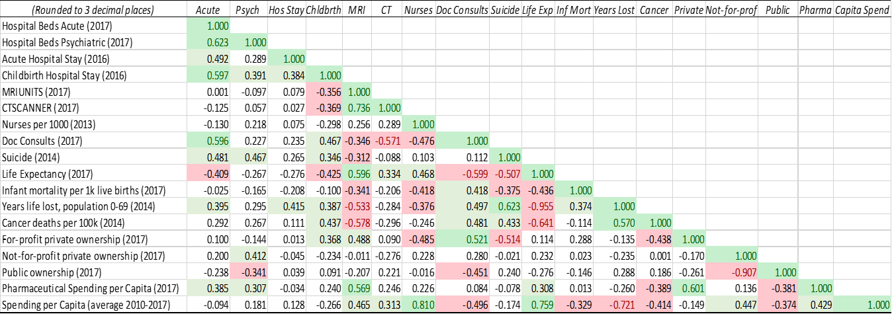

Figure 3 Correlation Table

Source: Adapted from OECD (2020), Computed tomography (CT) scanners, https://data.oecd.org/healtheqt/computed-tomography-ct-scanners.htm; OECD (2020), Deaths from cancer, https://data.oecd.org/healthstat/deaths-from-cancer.htm; OECD (2020), Doctors’ consultations, https://data.oecd.org/healthcare/doctors-consultations.htm; OECD (2020), Health spending, https://data.oecd.org/healthres/health-spending.htm#indicator-chart; OECD (2020), Hospital beds, https://data.oecd.org/healtheqt/hospital-beds.htm; OECD (2020), Infant mortality rate, https://data.oecd.org/healthstat/infant-mortality-rates.htm; OECD (2020), Length of hospital stay, https://data.oecd.org/healthcare/length-of-hospital-stay.htm#indicator-chart; OECD (2020), Life expectancy at birth, https://data.oecd.org/healthstat/life-expectancy-at-birth.htm; OECD (2020), Magnetic resonance imaging (MRI) units, https://data.oecd.org/healtheqt/magnetic-resonance-imaging-mri-units.htm; OECD (2020), Nurses, https://data.oecd.org/healthres/nurses.htm; OECD (2020), Pharmaceutical spending, https://data.oecd.org/healthres/pharmaceutical-spending.htm#indicator-chart; OECD (2020), Potential years of life lost, https://data.oecd.org/healthstat/potential-years-of-life-lost.htm; OECD (2020), Suicide rates, https://data.oecd.org/healthstat/suicide-rates.htm#indicator-chart; Eurostat. (2019). Hospital Beds by Hospital Ownership [Data File]. Available from https://ec.europa.eu/eurostat/web/health/data/database

Figure 3 is the correlation table. In the table, correlations of 0.5 or higher are highlighted with changed color text, as are correlations equal to or lower than -0.5. Weaker correlations, those of 0.3 or higher, and those of -0.3 and lower are also highlighted, but without text color. The correlation table coupled with some of the metrics presented in figure 2 show how many factors may impact the various systems, and that the differences are likely not purely due to differences between concepts such as system type and gatekeeping status. Relevant to spending status, there exists a fairly noteworthy correlation between the percentage of for-profit hospital beds and pharmaceutical spending per capita. Pharmaceutical spending per capita is also correlated with overall spending per capita, with a correlation of over 0.4 in the years contained within the chart. Another noteworthy correlation relating to infrastructure variables is that of MRI Units per million people, which is correlated quite strongly with life expectancy. The nurses per 1000 population is noteworthily correlated with various outcome variables, with a -0.417 correlation with infant mortality rates and a positive correlation of 0.4678 with life expectancy.

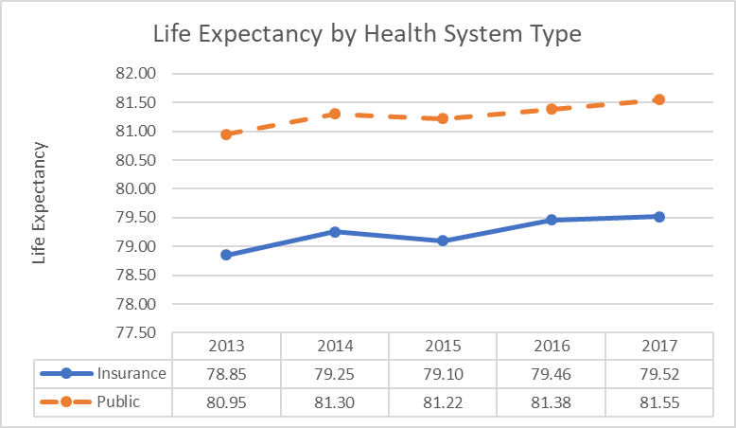

Figure 4 Life Expectancy by Health System

Source: Adapted from data from OECD (2020), Life expectancy at birth, https://data.oecd.org/healthstat/life-expectancy-at-birth.htm

When observing the systems across a five-year period in the metric of life-expectancy, the average public-system had a higher life expectancy than that of the average insurance-based system, as shown in Figure 4. The difference in each year was fairly steady at about a 2-year difference between the average observation in each system for each of the years of 2013 through 2017.

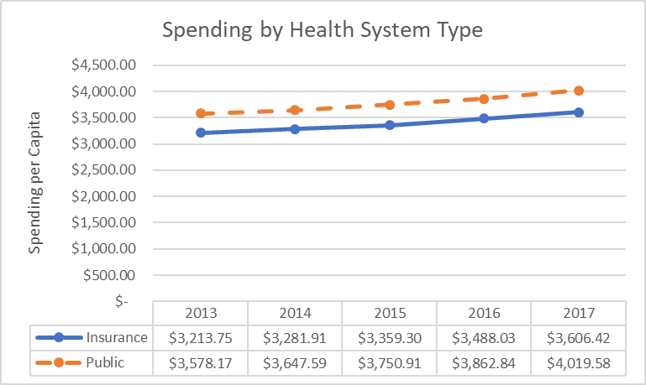

Figure 5 Spending and Health Systems

Source: Adapted from data from OECD (2020), Health spending, https://data.oecd.org/healthres/health-spending.htm#indicator-chart

In terms of spending in USD per capita, the public-systems averaged higher spending over the time period being observed, and the difference between the public systems and insurance-based systems was fairly consistent from 2013 through 2017, as seen in Figure 5.

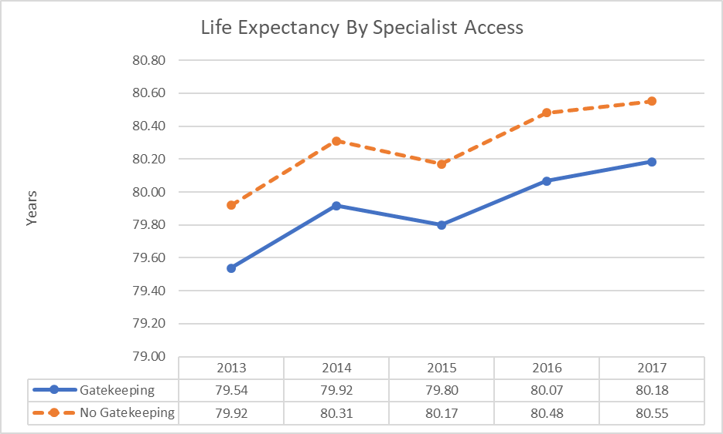

Figure 6 Life Expectancy and Specialist Access

Source: Adapted from OECD (2020), Life expectancy at birth, https://data.oecd.org/healthstat/life-expectancy-at-birth.htm

Looking at gatekeeping, we see that the systems using gatekeeping methods to restrict specialist access had lower life expectancies than those who did not restrict such access, as seen in Figure 6.

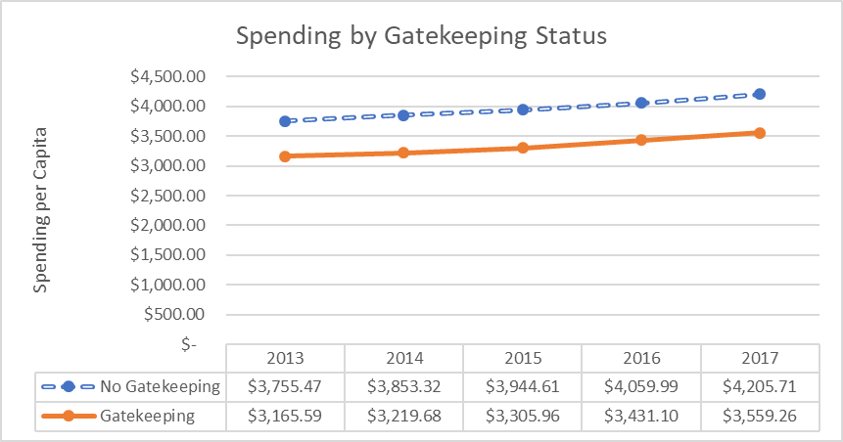

Figure 7 Spending and Specialist Access

Source: Adapted from OECD (2020), Health spending, https://data.oecd.org/healthres/health-spending.htm#indicator-chart

We also see that the systems that engaged in gatekeeping had lower spending per capita on healthcare than the systems who did not restrict access to specialists through gatekeeping measures, as seen in Figure 7.

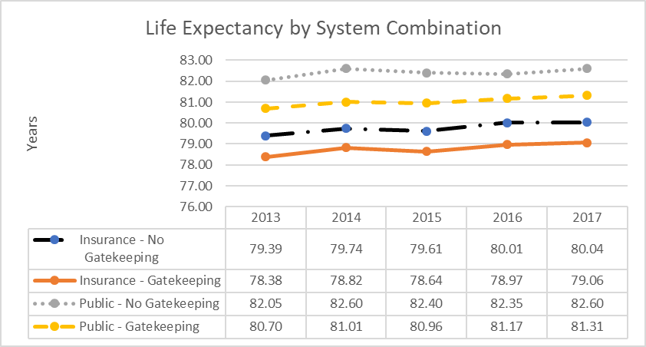

Figure 8 Life Expectancy by Combination of Gatekeeping and System Type

Source: Adapted from Life expectancy at birth, https://data.oecd.org/healthstat/life-expectancy-at-birth.htm

When examining a combination of gatekeeping policies and health system type, as we did in Figure 8, we can see how the two topics mesh together. Public healthcare systems that did not restrict specialist access had the highest sample average in the life expectancy metric, with public systems with gatekeeping performing the second best. In third was the insurance-based systems who did not gatekeep, and then in last was the insurance-based systems who engaged in specialist gatekeeping.

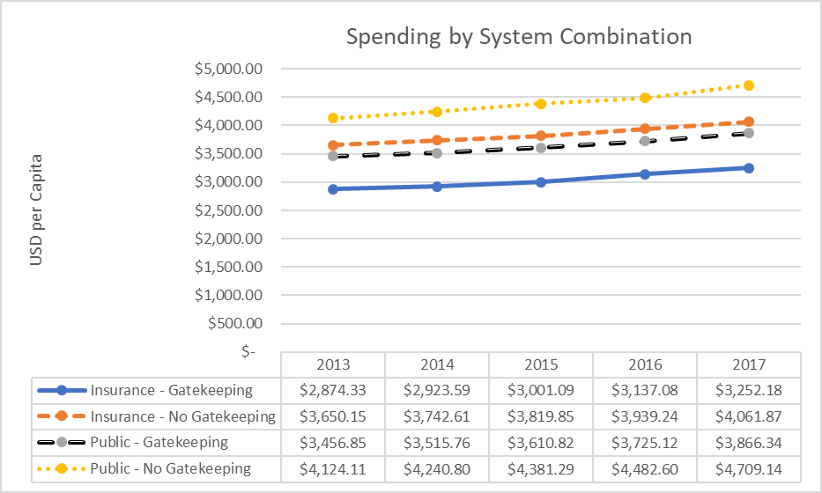

Figure 9 Spending by Combination of Gatekeeping and System Type

Source: Adapted from OECD (2020), Health spending, https://data.oecd.org/healthres/health-spending.htm#indicator-chart

Looking at spending per capita by combination of gatekeeping process and whether or not the healthcare system was insurance-based or public, see Figure 9, we see that the public systems without gatekeeping had the highest sample average of spending, with the insurance systems without gatekeeping coming in behind them. Public systems with gatekeeping had slightly lower expenditures than the insurance-based gatekeeping systems, putting them in the second to lowest spender per capita. Finally, the lowest spender average spender was the insurance-based gatekeeping systems. In 2017 they spent only around 2/3 as much per capita as did the public systems who did utilize gatekeeping. Overall, the system combination with the highest life expectancy, the public system without gatekeeping, also possessed the highest per capita spending. The system with the lowest spending, the insurance-based system with gatekeeping, also had the lowest life expectancy. However, the differences between the systems based upon system type such as public and insurance, as well as comparing gatekeeping to non-gatekeeping, could not be shown to be statistically significant, see Figures 10 and 11.

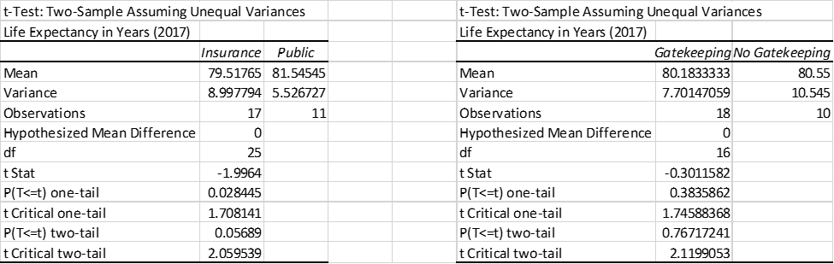

Figure 10 T-Tests comparing Systems and Gatekeeping

Source: Adapted from OECD (2020), Life expectancy at birth, https://data.oecd.org/healthstat/life-expectancy-at-birth.htm

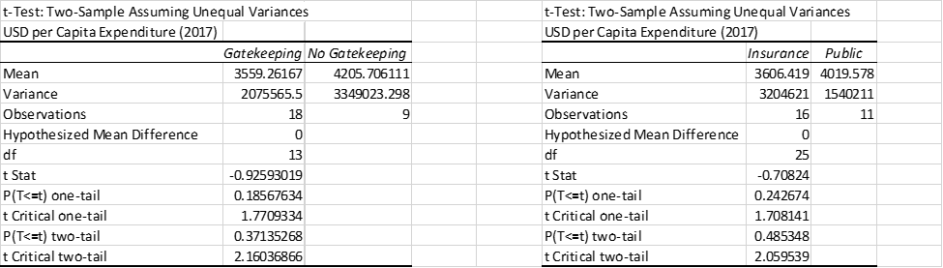

Figure 11 T-test Examing Spending and System Type and Gatekeeping Status

Source: Adapted from OECD (2020), Health spending, https://data.oecd.org/healthres/health-spending.htm#indicator-chart



Figure 12 Spending and Life Expectancy- Regression

Source: Adapted from OECD (2020), Health spending, https://data.oecd.org/healthres/health-spending.htm#indicator-chart; OECD (2020), Life expectancy at birth, https://data.oecd.org/healthstat/life-expectancy-at-birth.htm

However, the relationship between life expectancy and spending of systems was supported by a regression analysis of the metrics of various countries in their 2017 data, showing a statistically significant relationship between spending per capita and life expectancy, as shown in Figure 12.



Figure 13 Spending and Cancer Deaths- Regression

Source: Adapted from OECD (2020), Health spending, https://data.oecd.org/healthres/health-spending.htm#indicator-chart; OECD (2020), Deaths from cancer, https://data.oecd.org/healthstat/deaths-from-cancer.htm

Also examined was the cancer deaths and spending in the year of 2014, showing a statistically significant inverse relationship between spending and cancer deaths, in Figure 13.

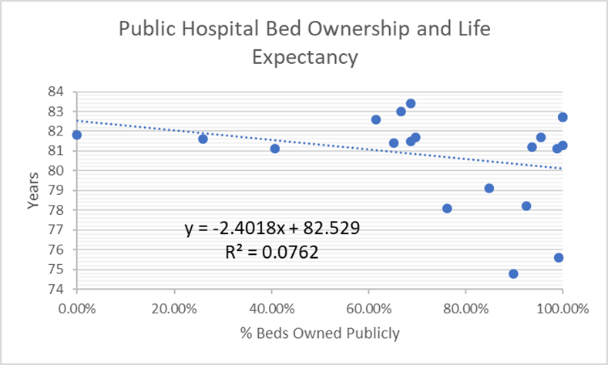

Figure 14 Bed Ownership and Life Expectancy

Source: Adapted from OECD (2020), Life expectancy at birth, https://data.oecd.org/healthstat/life-expectancy-at-birth.htm; Eurostat. (2019). Hospital Beds by Hospital Ownership [Data File]. Available from https://ec.europa.eu/eurostat/web/health/data/database

Another point of interest was the ownership of healthcare provision resources and how that may impact the spending of countries. We examined how the ownership of healthcare provision resources may impact the outcomes and spending of healthcare. In Figure 14, there appears to be a negative correlation between the percentage of beds owned by the government and the life expectancy of the country. However, the coefficient of determination is quite low.

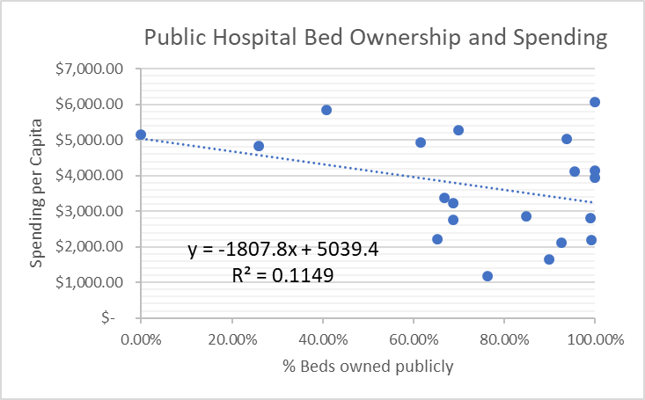

Figure 15 Bed Ownership and Spending

Source: Adapted from OECD (2020), Health spending, https://data.oecd.org/healthres/health-spending.htm#indicator-chart; Eurostat. (2019). Hospital Beds by Hospital Ownership [Data File]. Available from https://ec.europa.eu/eurostat/web/health/data/database

There also appears to be a negative correlation between government bed ownership and costs, as shown in Figure 15. Although this would imply that that higher government ownership of beds is related to lower life expectancies, the relationship between government bed ownership and life expectancy was shown to not be statistically significant, see Figure 16. The relationship between bed ownership and spending was also not statistically significant.



Figure 16 Bed Ownership and Life Expectancy- Regression

Source: Adapted from OECD (2020), Life expectancy at birth, https://data.oecd.org/healthstat/life-expectancy-at-birth.htm; Eurostat. (2019). Hospital Beds by Hospital Ownership [Data File]. Available from https://ec.europa.eu/eurostat/web/health/data/database



Figure 17 Spending and Years of Life Lost- Regression

Source: Adapted from OECD (2020), Health spending, https://data.oecd.org/healthres/health-spending.htm#indicator-chart; OECD (2020), Potential years of life lost, https://data.oecd.org/healthstat/potential-years-of-life-lost.htm

A statistically significant finding was the relationship between the spending of a country and the country’s potential years of life lost, see Figure 17.



Figure 18 Structural Variables and Life Expectancy- Multiple Regression

Source: Adapted from OECD (2020), Life Expectancy at Birth, https://data.oecd.org/healthstat/life-expectancy-at-birth.htm#indicator-chart; OECD (2020), Hospital Beds, https://data.oecd.org/healtheqt/hospital-beds.htm; OECD (2020), Magnetic resonance imaging (MRI) units, https://data.oecd.org/healtheqt/magnetic-resonance-imaging-mri-units.htm#indicator-chart; OECD (2020), Nurses, https://data.oecd.org/healthres/nurses.htm

Figures 18 and 19 examine the structural variables as they relate to various outcome measures, those of life expectancy and infant mortality, respectively. Through this, we see the impact that MRI units have upon life expectancy, but that this impact does not carry over to infant mortality. There is no statistically significant relationship between structural variables and the outcome of infant mortality.



Figure 19 Structural Variables and Infant Mortality- Multiple Regression

Source: Adapted from data from OECD (2020), Infant mortality rate, https://data.oecd.org/healthstat/infant-mortality-rates.htm; OECD (2020), Hospital Beds, https://data.oecd.org/healtheqt/hospital-beds.htm, (OECD- Computed tomography (CT) scanners, 2020), OECD (2020), Magnetic resonance imaging (MRI) units, https://data.oecd.org/healtheqt/magnetic-resonance-imaging-mri-units.htm#indicator-chart, and OECD (2020), Nurses, https://data.oecd.org/healthres/nurses.htm

The finding of a lack of statistical significance when investigating the role of gatekeeping in costs is in line with the literature, as previous studies have had trouble finding statistical significance in the area as well [[(](https://journals.sagepub.com/doi/full/10.1177/0011392112438333)Reibling & Wendt, 2012)](https://journals.sagepub.com/doi/full/10.1177/0011392112438333). Similarly to our investigation into the outcomes of gatekeeping and non-gatekeeping systems, where we found no statistically significant difference, the study also notes that previous research found little difference between gatekeeping systems and non-gatekeeping systems [[(](https://journals.sagepub.com/doi/full/10.1177/0011392112438333)Reibling & Wendt, 2012)](https://journals.sagepub.com/doi/full/10.1177/0011392112438333). Our result of no statistical difference between outcomes, as well as in expenditures, in our study was different than that of some existing literature, which did not find support for a lack of difference between the outcomes of the systems, and also found difference in cost controlling ability [([Van Der Zee & Kroneman, 2007)](https://bmchealthservres.biomedcentral.com/articles/10.1186/1472-6963-7-94)](https://bmchealthservres.biomedcentral.com/articles/10.1186/1472-6963-7-94).

# Analysis

There was not a statistically significant result found when comparing the outcomes of the systems against one another. This means that we cannot reject the null hypothesis that there is no difference between the systems. However, there were statistically significant findings in other areas, such as spending per capita and life expectancy, and spending per capita and cancer deaths. This indicates that overall spending is more important to outcomes than is the type of system that is being used to facilitate a country’s health. Surprising however was the lack of correlation found between spending and gatekeeping status, as well as life expectancy and gatekeeping status, showing that the hypothesis that gatekeeping would limit people’s ability to readily access care and thus negatively impact health, but save money, does not appear to be the case. I therefore cannot reject the null hypothesis that there is no difference between systems who gatekeep and those who do not, in terms of outcomes. The main limitation of the study was in its inability to find statistical significance, which may be related to the small sample, consisting of only 28 countries. Another potential issue is that rather than the groupings being completely distinct, groupings could be viewed more as the circles in a Venn diagram, with large amounts of overlap in their practices. Additionally, the study did not examine every possible relationship that could influence healthcare in detail, only touching upon some of the metrics viewed to be most important with statistical analysis, and relegating others to the correlation table. This also only accounts for some variables, as there are likely variables that might be immensely relevant that were missed. Also, the examination of Europe limits the applicability of any results, as European countries have high levels of economic development, as well as having high levels of integration through systems such as the European Union, which may make them less than fully independent observations when it comes to analysis.

# Discussion

The most practical method to address the implications of the study would be to expand the pool of countries. This would include adding additional countries of similar healthcare system types to the analysis to provide a larger sample, and to examine more variables in more detail than was done here, in order to determine what truly causes differences in European healthcare systems, and health systems generally. There is also the possibility that there may simply not be any major differences between the various system types, insurance systems and public systems may both be nearly equal, gatekeeping may not be effective enough to cause differences, and who owns the hospital beds simply may not matter that much in terms of determining spending and outcomes.

# Conclusions, Recommendations, and Public Health Implications

In conclusion, it was not possible to determine what the best system of healthcare is. Additionally, there was not a statistically significant difference between various systems, and thus it is not appropriate to advocate for one system over another when it comes to what system the United States of America should use. However, there were findings, such as the relationship between spending per capita and health outcomes, and thus I would not recommend attempts to drastically cut health spending before first further investigating the causes of excessive health spending, and attempting to determine what the right spending point is. Further research should be done in some of the areas shown in the correlation table, especially in that infrastructure variables such as MRI units, CT scanners, and the number of nurses a country has seeming promising based upon the results in the correlation table. Also, worth noting is the correlation between doctor consults and health outcomes, which may also be worth looking into. Additionally, attempting to quantify the concepts of system type and levels of gatekeeping may be a way in which future research can expand upon what was touched on in this paper. Although this study was unable to determine the best way to run a healthcare system, it possesses importance to the field of public health in that it showed that there may not currently be a best system, and that people may consider focusing resources on researching topics such as the relationship between healthcare infrastructure and health, as well as allocating resources to healthcare in the proper manner.

# Bibliography

Albreht T, Pribaković Brinovec R, Jošar D, Poldrugovac M, Kostnapfel T, Zaletel M, Panteli D, Maresso A. Slovenia: Health system review. Health Systems in Transition, 2016; 18(3):1–207.

Alexa J, Rečka L, Votápková J, van Ginneken E, Spranger A, Wittenbecher F. Czech Republic: Health system review. Health Systems in Transition, 2015; 17(1):1–165.

Anell A, Glenngård AH, Merkur S. Sweden: Health system review. *Health Systems in Transition*, 2012, 14(5):1–159.

Bachner F, Bobek J, Habimana K, Ladurner J, Lepuschütz L, Ostermann H, Rainer L, Schmidt A E, Zuba M, Quentin W, Winkelmann J. Austria: Health system review. *Health Systems in Transition*, 2018; 20(3): 1 – 256

Berthet, F., Calteux, A., Wolter, M., Weber, L., van Ginneken, E., & Spranger, A., (2015). Luxembourg: HiT in brief. European observatory on health systems and policies. Copenhagen, 1-18. Retrieved from http://www.euro.who.int/__data/assets/pdf_file/0006/287943/Mini-HiT_Luxembourg-rev1.pdf?ua=1

Bernal-Delgado E, García-Armesto S, Oliva J, Sánchez Martínez FI, Repullo JR, PeñaLongobardo LM, Ridao-López M, Hernández-Quevedo C. Spain: Health system review. Health Systems in Transition, 2018;20(2):1–179.

Busse R, Blümel M. Germany: health system review. Health Systems in Transition, 2014, 16(2):1–296.

Busse, R., Blümel, M., Knieps, F., & Bärnighausen, T. (2017). Statutory health insurance in Germany: a health system shaped by 135 years of solidarity, self-governance, and competition. The Lancet, 390(10097), 882-897.

Chevreul K, Berg Brigham K, Durand-Zaleski I, Hernández-Quevedo C. France: Health system review. Health Systems in Transition, 2015; 17(3): 1–218.

Cylus J, Richardson E, Findley L, Longley M, O’Neill C, Steel D. United Kingdom: Health system review. Health Systems in Transition, 2015; 17(5): 1–125.

De Pietro C, Camenzind P, Sturny I, Crivelli L, Edwards-Garavoglia S, Spranger A, Wittenbecher F, Quentin W. Switzerland: Health system review. Health Systems in Transition, 2015; 17(4):1–288.

Economou C, Kaitelidou D, Karanikolos M, Maresso A. Greece: Health system review. Health Systems in Transition, 2017; 19(5):1–192.

Eurostat. (2019). *Hospital Beds by Hospital Ownership* [Data File]. Available from https://ec.europa.eu/eurostat/web/health/data/database

Eurostat. (n.d.). Overview. Retrieved February 17, 2020, from https://ec.europa.eu/eurostat/about/overview

Ferré F, de Belvis AG, Valerio L, Longhi S, Lazzari A, Fattore G, Ricciardi W, Maresso A. Italy: Health System Review. Health Systems in Transition, 2014, 16(4):1–168.

Gaál P, Szigeti S, Csere M, Gaskins M, Panteli D. Hungary: Health system review. Health Systems in Transition, 2011; 13(5):1–266.

Gerkens S, Merkur S. Belgium: Health system review. *Health Systems in Transition*, 2010, 12(5):1–266.

Grosios, K., Gahan, P. B., & Burbidge, J. (2010). Overview of healthcare in the UK. The EPMA journal, 1(4), 529–534. doi:10.1007/s13167-010-0050-1

Habicht T, Reinap M, Kasekamp K, Sikkut R, Laura Aaben L, van Ginneken, Estonia: Health system review. Health Systems in Transition, 2018; 20(1): 1 – 193

Keskimäki I, Tynkkynen LK, Reissell E, Koivusalo M, Syrjä V, Vuorenkoski L, Rechel B, Karanikolos M. Finland: Health system review. Health Systems in Transition, 2019; 21(2): 1 – 166

Kroneman M, Boerma W, van den Berg M, Groenewegen P, de Jong J, van Ginneken E (2016). The Netherlands: health system review. Health Systems in Transition, 2016; 18(2):1–239.

Kulu-Glasgow, I., Delnoij, D., & de Bakker, D. (1998). Self-referral in a gatekeeping system: patients’ reasons for skipping the general-practitioner. Health policy, 45(3), 221-238.

Legido-Quigley, H., Glinos, I., Baeten, R., & McKee, M. (2007). Patient mobility in the European Union. Bmj, 334(7586), 188-190.

lo Storto, C., & Goncharuk, A. G. (2017). Efficiency vs effectiveness: A benchmarking study on European healthcare systems. Economics & Sociology, 10(3), 102-115.

McDaid D, Wiley M, Maresso A and Mossialos E. Ireland: Health system review. Health Systems in Transition, 2009; 11(4): 1 – 268

Mitenbergs U, Taube M, Misins J, Mikitis E, Martinsons A, Rurane A, Quentin W. Latvia: Health system review. Health Systems in Transition, 2012; 14(8): 1 – 191

Murauskiene L, Janoniene R, Veniute M, van Ginneken E, Karanikolos M. Lithuania: health system review. Health Systems in Transition, 2013; 15(2): 1–150.

OECD (2020), Computed tomography (CT) scanners (indicator). doi: 10.1787/bedece12-en (Accessed on 18 January 2020)

OECD (2020), Deaths from cancer (indicator). doi: 10.1787/8ea65c4b-en (Accessed on 18 January 2020)

OECD (2020), Doctors' consultations (indicator). doi: 10.1787/173dcf26-en (Accessed on 18 January 2020)

OECD (2020), Health spending (indicator). doi: 10.1787/8643de7e-en (Accessed on 18 January 2020)

OECD (2020), Hospital beds (indicator). doi: 10.1787/0191328e-en (Accessed on 18 January 2020)

OECD (2020), Infant mortality rates (indicator). doi: 10.1787/83dea506-en (Accessed on 18 January 2020)

OECD (2020), Length of hospital stay (indicator). doi: 10.1787/8dda6b7a-en (Accessed on 18 January 2020)

OECD (2020), Life expectancy at birth (indicator). doi: 10.1787/27e0fc9d-en (Accessed on 18 January 2020)

OECD (2020), Magnetic resonance imaging (MRI) units (indicator). doi: 10.1787/1a72e7d1-en (Accessed on 18 January 2020)

OECD (2020), Nurses (indicator). doi: 10.1787/283e64de-en (Accessed on 18 January 2020)

OECD (2020), Pharmaceutical spending (indicator). doi: 10.1787/998febf6-en (Accessed on 18 January 2020)

OECD (2020), Potential years of life lost (indicator). doi: 10.1787/193a2829-en (Accessed on 18 January 2020)

OECD (2020), Suicide rates (indicator). doi: 10.1787/a82f3459-en (Accessed on 18 January 2020)

Olejaz M, Juul Nielsen A, Rudkjøbing A, Okkels Birk H, Krasnik A, Hernández-Quevedo C. Denmark: Health system review. *Health Systems in Transition*, 2012, 14(2):1 – 192.

Organisation for Economic Co-operation and Development. (2019). List of OECD Member countries - Ratification of the Convention on the OECD. Retrieved February 17, 2020, from https://www.oecd.org/about/document/list-oecd-member-countries.htm

Popovich L, Potapchik E, Shishkin S, Richardson E, Vacroux A, and Mathivet B. Russian Federation: Health system review. Health Systems in Transition, 2011; 13(7):1–190.

Reibling, N., & Wendt, C. (2012). Gatekeeping and provider choice in OECD healthcare systems. Current Sociology, 60(4), 489-505.

Ringard Å, Sagan A, Sperre Saunes I, Lindahl AK. Norway: Health system review. Health Systems in Transition, 2013; 15(8): 1– 162.

Sagan A, Panteli D, Borkowski W, Dmowski M, Domański F, Czyżewski M, Goryński P, Karpacka D, Kiersztyn E, Kowalska I, Księżak M, Kuszewski K, Leśniewska A, Lipska I, Maciąg R, Madowicz J, Mądra A, Marek M, Mokrzycka A, Poznański D, Sobczak A, Sowada C, Świderek M, Terka A, Trzeciak P, Wiktorzak K, Włodarczyk C, Wojtyniak B, Wrześniewska-Wal I, Zelwiańska D, Busse R. Poland: Health system review. *Health Systems in Transition*, 2011, 13(8):1–193.

Sigurgeirsdóttir S, Waagfjörð J, Maresso A. Iceland: Health system review. Health Systems in Transition, 2014; 16(6):1–182.

Simões J, Augusto GF, Fronteira I, Hernández-Quevedo C. Portugal: Health system review. *Health Systems in Transition*, 2017; 19(2):1–184.

Smatana M, Pažitný P, Kandilaki D, Laktišová M, Sedláková D, Palušková M, van Ginneken E, Spranger A (2016). Slovakia: Health system review. *Health Systems in Transition*, 2016; 18(6):1–210.

Tatar M, Mollahaliloğlu S, Şahin B, Aydın S, Maresso A, HernándezQuevedo C. Turkey: Health system review. *Health Systems in Transition*, 2011, 13(6):1–186.

U.S. Mission to the Organization For Economic Cooperation & Development. (n.d.). What is the OECD? Retrieved February 17, 2020, from https://usoecd.usmission.gov/our-relationship/about-the-oecd/what-is-the-oecd/

Van Der Zee, J., & Kroneman, M. W. (2007). Bismarck or Beveridge: a beauty contest between dinosaurs. *BMC health services research*, *7*(1), 94.

Wendt, C., Frisina, L., & Rothgang, H. (2009). Healthcare system types: a conceptual framework for comparison. Social Policy & Administration, 43(1), 70-90.