Title Page
Association Analysis of the LTA/TNF/LTB Region on Chromosome 6p21 with Systemic Lupus Erythematous (SLE)

by

Jodi Ellen Kutzner

B.S., Saint Francis University, 2018

Submitted to the Graduate Faculty of the

Department of Human Genetics

Graduate School of Public Health in partial fulfillment

of the requirements for the degree of

Master of Public Health

University of Pittsburgh

2020

Committee Page
UNIVERSITY OF PITTSBURGH

Graduate School of Public Health

This essay is submitted

by

Jodi Ellen Kutzner

on

April 17, 2020

and approved by

Essay Advisor:
F. Yesim Demirci, MD
Associate Professor
Department of Human Genetics
Graduate School of Public Health
University of Pittsburgh

Essay Reader:
Candace Kammerer, PhD
Associate Professor
Department of Human Genetics
Graduate School of Public Health
University of Pittsburgh

Essay Reader:
Allison L. Kuipers, PhD
Assistant Professor
Department of Epidemiology
Graduate School of Public Health
University of Pittsburgh

Copyright © by Jodi Ellen Kutzner

2020

Abstract
F. Yesim Demirci, MD

Association Analysis of the LTA/TNF/LTB Region on Chromosome 6p21 with Systemic Lupus Erythematous (SLE)

Jodi Ellen Kutzner, MPH

University of Pittsburgh, 2020

Abstract

Systemic Lupus Erythematous (SLE) is a chronic, multisystem autoimmune disease that is characterized by the production of a wide variety of autoantibodies against various self-antigens. SLE is a complex disease that is believed to result from an intricate interaction of environmental and hormonal risk factors with multiple genetic susceptibility loci. The major histocompatibility complex (MHC) region located on chromosome 6p21 was the first risk locus found to be associated with SLE and it still constitutes the strongest contributor to genetic susceptibility. The genes at the MHC locus encode for various proteins including those involved in inflammation, antigen presentation, and other innate and/or adaptive immune responses. The MHC class III region harbors 3 genes belonging to the Tumor Necrosis Factor Super Family, LTA/TNF/LTB, whose protein products show biological interactions. The primary objective of this essay was to investigate the association of genetic polymorphisms at the LTA/TNF/LTB locus with susceptibility to SLE. For this purpose, a total of 14 SNPs (located in the LTA/TNF/LTB gene cluster or flanking intergenic regions) were evaluated for their association with SLE in a case-control sample comprising European-descent subjects (661 cases and 487 controls). Association analysis results implicated two SNPs at this locus in SLE susceptibility: rs1800683 and rs1800629 located within LTA (5’ UTR variant) and between LTA and TNF (TNF promoter variant), respectively. Moderate linkage disequilibrium (LD) was detected between these 2 SNPs (r²<0.5) and the same or closely linked SNPs have also been similarly found to be associated with SLE in prior studies. In summary, the results of this study provide further support for a potential role of functionally relevant LTA/TNF polymorphisms in susceptibility to SLE, a disease that represents a significant public health concern as it affects relatively young adults and causes significant morbidity and mortality.

Table of Contents
1.0 An Introduction to Systemic Lupus Erythematous 1
1.1 Definition and Clinical Features 1
1.2 Epidemiology 3
1.3 Clinical Management 4
1.4 Public Health Relevance 5
2.0 Immunopathogenesis of SLE 6
3.0 Genetics of SLE 7
4.0 LTA/TNF/LTB Gene Cluster on Chromosome 6p21 and immunological functions of encoded proteins 9
5.0 Study Objective and Specific Aims 12
6.0 Methods 13
7.0 Results 15
7.1 Single-Site Association Analysis 17
7.2 Haplotype Analysis of SLE-associated SNPs 18
7.3 Functional Assessment of SLE-associated SNPs 18
8.0 Discussion 20
Bibliography 24

List of Tables
Table 1 American College of Rheumatology (ACR) classification criteria for SLE* 2
Table 2 Systemic Lupus International Collaborating Clinics (SLICC) classification criteria for SLE* 3
Table 3 The LTA/TNF/LTB region SNPs selected for association analysis with SLE 15
Table 4 Single-site association results for the SNPs of interest in SLE case-control sample 17
Table 5 Two-site haplotype analysis of SLE associaed SNPS (rs 1800683-rs1800629) 18

List of Figures
Figure 1Genes and immune pathways implicated in SLE susceptibility 7
Figure 2 Complicated cellular and molecular network of TNF/LT/LIGHT family members 10
Figure 3 Location of the SNPs within the LTA/TNF/LTB gene cluster and flanking intergenic regions at 6p21 14
Figure 4 The LD plot showing the pairwise correlations between the SNPs of interest in the study sample 16
Figure 5 Functional annotation of SLE associated SNPs using HaploReg tool 19

1.0 An Introduction to Systemic Lupus Erythematous
Autoimmune diseases (AIDs) comprise a heterogeneous group of disorders that are caused by the loss of immunological tolerance to self-antigens, where the immune system attacks the body’s own cells and tissues. AIDs can be organ-specific or systemic (not limited to a single organ) and may collectively affect up to ~10% of the general population (Marson, 2015).

Definition and Clinical Features
Systemic Lupus Erythematous (SLE) is a chronic, multisystem autoimmune disease that is characterized by the formation of a wide variety of autoantibodies against various self-antigens (Pan, 2019). The clinical presentation of SLE is heterogeneous in nature, affecting many different organs/systems (i.e. skin, joints, heart, kidneys, lungs, central nervous system, and hematopoietic system) in the body and resulting in variable manifestations and outcomes. Although symptoms and findings vary from person to person, ranging from mild to life-threatening, the most common maladies associated with SLE include arthralgia/arthritis, skin rashes, malaise, headaches, and loss of weight and appetite (Cojocaru, 2011). SLE classification criteria have been developed and implemented to enable consistency in the definition of SLE for research and surveillance purposes. The most commonly used SLE criteria comprise those initially developed and later revised by the American College of Rheumatology (ACR) (Table 1) (Hochberg, 1997). The updated ACR criteria were subsequently further revised and validated by the Systemic Lupus International Collaborating Clinics (SLICC) group (Table 2) (Petri, 2012). To address the challenges associated with its high clinical heterogeneity, ongoing clinical studies have focused on further improving classification criteria for SLE (Aringer, 2019).

Table 1 American College of Rheumatology (ACR) classification criteria for SLE*
Skin Criteria | - Malar rash  - Discoid rash  - Photosensitivity (in sun-exposed areas)  - Oral ulcerations
Systemic Criteria | - Arthritis (symmetric, non-erosive)  - Serositis (pleuritis, pericarditis)  - Renal disorder (persistent proteinuria or cellular urinary casts)  - Neurologic disorder (seizures or psychosis with no other explanation)
Laboratory Criteria | - Hematologic disorder (hemolytic anemia, leukopenia, or thrombocytopenia)  - Immunologic disorder (antiphospholipid, anti-dsDNA, or anti-Sm antibodies)  - Antinuclear antibody (ANA)
*Requires a minimum of 4 out of 11 at any given time
(Tan, 1982) (Hochberg, 1997)
Note: Common symptoms of SLE that are not listed among ACR criteria include fever, extreme fatigue, weight loss, hair loss, and Raynaud’s phenomenon

Table 2 Systemic Lupus International Collaborating Clinics (SLICC) classification criteria for SLE*
Clinical Criteria | Immunologic Criteria
- Acute Cutaneous Lupus  - Chronic Cutaneous Lupus  - Oral or nasal ulcers  - Non-scarring alopecia  - Synovitis involving 2 or more joints  - Serositis  - Renal  - Neurologic  - Hemolytic anemia  - Leukopenia  - Thrombocytopenia | - Antinuclear antibodies (ANA)  - Anti-dsDNA antibody  - Anti-Sm antibody  - Antiphospholipid antibodies  - Low complement (C3, C4, CH50)  - Direct Coomb’s test in the absence of hemolytic anemia
* ”Requires a minimum of 4 (at least 1 clinical and 1 immunologic criteria) OR biopsy-proven lupus nephritis with positive ANA or anti-dsDNA”
(Petri, 2012)

Epidemiology
The overall age-adjusted rates of >5 incident cases per 100,000 persons and >72 prevalent cases per 100,000 persons were estimated based on CDC funded population-based SLE registries (Stojan, 2018). SLE prevalence is difficult to estimate because the immunological abnormalities may occur long before the clinical signs and symptoms appear, so diagnosis is delayed, especially in younger populations. The disease is characterized by a significant female preponderance, with a lifetime female-male ratio of about 9:1 (Weckerle, 2011). The exact mechanisms underlying the gender bias in autoimmunity remain to be fully understood but it is believed to be mediated by various factors such as sex hormones, sex chromosomal genes, and sex differences in epigenetic regulation. Women of child-bearing age are most frequently affected by SLE (Kaul, 2016). Additionally, SLE is far more frequent and severe in non-Caucasian populations, specifically African American, Hispanic, and Asian ethnicities. Long-term negative outcomes of SLE, such as higher mortality rate, have been correlated with ethnic minorities (Gonzalez, 2013). The overall standardized mortality ratio (SMR) for SLE is 2.4, indicating that there is an increased number of deaths in SLE patients compared to the general population (Bernatsky, 2006).

Clinical Management
Currently, there is no cure for SLE, but there are certain medical treatments and lifestyle changes that can lessen the burden of disease. Anti-inflammatory and immunosuppressive drugs currently comprise the mainstream treatment for SLE, but the drugs work to varying degrees in individuals (Yildirim-Toruner, 2011). New, targeted therapies are being developed as the pathogenesis of SLE is better understood. Once the initiation and progression of disease is made clearer, therapeutic options can be formed to block certain phases or pathways in SLE pathogenesis. There are also behavioral and lifestyle adjustments that can keep SLE in remission. The best way to keep SLE under control is by adhering to medical treatments and visiting a rheumatologist regularly. Lifestyle changes to lessen symptoms include quitting smoking and using sunscreen. Both smoking and UV exposure have been implicated in lupus onset and flares (Lupus Foundation of America, 2019).

Public Health Relevance
Because it affects relatively young adults and causes significant morbidity and mortality, SLE represents a significant public health concern (Carter, 2016). SLE imposes an economic burden on both patients and society, as many individuals either have to register as disabled or quit/switch jobs due to the ongoing pain, fatigue and reduced physical activity (Macejova, 2013). Direct and indirect costs for those with SLE are significantly higher than the general population. Direct costs, including the diagnosis, treatment and management of SLE, could reach almost $70,000 per year depending upon the severity of their disease. Indirect costs, relating to disability and loss of productivity could reach approximately $20,000 each year due to loss of activity due to their diagnosis (Carter, 2016). In addition, this disorder disproportionally affects women of child-bearing age, creating issues in social activities, relationships and family-planning. Late diagnosis and treatment are associated with poor outcomes in SLE patients. Public health initiatives are aimed towards finding earlier detection biomarkers, including genetic markers, for SLE and educating affected individuals on self-management tools to improve the personal and economic tolls of this disease. Identification of genetic susceptibility variants may help to not only assess the individual risk for SLE but also improve our understanding of underlying biological mechanisms/pathways, which in turn may guide the development of new and better biomarkers and/or therapeutic options for this devastating disease.

Immunopathogenesis of SLE
The pathogenesis of SLE is not fully understood, but dysregulation of the innate and adaptive immune systems seems to play a major role in this autoimmune disorder. SLE is characterized by the occurrence of a wide variety of autoantibodies, mainly targeting the components of various nucleoproteins and nucleoprotein complexes (Namjou, 2007). SLE-associated immunological dysfunction is believed to precede the onset of clinical disease and may involve multiple abnormalities including increased cell death (e.g. apoptosis, NETosis), defective clearance of apoptotic debris and/or antigen-antibody complexes, altered antigen processing and/or presentation, altered signaling pathways [e.g., type I interferon (IFN) and nuclear factor kappa light chain enhancer of activated B cells (NFκB)], T-cell dysregulation, and B-cell hyperactivity (Teruel, 2017). Abnormal cytokine secretion prolongs inflammation at the site where B cells are producing autoantibodies, creating the cycle of autoimmunity and eventually leading to permanent tissue damage (Pan, 2019).

Genetics of SLE
SLE has a complex genetic basis (multifactorial and polygenic) and is believed to result from an intricate interaction of environmental and hormonal risk factors with multiple genetic susceptibility loci (Kaul, 2016). SLE and other autoimmune disorders tend to run in families, but usually do not follow Mendelian (monogenic) inheritance patterns. In total, there are over 80 genetic loci found to be associated with SLE susceptibility (Chen, 2017), mainly implicating common variants with potential effects on the genes involved in various immune functions/pathways (Figure 1).

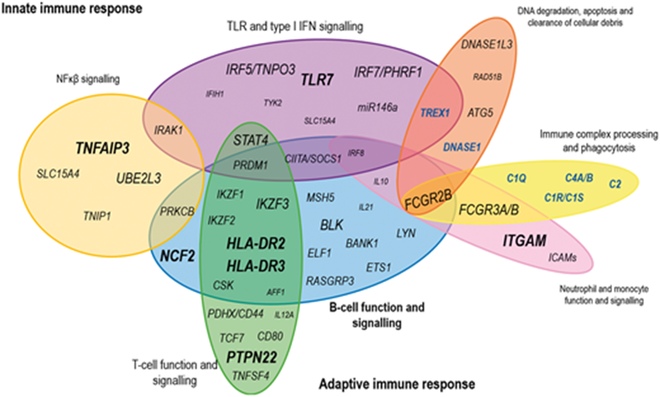

Figure 1Genes and immune pathways implicated in SLE susceptibility
Adapted from (Teruel, 2017) “The character size indicates the effect of each gene on SLE susceptibility, as measured by the odds ratio (OR) to risk that it confers. Larger character size indicates genes with large effects (OR ≥ 2), whereas smaller character size corresponds to genes with smaller effect size (OR ≤ 1.2). Similarly, the cluster size of the pathway emphasizes its relevance in SLE pathology, according to the number of the genes and their individual effects. The SLE-associated genes represented by rare variants with high prevalence of the disease are in bold black-blue.”

The first risk locus to be associated with SLE was the major histocompatibility complex (MHC) locus and this locus still provides the strongest risk for genetic susceptibility. The MHC locus harbors various genes that encode molecules involved in antigen presentation, inflammation, the complement system and other innate and adaptive immune system functions, hinting at the region’s importance in autoimmunity (Matzaraki, 2017). The MHC region is, in general, difficult to work with due to the extended linkage disequilibrium (LD) that makes statistical interpretation of associations with single nucleotide polymorphisms (SNPs) challenging. Nonetheless, variants within this region strongly influence SLE susceptibility (Bolstad, 2012). Advances in genetic technologies and association studies are expected to increase the ability to fine-map the MHC associations.
The MHC region on chromosome 6p21 is divided into three subregions harboring the human leukocyte antigen (HLA) and/or non-HLA genes: the class I region containing class I HLA genes (e.g., HLA-A, HLA-B and HLA-C genes), the class II region containing class II HLA genes (e.g., HLA-DR, HLA-DQ and HLA-DP genes), and the class III region (located in between class I and II regions) containing only non-HLA genes (Horton, 2004). Studies suggest the involvement of both HLA and non-HLA genes at the MHC locus in SLE-related immunopathology (Morris, 2012).

LTA/TNF/LTB Gene Cluster on Chromosome 6p21 and immunological functions of encoded proteins
The MHC class III region contains various non-HLA genes, including three genes belonging to the Tumor Necrosis Factor Super Family (TNFSF) and forming a tight gene cluster at 6p21. These three genes are LTA, TNF, and LTB, whose protein products [lymphotoxin-alpha, tumor necrosis factor (a.k.a. TNF-alpha), and lymphotoxin-beta, respectively] show biological interactions (Sedy, 2014) (Figure 2). The TNFSF signals to assist immune cells with proliferation and differentiation into effector cells (Sonar, 2015). Additionally, polymorphisms in the genes encoding TNFSF members have been reported to be associated with susceptibility to various infections, inflammatory conditions, autoimmune diseases, and cancers. Studies of this gene cluster in SLE are relatively limited (predominantly focusing on selected variants) and the results are inconsistent/inconclusive, while their meta-analyses suggest ethnic-specific variant effects/associations (Chen, 2019).
The LT/TNF/LIGHT system, which includes four closely related TNFSF members [lymphotoxin-alpha/beta (encoded by LTA/LTB on chromosome 6p21), TNF-alpha (encoded by TNF on chromosome 6p21), and LIGHT (encoded by TNFSF14 on chromosome 19p13)], plays an important role in orchestrating the formation, maintenance, and remodeling of lymphoid tissue that is an integral part of the immune system (Zhu, 2011). The LT/TNF/LIGHT proteins and their cognate receptors (Figure 2) form a complex cellular and molecular network involved in the development and maintenance of the immune system, inflammation and cell death (Remouchamps, 2011). They execute their functions through multi-directional interactions via membrane-bound and/or soluble forms, resulting in local and distant regulatory effects.

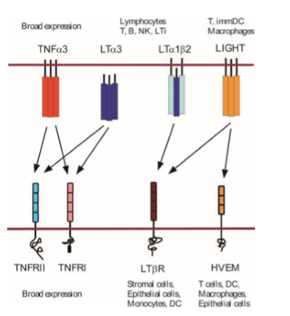
MMP
MMP

Figure 2 Complicated cellular and molecular network of TNF/LT/LIGHT family members
Adapted and Modified from (Zhu, 2011) Interactions between ligands and receptors (line arrows) and cells involved in their production are depicted. The action sites for metalloproteinases (MMPs) that convert membrane-bound ligands into secreted/soluble forms are indicated by bolded arrows (Gubernatorova, 2016).

Tumor Necrosis Factor (TNF) is a multifunctional protein that has both pro- and anti-inflammatory functions within the immune system. This cytokine is mainly secreted by immune cells, predominantly by monocytes/macrophages and T cells. TNF can signal T lymphocytes to activate and proliferate or to undergo apoptosis (Mehta, 2018). The relationship between TNF and different T cell subtypes appears to be quite complex including several paradoxical effects on T cell biology (Bystrom, 2018). Other functions of TNF include stimulating cytokine production (inducing a cascade of various inflammatory cytokines), orchestrating the tissue recruitment of immune cells, enhancing adhesion molecule expression, increasing neutrophil activation, acting as a co-stimulator for T cell activation and antibody production, and resolution of inflammation and induction of tissue repair (Chen, 2019). Almost all cells express TNF receptors, making it a ubiquitous protein across all body systems (Mehta, 2018). Overproduction of TNF has been observed in different autoimmune diseases characterized by chronic inflammation. Elevated TNF levels were also detected in SLE patients and shown to correlate with active disease (Postal, 2011). TNF inhibitors have been used in the clinical setting to deter rheumatic diseases and lower inflammation (Croft, 2017). Adversely though, some anti-TNF therapies have actually been shown to cause lupus-like symptoms when used for other inflammatory diseases, indicating the delicate balance of interactions between this ligand and its receptors (Shovman, 2018).
Originally considered functionally redundant to TNF, the lymphotoxin (LT) proteins have later been shown to play important roles in lymphoid tissue development/homeostasis and effector immune responses (Bienkowska, 2014), and more recently also in type I interferon (IFN-I) production by dendritic cells (Gommerman, 2014) as well as in gut microbiota regulation (Upadhyay, 2013). LTA and LTB are expressed by T cells, B cells, NK cells, and innate lymphoid cells (Zhu, 2011). Together, LTA and LTB can form a stable heterodimeric complex (Figure 2). LTB is far less studied than LTA or TNF (Albarbar, 2015).

Study Objective and Specific Aims
The primary objective of this study was to investigate the genetic association of the LTA/TNF/LTB region on chromosome 6p21 with SLE susceptibility. Because LTA/TNF/LTB are strong candidate genes, functionally relevant variants at this locus might contribute to the risk of developing SLE. Below are the specific aims of this study:

Specific Aim 1: To investigate the association of the LTA/TNF/LTB locus with susceptibility to SLE in a data set comprising fourteen QC-passed single nucleotide polymorphisms (SNPs) genotyped or imputed in an SLE case-control sample of European ancestry (~1,150 subjects).

Specific Aim 2: To use publicly available resources and bioinformatics tools (i) to assess in silico whether the SLE-associated variants have putative functional effects in order to gain further insights into SLE pathogenesis, and (ii) to evaluate the replication of identified associations in previously reported studies/data sets.

Methods
The study data set has included the LTA/TNF/LTB region SNPs data derived from a genome-wide genotype data on an SLE case-control sample that were imputed using the 1000 Genomes and HapMap reference panels (performed by Golden Helix using the Beagle software package). Study subjects were recruited at three sites (Pittsburgh, Chicago, and Montreal) using similar protocols. Additional information on these collections can be found in previous publications (Pineau, 2006) (Rhew, 2009) (Demirci, 2011) (Bernatsky, 2013) (Demirci, 2016). DNAs extracted from stored buffy coat samples were genotyped using Affy SNP6 platform. After excluding the subjects with cryptic relationship, removing the samples with poor performance and also the outliers identified by population stratification analysis, ~1,150 European-descent subjects were available for subsequent analyses. SLE subjects (n=661) were 18 years of age or older (mean age 45 ± 12 years; 97% women) and met the American College of Rheumatology (ACR) classification criteria for definite or probable SLE (Tan, 1982) (Hochberg, 1997). SLE-free controls (n=487) were 21 years or older (mean age 49 ± 11 years; 100% women).
Data were available for fifteen SNPs with minor allele frequency (MAF) > 1% (7 directly genotyped and 8 imputed with a high-probability) from the LTA/TNF/LTB gene cluster and flanking intergenic regions on chromosome 6p21 (Figure 3). The genotype and allele frequencies were calculated by direct counting method. Observed genotype frequencies were compared to those expected under Hardy–Weinberg equilibrium (HWE) and the significance of deviations was tested by the chi-squared goodness-of-fit test. A total of 14 SNPs with >90% call rate and in concordance with HWE were included in subsequent association analyses (1 SNP was removed due to lower call rate).
Genotype distribution differences between SLE cases and controls were tested for each SNP by conducting logistic regression analysis under the dominant (minor allele homozygote = 1, heterozygote = 1, major allele homozygote = 0) and additive (minor allele homozygote = 2, heterozygote = 1, major allele homozygote = 0) models that included the site and age as covariates. The Haploview program (https://www.broadinstitute.org/haploview/haploview) version 4.2 was used to assess the LD between the pairs of studied SNPs and also to perform haplotype association analysis of SLE-relevant SNPs in the study sample. Multiple testing concerns were addressed by performing Bonferroni correction in single-site analyses and permutation testing in haplotype analysis. In silico assessment of putative functional effects of SLE-associated SNPs was done using RegulomeDB (https://regulomedb.org/regulome-search/) version 2.0 and HaploReg (https://pubs.broadinstitute.org/mammals/haploreg/haploreg_v4.php) version 4 bioinformatics tools.
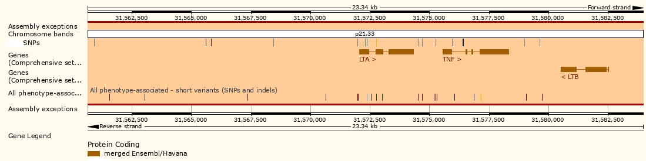

Figure 3 Location of the SNPs within the LTA/TNF/LTB gene cluster and flanking intergenic regions at 6p21
Generated using the Ensembl genome browser (https://useast.ensembl.org/index.html) and the human GRCh38 assembly as the reference (of note, the most recent info on NCBI gene portal suggests the presence of longer LTA splice forms with additional 5’UTR exons and introns extending to include the SNPs shown as upstream intergenic variants in this figure).

Results
The information on fourteen LTA/TNF/LTB region SNPs selected for association analysis with SLE in this study can be found in Table 3. The LD plot showing the pairwise correlations between the SNPs of interest in the study sample is provided in Figure 4.

Table 3 The LTA/TNF/LTB region SNPs selected for association analysis with SLE
# | Ref SNP ID | Position on chr 6 (hg38) | Location in gene cluster region | Alleles | MAF All | MAF Cases | MAF Controls | HWE P-value
1 | rs13215091 | 31560913 | LTA: Upstream | C>T | 0.052 | 0.055 | 0.049 | 0.063
2 | rs2857602 | 31565601 | LTA: Upstream | T>C | 0.400 | 0.382 | 0.423 | 0.942
3 | rs2857708 | 31565829 | LTA: Upstream | C>T | 0.111 | 0.095 | 0.131 | 0.986
4 | rs2844484 | 31568447 | LTA: Upstream | C>T | 0.399 | 0.381 | 0.423 | 0.888
5 | rs2844482 | 31571990 | LTA: Upstream | C>T | 0.140 | 0.136 | 0.146 | 0.915
6 | rs1800683 | 31572294 | LTA: 5' UTR | G>A | 0.351 | 0.383 | 0.307 | 0.336
7 | rs2239704 | 31572364 | LTA: Intron | C>A | 0.400 | 0.380 | 0.426 | 0.871
8 | rs2229094 | 31572779 | LTA: Missense | T>C | 0.242 | 0.232 | 0.255 | 1
9 | rs1799964 | 31574531 | LTA: Downstream, TNF: Upstream | T>C | 0.192 | 0.185 | 0.201 | 0.604
10 | rs1800630 | 31574699 | LTA: Downstream, TNF: Upstream | C>A | 0.137 | 0.135 | 0.140 | 0.898
11 | rs1800629 | 31575254 | TNF: Upstream | G>A | 0.176 | 0.201 | 0.142 | 0.827
12 | rs3093661 | 31575981 | TNF: Intron | G>A | 0.031 | 0.026 | 0.037 | 1
13 | rs3093662 | 31576412 | TNF: Intron | A>G | 0.066 | 0.066 | 0.066 | 0.678
14 | rs3093672 | 31579643 | TNF: Downstream, LTB: Downstream | G>A | 0.017 | 0.020 | 0.012 | 1

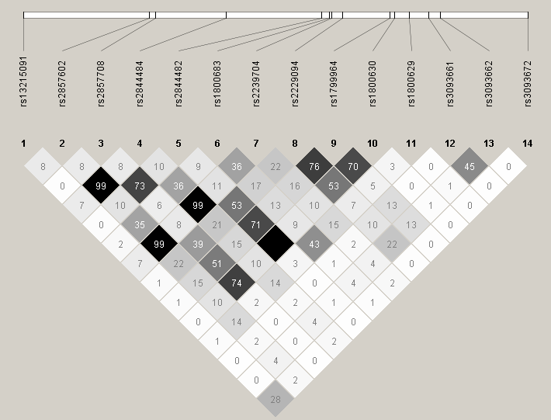

Figure 4 The LD plot showing the pairwise correlations between the SNPs of interest in the study sample
Plot was generated using Haploview version 4.2 where the extent of LD between the SNPs of interest was depicted as pairwise r²×100 values.

Single-Site Association Analysis
Logistic regression analysis of the effects of genotypes on SLE risk under the dominant and additive models (Table 4) identified 2 SNPs consistently associated with SLE risk even after Bonferroni correction: rs1800683 (P<3E-04, corrected P<4E-03) and rs1800629 (P<4E-05, corrected P<5E-04), located within LTA (5’ UTR) and upstream of TNF (promoter), respectively. Moderate LD (r²=0.43) was detected between these 2 SNPs in the studied case-control sample (Figure 4).

Table 4 Single-site association results for the SNPs of interest in SLE case-control sample
SNP | Minor Allele | Dominant Model |  |  | Additive Model
 |  | OR (95%CI) | P-value | Corrected P-value | OR (95%CI) | P-value | Corrected P-value
rs13215091 | T | 1.061 (0.686-1.643) | 7.89E-01 | 1 | 1.010 (0.679-1.502) | 9.60E-01 | 1
rs2857602 | C | 0.816 (0.622-1.071) | 1.42E-01 | 1 | 0.772 (0.639-0.932) | 6.89E-03 | 0.09653
rs2857708 | T | 0.661 (0.478-0.914) | 1.20E-02 | 0.16757 | 0.700 (0.520-0.943) | 1.81E-02 | 0.25272
rs2844484 | T | 0.808 (0.616-1.060) | 1.23E-01 | 1 | 0.768 (0.636-0.927) | 5.77E-03 | 0.08074
rs2844482 | T | 0.875 (0.649-1.180) | 3.81E-01 | 1 | 0.898 (0.689-1.171) | 4.27E-01 | 1
rs1800683 | A | 1.666 (1.266-2.193) | 2.50E-04 | 0.00350 | 1.532 (1.253-1.875) | 2.68E-05 | 0.00037
rs2239704 | A | 0.792 (0.602-1.040) | 9.30E-02 | 1 | 0.752 (0.622-0.909) | 3.03E-03 | 0.04249
rs2229094 | C | 0.866 (0.663-1.131) | 2.90E-01 | 1 | 0.890 (0.717-1.105) | 2.90E-01 | 1
rs1799964 | C | 0.909 (0.693-1.193) | 4.93E-01 | 1 | 0.922 (0.731-1.164) | 4.95E-01 | 1
rs1800630 | A | 0.946 (0.699-1.280) | 7.19E-01 | 1 | 0.947 (0.724-1.238) | 6.89E-01 | 1
rs1800629 | A | 1.848 (1.377-2.478) | 3.46E-05 | 0.00048 | 1.720 (1.328-2.227) | 2.96E-05 | 0.00041
rs3093661 | A | 0.853 (0.504-1.442) | 5.52E-01 | 1 | 0.830 (0.497-1.386) | 4.75E-01 | 1
rs3093662 | G | 1.026 (0.693-1.518) | 8.99E-01 | 1 | 1.035 (0.716-1.496) | 8.55E-01 | 1
rs3093672 | A | 1.617 (0.761-3.433) | 2.05E-01 | 1 | 1.617 (0.761-3.433) | 2.05E-01 | 1
Odds ratios (ORs) and P-values were determined by logistic regression analysis that included the recruitment site and age as covariates; corrected P-values were calculated using the Bonferroni method.

Haplotype Analysis of SLE-associated SNPs
Haplotype analysis of two SLE-associated SNPs (rs1800683–rs1800629) in the study sample revealed three common haplotypes (Table 5). Of these, the most frequent haplotype carried the two protective alleles for SLE (GG; 62.4% in cases vs. 69.5% in controls, P=5E-04) followed by the second most frequent haplotype that carried the two risk alleles (AA; 20.6% in cases vs. 15.1% in controls, P=9E-04). The third common haplotype that carried the risk allele of rs1800683 and protective allele of rs1800629 showed no significant risk or protective effect (AG; 16.9% in cases vs. 15.4% in controls, P=0.3254).

Table 5 Two-site haplotype analysis of SLE associaed SNPS (rs 1800683-rs1800629)
Haplotype | Overall Freq | Case Freq | Control Freq | Chi Square | P-value | Permutation P-value
GG | 0.654 | 0.624 | 0.695 | 11.982 | 5.00E-04 | 0.0020
AA | 0.183 | 0.206 | 0.151 | 11.02 | 9.00E-04 | 0.0020
AG | 0.163 | 0.169 | 0.154 | 0.967 | 0.3254 | 0.5560
Red: Risk allele, Blue: Protective allele; Number of Permutations: 1000

Functional Assessment of SLE-associated SNPs
The SLE-associated SNPs, rs1800683 and rs1800629, have RegulomeDB scores of 2b and 1d, respectively, indicating a strong regulatory potential (2b=“TF binding + any motif + DNase Footprint + DNase peak”, 1d= “eQTL + TF binding + any motif + DNase peak”) (details of the scoring scheme can be found at https://regulomedb.org/regulome-help/).
The evaluation of the rs1800683 and rs1800629 SNPs, as well as those in complete LD (r²=1) with these 2 SNPs in European subjects (rs909253 and rs2516482, respectively), using HaploReg version 4 further supports a potential regulatory function for these polymorphisms (Figure 5).
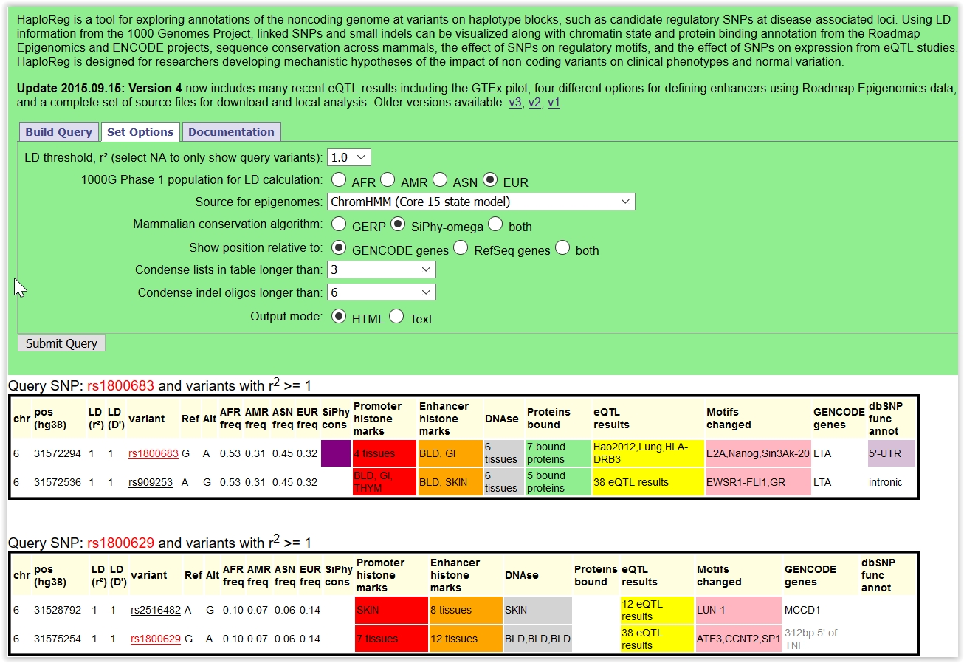

Figure 5 Functional annotation of SLE associated SNPs using HaploReg tool
HaploReg version 4 was used to evaluate the regulatory potential of the rs1800683 and rs1800629 SNPs plus those SNPs in complete LD (r²=1) with them in European-descent subjects.

Discussion
In this study, the association of genetic polymorphisms at the LTA/TNF/LTB locus with SLE risk was evaluated in ~1,150 European-descent SLE case-control subjects. The LTA/TNF/LTB gene cluster (Figure 3) resides within the MHC class III region on chromosome 6p21 and harbors 3 members of the Tumor Necrosis Factor Super Family (TNFSF) whose protein products show significant biological interactions (Figure 2) and carry out multiple important immune functions, including their contributions to acute/chronic inflammation.
Of fourteen LTA/TNF/LTB region SNPs (MAF>1%) investigated in this study for association with SLE under the dominant and additive models (enabling more powerful statistical analyses as compared to the recessive model), two SNPs were consistently found to be associated with SLE risk: rs1800683 and rs1800629 located within LTA (5’ UTR variant) and between LTA and TNF (TNF promoter variant), respectively (Tables 3 and 4). While the association of the rs1800629 SNP with SLE appeared to be model-independent, the rs1800683 SNP showed a stronger association under the additive model (Table 4). Moderate LD was present between these 2 SNPs (r²<0.5) in the study sample comprising European-descent subjects (Figure 4) and t he haplotypes carrying the risk or protective alleles of both SNPs showed significant association with SLE (Table 5).
The TNF promoter SNP rs1800629 is one of the most commonly studied variants from the LTA/TNF/LTB gene cluster in relation to SLE and other autoimmune diseases, which has yielded somewhat inconsistent association results. However, most recent meta-analyses (Yang, 2017) (Chen, 2019) support its overall contribution to SLE risk and suggest ethnic-specific effects/associations – mainly observed in Europeans and Latin Americans, but not in Africans and Asians (Chen, 2019). Consistent with these observations, the results of current study in European-descent subjects also support a potential role of TNF/rs1800629 in SLE susceptibility.
While the LTA 5’ UTR SNP rs1800683 is overall not a commonly studied/reported polymorphism in the literature, rs909253 – an intronic LTA SNP that is in complete LD with rs1800683 in Europeans (Figure 5) – was reported to be associated with SLE in Caucasians and Asians (Ahmed, 2014) (Zhang, 2015) (Umare, 2017), as well as, with Sjögren’s syndrome in Europeans (Bolstad, 2012), another systemic autoimmune disease that share several clinical and molecular aspects with SLE (Teruel, 2016). In the Sjögren’s syndrome study (Bolstad, 2012), which also evaluated the entire LTA/TNF/LTB locus, rs1800629 and rs909253 (closely linked to rs1800683) showed the strongest associations with disease risk out of all tested SNPs, similar to the observations with SLE risk in the current study.
Consistent with their locations in LTA (5’UTR) and TNF (promoter), in silico assessment of the functional effects of rs1800683 and rs1800629 (using RegulomeDB and HaploReg) suggests potential regulatory effects of these SNPs on gene expression. Indeed, previously published studies reported modified transcriptional activity and altered plasma/serum cytokine levels associated with rs909253 (closely linked to rs1800683) and rs1800629 (Bolstad, 2012) (Umare, 2017) (Chen 2019). Interestingly, LTA and TNF cytokines show homology in their amino-acid composition and bind to the same receptors, TNFRI and TNFRII (Figure 2).
In summary, the results of this study provide further support for the potential involvement of functionally relevant LTA/TNF polymorphisms in SLE susceptibility and SLE-related immunopathogenesis. However, although it is not the focus of current study, their effects should be assessed in relation to other SLE-relevant variants located throughout the entire MHC region due to well-known extended LD observed in this region. It should also be noted that some associations might have been missed due to insufficient study power stemming from the modest size of the study sample. Furthermore, considering the ethnic-specific associations suggested for this locus (Chen, 2019), it would also be highly relevant to comprehensively study other ethnic groups, such as African Americans and Hispanic Americans, who are disproportionately (more commonly and more severely) affected by SLE. Continuing further genetic research may increase our understanding of biological mechanisms underlying SLE.
Due to heterogeneous nature of SLE symptoms and difficulties of differential diagnosis, genetic tools may be helpful to improve the diagnosis and management of patients with SLE. Furthermore, because SLE patients are suspected to develop immunological findings before the clinical manifestation of disease, genetic tools may serve for diagnosis of preclinical disease and primary prevention of clinical disease. Genetic profiles may also serve as biomarkers for monitoring disease progression and for personalizing treatment regimens for SLE patients. Common forms of SLE have a complex genetic basis with no clear familial inheritance pattern, but instead result from complex interactions between demographic traits, environmental factors, and multiple genetic loci. SLE and other autoimmune diseases may cluster within families and concordance rates are higher in monozygotic versus dizygotic twins, consistent with multifactorial polygenic nature of the disease (Ulff-Moller, 2017). With access to known risk by patients, primary and secondary prevention methods can be used to either prevent the onset of clinical disease or reduce the risk of flare-ups in order to avoid cumulative organ damage. A possible solution for calculating risk of complex diseases like SLE is implementing Polygenic Risk Scores (PRS). Complex diseases are influenced by many genetic variants with small to moderate effect sizes. In order to meaningfully predict the risk, all of these genetic variants must be examined in aggregate to understand the overall impact of having multiple risk variants (Torkamani, 2018). PRS are calculated as weighted sum scores of risk alleles by applying effect sizes from genome-wide association studies as their weight. Although PRS are theoretically a sound measure of genetic variance, whether or not they hold validity to polygenic predisposition is still under debate due to their limitations of unknown variant effect sizes, discrepancies in weighted sums, and missing heritability (Janssens, 2019) (Chen, 2020). Another drawback to PRS is that the GWAS data that the weighted sums are calculated from often lack understudied minority groups in which SLE is more severe and common. Further research into the efficacy of PRS is necessary before moving this model into the clinical setting.
As more is learned about SLE in different populations and genetic screening tools are respectively developed, it will be important to build the knowledge and awareness of rheumatologists, other practitioners and the general population. The screening would likely primarily target those who harbor the greatest risk factors for developing SLE: female gender, African/Hispanic/Asian ancestry, and family history of SLE and/or other autoimmune disease(s) (Carter, 2016). SLE can mimic many other conditions, so increasing the awareness of this disorder and new screening tools among both practitioners and the general population is key to making faster diagnoses. Organizations, such as The Lupus Foundation of America (https://www.lupus.org/) and The American College of Rheumatology (https://www.rheumatology.org/), advocate to lawmakers, physicians and patients to enable better disease management and disease prevention for SLE. Utilizing national organizations to begin conversations about the potential use of genetic testing would provide an avenue for more research and overall education related to SLE screening. The public health goal of increasing the use of screening practices for SLE would be to provide earlier detection and therefore lower the economic burden and improve quality of life for SLE patients.

Bibliography
Ahmed, H. H., Taha, F. M., Darweesh Hel, S., & Morsi, H. M. (2014). Association between TNF promoter -308 G>A and LTA 252 A>G polymorphisms and systemic lupus erythematosus. Mol Biol Rep, 41(4), 2029-2036.
Albarbar, B., et al. (2015). Regulation of cell fate by lymphotoxin (LT) receptor signalling: Functional differences and similarities of the LT system to other TNF superfamily (TNFSF) members. Cytokine Growth Factor Rev 26(6): 659-671.
Aringer, M., et al. (2019). 2019 European League Against Rheumatism/American College of Rheumatology Classification Criteria for Systemic Lupus Erythematosus. Arthritis Rheumatol 71(9): 1400-1412.
Bernatsky, S., et al. (2006). Mortality in systemic lupus erythematosus. Arthritis Rheum 54(8): 2550-2557.
Bernatsky, S., et al. (2013). Cancer risk in systemic lupus: an updated international multi-centre cohort study. J Autoimmun, 42, 130-135.
Bienkowska, J., et al. (2014). Lymphotoxin-LIGHT pathway regulates the interferon signature in rheumatoid arthritis. PLoS One 9(11): e112545.
Bolstad, A. I., et al. (2012). Association between genetic variants in the tumour necrosis factor/lymphotoxin alpha/lymphotoxin beta locus and primary Sjogren's syndrome in Scandinavian samples. Ann Rheum Dis 71(6): 981-988.
Bystrom J., et al. (2018). TNFα in the regulation of Treg and Th17 cells in rheumatoid arthritis and other autoimmune inflammatory diseases. Cytokine 101:4-13.
Carter, E. E., et al. (2016). The global burden of SLE: prevalence, health disparities and socioeconomic impact. Nat Rev Rheumatol 12(10): 605-620.
Chen, L., et al. (2017). Genetic advances in systemic lupus erythematosus: an update. Curr Opin Rheumatol 29(5): 423-433.
Chen, L., et al. (2019). Association between tumor necrosis factor polymorphisms and rheumatoid arthritis as well as systemic lupus erythematosus: a meta-analysis. Braz J Med Biol Res 52(3): e7927.
Chen, L et al. (2020). Genome-wide assessment of genetic risk for systemic lupus erythematosus and disease severity. Hum Mol Genet. doi:10.1093/hmg/ddaa030
Cojocaru, M., et al. (2011). Manifestations of systemic lupus erythematosus. Maedica (Buchar) 6(4): 330-336.
Croft, M. and R. M. Siegel (2017). Beyond TNF: TNF superfamily cytokines as targets for the treatment of rheumatic diseases. Nat Rev Rheumatol 13(4): 217-233.
Demirci, F. Y., et al. (2011). Functional polymorphisms of the coagulation factor II gene (F2) and susceptibility to systemic lupus erythematosus. J Rheumatol, 38(4), 652-657.
Demirci, F. Y., et al. (2016). Identification of a New Susceptibility Locus for Systemic Lupus Erythematosus on Chromosome 12 in Individuals of European Ancestry. Arthritis Rheumatol, 68(1), 174-183.
Gommerman, J. L., et al. (2014). The Lymphotoxin Network: orchestrating a type I interferon response to optimize adaptive immunity. Cytokine Growth Factor Rev 25(2): 139-145.
Gonzalez, L. A., et al. (2013). Ethnicity in systemic lupus erythematosus (SLE): its influence on susceptibility and outcomes. Lupus 22(12): 1214-1224.
Gubernatorova, E. O., & Tumanov, A. V. (2016). Tumor Necrosis Factor and Lymphotoxin in Regulation of Intestinal Inflammation. Biochemistry (Mosc) 81(11):1309-1325.
Hochberg, M. C. (1997). Updating the American College of Rheumatology revised criteria for the classification of systemic lupus erythematosus. Arthritis Rheum 40(9): 1725.
Horton, R., et al. (2004). Gene map of the extended human MHC. Nat Rev Genet 5(12): 889-899.
Janssens, A. (2019). Validity of polygenic risk scores: are we measuring what we think we are? Hum Mol Genet, 28(R2), R143-r150.

Kaul, A., et al. (2016). Systemic lupus erythematosus. Nat Rev Dis Primers 2: 16039.
Lupus Foundation of America. (2019). Dos and dont's for living well with lupus. Retrieved from https://www.lupus.org/resources/dos-and-donts-for-living-well-with-lupus.
Macejova, Z., et al. (2013). Systemic lupus erythematosus--disease impact on patients. Cent Eur J Public Health 21(3): 171-173.
Marson, A., et al. (2015). Genetic basis of autoimmunity. J Clin Invest 125(6): 2234-2241.
Matzaraki, V., Kumar, V., Wijmenga, C., & Zhernakova, A. (2017). The MHC locus and genetic susceptibility to autoimmune and infectious diseases. Genome Biol. 18(1):76.
Mehta, A. K., et al. (2018). TNF activity and T cells. Cytokine 101: 14-18.
Morris, D. L., et al. (2012). Unraveling multiple MHC gene associations with systemic lupus erythematosus: model choice indicates a role for HLA alleles and non-HLA genes in Europeans. Am J Hum Genet 91(5): 778-793.
Namjou, B., et al. (2007). Genetics of clinical expression in SLE. Autoimmunity 40(8): 602-612.
Pan, L., Lu, M. P., Wang, J. H., Xu, M., & Yang, S. R. (2019). Immunological pathogenesis and treatment of systemic lupus erythematosus. World J Pediatr.
Petri, M., et al. (2012). Derivation and validation of the Systemic Lupus International Collaborating Clinics classification criteria for systemic lupus erythematosus. Arthritis Rheum 64(8): 2677-2686.
Pineau, C. A., Bernatsky, S., Abrahamowicz, M., Neville, C., Karp, I., & Clarke, A. E. (2006). A comparison of damage accrual across different calendar periods in systemic lupus erythematosus patients. Lupus, 15(9), 590-594.
Postal, M., & Appenzeller, S. (2011). The role of Tumor Necrosis Factor-alpha (TNF-α) in the pathogenesis of systemic lupus erythematosus. Cytokine 56(3):537-543.
Remouchamps, C., Boutaffala, L., Ganeff, C., & Dejardin, E. (2011). Biology and signal transduction pathways of the Lymphotoxin-αβ/LTβR system. Cytokine Growth Factor Rev. 22(5-6):301-310.
Rhew, E. Y., et al. (2009). Differences in subclinical cardiovascular disease between African American and Caucasian women with systemic lupus erythematosus. Transl Res, 153(2), 51-59.
Sedy, J., et al. (2014). Tumor necrosis factor superfamily in innate immunity and inflammation. Cold Spring Harb Perspect Biol 7(4): a016279.
Shovman, O., et al. (2018). Diverse patterns of anti-TNF-alpha-induced lupus: case series and review of the literature. Clin Rheumatol 37(2): 563-568.
Sonar, S. and G. Lal (2015). Role of Tumor Necrosis Factor Superfamily in Neuroinflammation and Autoimmunity. Front Immunol 6: 364.
Stojan, G. and M. Petri (2018). Epidemiology of systemic lupus erythematosus: an update. Curr Opin Rheumatol 30(2): 144-150.
Tan, E. M., et al. (1982). The 1982 revised criteria for the classification of systemic lupus erythematosus. Arthritis Rheum 25(11): 1271-1277.
Teruel, M. and Alarcon-Riquelme, M. E. (2016). Genetics of systemic lupus erythematosus and Sjogren's syndrome: an update. Curr Opin Rheumatol, 28(5), 506-514.
Teruel, M., et al. (2017). Omics studies: their use in diagnosis and reclassification of SLE and other systemic autoimmune diseases. Rheumatology (Oxford) 56(suppl_1): i78-i87.
Torkamani, A., Wineinger, N. E., & Topol, E. J. (2018). The personal and clinical utility of polygenic risk scores. Nat Rev Genet, 19(9), 581-590.
Ulff-Moller, C. J., Simonsen, J., Kyvik, K. O., Jacobsen, S., & Frisch, M. (2017). Family history of systemic lupus erythematosus and risk of autoimmune disease: Nationwide Cohort Study in Denmark 1977-2013. Rheumatology (Oxford), 56(6), 957-964.
Umare, V. D., Pradhan, V. D., Rajadhyaksha, A. G., Patwardhan, M. M., Ghosh, K., & Nadkarni, A. H. (2017). Impact of TNF-alpha and LTalpha gene polymorphisms on genetic susceptibility in Indian SLE patients. Hum Immunol, 78(2), 201-208.
Upadhyay, V. and Y. X. Fu (2013). Lymphotoxin signalling in immune homeostasis and the control of microorganisms. Nat Rev Immunol 13(4): 270-279.
Weckerle, C. E. and T. B. Niewold (2011). The unexplained female predominance of systemic lupus erythematosus: clues from genetic and cytokine studies. Clin Rev Allergy Immunol 40(1): 42-49.
Yang, Z. C., Xu, F., Tang, M., & Xiong, X. (2017). Association between TNF-alpha promoter -308 A/G polymorphism and systemic lupus erythematosus susceptibility: A case-control study and meta-analysis. Scand J Immunol, 85(3), 197-210.
Yildirim-Toruner, C. and B. Diamond (2011). Current and novel therapeutics in the treatment of systemic lupus erythematosus. J Allergy Clin Immunol 127(2): 303-312; quiz 313-304.
Zhang, C., et al. (2015). Association of lymphotoxin alpha polymorphism with systemic lupus erythematosus and rheumatoid arthritis: a meta-analysis. Int J Rheum Dis 18(4): 398-407.
Zhu, M., & Fu, Y. X. (2011). The role of core TNF/LIGHT family members in lymph node homeostasis and remodeling. Immunol Rev. 244(1):75-84.

