Optimizing the Post-Operative Patient Transition From Anesthesia to the Cardiothoracic Intensive Care Unit:
a Handoff Improvement Initiative

by

Katherina Shabalov

BS, Healthcare Management & Policy, Georgetown University, 2014

Submitted to the Graduate Faculty of
Health Policy and Management
Graduate School of Public Health in partial fulfillment
of the requirements for the degree of
Master of Health Administration

University of Pittsburgh

2020

Committee Page

UNIVERSITY OF PITTSBURGH
GRADUATE SCHOOL OF PUBLIC HEALTH

This essay is submitted
by
Katherina Shabalov

on

April 22, 2020
and approved by

Essay Advisor:

Mark Roberts, MD, MPP
Professor and Chair, Health Policy and Management
Graduate School of Public Health
University of Pittsburgh
Essay Readers:
Amy McLaughlin, BSN, MSN
Director, Nursing
UPMC Presbyterian Shadyside
Pittsburgh, Pennsylvania

Jane Guttendorf. DNP, RN, CRNP, ACNP-BC
Assistant Professor, Acute & Tertiary Care
School of Nursing
University of Pittsburgh

Copyright © by Katherina Shabalov
2020

Abstract
Mark Roberts, MD, MPP
Optimizing the Post-Operative Patient Transition from Anesthesia to the Cardiothoracic Intensive Care Unit: A Handoff Improvement Initiative
Katherina Shabalov, MHA
University of Pittsburgh, 2020
Abstract
Patient handoffs from the operating room to the intensive care unit are critical moments in time where inefficiency and lapses in communication put patient safety at risk. Taken as a whole, this project explores the development of a standardized handoff process from the operating room to the cardiothoracic intensive care unit and its subsequent impact on provider perceptions of handoff process, culture, and overall quality. This essay focuses on the pre-survey results and process redesign, which was led by a multi-professional work group with representatives from Nursing, Anesthesia, and Administration. Pre-survey results demonstrate widespread discontent with the current handoff process, culture, and overall quality, and it is hypothesized that the development of the standardized handoff approach will lead to increases in provider perceptions of handoffs across a large number of measures. Ultimately, preventable medical errors are a significant public health concern and initiatives, like the one explored in this essay, that address a cause of preventable medical errors, have the potential to impact public health more broadly.

Table of Contents
List of Abbreviations ix
1.0 Introduction 1
1.1 Project Goal 3
1.2 Setting 3
1.3 Public Health Relevance 4
2.0 Literature Review 5
2.1 Handoffs From The Operating Room To The Intensive Care Unit After Cardiothoracic Surgery – From The Society Of Thoracic Surgeons Workforce On Critical Care 5
2.2 A Structured Transfer Of Care Process Reduces Perioperative Complications In Cardiac Surgery Patients [Oregon Health & Science University] 6
2.3 Operating Room To ICU Patient Handovers: Multi-Disciplinary Humanistic Approach [Durham Veterans Affairs Medical Center] 7
2.4 Implementation Of A Standardized Handoff Protocol For Post-Operative Admissions To The Surgical Intensive Care Unit [Baylor Scott & White Medical Center – Temple] 8
2.5 Pilot Implementation Of A Perioperative Protocol To Guide Operating Room-To-Intensive Care Unit Patient Handoffs 8
3.0 Methods 10
3.1 Framework 10
3.2 Data Collection And Redesign 10
3.3 Pre-Intervention Handoff 12
3.4 Pilot Post-Intervention Handoff Process 13
3.5 Pilot Post-Intervention Handoff Tool 15
3.6 Post-Pilot Handoff Process & Tool Changes 17
4.0 Results 19
4.1 Respondent Characteristics 19
4.2 Pre-Intervention Survey 19
4.2.1 Handoff Process 20
4.2.2 Handoff Culture 20
4.2.3 Handoff Quality 21
4.3 Limitations 22
5.0 Discussion 24
6.0 Conclusion 26
Appendix A Handoff Pre-Intervention Survey 27
Appendix B Pre-Intervention Handoff Tool 29
Appendix C Handoff Tool Skeleton 30
Appendix D Pre-Intervention Survey Results 31
Appendix E Pre-Intervention Survey Open Ended Responses 32
Bibliography 33

List of Tables
Table 1. Handoff Satisfaction Survey Respondents By Discipline 19

List of Figures
Figure 1. Intervention Handoff Protocol Process Guide 14
Figure 2. Pilot Handoff Tool 16
Figure 3. Updated Handoff Tool 18
Figure 4. Pre-Intervention Survey Results - Process 20
Figure 5. Pre-Intervention Survey Results - Culture 21
Figure 6. Pre-Intervention Survey Results - Quality 22

List of Abbreviations
Abbreviation | Explanation
AHRQ | Agency for Healthcare Research and Quality
CTICU | Cardiothoracic Intensive Care Unit
ICU | Intensive Care Unit
OR | Operating Room
PDSA | Plan-Do-Study-Act
CRNA | Certified Registered Nurse Anesthetist
RN | Registered Nurse
NDNQI | The National Database of Nursing Quality Indicators
UPMC | University of Pittsburgh Medical Center

Introduction
Today, quality & safety are top priorities in the realm of healthcare. Not only have quality & safety become central to changes occurring in the delivery of patient care, they have also become the focus of regulation, legislation, accrediting organizations, professional organizations, and even the evolving payer landscape. In the inpatient setting, many challenges exist in the realm of quality & safety. One such challenge is patient handoffs – ensuring that the transfer of patient information, equipment, responsibility, and accountability between providers is effective (Friesen, 2008; Lee, 2016). As a high-risk, frequently occurring component of a patient’s healthcare pathway, handoffs have become a central target for quality improvement (QI) projects across healthcare institutions, including UPMC Shadyside, the hospital explored in this essay. (Lee, 2016)
Crossing the Quality Chasm famously recognizes the role of handoffs in preventable medical errors by stating “it is in inadequate handoffs that safety often fails first” (Institute of Medicine, 2001, p.45). While adverse events can occur at any time, handoffs are a particularly high-risk period for “clinical instability and events that can result in patient harm” (Chatterjee, et al, 2019, p.14). Although seemingly straightforward, the transition of patient care during a handoff is often a weak point in a patient’s inpatient care. Each transition runs the risk of being impacted by poor communication, interruptions, timing constraints, cultural differences, inadequate training, and lack of standardized processes, which can all play a role in the insufficient or inaccurate transfer of information (The Joint Commission, 2017). It is also important to note that as inpatient care has advanced and become more complicated, so too has the handoff process (Lane-Fall, 2016).
While ineffective handoffs do not always result in harm or near-misses, patient harm does occur and can range from minor to severe (Lee, 2016). In fact, the Joint Commission cites that 80 percent of serious medical errors and 35 percent of sentinel events can be attributed to inadequate handoffs (Riesenberg, 2012). Poor handoffs have also been shown to result in delays in treatment, inappropriate treatment, or increased length of stay (Abraham, 2011). As a result, handoff improvement has been the subject of substantial efforts by a variety of stakeholders, including the Agency for Healthcare Research and Quality (AHRQ), The Joint Commission, and even the World Health Organization (Gephart, 2016). In 2009, The Joint Commission established National Patient Safety Goal 2E, requiring that all accreditation programs implement standardized and structured handoff processes “that include the opportunity for face-to-face questions and clarification.” They have also emphasized that these handoffs, “have limited interruptions, include communication of updated information on patient changes, and discussion of anticipated changes.” (Petrovic, 2012).
Within the umbrella of handoffs, post-operative handoffs, especially those to the cardiothoracic intensive care unit (CTICU), are particularly challenging and high-risk. While many handoffs in a hospital are uni-disciplinary, nonhierarchical (ie. resident-to-resident), and involve a patient already on a unit, post-operative handoffs are interdisciplinary, multi-specialty, and involve providers at different levels of training at a time when patients are transitioning locations (Petrovic, 2012). Handoffs to the CTICU, the subject of this essay, present an added level of complexity: they involve an acutely ill patient population, the need to transfer complex monitoring equipment, a noisy environment, and the exchange of information between providers, who have different cultures and expectations. The CTICU is also a complex care setting where serious patient complications are common (Hall, et al, 2017).
Literature suggests that implementing a standardized approach to handoffs has the potential to address some of the challenges (Jewell, 2016). Yet, while broad strategies exist from across studies in various healthcare settings, there has been no evidence to support a specific protocol for handoffs as a whole or in a particular setting, such as the CTICU (Gephart, 2012). As a result, handoff improvement remains an organization-specific challenge – and this essay addresses this challenge within the context of the CTICU at UPMC Shadyside.

Project Goal
The goal of this pilot is to refine the current handoff process between Cardiac Anesthesia and CTICU Nursing in order to improve provider perceptions of culture, process, and overall handoff quality. In order to achieve this objective, baseline perceptions and handoff practices were assessed, a new standardized handoff process and checklist were developed, and the new processes were piloted. This essay focuses on the pre-survey results and process redesign.

Setting
This pilot was conducted at UPMC Shadyside, a 467-bed tertiary care hospital. The CTICU is an 18-bed unit with continuous on-site coverage that conducted 1436 cardiac procedures in 2018 and 1323 in 2019. The handoff process explored in this essay takes place in the transition from the Operating Room (OR) to the CTICU, and ideally occurs as a collaborative effort of Certified Registered Nurse Anesthetists (CRNAs) and Nurses. This project came to fruition due to anecdotal staff dissatisfaction with the current process and events that stemmed from ineffective handoffs.

Public Health Relevance
Because every individual will one day become a patient, ensuring that every healthcare encounter is safe is central to public health. Since handoffs are a critical aspect impacting the safety of care for any patient, improving the handoff process and culture within a hospital has direct relevance to public health. While this particular process improvement project is being piloted for the CTICU, elements of the handoff process, if successful, can be expanded to other ICUs within the hospital, and other high-risk transfers of care, underscoring a broader potential impact of the subject matter explored in this essay.

Literature Review
This purpose of this literature review is to explore recent publications in order to (1) provide evidence supporting the implementation of a standardized handoff process, (2) confirm elements critical to a successful handoff, (3) explore the methodologies utilized for handoff quality improvement projects at other institutions, and (4) identify best practices for improving post-operative handoffs. These findings guided the overall design of the handoff initiative and strategies discussed during the regular work group meetings.

Handoffs From The Operating Room To The Intensive Care Unit After Cardiothoracic Surgery – From The Society Of Thoracic Surgeons Workforce On Critical Care
This systematic review of 21 studies supports the implementation of a structured OR-to-ICU handoff process. The results demonstrate that establishing a structured post-surgical handoff process leads to improvements in process compliance, increased provider satisfaction, and prevention of adverse events (Chatterjee, et al, 2019).
The article describes two elements central to ensuring a successful handoff: a clearly structured process and enhanced communication. According to Chatterjee et al. (2019), un-structured handoffs lead to side conversations and a lack of team focus, ultimately resulting in critical information not being communicated. The authors specifically cite that intraoperative events or surgical concerns are amongst the most critical pieces of information for anesthesia providers to share during handoffs. In order to provide additional insight into handoff structure and communication, the article includes example handoff protocols and checklists to serve as guides for others developing handoff processes.
The article also describes elements central to ensuring provider satisfaction with a redesigned handoff process: the ability of providers to consistently hear report, the consistent communication of the appropriate content, and the opportunity to review, evaluate, and revise any implemented processes. Many of the studies in this review assessed the impact of handoff redesign by evaluating provider satisfaction through surveys or changes in nursing satisfaction scores (Chatterjee, et al, 2019).

A Structured Transfer Of Care Process Reduces Perioperative Complications In Cardiac Surgery Patients [Oregon Health & Science University]
This study reviews a post-surgical handoff intervention implemented at Oregon Health & Science University. This pilot intervention found that the introduction of a “collaborative, comprehensive, structured” post-operative handoff process led to a decrease in preventable complications. The handoff process intervention involved the addition of a notification from the anesthesia team to the ICU team towards the end of the surgery, the development of a scripted handover process, and the use of technology to give Nursing advance warning about intraoperative issues. The article underscored that updates made to the handoff process did not increase workload greatly, which helped ensure buy-in from the personnel (Hall, 2017).

Operating Room To ICU Patient Handovers: Multi-Disciplinary Humanistic Approach [Durham Veterans Affairs Medical Center]
This study reviews the OR-to-ICU handoff redesign at Durham [North Carolina] Veterans Affairs Medical Center (DVMC). The study found that the new process established improved team behaviors and staff satisfaction, as well as reduced clinical workload. Notably, three years after implementation, providers at DVMC reported higher satisfaction with their new handoff process, with 64% ranking the new handover as much better (Segall, et al, 2016).
In order to describe the baseline handoff process and identify problems, these investigators used ethnographic methods, such as observations, surveys, interviews, and focus groups. The redesign process itself was driven by a stakeholder team that incorporated provider needs and expectations. The redesign was also iterative and process-driven, with multiple changes to aspects of the redesigned process. Post-intervention, the investigators repeated their initial observations and surveys to identify the impact of the new handoff process (Segall, et al, 2016).
Their handoff process intervention included clearly defined roles, a specific sequence of events for the handoff, and a structured transfer of information. Their process began with a handwritten preliminary report completed by anesthesia that was delivered to the primary nurse one hour before patient arrival to the ICU in order to provide Nursing with enough information to prepare the room. Upon arrival to the unit, both delivering and receiving teams are expected to complete the physical handoff. Following the physical handoff, two providers step away from the bedside to conduct the verbal handoff. Finally, their new process concluded with a designated time to ask questions and a verbal confirmation of transfer of care (Segall, et al, 2016).

Implementation Of A Standardized Handoff Protocol For Post-Operative Admissions To The Surgical Intensive Care Unit [Baylor Scott & White Medical Center – Temple]
This article reviewed the implementation of a standardized protocol for handoffs between OR and the Surgical ICU team at Baylor Scott & White Medical Center. The study found that the intervention led to significant improvement in provider presence and the increased communication of consistent details, such as complications, difficult airways, ventilator settings, and pressor requirements. This handoff intervention included the development of a protocolized script, checklists, and a complete perioperative handoff protocol, which was made available to staff online and in inpatient care areas. Investigators gauged pre-intervention satisfaction with the handoff process through a 5-point guided Likert scale survey about beliefs and attitudes surrounding handoffs, with questions on topics such as safety, completeness, and communication efficacy. (Mukhopadhyay, et al., 2018).

Pilot Implementation Of A Perioperative Protocol To Guide Operating Room-To-Intensive Care Unit Patient Handoffs
This article reviewed the implementation of a standardized protocol and checklist for handoffs between the OR to the Cardiac Surgery ICU at a large tertiary care center that conducts 1,200 procedures annually. The pilot resulted in increased information shared during handoffs, the presence of all team members at the bedside, and more nurses who said they could hear the entirety of the report. There was also a reduction in parallel conversations and the number of questions from the ICU team at the end of the handoffs (Petrovic, 2012).
This handoff intervention focused on clearly defining the roles of the handoff team and the order of operations for the handoff. Their redesigned process began with the transfer of equipment, followed by verbal report including pertinent clinical information, and concluded with a question and answer period. In order to educate staff on this new process, they developed large handover protocols that were placed over each bed and distributed laminated checklist pocket cards (Petrovic, 2012).
Investigators used pre-intervention and post-intervention surveys to determine provider satisfaction with the handoff process. The survey included questions on a 5-point Likert scale about aspects of the handoff such as receiving information about potential problems, smooth physical transfer, and clarity on the start and end of the process. The surveys distributed indicated that there was an increase in the number of nurses who “strongly agreed” with 4 of 9 positively framed statements (Petrovic, 2012).

Methods

Framework
This Institute for Health Improvement’s four step Plan-Do-Study-Act (PDSA) cycle served as the framework for this process improvement project. During the ‘Plan’ phase of the project, handoff issues were identified and solutions were developed. During the ‘Do’ phase, the Anesthesia and Nursing staff implemented the subsequent changes. As part of the ‘Study’ phase, provider feedback was solicited and the work group identified necessary adjustments to the pilot process and handoff tool. As part of the ‘Act’ phase, adjustments to the process and tool were made and subsequently implemented. Successive iterations of the PDSA cycle, which will include the distribution and analysis of the post-implementation survey, go beyond the scope of this project. While this essay does not cover the entirety of the PDSA cycles for this project, the overall project plan includes distributing and reviewing the post-pilot satisfaction survey, developing modifications, and iterating the PDSA cycle (Institute for Health Improvement, 2020).

Data Collection And Redesign
This handoff initiative stemmed from ongoing concerns about the safety and culture of post-surgical handoffs to the CTICU. In order to gauge baseline provider perceptions of handoffs and identify specific areas for improvement, an anonymous survey was developed. This survey included 16 questions on a 5-point Likert scale with response options ranging from “strongly agree” to “strongly disagree,” as well as 4 open-ended questions (See Appendix A). The selection of questions was informed by conversations with Nursing and Anesthesia leadership, as well as provider satisfaction surveys reviewed during the handoff literature search. This survey was created through SurveyMonkey® and distributed by email in July 2019 to all providers in Anesthesia and Nursing (n=130). Likert scale responses were analyzed within SurveyMonkey®, while open-ended questions were manually grouped using conventional content analysis in order to identify insights based on the data (Hsieh & Shannon, 2005).
A work group of key stakeholders including physicians, CTICU leadership, staff nurses, and Administration was established to lead the handoff improvement efforts. This work group met in-person three times during August-December 2019 to discuss topics such as: the ideal order of tasks during handoffs, critical information for communication during handoffs, elements for inclusion on the handoff tool, the ideal-state handoff process, and ultimately, implementation strategy. Results from the provider satisfaction survey and historical experiences from clinical members of the work group served as the basis for identifying the core issues and brainstorming workable solutions. Ultimately, the work group developed a formalized handoff process and process map, with a specific sequence for essential handoff tasks. The work group also developed a new written handoff tool to replace one that was previously in use.
The new handoff process was piloted in January 2020 as the first phase of this handoff initiative. One central member of the work group served as the primary champion post-implementation, leading the roll-out, answering questions, soliciting feedback, and garnering support. In early March 2020, the handoff work group met to discuss the initial feedback to the pilot roll-out and decide upon critical updates to the handoff process and tool.
Although not within the scope of this essay, providers will be surveyed in the future to determine satisfaction with the updated handoff process, gauge improvement since the last survey, and provide input on additional modifications to the process and handoff tool. The post- implementation survey will include the questions from the pre-pilot survey so that changes in pre- and post-intervention perceptions of handoffs could be compared. This post-pilot survey will be used to gauge progress and guide the iterative changes that will be made to the handoff process and tool.

Pre-Intervention Handoff
Prior to the intervention, although there was an existing handoff tool, there was no established standardized handoff process. Typically, the only time the Operating Room (OR) placed a phone call to the CTICU to share any information about the handoff was when the OR called the CTICU to inform Nursing of the patient’s imminent arrival. Once the patient arrived in the CTICU, the process was inconsistent, disorganized, untimely, and variable based on personnel present. There was no established prioritization or sequence of events, and tasks were frequently performed simultaneously, leading to an overall rushed and chaotic environment.
The transfer of information during the handoff was also inconsistent and frequently incomplete. There were no established guidelines for what should be included in verbal report and subsequently, verbal reports also varied depending on the sending provider and general environment that day. Critical information was often omitted or unheard, or conversely, unnecessary information was communicated. Elements that providers identified as important in the pre-survey, such as the procedure conducted, medications given, pre- and post-operative ejection fraction, and events during surgery were not consistently communicated.
Lastly, the official paper handoff tool that was in use was not effective. It was extensive in length with unnecessary information, and missed information that was deemed critical to Nursing. It also used an open-ended format that was generally cumbersome to fill out, which resulted in it often being left incomplete by Anesthesia or not shared all-together.

Pilot Post-Intervention Handoff Process
Based on the on the results of the survey, discussions within the work group, and the analysis of the open-ended questions, priorities for redesign were established. These included, the order and prioritization of handoff tasks, the communication of pertinent information, and the redesign of the handoff tool.
The overall handoff process and process guide created by the work group delineated a clear sequence of events and prioritization of tasks. It separated the handoff process into three distinct parts: (1) preparation, (2) physical handoff, and (3) verbal handoff.

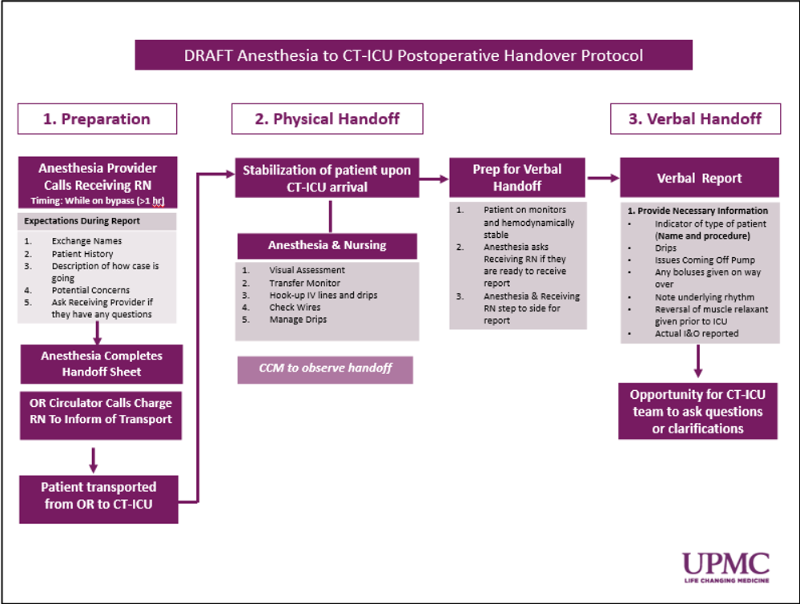

Figure 1. Intervention Handoff Protocol Process Guide

(1) Preparation: As part of the new process, this will begin with a new handoff element that was not previously in place: the addition of an intraoperative phone call where Anesthesia will give preliminary report to Nursing. This report will include an exchange of names, a brief patient history, a description of the planned procedure and progress of the case, potential concerns, and an opportunity for questions. The element of the intraoperative phone call was suggested in the open-ended portion of the survey and presents an opportunity for improved communication, rapport between providers, and efficiency of the eventual handoff. At the end of the procedure, anesthesia should complete the handoff tool and the OR Circulator will be responsible for calling the Charge RN to inform them of impending patient transport. Subsequently the patient will be transferred.

- Physical Handoff: Upon arrival to the CTICU, both sending and receiving providers will complete time critical elements to ensure the patient has been transferred to the ICU monitor and is hemodynamically stable, prior to giving verbal report. While the Anesthesia provider is giving verbal report to the receiving Nurse, those providers not involved in the verbal report can complete non-time critical elements.

- Verbal Report: Once the patient is stable, the Anesthesia provider asks the receiving RN if they are ready for report, and both step to the side to ensure verbal report is given without distractions. Pertinent information for verbal report identified during the pre-intervention survey and group discussion included: indicator of the patient, drips, issues coming off pump, boluses given during transport, the patient’s underlying rhythm, whether or not a reversal of muscle relaxant was given, and the actual intake and output during the operation. The new handoff tool will serve as a script for the verbal report. At the conclusion of the verbal report, the expectation is that there will be a clear time for questions or clarifications.

Pilot Post-Intervention Handoff Tool
Based on discussions and evidence in the literature, the work group decided to redesign the current handoff tool. One of the priorities for redesign was reformatting the open-ended fields to be in checklist format to structure and simplify completion of the tool (See Appendix B). The work group came to the consensus to use the skeleton of another handoff tool within the UPMC system that used a checklist format (Appendix C). The work group adapted the tool to reflect priorities for this CTICU. Included in the changes made: inclusion of time out of the OR, as well as the addition of dosing height and weight (important to preprogram the infusion pumps), types of procedures, pre-and post-operative ejection fraction, and a section highlighting issues related to separation from cardiopulmonary bypass. A large section for notes was added, as were phone numbers for the providers at this location.

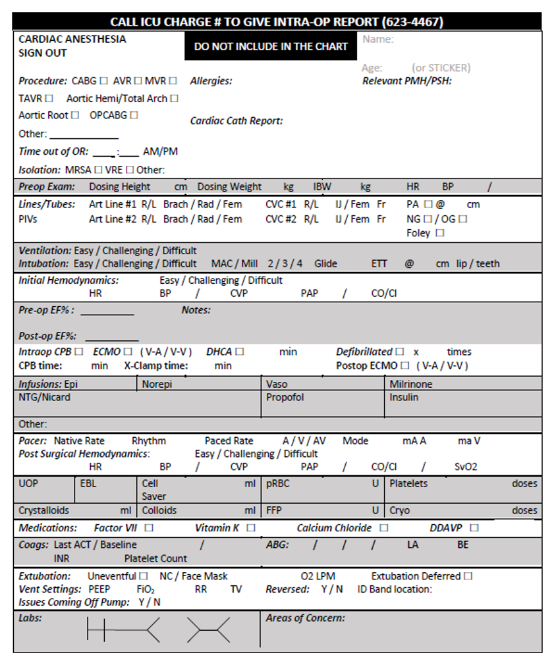

Figure 2. Pilot Handoff Tool

Post-Pilot Handoff Process & Tool Changes
One month after the initial pilot implementation, feedback from both Anesthesia and CTICU providers was solicited. This feedback guided small changes to the process and tool that were made and subsequently implemented.
For the handoff process, providers shared feedback that the intraoperative did not improve communication, rapport, and efficiency. Rather, the information shared during the call was not typically communicated to the nurse taking care of the patient, ultimately requiring additional steps for Anesthesia providers without adding value for Nursing. As a result, the handoff work group came to the consensus to remove the intraoperative phone call from the updated handoff process, with the exception of severe cases when a brief intraoperative call would be placed.
For the handoff tool, anesthesia providers shared that they needed additional room to write patient medical/surgical history and that extraneous information such as labs, extubating, vent settings, and ID band location could be removed. They also requested Fentanyl, Versed, Precedex, and Ketamine be added to the section on infusions. The work group decided to implement these changes and made the necessary adjustments to the handoff tool. Nursing shared that the Time out of the OR continued to frequently be left blank. In order to address this concern, the work group decided to make the “Time out of OR” section more central and prominent in the updated handoff tool.

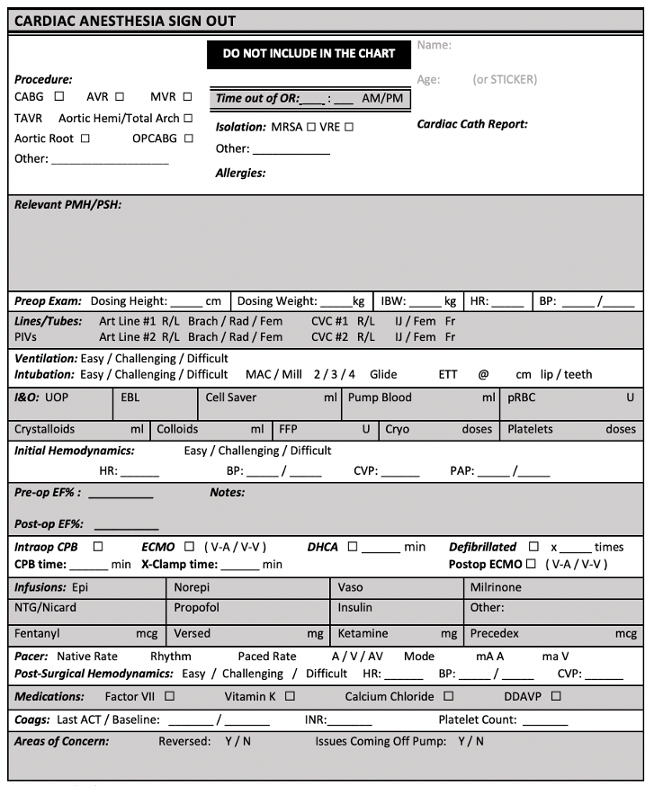

Figure 3. Updated Handoff Tool

Results

Respondent Characteristics
Table 1 below demonstrates the breakdown of respondents by discipline for the pre- and post- intervention surveys administered. Out of the 129 surveys distributed, 87 surveys were completed, totaling a 67 percent overall response rate to the pre-intervention survey. Over 60 percent of each of the largest provider groups – CRNAs, Anesthesia Attendings, and CT ICU RNs – participated. Table 1 demonstrates the breakdown of respondents by specialty.

Table 1. Handoff Satisfaction Survey Respondents By Discipline
Responder Category | Pre-Intervention
CTICU RN | 48 (76%)
CRNA | 29 (60%)
SRNA | 2 (50%)
Anesthesia Residents | 3 (75%)
Anesthesia Fellow | 0 (0%)
Anesthesia Attendings | 5 (62.5%)
Total | 87 (67%)

Pre-Intervention Survey
Appendix D contains the results of the pre-survey Likert-scale questions. As a whole, the results illustrate clear dissatisfaction with the handoff process amongst a portion of the respondents, with less than 50 percent responding with “agree” or “strongly agree” to 10 of the 16 positively framed statements. Collectively, satisfaction levels for culture and overall quality ranked lower than for process.

Handoff Process
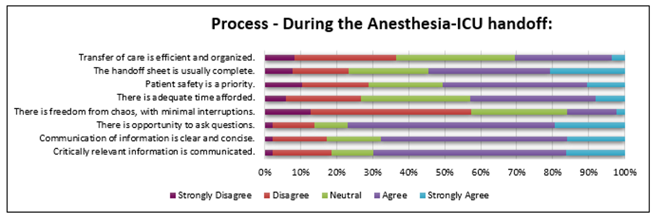
Figure 4 illustrates the results of the handoff questions related to process. Collectively the responses to the process-focused questions received a weighted score of 3.3 on a 5.0 scale. The two questions that received the lowest weighted scores, averaging below 3.0 on a 5.0 scale, were “there is freedom from chaos with minimal interruptions” (2.48) and “transfer of care is efficient and organized” (2.89). Notably, “there is freedom from chaos with minimal interruptions” was the lowest scoring statement across all categories of the survey. In total, all weighted averages for process questions fell equal to or below 3.8 on a 5.0 scale.

Figure 4. Pre-Intervention Survey Results - Process

Handoff Culture
Figure 5 highlights the responses to the survey questions related to handoff culture. As a whole, questions related to culture received a weighted score of 2.89 on a 5.0 scale, scoring lower than questions related to process or overall quality. Three of the four statements, “there is a feeling of respect and collegiality from counterparts” (2.64) “there is adequate interdepartmental teamwork” (2.88) and “there is a work climate that promotes patient safety” (2.97) received scores that fell below 3.0 on a 5.0 scale. The highest scoring statement, “There is a feeling of professionalism” (3.07) fell slightly above the 3.0 mark.

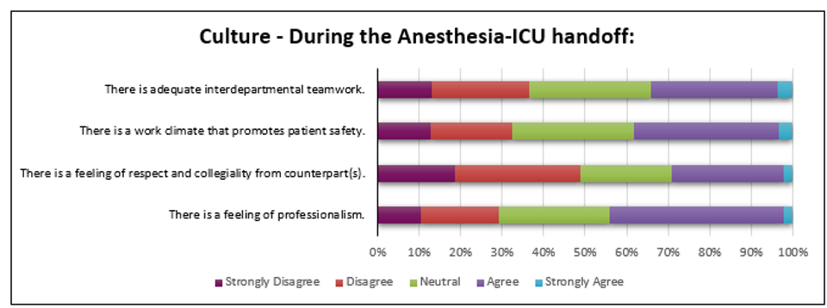

Figure 5. Pre-Intervention Survey Results - Culture

Handoff Quality
Figure 6 illustrates the survey responses to questions about overall handoff quality. These responses received a weighted score of 2.94 on a 5.0 scale. Notably, only 22 percent of respondents agreed or strongly agreed with the general statement, “I am satisfied with the current way anesthesia to ICU handoffs are conducted” (2.64). The statement “the anesthesia to ICU process is uniform and consistent,” (2.60) also scored below a 3.0 on a 5.0 scale and was the second to lowest overall scoring statement amongst the 16 questions in the survey.

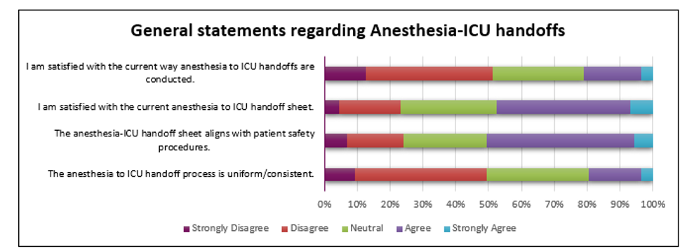

Figure 6. Pre-Intervention Survey Results - Quality

Appendix E contains results from the open-ended questions grouped into core-issues. Issues identified included: inappropriate prioritization of tasks, chaos during handoff, communication of medications, communication of essential information, communication of non-essential information, the information reflected in the handoff tool, and the consistent completion of the handoff tool.

Limitations
There are substantial limitations to these results. First and foremost, due to the timeline of this project, provider satisfaction was unable to be surveyed, and thus there is an inability to compare pre-intervention and post-implementation provider satisfaction and thus the impact of the intervention. Additionally, the project methodology centers exclusively on provider perceptions of handoffs, without looking at the impact of this intervention on patient outcomes, adverse events, or medical errors. As such, the results of the project will not align with the institutional goals for the handoff initiative, which include improving the quality and safety of handoffs. The project methodology also does not explore adherence to the new handoff process through direct observations.
In terms of the pre-survey distributed, the nature of the Likert scale questions utilized may have served as a limitation: depending on the respondent, “agree” and “strongly agree” may mean different things to each individual. The representativeness of the sample to the overall population of providers may also be a limiting factor. Although response rates were substantial, the sample of those providers in and of itself is small – with categories like anesthesia attendings or residents, having 5 and 2 individuals respond, respectively.
The full scope of the project also has limitations. At the time of planned future survey distribution, it will be difficult to truly discern whether there has been widespread adoption of the new process amongst the providers. In addition, the overall OR environment has semi-regular changeover in trainees, who may also not be accustomed to the handover process. As a result, all of these factors may impact how much the survey results accurately reflect the usage of the new process.
The future results could also reflect the perception of a different population of providers than the initial survey. This is due to factors such as the changeover in trainees or any turnover in either Anesthesia or the CTICU, as well as different providers choosing to respond to the pre- and post-survey.

Discussion
Through the distribution of the pre-survey, we captured the feedback of over 60 percent of providers. Taken as a whole, the pre-results demonstrated significant room for improvement and verified the anecdotal discontent with handoffs that was being vocalized. The results of the survey both in the Likert-scale and open-ended questions confirmed that the issues staff identified align with those commonly highlighted in the literature, such as “incomplete transfer of information, lack of consistency and organization, inaccurate information, information overload, distractions, absent or inefficient execution of clinical tasks, and poor standardization” (Segall, 2012). The pre-survey results also highlighted site-specific priorities, such as the inclusion of whether boluses were given and the need to include phone numbers.
The timeline of the project did not allow for the distribution of the post-survey. The results of the future post-survey will indicate whether the hypothesis of the project holds true: that results will demonstrate that the refined handoff approach leads to significant increases in provider perceptions of handoffs across a large number of measures. Although no direct improvement in measures of quality and safety will have been assessed in the project, if this hypothesis holds true, the results may suggest improvements in those measures, since improved staff satisfaction has been linked to “improved quality of care and patient outcomes in other settings” (Segall 2016). Open-ended responses to the future post-survey will likely suggest whether the new handoff process led to improved team-work and support between Anesthesia and CTICU providers. Using perception as a proxy, the closed ended questions will also demonstrate whether the outcomes of the pilot improve culture, process and overall handoff quality. Lastly, the post-survey results will serve as a final indicator of whether this intervention aligns with widespread evidence in the literature in favor of a formalized process for post-operative handoffs.
Today, the pilot process is still in the process of being adapted and further refined. Realistic adoption and long term sustainability of these changes is still uncertain and results may indicate greater, or conversely, less improvement in the perceptions of handoff process, culture, and overall quality. Even after the initial post-intervention survey distribution, it will be important to re-evaluate the impact of the handoff initiative further down the line, in order to gauge sustainability and long-term success. After the conclusion of the initial pilot of this project, other pre-intervention and post-intervention measures such as patient outcomes and adverse events could also be studied to determine any potential impact the new process has beyond provider perceptions.
In order to ensure the success of this handoff initiative and assure sustainability, it will be important to supplement this initiative with educational components for house staff, as well as to incorporate handoff education for new trainees. During work group discussions, it was suggested that the handoff protocol become readily available to new employees, particularly since no part of the educational process currently includes education on how to conduct a “proper handoff.”
While improving the handoff process within this CTICU is an important goal, these issues are not unique to the CTICU at UPMC Shadyside and are likely present in other ICUs on the campus. Other post-operative settings should consider using this handoff improvement initiative as a model for defining their specific handoff process and refining the handoff tool in alignment with their providers’ priorities.

Conclusion
This staff-led handoff pilot project aims to examine whether the implementation of a formalized handoff process and new handoff tool will improve provider perceptions of process, culture, and overall handoff quality in an environment where issues and discontent had persisted. The project findings after the distribution of the post-survey will add to the body of literature from across U.S. healthcare institutions, where handoffs continue to be a common target of quality improvement projects. While the full impact of this site-specific initiative was not able to be assessed within the timeline of this essay, the future survey and other measures including patient outcomes and Nursing Quality Indicators® (NDNQI®) RN Satisfaction Scores, should be evaluated. While this initiative is specific to this CTICU, it has the potential to have an impact beyond this scope: if successful, elements of this handoff process could be implemented in the other ICUs at this hospital, as well as within the system. Taken as a whole, this demonstrates a clear effort to address an important topic in quality and safety and one that ultimately impacts public health.

        - Handoff Pre-Intervention Survey
CT-ICU/Anesthesia Handoff Pre-survey

A work team has come together to examine the way we do ICU to anesthesia handoffs and your voice matters in this process. The purpose of the below survey is to gauge perceptions of the current anesthesia to ICU handoff process from all members of the team.

Your input on anesthesia to ICU handoffs is valuable and allows us to gain a comprehensive understanding of the current process and identify any potential areas for improvement. We will survey on anesthesia to ICU handoffs again in the future.

The below survey is anonymous and should take no more than 10 minutes.

Thank you for participating.

Intro Questions
- What is your role in the Anesthesia to ICU handoff process?
  - CTICU RN
  - CRNA
  - SRNA
  - Anesthesia Fellow
  - Anesthesia Resident
  - Anesthesia Attending

Process Questions

During the Anesthesia-ICU handoff process:
- Critically relevant information is communicated (strongly disagree – strongly agree)
- Communication of information is clear and concise (strongly disagree – strongly agree)
- There is opportunity to ask questions (strongly disagree – strongly agree)
- There is freedom from chaos, with minimal interruptions (strongly disagree – strongly agree)
- There is adequate time afforded (strongly disagree – strongly agree)
- Patient safety is a priority (strongly disagree – strongly agree)
- The handoff sheet is usually complete (strongly disagree – strongly agree)
- Transfer of care is efficient and organized (strongly disagree – strongly agree)

Culture-based Questions

During the Anesthesia-ICU handoff process:
- There is a feeling of professionalism (strongly disagree – strongly agree)
- There is a feeling of respect and collegiality from counterpart (strongly disagree – strongly agree)
- There is a work climate that promotes patient safety (strongly disagree – strongly agree)
- There is adequate interdepartmental teamwork (YES or NO)

General Questions

- The anesthesia to ICU handoff process is uniform (strongly disagree – strongly agree)
- The anesthesia-ICU handoff form aligns with patient safety procedures (strongly disagree – strongly agree)
- I am satisfied with the current anesthesia to ICU handoff sheet (strongly disagree – strongly agree)
- I am satisfied with the current way anesthesia to ICU handoffs are conducted (strongly disagree – strongly agree)

Open-ended questions

- List some short words or phrases that come to mind when you think about anesthesia to ICU handoffs
- List any barriers you believe exist to ensuring successful handoffs
- List any improvements that could be made in current handoff sheet/process
- Additional comments
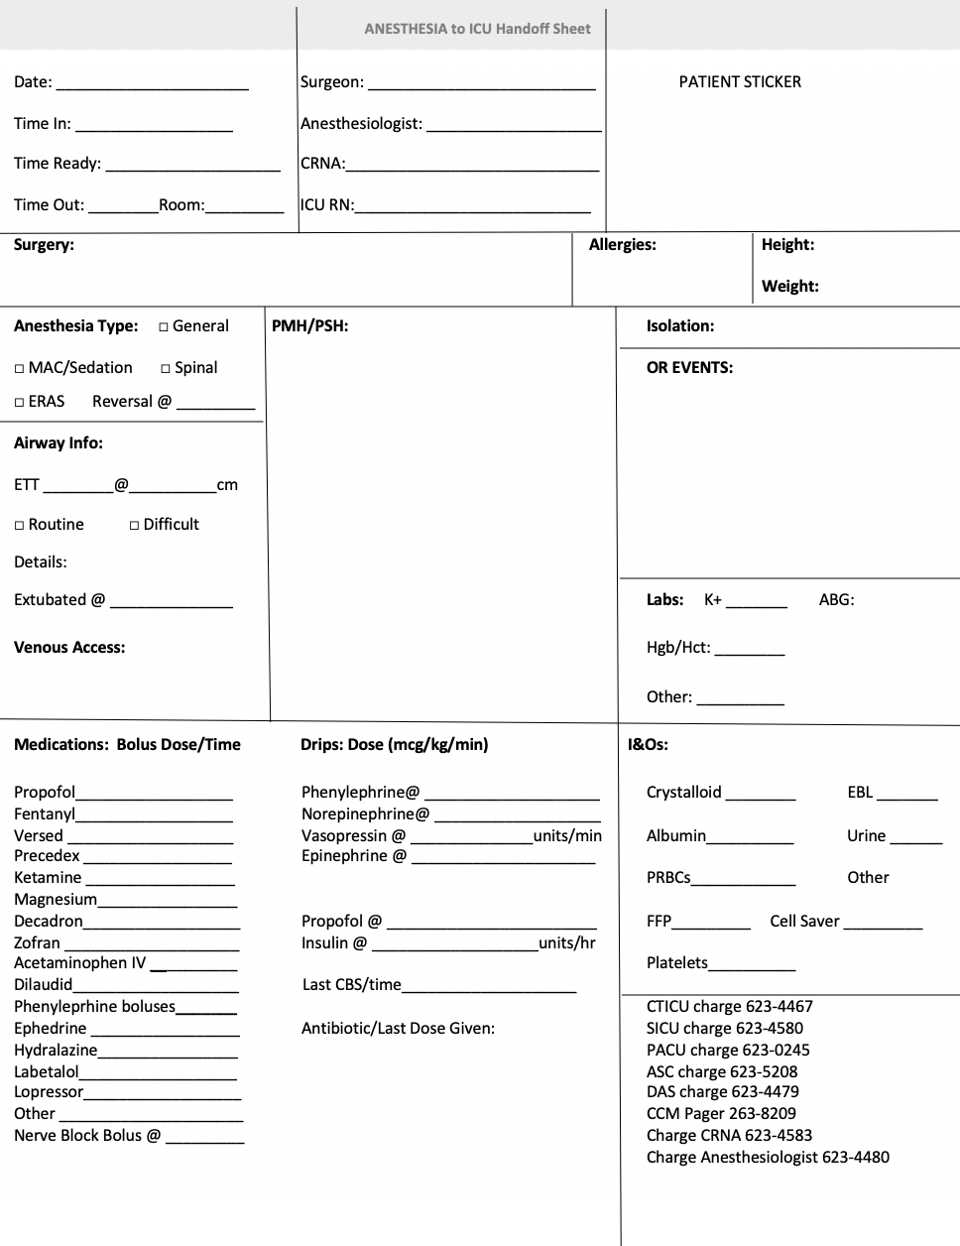
        - Pre-Intervention Handoff Tool
        - Handoff Tool Skeleton
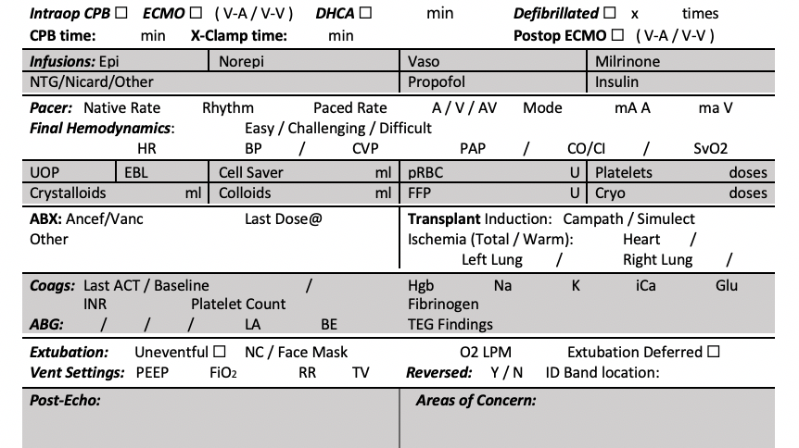
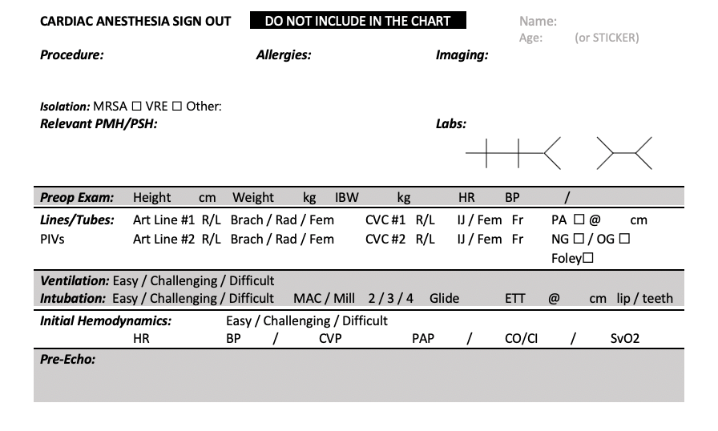

        - Pre-Intervention Survey Results
Please rate the following statements as it relates to the current process. During the Anesthesia-ICU handoff:
 | Strongly Disagree | Disagree | Neutral | Agree | Strongly Agree | Weighted Average
Critically relevant information is communicated | 2.33% | 16.28% | 11.63% | 53.49% | 16.28% | 3.65
Communication of information is clear and concise | 2.30% | 14.94% | 14.94% | 51.72% | 16.09% | 3.64
There is opportunity to ask questions. | 2.30% | 11.49% | 9.20% | 57.47% | 19.54% | 3.80
There is freedom from chaos, with minimal interruptions. | 12.64% | 44.83% | 26.44% | 13.79% | 2.30% | 2.48
There is adequate time afforded | 5.81% | 20.93% | 30.23% | 34.88% | 8.14% | 3.19
Patient safety is a priority | 10.34% | 18.39% | 20.69% | 40.23% | 10.34% | 3.22
The handoff sheet is usually complete | 6.90% | 13.79% | 19.54% | 41.38% | 18.39% | 3.51
Transfer of care is efficient and organized. | 8.24% | 28.24% | 32.94% | 27.06% | 3.53% | 2.89
Overall |  |  |  |  |  | 3.30

Please rate the following statements as it relates to the current culture. During the Anesthesia-ICU handoff:
 | Strongly Disagree | Disagree | Neutral | Agree | Strongly Agree | Weighted Average
There is a feeling of professionalism. | 10.47% | 18.60% | 26.74% | 41.86% | 2.33% | 3.07
There is a feeling of respect and collegiality from counterpart(s). | 18.60% | 30.23% | 22.09% | 26.74% | 2.33% | 2.64
There is a work climate that promotes patient safety. | 12.79% | 19.77% | 29.07% | 34.88% | 3.49% | 2.97
There is adequate interdepartmental teamwork. | 12.94% | 25.53% | 29.41% | 30.59% | 3.53% | 2.88
Overall |  |  |  |  |  | 2.89

General Statements Regarding Anesthesia-ICU handoffs:
 | Strongly Disagree | Disagree | Neutral | Agree | Strongly Agree | Weighted Average
The anesthesia to ICU handoff process is uniform/consistent. | 9.20% | 40.23% | 31.03% | 16.09% | 3.45% | 2.64
The anesthesia-ICU handoff sheet aligns with patient safety procedures. | 6.90% | 17.24% | 25.29% | 44.83% | 5.75% | 3.25
I am satisfied with the current anesthesia to ICU handoff sheet | 4.65% | 18.60% | 29.07% | 40.70% | 6.98% | 3.27
I am satisfied with the current way anesthesia to ICU handoffs are conducted. | 12.79% | 38.37% | 27.91% | 17.44% | 3.49% | 2.60
Overall |  |  |  |  |  | 2.94
        - Pre-Intervention Survey Open Ended Responses
Issue | Related Comments from Survey
Inappropriate Prioritization of Tasks During Handoffs | - “anesthesia rushing through report, lack of understanding between anesthesia and our immediate priorities settling the patient in.”  - “hook patient to the monitors before disconnecting transfer monitors. Listen to report without interruption, unless they have looked the patient up when assigned before patient transferred.”  - “distracted nurses focus on wrong priorities adversarial at times.”
Chaos During Handoff & Too Many Individuals Present | - “Too many nonessential people in the room when the heart is brought over.”  - “Too many staff members at the bedside during that time, staff members rushing to get “task work” done as well as CRNA’s rushing to get the report given to enable quick turnovers in between cases.”  - “Designated helpers to connect monitors, draw labs, etc. while RN and CRNA can give/receive report without distractions.”  - “One person takes report while other nurses places monitors. Function as a team and colleagues rather than defensive and aggressive towards anesthesia.”
Medications During Transport Are Not Communicated | - “One barrier to ensuring a successful handoff is being truthful. Sometimes, they bring patients over on pressors without notifying the attending. When the attending shows up, they get upset with the nurse. Or they push a blood pressure medication on the ride over, and then the patient crashes as soon as they arrive.”  - A lack of consistency in the understanding of who is responsible for managing the care of the patient during the transition from anesthesia to the ICU nurse (for example, if medicine boluses are being pushed by anesthesia at the bedside in the ICU, this is frequently not communicated to the ICU nurse).
Essential Information is Not Communicated | - “Information still left out and had to be asked--underlying rhythm under pacer, why are we pacing, did any events happen during the case […]Also, pre- and post- EF should be communicated, and it NEVER is.”  - “depending on who anesthesia is they often don't tell you about drug bolus given.”  - “Information still left out and had to be asked--underlying rhythm under pacer, why are we pacing, did any events happen during the case.”  - “Don't forget pertinent information during the case, i.e., they arrested, are asystole under their pacemaker.”
Unnecessary Information Communicated During Handoffs | - “PMH, surgery performed, I&O, adverse events in OR such as multiple defib/reason emergent IABP inserted/last BGL etc is the information we request. How much of each drug anesthesia/ how much fluid given during case does not need verbally relayed- can just be written on sheet. Boluses administered during transfer from OR to unit would also be much appreciated.”  - “Focus a lot on what peripheral lines and central lines are in, a lot of PMH which is already researched, I frequently have to ask what was procedure.”  - “unorganized & containing a lot of information not pertinent to ICU but missing pertinent information- a lot of times no information known regarding how many bypass grafts done on patient or no I&O done on patient.”
Handoff Sheet Does Not Reflect Pertinent Information | - “better handoff sheets with important info communicated.”  - “Handoff sheet should reflect the information the ICU staff prioritizes so excess or non-essential information can be omitted.”  - Add “neo pushes, arrests in OR.”  - “Delete drugs frequently not used. Possible phone report prior to transferring patient to ICU.”  - “Handoff that has a checklist for standards such as, iv line labels present, central line dressing in place, last blood sugar number, any " vasoactive drug pushes" made during transfer from OR to ICU”
Handoff Sheet Is Not Always Completed | - “they usually don't have OR sheet.”  - “Sometimes the "official" handoff sheet is not completed and you are just handed a little piece of paper with only the I's and O's. It would be nice if the handoff sheet was filled out more consistently.”

Bibliography
Abraham, J., Nguyen, V., Almoosa, K. F., Patel, B., & Patel, V. L. (2011). Falling through the cracks: information breakdowns in critical care handoff communication. AMIA ... Annual Symposium proceedings. AMIA Symposium, 2011, 28–37. doi: 10.097/ACM.0b013e3181bf51a6.
Chatterjee, S., Shake, J. G., Arora, R. C., Engelman, D. T., Firstenberg, M. S., Geller, C. M., … Whitman, G. J. (2019). Handoffs from the operating room to the intensive care unit after cardiothoracic surgery: From the Society of Thoracic Surgeons Workforce on Critical Care. Annals of Thoracic Surgery, 107(2), 619–630. doi: 10.1016/j.athoracsur.2018.11.010
Classen, D. C., Resar, R., Griffin, F., Federico, F., Frankel, T., Kimmel, N., … James, B. C. (2011). ‘Global Trigger Tool’ shows that adverse events in hospitals may be ten times greater than previously measured. Health Affairs, 30(4), 581–589. doi: 10.1377/hlthaff.2011.0190
Institute of Medicine (U.S.). (2001). Crossing the quality chasm: A new health system for the 21st century. Washington, D.C: National Academy Press. https://doi.org/10.17226/10027.
Friesen, M.A., White, S.V., Byers, J.F. (2008). Handoffs: Implications for Nurses. In: Hughes R.G., (Ed.) Patient Safety and Quality: An Evidence-Based Handbook for Nurses. Rockville (MD): Agency for Healthcare Research and Quality (US), Chapter 34. Retrieved from https://www.ncbi.nlm.nih.gov/books/NBK2649/
Gephart S. M. (2012). The art of effective handoffs: what is the evidence?. Advances in neonatal care : official journal of the National Association of Neonatal Nurses, 12(1), 37–39. https://doi.org/10.1097/ANC.0b013e318242df86
The Joint Commission. (2017, September 12). Sentinel Event Alert 58: Inadequate Handoffs. Retrieved from https://www.jointcommission.org/- /media/tjc/documents/resources/ patient- safety-topics/sentinel-event/sea_58_hand_off_comms_9_6_17_final_(1).pdf
Hall, M., Robertson, J., Merkel, M., Aziz, M., & Hutchens, M. (2017). A structured transfer of care process reduces perioperative complications in cardiac surgery patients. Anesthesia and Analgesia, 125(2), 477–482. doi: 10.1213/ane.0000000000002020.
Hsieh, H.F., Shannon, S.E. (2005). Three approaches to qualitative content analysis. Qual Health Res. 15, 1277–1288. doi: 10.1177/1049732305276687
Institute for Health Improvement. (2020). How to Improve. Retrieved from http://www.ihi.org/resources/Pages/HowtoImprove
Jewell, J. A. (2016). Standardization of inpatient handoff communication. Pediatrics, 138(5). doi: 10.1542/peds.2016-2681
Keebler, J. R., Lazzara, E. H., Patzer, B. S., Palmer, E. M., Plummer, J. P., Smith, D. C., … Riss, R. (2016). Meta-analyses of the effects of standardized handoff protocols on patient, provider, and organizational outcomes, Human Factors, 58(8), 1187-1205. doi: 10.1177/0018720816672309
Lane-Fall, M. B., Beidas, R. S., Pascual, J. L., Collard, M. L., Peifer, H. G., Chavez, T. J., … Barg, F. K. (2014). Handoffs and transitions in critical care (HATRICC): protocol for a mixed methods study of operating room to intensive care unit handoffs. BMC Surgery, 14, 96. doi:10.1186/1471-2482-14-96
Lee, S. H., Phan, P. H., Dorman, T., Weaver, S. J., & Pronovost, P. J. (2016). Handoffs, safety culture, and practices: evidence from the hospital survey on patient safety culture. BMC Health Services Research, 16, 254. doi:10.1186/s12913-016-1502-7
Mukhopadhyay, D., Wiggins-Dohlvik, K. C., Mrdutt, M. M., Hamaker, J. S., Machen, G. L.,Davis, M. L., … Shake, J. G. (2018). Implementation of a standardized handoff protocol for post-operative admissions to the surgical intensive care unit. The American Journal of Surgery, 215(1), 28–36. doi: 10.1016/j.amjsurg.2017.08.005
Petrovic, M. A., Aboumatar, H., Baumgartner, W. A., Ulatowski, J. A., Moyer, J., Chang, T. Y., … Martinez, E. A. (2012). Pilot implementation of a perioperative protocol to guide operating room–to–intensive care unit patient handoffs. Journal of Cardiothoracic and Vascular Anesthesia, 26(1), 11–16. doi: 10.1053/j.jvca.2011.07.009
Petrovic, M. A., Martinez, E. A., & Aboumatar, H. (2012). Implementing a perioperative handoff tool to improve postprocedural patient transfers. The Joint Commission Journal on Quality and Patient Safety, 38(3). doi: 10.1016/s1553-7250(12)38018-5
Riesenberg L. A. (2012). Shift-to-shift handoff research: Where do we go from here? Journal of Graduate Medical Education, 4(1), 4–8. doi:10.4300/JGME-D-11-00308.1
Segall, N., Bonifacio, A. S., Barbeito, A., Schroeder, R. A., Perfect, S. R., Wright, M. C., … Mark, J. B. (2016). Operating room-to-ICU patient handovers: A multidisciplinary human-centered design approach. The Joint Commission Journal on Quality and Patient Safety, 42(9), 400–414. doi:10.1016/s1553-7250(16)42081-7
Segall, N., Bonifacio, A. S., Schroeder, R. A., Barbeito, A., Rogers, D., Thornlow, D. K., … Durham VA Patient Safety Center of Inquiry (2012). Can we make postoperative patient handovers safer? A systematic review of the literature. Anesthesia and Analgesia, 115(1),102–115. doi:10.1213/ANE.0b013e318253af4b
Wakefield, M.K. (2008). The Quality Chasm Series: Implications for Nursing. In: Hughes R.G, (Ed.) Patient Safety and Quality: An Evidence-Based Handbook for Nurses. Rockville (MD): Agency for Healthcare Research and Quality (US); Chapter 4. Retrieved from https://www.ncbi.nlm.nih.gov/books/NBK2677/
Wheeler, K. K. (2014). Effective handoff communication. OR Nurse Journal, 22–26. Retrieved from https://www.nursingcenter.com/wkhlrp/Handlers/articleContent.pdf

