allaTitle Page
Potential Contamination Issues Associated with the New Castle Power Generating Station Coal Ash Pit

by

Mikayla Kerr

BS in Public Health, Mercyhurst University, 2018

Submitted to the Graduate Faculty of

Environmental and Occupational Health

Graduate School of Public Health in partial fulfillment

of the requirements for the degree of

Master of Public Health

University of Pittsburgh

2020
Committee Membership Page
UNIVERSITY OF PITTSBURGH

Graduate School of Public Health

This essay is submitted

by

Mikayla Kerr

on

April 27, 2020

and approved by

Essay Advisor:
James Peterson, PhD, Associate Professor, Environmental and Occupational Health, Graduate School of Public Health, University of Pittsburgh

Committee Member:
Linda Pearce, PhD, Assistant Professor, Environmental and Occupational Health, Graduate School of Public Health, University of Pittsburgh

Committee Member:
Fabrisia Ambrosio, PhD, MPT, Associate Professor, Departments of Physical Medicine & Rehabilitation, Physical Therapy, Bioengineering, Microbiology & Molecular Genetics, Environmental & Occupational Health, and the McGowan Institute for Regenerative Medicine Academic, University of Pittsburgh

Copyright © by Mikayla Kerr

2020

Abstract
James Peterson, PhD

Potential Contamination Issues Associated with the New Castle Power Generating Station Coal Ash Pit

Mikayla Kerr, MPH

University of Pittsburgh, 2020

Abstract

Electric generating stations use a variety of fuel sources to create power, one being coal. Once coal is burned, the associated waste is no longer useful and is often disposed of in coal ash pits and landfills. These coal ash impoundments are of a public health relevance as they are often not lined and can release harmful chemicals into the surrounding environment. The New Castle Power Generating Station coal ash pits are unlined as they were created before regulations were put into place that required them, and therefore the potential for groundwater contamination is much greater. The costs and benefits are worth investigating in an effort to make the best recommendation for the New Castle Power Generating Station.

Table of Contents
Preface viii
1.0 Introduction 1
2.0 Review 3
2.1 Coal Ash Pit Construction 6
2.2 Other Forms of Disposal 6
2.3 Potential Contamination 7
2.4 Run off Contamination 11
2.5 Coal Ash Rule 12
3.0 Analytical Section 14
3.1 Community Health Impacts of Contaminated Water 19
3.2 Potential Spill Costs 22
3.3 Recommendations for Coal Ash Pit Groundwater Contamination 23
4.0 Conclusion 26
Bibliography 28
List of Tables
Table 1: pH Results 18
Table 2: Age-Adjusted Incidence Rate of Bladder Cancer 21
List of Figures
Figure 1: Georgia Power, Power Plant Schematic 4
Figure 2: Waste Impoundments Categories 6
Figure 3: West Pittsburg location 15
Figure 4: Generating Stations, Coal Ash Pits and Landfill location 16
Figure 5: Sample Locations 17
Figure 6: Close-up of Location A 17
Figure 7: Close up of Location B 18

Preface
I want to thank my advisor Dr. James Peterson for offering advice, having confidence in my abilities and assisting with revisions. Thank you to my committee members Dr. Linda Pearce and Dr. Fabrisia Ambrosio for taking the time to review, comment and make suggestions on my essay. I am forever grateful for the love, patience and guidance Diana, Aaron, Ross and Cody have shown me throughout graduate school.

Introduction
Western Pennsylvania is not unique in the challenges it faces creating power in a manner that is not destructive to the environment. Old ways are often abandoned in exchange for more efficient and cost effective ways of creating power. This is the case at the West Pittsburg, Pennsylvania power station. Before switching to natural gas in 2016, the power plant used coal to create electricity and disposed of the waste onsite in a landfill and ash pit. The waste pits were created before federal regulations were put into place governing the disposal of coal ash. Additionally, there were no requirements to line the waste pit, and it remains unlined today (1).
The power station has since been converted to natural gas leaving the coal ash pit untouched. New Castle News, a local newspaper, brought light to the contamination of the ground water below the coal ash pit (2). The water below the coal ash pit tested positive for arsenic, cobalt, lithium and other metal contaminants at levels that are far above the EPA standards, with arsenic being 372 times greater than the EPA standard of 10 ppb in drinking water (2). These chemicals and several others present have potential negative effects and unknown synergistic effects on the health of humans and the ecosystems. The known health effects of arsenic exposure alone are: hardening of the skin, vascular disease and some cancers (3). The power company has not taken any steps to prevent the release of the hazardous elements into the local environment beyond current statutory regulations (1).
In this essay, I will explore the potential risks to humans and the local ecosystem. I will review the overall costs, risks and benefits and provide a rationale for the recommendations that the unlined coal ash pit be either lined or transported to a proper waste area. Moreover, the purpose of this study will inform the people of the greater West Pittsburg area and the owners of the power plant of the potential damage resulting from the coal ash pit and, the potential health effects, as well as the financial costs of remediation. This information may be used to inform other towns on the impacts of unlined coal ash pits and options moving forward.
I will begin with a literature review inclusive of field observations of the local environment. This approach was chosen so that the ample knowledge from other sources could be applied to the situation in New Castle. The literature review will inform readers with factual knowledge concerning the potential hazards associated with unlined coal ash pits. The observations will hopefully provide relevance and context when comparing the West Pittsburg power generating station to other power plant locations.
The future of the coal pit is relevant to the people who live in proximity to the power station, some of whom depend upon well water as their main source of water. The water below the ash pit has the potential to actively affect the health of plants and animals surrounding the power plant by leaching into the river water adjacent to the power plant. The power plant is a mere 50 feet from the river, while the coal ash pits are less than 600 feet away. The local residents have the right to know if there are contaminants in the ground water so they may take steps to protect their health. The final recommendation for the power plant will include the potential health effects and costs to makes changes to the pit in order to reduce contamination. Observations and pH tests are used to determine if there has been leaching into the river.
I was raised in the greater New Castle area, just under a mile from the power plant. Following the release of a news article highlighting the concentrations of arsenic and other metals in the groundwater below the ash pit, I felt the subject would be worth investigating. I sought to determine if there were any risks the contamination of the groundwater below the ash pit would pose and the associated costs of remediation.

Review
Coal burning led to the “rapid growth of transportation and industrial sectors” as it creates more energy than wood burning (4). Trains were able to travel longer distances and consume less fuel. People could travel further, and companies grew into industries providing more resources for the increasing populations. Today, electricity is almost strictly produced from fossil fuels. Although other forms of energy such as nuclear power, solar energy or wind power are available, some locations like the West Pittsburg power plant continued to use coal until 2016 when it was converted to natural gas (5).
Pennsylvania is a top producer of coal in the Appalachian region (4). As of 2018, 27.5% of electricity is produced by coal, a prominent production source (6). Electric power plants consume far greater amounts of coal than any other industry or commercial use. Electric power plants consumed 637 million short tons of coal in 2018 as compared to industrial use of 50 million short tons, and 1 million short tons for commercial use (6). One short ton is equal to 2000 pounds, while a metric ton is equal to 1000 kilograms, or about 2200 pounds.
The transformation of coal to electricity has since become more complicated than it was in the late 1800s, but the basic idea remains the same. Coal is burned to heat water into steam, the steam then flows through a turbine to create movement and the movement powers a generator, creating electricity (7). Figure 1 is a schematic which is adopted from the power plant in Scherer, Georgia displaying the process in which electricity is made using coal (8). Regulations on power plants now prevent companies from releasing the coal exhaust directly into the atmosphere. Filters are used to control the release of toxic chemicals into the environment; “sulfur scrubbers for removing sulfur compounds, low NO_{x} burners and catalytic reduction systems to remove nitrogen oxides, and fabric filters and electrostatic precipitators to control dust emissions” (7). Carbon Dioxide, another component of coal exhaust, is not as strictly regulated and is released into the atmosphere.
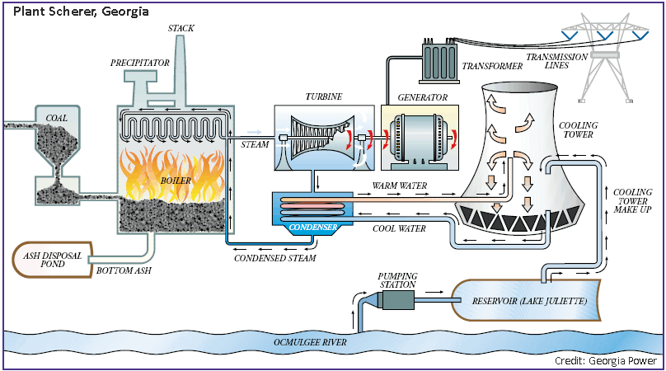

Figure 1: Georgia Power, Power Plant Schematic
Coal to power conversion process.
Another byproduct of burning coal is coal ash. After the coal is burned, the ash remaining at the bottom is no longer useful in creating electricity (7). Some companies send the waste to be disposed of in landfills and hazardous sites, while others dispose of the waste on site. The West Pittsburg power plant disposed of their waste in two onsite coal ash pits and one landfill (1). In 2016, the power plant was converted to natural gas and the ash pits remain inactive today (5).
Coal fired power plants waste is inclusive of several components: bottom ash, fly ash, boiler slag and flue gas (4). There are several different terms used to describe the waste: fossil fuel combustion wastes (FFCW), coal combustion products (CCPs), coal combustion by-products (CCBs) and coal combustion waste (CCW). The remainder of this essay will refer to the waste as CCW. Bottom ash is the coal ash that sits at the bottom of the combustion boiler where the coal is burned and is made up of the “large ash particles” (4). Fly ash is made up of the smallest particles that become airborne and are then trapped by particulate control devices (4). Boiler slag, in contrast, is the waste that remains at the bottom of the boiler, made up of “molten inorganic material” (4). Flue gas is the gas and airborne particles. Waste gas enters the atmosphere following the absorption of sulfur dioxide by scrubbers. Sulfur dioxide is combined with calcium to be neutralized, resulting in a solid that is disposed of with the other waste material (9).
The different components of CCW are placed into coal ash pits mixed with water or are simply placed in an onsite landfill (10). The ash is combined with water to prevent air from distributing the waste. The waste pits were not regulated or required to have a liner protecting the ground water (10). Across the United States, there are about 629 coal ash ponds in use at 495 coal-fired power plants (10). In addition, contamination of ground water is above the standards set by the federal government in 207 of the coal ash pit locations with pollutants such as lead, arsenic and chromium. (10). These coal ash pits are not required to take preventative action as they were constructed prior to the current regulations (10). Thus there are fewer regulations regarding coal ash pits than those for standard landfills for household trash. Standard landfills use several preventative measures, such as like ground water monitoring, several liner layers and leachate collection, to avoid contamination (11). The same precautions could be taken with coal ash pits to slow, if not stop, the pollution of the ground water.

Coal Ash Pit Construction
The coal ash pits typically take on one or a combination of four types: cross valley, side-hill, diked, and incised (1). Cross valley are pits that fill the area between two hills, taking advantage of the natural topography and a large embankment to hold the waste. The side-hill formation involves the creation of a U-shaped embankment on the side of a hill. Diked pits use raised ground embankment the entire way around a pool above the original topography. Incised pits are pits that have been dug into the ground to create a pool for the waste. The West Pittsburg plant used a combination of diked and incised formations to contain the coal ash waste (1). Figure 2 displays the four categories of waste impoundments (1).
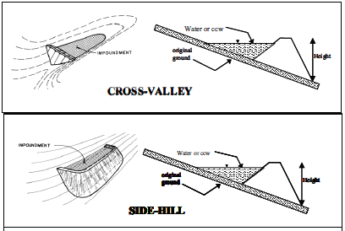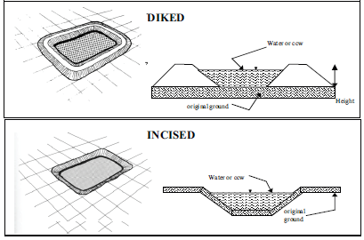

Figure 2: Waste Impoundments Categories

Other Forms of Disposal
Although coal ash pits or impoundments are the predominant form of disposal, there are other ways of disposing and recycling the ash into other products. Recycling coal combustion waste provides a variety of uses and benefits. Reusing ash waste lowers the need for newly attained materials, lowers emissions and as a result, reduces the impacts on the environment and the costs associated with disposal (12). In 2018, more than half of the coal ash produced in the United States was beneficially used rather than disposed of (13). From 2016 to 2017, the American Coal Ash Association reported that although the production of coal ash had increased four percent, the percentage of ash recycled went from 56% to 64.4%, a difference of 11.6 million tons. 71.8 million tons were saved from entering a coal ash pit or other form of disposal (13).
The two methods of reusing CCW are encapsulated and un-encapsulated. Encapsulating CCW provides protection to the outside environment preventing contamination and is often used to fortify concrete, grout, wallboard and roofing materials (13). Although the majority of recycled CCW is used in encapsulating products, just under one third is un-encapsulated, or used without any manipulation (12). Uses of un-encapsulated CCW include structural fills, synthetic gypsum to improve soil in agriculture and blasting grit also known as sand blast cleaning (13). The EPA examined CCW recycling and concluded that the exposures when using the new products are less than or equal to the already established levels of allowed exposures (12). Coal generated electricity is decreasing and recycling of CCW is increasing, creating a new potential for the elimination of coal ash pits and disposal.

Potential Contamination
Coal is made up of primarily carbon. Coal contains many other compounds that either collect at the bottom of the boiler, are airborne and collected as part of the flue gases, or escape through the smoke stacks. Some of these other compounds pose a threat to the environment.
Sulfur makes up between three and ten percent of coal depending on the type and source of the coal. Sulfur dioxide is created as a result of burning coal, and when released into the atmosphere, combines with water to become an acid (7). The sulfuric and sulfurous acids produced corrode metals and other materials like limestone and roofing slate (7). Leaf structure damage occurs when leaves are unable to convert the sulfuric acid to a less dangerous compound at a fast enough rate (7). Sulfur derived acids in the atmosphere result in acid rain (7). Acid rain has diverse effects on fish such as decreased reproduction and decrease in organisms that fish rely on for food (4). As a result, there are lasting effects up and down the food chain. The specific health effects on humans are difficult to determine as humans are often exposed to many other contaminants due to coal burning. Some of the main human health issues include reduced lung function, respiratory illness and/or reduced capability of the immune system within the lungs (4).
Nitrogen oxides form after burning organic nitrogen found in coal. They can take on various forms, for example, NO, NO₂, and N₂O (7). Nitrogen oxides and sulfur can be found in flue gases (7). Like sulfur, nitrogen oxides react with water and can cause acid rain and the acidification of bodies of water. Short term exposures are mainly hazardous to people with chronic obstructive pulmonary disease but may also create changes in airway responsiveness and function in people with respiratory disease (4). Long term exposures may cause people to get respiratory infections more frequently and lead to changes within the lungs (4).
Another component of flue gases is particulate matter (PM). When coal is burned and releases smoke, small particles become airborne and rise with the flue gases. The particle sizes are differentiated into two categories, particles less than 2.5µm are fine particles and those greater than 2.5µm but less than 10µm are coarse particles, also called PM_{2.5} and PM₁₀ respectively (4). Particulate matter less than 10µm poses the greatest risk to human health, as it can get deep into the lungs and even potentially into the blood stream (16). PM exposure can reduce life expectancy of people who live near a source of particulate matter (17). More specifically, PM_{2.5} increases the risk of heart attacks, stroke, arrhythmia, and even cardiovascular morbidity and mortality (17). Particulate matter can cause visibility impairments also known as haze (16). The particles easily travel distances through the atmosphere causing long term negative effects for instance: contributing to acid rain, damaging plants, increasing the hydrogen ion concentration in streams and bodies of water as well as decreasing diversity (16).
Volatile organic compounds (VOCs) are a group of compounds that contain carbon and evaporate easily. VOCs are involved in reactions in the atmosphere that aid in the formation of ozone (18). Ozone (O₃) is responsible for damaging effects on human health and the environment. VOCs are found in coal and released into the atmosphere as a result of combustion along with the other components of flue gases (19). The concentrations of VOCs are dependent upon several factors of the coal burning process including, temperature, speed of coal entering the boiler, and the containment control mechanisms (19). The main environmental effect of VOCs is the aid in the formation of ozone, the effects on plants are minimal (20). Studies in which plants were exposed to high concentrations of VOC’s over an extended time showed effects on the flowering, fruiting, and plant reproduction (20). VOC’s human health issues are unlikely due to rapid reaction in the air but may include: irritation, headaches, nausea, and damage to central nervous system (21).
Heavy metal contaminants also make up parts of coal ash waste. The metals may settle at the bottom of the boiler with the ash or be suspended in the air as part of the flue gases and collected by the scrubbers (7). The heavy metals contained in CCW may include cadmium, mercury, arsenic, chromium, lead, cobalt, lithium and other metals, all of which harm plants, animals and humans at increased concentrations. Arsenic, although found readily in the earth’s crust, can cause health issues like, hyperpigmentation (darkened skin spots), keratosis (hardening of skin), vascular disease and some cancers (3). Arsenic in CCW may become airborne (3) and interact with humans, plants, and animals causing negative effects. Some levels of arsenic are found in ground water throughout the world, but in the case of unlined coal ash pits, the levels are increased. According to the Annual Groundwater Monitoring and Corrective Action Report, on the New Castle Generating Station ash pit, there is a clear increase in concentration of arsenic moving downgradient and following the direction of groundwater flow which indicates the influence of the coal ash pit (22). Contamination of water wells and streams are possible routes of increased exposure in areas surrounding unlined pits.
Cadmium may cause a variety of health effects on humans. Its target organ is the kidneys and chronic exposure has been shown to cause renal failure (23). Inorganic mercury itself is toxic to humans but poses much less of a threat when compared to its organic counterpart methylmercury. Inorganic mercury that enters streams and bodies of water is transformed to methylmercury by bacteria and plankton and enters the food chain (4). People who consume fish or other sea life that lived in contaminated water are most at risk for toxicity (4). Mercury in all forms is harmful to the “brain, kidneys, and developing fetus” (4). Another metal found in coal ash is chromium. Chromium III is essential for life and aids in bodily processes but chromium in coal ash is much more concentrated than what is necessary for humans and may take on different forms following combustion (24). Chromium IV is toxic and damages membranes inclusive of skin, nose lining, stomach and intestines and may cause breathing issues when inhaled (24).
Lead use has mostly been discontinued due to the negative health effects but it is also found in coal ash at high concentrations (4). The main concern with lead toxicity is the central nervous system among young and developing children but may also occur in adults (4). Lead is highly persistent in humans, remaining in the blood and accumulating in the bones and other tissues that may lead to damage to kidneys and liver (4). Lithium, molybdenum, cobalt and other metals are at elevated levels in coal ash, contaminate waters below coal ash pits (4) and therefore may have lasting negative effects on human health and the ecosystem. Each metal alone causes these effects, but there is unknown synergistic effects and even greater degree of unknown effects alongside chronic health conditions or diseases.

Run off Contamination
Coal ash pits are open and exposed to the elements. Electricity producing plants are often located near a stream or source of water, as is the case with the West Pittsburg Generating station. The local streams and rivers can be contaminated in addition to the ground water below the coal ash pits. The unlined pits have the potential to leach the components of coal combustion waste into drinking water (10). Even though the generating station no longer uses coal to create energy, the coal ash pits remain a steady source of pollution. The process could be significantly slowed if not stopped (10) if the pit were to be brought up to today’s standards and a composite liner put into place.
People who live outside of city limits often rely on well water as their source of drinking water. Wells that are in close proximity to coal ash disposal sites are at greater risk for components of CCW contaminating their water wells. People who consume the contaminated water will also take in the toxins (10). The EPA reported a staggering “900 cancer cases per 100,000 exposed individuals” (10). The leaching of coal ash contaminants into drinking water is not well quantified but has huge ramifications on human morbidity and mortality. This increased rate of cancer is higher than the rate of cancer in people who smoke a pack of cigarettes a day (10). This is reasonable cause for action to identify the contaminated drinking wells, stop the contamination at the source, and start remediation efforts.

Coal Ash Rule
The coal ash spill that lead to the “Coal Ash Rule” is an example of the lasting effects that a spill can have on a community and the entire nation. In Roane County, Tennessee a dike that was holding back coal ash failed and released 5.4 million cubic yards into the nearby Emory River in 2008 (25). The EPA, Tennessee Valley Authority, and Tennessee Department of Environment and Conservation began working together to devise a clean-up plan moving forward (25). A year and a half was devoted to removing coal ash from the river to prevent flooding and resume recreation (25). Secondly, the coal ash was removed from the coal ash pits and a liner and cap were installed (25). Thirdly, to determine the risk to the local ecology and humans a risk assessment was completed (25). The whole process took 6 years and cost over one billion dollars (25). This took a toll on the community and required innumerable resources to restore the area.
Both slow leaching and dike failure cause damage that is not always reversible. Considering all of the resources that were put into the cleanup, remediation and restoration following the dike failure, a similar effort should be put into the coal ash pits and landfills that are known to be contaminating ground water in order to prevent devastating health effects.
The spill occurred in December of 2008, and in June of 2010 the Environmental Protection Agency proposed new standards for inspecting and addressing the condition of coal ash pits in order to prevent future spills (14). The national government’s CCW regulations require inspections of all pits that have waste from coal generated power, even at locations that are no longer using coal as a power source. The assessment identifies problem points, recommendations, and characterizes the overall “hazard potential” the ash pit presents (1).
The final regulation on coal ash includes the pit design and the potential contamination of groundwater. Companies who use an unlined pit must either make changes to the pit to be in compliance with the new regulations or discontinue the use of the coal ash pit (15). Regulations state that new or expanded pits must include a “composite liner, which is a liner system consisting of two components- a geomembrane and a two-foot layer of compacted soil” (15). The composite liner provides protection from leaching of CCW into groundwater and requires regular monitoring of the groundwater (15). The liner must also include a method of removing leachate that collects in the pit to further prevent the leachate from entering the groundwater (15). The groundwater testing requirement keeps companies accountable for the release of harmful chemicals into water sources for humans and the environment

Analytical Section
The land for the West Pittsburg power plant was purchased by the Pennsylvania Power Company in 1937 and started power production in 1939 (26). The power plant sits on 44 acres and was built to provide electricity to Lawrence County and the surrounding areas (26). By 1957, an upgrade was in motion to increase the kilowatt output from about 150,000 to about 260,000 kilowatts (26). An increase in kilowatts meant that more fuel would be consumed, the consumption of coal per hour could be as much as 690 tons. (26) By 2012, the “New Castle Generating Station” had changed hands several times (26). Following the changes to pollution standards in 2012, the owners, NRG Energy, decided to make costly changes to the power plant and transform it to solely run on natural gas (26), a more efficient alternative to coal.
Most power plants are located near a source of water, the power plant in West Pittsburg was built near the Beaver River to have easy access to water for the cooling procedures. The actual building structure is less than 50 feet from the river and the closest coal ash pit is less than 600 feet from the Beaver River (27). The northern section of the 44 acres is a landfill in which a majority of the waste from the plant is placed (27). South of the landfill are two coal ash pits, where the ash is combined with water. The two coal ash pits measure about 150 feet across, the smaller being around 250 feet long and the larger closer to 500 feet long (27). South of the coal ash pits is the generating station in which the coal was burned (5). Neighboring the power station is a small town called, West Pittsburg which is no larger than a quarter of a square mile, or just over 100 football fields (27). The main concern for this town is that the pollution from the plant may be affecting the health of the residents. Figures 3 and 4 below are for visual reference of the area.

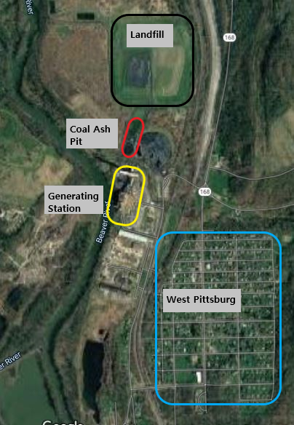

Figure 3: West Pittsburg location
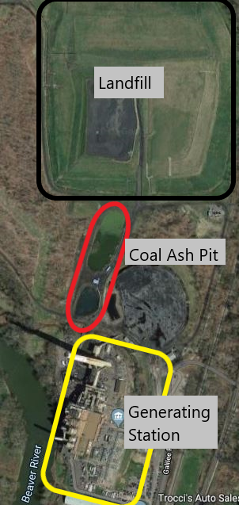

Figure 4: Generating Stations, Coal Ash Pits and Landfill location

Two water samples were collected from the Beaver River in October 2019, one sample before the power station, Location A, and one after the NRG Generating Station, Location B. Figures 5, 6 and 7 below display the Locations A and B(27). The air temperature was 18.89° C and raining. Hydrogen ion concentration, or pH, can be used as a proxy to determine if pollution has entered the river. Although the pH of coal ash varies from acidic to alkaline (28), depending on the contents. A difference between the two samples may be a sign of influence like run off from the coal ash pits. The influence from carbon dioxide, sulfur dioxide and other products of coal ash are associated with changes to pH (28).
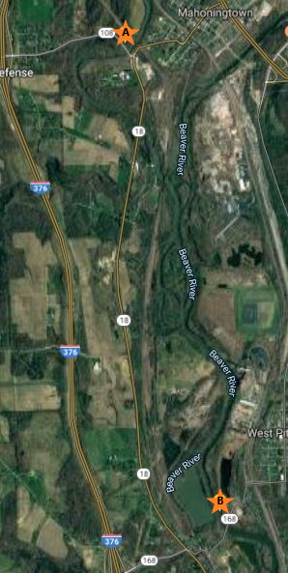

Figure 5: Sample Locations
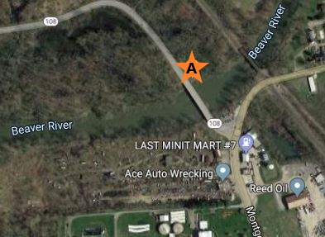

Figure 6: Close-up of Location A

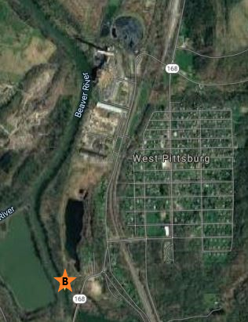
Figure 7: Close up of Location B

The pH of each sample was tested with three methods. pHydrion Papers with the ability to measure pH 1 to 12, were dipped into each sample to reveal pH 7 of both samples. EMD colorpHast pH-indicator strips, with the ability to measure 0 through 14, also indicated a pH of 7 in both samples. The final method, representing a more precise measurement, a Corning pH Meter 220, measured a pH of 6.88 at Location A and 6.45 at Location B. These pH tests are a simple method to determine if there is contamination entering the water but more tests are needed to determine if specific contaminants like arsenic, lead and cadmium have entered the river.

Table 1: pH Results
Method | pHydrion Papers | EMD colorpHast | Corning pH Meter 200
Location A | 7 | 7 | 6.88
Location B | 7 | 7 | 6.45

The consistency in these samples reveal that there is at most a small change in pH of the Beaver River water due to CCW. The 0.43 difference in pH on the Corning pH Meter 200 may represent some contamination although there are many factors that could be contributing to the difference. Rivers and streams are usually the healthiest within a zone of neutral pH, or around 7. The Beaver River pH levels are likely not affecting the health of the river ecosystem.
The town of West Pittsburg does not rely on well water as their drinking water supply but rather has city water delivered to their home (29). A widespread well water testing investigation beyond West Pittsburg would be necessary to quantify the actual impacts neighboring communities who use well water. Well water testing could confirm or disprove if the ground water contamination below the coal ash pits is leaching into nearby wells. More information is needed to determine the coal ash pit is impacting local citizens.

Community Health Impacts of Contaminated Water
There are many studies in a laboratory setting on the health impacts of contaminants from coal combustion and less so directly on the impacts of local residents. A literature review in the North Carolina Medical Journal, described the impact to residents local to the generating stations and the CCW (30). North Carolina is a state with a majority of its electricity produced by coal generating stations (30). People living close to coal generating stations have the potential to be exposed to pollutants and CCW directly through the air or indirectly through consuming contaminated water or plants and animals that have been living in the area. Although the literature review provided no direct measurement of local community health, people living in areas surrounding coal generating stations are likely to have increased rates of premature mortality, risk of respiratory disease, lung cancer, cardiovascular disease and decreased child health outcomes (30). These potential health effects and many more associated with exposures to CCW and generating plants identify the need for direct health impact studies that may further inform regulations and thus decrease these health impacts. In summary, there is evidence to accept the fact that without proper storage of CCW, there are huge costs to health which could have a similar impact on West Pittsburg and the surrounding areas.
Arsenic in groundwater at the New Castle Generating station was discovered to be 372 times the national standards of 10 micrograms per liter (22). The health impacts on a community of elevated arsenic can range from no effect to increased cancer risk. Arsenic levels in the groundwater in western Pennsylvania vary with several locations testing at 4 micrograms per liter and above (31). Within Lawrence County, arsenic levels for the most part fall below 4 micrograms per liter (31). The monitor wells on the New Castle Generating station property are placed in several locations surrounding the landfill and coal ash pits. Background arsenic levels are calculated from these monitoring wells taking into account the groundwater flow (22). The “CCR Compliance Groundwater Monitoring and Corrective Action Annual Report” prepared for the generating station established a background level of 0.007 milligrams per liter below the 0.01 national standard (22). Two of the wells sampled water downgradient of the onsite landfill and coal ash pit and returned levels several hundred times the national standard (22). Further investigation of the site revealed that the two monitor wells are at the depth of a historic “120-acre ash impoundment” and “situated entirely within ash” (22). Therefore, the current coal ash impoundments cannot be directly tied to the contamination of groundwater.
Another way to determine if contaminated groundwater is affecting people’s health is to look at levels of cancer in the county and compare that to another county that does not have the elevated levels of contamination in groundwater. One key cancer related to arsenic specifically is bladder cancer. The Pennsylvania Department of Health reports cases of cancer across the state by type of cancer and county. Table 2 below displays age-adjusted incidence rates of bladder cancer in four counties in Pennsylvania to serve as a comparison (32). Lackawanna County was chosen as a comparison as it did not have any reported arsenic groundwater concentrations above 4 micrograms per liter in the “USGS report on Arsenic Concentrations in Pennsylvania” (31). Lawrence County’s bladder cancer incidence rate is 23.6 as compared to the state’s rate, 24.3 (32). Certainly, there are other factors that may lead to bladder cancer diagnosis but it appears that the arsenic concentrations in areas of Lawrence County are not increasing bladder cancer incidence rates above the average for the state or other counties that do not have the reported arsenic groundwater contamination.

Table 2: Age-Adjusted Incidence Rate of Bladder Cancer
Age-Adjusted Incidence Rates of Bladder Cancer of Pennsylvania Counties, 2016
County | Age-Adjusted Incidence Rate | Notes
Lawrence | 23.6
Lackawanna | 28.3
Clarion | 30.7 | Highest incidence in the state
Union | 17.0 | Lowest incidence in the state

Disclaimer: “These data were provided by the Pennsylvania Department of Health. The department specifically disclaims any responsibility for any analysis interpretations or conclusions.”

Potential Spill Costs
The costs of a spill can only be estimated and may not include all present factors. In early 2014, a coal ash spill located in Eden, North Carolina occurred along the Dan River (33). The Dan River coal ash spill is an example of what the potential costs would be should the West Pittsburg coal ash pits have the same or similar fate. Dennis Lemly performed an analysis of the costs associated with the Dan River spill in North Carolina. The spill was estimated to be about 39,000 tons of coal ash and 27 million gallons of coal ash contaminated water (33). Lemly used four categories to calculate the costs associated with the first 6 months following the spill including: Ecological Impacts, Recreational Impacts, Human Health and Consumptive Use, and Esthetic Values (33). The grand total amounts to just under $300,000,000 which used conservative values and does not include the long term impacts on the environment and humans (33).
One can apply the assumptions that Lemly used to a different situation. Without knowing the exact amount of coal ash disposed in the coal ash pits, it is hard to predict what the cost of a spill may be. The amount of coal ash contained in the two coal ash pits can be estimated by determining the size of the pits using the satellite image to find the circumference of the pits and then using a conservative estimate of a depth of one foot. The area of the pit was then calculated from these estimates to be approximately 115,000 cubic feet (27) and would contain about 3,565 tons of waste. The Dan River coal ash spill was ~11 times (33) the amount of coal ash estimated in the West Pittsburg pits. Assuming that the cost is primarily dependent upon the number of tons, a spill into the Beaver River would cost about $27,000,000 to remediate in the first six months after a spill. This does not take into account the costs associated with clean-up and the long term costs beyond six months.
Estimating the cost benefit can be difficult and are often a conservative value. Other research by Lemly suggests that new landfills with “state-of-the-art composite liners and leachate collection systems” cost about 15 million dollars to construct (34). This estimate is still much less than the costs associated with a potential spill and the estimate of the overall destruction costs associated with damages due to unlined coal ash pits (34). It is estimated that destruction of the environment over a fifty-year period would cost a staggering $3.85 billion (34). This value is enough to create 257 landfills with appropriate liners and leachate systems (34). The preventative approach would save millions of dollars as well as prevent the potential contamination of people and animals. Although this approach protects the groundwater from contamination, there are still concerns related to runoff from the coal ash pits (34). Runoff and leaching on the surface still leaves the ecosystem at risk to damages.
The Resource Conservation and Recovery Act does not label coal ash waste as hazardous waste but doing so would eliminate risk of contamination for the community. The Federal Remediation Technology Roundtable made estimates as to the cost of excavating and disposing of hazardous waste in the early 2000s (35). When accounting for inflation the cost is estimated to be $275.4 per ton to $469.2 per ton or $982,000 to $1,672,698 total cost, assuming there are 3,565 tons of waste in the coal ash pits (35). Treating the waste as if it is hazardous waste is by far the least expensive route that would control the impacts on environment, human health and economics.

Recommendations for Coal Ash Pit Groundwater Contamination
Although it may not be possible to reverse the contamination that has already occurred to the groundwater, it is possible to stop the continued release into the environment from the unlined pits. The federal government does not require that unlined coal ash pits be brought up to today’s standards if they are no longer in use (14), thus leaving coal ash pits like the ones in West Pittsburg, unmanaged. Alternatives to the current situation will prevent the contamination from getting worse and future generations dealing with an even greater issue, like the disastrous spill in Tennessee. Potential solutions include, updating the coal ash pits to include a composite liner and leachate system, disposing of the coal ash as if it were classified as hazardous waste to remove it from the area, remediating the area to what it had been before the generation plant was there or continual monitoring for increased contamination.
Coal ash waste is not treated as a hazardous waste under the Resource Conservation and Recovery Act (RCRA), but treating the waste as such would eliminate the risk of contaminating the local ecosystem and potentially the well water supply. Hazardous Waste is managed from “cradle-to-grave” meaning that “generators must ensure and fully document the hazardous waste they produce is properly identified, managed, and treated prior to recycling or disposal” (36). The main goal of hazardous waste regulations is to eliminate contact with humans and the ecosystem (36). CCW contains a variety of components that may be harmful and if treated as hazardous waste may actually decrease the cost to society when accounting for the cost of environmental damages that occur over time.
Another option to eliminate potential human and environmental exposure would be to update the coal ash pits to include a composite liner and leachate collection system. (14, 15). The “Coal Ash Rule” does require testing of the groundwater below the coal ash pits but only requires that a liner and leachate system be in place if the ash pit will continue to be used (14). There is the option to close the ash pit without taking action (14). Without making changes to the coal ash pit, groundwater will continue to be contaminated by the leaching of CCW. Although the leachate and liner system are not required for coal ash pits that are no longer in use it is a recommended option for the safety of the local community.
The best but most costly recommendation is to remediate the coal ash disposal area to what it was prior to the power generating station. The main goal in remediation is to determine methods that will “transform toxic metals to a less toxic form or bio-absorb them” (37). For instance, some arsenic resistant aerobic microbes have the ability to transform arsenic found in coal ash to a less toxic form, (37) therefore reducing the overall impact on the environment. Another example of remediation technology is the use of macroalga. In this study, macroalga were able to sequester metals found in coal ash pits and improve the quality of the water (38). Remediation is a lengthy process but will ultimately return the coal ash disposal area into one that will not contaminate the groundwater for years to come.
The final and most economical recommendation is to continue to sample the monitor wells and observe differences each year. Additionally, continual surveillance of health outcomes related to coal ash contamination will display trends through time and help determine if contamination is actively affecting the health of the locals. A more finite view of health outcomes in neighborhoods within Lawrence County would further display the connection or lack of connection with contamination.

Conclusion
At present, the owner of the electric generating plant, NRG, is not investing in making any additional changes to the West Pittsburg power plant site. Recommendations for the safety of the local community and the environment would be to treat the current CCW as hazardous waste. Treating the waste at the West Pittsburgh site as hazardous would eliminate the continued risk of leaching into the groundwater and runoff or leaching into the stream and local environment. Furthermore, removing the waste from the current location prevents the power plant owners from a spill and facing removal costs like that of The Dan River spill or the Kingston, Tennessee spill. A public health approach in preventing any accidents will put both the power plant owners and the local citizens at ease.
Following the investigation of power plants and some of the factors surrounding it, it is clear that there is the potential for many health concerns. The risk to humans and the local environment has not been confirmed and thus will require more testing but there are clear risks that have been displayed in other cases. Although the costs of cleaning up the area and eliminating the source of contamination cannot be fully computed, examples from other contaminations display the benefit to getting ahead of the issue instead of ignoring it until a much larger issue arises. Electric companies like the NRG should not be grandfathered out of the new regulations because of discontinued use of the coal ash impoundments, but rather held to the same standards in order keep local residents and wildlife healthy Energy companies should take full advantage of the knowledge and technology that is present to stop the contamination.
Companies new and old should take into consideration more factors when planning, building and executing business. Waste is part of virtually every company and they should remain responsible, and figure the cost of proper waste disposal into the overhead. A company’s decision makers should visualize the impact of their waste and make verdicts as if they were living in a closed ecosystem with their product from retrieval of supplies to final product to have a better understanding of the impacts.
Some may believe that there is already contamination and nothing can be done to fix it. New technology allows for improvement in practice and lessening or ultimately stopping the groundwater contamination. The site is not beyond repair and although lining the coal ash pits will not completely solve the issue it is an improvement and mediates risk in the future.
Future recommendations would be to create legislation to have power companies responsible for their product for the full life cycle. The price for mediating the risk does not compare to the price of healthcare. All parts of our lives are interconnected and it is important to take a holistic approach for the best outcomes and the future of the community.
Overall, more research is necessary to understand the complexity of this issue. Water samples from local drinking wells and the Beaver River can confirm how widespread the contaminants are potentially leaching. After determining the severity of contamination, steps may be taken to stop the contamination through a liner system or hazardous waste disposal, remediate the area, and create legislation at the local, state and national level that will prevent this from happening again.

Bibliography
1. Agency USEP. Dam Safety Assessment of CCW Impoundments: NRG Power Midwest LP, New Castle Generating Station, West Pittsburg, Lawrence County, Pennsylvania. In: Agency USEP, editor. 2014.

2. Finnerty J. Local plant listed among nation’s worst groundwater polluters. New Castle News. 2019 03/06/2019.

3. Chung JY, Yu SD, Hong YS. Environmental source of arsenic exposure. J Prev Med Public Health. 2014;47(5):253-7.

4. Miller BG. Coal energy systems. Amsterdam ; Boston: Elsevier Academic Press,; 2005.

5. Grzebieniak M. West Pittsburg electric plant completes transformation to gas. New Castle News 2016 12/23/2016.

6. Annual Energy Review 2018 [Internet]. U.S. Energy Information Administration. 2019.

7. Breeze P. Coal-fired generation. Amsterdam, Netherlands: Academic Press,; 2015.

8. Geogia's Plant Scherer Coal-Fired Power Production Method. In: Survey USG, editor.

9. Agency USEP. Air Pollution Control Technology Fact Sheet. United States Environmental Protection Agency.

10. Goemann E. Surveying the threat of groundwater contamination from coal ash ponds. Duke Environmental Law & Policy Forum. 2015;25(2):427.

11. Agency USEP. Municipal Solid Waste Landfills: United States Environmental Protection Agency; 2018

12. Agency USEP. Coal Ash Reuse: United States Evironmental Protection Agency; 2019 [updated 07/15/2019.]

13. Association ACA. Coal Ash Recycling Reaches Record 64 Percent Amid Shifting Production and Use Patterns: American Coal Ash Association; 2018

14. Agency USEP. Disposal of Coal Combustion Residuals from Electric Utilities Rulemakings: United States Environmental Protection Agency; 2019 [updated 03/19/2020.]

15. Agency USEP. Frequent Questions about the 2015 Coal Ash Disposal Rule: United States Environmental Protection Agency; 2018 [updated 11/02/2018.]

16. Agency USEP. Particulate Matter (PM) Pollution: United States Environmental Protection Agency.; 2018 [updated 06/20/2018]

17. Brook RDR, Sanjay; Pope, 3rd, C Arden; Brook, Jeffrey R; Bhatnagar, Aruni; Diez-Roux, Ana V; Holguin, Fernando; Hong, Yuling; Luepker, Russell V; Mittleman, Murray A; Peters, Annette; Siscovick, David; Smith, Jr, Sidney C; Whitsel, Laurie; Kaufman, Joel D. Particulate matter air pollution and cardiovascular disease: An update to the scientific statement from the American Heart Association. Circulation. 2010;121(21).

18. Agency USEP. Report on Environment: Volatile Organic Compounds Emissions. United States Environmental Protection Agency; 2018.

19. Cheng JZ, Yongsheng; Wang, Tao; Xu, Hong; Norris, Pauline; Pan, Wei-Ping. Emission of volatile organic compounds (VOCs) during coal combustion at different heating rates. Fuel. 2018;225.

20. Cape JN. Effects of airborne volatile organic compounds on plants. Environmental Pollution. 2003;122.

21. Agency USEP. Volatile Organic Compounds' Impact on Indoor Air Quality: United States Environmental Protection Agency; 2017 [updated 11/06/2017].

22. Aptim Environmental & Infrastructure I. CCR Compliance Groundwater Monitoring and Corrective Action Annual Report North Ash Pond and Ash Landfill. Aptim Environmental & Infrastructure, Inc; 2019.

23. Registry AfTSaD. Cadmium Toxicity: What Diseases Are Associated with Chronic Exposure to Cadmium? : Agency for Toxic Substances and Disease Registry; 2008 [updated 12/10/2013]

24. Registry AfTSaD. Toxicological Profile for Chromium: Agency for Toxic Substances and Disease Registry,; 2019 [updated 09/26/2019]

25. Agency USEP. U.S. Environmental Protection Agency and Tennessee Valley Authority Kingston Coal Ash Release Site Project Completion Fact Sheet: United States Environmental Protection Agency; 2014 [updated 12/2014]

26. J. BJ. Power Plant- West Pittsburg PA. Lawrence County Memoirs: Historical Recollections from Lawrence County Pennsylvania and Surrounding Areas; 2013

27. Google. NRG New Castle Generating Station: Google; 2019

28. Roy WR, Berger, P.M. Geochemical Controls of Coal Fly Ash Leachate pH. Coal Combustion and Gasification Products. 2011;3:63-6.

29. Wachter D. Officials: No risk from groundwater contamination. New Castle News. 2019 03/06/2019.

30. Kravchenko J, Lyerly HK. The Impact of Coal-Powered Electrical Plants and Coal Ash Impoundments on the Health of Residential Communities. N C Med J. 2018;79(5):289-300.

31. Eliza L. Gross DJL. Arsenic Concentrations, Related Environmental Factors, and the Predicted Probability of Elevated Arsenic in Groundwater in Pennsylvania. 2012.

32. Cancer Dashboard [Internet]. Pennsylvania Department of Health. 2016.

33. Dennis Lemly A. Damage cost of the Dan River coal ash spill. Environ Pollut. 2015;197:55-61.

34. Lemly AD, Skorupa JP. Wildlife and the coal waste policy debate: proposed rules for coal waste disposal ignore lessons from 45 years of wildlife poisoning. Environ Sci Technol. 2012;46(16):8595-600.

35. Roundtable FRT. Excavation, Retrieval and Off-Site: Federal Remediation Technologies Roundtable;

36. Agency USEP. Learn the Basics of Hazardous Waste: United States Environmental Protection Agency; 2019 [updated 02/19/2020]

37. Roychowdhury R, Roy M, Rakshit A, Sarkar S, Mukherjee P. Arsenic Bioremediation by Indigenous Heavy Metal Resistant Bacteria of Fly Ash Pond. Bull Environ Contam Toxicol. 2018;101(4):527-35.

38. Roberts DA, Paul NA, Bird MI, de Nys R. Bioremediation for coal-fired power stations using macroalgae. J Environ Manage. 2015;153:25-32.

