Title Page

**Pittsburgh’s History of Poor Air Quality: A Viewpoint on Environmental Injustice in the Monongahela River Valley**

by

**Jessica Albrecht**

BA, Kent State University, 2018

Submitted to the Graduate Faculty of

Environmental and Occupational Health

Graduate School of Public Health in partial fulfillment

of the requirements for the degree of

Master of Public Health

University of Pittsburgh

2020

age

UNIVERSITY OF PITTSBURGH

Graduate School of Public Health

This essay is submitted

by

**Jessica Albrecht**

on

April 1, 2020

and approved by

**Essay Advisor:** James Peterson, PhD, Associate Professor, Environmental and Occupational Health, Graduate School of Public Health, University of Pittsburgh

Linda Pierce, PhD, Assistant Professor, Environmental and Occupational Health, School Graduate School of Public Health, University of Pittsburgh

George Bandik, PhD, Department of Chemistry*,* Kenneth P. Dietrich School of Arts and Sciences, University of Pittsburgh

Copyright © by Jessica Albrecht

2020

James Peterson, PhD

**Pittsburgh’s History of Poor Air Quality: A Viewpoint on Environmental Injustice in the Monongahela River Valley**

Jessica Albrecht, MPH

University of Pittsburgh, 2020

**Abstract**

Pittsburgh’s legacy of poor air quality is seen in even the most surface level analyses of the areas history. Due to recent concern, and despite modern improvements, most communities around Pittsburgh breathe air that does not meet EPA standards. Harmful air pollutants such as sulfur dioxide and fine particulate matter have been associated with negative health outcomes in these neighborhoods. Research over the past decade has shown a strong relationship between these air pollutants and established health endpoints and may cause a broader number of disease outcomes than previously thought. Now that poor ambient air quality has been established as a significant public health concern there has been an enormous effort to lessen air pollution and negate health effects seen in individuals in the Monongahela River Valley. These environmental quality factors are fundamental determinants of human health and can lead to health disparities when areas where people live and work are burdened by social inequities. The social inequities seen in neighborhoods in the Monongahela River Valley exist in a combination of substandard environmental quality, higher frequency of sickness and disease, and worse access to health services than in nearby wealthier communities. Thousands of residents live and work in areas in the Mon Valley where air pollution levels are high enough to cause both acute and chronic health outcomes. Those exposed to this pollution are often low-income families and people of color living in close proximity to industrial sources. Socioeconomic status, cultural influences, and access to health services all determine social inequities that affect the overall health of a community. Data strongly suggests that the low socioeconomic status of populations in these communities has led to the disproportional risk and burden of pollution the areas presently experience. The public health significance of air quality related disease outcomes suggests that clear communication and mitigation strategies are necessary to protect vulnerable populations.

Table of Contents

1.0 Introduction 1

2.0 Review 3

3.0 Analysis 10

4.0 Conclusion 20

Bibliography 24

List of Figures

Figure 1. Major species long-term averages for Liberty and the oher SWPA siyes (averaged) 13

Figure 2. ER visits for respiratory illness and cardiovascular disease before and after the closing of the Shenango Plant 14

Figure 3. Population change in Monongahela River Valley municipalities, 1980-2000. 17

Figure 4. Median household income by municipality relative to Allegheny County, 2000 18

Figure 5. Population distribution by race 19

# Introduction

Methodical investigations into the risk of exposure to industrial emissions in communities in Pittsburgh, Pennsylvania have been carried out and well documented. Such neighborhoods include Clairton and Braddock Pennsylvania, just south of downtown Pittsburgh, which both house active factories: Clairton Coke Works and the U.S. Steel Edgar Thompson Plant. Impacts of prolonged and continued exposure in the Mon Valley have resulted in abundant health issues in zones of majorly polluted air surrounding the remaining factories. Such risks generate from occupational hazards and environmental hazards that additionally affect community members unassociated with the plants.

The public health impact of factory based toxic air pollution is far-reaching. Elevated risks from air toxins are found in communities near industrial facilities and urban areas with multiple emission sources. Communities in the Mon Valley fall into both of these categories. Specifically, Clairton and Braddock residents are further likely to bear the burden of negative health effects and financial concerns that coincide with environmental pollutant related illness. The factories both emit harmful pollutants to ambient air quality such as sulfur dioxide (SO2), nitrogen dioxide (NO2), carbon monoxide (CO), and fine particulate matter (specifically PM 2.5) (Villeneuve, P.J, et. al. 2003). Health hazards inherently linked to prolonged exposure may include lung diseases, respiratory issues, cancer and most commonly an exceptionally increased incidence of intensified childhood asthma. The situations present in Clairton and Braddock are characteristic of such public health hazards and have brought the notion of environmental injustice to the forefront. Disproportionate exposure of the Clairton and Braddock neighborhoods to pollution, foul odors, and the abundant negative health effects are a result of stunted regulations, and a lack of governmental programs and environmental protection.

# Review

Poor air quality is among the widest reaching environmental and public health issues in the world. Air quality is able to negatively affect the human body, animals, bodies of water, and contributes in a large scale to poor health conditions, eutrophication, and global climate change. While Pittsburgh is a small town in the grand scheme of things, the impact of industrial emissions is among the top contributors to climate change on a global scale. Reducing emissions is the simplest way to lessen the impact of such pollution on environmental and human health. Despite abundant change in air quality since the Clean Air Act in 1970, outdoor air pollution still threatens human and environmental health. Primarily, air pollutants can be irritants to the eyes, nose, and throat. Though, these irritations can and often do lead to more serious health concerns including respiratory conditions, aggravated asthma, and heart and cardiovascular system issues.

The biggest threat to ambient air quality is pollution emitted from factories and industrial plants where regulations are lacking and legislation is deficient. The public health impact of factory-based pollution is extensive and can contribute to larger global health issues. Prolonged and continued exposure to air pollutants can cause more serious long-term problems to human health that previously assumed. Cancer health risks from air toxins hit a record high during the most recent EPA National Assessment of Inhalation Risks from Air Toxins. An estimated 14 million peopled in more than 60 urban locations showed a lifetime cancer risk greater than 100 in one million. Similarly, the assessment showed that the United States as a nation experiences lifetime cancer risks greater than 10 in one million (Clean Air Act Overview, 2019). This distressing detection led to EPA standards requiring further reductions in emissions. Air toxins and environmental pollutants originate mostly from manmade sources and emissions. These emissions attribute to 23% of all global deaths per year. In North and South America, 847,000 deaths can be attributed to environmentally caused deaths. Non-communicable diseases acknowledged as environmentally influenced include most cancers, chronic respiratory diseases, respiratory infections, and stroke. Individuals can be exposed to risk factors in their homes, work places and communities (WHO, 2019).

Low and middle-income countries possess the highest disease prevalence and death rates relative to population. Similarly, this is also seen in low and middle-income neighborhoods globally despite the country’s overall national socioeconomic status. Disproportionate risks of environmental and climate related health effects impair children, the elderly, the poor, and future generations most of all. The National Climate Assessment summarizes the impacts of climate change on the United States specifically among vulnerable populations. The 2014 assessment backed by comparable studies show that climate change related impacts, specifically degraded air quality and air pollutants, disproportionately affect certain communities including low-income and communities of color. Environmental impacts on health are uneven across age and mostly affect the poor. These impacts on health are associated with increased deaths, illnesses, and economic challenges afflicted on such populations (NCA, 2014). Health challenges most commonly associated with degraded air quality are respiratory diseases and cancer. As such, these disease outcomes are seen largely in areas such as the Mon Valley.

The history of poor air quality in Pittsburgh and the Monongahela River Valley region is extensive. Pittsburgh had become an industrial powerhouse in the 1870’s. The geography of industrialization transformed from small factories located inside the city limits to a large integrated region stretching 50 miles across Allegheny County expanding into towns further down the river such as Clairton, Donora, Homestead and Braddock. By 1910, Pittsburgh was a vast urban landscape containing a prosperous city surrounded by mill towns and numerous suburban housing neighborhoods. These areas housed 939 factories that employed more than 10,000 workers (Muller, 2001). Prosperous communities were built around plants situated along the river during the restructuring of the city. The “small town” nature of these neighborhoods further from the city center attracted potential employees and their families. This unrestricted growth into outer areas created new, thriving municipalities and a strong workforce.

Pittsburgh, Pennsylvania was and still is most known for its abounding steel production starting during the industrial revolution in 1875. While the city prospered and industry developed, the issue of poor air quality grew as well. Pittsburgh’s ideal geographic location on the three rivers made it the ultimate site for the industrial productions that inevitably produced the biggest problem the city would ever face. The “smoky city” was coined during the century of industry in the city that created overwhelmingly foul air conditions throughout the area. Smoke, smog, dust, and odors were evident at all hours of the day for decades. The haze that fell over the city was only seen as a problem some. Largely, people saw the constant smoke as a sign of prosperity and productivity. Lack of research and knowledge of the consequences of air pollution led to a stall on atmospheric clean up efforts. While eventually smoke control ordinances and committees were created, there was a lack of control and enforcement of these novel regulations (Pittsburgh’s Dark History, 2015). Air quality quickly plummeted and residents were exposed to hazards such as a daylong smog and haze over the city, increased asthma prevalence, and inhaled particulate matter in the smoke with unidentified consequences to residents at the time. Soon, newly recognized issues with perpetual emissions allowed local lawmakers and residents to make cognizant judgments about the once mighty Pittsburgh steel mills.

General air clean up efforts of the Pittsburgh area began with the election of a new mayor in 1946. David L. Lawrence presented a plan to clean the city’s air and infrastructure following World War II. Under his jurisdiction, smoke ordinances were now being enforced and streets and buildings were cleaned of the layers of built up dust. The steel industry drastically slowed down in Pittsburgh in the 1980s bringing a predictable decline in emissions and an immediate benefit to overall air quality. Though the industries responsible for the pollution were now condensed, remaining factories and residual particulate matter still existed in the atmosphere leaving Pittsburgh’s air quality among the worst in the nation.

Currently, Mon Valley residents still experience major air quality issues. Despite the closing and relocation of mills to areas beyond downtown limits, pollution remains a matter of discussion. The two largest remaining plants in the Mon Valley, Clairton Coke Works and the U.S. Steel Edgar Thompson Plant, employ nearly 3,000 workers preserving many jobs in the area. Clairton Coke Works is located on nearly 400 acres along three miles of the Monongahela River. Similarly, the Edgar Thompson Plant of Braddock is just 6 miles away up river. Situated just downwind of the Edgar Thompson plant is the town of Donora, site of the infamous 1984 smog. This environmental disaster killed 20 people and left an additional 6,000 hospitalized with respiratory problems. Unmistakably, the areas around Pittsburgh are all too familiar with the disastrous effects that industrial air pollutants have on unsuspecting populations (Jones, 1975).

Clairton is still the country’s single largest source of coke, a key component in steelmaking. Multiple processes carried out at the plants account for a variety of emissions. Despite 21st century development and more stringent laws, the issue of emissions persists. Before 1970, coke quenching was a method still in progress. Techniques such as coke quenching used 3.5 million gallons of water per day and emitted approximately ten tons of phenol, one ton of cyanide, twenty tons of ammonia, and five tons of hydrogen sulfide into the atmosphere daily (Jones, 1975). Such processes violated Article 17 of the Allegheny County Health Department’s rules and regulations on air pollution control and have since been modified to reduce the amount of phenol emitted through local industry. Though changes such as this were considered progress, it is typical for standards not to be upheld at plants. Industry often maneuvers around newly established benchmarks and the plant was found to be emitting more than allowable by law for another decade.

Evidently, the continued neglect of emissions policies is a casual factor in the poor air quality persisting in the area. Statements on ambient air attributes in the Mon Valley today paint the picture of a town shrouded in disregard. An annual State of the Air report ranked the region as the 8th worst air quality in the country for year-round measures on fine particulate pollution. Additionally, Allegheny County was ranked 14th worst for short-term particulate pollution, referring to “the number of days with unhealthy particle levels when air quality is especially dangerous” (Pittsburgh Air Pollution, 2019). Essentially, the area consistently fails annual air quality tests. Particularly severe conditions have led to multiple Clairton residents filing lawsuits against U.S. Steel in regards to Clairton Coke Works and concerns of pollution harming residents. A furnace fire in December of 2016 led to a three-month period of malfunctioning pollution filters and controls. During this time, statements claim that pollution from Clairton Coke Works exposed people to five times the allowed value of “sulfur dioxide, particulate matter, ammonia, benzene, carbon disulfide, lead, naphthalene, toluene, a mix of methane, carbon dioxide and carbon monoxide and other toxic and hazardous chemicals” wholly violating the Clean Air Act (Frazier, 2019). Alas, 70,000 pounds of sulfur dioxide were emitted a day, roughly five times the permitted amount. Pollution from such chemicals has been linked to abundant negative health endpoints including heart and respiratory diseases, cancer, and asthma. Testimonials from residents in the area claim that most kids need inhalers when playing sports and cancer is a disease often seen among friends and family. These class-action suits designed to confront environmental pollution allow anyone within a three-mile radius of the coke works plant to seek council. This metric covers about 36,000 people in the Clairton area.

Inquiry proved that the threat of emissions violations is a particularly relevant worry to residents. Investigations surrounding legal actions for community members uncovered at least 6,700 air pollution violations spanning between 2012 and 2015 as reported by the Allegheny County Health Department (ACHD). Consequently, U.S. Steel has been fined $6.65 million due to violations of emissions procedures. As a result of the law suits, U.S. Steel made a settlement with the ACHD to limit pollution, meet pollution standards, inspect the walls of coke ovens and fix inadequacies, and observe smoke plumes from equipment several times a day. Despite action being taken, residents still feel that local and federal governments have failed to do enough to protect its citizens and were unsuccessful when addressing the crisis. Research from the EPA backs this as Clairton has experienced declining air quality since 2014 with the Clairton Coke Works being cited as the cause. The ACHD also sites the Clairton plant as the source of declined air quality because of “ever-increasing visible emissions and unexplained exceedance” (Frazier, 2019).

People with heart disease are additionally vulnerable to the effects of particulate matter pollution that comes from industrial emissions. Ultimately, particulate matter inhalation can cause heart attacks, according to the U.S. Centers for Disease Control and Prevention. Even short-term exposures may increase these risks in those already at risk for heart conditions. Breathing in particulate matter can raise risk of blood clots, raise blood pressures, and cause inflammation in blood vessels. All of these conditions may block nutrients from reaching the heart and brain triggering a health emergency for those exposed (Friedman MS, Powell KE, Hutwagner L, et al., 2009). Such health risks are probable in the Pittsburgh area and are seen among populations in high-risk areas such as the Mon Valley.

# Analysis

Pittsburgh’s air quality is monitored, tested and reported on regularly. Continuous monitoring has revealed Pittsburgh to have air quality far below national averages, pollution levels above EPA standards, and respiratory disease frequencies higher than other industrially heavy areas around the country. By February 5th, 2019, Pittsburgh had already had nine code orange air pollution warnings issued for the year. Based on the federal Environmental Protection Agency’s color-coded “action days” index, orange level warnings represent unhealthy amounts of pollution levels for sensitive people. Although the general public is not at high risk, people with heart and lung disease, older adults, children, and anyone with asthma are at a high risk from the presence of particles in the air. Specifically in the Mon Valley, three days in this time period were issued a code red air pollution warning signifying unhealthy pollution levels for all. According to air quality map archives from the Pennsylvania EPA, the remainder of 2019 was filled with mostly yellow code air pollution warnings (AIRNow, 2019). Yellow warnings signify more moderate conditions but still unusually sensitive people were suggested to consider reducing prolong or heavy exertion while outside. Considering the unusually high incidence of childhood and adult asthma in the area, a yellow warning affects a large portion of the population.

While these warnings impact many Pennsylvanian residents, Allegheny County is at higher risk for negative health effects. Ranked number nine in worst air quality in the country, the county has received all F’s on the American Lung Association’s 2018 air quality report card. Similarly, Pittsburgh was among six regions in the United States where year-round particulate matter pollution actually increased since the previous year. The report card style grading system left Allegheny County with an F for ozone, daily particulate matter levels and long-term particulate matter levels (Particulate Pollution, 2017). As a result, the counties occurrence of specific negative health outcomes reflects the poor conditions suffered by individuals in the region. The Mon Valley’s asthma rates significantly outpace the national average and Allegheny County is in the top 2% of all counties for the risk of cancer caused by air pollution (Pittsburgh Regional Environmental Threats Analysis Report, 2013). Among the greatest threats to vulnerable populations are both SO2 and PM 2.5 though healthy people may experience health impacts from repeated exposure as well. SO2 exposure is often related to respiratory irritation such as sore throat, wheezing, and chest tightness. More severely, according to the CDC, particulate matter is linked to eye, lung and throat irritation, low birth weights, and lung cancer (Murasic, 2019).Air pollution exposure can exacerbate pre-existing respiratory disease, cause new asthma cases, and develop or progress chronic illnesses such as lung cancer, emphysema, and other chronic diseases respiratory diseases. Outdoor air pollutants such as particulate matter, NO2 and SO2 are shown to increase mortality in according to a cohort study in England assessing the mortality associations with long-term exposure to outdoor air pollutants (Casey, IM, et. al 2013). These long-term exposures are particularly detrimental to those with cardiovascular disease. PM 2.5 from the Clairton Coke Works Plant is the most worrying of resulting air toxics.

Specific health outcomes have been linked to the industrial pollution from the Clairton plant. A report by Dr. Deborah Gentile in the Allegheny County Medical Society Bulletin stated there is a clear link between the coke-plant and the asthma epidemic in Pittsburgh area elementary schools. Children living in the shadow of the Clairton Coke Works Plant exist in an area of asthma provoking pollution. Gentile, a Pittsburgh-based pediatrician, states the consistent toxic pollution from the Clairton Coke Works is to blame. Children who suffer most are usually black and have low socioeconomic background. The demographics of Clairton Elementary School, where asthma rates are roughly double state average, are 64.7% black, 19.3% white, and 100% of students receive a free or discounted lunch (Elliot, Jennifer, et. al. 2017). A research study tested 213 children from Clairton Elementary School and found that 18.4% of children had asthma. Compared to the state average of 9-10% incidence of childhood asthma and the national average of 8%, 18.4% is alarmingly high. Geographically, most kids are within one mile from the plant and about 25% of those are downwind. The coke process emits air pollution that is carried right through the homes and neighborhoods of these children. In particular, PM 2.5 and black carbon are released from the mill and are known asthma triggers. Gentile asserts "these results highlight the need for state-mandated asthma screens as well as novel treatment delivery models for high-risk groups, such as school-based clinics" (Elliot, Jennifer, et. al. 2017).

Health issues related to poor air quality specifically in the Mon Valley vary but are most immediately seen as respiratory issues. Due to regional transport, urban excess, and localized impact, the area sees large totals of PM 2.5 major species. Southwestern PA is also affected by the long-range transport PM 2.5 and precursors along with the legacy pollution present in the Pittsburgh area from anthropogenic activity. At the Liberty monitoring site near Clairton supervised by the Allegheny County Health Department, these species have been observed in excess compared to southwestern Pennsylvania averages (Figure 1).

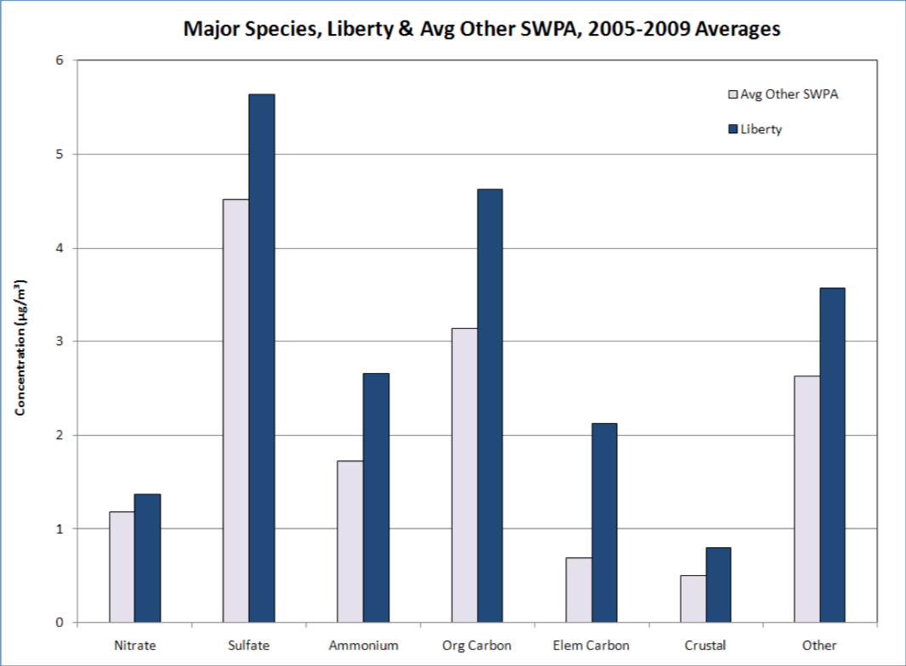

Figure 1. Major species long-term averages for Liberty and the oher SWPA siyes (averaged)

Source: ACHD Air Quality Program

Community sentiments are best illustrated in the abundance of advocacy groups focused on air quality in the Pittsburgh area. Groups such as the Breathe Project, Clean Air Council, and Group Against Smog and Pollution (GASP) are activism groups focused on diligent monitoring, education, litigation, and policy-making around air quality in the Pittsburgh region. Such organizations have worked with the community to take it upon themselves to push for air permits and regulatory changes to ensure improved overall public health.

While shutting down all plants is not a viable option, it is one that would surely alleviate respiratory issues seen in the areas where they are located. In 2016, the Shenango Coke Works was closed after years of community protest and Clean Air Act violations. A study published by the Allegheny County Health Department found that emergency room visits for asthma and chronic obstructive pulmonary disease dropped by 37.9% in the area the year that the plant closed. Similarly, emergency room visits for cardiovascular diseases including heart attacks and stroke decreased by 26.5% (Marusic, 2018).ER visits for respiratory illness in 2015 were 10,216 per 100,000 in communities surrounding the Shenango plant versus 6,344 in 2016 following the close of the plant. Likewise, ER visits for cardiovascular disease decreased from 9,388 to 6,899 per 100,000 the year after closing (Figure 2).

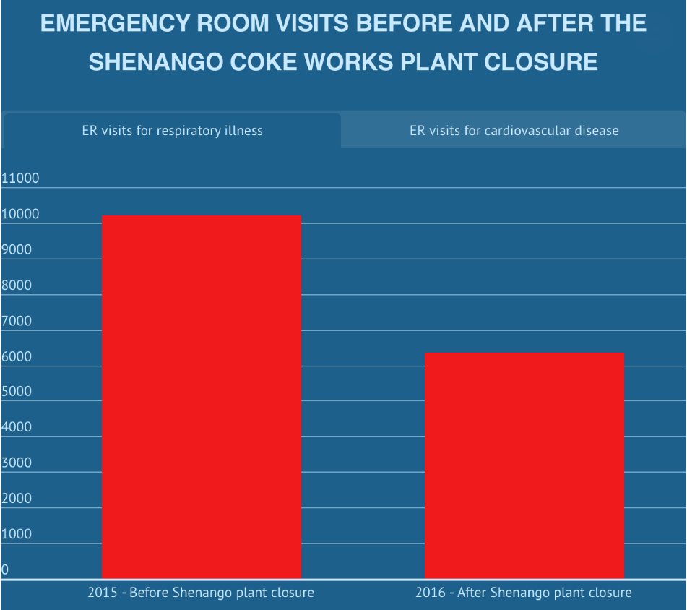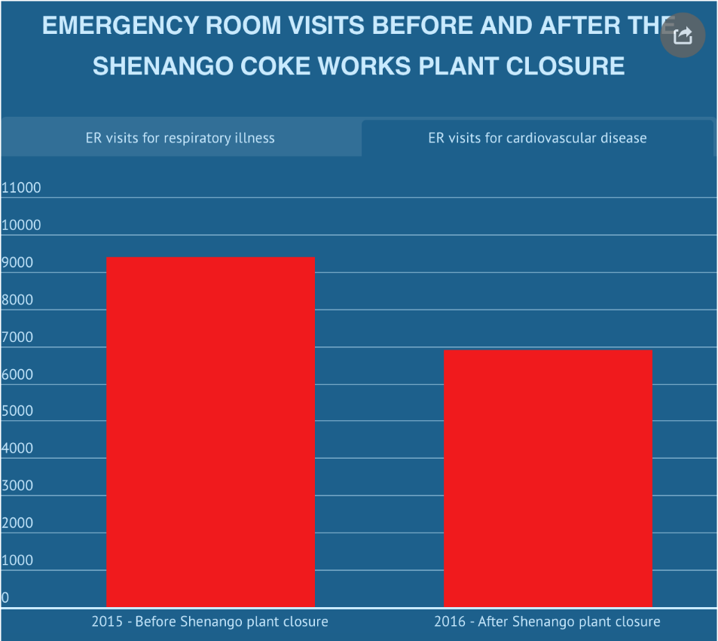

Figure 2. ER visits for respiratory illness and cardiovascular disease before and after the closing of the Shenango Plant

Source: ACHD air quality reports and studies

The measurable, significant drop in health impacts is a powerful testimonial about how the public can be directly impacted by polluters in their community. Confounding factors could play a part in the significant drop in ER visits, such as emergency room access and insurance benefits in the region as well as wind and weather patterns that could have changed to impact the dramatic drop in numbers. However, all of these issues were investigated and none were found to have had any influence on the rate change (ACHD, 2017). Despite discussion over the findings, it is certain that people in the area are able to breathe easier and have had less reported respiratory health issues.

Societal and monetary obstacles delay the objective of overall healthier communities and environments. These hindrances are seen in areas such as the Mon Valley by way of environmental injustices. By definition, environmental justice demands equal opportunity for all communities to have a healthy environment in which to live, learn and work. Moreover, the same degree of protection against environmental and health hazards should be set forth despite socioeconomic status, ethnicity, or neighborhood. Unfortunately, this level of health equity is rarely achieved.

According to a GIS environmental justice analysis of particulate air pollution in Hamilton, Canada, associations between socioeconomic position and health are unmistakable. While confounding factors such as access to health care and medical treatment do exist, it was evident from map clusters of heart and lung disease, impaired lung function, and lung cancer that groups of lower socioeconomic status receive the highest exposure. This influence results in more severe effects on their health than it does in the average population. The guidance of these findings could help change mitigation tactics since current air pollution standards do not focus on lessening exposure of the highest exposed areas. Rather, these standards are a benchmark designed to reduce average exposure over a large area (Jerret et al. 2001). As part of the environmental justice movement, research and practices have been applied in areas to alleviate some of the inequities in health due to socioeconomic disparities.

Exposure differentials related to social circumstances include land use in areas of lower income that in turn effect those of in the area directly exposed to the pollution. The disproportionate exposure to some pollutants, including PM 2.5 in Pittsburgh’s Mon Valley region, is characterized by low socioeconomic status and racial composition. Explanations range from the housing market, class bias, to systemic racism. Regardless of rationalization, the fact remains that high land cost in wealthier neighborhoods deters industry from buying land in these areas. They are more often forced upon lower income areas where land is cheaper, thus continually distributing pollutants upon these communities. In the United States, poor people and people of color experience higher cancer rates, asthma rates, mortality rates, and overall poorer health than their affluent and white counterparts.

Mill towns in the Mon Valley region were thriving and populations were growing at high rates in the early 1900s. Between 1960 and 1970, population rates started steadily declining as deindustrialization began (Figure 3). The Pittsburgh Quarterly described the situation as, “sprawling facilities running along the Monongahela and Ohio rivers toppled like ten pins... The demise of the steel industry in Pittsburgh played out with the inevitability of a Greek tragedy” (Dietrich, 2014). As more and more families moved out of steel mill towns such as Braddock, Clairton, Duquesne, Homestead, Rankin and McKeesport, the economic landscape of the area changed drastically.

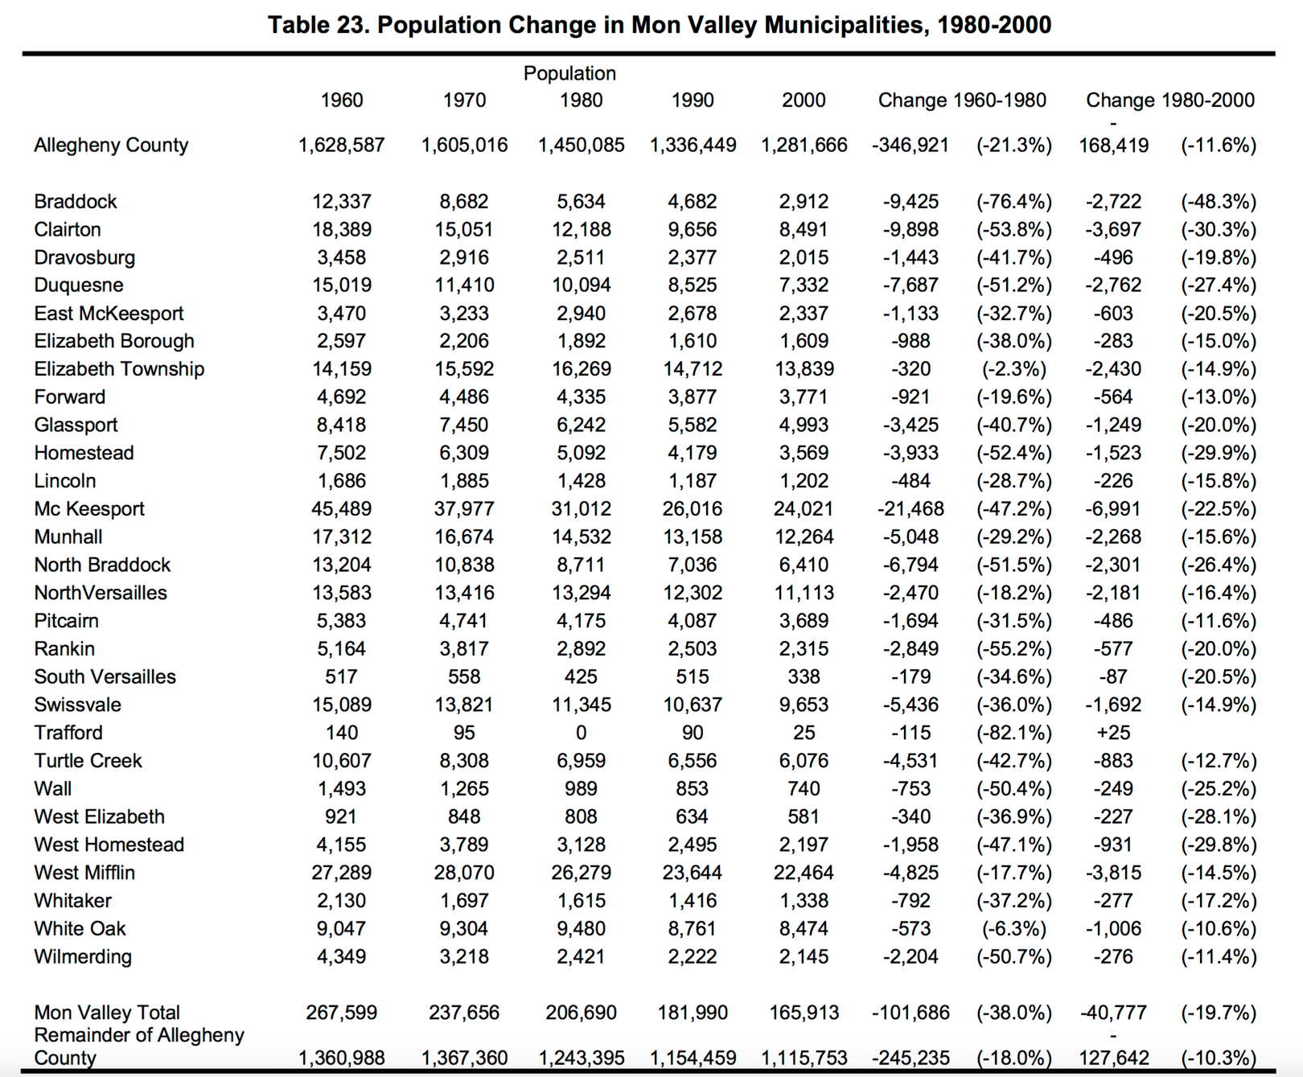

Figure 3. Population change in Monongahela River Valley municipalities, 1980-2000.

Source: Housing and Socio-Demographic Trends part of the Allegheny County Comprehensive Plan out of the University of Pittsburgh.

Economic stability that came along with the jobs generated by the steel mills in these towns appeared to have declined as rapidly as the population did. The deindustrialization of the area from the 1970’s on has had lasting negative economic effects on the Monongahela River Valley. Across Allegheny County, lowest household incomes are found in Pittsburgh, the Mon Valley, and nearby river communities. The Mon Valley currently has above average rates of people on welfare and social security. Statistically, 2 out of every 5 households in the region receives social security benefits. Similarly, there are 33 out of 40 Mid-Mon Valley municipalities with average incomes less than the state average. Another 33 out of 40 households in the MonValley region have at least one person in their residence over 65 years old. Essentially, “about 5,000 of the Valley’s 117,398 residents are dependent upon public assistance” (US Census).

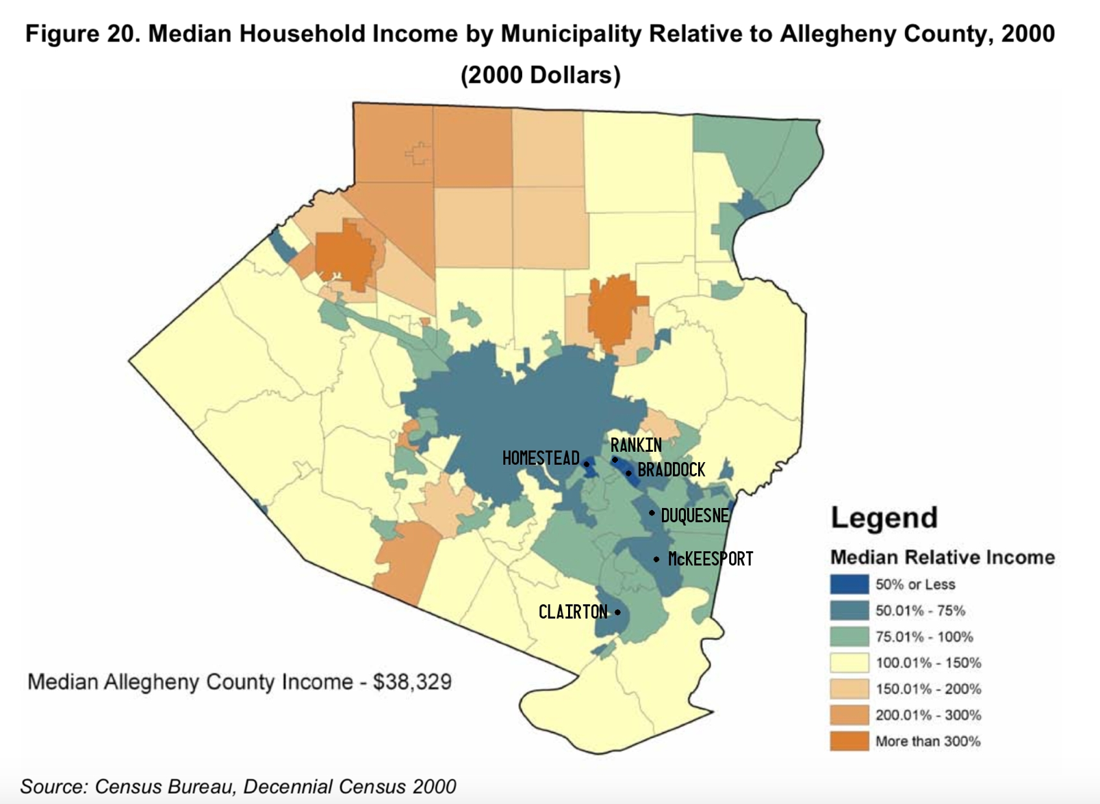

Figure 4. Median household income by municipality relative to Allegheny County, 2000

Source: Census Bureau, Decennial Census 2000

As seen in Figure 4, median household incomes in MonValley communities are mostly 50% less than the county average of $38,329. While residents in low-income communities face an assortment of social, financial, and political obstacles, environmental injustice is seen most of all in the once industrialized regions filled with legacy pollution that continues to effect people. Despite air quality improvements since the industrialization of most of Pittsburgh neighborhoods, the remaining mills are still located in communities of color, low income, and aging populations. The associated effects on health and environment occurring in these areas continue due to a lack of protection through laws, regulations, and governmental programs (Maantay, 2002). The Edgar Thomson Steel Works, owned by US Steel, is located in the heart of Braddock near businesses, restaurants, and schools**.** The mill has been active since opened by Andrew Carnegie in 1872. While most Mon Valley communities see similar air quality and associated risk, Braddock in particular sits below some of the most polluted air in America. Figure 3 illustrates distribution by race of the most affected areas in the Monongahela River Valley. Overwhelmingly, these areas are predominantly communities of color.



Figure 5. Population distribution by race

Data source: United States Census Bureau

The scope of the Mon Valley’s air toxicity is emblematic of what it means to suffer from environmental injustice. The public health threats that affect communities of color with limited resources whom bear the brunt of pollution intersect with other societal challenges. Policy that protects such areas is needed in order to revive the economy, schooling, and public health (Mock and Montgomery, 2018).

# Conclusion

Over the past decade substantial research on particulate matter air pollution and the established health endpoints has improved. Not only has particulate matter been found to exert greater impact on established health endpoints, but is also responsible for a larger number of disease outcomes. These studies, data have “firmly established this significant public health problem, there has been an enormous effort to identify what it is in ambient PM that affects health and to understand the underlying biological basis of toxicity by identifying mechanistic pathways” (APHA, 2017). In turn, this information can be used to guide further research and policy in order to protect communities and vulnerable populations from toxics found in air pollution. Public awareness and opinion generated from air quality studies can communicate the emerging risks of poor air quality and the toll in can take on public health, the local economy, education, and general quality of life. An intervention in moving towards cleaner air depends upon air monitoring and reporting of data to keep the public informed, as well as realistic and effective policies to reduce emissions. Millions of Americans live in areas exposed to air pollution levels far exceeding national averages and EPA mandated allowances. Largely those most exposed to these situations are low-income neighborhoods and people of color living in close proximity to industrial sites in areas of legacy pollution such as those living in Mon Valley communities. In order to assure all individuals have equal opportunity to live in healthy environments, governmental agencies and policy makers should aggressively address pinpointed exposures to hazardous air pollutants.

Air pollution reduction strategies are highly political in nature often including policy change and governmental regulation changes. Impact assessment studies suggest that public health greatly benefits from cleaner air. In general, the Monongahela Valley’s history of fossil fuel combustion and reliance on polluted energy suggests that “for many policy options, the benefit of air pollution abatement will go far beyond what prudent health-impact assessments may derive. From a climate change and air pollution perspective, improved energy efficiency and a strong and decisive departure from the "fossil fuel" combustion society is a science-based must” (Kuenzli, 2002). Implementing plans to combat both air pollution and health inequities in at risk communities may occur through assorted prospects. Firstly, providing guidance in implementing monitoring technologies in communities to assess localized air quality exposure would allow communities to assess their own risk and choose how to utilize the data. Local government and health departments could critically help communities analyze and assess data in order to communicate hazards and solutions. The Pittsburgh areas widespread child asthma cases are largely uncontrolled. Recent research shows that 60% of all childhood asthma cases in the Pittsburgh area are uncontrolled, meaning these children suffer from symptoms but lack diagnosis and subsequently lack treatment. Compared to the Pennsylvania state average of 27%, it’s clear that there is a lack of health equity. Mandating schools to require asthma screening and similar respiratory examinations can help eliminate uncontrolled cases of asthma. According to an Environmental Health News report on Pittsburgh asthma rates, an attending Pittsburgh physician had “actually met kids that are only breathing at about a third of the capacity they should be" (Marusic, 2018.). Collaboration between local government officials, the Alleghany County Health Departments, and state representatives to advocate for legal change and better regulations on major polluters is crucial in reducing exposures. Similarly, there is a need for government agencies to advocate for renewable energy sources. The long-term benefits of cleaner energy outweigh the costs of air pollution controls and alternatives. In order to reduce industrial emissions and our reliance on fossil fuels, eliminating highly polluting sources of energy is a tangible solution.

Personal abatement strategies are meaningful to adopt as well. Measures to take against ambient air pollution on an individual level include habitual changes to daily schedules. Raising awareness and educating the community about air quality warnings can allow vulnerable populations to further protect themselves. Regulating daily activities according to the air quality index (AQI) further protects individuals (Jiang, Xu-Qin, et. al. 2016). AQI can vary from locale and outcomes depend on overall concentration of air pollutants and duration of exposure. Adjusting daily activity based on AQI and local air quality reports is an education and awareness initiative that gives individuals immediate control. While changes are needed on a legislative level, legal change can take a while**.**

Cultural influences, access to health services, socioeconomic status and literacy levels all comprise social determinants of health. The fundamental influences are further impacted by environmental factors such as air and water quality. An unhealthy environment can lead to health disparities when areas where people live, and work are burdened by social inequities. Monongahela River Valley communities experience these environmental health disparities through their unequal exposure to high air pollution levels and greater burden of disease than wealthier, less polluted communities in other areas of Pittsburgh.

Abundant studies been done to better understand the correlation between air pollution exposures and socioeconomic disparities. Monitoring and research continue to recognize the relationship between the two. Initiatives to reduce inequities in pollution exposures and resulting health outcomes have only improved in the past few decades after the start of the environmental justice movement in the 1990s. An effort to eliminating environmental injustice requires a nuanced understanding of its causes. Various factors contribute to this including but not limited to discriminatory siting in industry, weak policies, unequal regulation and enforcement, and unequal political power. To better focus public health efforts in alleviating these social and economic disparities and reduce overall air pollution, multiple avenues of action are necessary to create political and social change on a national and regional level.

# Bibliography

1. ACHD. “Air Quality Reports and Studies.” *Allegheny County Health Department.* <https://www.alleghenycounty.us/Health-Department/Resources/Data-and-Reporting/Air-Quality-Reports/Air-Quality-Reports-and-Studies.aspx>
2. AIRNow (2019). AIRNow Archives: Air Quality Maps Monthly Overview. *Pennsylvania EPA.* <https://airnow.gov/index.cfm?action=airnow.mapsarchivecalendar>
3. APHA. (2017). “Public Health Opportunities to Address the Health Effects of Air Pollution” *American Public Health Association.* <https://www.apha.org/policies-and-advocacy/public-health-policy-statements/policy-database/2018/01/18/public-health-opportunities-to-address-the-health-effects-of-air-pollution>
4. Carey IM, Atkinson RW, Kent AJ, et al. (2013). “Mortality associations with long-term exposure to outdoor air pollution in a national English cohort.” *American Journal of Respiratory Critical Care Medicine.*
5. Clean Air Act Overview. (2019). “Air Pollution: Current and Future Challenges.” *United States Environmental Protection Agency*. <https://www.epa.gov/clean-air-act-overview/air-pollution-current-and-future-challenges#toxic>
6. Dietrich, William S., II. (2014). “A Very Brief History of Pittsburgh.” *Pittsburgh Quarterly.*
7. Deitrick, Sabina, Christopher Briem, & Angela Williams. University of Pittsburgh. “Housing and Socio-Demographic Trends” *Allegheny County Comprehensive Plan.* December 2005. <https://ucsur.pitt.edu/files/center/HousingSociodemTrends2005.pdf>
8. Elliot, Jennifer, Albert Prestio, and Deborah Gentille. (2017). “Special Report: Study reveals air pollution contributes to alarmingly high asthma rates in Clairton*.” Allegheny County Medical Society Bulletin*. <https://www.acms.org/wp-content/uploads/2019/07/17aug.pdf>
9. Frazier, Reid. (2019). *“*Groups sue US Steel alleging potentially ‘thousands’ of Clean Air Act violations.” *State Impact Pennsylvania NPR.* <https://stateimpact.npr.org/pennsylvania/2019/04/29/groups-sue-u-s-steel-alleging-potentially-thousands-of-clean-air-act-violations/>
10. Frazier, Reid. (2019). “Razorblades and feathers in my throat”: a fire at a US Steel plant near Pittsburgh made a major polluter even worse*. State Impact Pennsylvania NPR.* <https://stateimpact.npr.org/pennsylvania/2019/04/15/razorblades-and-feathers-in-my-throat-a-fire-at-a-u-s-steel-plant-near-pittsburgh-made-a-major-polluter-even-worse/>
11. Friedman MS, Powell KE, Hutwagner L, et al. (2009). “Respiratory Health and Air Pollution.” *Center for Disease Control and Prevention.* <https://www.cdc.gov/features/air-quality-hearthealth/index.html>
12. Hamzah NA, Mohd Tamrin SB, Ismail NH. (2016). “Metal dust exposure and lung function deterioration among steel workers: an exposure-response relationship.” *Int J Occupational Environmental Health*.
13. Jerret and Levy Jerrett M, Burnett RT, Kanaroglou P, Eyles J, Finkelstein N, Giovis C, et al. (2001). “A GIS–environmental justice analysis of particulate air pollution in Hamilton, Canada.” *Journal of Exposure Science and Environmental Epidemiology.*
14. Jiang, Xu-Qin, Mei, Xiao-Dong, and Feng, Di. (2016). “Air pollution and chronic airway diseases: what should people know and do?” *Journal of Thoracic Disease.*
15. Jones, Charles O. (1975). “Clean Air: the policies and politics of pollution control.” *University of Pittsburgh Press.* <https://digital.library.pitt.edu/islandora/object/pitt%3A31735057893657/viewer#page/1/mode/2up>
16. Kelly, Frank J and Fussel, Julia C. (2015). “Air pollution and public health: emerging hazards and improved understanding of risk.” *Environmental Geochemistry and Health.* <https://www.ncbi.nlm.nih.gov/pmc/articles/PMC4516868/>
17. Kuenzli, Nino (2002). “The public health relevance of air pollution abatement” *Institute for Social and Preventive Medicine, Basel University.* <https://www.ncbi.nlm.nih.gov/pubmed/12166570>
18. Maantay, Juliana (2002). “Mapping Environmental Injustices: Pitfalls and Potential of Geographic Information Systems in Assessing Environmental Health and Equity.” *Department of Geology and Geography, Lehman College.* <https://ehp.niehs.nih.gov/doi/pdf/10.1289/ehp.02110s2161>
19. Marusic, Kristina. (2018). “ER visits for asthma dropped 38% the year after one of Pittsburgh’s biggest polluters shut down.” *Environmental Health News*. <https://www.ehn.org/shenango-coke-works-closed-asthma-dropped-2566777141.html?rebelltitem=1#rebelltitem1>
20. Marusic, Kristina. (2019). “Pittsburgh air has been unsafe for people with asthma for 25% of days in 2019 so far*.” Environmental Health News.* <https://www.ehn.org/pittsburgh-warned-stay-indoors-pollution-2627997216.html>
21. Marusic, Kristina. (2018). “Q&A with Rich Fitzgerald, Allegheny County PA Executive.” *Environmental Health News*. <https://www.ehn.org/rich-fitzgerald-jim-kelly-asthma-2595821272.html>
22. Mock, Brentin and David Montgomery (2018). “Environmentalists by Necessity.” *CityLab.* <https://www.citylab.com/environment/2018/08/environmentalists-by-necessity/566480/>
23. Muller, Edward K (2001). “Industrial Suburbs and the Growth of Metropolitan Pittsburgh from 1870-1920.” *Journal of Historical Geography.*
24. NCA. (2014). “National Climate Assessment Full Report.” *U.S. Global Change Research Program.* <https://nca2014.globalchange.gov/report>
25. O’Neill, Marie S., Jerret, Michael, Kawachi, Ichiro, Levy, Jonathan, I., Cohen, Aaron J., Gouveia, Nelson, Wilkinson, Paul. (2003). “Health Wealth and Air Pollution: Advancin Theory and Methods.”  *National Center for Biotechnology Information.* <https://www.ncbi.nlm.nih.gov/pmc/articles/PMC1241758/pdf/ehp0111-001861.pdf>
26. Particulate Pollution. (2017). Pennsylvania: Allegheny County. *American Lung Association.* <https://www.lung.org/our-initiatives/healthy-air/sota/city-rankings/states/pennsylvania/allegheny.html>
27. “Pittsburgh Air Pollution” (2019). *Clean Air Council Public Health Program*. <https://cleanair.org/public-health/pittsburgh-air-pollution/>
28. “Pittsburgh Regional Environmental Threats Analysis (PREATA) Report.” (2013). *University of Pittsburgh Graduate School of Public Health Center for Healthy Environments and Communities.* <http://www.heinz.org/UserFiles/Library/PRETA_HAPS.pdf>
29. “Pittsburgh’s Dark History” (2015). *Popular Pittsburgh.* Popular Pittsburgh <https://popularpittsburgh.com/darkhistory/>
30. PM days 2015-2016 <https://infogram.com/bad-air-days-shenango-vs-clairton-1h8n6mn75n1m2xo>
31. United States Census Bureau. “General Population and Housing Statistics, Demographic and Housing Estimates.” *American Fact Finder.* <https://factfinder.census.gov/faces/nav/jsf/pages/community_facts.xhtml?src=bkmk>
32. US Census (2018). Quick Facts Allegheny County, Pennsylvania. United States Census Bureau. <https://www.census.gov/quickfacts/alleghenycountypennsylvania>
33. Villeneuve, P.J., Burnett, R.T., Shi, Y., Krewski, D., Goldberg, M.S., Herzman, C., Chen, Y., Brook, J., (2003, November). A time-series study of air pollution, socioeconomic status, and mortality in Vancouver, Canada. *J. Expo. Anal. Environ. Epidemiol.*
34. World Health Organization. (2019). “Environmental Impacts on Health.” *Electronic Library of Construction Occupational Safety and Health* <http://elcosh.org/document/4214/d001498/who-infographic%3A-environmental-impacts-on-health-what-is-the-big-picture%3F.html>