\Title Page
Utility of CREBRF Genotype with BMI in Prediction of Type 2 Diabetes

by

Jessica Tiner

BS Biology, BS Biochemistry, Elmira College, 2018, 2018

Submitted to the Graduate Faculty of the

Department of Human Genetics

Graduate School of Public Health in partial fulfillment
of the requirements for the degree of

Master of Public Health

University of Pittsburgh

2020

Committee Page
UNIVERSITY OF PITTSBURGH

Graduate School of Public Health

This essay is submitted

by

Jessica Tiner

on

May 5, 2020

and approved by

Essay Advisor: Ryan Minster, PhD, MSIS, Assistant Professor, Human Genetics, Graduate School of Public Health, University of Pittsburgh

Essay Reader: Candace Kammerer, PhD, Associate Professor, Human Genetics, Graduate School of Public Health, University of Pittsburgh

Essay Reader: Jenna Carlson, PhD, Assistant Professor, Biostatistics, Graduate School of Public Health, University of Pittsburgh

Copyright © by Jessica Tiner

2020

Abstract
Ryan Minster, PhD
Utility of CREBRF Genotype with BMI in Prediction of Type 2 Diabetes

Jessica Tiner, MPH

University of Pittsburgh, 2020

Abstract
Type 2 diabetes (T2D) is a major global health concern which particularly affects Samoans, who have high rates of obesity (66% of women and 45% of men) and, as a result, face high rates of obesity-related morbidities including diabetes. In Samoa in 2013, 23% of women and 21% of men were diabetic. The minor allele of a common genetic variant in Samoans, rs373863828 (CREBRF:p.R457Q) has been associated with a 1.6-fold lower risk of T2D. The American Diabetes Association recommends screening adults for T2D when their BMI is >25 kg/m². This BMI action point might be inappropriate for Samoans and more precise values may be determined using genetic information. Here we determine how the addition of CREBRF genotype affects the usefulness of BMI in predicting T2D status in Samoans. We used receiver operating characteristic (ROC) curves analysis to assess the utility of BMI with and without the genotype in predicting diabetes status, BMI action points and specificity at 80% sensitivity, in men and women, both overall and by genotype group. In females, the 80% sensitivity action points for BMI were 30.3 kg/m² overall (with 27% specificity), 30.3 kg/m² for GG (30%), 31.4 kg/m² for GA (30%), and 29.7 kg/m² for AA (17%). In men, they were 28.7 kg/m² overall (with 40% specificity), 27.8 kg/m² for GG (39%), 30.6 kg/m² for GA (48%), and 32.2 kg/m² for AA (57%). These analyses show that higher Samoan-specific screening thresholds are merited, and that the addition of the CREBRF genotype does not usefully alter the ability of BMI to predict T2D as assessed by examining the change in the AUC. However, 80% sensitivity threshold values by genotype suggest that including CREBRF genotype may be beneficial over BMI alone, by improving specificity without loss of sensitivity. This benefit needs to be weighed nonetheless against the costs of genotyping for this variant. The public health significance of this study is that it illustrates the need for stronger T2D screening and prevention outreach in Samoa. In addition, it supports the creation of higher, Samoan-specific BMI action points to be used for T2D screening.

Table of Contents
Preface x
1.0 Introduction 1
1.1 Rising Prevalence of Obesity and Diabetes in Samoa 2
1.1.1 Changes in Samoa and the Impact on Health 3
1.1.2 Attitudes and Beliefs of Samoans on Health 5
1.2 Type 2 Diabetes 6
1.2.1 Screening and Treatment 8
1.2.2 Non-genetic risk factors associated with developing type 2 diabetes 9
1.2.3 Genetics and Diabetes 10
1.3 CREBRF 12
1.3.1 Function of CREBRF 12
1.3.2 CREBRF in Other Populations 13
1.4 Hypothesis 14
2.0 Methodology 15
2.1 Sample Collection 15
2.1.1 Sample Demographics 16
2.2 Sample Limitations 18
2.3 Statistical Analysis 19
3.0 Results 20
4.0 Discussion 26
5.0 Conclusion 31
Bibliography 33

List of Tables
Table 1. Number of females and males diabetic and non-diabetic participants separated by genotype. 18
Table 2. Sensitivity and Specificity at current ADA screening recommendations (BMI = 25 kg/m²) overall and per genotype group for each sex. 22
Table 3. The resulting BMI action point and specificity value corresponding to a sensitivity of 80% in females overall and per genotype. 23
Table 4. The resulting BMI action point and specificity value corresponding to a sensitivity of 80% in males overall and per genotype. 23

List of Figures
Figure 1. Histogram of age in females. 17
Figure 2. Histogram of age in males. 17
Figure 3. ROC Curve for BMI and diabetes, adjusted for age in females without CREBRF genotype (blue) and with CREBRF genotype (black). 20
Figure 4. ROC Curve for BMI and diabetes, adjusted for age in men without CREBRF genotype (blue) and with CREBRF genotype (black). 21
Figure 5. Sensitivity by BMI action point for each genotype in females. 24
Figure 6. Sensitivity by BMI action point for each genotype in males. 25

Preface
I would like to thank my parents for supporting me through this process and Richard for always being my rock. Also, thank you to Dr. Minster and the faculty at Pitt Public Health who helped me with this project.

Introduction
Noncommunicable diseases (NCDs) have been on the rise in populations across the globe and have been estimated to account for 71% of all deaths. Approximately 37% of deaths from NCDs are premature, occurring in individuals aged 30 to 69 (World Health Organization (WHO), 2018). Reducing the prevalence and the threat of premature death from chronic conditions is a serious public health challenge in all nations. However, a disproportionate number of premature deaths caused by NCDs are occurring in low- and middle-income countries (LMIC) with these communities accounting for 85% of premature deaths from NCDs (WHO, 2018). This striking disparity illustrates the need for additional development of preventative programing targeting NCDs in LMICs.
Samoa, officially known as the Independent State of Samoa, is one of many nations struggling to address the rising number of NCDs affecting its community. Located in the Pacific Ocean, Samoa includes two main islands and other small islands which together house almost 200,000 people (WHO, 2017). Samoa is classified as a lower-middle–income country with an average annual health spending of $232 per person (The Institute for Health Metrics and Evaluation, 2019). The government is responsible for a majority of healthcare spending. Of the $232, the Samoan government pays $178 per person. Much like other nations, NCDs are the largest threat to health in Samoa. They accounted for approximately 81% of total deaths in 2016 (WHO, 2018). In 2013, half of individuals between 18 and 64 years old were classified as being high risk of developing an NCD (WHO, 2017). The increasing rate of NCDs is not only a major health concern, but also an economic one as well. These chronic conditions can have severe impacts on a country’s economy because of the direct medical coasts and the loss of wages (WHO, 2016). In addition to having an impact on the country itself, the financial burden of NCDs can also affect the global economy.

Rising Prevalence of Obesity and Diabetes in Samoa
Similar to many countries, the prevalence of obesity and T2D have been on the rise in Samoa. In 1978, approximately 27.7% of men and 44.4% of women in Samoa had obesity with a body mass index (BMI) value of ≥ 30 kg/m². Thirty-five years later, the prevalence of obesity had risen to be 53.1% of men and 76.7% of women (S. Lin et al., 2017). The greatest change was seen in the younger age groups. Obesity prevalence increased by 4.6 percentage points per 5 years in 25–34 year-olds, whereas the increase was 4.2 percentage points per 5 years for 35–44 year-olds, 45–54 year-olds, and 55–64 year-olds (S. Lin et al., 2017).
Similar trends have been seen in the number of Samoans affected by diabetes. An estimated 2.2% of women and 1.2% of men were diabetic in 1978. In 2013, 19.5% of women and 19.6% of men were diabetic (S. Lin et al., 2017). This increase has been seen across all age groups. However, older age groups had higher increases in obesity prevalence. For 25–34 year-olds, there was a 1.2% change per 5 years while 55–64 year-olds showed an 3.5% increase per 5 years (S. Lin et al., 2017). Lin and colleagues (2017) used random-effects meta-regression to estimate levels of obesity and T2D in Samoa in 2020. Obesity prevalence is expected to be 59% in men and 81% in women. Type 2 diabetes is estimated to affect 26% of both men and women (S. Lin et al., 2017).

Changes in Samoa and the Impact on Health
Since World War II, Pacific Island communities have experienced significant changes that have altered the lifestyles and health of their residents. Modernization, urbanization, and migration have each been involved in the transformation into present day Samoa. Examples of these changes include altered diets in response to new food being imported and less physical activity as a result of more individuals working in sedentary office settings (Hawley & McGarvey, 2015). These are examples of environmental factors which have substantial impacts on health and are partially responsible for the rise in NCDs.
Food access and availability are two major environmental conditions that influence health and the risk of developing chronic conditions. In many LMICs, nutritional transition has caused an increased availability of unhealthy processed foods. This change in food availability has led to individuals consuming higher amounts of foods made with vegetable oil and animal fat and has led to an increased number of poor health outcomes (Popkin, 2004). The traditional Samoan diet is high in coconut products, seafood, and high fiber carbohydrates, such as yams and taro. This traditional diet has been replaced by a modern one characterized as being high in red meat and highly processed, fatty foods (Wang et al., 2017) . Examples of these processed foods include potato chips, rice, and instant soup (DiBello et al., 2009). A cross-sectional study analyzing dietary patterns in American Samoans found that individuals following a traditional diet, in which they consumed higher amounts of saturated fats and fiber, had smaller abdominal circumferences and higher HDL cholesterol concentrations. The modern diet was associated with higher triglyceride levels and an increased prevalence of metabolic syndromes (DiBello et al., 2009). This highly processed food is cheaper compared to the price of high quality, nutritious locally grown locally food (Hawley & McGarvey, 2015).
In addition, the total energy available in the Samoan food system has been increasing since the 1960s. Between 1961 and 2017, there was a 47% increase in the total energy available. The availability of locally grown fruits, coconut products, and root crops has remained stagnant during this period while the availability of meats and vegetable oils increased (Seiden, Hawley, Schulz, Raifman, & Mcgarvey, 2012). In 1997, the average dietary energy supply was 2,767 kcal/cap/day. This increased to 3,004 kcal/cap/day in 2017 (Food and Agriculture Organization of the United Nations (FAO), n.d.) The higher amount of food available in the Samoan system shows that individuals have access to more food, with most food being high in fat. In 2019, the average calories consumed by Samoans is estimated to be 2,800 kcals/capita/day. Most of these calories consumed came from carbohydrates (55%) and fats (34%). The estimated daily consumption of fruits and vegetables is 300 grams for Samoans, 100 grams less than the recommended amount (FAO, 2019).
Samoa has also seen a major shift in industry which has led to fewer individuals working in agriculture settings and more in sedentary jobs. In 1997, the percentage of the workforce employed in agriculture was 41.7%. This number dropped to 5.2% in 2017 (FAO, n.d.). This shift from a self-agriculture–based to a market-based economy has led to changes major changes in behaviors (Hawley & McGarvey, 2015). With more Samoans working at stationary office jobs as opposed to working in the farming industry, the country as a whole is less physically active. In addition, more individuals are moving into urban areas and getting less exercise (Hawley & McGarvey, 2015). The World Health Organization recommends that individuals 18 through 64 years old get a minimum of 150 minutes of moderate-intensity exercise or 75 minutes of vigorous activity per week (WHO, 2011). The 2002 WHO Step Survey estimated that 51.7% of Samoan adults aged 24 through 64 had low levels of activity defined as less than 600 MET minutes per week which equates to the WHO recommended weekly amount (WHO, 2002). High levels of physical activity have been associated with numerous health benefits. A 10-year long cohort study showed that adults who completed more than 5,000 MET minutes a week had a 2-fold higher chance of successful aging, defined as absence of disability, poor mental health and chronic disease, compared to those who completed less than 1,000 MET minutes/week (Gopinath, Kifley, Flood, & Mitchell, 2018). Therefore, because physical activity has a significant impact on health, this cultural shift towards a sedentary lifestyle is important to consider when analyzing the rise in NCDs.

Attitudes and Beliefs of Samoans on Health
Health literacy is an essential piece of an individual’s physical health. This concept encompasses an individual’s skills, beliefs, knowledge, motivation, and attitudes on any topic related to health. Being able to understand the health implications of a behavior may encourage individuals to act differently. In public health, addressing health literacy is critical for addressing any health problem, especially NCDs which are significantly impacted by behaviors. Patients with low literacy are at greater risk of poorer health outcomes (Gorman, 2012). In Samoa, most students transition into secondary school. However, a 2014 report estimated that 50% of 11 and 12 year-old year-6 students were at risk for poor educational outcomes (World Bank Group, 2014). Having a low-level literacy creates a barrier between patients and healthcare workers and thus is important to focus on when creating impactful solutions.
In Samoa, a number of cultural beliefs (i.e., fa‘asāmoa or “the Samoan way”) may influence health literacy. A research study by Bollars et al., based on the model of the European Health Literacy project (HLS-EU), interviewed six different focus groups to better understand how individuals gain, comprehend, and apply information in a health setting. Researchers discovered seven different concepts as part of fa‘asāmoa that may be influencing their health. These concepts included: the role of the community, perception of health systems, adherence to medication, the role of the family circle (‘āiga), traditional medicine, basic knowledge of NCDs, and lack of personal ownership (Bollars, Sorensen, de Vries, & Meertens, 2019). All of these concepts are involved in the development of NCDs and should be considered when developing interventions. Notably, in Samoa, an individual’s health is not a personal issue but instead is influenced by decisions of multiple of people. The ‘āiga is responsible for making health decisions which are often greatly influenced by community leaders. The Church also plays significant role in decision making (Bollars et al., 2019). Christianity is the predominate religion in Samoa and the opinions of church and community leaders are considered when making health decisions.
In addition, although there is a basic knowledge of the risk factors leading to NCDs, there is still a lack of understanding on the consequences of these conditions. Poor adherence to medication and negative perception of the healthcare system are both casual factors in the development of NCDs and poor health outcomes. Moreover, the importance of understanding fa‘asāmoa is critical to better understanding the reasons why individuals are developing NCDs and to identify the best ways to address the problem.

Type 2 Diabetes
Diabetes is a group of metabolic conditions defined by the presence of hyperglycemia, high blood glucose. Diabetes is separated into types based on the mechanism behind the development of the disease. Type 1 diabetes is a condition that occurs when the body destroys β-cells in the pancreas, thus inhibiting the production of insulin. Type 2 diabetes (T2D), also referred to as non-insulin dependent diabetes, is the most common kind of diabetes, accounting for 90%–95% of cases (American Diabetes Association (ADA), 2014). In T2D, the body becomes resistant to insulin. Insulin is responsible for signaling the body to remove sugar from the blood. In both forms of diabetes, this pathway is blocked, and blood glucose levels remain high leading to negative impacts on the body. T2D is commonly diagnosed in older individuals but has been appearing more often in younger individuals. In the United States, between 2002 and 2012, incidence rates of T2D in adolescents (10–19 years of age) increased by 7.1% annually (Mayer-Davis et al., 2017). A majority of individuals with T2D are obese or have a high amount of abdominal body fat (ADA, 2014). Thus, with increased rates of obesity, there has been a corresponding increase in T2D. Globally, T2D prevalence has been continuing to increase and today, over one billion people have the disease (International Diabetes Federation, 2019).
Chronic hyperglycemia can impair critical systems such as the nervous, urinary, and cardiovascular systems. Organs at greatest risk of damage include the kidneys, eyes, and heart. Common symptoms of hyperglycemia include excessive urination, weight loss, excessive thirst, and blurred vision. Individuals with T2D can fail to notice these clinical symptoms, and because of this, T2D often goes undiagnosed and can lead to severe health outcomes. If left untreated, T2D can lead to renal failure, loss of vision, and foot ulcers and amputations (ADA, 2014).
Although the prevalence of particular NCDs varies among different populations, Pacific Islanders have a disproportionately higher number of obesity and type 2 diabetes cases (T2D) (Karter et al., 2013; King et al., 2012). The death rate from T2D is similar between Samoa and the United States. In 2007, there were 29 deaths per 100,000 people in Samoa caused by diabetes (Fan & Le’au, 2015). In the US, the death rate from diabetes was 25.7 per 100,000 individuals (Kenneth D. Kochanek, M.A., Sherry L. Murphy, B.S., Jiaquan Xu, M.D., and Elizabeth Arias, Ph.D., 2017). However, LMICs tend to have a higher number of undiagnosed cases of diabetes compared to non-LMICs. A review completed by Beagley et al., compared rates of undiagnosed diabetes globally by separating countries into seven regions and three different World Bank income classification (low, middle, and high). An estimated 83.8% of cases of undiagnosed diabetes were in low- and middle-income countries. The top 10 countries with the highest rates of undiagnosed diabetes were all in the Pacific Islands (Beagley, Guariguata, Weil, & Motala, 2014).

Screening and Treatment
Type 2 diabetes can be a manageable disease if an individual has access to proper healthcare and treatment. Effective treatment plans, which may include changing diet and incorporating more physical exercise, and medication, can greatly improve a patient’s outcome. Proper diagnosis of the condition is necessary for these plans to be implemented. Individuals who are left undiagnosed or go without treatment may experience severe health outcomes. Chronic high blood sugar can cause kidney, eye, and other various organs to fail which will eventually lead to premature death (WHO, 2016). Thus, screening and diagnostic testing for T2D are important tools for identifying cases and preventing these poor health outcomes.
Screening refers to procedures used to identify asymptomatic individuals at high risk of developing a condition. Diagnostic testing is used to confirm whether a patient has a disease. The ADA recommends that individuals above the age of 45 and at a BMI action point of 25 kg/m² should be screened for T2D. Other factors that may impact the decision to screen include family history, presence of symptoms, and having other conditions such as low HDL cholesterol or hypertension (ADA, 2004). Race and ethnicity are also considered when deciding to screen a patient for T2D. For example, Asian populations develop T2D at a lower BMI compared to White populations, thus screening recommendations have been lowered to an action point of 23 kg/m² (Hsu, Araneta, Kanaya, Chiang, & Fujimoto, 2015).
Fasting plasma glucose (FPG) is most the commonly used test for determining diabetes status. This test measures an individual’s blood sugar levels after eight hours of fasting from food. A similar test is the 75 g oral glucose tolerance test (OGTT) which measures an individual’s blood sugar levels both before and two hours after they consume a sugary beverage. Because of the time involved, an FPG test is more often used. If an individual is unable to fast, a plasma glucose test may be used (ADA, 2004). All three of these tests require a blood draw and may be expensive to provide in an area with limited health resources. A cost analysis study in the United States determined that the cost of screening individuals aged 45–74 years at a BMI ≥ 25 kg/m² ranged from $215 to $282 per case identified (Zhang et al., 2003). OGTT was determined to be the most cost-effective strategy, yet this may not be the same case in other scenarios.

Non-genetic risk factors associated with developing type 2 diabetes
Multiple factors are associated with increasing an individual’s risk of developing T2D. These include obesity, dietary behaviors, and physical exercise. Obesity itself can lead to insulin resistance, and most individuals with T2D are obese. Individuals without obesity who nonetheless have a high percentage of abdominal body fat may also be at a higher risk of developing the disease (ADA, 2014). This is because the proportion and location of fat, rather than the amount, affects an individual’s risk of developing T2D. Individuals with a high percentage of abdominal fat are at a higher risk of the condition compared to individuals with the same body mass index (Hayashi et al., 2008).
In addition to weight, individual behaviors such as diet and exercise are significant in T2D development. High caloric diets comprised of animal fats and processed sugars, along with a sedentary lifestyle, greatly increases an individual’s risk of developing T2D (Ma, 2010). Family history of diabetes also is a significant factor in determining an individual’s risk of the disease. Individuals who have a first-degree relative with T2D are estimated to have a three times greater risk of developing the disease compared to those without the disease in their immediate family (Ali, 2013; Florez, Hirschhorn, & Altshuler, 2003).

Genetics and Diabetes
Family history and genetics are important risk factors in the development of T2D. Both type 1 and type 2 diabetes are polygenic, meaning that they are influenced by multiple genes. There is clear evidence that having a close family member, such as a parent or a sibling, with the condition increases an individual’s risk of developing T2D. Simmons et al. 1995 found that, in a diabetic cohort of Pacific Islanders, 15% of individuals had a mother with T2D and a nonaffected father, approximately 4% of the cohort had both parents affected, and 22% of individuals had a sibling with T2D.
In addition to the polygenic forms of diabetes, monogenic forms exist that are associated with mutations in specific genes. One example is Maturity onset diabetes of the young (MODY) which develops when insulin cannot be secreted by the pancreas (ADA, 2014). This condition often occurs during adolescence or late-adulthood and is estimated to account for 1% to 5% of diabetes cases in the United States (National Institutes of Health, 2007). Unlike other forms of diabetes, individuals with MODY typically are of normal weight. MODY is not protective against obesity, and thus individuals with MODY can still develop insulin resistance. (R. Naylor & Johnson, 2019). The inheritance pattern for MODY is autosomal dominant, so individuals only need to inherit one copy of the mutated gene in order to develop the disease. Autosomal dominant conditions typically present in each generation and can appear in both sexes. Disease can also be inherited through de novo mutations, meaning that unaffected parents can pass a new mutation causing the disease to their child. As a result, an affected individual may not necessarily have a family history of the disease. Currently, there have been 14 different pathogenic variants associated with MODY and multiple other genes of interest. Of these variants, those in GCK and HNF1A are the most common. It is estimated that variants in GCK account for 30%–50% of cases, and variants in HNF1A account for 30%–65% of cases (R. Naylor & Johnson, 2019). Along with family history and laboratory testing, molecular genetic testing is often used to diagnose MODY.
In addition to the genes associated with monogenic T2D, over 400 genomic regions have been significantly associated with T2D risk (Mahajan et al., 2018). Unlike the genes associated with MODY, the variants in these regions are typically rare and have a small effect on the development of the disease. However, a few variants have been associated with modest differences in the risk of T2D. An example of this is TCF7L2, variants in which have been found to have a large effect on T2D in Europeans. The variant rs7903146 (NM_001146274.2[TCF7L2]:​c.450+​33966C>T), located in an intron of TCF7L2, has been associated with increased glucose production and reduced insulin secretion (Lyssenko et al., 2007). The 1000 Genomes study estimates that this variant has a risk allele frequency of 0.30 in European and African populations (Auton et al., 2015).
Various genetic studies have sought to identify the genes involved in T2D using genome-wide association studies (GWAS). The number of T2D-associated variants continues to grow as more studies are completed. To date, however, most studies have been conducted with populations of European descent. As a result, little is known regarding the genetics of T2D in Pacific Islander populations. In an effort to address this problem, the Population Architecture using Genomics and Epidemiology (PAGE) Study completed GWAS with 49,839 non–European-ancestries individuals that included 3,940 Native Hawai‘ians for several phenotypes including T2D. In its stratified analyses of only Native Hawai‘ians, no loci were associated with T2D with genome-wide significance (Wojcik et al., 2019).

CREBRF
In Samoans, a genetic variant, rs373863828 (NM_153607.3[CREBRF]:c.1370G>A [p.R457Q]), is associated with both obesity and T2D. Individuals carrying the variant have higher odds of obesity (OR = 1.305) while also having lower odds of having T2D (OR = 0.568) (Minster et al., 2016). Thus, CREBRF is unusual because obesity and T2D are typically thought to be directly associated with each other.

Function of CREBRF
The complete function of CREBRF remains unknown. However, overexpression of it in mouse preadipose cell lines has been found to affect multiple pathways, including cellular energy storage and usage and response to nutritional stress (Minster et al., 2016). When comparing the variant form of CREBRF to the wild type, the variant was found to result in greater energy storage and less energy usage. In Drosophila melanogaster, REPTOR (a CREBRF ortholog) was highly expressed after starvation. In REPTOR-knockout flies, the flies had a lower total energy storage and body weight (Tiebe et al., 2015). Additional research has also discovered that CREBRF is involved in metabolic regulation in muscle and liver cells (Tiebe, Lutz, Senyilmaz Tiebe, & Teleman, 2019). In addition to potentially having a role in obesity and T2D development, CREBRF has also been associated with height in Samoans. Samoan adults and children with the obesity-risk allele of the variant had greater mean height (Carlson et al., 2019).

CREBRF in Other Populations
rs373863828 is extremely rare (minor allele frequency [MAF] < 0.0001) or not found in most populations (including people of European, African, American and Asian ancestries), but approximately 50% of Samoans are carriers for the variant (Minster et al., 2016). This variant and its association with obesity and T2D have also been observed in Māori and other Polynesians in New Zealand (Krishnan, Major, Topless, Dewes, Yu, Thompson, McCowan, de Zoysa, Stamp, Dalbeth, Harré Hindmarsh, et al., 2018), in Tongans (Naka et al., 2017), in Native Hawai‘ians (M. Lin et al., 2019), and in Micronesians living in Guam and Saipan (Hanson et al., 2019). In a study population of Māori and Polynesian individuals living in New Zealand, CREBRF was associated with a difference in log-transformed BMI of 0.038 (95% CI [0.022, 0.055], p = 4.8 × 10⁻⁶) and an odds ratio of 0.59 for T2D (95% CI [0.47, 0.73], p = 1.9×10⁻⁶) (Krishnan, Major, Topless, Dewes, Yu, Thompson, McCowan, de Zoysa, Stamp, Dalbeth, Harre Hindmarsh, et al., 2018). The CREBRF variant has similar effects on BMI and obesity (BMI: β = 1.38 kg/m²; p = 2.5 × 10⁻²⁹) and T2D (OR 0.65, p = 1.5 × 10⁻¹³) across populations where it is present (Hanson et al., 2019).

Hypothesis
CREBRF offers a unique opportunity to potentially utilize genetic information to create genotype-specific diabetes screenings for Samoans. This variant has a significant impact on T2D risk and is also common the population. Thus, CREBRF may provide a clinical benefit in improving the predictability of BMI for T2D.

Methodology

Sample Collection
The Soifua Manuia study, meaning “Good Health” in Samoan, is a research study intended to better understand the genetics of the Samoan population. This study is one of several being conducted by the Obesity, Lifestyle and Genetic Adaptations Study Group (OLaGA; olaga means life in Samoan) centering around improving health in Samoa.
Recruitment methods were previously described in Hawley et al., 2014. From February to July 2010, recruitment for the Soifua Manuia study was completed in 33 villages across Samoa. The villages chosen had a population of at least 500 residents. Nine villages from the Apia Urban Area (AUA) census region were chosen; eight from Northwest Upolu census region (NWU); eight from the Rest of Upolu (ROU) census region; and eight from Savai‘i (SAV). Researchers spent 2–3 days in each village gathering biologic samples and anthropometric measurements from participants. Biologic samples included a fasting (at least 10 hours) blood sample for biochemical analysis and a blood sample for DNA analysis. Researchers collected measurements including blood pressure, height, and weight. Additionally, participants completed questionnaires regarding their health history including what medications they were currently taking.
To be involved with the study, participants had to between 24.5 and less than 65 years old, not pregnant, and have no physical or cognitive impairments that would inhibit their ability to properly complete the questionnaire or take anthropometric metrics. Participants had to be of Samoan ethnicity, which was defined as having four Samoan grandparents.
This study was approved by the institutional review board of Brown University and the Health Research Committee of the Samoa Ministry of Health. Permission to recruit participants in each village was given by the village mayor and women’s committee. Prior to participating, fieldworkers explained details of the study verbally to interested individuals in Samoan. All participants gave written informed consent via consent forms in Samoan language.
T2D status was defined as having a fasting blood glucose level ≥ 126 mg/dl or currently taking medication for diabetes (American Diabetes Association, 2014). To classify obesity in our sample, we used Polynesian BMI ranges of < 26 kg/m² for normal weight, 26 kg/m²–32 kg/m² for overweight, and > 32 kg/m² for obesity.

Sample Demographics
In total 3,504 individuals participated in the study. Of these, 29 participants were subsequently excluded because they did not meet all the inclusion criteria. Information on diabetes status and a blood sample for DNA testing were available for 2,865 participants (1,714 women; 1,151 men). Among the female participants, 288 were classified as having T2D and 1,426 participants were not (Table 1). A majority of the female participants had GG genotype (n = 965), followed by GA (n = 718), and AA (n = 159) (Table 1). The distribution of age among the women is shown in Figure 1. Of the male participants, 183 were classified as having T2D and 968 participants were not (Table 1). Similar to women, the majority of male participants were GG (n = 665), followed by GA (n = 490), and AA (n = 91). The distribution of age among the men is shown in Figure 2.

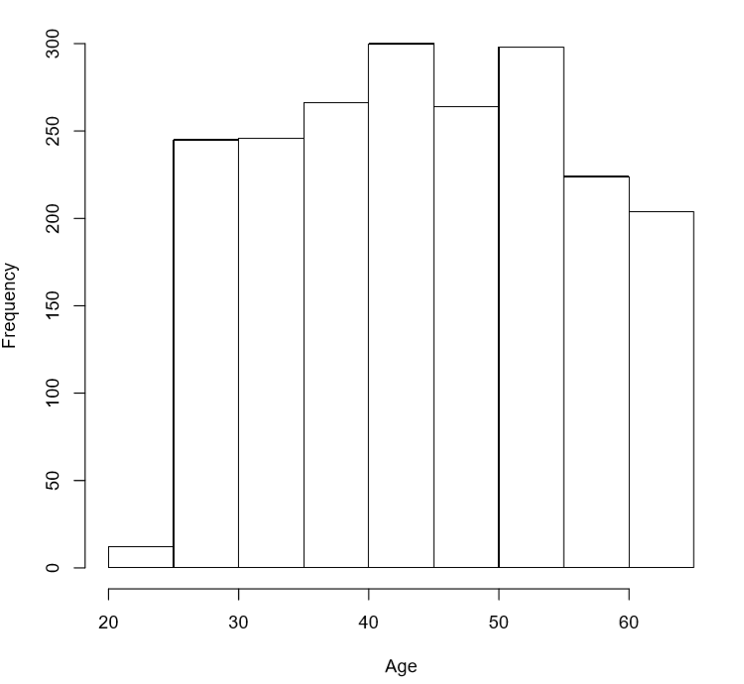

Figure 1. Histogram of age in females.
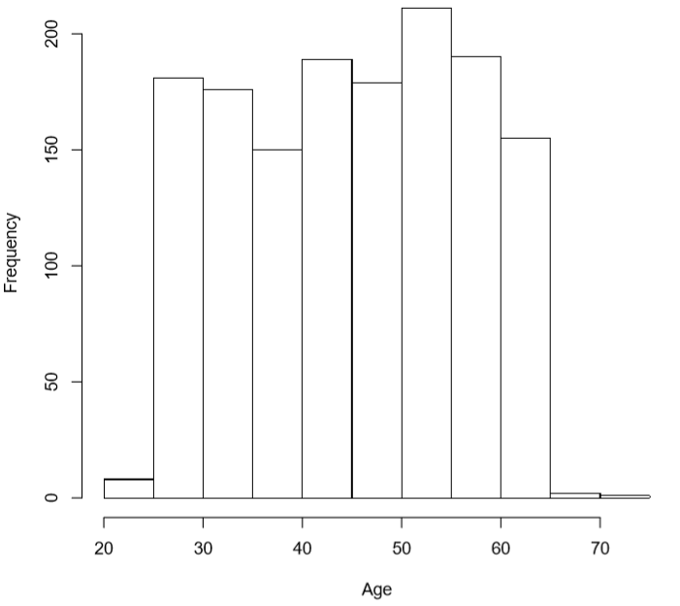

Figure 2. Histogram of age in males.

Table 1. Number of females and males diabetic and non-diabetic participants separated by genotype.
 | Female  (n = 1,714) |  | Male  (n = 1,151)
 | Non-Diabetic | Diabetic | Non-Diabetic | Diabetic
 | n = 1426 | n = 288 | n = 968 | n = 183
GG | 721 (51%) | 183 (63%) | 503 (52%) | 110 (60%)
GA | 577 (40%) | 89 (31%) | 383 (40%) | 67 (37%)
AA | 128 (9%) | 16 (6%) | 82 (8%) | 6 (3%)

Sample Limitations
Although a considerable attempt was made to have a representative sample of Samoa, there were some limitations with the data that was collected. Because of the September 2009 tsunami, recruitment was not completed in Southeastern Upolu (part of ROU) to avoid encumbering the recovering communities. In addition, there was an over-representation of residents from ROU and SAV communities compared to the other areas. Of the participants undergoing genetic testing, 32% of were from ROU; 33%, from SAV; and only 20% were from NWU and 16% were from AUA (Hawley et al., 2014). A higher proportion of women and of older participants were surveyed which is attributed to recruitment occurring during the week while some individuals were working. Women and older individuals tended to be at home more often.

Statistical Analysis
We used receiver operating characteristic (ROC) curve analysis to determine the ability of BMI to predict T2D status. All models were completed separately in men and women and calculated both with and without CREBRF genotype information. To determine how effective BMI was in classifying participants’ T2D status, we calculated the area under the curve (AUC) and used the values to compare the models. DeLong’s test for two ROC curves was used to determine if the two AUC values were statistically significantly different.
Separate ROC curves were also created for each genotype group. We used these models to compare BMI action points and resulting specificity at a set 80% sensitivity for each genotype group and the overall cohort. We also calculated sensitivity and specificity values at a set BMI of 25 kg/m². We used bootstrapping to calculate the 95% confidence intervals for the BMI action points and specificity values for 10,000 random samples of our sample population. All analyses were completed in R Studio.

Results
In both sexes, the ROC curves of BMI for T2D were similar with and without the addition of the genotype (Figures 3 and 4). In women, the AUC is 0.74 without CREBRF genotype, and 0.75 with CREBRF genotype. In men, the AUC is 0.75 without CREBRF genotype, and 0.77 with CREBRF genotype. These differences were not statistically significant (p = 0.61 and p = 0.52, respectively).
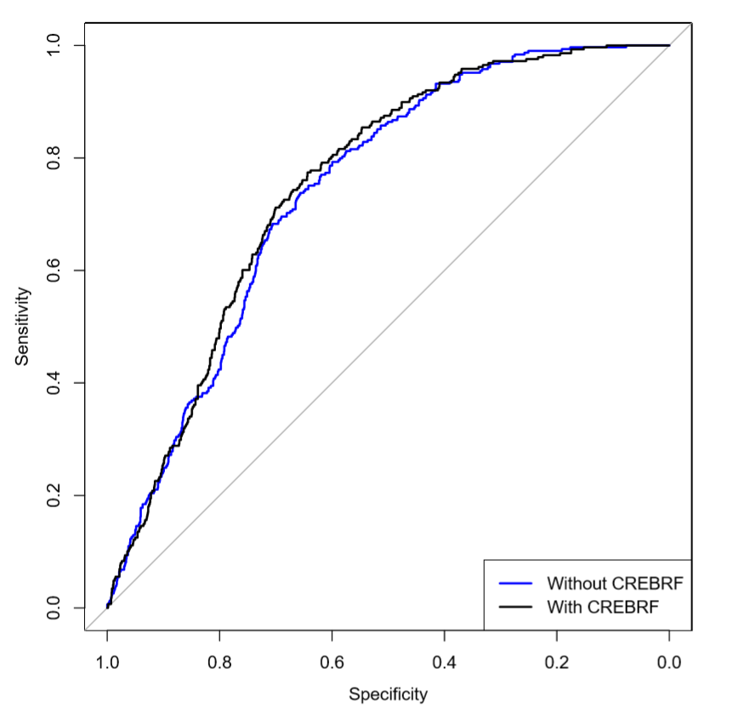

Figure 3. ROC Curve for BMI and diabetes, adjusted for age in females without CREBRF genotype (blue) and with CREBRF genotype (black).

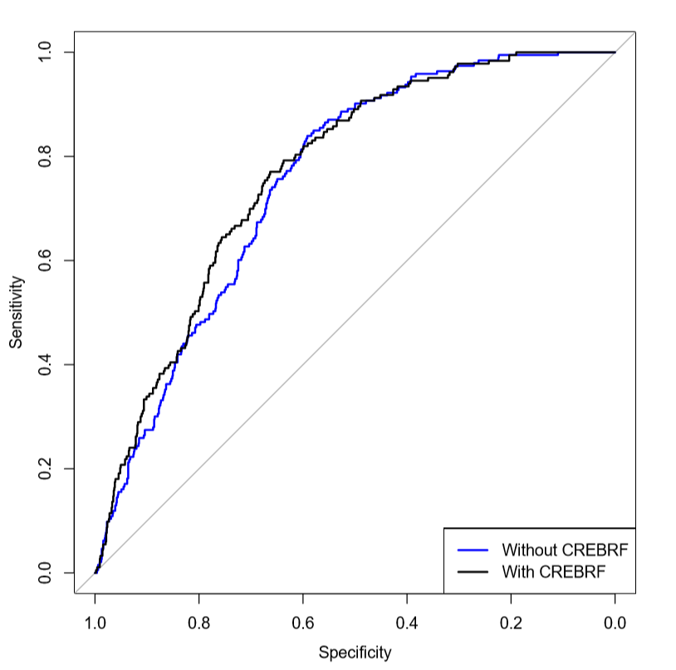

Figure 4. ROC Curve for BMI and diabetes, adjusted for age in men without CREBRF genotype (blue) and with CREBRF genotype (black).
Screening the overall cohort at the current screening recommendations of a BMI of 25 kg/m² would result in capturing all participants with T2D (97% of women with T2D and 96% of men with T2D). However, in this population, screening at 25 kg/m² results in a low specificity, that is, a majority of people screened will not actually have T2D (only 6.7% of T2D-positive women and 13% of T2D-positive men in fact have T2D) (Table 2). Although there is no specific standard for specificity and sensitivity screenings, having such a low specificity may result in unwanted consequences such as risks to the participants and extra costs. At the current screening recommendations, there does not appear to be any difference in sensitivity and specificity between the different genotype groups.

Table 2. Sensitivity and Specificity at current ADA screening recommendations (BMI = 25 kg/m²) overall and per genotype group for each sex.
 | Females |  | Males
 | Sensitivity | Specificity | Sensitivity | Specificity
Overall | 97% [95%–99%] | 6.7% [5.5%–8.1%] | 96% [96%–96%] | 13% [13%–13%]
GG | 97% [94%–99%] | 7.8% [5.7%–9.6%] | 95% [91%–99%] | 16% [13%–20%]
GA | 100% [100%–100%] | 5.5% [3.6%–7.3%] | 99% [95%–100%] | 10% [7.2%–13%]
AA | 94% [79%–100%] | 3.1% [0%–5.3%] | 100% [100%–100%] | 9.8% [2.8%–15%]

The action point BMIs and specificities at 80% sensitivity are given in Table 3 and 4. In females overall, the action point was 30.3 kg/m² with a specificity of 27%. Thus, if all females were screened for T2D at 30.3 kg/m², we would expect to see 80% of those who screened positive to truly have T2D and 27% of those who screened negative to not have T2D. The genotype specific results are as follows: in GG females, the action point was 30.3 kg/m² with a 30% specificity; for GA females, the action point was 31.4 kg/m² with a 30% specificity; for AA females, the action point was 29.7 kg/m² with a 17% specificity. In males, the overall action point BMI was 28.7 kg/m² with a 40% specificity. If males were screened for T2D at 28.8 kg/m², we would expect that 80% of those who screened positive to have T2D and 40% of those who screened negative to not have the disease. For GG males, the action point was 27.8 kg/m² with a 39% specificity; for GA males, the action point was 30.6 kg/m² with a 48% specificity; for AA males, the action point was 32.2 kg/m² with a specificity of 57%. The action points and specificities are not significantly different between the genotype groups for either sex in this sample.

Table 3. The resulting BMI action point and specificity value corresponding to a sensitivity of 80% in females overall and per genotype.
 | Action Point (kg/m²) | Specificity
Overall | 30.3 [29.6–31.3] | 27% [22%–33%]
GG | 30.3 [29.0–31.3] | 30% [22%–38%]
GA | 31.4 [30.3–32.8] | 30% [22%–39%]
AA | 29.7 [22.1–34.6] | 17% [1.6%–41%]

Table 4. The resulting BMI action point and specificity value corresponding to a sensitivity of 80% in males overall and per genotype.
 | Action Point (kg/m²) | Specificity
Overall | 28.7 [27.7–30.3] | 40% [33%–51%]
GG | 27.8 [26.9–29.5] | 39% [33%–52%]
GA | 30.6 [28.3–31.6] | 48% [32%–58%]
AA | 32.2 [29.9–37.4] | 57% [34%–84%]

Sensitivity plotted against BMI shows a similar pattern per genotype in both sexes (Figure 5 and 6). In females, there appears to be a slight shift between the GG and GA curves. For AA females, the line is very granular due to the low number of individuals within that group. For males, there is more overlap between the GG and GA curves. Similar to the female plot, the AA male group is small and appears granular rather than as a smoothed line.

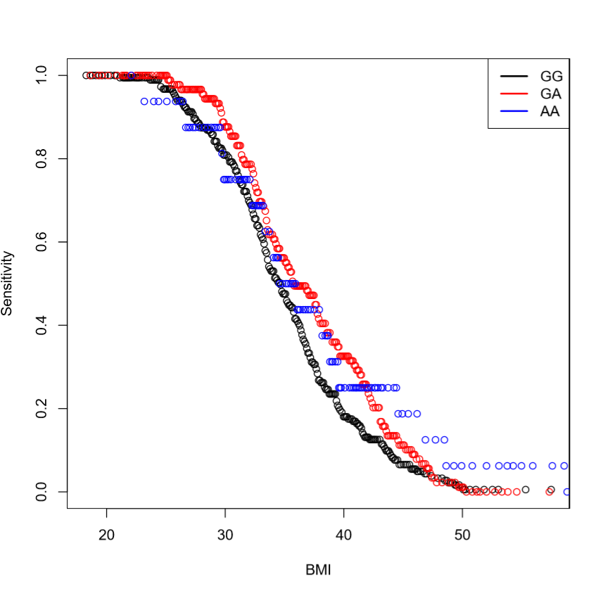

Figure 5. Sensitivity by BMI action point for each genotype in females.
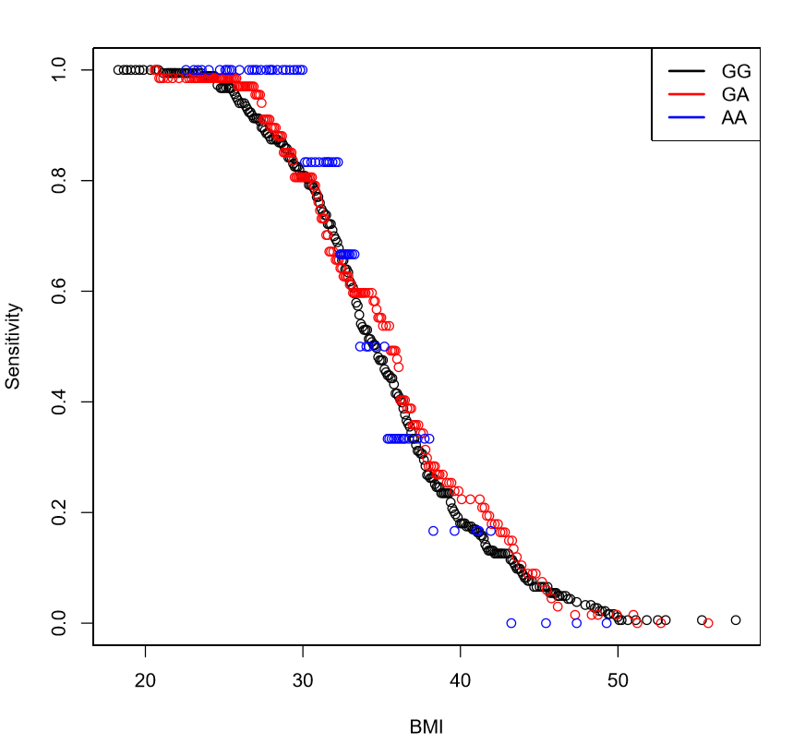

Figure 6. Sensitivity by BMI action point for each genotype in males.

Discussion
This purpose of this study was to analyze the current T2D screening guidelines and determine whether the addition of the CREBRF genotype alters the ability of BMI in predicting diabetes status. We found that, at current ADA guidelines, nearly all of Samoans with T2D will be captured. If Samoans were tested for T2D at a BMI of 25 kg/m² or greater, 97% of females and 96% of males with diabetes would be correctly identified as having the disease. However, at the same time, there would be a significant number of individuals being screened for the disease who do not have T2D. Only 6.7% of females and 13% of males without T2D would be correctly identified as not having the disease. For a nation of ~200,000 individuals of whom approximately 85% are overweight, there would be 68,255 false positives. To reduce the number of false positive screens for T2D, the BMI action point recommendations can be altered to better fit the population, similar to how they were changed to 23 kg/m² to better capture Asian Americans with T2D (Hsu et al., 2015). The overall analysis of BMI and T2D showed BMI action points that would identify 80% of individuals with T2D of 30.3 kg/m² (95% CI 29.6 kg/m²–31.3 kg/m²) in females and 28.7 kg/m² (95% CI 27.7 kg/m²–30.3 kg/m²) in males. These results suggest that a T2D action point for the Samoan population that is higher than the ADA guidelines might be warranted.
At 80% sensitivity, the addition of the CREBRF genotype did not greatly alter the BMI action point. The genetic information did increase the specificity of the test in four of the six sex–genotype categories. This results in a net increase in specificity from 40% to 45% in men and 27% to 30% in women when using genotype. Although the addition of the CREBRF genotype did not result in action points nor specificities differing with statistical significance in this study sample, if the point estimates of the specificities held true for across the population the use of genotype-specific action points differences in specificity of the screening while keeping sensitivity constant would result in 2,526 fewer (5% reduction) unnecessary screenings.
This study has several limitations. First, the sample has a higher number of older individuals compared to the population. This means there is reduced generalizability to the population as a whole. Second, only a small number of AA participants had diabetes, and the number was smaller when stratified by sex. This means that estimation of statistics in these subgroups is much less certain than the others.
Moreover, the clinical utility of using genetic information in diagnosis of diabetes needs to be weighed against the costs involved. The estimated cost of genotyping for CREBRF:c.1370G>A (rs373863828) in a research context is $0.68 per sample (Dana-Farber / Harvard Cancer Center, n.d.). However, this estimate does not consider the cost of the equipment, personnel, and resources required to run the test. Currently genetic testing resources are limited in Samoa and would most likely require samples to be sent to other countries for processing. This lack of infrastructure would cause a significant barrier in using CREBRF in screening for T2D.
Greeley and colleagues (2011) modelled the effects of implementing genetic testing for neonatal diabetes mellitus across a 30-year timeline and reported that the program would reduce poor health outcomes and lower costs. One major limitation of their model is that it assumed the testing sensitivity and specificity were both 100% (Greeley et al., 2011). Naylor and colleagues used a cost benefit analysis to determine the utility of genetic testing 20–40-year-old diabetic patients for MODY. Their results showed that testing for MODY was cost effective in certain populations, specifically when disease prevalence was high or costs of tests were low (R. N. Naylor et al., 2014). The current prevalence of T2D in the Samoan population was much higher than their estimated prevalence of MODY. Genetic testing for MODY requires the analysis of multiple mutations, whereas CREBRF testing would only be looking at one. However, this analysis was completed in the United States and therefore does not consider the potential barriers to testing that exist in Samoa.
Additionally, before CREBRF can be even considered for use in the clinic, screening for T2D in Samoa needs to be greatly improved. Most individuals are diagnosed with T2D only after they have gone to the hospital for T2D-related complications. Between January and June 2016, diabetes accounted for 6.4% of hospital admissions. Of these admissions, 87% of cases were T2D, 11% were gestational diabetes, and 2% were type 1 diabetes. Of the 350 admissions with a primary diagnosis of all diabetes cases, 219 patients had circulatory issues, 23 had multiple issues, 4 had renal complications, and 2 had hyperosmolality (Samoa Ministry of Health, n.d.). Based on the high number of individuals being diagnosed with T2D during a hospital visit and the high number of individuals going undiagnosed, T2D screening is likely limited in Samoa. Education campaigns and other public health programing may be beneficial for improving T2D screening.
Many factors must be considered when designing and implementing a public health program. The social-ecological model is one tool that can be used to better understand these factors and lead to more successful diabetes prevention programs. First, at the individual level, it is important to understand the beliefs, opinions, and behaviors of the population. This level also includes demographic factors such as age, education, and income that may impact health status. The individual level is critical for creating any program or initiative because individuals are responsible for their own behaviors and behaviors have significant role in health (Whittemore, Melkus, & Grey, 2004). Examples of such programs include educational campaigns that target an individual’s knowledge, self-care, lifestyle, and self-confidence. These programs, also known as self-management training, vary in effectiveness but have been shown to be useful in improving glycemic control in T2D patients (Norris, Engelgau, & Venkat Narayan, 2001). However, long-term impact of these programs is unknown.
The next level in the social-ecological model is the interpersonal level which refers to the interaction between an individual and others. Opinions of neighbors, family members, and peers can have significant impacts on individual behaviors (Whittemore et al., 2004). In Samoa, health decisions are made as a family (Bollars et al., 2019). Thus, when developing an intervention for this population, it is necessary to address the knowledge of at-risk individual and their family members. In addition to interpersonal, the community is another level that has a critical impact on health in Samoa (Bollars et al., 2019). The community level includes any social norms and also the traits of the neighborhoods and businesses that are located in the community (Whittemore et al., 2004).
The final two levels of the social-ecological model are the institutional and policy. The institutional level of the model represents organizations that are present such as churches or schools (Whittemore et al., 2004). The Church was identified as one of the factors that influenced health and health literacy in Samoa suggesting the need for collaboration when creating preventive programs (Bollars et al., 2019). The policy level of the social-ecological model refers to laws and polices put in place by the government (Whittemore et al., 2004). An example of an intervention at this level may refer to increasing funding for screening programs.
Moreover, all these factors are significant in health and therefore should be considered when trying to address health disparities. Any public health intervention to address the rising cases of diabetes in Samoa and the high number of T2D related complications needs to use culturally responsive approaches. Successful past T2D interventions in Native Hawaiian and Pacific Islander populations used community-based programs and social support networks. For example, Partnerships for Improving Lifestyle Interventions (PIU) ‘Ohana Program Diabetes Prevention Program Lifestyle Intervention (DPP-LI) was a program designed for Native Hawaiian and Pacific Islander populations. The goal of this program was to help individuals lose weight and was accomplished by using family and community interventions. A pilot of the program showed an average weight loss from pre- to post-3 month follow up of −1.5 kg (95% CI = −2.0, −1.0) (McElfish et al., 2019). Intervention programs may also focus on addressing social determinants of health which inhibited individuals from living healthy lifestyles. Examples of these barriers include food access, transportation, and cost of healthcare (McElfish et al., 2019).

Conclusion
In summary, T2D is a serious public health issue in Samoa and affects not only the health of the nation but also the economy. The results of this study suggest that the current ADA-recommended BMI thresholds for T2D screening are too low for screening in Samoans. The current recommendations are that individuals who are at a BMI of 25 kg/m² or above should screened for T2D. Our results found that if Samoans were screened at this BMI action point, almost all the individuals screened would not have T2D. Although inclusion of the CREBRF genotype did not significantly change the ability of BMI to predict diabetes, specificity was improved when sensitivity was held constant. Before CREBRF can be used in the clinic, diabetes screening in Samoa needs significant improvement and barriers to improving screening need to be addressed. Based on the number of T2D cases diagnosed after symptoms occur, and the high estimated rate of undiagnosed individuals in the population, development of public health interventions to improve diagnosis methods are required (Beagley et al., 2014; Samoa Ministry of Health, n.d.). Developing such interventions will require collaboration between individuals, communities, governments, and healthcare providers. By working to improve T2D screening, Samoa would be able to lower its rates of negative health consequences associated with the condition.
In addition, the economic and health consequences associated with high rates of T2D in Samoans impacts other nations as well. With an estimated 213,000 Samoans living in Australia, New Zealand, and the United States, other countries have an interest in addressing T2D in their Samoan population (Harris & Jones, 2005; New Zealand Government, 2020; Queensland Government, 2013). These countries have stronger diabetes screening programs already established and therefore would require different styled interventions than the ones used in Samoa. However, these nations may be closer to being able to use the CREBRF genotype information in the clinic.

Bibliography
Ali, O. (2013). Genetics of type 2 diabetes. World Journal of Diabetes, 4(4), 114–123. https://doi.org/10.4239/wjd.v4.i4.114
American Diabetes Association. (2004). Screening for Type 2 Diabetes. Diabetes Care, 27(suppl 1), s11 LP-s14. https://doi.org/10.2337/diacare.27.2007.S11
American Diabetes Association. (2014). Diagnosis and Classification of Diabetes Mellitus. 37(January), 81–90. https://doi.org/10.2337/dc14-S081
Auton, A., Abecasis, G. R., Altshuler, D. M., Durbin, R. M., Bentley, D. R., Chakravarti, A., … Schloss, J. A. (2015). A global reference for human genetic variation. Nature, 526(7571), 68–74. https://doi.org/10.1038/nature15393
Beagley, J., Guariguata, L., Weil, C., & Motala, A. A. (2014). Global estimates of undiagnosed diabetes in adults. Diabetes Research and Clinical Practice, 103(2), 150–160. https://doi.org/10.1016/j.diabres.2013.11.001
Bollars, C., Sorensen, K., de Vries, N., & Meertens, R. (2019). Exploring health literacy in relation to noncommunicable diseases in Samoa: a qualitative study. BMC Public Health, 19(1), 1151. https://doi.org/10.1186/s12889-019-7474-x
Carlson, J. C., Rosenthal, S. L., Russell, E. M., Hawley, N. L., Sun, G., Cheng, H., … Minster, R. L. (2019). A missense variant in CREBRF is associated with taller stature in Samoans. BioRxiv, 690586. https://doi.org/10.1101/690586
Dana-Farber / Harvard Cancer Center. (n.d.). Genotyping and Genetics for Population Sciences Core.
DiBello, J. R., McGarvey, S. T., Kraft, P., Goldberg, R., Campos, H., Quested, C., … Baylin, A. (2009). Dietary Patterns Are Associated with Metabolic Syndrome in Adult Samoans. The Journal of Nutrition, 139(10), 1933–1943. https://doi.org/10.3945/jn.109.107888
Fan, V. Y., & Le’au, R. F. (2015). Insights in public health: a tale of two polities: health in Independent and American Samoa. Hawai’i Journal of Medicine & Public Health, 74(5), 179–184.
Florez, J. C., Hirschhorn, J., & Altshuler, D. (2003). The inherited basis of diabetes mellitus: implications for the genetic analysis of complex traits. Annual Review of Genomics and Human Genetics, 4, 257–291. https://doi.org/10.1146/annurev.genom.4.070802.110436

Food and Agriculture Organization of the United Nations. (2019). Samoa Food Security Profile. 8–11.
Gopinath, B., Kifley, A., Flood, V. M., & Mitchell, P. (2018). Physical Activity as a Determinant of Successful Aging over Ten Years. Scientific Reports, 8(1), 2–6. https://doi.org/10.1038/s41598-018-28526-3
Gorman, E. J. (2012). Health literacy and health literacy and health outcomes. (87), 1–85.
Greeley, S. A. W., John, P. M., Winn, A. N., Ornelas, J., Lipton, R. B., Philipson, L. H., … Huang, E. S. (2011). The Cost-Effectiveness of Personalized Genetic Medicine. Diabetes Care, DC_101616. https://doi.org/10.2337/dc10-1616
Hanson, R. L., Safabakhsh, S., Curtis, J. M., Hsueh, W.-C., Jones, L. I., Aflague, T. F., … Nelson, R. G. (2019). Association of CREBRF variants with obesity and diabetes in Pacific Islanders from Guam and Saipan. Diabetologia, 1–6. https://doi.org/10.1007/s00125-019-4932-z
Harris, P. M., & Jones, N. A. (2005). We the people: Pacific Islanders in the United States. (August), 1–20.
Hawley, N. L., & McGarvey, S. T. (2015). Obesity and Diabetes in Pacific Islanders: the Current Burden and the Need for Urgent Action. Current Diabetes Reports, 15(5), 29. https://doi.org/10.1007/s11892-015-0594-5
Hawley, N. L., Minster, R. L., Weeks, D. E., Viali, S., Reupena, M. S., Sun, G., … Mcgarvey, S. T. (2014). Prevalence of adiposity and associated cardiometabolic risk factors in the samoan genome-wide association study. American Journal of Human Biology, 26(4), 491–501. https://doi.org/10.1002/ajhb.22553
Hayashi, T., Boyko, E. J., McNeely, M. J., Leonetti, D. L., Kahn, S. E., & Fujimoto, W. Y. (2008). Visceral Adiposity, Not Abdominal Subcutaneous Fat Area, Is Associated With an Increase in Future Insulin Resistance in Japanese Americans. Diabetes, 57(5), 1269 LP – 1275. https://doi.org/10.2337/db07-1378
Hsu, W. C., Araneta, M. R. G., Kanaya, A. M., Chiang, J. L., & Fujimoto, W. (2015). BMI cut points to identify at-risk Asian Americans for type 2 diabetes screening. Diabetes Care, 38(1), 150–158. https://doi.org/10.2337/dc14-2391
International Diabetes Federation. (2019). IDF Diabetes Atlas. In Dunia : IDF (9th Editio).
Karter, A. J., Schillinger, D., Adams, A. S., Moffet, H. H., Liu, J., Adler, N. E., & Kanaya, A. M. (2013). Elevated rates of diabetes in pacific islanders and asian subgroups. Diabetes Care, 36(3), 574–579. https://doi.org/10.2337/dc12-0722
Kenneth D. Kochanek, M.A., Sherry L. Murphy, B.S., Jiaquan Xu, M.D., and Elizabeth Arias, Ph.D. (2017). National Vital Statistics Reports Deaths 2017. Clinics and Research in Hepatology and Gastroenterology, 68(1), 9–19. https://doi.org/10.1111/mec.13536.Application
King, G. L., Mcneely, M. J., Thorpe, L. E., Mau, M. L. M., Ko, J., Liu, L. L., … Chow, E. A. (2012). Understanding and addressing unique needs of diabetes in Asian Americans, Native Hawaiians, and Pacific Islanders. Diabetes Care, 35(5), 1181–1188. https://doi.org/10.2337/dc12-0210
Krishnan, M., Major, T. J., Topless, R. K., Dewes, O., Yu, L., Thompson, J. M. D., … Merriman, T. R. (2018). Discordant association of the CREBRF rs373863828 A allele with increased BMI and protection from type 2 diabetes in Maori and Pacific (Polynesian) people living in Aotearoa/New Zealand. Diabetologia, 61(7), 1603–1613. https://doi.org/10.1007/s00125-018-4623-1
Krishnan, M., Major, T. J., Topless, R. K., Dewes, O., Yu, L., Thompson, J. M. D., … Merriman, T. R. (2018). Discordant association of the CREBRF rs373863828 A allele with increased BMI and protection from type 2 diabetes in Māori and Pacific (Polynesian) people living in Aotearoa/New Zealand. Diabetologia, 61(7), 1603–1613. https://doi.org/10.1007/s00125-018-4623-1
Lin, M., Caberto, C., Wan, P., Li, Y., Lum-Jones, A., Tiirikainen, M., … Chiang, C. W. K. (2019). Population specific reference panels are crucial for the genetic analyses of Native Hawai‘ians: an example of the CREBRF locus. BioRxiv, 789073. https://doi.org/10.1101/789073
Lin, S., Naseri, T., Linhart, C., Morrell, S., Taylor, R., McGarvey, S. T., … Zimmet, P. (2017). Trends in diabetes and obesity in Samoa over 35 years, 1978-2013. Diabetic Medicine : A Journal of the British Diabetic Association, 34(5), 654–661. https://doi.org/10.1111/dme.13197
Lyssenko, V., Lupi, R., Marchetti, P., Guerra, S. Del, Orho-melander, M., Almgren, P., … Groop, L. (2007). Mechanisms by which common variants in the. J.Clin.Invest, 117(8), 2155–2163. https://doi.org/10.1172/JCI30706DS1
Ma, R. C. W. and P. C. Y. T. (2010). Epidemiology of Type 2 Diabetes. In R. Holt, C. Cockram, A. Flyvbjerg, and B. Goldstein. (Ed.), Textbook of Diabetes (4th Editio). https://doi.org/10.1002/9780813804149.ch2
Mahajan, A., Taliun, D., Thurner, M., Robertson, N. R., Torres, J. M., Rayner, N. W., … McCarthy, M. I. (2018). Fine-mapping type 2 diabetes loci to single-variant resolution using high-density imputation and islet-specific epigenome maps. Nature Genetics, 50(11), 1505–1513. https://doi.org/10.1038/s41588-018-0241-6
Mayer-Davis, E. J., Lawrence, J. M., Dabelea, D., Divers, J., Isom, S., Dolan, L., … Wagenknecht, L. (2017). Incidence trends of type 1 and type 2 diabetes among youths, 2002-2012. New England Journal of Medicine, 376(15), 1419–1429. https://doi.org/10.1056/NEJMoa1610187
McElfish, P. A., Purvis, R. S., Esquivel, M. K., Sinclair, K. A., Townsend, C., Hawley, N. L., … Kaholokula, J. K. (2019). Diabetes Disparities and Promising Interventions to Address Diabetes in Native Hawaiian and Pacific Islander Populations. Current Diabetes Reports, 19(5), 19. https://doi.org/10.1007/s11892-019-1138-1
Minster, R. L., Hawley, N. L., Su, C.-T., Sun, G., Kershaw, E. E., Cheng, H., … McGarvey, S. T. (2016). A thrifty variant in CREBRF strongly influences body mass index in Samoans. Nature Genetics, 48(9), 1049–1054. https://doi.org/10.1038/ng.3620
Naka, I., Furusawa, T., Kimura, R., Natsuhara, K., Yamauchi, T., Nakazawa, M., … Ohashi, J. (2017). A missense variant, rs373863828-A (p.Arg457Gln), of CREBRF and body mass index in Oceanic populations. Journal of Human Genetics, 62(9), 847–849. https://doi.org/10.1038/jhg.2017.44
National Institutes of Health. (2007). Monogenic Forms of Diabetes : Neonatal Diabetes Mellitus and Maturity-onset Diabetes of the Young. 1–12.
Nations, F. and A. O. of the U. (n.d.). Samoa.
Naylor, R., & Johnson, A. K. (2019). Maturity-Onset Diabetes of the Young Overview 1 . Clinical Characteristics of MODY 2 . Genetic Causes of MODY. 1–20.
Naylor, R. N., John, P. M., Winn, A. N., Carmody, D., Greeley, S. A. W., Philipson, L. H., … Huang, E. S. (2014). Cost-Effectiveness of MODY Genetic Testing: Translating Genomic Advances Into Practical Health Applications. Diabetes Care, 37(1), 202 LP – 209. https://doi.org/10.2337/dc13-0410
New Zealand Government. (2020). 2018 Census totals by topic – national highlights.
Norris, S. L., Engelgau, M. M., & Venkat Narayan, K. M. (2001). Effectiveness of Self-Management Training in Type 2 Diabetes. Diabetes Care, 24(3), 561 LP – 587. https://doi.org/10.2337/diacare.24.3.561
Popkin, B. M. (2004). The Nutrition Transition: An Overview of World Patterns of Change. Nutrition Reviews, 62. https://doi.org/10.1301/nr.2004.jul.S140
Queensland Government. (2013). Pacific Islander and Maori population size and distribution.
Samoa Ministry of Health. (n.d.). National Noncommunicable Disease Control Policy 2018 – 2023.
Seiden, A., Hawley, N. L., Schulz, D., Raifman, S., & Mcgarvey, S. T. (2012). Long-term trends in food availability, food prices, and obesity in samoa. American Journal of Human Biology, 24(3), 286–295. https://doi.org/10.1002/ajhb.22237
The Institute for Health Metrics and Evaluation. (2019). Country Profile: Samoa. 1–8.
Tiebe, M., Lutz, M., De La Garza, A., Buechling, T., Boutros, M., & Teleman, A. A. (2015). REPTOR and REPTOR-BP Regulate Organismal Metabolism and Transcription Downstream of TORC1. Developmental Cell, 33(3), 272–284. https://doi.org/10.1016/j.devcel.2015.03.013
Tiebe, M., Lutz, M., Senyilmaz Tiebe, D., & Teleman, A. A. (2019). Crebl2 regulates cell metabolism in muscle and liver cells. Scientific Reports, 9(1), 19869. https://doi.org/10.1038/s41598-019-56407-w
Wang, D., Hawley, N. L., Thompson, A. A., Lameko, V., Reupena, M. S., McGarvey, S. T., & Baylin, A. (2017). Dietary Patterns Are Associated with Metabolic Outcomes among Adult Samoans in a Cross-Sectional Study. The Journal of Nutrition, 147(4), 628–635. https://doi.org/10.3945/jn.116.243733
Whittemore, R., Melkus, G. D. E., & Grey, M. (2004). Applying the social ecological theory to Type 2 diabetes prevention and management. Journal of Community Health Nursing, 21(2), 87–99. https://doi.org/10.1207/s15327655jchn2102_03
Wojcik, G. L., Graff, M., Nishimura, K. K., Tao, R., Haessler, J., Gignoux, C. R., … Carlson, C. S. (2019). Genetic analyses of diverse populations improves discovery for complex traits. Nature, 570(7762), 514–518. https://doi.org/10.1038/s41586-019-1310-4
World Bank Group. (2014). Samoa Student assessment.
World Health Organization. (2002). Samoa STEPS Survey Samoa STEPS Survey Fact Sheet. 1(August), 53–54.
World Health Organization. (2016). Global report on diabetes. Isbn, 978, 92–94.
World Health Organization. (2017). Pacific Island Countries and Areas – WHO Cooperation Strategy 2018–2022. https://doi.org/10.1163/9789004387546_007
World Health Organization. Noncommunicable Diseases (NCDs) Country Profiles: Samoa. , (2018).
World Health Organization. (2011). Global recommendations on physical activity for health, 18-64 years old. 1. https://doi.org/10.1080/11026480410034349
Zhang, P., Engelgau, M. M., Valdez, R., Benjamin, S. M., Cadwell, B., & Venkat Narayan, K. M. (2003). Costs of Screening for Pre-diabetes Among U.S. Adults. Diabetes Care, 26(9), 2536 LP – 2542. https://doi.org/10.2337/diacare.26.9.2536

