Applying process analysis and inventory modeling to improve the operating room supply system at a suburban acute care medical center

By Kelly Larson, Jacob Bowley, and Louis Luangkesorn.

Abstract

Background: The supply rooms serving an operating room suite of a suburban hospital provides equipment and supplies for each day’s procedures. The number and diversity of procedures and the different practices of individual surgeons led to a large number of different items that need to be stored in a limited space. This limited space is further stressed due to the presence of items that have not been in use for long periods of time.
Materials and Methods: Process engineering and inventory management models from industrial engineering were applied to identify and organize operating room dedicated inventory items and create an inventory management policy to improve the availability of operating room supplies and reduce workload on the supply staff. Inventory simulation models were used to establish that the revised material handling and inventory policies will lead to improved availability of required items in the surgical suite.
Results: The proposed inventory management policy was tested through simulation to demonstrate a decrease in the inventory shortfalls in the OR supply room and the amount of work needed to obtain and return supplies.
Conclusion: This project was intended to improve the supply operations for the hospital OR suite.

Introduction

Problem Description
The Operating Room (OR) suite located in a suburban acute care medical center performs around 13,000 surgical procedures per year. The OR Supply Chain department has many responsibilities, including the inventory management of supplies used in the OR suite. The supplies and equipment used in the OR are housed in one large primary supply room, multiple other small supply rooms within the OR suite, and can also draw on the main supply room of the hospital. In order to ensure that the OR staff has access to the supplies and equipment they need, these OR supply rooms are replenished daily.

Examination of the historical OR supply room restocking process identified potential opportunities for improvement, particularly dealing with issues such as inappropriate inventory levels, difficulty finding items, unidentified dead stock (stock items not in current use), wasted activity during the restocking process, and overall space utilization. These issues result in the OR supply rooms not facilitating ease of access of the necessary supplies for the OR and Supply Chain staff.

The methodology for this project involved evaluating the problems identified from an engineering perspective, including analyzing the process and inventory levels. For the process analysis, observations and personal conversations with employees revealed potential issues with and solutions for the current process. Analysis of process maps and spaghetti diagrams also helped the formulation of recommendations. Additionally, a simulation model was created using the data from the hospital’s inventory management system in order to analyze inventory levels. Other industrial engineering principles such as lean values and human factors-centered design were also utilized when approaching the problems identified.

These analyses led to various results, including:
- Dead stock identification
- Supply room picking and put-away process improvement recommendations
- Inventory level simulation model
Each of these results aim in facilitating the ease of access to supplies for the OR and Supply Chain staff.

Methods

Data sources
To analyze inventory and workflow, the following data sources were used:
- Inventory Audit Data – which represents the inventory on the shelf in the OR supply rooms on 2/28/18
- Purchase Order Data – which represents the purchasing data for non-stock items for the past year
- Storeroom Order Data – which represents ordering data for stock items from the central supply room for the past year

Process analysis
For the process analysis, the study team began by interviewing OR supply room staff to gain an understanding of the current process. The team used the process maps, personal conversations, and process observations to evaluate potential for improvement. The process analysis techniques applied include lean principles and analysis of value-added steps.
At this hospital, there is a main supply room with large storage areas that serves the hospital as a whole. The OR suite is also served by an OR supply room and additional smaller supply rooms and closets. On a daily basis, the OR suite staff reviews the supply requirements as presented by the surgical staff for the day’s scheduled procedures. These requirements can be met from the OR supply rooms, or through a special trip to the main supply room. When the day’s surgical procedures have been resourced, the OR supply rooms are restocked from the main supply room.

For order picking, a pick sheet is generated early in the morning and an employee stocks a large cart in the main hospital storage room. Next, the employee travels to the OR to begin the put away process in each of the OR suite supply rooms and closets. The key observation from this process is that a specific employee usually performs this process. However, when this employee is not available, the other members of the team are not as efficient in the put away process. The lack of a standardized procedure is one area the project looked to improve. Also, the put away process involved multiple trips between aisles and excess motion. One area of improvement was to develop a simpler put away process. The spaghetti diagram (Figure 1) demonstrates the observed employee movements for the put away process on one day. [3]
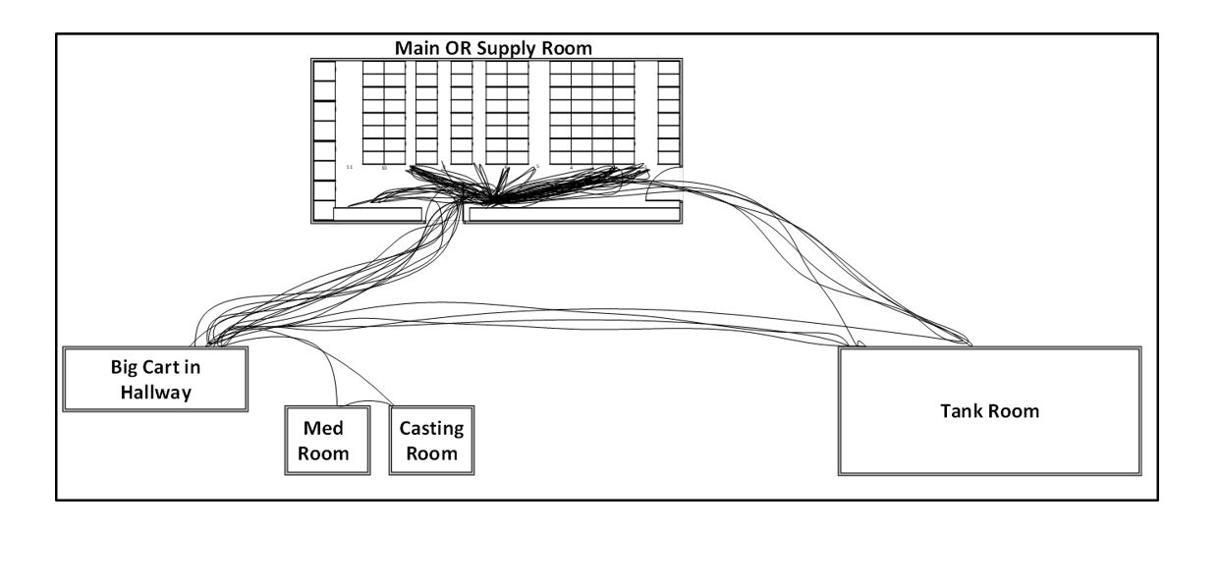
Figure 1: Spaghetti diagram showing current walking paths for workers replenishing OR supply room.

Material handling and inventory simulation
An inventory simulation model was created in a Microsoft Excel spreadsheet using Visual Basic for Applications (VBA) to support decision making for selecting optimal reorder and order up to points.
This model was created based on an (s,S) model. [4] For each product, each day the demand was modeled using a uniform distribution. At the end of each day the remaining inventory is compared to the reorder point s. If the inventory drops below s, an order is made so that the inventory position (inventory plus order) reaches the order up to level S. The order then arrives. The simulation will keep track of day-to-day inventory, orders that are en route, the number of orders, and the number of stockouts.
Many assumptions were used in the development of this simulation model, as shown in Figure 2:
Figure 2: Numerical assumptions for simulation model.

Visual Cues
Modifications to the Supply Chain system at the hospital were proposed based on principles of Human Factors Engineering. One approach to this improvement was the development of visual cues to be used as memory aids in the St. Clair OR supply rooms. Memory aids can be characterized as “putting ‘knowledge in the world’ (i.e. perception) so that the operator does not have to rely on ‘knowledge in the head’ (i.e. long-term memory).” [1] In this way, memory aids such as signs and other visual identifiers in the supply room has the potential to help enhance the OR Supply Chain system.
The approach for visual cues was to make recommendations for simple ways to identify that items in the OR supply rooms need to be replenished, to reduce the need for counting and to facilitate restocking to established order up to values. Based on observations of the OR supply areas, recommendations were made for visual cues which seemed fitting for items in the OR supply rooms.

Dead Stock Identification
It was indicated by the Supply Chain department that there was an expected issue of unidentified dead stock in the OR supply rooms. Dead stock is defined as items which are currently sitting on the shelf in the OR supply rooms, but have not been ordered in the past year. These are items which are infrequently used and may not need space in the OR supply rooms.
To identify dead stock, items which were present in the inventory audit data (I.e. were currently in inventory on 2/28/18) were compared to the ordering data. Items which were not ordered in the past year but were present in the inventory audit data, i.e. had no demand in the prior year, were flagged as dead stock.

Inventory location analysis
The purpose of the inventory location analysis was to identify items which are frequently used in the OR, but do not have a specified location in the OR supply rooms. These items would need to be requested and brought to the ORs separately from the normal flow of OR inventory. As such, providing frequently used items with a location in the OR supply rooms can reduce unnecessary flow of people and materials.
This analysis used storeroom order data which included ordering data for stock items from the central supply room by the OR suite for the past year. The approach of this analysis was to create a list of the items which have locations in the data listed as “NA” (i.e. not specified). From there, summary values (such as a count of the number of times the items were ordered) were collected. This list represents items which could be considered as candidates for locations in the OR supply rooms.

Results

Process improvement
The current order picking procedure does not promote a standardized put away process. Therefore, the employee restocks items based on the order he picks them from a large supply cart. One suggestion for a more efficient process would be to organize these items before the put away process. The items could be placed into totes based on room or aisle. By organizing the cart in this way during the picking process, the put away process would be faster and standardized. The improved process would reduce walking and is demonstrated in a spaghetti diagram in Figure 3.
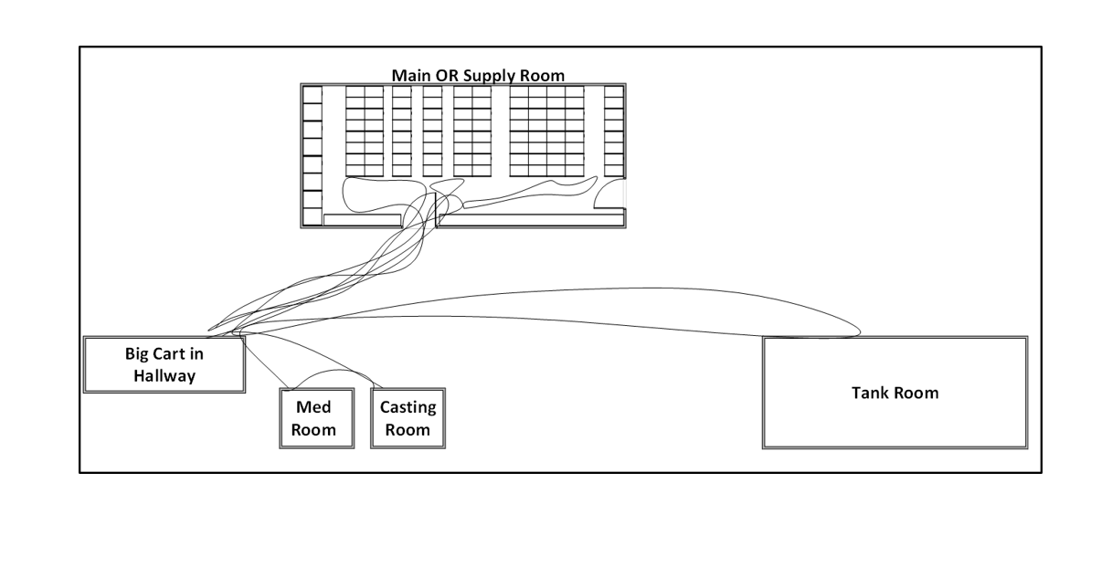
Figure 3: Spaghetti diagram showing walking paths for workers replenishing OR supply room based on proposed item locations.

The associated measured material handling improvement is a 59% reduction in walking. The reduction of walking translates to cost savings because the employee can do the same work on a shorter shift. This improvement is visually represented with the spaghetti diagrams in Figure 8 and 9. The quantitative result was calculated using observations compared to the recommended process.

Inventory policy simulation
The purpose of creating the inventory simulation model was to support the Supply Chain department's decision making when setting reorder points and order up to levels for supplies in the OR supply rooms. The final simulation model allows for the user to input the material code they are interested in simulating, as shown in Figure 2. There is also an option to enter a reorder point and order up to point (if nothing is entered, the value to test is calculated based on the order up to and reorder point equations shown in Figure 3.
Figure 4: Example of simulation model parameters for stock items.
To find the optimal reorder point and order up to values, the user inputs a weight associated with restocks, stockouts, and the cost of holding. This is to give flexibility so that the user can determine which of these considerations are most important. For instance, for a very high valued or physically large item, it might be important to reduce the cost of holding. On the other hand, for an item which would create a dire situation in the case of a stockout, a large weight might need to be placed on stockouts. From there, the model determines which combination of reorder points and order up to levels minimizes each of these considerations. Since the order up to value represents the maximum inventory of the item, this is then compared to "current" inventory level (from the inventory audit on 2/28/18). This is multiplied by the average unit cost, in order to find the estimated savings of inventory on hand, as shown in Figure 5:
$$Potential Inventory Reduction=\left(Current Inventory Level-Optimal Order Up To\right)*Unit Cost$$
Figure 5: Inventory cost reduction equation.
An example of finding the optimal reorder point and order up to level can be found in Figure 6.
Figure 6: Inventory ordering policy optimization tool.
As an example of the simulations results, an example will be detailed for a stent. This is a non-stock item with an assumed lead time of two days, and an average unit cost of $139.20 per unit. As of the 2/28/18 inventory audit, there were 24 units of this item on the shelf.
After running the simulation model (simulating 1,000 trials of one year for each of 25 combinations of order up to values and reorder points), it was found that the optimal order up to value is 8, with a reorder point of 4. This had an average of 0 stockouts and 42 restocks. When comparing the order up to value, which represents the theoretical maximum inventory level for this item, to the current inventory level, the excess 16 items correspond to a value of $2,227 which are currently on the shelf but do not need to be.
This is just one example of an item that could provide the Supply Chain department an opportunity to reduce the amount of money tied up in inventory. By running this simulation for more of the high-value, frequently-used items, there is a large potential for inventory reduction.

Visual cues
Based on observations of the OR supply rooms, it was found that many small items were kept in bins of various sizes. In order to facilitate meeting set reorder point and order up to values, it is recommended to place a simple card inside of the bins to denote that the reorder point has been reached. This is illustrated in Figure 7:
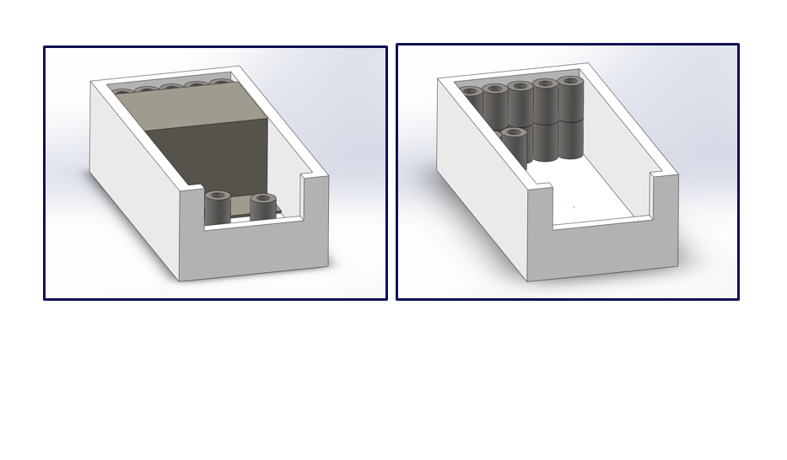
Figure 7: Example of visual cues for small items in bins.

For larger items which are not kept in bins, a "parking lot" style visual cue can be used for denoting order up to values and reorder points. Figure 8 illustrates this type of visual cue, used for PC units (“brains”) for infusion pumps.

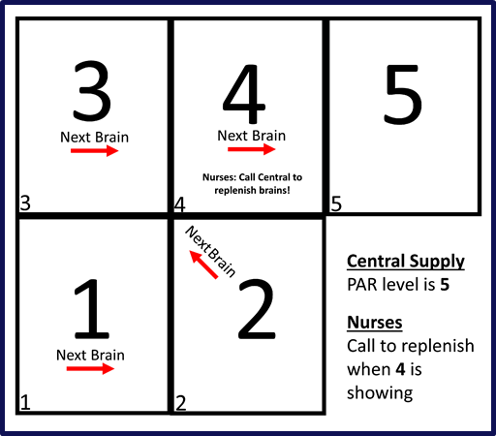
Figure 8: Example of visual cue for large items. [2]
The improvement of visual cues has potential to improve the reorder and restock process. Without quantifying the impact, it is evident that the visual cues would improve productivity by reducing the time spent on these processes. The card at the reorder point means the employee does not need to count the items in the bin if the quantity is larger than the reorder point. Also, the visual guide on the side of each aisle would help new employees save time because they would not need to search for items in the aisles one by one.

Dead Stock Identification
The results of the dead stock identification analysis were that over 1,500 different items were identified as not having been ordered in the past year and flagged as dead stock, equating to 32% of the value of the value of the inventory in the OR supply rooms. This list is then able to be reviewed for items which were used in procedures that have become obsolete, are no longer used in procedures, or are only required for rare procedures. Items required for rare procedures can be moved out of the main OR supply room to one of the smaller supply closets, or into the main hospital supply area. Removing these items has potential of both reducing the amount of capital tied up in inventory, as well as freeing up space in the OR supply room for other items which are frequently used.

Items Without Locations Analysis
The final result of this analysis was a simple list of items which are ordered to the OR but do not have specified locations in the OR supply rooms. This list was created using pivot tables in Microsoft Excel. The Supply Chain department can use this list to compare summary values for the various items (for instance, the number of times an item has been requested in the past year), and determine which items should be given standard locations.
Error! Reference source not found. shows an example highlighting that the top three items on the results list have been requested greater than 60 times in the past year, but do not have a specified location in storage. Assuming that there are 260 workdays in the year (weekdays) for the OR Supply Chain staff, this equates to greater than 23% of the days.
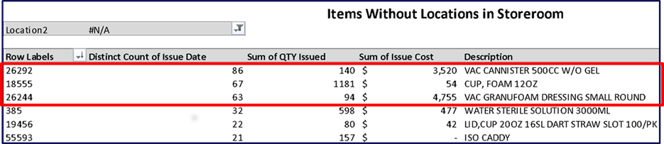
Figure 9: Example report of items without assigned storage locations.
Specifying locations for these items within the OR supply rooms would result in improvements in requesting these materials, as well as the labor savings associated with moving the materials.

Discussion
Through discussion with OR staff, the team was able to narrow the scope of the OR supply room improvement project to a few key pain-points for the OR and supply room staff, including poor space utilization, unidentified dead stock taking up inventory space, wasted motion during the picking and put-away processes, and inappropriate inventory levels. From analyzing these issues using observations, personal conversations with employees, process mapping, using spaghetti diagrams, data analyses, lean values and visual cues, the team was able to formulate recommendations for the OR.

The results of this study indicate that time and money can be saved though process improvements and improvements to inventory management policies. The main issue of an inefficient process can be improved with a more standardized and organized put away process involving the use of small totes. Dead stock and supply items without OR supply room locations were identified through inventory analysis. Also, a simulation model is able to determine optimal reorder points and order up to levels using input client data.
This project provided an example of the use of the application of process analysis, inventory models, and human factor analysis to provide recommendations for improvement in a specific setting. The results of this student project are being applied by the sponsor hospital and provided the students with invaluable experience in applying these types of methods in a setting with the range of issues that occur with a real life operations and staff.

Acknowledgments
We would like to thank the following individuals for their help throughout this project: Tanya Bahl, John Cordier, Professor Barry Ross, Dr. Wesley Rohrer, Professor Caroline Kolman, Dr. Natasa Vidic, and Dr. Larry Shuman. We would also like to thank all of the staff in the sponsor hospital for their help and guidance.

References

[1] Wickens, Christopher D., et al. An Introduction to Human Factors Engineering. 2nd ed., Upper Saddle River, NJ: Pearson; 2004.
[2] Larson, Kelly, and Bryan Norman. Visual Aid Used for Infusion Pumps at Two UPMC Hospitals, unpublished report, 2017
[3] Groover, M. P. Work systems: The methods, measurement and management of work. Upper Saddle River, NJ: Pearson, 2014.
[4] Nahmias, Steven and Tava L. Olsen. Production and Operations Analysis, 7th ed. Long Grove, IL: Waveland Press., 2015.

All work done at the University of Pittsburgh. Kelly Larson, Premier Inc.; Jacob Bowley, Armstrong Flooring; Louis Luangkesorn University of Pittsburgh, lluangkesorn@pitt.edu.

