Reengineering the registration process to reduce wait time queues in an outpatient diagnostic center

by Jacqueline Welsh, Tony Liu, Amy Tran, Maggie Wen, Louis Luangkesorn

Abstract
Introduction

The St. Clair Hospital Outpatient Center is an outpatient clinic that offers services such as lab work, CT and MRI scans, and other diagnostic testing. They have three patient types, walk-in patients, pre-scheduled patients, and patients for scheduling. To go through the registration process, each patient must first check-in at the check-in desk, wait to be called to the registration desk, and the finally wait to be called for their appointment. Since every patient must first check-in at the check-in desk, a large queue will build up, forcing patients to stand and wait. This long and uncomfortable wait proved to be a pain point for patients and a source of patient dissatisfaction.

Methods

To start the improvement process, the team used previously collected data as well as their own observations to build multiple simulation models to test different staffing alternatives. Their first simulation model, the original model (1 check-in staff, 2 registration staff, and 2 scheduling staff), yielded a large bottleneck of 11 people at check-in and a wait time of over 27 minutes.

Results

After testing, the team determined the best alternative to combine check-in and scheduling staff (three total) and have two registration staff, thus reducing the wait times, and reducing the check-in queue to 2 people. However, this pushes the queue to the registration process. The team then recommend using human factor methods such as posting wait times, providing entertainment, and re-configuring seating to increase visibility of the process.

Conclusions

By reconfiguring the registration staff, this will reduce the initial check-in queue and reduce patient waiting time to check-in to their appointment. Although this will push the wait time to the waiting area instead of the check-in queue, by providing said human factors methods, the patient experience will improve.
Keywords: simulation, patient satisfaction, human factors, wait time, queueing, healthcare systems engineering

Introduction

Problem Description
St. Clair Hospital is a well-respected award-winning community hospital system located in the southern suburbs of Pittsburgh, Pennsylvania. Its mission is to provide highly valued, service-oriented health care to the community. In addition to the main hospital, the system includes two outpatient centers, one located in Bethel Park, PA and a smaller one in Peters Township, PA. The outpatient centers offer an array of advanced imaging and lab services including x-ray, CT, MRI, EKG, and echocardiograms. In addition, it shares a building with urgent care, physical therapy, diabetes center, breast care center, and several other physician practices. This project focuses specifically on the Bethel Park outpatient care location.

In 2009, the outpatient center was renovated to accommodate growing demand, however, even with the remodeled space, the demand caused a wait time problem specifically at the patient check-in area.

Available Knowledge
Patients at the outpatient center can be categorized into three main groups: walk-in, pre-scheduled, and scheduling. All patients currently go through the check-in process. In addition, walk-in patients go through the registration process in order to receive services. The check-in process includes documenting patients’ arrival in the electronic information system and ensuring that order scripts are available. On the other hand, registration process involves updating basic patient information such as date of birth, phone number, and address. In addition, insurance information is collected and verified to complete registration.

Rationale
Since early 2018, the diagnostic department at the St. Clair Outpatient Center has received declined patient satisfaction scores around the registration process. This has a negative impact on the overall patient experience at the outpatient center. By offering improvements to the registration process, the team will be able to improve overall patient experience to reflect quality of care.

Specific Aims
The purpose of this project is to help St. Clair Hospital better understand their current situation and provide them with options to improve the patient experience. The goal is to utilize industrial engineering techniques and concepts to analyze the current situation, identify areas for improvement, and provide sound recommendations to the management team.

Methods

Context
When first approaching how to improve the registration process, the team conducted best practice research to determine what would the best option be for St. Clair. The team found that pre-registering and collecting demographic information prior to the appointment was important to alleviate the burden on the staff and wait times in the physical registration room [2]. Although St. Clair does serve many pre-registered patients and has over the phone option to change/confirm this information, it is not utilized often and is difficult to use when the majority of patients are walk-ins for lab work. The team also noticed that many patients would come to their appointment without the correct scripts, forcing the staff to call and have to wait for this information. Being able to confirm this beforehand would prevent this extra step and work on the backend of the process. The team also found that confirming payment and insurance information prior to the appointment is important as well to eliminate any further follow-up work the staff have to complete on their own time after the appointment [4]. The team noticed this issue also during our observations that often patients would not have their correct Medicare cards or their most recent insurance information, which caused either the patient to delay their appointment or for the registration staff to have to mark this incorrect information and correct it later. To incorporate this best practice, the team decided to utilize two methods for improvement: simulation and human factors methods, where simulation optimize configurations in registration area and human factor enhance comfort level in waiting area.

Interventions
To build the simulation models, the team used time stamps from registration log data provided by St. Clair Hospital, as well as collected data. The time stamping data provided was collected from when a patient entered to check in to when they were claimed by the registration, and then from when they were claimed by the registration to when they finished registration. The team was able to use this collected data from January 2018 to December 2018 to create a staffing analysis and determine peak times during the working hours as well as during the week, shown in Appendix E. Through this analysis, the team determined that the busiest days were 8am-11am on Mondays and Tuesdays. Breaking down each step in the process, the average processing time between created and claimed to be 8.4 minutes, claimed to completed (the registration step) to be 5.7 minutes, and from created to completed complete registration processing time, to be 14.1 minutes. Although this data provided insight to the current state, the team needed to collect the waiting period while in the check-in queue.

Through observations in St. Clair Hospital Outpatient Center registration area, several essential time points are collected during peak time from 9:30am to 11:20am. These time points include arrival time, check-in start time, check-in end time, registration start time, registration end time, scheduling start time and scheduling end time. These are defined in Figure 1.

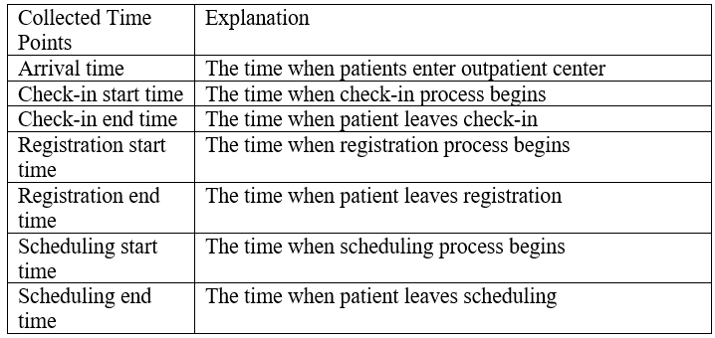
Figure 1 Time points collected in data set
.

Study of the Interventions
Each service time is calculated as the time interval between service start time and service end time. Since all the time points are collected in minute, service times are in minute and are not accurate enough. In this case, the collected observation data are used as censored data. The team assume the largest value observation data can represent is left censoring and the smallest value observation data can represent is right censoring. For example, when observation data is collected as 1 minute for a service process, which can represent that the process could take from minimum 60 seconds to maximum 119 seconds. The equations below show the calculations for the censored time boundaries:

Left Censoring = observation data * 60
Right Censoring = (observation data + 1) * 60 – 1

Where observation data is recorded in minutes, but left and right censoring is applied to the seconds. One special situation is that when the observation time is recorded as 0 minute, which implies the process time is less than 59 seconds, the team assumed left censoring is at 30 seconds since it is impossible that service time is 0 second.

Distribution Fitting
Before fitting one or more distributions to a data set, it is generally necessary to choose good candidates among a predefined set of distributions. Skewness and kurtosis is used in this purpose to help choose candidates to describe processes among a set of parametric distributions.[3] After limiting candidate distributions, using left and right censoring data in fitdist function, one or more parametric distributions may be fitted to a data set. Figures 2 and 3 show the cumulative distribution of the recorded and fitted registration and scheduling time.

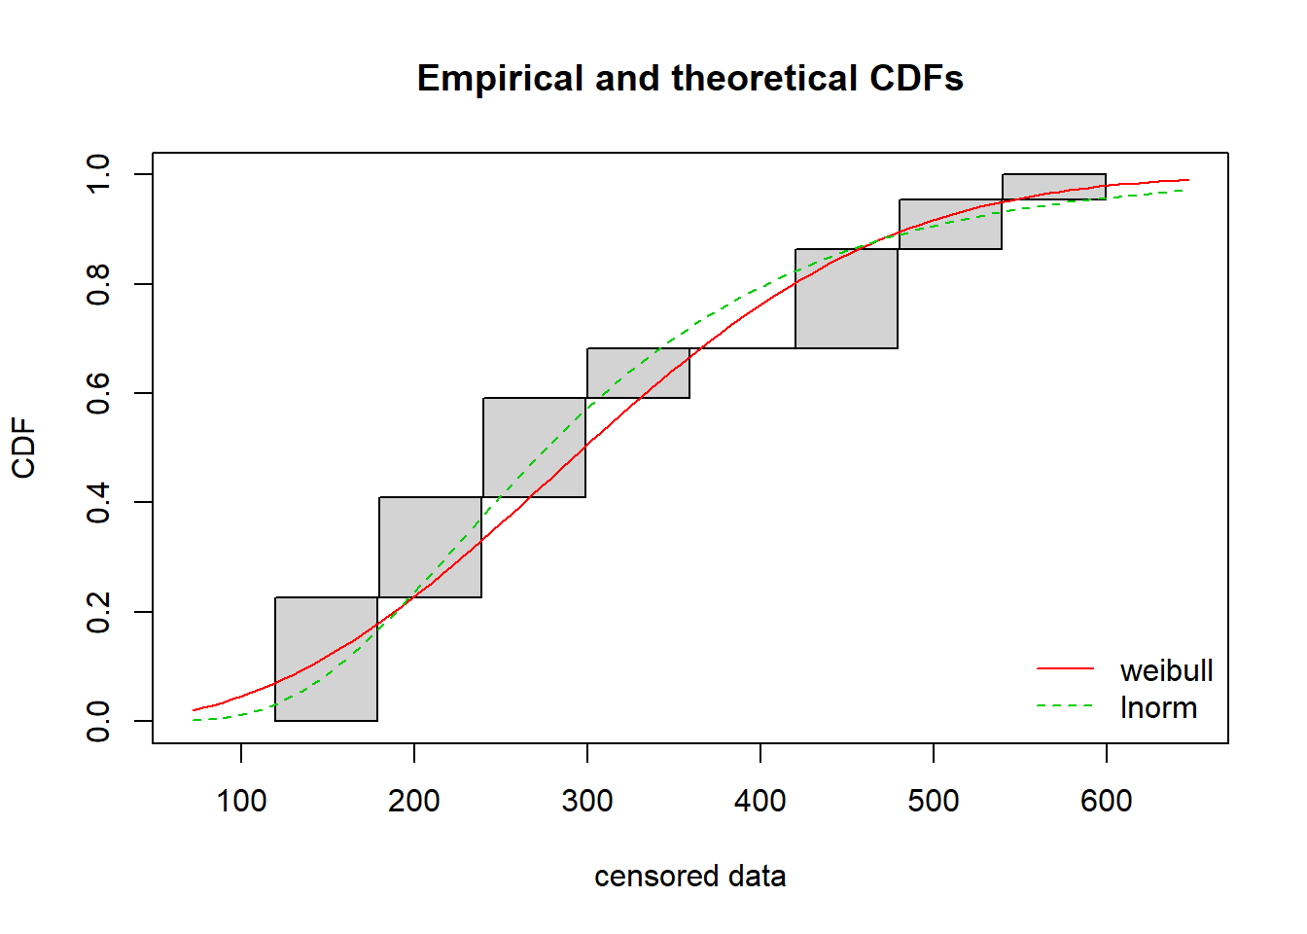
Figure 2. Cumulative distribution of registration time.
Figure 3. Cumulative distribution of scheduling time

Seasonality
Using patient registration time log data collected by St. Clair Hospital, patient volume time series are generated by month for 2018. Due to the formal error when collecting, the team was only able to look at 9 months in 2018, which is shown in Figure 4 F. Lacking a strong pattern, we assume there is no seasonality in patient volume each month.
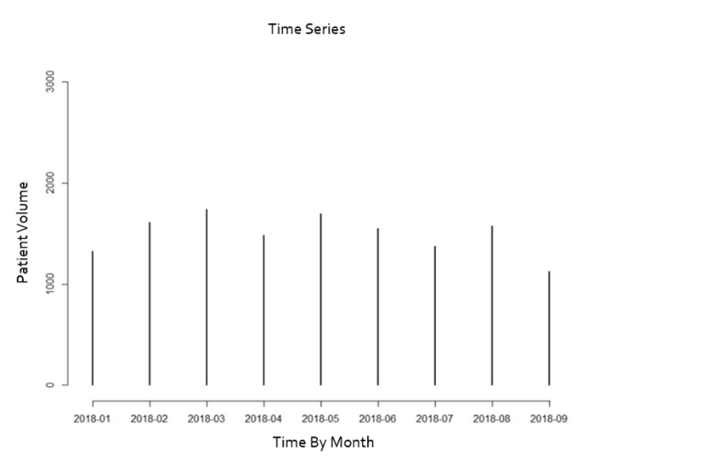
Figure 4. Monthly patient volume

Measures

Simulation Modeling
Simulation allows us to rebuild the process and to test different possible configurations to reduce wait times and queue in the system. Based on the simulation, it can determine patient wait time, patient waiting volume and resource utilizations as our metrics.

Model 1 – Original Process
The first model follows existing process in St. Clair hospital outpatient center registration area. 1 staff works at check-in. 2 staff work at registration. And 2 staff work at scheduling. In order to calculate wait time and volume, three different wait queues for check-in, registration and scheduling are set as resources with infinite capacity. The simplified process for this model is shown in Figure 5.

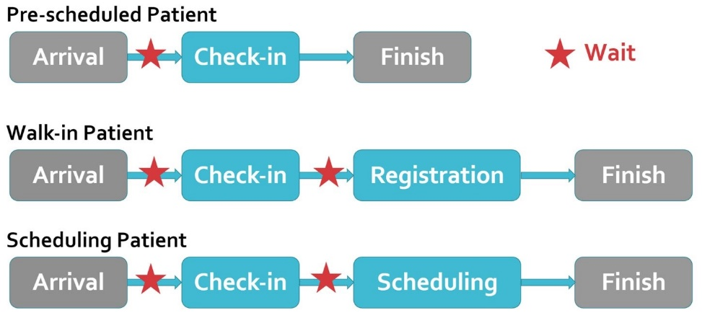
Figure 5. Current process map

Model 2 – Alternative 1
The first alternative model moves one scheduling staff to check-in. This results in 2 staff working at check-in, 2 staff working at registration and 2 staff working at scheduling. Simplified process for this model is shown in Figure 6.

Figure 6. Process map for alternative 1

Model 3 – Alternative 2
The second alternative model combines check-in and scheduling together, where 3 check-in staff handle initial check-in and any scheduling needs, and 2 registration staff handle verifying information and collecting co-pay. Simplified process for this model is shown in Figure 7.

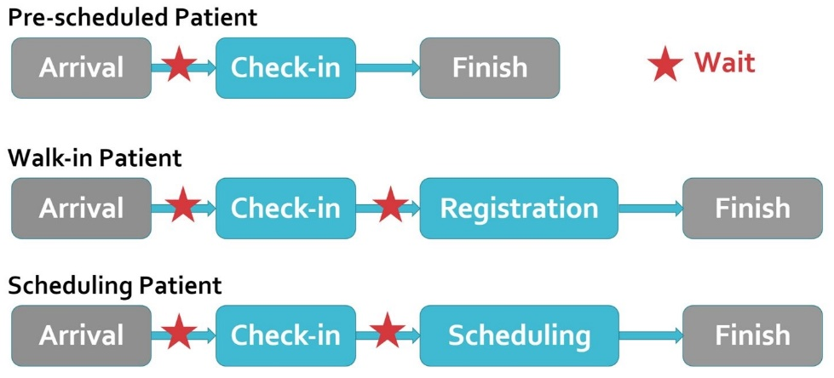
Figure 7. Process map for alternative 2

Simmer
Simmer, a discrete event simulation package for R, is used to build the three models [1]. Three trajectories are built based on the patient types: pre-scheduled, walk-in and scheduling. Check-in, registration, scheduling and three different waiting queues are set as resources. We use the real observed arrival time as simulation arrival schedule. Simmer records simulation process based on time stream, example of which is shown in Figure 8. The highlighted part shows how walk-in patient number zero goes through its registration process.

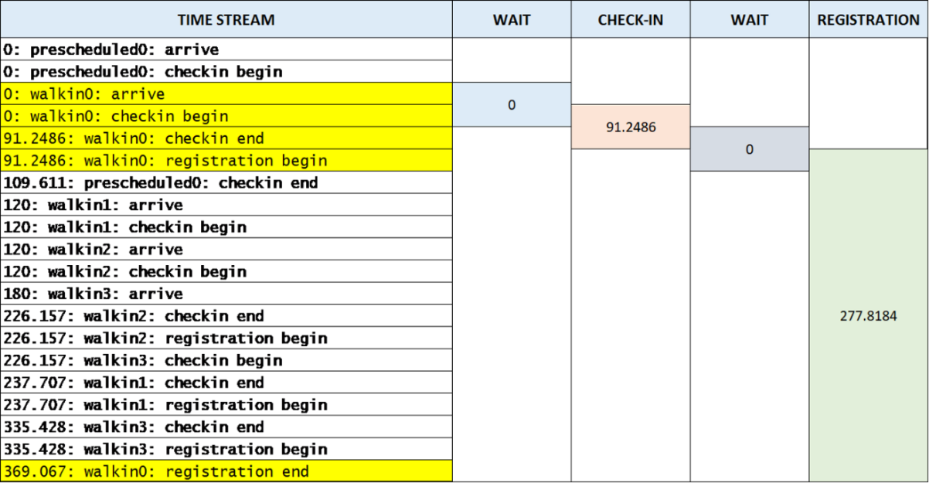
Figure 8. Sample patient flow from simulation model.

Human Factors Elements
After the team built our simulation and determined alternatives for staff utilization, the team decided to also incorporate human factors concepts to improve patient experience within the waiting room. The team determined that there will always be an element of wait time during this process, but if the team can improve the patient experience during this time, it might help improve patient satisfaction overall.

Best Practices
The best practices the team found to improve patient waiting experience include having posted wait times, having an open seating arrangement, offer refreshments and entertainment, and have a space for personal belongings. Providing a dashboard for patient wait times will help alleviate patient anxiety about missing their appointment, and also creates a perception of shorter wait times. Having a more open seating arrangement provides better visibility to the process and will also help patients see what is going on and anticipate their appointment. Offering positive distractions such as refreshments and entertainment, and a space for personal belongings proves a positive regard for their time and overall patient experience.

Table 1. Cost estimation
HF Best Practice | Item | Cost
Posted wait times | Dasheroo, TV monitor | $600
Entertainment | Artwork, Games/Puzzles, TV | ~$370
Facing the registration area | --- | Re-configure the chairs
Refreshments | Coffee Pot, Hot Water for Tea, Cups and Utensils | ~$82
Space for Personal Belongings | Storage Cubby | $50

In the table above is a breakdown of each item needed for each human factors best practice as well as the items needed and a cost estimation. The total implementation cost would be $1,075.

Analysis
Three metrics are generated from simulation models by 50 replications, which are resources utilizations, maximum wait time and maximum wait volume in each resource. The team looked at the worst situation in each model since each patient’s experience is unique. Using simulation, the team was able to collect resource statistics as shown in Figure 9, which allowed for calculating the three metrics.

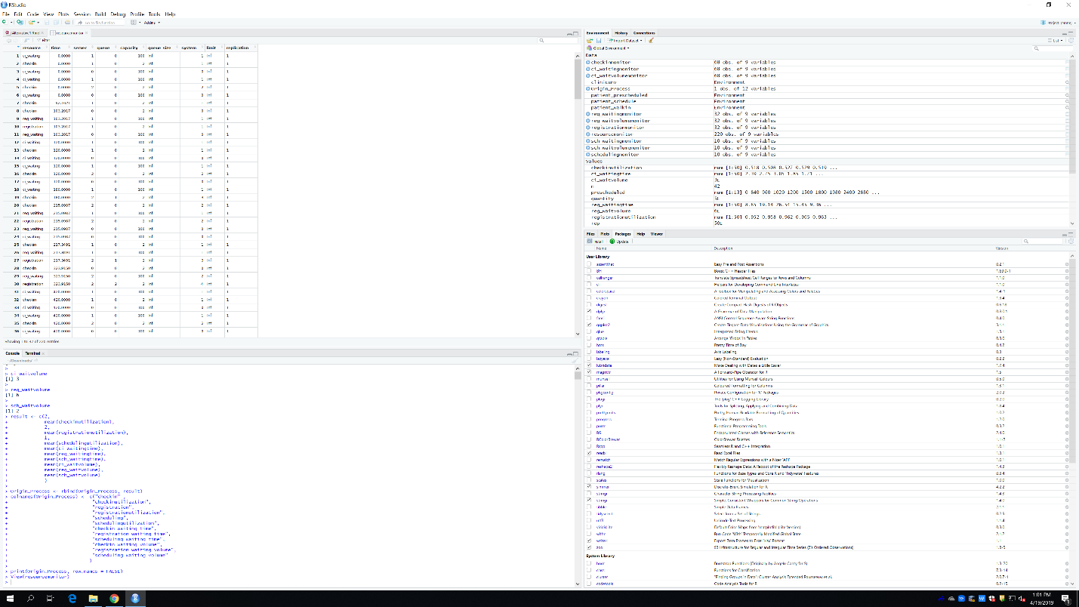
Figure 9. Sample resource table output from simulation.

Resources Utilization
Calculated resources utilizations for three models are shown in Figure 11. Resources utilization shows the percentage of the available time that each station is operating. Filtering the resources table by resource names, the team calculated utilization of each resources station using the equation in Figure 10 below:

$$utilization=\frac{Sum of the time each staff is operating}{total session time ×number of staff in each station}$$
Figure 10. Utilization equation

In model one, scheduling utilization is lower than 40 percent, which implies there are too much idle time in scheduling and the team can reduce the number of workers there. After moving one staff from scheduling to check-in in the first alternative model, though it enhances utilization in scheduling, check-in station is not fully utilized. In the second alternative model, the team combined check-in and scheduling stations, where all the resource utilizations are above 60%.
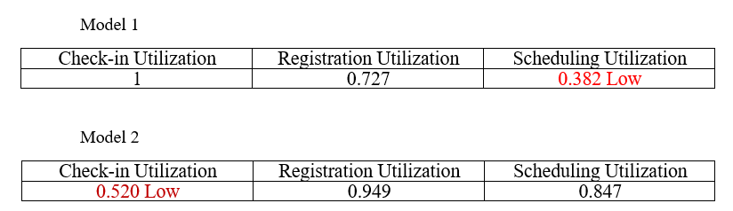
Figure 11. Example of model comparison statistics.

Max Wait Volume
Calculated maximum wait volumes for three models are shown in Figure 12. Maximum wait volume demonstrates the maximum number of patients waiting in a queue during a session. Filtering the resources table by queue names, the team calculated maximum wait volume as function below:
In model one, check-in wait volume is high which creates a bottleneck in the system. After moving one staff from scheduling to check-in in the first alternative model, the team was able to eliminate the bottleneck at check-in station. In the second alternative model, the team combined check-in and scheduling stations, which pushes the queue from the combined station to registration station.

$$maximum wait volume=max⁡(number of patient in a queue)$$
Figure 12. Maximum wait volume equation

Max Wait Time
Calculated maximum wait times for three models are shown in Figure 13. Maximum wait time demonstrates the longest time of patient waiting in a queue during a session. Filtering the resources table by queue names, the team calculated maximum wait time as function below:

$$maximum wait time=max⁡(each {patient}^{'}s wait time)$$
Figure 13. Maximum wait time equation

In model one, check-in wait time is quite long which creates a bottleneck in the system. After moving one staff from scheduling to check-in in the first alternative model, the team was able to eliminate the bottleneck at check-in station. However wait time in scheduling and recitation become higher than before. In the second alternative model, the team combined check-in and scheduling stations, which pushes the queue from the combined station to registration station.

Ethical Considerations
The team had to consider the impact of quality of care on the patients before considering recommendations because this is still the ultimate goal of the organization. Regulations such as HIPAA also must be considered to protect patient privacy as well.The team’s observations and analysis could not interfere with the patient care or primary functions of the outpatient center.

Results
The second alternative model was picked as the final client model, where check-in and scheduling are combined as one station. This eliminates the bottleneck, long queue, at check-in station and allows high utilizations in every station. However in this case, wait time and wait volume at registration are increased. The reason why the team recommended this option is so that patients can only stand in line when they are waiting for the check-in, but they are able to sit in the waiting area when waiting for registration. Since a large group of patients is older , it would be beneficial to them to allow them to sit while waiting.
Since the team moved queue from check-in to registration, the team decided to increase the amount of seats in waiting area. In order to increase the comfort level, it is necessary to offer refreshments and entertainment, and have a space for personal belongings. Also, providing a dashboard for patient wait times helps alleviate patient anxiety about missing their appointment, and creates a perception of shorter wait times. Figure 14 shows the current configuration of registration area in St. Clair hospital, and Figure 14 shows our recommended configuration.

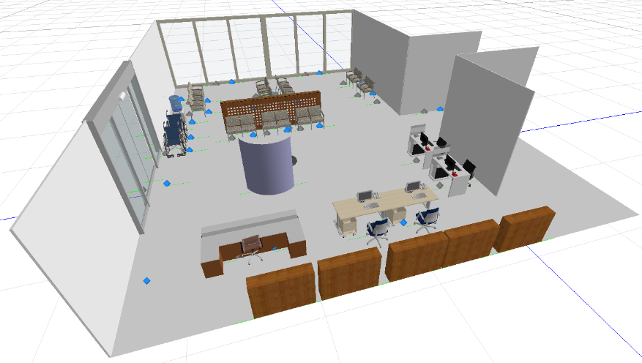
Figure 14. Current layout of registration area

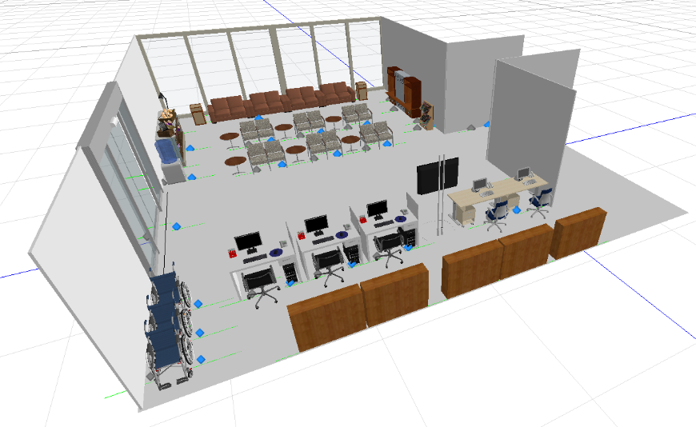
Figure 15. Recommended registration area layout

Discussion

Summary
The team focused our metric of improvement on the maximum waiting volume and the utilization for each step in the process. Our main goal was to reduce the queue in the check-in area and to increase utilization in each of the other stations. By combining check-in and scheduling capabilities, the team was able to re-allocate present resources to increase overall utilization, and also reduce the queue and present bottleneck at the check-in station. In the original process, with one check-in staff member, two registration staff, and one scheduling, the simulation had an average queue for the check-in of 11 people, and a very low scheduling utilization of 0.382. A second alternative the team offered was to add another check-in person, which was more accurate compared to the original process because often registration staff would take over check-in responsibilities when the initial queue got to be too long. However, adding this extra person did not offer a strong alternative because although the check in queue average dropped to only 3 people, the check-in utilization was very low at 0.520. By combining capabilities and duties, to have 3 people operating scheduling and check-in, the simulation maximized utilization with 0.602 for the combined scheduling and check-in, and lower the queue to being 2 people. Although this pushes the registration wait time to be 14.90 minutes, much larger than the original process of 2.19 minutes, it eliminates the queue build-up in the entrance way to the clinic, and allows for patients to sit in the waiting room. By pushing the queue to the waiting room, the client could use this opportunity to improve the waiting experience.

The team observed that the majority of the patient population was elderly and having to wait while standing in line proved to be uncomfortable. The team also noticed that many required assistance with registration and sometimes struggled to hear their names when called for their appointments. Although adding the additional human factors methods such as posted wait times, and entertainment will add more costs to implement and maintain, improving patient experience will have a positive effect on overall patient satisfaction. Providing posted weight times reduces patient anxiety because they will be able to track where they are in the process and also give the perception of a shorter weight time. Entertainment such as puzzles and TV will provide positive distractions and a better regard for their time, similar to providing refreshments to patients. Re-configuring the patient seating to face to queue as well as registration will help patients monitor the queue and prevent patients from missing their names when called. Finally, providing space for patient’s belongings will increase comfort by allowing patients to have a safe space for their belongings during their appointment. Although these could be potentially costly measures to maintain, showing regard for patient comfort and experience will improve overall satisfaction and quality of care.

Interpretation
Based on our observations, analysis of the data collected, and simulation model, it is our recommendation that St. Clair Outpatient Diagnostic Center consider making two primary – change staff allocation and utilizing human design elements to enhance the patient experience in the waiting room. Based on the model that the team created, they found that staffing utilization should be adjusted for the check-in portion of the visit. This can be done by reallocation and adjusting the duties performed at the location. Instead of having one staff at check-in and two staff scheduling, it would be optimal to combine the scheduling and check-in functions into one, and have three staff members perform them. Doing so will facilitate in reducing the amount of time that patients will have to wait be checked-in when they arrive. Because the Outpatient Center has various providers and services within the building, it is not uncommon that patients are sent to go down to the Diagnostic Center, on their way out, and schedule an appointment. With the recommended check-in/scheduling phase, patients will be able to have a staff member assist them with scheduling any necessary tests without having to wait for a separate scheduler, as they formerly did.

As a result of getting patients checked-in and in the system or scheduled, the queue will shift to the ‘registration’ portion of this process. In order to address this, our second recommendation would be to utilize human design elements in order to provide an enhanced experience for patients to accommodate for slightly longer wait time. Based on best practice research previously discussed in this report, the team examined various human factors elements that would be most appropriate for the patient mix and typical waiting room duration. Through this, devised a list of the top five elements that would impact the patients’ experience the most. The first element is to utilize a dashboard to display estimated wait time, where each patient falls in the queue, and any additional information or fun facts as a visual for the patient. Patients often feel most anxious when they do not know what to expect; thus, by making this information readily available to them, St. Clair can assist in alleviating this anxiety, and be an option for seeing their name being called in case they happened to miss it. As noted above, shorter perceived stays have resulted in patients and their families feeling more satisfied. This could be implemented by purchasing a monitor, estimated at around $600, in combination with the Dasheroo program. This program would provide the platform to display desired real-time metrics. In connection to this first element, the second element would be to re-configure the seating arrangements so that they face the registration area. Doing so allows the patients to feel more engaged with the process, and helps prevent them from missing their name when called, as they can also monitor the queue as much or as little as they would like. This element would be free of cost and require minimal manual effort.

The third component would be to provide entertainment items to act as positive distractions. This could take the form of magazines, puzzles, and other interactive or stimulating activities. Not only does this preoccupy patients, but it demonstrates a high regard for the patients’ time. The estimated cost for these items would be around $380. This cost would vary depending on volume. The fourth component, also demonstrating regard for the patients and their families, is offering additional refreshments. These refreshments could include coffee or tea. This cost would also be dependent on volume. Lastly, the fifth component would be to provide a space for personal belongings. Particularly in the fall and winter months, patients and families have additional articles of clothing that they are often seen carrying around each time they have to get up or be seen. Additionally, a good percentage of the patients require assistance with mobility, such as a walker or cane; thus if provided a space to put their belongings, they will not have to worry about maneuvering several things at one time. The cost of applying a structure to achieve this would be around $50. There is also an opportunity to utilize unused space in the waiting room.

Limitations
Some limitations to the recommendations include the cost of maintenance to some of the human factors elements. Due to the healthcare environment, there could be obstacles to implementation, also an extra charge associated with it. Another limitation is that the team could not test the recommendations outside of a model, which limited the overall feasibility. However, by using collected data to build each simulation also focusing on best practice for the environment, the team was able to limit the effects of this.

Conclusions
While St. Clair Outpatient Diagnostic Center continues to provide high quality diagnostic services to its patients, its current registration process creates a long wait at initial check-in, causing significant patient dissatisfaction. Such dissatisfaction was assessed using current and historical CGCAHPS data, written reviews online, and verbal complaints in office. Due to time constraints, the scope of the problem was refined to only examine the process beginning from when the patient first arrives, to the time they are fully registered and waiting to be called back by the appropriate technician

Current state assessment was done through process observation and mapping, analysis of current Accutrack data, and the results of a simulation model. Pain points that were identified included patient scripts not being available at the time of check-in, difficulty to pre-register patients when many are walk-in, and patients not having complete or inaccurate insurance information resulting in additional time being required to address such issues. Simulation models were built utilizing stamped data that was attached through St. Clair and data collection. Additional staffing analyses were also done with this information to determine the busiest times and days. In order to determine estimated times patients were waiting to be checked in, the observation data was used as censor data. The data set was then fit to a distribution using left and right censoring data. The check-in process fit in a lognormal distribution. Sixty seconds were added to account for additional paperwork time for the check-in process, and ninety seconds for the registration process. Looking at the patient volume time series, no seasonality was found. Simulation models were used to rebuild the process to allow the testing of various possible configurations, derived from patient wait time, patient wait volume, and resource utilizations. Simmer, a process-oriented and trajectory-based Discrete-Event Simulation for R, is used to build these to account for pre-scheduled, walk-in, and scheduling. Based on the findings, the optimal model combines check-in and scheduling together with three check-in staff, and leaves two registration staff to verify information and collect copay.

Best practice research was conducted to evaluate which human factor elements would be most impactful in this Diagnostic Center setting based on patient mix and average duration of wait time for services. The five elements identified to make the most profound difference are making wait times and queue visible to patients, providing entertainment and light refreshments, re-configuring seating to face the registration area, and providing designated space for personal belongings. It is with strong conviction that implementation of these five human factor elements and reallocation of staff and duties in the registration process will reduce duration of time patients are standing at check-in, and improve overall patient satisfaction.

Acknowledgements
We would like to thank St. Clair Hospital for this opportunity to work with them and apply the concepts we’ve learned through our industrial engineering curriculum to a real world application. We enjoyed the process and also learning more about the healthcare field. We would like to thank our sponsors Matt Daffenbach, Jenny Petruski, and Tania Lyon as well as Caroline Kolman and Dr. Wes Rohr for their support throughout the process.

References

Azcorra, I. U. (2018). simmer: Discrete Event Simulation for R. Journal of Statistical Software. Retrieved from simmer DES for R.

Charitie K. Horsley, C. (2013, April 19). Five Practices to Improve Your Registration . Retrieved from AAPC: Advancing the Business of Healthcare: https://www.aapc.com/blog/24860-five-practices-to-improve-your-registration/

Delignette-Muller, M. L. (2015). fitdistrplus: An R Package for Fitting Distributions . Journal of Statistical Software, 7-25.

Heath, S. (2017, October 27). Patient Pre-Registration Tips for a Quality Consumer Experience. Retrieved from Patient Engagement HIT: https://patientengagementhit.com/features/patient-pre-registration-tips-for-a-quality-consumer-experience
III, F. W. (2008). Integrated Enterprise Excellence, Vol III Improvement Project Execution: A Management and Black Belt Guide for Going Beyond Lean Six Sigma and the Balanced Scorecard. Austin: Bridgeway Books.

Corresponding author: lluangkesorn@pitt.edu

