Strategies for Engaging Community Health Workers to Reduce Malaria Mortality in Children Under Five in Rural Togo

by
Megan Elizabeth Arden
BS Microbiology, Immunology, and Molecular Genetics, University of California, Los Angeles, 2016

Submitted to the Graduate Faculty of the
Department of Infectious Diseases and Microbiology
Graduate School of Public Health in partial fulfillment
of the requirements for the degree of
Master of Public Health

University of Pittsburgh
2020

UNIVERSITY OF PITTSBURGH
GRADUATE SCHOOL OF PUBLIC HEALTH

This essay is submitted by
Megan Elizabeth Arden
on
June 12, 2020
and approved by

Essay Advisor:
Linda Rose Frank, PhD, MSN, ACRN, FAAN
Professor, Infectious Diseases and Microbiology, Graduate School of Public Health
Professor of Medicine, CTSI, School of Medicine
Professor of Nursing, Health and Community Systems
University of Pittsburgh

Essay Readers:
Joanne Russell, MPPM
Director, Center for Global Health
Assistant Dean, Global Health Programs, Office of the Dean
Assistant Professor, Behavioral and Community Health Sciences
Graduate School of Public Health
University of Pittsburgh

Sarah Krier, PHD, MPH
Assistant Professor, Infectious Diseases and Microbiology,
Graduate School of Public Health
University of Pittsburgh

Copyright © by Megan Elizabeth Arden
2020

Linda Rose Frank, PhD, MSN, ACRN, FAAN

Strategies for Engaging Community Health Workers to Reduce Malaria Mortality in Children Under Five in Rural Togo

Megan Elizabeth Arden, MPH
University of Pittsburgh, 2020
Abstract
In the West African nation of Togo, malaria is highly transmitted; therefore, there are various malaria prevention, treatment, and case control measures in place. Nevertheless, malaria remains the top cause of death in children under 5. One of the interventions in place is Integrated Community Case Management (iCCM), an initiative that provides care to children for malaria, pneumonia, and diarrhea, though it has not been well implemented in Togo. Community Health Workers (CHWs) play an integral role in the implementation of iCCM, and strategies to fully engage them, deserve consideration for its success. A literature search through Ovid Medline, PAIS, and Google, along with my lived experience in Togo revealed relevant data on community health workers in Togo. Search terms included “Togo”, “community health workers”, “integrated community case management”, “scoping review”, “active case detection”, “malaria”, “African countries” and “English language”. Additionally, literature from the World Health Organization (WHO) was searched to gather data on individual governments, health policies, and funding. Strategies to consider in successful CHW program implementation in Togo fell into the following categories: public health policy, CHW selection, and CHW practice. This essay provides strategies to better engage CHWs in Togo. By supplementing current malaria strategies in place, the public health significance of these recommendations will increase access to malaria care in rural communities and reduce the malaria mortality rate in children under 5 in Togo.
Table of Contents
Preface viii
Abbreviations ix
Introduction 1
Methods and Limitations 2
Background of Togo 3
History 5
Demographics 6
Religion 7
Health 8
Malaria in Togo 11
Malaria Prevalence 13
Rural Togo 14
Rural Education 15
Rural Health 16
Community Health Workers 20
CHWs in Togo 23
Malaria Control 26
iCCM 32
Recommendations 33
Public Health Policy Recommendations 34
CHW Selection Recommendations 35
CHW Practice Recommendations 36
Conclusion 38
Appendix: Supplementary Tables 40
Bibliography 48

List of Tables

Table 1: Select maternal and neonatal health indicators in Togo. 9
Table 2: Select water and sanitation health indicators in Togo. 10
Table 3: Select maternal and neonatal health indicators in Togo, separated by urban and rural communities. 18
Table 4: Select water and sanitation health indicators in Togo, separated by urban and rural communities. 19

List of Figures
Figure 1: Geographical map of Togo. 4
Figure 2: Womé, one of the many waterfalls in the Plateaux region. 5
Figure 3: Population distribution in Togo in 2020. 6
Figure 4: Djenkoumé, a celebration meal shared among multiple guests. 11
Figure 5: Tree seedlings about to be planted. 14
Figure 6: Healthcare facilities throughout Togo, by region in 2018. 16
Figure 7: Healthcare personnel throughout Togo, by region in 2018. 17
Figure 8: The view down a well-maintained rural road. 37
Figure 9: The empty market area. 39

Preface
From 2017-2019, I served as a Community Health and Malaria Prevention Extension Agent in Peace Corps Togo. I served in a community with a population of roughly 3,700 people, in the southern part of the country. Though this essay will explore many of the health issues present in Togo, there were many more aspects of Togo that made my service enjoyable and rewarding. Therefore, I would like to thank the Peace Corps staff and host country nationals of tiny, terrific Togo for inviting me into their country. I would also like to thank my advisors, Dr. Sarah Krier, Joanne Russell, and Dr. Linda Frank, for their continued support, even throughout my time abroad. Their own global experiences motivated me to always remember why and for who I am working in the public health field.

Abbreviations
ACD - Active Case Detection
ACT- Artemisinin-based Combination Therapy
CDC- Centers for Disease Control and Prevention
CHW- Community Health Workers
ICBHSS- Integrated Community-Based Health Systems Strengthening
iCCM- Integrated Community Case Management
IMCI- Integrated Management of Childhood Illnesses
IpT- Intermittent Preventive Treatment
IRS-Indoor Residual Spraying
ITN/LLIN-Insecticide-Treated Mosquito Net/Long-Lasting Insecticidal Net
MSHP- Ministry of Health and Public Hygiene
NGO- Nongovernmental Organization
PCD- Passive Case Detection
PMI- President’s Malaria Initiative
RCD- Reactive Case Detection
RDT- Rapid Diagnostic Test
SP- Sulfaxodine-Pyrimethamine
UNICEF- United Nations Children’s Fund
USAID- United States Agency for International Development
USP- Peripheral Care Units
WHO- World Health Organization
XOF- West African CFA franc

Introduction
Malaria has affected populations around the world for millennia. While as of 2018, 36 countries and territories eliminated malaria by implementing specific measures, there is still work to be done in Togo. Malaria is the leading cause of death in children under 5 in Togo and since the United Nation’s Sustainable Development Goal 3 targets ending the malaria epidemic and reducing under-5 mortality, Togo’s vulnerability to malaria is a priority. A table of relevant Goal 3 targets are found in Table 1 of the Appendix. In 2019, Dr. Pedro Alonso, director of the World Health Organization (WHO) and the WHO Global Malaria Program, reflected on the fight against malaria and commended countries that vary the types of malaria control strategies they implement within each country, in order to best use their resources to meet the needs of heterogeneous contexts. Similarly, it is necessary that malaria control interventions in Togo be tailored in order to best reach the most vulnerable portions of the population.
Two of the objectives in the Togolese Ministry of Health and Public Hygiene (MSHP)’s mission are to 1) combat HIV/AIDS, malaria, tuberculosis and other diseases including non-communicable diseases, diseases with epidemic potential and neglected tropical diseases and 2) improve the organization, management and health services. To address the unequal distribution of healthcare facilities throughout the country, community health workers (CHWs) can be engaged to reach rural communities, especially through the implementation of Integrated Community Case Management (iCCM), which targets malaria, pneumonia, and diarrhea. Though there is currently an iCCM program in place in Togo, there is a need for improvement. This essay discusses considerations for effectively utilizing CHWs in the implementation of iCCM in Togo as a way to increase access to malaria care for children under five and reduce malaria mortality in that population. The following sections will present the background of Togo, including the role of CHWs. Next, the interventions and policies that currently address malaria in Togo will be addressed. Last, recommendations for CHW engagement and their implications will be given.

Methods and Limitations

The objective of this essay is to provide recommendations for optimal CHW engagement in iCCM, with a focus on malaria control strategies in areas of Togo with low access to healthcare services. A comprehensive review of literature was conducted on publications that focused on CHW performance within malaria case management programs in Togo. Medline (Ovid) were searched; a health sciences librarian developed all searches with my assistance. The date of the last search for articles was April 27, 2020. Search terms were “Togo”, “community health workers”, “integrated community case management”, “scoping review” and “English language”. A combination of MeSH terms and title, abstract, and keywords were used to develop the initial Medline search. The search was then adapted to PAIS: Public Affairs Information Service (ProQuest). A previous search on Medline (Ovid) and PAIS was done on January 30, 2020. Search terms were “active case detection”, “malaria”, and “African countries”. Strategies and date searched for each database can be found in Tables 5, 5a, 5b, 5c, 5d, and 6 in the Appendix.
Google and Google Scholar were also searched on May 14, 2020, to find relevant articles on community health workers in Togo. Literature from the WHO was searched to gather data on individual governments, health policies, and funding. Last, descriptions of my field experience in Togo as a Peace Corp volunteer was included to supplement data found in the searches. One limitation to this search was the lack of relevant published studies on CHWs and iCCM in Togo. Additionally, there was no documentation of the current iCCM or CHW policy in Togo.

Background of Togo

The Togolese Republic is a French speaking West African nation bordered by Ghana, Burkina Faso, Benin, and the Atlantic Ocean. Though it is a small nation, with a total area of 21,853 square miles, the estimated population in 2020 of 8,608,444 people make up the 37 ethnic groups in Togo each with their own languages. Besides French, the two major languages in the south are Mina and Ewe, while in the north, the major languages are Kabye and Dagomba. There are five administrative divisions from south to north: Maritime, Plateaux, Centrale, Kara, and Savanes. The geography also varies throughout the country, with a coastline in the south to mountains in the central, and savannahs in the north.

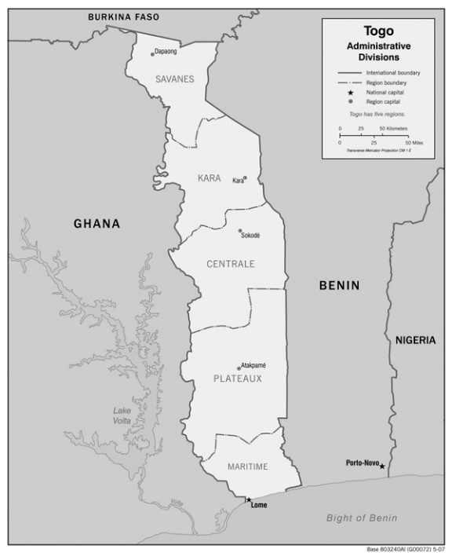
Figure 1: Geographical map of Togo.
(Map by vidiani 2020)

Togo’s climate is generally described as tropical, with average temperatures of 81.5°F in the south to 86°F in the north. Malaria transmission is often seasonal, with peaks during the rainy season, of which there are two rainy seasons in the central and southern parts of Togo, and one in the north. Landoh et al. reported that from 2005 to 2010, malaria transmission was highest during the rainy seasons in a district in the Plateaux Region.
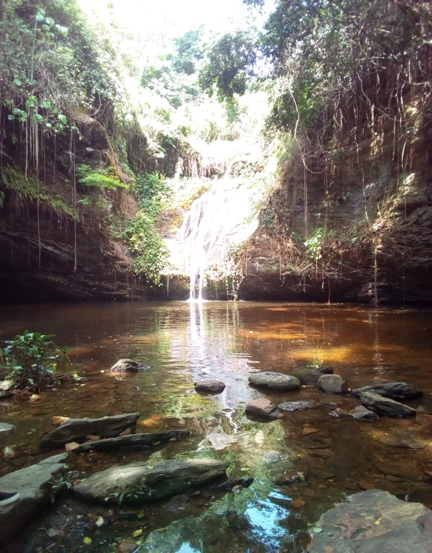
Figure 2: Womé, one of the many waterfalls in the Plateaux region.

History

Togoland, a German protectorate that was established in 1884, was seized by British and French forces in 1914. The League of Nations divided Togoland into the British west (later renamed Ghana), and the French east. In 1960, Togo gained independence from France as the République Togolaise, and in 1961, Sylvanus Olympio was elected as the first president. He was then assassinated in 1963, and Nicolas Grunitzky became president. In 1967, General Gnassingbé Eyadema seized power, dissolved political parties, and became the military ruler and stayed in power for four decades. He was then elected president in 1977, after being the sole candidate, and was re-elected in 1986, 1998, and 2003. Eyadema dissolved the government in 1992, causing the European Union to break ties with Togo. When General Eyadema died, in 2005, the military appointed his son, Faure Gnassingbé, as president. International pressure caused Togo to hold elections, which Faure Gnassingbé won, though it was considered rigged and was followed by deadly violence. Nevertheless, in 2007, the European Union restored full ties, and he was re-elected in 2010 and 2015. Local elections in 2019 re-instated a maximum of two, 5-year presidential terms, though Faure’s Gnassingbé prior terms do not count, and he is re-elected in 2020.

Demographics

Estimates for 2020 indicate that the 0-14 age group will make up 39.73% of the population, while the 15-64 age group will make up 56.71%. The over 65 age group will make up only 3.57% of the population.
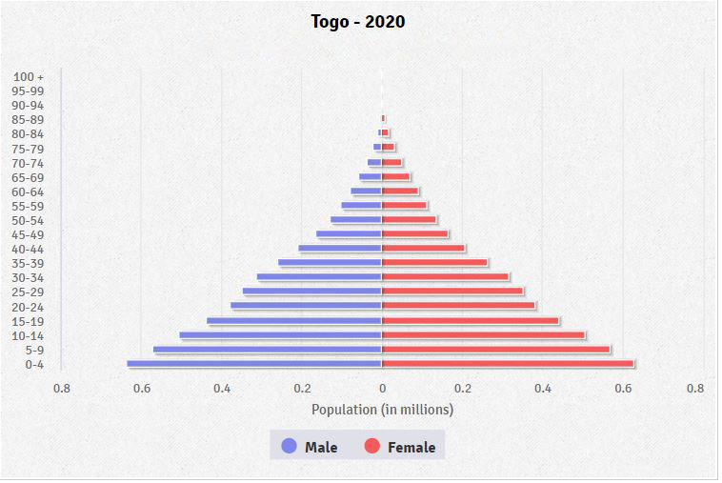
Figure 3: Population distribution in Togo in 2020.
(Table by CIA 2020)

The World Bank economic classification of Togo is low-income, defined as having a gross national income of $1,025 USD or less per capita in 2018, while 49.8% of the population lived below $1.90/day. As of May 17, 2020, this converts to below 1153.30 West African CFA franc (XOF)/day, which is the currency used by Togo and seven other African countries that used to be French colonies. In 2015, 64.25% of the population age 15 and over were literate, while in 2019, only 12.4 individuals per 100 inhabitants used the internet. Nevertheless, 77.9 individuals per 100 inhabitants of the population had a mobile cellular subscription in 2018. Even in my community, which did not have electricity, most adults had cellphones without internet subscriptions which they paid to charge at local stores with access to solar panel energy. Most recent data from 2019 puts the male to female primary or elementary school enrollment ratio at 120.1 to 125.9 per 100 population. For secondary (or middle and high) school, the enrollment ratio was at 71.4 to 51.9 per 100 population.

Religion

According to the CIA, the three major religions practiced in Togo are Christianity (43.7% of the population), Animistic and ancestral folk beliefs (35.6%), and Islam (14%). Animistic beliefs consist of the belief in intermediate deities who are links between humans and the supernatural and practitioners may have home altars on which they offer sacrifices. Worshippers aim to maintain balance in the universe and believe all parts of nature and life are linked together. Fetish priests are prominent in Togolese communities. They may give out amulets which offer protection to families, or practice herbalism and mysticism along with western medicine. Each ethnic group has varying practices, and some may worship ancestors or have social initiations into adult life. In the southern part of the country, many people practice Vodou, where the believers go into a deep trance to communicate with the spirits.
My good friend’s dad was a leader in the Animist faith in the community in which I served. I did not learn much about this religion, as he was often discouraged by community leaders, who preferred he practice Christianity. I would often see him feed his fetishes with food and water, and people would visit him from as far as Ghana to contact their ancestors. Interestingly enough, the prominent healthcare workers were clearly associated with the various Christian denominations present in the community. My friend’s dad and family still went to the public clinic, though I did hear stories of contention between animist and government healthcare workers in Togo.

Health
There are three levels of care in Togo: primary, secondary, and tertiary. The primary level consists of CHWs who connect communities to healthcare services, peripheral care units (USPs), which are the foundation and most basic health care facilities found in communities, and last, district hospitals to which patients with severe infections are usually referred. On the secondary level there are regional hospitals, and the tertiary level has university hospital centers. In 2017 there were only 1047 USPs, 101 district hospitals, 6 regional hospitals, 3 University Hospital Centers, 54 infirmaries, and 59 unspecified facilities. In 2019, only 6.6% of the Central government expenditure was allocated for health. Last, in 2018, 45.6% of health facilities in Togo experienced drug stockouts, or shortages, within the previous three months.
Togo is in the African region, stratum D (AFR D), meaning that there is high child and high adult mortality. In 2015, more than half of the DALYs lost, 58.86%, were due to communicable, maternal, perinatal and nutritional causes; within that category, the top three causes that year were infectious diseases such as lower respiratory infections (434,400), malaria (387,300), and HIV/AIDS (317,900). The top three causes of death in 2016 were lower respiratory infections (6,800 deaths), HIV/AIDS (5,100 deaths), and malaria (4,500 deaths). Additionally, in 2018, there were 2,002,877 persons with known malaria, the HIV prevalence rate among adults aged 15-49 years was 2.3%, and the tuberculosis incidence rate was 36 per 100,000 population. Additional data on the health status in Togo is presented in Tables 1 and 2.
Table 1: Select maternal and neonatal health indicators in Togo.
Indicator | Year | Value | Units
Maternal mortality rate | 2015 | 368 | Deaths per 100,000 live births
Women aged 20-24 who gave birth before age 18 | 2014 | 13 | %
Births delivered by caesarian section | 2014 | 7 | %
Pregnant women who receive 4+ antenatal visits | 2014 | 57 | %
Births attended by skilled health personnel | 2014 | 59 | %
Births in health facilities | 2014 | 73 | %
Neonatal mortality rate | 2014 | 26 | Deaths per 1,000 live births
Newborns who received care within 2 days of being born | 2014 | 35 | %
(UNICEF 2018)
Table 1 Continued
Table 2: Select water and sanitation health indicators in Togo.
Indicator | Year | Value | Units
Percent of the population performing open defection | 2017 | 48 | %
Percent of population without a basic handwashing facility at home | 2017 | 78 | %
Percent of population with unimproved drinking water sources* | 2017 | 16 | %
Percent of population with improved drinking water sources | 2017 | 84 | %
Out of those with improved water supplies, percent with access to piped water | 2017 | 26 | %
Out of those with improved water supplies, percent with access to non-piped water** | 2017 | 45 | %
Percent of the population’s whose water source was at least 30 minutes away | 2017 | 6 | %
(UNICEF & WHO 2019)
* defined as unprotected wells and springs
** includes boreholes, protected wells, rainwater, and packaged water

Last, the overall life expectancy at birth in 2017 was 65.45 years old. Altogether, this data suggests that Togo is in the Age of Receding Pandemics, and positively, Togo became the first sub-Saharan African country to eliminate lymphatic filariasis, in 2017. Nevertheless, malaria is not substantially receding, and especially not for children under five.

Malaria in Togo
Many in Togo, especially in rural areas, live in and share communal spaces, including latrines and shower areas. Compound members were often as close as family members, if not actually related to each other. I ate most of my meals with my hands out of the same bowls as my neighbors, and often called on them to catch mice and bats in my room, which I was too afraid to trap by myself. Living communally also means that the same mosquito with the Plasmodium parasite can easily transmit it to many people in the same area.
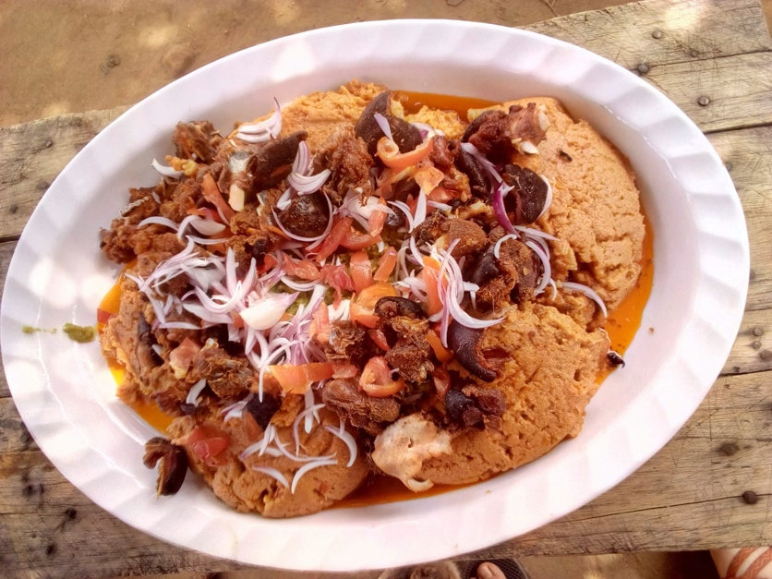
Figure 4: Djenkoumé, a celebration meal shared among multiple guests.

Malaria is a disease that can be caused by six different Plasmodium species parasites: Plasmodium falciparum, P. vivax, P. ovale curtisi, P. ovale wallikeri, P. malariae, and P. knowlesi. P. falciparum is the major cause of death among the species. An area is considered to have high transmission rates of malaria when there is more than one person with malaria per 1000 population. This occurs in Togo and 100% of those are transmitted by P. falciparum. Infected female Anopheles mosquitoes inject the host with the sporozoite form of the parasite. The sporozoites infect the liver, where they develop into schizonts which release merozoites. The parasites then multiply asexually in the red blood cells. In the erythrocytes, the trophozoite form of the parasite become schizonts, which also rupture and release merozoites. From there, some of the parasites differentiate into gametocytes, where the Anopheles mosquito then picks them up when they take a blood meal, where they multiply, and continue the cycle. Malaria infection often produces non-specific symptoms that include fever, aches, nausea, and rigor. If untreated, complicated or severe malaria can progress to cerebral malaria, which results in seizures, neurologic abnormalities, comas, severe anemia, and respiratory distress.
Funding for malaria control in Togo comes from multiple donors and has fluctuated between 2016 and 2018. Tables 8 and 8a in the Appendix report the contributions, by year, donor, and as reported by both the donors and the Togolese government. Interestingly, the reported amounts contributed by donor differed between donor and the national government’s count, with the Togolese government reporting higher amounts from the Global Fund, and lower amounts from the World Bank in 2018. With 64,000USD, the national government contributed the second lowest amount of funds towards malaria funding in 2018. Furthermore, countries that invest low levels into their health, tend to have residents pay high out-of-pocket payments. There are studies that have shown that reducing out-of-pocket spending to below 20% of the total health expenditure ensures financial risk protection. Out-of-pocket payments in Togo accounted for more than 40% of the total health expenditure in 2010, and 22.8% of malaria spending in 2016. These payments can be a barrier to accessing health care, for those who cannot afford it. The National Health Insurance Institute of Togo implemented mandatory health insurance, though as of 2018, it has not included coverage for informal sector workers, such as many in rural Togo. Possible reasons for this included the fact that many in the informal sector are not able to pay insurance premiums in advance, due to their low incomes. Nevertheless, informal sector workers were found to be willing to pay a premium, and it was suggested that extending health insurance to them may be feasible if the government offered a subsidy policy, and funded half of the premiums per worker.

Malaria Prevalence
Malaria is a major global health concern. According to the WHO, in 2018 there were 228 million persons with malaria worldwide, with 405,000 deaths, and 67% of deaths occurring in children under 5 years old. Of those 228M in 2018, 213M were in the WHO African region. In 2018, there were 2,002,877 persons with known malaria in Togo, 76,870 of which were classified as complicated. Fifty eight percent of the hospitalizations and 69.9% of deaths due to malaria in Togo were in children under 5. Data from 2017 puts malaria as the leading cause of death in children under 5, at 36% of all deaths in that age group.

Rural Togo
Almost all Togolese residents (especially in rural communities) are farmers in some capacity; even government workers such as teachers and nurses have farmland. Many are subsistence farmers, relying on their harvest and/or profits from their harvests to live. The most recent data from 2011 indicates that 67.4% of the land was used for agriculture. In 2019, 38.4% of the employed population was in the agriculture sector, the second highest employment sector in Togo. Also, 90.4% of Togolese workforce in 2017 worked in the informal sector. Entire families may go to the fields, including children after school and on the weekends. So, when a child becomes sick, not only do families lose out on labor, but also their next meal is affected.
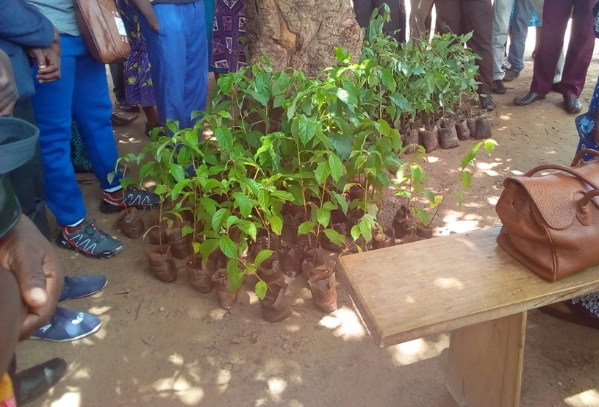
Figure 5: Tree seedlings about to be planted.
Approximately 1/3 of the country’s roadways are paved, and there are only three main road systems throughout the country. Lomé, the capital city, and the village I served in, are both located in the Maritime region. Though Lomé is located in the Maritime region, it is often described as its own area called Lomé commune. This is probably due to the contrast between the urbanization of the capital city, and the rural area that is the rest of Maritime and most of Togo, in general. In 2018, 57.9% of the population lived in rural areas.
In rural, isolated communities in Togo, traditional customs often trump the formal legal system. For example, Togolese law prohibits female genital mutilation and cutting, but in 2015, it was reported that 3.1% of girls and women between ages 15 and 49 had the procedure. The law is rarely enforced, because many cases occur in rural, isolated communities where people were not aware of the law, or traditional customs trumped the legal system. Additionally, child labor under the age of 15 is prohibited by law, but there are not any corresponding penalties, and it is mainly enforced in urban areas, within formal sectors. Many children, from as young as 5 years old, still assist families in farming, especially in informal sectors in rural Togo.

Rural Education
School attendance is required for all children up until age 15, but public tuition is only free up through primary school. Paying for secondary school was a barrier for continuing education for many students in my community. Students were sent home if their fees were not paid, and I heard stories of students, often girls, not continuing into high school, due to their families not being willing, or more often, not able to pay. Net attendance in elementary school from 2013-14 slightly differed by residence. In urban areas, the attendance rate was 96%, while in rural areas it was 85%. There was also a disparity in middle and high school net attendance with the urban population at a 62% attendance rate, and rural with 38%.

Rural Health
A couple of months ago, the Volunteer who replaced me, informed me that a young family member of one of our close Togolese friends, had passed away. Though I do not know the cause of death, I do know that the child had been sick for a while, before being taken to the clinic. The necessary treatment was not available, and the roundtrip cost was too expensive for the family to go the larger district hospital, approximately 11km away.
The distribution of these services throughout the country is unequal, as demonstrated in Figure 7.

Figure 6: Healthcare facilities throughout Togo, by region in 2018.
(MSHP 2019)

Additionally, out of 114 high level hospitals in Togo, almost half of them, 52, were in Lomé, leaving the other regions to rely on less advanced healthcare. Consequently, Figure 8 shows that healthcare professionals (physicians, physician assistants, nurses, midwives, birth attendants) are not equally distributed.

Figure 7: Healthcare personnel throughout Togo, by region in 2018.
(MSHP 2019)

The village I lived in was only 50km from the capital city, but I experienced many of these difficulties. The community did not have access to running water, but there were approximately five pay per use pipes located throughout the village. There were also multiple boreholes and wells that filled with rainwater, all well within 30 minutes of all the households. However, these pipes often were busy, and women (the main family member who carried water) often had to wait, and then carry up to 25 liters of water on their heads, back home. The pipes often broke, and I was asked to build another one by multiple community members, which proved impossible because the Volunteer before me had also fundraised the cost of one of the pipes. When the closest pipes to my house broke, either I prayed for rain, showered with packaged water, or a neighbor would take pity on me and carry water for me from a further water source.
As a Peace Corps Volunteer, I was required to have a personal latrine near my house; my five neighbors had to share the other latrine in our vicinity. Many in my community did not have latrines, and I often saw people as they emerged from the field near my compound, where they openly defecated. In bigger cities, in addition to latrines, other households, including the host family I lived with during my preservice training, had flush toilets or pour flush toilets. These data all point towards the need for improved healthcare access and service delivery in Togo, but specifically, in the underserved, rural regions of the country. Disparities exist in maternal health, improved water sources and sanitation in Togo by residence, and Tables 3 and 4 demonstrate these differences between urban and rural communities.

Table 3: Select maternal and neonatal health indicators in Togo, separated by urban and rural communities.
Indicator | Year | Value | Units
Women aged 20-24 who gave birth before age 18
Urban | 2014 | 9 | %
Rural | 2014 | 17 | %
Births delivered by caesarian section
Urban | 2014 | 12 | %
Rural | 2014 | 3 | %
Pregnant women who receive 4+ antenatal visits
Urban | 2014 | 72 | %
Rural | 2014 | 49 | %
Births attended by skilled health personnel
Urban | 2014 | 92 | %
Rural | 2014 | 41 | %
Births in health facilities
Urban | 2014 | 94 | %
Rural | 2014 | 61 | %
Neonatal mortality rate
Urban | 2014 | 28 | Deaths per 1,000 live births
Rural | 2014 | 31 | Deaths per 1,000 live births
Newborns who received care within 2 days of being born
Urban | 2014 | 43 | %
Rural | 2014 | 31 | %
(UNICEF 2018)

Table 4: Select water and sanitation health indicators in Togo, separated by urban and rural communities.
Indicator | Year | Value | Units
Percent of the population performing open defection
Urban | 2017 | 13 | %
Rural | 2017 | 72 | %
Percent of population with unimproved drinking water sources*
Urban | 2017 | 7 | %
Rural | 2017 | 22 | %
Percent of population with improved drinking water sources
Urban | 2017 | 93 | %
Rural | 2017 | 78 | %
Out of those with improved water supplies, percent with access to piped water
Urban | 2017 | 45 | %
Rural | 2017 | 12 | %
Out of those with improved water supplies, percent with access to non-piped water**
Urban | 2017 | 48 | %
Rural | 2017 | 44 | %
Percent of the population’s whose water source was at least 30 minutes away
Urban | 2017 | 3 | %
Rural | 2017 | 8 | %
(UNICEF and WHO 2019)
* defined as unprotected wells and springs
** includes boreholes, protected wells, rainwater, and packaged water
The prevalence of malaria in children under 5 in 2017 differed by region: 47% of children tested positive for malaria in the Plateaux region, 35% in Savanes, 31% in Maritime, 20% in Centrale, 18% in Kara, and 7% in the capital city, Lomé. This is of importance because, as demonstrated in Figure 3, the age group with the largest percentage of the population, over 0.6%, is the 0-4 age group, and the rates in Togolese child mortality has not significantly decreased, despite the plans and policies on Integrated Management of Childhood Illnesses (IMCI) and integrated Community Case Management (iCCM).
A previously endorsed strategy, the facility based IMCI, aimed to improve child survival rates. IMCI failed to significantly reduce child mortality, due to “inadequate scale of implementation, lack of household recognition of symptoms and low prioritization of care seeking, and in some instances competing private sector services”. Therefore, the WHO and UNICEF (United Nations’ Children’s Fund) has endorsed iCCM since 2004 as a strategy that improves access to healthcare for children who live in rural communities and health systems with limited resources. This strategy places high importance on CHWs as part of the primary healthcare system, and places emphasis on supporting them in providing care at household and community levels. This care involves treating childhood illness like malaria with antimalarials (ACT), pneumonia with antibiotics, and diarrhea with zinc and oral rehydration salts. The intervention was created to address these issues, yet many challenges remain for this latest strategy, including how to effectively engage, supervise and supply CHWs.

Community Health Workers
My position as a Peace Corps Volunteer allowed me to develop strong relationships with the healthcare workers in my community. The government workers, such as the birth attendant and nurse, were not from the community and could be transferred multiple times during their career. For example, throughout my service, my community had two different nurses. On the other hand, the CHWs, were usually permanent residents of the communities in which they served. One of the CHWs I worked with was from another region of the country, though he has been living in our community for over 10 years, while the other I worked with, has lived there for most of his life.
A CHW is the connection between healthcare providers and community services and communities that cannot easily access these services. Generally, CHWs receive some training, but usually do not have a formal tertiary education certificate or degree related to their training. CHWs can be any type of community-based worker, known by names such as village health workers, or community resource people. They can also perform specialized duties as community rehabilitation facilitators, traditional birth attendants, or HIV/AIDS communicators. A scoping review of publications on CHWs found that the most commonly reported activities performed by CHWs were related to maternal-child health. Within that category, their roles usually separated into maternal and newborn health, promotion of child health, and treatment of childhood illnesses, specifically iCCM.
Haines et al. proposes that there are four determinants of a successful CHW program: 1) Community factors 2) national socioeconomic and political factors 3) health system factors and 4) international factors. Community factors include leadership, location and infrastructure (including those related to transportation), local epidemiology, health beliefs and concepts of illness, community mobilization and empowerment. Socioeconomic and political factors can include macroeconomic policies, political will, corruption, and governance structures. Health system factors are remuneration, training, supervision, drug supply chains, use of effective interventions, and appropriate policies. Last, international factors include donor policies, migration flows, technical assistance, and biomedical research. These factors are listed in Table 2 of the Appendix.
The WHO indicates that countries of all income statuses can implement large-scale CHW initiatives; however, development partners and external funders may need to coordinate and combine support to these programs. The document listed suggestions for successful implementation in specific categories: CHW recruitment and selection for pre-service training, length of pre-service training, pre-service training curriculum and logistics, formal certification, supportive supervision, remuneration, written agreements, career ladder, target population criteria, data collection, types of CHWs, community engagement, and supply availability. A list of these suggestions and recommendations are found in Table 3 in the Appendix.
Kane et al. also identified mechanisms associated with CHW performance; performance would be higher if several mechanisms were triggered. The first mechanism is a sense of relatedness to local public health services, which is triggered when CHWs interact with nurses through referrals and monthly reports. The second mechanism is triggered when the CHWs feel a sense of credibility and legitimacy. The third mechanism is the anticipation of being valued by local health providers. The fourth mechanism is when the CHWs have assurance of back up support, which was reinforced by having access to the nurses at the local health centers. Fifth, it is important that CHWs perceive an improvement in their social status by community members. The sixth mechanism is a sense of relatedness and accountability to beneficiaries, which can be achieved during the selection of CHWs and ensuring that they come from the communities in which they serve. The last mechanism is triggered when CHWs have an anticipation of being valued by the community they serve. A list of the seven mechanisms is in Table 4 in the Appendix.

CHWs in Togo

In 2018, Togo had a reported 7,086 CHWs, who were trained to treat and report diseases in populations over 5km from health facilities. There were other “reserve CHWs” who were not officially CHWs, but sometimes performed CHW duties. One of these was also my best friend in Togo, and I was often seen following her around the village. She is trained in another profession, but works as a CHW during large community events, such as the mosquito net distributions. She is also called upon by the village chief to participate in Peace Corps activities, aid with election activities, and seems to be highly respected and trusted in the community. Women like her can and should be selected as official CHWs, and consistently properly compensated, so that their occupations can provide for their livelihoods.
According to the 2017 Malaria Indicator Survey, 76% of respondents reported receiving malaria diagnostic testing by a CHW. In that same survey, while only 5% reported seeking treatment from a CHW, 42% reported seeking treatment from a trained provider and 43% reported not seeking treatment at all but did report the reasons that influenced this behavior, though the reasons behind these responses were not given.
In a study evaluating 177 CHWs throughout Togo who worked from 2009-2015, found that CHWs contributions to solving health problems was poor. Though 87% performed home visits, 96.6% participated in meetings at a health facility, 84% incorporated recommendations from their supervisors, and 96.6% understood their duties, only 62.1% cared for patients according to the protocol.
Landoh et al. retrospectively analyzed secondary data of malaria trends in the Plateaux region of Togo from 2005 to 2010. The authors found that there existed a positive correlation between the numbers of CHWs trained, and the reported number of persons with malaria, though not between the number of CHWs trained and the malaria mortality rate.
In 2013, Togo’s Ministry of Health’s lymphedema morbidity management program, the first in Africa to be implemented on a national scale, was reported on. The program met its goals in Togo, which included delivering care to the targeted population, maintaining high patient coverage and treatment coverage, and successfully integrating the intervention into the national health package so that the project could continue, even after external funding ended. According to the authors, this was achieved in part because the program used the existing network of CHWs to perform follow up visits to persons with lymphedemas, which allowed treatment to be disseminated quickly throughout the nation. Additionally, some patients in the project reported that knowing a CHW would visit them created a positive impact in their daily lives.
Thirdly, in Koffi et al.’s qualitative study into how to better engage men in family planning interventions in Togo, majority of the participants believed that CHWs were reliable sources of dissemination information in the community. This suggests that CHWs are already trusted and utilized by both national health structures and many communities to address health outcomes in Togo; however, there still remains a high malaria mortality rate for children under 5 in Togo, and a gap for those who do not or cannot access treatment from a trained healthcare provider.
The percent of Togolese villages with at least one CHW trained in iCCM has increased from 46.8% (2017) to 66%. Integrate Health, a prominent nongovernmental organization (NGO) in northern Togo since 2004, is currently implementing an Integrated Community-Based Health Systems Strengthening (ICBHSS) model, utilizing CHWs. Importantly, they are incorporating community feedback into CHW selection and providing them trainings, equipment, supervision, and salaries. A previous CHW-led initiative implemented by Integrate Health, then called Hope through Health in 2017, reported that CHW salaries accounted for 27% of the community-level costs, the most at that level. The CHWs were each estimated to have saved 2.7 lives. This organization also reports that they pay their CHWs roughly minimum wage, which is 35,000XOF ($57.70) per month.
There were approximately seven official CHWs that worked out of USP in my community; three of them were women. Since I lived in southern Togo, they did not work with Integrate Health. Two lived and worked in the neighboring village about 1.5km away from the clinic, while two others lived and worked in our community itself. Each village is small enough to be traversed by foot. The remaining three CHWs, lived in our community, but worked in farther, more isolated communities. Accessing these communities required hiring passenger motorcycles for a 30-minute one-way trip. On a visit to one of these smaller communities, a CHW and I had to walk halfway, because the road was too muddy for the motorcycle driver to navigate with us also on. Many subsequent trips were cancelled due to this issue as well. I don’t know how much the CHWs were paid to perform this often-sporadic work, and data on CHW payment in Togo is not well documented online. In 2018, 23.39% (17.97M XOF) of the Ministry of Health’s total budget was allocated to personnel cost. Nevertheless, I do know that the CHWs I worked with performed their duties as a supplementary income to their fulltime occupations, often as farmers.

Malaria Control

I performed the majority of my malaria prevention activities with children and adolescents, because I found that most adults I surveyed during needs assessments were already well-informed on malaria transmission and control (except for the one individual who told me that though they had heard multiple times that malaria was transmitted by mosquitoes, they still believed that it was caused by working hard in the sun). Behavior change proved to be more difficult, as I found that though majority of the households owned mosquito nets from the mass distributions, many did not consistently sleep under them. Moreover, Adom et al. found that though 91.5% of households were knowledgeable about malaria prevention methods, their behaviors did not match. Only 38.6% cleaned weeds and grasses around their compounds, while 83.7% did not have empty containers around their households. I found it encouraging to work with the adolescents and children, in the hopes that they would practice healthy behaviors in their future households.
There are many prevention and elimination strategies available, and with those already in place in Togo, they are reported to be on track to reduce incidence by at least 40% by 2020. The type of treatment necessary depends on the type of infection, the Plasmodium species, from which the infection comes, and the patient. Artemisinin-based combination therapy (ACT) is an oral medication recommended for uncomplicated malaria treatment, and is the preferred treatment in Togo. Uncomplicated P. vivax blood stage infections (which are not present in Togo) in pregnant women can be treated either with chloroquine or quinine for the first trimester and ACT for the second and third trimesters while pregnant women infected by blood stage P. falciparum infections can take quinine in the first trimester, and then ACT for the second and third trimesters. Severe or complicated malaria is treated with intravenous and intramuscular artesunate for at least 24 hours or until they can take the corresponding oral medication. This strategy has been officially adopted by the Togolese healthcare system; however, has either not yet been implemented or data on its utilization not yet been reported to the WHO.
There are many preventative methods available against malaria; they can be categorized as either focusing on vector control or targeting high-risk groups. Vector control practices include the use of Insecticide-Treated Mosquito Net/Long-Lasting Insecticidal Net (ITN/LLIN) and Indoor Residual Spraying (IRS). Mosquito nets protect those underneath by not only providing a physical barrier, but also by killing the vector that lands on it. This method can be sustained by mass distribution campaigns, behavior change communication, and routine distribution channels, such as at clinic visits, or school settings. The promotion of the utilization of mosquito nets by the Togolese government started in 2004, and as of 2018, Togo has at least 80% coverage of LLINs, though the distribution of nets does not ensure that they are consistently being hung and slept under.
On the other hand, IRS targets mosquitos after they take a blood meal and are resting on the walls, protecting the house’s occupants against subsequent bites. This method does not require human behavior change but may only be effective for two to six months. There is not any data available on the implementation of IRS in Togo, though it is reported that the government has included its use in their national health policy. The rise of insecticide resistance is a challenge affecting both vector control methods, especially since ITNs can only be impregnated with pyrethroids, to which Anopheles mosquito vectors are growing resistant. Additionally, from 2011-2013, the only insecticide class that Togo did not record resistance to was organophosphates. Surprisingly, that was the only class that was not used in malaria vector control in 2017. The only region without any reported resistance is the WHO European Region. Table 7 depicts these regions in the Appendix. Last, larval source management, managing few, fixed, and findable water sources to decrease the reproduction of adult vectors, is a supplementary vector control practice that can be utilized along with the other vector control methods, but not as a stand-alone practice. There is not any data on the national implementation of this in Togo, and was not promoted outside of American Peace Corps discussion, which is common in many African countries.
Antimalarial medications are tools that can be used to prevent malaria disease in high-risk groups: travelers to endemic countries, children under 5, and pregnant women. Travelers are strongly recommended to take chemoprophylaxis to prevent them from contracting the disease. In moderate-high transmission zones, there are medications available for pregnant women and children under five. Intermittent preventive treatment (IpT) includes giving at least three oral doses of sulfaxodine-pyrimethamine (SP) to pregnant women after their first trimester and three doses of SP to infants alongside their routine vaccines. There is no data found on the routine administration of SP to infants and children, though it has been reported that in 2018 at least 30% of pregnant women throughout Togo received SP. Tizifa et al. also discusses seasonal malaria chemoprevention, presumptive monthly courses of amodiaquine and SP administered by CHWs, as a practice recommended for children under five during the high transmission seasons. In Togo, seasonal chemoprevention began being administered to children under 5 years old during the rainy seasons in the Centrale, Kara, and Savanes regions in 2018. An average of 98.67% of children in these regions have been administered SP during three cycles of this intervention.
There are many methods under development, such as house improvement (modernizing houses to include installation of screens and ceilings), sugar feeding (toxic sugar bait to kill female and male mosquitos), mass drug administration (distributing ivermectin, regardless of symptoms), swarm sprays (spraying insecticides on mosquito mating swarm locations), targeting livestock (IRS of livestock structures), spatial repellents (mosquito coils, vaporizers, etc.), and genetically modified mosquitos (modifying them so they cannot reproduce or resistant to malaria). Last, in 2019, the first malaria vaccine, targeting the Plasmodium falciparum parasite was rolled out. This RTS, S vaccine is currently only being distributed to children under the age of two, in certain districts of Kenya, Ghana, and Malawi, until 2023. Though there are not any WHO recommendations to extend the vaccine use after the pilot ends, evaluation from this implementation will inform future policy. Additionally, the Phase 3 trial of the vaccine development from 2009 to 2014, reported that the vaccine prevented 39% incidences of malaria, 29% of severe malaria incidences, and reduced the need for blood transfusions in treating malaria anemia by 29%.
The common, most impactful diagnostic techniques are Rapid Diagnostic Tests (RDTs) and microscopy. Giemsa-stained blood smears are the gold standard for diagnoses, though microscopy requires well-equipped facilities and well-trained staff. RDTs do not require a large volume of blood to detect the malaria antigen and are much simpler and quicker to use and interpret. In Togo, diagnostic tests are available for patients of all ages, with RDTs being used for diagnoses at the community level. These tests are only free for pregnant women and infants.
There are three case detection methods described by the WHO: Passive Case Detection (PCD), Active Case Detection (ACD), and Reactive Case Detection (RCD). During PCD, malaria infections are detected by a healthcare worker when patients seek care because they are sick and believe they have symptoms of malaria. While in Togo, I often saw patients go to the USP with suspected malaria symptoms. Majority of them were residents of the village where the USP was located, though less often residents from surrounding areas would arrive for treatment. ACD occurs when healthcare workers perform regular home visits to seek out persons with malaria and diagnose them, either with or without prior screening for symptoms. ACD is not implemented in Togo as an exclusive malaria control strategy, but it can be used for various infectious diseases, and it is incorporated it into the larger iCCM initiative to find, diagnose, and treat individuals who otherwise would not visit healthcare facilities. This method requires more effort, though it detects more persons with malaria and is ideal for populations that are high-risk, vulnerable, and have either low transmission rates or limited and under-utilized health services. RCD is an active response to a person with malaria detected by one of the previous mentioned methods. Using a previously detected person as the indication of a transmission “hotspot”, health workers then test all of the contacts of that index infections. As all areas of Togo are considered high transmission zones of malaria, this method is not implemented.
In areas with high malaria transmission, such as Togo, young children are at the highest risk for severe disease, but due to repeated infections, their risk for death due to malaria drops as they age and they develop naturally acquired immunity. This can also lead to many having asymptomatic infections, which are clearly difficult to find, yet important to diagnose to fully stop transmission of the disease. In these situations, reactive case detection can be utilized. However, concentrating on these should be considered if other elimination strategies such as vector control, surveillance, and case management are already successfully in place, and the population is near elimination status.

iCCM
The intervention, iCCM, can effectively support CHWs to treat children for malaria and other diseases that disproportionately affect children, when equipment and commodities are consistently available to well trained and supported CHWs. Stakeholder reports from 29 programs demonstrated the varied implementation of iCCM, and across all of the programs, a mix of 114 tools including equipment, guides, job aids, reporting templates, communication tools, and mobile phone applications were identified.
Another scoping review of the integration of iCCM into government led health systems in low or middle-income countries found that for sustainability, iCCM needs both strong government ownership and government-led funding. The authors reported the following: a need for a structure of supervision, to alleviate the burden from already overworked health facility staff; a need for targeted, rather than universal iCCM implementation, to reach communities that are truly inaccessible; many countries struggled with providing incentives to CHWs; medicines should consistently be provided through the existing government supply, instead of from outside donors; and the need for country-specific data quality and cost-effectiveness. Not surprisingly, Togo was excluded from this review because of insufficient literature online in English.
The only study found which discusses iCCM in Togo was conducted by Lauria et al., who is currently implementing an ICBHSS model in northern Togo. This intervention is part of a private-public partnership with the Togolese government and will include iCCM components and is projected to be completed by June 2022. The results will reveal the progress and challenges to this improved implementation of IMCI, and in the meantime, this paper focuses on factors that should be considered when engaging CHWs that work on malaria control in low-income sub-Saharan African countries.

Recommendations

Children under the age of 5 in Togo are the most vulnerable to malaria. Although there are currently many interventions in place to combat malaria in all Togolese populations, there is still work to be done in order to one day eliminate the disease, especially in populations that do not have consistent and barrier-free access to healthcare services. This issue is being addressed by iCCM, a strategy performed by CHWs in Togo, though it can be improved. Togolese issues require creativity to provide Togolese solutions.
As CHWs are a critical element of implementing iCCM, improving their work is necessary. Taking into the account my experience with CHWs during my service, and recommendations from published studies, I recommend that CHWs role be better integrated into the formal healthcare system, that they have access to a consistent supply of malaria treatment, removal of user fees, consistent selection of female CHWs, and incorporating community feedback into CHW selection and work.

Public Health Policy Recommendations

There was no documentation found online on the current iCCM strategy. Nevertheless, there are still barriers that prevents its optimal implementation. To ensure that the CHWs can consistently diagnose and treat persons with malaria, the government has to ensure the continued availability of these tools. Drug shortages are frequent in Togolese healthcare facilities. Policies that secure funding and the coordinated management of malaria supplies throughout the country are needed to reduce the frequency of these shortages. Currently, the NGO Integrate Health has secured funding to fully stock select healthcare facilities in northern Togo as a part of their ongoing improved iCCM intervention. However, this needs to be extended throughout the country, to reach all isolated populations.
Secured funding can also reduce user fees, so that CHWs can provide quality care. The removal of consultation fees, diagnostic and treatment fees is also a part of Integrate Health’s intervention, but once again, this needs to be implemented on a national level. Neither the RDTs nor the treatment are free in the public sector in Togo, however, government or local officials should consider the ethics of disclosing health information through the iCCM program to the population when a treatment or solution is not easily accessible. The alternative is that the heads of households pay for the diagnostic and treatment of both simple and severe malaria, which may be a hindrance to the participants who mostly rely on small scale farming for their incomes, and therefore, render CHWs underutilized and unnecessary.
Last, though they are already considered as a part of the primary level of the healthcare system, the CHWs role need to be better integrated into the healthcare system. All of the CHWs I knew were obligated to also continue their jobs as farmers, because their work was sporadic and compensation for their work was not consistent. Being a CHW should not be an afterthought, but a professional occupation, since the diseases they are treating are dangerous to vulnerable communities. Policies that will address this issue can include cementing CHWs’ roles into the formal healthcare system with written agreements stating their duties, working conditions, remuneration, and workers’ rights; and creating opportunities for advancement to higher-level positions within the health system. Written agreements can be helpful as 62% of the population over 15 is literate in Togo, therefore, the presence of literate CHWs is very likely. The agreements will lend more legitimacy to CHW programs, and their roles can remain constant as government workers such as the nurses’ transfer between facilities. The feasibility of creating a pathway into the formal healthcare system is unknown, and there is a lack of evidence of this being implemented in other countries. Yet, coordination with the Ministry of Education can lead to an exemplary strategy.

CHW Selection Recommendations

Reaching isolated populations, where health beliefs may have developed separately from the influence of western medicine, is crucial and requires strategies that facilitate the engagement of all health partners. The selection of CHWs is crucial to their expected work in the iCCM program. When community leaders and members participate in CHW selection, monitoring, and are provided with transparent evaluation results, the CHW’s work is better accepted and sustained. Unlike government workers which are relocated by higher level government officials, the community can give input into CHW selection. Importantly, CHWs should be a part of the target community as much as possible. For example, the CHWs who worked out of the same USP as me, were in charge of various surrounding communities, even though they all lived in the village where the USP was located, and the next closest village. This posed a challenge, as these workers often had schedules where they went to visit the surrounding communities but were not readily available to diagnose and treat symptoms that came up on a daily basis in the children in the surrounding, more rural communities. Selecting CHWs from these smaller communities themselves would help bring the necessary care more speedily.
As community leaders throughout Togo consider CHW candidates, they should be encouraged to consider selecting a gender equitable ratio of CHWs. Selecting more, or an equal number of, female and male CHWs has been recommended worldwide and practiced in certain areas of Togo. In my experience, children were primarily taken care of by women, so incorporating women CHWs to care for children with malaria, may be a suitable choice.

CHW Practice Recommendations
Accessing every corner of the country is very difficult, and not even the roads of the capital city of Togo are all paved. Motorcycles are abundant in Togo, though during the rainy seasons, when malaria infections are highest, it is difficult to access rural areas even with motorcycles.
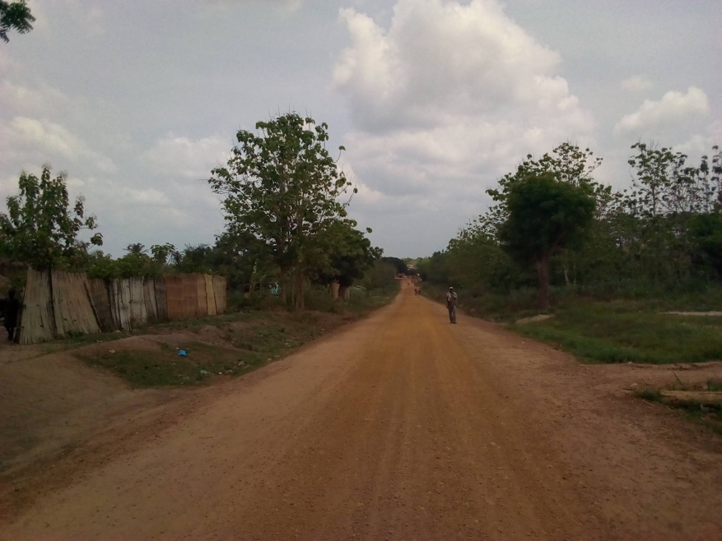
Figure 8: The view down a well-maintained rural road.
As mentioned under policy recommendations, ensuring that CHWs are equipped with the appropriate diagnostic and treatment tools is necessary. Supplying CHWs in isolated communities with antimalarials so that they can make less trips to the larger healthcare facilities to restock, should be considered. Though supplying CHWs with oral ACT for simple malaria infections should be feasible, treatment for complicated malaria infections may cause challenges. In accordance with Togolese policy, pre-referral treatment of severe malaria with artesunate suppositories or artemether IM should be administered. However, this treatment requires cold storage, which is often not reliably available in the rural areas without consistent technology, electricity, and paved roads, where CHWs often work. This is a barrier for access to severe malaria symptoms in rural areas; to overcome it, the only feasible action would be to refer patients to a healthcare facility. Unfortunately, the beneficiaries of CHW programs often live great distances from a facility, and unless the healthcare system in Togo can also provide consistent transportation or ambulatory services for severe infections, the patients will have to rely on iCCM to detect uncomplicated infections early on. Therefore, providing CHWs who perform this work with policy changes and community support is important.

Conclusion

Market day was my favorite day of the week. The culture in my community places an importance on the day of the week one is born, and market day was held on the same day of the week that I was born. Besides the connection to my name, I loved the market because I could consume foods and drinks that were only available once a week and connect with community members all at once. Malaria still continues to negatively affect those I grew to love and respect, especially children under 5, who are most likely to die because of the infections. By improving the public health policies that affect CHWs, altering the CHW selection criteria and considering methods to optimize their practices in rural areas, CHWs should be better equipped to perform their malaria control work. The recommendations given have great public health significance by supporting an increase in access to healthcare services provided by CHWs throughout Togo. The implementation of them will ultimately lead to the reduction of malaria mortality and morbidity rates in children under five in rural areas of Togo and support the movement towards malaria elimination.
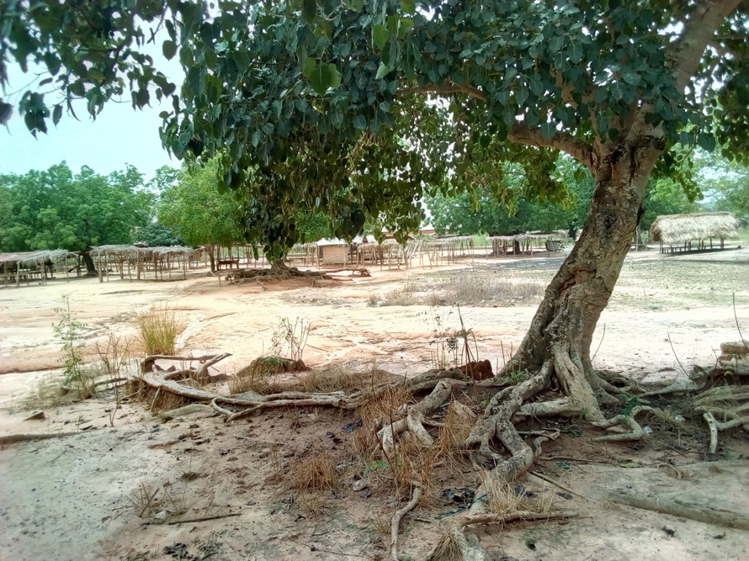
Figure 9: The empty market area.

Appendix: Supplementary Tables

Table 1: UN’s Sustainable Development Goal
Goal 3 | Good health and well-being
Target 3.2 | By 2030, end preventable deaths of newborns and children under 5 years of age, with all countries aiming to reduce neonatal mortality to at least as low as 12 per 1,000 live births and under-5 mortality to at least as low as 25 per 1,000 live births.
Target 3.3 | By 2030, end the epidemics of AIDS, tuberculosis, malaria and neglected tropical diseases and combat hepatitis, water-borne diseases and other communicable diseases.
Target 3.12 | Substantially increase health financing and the recruitment, development, training and retention of the health workforce in developing countries, especially in least developed countries and small island developing states
- Community factors
- National Socioeconomic and political factors
- Health system factors
- International factors

Table 2: Determinants of a successful CHW program

Table 3: WHO Recommendations and Suggestions for CHW Programs
- CHW recruitment and selection for pre-service training
- Length of pre-service training
- Pre-service training curriculum
- Pre-service training logistics
- Formal certification
- Supportive supervision
- Remuneration/Career Ladder
- Written Agreements
- Target population criteria
- Data collection
- Types of CHWs
- Community Engagement
- Supply availability

Table 4: Kane et al. Identified Mechanisms for CHW Performance
- Sense of relatedness to the local public health services, and thus accountability to the system
- Sense of credibility and legitimacy in being part of local public health services
- Anticipation of being valued by local public health services
- Assurance that there is a system for back-up support
- Perception of improvement in social status and playing a valuable role
- Sense of relatedness and accountability to the beneficiaries
- Anticipation of being valued by the community

Table 5: Summary of Databases Searched
Table | Vendor/ Interface | Database | Date searched | Database update | Searcher(s)
5a | Ovid | Medline® | January 27, 2020 | Ovid MEDLINE(R) and Epub Ahead of Print, In-Process & Other Non-Indexed Citations and Daily 1946 to January 27, 2020 | Helena VonVille; Megan Arden
5b | Ovid | Medline® | April 27, 2020 | Ovid MEDLINE(R) and Epub Ahead of Print, In-Process & Other Non-Indexed Citations and Daily 1946 to April 27, 2020 | Helena VonVille; Megan Arden
5c | National Library of Medicine | PAIS: Public Affairs Information Service | January 30, 2020 | January 30, 2020 | Helena VonVille; Megan Arden
5d | National Library of Medicine | PAIS: Public Affairs Information Service | April 27, 2020 | April 27, 2020 | Helena VonVille; Megan Arden
Table 5a: Medline® search strategy
Provider/Interface | Ovid
Database | Medline®
Date searched | January 27, 2020
Database update | Ovid MEDLINE(R) and Epub Ahead of Print, In-Process & Other Non-Indexed Citations and Daily 1946 to January 27, 2020
Search developer(s) | Helena VonVille; Megan Arden
Limit to English? | Yes
Date Range | No date limits set

1 | (active case detection or active case finding or case management or proactive case detection or reactive case detection).ti,ab,kw.
2 | Malaria/ or Malaria, Falciparum/ or Plasmodium falciparum/
3 | malaria.ti,ab,kw.
4 | 2 or 3
5 | 1 and 4
6 | limit 5 to english language
7 | togo/ or togo.ti,ab,kw.
8 | 6 and 7
9 | 6 not 8
10 | africa/ or "africa south of the sahara"/ or africa, central/ or cameroon/ or central african republic/ or chad/ or congo/ or "democratic republic of the congo"/ or equatorial guinea/ or gabon/ or "sao tome and principe"/ or africa, eastern/ or burundi/ or djibouti/ or eritrea/ or ethiopia/ or kenya/ or rwanda/ or somalia/ or south sudan/ or sudan/ or tanzania/ or uganda/ or africa, southern/ or angola/ or botswana/ or lesotho/ or malawi/ or mozambique/ or namibia/ or swaziland/ or zambia/ or zimbabwe/ or africa, western/ or benin/ or burkina faso/ or cabo verde/ or cote d'ivoire/ or gambia/ or ghana/ or guinea/ or guinea-bissau/ or liberia/ or mali/ or mauritania/ or niger/ or nigeria/ or senegal/ or sierra leone/ or togo/
11 | Africa, Western/ or Benin/ or Burkina Faso/ or Cabo Verde/ or Cote d'Ivoire/ or Gambia/ or Ghana/ or Guinea/ or Guinea-Bissau/ or Liberia/ or Mali/ or Mauritania/ or Niger/ or Nigeria/ or Senegal/ or Sierra Leone/ or Togo/
12 | (Benin or Burkina Faso or Cabo Verde or Cote d'Ivoire or Gambia or Ghana or Guinea or Guinea-Bissau or Liberia or Mali or Mauritania or Niger or Nigeria or Senegal or Sierra Leone or Togo).ti,ab,kw.
13 | 11 or 12
14 | 9 and 13
15 | africa/ or "africa south of the sahara"/ or africa, central/ or cameroon/ or central african republic/ or chad/ or congo/ or "democratic republic of the congo"/ or equatorial guinea/ or gabon/ or "sao tome and principe"/ or africa, eastern/ or burundi/ or djibouti/ or eritrea/ or ethiopia/ or kenya/ or rwanda/ or somalia/ or south sudan/ or sudan/ or tanzania/ or uganda/ or africa, southern/ or angola/ or botswana/ or lesotho/ or malawi/ or mozambique/ or namibia/ or swaziland/ or zambia/ or zimbabwe/
Table 5a Continued
16 | (africa or "south of the sahara" or cameroon or "central african republic" or chad or congo or "equatorial guinea" or gabon or "sao tome" or "principe" or burundi or djibouti or eritrea or ethiopia or kenya or rwanda or somalia or south sudan or sudan or tanzania or uganda or angola or botswana or lesotho or malawi or mozambique or namibia or Rhodesia or eswatini or swaziland or zaire or zambia or Zimbabwe).ti,ab,kw.
17 | 15 or 16
18 | (9 and 17) not 14
19 | 9 not (14 or 18)

Table 5b: Medline® search strategy
Provider/Interface | Ovid
Database | Medline®
Date searched | April 27, 2020
Database update | Ovid MEDLINE(R) and Epub Ahead of Print, In-Process & Other Non-Indexed Citations and Daily 1946 to April 27, 2020
Search developer(s) | Helena VonVille; Megan Arden
Limit to English? | Yes
Date Range | No date limits set

1 | (integrated community case management or iccm).ti,ab,kw.
2 | limit 1 to english language
3 | Community Health Workers/
4 | (chw* or Community Health Worker*).ti,ab,kw.
5 | (3 or 4) and english.la.
6 | 2 and 5
7 | 2 or 5
8 | africa/ or "africa south of the sahara"/ or africa, central/ or cameroon/ or central african republic/ or chad/ or congo/ or "democratic republic of the congo"/ or equatorial guinea/ or gabon/ or "sao tome and principe"/ or africa, eastern/ or burundi/ or djibouti/ or eritrea/ or ethiopia/ or kenya/ or rwanda/ or somalia/ or south sudan/ or sudan/ or tanzania/ or uganda/ or africa, southern/ or angola/ or botswana/ or lesotho/ or malawi/ or mozambique/ or namibia/ or swaziland/ or zambia/ or zimbabwe/ or africa, western/ or benin/ or burkina faso/ or cabo verde/ or cote d'ivoire/ or gambia/ or ghana/ or guinea/ or guinea-bissau/ or liberia/ or mali/ or mauritania/ or niger/ or nigeria/ or senegal/ or sierra leone/ or togo/
Table 5b Continued
9 | (africa or "south of the sahara" or cameroon or "central african republic" or chad or congo or "equatorial guinea" or gabon or "sao tome" or "principe" or burundi or djibouti or eritrea or ethiopia or kenya or rwanda or somalia or south sudan or sudan or tanzania or uganda or angola or botswana or lesotho or malawi or mozambique or namibia or Rhodesia or eswatini or swaziland or zaire or zambia or Zimbabwe).ti,ab,kw.
10 | Africa, Western/ or Benin/ or Burkina Faso/ or Cabo Verde/ or Cote d'Ivoire/ or Gambia/ or Ghana/ or Guinea/ or Guinea-Bissau/ or Liberia/ or Mali/ or Mauritania/ or Niger/ or Nigeria/ or Senegal/ or Sierra Leone/ or Togo/
11 | (Benin or Burkina Faso or Cabo Verde or Cote d'Ivoire or Gambia or Ghana or Guinea or Guinea-Bissau or Liberia or Mali or Mauritania or Niger or Nigeria or Senegal or Sierra Leone or Togo).ti,ab,kw.
12 | 8 or 9 or 11
13 | 6 and 12
14 | 7 and 12
15 | 10 or 11
16 | 6 and 15
17 | 7 and 15
18 | Malaria/ or Malaria, Falciparum/ or Plasmodium falciparum/
19 | malaria.ti,ab,kw.
20 | 18 or 19
21 | 13 and 20
22 | 14 and 20
23 | 16 and 20
24 | 17 and 20
25 | exp child/ or exp infant/
26 | Pediatrics/
27 | (infant* or newborn* or child* or paediatric* or pediatric*).ti,ab,kw.
28 | 25 or 26 or 27
Table 5b Continued
29 | 13 and 28
30 | 14 and 28
31 | 16 and 28
32 | 17 and 28
33 | 2 and scoping review.ti.
34 | togo/ or togo.ti,ab,kw.
35 | 7 and 34

Table 5c: PAIS search strategy
Provider/Interface |  |  | ProQuest
Database |  |  | PAIS
Date searched |  |  | January 30, 2020
Database update |  |  | January 30, 2020
Search developer(s) |  |  | Helena VonVille; Megan Arden
Limit to English? |  |  | Yes
Date Range |  |  | No date limits set

S1 | malaria AND (active case) AND (Benin or Burkina Faso or Cabo Verde or Cote d'Ivoire or Gambia or Ghana or Guinea or Guinea-Bissau or Liberia or Mali or Mauritania or Niger or Nigeria or Senegal or Sierra Leone or Togo) NOT HIV
S2 | malaria AND (active case) AND (Benin or Burkina Faso or Cabo Verde or Cote d'Ivoire or Gambia or Ghana or Guinea or Guinea-Bissau or Liberia or Mali or Mauritania or Niger or Nigeria or Senegal or Sierra Leone or Togo) NOT S1
S3 | malaria AND (active case) AND (africa or "south of the sahara" or cameroon or "central african republic" or chad or congo or "equatorial guinea" or gabon or "sao tome" or "principe" or burundi or djibouti or eritrea or ethiopia or kenya or rwanda or somalia or south sudan or sudan or tanzania or uganda or angola or botswana or lesotho or malawi or mozambique or namibia or Rhodesia or eswatini or swaziland or zaire or zambia or Zimbabwe) NOT (HIV OR S1 OR S2)
S4 | malaria AND (active case) AND (africa or "south of the sahara" or cameroon or "central african republic" or chad or congo or "equatorial guinea" or gabon or "sao tome" or "principe" or burundi or djibouti or eritrea or ethiopia or kenya or rwanda or somalia or south sudan or sudan or tanzania or uganda or angola or botswana or lesotho or malawi or mozambique or namibia or Rhodesia or eswatini or swaziland or zaire or zambia or Zimbabwe) NOT (S1 OR S2 OR S3)
Table 5d: PAIS search strategy

Provider/Interface | ProQuest
Database | PAIS
Date searched | April 27, 2020
Database update | April 27, 2020
Search developer(s) | Helena VonVille; Megan Arden
Limit to English? | Yes
Date Range | No date limits set

S1 | Togo AND community health workers OR integrated community case management

Table 6: Non-database searches yielding new studies
 | Search Terms
Google | “Togo”, “community health workers”, “integrated community case management”
Google Scholar | “Togo”, “community health workers”, “integrated community case management”

Table 7: Insecticide resistance by insecticide class in Togo. (“WHO” 2018)
Insecticide class | Years | % of sites with confirmed resistance and total number of sites tested (n) | Used for malaria vector control in 2017
Carbamates | 2011-2013 | 100% (5) | No
Organochlorines | 2011-2013 | 100% (6) | No
Organophosphates | 2011-2013 | 0% (2) | No
Pyrethroids | 2011-2013 | 100% (7) | Yes

Table 8: Funding for malaria control in Togo, as reported by donors. (“WHO” 2019)
 | Global Fund | PMI/USAID | World Bank | UK
2016 | 4.9M | 0 | 1.9M | 30.4M
2017 | 18.2M | 0 | 2.3M | 7.3M
2018 | 6.6M | 0 | 2.3M | 5.2M
Table 8a: Funding for malaria control in Togo, as reported by Togo. (“WHO” 2019)
 | Government national malaria program | Global Fund | World Bank | PMI/USAID | Other bilateral | WHO | UNICEF | Other contributions
2016 | 68K | 2.9M | 943K | 0 | 0 | 7.1K | 169K | 10.6K
2017 | 1.8M | 24.4M | 1.0M | 0 | 0 | 7.8K | 556K | 5.2M
2018 | 64K | 23.8M | 440K | 0 | 0 | 4.7K | 553K | 0

Bibliography
“2019 Country Reports on Human Rights Practices: Togo.” U.S. Department of State. Accessed May 15, 2020 from
https://www.state.gov/reports/2019-country-reports-on-human- rights-practices/togo/

“A framework for malaria elimination.” World Health Organization. (2017). Accessed from https://www.who.int/malaria/publications/atoz/9789241511988/en/

Adom, Panaveyi Vicky Malou, Makoutode, Charles Patrick, Ouendo, Edgar Marius, Gnaro, Takpaya, Napo-Koura, Gado, and Michel Makoutode. “Community Health Worker’s Role in Solving Health Problems at the Community Level in Benin and Togo.” Universial Journal of Public Health 4, no. 5 (2016): 250-258. doi: 10.13189/ujph.2016.040505.

Ahluwalia, Julian, Brooks, Samantha K., Weinman, John, and G. James Rubin. “A systematic review of factors affecting adherence to malaria chemoprophylaxis amongst travellers from non-endemic countries.” Malaria Journal 19 no. 16. (2020): 1-20. doi: https://doi.org/10.1186/s12936-020-3104-4.

Alonso, Pedro. “Letter to Malaria Partners-2019.” WHO. December 23, 2019. https://www.who.int/malaria/news/2019/letter-partners-december/en/

Ballard, M., Schwarz, R., Johnson, A., Church, S., Palazuelos, D., McCormick, L., Sall, E., and K. Fiori. “Practitioner Expertise to Optimize Community Health Systems: Harnessing Operational Insight.” (2017). Retrieved from: https://www.chwimpact.org. doi:10.13140/RG.2.2.35507.94247.

Bosch-Capblanch, Xavier and Claudine Marceau. “Training, supervision and quality of care in selected integrated community case management (iCCM) programmes: A scoping review of programmatic evidence.” Journal of Global Health 4 no. 2. (2014): 1-13. doi: 10.7189/jogh.04.020403.

“Cost effectiveness and strategic planning (WHO-CHOICE).” WHO. Accessed on May 1, 2020 from https://www.who.int/choice/demography/african_region/en/

Cowman, Alan F., Healer, Julie, Marapana, Danushka, and Kevin Marsh. “Malaria: Biology and Disease.” Cell 167. (2016): 610-624. doi: http://dx.doi.org/10.1016/j.cell.2016.07.055

Cox, Francis EG. “History of the discovery of the malaria parasites and their vectors.” Parasites Vectors 3 no. 5. (2010):1-9. doi: https://doi.org/10.1186/1756-3305-3-5

D’Alessandro, Umberto, Hill, Jenny, Tarning, Joel, Pell, Christopher, Webster, Jayne, Gutman, Julie, and Esperanca Sevene. “Treatment of uncomplicated and severe malaria during pregnancy.” Lancet Infectious Diseases 18. (2018): e133-46. doi: http://dx.doi.org/10.1016/ S1473-3099(18)30065-3
Decalo, Samuel, Pedanou, Macaire K., Echenberg, Myron, and Hubert Jules Deschamps. “Togo.” Brittanica. (2020). https://www.britannica.com/place/Togo

“Distribution of causes of death among children aged <5 years (%).” [Data set]. Global Health Observatory. Accessed May 17, 2020 from https://www.who.int/data/gho/data/indicators/indicator-details/GHO/distribution-of causes-of-death-among-children-aged-5-years-(-)

Djahini-Afawoubo, Dosse Mawussi and Esso-Hanam Atake. “Extension of mandarory health insurance to informal sector workers in Togo.” Health Economics Review 8 no. 22. (2018): 1-13. doi: https://doi.org/10.1186/s13561-018-0208-4

Druetz, Thomas, Kadio, Kadidiatou, Haddad, Slim, Kouanda, Seni, and Valery Ridde. “Do community health workers perceive mechanisms associated with the success of community case management of malaria? A qualitative study from Burkina Faso.” Social Science & Medicine 124. (2014): 232-240. http://dx.doi.org/10.1016/j.socscimed.2014.11.053.

“Education Pathway Analysis dashboard.” UNICEF, accessed on May 15, 2020 from https://data.unicef.org/resources/education-pathway-analysis-dashboard/

“Enquête sur les Indicateurs du Paludisme au Togo 2017.” Ministère de la Santé et de la Protection Sociale (MSPS) et ICF. 2017. Accessed from https://www.dhsprogram.com/pubs/pdf/MIS29/MIS29.pdf

George, Asha, Rodriguez, Daniela C., Rasanathan, Kumanan, Brandes, Neal and Sara Bennett. “iCCM policy analysis: strategic contributions to understanding its character, design and scale up in sub-Saharan Africa.” Health Policy and Planning 30 no.2. (2015): ii3-ii11. doi:10.1093/heapol/czv096

“Global Health Estimates 2016: Disease burden by Cause, Age, Sex, by Country and by Region, 2000-2016.” WHO. Accessed on May 17, 2020 from http://origin.who.int/healthinfo/global_burden_disease/estimates/en/

“Global Health Observatory data repository.” GHO. Accessed on May 15, 2020 from https://apps.who.int/gho/data/node.main.HWFGRP_0180?lang=en

“Goal 3 Targets.” United Nations Development Programme. Accessed May 17, 2020 from https://www.undp.org/content/undp/en/home/sustainable-development-goals/goal-3-good-health-and-well-being.html#targets

Haakenstad, Annie, Harle, Anton Connor, Tsakalos, Golsum, Micah, Angela E., Tao, Tianchan, Anjomshoa, Mina, Cohen, Jessica, et al. “Tracking spending on malaria by source in 106 countries, 2000–16: an economic modelling study.” Lancet Infectious Diseases 19 no. 17. (2019):703-16. Doi: http://dx.doi.org/10.1016/ S1473-3099(19)30165-3

Haines, Andy, Sanders, David, Lehmann, Uta, Rowe, Alexander K., Lawn, Joy E., Jan, Steve, Walker, Damian G., and Zulfiqar Bhutta. “Achieving child survival goals: potential contribution of community health workers.” Lancet 369 no. 21. (2007): 2121-31. doi:10.1016/ S0140-6736(07)60325-0

Landoh, Essoya D., Tchamdja, Potougnima, Saka, Tint, Bayaki, Khin S., Gitta, Sheba N., Wasswa, Peter and Christiaan de Jager. “Morbidity and mortality due to malaria in Est Mono district, Togo, from 2005 to 2010: a times series analysis.” Malaria Journal 11 no. 389. (2012):1-7. doi:10.1186/1475-2875-11-389.

Lauria, Molly E., Fiori, Kevin P., Jones, Heidi E., Gbeleou, Sesso, Kenkou, Komlan, Agoro, Sibabe, Agbèrè, Abdjourahmane Diparide, Lue, Kelly D., and Lisa R. Hirschhorn. “Assessing the Integrated Community-Based Health Systems Strengthening initiative in northern Togo: a pragmatic effectiveness-implementation study protocol.” Implementation Science 14 no. 92. (2019): 1-13. https://doi.org/10.1186/s13012-019- 0921-3.

Li, X.H., Kondrashin, A., Greenwood, B., Lindblade, K., Galappaththy, G.L., and P. Alonso. “A Historical review of WHO Certification of Malaria Elimination.” Trends in Parasitology 35 no.2. (2018):163-171. doi: https://doi.org/10.1016/j.pt.2018.11.011

“Malaria.” WHO. (2018). Accessed from https://www.who.int/malaria/en/
“Maternal and Newborn Health Disparities in Togo.” UNICEF. September 2018:1-8. Accessed
from https://data.unicef.org/resources/maternal-newborn-health-disparities-country-profiles/

Mathieu, Els, Dorkenoo, Ameyo M., Datagni, Michael, Cantey, Paul T., Morgah, Kodjo, Harvey, Kira, Ziperstein, Joshua, Drexler, Naomi, Chapleau, Gina and Yao Sodahlon. “It is Possible: Availability of Lymphedema Case Management in each Health Facility in Togo. Program Description, Evaluation, and Lessons Learned.” American Journal of Tropical Medicine and Hygiene 89 no.1. (2013):16–22. doi:10.4269/ajtmh.12-0453

Nanyonjo, Agnes, Counihan, Helen, Gudoi Siduda, Sam, Belay, Kassahun, Sebikaari, Gloria, and James Tibenderana. “Institutionalization of integrated community case management into national health systems in low- and middle-income countries: a scoping review of the literature.” Global Health Action 12 (2019): 1. doi: https://doi.org/10.1080/16549716.2019.1678283.

“Progress on household drinking water, sanitation and hygiene 2000-2017. Special focus on
inequalities.” UNICEF and WHO (2019): 1-139. Accessed from https://www.unicef.org/reports/progress-on-drinking-water-sanitation-and-hygiene-2019

“Q&A on the malaria vaccine implementation programme (MVIP).” WHO (2020). Accessed from
https://www.who.int/malaria/media/malaria-vaccine-implementation- qa/en/

Ramamurti, Gita, Hoej, Pernille, and Jennifer Schechter. “Investing in a community health program in Togo leads to an 11:1 return.” Financing Alliance for Health. (2017). Accessed from http://www.financingalliance.org/blog/2017/5/6/investing-in-a community-health-program-in-togo-leads-to-an-111-return

“Rapport Annuel de Performance: Année 2018.” Ministère de la Santé et de L’hygiène Publique. June 2019: 1-74. Accessed from https://www.afro.who.int/fr/publications/rapport- annuel-de-performance-2018-ministere-de-la-sante-et-de-lhygiene-publique.

Schneider, H, Dickson Okello and Uta Lehmann. “The global pendulum swing towards community health workers in low- and middle-income countries: a scoping review of trends, geographical distribution and programmatic orientations, 2005 to 2014.” Human Resources for Health 14 no. 65. (2016): 1-12. doi: 10.1186/s12960-016-0163-2

“State of Health Financing in the African Region.” WHO Regional Office for Africa. (2013):1-46. Accessed from https://www.afro.who.int/sites/default/files/2017-06/state-of-health-financing-afro.pdf

Sturrock, Hugh J.W., Novotny, Joe M., Kunene, Simon, Dlamini, Sabelo, Zulu, Zulisile, Cohen, Justin M., Hsiang, Michelle S., Greenhouse, Bryan , and Roly D. Gosling. “Reactive Case Detection for Malaria Elimination: Real-Life Experience from and Ongoing Program in Swaziland.” PLoS ONE 8 no. 5: e63830. (2013): 1-8. doi:10.1371/journal.pone.0063830

Tekou, Koffi,B., Weidert, Karen, Bitasse, Eralakaza Ouro, Adjoko, Marthe E., Mensah, Jacques Emina, Mensah, Sheila, Bongiovanni, Annette, and Ndola Pratab. “Engaging men in family planning: perspectives from married men in Lomé, Togo.” Global Health Science and Practice 6 no. 2. (2018): 316-327. https://doi.org/10.9745/GHSP-D-17-00471

“The World Factbook: TOGO.” CIA. Last updated March 16, 2020. https://www.cia.gov/library/publications/the-world- factbook/geos/to.html

Tiono, A.B., Kangoye, D. T., Rehman, A.M., Kargougou, D.G., Kabore, Y., Diarra, A., Ouedraogo, E., Nebie, I., Ouedraogo, A., Okech, B., Milligan, P., and S.B. Sirima. “Malaria Incidence in Children in South-Wet Burkina Faso: Comparison of Active and Passive Case Detection Methods.” PLoS ONE 9 no.1: e86936. (2014): 1-11. doi:10.1371/journal.pone.0086936

Tizifa, Tinashe A., Kabaghe, Alinune N., McCann, Robert S., van der Berg, Hank, Vugt, Michelle V., and Kamija S. Phiri. “Prevention Efforts for Malaria.” Current Tropical Medicine Reports 5. (2018): 41-50. doi: https://doi.org/10.1007/s40475-018-0133-y

“Togo.” World Bank. Accessed May 1, 2020, http://data.worldbank.org/country/togo
“Togo: WHO Statistical Profile.” WHO. January 2015. Accessed from http://www.who.int/gho/countries/tgo.pdf?ua=1

“Togo Religions and Beliefs.” African Union Extraordinary Summit on Maritime Security and
Safety and Development in Africa. Accessed May 17, 2020 from http://www.african-union- togo2015.com/en/togo/about

“Togo Social Indicators.” [Data set]. United Nations. Accessed May 17, 2020 from http://data.un.org/en/iso/tg.html

“Tuberculosis profile: Togo.” WHO. Accessed May 15, 2020 from https://worldhealthorg.shinyapps.io/tb_profiles/?_inputs_&lan=EN&iso2=TG&main_tab s=est_tab

Van den Berg, Machteld, Ogutu, Bernhards, Sewankambo, Nelson K., Biller-Andorno, Nikola, and Marcel Tanner. “RTS, S malaria vaccine pilot studies: addressing the human realities in large-scale clinical trials.” Trials 20 no. 316. (2019):1-4. doi: https://doi.org/10.1186/s13063-019-3391-7

“Map of administrative districts in Togo.” Vidiani. [Image]. 2011. Retrieved from http://www.vidiani.com/togo-administrative-map-with-regions-capitals-greyscale/

“WHO guideline on health policy and system support to optimize community health worker programmes.” WHO. (2018). Accessed from https://apps.who.int/iris/bitstream/handle/10665/275474/9789241550369-eng.pdf

Wongsrichanalai, Chansuda, Barcus, Mazie J., Muth, Sinuon, Sutamihardja, Awalludin, and Walther H. Wernsdorfer. “A Review of Malaria Diagnostic Tools: Microscopy and Rapid Diagnostic Test (RDT).” American Journal of Tropical Medicine and Hygiene 77 no.6. (2007): 119-127. doi: https://doi.org/10.4269/ajtmh.2007.77.119

“World Malaria Report 2018: Togo.” WHO. Accessed May 17, 2020 from www.who.int/malaria/publications/country-profiles/profile_tgo_en.pdf.

“World Malaria Report 2019.” WHO. (2019). Accessed from https://www.who.int/publications-detail/world-malaria-report-2019

Cox, “History of the discovery” 1.
Li et al., “A Historical review,” 167.
“Distribution of causes of death,” Global Health Observatory (GHO), https://www.who.int/data/gho/data/indicators/indicator-details/GHO/distribution-of-causes-of-death-among-children-aged-5-years-(-).
“Goal 3 Targets,” United Nations Development Programme https://www.undp.org/content/undp/en/home/sustainable-development-goals/goal-3-good-health-and-well-being.html#targets.
Alonso, “Letter to Malaria Partners-2019,” World Health Organization (WHO), https://www.who.int/malaria/news/2019/letter-partners-december/en/.
“Rapport Annuel de Performance,” Ministère de la Santé et de L’hygiène Publique (MSHP), 12.
George et al., “iCCM policy analysis,” ii4.
Lauria et al., “Assessing the Integrated Community-Based Health Systems Strengthening initiative,” 2.
“The World Factbook: TOGO,” Central Intelligence Agency (CIA), https://www.cia.gov/library/publications/the-world-factbook/geos/to.html.
Landoh et al., “Morbidity and mortality,” 2.
Landoh et al., 4.
“Togo profile-Timeline,” BBC, https://www.bbc.com/news/world-africa-14107024
“The World Factbook: TOGO,” CIA.
“Togo,” World Bank, http://data.worldbank.org/country/togo.
“Togo Country Profile,” World Bank, https://databank.worldbank.org/views/reports/reportwidget.aspx?Report_Name=CountryProfile&Id=b450fd57&tbar=y&dd=y&inf=n&zm=n&country=TGO.
Decalo et al., “Togo,” https://www.britannica.com/place/Togo.
Decalo et al., “Togo.”
“Togo Environment and Infrastructure Indicators” UN data, http://data.un.org/en/iso/tg.html.
“Togo Country Profile,” World Bank.
“Togo Social Indicators” UN data, http://data.un.org/en/iso/tg.html.
“The World Factbook: TOGO,” CIA.
“Togo Religions and Beliefs,” African Union Extraordinary Summit on Maritime Security and Safety and Development in Africa, http://www.african-union-togo2015.com/en/togo/about.
“Togo Religions and Beliefs,” African Union Extraordinary Summit on Maritime Security and Safety and Development in Africa.
“Rapport Annuel de Performance,” MSHP, 13.
MSHP, 13.
“Togo Social Indicators” UN data.
“Rapport Annuel de Performance,” MSHP, 22.
“Cost effectiveness and strategic planning,” WHO, https://www.who.int/choice/demography/african_region/en/.
“Togo: WHO Statistical Profile,” WHO, http://www.who.int/gho/countries/tgo.pdf?ua=1.
“Global Health Estimates 2016,” WHO, http://origin.who.int/healthinfo/global_burden_disease/estimates/en/.
“Rapport Annuel de Performance, MSHP, 9.
“Togo Country Profile,” World Bank.
“Tuberculosis profile: Togo,” WHO, https://worldhealthorg.shinyapps.io/tb_profiles/?_inputs_&lan=EN&iso2=TG&main_tabs=est_tab
Source: Data adapted from “Maternal and Newborn Health,” UNICEF, 2-3, 7, accessed on May 15, 2020, https://data.unicef.org/resources/maternal-newborn-health-disparities-country-profiles/
Source: Data adapted from “Progress on Household Drinking Water,” UNICEF & WHO, 38, 102-3, 122, accessed on May 15, 2020, from https://www.unicef.org/media/55276/file/Progress%20on%20drinking%20water,%20sanitation%20and%20hygiene%202019%20.pdf.
Decalo et al., “Togo”.
Cowman et al., “Malaria: Biology and Disease,” 610.
“World Malaria Report 2018: Togo,” WHO, www.who.int/malaria/publications/country-profiles/profile_tgo_en.pdf.
Cowman et al., “Malaria: Biology and Disease,” 611.
Cowman et al., 616.
“World malaria report 2019,” WHO, 124-5, https://www.who.int/publications-detail/world-malaria-report-2019.
“World malaria report 2019,” WHO,125.
“State of Health Financing in the African Region,” WHO Regional Office for Africa, 22.
“State of Health Financing,” WHO Regional Office for Africa, 23.
“State of Health Financing,” WHO Regional Office for Africa, 45.
Haakenstad et al., “Tracking spending on malaria,” 712.
Djahini-Afawoubo and Atake, “Extension of mandatory health insurance,” 1.
Djahini-Afawoubo and Atake, 12.
“World malaria report 2019,” WHO, 4.
“World malaria report 2019,” WHO, 4.
“Rapport Annuel de Performance,” MSHP, 9.
“Rapport Annuel de Performance,” MSHP, 38.
“Distribution of causes of death,” distributed by GHO,. https://www.who.int/data/gho/data/indicators/indicator-details/GHO/distribution-of-causes-of-death-among-children-aged-5-years-(-).
“The World Factbook: TOGO,” CIA.
“Togo Economic Indicators” UN data, http://data.un.org/en/iso/tg.html.
Djahini-Afawoubo and Atake, 1.
Decalo et al., “Togo.”
Decalo et al., “Togo.”
“2019 Country Reports,” U.S. Department of State, https://www.state.gov/reports/2019-country-reports-on-human-rights-practices/togo/.
“2019 Country Reports,” U.S. Department of State.
U.S. Department of State.
“Education Pathway Analysis dashboard”, UNICEF, https://data.unicef.org/resources/education-pathway-analysis-dashboard/.
Source: Data adapted from “Rapport Annuel de Performance,” MSHP, 13.
Source: Data adapted from “Rapport Annuel de Performance,” MSHP, 21.
Source: Data adapted from “Maternal and Newborn Health,” UNICEF, 7.
Source: Data adapted from “Progress on Household Drinking Water,” UNICEF and WHO 102-3, 122.
“Enquête sur les Indicateurs du Paludisme," Ministère de la Santé et de la Protection Sociale (MSPS) and ICF, 47.
Lauria et al., “Assessing the Integrated Community-Based Health Systems Strengthening initiative,” 2.
George et al., ii5.
George et al., “iCCM policy analysis” ii4.
Haines et al., “Achieving child survival goals,” 2122.
Schneider, Okello and Lehmann, “The global pendulum swing,” 4.
Schneider, Okello and Lehmann, 5-6.
“WHO guideline on health policy,” MSHP, 17.
Druetz et al., “Do community health workers,” 233.
“Global Health Observatory data repository,” GHO https://apps.who.int/gho/data/node.main.HWFGRP_0180?lang=en
Landoh et al., “Morbidity and mortality,” 2.
“World malaria report 2019,” MSHP, 140.
Adom et al., “Community Health Worker’s Role,” 252.
Adom et al.,” 257.
Landoh et al., “Morbidity and mortality,” 2.
Landoh et al., 4.
Mathieu et al., “It is Possible,” 20.
Mathieu et al., 21-22.
Mathieu et al., 21.
Mathieu et al., 20.
Tekou B. Koffi et al., “Engaging men in family planning,” 323.
“Rapport Annuel de Performance,” MSHP,7.
Lauria et al., “Assessing the Integrated Community-Based Health Systems Strengthening initiative,” 2.
Lauria et al., 4.
Ramamurti, Hoej, and Schechter, “Investing in a community health program,” http://www.financingalliance.org/blog/2017/5/6/investing-in-a-community-health-program-in-togo-leads-to-an-111-return.
Ballard et al., “Practitioner Expertise to Optimize Community Health Systems,” 18, https://www.chwimpact.org.
“Rapport Annuel de Performance,” MSHP, 57.
Adom et al.,” 256.
“World malaria report 2019,” WHO, 99.
Cowman et al., “Malaria: Biology and Disease,” 616.
“World Malaria Report 2018: Togo,” WHO.
D’Alessandro et al., “Treatment of uncomplicated,” e136.
D’Alessandro et al., e137.
“World malaria report 2019,” WHO, 117.
Tizifa et al., “Prevention Efforts for Malaria,” 42.
Tizifa et al., 43.
Landoh et al., “Morbidity and mortality,” 2.
“World malaria report 2019,” WHO, 98.
“A framework for malaria elimination,” WHO, 25, https://www.who.int/malaria/publications/atoz/9789241511988/en/.
“World malaria report 2019,” WHO, 117.
Tizifa et al., “Prevention Efforts for Malaria,” 44.
“World Malaria Report 2018: Togo,” WHO.
“A framework for malaria elimination,” WHO, 26.
Tizifa et al., 44.
Tizifa et al., 46.
Ahluwalia et al., “A systematic review of factors,” 2.
Tizifa et al., “Prevention Efforts for Malaria,” 46.
“World malaria report 2019,” WHO, 98.
Tizifa et al., 46.
“Rapport Annuel de Performance,” WHO, 39.
Tizifa et al., “Prevention Efforts for Malaria,” 44-46.
van den Berg et al., “RTS, S malaria vaccine,” 2.
“Q&A on the malaria vaccine,” WHO, https://www.who.int/malaria/media/malaria-vaccine-implementation-qa/en/
Wongsrichanalai et al., “A Review of Malaria Diagnostic Tools,” 119.
Wongsrichanalai et al., 119,123.
“World Malaria Report 2018: Togo,” WHO.
“A framework for malaria elimination,” WHO, 28.
Tiono et al., “Malaria Incidence in Children,” 1.
Tiono et al., 2.
“World Malaria Report 2018: Togo,” WHO.
“A framework for malaria elimination,” WHO, 29.
Sturrock et al., “Reactive Case Detection,” 1.
Cowman et al., “Malaria: Biology and Disease,” WHO, 615.
“A framework for malaria elimination,” 30.
Nanyonjo et al., “Institutionalization of integrated community case management,” 1.
Bosch-Capblanch and Marceau, “Training, supervision and quality of care,” 7.
Nanyonjo et al., “Institutionalization of integrated community case management,” 9.
Nanyonjo et al., 10-11.
Nanyonjo et al., 3.
Lauria et al., 2.
Lauria et al., “Assessing the Integrated Community-Based Health Systems Strengthening initiative,” 2.
“Rapport Annuel de Performance,” MSHP, 22.
Lauria et al., “Assessing the Integrated Community-Based Health Systems Strengthening initiative,” 4.
“Rapport Annuel de Performance:Annee 2018,” MSHP, 13.
“WHO guideline on health policy,” WHO, 49.
“WHO guideline on health policy,” WHO, 50.
“WHO guideline on health policy,” WHO, 58.
“WHO guideline on health policy,” WHO, 33.
Lauria et al., “Assessing the Integrated Community-Based Health Systems Strengthening initiative,” 4.
“World malaria report 2019,” WHO, 117.
Source: Data from World Health Organization, “World Malaria Report 2018: Togo
Source: Data from World Health Organization, “World malaria report 2019,” (2019): 124, https://www.who.int/publications-detail/world-malaria-report-2019.
Source: Data from World Health Organization, “World malaria report 2019,” (2019): 125, https://www.who.int/publications-detail/world-malaria-report-2019.

