Reproduced with permission from Environmental Science and Technology, Sleight, T.; Khanna, V.; Gilbertson, L.; Ng, C. Network Analysis for Identifying High Impact Biodegradation Metabolites: A PAH Case Study. Environ. Sci. Technol. Rev. 2020. Copyright 2021, American Chemical Society

Supporting Information for

Network Analysis for Identifying High Impact Biodegradation Metabolites: A PAH Case Study
Authors:
Trevor W. Sleight, Vikas Khanna, Leanne M. Gilbertson and Carla A. Ng
108 Pages, 11 Figures, 12 Tables

Contents

Supporting Information Section 1: Acenaphthene S2
Figure S1.1: Acenaphthene High Throughput Plot with Pathway Match Metabolites S2
Table S1.1: Acenaphthene Yellow Node (Pathway Matches) Smiles Codes S3
Figure S1.2: Maximum Common Substructures (MCS) in the Top 1% of Betweenness: Acenaphthene. S7
Table S1.2: Acenaphthene Empirical Literature Review S8
Table S1.3: Acenaphthene Empirical Review Summary S13
Supporting Information Section 2: Anthracene S15
Figure S2.1: Anthracene High Throughput Plot with Pathway Match Metabolites S15
Table S2.1: Anthracene Yellow Node (Pathway Matches) Smiles Codes S16
Figure S2.2: Maximum Common Substructures (MCS) in the Top 1% of Betweenness: Anthracene. S17
Table S2.2: Anthracene Empirical Literature Review S18
Table S2.3: Anthracene Empirical Review Summary S32
Section 3: Fluorene S36
Figure S3.1: Fluorene High Throughput Plot with Pathway Match Metabolites S36
Table S3.1: Fluorene Yellow Node (Pathway Matches) Smiles Codes S37
Figure S3.2: Maximum Common Substructures (MCS) in the Top 1% of Betweenness: Fluorene. S39
Table S3.2: Fluorene Empirical Literature Review S40
Table S3.3 Fluorene Empirical Review Summary S54
Section 4: Phenanthrene S57
Figure S4.1: Phenanthrene High Throughput Plot with Pathway Match Metabolite S57
Table S4.1: Phenanthrene Yellow Node (Pathway Matches) Smiles Codes S58
Figure S4.2: Maximum Common Substructures (MCS) in the Top 1% of Betweenness: Phenanthrene S59
Table S4.2: Phenanthrene Empirical Literature Review S60
Table S4.3: Phenanthrene Empirical Review Summary S91
Section 5: Analysis and Plotting Code S98
Section 6. Sensitivity Analysis S100
Figure S6.1: Network Metrics at Different Aerobic Likelihood Spreads S102
Figure S6.2: Sensitivity Analysis of Different Weighting Schemes S102
Figure S6.3: Selection of the Threshold for High Node Throughput S103

Supporting Information Section 1: Acenaphthene
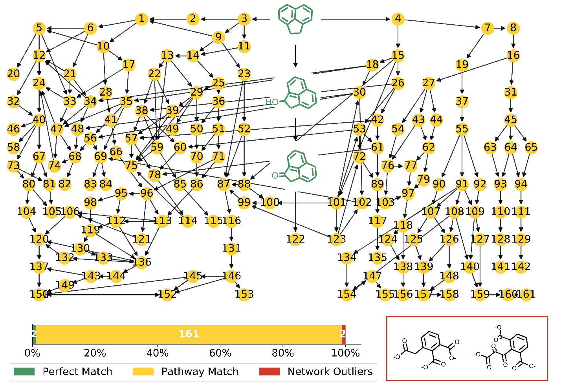
Figure S1.1: Acenaphthene High Throughput Plot with Pathway Match Metabolites. SMILES codes for the nodes are presented in Table S1.1.

Figure S1.1 shows a network constructed from only the High Node Throughput compounds. Reconstructing the network with only this subset of compounds yields a much smaller more manageable network.
Perfect Match compounds match a literature reference exactly. Pathway Match compounds are High Node Throughput compounds that are found on a degradation pathway to or from a Perfect Match compound. Network Outliers are High Node Throughput compounds that do not have a Perfect Match compound either above or below them in their degradation chains. Table S1.1 contains the SMILES codes for the Pathway Match compounds.
Acenaphthene, and to a lesser extent, Fluorene, both have an aliphatic 5-carbon ring in their structure, which breaks open early in the degradation pathway, contributing to a high number of metabolites with a High Node Throughput Value.

Table S1.1: Acenaphthene Yellow Node (Pathway Matches) Smiles Codes

1 | OC1Cc2cccc(C([O-])=O)c2\C1=C/C([O-])=O |  | 81 | Oc1cc(CC([O-])=O)c(C([O-])=O)c(c1)C([O-])=O
2 | OC1Cc2cccc3c(O)c(O)cc1c23 |  | 82 | OC1(OC(=O)Cc2cccc(C([O-])=O)c12)C([O-])=O
3 | Oc1cc2CCc3cccc(c1O)c23 |  | 83 | [O-]C(=O)c1cccc2COC(=O)Cc12
4 | Oc1cc2cccc3CCc(c1O)c23 |  | 84 | [O-]C(=O)c1cccc2CC(=O)OCc12
5 | OC1(CC([O-])=O)C(=O)Cc2cccc(C([O-])=O)c12 |  | 85 | OC1COC(=O)c2c1cccc2C([O-])=O
6 | OC1Cc2cccc(C([O-])=O)c2C1(O)CC([O-])=O |  | 86 | OC(CC([O-])=O)(C=O)c1c(cccc1C([O-])=O)C([O-])=O
7 | [O-]C(=O)\C=c1\cccc2CCC(C([O-])=O)=c12 |  | 87 | [O-]C(=O)c1cccc2CCC(=O)c12
8 | OC1Cc2ccc\c(=C\C([O-])=O)c2=C1C([O-])=O |  | 88 | OC1(CCc2cccc(C([O-])=O)c12)C(=O)C([O-])=O
9 | [O-]C(=O)\C=C1\CCc2cccc(C([O-])=O)c12 |  | 89 | [O-]C(=O)c1cccc2C(=O)CCc12
10 | [O-]C(=O)\C=C1\C(=O)Cc2cccc(C([O-])=O)c12 |  | 90 | Oc1cc2C(=O)OCC(C([O-])=O)=c2\c(=C/C([O-])=O)c1O
11 | OC1Cc2cc(O)c(O)c3cccc1c23 |  | 91 | OC\C(C([O-])=O)=c1/c(ccc/c/1=C/C([O-])=O)C([O-])=O
12 | OC1Cc2cccc(C([O-])=O)c2C1=O |  | 92 | Oc1c\c(=C\C([O-])=O)c2=C(COC(=O)c2c1O)C([O-])=O
13 | OC1CC(O)(CC([O-])=O)c2c1cccc2C([O-])=O |  | 93 | OCc1cc(O)c(O)\c(=C\C([O-])=O)\c\1=C\C([O-])=O
14 | OC1C\C(=C\C([O-])=O)c2c1cccc2C([O-])=O |  | 94 | OCc1c(O)c(O)c\c(=C\C([O-])=O)\c\1=C\C([O-])=O
15 | OC(=O)C(=O)C1CCc2cccc(C(O)=O)c12 |  | 95 | OC(C(C([O-])=O)c1c(cccc1C([O-])=O)C([O-])=O)C([O-])=O
16 | [O-]C(=O)\C=c1\cccc2CC(=O)C(C([O-])=O)=c12 |  | 96 | [O-]C(=O)\C=C(\C([O-])=O)c1c(cccc1C([O-])=O)C([O-])=O
17 | OC(C1C(=O)Cc2cccc(C([O-])=O)c12)C([O-])=O |  | 97 | OC(C([O-])=O)c1c(O)c(O)c(O)\c(=C\C([O-])=O)\c\1=C(\O)C([O-])=O
18 | OC1Cc2cccc(C([O-])=O)c2C1C(=O)C([O-])=O |  | 98 | [O-]C(=O)C(C(=O)C([O-])=O)c1c(cccc1C([O-])=O)C([O-])=O
19 | OC1CC(C([O-])=O)=c2c1ccc\c2=C\C([O-])=O |  | 99 | OC1CCc2cccc(C([O-])=O)c12
20 | OC1(CC([O-])=O)OC(=O)Cc2cccc(C([O-])=O)c12 |  | 100 | OC1(CCc2cccc(C([O-])=O)c12)C([O-])=O
21 | OC(C([O-])=O)C1(O)C(O)Cc2cccc(C([O-])=O)c12 |  | 101 | [O-]C(=O)C1CCc2cccc(C([O-])=O)c12
22 | OC(C([O-])=O)C1(O)CC(O)c2cccc(C([O-])=O)c12 |  | 102 | OC1Cc2cccc(C([O-])=O)c2C1
23 | OC1(CC([O-])=O)CCc2cccc(C([O-])=O)c12 |  | 103 | OC(C([O-])=O)c1c(O)c(O)c\c(=C\C([O-])=O)\c\1=C(\O)C([O-])=O
24 | [O-]C(=O)c1cccc2CC(=O)C(=O)c12 |  | 104 | [O-]C(=O)C(=O)c1cccc(C([O-])=O)c1C([O-])=O
25 | [O-]C(=O)\C=C1\CC(=O)c2cccc(C([O-])=O)c12 |  | 105 | OC(C([O-])=O)c1cc(O)cc(C([O-])=O)c1C([O-])=O
26 | OC1CC(C(=O)C([O-])=O)c2c1cccc2C([O-])=O |  | 106 | OC(CC([O-])=O)c1c(cccc1C([O-])=O)C([O-])=O
27 | [O-]C(=O)\C=c1\cccc2CC(=O)OC(C([O-])=O)=c12 |  | 107 | OC\C(C([O-])=O)=c1/c(cc(O)c(O)/c/1=C/C([O-])=O)C([O-])=O
28 | [O-]C(=O)\C=C1\C(=O)OCc2cccc(C([O-])=O)c12 |  | 108 | [O-]C(=O)\C=c1\cccc(C([O-])=O)\c\1=C(/C=O)C([O-])=O
29 | OC1(CC([O-])=O)CC(=O)c2cccc(C([O-])=O)c12 |  | 109 | OC\C(C([O-])=O)=c1/c(C([O-])=O)c(O)c(O)c/c/1=C/C([O-])=O
30 | OC1Cc2cccc(C([O-])=O)c2C1C([O-])=O |  | 110 | Oc1cc(C=O)\c(=C/C([O-])=O)\c(=C/C([O-])=O)\c1O
31 | [O-]C(=O)\C=c1\cccc2CC(=O)C=c12 |  | 111 | Oc1c\c(=C\C([O-])=O)\c(=C\C([O-])=O)\c(C=O)c1O
32 | OC1Cc2cccc(C([O-])=O)c2C(=O)O1 |  | 112 | OC(C([O-])=O)C(O)(C([O-])=O)c1c(cccc1C([O-])=O)C([O-])=O
33 | OC(C([O-])=O)C1(O)C(=O)Cc2cccc(C([O-])=O)c12 |  | 113 | OC(CC([O-])=O)(C([O-])=O)c1c(cccc1C([O-])=O)C([O-])=O
34 | OC1Cc2cccc(C([O-])=O)c2C1(O)C(=O)C([O-])=O |  | 114 | OC1CC(=O)c2cccc(C([O-])=O)c12
35 | [O-]C(=O)C(=O)C1C(=O)Cc2cccc(C([O-])=O)c12 |  | 115 | OCC(O)c1cccc(C([O-])=O)c1C([O-])=O
36 | [O-]C(=O)\C=C1\COC(=O)c2cccc(C([O-])=O)c12 |  | 116 | [O-]C(=O)c1cccc2CCC(=O)Oc12
37 | [O-]C(=O)\C=c1\cccc2C(=O)CC(C([O-])=O)=c12 |  | 117 | [O-]C(=O)c1cccc2OC(=O)CCc12
38 | OC1CC(O)(C(=O)C([O-])=O)c2c1cccc2C([O-])=O |  | 118 | O\C(C([O-])=O)=c1/c(C(=O)C([O-])=O)c(O)c(O)c(O)/c/1=C/C([O-])=O
39 | OC(C([O-])=O)C1(O)CC(=O)c2cccc(C([O-])=O)c12 |  | 119 | OC(C([O-])=O)(C(=O)C([O-])=O)c1c(cccc1C([O-])=O)C([O-])=O
40 | [O-]C(=O)c1cccc2CC(=O)OC(=O)c12 |  | 120 | [O-]C(=O)c1cccc(C([O-])=O)c1C([O-])=O
41 | OCc1cccc(C([O-])=O)c1\C(=C/C([O-])=O)C([O-])=O |  | 121 | [O-]C(=O)\C=C/c1c(cccc1C([O-])=O)C([O-])=O
42 | [O-]C(=O)C(=O)C1CC(=O)c2cccc(C([O-])=O)c12 |  | 122 | O=C1OCc2cccc3cccc1c23
43 | O\C(C([O-])=O)=c1/c(CC([O-])=O)ccc/c/1=C/C([O-])=O |  | 123 | [O-]C(=O)c1cccc2CCCc12
44 | Oc1cc2CC(=O)OC(C([O-])=O)=c2\c(=C/C([O-])=O)c1O |  | 124 | O\C(C([O-])=O)=c1/c(C=O)c(O)c(O)c(O)/c/1=C/C([O-])=O
45 | [O-]C(=O)\C=c1\cccc2COC(=O)C=c12 |  | 125 | OC\C(C([O-])=O)=c1/c(O)c(O)c(O)c(O)/c/1=C/C([O-])=O
46 | Oc1cc(C([O-])=O)c2C(=O)OC(=O)Cc2c1O |  | 126 | Oc1cc(C([O-])=O)\c(=C(/C=O)C([O-])=O)\c(=C/C([O-])=O)\c1O
47 | OC1(C(=O)C([O-])=O)C(=O)Cc2cccc(C([O-])=O)c12 |  | 127 | OC\C(C([O-])=O)=c1/c(O)c(O)c(O)c/c/1=C/C([O-])=O
48 | OC1Cc2cccc(C([O-])=O)c2C1(O)C([O-])=O |  | 128 | Oc1cc(C([O-])=O)\c(=C/C([O-])=O)\c(=C/C([O-])=O)\c1O
49 | CC(=O)c1cccc(C([O-])=O)c1C(=O)CC([O-])=O |  | 129 | Oc1c\c(=C\C([O-])=O)\c(=C\C([O-])=O)\c(C([O-])=O)c1O
50 | OC1(CC([O-])=O)COC(=O)c2cccc(C([O-])=O)c12 |  | 130 | OC(C([O-])=O)(C([O-])=O)c1c(cccc1C([O-])=O)C([O-])=O
51 | OC\C(=C\C([O-])=O)c1c(cccc1C([O-])=O)C([O-])=O |  | 131 | Oc1c(CCC([O-])=O)cccc1C([O-])=O
52 | OC(C([O-])=O)C1(O)CCc2cccc(C([O-])=O)c12 |  | 132 | [O-]C(=O)c1cccc(C([O-])=O)c1C=O
53 | OC1CC(C([O-])=O)c2c1cccc2C([O-])=O |  | 133 | OC(C([O-])=O)c1c(cccc1C([O-])=O)C([O-])=O
54 | Oc1c\c(=C\C([O-])=O)c2=C(OC(=O)Cc2c1O)C([O-])=O |  | 134 | OC\C(C([O-])=O)=c1/c(O)c(O)cc/c/1=C/C([O-])=O
55 | [O-]C(=O)\C=c1\cccc2C(=O)OCC(C([O-])=O)=c12 |  | 135 | Oc1cccc(C([O-])=O)c1CCC([O-])=O
56 | [O-]C(=O)C1C(=O)Cc2cccc(C([O-])=O)c12 |  | 136 | [O-]C(=O)C(=O)c1c(cccc1C([O-])=O)C([O-])=O
57 | OC1(CC(=O)c2cccc(C([O-])=O)c12)C(=O)C([O-])=O |  | 137 | Oc1cc(C([O-])=O)c(C([O-])=O)c(C([O-])=O)c1O
58 | Oc1cc2CC(=O)OC(=O)c2c(C([O-])=O)c1O |  | 138 | O\C(C([O-])=O)=c1/c(C([O-])=O)c(O)c(O)c(O)/c/1=C/C([O-])=O
59 | OC1CC(=O)c2c1cccc2C([O-])=O |  | 139 | Oc1c(O)c(O)\c(=C(/C=O)C([O-])=O)\c(=C/C([O-])=O)\c1O
60 | OC1CC(O)(C([O-])=O)c2c1cccc2C([O-])=O |  | 140 | Oc1c\c(=C\C([O-])=O)\c(=C(\C=O)C([O-])=O)\c(C([O-])=O)c1O
61 | [O-]C(=O)C1CC(=O)c2cccc(C([O-])=O)c12 |  | 141 | Oc1c(O)c(O)\c(=C/C([O-])=O)\c(=C/C([O-])=O)\c1O
62 | O\C(C([O-])=O)=c1/c(CC([O-])=O)cc(O)c(O)/c/1=C/C([O-])=O |  | 142 | Oc1c\c(=C\C([O-])=O)\c(=C\C([O-])=O)\c(O)c1O
63 | Oc1cc2COC(=O)C=c2\c(=C/C([O-])=O)c1O |  | 143 | Oc1cc(C([O-])=O)c(C(=O)C([O-])=O)c(C([O-])=O)c1O
64 | OCc1ccc\c(=C\C([O-])=O)\c\1=C\C([O-])=O |  | 144 | Oc1cc(C([O-])=O)c(C(=O)C([O-])=O)c(c1)C([O-])=O
65 | Oc1c\c(=C\C([O-])=O)c2=CC(=O)OCc2c1O |  | 145 | Oc1cccc(C([O-])=O)c1O
66 | [O-]C(=O)\C=C(\C([O-])=O)c1c(C=O)cccc1C([O-])=O |  | 146 | Oc1c(cccc1C([O-])=O)C([O-])=O
67 | OC(=O)Cc1cccc(C([O-])=O)c1C([O-])=O |  | 147 | Oc1cc\c(=C\C([O-])=O)c(=C(C([O-])=O)C([O-])=O)c1O
68 | OC1(C([O-])=O)C(=O)Cc2cccc(C([O-])=O)c12 |  | 148 | Oc1cc(C([O-])=O)c(=C(C([O-])=O)C([O-])=O)\c(=C/C([O-])=O)c1O
69 | [O-]C(=O)c1cccc2CC(=O)Cc12 |  | 149 | Oc1cc(C([O-])=O)c(C(=O)C([O-])=O)c(O)c1O
70 | OCC(O)(CC([O-])=O)c1c(cccc1C([O-])=O)C([O-])=O |  | 150 | Oc1cc(C([O-])=O)c(C([O-])=O)c(O)c1O
71 | [O-]C(=O)\C=C(\C=O)c1c(cccc1C([O-])=O)C([O-])=O |  | 151 | Oc1ccc(O)c(O)c1O
72 | OC1CCc2c1cccc2C([O-])=O |  | 152 | Oc1ccc(C([O-])=O)c(O)c1O
73 | OC(=O)c1c(CC([O-])=O)cccc1C([O-])=O |  | 153 | Oc1cc(C([O-])=O)c(O)c(C([O-])=O)c1O
74 | OC1C(=O)Cc2cccc(C([O-])=O)c12 |  | 154 | Oc1cc\c(=C\C([O-])=O)\c(=C(\C=O)C([O-])=O)\c1O
75 | [O-]C(=O)c1cccc2C(=O)CC(=O)c12 |  | 155 | Oc1cc\c(=C\C([O-])=O)c(=CC([O-])=O)c1O
76 | O\C(C([O-])=O)=c1/c(CC([O-])=O)c(O)c(O)c/c/1=C/C([O-])=O |  | 156 | O\C(C([O-])=O)=c1/c(O)c(O)c(O)c(O)/c/1=C/C([O-])=O
77 | O\C(C([O-])=O)=c1/c(CC([O-])=O)c(O)c(O)c(O)/c/1=C/C([O-])=O |  | 157 | Oc1c(O)c(O)c(=C(C([O-])=O)C([O-])=O)\c(=C/C([O-])=O)c1O
78 | OC1(CC(=O)c2cccc(C([O-])=O)c12)C([O-])=O |  | 158 | Oc1c(O)c(O)\c(=C\C([O-])=O)c(=CC([O-])=O)c1O
79 | OC(C([O-])=O)c1cc(O)c(O)\c(=C\C([O-])=O)\c\1=C(\O)C([O-])=O |  | 159 | Oc1c\c(=C\C([O-])=O)\c(=C(\C=O)C([O-])=O)\c(O)c1O
80 | OC(C([O-])=O)c1cccc(C([O-])=O)c1C([O-])=O |  | 160 | Oc1c\c(=C\C([O-])=O)c(=C(C([O-])=O)C([O-])=O)c(O)c1O
 |  |  | 161 | Oc1c\c(=C\C([O-])=O)c(=CC([O-])=O)c(O)c1O

High Betweenness Maximum Common Substructures:

The compounds with the highest betweenness centrality display similar substructures. Code was adapted from the RDKit Cookbook, referenced in the main text. The Tanimto Similarities between the Morgan Fingerprints were first calculated, and then clusters were developed with Butina Clustering using a cutoff of 0.4. For full details and the actual python code, see the github linked in the main text.
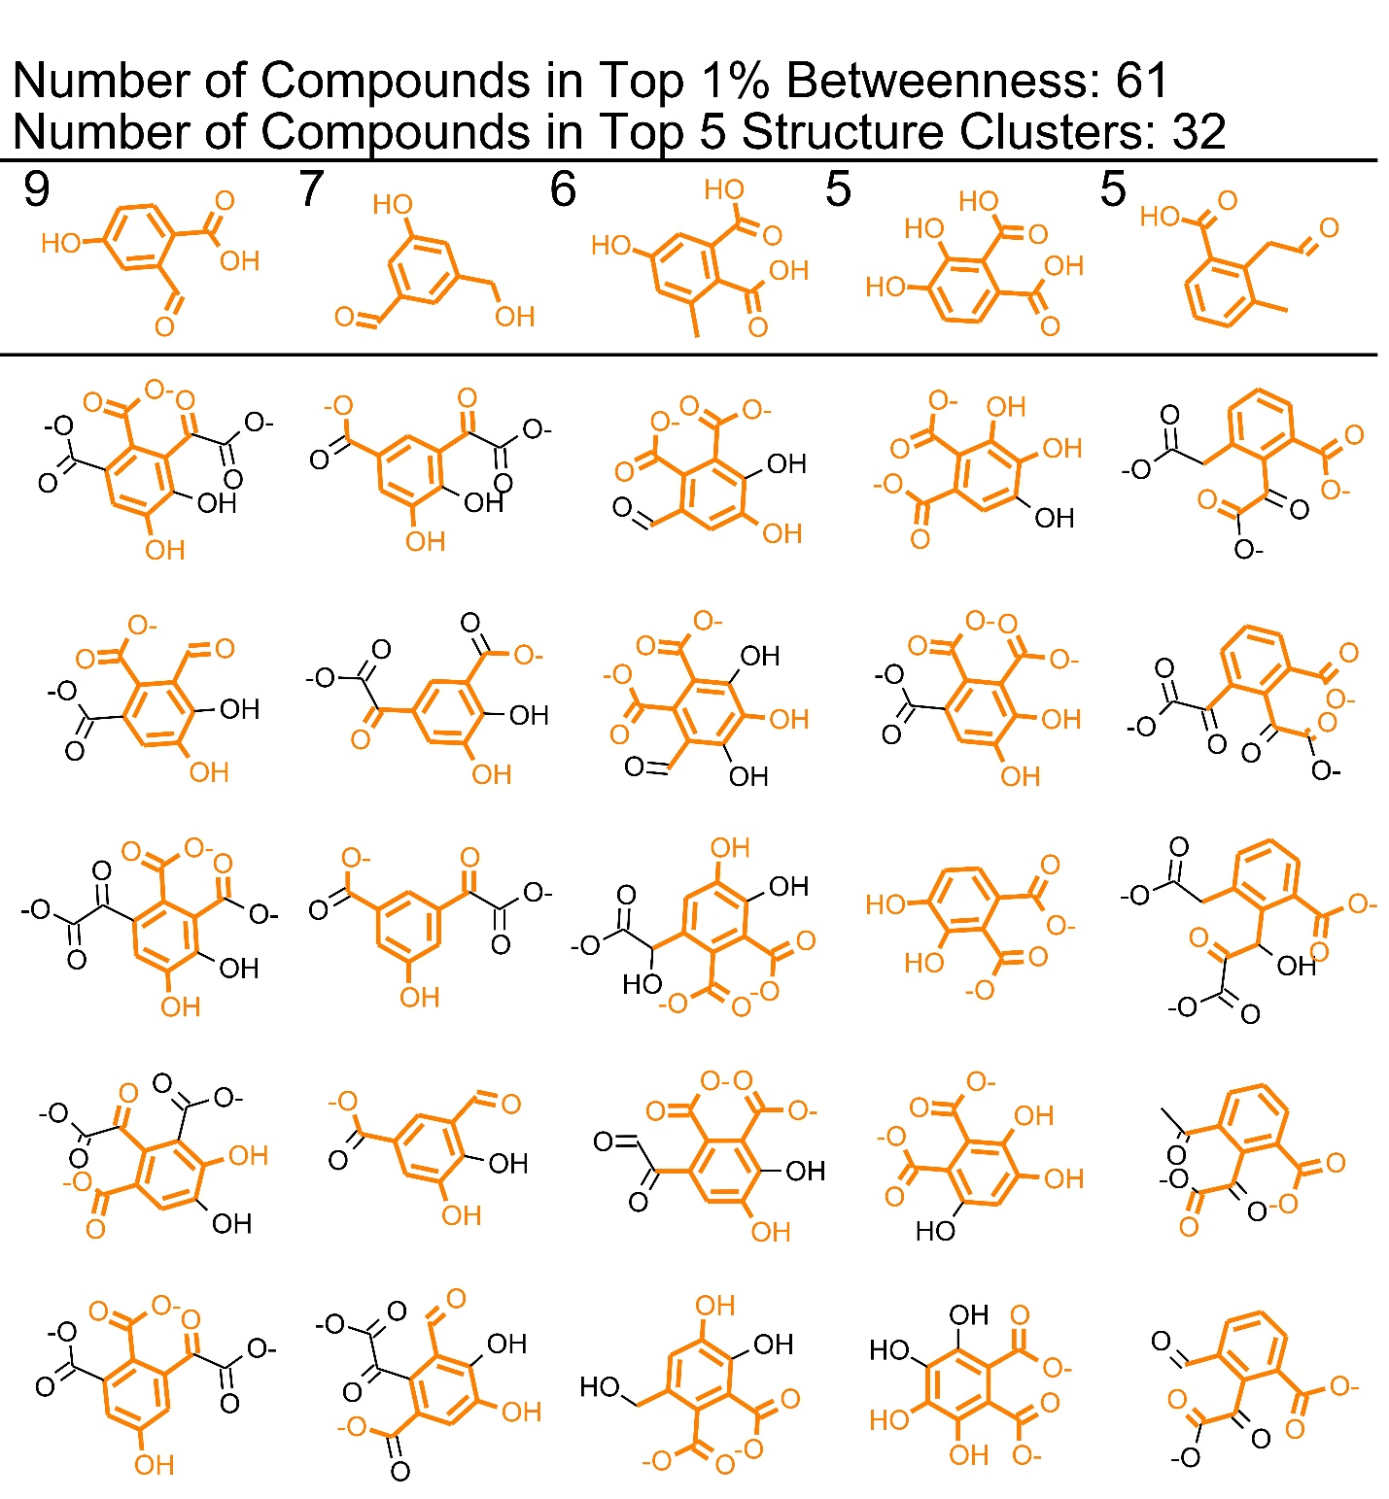
Figure S1.2: Maximum Common Substructures (MCS) in the Top 1% of Betweenness: Acenaphthene. The first row shows the MCS in top 5 largest clusters. The numbers indicate how many compounds are contained in each cluster. The compounds in the vertical columns with the substructure highlighted in orange are presented as examples of which compounds are included in the cluster. In the case of acenaphthene, each cluster has a unique substructure.

Table S1.2: Acenaphthene Empirical Literature Review

Structure: | Network Metrics | Empirical Studies finding the same thing | Similar Compounds
Acenaphthene
OC1Cc2cccc3cccc1c23  1-Acenaphthenol | Perfect Match  Throughput: 0.015 | Ghosal et al, 2013 ¹ Komatsu et al, 1993²  Mallick, 2019³  Schocken et al, 1984⁴  Birolli et al, 2018⁵  Liu et al, 2006⁶  Birolli et al, 2018⁵
OC1c2cccc3cccc(c23)C1O  cis-1,2-Acenaphthenediol  1,2-Acenaphthenediol | Partial Match  Throughput: 0.015 | Mallick, 2019³  Schocken et al, 1984⁴ Kouzuma et al, 2006
C1=Cc2cccc3cccc1c23  acenaphthylene | Partial Match  OC1Cc2cccc3cccc1c23  Throughput: 0.015 | Birolli et al, 2018⁵
OC1=C(O)c2cccc3cccc1c23  1,2-dihydroxyacenaphthylene | No Match (Single paper) | Schocken et al, 1984⁴
O=C1Cc2cccc3cccc1c23  1-Acenaphthenone | Perfect match  Throughput: 0.015 | Ghosal et al, 2013¹  Komatsu et al, 1993²  Mallick, 2019³  Schocken et al, 1984⁴  Chapman et al, 1995⁷
O=c1c2cccc3cccc(c23)c1=O  Acenaphthenequinone | Partial Match  Throughput: 0.015  OC1Cc2cccc3cccc1c23 | Ghosal et al, 2013¹  Mallick, 2019³  Chapman et al, 1995⁷  Poothrigpun et al, 2006⁸
[O-]C(=O)c1cccc2ccccc12  1-Naphthoic acid | Low Throughput Match  Throughput: 0.000002 | Ghosal et al, 2013¹  Mallick, 2019³  Poothrigpun et al, 2006⁸  Nayak et al, 2009⁹
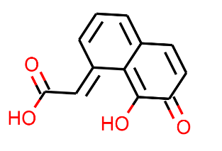  O=C(O)/C=c1\cccc2c1=C(O)C(=O)C=C2  or  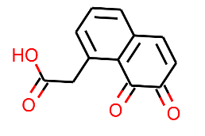  O=C(O)Cc1cccc2c1C(=O)C(=O)C=C2  7,8-diketonaphthyl-1-acetic acid | No Match (Single paper) | Selifononv et al, 1993¹⁰
Oc1cccc(C([O-])=O)c1C([O-])=O  o-methoxy-o-phthalic acid | Low Throughput Match  Throughput: 0.0078 | Selifononv et al, 1993¹⁰
Oc1ccccc1C([O-])=O  Salicylic Acid/ 2-hydroxybenzoic acid | Low Throughput Match  Throughput: 0.0027 | Ghosal et al, 2013¹  Mallick, 2019³  Nayak et al, 2009⁹  Poothrigpun et al, 2006⁸
Gentisate  gentisic acid  O=C(O)c1cc(O)ccc1O | Low Throughput Match  Oc1ccc(O)c(c1)C([O-])=O  Throughput: 0.00039 | Poothrigpun et al, 2006⁸
3-Formyl Salicylic Acid  O=Cc1cccc(C(=O)O)c1O | Low Throughput Match  Oc1c(C=O)cccc1C([O-])=O  Throughput: 0.00022 | Mallick, 2019³
Oc1ccc2ccccc2c1O  1,2-Dihydroxyacenapthylene | Low Throughput Match  Throughput: 0.000001 | Mallick, 2019³  Nayak et al, 2009⁹
O=C1OC(=O)c2cccc3cccc1c23  1,8-Naphthalic anhydride | Partial Match  Throughput: 0.015 | Mallick, 2019³  Chapman et al, 1995⁷
O=C(O)c1cccc2cccc(C(=O)O)c12  Napthalene-1,8-dicarboxylic acid dimethyl ester | Low Throughput Match  [O-]C(=O)c1cccc2cccc(C([O-])=O)c12  Throughput: 0.00017 | Mallick, 2019³  Chapman et al, 1995⁷  Nayak et al, 2009⁹  Poothrigpun et al, 2006⁸  Selifononv et al, 1993¹⁰
Oc1ccccc1O  Catechol | Low Throughput Match  Throughput: 0.00055 | Mallick, 2019³, Mallick 2011¹¹

Table S1.3: Acenaphthene Empirical Review Summary
 | Perfect Match | Partial Match
High Throughput | 2 | 4
Low Throughput | 8 | 0

No Match (Single) 2
No Match (Multiple) 0

References
(1) Ghosal, D., et al., Characterization of the Metabolic Pathway Involved in Assimilation of Acenaphthene in Acinetobacter Sp. Strain Agat-W. Res Microbiol, 2013. 164(2): p. 155-63.
(2) Komatsu, T., T. Omori, and T. Kodama, Microbial-Degradation of the Polycyclic Aromatic-Hydrocarbons Acenaphthene and Acenaphthylene by a Pure Bacterial Culture. Bioscience Biotechnology and Biochemistry, 1993. 57(5): p. 864-865.
(3) Mallick, S., Biodegradation of Acenaphthene by Sphingobacterium Sp. Strain Rtsb Involving Trans-3-Carboxy-2-Hydroxybenzylidenepyruvic Acid as a Metabolite. Chemosphere, 2019. 219: p. 748-755.
(4) Schocken, M.J. and D.T. Gibson, Bacterial Oxidation of the Polycyclic Aromatic-Hydrocarbons Acenaphthene and Acenaphthylene. Applied and Environmental Microbiology, 1984. 48(1): p. 10-16.
(5) Birolli, W.G., et al., Biodegradation of Anthracene and Several Pahs by the Marine-Derived Fungus Cladosporium Sp Cbmai 1237. Marine Pollution Bulletin, 2018. 129(2): p. 525-533.
(6) Liu, L., R.D. Schmid, and V.B. Urlacher, Cloning, Expression, and Characterization of a Self-Sufficient Cytochrome P450 Monooxygenase from Rhodococcus Ruber Dsm 44319. Applied Microbiology and Biotechnology, 2006. 72(5): p. 876-882.
(7) Chapman, P.J., et al., Fossil Fuel Biodegradation: Laboratory Studies. Environmental Health Perspectives, 1995. 103: p. 79-83.
(8) Poonthrigpun, S., et al., Novel Intermediates of Acenaphthylene Degradation by Rhizobium Sp Strain Cu-A1: Evidence for Naphthalene-1,8-Dicarboxylic Acid Metabolism. Applied and Environmental Microbiology, 2006. 72(9): p. 6034-6039.
(9) Nayak, A.S., et al., Metabolism of Acenaphthylene Via 1,2-Dihydroxynaphthalene and Catechol by Stenotrophomonas Sp Rmsk. Biodegradation, 2009. 20(6): p. 837-843.
(10) Selifonov, S.A., et al., Acenaphthene Catabolism by Strains of Alcaligenes-Eutrophus and Alcaligenes-Paradoxus. Microbiology, 1993. 62(1): p. 85-92.
(11) Mallick, S., J. Chakraborty, and T.K. Dutta, Role of Oxygenases in Guiding Diverse Metabolic Pathways in the Bacterial Degradation of Low-Molecular-Weight Polycyclic Aromatic Hydrocarbons: A Review. Crit Rev Microbiol, 2011. 37(1): p. 64-90.

Supporting Information Section 2: Anthracene
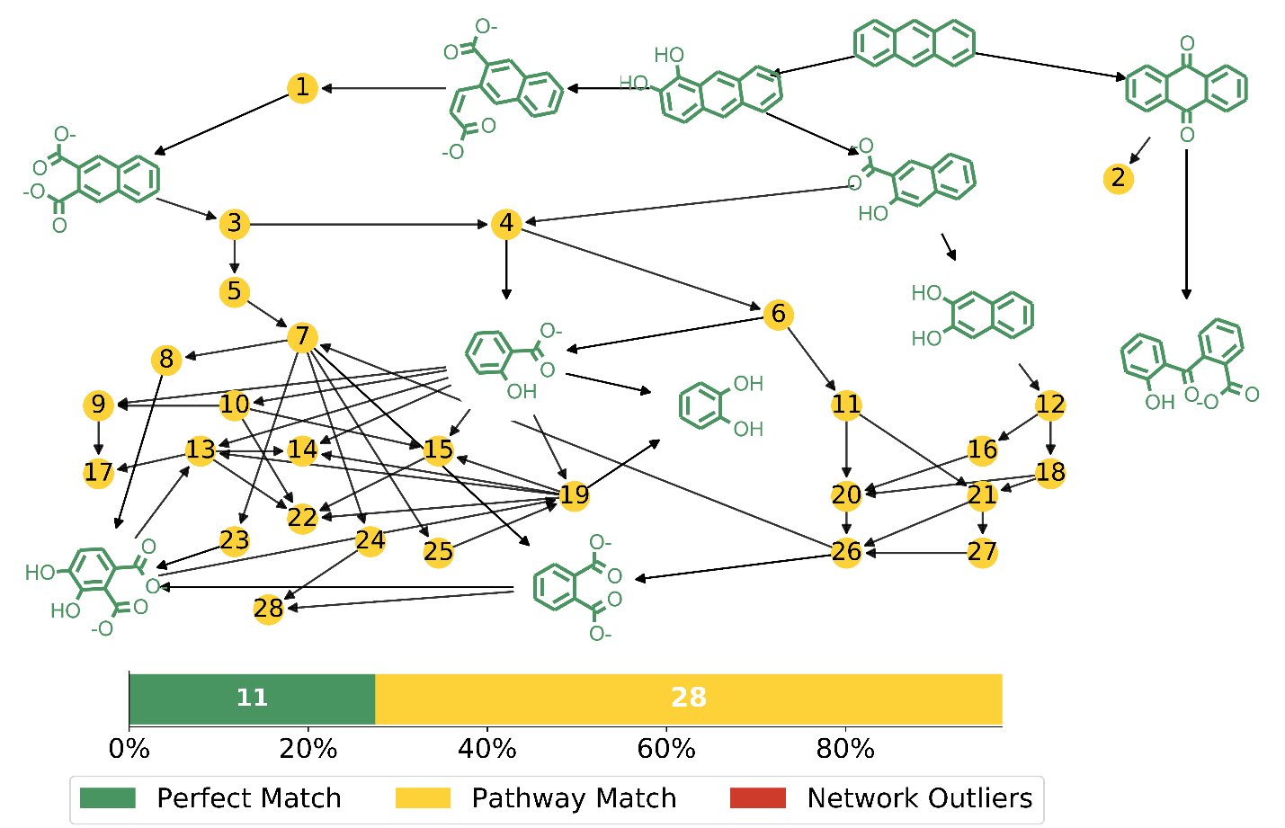
Figure S2.1: Anthracene High Throughput Plot with Pathway Match Metabolites. SMILES codes for the nodes are presented in Table S2.1.
Figure S2.1 shows a network constructed from only the High Node Throughput compounds. Reconstructing the network with only this subset of compounds yields a much smaller more manageable network.
Perfect Match compounds match a literature reference exactly. Pathway Match compounds are High Node Throughput compounds that are found on a degradation pathway to or from a Perfect Match compound. Network Outliers are High Node Throughput compounds that do not have a Perfect Match compound either above or below them in their degradation chains. Table S2.1 contains the SMILES codes for the Pathway Match compounds.

Table S2.1: Anthracene Yellow Node (Pathway Matches) Smiles Codes

1 | OC(CC([O-])=O)c1cc2ccccc2cc1C([O-])=O |  | 15 | Oc1ccc(O)c(C([O-])=O)c1O
2 | O=c1oc2ccccc2c(=O)c2ccccc12 |  | 16 | [O-]C(=O)Cc1ccccc1C([O-])=O
3 | Oc1c(C([O-])=O)c(cc2ccccc12)C([O-])=O |  | 17 | Oc1cc(O)c(O)c(O)c1O
4 | Oc1c(O)c2ccccc2cc1C([O-])=O |  | 18 | OC(C(=O)C([O-])=O)c1ccccc1C([O-])=O
5 | [O-]C(=O)C(=O)C(=C\c1ccccc1C([O-])=O)\C([O-])=O |  | 19 | Oc1cccc(C([O-])=O)c1O
6 | Oc1cc2ccccc2c(O)c1O |  | 20 | OC(C([O-])=O)c1ccccc1C([O-])=O
7 | [O-]C(=O)c1ccccc1C=O |  | 21 | [O-]C(=O)C(=O)C(=O)c1ccccc1C([O-])=O
8 | Oc1ccc(C([O-])=O)c(C=O)c1O |  | 22 | Oc1ccc(O)c(O)c1O
9 | Oc1cc(O)c(cc1O)C([O-])=O |  | 23 | Oc1ccc(C=O)c(C([O-])=O)c1O
10 | Oc1ccc(O)c(c1)C([O-])=O |  | 24 | Oc1cc(C=O)c(cc1O)C([O-])=O
11 | OC(C(=O)C(O)=O)c1ccccc1C(O)=O |  | 25 | Oc1cccc(C=O)c1O
12 | OC(=O)C(=O)Cc1ccccc1C(O)=O |  | 26 | [O-]C(=O)C(=O)c1ccccc1C([O-])=O
13 | Oc1ccc(C([O-])=O)c(O)c1O |  | 27 | [O-]C(=O)c1ccccc1C(=O)C=O
14 | Oc1cccc(O)c1O |  | 28 | Oc1cc(C([O-])=O)c(cc1O)C([O-])=O

High Betweenness Maximum Common Substructures:
The compounds with the highest betweenness centrality display similar substructures. Code was adapted from the RDKit Cookbook, referenced in the main text. The Tanimto Similarities between the Morgan Fingerprints were first calculated, and then clusters were developed with Butina Clustering using a cutoff of 0.4.
For full details and the actual python code to plot this figure, see the github linked in the main text.

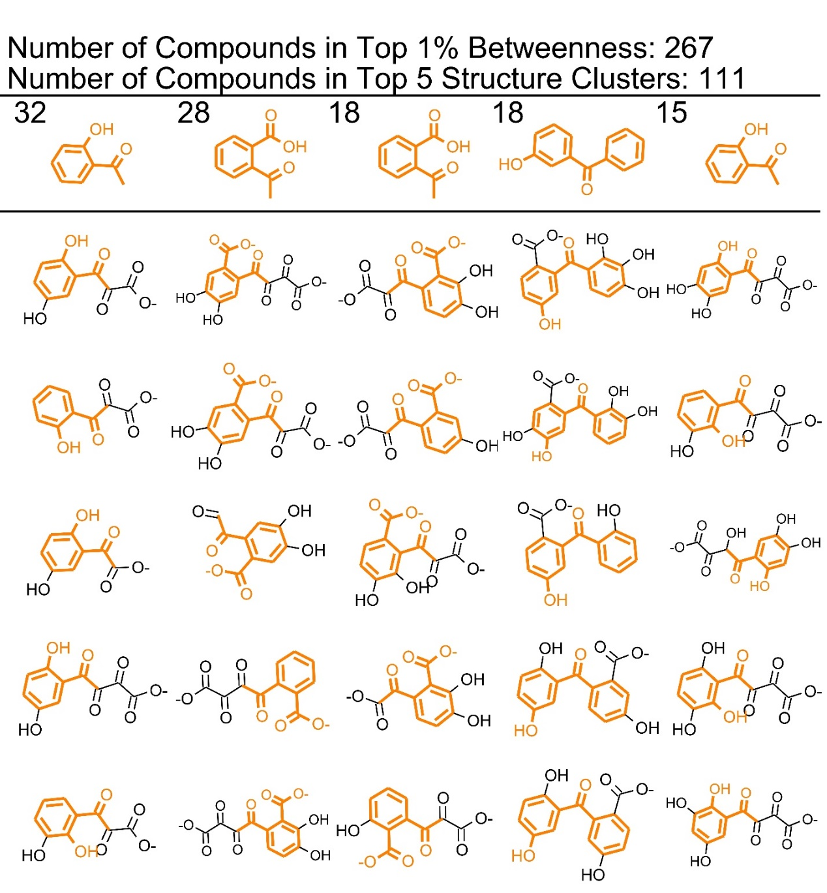
Figure S2.2: Maximum Common Substructures (MCS) in the Top 1% of Betweenness: Anthracene. The first row shows the MCS in top 5 largest clusters. The numbers indicate how many compounds are contained in each cluster. The compounds in the vertical columns with the substructure highlighted in orange are presented as examples of which compounds are included in the cluster. In the case of anthracene, the same MCS occurs in several different clusters.

Table S2.2: Anthracene Empirical Literature Review

Structure: | Network Metrics | Empirical Studies finding the same thing
Anthracene
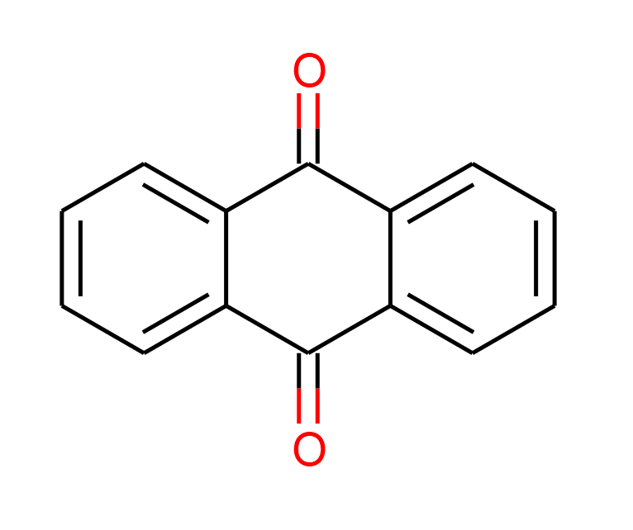  O=C1c2ccccc2C(=O)c2ccccc12  9,10-Anthraquinone | Perfect Match  Node Throughput: 0.029 | Leneva et al, 2008 ¹, Moody et al, 2001 ², Ahmed et al, 2012 ³, Hadibarata et al, 2012 ⁴ Li et al, 2014 ⁵ Ye et al, 2011 ⁶  Aranda et al, 2017⁷  Birolli et al, 2018⁸  Gunther et a, 1998⁹  Hadibarata et al, 2013¹⁰ Hammel et al, 1991¹¹, Baboshin et al, 2005¹², Bezalel et al, 1996¹³, Bylik et al, 1999¹⁴  Cajthaml et al, 2002¹⁵  Chigu et al, 2010¹⁶  Coutino-Gonzalez et al, 2010¹⁷  Field et al, 1992¹⁸  Guiraud et al, 2008¹⁹  Kastner et al, 1999²⁰  Li et al, 2014⁵  Lisowska et al, 1999²¹  Pathak et al, 2008²²  Peng et al, 2018²³  Pizzul et al, 2006²⁴  Sutherland et al, 1992²⁵  Tarafdar et al, 2017²⁶  Traczewska et al, 2000²⁷  Weigand et al, 1999²⁸  Wu et al, 2008²⁹  Wu et al, 2010³⁰
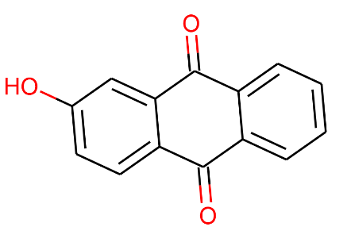  2-hydroxyanthraquinone  O=C1c2ccccc2C(=O)c2cc(O)ccc21 | Partial Match  O=C1c2ccccc2C(=O)c2ccccc12  Throughput: 0.029 | Chigu et al, 2010¹⁶
1,4-Anthraquinone  O=C1C=CC(=O)C2C=c3ccccc3=CC12 | No Match (Single paper) | Godoy et al, 2016³¹
1-4 dihydroxyanthraquinone  O=C1c2ccccc2C(=O)c2c(O)ccc(O)c21 | Partial Match  O=C1c2ccccc2C(=O)c2ccccc12  Throughput: 0.029 | Guiraud et al, 2008¹⁹
1,8 dihydroxyanthraquinone  O=C1c2cccc(O)c2C(=O)c2c(O)cccc21 | Partial Match  O=C1c2ccccc2C(=O)c2ccccc12  Throughput: 0.029 | Guiraud et al, 2008¹⁹
O=C1c2ccccc2Cc2ccccc12  9-Anthraquinone  Anthrone | Partial Match  O=C1c2ccccc2C(=O)c2ccccc12  Throughput: 0.029 | Aranda et al, 2017⁷  Birolli et al, 2018⁸  Cajthaml et al, 2002¹⁵  Chigu et al, 2010¹⁶  Richnow et al, 1998³²  Wu et al, 2010³⁰
Oc1c2ccccc2c(O)c2ccccc12  9,10 dihydroxy anthracene | Partial Match  immediate parent and daughter contained in model | Bidi et al, 2018³³  Traczewska et al, 2000²⁷
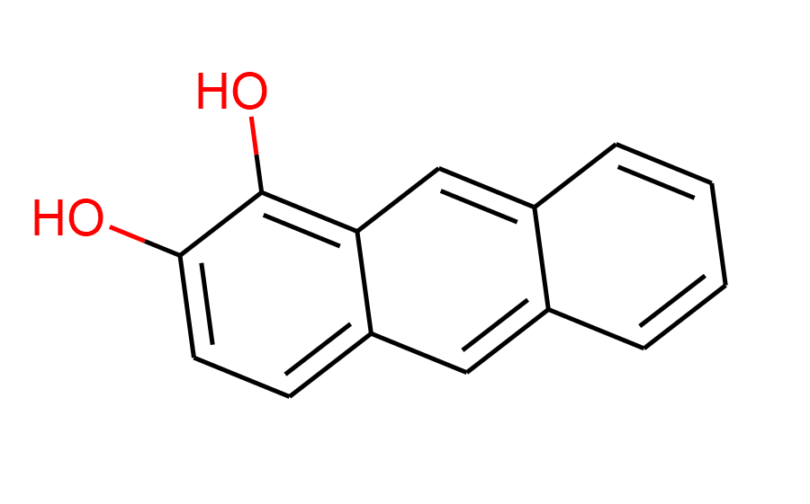  Oc1ccc2cc3ccccc3cc2c1O  1,2-dihydroxyanthracene | Perfect Match  Throughput: 0.97 | Chandrasekhar et al, 2010³⁴  Fukelar et al, 2017, ³⁵, Leneva et al, 2009 ¹ Moody et al, 2001 ², Ahmed et al, 2012 ³ Hammel et al, 1991¹¹, Bezalel et al, 1996¹³  Brinda et al, 2011³⁶  da Silva et al, 2004³⁷  Pathak et al, 2008²²  Sutherland et al, 1992²⁵  van Herwijnen et al, 2003³⁸
1-methylanthracene  Cc1cccc2cc3ccccc3cc12 | No Match (Single paper) | Tarafdar et al, 2017²⁶
1-anthrol  Oc1cccc2cc3ccccc3cc12 | Partial Match  Throughput: 0.97  Oc1ccc2cc3ccccc3cc2c1O | Sutherland et al, 1992²⁵
O=C1OC2=CC3=CC=CC=C3C=C2C=C1  6,7 benzocoumarin | No Match (Multiple papers)  however, this compound forms from an out-and back-pathway that does not contribute to the overall biodegradation chain. | Ahmed et al, 2012³ Leneva et al, 2009¹  Baboshin et al, 2005¹²  Kim et al, 1997³⁹  Pathak et al, 2008²²  van Herwijnen et al, 2003³⁸
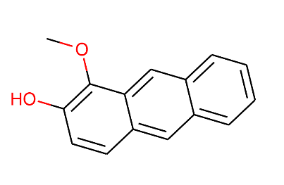  COC1=C(C=CC2=CC3=CC=CC=C3C=C21)O  1-methoxy-2-hydroxyanthracene | No Match (Multiple papers)  because EAWAG does not predict methylations. The immediate precursor 1,2-dihydroxyanthracene is predicted with a node throughput of 0.91 | Ahmed et al, 2012 ³  Pathak et al, 2008²²
Benzophenone  O=C(c1ccccc1)c1ccccc1 | Low Throughput Partial Match  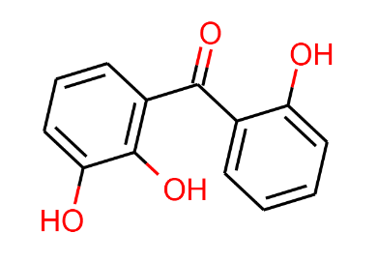  Throughput: 0.0018  Oc1cccc(C(=O)c2ccccc2O)c1O | Wu et al, 2010³⁰
2,2’-Methylenediphenol  Oc1ccccc1Cc1ccccc1O | Low Throughput Partial Match  Throughput: 0.0018  Oc1cccc(C(=O)c2ccccc2O)c1O | Tarafdar et al, 2017²⁶
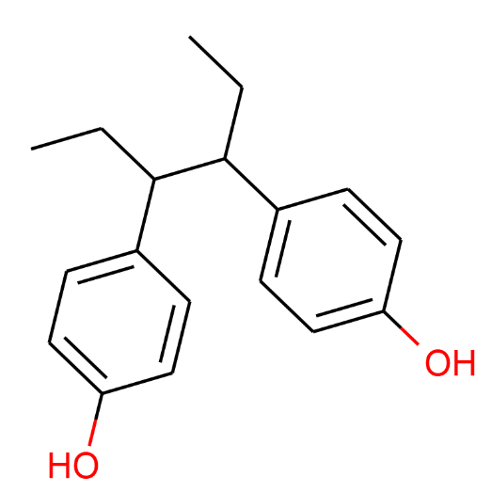  4,4’-(Hexane-3,4-diyl)diphenol  CCC(c1ccc(O)cc1)C(CC)c1ccc(O)cc1 | No Match (Single paper) | Tarafdar et al, 2017²⁶
1-Methoxy-4-(p-tolylethynyl)benzene  COc1ccc(C#Cc2ccc(C)cc2)cc1 | No Match (Single paper) | Tarafdar et al, 2017²⁶
2,2’-(1,4-Phenylene)dipropionic acid  CC(C(=O)O)c1ccc(C(C)C(=O)O)cc1 | No Match (Single paper) | Tarafdar et al, 2017²⁶
9-fluorenol, 9-Hydroxyfluorene  OC1c2ccccc2-c2ccccc12 | No Match (Single paper) | Brinda et al, 2011³⁶
2-Propanone, 1,1-diphenyl-  CC(=O)C(c1ccccc1)c1ccccc1 | No Match (Single paper) | Wu et al, 2010³⁰
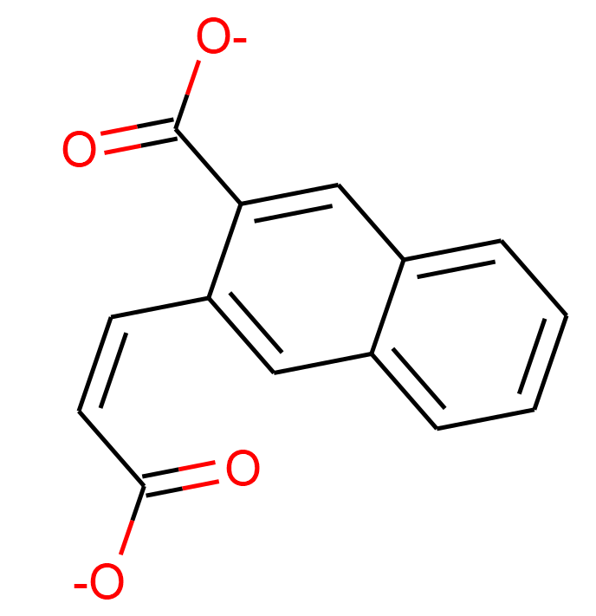  [O-]C(=O)\C=C/c1cc2ccccc2cc1C([O-])=O  3-[(Z)-2-carboxyvinyl]-2-naphthoate, 3-(2-carboxyvinyl)naphthalene-2-carboxylic | Perfect Match  Node Throughput: 0.32 | Moody et al, 2001 ²  Brinda et al, 2011³⁶
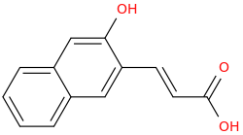  (E)-3-(2-hydroxynaphthalen-3-yl)acrylic acid  O=C(O)C=Cc2cc1ccccc1cc2O | Partial Match  Immediate Parent and Daughter predicted: Occupies the same place in the degradation chain as 3-[(Z)-2-carboxyvinyl]-2-naphthoate. | Ahmed et al, 2012 ³
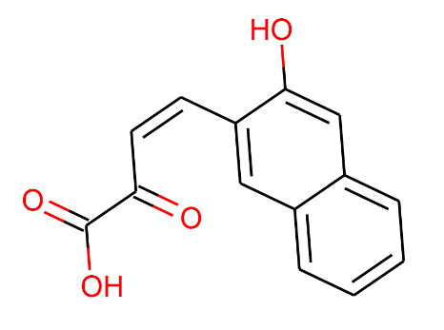  cis-4-(2-Hydroxynaphth-3-yl)-2-oxobut-3-enoic acid  O=C(O)C(=O)/C=C\c1cc2ccccc2cc1O | No Match (Single paper) | van Herwijnen et al, 2003 ³⁸
4-(3-Hydroxy-2-naphthyl)butanoic acid  O=C(O)CCCc1cc2ccccc2cc1O | No Match (Multiple papers) | Weigand et al, 1999²⁸  Baboshin et al, 2005¹²
2-Hydroxy-3-naphthyl -propionic  Acid  O=C(O)CCc1cc2ccccc2cc1O | No Match (Single paper) | Baboshin et al, 2005¹²
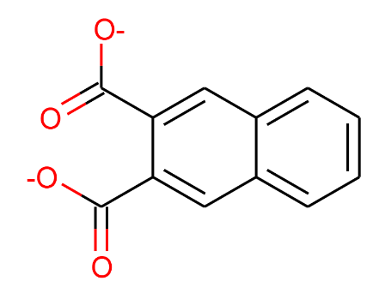  Naphthalene 2,3 dicarboxylic acid  [O-]C(=O)c1cc2ccccc2cc1C([O-])=O | Perfect Match  Throughput: 0.16 | van Herwijnen et al, 2003⁴⁰
Oc1cc2ccccc2cc1C([O-])=O  3-Hydroxy-2-naphthoate | Perfect Match  Throughput: 0.32 | Menn et al, 1993 ⁴¹  Weigand et al, 1999²⁸  Different protonation state:  Hadibarata et al, 2013¹⁰, Baboshin et al, 2005¹²  Liu et al, 1992⁴²  Richnow et al, 1998³²  Story et al, 2001⁴³  Van Herwijnen et al, 2003³⁸
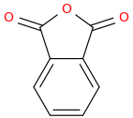  C1(C=2C(C(=O)O1)=CC=CC2)=O  Phthalic anhydride | Partial Match  Not predicted, but its immediate precursor and immediate daughter are | Ye et al, 2011⁶  Bylik et al, 1999¹⁴  Cajthaml et al, 2002¹⁵  Traczewska et al, 2000²⁷
O=C1OCc2ccccc21  Phthalide | No Match (Single paper) | Cajthaml et al, 2002¹⁵
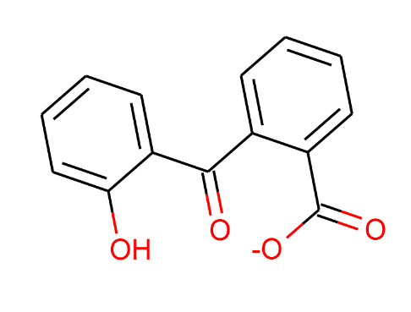  2-(2'-hydroxybenzoyl)-benzoic acid  Oc1ccccc1C(=O)c1ccccc1C([O-])=O | Perfect Match  Throughput: 0.015 | Cajthaml et al, 2002¹⁵
dimethyl phthalic acid  COC(=O)c1ccccc1C(=O)OC | No Match (Single paper)  Note: EAWAG does not predict methylations | Cajthaml et al, 2002¹⁵
c1ccc2ccccc2c1  Naphthalene | Partial Match  Throughput: 0.14  Oc1cc2ccccc2cc1O | Das et al, 2017 ⁴⁴ Godoy et al, 2016³¹  Tarafdar et al, 2017²⁶
Cc1ccc2ccccc2c1  Napthalene-2-methyl  2-Methylnaphthalene | No Match (Multiple papers) | Das et al, 2017 ⁴⁴ Godoy et al, 2016³¹
Cc1cccc2ccccc12  1-Methylnaphthalene | No Match (Single paper) | Godoy et al, 2016³¹
Oc1cc2ccccc2cc1O  Dihydroxynaphthalene | Perfect Match  Throughput: 0.16 | Chandrasekhar et al, 2010³⁴  Hadibarata et al, 2013¹⁰ Baboshin et al, 2005¹²  Hadibarata et al, 2013⁴⁵  Weigand et al, 1999²⁸
O=c1ccc2ccccc2o1  Coumarin | No Match (Multiple papers) | Hadibarata et al, 2013¹⁰  Hadibarata et al, 2013⁴⁵  Tarafdar et al, 2017²⁶
[O-]C(=O)Cc1ccccc1  Phenylacetate/Benzeneacetic acid | Low Throughput Partial Match  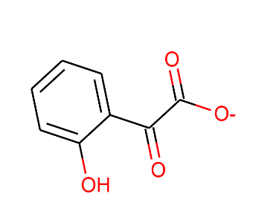  Throughput 0.002296  Oc1ccccc1C(=O)C([O-])=O | Bidi et al, 2018, ³³ Das et al, 2017 ⁴⁴
Ehyl (E)-3-(2-acetyl-4-methoxyphenyl)acrylate  CCOC(=O)/C=C/c1ccc(OC)cc1C(C)=O | No Match (Single paper) | Tarafdar et al, 2017²⁶
Oc1ccc(cc1O)C([O-])=O  protocatechuic acid | Low Throughput Match  Node Throughput: 0.0011 | van Herwijnen et al, 2003³⁸
o-phthalic acid  [O-]C(=O)c1ccccc1C([O-])=O | Perfect Match  Node Throughput: 0.12 | Ahmed et al, 2012 ³,  Das et al, 2017 ⁴⁴  Chandrasekhar et al, 2010³⁴  Hadibarata et al, 2012 ⁴  Ye et al, 2011, ⁶  Richnow et al, 1998³²  Tarafdar et al, 2017²⁶  van Herwijnen et al, 2003³⁸
3,4 dihydroxy phlalate  Oc1ccc(C([O-])=O)c(C([O-])=O)c1O | Perfect Match  Throughput 0.070 | Brinda et al, 2011³⁶
O=Cc1ccccc1  Benzaldehyde | Partial Match  its immediate precursor (phthalic acid) is predicted and a compound with the same carbon backbone is predicted  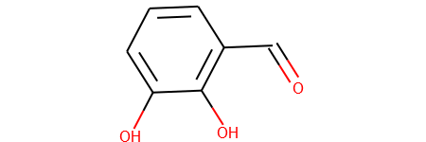  Throughput: 0.031  Oc1cccc(C=O)c1O | Das et al, 2017 ⁴⁴  Tarafdar et al, 2017²⁶
Salicylaldehyde  Oc1ccccc1C=O | Low Throughput Match  Throughput: 0.000005 | Chandrasekhar et al, 2010³⁴
[O-]C(=O)c1ccccc1  Benzoic Acid | Partial Match  Throughput 0.11 | Hadibarata et al, 2012 ⁴, Hadibarata et al, 2013¹⁰  Tarafdar et al, 2017²⁶
Salicylate/Salicylic Acid  Oc1ccccc1C([O-])=O | Perfect Match  Throughput: 0.11 | Chandrasekhar et al, 2010³⁴
Catechol  Oc1ccccc1O | Perfect Match  Throughput: 0.015 | Chandrasekhar et al, 2010³⁴  Fulekar et al, 2017³⁵  Hadibarata et al, 2012 ⁴  Bidi et al, 2018, ³³
Phenol  Oc1ccccc1 | Low Throughput Match  Throughput 6.766063e-08 | Chandrasekhar et al, 2010³⁴  Tarafdar et al, 2017²⁶

Table S2.3: Anthracene Empirical Review Summary

 | Perfect Match | Partial Match
High Throughput | 11 | 11
Low Throughput | 3 | 3

No Match (Single) 13
No Match (Multiple) 5
No Match Explanations:
Several of the No-Match Compounds are the result of methylation or other straight chain addition after the cleavage of another bound. EAWAG does not predict this type of transition, so these compounds would not be found. Certain anhydride, oxide, or coumarin structures are also not predicted, so these compounds are either classified as no Match or Partial Match if their immediate parent and daughter compounds are predicted.
References
(1) Leneva, N.A., et al., Phenanthrene and anthracene degradation by microorganisms of the genus Rhodococcus. Applied Biochemistry and Microbiology, 2009. 45(2): p. 169-175.
(2) Moody, J.D., et al., Degradation of phenanthrene and anthracene by cell suspensions of Mycobacterium sp. strain PYR-1. Appl Environ Microbiol, 2001. 67(4): p. 1476-83.
(3) Ahmed, A.T., et al., Degradation of Anthracene by Alkaliphilic Bacteria Bacillus badius. Environment and Pollution, 2012. 1(2).
(4) Hadibarata, T., A.B. Khudhair, and M.R. Salim, Breakdown products in the metabolic pathway of anthracene degradation by a ligninolytic fungus Polyporus sp. S133. Water, Air, & Soil Pollution, 2012. 223(5): p. 2201-2208.
(5) Li, X., et al., Peculiarities of metabolism of anthracene and pyrene by laccase-producing fungus Pycnoporus sanguineus H1. Biotechnol Appl Biochem, 2014. 61(5): p. 549-54.
(6) Ye, J.S., et al., Biodegradation of anthracene by Aspergillus fumigatus. J Hazard Mater, 2011. 185(1): p. 174-81.
(7) Aranda, E., et al., Isolation of of Ascomycota fungi with capability to transform PAHs: Insights into the biodegradation mechanisms of Penicillium oxalicum. International Biodeterioration & Biodegradation, 2017. 122: p. 141-150.
(8) Birolli, W.G., et al., Biodegradation of anthracene and several PAHs by the marine-derived fungus Cladosporium sp CBMAI 1237. Marine Pollution Bulletin, 2018. 129(2): p. 525-533.
(9) Gunther, T., et al., Oxidation of PAH and PAH-derivatives by fungal and plant oxidoreductases. Journal of Basic Microbiology, 1998. 38(2): p. 113-122.
(10) Hadibarata, T., et al., Degradation and transformation of anthracene by white-rot fungus Armillaria sp F022. Folia Microbiologica, 2013. 58(5): p. 385-391.
(11) Hammel, K.E., B. Green, and W.Z. Gai, Ring fission of anthracene by a eukaryote. Proceedings of the National Academy of Sciences of the United States of America, 1991. 88(23): p. 10605-10608.
(12) Baboshin, M.A., et al., The microbial transformation of phenanthrene and anthracene. Microbiology, 2005. 74(3): p. 303-309.
(13) Bezalel, L., et al., Initial oxidation products in the metabolism of pyrene, anthracene, fluorene, and dibenzothiophene by the white rot fungus Pleurotus ostreatus. Applied and Environmental Microbiology, 1996. 62(7): p. 2554-2559.
(14) Bilyk, A. and T.M. Traczewska, Anthracene and phenanthrene degradation by bacteria immobilized on activated carbon and zeolites. Environmental Protection Engineering, 1999. 25(3): p. 123-129.
(15) Cajthaml T, et al., Study of fungal degradation products of polycyclic aromatic hydrocarbons using gas chromatography with ion trap mass spectrometry detection. Journal of Chromatography, 2002. 974: p. 213–222.
(16) Chigu, N.L., et al., Cytochrome P450 monooxygenases involved in anthracene metabolism by the white-rot basidiomycete Phanerochaete chrysosporium. Applied Microbiology and Biotechnology, 2010. 87(5): p. 1907-1916.
(17) Coutino-Gonzalez, E., et al., The earthworm Eisenia fetida accelerates the removal of anthracene and 9, 10-anthraquinone, the most abundant degradation product, in soil. International Biodeterioration & Biodegradation, 2010. 64(6): p. 525-529.
(18) Field, J.A., et al., BIODEGRADATION OF POLYCYCLIC AROMATIC-HYDROCARBONS BY NEW ISOLATES OF WHITE ROT FUNGI. Applied and Environmental Microbiology, 1992. 58(7): p. 2219-2226.
(19) Guiraud, P., et al., Involvement of Tetrahymena pyriformis and selected fungi in the elimination of anthracene, and toxicity assessment of the biotransformation products. Ecotoxicology and Environmental Safety, 2008. 69(2): p. 296-305.
(20) Kastner, M., et al., Formation of bound residues during microbial degradation of C-14 anthracene in soil. Applied and Environmental Microbiology, 1999. 65(5): p. 1834-1842.
(21) Lisowska, K. and J. Długoński, Removal of anthracene and phenanthrene by filamentous fungi capable of cortexolone 11-hydroxylation. Journal of Basic Microbiology, 1999. 39(2): p. 117-125.
(22) Pathak, H., et al., Technical Note: Degradation of Phenanthrene and Anthracene byPseudomonasStrain, Isolated From Coastal Area. Bioremediation Journal, 2008. 12(2): p. 111-116.
(23) Peng, T., et al., Identification of A Ring-Hydroxylating Dioxygenases Capable of Anthracene and Benz a anthracene Oxidization from Rhodococcus sp. P14. Journal of Molecular Microbiology and Biotechnology, 2018. 28(4): p. 183-189.
(24) Pizzul, L., M.D. Castillo, and J. Stenstrom, Characterization of selected actinomycetes degrading polyaromatic hydrocarbons in liquid culture and spiked soil. World Journal of Microbiology & Biotechnology, 2006. 22(7): p. 745-752.
(25) Sutherland, J.B., et al., IDENTIFICATION OF XYLOSIDE CONJUGATES FORMED FROM ANTHRACENE BY RHIZOCTONIA-SOLANI. Mycological Research, 1992. 96: p. 509-517.
(26) Tarafdar, A., A. Sinha, and R.E. Masto, Biodegradation of anthracene by a newly isolated bacterial strain, Bacillus thuringiensis AT.ISM.1, isolated from a fly ash deposition site. Letters in Applied Microbiology, 2017. 65(4): p. 327-334.
(27) Traczewska, T.M., Changes of toxicological properties of biodegradation products of anthracene and phenanthrene. Water Science and Technology, 2000. 41(12): p. 31-38.
(28) Weigand, H., et al., Desorption controlled mobility and intrinsic biodegradation of anthracene in unsaturated soil. Physics and Chemistry of the Earth Part B-Hydrology Oceans and Atmosphere, 1999. 24(6): p. 549-555.
(29) Wu, M.L., et al., Analysis of phenanthrene biodegradation by using FTIR, UV and GC-MS. Spectrochim Acta A Mol Biomol Spectrosc, 2010. 75(3): p. 1047-50.
(30) Wu, Y.R., Z.H. Luo, and L.L. Vrijmoed, Biodegradation of anthracene and benz[a]anthracene by two Fusarium solani strains isolated from mangrove sediments. Bioresour Technol, 2010. 101(24): p. 9666-72.
(31) Godoy, P., et al., Exploring the potential of fungi isolated from PAH-polluted soil as a source of xenobiotics-degrading fungi. Environmental Science and Pollution Research, 2016. 23(20): p. 20985-20996.
(32) Richnow, H.H., et al., The use of 13C-labelled polycyclic aromatic hydrocarbons for the analysis of their transformation in soil. Chemosphere, 1998. 36(10): p. 2211-2224.
(33) Bibi, N., et al., Anthracene biodegradation capacity of newly isolated rhizospheric bacteria Bacillus cereus S13. PLoS One, 2018. 13(8): p. e0201620.
(34) Chandrasekhar, N. and C.S. Karigar, Bacteral degradation of anthracene by Pseudomonas fluorescens KCP2. Asian Journal of Microbiology, Biotechnology and Environmental Sciences. 12(3): p. 591-597.
(35) Fulekar, M.H., Microbial degradation of petrochemical waste-polycyclic aromatic hydrocarbons. Bioresour Bioprocess, 2017. 4(1): p. 28.
(36) Brinda, L.M. and M. Velan, Biodegradation of Anthracene Influence Of selected physiochemical parameters and metabolism. Proceedings of the International Conference on Green Technology and Environmental Conservation, GTEC-2011, 2011: p. 167-172.
(37) da Silva, M., et al., Metabolism of aromatic hydrocarbons by the filamentous fungus Cyclothyrium sp. Chemosphere, 2004. 57(8): p. 943-952.
(38) van Herwijnen, R., et al., Degradation of anthracene by Mycobacterium sp strain LB501T proceeds via a novel pathway, through o-phthalic acid. Applied and Environmental Microbiology, 2003. 69(1): p. 186-190.
(39) Kim, E.B., et al., Evidence for the role of 2-hydroxychromene-2-carboxylate isomerase in the degradation of anthracene by Sphingomonas yanoikuyae B1. Fems Microbiology Letters, 1997. 153(2): p. 479-484.
(40) van Herwijnen, R., et al., Elucidation of the metabolic pathway of fluorene and cometabolic pathways of phenanthrene, fluoranthene, anthracene and dibenzothiophene by Sphingomonas sp LB126. Research in Microbiology, 2003. 154(3): p. 199-206.
(41) Menn, F.-M., B.M. Applegate, and G.S. Sayler, NAH Plasmid-Mediated Catabolism of Anthracene and Phenanthrene to Naphthoic Acids. Applied and Environmental Microbiology, 1993. 59(6): p. 1938-1942.
(42) Liu, D., et al., Microbial degradation of polycyclic aromatic hydrocarbons and polycyclic aromatic nitrogen heterocyclics. Environmental Toxicology and Water Quality, 1992. 7(4): p. 355-372.
(43) Story, S.P., et al., Convergent and divergent points in catabolic pathways involved in utilization of fluoranthene, naphthalene, anthracene, and phenanthrene by Sphingomonas paucimobilis var. EPA505. Journal of Industrial Microbiology & Biotechnology, 2001. 26(6): p. 369-382.
(44) Das, M., et al., Enhanced Biodegradation of Anthracene by Bacillus Cereus Strain JMG-01 Isolated from Hydrocarbon Contaminated Soils. Soil and Sediment Contamination: An International Journal, 2017. 26(5): p. 510-525.
(45) Hadibarata, T., et al., Microbial transformation and sorption of anthracene in liquid culture. Bioprocess and Biosystems Engineering, 2013. 36(9): p. 1229-1233.

Section 3: Fluorene
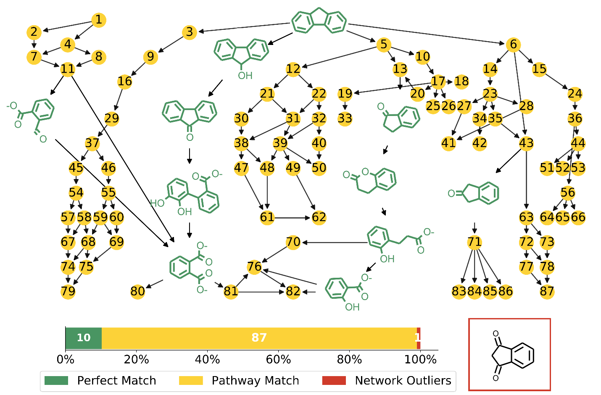
Figure S3.1: Fluorene High Throughput Plot with Pathway Match Metabolites. SMILES codes for the nodes are presented in Table S3.1.

Figure S3.1 shows a network constructed from only the High Node Throughput compounds. Reconstructing the network with only this subset of compounds yields a much smaller more manageable network.
Perfect Match compounds match a literature reference exactly. Pathway Match compounds are High Node Throughput compounds that are found on a degradation pathway to or from a Perfect Match compound. Network Outliers are High Node Throughput compounds that do not have a Perfect Match compound either above or below them in their degradation chains. Table S3.1 contains the SMILES codes for the Pathway Match compounds.

Table S3.1: Fluorene Yellow Node (Pathway Matches) Smiles Codes

1 | [O-]C(=O)C(=O)Cc1ccccc1C([O-])=O |  | 44 | [O-]C(=O)\C=C/C1=CC(=O)c2ccccc12
2 | [O-]C(=O)Cc1ccccc1C([O-])=O |  | 45 | Oc1ccc2oc(=O)\c(=C\C([O-])=O)\c(=C/C([O-])=O)\c2c1O
3 | Oc1cc2Cc3ccccc3-c2cc1O |  | 46 | Oc1ccc2c(oc(=O)\c(=C\C([O-])=O)\c\2=C/C([O-])=O)c1O
4 | OC(C(=O)C([O-])=O)c1ccccc1C([O-])=O |  | 47 | OC1C(=Cc2ccccc12)C([O-])=O
5 | Oc1ccc2Cc3ccccc3-c2c1O |  | 48 | OC(CC([O-])=O)C1=Cc2ccccc2C1=O
6 | Oc1ccc2-c3ccccc3Cc2c1O |  | 49 | OC1C(\C=C/C([O-])=O)C(=O)c2ccccc12
7 | OC(C([O-])=O)c1ccccc1C([O-])=O |  | 50 | [O-]C(=O)\C=C/c1cc2ccccc2oc1=O
8 | [O-]C(=O)C(=O)C(=O)c1ccccc1C([O-])=O |  | 51 | OC1(CC(=O)c2ccccc12)\C=C/C([O-])=O
9 | [O-]C(=O)\C=C1\Cc2ccccc2\C\1=C\C([O-])=O |  | 52 | OC(CC([O-])=O)C1=CC(=O)c2ccccc12
10 | O\C(=C\C=C1\Cc2ccccc2C1=O)C([O-])=O |  | 53 | [O-]C(=O)\C=C/c1cc(=O)oc2ccccc12
11 | [O-]C(=O)C(=O)c1ccccc1C([O-])=O |  | 54 | [O-]C(=O)\C=C/c1oc(=O)\c(=C\C([O-])=O)\c(=C/C([O-])=O)\c1C([O-])=O
12 | [O-]C(=O)\C=C/C1=C(C([O-])=O)c2ccccc2C1 |  | 55 | [O-]C(=O)\C=C/c1c(oc(=O)\c(=C\C([O-])=O)\c\1=C/C([O-])=O)C([O-])=O
13 | [O-]C(=O)C1Cc2ccccc2C1=O |  | 56 | [O-]C(=O)\C=C/c1c(oc(=O)c2ccccc12)C([O-])=O
14 | O\C(=C\C=C1/C(=O)Cc2ccccc12)C([O-])=O |  | 57 | [O-]C(=O)\C=C/c1c\c(=C\C([O-])=O)\c(=C/C([O-])=O)\c(=O)o1
15 | [O-]C(=O)\C=C/C1=C(Cc2ccccc12)C([O-])=O |  | 58 | OC(CC([O-])=O)c1oc(=O)\c(=C\C([O-])=O)\c(=C/C([O-])=O)\c1C([O-])=O
16 | OC1\C(=C\C([O-])=O)\C(=C/C([O-])=O)\c2ccccc12 |  | 59 | OC(CC([O-])=O)c1c(oc(=O)\c(=C\C([O-])=O)\c\1=C/C([O-])=O)C([O-])=O
17 | [O-]C(=O)C(=O)\C=C/C1Cc2ccccc2C1=O |  | 60 | [O-]C(=O)\C=C/c1coc(=O)\c(=C\C([O-])=O)\c\1=C/C([O-])=O
18 | OC(CC1Cc2ccccc2C1=O)C(=O)C([O-])=O |  | 61 | [O-]C(=O)C1=Cc2ccccc2C1=O
19 | [O-]C(=O)C(=O)\C=C/C1Cc2ccccc2C(=O)O1 |  | 62 | OC1C(C([O-])=O)C(=O)c2ccccc12
20 | OC(CC(=O)C([O-])=O)C1Cc2ccccc2C1=O |  | 63 | OC1(C([O-])=O)C(=O)Cc2ccccc12
21 | [O-]C(=O)\C=C/C1=Cc2ccccc2C1 |  | 64 | Oc1ccc2c(\C=C/C([O-])=O)c(oc(=O)c2c1O)C([O-])=O
22 | OC1C(\C=C/C([O-])=O)=C(C([O-])=O)c2ccccc12 |  | 65 | Oc1ccc2c(c1O)c(\C=C/C([O-])=O)c(oc2=O)C([O-])=O
23 | [O-]C(=O)C(=O)\C=C/C1C(=O)Cc2ccccc12 |  | 66 | O\C(C([O-])=O)=C(\C=C/C([O-])=O)/c1ccccc1C([O-])=O
24 | OC1C(C([O-])=O)=C(\C=C/C([O-])=O)c2ccccc12 |  | 67 | OC(CC([O-])=O)c1c\c(=C\C([O-])=O)\c(=C/C([O-])=O)\c(=O)o1
25 | OC1C(\C=C/C(=O)C([O-])=O)C(=O)c2ccccc12 |  | 68 | [O-]C(=O)\C=c1\c(C([O-])=O)c(oc(=O)\c\1=C\C([O-])=O)C([O-])=O
26 | OC1(Cc2ccccc2C1=O)\C=C/C(=O)C([O-])=O |  | 69 | OC(CC([O-])=O)c1coc(=O)\c(=C\C([O-])=O)\c\1=C/C([O-])=O
27 | OC1(\C=C/C(=O)C([O-])=O)C(=O)Cc2ccccc12 |  | 70 | Oc1cccc(CCC([O-])=O)c1O
28 | OC(CC1C(=O)Cc2ccccc12)C(=O)C([O-])=O |  | 71 | O=C1Cc2ccccc2CO1
29 | [O-]C(=O)\C=C1\C(=O)c2ccccc2\C\1=C\C([O-])=O |  | 72 | OC1C(=O)Cc2ccccc12
30 | OC(CC([O-])=O)C1=Cc2ccccc2C1 |  | 73 | OC1(OC(=O)Cc2ccccc12)C([O-])=O
31 | OC1C(\C=C/C([O-])=O)=Cc2ccccc12 |  | 74 | [O-]C(=O)\C=c1\cc(oc(=O)\c\1=C\C([O-])=O)C([O-])=O
32 | [O-]C(=O)\C=C/C1=C(C([O-])=O)c2ccccc2C1=O |  | 75 | [O-]C(=O)\C=c1\c(coc(=O)\c\1=C\C([O-])=O)C([O-])=O
33 | OC(Cc1ccccc1C([O-])=O)\C=C/C(=O)C([O-])=O |  | 76 | Oc1cccc(C([O-])=O)c1O
34 | [O-]C(=O)C(=O)\C=C/C1OC(=O)Cc2ccccc12 |  | 77 | O=C1Cc2ccccc2C1=O
35 | OC(CC(=O)C([O-])=O)C1C(=O)Cc2ccccc12 |  | 78 | OC1OC(=O)Cc2ccccc12
36 | [O-]C(=O)\C=C/C1=C(C([O-])=O)C(=O)c2ccccc12 |  | 79 | [O-]C(=O)\C=c1\ccoc(=O)\c\1=C\C([O-])=O
37 | [O-]C(=O)\C=c1\c2ccccc2oc(=O)\c\1=C\C([O-])=O |  | 80 | Oc1cc(C([O-])=O)c(cc1O)C([O-])=O
38 | OC(CC([O-])=O)C1=Cc2ccccc2C1O |  | 81 | Oc1ccc(C([O-])=O)c(C([O-])=O)c1O
39 | [O-]C(=O)\C=C/C1=Cc2ccccc2C1=O |  | 82 | Oc1ccc(C([O-])=O)c(O)c1O
40 | [O-]C(=O)\C=C/c1c(C([O-])=O)c2ccccc2oc1=O |  | 83 | Oc1cc2COC(=O)Cc2cc1O
41 | OC(CC1(O)C(=O)Cc2ccccc12)C(=O)C([O-])=O |  | 84 | Oc1ccc2CC(=O)OCc2c1O
42 | OC(\C=C/C(=O)C([O-])=O)c1ccccc1CC([O-])=O |  | 85 | OCc1ccccc1CC([O-])=O
43 | [O-]C(=O)C1C(=O)Cc2ccccc12 |  | 86 | Oc1ccc2COC(=O)Cc2c1O
 |  |  | 87 | O=C1Cc2ccccc2C(=O)O1

High Betweenness Maximum Common Substructures:

The compounds with the highest betweenness centrality display similar substructures. Code was adapted from the RDKit Cookbook, referenced in the main text. The Tanimto Similarities between the Morgan Fingerprints were first calculated, and then clusters were developed with Butina Clustering using a cutoff of 0.4. For full details and the actual python code, see the github linked in the main text.

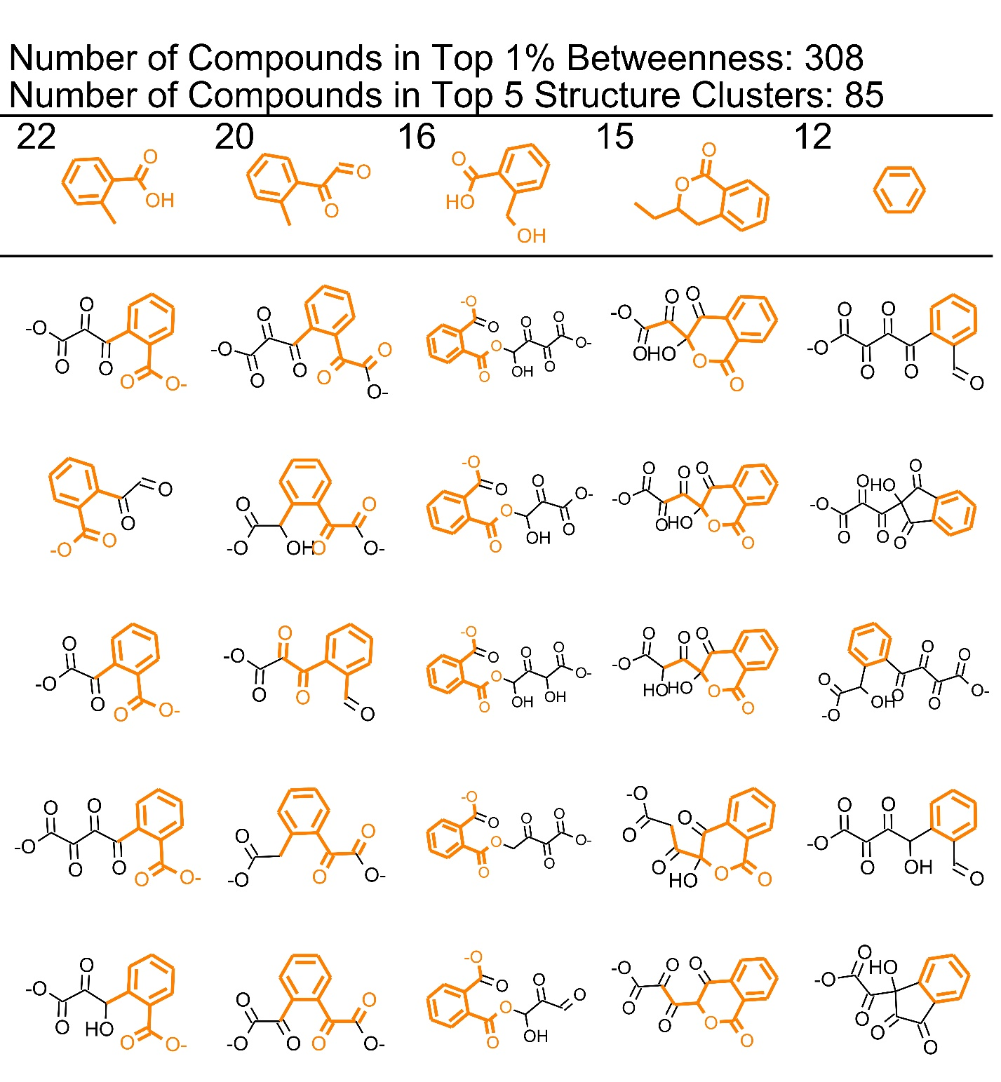
Figure S3.2: Maximum Common Substructures (MCS) in the Top 1% of Betweenness: Fluorene. The first row shows the MCS in top 5 largest clusters. The numbers indicate how many compounds are contained in each cluster. The compounds in the vertical columns with the substructure highlighted in orange are presented as examples of which compounds are included in the cluster. In the case of fluorene, the same MCS occurs in several different clusters.

Table S3.2: Fluorene Empirical Literature Review

Structure: | Network Metrics | Empirical Studies finding the same thing
Fluorene
Fluorene, 1,4-dihydro-  C1=CCC2=C(C1)Cc1ccccc12 | Partial Match due to parent/daughter products | Bharti et al, 2019¹
Dibenzofuran  C1=CC2OC3C=CC=CC3C2C=C1 | No Match (Multiple papers) | Yamazoe et al, 2004²  Cajthaml et al, 2002³  Yu et al, 2014⁴
2-hydroxydibenzofuran  OC1=CC2C(C=C1)OC1C=CC=CC12 | No Match (Single paper) | Yamazoe et al, 2004²
1,2-dihydroxy-,1,2-dihydrodibenzofuran  OC1C=Cc2oc3ccccc3c2C1O | No Match (Single paper) | Yamazoe et al, 2004²
9-fluorenol, 9-Hydroxyfluorene  OC1c2ccccc2-c2ccccc12 | Perfect Match  Throughput: 0.01 | Zhang et al⁵  Yamazoe et al, 2004⁶ Chupungars et al, 2009⁷  Juckpeck et al, 2012⁸ Lazim et al, 2016⁹  Liu et al, 2006¹⁰  Luan et al, 2006¹¹  Pozdnyakova et al, 2016¹²  Sokolovska et al, 2002¹³  Finkelstein et al, 2003¹⁴  Aranda et al, 2010¹⁵  Bezalel et al, 1996¹⁶  Birolli et al, 2018¹⁷  Chapman et al, 1995¹⁸  Grifoll et al, 1992¹⁹  Grifoll et al, 1994²⁰  Kolomytseva et al²¹  Pothuluri et al, 1993²²  Reddy et al, 2017²³  Torres-Farradá et al, 2019²⁴  Van Herwijnen et al, 2003²⁵  Wischmann et al, 1996²⁶
9-Fluorenone  O=C1c2ccccc2-c2ccccc12 | Perfect Match  Throughput: 0.01 | Zhang et al⁵  Yamazoe et al, 2004⁶ Chupungars et al, 2009⁷ Hadibarata et al, 2014²⁷ Shao et al, 2015,²⁸  Luan et al, 2006¹¹  Nam et al, 2015²⁹ Pozdnyakova et al, 2016¹²  Sokolovska et al, 2002¹³  Finkelstein et al, 2003¹⁴  Aranda et al, 2010¹⁵,  Bezalel et al, 1996¹⁶  Bressler et al, 2000³⁰  Chapman et al, 1995¹⁸  Grifoll et al, 1992¹⁹  Grifoll et al, 1994²⁰  Pothuluri et al, 1993²²  Reddy et al, 2017²³  Shao et al, 2015²⁸  Torres-Farradá et al, 2019²⁴  Van Herwijnen et al, 2003²⁵  Wischmann et al, 1996²⁶
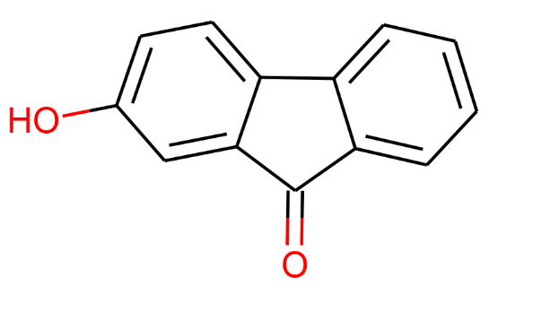  2-Hydroxy-9-fluorenone  O=c2c1ccccc1c3ccc(O)cc23 | Partial Match  Throughput: 0.01  O=C1c2ccccc2-c2ccccc12 | Finkelstein et al, 2003¹⁴  Kolomytseva et al²¹  Pothuluri et al, 1993²²
1,1a-dihydroxy-hydro-fluorenone  O=C1c2ccccc2C2=CC=CC(O)C12O | Partial Match  Throughput:0.01  O=C1c2ccccc2-c2ccccc12 | Grifoll et al, 1994²⁰
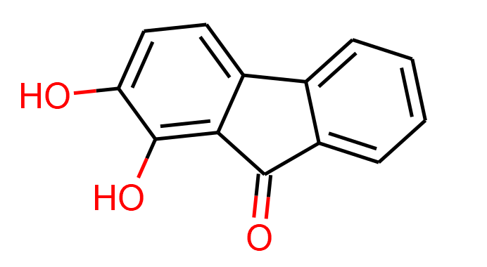  1,2 Dihydroxy-9 fluorenone  Oc1ccc2-c3ccccc3C(=O)c2c1O | Low Throughput Match  Throughput: 0.000019  Oc1ccc2-c3ccccc3C(=O)c2c1O | Reddy et al, 2017²³
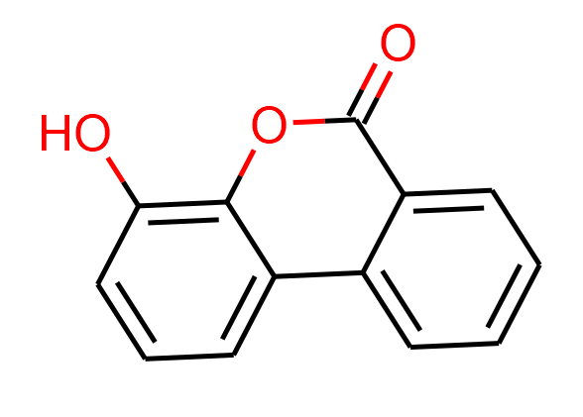  8-hydroxy-3,4-benzocoumarin  O=c1oc2c(O)cccc2c2ccccc12 | No Match (Multiple papers) | Grifoll et al, 1994²⁰  van Herwijnen et al, 2003²⁵
2,7-dihydroxyfluorene  OC1=CC2CC3C=C(O)C=CC3C2C=C1 | Partial Match  Throughput: 0.33  Oc1ccc2-c3ccccc3Cc2c1O | Finkelstein et al, 2003¹⁴
Oc1cccc2c1Cc1ccccc1-2  1-hydroxyfluorene | Partial Match  Throughput: 0.33  Oc1ccc2-c3ccccc3Cc2c1O | Luan et al, 2006¹¹
Oc1ccc2c(c1)Cc1ccccc1-2  2-hydroxyfluorene | Partial Match  Throughput: 0.33  Oc1ccc2-c3ccccc3Cc2c1O | Luan et al, 2006¹¹  Finkelstein et al, 2003¹⁴  Aranda et al, 2010¹⁵  Birolli et al, 2018¹⁷
Oc1ccc2c(c1)-c1ccccc1C2  3-hydroxyfluorene | Partial Match  Throughput: 0.33  Oc1ccc2Cc3ccccc3-c2c1O | Luan et al, 2006¹¹
O=C1C2C=CC=CC2C2C(O)=CC=CC12  4-hydroxy-9-fluorenone | Partial Match  Throughput: 0.01 | Nam et al, 2015²⁹  Birolli et al, 2018¹⁷  Casellas et al³²,  Yamazoe et al, 2004,⁶
O=C1OC2C(O)=CC=CC2C2C=CC=CC12  8-hydroxy-3,4-benzocoumarin | No Match (Multiple papers) | Nam et al, 2015²⁹  Trenz et al, 1994³¹
Benzophenone  O=C(c1ccccc1)c1ccccc1 | No Match (Single paper) | Birolli et al, 2018¹⁷
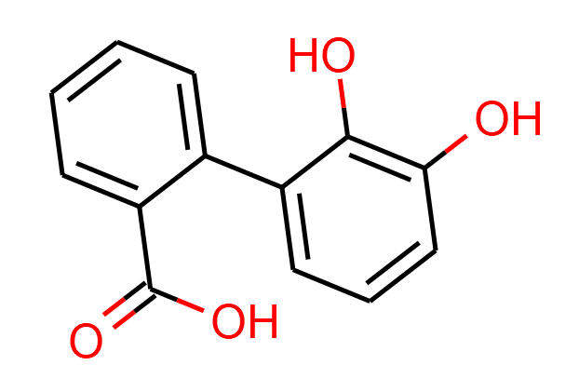  2-carboxy-2',3'-dihydroxy-biphenyl  O=C(O)c1ccccc1-c1cccc(O)c1O | Perfect Match  (different protonation state)  Throughput: 0.01  Oc1cccc(c1O)-c1ccccc1C([O-])=O | van Herwijnen et al, 2003²⁵
Oc1ccccc1-c1cccc(O)c1O  2,3,2'-trihydroxybiphenyl | Low Throughput Partial Match  Throughput: 0.0032  Oc1cccc(c1O)-c1cccc(O)c1O | Yamazoe et al, 2004²
O\C(=C\C=C\C(=O)c1ccccc1O)C([O-])=O  2-Hydroxy-6-(2-hydroxyphenyl)-6-oxo-2,4-hexadienoic acid | Low Throughput Match  Throughput: 3.364349e-10  O\C(=C\C=C\C(=O)c1ccccc1O)C([O-])=O  (different protonation state) | Yamazoe et al, 2004²
O=C(O)C(=O)C=CC=C(O)c1ccccc1O  2-oxo-6-(2’-hydroxyphenyl)-6-hydroxy-3,5-hexadienoic acid | Low Throughput Partial Match  Throughput: 3.364349e-10  O\C(=C\C=C\C(=O)c1ccccc1O)C([O-])=O | Yamazoe et al, 2004²
O=C(O)C(O)=CC=c2oc1ccccc1c2=O  2-hydroxy-4-(3'-oxo-3'H-benzofuran-2'-yliden)but-2-enoic acid | No Match (Single paper) | Yamazoe et al, 2004²
O=C(O)C(=O)C=CC2Oc1ccccc1C2=O  2-oxo-4-(3’-hdyroxy-benzofuran-2’-yl)-but-3-enoic acid | No Match (Single paper) | Yamazoe et al, 2004²
3-(1-oxo-2,3-dihydro-1H-inden-2-yl) propanoic acid  O=C(O)CCC1Cc2ccccc2C1=O | Low Throughput Partial Match  OC(CC1Cc2ccccc2C1=O)C([O-])=O  Throughput: 0.0024 | Zhang et al,⁵
β-Indanone-β-hydroxyacetic acid  O=C(O)C(O)=C1Cc2ccccc2C1=O | Low Throughput Partial Match  (different protonation state)  [O-]C(=O)\C=C1\Cc2ccccc2C1=O  Throughput: 7.421633e-07 | Finkelstein et al, 2003¹⁴
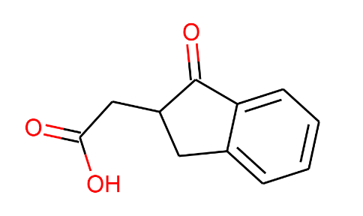  2-(1-oxo-2,3-dihydro-1H-inden-2-yl) acetic acid  O=C(O)CC1Cc2ccccc2C1=O | Low Throughput Match  (different protonation state)  [O-]C(=O)CC1Cc2ccccc2C1=O  Throughput:  0.00025 | Zhang et al,⁵
1-Indanone  O=C1CCc2ccccc12 | Perfect Match  Throughput: 0.093 | Casellas et al³², Zhang et al,⁵ Kristanti et al, 2015,³³ Finkelstein et al, 2003¹⁴
2,3-Dihydroxy inandone  OC1C(O)c2ccccc2C1=O | Low Throughput Match  Throughput: 0.0074 | Reddy et al, 2017²³
O=C1Cc2ccccc2C1  2-Indanone | Perfect Match  Throughput: 0.048 | Casellas et al³²,
Formyl-indanone  O=CC1CC2C=CC=CC2C1=O | No Match (Multiple papers) | Casellas et al³²,  Finkelstein et al, 2003¹⁴
4-hydroxy-1-tetralone  O=C1CCC(O)c2ccccc21 | No Match (Single paper) | Ressler et al, 1999,³⁴
O=C1CCOc2ccccc21  Chromone | Partial Match  Throughput: 0.093  O=C1CCc2ccccc2O1 | Yamazoe et al, 2004²
O=C1CCc2ccccc2O1  3,4-Dihydroxycumarine | Perfect Match  Throughput: 0.093 | Finkelstein et al, 2003¹⁴  Grifoll et al, 1992¹⁹
3-(chroman-4-on-2-yl) pyruvate  O=C(O)C(O)=CC1CC(=O)c2ccccc2O1 | No Match (Single paper) | Yamazoe et al, 2004²
3(2-Hydroxyphenyl)propionate  Oc1ccccc1CCC([O-])=O | Perfect Match  Throughput: 0.093 | Casellas et al³²,
Phthalic Acid  [O-]C(=O)c1ccccc1C([O-])=O | Perfect Match  Throughput: 0.039 | Yamazoe et al, 2004⁶  Luan et al, 2006¹¹  Pozdnyakova et al, 2016¹²  Sokolovska et al, 2002¹³  Grifoll et al, 1994²⁰  Reddy et al, 2017²³  Torres-Farradá et al, 2019²⁴  Trenz et al, 1994³¹  van Herwijnen et al, 2003²⁵  Yu et al, 2014⁴
2-Carboxybenzaldehyde  O=Cc1ccccc1C(=O)O | Perfect Match  [O-]C(=O)c1ccccc1C=O  Throughput  0.027 | Reddy et al, 2017²³
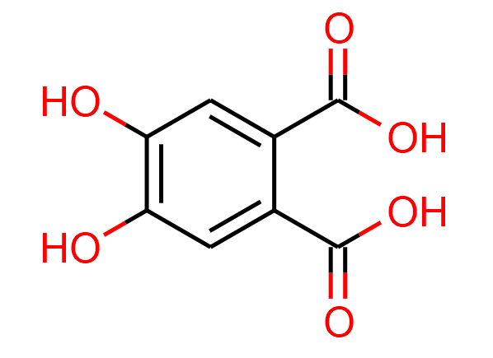  4,5-dihydroxyphthalate  O=C(O)c1cc(O)c(O)cc1C(=O)O | Low Throughput Match  OC(=O)c1cc(O)c(O)cc1C([O-])=O  Throughput  5.596969e-08 | Grifoll et al, 1994²⁰
Phthalic acid anhydride  O=C1OC(=O)c2ccccc21 | No Match (Single paper) | Yamazoe et al, 2004,⁶
O=C(O)c1ccc(O)c(O)c1  Protocatechuic acid  3,4-Dihydroxybenzoic acid | Partial Match  OC(=O)c1cccc(O)c1O  Throughput: 1.87e-10 | Lazim et al, 2016⁹  Sokolovska et al, 2002¹³  van Herwijnen et al, 2003²⁵  Wattiau et al, 2001³⁵  Different protonation  Grifoll et al, 1994²⁰
Catechol  Oc1ccccc1O | Low Throughput Match  Throughput: 0.0045 | Hadibarata et al, 2014,²⁷  Yamazoe et al, 2004²  Reddy et al, 2017²³
Benzoic Acid  O=C(O)c1ccccc1 | Partial Match  Throughput: 0.031 | Reddy et al, 2017²³
4-Hydroxybenzoic acid  O=C(O)c1ccc(O)cc1 | Low Throughput Partial Match  Throughput: 0.00035  Oc1ccc(cc1O)C([O-])=O | Reddy et al, 2017²³
3,4-Dihydroxybenzoate  Protocatechuic acid  Oc1ccc(cc1O)C([O-])=O | Low Throughput Match  Throughput: 0.00035 | Torres-Farradá et al, 2019²⁴
Salicylic Acid  Salicylate  Oc1ccccc1C([O-])=O | Perfect Match  Throughput:  0.031 | Shao et al, 2015,²⁸  Yamazoe et al, 2004² Casellas et al³², Kristanti et al, 2015,³³ Hadibarata et al, 2014,²⁷  Shao et al, 2015²⁸
1-hydroxybenzene  Phenol  Oc1ccccc1 | Low Throughput Match  Throughput: 2.199903e-08 | Yu et al, 2014⁴

Table S3.3 Fluorene Empirical Review Summary

 | Perfect Match | Partial Match
High Throughput | 10 | 11
Low Throughput | 8 | 5

No Match (Single) 8
No Match (Multiple) 4
No Match Explanations:
Several of the No-Match Compounds are the result of methylation or other straight chain addition after the cleavage of another bound. EAWAG does not predict this type of transition, so these compounds would not be found. Certain anhydride, oxide, or coumarin structures are also not predicted, so these compounds are either classified as no Match or Partial Match if their immediate parent and daughter compounds are predicted.

References
(1) Bharti, V., B. Gupta, and J. Kaur, Novel Bacterial Strains Pseudomonas sp. and Bacillus sp. Isolated from Petroleum Oil Contaminated Soils for Degradation of Flourene and Phenanthrene. Pollution, 2019. 5(3): p. 657-669.
(2) Yamazoe, A., O. Yagi, and H. Oyaizu, Degradation of polycyclic aromatic hydrocarbons by a newly isolated dibenzofuran-utilizing Janibacter sp. strain YY-1. Appl Microbiol Biotechnol, 2004. 65(2): p. 211-8.
(3) Cajthaml T, et al., Study of fungal degradation products of polycyclic aromatic hydrocarbons using gas chromatography with ion trap mass spectrometry detection. Journal of Chromatography, 2002. 974: p. 213–222.
(4) Yu, C., J. Yao, and J. Jin, Characteristics and metabolic pathways of fluorene (FLU)degradation by strain Rhodococcussp. USTB-C isolated from crude oil. Journal of Chemical and Pharmaceutical Research, 2014. 6(3): p. 560-565.
(5) Zhang, Z.Z., et al., Degradation of n-alkanes and polycyclic aromatic hydrocarbons in petroleum by a newly isolated Pseudomonas aeruginosa DQ8. Bioresource Technology, 2011. 102(5): p. 4111-4116.
(6) Yamazoe, A., O. Yagi, and H. Oyaizu, Biotransformation of fluorene, diphenyl ether, dibenzo-p-dioxin and carbazole by Janibacter sp. Biotechnology Letters, 2004. 26(6): p. 479-486.
(7) Chupungars, K., P. Rerngsamran, and S. Thaniyavarn, Polycyclic aromatic hydrocarbons degradation by Agrocybe sp. CU-43 and its fluorene transformation. International Biodeterioration & Biodegradation, 2009. 63(1): p. 93-99.
(8) Juckpech, K., O. Pinyakong, and P. Rerngsamran, Degradation of polycyclic aromatic hydrocarbons by newly isolated Curvularia sp F18, Lentinus sp S5, and Phanerochaete sp T20. Scienceasia, 2012. 38(2): p. 147-156.
(9) Lazim, Z.M. and T. Hadibarata, Ligninolytic fungus Polyporus sp S133 mediated metabolic degradation of fluorene. Brazilian Journal of Microbiology, 2016. 47(3): p. 610-616.
(10) Liu, L., R.D. Schmid, and V.B. Urlacher, Cloning, expression, and characterization of a self-sufficient cytochrome P450 monooxygenase from Rhodococcus ruber DSM 44319. Applied Microbiology and Biotechnology, 2006. 72(5): p. 876-882.
(11) Luan, T.G., et al., Study of metabolites from the degradation of polycyclic aromatic hydrocarbons (PAHs) by bacterial consortium enriched from mangrove sediments. Chemosphere, 2006. 65(11): p. 2289-96.
(12) Pozdnyakova, N.N., et al., Degradation of Fluorene and Fluoranthene by the Basidiomycete Pleurotus ostreatus. Applied Biochemistry and Microbiology, 2016. 52(6): p. 621-628.
(13) Sokolovska, I., et al., Biodegradation of fluorene at low temperature by a psychrotrophic Sphingomonas sp L-138. Chemical Papers-Chemicke Zvesti, 2002. 56(1): p. 36-40.
(14) Finkelstein, Z.I., et al., Fluorene transformation by bacteria of the genus Rhodococcus. Microbiology, 2003. 72(6): p. 660-665.
(15) Aranda, E., R. Ullrich, and M. Hofrichter, Conversion of polycyclic aromatic hydrocarbons, methyl naphthalenes and dibenzofuran by two fungal peroxygenases. Biodegradation, 2010. 21(2): p. 267-281.
(16) Bezalel, L., et al., Initial oxidation products in the metabolism of pyrene, anthracene, fluorene, and dibenzothiophene by the white rot fungus Pleurotus ostreatus. Applied and Environmental Microbiology, 1996. 62(7): p. 2554-2559.
(17) Birolli, W.G., et al., Biodegradation of anthracene and several PAHs by the marine-derived fungus Cladosporium sp CBMAI 1237. Marine Pollution Bulletin, 2018. 129(2): p. 525-533.
(18) Chapman, P.J., et al., Fossil fuel biodegradation: Laboratory studies. Environmental Health Perspectives, 1995. 103: p. 79-83.
(19) Grifoll, M., et al., ISOLATION AND CHARACTERIZATION OF A FLUORENE-DEGRADING BACTERIUM - IDENTIFICATION OF RING OXIDATION AND RING FISSION-PRODUCTS. Applied and Environmental Microbiology, 1992. 58(9): p. 2910-2917.
(20) Grifoll, M., S.A. Selifonov, and P.J. Chapman, EVIDENCE FOR A NOVEL PATHWAY IN THE DEGRADATION OF FLUORENE BY PSEUDOMONAS SP STRAIN F274. Applied and Environmental Microbiology, 1994. 60(7): p. 2438-2449.
(21) Kolomytseva, M.P., et al., Role of surfactants in optimizing fluorene assimilation and intermediate formation by Rhodococcus rhodochrous VKM B-2469. Bioresource Technology, 2009. 100(2): p. 839-844.
(22) Pothuluri, J.V., et al., BIOTRANSFORMATION OF FLUORENE BY THE FUNGUS CUNNINGHAMELLA-ELEGANS. Applied and Environmental Microbiology, 1993. 59(6): p. 1977-1980.
(23) Reddy, P.V., et al., Catabolism of fluorene through 2,3-dihydroxy indanone in Paenibacillus sp PRNK-6. International Biodeterioration & Biodegradation, 2017. 123: p. 156-163.
(24) Torres-Farradá, G., et al., Biodegradation of polycyclic aromatic hydrocarbons by native Ganoderma sp. strains: identification of metabolites and proposed degradation pathways. Applied Microbiology and Biotechnology, 2019.
(25) van Herwijnen, R., et al., Elucidation of the metabolic pathway of fluorene and cometabolic pathways of phenanthrene, fluoranthene, anthracene and dibenzothiophene by Sphingomonas sp LB126. Research in Microbiology, 2003. 154(3): p. 199-206.
(26) Wischmann, H., et al., Degradation of selected PAHs in soil/compost and identification of intermediates. International Journal of Environmental Analytical Chemistry, 1996. 64(4): p. 247-255.
(27) Hadibarata, T. and R.A. Kristanti, Fluorene biodegradation and identification of transformation products by white-rot fungus Armillaria sp F022. Biodegradation, 2014. 25(3): p. 373-382.
(28) Shao, Y.X., et al., Biodegradation of PAHs by Acinetobacter isolated from karst groundwater in a coal-mining area. Environmental Earth Sciences, 2015. 73(11): p. 7479-7488.
(29) Nam, I.-H., et al., Effects of Heavy Metals on Biodegradation of Fluorene by a Sphingobacterium sp. Strain (KM-02) Isolated from Polycyclic Aromatic Hydrocarbon-Contaminated Mine Soil. Environmental Engineering Science, 2015. 32(10): p. 891-898.
(30) Bressler, D.C., P.M. Fedorak, and M.A. Pickard, Oxidation of carbazole, N-ethylcarbazole, fluorene, and dibenzothiophene by the laccase of Coriolopsis gallica. Biotechnology Letters, 2000. 22(14): p. 1119-1125.
(31) Trenz, S.P., et al., DEGRADATION OF FLUORENE BY BREVIBACTERIUM SP STRAIN DPO-1361 - A NOVEL C-C BOND-CLEAVAGE MECHANISM VIA 1,10-DIHYDRO-1,10-DIHYDROXYFLUOREN-9-ONE. Journal of Bacteriology, 1994. 176(3): p. 789-795.
(32) Casellas, M., et al., New metabolites in the degradation of fluorene by Arthrobacter sp strain F101. Applied and Environmental Microbiology, 1997. 63(3): p. 819-826.
(33) Kristanti, R.A. and T. Hadibarata, Biodegradation and Identification of Transformation Products of Fluorene by Ascomycete Fungi. Water, Air, & Soil Pollution, 2015. 226(12).
(34) Ressler, B.P., H. Kneifel, and J. Winter, Bioavailability of polycyclic aromatic hydrocarbons and formation of humic acid-like residues during bacterial PAH degradation. Applied Microbiology and Biotechnology, 1999. 53(1): p. 85-91.
(35) Wattiau, P., et al., Fluorene degradation by Sphingomonas sp LB126 proceeds through protocatechuic acid: a genetic analysis. Research in Microbiology, 2001. 152(10): p. 861-872.

Section 4: Phenanthrene
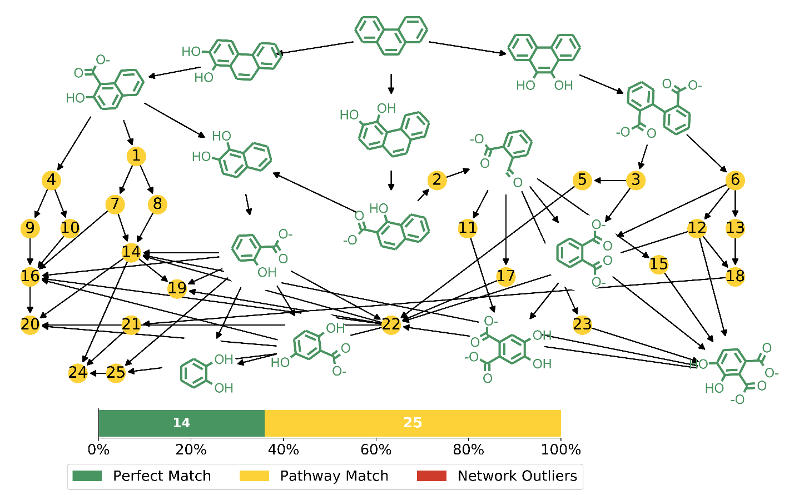
Figure S4.1: Phenanthrene High Throughput Plot with Pathway Match Metabolite. SMILES codes for the nodes are presented in Table S1.1.

Figure S4.1 shows a network constructed from only the High Node Throughput compounds. Reconstructing the network with only this subset of compounds yields a much smaller more manageable network.
Perfect Match compounds match a literature reference exactly. Pathway Match compounds are High Node Throughput compounds that are found on a degradation pathway to or from a Perfect Match compound. Network Outliers are High Node Throughput compounds that do not have a Perfect Match compound either above or below them in their degradation chains. Table S4.1 contains the SMILES codes for the Pathway Match compounds.

Table S4.1: Phenanthrene Yellow Node (Pathway Matches) Smiles Codes

1 | Oc1ccc2ccc(O)c(C([O-])=O)c2c1O |  | 13 | Oc1cc(O)c(O)c(c1O)-c1ccccc1C([O-])=O
2 | [O-]C(=O)C(=O)\C=C\c1ccccc1C([O-])=O |  | 14 | Oc1ccc(C([O-])=O)c(O)c1O
3 | Oc1cccc(c1O)-c1ccccc1C([O-])=O |  | 15 | Oc1ccc(C([O-])=O)c(C=O)c1O
4 | Oc1ccc2c(C([O-])=O)c(O)ccc2c1O |  | 16 | Oc1ccc(O)c(C([O-])=O)c1O
5 | Oc1cccc(c1O)-c1cccc(O)c1O |  | 17 | Oc1cccc(C=O)c1O
6 | Oc1ccc(C([O-])=O)c(c1O)-c1ccccc1C([O-])=O |  | 18 | Oc1cccc(c1O)-c1c(O)c(O)cc(O)c1O
7 | Oc1ccc(C([O-])=O)c(O)c1C([O-])=O |  | 19 | Oc1cccc(O)c1O
8 | Oc1ccc2ccc(O)c(O)c2c1O |  | 20 | Oc1ccc(O)c(O)c1O
9 | Oc1ccc2c(O)c(O)ccc2c1O |  | 21 | Oc1cc(O)c(O)c(C([O-])=O)c1O
10 | Oc1ccc(O)c(C([O-])=O)c1C([O-])=O |  | 22 | Oc1cccc(C([O-])=O)c1O
11 | Oc1cc(C=O)c(cc1O)C([O-])=O |  | 23 | Oc1ccc(C=O)c(C([O-])=O)c1O
12 | Oc1cccc(c1O)-c1c(O)c(O)ccc1C([O-])=O |  | 24 | Oc1cc(O)c(O)c(O)c1O
 |  |  | 25 | Oc1cc(O)c(cc1O)C([O-])=O

High Betweenness Maximum Common Substructures:
The compounds with the highest betweenness centrality display similar substructures. Code was adapted from the RDKit Cookbook, referenced in the main text. The Tanimto Similarities between the Morgan Fingerprints were first calculated, and then clusters were developed with Butina Clustering using a cutoff of 0.4. For full details and the actual python code, see the github linked in the main text.
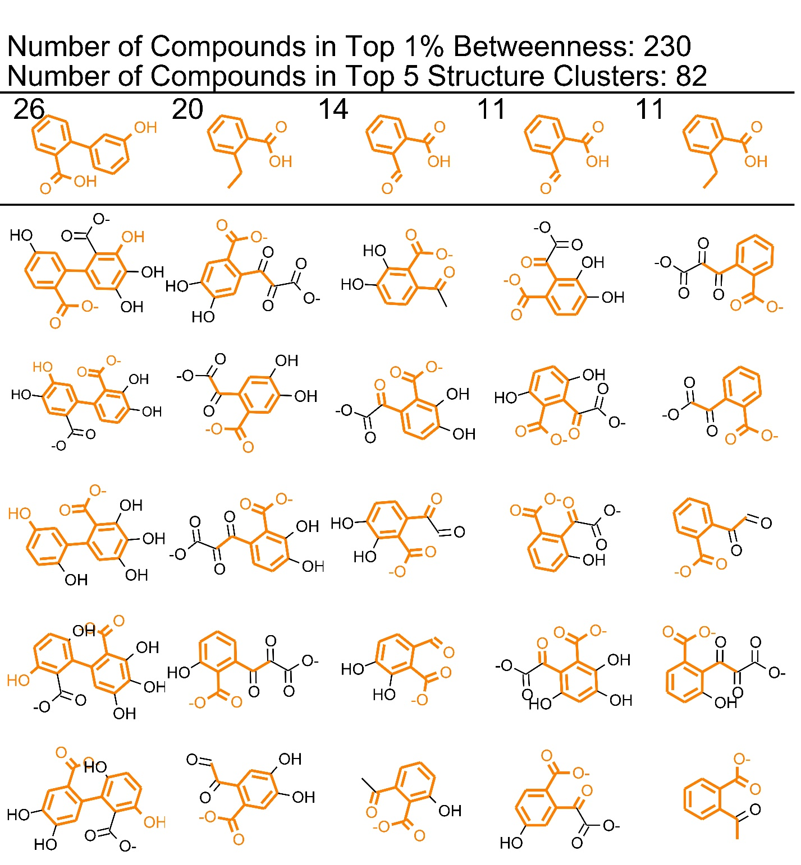
Figure S4.2: Maximum Common Substructures (MCS) in the Top 1% of Betweenness: Phenanthrene. The first row shows the MCS in top 5 largest clusters. The numbers indicate how many compounds are contained in each cluster. The compounds in the vertical columns with the substructure highlighted in orange are presented as examples of which compounds are included in the cluster. In the case of phenanthrene, the same MCS occurs in several different clusters.

Table S4.2: Phenanthrene Empirical Literature Review

Structure: | Network Metrics | Empirical Studies finding the same thing
Phenanthrene
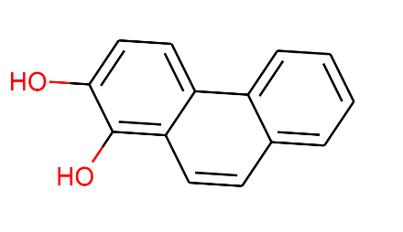  1,2-Dihydroxyphenanthrene, cis-phenanthrene dihydrodiol  Oc1ccc2c(ccc3ccccc23)c1O | Perfect Match  Throughput 0.33 | Gao et al, 2013, ¹  Ghosal et al, 2010²  Guerin et al, 1998³  Lee et al, 2009,⁴  Lin et al, 2014,⁵  Lu et al, 2013,⁶  Keum et al, 2006⁷  Kim et al, 2005⁸  Kweon et al, 2010⁹  Lisowska et al, 2006¹⁰  Mallick et al, 2007,¹¹  Roy et al, 2012,¹²  Sack et al, 1997¹³  Seo et al, 2007¹⁴  Seo et al, 2009,¹⁵  Seo et al, 2012,¹⁶  van Herwijnen et al, 2003¹⁷
1,2 Phenanthrene Oxide  C1=CC2OC2c2ccc3ccccc3c21 | Partial Match  also immediate parent/daughter predicted  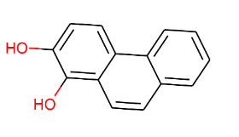  Throughput 0.33  Oc1ccc2c(ccc3ccccc23)c1O | Nie et al, 2016,¹⁸
1-Hydroxyphenanthrene,  1-phenanthrol;  Oc1cccc2c1ccc1ccccc12 | Partial Match  also immediate parent/daughter predicted  Oc1ccc2c(ccc3ccccc23)c1O  Throughput: 0.33 | Aranda et al, 2010¹⁹  Bourguignon et al, 2019²⁰  Casillas et al, 1996²¹  da Silva et al, 2004²²  Hesham et al, 2014,²³  Liu et al, 1992,²⁴  Liu et al, 1992²⁴  Sack et al, 1997²⁵  Sack et al, 1997¹³  Schrlau et al, 2017²⁶  Zhong et al, 2011²⁷,
2-phenanthrol  Oc1ccc2c(ccc3ccccc32)c1 | Partial Match  also immediate parent/daughter predicted  Oc1ccc2c(ccc3ccccc23)c1O  Throughput: 0.33 | Bourguignon et al, 2019²⁰  Casillas et al, 1996²¹  Sack et al, 1997²⁵  Sack et al, 1997¹³
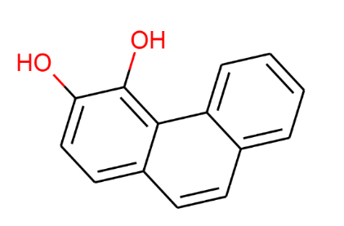  3,4-dihydroxyphenanthrene  Oc1ccc2ccc3ccccc3c2c1O | Perfect Match  Throughput:0.33 | Allen et al, 1999²⁸  Casillas et al, 1996²¹  da Silva et al, 2004²²  Gao et al, 2013,¹  Keum et al, 2006⁷  Kweon et al, 2010⁹  Lisowska et al, 2006¹⁰  Pathak et al, 2008²⁹  Rehmann et al, 1996³⁰  Roy et al, 2012,¹²  Sack et al, 1997¹³  Seo et al, 2007¹⁴  Seo et al, 2009,¹⁵  Seo et al, 2012,¹⁶  Stingley et al, 2004³¹  Story et al, 2001³²  Sun et al, 2019,³³  Sutherland et al, 1991³⁴  Umar et al, 2018³⁵  Umar et al, 2017,³⁶  Zeinali et al, 2008³⁷  Zhang et al, 2010³⁸
4-phenanthrol  Oc1cccc2ccc3ccccc3c12 | Partial Match  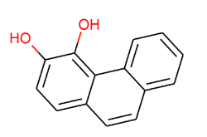  Throughput:0.33  Oc1ccc2ccc3ccccc3c2c1O | Aranda et al, 2010¹⁹  Casillas et al, 1996²¹  da Silva et al, 2004²²  Sack et al, 1997¹³  Schrlau et al, 2017, ²⁶  Sutherland et al, 1991³⁴  Zhong et al, 2011²⁷
4-methoxy phenanthrene  COc1cccc2ccc3ccccc3c12 | No Match (Single paper) | Bourguignon et al, 2019²⁰
1-methoxy phenanthrene  COc1cccc2c1ccc1ccccc12 | No Match (Single paper) | Sack et al, 1997²⁵
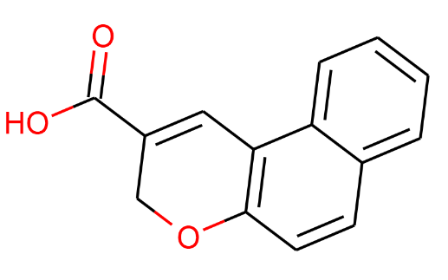  3H-benzo[f]chromene-2-carboxylic acid  O=C(O)C1=Cc2c(ccc3ccccc23)OC1 | No Match (Single paper) | Safoneva et al, 2005³⁹
3-hydroxyphenanthrene;  3-phenanthrol  Oc1ccc2ccc3ccccc3c2c1 | Partial Match  Oc1ccc2ccc3ccccc3c2c1O  Throughput: 0.33 | Aranda et al, 2010¹⁹ Baboshin et al, 2005⁴⁰ Bourguignon et al, 2019²⁰  Casillas et al, 1996²¹  da Silva et al, 2004²²  Leneva et al 2009,⁴¹  Rehmann et al, 1996³⁰  Sack et al, 1997¹³  Schrlau et al, 2017, ²⁶  Sutherland et al, 1991³⁴  Zhong et al, 2011²⁷,
3,4 phenanthrene oxide  C1=CC2OC2c2c1ccc1ccccc21 | Partial Match  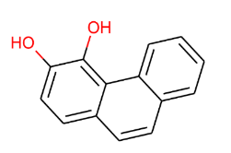  Oc1ccc2ccc3ccccc3c2c1O  Throughput: 0.33 | Nie et al, 2016,¹⁸
9,10 phenanthrene oxide  c1ccc2c(c1)-c1ccccc1C1OC21 | Partial Match  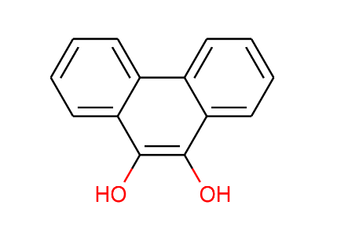 Oc1c(O)c2ccccc2c2ccccc12  Throughput: 0.33 | Bezalel et al, 1996⁴²
9,10-Dihydroxyphenanthrene  cis-9,10-Dihydrophenanthrene-9,10-diol  phenanthrene 9,10-dihydrodiol  Oc1c(O)c2ccccc2c2ccccc12 | Perfect Match  Throughput: 0.33 | Bezalel et al, 1996⁴³, Bezalel et al, 1996⁴²  Bourguignon et al, 2019²⁰  Cajthaml et al, 2002⁴⁴  Casillas et al, 1996²¹  Gao et al, 2013, ¹  Fu et al, 2018⁴⁵  Hennessee et al,⁴⁶  Hidayat et al, 2018, ⁴⁷  Kim et al, 2005⁸  Kweon et al, 2010⁹  Lisowska et al, 2006¹⁰  Luan et al 2006,⁴⁸  Muratova et al, 2014, ⁴⁹,  Mishra et al, 2019⁵⁰  Ning et al, 2010⁵¹  Pathak et al, 2008²⁹  Rehmann et al, 1996³⁰  Sack et al, 1997¹³  Sack et al, 1997⁵²  Safoneva et al, 2005³⁹  Schrlau et al, 2017,²⁶  Seo et al, 2006⁵³  Seo et al, 2012,¹⁶ Sun et al, 2019,³³  Sutherland et al, 1991³⁴  Sutherland et al, 1990⁵⁴  Tatarko et al, 1993⁵⁵  van Herwijnen et al, 2003,¹⁷ Yang et al, 2014⁵⁶ Zeinali et al, 2008³⁷,
9-phenanthrol  Oc1cc2ccccc2c2ccccc12 | Partial Match  Oc1c(O)c2ccccc2c2ccccc12  Throughput: 0.33 | Bezalel et al, 1996⁴²  Bourguignon et al, 2019²⁰  Capotorti et al, 2005,⁵⁷  Casillas et al, 1996²¹  Fu et al, 2018⁴⁵  Jin et al, 2016⁵⁸,  Schrlau et al, 2017, ²⁶  Sutherland et al, 1990⁵⁴  Sutherland et al, 1991³⁴  Sun et al, 2019,³³  Szewczyk et al, 2003⁵⁹  Tatarko et al, 1993⁵⁵  van Herwijnen et al, 2003¹⁷  Yang et al, 2014⁵⁶  Zhang et al, 2010³⁸  Zhong et al, 2011²⁷
9-methoxyphenanthrene  COc1cc2ccccc2c2ccccc12 | No Match (Single paper) | Cajthaml et al, 2002⁴⁴
1-phenanthrene carboxylic acid  O=C(O)c1cccc2c1ccc1ccccc12 | No Match (Single paper) | Mishra et al, 2019⁵⁰
1-Methoxy-2-hydroxyphenanthrene  COc1c(O)ccc2c1ccc1ccccc12 | No Match (Single paper) | Kim et al, 2005⁸
2-hydroxy-7-methoxy-phenanthrene  COc1ccc2c(ccc3cc(O)ccc32)c1 | No Match (Single paper) | da Silva et al, 2004²²
9,10-phenanthrenequinone  O=C1C(=O)c2ccccc2-c2ccccc12 | Partial Match  Oc1c(O)c2ccccc2c2ccccc12  Throughput:0.33 | Fu et al, 2018⁴⁵  Hadibarata et al, 2010⁶⁰  Hadibarata et al, 2011⁶¹  Li et al, 2018⁶²  Muratova et al, 2014, ⁴⁹  van Herwijnen et al, 2003¹⁷
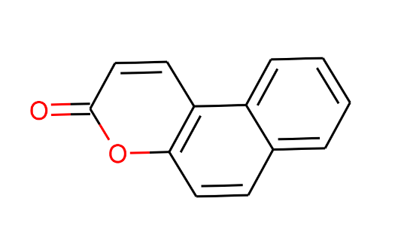  5,6-Benzocoumarin  O=c1ccc2c(ccc3ccccc32)o1 | No Match (Multiple papers) | Ghosal et al, 2010²  Hennessee et al,⁴⁶  Keum et al, 2006⁷  Mallick et al, 2007,¹¹  Nie et al, 2016,¹⁸  Pinyakong et al, 2000,⁶³  Roy et al, 2012,¹²  Seo et al, 2006⁵³  Seo et al, 2007¹⁴  Seo et al, 2012,¹⁶
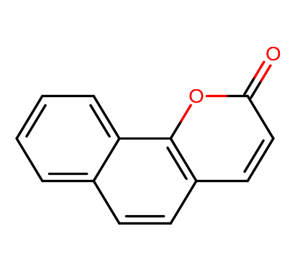  7,8-Benzocoumarin  O=c1ccc2ccc3ccccc3c2o1 | No Match (Multiple papers) | Baboshin et al, 2005⁴⁰  Hennessee et al,⁴⁶  Keum et al, 2006⁷  Leneva et al, 2009, ⁴¹  Muratova et al, 2014, ⁴⁹  Nie et al, 2016,¹⁸  Pinyakong et al, 2000,⁶³  Roy et al, 2012,¹²  Seo et al, 2006⁵³  Seo et al, 2007¹⁴  Seo et al, 2012,¹⁶  Sun et al, 2019,³³,
3,4-benzocoumarin  6H-Benzo[c]chromen-6-one  O=c1oc2ccccc2c2ccccc12 | No Match (Multiple papers) | Seo et al, 2012,¹⁶  Cajthaml et al, 2002⁴⁴  Wang et al, 2016⁶⁴  *Cajthaml suggested that this structure forms from another due to dehydration in the GM/MS process
8-Hydroxy-3,4-benzocoumarin  O=c1oc2c(O)cccc2c2ccccc12 | No Match (Single paper) | Seo et al, 2012,¹⁶
2-dibenzofuranol  Oc1ccc2oc3ccccc3c2c1 | No Match (Single paper) | Li et al, 2018⁶²
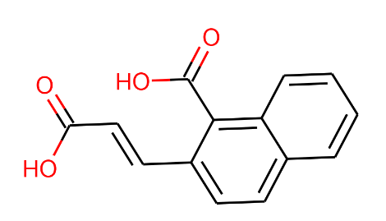  2-(2-Carboxy-vinyl)-1-naphthoic acid  O=C(O)C=Cc1ccc2ccccc2c1C(=O)O | No Match (Multiple papers) | Hennessee et al,⁴⁶ Seo et al, 2012,¹⁶
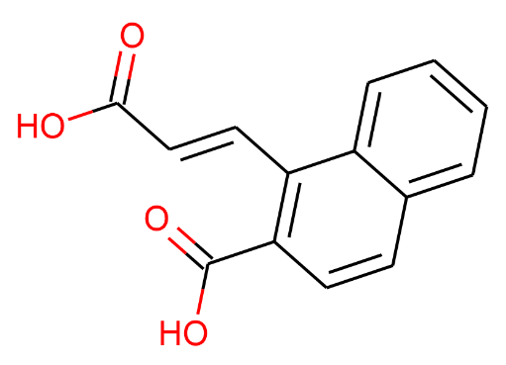  1-[(E)-2-carboxyvinyl]-2-naphthoic acid  O=C(O)/C=C/c1c(C(=O)O)ccc2ccccc12 | No Match (Single paper) | Seo et al, 2012,¹⁶
4-(1-Hydroxynaphthalen-2-yl)-2-oxobut-3-enoic acid  O=C(O)C(=O)C=Cc1ccc2ccccc2c1O | No Match (Multiple papers) | Adebusuyi et al, 2012⁶⁵  Keum et al, 2008⁶⁶  Seo et al, 2012,¹⁶  Zeinali et al, 2008³⁷
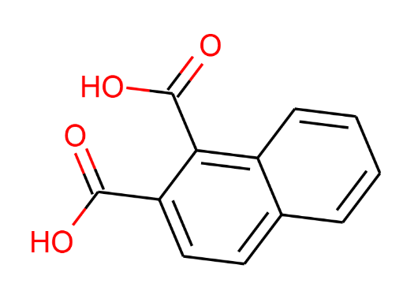  Naphthalene-1,2-dicarboxylic acid,  1,2-Dicarboxynaphthalene  O=C(O)c1ccc2ccccc2c1C(=O)O | No Match (Multiple papers) | Hennessee et al,⁴⁶  Keum et al, 2006⁷  Kim et al, 2005,⁸  Mallick et al, 2007,¹¹  Seo et al, 2006⁵³  Seo et al, 2012,¹⁶
Naphthalene-1,2-dicarboxylic acid anhydride  2,3-naphthalic anhydride  O=C1OC(=O)c2c1ccc1ccccc21 | No Match (Multiple papers) | Cajthaml et al, 2002⁴⁴  Hennessee et al,⁴⁶
2-hydroxy-2,3-dihydronaphtho[ 2,1-b]furan  OC1Cc2c(ccc3ccccc23)O1 | No Match (Single paper) | Nie et al, 2016,¹⁸
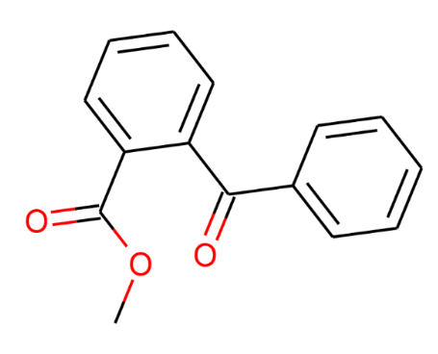  Benzoic acid, 2-benzoyl-, methyl ester  COC(=O)c1ccccc1C(=O)c1ccccc1 | No Match (Single paper) | Luan et al 2006,⁴⁸
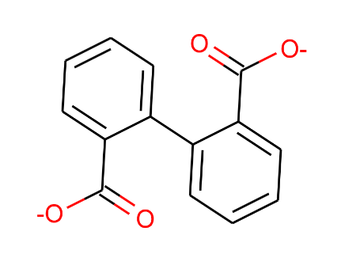  2,2′-Diphenic Acid  [O-]C(=O)c1ccccc1-c1ccccc1C([O-])=O | Perfect Match  Throughput: 0.33 | Arias et al 2008⁶⁷, Bezalel et al, 1996⁴³.  Fu et al, 2018⁴⁵  Hidayat et al, 2018, ⁴⁷,  Kim et al, 2005,⁸  Hadibarata et al, 2010⁶⁰  Hadibarata et al, 2011⁶¹  Mishra et al, 2019⁵⁰  Moody et al, 2001,⁶⁸  Muratova et al, 2014, ⁴⁹,  Rehmann et al, 1996³⁰  Seo et al, 2006⁵³  Seo et al, 2012,¹⁶  Sun et al, 2019,³³  Zeinali et al, 2008³⁷,
2,2'-biphenyldimethanol  OCc1ccccc1-c1ccccc1CO | Partial Match  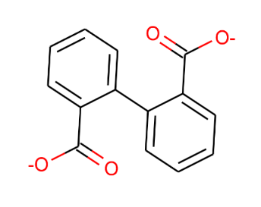  Throughput: 0.33  [O-]C(=O)c1ccccc1-c1ccccc1C([O-])=O | Hammel et al, 1992, ⁶⁹
2,2’ Dihydroxybenzophenone  O=C(c1ccccc1O)c1ccccc1O | No Match (Single paper) | Wang et al, 2016⁶⁴
Biphenyl-2-carboxylic acid  O=C(O)c1ccccc1-c1ccccc1 | Partial Match  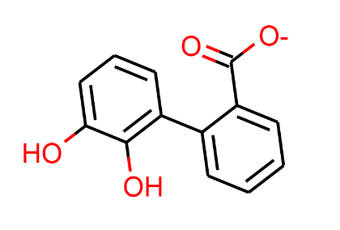  Throughput: 0.16  Oc1cccc(c1O)-c1ccccc1C([O-])=O | Seo et al, 2012,¹⁶
2'-hydroxy-2-carboxy biphenyl  O=C(O)c1ccccc1-c1ccccc1O | Partial Match  Throughput: 0.16  Oc1cccc(c1O)-c1ccccc1C([O-])=O | Cajthaml et al, 2002⁴⁴
Dimethyl-2-6-napthalenedicarboxylate  COC(=O)c1ccc2cc(C(=O)OC)ccc2c1 | No Match (Single paper) | Wang et al, 2016⁶⁴
2-hydroxy-1-napthoic acid methyl ester,  Methyl 2-hydroxy-1-naphthoate  COC(=O)c1c(O)ccc2ccccc12 | No Match (Multiple papers) | Lu et al, 2013,⁶  Mallick et al, 2007,¹¹ Roy et al, 2012,¹²
3-naphthyl allyl alcohol  OCC=Cc1cccc2ccccc12 | No Match (Multiple papers) | Nie et al, 2016,¹⁸  Nzila et al, 2018⁷⁰
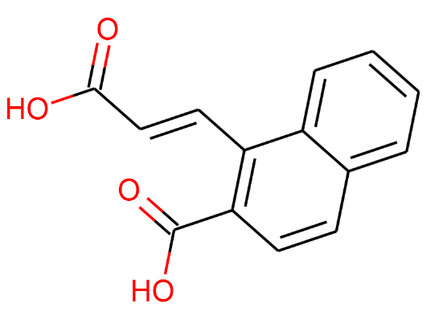  1-[(E)-2-Carboxyvinyl]-2-naphthoic acid  O=C(O)/C=C/c1c(C(=O)O)ccc2ccccc12 | No Match (Single paper) | Seo et al, 2006⁵³
2-[(E)-2-Carboxyvinyl]-1-naphthoic acid  O=C(O)/C=C/c1ccc2ccccc2c1C(=O)O | No Match (Single paper) | Seo et al, 2006⁵³
1-hydroxy-2-naphthaldehyde, 1-hydroxynaphthalene-  2-carbaldehyde  Oc1c(C=O)ccc2ccccc12 | Partial Match  Throughput: 0.17  Oc1c(ccc2ccccc12)C([O-])=O | Keum et al, 2006⁷  Leneva et al, 2009, ⁴¹  Nie et al, 2016,¹⁸  Zhang et al, 2010³⁸
2-hydroxynaphthalene-1-carbaldehyde  O=Cc1c(O)ccc2ccccc12 | Partial Match  Throughput: 0.17  Oc1ccc2ccccc2c1C([O-])=O | Nie et al, 2016,¹⁸
1,2-dihydroxynaphthalene; naphthalene-1,2-diol  Oc1ccc2ccccc2c1O | Perfect Match  Throughput 0.14 | Keum et al, 2006⁷  Prabhu et al, 2003,⁷¹  Prakash and Lal, 2013,⁷²  Seo et al, 2006⁵³  Seo et al, 2007¹⁴  Seo et al, 2012,¹⁶  Story et al, 2001³²
2-hydroxy-1-(1- hydroxy-2- naphthalenyl)- ethanone  O=C(CO)c1ccc2ccccc2c1O | No Match (Single paper) | Nie et al, 2016,¹⁸
Oc1c(ccc2ccccc12)C([O-])=O  1-hydroxy-2-naphthoic acid | Perfect Match  Throughput: 0.17 | Hennessee et al,⁴⁶  Leneva et al, 2009, ⁴¹  Menn et al, 1993⁷³  Baboshin et al, 2005⁴⁰ Balashova et al, 1999⁷⁴  Coppotelli et al, 2010, ⁷⁵, Doddamani et al, 2000, ⁷⁶,  Festa et al, 2017⁷⁷  Froehner et al, 2009⁷⁸  Guerin et al, 1998³  Noll et al, 1996⁷⁹  Hadibarata et al, 2007⁸⁰  Huang et al, 2016,⁸¹  Keum et al, 2006⁷  Kiyohara et al, 1976⁸²  Li et al, 2014⁸³  Liu et al, 1992²⁴  Machate et al, 1997⁸⁴  Mallick et al, 2008,⁸⁵  Muratova et al, 2014, ⁴⁹  Ovchinnikova et al, 2009⁸⁶  Pinyakong et al, 2000,⁶³ Prabhu et al, 2003⁷¹ Prakash and Lal, 2013,⁷²  , Lin et al, 2014,⁵, Liu et al, 1992,²⁴ Lu et al, 2013,⁶  Puntus et al, 2008⁸⁷  Rehmann et al, 1996³⁰  Sanseverino et al, 1993,⁸⁸  Samanta et al, 1999⁸⁹  Seo et al, 2007¹⁴  Seo et al, 2006⁵³  Seo et al, 2012,¹⁶  Story et al, 2001³²  Sun et al, 2019,³³  Tao et al, 2007⁹⁰  Tittabutr et al, 2011,⁹¹ Wang et al, 2016⁹² Wang et al, 2008⁹³  Wischmann et al, 1996⁹⁴  Zhang et al, 2005⁹⁵  Zeinali et al, 2008³⁷ Zhong et al, 2011²⁷  Different protonation:  Keum et al, 2008⁶⁶
2-hydroxy-1-naphthoic acid  Oc1ccc2ccccc2c1C([O-])=O | Perfect Match  Throughput: 0.17 | Balashova et al, 1999⁷⁴  Ghosal et al, 2010²  Keum et al, 2006⁷  Puntus et al, 2008⁸⁷  Seo et al, 2007¹⁴  Seo et al, 2006⁵³  Tittabutr et al, 2011,⁹¹
1-hydroxy-2-naphthoic acid methyl ester  COC(=O)c1ccc2ccccc2c1O | No Match (Single paper) | Roy et al, 2012,¹²
5,8-Dihydroxy-1,4-naphthoquinone  O=C1C=CC(=O)c2c(O)ccc(O)c21 | No Match (Single paper) | Wang et al, 2016⁶⁴
Oc1cccc2ccccc12  1-napthol, α-naphthol | Partial Match  Throughput: 0.14  Oc1ccc2ccccc2c1O | Lu et al, 2012, ⁹⁶ Huang et al, 2016,⁸¹, Kim et al, 2005,⁸  Li et al, 2014⁸³  Lu et al, 2013,⁶ Nie et al, 2016,¹⁸ Prabhu et al, 2003⁷¹, Ressler et al, 1999,⁹⁷  Samanta et al, 1999⁸⁹  Tao et al, 2007⁹⁰  Wang et al, 2008⁹³  Zhang et al, 2005⁹⁵  Zhong et al, 2011²⁷
Oc1ccc2ccccc2c1  2-naphthol | Partial Match  Throughput: 0.14  Oc1ccc2ccccc2c1O | Balashova et al, 1999⁷⁴  Ghosal et al, 2010²  Mallick et al, 2007,¹¹ Mallick et al, 2008,⁸⁵  Nie et al, 2016,¹⁸  Puntus et al, 2008⁸⁷
1-Naphthalenemethanol  1-naphthyl-methylalcohol  OCc1cccc2ccccc12 | Partial Match  Throughput: 0.17  Oc1ccc2ccccc2c1C([O-])=O | Nie et al, 2016,¹⁸
2-Naphthalenemethanol  OCc1ccc2ccccc2c1 | Partial Match  Throughput: 0.17  Oc1c(ccc2ccccc12)C([O-])=O | Nie et al, 2016,¹⁸
[O-]C(=O)c1cccc2ccccc12  Napthoic Acid (1-napthoic acid shown, but the position was not specified by the paper) | Partial Match  Throughput: 0.17  Oc1ccc2ccccc2c1C([O-])=O | Dictor et al, 2006, ⁹⁸
1,5-dihydroxy-2-naphthoic acid  O=C(O)c1ccc2c(O)cccc2c1O | Low Throughput Partial Match  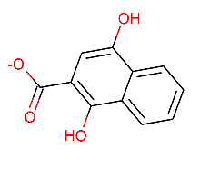Throughput: 0.002451  Oc1cc(C([O-])=O)c(O)c2ccccc12 | Pinyakong et al, 2000,⁶³
4-Hydroxycoumarin  O=c1cc(O)c2ccccc2o1 | No Match (Single paper) | Wang et al, 2016⁶⁴
O=c1occc2ccccc12  Isocoumarin | No Match (Single paper) | Nie et al, 2016,¹⁸
Coumarin  O=c1ccc2ccccc2o1 | No Match (Multiple papers) | Nie et al, 2016,¹⁸  Pinyakong et al, 2000,⁶³  Seo et al, 2007¹⁴  Seo et al, 2012,¹⁶  Wang et al, 2008⁹³
O=C1OC(=O)c2ccccc21  Phthalic anhydride | No Match (Single paper) | Huang et al, 2016⁸¹
COc1ccc(C=CC(=O)O)c(O)c1  2-Hydroxy-4-methoxy cinnamate | No Match (Single paper) | Hesham et al, 2014, ²³
O=C(O)C(=O)/C=C\c1ccc2ccccc2c1O  Cis-4-(1-hydroxynaphth-2-yl)-2-oxobut-3-enoic acid | No Match (Multiple papers) | Kim et al, 2005⁸  Lin et al, 2014,⁵
O=C(O)C(=O)c1ccc2ccccc2c1O  1-hydroxy-α-oxo-2- naphthaleneacetic acid | No Match (Single paper) | Nie et al, 2016, ¹⁸
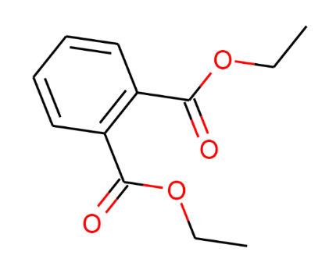  Diethyl phthalate  CCOC(=O)C1=C(C=CC=C1)C(=O)OCC | No Match (Multiple paper)  However, this is most likely formed from o-phthalate, a matched compound. | Moscoso et al, 2012,⁹⁹  Masakorala et al, 2013¹⁰⁰  Nzila et al, 2018⁷⁰
2-Acetoxybenzoic acid; aspirin  CC(=O)Oc1ccccc1C(=O)O | No Match (Multiple paper) | Lu et al, 2012,⁹⁶ Lu et al, 2013,⁶
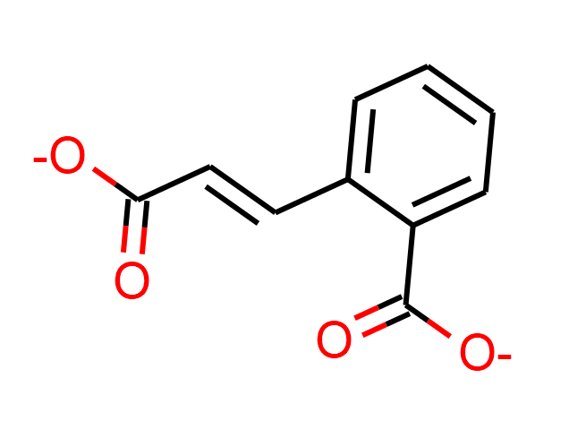  2-Carboxy-cinnamic acid  trans-2-carboxycinnamic acid  [O-]C(=O)\C=C\c1ccccc1C([O-])=O | Low Throughput Match  Throughput: 5.07e-06  [O-]C(=O)\C=C\c1ccccc1C([O-])=O | Hennessee et al,⁴⁶  Keum et al, 2006⁷  Seo et al, 2007¹⁴  Seo et al, 2006⁵³  Seo et al, 2012,¹⁶
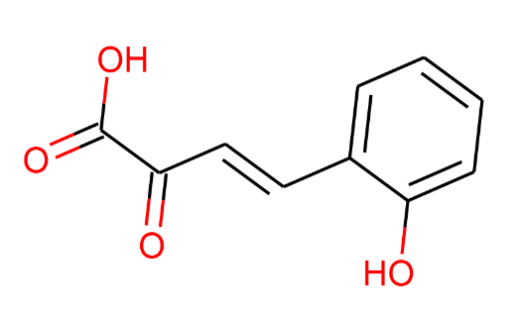  2-Hydroxybenzalpyruvic acid  O=C(O)C(=O)C=Cc1ccccc1O | Low Throughput Partial Match  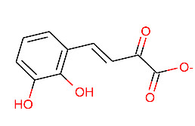  Throughput: 2.74e-13  Oc1cccc(\C=C\C(=O)C([O-])=O)c1O | Seo et al, 2007¹⁴
4-hydroxyphenylacetic acid  O=C(O)Cc1ccc(O)cc1 | Low Throughput Partial Match  Throughput: 2.12e-08  OC(=O)Cc1cc(O)ccc1O | Zeinali et al, 2008³⁷
o-hydroxyphenylacetic acid  O=C(O)Cc1ccccc1O | Low Throughput Partial Match  Throughput: 0.000001  OC(=O)Cc1cccc(O)c1O | Zeinali et al, 2008³⁷
phthalic acid,  1,2-benzenedicarboxylic acid  [O-]C(=O)c1ccccc1C([O-])=O | Perfect Match  Throughput: 0.10 | Brinda et al, 2013,¹⁰¹  Hennessee et al,⁴⁶  Hidayat et al, 2018, ⁴⁷,  Kim et al, 2005, ⁸  Luan et al, 2006,⁴⁸  Moody et al, 2001,⁶⁸,  Rehmann et al, 1996³⁰  Samanta et al, 1999⁸⁹  Seo et al, 2012,¹⁶  Sun et al, 2019,³³  Torres-Farradá et al, 2019¹⁰²  Umar et al, 2017,³⁶  Umar et al, 2018³⁵  Wang et al, 2016⁶⁴  Wang et al, 2016⁹²  Wang et al, 2008⁹³  Zhang et al, 2005⁹⁵  Zeinali et al, 2008³⁷  Zhang et al, 2010³⁸  Different Protonation:  Bourguignon et al, 2019²⁰  Chebbi et all, 2017¹⁰³  Guerin et al, 1998³  Hadibarata et al, 2010⁶⁰  Keum et al, 2006⁷  Li et al, 2014⁸³  Mishra et al, 2019⁵⁰  Seo et al, 2007¹⁴  Seo et al, 2006⁵³  Thomas et al, 2016¹⁰⁴
3,4-Dihydroxyphthalate  Oc1ccc(C([O-])=O)c(C([O-])=O)c1O | Perfect Match  Throughput: 0.067 | Seo et al, 2006⁵³  Seo et al, 2012,¹⁶
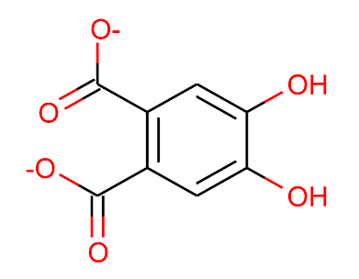  4,5-Dihydroxyphthalate  Oc1cc(C([O-])=O)c(cc1O)C([O-])=O | Perfect Match  Throughput: 0.057 | Seo et al, 2012,¹⁶  Keum et al, 2006⁷
2-hydroxy-1-naphthaldehyde  O=Cc1c(O)ccc2ccccc12 | Partial Match  Throughput:0.17  Oc1ccc2ccccc2c1C([O-])=O | Keum et al, 2006⁷
Oc1ccccc1C([O-])=O  Salicylic Acid/ 2-hydroxybenzoic acid | Perfect Match  Throughput:0.068 | Coppotelli et al, 2010, ⁷⁵,  Chen et al, 1999¹⁰⁵  Ghosal et al, 2010²  Guerin et al, 1998³  Hadibarata et al, 2011⁶¹  Hadibarata et al, 2007⁸⁰  Janbandhu et al, 2011¹⁰⁶  Leneva et al, 2009, ⁴¹  Li et al, 2014⁸³  Lin et al, 2014,⁵  Lu et al, 2013,⁶  Mallick et al, 2007, ¹¹  Mallick et al, 2008,⁸⁵  Muratova et al, 2014, ⁴⁹  Nie et al, 2016,¹⁸  Prabhu et al, 2003,⁷¹ Prakash and Lal, 2013,⁷²  Samanta et al, 1999⁸⁹  Seo et al, 2007¹⁴  Seo et al, 2006⁵³  Tao et al, 2007⁹⁰  Roy et al, 2012,¹² Seo et al, 2012,¹⁶ Sun et al, 2019,³³ Wang et al, 2008⁹³  Different protonation  Shao et al, 2015¹⁰⁷
3-methylsalicylic acid  Cc1cccc(C(=O)O)c1O | No Match (Single paper) | Mishra et al, 2019⁵⁰
Oc1ccccc1C=O  Salicylaldehyde | Partial Match  Throughput:0.015  Oc1cccc(C=O)c1O | Ghosal et al, 2010²  Guerin et al, 1998³  Hadibarata et al, 2007⁸⁰  Janbandhu et al, 2011¹⁰⁶  Mallick et al, 2007,¹¹ Muratova et al, 2014, ⁴⁹ Roy et al, 2012,¹²
Catechol  Oc1ccccc1O | Perfect Match  Throughput:0.010 | Ghosal et al, 2010²  Guerin et al, 1998³  Hadibarata et al, 2011⁶¹  Hadibarata et al, 2007⁸⁰  Janbandhu et al, 2011¹⁰⁶  Leneva et al, 2009,⁴¹  Li et al, 2014⁸³  Mallick et al, 2007,¹¹ Mallick et al, 2008,⁸⁵  Nie et al, 2016,¹⁸  Roy et al, 2012,¹²  Seo et al, 2012,¹⁶  Wang et al, 2008⁹³  Torres-Farradá et al, 2019¹⁰²  Zhang et al, 2005⁹⁵
3,4-Dihydroxybenzoate  Protocatechuic acid  Oc1ccc(cc1O)C([O-])=O | Low Throughput Match  Throughput: 0.0011 | Guerin et al, 1998³  Hadibarata et al, 2010⁶⁰  Keum et al, 2006⁷  Keum et al, 2008⁶⁶  Li et al, 2014⁸³  Rehmann et al, 1996³⁰  Samanta et al, 1999⁸⁹  Seo et al, 2006⁵³  Seo et al, 2012,¹⁶  Sun et al, 2019,³³  Torres-Farradá et al, 2019¹⁰²
Gentisate  Oc1ccc(O)c(c1)C([O-])=O | Perfect Match  Throughput: 0.011 | Keum et al, 2008⁶⁶, Nzila et al, 2018⁷⁰  Different protonation:  Seo et al, 2007¹⁴
4-Hydroxybenzoic acid  O=C(O)c1ccc(O)cc1 | Partial Match  Throughput: 0.068  Oc1ccccc1C([O-])=O | Hidayat et al, 2018, ⁴⁷
2-(Hydroxymethyl)benzoic acid  O=C(O)c1ccccc1CO | Partial Match  Throughput: 0.079  [O-]C(=O)c1ccccc1C=O | Seo et al, 2012,¹⁶
2-carboxybenzaldehyde  2-Formylbenzoic acid  [O-]C(=O)c1ccccc1C=O | Perfect Match  Throughput: 0.079 | Keum et al, 2006⁷  Rehmann et al, 1996³⁰  Seo et al, 2006⁵³  Zhang et al, 2010³⁸
2-methylphenol  Cc1ccccc1O | Partial Match  Throughput: 0.015  Oc1cccc(C=O)c1O | Li et al, 2018⁶²
Benzoic Acid  O=C(O)c1ccccc1 | Partial Match  Throughput: 0.068  Oc1ccccc1C([O-])=O | Hidayat et al, 2018, ⁴⁷  Li et al, 2014⁸³  Zeinali et al, 2008³⁷  Different Protonation:  Bourguignon et al, 2019²⁰
Phenol  Oc1ccccc1 | Low Throughput Match  Throughput: 1.28e-07 | Nie et al, 2016,¹⁸
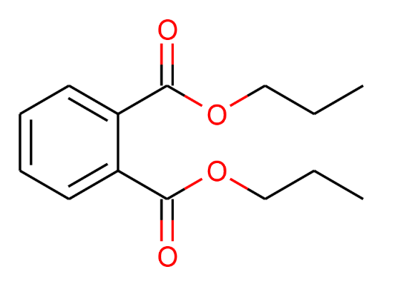  Diosbutyl phthalate  CCCOC(=O)c1ccccc1C(=O)OCCC | No Match  However this study used alkane chains mixed in with the PAH.  These compounds are most likely derived from o-phthalate.  These compounds are not counted in the accuracy scoring. | Wang et al, 2007¹⁰⁸
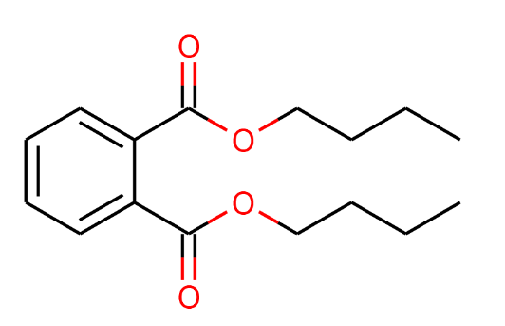  Dibutyl phthalate  CCCCOC(=O)c1ccccc1C(=O)OCCCC |  | Wang et al, 2007¹⁰⁸
mono(2-ethylhexyl) phthalate  CCCCC(CC)COC(=O)C1=C(C=CC=C1)C(O)=O |  | Wang et al, 2007¹⁰⁸
1,2-benzenedicarboxylic acid, diisooctyl ester  CC(C)CCCCCOC(=O)C1=CC=CC=C1C(=O)OCCCCCC(C)C |  | Mishra et al, 2019⁵⁰

Table S4.3: Phenanthrene Empirical Review Summary

 | Perfect Match | Partial Match
High Throughput | 14 | 25
Low Throughput | 3 | 4

No Match (Single) 25
No Match (Multiple) 13
No Match Explanations:
Several of the No-Match Compounds are the result of methylation or other straight chain addition after the cleavage of another bound. EAWAG does not predict this type of transition, so these compounds would not be found. Certain anhydride, oxide, or coumarin structures are also not predicted, so these compounds are either classified as no Match or Partial Match if their immediate parent and daughter compounds are predicted.

References
(1) Gao, S., et al., Multiple Degradation Pathways of Phenanthrene by Stenotrophomonas Maltophilia C6. Int Biodeterior Biodegradation, 2013. 79: p. 98-104.
(2) Ghosal, D., et al., Degradation of Phenanthrene Via Meta-Cleavage of 2-Hydroxy-1-Naphthoic Acid by Ochrobactrum Sp. Strain Pwtjd. FEMS Microbiol Lett, 2010. 313(2): p. 103-10.
(3) Guerin, W.F. and G.E. Jones, Mineralization of Phenanthrene by a Mycobacterium Sp. Applied and Environmental Microbiology, 1988. 54(4): p. 937-944.
(4) Lee, S., H. Ryu, and K. Nam, Phenanthrene Metabolites Bound to Soil Organic Matter by Birnessite Following Partial Biodegradation. Environmental Toxicology and Chemistry, 2009. 28(5): p. 946-952.
(5) Lin, M., et al., Biodegradation of Phenanthrene by Pseudomonas Sp. Bz-3, Isolated from Crude Oil Contaminated Soil. International Biodeterioration & Biodegradation, 2014. 94: p. 176-181.
(6) Lu, J., et al., A Fusant of Sphingomonas Sp. Gy2b and Pseudomonas Sp. Gp3a with High Capacity of Degrading Phenanthrene. World J Microbiol Biotechnol, 2013. 29(9): p. 1685-94.
(7) Keum, Y.S., et al., Degradation Pathways of Phenanthrene by Sinorhizobium Sp. C4. Appl Microbiol Biotechnol, 2006. 71(6): p. 935-41.
(8) Kim, Y.H., et al., Effects of Ph on the Degradation of Phenanthrene and Pyrene by Mycobacterium Vanbaalenii Pyr-1. Appl Microbiol Biotechnol, 2005. 67(2): p. 275-85.
(9) Kweon, O., et al., Substrate Specificity and Structural Characteristics of the Novel Rieske Nonheme Iron Aromatic Ring-Hydroxylating Oxygenases Nidab and Nida3b3 from Mycobacterium Vanbaalenii Pyr-1. MBio, 2010. 1(2).
(10) Lisowska, K., et al., The Effect of the Corticosteroid Hormone Cortexolone on the Metabolites Produced During Phenanthrene Biotransformation in Cunninghamella Elegans. Chemosphere, 2006. 64(9): p. 1499-1506.
(11) Mallick, S., S. Chatterjee, and T.K. Dutta, A Novel Degradation Pathway in the Assimilation of Phenanthrene by Staphylococcus Sp. Strain Pn/Y Via Meta-Cleavage of 2-Hydroxy-1-Naphthoic Acid: Formation of Trans-2,3-Dioxo-5-(2'-Hydroxyphenyl)-Pent-4-Enoic Acid. Microbiology, 2007. 153(Pt 7): p. 2104-15.
(12) Roy, M., P. Khara, and T.K. Dutta, Meta-Cleavage of Hydroxynaphthoic Acids in the Degradation of Phenanthrene by Sphingobium Sp. Strain Pnb. Microbiology, 2012. 158(Pt 3): p. 685-95.
(13) Sack, U., et al., Comparison of Phenanthrene and Pyrene Degradation by Different Wood-Decaying Fungi. Applied and Environmental Microbiology, 1997. 63(10): p. 3919-3925.
(14) Seo, J.S., et al., Degradation of Phenanthrene by Burkholderia Sp C3: Initial 1,2- and 3,4-Dioxygenation and Meta- and Ortho-Cleavage of Naphthalene-1,2-Diol. Biodegradation, 2007. 18(1): p. 123-131.
(15) Seo, J.S., Y.S. Keum, and Q.X. Li, Bacterial Degradation of Aromatic Compounds. Int J Environ Res Public Health, 2009. 6(1): p. 278-309.
(16) Seo, J.-S., Y.-S. Keum, and Q.X. Lic, Mycobacterium Aromativorans Js19b1t Degrades Phenanthrene through C-1,2, C-3,4 and C-9,10 Dioxygenation Pathways. 70, 2012. Int Biodeterior Biodegradation: p. 96–103.
(17) van Herwijnen, R., et al., Elucidation of the Metabolic Pathway of Fluorene and Cometabolic Pathways of Phenanthrene, Fluoranthene, Anthracene and Dibenzothiophene by Sphingomonas Sp Lb126. Research in Microbiology, 2003. 154(3): p. 199-206.
(18) Nie, M.Q., et al., Phenanthrene Metabolites from a New Polycyclic Aromatic Hydrocarbon-Degrading Bacterium Aeromonas Salmonicida Subsp. Achromogenes Strain Ny4. Polycyclic Aromatic Compounds, 2016. 36(2): p. 132-151.
(19) Aranda, E., R. Ullrich, and M. Hofrichter, Conversion of Polycyclic Aromatic Hydrocarbons, Methyl Naphthalenes and Dibenzofuran by Two Fungal Peroxygenases. Biodegradation, 2010. 21(2): p. 267-281.
(20) Bourguignon, N., et al., Identification of Proteins Induced by Polycyclic Aromatic Hydrocarbon and Proposal of the Phenanthrene Catabolic Pathway in Amycolatopsis Tucumanensis Dsm 45259. Ecotoxicology and Environmental Safety, 2019. 175: p. 19-28.
(21) Casillas, R.P., et al., Initial Oxidative and Subsequent Conjugative Metabolites Produced During the Metabolism of Phenanthrene by Fungi. Journal of Industrial Microbiology, 1996. 16(4): p. 205-215.
(22) da Silva, M., et al., Metabolism of Aromatic Hydrocarbons by the Filamentous Fungus Cyclothyrium Sp. Chemosphere, 2004. 57(8): p. 943-952.
(23) Hesham Ael, L., et al., Biodegradation Ability and Catabolic Genes of Petroleum-Degrading Sphingomonas Koreensis Strain Asu-06 Isolated from Egyptian Oily Soil. Biomed Res Int, 2014. 2014: p. 127674.
(24) Liu, D., et al., Microbial Degradation of Polycyclic Aromatic Hydrocarbons and Polycyclic Aromatic Nitrogen Heterocyclics. Environmental Toxicology and Water Quality, 1992. 7(4): p. 355-372.
(25) Sack, U., et al., Novel Metabolites in Phenanthrene and Pyrene Transformation by Aspergillus Niger. Applied and Environmental Microbiology, 1997. 63(7): p. 2906-2909.
(26) Schrlau, J.E., et al., Formation of Developmentally Toxic Phenanthrene Metabolite Mixtures by Mycobacterium Sp. Elw1. Environ Sci Technol, 2017. 51(15): p. 8569-8578.
(27) Zhong, Y., et al., Production of Metabolites in the Biodegradation of Phenanthrene, Fluoranthene and Pyrene by the Mixed Culture of Mycobacterium Sp. And Sphingomonas Sp. Bioresour Technol, 2011. 102(3): p. 2965-72.
(28) Allen, C.C.R., et al., Contrasting Effects of a Nonionic Surfactant on the Biotransformation of Polycyclic Aromatic Hydrocarbons to Cis-Dihydrodiols by Soil Bacteria. Applied and Environmental Microbiology, 1999. 65(3): p. 1335-1339.
(29) Pathak, H., et al., Technical Note: Degradation of Phenanthrene and Anthracene Bypseudomonasstrain, Isolated from Coastal Area. Bioremediation Journal, 2008. 12(2): p. 111-116.
(30) Rehmann, K., C. Steinberg, and A. Kettrup, Branched Metabolic Pathway for Phenanthrene Degradation in a Pyrene-Degrading Bacterium. Polycyclic Aromatic Compounds, 1996. 11(1-4): p. 125-130.
(31) Stingley, R.L., A.A. Khan, and C.E. Cerniglia, Molecular Characterization of a Phenanthrene Degradation Pathway in Mycobacterium Vanbaalenii Pyr-1. Biochem Biophys Res Commun, 2004. 322(1): p. 133-46.
(32) Story, S.P., et al., Convergent and Divergent Points in Catabolic Pathways Involved in Utilization of Fluoranthene, Naphthalene, Anthracene, and Phenanthrene by Sphingomonas Paucimobilis Var. Epa505. Journal of Industrial Microbiology & Biotechnology, 2001. 26(6): p. 369-382.
(33) Sun, S.S., et al., Salicylate and Phthalate Pathways Contributed Differently on Phenanthrene and Pyrene Degradations in Mycobacterium Sp. Wy10. Journal of Hazardous Materials, 2019. 364: p. 509-518.
(34) Sutherland, J.B., et al., Metabolism of Phenanthrene by Phanerochaete-Chrysosporium. Applied and Environmental Microbiology, 1991. 57(11): p. 3310-3316.
(35) Umar, Z.D., et al., Effective Phenanthrene and Pyrene Biodegradation Using Enterobacter Sp. Mm087 (Kt933254) Isolated from Used Engine Oil Contaminated Soil. Egyptian Journal of Petroleum, 2018. 27(3): p. 349-359.
(36) Umar, Z.D., et al., Rapid Biodegradation of Polycyclic Aromatic Hydrocarbons (Pahs) Using Effective Cronobacter Sakazakii Mm045 (Kt933253). MethodsX, 2017. 4: p. 104-117.
(37) Zeinali, M., M. Vossoughi, and S.K. Ardestani, Degradation of Phenanthrene and Anthracene by Nocardia Otitidiscaviarum Strain Tsh1, a Moderately Thermophilic Bacterium. J Appl Microbiol, 2008. 105(2): p. 398-406.
(38) Zhang, Z., C. Inoue, and G. Li, Coordination in Phenanthrene Biodegradation: Pyruvate as Microbial Demarcation. Bull Environ Contam Toxicol, 2010. 85(6): p. 581-4.
(39) Safonova, E., et al., Biodegradation of Phenanthrene by the Green Alga Scenedesmus Obliquus Es-55. Engineering in Life Sciences, 2005. 5(3): p. 234-239.
(40) Baboshin, M.A., et al., The Microbial Transformation of Phenanthrene and Anthracene. Microbiology, 2005. 74(3): p. 303-309.
(41) Leneva, N.A., et al., Phenanthrene and Anthracene Degradation by Microorganisms of the Genus Rhodococcus. Applied Biochemistry and Microbiology, 2009. 45(2): p. 169-175.
(42) Bezalel, L., Y. Hadar, and C.E. Cerniglia, Enzymatic Mechanisms Involved in Phenanthrene Degradation by the White Rot Fungus Pleurotus Ostreatus. Applied and Environmental Microbiology, 1997. 63(7): p. 2495-2501.
(43) Bezalel, L., et al., Metabolism of Phenanthrene by the White Rot Fungus Pleurotus Ostreatus. Applied and Environmental Microbiology, 1996. 62(7): p. 2547-2553.
(44) Cajthaml T, et al., Study of Fungal Degradation Products of Polycyclic Aromatic Hydrocarbons Using Gas Chromatography with Ion Trap Mass Spectrometry Detection. Journal of Chromatography, 2002. 974: p. 213–222.
(45) Fu, W.Q., et al., Biodegradation of Phenanthrene by Endophytic Fungus Phomopsis Liquidambari in Vitro and in Vivo. Chemosphere, 2018. 203: p. 160-169.
(46) Hennessee, C.T. and Q.X. Li, Effects of Polycyclic Aromatic Hydrocarbon Mixtures on Degradation, Gene Expression, and Metabolite Production in Four Mycobacterium Species. Appl Environ Microbiol, 2016. 82(11): p. 3357-3369.
(47) Hidayat, A. and D.H.Y. Yanto, Biodegradation and Metabolic Pathway of Phenanthrene by a New Tropical Fungus, Trametes Hirsuta D7. Journal of Environmental Chemical Engineering, 2018. 6(2): p. 2454-2460.
(48) Luan, T.G., et al., Study of Metabolites from the Degradation of Polycyclic Aromatic Hydrocarbons (Pahs) by Bacterial Consortium Enriched from Mangrove Sediments. Chemosphere, 2006. 65(11): p. 2289-96.
(49) Muratova, A., et al., Degradation of Phenanthrene by the Rhizobacterium Ensifer Meliloti. Biodegradation, 2014. 25(6): p. 787-95.
(50) Mishra, A., et al., Degradation and Detoxification of Phenanthrene by Actinobacterium Zhihengliuella Sp. Istpl4. Environmental Science and Pollution Research, 2019.
(51) Ning, D., et al., Novel Evidence of Cytochrome P450-Catalyzed Oxidation of Phenanthrene in Phanerochaete Chrysosporium under Ligninolytic Conditions. Biodegradation, 2010. 21(6): p. 889-901.
(52) Sack, U., M. Hofrichter, and W. Fritsche, Degradation of Phenanthrene and Pyrene by Nematoloma Frowardii. Journal of Basic Microbiology, 1997. 37(4): p. 287-293.
(53) Seo, J.S., et al., Phenanthrene Degradation in Arthrobacter Sp. P1-1: Initial 1,2-, 3,4- and 9,10-Dioxygenation, and Meta- and Ortho-Cleavages of Naphthalene-1,2-Diol after Its Formation from Naphthalene-1,2-Dicarboxylic Acid and Hydroxyl Naphthoic Acids. Chemosphere, 2006. 65(11): p. 2388-2394.
(54) Sutherland, J.B., et al., Stereoselective Formation of a K-Region Dihydrodiol from Phenanthrene by Streptomyces Flavovirens. Archives of Microbiology, 1990. 154(3): p. 260-266.
(55) Tatarko, M. and J.A. Bumpus, Biodegradation of Phenanthrene by Phanerochaete-Chrysosporium - on the Role of Lignin Peroxidase. Letters in Applied Microbiology, 1993. 17(1): p. 20-24.
(56) Yang, H.Y., et al., Degradation of Recalcitrant Aliphatic and Aromatic Hydrocarbons by a Dioxin-Degrader Rhodococcus Sp. Strain P52. Environ Sci Pollut Res Int, 2014. 21(18): p. 11086-93.
(57) Capotorti, G., et al., Formation of Sulfate Conjugates Metabolites in the Degradation of Phenanthrene, Anthracene, Pyrene and Benzo a Pyrene by the Ascomycete Aspergillus Terreus. Polycyclic Aromatic Compounds, 2005. 25(3): p. 197-213.
(58) Jin, J., J. Yao, and Q. Zhang, Biodegradation of Phenanthrene by Pseudomonas Sp. Jpn2 and Structure-Based Degrading Mechanism Study. Bull Environ Contam Toxicol, 2016. 97(5): p. 689-694.
(59) Szewczyk, R., et al., Application of Microscopic Fungi Isolated from Polluted Industrial Areas for Polycyclic Aromatic Hydrocarbons and Pentachlorophenol Reduction. Biodegradation, 2003. 14(1): p. 1-8.
(60) Hadibarata, T. and S. Tachibana, Characterization of Phenanthrene Degradation by Strain Polyporus Sp. S133. Journal of Environmental Sciences, 2010. 22(1): p. 142-149.
(61) Hadibarata, T., S. Tachibana, and M. Askari, Identification of Metabolites from Phenanthrene Oxidation by Phenoloxidases and Dioxygenases of Polyporus Sp S133. Journal of Microbiology and Biotechnology, 2011. 21(3): p. 299-304.
(62) Li, X., et al., Diversity of Phenanthrene and Benz[a]Anthracene Metabolic Pathways in White Rot Fungus Pycnoporus Sanguineus 14. International Biodeterioration & Biodegradation, 2018. 134: p. 25-30.
(63) Pinyakong, O., et al., Identification of Novel Metabolites in the Degradation of Phenanthrene by Sphingomonas Sp Strain P2. Fems Microbiology Letters, 2000. 191(1): p. 115-121.
(64) Wang, F.K., et al., Characterization of a Phenanthrene-Degrading Microbial Consortium Enriched from Petrochemical Contaminated Environment. International Biodeterioration & Biodegradation, 2016. 115: p. 286-292.
(65) Adebusuyi, A.A., et al., The Emhabc Efflux Pump Decreases the Efficiency of Phenanthrene Biodegradation by Pseudomonas Fluorescens Strain Lp6a. Applied Microbiology and Biotechnology, 2012. 95(3): p. 757-766.
(66) Keum, Y.S., et al., Comparative Metabolomic Analysis of Sinorhizobium Sp. C4 During the Degradation of Phenanthrene. Appl Microbiol Biotechnol, 2008. 80(5): p. 863-72.
(67) Arias, L., et al., A Microcosm System and an Analytical Protocol to Assess Pah Degradation and Metabolite Formation in Soils. Biodegradation, 2008. 19(3): p. 425-34.
(68) Moody, J.D., et al., Degradation of Phenanthrene and Anthracene by Cell Suspensions of Mycobacterium Sp. Strain Pyr-1. Appl Environ Microbiol, 2001. 67(4): p. 1476-83.
(69) Hammel, K.E., et al., Oxidative-Degradation O Phenanthrene by the Ligninolytic Fungus Phanerochaete-Chrysosporium. Applied and Environmental Microbiology, 1992. 58(6): p. 1832-1838.
(70) Nzila, A., et al., Isolation and Characterisation of Bacteria Degrading Polycyclic Aromatic Hydrocarbons: Phenanthrene and Anthracene. Archives of Environmental Protection, 2018. 44(2): p. 43-54.
(71) Prabhu, Y. and P.S. Phale, Biodegradation of Phenanthrene by Pseudomonas Sp. Strain Pp2: Novel Metabolic Pathway, Role of Biosurfactant and Cell Surface Hydrophobicity in Hydrocarbon Assimilation. Appl Microbiol Biotechnol, 2003. 61(4): p. 342-51.
(72) Prakash, O., Role of Unstable Phenanthrene-Degrading Pseudomonas Species in Natural Attenuation of Phenanthrene-Contaminated Site. Korean Journal of Microbiology and Biotechnology, 2013. 41(1): p. 79-87.
(73) Menn, F.-M., B.M. Applegate, and G.S. Sayler, Nah Plasmid-Mediated Catabolism of Anthracene and Phenanthrene to Naphthoic Acids. Applied and Environmental Microbiology, 1993. 59(6): p. 1938-1942.
(74) Balashova, N.V., et al., Phenanthrene Metabolism by Pseudomonas and Burkholderia Strains. Process Biochemistry, 1999. 35(3-4): p. 291-296.
(75) Coppotelli, B.M., et al., Study of the Degradation Activity and the Strategies to Promote the Bioavailability of Phenanthrene by Sphingomonas Paucimobilis Strain 20006fa. Microb Ecol, 2010. 59(2): p. 266-76.
(76) Doddamani, H.P. and H.Z. Ninnekar, Biodegradation of Phenanthrene by a Bacillus Species. Current Microbiology, 2000. 41(1): p. 11-14.
(77) Festa, S., et al., Assigning Ecological Roles to the Populations Belonging to a Phenanthrene-Degrading Bacterial Consortium Using Omic Approaches. Plos One, 2017. 12(9): p. 21.
(78) Froehner, S., E.C. da Luz, and M. Maceno, Enhanced Biodegradation of Naphthalene and Anthracene by Modified Vermiculite Mixed with Soil. Water Air and Soil Pollution, 2009. 202(1-4): p. 169-177.
(79) Noll, H., T. Machate, and A. Kettrup, Microbial Degradation of Phenanthrene in a Constructed Wetland. Polycyclic Aromatic Compounds, 1996. 11(1-4): p. 137-144.
(80) Hadibarata, T., S. Tachibana, and K. Itoh, Biodegradation of Phenanthrene by Fungi Screened from Nature. Pakistan Journal of Biological Sciences, 2007. 10(15): p. 2535-2543.
(81) Huang, X., et al., Biodegradation of Phenanthrene by Rhizobium Petrolearium Sl-1. J Appl Microbiol, 2016. 121(6): p. 1616-1626.
(82) Kiyohara, H., K. Nagao, and R. Nomi, Degradation of Phenanthrene through O-Phthalate by an Aeromonas Sp. Agricultural and Biological Chemistry, 1976. 40(6): p. 1075-1082.
(83) Li, F., L. Zhu, and D. Zhang, Effect of Surfactant on Phenanthrene Metabolic Kinetics by Citrobacter Sp. Sa01. Journal of Environmental Sciences (China), 2014. 26(11): p. 2298-2306.
(84) Machate, T., et al., Degradation of Phenanthrene and Hydraulic Characteristics in a Constructed Wetland. Water Research, 1997. 31(3): p. 554-560.
(85) Mallick, S. and T.K. Dutta, Kinetics of Phenanthrene Degradation by Staphylococcus Sp. Strain Pn/Y Involving 2-Hydroxy-1-Naphthoic Acid in a Novel Metabolic Pathway. Process Biochemistry, 2008. 43(9): p. 1004-1008.
(86) Ovchinnikova, A.A., et al., Phenanthrene Biodegradation and the Interaction of Pseudomonas Putida Bs3701 and Burkholderia Sp Bs3702 in Plant Rhizosphere. Microbiology, 2009. 78(4): p. 433-439.
(87) Puntus, I.F., et al., Phenanthrene Degradation by Bacteria of the Genera Pseudomonas and Burkholderia in Model Soil Systems. Microbiology, 2008. 77(1): p. 7-15.
(88) Sanseverino, J., et al., Plasmid-Mediated Mineralization of Naphthalene, Phenanthrene, and Anthracene. Applied and Environmental Microbiology, 1993. 59(6): p. 1931-1937.
(89) Samanta, S.K., A.K. Chakraborti, and R.K. Jain, Degradation of Phenanthrene by Different Bacteria: Evidence for Novel Transformation Sequences Involving the Formation of 1-Naphthol. Applied Microbiology and Biotechnology, 1999. 53(1): p. 98-107.
(90) Tao, X.Q., et al., A Phenanthrene-Degrading Strain Sphingomonas Sp Gy2b Isolated from Contaminated Soils. Process Biochemistry, 2007. 42(3): p. 401-408.
(91) Tittabutr, P., I.K. Cho, and Q.X. Li, Phn and Nag-Like Dioxygenases Metabolize Polycyclic Aromatic Hydrocarbons in Burkholderia Sp. C3. Biodegradation, 2011. 22(6): p. 1119-33.
(92) Wang, H., et al., Efficient Biodegradation of Phenanthrene by a Novel Strain Massilia Sp. Wf1 Isolated from a Pah-Contaminated Soil. Environ Sci Pollut Res Int, 2016. 23(13): p. 13378-88.
(93) Wang, J., et al., Kinetics and Characteristics of Phenanthrene Degradation by a Microbial Consortium. Petroleum Science, 2008. 5(1): p. 73-78.
(94) Wischmann, H., et al., Degradation of Selected Pahs in Soil/Compost and Identification of Intermediates. International Journal of Environmental Analytical Chemistry, 1996. 64(4): p. 247-255.
(95) Zhang, L., et al., Phenanthrene-Degrading Pathway of Agrobacterium Sp Phx1. Science in China Series D-Earth Sciences, 2005. 48: p. 269-275.
(96) Lu, J., et al., Biodegradation Kinetics of Phenanthrene by a Fusant Strain. Curr Microbiol, 2012. 65(3): p. 225-30.
(97) Ressler, B.P., H. Kneifel, and J. Winter, Bioavailability of Polycyclic Aromatic Hydrocarbons and Formation of Humic Acid-Like Residues During Bacterial Pah Degradation. Applied Microbiology and Biotechnology, 1999. 53(1): p. 85-91.
(98) Dictor, M.C., et al., Influence of Ageing of Polluted Soils on Bioavailability of Phenanthrene. Oil & Gas Science and Technology, 2006. 58(4): p. 481-488.
(99) Moscoso, F., et al., Technoeconomic Assessment of Phenanthrene Degradation by Pseudomonas Stutzeri Cect 930 in a Batch Bioreactor. Bioresour Technol, 2012. 104: p. 81-9.
(100) Masakorala, K., et al., Isolation and Characterization of a Novel Phenanthrene (Phe) Degrading Strain Psuedomonas Sp. Ustb-Ru from Petroleum Contaminated Soil. Journal of Hazardous Materials, 2013. 263: p. 493-500.
(101) Brinda, L.M., K. Muthukumar, and M. Velan, Optimization of Minimal Salt Medium for Efficient Phenanthrene Biodegradation Bymycoplanasp. Mvmb2 Isolated from Petroleum Contaminated Soil Using Factorial Design Experiments. CLEAN - Soil, Air, Water, 2013. 41(1): p. 51-59.
(102) Torres-Farradá, G., et al., Biodegradation of Polycyclic Aromatic Hydrocarbons by Native Ganoderma Sp. Strains: Identification of Metabolites and Proposed Degradation Pathways. Applied Microbiology and Biotechnology, 2019.
(103) Chebbi, A., et al., Polycyclic Aromatic Hydrocarbon Degradation and Biosurfactant Production by a Newly Isolated Pseudomonas Sp. Strain from Used Motor Oil-Contaminated Soil. International Biodeterioration & Biodegradation, 2017. 122: p. 128-140.
(104) Thomas, F., et al., Isolation and Substrate Screening of Polycyclic Aromatic Hydrocarbon Degrading Bacteria from Soil with Long History of Contamination. International Biodeterioration & Biodegradation, 2016. 107: p. 1-9.
(105) Chen, S.H. and M.D. Aitken, Salicylate Stimulates the Degradation of High Molecular Weight Polycyclic Aromatic Hydrocarbons by Pseudomonas Saccharophila P15. Environmental Science & Technology, 1999. 33(3): p. 435-439.
(106) Janbandhu, A. and M.H. Fulekar, Biodegradation of Phenanthrene Using Adapted Microbial Consortium Isolated from Petrochemical Contaminated Environment. Journal of Hazardous Materials, 2011. 187(1-3): p. 333-340.
(107) Shao, Y.X., et al., Biodegradation of Pahs by Acinetobacter Isolated from Karst Groundwater in a Coal-Mining Area. Environmental Earth Sciences, 2015. 73(11): p. 7479-7488.
(108) Wang, J., H.K. Xu, and S.H. Guo, Isolation and Characteristics of a Microbial Consortium for Effectively Degrading Phenanthrene. Petroleum Science, 2007. 4(3): p. 68-75.

Section 5: Analysis and Plotting Code

A full analysis of the PAH degradation network will generate the following files. Examples are provided at https://github.com/ngLabGroup/networksPlotting
Raw Data Files:
RawExampleData.xlsx – Edgelist obtained from EAWAG or similar pathway predictor
BATCH.OUT files from EPI Suite™. These contain the Log K_{ow} (LogP) value, there may be several depending on the size of the network.
RuleData.xlsx – Contains the aerobic weightings as defined by EAWAG. This is an input for the nodeThroughput.py script
Generated Data Files:
ExampleEpiLogKow.xlsx – Log K_{ow} Estimation from EpiSuite. Similar files could be generated if parameters were desired than cannot be computed by RDKit. Other files can merge them in based on the SMILES codes.
ExamplePositions.xlsx – Optional file for improving waterfall plots. Allows nodes to be manually moved for viewing
ExampleQFNodes.xlsx – Example of the output from the nodeThroughput.py
LiteratureMatches_Highthroughput.xlsx – Reference file for compounds that match literature and that pass whatever threshold is selected as high throughput. Can be tabbed out to serve multiple compounds. The high throughput compounds can be easily copied from the node throughput file. It is usually desirable to be able to reference these compounds easily, which is why they are stored in their own excel file rather than being pulled from the node throughput file
ExamplePathWeight.xlsx The Edgeless after Relevant Pathway filtering has been applied
Supporting Code Scripts:
- CustomFunctions_PAHteam.py contains several functions that are needed for the other scripts
Analysis Code Scripts:
Run the scripts in the order that they appear on the page
- addEpiSuiteLogKow.py This script is used to package the outputs from the Kowwin module of the EpiSuite BATCH.OUT files into an excel file
- nodeThroughput.py This script applies the nodeThroughput algorithm and write out the ExampleNT_BTW_Nodes.xlsx file
- relevantPathwayFiltering.py This script allies the Relevant Pathway filter and writes out the ExamplePathWeight.xlsx
- network_Molecular_correlations.py This script computes the correlations between network data and chemistry data
- substructureFinder.py This script is used to locating Partial Matches. This script works best if it is manipulated deliberately.
Plotting Code Scripts:
- waterfallPlot_LitMatchs.py – This script generates Figure 5 in the main test as well as the plots in the SI for each PAH.
- pathwayMatchLegend.py – This script generates the percentage bar in Figure 5. These two plots can be combined with an image program.
- lit_comparisonBarPlots.py – This script generates Figure 6 in the main text
- betweennessMCS_plotter.py – This script will not work with the small example data set as the MCS code requires many more compounds, but is provided as reference.
Example Data Sets:
We cannot provide the full data sets, however small partial datasets are provided to demonstrate the workings of the code.

Section 6. Sensitivity Analysis
Weighting Sensitivity Analysis
The compounds in the High Node Throughput category can be classified based on how they connect to each other, especially by how they connect to the empirical literature matches (Perfect Matches). This is one of the major strengths of applying a networks approach to this problem. As the figures of the individual network plots in the earlier SI sections illustrate, High Node Throughput Compounds can be classified as either “Perfect Match”, where compounds match an empirical literature value exactly, “Pathway Match” where they are on a degradation pathway to or from a “Perfect Match” compound, or as a “Network Outlier” where the node does not match an empirical literature study exactly and there is no direct pathway among other High Node Throughput compounds to or from a literature match.
EAWAG-PPS categorizes the biodegradation reactions (network edges) by aerobic likelihood. In this paper, the categories of “Neutral”, “Likely”, and “Very Likely” were considered. The categories of “Unlikely” and “Very Unlikely” were assumed to be negligible. In order to determine the proper numerical weighting (Edge Aerobic Likelihood Score) to assign to the different aerobic likelihood categories, a sensitivity analysis was conducted. Figure S6.1 shows the results of this analysis for the High Node Throughput compounds, (nodes with a greater than 0.01 Node Throughput value).
The ideal Edge Aerobic Likelihood Score would assign scores (weights) to the biodegradation edges such that after applying the Node Throughput algorithm, as many of the Perfect Match literature metabolites as possible fall into the “High Node Throughput” category after the Node Throughput algorithm was applied. In order to determine the ideal weighting scheme an initial scoring of 1,2,3 (spread of 1) was assigned to the edge categories of “Neutral”, “Likely”, and “Very Likely”. The spread was then incrementally increased by integer values; a spread of 2 would be a scheme of 1,3,5, and a spread of 3 would be a scheme of 1,4,7, etc, on up to a spread of 99. The number of predicted metabolites above the High Node Threshold of 0.01 was then considered to determine the best Edge Aerobic Likelihood scoring scheme. The 0.01 threshold as the definition for High Node Throughput was estimated initially as a good threshold for selecting the most relevant metabolites and was re-verified below.
As the Edge Aerobic Likelihood Scores are increased, the “Neutral” category is help constant at 1 and the weightings of the “Likely” and “Very Likely” categories are increased. The Aerobic Likelihood Scores are part of the Edge Throughput Value Equation (1) in the main text.
$\text{Edge Throughput Value=Edge Aerobic Likelihood Score}\frac{\text{Source Node Throughput Value}}{\sum{\text{All Outgoing Edge Aerobic Likelihood Scores}}}$ (1)

and each node’s “Throughput” value is assigned by:

$\text{Node Throughput Value=}\sum{\text{Incoming Edge Throughput Values}}$ (2)

The greater the spread of the Aerobic Likelihood categories, the greater the final Edge Throughput Value assigned to the “Likely” and “Very Likely” edges will be, and the lower the final Edge Throughput Value assigned to the “Neutral” edges will be. A greater spread between the categories will result in assigning more Edge Throughput to the “Likely” and “Very Likely” edges and less to the “Neutral” Edges.
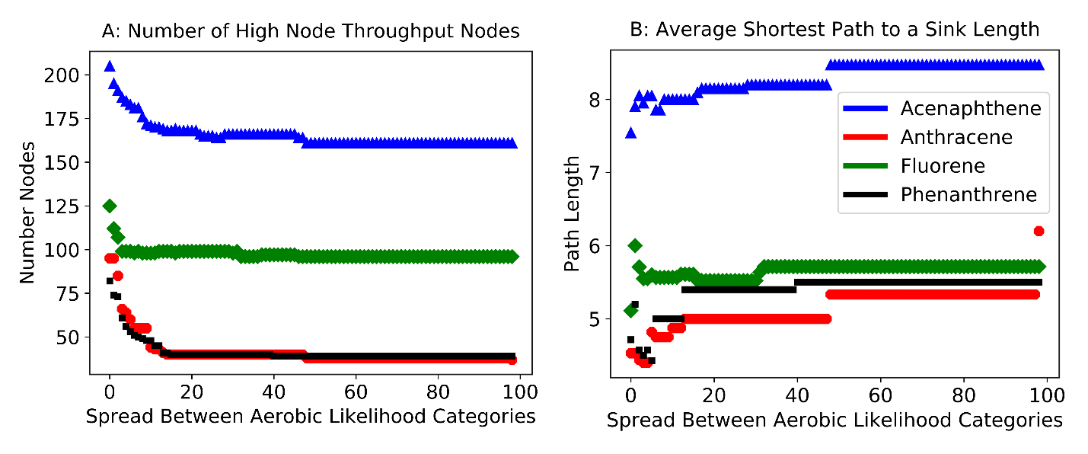

Figure S6.1: Network Metrics at Different Aerobic Likelihood Spreads

The increase in spread will result in an overall lower number of nodes because branches that are started by a “Neutral” edge will have lower Node Throughput assigned to them and their daughter products consequently will fall below the cutoff for High Throughput earlier along the degradation pathway. Additionally, the average shortest path length to a sink compound increases as more weight is assigned to the “Likely” and “Very Likely” categories, as the degradation chains will go farther before the final sink has less than a 0.01 Node Throughput value. These two networks measurements are summarized for each PAH in Figure S6.2.
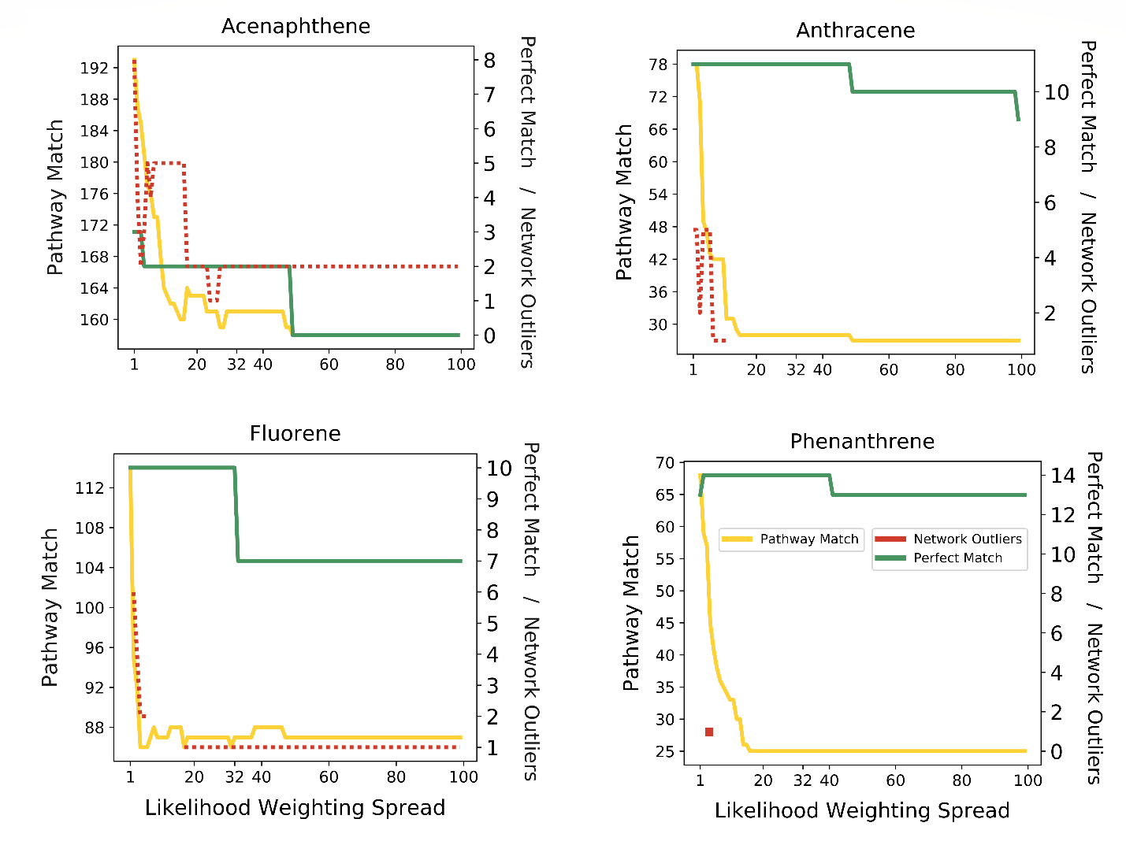
Figure S6.2: Sensitivity Analysis of Different Weighting Schemes. The aerobic likelihood weighting of the aerobic likelihood categories of “Neutral”, “Likely”, and “Very Likely” was incrementally increased from 1,2,3, to 1, 100, 199. The categorization of the High Node Throughput compounds based on the Edge Aerobic Likelihood spread is shown for each PAH.

The spread was increased as much as possible while minimizing Network Outliers and maximizing Perfect Match Compounds. The optimal Edge Aerobic Likelihood scheme was found to be a spread of 32, resulting in a numerical scoring scheme of 1,33,65 for the 3 different categories. A spread of 33 would have caused 3 of the Fluorene metabolites to fall below the High Node Throughput cutoff of 0.01. This process maximized the number of Perfect Match metabolites that showed a Node Throughput of greater than 0.01.
High Node Throughput Threshold Selection
The threshold of 0.01 was used as an initial screening threshold for optimizing the edge weighting. After the ideal edge weighting was selected, the threshold was re-verified by considering the number of literature compounds that fell above possible thresholds vs the total number of compounds selected. 0.01 proves to be a good threshold for the definition of High Node Throughput, identifying 34 of the possible 55 (~62%) of the Perfect Match category metabolites while selecting a reasonable number of other predicted metabolites to consider. This analysis is summarized in Figure S6.3.
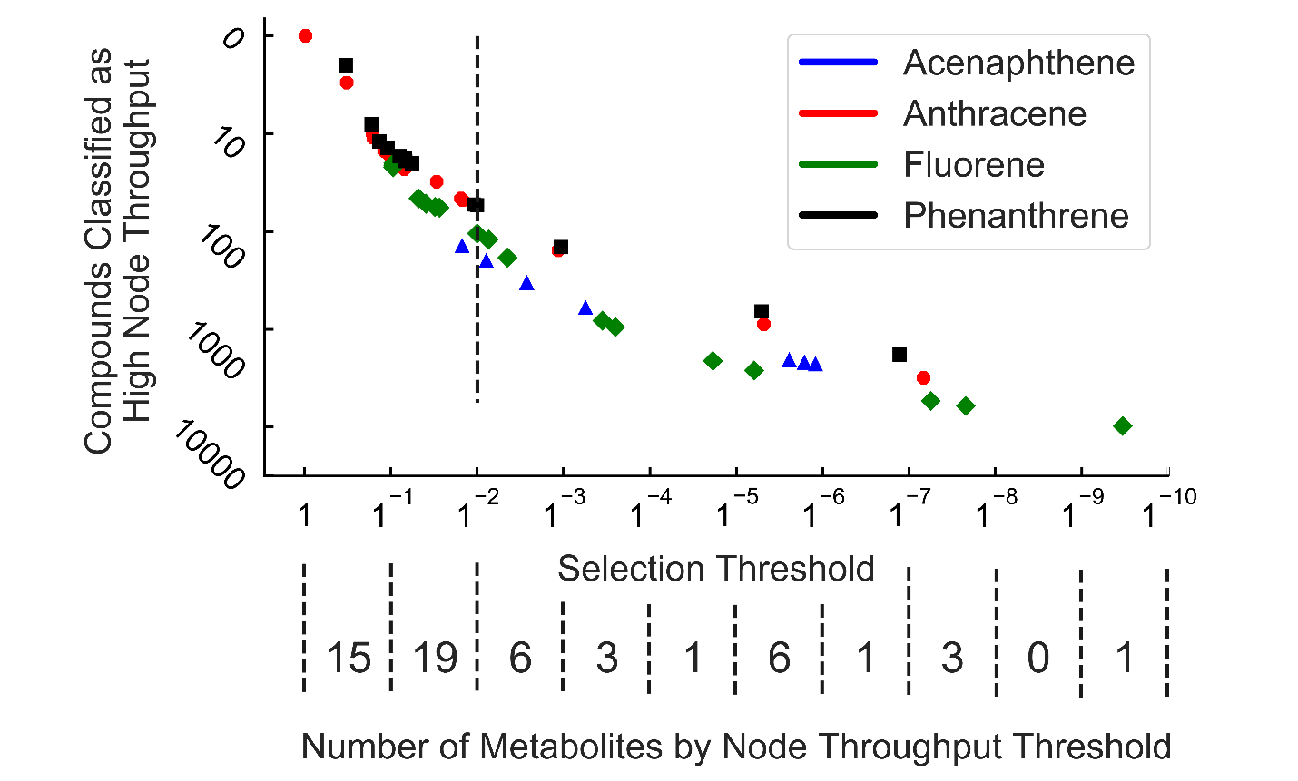
Figure S6.3: Selection of the Threshold for High Node Throughput. Both axes are log₁₀ transformed. The heatmap shows how many literature metabolites are found above each order of magnitude of Node Throughput. The dashed line shows the threshold for High Node Throughput of 0.01 used in the main text. Each literature compound is plotted with its Node Throughput value on the vertical axis and the total number of High Node Throughput Compounds that would be selected if that value was used as the threshold on the horizontal axis (the number of High Node Throughput Compounds with a Node Throughput value greater than Throughput value of the Perfect Match value plotted)

