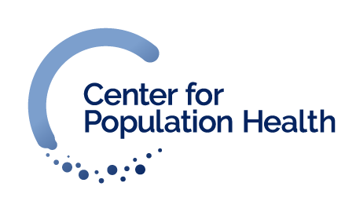
Cambria and Somerset Counties Community Health Listening Sessions Information Form
We request that you complete each question, but all questions are optional.

What is your race/ethnicity? (select one):
__White
__Black or African-American
__American Indian or Alaskan Native
__Native Hawaiian or other Pacific Islander
__Asian
__From multiple races
__Some other race (please specify):__________________________________

What is your gender? (select one):
__Female
__Male
__Other (please specify):___________________________________

Questions on back

What is your age?
__18-20
__21-29
__30-39
__40-49
__50-59
__60 or older

How did you hear about this session? (select one or more)
__Flyer
__Word of mouth
__Other (please specify):____________________________________

