SPATIAL ANALYSIS OF MEASLES VACCINATION RATES:
EAST AFRICA, 2007-2011

by
Tenley Brownwright
B.A. Environmental Studies, Dartmouth College, 2010

Submitted to the Graduate Faculty of
Department of Epidemiology
Graduate School of Public Health in partial fulfillment
of the requirements for the degree of
Master of Public Health

University of Pittsburgh
2013

UNIVERSITY OF PITTSBURGH
GRADUATE SCHOOL OF PUBLIC HEALTH

This essay is submitted
by
Tenley Brownwright

on

December 1 2013
and approved by

Essay Advisor:
Nancy Glynn, PhD ______________________________________
Research Assistant/Professor of Epidemiology
Department of Epidemiology
Graduate School of Public Health
University of Pittsburgh

Essay Reader:
Ravi Sharma, PhD ______________________________________
Assistant Professor
Department of Behavioral and Community Health Sciences
Graduate School of Public Health
University of Pittsburgh

Essay Reader:
Evelyn Talbott, PhD ______________________________________
Professor
Department of Epidemiology
Graduate School of Public Health
University of Pittsburgh

Copyright © by Tenley Brownwright
2013
ABSTRACT
Background: This paper examined spatial variation of measles vaccination rates in a ten-country East African area and constructed a spatial model of demographic variables that account for vaccination decisions.
Nancy Glynn, PhD

SPATIAL ANALYSIS OF MEASLES VACCINATION RATES:
EAST AFRICA, 2007-2011

Tenley Brownwright, MPH
University of Pittsburgh, 2013

Methods: Data were collected from Demographic and Health Surveys (DHS) over a five-year period (2007-2011) and processed in SPSS 21 to select from key variables (measles vaccination rates, geographic data, and select demographic variables). Spatial analysis (local and global Moran’s I; Hot Spot Analysis) was performed in ArcGis 10.1 and GeoDa 1.4.3. Spatial regression (Queen’s Contiguity) was performed in GeoDa 1.4.3.
Results: Spatial analysis revealed spatial autocorrelation of measles vaccination rates (Moran’s I of cluster data=0.388;p<0.001). Hot Spot Analysis revealed significant clusters of low vaccination rates both within countries and spanning borders between countries, including countries that reported vaccination rates exceeding 90 percent. Twenty six percent of the variance in measles vaccination rate was explained by mother’s education (years) and distance of healthcare facility.
Conclusions: Even countries that reported overall high vaccination rates exhibited clusters of low vaccination rates. While statistics are often reported on a national scale, thus informing policy and intervention decisions, these results indicate that future decisions should be made with considerations to the localized, spatially diverse nature of measles vaccination rates. Doing so should result in more efficient and effective interventions.

TABLE OF CONTENTS
1.0 Introduction 1
1.1 SIGNIFICANCE 3
1.2 OBJECTIVES 4
2.0 METHODS 5
2.1 DATA 5
2.1.1 Study area. 6
2.1.2 Demographic and Vaccination Data 9
2.2 Processing 10
2.3 Spatial AUTOCORRELATION 12
2.4 Spatial Regression 12
3.0 RESULTS 15
3.1 TESTS OF SPATIAL AUTOCORRELATION 15
3.2 SPATIAL REGRESSION 17
4.0 DISCUSSION 19
4.0.1 Limitations 19
bibliographY 22
List of tables
Table 1. Results of Spatial Regression Model 17

List of figures

Figure 1. Country Vaccination Rate by Study Year 8
Figure 2. Study Area: Clusters and L2 Polygons 11
Figure 3. Spatial Regression 13
Figure 4. Cluster Analysis 16

Introduction
Measles is a highly contagious viral disease. Despite the existence of a safe, inexpensive, and effective vaccine, it remains one of the leading causes of childhood morbidity and mortality throughout the developing world. Measles accounted for 158,000 deaths in 2011, more than 95 percent of which occurred in low-income countries(Organization 2013).
Symptoms of measles include high fever, appearing 10-12 days after exposure, cough, watery eyes, and characteristic rash(Organization 2013). Complications include blindness, diarrhea, pneumonia, encephalitis, and death. These outcomes are most common in young children, pregnant women, and adults suffering from malnutrition or those lacking access to basic health care(Organization 2013).
Vaccination can greatly reduce morbidity and mortality risk. The measles vaccine is 85 percent effective after one dose, and 99.6 percent (IQR 98.1-100%) effective after the standard two-dose cycle(Sudfeld CR 2010). Effectiveness may be slightly diminished in high-prevalence countries, which must give the first measles dose at a low age, increasing the chance that an individual may seroconvert. Even in these countries, however, the two-dose measles vaccine provides coverage for the vase majority of the population(Orenstein WA 1986, Organization 2009, Sudfeld CR 2010).
Despite the vaccine’s effectiveness on an individual level, however, it requires extremely high-levels of population compliance to create herd immunity. Measles is highly infectious, with an R₀ of 15-20 people(Griffin DE 2008). As a result, the population coverage needed for herd immunity is likewise high: most recently estimated at 97.1 percent (95%CI 96.1-97.8)(van Boven M 2010). Only a few countries, developing or developed have achieved this level of vaccination: much of Eastern European countries, a few Western European countries, and some African countries (Rwanda, Eritrea, and Tunisia)(Organization). The United States has achieved between a 90 and 92 percent vaccination rate in recent years(Organization).
Throughout the developing world, many studies have been conducted to determine the reasons behind individual vaccination decisions, including the measles vaccine specifically. Reasons found vary by country (and study), but many overlap, including those studied here. Distance to a health facility was a common reason cited, in studies in Istanbul, Tanzania, Kenya, and Pakistan(Ndiritu M 2006, Torun SD 2006, Cockcroft A 2009, Le Polain de Waroux O 2013). Mother’s maternal education correlated highly and positively with vaccination decision in Turkey, Tanzania, Uganda, and Pakistan(Altinkaynak S 2004, Cockcroft A 2009, Fadnes LT 2011, Le Polain de Waroux O 2013). In Turkey, paternal education was examined and found to have no effect(Altinkaynak S 2004). Similarly, knowledge about vaccination, as measured by a short exam, was found to be correlated with vaccination decision in the studies in Istanbul in Pakistan(Altinkaynak S 2004, Cockcroft A 2009). Number of children was found to be a factor in two separate studies in Kenya, but not in Turkey(Altinkaynak S 2004, Ndiritu M 2006, Maina LC 2013). Perhaps most interesting, particularly for this study (where income was not selected for the model), socio-economic status had no effect on vaccination decision in the Turkish study(Altinkaynak S 2004).
Finally, and very importantly, vaccine coverage was found to be lower the later the vaccine was given(Fadnes LT 2011). This is very important for the measles vaccine, which is typical started at one year of age to prevent seroconversion and requires two doses to ensure immunity.

SIGNIFICANCE
One dose of the measles vaccine reduces incidence of disease by 85 percent (95% CI 83%-87%)(Sudfeld CR 2010). Measles vaccine also appears to have an effect on non-measles mortality, reducing mortality from all causes by 43 percent(Aaby P 1995). High vaccination rates (97.1 percent) are needed to protect the entire population, however(van Boven M 2010).
Even if a country does achieve a 97.1 percent vaccination rate, however, for that country to achieve true herd immunity, the vaccinated individuals would need to be perfectly distributed throughout the country. This is an improbable scenario, as non-vaccination is more common within family units(Torun SD 2006). Vaccination statistics, however, including measles, are often reported on a national, rather than local scale. Some studies have been conducted comparing one district to another, or a hospital or clinic service area to another, thereby examining some geographic variation. However, the hypothesis of these studies has not been to examine the spatial variation of vaccination rates, but rather some other underlying question; most often, it is a cross-sectional survey to elucidate the reasons for the differences in rates in that very small area.
Service providers such as health departments may study a district or municipality. This study, however, brings together a large ten-country region to examine any clusters that may span borders, and any similar themes in vaccination decisions.

OBJECTIVES
            - Examine the ten-country area for spatial variation:
              - Autocorrelation
              - Clustering (cluster locations)
            - Create a spatial regression model to identify underlying demographic variables associated with the observed vaccination pattern

METHODS
In order to achieve these objectives, a ten-country area was selected. This method enables detections of patterns and clusters that may span borders.

2.1 DATA
Data were selected from the Demographic and Health Surveys (DHS), a United States Agency of International Development (USAID)-funded project administered by ICF International. These surveys are conducted in countries throughout the developing world and updated approximately every ten years. Specialty surveys select for keys variables and include geographic data. This study uses the Children’s Recode, which includes children’s health topics such as respiratory infection, diarrheal disease, and vaccination record.
DHS surveys are administered at the household level. These households are randomly sampled from clusters, which themselves are sampled to provided a random but statistically representative sample of the population’s demographics.
Respondents to the Children’s Recode questionnaires were mothers. Some questions (including measles vaccination status) refer to the child’s status, while others refer to household status. Also included in this analysis is a separate geographic data set, linked to the Children’s Recode during processing.
The surveys take an average of 18-20 months to administer. DHS survey year given in this study is the year the survey was performed. The analysis and completion time appears to be around two years for surveys done in the region. The most recent surveys included in this analysis (performed in fall 2013), were completed in 2011.

Study area.
The study area was selected based on several criteria: available of recent DHS survey (Children’s recode, geographic data), contiguity to other East African nations in study area, and relative similarity of demographics and income. DHS publishes an additional major survey (the Malaria Indicator Survey), which does not have the necessary information. When an MIS study is published, a DHS study/Children’s Recode is often not as recent. In addition, a few countries that might have added to the analysis did not have recent or complete surveys. Any non-contiguous countries were excluded, due to the spatial analysis. Any countries with very dissimilar demographic or overall income (ie, South Africa) were also excluded, as they might change the regression analysis.
The end result was a 10-country area in East Africa, with surveys ranging from 2007-2011, with n=108,319 respondents:
- Burundi
- Democratic Republic of the Congo
- Ethiopia
- Kenya
- Madagascar
- Malawi
- Rwanda
- Tanzania
- Zambia
- Zimbabwe
Though Madagascar is an island, and thus not strictly contiguous, because no other countries separate it from the study area, it was considered contiguous for the purpose of the analysis.
These countries had wide-ranging overall vaccination levels:
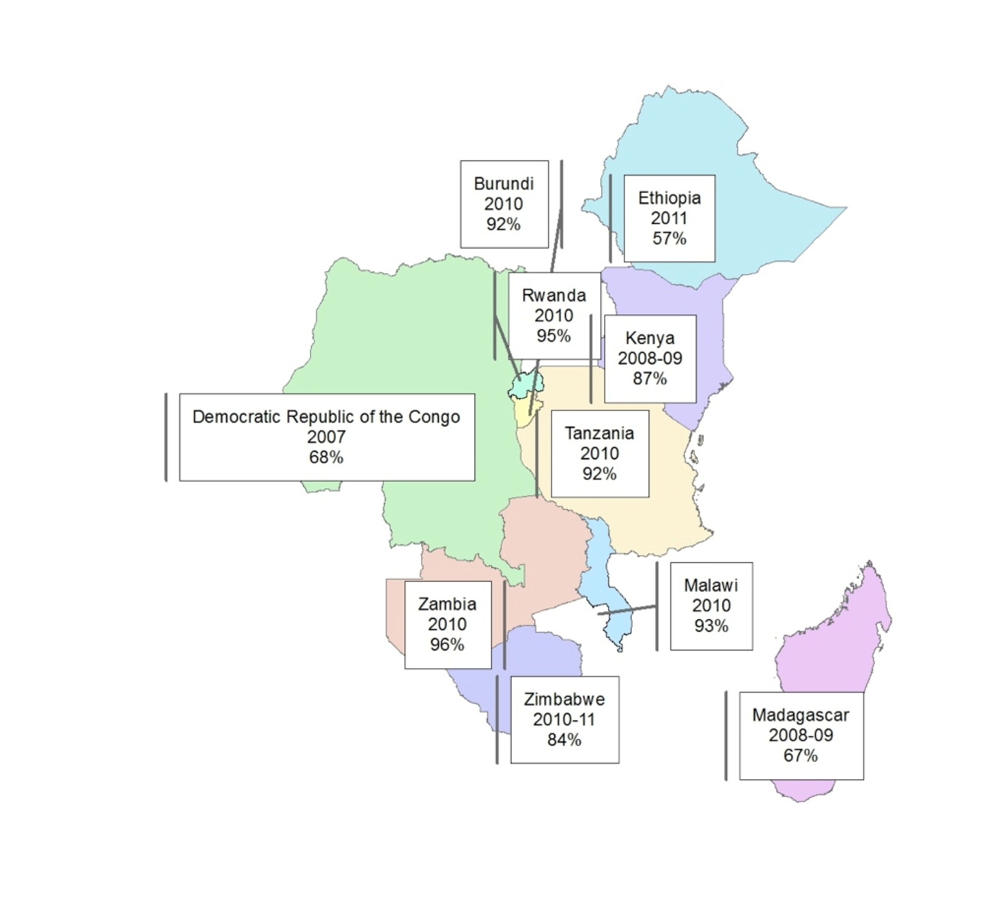
Figure 1. Country Vaccination Rate by Study Year
Of the countries in the study area, only Zambia is within the 95% CI for herd immunity; Rwanda, Malawi, Tanzania, and Burundi approach this rate. These countries, however, share borders with countries falling well below the 90% overall vaccination rate.

2.1.2 Demographic and Vaccination Data
The Children’s Recode has a large amount of demographic data, not all of which could be analyzed. Original variables selected for preliminary analysis included:
- Mother’s age
- Type of place of cluster (urban or rural)
- Highest education level of mother
- Education level of mother in single years
- Number of children at home
- Educational attainment of mother (0-5)
- Wealth index
- Several health access variables, measured in a question posed to the mother:
  - Having permission to seek care
  - Having money to seek care
  - Distance
  - Not wanting to go alone
- Measles vaccine
These variables were processed in SPSS 21 to recode any missing variables from “9” or “99” to “.”.
Measles vaccine was also recoded in an indicator variable. Though the original vaccine variable had responses for vaccination card, mother’s response, and unknown, vaccination card and mother’s response were recoded to “yes” and unknown was coded to missing. It is possible that in some countries, those that do not have routine vaccination drives, many of those that were recoded as missing, likely are unvaccinated. In countries with routine vaccination drives, many of those that recoded as missing may likely be vaccinated individuals. Unfortunately, this information is unknown as DHS is a simple survey and titers were not drawn on respondents who answered “unknown.”

Processing
These variables were then aggregated to the clusters level in SPSS21, n=4,805 clusters.
To account for DHS sampling methods, weights were used during this process. Though the DHS clusters are displaced for privacy, this does not affect the accuracy of the results obtained.
The clusters were then aggregated to polygon (level 2) divisions in ArcGIS 10.1 using spatial join. This resulted in n=988 polygons.
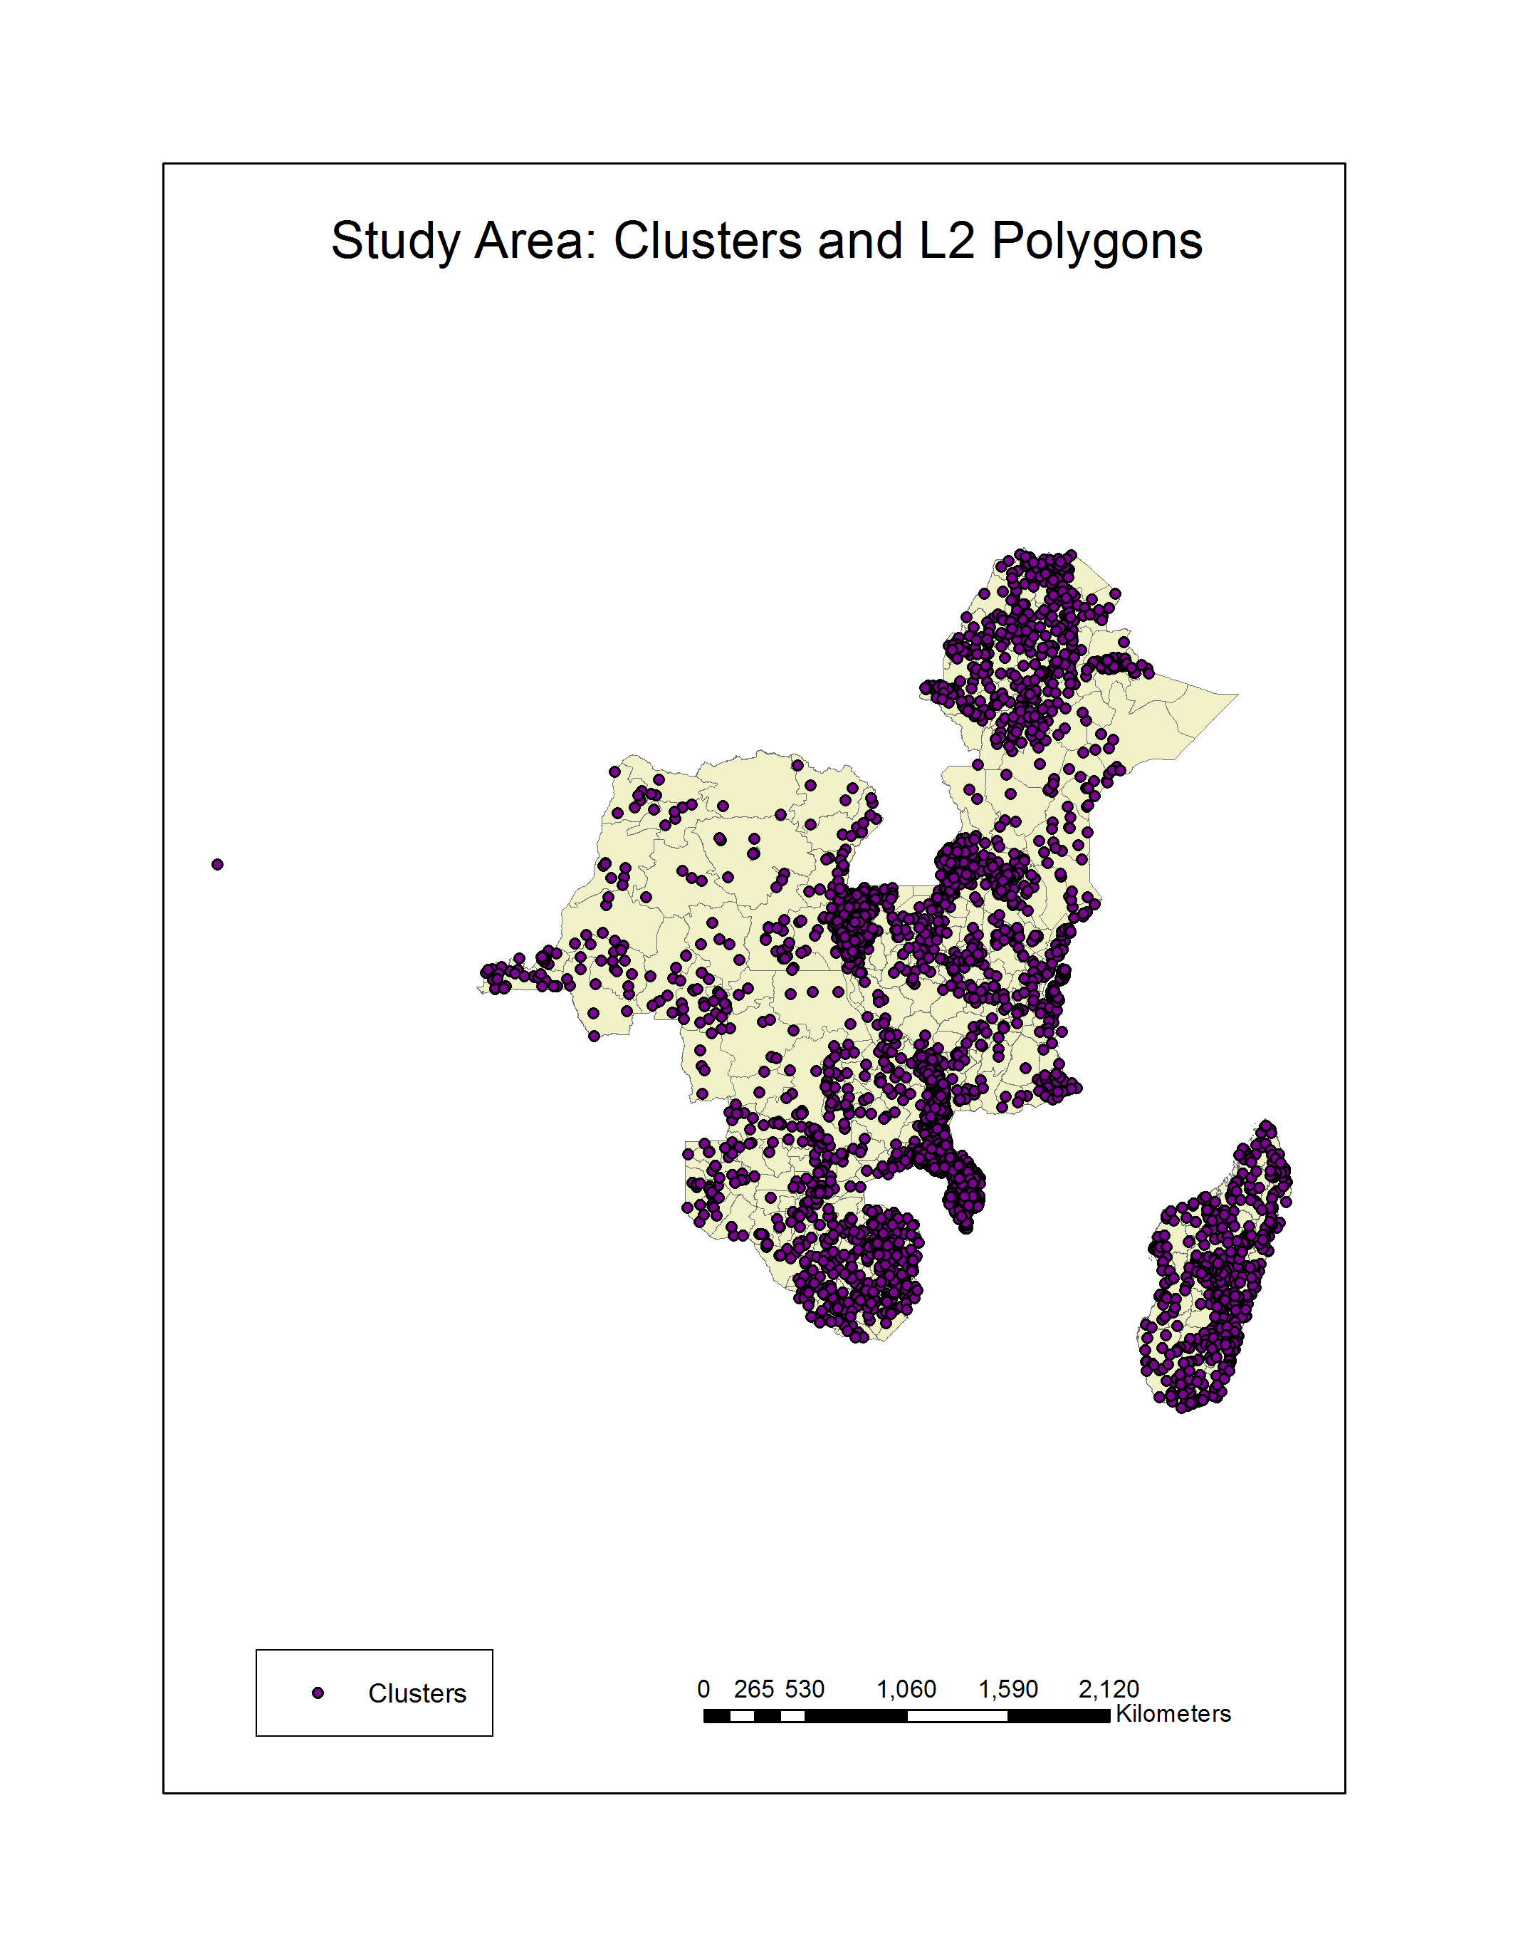
Figure 2. Study Area: Clusters and L2 Polygons

Spatial AUTOCORRELATION
Several test of spatial autocorrelation were run in ArcMap 10.1. These included local Moran’s I (on clusters, n=4,805) and Hot Spot Analysis/Getis-Ord Gi. During this process, row standardization was used to control for random sampling.
In GeoDa 1.4.3, Global Moran’s I was run (polygons, n=988). A queen contiguity weights matrix was created for this analysis.

Spatial Regression
Tests were also preformed to determine the need for spatial regression. A significant Moran’s I (0.388, p<0.001) indicated a need for spatial regression over conventional regression. A non-normal residual plot from the global Moran’s I run in GeoDa confirmed this need: 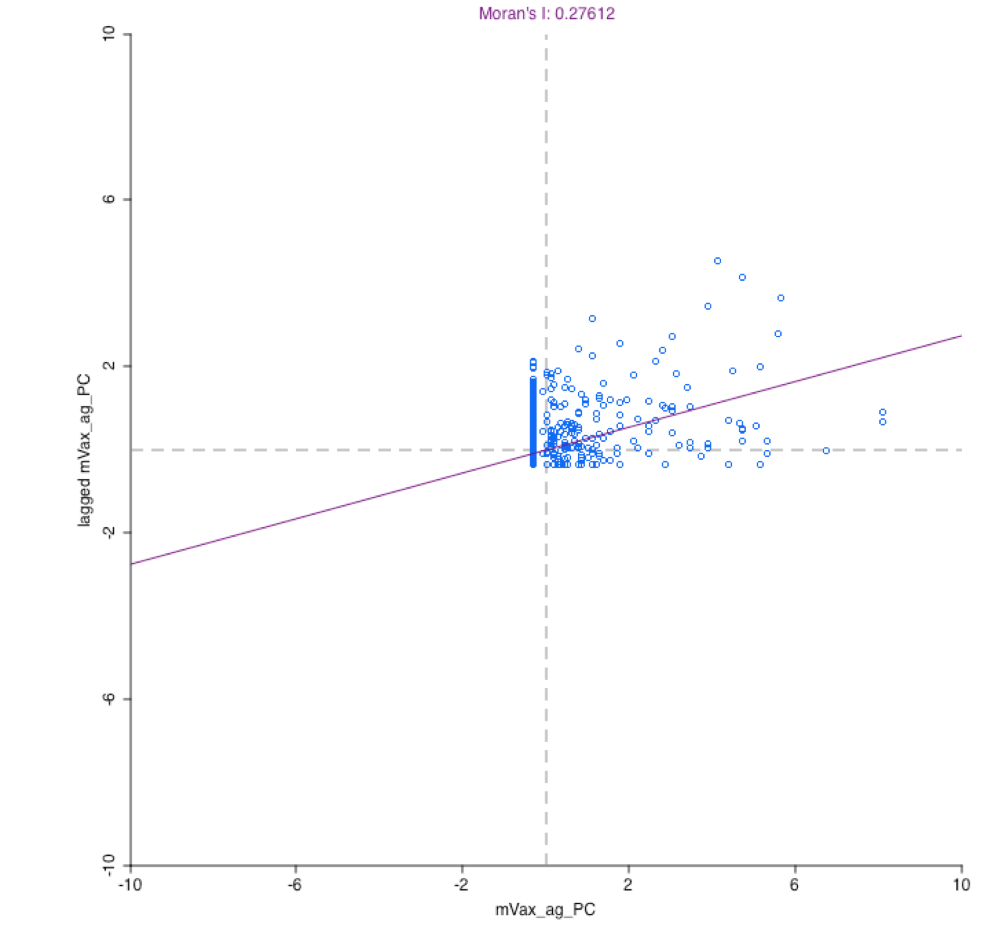
Figure 3. Spatial Regression
As a result, a spatial regression model was constructed in SPSS 21.
Since many of the variables were interrelated, there was significant concerns of violating the assumption of independence. Many of the variables (income, primarily, but also number of children, health metrics) could not be used in the model for this reason. Barrier to care: distance and mother’s education, however, resulted in a multicollinearity regression number of 5.36, well under the <10 threshold for autocorrelation.

RESULTS
Results revealed several findings, including spatial autocorrelation, significant clusters in key regions, and a strong model.

TESTS OF SPATIAL AUTOCORRELATION
Both tests Moran’s I measures indicate significant spatial autocorrelation within measles vaccination status. Global Moran’s I preformed on clusters (n=4805) in ArcGis 10.1) shows significant and positive autocorrelation; Moran’s I=0.388, p<0.001. Another global Moran’s I preformed on Level 2 polygon division (n=988) also shows spatial autocorrelation; Moran’s I=0.276. Thus, the measles vaccination exhibits spatial autocorrelation over the 10-country area.
For the purposes of any future interventions, however, it is important to know that measles vaccination rates are not perfectly dispersed, but to also to know where clusters of high-vaccinated and, more importantly, low-vaccinated individuals may be. Local Moran’s I located low-vaccination cluster (clusters where low vaccinated individuals are surrounded by other clusters of low-vaccinated individuals) throughout the region. These are marked by “LL,” and are especially vulnerable to an outbreak of measles. Clusters marked HH, or clusters of high vaccinated individuals surrounded by similarly high vaccinated individuals, are far less vulnerable to an outbreak.
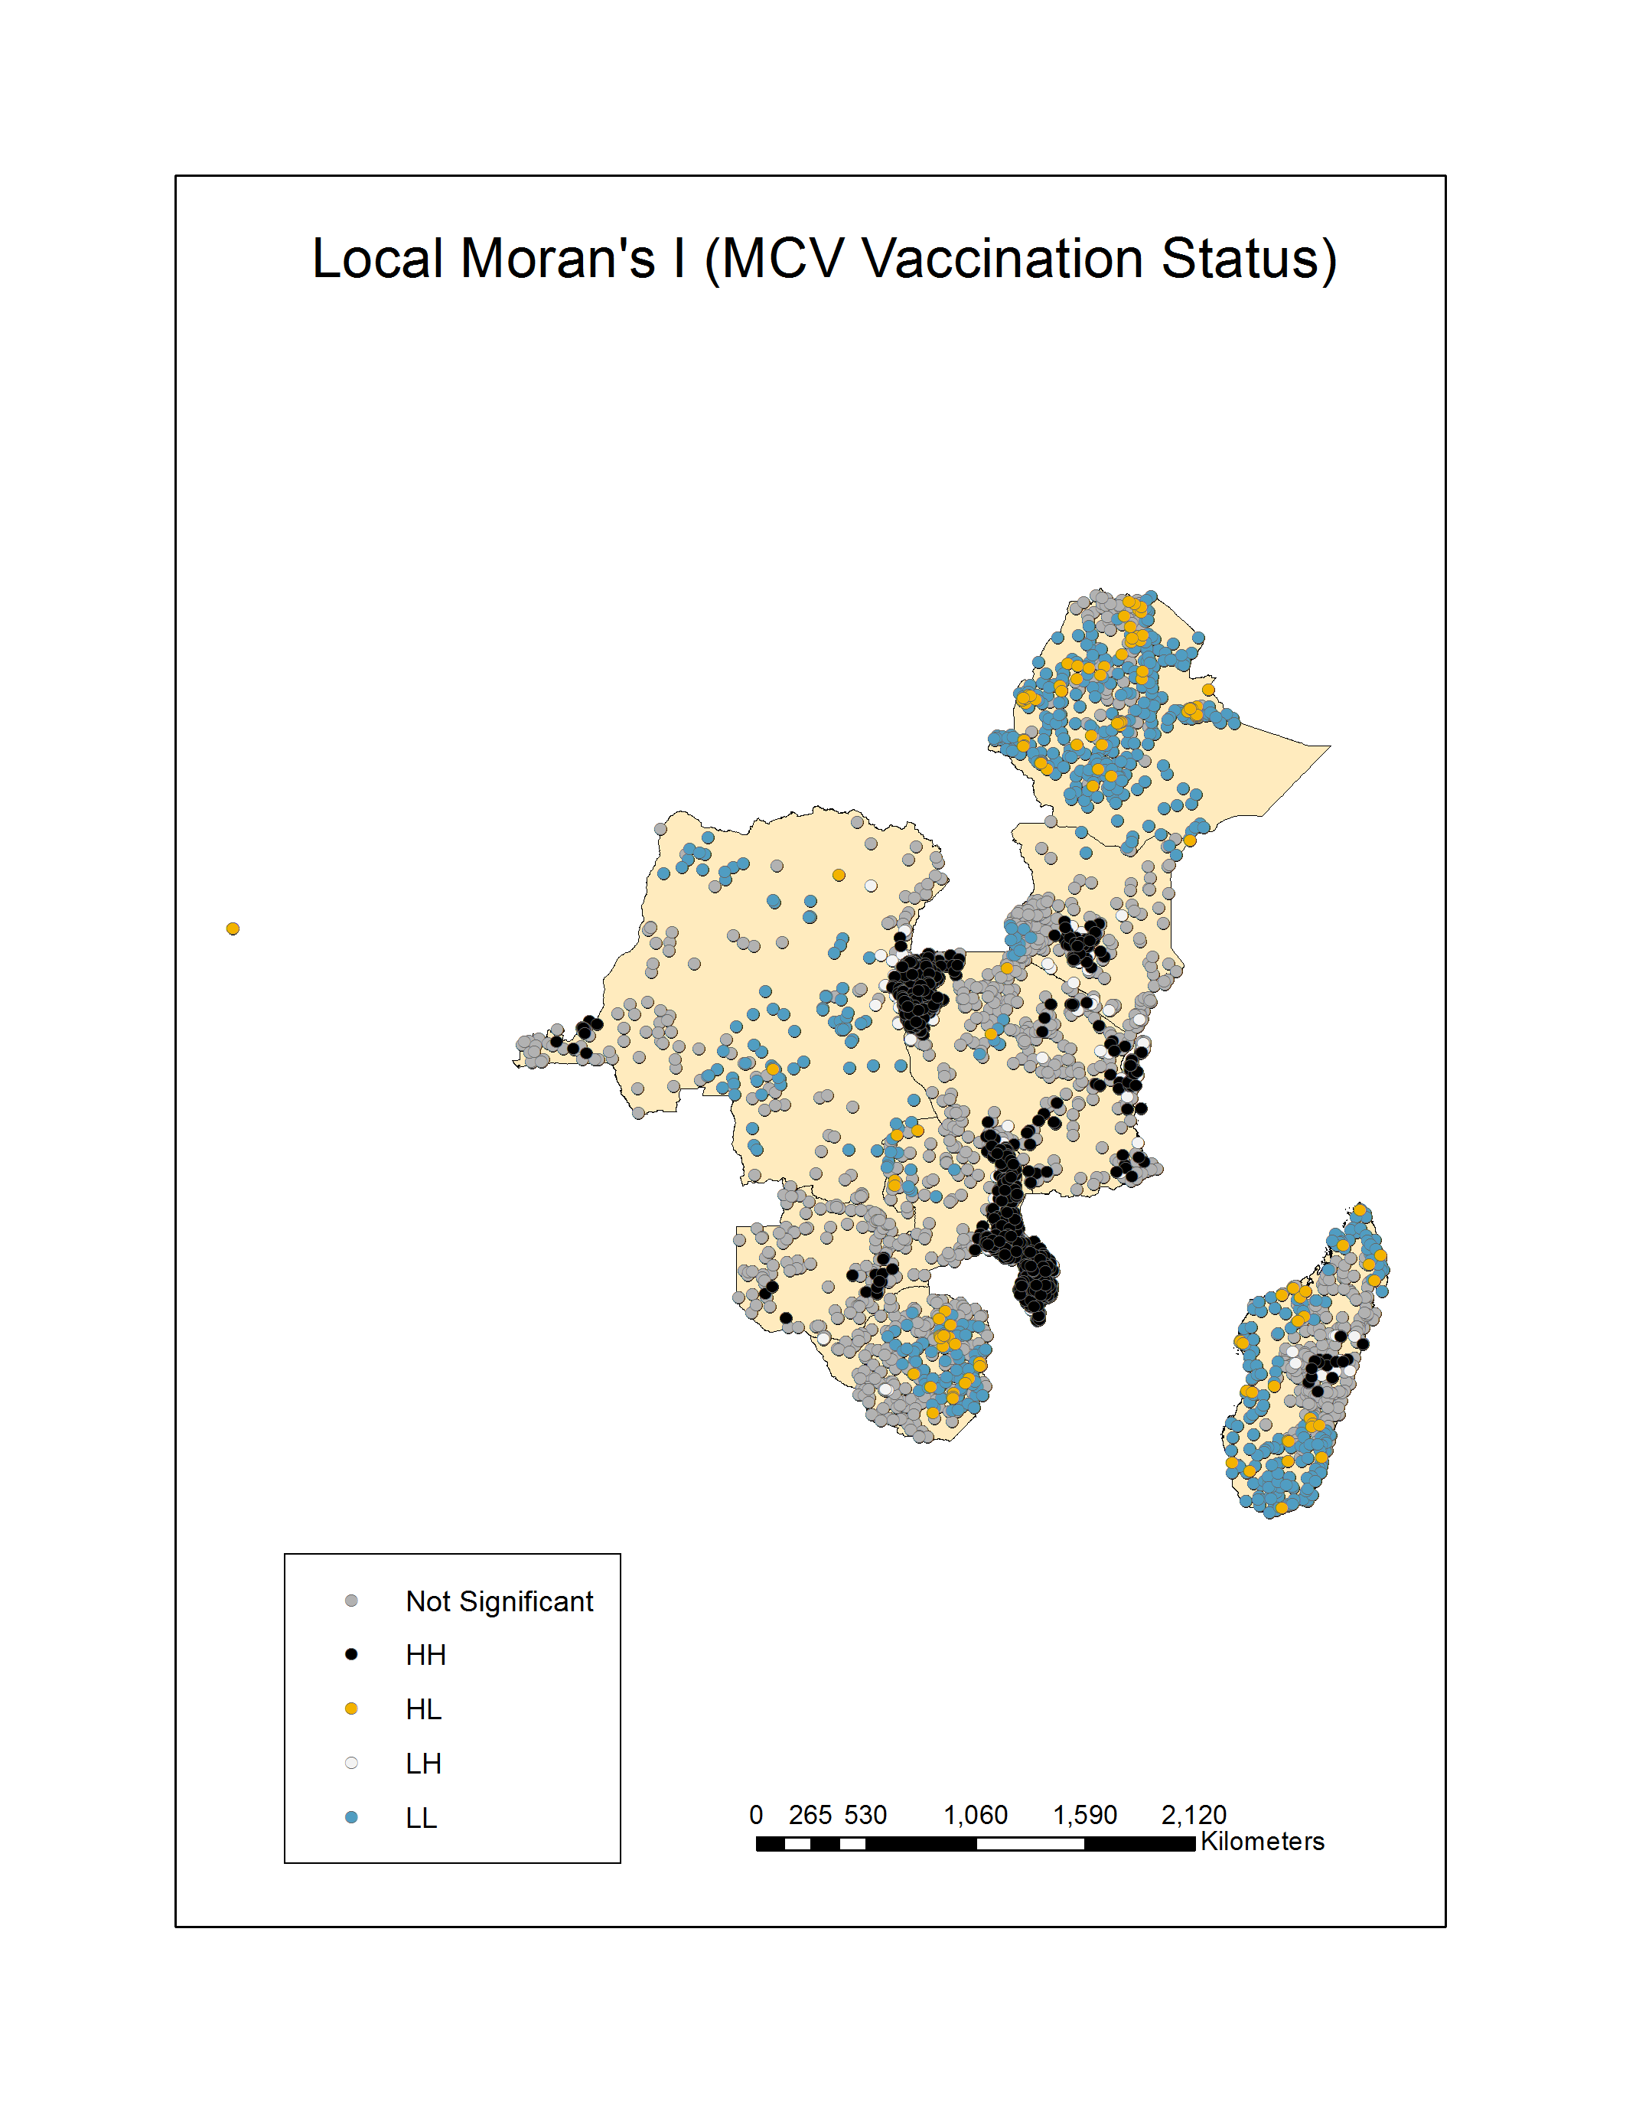
Figure 4. Cluster Analysis
The “LL” clusters exist both within and across country borders. Most important to future work is the cluster located on the border between the Democratic Republic of the Congo and Zambia. Though Zambia reported a 96 percent vaccination rate in the study year, on the low end of the confidence interval for herd immunity, this cluster may be at high risk for a future measles outbreak.

SPATIAL REGRESSION
The spatial regression model was created with two variables selected from the demographic data: mother’s education (years) and distance as a barrier to care. This model had a multicollinearity regression number of 5.36, an acceptable amount.
Results of the model were:
Table 1. Results of Spatial Regression Model
Variable | Odds Ratio | Std. err. | t-stat. | P.
Constant | 1.49 | 0.0173 | 23.065 | <0.001
Education (years) | 1.265 | 0.0212 | 11.056 | <0.001
Barrier to care (distance) | 1.231 | 0.0208 | 16.397 | <0.001
R²=0.2622, p<0.001

The individual results of the model correspond well with previous studies. Distance to care was previous shown to be associated with low vaccine uptake in similar demographics in Tanzania, as well as in Istanbul(Torun SD 2006, Le Polain de Waroux O 2013). Maternal education correlated with child’s vaccination status in Uganda(Fadnes LT 2011). Both variables were associated with vaccination in Pakistan(Cockcroft A 2009). Though none of these studies created a model using these variables, or had the wide geographic area of this study, these results are not without precedent.
The result is a strong model, with just two variables explaining over 26 percent of the variation in vaccination status.

DISCUSSION
High levels of spatial variation were found throughout the study area. Though some countries (Zambia, Rwanda, Malawi) exhibited overall immunization rates approaching the requirement for herd immunity, the degree of spatial variation exhibited in the ten-country study area still leaves this area vulnerable to outbreaks. This is particularly obvious in Zambia, which showed one such cluster of low-vaccinated areas despite reporting an overall vaccination rate of 96 percent, on the low end of the 95 percent confidence interval for herd immunity.
Clusters such as these may be vulnerable to measles outbreaks, but vaccination statistics are commonly reported on the national, or at best, regional, level. This reporting may inform intervention decisions even when localized clusters, such as the one seen in Zambia, continue to exist. This study indicates that different metrics are necessary when reporting vaccination statistics, and any intervention decisions should be made with the knowledge that measles vaccination exhibits a pattern of spatial variation and clustering.

4.0.1 Limitations
A few limitations exist in this study. The last survey included in the analysis was conducted in 2011; no other surveys were available at the time of analysis. In addition, because of the DHS cycle of survey collection, data from 2007 was included. Though WHO statistics show only minor fluctuations on the national level in respect to measles vaccination rates, some local vaccination rates may have changes, as well as some demographic variables. As these are all variables specific to the DHS dataset, this is difficult to confirm or deny.
The geographic spacing of the samples also made it difficult to set specific parameters for spatial analysis. Though the sampling methods used by DHS account for variations in population density within each country, these variations can make it difficult to create precise bounds in the tests for spatial autocorrelation, which rely on distance bands. For example, the Democratic Republic of the Congo, which has a very low population density throughout much of the country, had a very low sample density, and many of the sample were very far apart. Malawi, in contrast, has a much higher population density, and many of the samples were much closer together. This was accounted for during analysis, but it is a limitation over a geographically homogenous sample.
Finally, only two demographic variables were included in the spatial regression model. Other factors studied previously in similar demographics were available in the dataset, but because these violated the assumption of independence, they were not included in the model for this study. This is not likely a significant limitation, because the model created was very strong, statistically significant, and with low multicollinearity.
There are limited issues with generalizability. The countries in the sample were specifically selected from one specific region with similar demographics. This limits generalizability. It is likely that the spatial autocorrelation seen in this study may be seen in other regions, however, and anecdotal evidence of measles outbreak gives some indication to that. The study was also conducted on measles vaccination only, though it is likely, because there is a high correlation between vaccination rates for measles and other diseases, that a similar result would be found for another vaccine.
Though additional studies are needed on other areas to extend generalizability, this analysis shows that spatial variation exists in measles vaccination rates in East Africa, linked to health access (distance) and maternal education. This knowledge should inform health policy and vaccination intervention decisions, which should be localized and area-specific.

bibliographY

Aaby P, S. S., Simondon F, Seck AMC, Knudsen K, Whittle H (1995). "Non-specific beneficial effect of measles immunisation: analysis of mortality studies from developing countries." BMJ 311: 481-485.

Altinkaynak S, E. V., Güraksin A, Kiliç A (2004). "Effect of several sociodemographic factors on measles immunization in children of Eastern Turkey." Public Health 118(8): 565-569.

Cockcroft A, A. N., Omer K, Ansari NM, Khan A, Chaudhry UU, Ansari U (2009). "One size does not fit all: local determinants of measles vaccination in four districts of Pakistan." BMC Int Health Hum Rights 14(9).

Fadnes LT, J. D., Engebretsen IM, Zembe W, Sanders D, Sommerfelt H, Tylleskär T; PROMISE-EBF Study Group (2011). "Vaccination coverage and timeliness in three South African areas: a prospective study." BMC Public Health 11(404).

Fadnes LT, N. V., Sommerfelt H, Tylleskär T, Tumwine JK, Engebretsen IM; PROMISE-EBF Study Group (2011). "Is vaccination coverage a good indicator of age-appropriate vaccination? A prospective study from Uganda." Vaccine 29(19): 3564-3570.

Griffin DE, P. C., Moss WJ (2008). "Measles vaccines." Front Biosci 13: 1352-1370.

Le Polain de Waroux O, A. S. J., Manzib F, Mrishob M, Shirimab K, Mshindab H, Alonso P, Tannere M, Schellenberg DM (2013). "Timeliness and completeness of vaccination and risk factorsfor low and late vaccine uptake in young children livingin rural southern Tanzania." Int Health 5: 139-147.

Maina LC, K. S., Kombich J (2013). "Immunization coverage and its determinants among children aged 12 - 23 months in a peri-urban area of Kenya." Pan Afr Med J 14(3).

Ndiritu M, C. K., Ismail A, Chiphatsi S, Kamau T, Fegan G, Feikin DR, Newton CR, Scott JA (2006). "Immunization coverage and risk factors for failure to immunize within the Expanded Programme on Immunization in Kenya after introduction of new Haemophilus influenzae type b and hepatitis b virus antigens." BMC Public Health 6(132).

Orenstein WA, M. L., Preblud SR, Hinman AR, Tomasi A, Bart KJ (1986). "Appropriate age for measles vaccination in the United States." Dev Biol Stand 65: 13-21.

Organization, W. H. Immunization: Measles (MCV) by Country. Geneva, WHO.

Organization, W. H. (2009) Module 7: Measles Update.

Organization, W. H. (2013). Measles. Geneva, WHO.

Sudfeld CR, N. A., Halsey AN (2010). "Effectiveness of measles vaccination and vitamin A treatment." Int J Epidemiol 39(1): 48-55.

Torun SD, B. N. (2006). "Vaccination coverage and reasons for non-vaccination in a district of Istanbul." BMC Public Health 6(125).

van Boven M, K. M., Wallinga J, O'Neill PD, Wichmann O, Hahné S (2010). "Estimation of measles vaccine efficacy and critical vaccination coverage in a highly vaccinated population." J R Soc Interface 7(52): 1537-1544.

