THE ROLE OF DIET IN GASTROINTESTINAL CANCER PREDISPOSITION IN RURAL AFRICANS AND AFRICAN AMERICANS

by
Hatem Kaseb
MBBCh, Faculty of Medicine, Cairo University, Egypt, 2003

MSc, Clinical & Chemical Pathology, Faculty of Medicine, Cairo University, Egypt, 2009

Submitted to the Graduate Faculty of

Graduate School of Public Health in partial fulfillment

of the requirements for the degree of

Master of Public Health

University of Pittsburgh
2016

UNIVERSITY OF PITTSBURGH
GRADUATE SCHOOL OF PUBLIC HEALTH

This essay is submitted
by
Hatem Kaseb

on

April 1st, 2016
and approved by

Essay Advisor:
Stephen J. D. O’Keefe, MD, MSc ______________________________________
Professor
Gastroenterology, Hepatology and Nutrition
School of Medicine
University of Pittsburgh

Essay Reader:
Candace M. Kammerer, PhD ______________________________________
Associate Professor
Human Genetics
Graduate School of Public Health
University of Pittsburgh

Copyright © by Hatem Kaseb
2016
Based on the analysis of worldwide epidemiological studies, it has been estimated that >90% of GI cancers are diet-related. African Americans (AA) have an extremely high risk of colon cancer (~65:100,000) while rural Africans (RA) rarely get the disease (<5:100,000). On the other hand, RA have an extremely high risk of squamous cell carcinomas of the esophagus (125:100,000 in men) while AA have a low risk. Our group performed 2-week food exchanges in subjects from the same populations, where AA were fed a high fiber, low fat African-style diet, and RA a high fat low fiber western-style diet under close supervision. Upper and lower endoscopies were performed to obtain mucosal biopsies for the measurement of mucosal biomarkers of cancer risk (Ki67 staining of proliferative epithelial cells) from the esophagus, stomach, and colon in matched groups (n=20, age 50-65, BMI 18.5-35 kg/m2) from each population. The short term westernization of the RA diet led to reciprocal changes in the upper and lower GI tract. In RA, the Ki67 staining of the stomach decreased and the Ki67 staining of the colon increased, suggesting that acute dietary change has dramatic effects on the colonic epithelium. In AA, the diet switch lead to insignificant changes in stomach Ki67 staining and a decrease in Ki67 staining of the colon. On the other hand, the esophageal Ki67 staining was low and did not change as a result of the diet change switch in both groups.
Stephen J.D. O’Keefe, MD, MSc
THE ROLE OF DIET IN GASTROINTESTINAL CANCER RISK PREDISPOSITION IN RURAL AFRICANS AND AFRICAN AMERICANS
Hatem Kaseb, MPH
University of Pittsburgh, 2016
ABSTRACT
PUBLIC HEALTH SIGNIFICANCE: The changes observed in the stomach and colon in such a short interval show that the gastric and colonic mucosa is remarkably sensitive to dietary composition. The numeric reductions in gastric epithelial cell proliferation in RA may be a consequence of increased intakes of antioxidant vitamins; whereas the increase in colonic epithelial proliferation in RA is likely explained by the decrease in fiber intake resulting in reduced fermentation and butyrogeneiss as previously described. Overall, our results support the recommendations that dietary habit changes can be an important tool for primary prevention of GI cancers.

TABLE OF CONTENTS
preface x
1.0 INTRODUCTION 1
2.0 Background 3
2.1 DIET AND ESOPHAGEAL CANCER RISK 5
2.2 DIET AND Gastric CANCER RISK 6
2.3 DIET AND colo-rectal CANCER RISK 7
3.0 methods 10
3.1 Study Design 10
3.2 SUBJECTS AND SAMPLE COLLECTION 11
3.2.1 Subjects and Recruitment 11
3.2.2 SCREENING 11
3.2.3 ENVIRONMENT AND LIVING CONDITIONS 12
3.2.4 INCLUSION CRITERIA 13
3.2.5 EXCLUSION CRITERIA 13
3.2.6 Mucosal Sampling and Colonoscopy 14
3.3 DIETARY ANALYSIS 14
3.4 HEMATOXYlIN AND EOSIN STAINING (H&E) 14
3.5 IMMUNOHISTOCHEMISTRY 15
3.5.1 Immunohistochemical staining 15
3.5.2 QUANTIFICATION OF IMMUNOHISTOCHEMICAL STAINING 16
3.6 STATISTICAL METHODS 16
4.0 RESULTS 17
4.1 SHORT DIET switch DOESNOT EFFECT ESOPHAGEAL MUCOSA 20
4.2 SHORT DIET switch LEADS TO CHANGES IN GASTRIC MUCOSA 21
4.3 short diet switch LEADS TO CHANGES IN COLON MUCOSA 23
5.0 DISCUSSION 25
5.1 Dietary change leads to variablle changes in gastrointestinal mucosa 25
5.2 High FIBER IN DIET CAN LEAD TO DECREASED RISK OF COLORECTAL CANCER 27
6.0 CONCLUSION 29
6.1 LIMITATIONS AND DIRECTIONS FOR FUTURE RESEARCH 29
6.2 PUBLIC HEALTH SIGNIFICANCE 30
bibliography 31

List of tables
Table 1. Dietary analysis of Rural African and African American diets 19
Table 2. KI67 in esophageal muosa pre and post dietary intervention in RA and AA 21
Table 3. KI67 in gastric glands pre and post dietary intervention in RA and AA 22

List of figures
Figure 1. Overview of the study design and timeline. 18
Figure 2. Diagnosis of esophageal biopsies in RA and AA at the baseline (pre-intervention) 20
Figure 3. Diagnosis of Gastric biopsies in RA and AA at the baseline (pre-intervention) 22
Figure 4. Colonic Mucosal Immunohistochemistry of Proliferative and Inflammatory Biomarkers 24

preface
I would like to thank my advisor, Dr. Stephen JD O’Keefe for providing me with the opportunity to be a member of his team. His constant support, encouragement and advice motivated me to do my best on the project. I am extremely grateful to him for helping me improve my scientific writing skills. I will never forget when he asked all the team members drink the 50 gm fiber drink so that we can feel and test for ourselves fiber as a possible dietary supplement. The experience with Dr. O’Keefe team taught me a lot about the importance of multi-centric collaboration and the enormous obstacles that researchers face to publish papers in high impact journals. I would like to thank Dr. Khaled Mohamed, Dr. Junhai Ou and Dr. Kishore Vipperla along with others who worked on this huge project as a whole. I thank Dr Candy Kammerer for her guidance and support on the idea of pursuing an MPH degree and for having time signing my endless progress and academic reports.

INTRODUCTION
Among 17 leading risk factors contributing to the morbidity and mortality in the US, diet has been reported to be the most influential (Murray et al., 2013). The following 14 components of diet have been found to effect health and disease: low intake of fruits, vegetables, whole grains, nuts and seeds, milk, fiber, calcium, seafood omega-3 fatty acids, polyunsaturated fatty acids; and high intake of red meat, processed meats, sugar-sweetened beverages, trans-fatty acids and sodium (Lim et al., 2012). Lifestyle modification, and particularly nutritional interventions, in patients with diabetes mellitus and hypertension has been shown to control the disease progression in a large percentage of patients and also delay the onset of disease in high risk patients at high risk for these diseases. Cancer prevention and/or treatment using dietary/lifestyle interventions have not had much progress because of the lack of evidence based information to support it (Abrams, 2014).
The ‘Western diet’, which is characterized by high intake of meat, fat, refined grains and dessert has been found to be a risk factor for colorectal cancer and other cancers in many epidemiological studies (Abrams, 2014). On the other hand a ‘Rural African diet’ rich in fruits, vegetables and poor in animal protein is similar to the diet of our ancestors and is a recognized as a healthy balanced diet (O’Keefe et al., 2015). We decided to study the effects of these diets on two groups of healthy volunteers. One of the main aims of the aims of the study was to assess how quickly a change in dietary habit can affect mucosal inflammation and gut microbiota. We assessed the diet of two groups of African Americans (AA) and Rural Africans (RA) at the baseline and then two weeks post a dietary switch. My specific role in this project was to assess and analyze the IHC results in both groups before and after the dietary switch.

Background
The prevalence of cancer is increasing worldwide due, in part, to increased life expectancy (Wie et al., 2014). Diet is one of the important risk factors of gastro intestinal (GI) cancers. Identifying dietary components may influence GI cancer risk is challenging because diet is a mega mixture of different micro- and macronutrients. In addition, macronutrients strongly overlap with one another, making stratification analysis technically impossible. Thus, researchers have focussed on the evaluation of dietary patterns (e.g., healthy, western, and high salt) rather than individual dietary components (Chen et al., 2002;Dawsey et al., 2014a). Other challenges that impeded the progress of this field are the lack of knowledge about the crucial roles of the GI microbiota and parasites such as Helicobacter pylori (HP) in mucosal inflammation and/or proliferation. In addition, dietary studies are complex and difficult to design due to a number of factors including, multiple confounding variables, recall bias, and the unavailability of healthy volunteers who are willing to change their dietary patterns for an extended period such as 6-7 years (Kubo et al., 2010;Dawsey et al., 2014a). The difficulty associated with recruitment has led many researchers to rely on hospitalized self-motivated participants, but such participants are a potential source of selection bias (Song et al., 2014). Furthermore in many developing countries, each community or culture have different eating and food preparation habits; this necessitates more local research in developing countries where funds are limited. Finally, the classic design of dietary studies usually involves using a three day food record system which might not correctly reflect the usual intake (Song et al., 2014). Overall, these difficulties and problems have greatly impeded the research on possible dietary influences on cancer risk.
One of the main aims of dietary intervention studies is to facilitate the design of cancer preventive strategies that can aid in decreasing the rate of GI cancers overall (Dawsey et al., 2014b). Based on the current literature, two approaches are possible, the first is dietary habit change and the second is the addition of nutritional supplements especially antioxidants (Dawsey et al., 2014b;Wie et al., 2014). Food-based prevention relies on the fact that the complex mixtures of bioactive phytochemicals might act additively or synergistically to inhibit cancer signaling networks (Dawsey et al., 2014a). Much evidence has accumulated concerning the Westernized diet as an important cause of GI tumors such as colorectal and esophageal cancer (Keszei et al., 2013;Song et al., 2014). The World Cancer Research Fund/ American Institute for Cancer Research (WCRF/AICR) recommends that the consumption of red meat and sodium be limited to < 300 g/week (43 g/d) and < 4 g/d, respectively, and intakes of vegetables and fruits to be more than 600 g/d (Wie et al., 2014). The amount of red meat in the typically western diet is estimated to be ≈110 g/d, which is significantly higher than the recommended amount (Song et al., 2014). Factors related to meat consumption that modify the GI risk include the amount consumed, addition of preservatives, and the cooking approach (Wie et al., 2014). In developing countries, the westernization of the diet in these countries is anticipated to increase the prevalence of chronic disease and be a huge public health burden. Most of these countries are already overburdened with other health problems such as parasitic infestations and AIDS. Recent research has shown that meat intake has risen in developing countries, and that red meat is the largest source of meat consumed (Song et al., 2014;Wie et al., 2014). Several studies have investigated the possible protective effect of vitamin supplementation especially on upper GI cancers. The results were indeed disappointing and no relation between vitamin or mineral supplementation and upper GI cancer risk was found (Dawsey et al., 2014b). Clearly, further research is crucial to understand the contribution of diet to health and disease.

DIET AND ESOPHAGEAL CANCER RISK
Esophageal cancer (EC) is the sixth most common cause of cancer death worldwide, with inter-geographic variability within different regions of the world. Incidence of EC is high in Southern Africa, NE belt of South America and some regions in China (Strickland, 2001;Sewram et al., 2003;Sewram et al., 2014). EC is classified based on the histological phenotype into Esophageal Squamous Cell Carcinoma (ESCC) and Esophageal Adenocarcinoma (EAC) (Ferlay et al., 2013). Although ESCC has a higher world-wide incidence, EAC has higher incidence rates in developed countries such as the USA (O'Sullivan et al., 2014). Risk factors for EC include smoking, alcohol consumption, diet patterns, obesity, reflux disease (RD), Barrett’s Esophagus (BE) and decreased levels of dental/mouth hygiene (Ahrens et al., 2014;Dawsey et al., 2014a;O'Sullivan et al., 2014). The poor prognosis for EC is mainly due to the vagueness of symptoms, delayed presentation and the lack of a possible screening tool.
Fiber consumption has been shown to confer protection against EAC (Kubo et al., 2010). In contrast, high red meat consumption conferred an increased risk of EAC (Huang et al., 2013). For BE (a risk factor for EAC), dietary vitamin C, vitamin E, β-carotene, folate, and an antioxidant score had variable effects on susceptiblity (Dawsey et al., 2014a). Overall, a healthy dietary pattern rich in fruits and vegetables and low in animal protein has been shown by multiple studies to confer protection against EAC (Chen et al., 2002;Dawsey et al., 2014a). Dietary risk factors for ESCC include the consumption of processed or boiled meat and hot beverages (De Stefani et al., 2014). Continuous consumption of boiled meat that leads to chronic esophagitis has been proposed as a mechanism of ESCC formation (De Stefani et al., 2014). On the other hand, the carcinogenic effect of processed meat appears to be related to the presence of nitrosamines, nitrites, and nitrates (Jakszyn and Gonzalez, 2006). Black tea, fresh fruits and vegetables have been shown to confer variable protective effect against ESCC (De Stefani et al., 2014). The cancer prevention mechanism of fruits and vegetables is probably due to the antioxidant and flavanol content (Heck and de Mejia, 2007). Results from a large prospective cohort study that investigated the effect of nutritional constituents on ESCC reported folate deficiency as a critical risk factor associated with increased ESCC risk (Xiao et al., 2014). On the other hand, EC patients whose presentation is late with un-resectable esophagus are at a great risk of malnutrition. The nutritional support of such patients is crucial to improve the quality of life of these patients (Dawsey et al., 2014a). Overall, the evidence supporting the role of diet as an important risk factor in EC has been shown across multiple studies and different geographical regions.

DIET AND Gastric CANCER RISK
Gastric cancer (GC) is the fifth most common malignancy and the third leading cause of death due to cancer worldwide (Ferlay et al., 2013). Risk factors for GC include smoking, HP infection, alcohol consumption, diet and increased weight (Buckland et al., 2014). Diet rich in fruit, vegetables and fiber has been shown to correlate with decreased risk of GC. Garlic, onions, leeks, and chives have been reported to protect against GC (Bianchini and Vainio, 2001). Recent research suggest that decreased GC due to vegetable consumption might be due to the antibacterial inhibitory effect of the allium vegetable on HP (Turati et al., 2015). Furthermore, substances such, such as diallyl sulfide, diallyl disulfide, and diallyl trisulfide found in garlic might also have anti-neoplastic effects (Turati et al., 2015). Red meat, salted, smoked, pickled, and preserved foods rich in salt, nitrites, and preformed N-nitroso compounds have been shown to be associated with an increased GC risk (Kim et al., 2014;Lin et al., 2014;Song et al., 2014). The nitrogenous residues in meat causes an increased proliferation in the GI mucosa and is associated with the formation of DNA adducts (Lewin et al., 2006). In addition, grilling or cooking meat at high temperature releases carcinogenic substances such as heterocyclic amines and polycyclic aromatic hydrocarbons (Song et al., 2014). Abstinence or low Alcohol consumption has been correlated with lower risk of non-cardia GC (Buckland et al., 2014), probably due to decreased levels of acetaldehyde, a metabolite of alcohol break down that leads to DNA damage (Buckland et al., 2014;Kim et al., 2014). Furthermore, the gene-diet interaction may explain the diverse geographical variations in GC cancer within different populations. Genetic variations in genes related to DNA repair, carcinogen metabolism, and inflammatory response have been shown to play different roles in this interaction (Kim et al., 2014). Overall, GC has been clearly shown to have a gene-diet interaction, with certain dietary patterns related to food preparation posing the highest risk.

DIET AND colo-rectal CANCER RISK
In the west, colorectal cancer is the second leading cause of cancer death. It afflicts ≈ 150,000 Americans and 1 million people worldwide annually, and approximately one third of them will die (O’Keefe et al., 2015). Risk factors of colorectal cancer include intestinal inflammation, the gut microbiota and diet (Irrazabal et al., 2014). Diet has emerged as an important risk factor that can mediate the other two risk factors. Migrant studies, such as those done in Japanese Hawaiians, have revealed that it only takes one generation for the immigrant population to assume the colorectal cancer incidence of the host western population (O’Keefe et al., 2015). Studies have also demonstrated that high meat consumption and low fiber consumption are important components of the dietary factor in colorectal cancer as well as other upper GI cancers as discussed previously (Wie et al., 2014). Heterocyclic amines and nitrosamines generated during the cooking of red meat are procarcinogens for different types of GI cancer especially colorectal; the carcinogenic effect of heterocyclic amines has been results from increased DNA damage (Wie et al., 2014). On the other hand, digestion of the complex carbohydrates such as fiber results in Short Chain Fatty Acids (SCFA), in particular butyrate. Butyrate is a principle source of energy for colonic epithelial cells and has anti-proliferative effects through the modulation of various genes controlling cellular proliferation (Donohoe et al., 2012;O’Keefe et al., 2015). Furthermore, the influence of the dietary habits including components and style of cooking have been shown to affect the gut microbiota; leading to the production of anti- or pro-neoplastic metabolites (Wie et al., 2014).
Evidence supporting the role of diet in colorectal cancer has led to an intense interest by researchers to identify possible mechanisms. Diet and other risk factors contribute to colorectal cancer susceptibility by changing the GI microenvironment; these changes result in genetic and epigenetic changes that eventually influence the development of cancer. The mechanisms involved in the development of colorectal cancer were some of the earliest to be understood. Some forms of colorectal cancer are caused by multiple stepwise mutational hits. Mutations in the APC gene, a tumor suppressor gene, is one of the first genes mutated in this process and is present in a larger majority of colorectal tumors (Medema and Vermeulen, 2011). The APC mutation is then followed by mutations in TP53, K-RAS and then finally by WNT/β-CATENIN pathway mutations (Lakatos and Lakatos, 2008). Unhealthy dietary patterns shifts the normal GI microbiota which is composed largely of obligate anaerobic bacteria towards facultative anaerobic bacteria; these bacteria lead to bowel inflammation (Winter et al., 2013). The host-microbiome interaction also plays a role; individuals with defective local intestinal immunity have higher odds of bacterial invasion and the induction of cytokines that lead to an exaggerated inflammatory environment (Jobin, 2012). Inflammation caused by diet-microbiome interaction has been shown to lead to cancer though multiple mechanisms that include enhanced DNA damage and down regulation of DNA repair enzymes (Irrazabal et al., 2014). Interestingly, metabolites such as hydrogen sulfide, of normal commensals have also been linked to colorectal cancer (Irrazabal et al., 2014). However, unlike the harmful bacterial metabolites that lead to DNA damage directly, hydrogen sulfide leads to increased proliferation and differentiation of the colonic epithelium (Deplancke et al., 2003). Overall, manipulating the GI microbiome through dietary intervention is a promising approach that might help prevent colorectal cancer especially in high-risk individuals. In addition dietary intervention might be useful in preventing recurrence/relapse in high risk individuals’ post-therapeutic interventions. The high probability of dietary interventions improving patients’ overall survival (OS) and disease free survival (DFS) necessitates understanding the effect of dietary interventions first in healthy volunteers. This goal was the main aim of our current study.

methods

Study Design
The study was submitted to the University of Pittsburgh and University of KwaZulu-Natal Institutional Review Boards for approval. A unique design in which, where 20 healthy middle-aged African Americans and 20 rural Africans from the same communities were studied first for 2 weeks in their own home environment, eating their usual food, and then again in-house whilst they were fed the intervention diet for 2 weeks (Figure 1). Consequently, each subject served as his/her own control. Intervention diets were designed to be both palatable and containing reverse quantities of fiber and fat compared to the usual diet. In other words, AA would be given ‘African style’ foods that would increase their average fiber intake from 14g/d to 55g/d and reducing their fat from 35% to 16% of total calories. In contrast, RA were given a ‘western style’ diet that reduced their fiber from 66g/d to 12g/d and increasing their fat intake from 16% to 52%. Because of the problems of compliance to acute dietary change and the accuracy of dietary recall to estimate actual intakes within the community, all the dietary intervention studies were conducted in-house, where meals were prepared and served under close supervision. The African Americans participants were housed in the University of Pittsburgh Clinical Translational Research Center (CTRC) and the rural Africans were housed in a rural lodging facility, close to their homes, with full kitchen facilities. Body weights were maintained within 2 kg by adjusting food quantities while keeping overall macronutrient composition the same.

SUBJECTS AND SAMPLE COLLECTION

Subjects and Recruitment
Age and sex matched healthy volunteers, ranging in age from 50-65 years, were randomly selected from the African American population in the Pittsburgh region of Pennsylvania and from the rural native South Africans from the rural Kwazulu region (Figure 1). Collaboration with Dr. Stephen Thomas, Director of Minority Studies at the University Of Pittsburgh School Of Public Health was established to recruit healthy African American volunteers from the Pittsburgh region; the study was also advertised in public areas. In South Africa, volunteers were recruited through advertisements placed in public community centers, e.g. post offices, town halls, civic centers, and through the iZulu Community Health Center. Appropriate compensation for time and testing was paid to volunteers for participation.

SCREENING
Signed informed consent was obtained from each participant. All African volunteers could understand English, but a nurse-translator participated in the consent process to ensure proper understanding of the details of the research procedures. Screening was performed in Pittsburgh at the CTRC and in Africa at Ngwelezana Hospital out-patient clinic, Empangeni, KwaZulu-Natal, South Africa. A detailed medical history was taken. A local bilingual nurse acted as interpreter for the rural Africans. A 20 ml blood sample was taken for full blood count, Erythrocyte sedimentation rate (ESR), electrolytes and urea, albumin, alkaline phosphatase, aspartate transaminase (AST) and bilirubin. If the potential participants’ results were normal and they satisfied the eligibility criteria, they were invited to participate in the study.

ENVIRONMENT AND LIVING CONDITIONS
The environment and living conditions of the RA and AA populations are quite different. The rural South Africans live in small family communities of several traditional ‘pole and dagga’ (wooden poles plastered with clay) thatched circular huts (‘rondavels’), now being gradually replaced with more robust brick and tin roof structures. Each community has about 5 acres of land, leased from the local chief, which supports small seasonal (during the ‘rainy season’ November to March) vegetable gardens that grow limited supplies of corn, pumpkins, watermelons, spinach and papayas, and a variety of animals, chickens, goats, and maybe a few cattle. Cattle are considered a sign of wealth and are used for milk and only slaughtered on ceremonial occasions. Consequently, milk products are consumed, but are rarely fresh; the milk is left outside the huts to ferment, and then consumed with relish as ‘maas’. Eggs are also eaten when available, but meat in any form is scarce and generally added as flavoring rather than forming the signature component. Foods are generally boiled, not fried, and are cooked in cast iron pots on open wood fires in a separate hut. Electricity is becoming more available, but is still very rudimentary and unreliable. The diet consists chiefly of ‘putu’, a stiff porridge made from refined commercial corn flour called ‘mielie meal’, with salt and vegetables added for flavoring. It is eaten communally, and forms the bulk of the 2-3 meals consumed each day. Water is usually obtained from community wells, but also from the rivers. Roads consist of rough tracks through the bush and most people have to walk between settlements and to the closest main road to catch public transportation (private minicab taxis) to the towns. Thus, there are many environmental differences that could explain the differences in disease patterns.

INCLUSION CRITERIA
- Ages 50-65 years, inclusive
- BMI between 20-35 Kg/m². Because obesity is an independent risk factor for colon cancer in the USA population and as there are known differences in the microbiota of the obese, we limited our inclusion criteria to the weight range of BMI = 20-35.

EXCLUSION CRITERIA
- Previous GI surgery resulting in disturbed gut function due to loss of bowel or altered anatomy
- Any form of chronic GI disease resulting in disturbed gut function, diarrhea, and malabsorption
- Any form of acute GI disease disturbing GI function and needing current medication, e.g. gastroenteritis, peptic ulcer disease
- Abnormal blood tests: CBC, ESR, urea and electrolytes, LFTs
- The detection of previously unrecognized ulceration (with depth and >0.5cm), stricture, severe inflammation, and polyps >1cm diameter during screening endoscopy
- History of any GI malignancy
- Present GI malignancy, previously known or detected at screening endoscopy
- Presence of any other form of cancer or malignancy
- Oral or IV antibiotic therapy within the last 6 weeks
- Unable or unwilling to modify dietary intake
- Insulin or steroid therapy that may result in altered gut function or immunity
- Chronic non-steroidal anti-inflammatory medication or use of short-term NSAIDS within 4 weeks of study.
- Known HIV disease
- Moderate and severe obesity with BMI>35 kg/ m²

Mucosal Sampling and Colonoscopy
A colonoscopy was performed to identify latent disease, polyps, or cancer at baseline (i.e., while consuming their usual diet), and then again after the conclusion of the dietary switch in the two study groups. Biopsies for biomarkers of cancer risk were taken at the same time points (Figure 1).

DIETARY ANALYSIS
Dietary analysis was conducted by the collection of individual data by a 3-day recall method and analyzed by the following software: Nutrition Data System for Research Software (database version 4.02–30) and MRC FoodFinder 3 software.

HEMATOXYlIN AND EOSIN STAINING (H&E)
Colonic mucosal biopsies were obtained by colonoscopy before and after dietary switch from the esophagus, stomach and 3 different sites (ascending, transverse and descending) of the colon and stored in 10% buffered formalin. Later, the biopsy samples were embedded in paraffin and 5-mm sections were cut and stained with hematoxylin and eosin (H&E) and/or immunohistochemical stains (see later). The histologic findings on the H&E stained sections were evaluated by a blinded experienced gastroenterological histopathologist. Any pathologic finding, such as presence of parasitic organisms, was recorded.

IMMUNOHISTOCHEMISTRY

Immunohistochemical staining
Slides for CD3 and Ki67 staining were deparaffinized at 60° for 2 hours. To inhibit endogenous peroxidase, the slides were pre-treated using 3% hydrogen peroxide/methanol for 10 min at room temperature (RT), followed by antigen retrieval with 0.2% pepsin solution (# P7012, Sigma, 3050 Spruce St., St. Louis, MO, USA) for 10 min at 37°. Serum Free Protein Block (# X0909, Dako, 6392 Via Real, Carpinteria, CA 93013, USA) was used for 10 min RT. The slides were drained and incubated with Primary antibodies CD3 and Ki-67 (# A0452, 1:100, rabbit polyclonal, Dako; # MIB-1, 1:100, mouse monoclonal, Dako) respectively for 1 hr RT. Secondary detection was applied using Immpress universal antibody Polymer detection kit (# MP-7500, Vector Labs, 30 Ingold Road, Burlingame, CA 94010, USA) for 30 min RT. The slides were stained with DAB substrate kit (# SK-4100, Vector Labs) for 10 min and counter stained using Shandon Hematoxylin (# 6765015, Thermo Scientific, 81 Wyman St, Waltham, MA 02451, USA).

QUANTIFICATION OF IMMUNOHISTOCHEMICAL STAINING
Immunohistochemical staining was quantified by counting the proportions of positive staining cells using light microscopy at x400 magnification was performed, under blinded conditions.
Ki67: The proportion of Ki67 positive staining cells were counted in well-oriented crypts (average/slide 8, range 4-14). Ki67 proliferation rate was defined as number of Ki67+ cells divided by the total number of crypt cells and expressed as percentage. The differences were found to be the same in the total crypt and in the upper crypt, so only the total crypt proportions were reported.
CD3: Only CD3+ staining intraepithelial lymphocytes (IEL) were counted in a representative area of at least 300 epithelial cells. The density of IELs was expressed as an index of number of CD3-positive lymphocytes per 100 epithelial cells.

STATISTICAL METHODS
Statistical analysis of the group differences in continuous variables was conducted using SPSS 16.0 (SPSS Inc). The significance of group differences for normally distributed data was assessed with unpaired and paired Student’s t-tests. The nonparametric data were analyzed with a Mann- Whitney U test or Kruskal-Wallis one-way analysis of variance by ranks for unpaired data, and Wilcoxon signed-rank test tests for paired data. A level of p < 0.05 was accepted as statistically significant. Data are presented as means ±SEMs.

RESULTS
The diet of RA and AA was drastically different as analyzed by dietary composition analysis at the baselines (Table 1). Interestingly the caloric intake in both groups was similar. However, there were major differences in the composition in many macro and micronutrients. The AA consumed more ‘total protein’ and most of their protein intake was animal protein when compared to RA. In addition, AA consumed twice the amount of fat that RA consumed and four times the amount of cholesterol that RA consumed (Table 1). The dietary analysis also showed that AA consumed higher mineral and vitamins when compared to RA (except Vitamin K) (Table 1).
The dietary switch was tolerated by both groups and their body weights were all maintained with 2 Kg. The two week dietary switch led to changes in the upper and lower GI mucosa of the participants (discussed later), indicating that acute dietary change has dramatic effects on the GI epithelium. The mucosal changes in both groups were also associated with significant changes in the gut microbiota (O’Keefe et al., 2015).

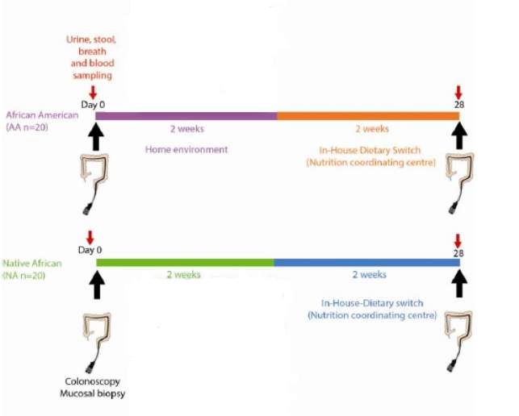
Figure 1. Overview of the study design and timeline.
Arrows indicate the repeat sampling times.
Included are photographic illustrations of key differences in food preparation and cooking methods between rural South Africans in KwaZulu-Natal, and westernized American populations in Pittsburgh, USA.

Table 1. Dietary analysis of Rural African and African American diets
 | Rural Africans | African American
Energy (Kcal) | 2353 | 2393
Total protein (g) | 68.5 | 86
Plant protein (g) | 46.2 | 26
Animal protein (g) | 22.3 | 60
Total fat (g) | 42.4 | 96
Carbohydrate, avail. (g) | 388.1 | 287
Total dietary fibre (g) | 27.4* | 15
Insoluble dietary fibre (g) | 3.2 | 9
Soluble dietary fibre (g) | 2.8* | 6
Ca (mg) | 279 | 734
Fe (mg) | 10.7 | 15.5
Vitamin A (RE) (mcg) | 966 | 4617
Total carotenoids (mcg) | 5667 | 4617
Thiamin (mg) | 1.41 | 1.9
Riboflavin (mg) | 0.69 | 2.2
Niacin (mg) | 12.9 | 27
Vitamin B6 (mg) | 1.186 | 2
Folate (mcg) | 348 | 486
Vitamin B12 (mcg) | 1.3 | 4.4
Vitamin K (mcg) | 276.42 | 177
Saturated fatty acids (FA) (g) | 8.75 | 33
Mono-unsaturated FA (g) | 13.61 | 32
Polyunsaturated FA (g) | 16.28 | 22
Cholesterol (mg) | 82 | 323
*-Excludes resistant starch

SHORT DIET switch DOESNOT EFFECT ESOPHAGEAL MUCOSA
The assessment of esophageal biopsies showed no histological abnormalities in the majority of patients in the two groups (Figure 2), however a significant fraction (≈20%) of the research subjects in both groups had reflux esophagitis. Furthermore, 5% of RA, but none of the AA, had esophageal candidiasis (Figure 2). The esophageal Ki67 staining was low and did not change as a result of the dietary change (Table 2). Overall, these results suggest that diet might not be a short term modifier of cancer risk in both groups.
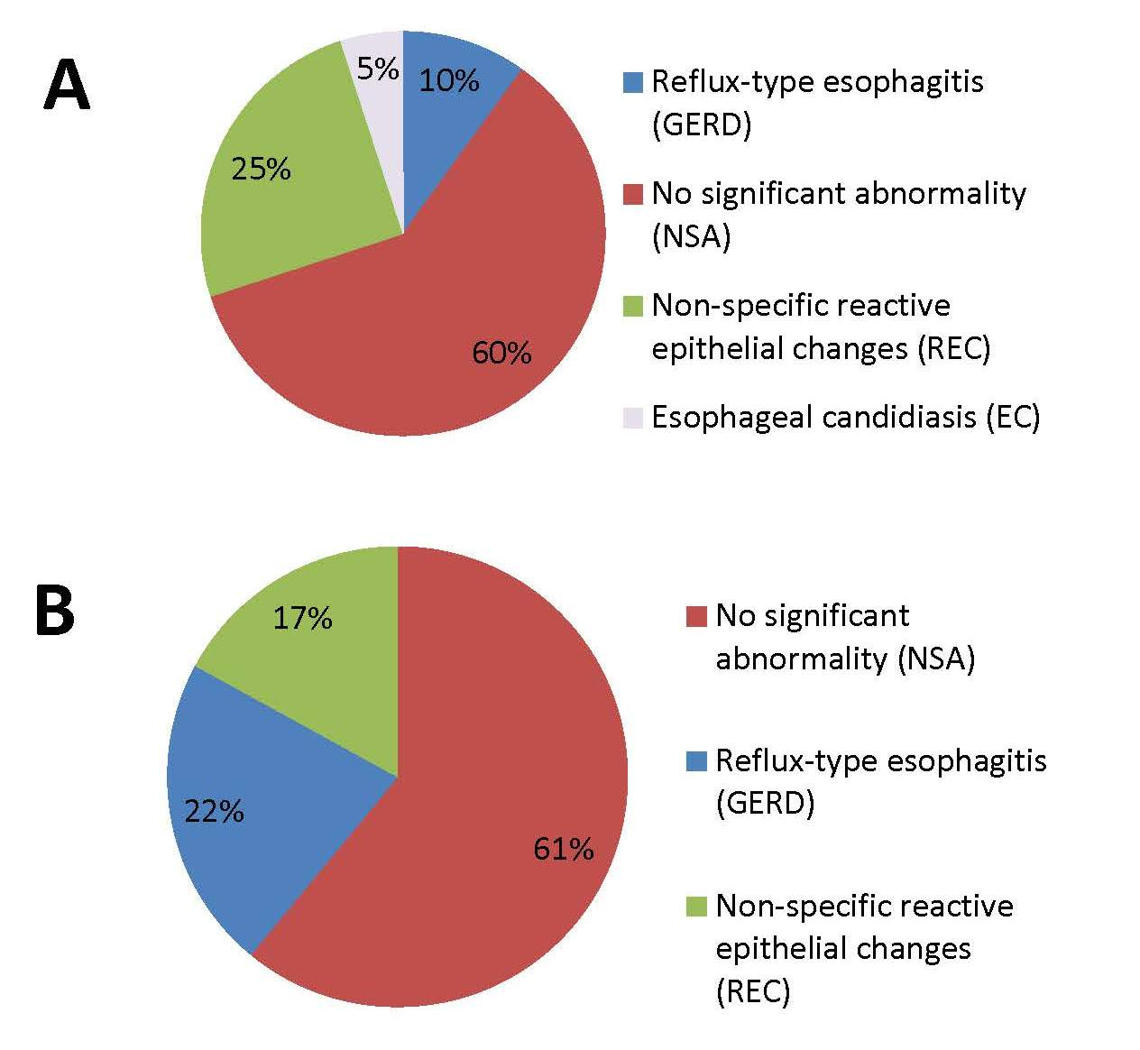

Figure 2. Diagnosis of esophageal biopsies in RA and AA at the baseline (pre-intervention)
A. Diagnosis of esophageal biopsies in RA.
B. Diagnosis of esophageal biopsies in AA.

Table 2. KI67 in esophageal muosa pre and post dietary intervention in RA and AA
 | Esophagus
 | Pre Intervention | Post Intervention
RA | 11+/-1.5% | 11+/-1.6%
AA | 16.82 +/-2.06 | 16.03+/- 1.98

SHORT DIET switch LEADS TO CHANGES IN GASTRIC MUCOSA
All of the RA gastric biopsies had Helicobacter pylori gastritis (100%) whereas 55% of the AA participants had Helicobacter pylori gastritis (Figure 3). Interestingly, the percent Ki67 in RA decreased after the consumption of the western diet; but the difference was not statistically significant (Table 3). There were no statistically significant changes due to the dietary intervention in the AA group.

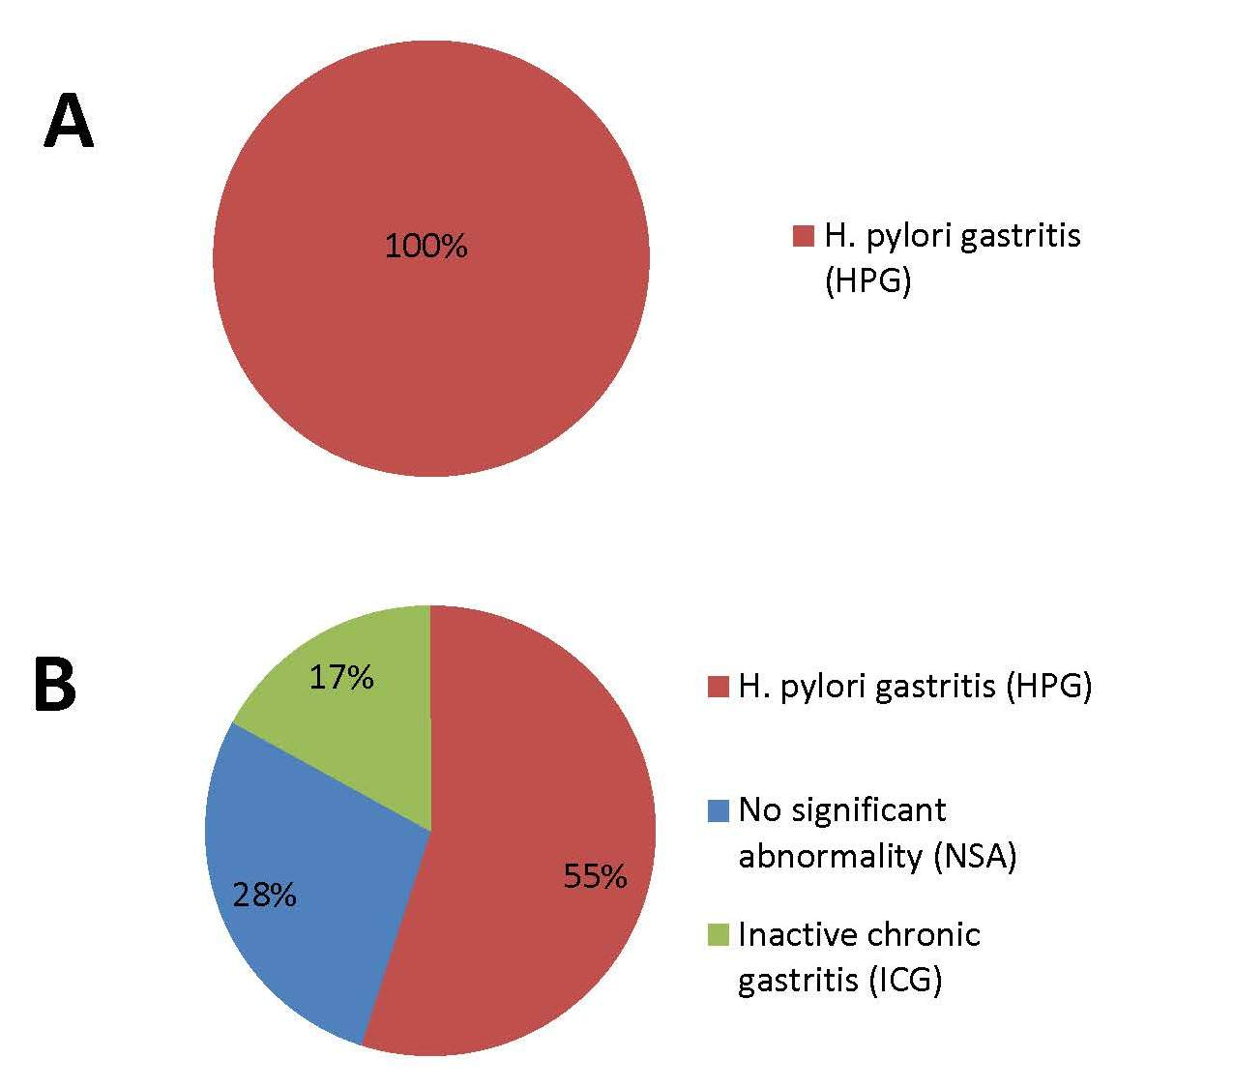
Figure 3. Diagnosis of Gastric biopsies in RA and AA at the baseline (pre-intervention)
A. Diagnosis of gastric biopsies in RA.
B. Diagnosis of gastric biopsies in AA.

Table 3. KI67 in gastric glands pre and post dietary intervention in RA and AA
 | Gastric glands (% KI 67)
 | Pre Intervention | Post Intervention
RA | 51.11+/-4.4 | 41.36+/-4.5
AA | 12.01+/- 1.8 | 20.52 +/-4.58

short diet switch LEADS TO CHANGES IN COLON MUCOSA
Changes in inflammation were assessed using, CD3+ intraepithelial lymphocytes and changes in mucosal proliferation were assessed by Ki 67. In AA, a high fiber, low fat diet was associated with a significant reduction in colonic mucosal inflammation and proliferation biomarkers of cancer risk within 2 weeks (Figure 4). On the other hand, the diet switch in RA to a high fat, low fiber diet resulted in opposite changes in these parameters (Figure 4). Interestingly, the dietary switch decreased proliferative rates in AA to levels lower than those of RA at baseline, whilst rates increased in RA to levels greater than AA at baseline (Figure 4).

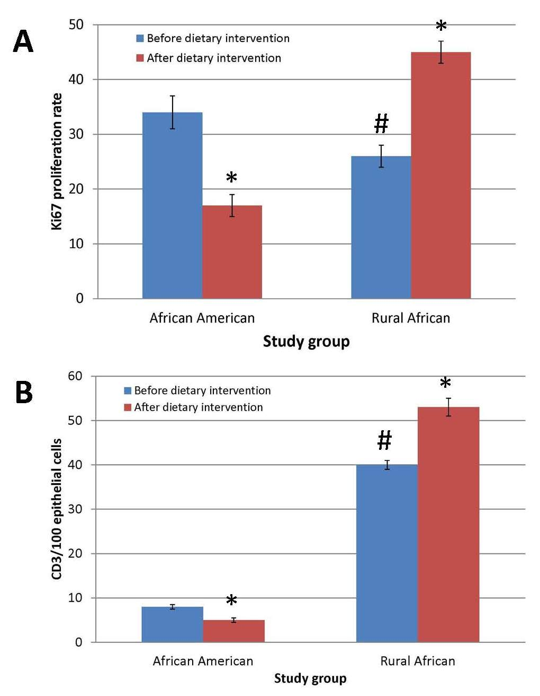
Figure 4. Colonic Mucosal Immunohistochemistry of Proliferative and Inflammatory Biomarkers
A-B. The bar graphs showing KI67 changes and CD3 changes respectively; the group mean ±SE results in 20 African Americans and 12 rural Africans. The two-tailed Mann-Whitney U-test was used for comparisons for non-paired samples and the Wilcoxon Rank Sum test for paired samples, with Bonferroni correction for multivariate comparisons. # indicate significant (p<0.05) baseline differences, * indicate significant changes induced by diet switch

DISCUSSION

Dietary change leads to variablle changes in gastrointestinal mucosa
Our study had multiple strengths. Firstly; it addressed cancer risk in African Americans, an ethnic group where there is not sufficient information available. Secondly, it was done in the home environment thereby controlling many of the external environmental factors that might have influenced our assessment. Finally, multiple approaches were used to confirm the findings such as Immunohitochemistry, metabolomics and microbiota analysis (O’Keefe et al., 2015).
RA and AA had a fundamentally different diet in terms of preparation, cooking, and composition (Table 1). The animal protein and fat intake was ≈ 2-3 fold higher in AA, and the chief carbohydrate and fiber form was resistant starch. Colonoscopies performed by our research team showed that AA had more polyps and higher rates of mucosal proliferation, as assessed by Ki67 epithelial cell staining, confirming its potential use as a biomarker of cancer risk (Ponz de Leon et al., 1988). The changes observed in the colonic mucosa of RA and AA were shown to be associated with profound differences in the microbiota (AA dominated by genus Bacteroides, RA by the genus Prevotella) and metabolic phenotype findings (O’Keefe et al., 2015). Two potential mechanisms for the mucosal diet-associated changes observed in the two groups can be hypothesized. The first mechanism involves the protective effect of dietary fiber in increasing butyrogenesis, and the promotional effect of dietary fat on stimulating bile acid synthesis by the liver. Short term diet changes have been shown to have a major impact on the colon by our group and others due to the colonic microbiota changes (Wu et al., 2011;David et al., 2014;O’Keefe et al., 2015). The RA and AA had very distinct colonic microbiota composition at baseline and after the dietary switch (O’Keefe et al., 2015). In AA, following the dietary switch to a high fiber, low fat diet; a significant reduction in colonic mucosal inflammation and proliferation biomarkers of cancer risk were observed after 2 weeks. This result is primarily due to an increase in saccharolytic fermentation and butyrogenesis and suppression of secondary bile acid synthesis (O’Keefe et al., 2015). In contrast, the diet switch in RA to a high fat low fiber diet resulted in opposite changes in all these parameters.
The changes in mucosa and the colonic microbiota results presented by our group suggest that diet might be a crucial factor in the precancerous GI changes (O’Keefe et al., 2015). The increased epithelial proliferation in GI tract predicts neoplastic change because the increase is associated with the risk of developing of DNA mutations due to the higher rate of exposure of sensitive proliferating cells to luminal carcinogens. This proliferative change in GI is referred to as “proliferation index”, is an important biomarker of premalignant conditions and is usually observed due to expansion of the proliferative zone, causing a shift of the proliferating cells from the base to the surface of the crypt. Continuous chronic inflammation has been shown to be associated with an increased cancer risk (Coussens and Werb, 2002). Patients with inflammatory bowel disease such as ulcerative colitis have a 5-fold increase in colon cancer; that can be drastically reduced by ≈ 50% by anti-inflammatory drugs such as Aspirin (Baron, 2009). Our results showed that CD3+ intraepithelial lymphocytes, a biomarker of mucosal inflammation, responded in a similar pattern to Ki67 proliferative biomarker. CD3+ intraepithelial lymphocytes provide a measure of T cell activation, these cells regulate the immune response when challenged with luminal antigens, such as bacteria (Kunisawa et al., 2007;Montufar-Solis et al., 2007). Assessing inflammation in RA is complex because of the prevalence of different intestinal and extraintestinal parasites. Our group identified intestinal parasites in the RA group; schistosoma in two subjects and a tapeworm segment in another (O’Keefe et al., 2015). Our group found unexpected colonic mucosal findings in RA consuming their usual baseline diets. They had high mucosal inflammation detected endoscopically, histologically, and by immunohistochemistry despite having low colon cancer rates. Intestinal protozoa have been hypothesized to stimulate immunosurveillance against colon cancer as well as other non-colonic cancer. The exact mechanism is not clear, but might include the ability to arrest butyrogenesis.

High FIBER IN DIET CAN LEAD TO DECREASED RISK OF COLORECTAL CANCER
Our group focused mainly on the potential of high fiber to modify metabolic pathways that can directly impact mucosal biomarkers of cancer risk, however many other aspects of the isocaloric diet were changed as well. Therefore, the associated change in animal protein or digestible carbohydrate might also be possible causes for the observed mucosal changes. Our results however, add evidence supporting the hypothesis that a high increase in fiber consumption and plant protein, together with a moderation in fat intake might lead to a decrease in colorectal cancer risk. Reduced butyrogenesis, the result of decreased fiber, might be allowing the chronic state of inflammation to progress through proliferation to neoplasia (Coussens and Werb, 2002). Our group’s results also confirm that the total quantities of fiber supplementation might be a critical factor in cancer prevention. Fiber supplementation at ≈35 g/d has generally failed to reduce polyp recurrence in clinical trials and only a total fiber intake that exceed 50 g/d as suggested by our current work and others seem sufficient enough to prevent colon cancer (Burkitt, 1973;O’Keefe et al., 2015).

CONCLUSION
RA have high rates of esophageal cancer (125:100,000) but low rates of gastric cancer (~7: 100,000) and colorectal cancer (<5:100,000). AA, an ethnic group that shares a common genetic pool with RA, have low rates of esophageal cancer (9:100,000), intermediate rates of gastric cancers (16:100,000), and significantly higher rates of colorectal cancer (~65:100,000). The changes observed in the stomach and colon in the short time interval in the current study show that the gastric and colonic mucosa is remarkably sensitive to dietary composition. The numeric reductions in gastric proliferation need to be confirmed by larger studies, but may be a consequence of increased intake of antioxidant vitamins. The increase in colonic epithelial proliferation is likely explained by reduced fiber intake resulting in reduced microbial fermentation and butyrogenesis, as previously described. Overall, our results support the recommendations that dietary changes may be an important tool for primary prevention of GI cancers. Furthermore, our results raise serious concerns that the progressive westernization of diet in African communities may lead to changes in the cancer risk of this group. The high prevalence of infectious diseases as well as the increase in cancer risk will lead to a serious ‘double burden’ on the health systems in these countries.

LIMITATIONS AND DIRECTIONS FOR FUTURE RESEARCH
We have shown in individuals from high risk and from low cancer risk populations that changes in the food content of fiber and fat had remarkable effects on their colonic microbiota and metabolome within 2 weeks, and, critically, that these changes were associated with significant changes in mucosal inflammation and proliferation. Whilst we cannot claim that these changes in mucosa will result in changes in the development of cancer, there is good experimental evidence that increased epithelial proliferation predicts neoplastic change. To better understand the role of diet in various GI cancers, additional longitudinal studies should be done utilizing individuals consuming both healthy and unhealthy dietary habits. In addition, better stratification of the study groups based on other cancer risk factors should be done to prevent potential confounders. Investigation of the effect of diet on GI mucosa and GI cancer risk should also be done in other ethnic groups; such studies could also focus on the effect of migration on dietary habits. Our results and others provide strong evidence that groups at high risk for GI cancers should consume more fiber in the diet, as well as consume a healthy diet to decrease the risk of colorectal cancer overall.

PUBLIC HEALTH SIGNIFICANCE
Our study has provided evidence that colorectal cancer prevention through increased fiber consumption and healthy diet is possible. High risk groups for colorectal cancer who consume more fiber and a healthy diet may be more likely have less GI mucosal inflammation. RA have high resident HP infection, and high mucosal inflammation, but have less gastric cancer. Thus, understanding the role of HP in the stomach microbiome interaction will definitely provide evidence whether the treatment of RA with HP is indeed useful. Our results also raise serious concerns that the progressive westernization of African communities may reduce butyrogenesis, thus enabling their high basal state of chronic inflammation to progress through proliferation to neoplasia, and culminating in the emergence of colorectal cancer as a major health issue.

bibliography
Abrams, D.I. (2014). Milking the evidence: diet does matter. J Clin Oncol 32, 2290-2292. doi: 10.1200/jco.2014.56.6299.
Ahrens, W., Pohlabeln, H., Foraita, R., Nelis, M., Lagiou, P., Lagiou, A., Bouchardy, C., Slamova, A., Schejbalova, M., Merletti, F., Richiardi, L., Kjaerheim, K., Agudo, A., Castellsague, X., Macfarlane, T.V., Macfarlane, G.J., Lee, Y.C., Talamini, R., Barzan, L., Canova, C., Simonato, L., Thomson, P., Mckinney, P.A., Mcmahon, A.D., Znaor, A., Healy, C.M., Mccartan, B.E., Metspalu, A., Marron, M., Hashibe, M., Conway, D.I., and Brennan, P. (2014). Oral health, dental care and mouthwash associated with upper aerodigestive tract cancer risk in Europe: the ARCAGE study. Oral Oncol 50, 616-625. doi: 10.1016/j.oraloncology.2014.03.001.
Baron, J.A. (2009). Aspirin and NSAIDs for the prevention of colorectal cancer. Recent Results Cancer Res 181, 223-229.
Bianchini, F., and Vainio, H. (2001). Allium vegetables and organosulfur compounds: do they help prevent cancer? Environ Health Perspect 109, 893-902.
Buckland, G., Travier, N., Huerta, J., Bueno-De-Mesquita, H.A., Siersema, P., Skeie, G., Weiderpass, E., Engeset, D., Ericson, U., Ohlsson, B., Agudo, A., Romieu, I., Ferrari, P., Freisling, H., Colorado-Yohar, S., Li, K., Kaaks, R., Pala, V., Cross, A.J., Riboli, E., Trichopoulou, A., Lagiou, P., Bamia, C., Boutron-Ruault, M., Fagherazzi, G., Dartois, L., May, A., Peeters, P., Panico, S., Johansson, M., Wallner, B., Palli, D., Key, T., Khaw, K., Ardanaz, E., Overvad, K., Tjonneland, A., Dorronsoro, M., Sanchez, M., Quiros, J., Naccarati, A., Tumino, R., Boeing, H., and Gonzalez, C. (2014). Healthy lifestyle index and risk of gastric adenocarcinoma in the EPIC cohort study. Int J Cancer. doi: 10.1002/ijc.29411.
Burkitt, D.P. (1973). Diseases of the alimentary tract and western diets. Pathol Microbiol (Basel) 39, 177-186.
Chen, H., Ward, M.H., Graubard, B.I., Heineman, E.F., Markin, R.M., Potischman, N.A., Russell, R.M., Weisenburger, D.D., and Tucker, K.L. (2002). Dietary patterns and adenocarcinoma of the esophagus and distal stomach. Am J Clin Nutr 75, 137-144.
Coussens, L.M., and Werb, Z. (2002). Inflammation and cancer. Nature 420, 860-867. doi: 10.1038/nature01322.
David, L.A., Maurice, C.F., Carmody, R.N., Gootenberg, D.B., Button, J.E., Wolfe, B.E., Ling, A.V., Devlin, A.S., Varma, Y., Fischbach, M.A., Biddinger, S.B., Dutton, R.J., and Turnbaugh, P.J. (2014). Diet rapidly and reproducibly alters the human gut microbiome. Nature 505, 559-563. doi: 10.1038/nature12820.
Dawsey, S.M., Fagundes, R.B., Jacobson, B.C., Kresty, L.A., Mallery, S.R., Paski, S., and Van Den Brandt, P.A. (2014a). Diet and esophageal disease. Ann N Y Acad Sci 1325, 127-137. doi: 10.1111/nyas.12528.
Dawsey, S.P., Hollenbeck, A., Schatzkin, A., and Abnet, C.C. (2014b). A prospective study of vitamin and mineral supplement use and the risk of upper gastrointestinal cancers. PLoS One 9, e88774. doi: 10.1371/journal.pone.0088774.
De Stefani, E., Deneo-Pellegrini, H., Ronco, A.L., Boffetta, P., Correa, P., Mendilaharsu, M., Acosta, G., Quarneti, A., and Silva, C. (2014). Diet patterns and risk of squamous cell oesophageal carcinoma: a case-control study in Uruguay. Asian Pac J Cancer Prev 15, 2765-2769.
Deplancke, B., Finster, K., Graham, W.V., Collier, C.T., Thurmond, J.E., and Gaskins, H.R. (2003). Gastrointestinal and microbial responses to sulfate-supplemented drinking water in mice. Exp Biol Med (Maywood) 228, 424-433.
Donohoe, D.R., Collins, L.B., Wali, A., Bigler, R., Sun, W., and Bultman, S.J. (2012). The Warburg effect dictates the mechanism of butyrate-mediated histone acetylation and cell proliferation. Mol Cell 48, 612-626. doi: 10.1016/j.molcel.2012.08.033.
Ferlay, J., Soerjomataram, I., Ervik, M., Dikshit, R., and Et Al. (2013). "Cancer Incidence and Mortality Worldwide: " in: IARC CancerBase No. 11 [Internet]. International Agency for Research on Cancer, Lyon, France 2013. Available from: http://globocan.iarc.fr.).
Heck, C.I., and De Mejia, E.G. (2007). Yerba Mate Tea (Ilex paraguariensis): a comprehensive review on chemistry, health implications, and technological considerations. J Food Sci 72, R138-151. doi: 10.1111/j.1750-3841.2007.00535.x.
Huang, W., Han, Y., Xu, J., Zhu, W., and Li, Z. (2013). Red and processed meat intake and risk of esophageal adenocarcinoma: a meta-analysis of observational studies. Cancer Causes Control 24, 193-201. doi: 10.1007/s10552-012-0105-9.
Irrazabal, T., Belcheva, A., Girardin, S.E., Martin, A., and Philpott, D.J. (2014). The multifaceted role of the intestinal microbiota in colon cancer. Mol Cell 54, 309-320. doi: 10.1016/j.molcel.2014.03.039.
Jakszyn, P., and Gonzalez, C.A. (2006). Nitrosamine and related food intake and gastric and oesophageal cancer risk: a systematic review of the epidemiological evidence. World J Gastroenterol 12, 4296-4303.
Jobin, C. (2012). Colorectal cancer: CRC--all about microbial products and barrier function? Nat Rev Gastroenterol Hepatol 9, 694-696. doi: 10.1038/nrgastro.2012.220.
Keszei, A.P., Goldbohm, R.A., Schouten, L.J., Jakszyn, P., and Van Den Brandt, P.A. (2013). Dietary N-nitroso compounds, endogenous nitrosation, and the risk of esophageal and gastric cancer subtypes in the Netherlands Cohort Study. Am J Clin Nutr 97, 135-146. doi: 10.3945/ajcn.112.043885.
Kim, J., Cho, Y.A., Choi, W.J., and Jeong, S.H. (2014). Gene-diet interactions in gastric cancer risk: a systematic review. World J Gastroenterol 20, 9600-9610. doi: 10.3748/wjg.v20.i28.9600.
Kubo, A., Corley, D.A., Jensen, C.D., and Kaur, R. (2010). Dietary factors and the risks of oesophageal adenocarcinoma and Barrett's oesophagus. Nutr Res Rev 23, 230-246. doi: 10.1017/s0954422410000132.
Kunisawa, J., Takahashi, I., and Kiyono, H. (2007). Intraepithelial lymphocytes: their shared and divergent immunological behaviors in the small and large intestine. Immunol Rev 215, 136-153. doi: 10.1111/j.1600-065X.2006.00475.x.
Lakatos, P.L., and Lakatos, L. (2008). Risk for colorectal cancer in ulcerative colitis: changes, causes and management strategies. World J Gastroenterol 14, 3937-3947.
Lewin, M.H., Bailey, N., Bandaletova, T., Bowman, R., Cross, A.J., Pollock, J., Shuker, D.E., and Bingham, S.A. (2006). Red meat enhances the colonic formation of the DNA adduct O6-carboxymethyl guanine: implications for colorectal cancer risk. Cancer Res 66, 1859-1865. doi: 10.1158/0008-5472.can-05-2237.
Lim, S.S., Vos, T., Flaxman, A.D., Danaei, G., Shibuya, K., Adair-Rohani, H., Amann, M., Anderson, H.R., Andrews, K.G., Aryee, M., Atkinson, C., Bacchus, L.J., Bahalim, A.N., Balakrishnan, K., Balmes, J., Barker-Collo, S., Baxter, A., Bell, M.L., Blore, J.D., Blyth, F., Bonner, C., Borges, G., Bourne, R., Boussinesq, M., Brauer, M., Brooks, P., Bruce, N.G., Brunekreef, B., Bryan-Hancock, C., Bucello, C., Buchbinder, R., Bull, F., Burnett, R.T., Byers, T.E., Calabria, B., Carapetis, J., Carnahan, E., Chafe, Z., Charlson, F., Chen, H., Chen, J.S., Cheng, A.T., Child, J.C., Cohen, A., Colson, K.E., Cowie, B.C., Darby, S., Darling, S., Davis, A., Degenhardt, L., Dentener, F., Des Jarlais, D.C., Devries, K., Dherani, M., Ding, E.L., Dorsey, E.R., Driscoll, T., Edmond, K., Ali, S.E., Engell, R.E., Erwin, P.J., Fahimi, S., Falder, G., Farzadfar, F., Ferrari, A., Finucane, M.M., Flaxman, S., Fowkes, F.G., Freedman, G., Freeman, M.K., Gakidou, E., Ghosh, S., Giovannucci, E., Gmel, G., Graham, K., Grainger, R., Grant, B., Gunnell, D., Gutierrez, H.R., Hall, W., Hoek, H.W., Hogan, A., Hosgood, H.D., 3rd, Hoy, D., Hu, H., Hubbell, B.J., Hutchings, S.J., Ibeanusi, S.E., Jacklyn, G.L., Jasrasaria, R., Jonas, J.B., Kan, H., Kanis, J.A., Kassebaum, N., Kawakami, N., Khang, Y.H., Khatibzadeh, S., Khoo, J.P., Kok, C., Laden, F., et al. (2012). A comparative risk assessment of burden of disease and injury attributable to 67 risk factors and risk factor clusters in 21 regions, 1990-2010: a systematic analysis for the Global Burden of Disease Study 2010. Lancet 380, 2224-2260. doi: 10.1016/s0140-6736(12)61766-8.
Lin, S.H., Li, Y.H., Leung, K., Huang, C.Y., and Wang, X.R. (2014). Salt processed food and gastric cancer in a Chinese population. Asian Pac J Cancer Prev 15, 5293-5298.
Medema, J.P., and Vermeulen, L. (2011). Microenvironmental regulation of stem cells in intestinal homeostasis and cancer. Nature 474, 318-326. doi: 10.1038/nature10212.
Montufar-Solis, D., Garza, T., and Klein, J.R. (2007). T-cell activation in the intestinal mucosa. Immunol Rev 215, 189-201. doi: 10.1111/j.1600-065X.2006.00471.x.
Murray, C., Abraham J, Ali Mk, A.M., Atkinson C, Baddour Lm, Bartels Dh, Benjamin Ej, Bhalla K, Birbeck G, Bolliger I, Burstein R, Carnahan E, Chen H, Chou D, Chugh Ss, Cohen A, Colson K, Cooper Lt, Couser W, Criqui Mh, and Dabhadkar Kc, D.N., Danaei G, Dellavalle Rp, Jarlais Dc, Dicker D, Ding El, Dorsey E, Duber H, Ebel Be, Engell Re, Ezzati M, Felson Dt, Finucane Mm, Flaxman S, Flaxman Ad, Fleming T, Forouzanfar Mh, Freedman G, Freeman Mk, Gabriel Se, Gakidou E, Gillum Rf, Gonzalez-Medina D, Gosselin R, Grant B, Gutierrez Hr, Hagan H, Havmoeller R, Hoffman H, Jacobsen Kh, James Sl, Jasrasaria R, Jayaraman S, Johns N, Kassebaum N, Khatibzadeh S, Knowlton Lm, Lan Q, Leasher Jl, Lim S, Lin Jk, Lipshultz Se, London S, Lozano R, Lu Y, Macintyre Mf, Mallinger L, Mcdermott Mm, Meltzer M, Mensah Ga, Michaud C, Miller Tr, Mock C, Moffitt Te, Mokdad Aa, Mokdad Ah, Moran Ae, Mozaffarian D, Murphy T, Naghavi M, Narayan K, Nelson Rg, Olives C, Omer Sb, Ortblad K, Ostro B, Pelizzari Pm, Phillips D, Pope C 3rd, Raju M, Ranganathan D, Razavi H, Ritz B, Rivara Fp, Roberts T, Sacco Rl, Salomon Ja, Sampson U, Sanman E, Sapkota a, Schwebel Dc, Shahraz S, Shibuya K, Shivakoti R, Silberberg D, Singh Gm, Singh D, Singh Ja, Sleet Da, Steenland K, Tavakkoli M, Taylor Ja, Thurston Gd, Towbin Ja, Vavilala Ms, Vos T, Wagner Gr, Weinstock Ma, Weisskopf Mg, Wilkinson Jd, Wulf S, Zabetian a, Lopez Ad. (2013). The state of US health, 1990-2010: burden of diseases, injuries, and risk factors. JAMA 310, 591-608. doi: 10.1001/jama.2013.13805.
O'sullivan, K.E., Phelan, J.J., O'hanlon, C., Lysaght, J., O'sullivan, J.N., and Reynolds, J.V. (2014). The role of inflammation in cancer of the esophagus. Expert Rev Gastroenterol Hepatol 8, 749-760. doi: 10.1586/17474124.2014.913478.
O’keefe, J.D., Jia V. Li, Leo Lahti, Junhai Ou, Franck Carbonero, Khaled Mohammed, James Kinross, Elizabeth Ruder, Kishore Vipperla, Vasudevan Naidoo, Lungile Mtshali, Sebastian Tims, Philippe G.B. Puylaert, James Delany, Alyssa Krasinskas, Ann C. Benefiel, Hatem O. Kaseb, Keith Newton, Jeremy K. Nicholson, Willem M. De Vos, H. Rex Gaskins *, and *, E.G.Z. (2015). Fat, Fiber and Cancer Risk in African Americans and Rural Africans. Nature communications (In review).
Ponz De Leon, M., Roncucci, L., Di Donato, P., Tassi, L., Smerieri, O., Amorico, M.G., Malagoli, G., De Maria, D., Antonioli, A., Chahin, N.J., and Et Al. (1988). Pattern of epithelial cell proliferation in colorectal mucosa of normal subjects and of patients with adenomatous polyps or cancer of the large bowel. Cancer Res 48, 4121-4126.
Sewram, V., De Stefani, E., Brennan, P., and Boffetta, P. (2003). Mate consumption and the risk of squamous cell esophageal cancer in uruguay. Cancer Epidemiol Biomarkers Prev 12, 508-513.
Sewram, V., Sitas, F., O'connell, D., and Myers, J. (2014). Diet and esophageal cancer risk in the Eastern Cape Province of South Africa. Nutr Cancer 66, 791-799. doi: 10.1080/01635581.2014.916321.
Song, P., Lu, M., Yin, Q., Wu, L., Zhang, D., Fu, B., Wang, B., and Zhao, Q. (2014). Red meat consumption and stomach cancer risk: a meta-analysis. J Cancer Res Clin Oncol 140, 979-992. doi: 10.1007/s00432-014-1637-z.
Strickland, P.T., Roth, M.J., Qiao, Y.L., Rothman, N., Tangrea, J.A., Dawsey, S.M., Wand, G.Q., Cho, S.H., Kang, D., Taylor, P.R (2001). High urine 1-hydroxypyrene glucuronide concentrations in Linxian, China, an area of high risk for squamous oesophageal cancer. Biomarkers 6, 381-386. doi: 10.1080/13547500110044780.
Turati, F., Pelucchi, C., Guercio, V., La Vecchia, C., and Galeone, C. (2015). Allium vegetable intake and gastric cancer: A case-control study and meta-analysis. Mol Nutr Food Res 59, 171-179. doi: 10.1002/mnfr.201400496.
Wie, G.A., Cho, Y.A., Kang, H.H., Ryu, K.A., Yoo, M.K., Kim, Y.A., Jung, K.W., Kim, J., Lee, J.H., and Joung, H. (2014). Red meat consumption is associated with an increased overall cancer risk: a prospective cohort study in Korea. Br J Nutr 112, 238-247. doi: 10.1017/s0007114514000683.
Winter, S.E., Lopez, C.A., and Baumler, A.J. (2013). The dynamics of gut-associated microbial communities during inflammation. EMBO Rep 14, 319-327. doi: 10.1038/embor.2013.27.
Wu, G.D., Chen, J., Hoffmann, C., Bittinger, K., Chen, Y.Y., Keilbaugh, S.A., Bewtra, M., Knights, D., Walters, W.A., Knight, R., Sinha, R., Gilroy, E., Gupta, K., Baldassano, R., Nessel, L., Li, H., Bushman, F.D., and Lewis, J.D. (2011). Linking long-term dietary patterns with gut microbial enterotypes. Science 334, 105-108. doi: 10.1126/science.1208344.
Xiao, Q., Freedman, N.D., Ren, J., Hollenbeck, A.R., Abnet, C.C., and Park, Y. (2014). Intakes of folate, methionine, vitamin B6, and vitamin B12 with risk of esophageal and gastric cancer in a large cohort study. Br J Cancer 110, 1328-1333. doi: 10.1038/bjc.2014.17.

